

Investigating El Nino Southern Oscillation as the main driver of forest fire in Kalimantan

Ida Bagus Mandhara Brasika^{1,3}, I Made Oka Guna Antara² , I Wayan Gede Astawa Karang^{1,3}

¹Department of Marine Science, Faculty of Marine Sciences and Fisheries, Universitas Udayana,
80361 Badung, Bali, Indonesia
²Center of Spatial Data Infrastructure Development, Universitas Udayana, 80234 Denpasar,
Bali, Indonesia
³Center of Remote Sensing and Ocean Science (CReSOS), Universitas Udayana, 80234 Denpasar,
Bali, Indonesia

Correspondence: Ida Bagus Mandhara Brasika (email: mandharabrasika@unud.ac.id)

Received: 31 July 2021; Accepted: 13 August 2021; Published: 30 November 2021

Abstract

Strong El Nino events have been identified as major factors contributing to the forest fire in Indonesia. This is due to El Nino Southern Oscillation (ENSO) variability has a distinct connection with tropical precipitation, mainly in Indonesia. El Nino years are typically drier, while La Nina events generally increase precipitation in Indonesia. Although very strong El Nino events have been connected with massive forest fires, fire continue to occur during the other phases of ENSO: La Nina and normal. Here, the research reports a time series of monthly counted fires in Kalimantan between the period 2001-2020 from MODIS fire hotspot and MODIS Burned Area products. The region is divided into three categories, Primary Intact Forest, Primary Degraded Forest and Outside Forest/ Deforested area. This categorization validates the location of the fire. Our results show that in general wildfires in Kalimantan follow a similar temporal pattern with Oceanic Nino Index (ONI), with several anomalies. If ONI is high, wildfires are more intense and vice versa. The wildfire appears almost every month and increases drastically in June-October of El Nino years. However, the proportion of wildfires in Primary Intact Forest are tiny and insignificant. The primary intact forest fire only appears in July-October and have a different pattern with wildfires in general. In conclusion, wildfires are highly correlated with El Nino but limited in primary intact forests. The fires dominantly appear in the deforested area, about 80%. The rest 20% are in degraded forest and only less than 1% in primary intact forest.

Keywords: Deforested, degraded forest, ENSO, forest fire, ONI, primary intact forest

Introduction

The interaction between ocean and atmosphere has shown a major contribution to global climate dynamics. The El Nino Southern Oscillation (ENSO) which consists of El Nino and La Nina events has been shown to have a massive connection with many large scale disasters such as flood, forest fire and others (Fuller & Murphy, 2006; Bouma, Kovats, Goubet, Cox, & Haines, 1997; Yin, Yu, & Chen, 2009). These two have different impacts for different regions, however, within a given region, they usually have opposite effects. Some areas are drier during El Nino events and wetter during La Nina, while others get more rain in El Nino years and less rain during La Nina.
ENSO is also blamed for many wildfires around the world. El Nino increases fire in many countries such as Indonesia, Vietnam and Australia (Gross, 2015). While La Nina can cause more wildfire to occur in some US regions, like Utah, compared to the El Nino season (Brown, Hall, & Westerling, 2004).
Focusing on Indonesia, many people assume that fires in Kalimantan are directly related to El Nino events. This is because several massive forest fires have occurred in years with very strong El Nino events. The most notable one was in 1997/98 (Page, et al., 2002), when fires caused an estimated 2.6 million hectares of burning land (Siegert, Ruecker, Hinrichs, & Hoffmann, Increased damage from fires in logged during droughts caused by El Nino, 2001). More recently, in 2015 (Huijnen, et al., 2016), Indonesia experienced its worst fire season in 20 years, when it exceeded the US $16 billion economic loss (Edwards, Naylor, Higgins, & Falcon, 2020). Both years had very strong El Nino. Thus a very strong El Nino is connected with massive forest fire (Field, et al., 2016). The Oceanic Nino Index (ONI) value for those years was more than 2.0 for 3 months consecutively. However, forest fires do not occur in El Nino years only.
Meanwhile, forest, specifically tropical forest, has the ability to resist from the fire and drought conditions. The intact tropical forest ecosystem has a closed-canopy that limits solar radiation reaching the forest floor, maintaining low temperature and high humidity underneath (Bonan, 2008) (Baker & Spracklen, 2019). It is also resilient during drought by sustaining elevated humidity (Uhl, Kauffman, & Cummings, 1988).
Many people assume that ENSO is the cause of fires in Indonesia, and numerous policy solutions have been proposed based on that assumption. However, other than weather, ecological and human activities have a significant impact on fire development (Lestari, Rumantir, & Tapper, 2016; Goldammer & Siegert, 1990). In this paper, it will examine to what extent ENSO influences forest fire in Indonesia, mainly in primary intact forest.

Literature review

ENSO characteristic

The El Nino is easily recognized by the Sea Surface Temperature (SST) measurement over the pacific oceans. However, its definition is debatable amongst scientists. (Quinn, Zopf, Short, & Kuo, 1978) divide the magnitude of El Nino into 4 scales (strong, moderate, weak and very weak) and produce a list of El Nino events since 1726. The measurement was based on the phenomenon around the west coast of Southern America and was often qualitative. To quantify the El Nino, the Japan Meteorological Agency defines the event which is consistent with the consensus of the ENSO research community, as follows:
- Analyze monthly mean SST’s in 2º x 2º grids.
- Calculate monthly SST anomalies averaged for the area 4ºN-4ºS and 90º-150ºW. This is essentially the region known as “Nino 3”
- Find periods during which 5-month running means of the monthly SST anomalies in the above-mentioned area are +0.5ºC or more for at least six consecutive months.

Although the El Nino occurs in 4 different regions, the research of El Nino focuses on the Nino 3 region, defined as 5ºN-5ºS, 90º-150ºW, due to its significant impact on climate and ocean (Trenberth, The Definition of El Nino, 1997). Figure 1 illustrates the regions of different kinds of El Nino.
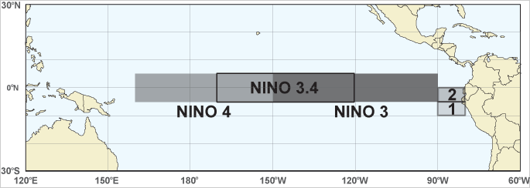
Source: Bureau of Meteorology, 2017

Figure 1. The area of monthly mean SST is calculated to define the occurrence of different El Nino.

ENSO spatial pattern

El Nino and La Nina are the warm and cool phases of a recurring climate pattern across the tropical pacific. The pattern can shift back and forth irregularly every two to seven years, and each phase triggers predictable disruptions of temperature, precipitation and winds. These changes disrupt the large-scale air movement in the tropics, triggering a cascade of global side effects. Figure 2 showed the general spatial pattern of the El Nino and La Nina events. The ideal pattern of El Nino is signed by the vast warm pool in the equatorial pacific oceans. This pool generates massive cumulonimbus, which produces heavy rain, over the pacific. As the rainfall in the ocean, the dry air will sink in the Indonesia and South America region. The spatial pattern of La Nina is the opposite of El Nino, heavy precipitation occurs over the Indonesian archipelago.
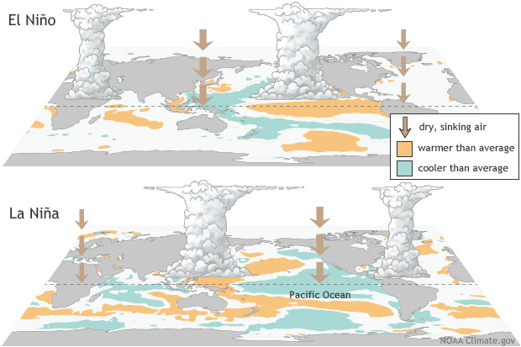
Source: National Oceanic and Atmospheric Administration, 2017

Figure 2. The physical atmosphere of spatial pattern in El Nino (above) and La Nina (bellow) events.

Kalimantan forest fire

Kalimantan has more inhabitants per area where the species richness is the most resilient to forest fire. This island incredibly has the third largest area in the world with 746.000 km² (Wooster, Perry, & Zoumas, 2012). Kalimantan possesses the world’s highest concentrations of Dipterocarp forest ecosystem. Figure 3 show Lowland Dipterocarp Forest and Upper Dipterocarp Forest are accounted as the widest area with 306 t/ha and 274 t/ha, respectively; the characteristic of this type of land is vulnerability to fire due to its drought-susceptibility even from small disturbance (Guhardja et al., 2000; Siegert et al., 2001; Cochrane, 2003; Goldammer, 2007)

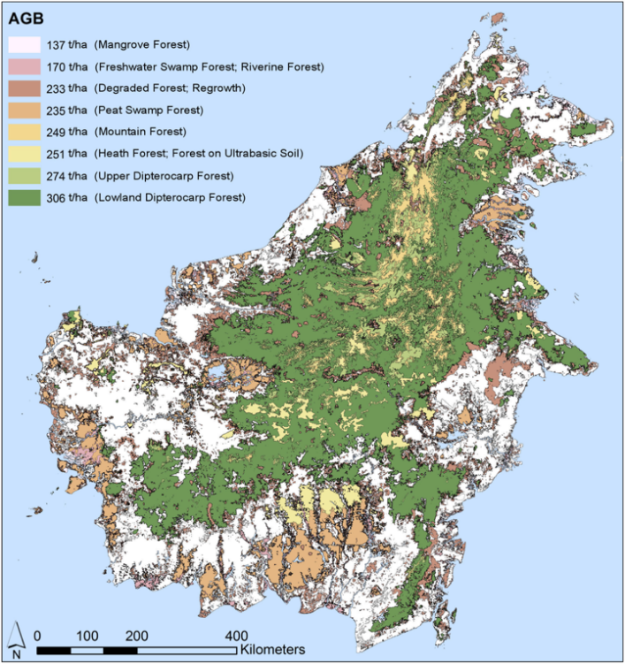
Figure 3. Borneo land cover classification of the year 2008 (Langner, et al., 2015)
Borneo has an equatorial tropical climate, with often relatively light winds and only small annual temperature and humidity variations. The precipitation over Kalimantan is 3000 m every year with seasonal variation which means the rainfall is high and crucial in this region (Hamada, et al., 2002). The El Nino regimes decrease this high precipitation in Borneo significantly, although it never drops to zero (Kirono, Tapper, & McBride, 1999; Guhardja, Fatawi, Sutisna, Mori, & Ohta, 2000). The record (fire activity on Borneo over the Pleistocene and the Holocene) from Goldammer (2007) showed the climatic oscillations (e.g. glacial-interglacial cycles and the ENSO) resulted in favourable conditions for fire ignition.

ENSO’s impact on Indonesia

As mentioned in the previous section, global climate events such as El Nino could encourage atmospheric conditions over Indonesia to be the driver of fire. The appearance of El Nino could decrease the amount of precipitation for 4-6 months in a row and is usually in the boreal winter (June-August) which should be the rainy season, so it causes the chaotic seasonal phase of Indonesia due to the “dry” of wet-season. Combining anthropogenic factors such as human ignition and human-induced drainage could produce extremely low fuel moisture regimes. Moreover, heavy fire areas might spread to the less disturbed area and peatland area, then ignite heavier fire (Guhardja, Fatawi, Sutisna, Mori, & Ohta, 2000; Langner, Miettinen, & Siegert, 2007). This extreme event is correlated with the vast forest fire in Indonesia when the uncontrollable and undesirable fire burns many forest areas in Sumatra and Kalimantan.

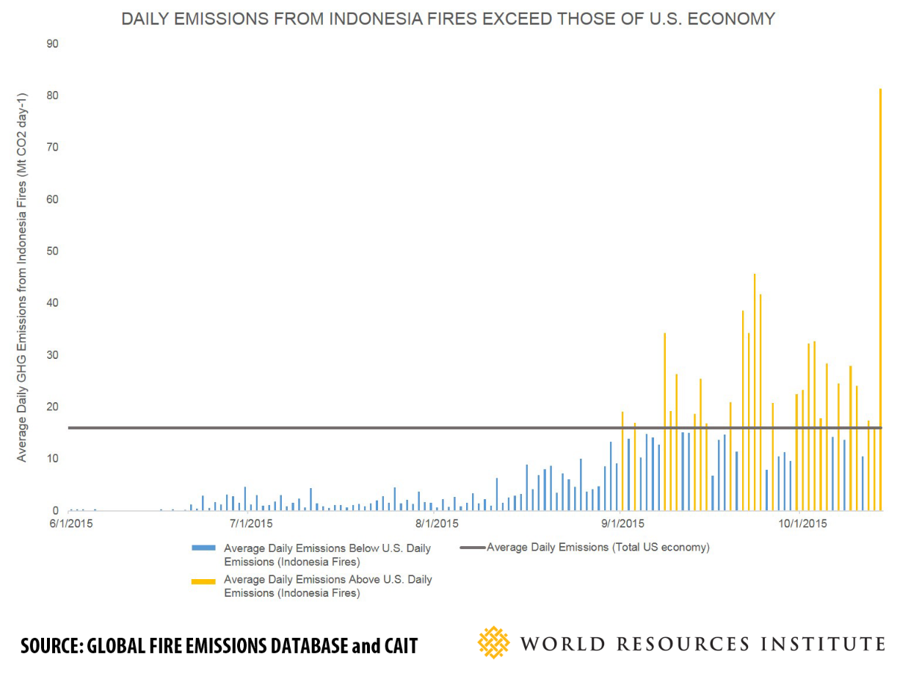
Source: Global Fire Emissions Database and Cait, WRI; Harris et al., (2015)
Figure 4. The comparison of Indonesia and US daily emission in the 2015 Indonesian massive forest fire.
In 2015/2016, the very strong El Nino occurred for more than 14 months then followed by weak La Nina. This climatic condition is pursued by a huge fire in Indonesian forest which emits a huge amount of carbon and other gases. Figure 4 portrays the daily emission of 2015 Indonesian fires is 4 times higher than the daily emission in the US. According to the government, 2.6 million hectares of Indonesian land were burnt between June and October 2015, an area four and half times the size of Bali. By October 2015, eight provinces had burned more than 100.000 hectares each (Adriani, Moyer, Kendrick, Henry, & Wood, 2016).

Method and study area

In this research, the fires are defined by their location. It is divided into 3 different areas which are Primary Intact Forest, Degraded Forest and Deforested/Outside Forest. This illustrates the exact location of the fire, it is in the forest or not. Then the temporal patterns are compared with Oceanic Nino Index to show the connection of fires on those 3 regions with El Nino.

Oceanic Nino Index

The presence of ENSO can be determined by index, one of it is Oceanic Nino Index (ONI) which is produced by NOAA (National Oceanic Atmospheric Agency) on a real-time basis. El Nino presence is defined by ONI show +0.5 or higher (Glantz & Ramirez, 2020), indicating that the region of the east-central pacific is significantly warmer than usual. On the other hand, if the ONI is -0.5 or lower, this indicates a La Nina event, meaning the region is cooler than usual (Dahlman, 2016).

This index is calculated by the average of Sea Surface Temperature (SST) on the region of Nino 3,4 for 3 months consecutively (Trenberth & Stepaniak, 2001) (Rasmusson & Carpenter, 1982). This number is then compared with the average of SST over 30 years (Trenberth, 1997). Based on this calculation, El Nino or La Nina events can be classified as Low, Moderate and Strong/High, as shown in the table 1.

Table 1. Classification of ENSO magnitude.

 | Low | Moderate | High
El Nino | +0.5 to +1 | +1 to +1.5 | >+1.5
La Nina | -0.5 to -1 | -1 to -1.5 | <-1.5

This index is important to define the ENSO phase (El Nino; La Nina; normal) and the magnitude (Low; Moderate; High). Then, it can analyze the spatial-temporal condition of forest fire in every phase and magnitude of ENSO.

FIRMS MODIS Active Fire

The active fire data is gained from satellite MODIS. This uses the MODIS Collection 6 (standard processing) MCD14ML from Fire Information for Resource Management System (FIRMS, 2021). The MODIS itself is a daily dataset with a resolution of 1-kilometre pixel starting from 2001 to 2020 but it can be generated into monthly forest fires.

Due to the property of MODIS, there are some limitations of this satellite to capture the small scale/local fire. There are also factors from the cloud cover, tree canopy and heavy smoke. However, the MODIS data information is adequate to capture the regional scale active fire distribution.

To reduce the potential false alarm, this study plot only the hotspots with high-confidence of fire. This confidence scale is set at more than 80% confidence. Then, the area also will be classified as three different types of land, primary intact forest; primary forest with tree loss (degraded forest); outside primary forest/deforested. This will give more detail of forest fire occurrence.

Forest loss distribution

The fire might occur outside the area of the primary forest, this can lead to a misinterpretation of the forest fire. Moreover, the primary forest cover changes every year. Here, the research uses primary forest cover loss in Indonesia from 2000 to 2012 (Margono et al., 2014) to analyse the location of the fire. In this dataset, the primary forest is divided into 2, intact and degraded. An intact primary forest is an area bigger than 50,000 ha without any significant human-caused disturbance and/or fragmentation (Potapov et al., 2008). A degraded primary forest is a primary forest that has partial canopy loss and altered forest composition and structure (Margono et al., 2012). While outside forest area is defined as the non-forest area of cleared/deforested forest. Thus, they classified the area as:

Table 2. Class of Area in Kalimantan)

Classes | Area explanation
0 | Out of area study
1 | No change of primary degraded forest from 2000-2012
2 | No change of primary intact forest from 2000-2012
3 | No change of non-primary from 2000-2012
4 | Primary intact, cleared 2005
5 | Primary intact, cleared 2010
6 | Primary intact, cleared 2012
7 | Primary intact, degraded 2005
8 | Primary intact, degraded 2010
9 | Primary intact, degraded 2012
10 | Primary degraded, cleared 2005
11 | Primary degraded, cleared 2010
12 | Primary degraded, cleared 2012
12 | Primary intact degraded 2005, cleared 2010
14 | Primary intact degraded 2005, cleared 2012
15 | Primary intact degraded 2010, cleared 2012
Source: Margono et al., 2014

These classes of area are illustrated spatially in figure 5. The dominant classes are 1 (no change of primary degraded forest from 2000-2012) and 3 (no change of non-primary from 2000-2012). Since 2000, the area of primary intact forest is very limited, most forest has been degraded or deforested.
The other classes of 10 (Primary degraded, cleared 2005), 11(Primary degraded, cleared 2010), 12 (Primary degraded, cleared 2012) are also significant. Thus, the clearing areas in the degraded forest is dominant in every period.
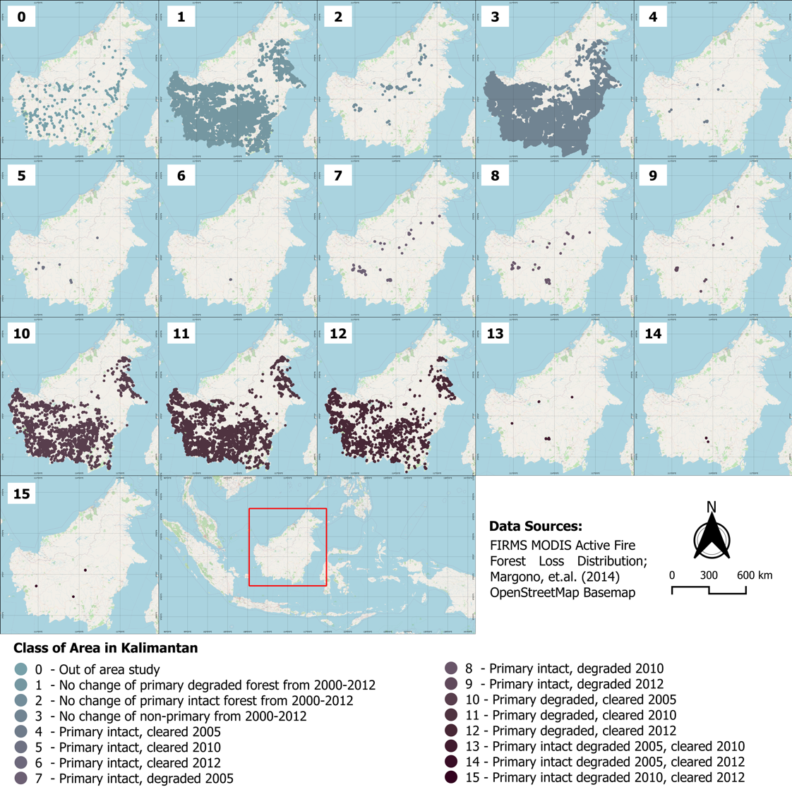

Figure 5. Spatial distribution of every forest class in Kalimantan (see table 2)

From these classes, it is redistributed to classify the area in every year between 2000 and 2020. The areas are classified as Primary Intact Forest, Degraded Forest and Outside Forest (Table 3).

Table 3. Redistribution of the class region (see Table 2).

 | 2000-2005 | 2006-2010 | 2011-2012 | 2013-2020
Primary Intact Forest | 2, 4, 5, 6, 7, 8, 9, 13, 14, 15 | 2, 5, 6, 8, 9, 15 | 2, 6, 9 | 2
Degraded Forest | 1, 10, 11, 12 | 1, 7, 11, 12, 13, 14 | 1, 7, 8, 12, 14, 15 | 1, 7, 8, 9
Outside Forest | 3 | 3, 4, 10 | 3, 4, 5, 10, 11, 13 | 3, 4, 5, 6, 10, 11, 12, 13, 14, 15

Results and discussion

Kalimantan fire time distribution

Fire in Kalimantan appears almost every month during 2001-2020 (Figure 6). However, the intensity of burnt areas increases in the July-October months. The fire became massive in 2002, 2004, 2007, 2009/2010, 2014/2015 and 2019. Although strong El Nino might cause a fire regime, the magnitude of El Nino is not always correlated with fire count. For example, in 2015 the ONI showed a very high score, compared to other years, but the peak of fire count is similar to the 2002 and 2019 seasons.

Between 2011-2013 is the low La Nina season. During this year, the fire remains increasing significantly between July-October. In this period, severe fire is mainly located in South Central Kalimantan (Yulianti & Hayasaka, 2013). Although the intensity is not as high as the strong El Nino season. Thus strong El Nino has a dominant impact on fire in Kalimantan, but other factors cause the fire.

Figure 6. Fire count over Kalimantan during 2001-2020

The results show about 80% of fire appears in the Outside Forest/Deforested, around 20% in Degraded Forest (Figure 7) and less than 1% in Primary Intact Forest. Reduction of tree canopy in the deforested and degraded forest has a massive impact on regional and local climate (Schultz, Lawrence, & Lee, 2017). The deforested region in Kalimantan experiences more extreme temperature events (McAlpine et al., 2018).

As fires burn the area periodically, the area of Degraded Forest and Outside Forest get bigger every year. The pattern of fire in Degraded Forest and Outside Forest is following a similar pattern with Figure 6. However, there are some differences. For example, comparing 2002 and 2015 which has similar peak fires. In 2002, there were more fires in the outside forest, while in 2015 in degraded forest.
(a)
(b)

Figure 7. Fire count by region between 2001-2020 within (a) Outside Forest and (b) Degraded Forest

Primary forest fire time distribution

Fire in the primary forest is measly compared to other types of regions, it is rare in tropical forest ecosystems (Cochrane, 2003) (Goldammer, 2007). Primary Intact Forest is more resilient compared with Degraded Forest, fire-affected on average only 0.9% of the primary intact forest while 6.2-11% on degraded forest or deforested region (Nikonovas, Spessa, Doerr, Clay, & Mezbahuddin, 2020). Although the pattern looks similar, the Primary Intact Forest fire has a unique condition as shown in Figure 8. First, the fire never happens outside the June-October months. Second, the highest forest fires appear in the 2004 season, not in 2015 when there is a very strong El Nino. Third, 2012 La Nina year has more fire than 2019 El Nino year.

Figure 8. Fire count in the primary forest fire of Kalimantan between 2001-2020.

The study also composites the monthly fire into the yearly fire (Figure 9). The black line is a primary forest fire and the bar is combines fire in all regions. The red bar is for El Nino year. Then, compare the fire in all regions with fire in primary forest only. In general, the fire follows the same pattern for both. The only main difference appears between 2002-2006. In the primary forest, the 2004 fire is higher than in 2002 and 2006. But in the combined region, 2004 saw a lower fire count compared to 2002 and 2006.

Figure 9. Comparison of yearly fire between primary forest fire and all-region fire

To get more detail, the research also plots the spatial distribution of forest cover in Figure 10. The region of Primary Intact Forest remains stable in every period, with almost no significant change. Meanwhile, degraded forest and outside forest areas decreased significantly from 2000 to 2012. Then, these regions bounce back and increase periodically between 2013-2020.
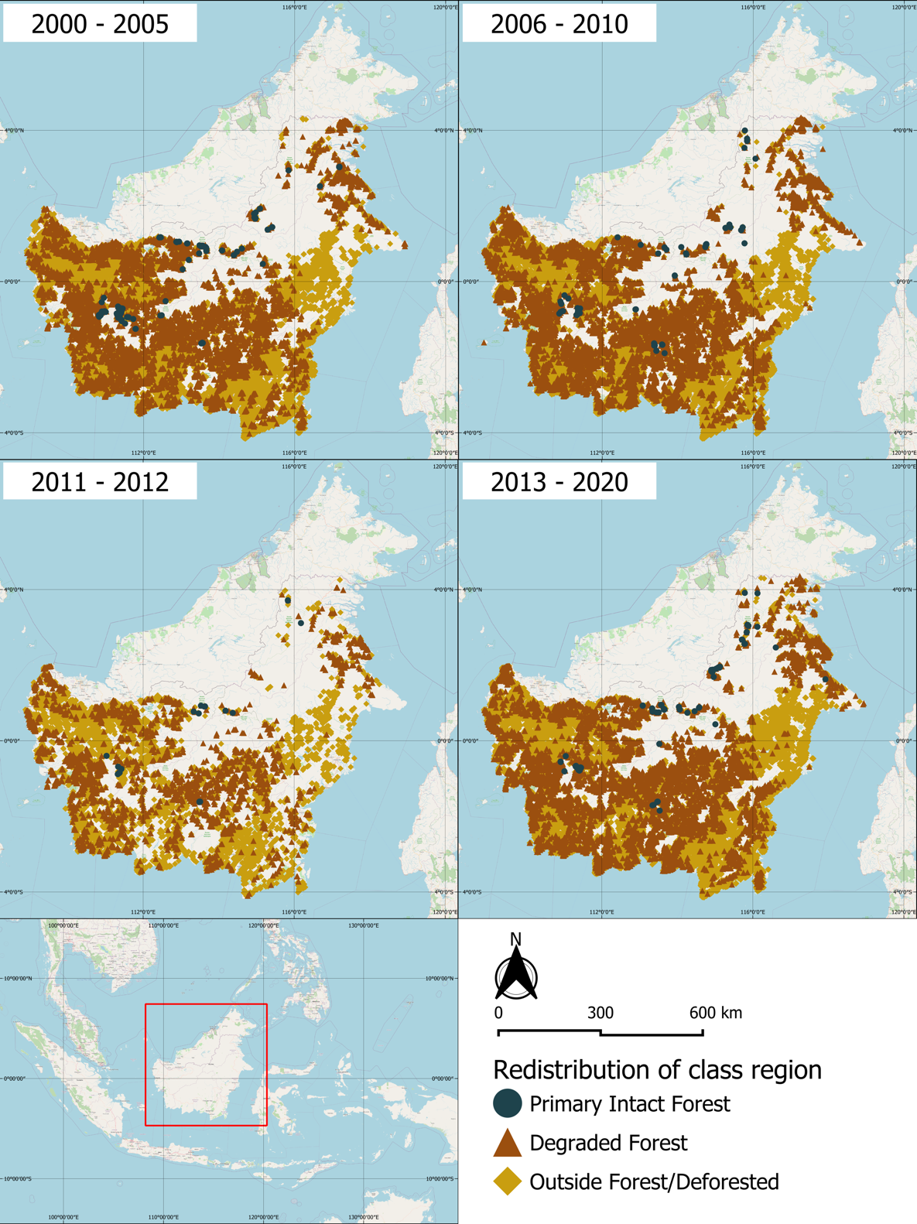

Figure 10. The distribution area of Primary Intact Forest, Degraded Forest and Outside Forest in four periods (2000-2005, 2006-2010, 2011-2012, 2013-2020)

Variability primary forest fire and El Nino

The monthly time series are plotted of Primary Forest Fire and ONI (Figure 11) to clarify the variability of these two phenomena. The fire appears almost every year and the general pattern of fire count is similar to ONI. However, there are some anomalies. For example, the 2004 season showed almost 40 fire counts in moderate El Nino, while very strong El Nino years like 2015 only gained half of it. The primary intact forest is highly resilient to fire as its monthly fire is considerably very low compared to other types of the region which reach 3.000-8.000 fire count in a month.

Figure 7. Time-series of monthly primary forest fire and El Nino Indeks.

Unfortunately, the remaining primary forest in Kalimantan is miserable. There are only 209.649 km² left or 28.4% of the whole Borneo (Gaveau et al., 2014). Moreover, the fire-resistant forest only covers 4.5% of the non-peatland and 3% of the peatlands area (Nikonovas, Spessa, Doerr, Clay, & Mezbahuddin, 2020). This is not only caused by fire (Goldammer & Siegert, 1990) (Siegert, Ruecker, Hinrichs, & Hoffmann, 2001), but also conversion to plantation and wood logging (Brookfield & Byron, 1990).

Conclusion

El Nino has a significant impact on fire in Kalimantan, although it is not the only dominant factor. However, the majority of fires do not occur in primary intact forest areas. Only less than 1% of the fire is in primary forest, about 20% in degraded forest. The rest almost 80% of wildfire occurs in the area outside forest/deforested area. Forest area, especially primary intact forest, is very resilient from fire. It needs very high dry conditions to start a fire in this region. This condition mainly appears during the dry season between (June-August). Sometimes, it is until October. Thus, the fire never occured outside the June-October period.
Then, looking at the variability, primary intact forest fire has shown different patterns compared with the general pattern of wildfires in Kalimantan. Higher El Nino Index did not always mean there are more massive fire within the primary intact forest. So, El Nino has less impact on the primary intact forest. In general, as fires are low in primary intact forest regions, it is hard to say that El Nino is a dominant factor of primary intact forest fire in Kalimantan. But, the impact of El Nino is clearly shown in the other area outside of the primary intact forest.

Acknowledgement

We acknowledge the use of data and/or imagery from NASA's Fire Information for Resource Management System (FIRMS) (https://earthdata.nasa.gov/firms), part of the NASA Earth Observing System Data and Information System (EOSDIS).

References

Adriani, M., Moyer, S., Kendrick, A., Henry, G., & Wood, S. (2016). The Cost of Fire: An Economic Analysis of Indonesia's 2015 Fire Crisis. Jakarta: World Bank Group.

Baker, J. C., & Spracklen, D. V. (2019). Climate Benefits of Intact Amazon Forests and the Biophysical Consequences of Disturbance. Frontiers in Forests and Global Change, 2:47. doi: 10.3389/ffgc.2019.00047

Bonan, G. B. (2008). Forests and Climate Change: Forcings, Feedbacks, and the Climate Benefits of Forests. Science, 320(5882), 1444-1449.

Bouma, M., Kovats, R., Goubet, S., Cox, J. S., & Haines, A. (1997). Global assesment of El Nino's disaster burden. The Lancet, 350(9089), 1435-1438.

Brookfield, H., & Byron, Y. (1990). Deforestation and timber extraction in Borneo and the Malay Peninsula: the record since 1965. Global Environmental Change, 1(1), 42-56.

Brown, T., Hall, B., & Westerling, A. (2004). The impact of twenty-first century climate change on wildland fire danger in the western United States: An applications perspective. Climate Change, 62, 365-388.

Bureau of Meteorology. (2017). bom.gov.au. Retrieved 08 02, 2017, from http://www.bom.gov.au/climate/ahead/about-ENSO-outlooks.shtml

Cochrane, M. A. (2003). Fire science for rainforests. Nature, 421, 913-919.

Dahlman, L. (2016, February 11). Climate Variability: Oceanic Nino Index. Retrieved from climate.gov: https://www.climate.gov/news-features/understanding-climate/climate-variability-oceanic-niño-index

Edwards, R. B., Naylor, R. L., Higgins, M. M., & Falcon, W. P. (2020). Causes of Indonesia's forest fire. World Development, 127(2020), 104717.

Field, R. D., Werf, G. R., Fanin, T., Fetzer, E. J., Fuller, R., Jethva, H., . . . Worden, H. M. (2016). Indonesian fire activity and smoke pollution in 2015 show persistent nonlinear sensitivity to El Nino-induce drought. Proceeding of the National Academy of Sciences of the United States of America (pp. 9204-9209). Falmouth: Woods Hole Research Center.

FIRMS, N. (2021, January). earthdata.nasa.gov. Retrieved from earthdata.nasa.gov/firms: https://earthdata.nasa.gov/firms

Fuller, D., & Murphy, K. (2006). The Enso-Fire Dynamic in Insular Southeast Asia . Climatic Change, 74, 435-455.

Gaveau, D. L., Sloan, S., Molidena, E., Yaen, H., Sheil, D., Abram, N. K., . . . Meijaard, E. (2014). Four Decades of Forest Persistence, Clearance and Logging on Borneo. PLOS One, 9(7),

e101654. doi:10.1371/journal.pone.0101654

Glantz, M. H., & Ramirez, I. J. (2020). Reviewing the Oceanic Nino Index (ONI) to Enhance Societal Readiness for El Nino's Impacts. Journal of Disaster Risk Science, 11(3), 394-403.

Goldammer, J. G. (2007). History of equatorial vegetation fires and fire research in Southeast Asia before the 1997-98 episode: A reconstruction of creeping environmental changes. Mitigation and Adaptation Strategies for Global Change, 12, 13-32.

Goldammer, J., & Siegert, B. (1990). The Impact of Drought and Forest Fires on Tropical Lowland Rain Forest of East Kalimantan. In G. J.G., Fire in the Tropical Biota. Ecological Studies (Analysis and Synthesis) (pp. 11-31). Berlin, Heidelberg: Springer.

Gross, M. (2015). A fire with global connections. Current Biology, 25(23), R1107-R1109.

Huijnen, V., Wooster, M., Kaiser, J., Gaveau, D., Flemming, J., Parrington, M., . . . Weele, M. v. (2016). Fire carbon emissions over maritime southeast Asia in 2015 largest since 1997. Scientific Reports, 6, 26886 (2016). https://doi.org/10.1038/srep26886

Guhardja, E., Fatawi, M., Sutisna, M., Mori, T., & Ohta, S. (2000). Rainforest Ecosystem of East Kalimantan, El Nino, Drought, Fire and Human Impacts. New York: Springer.

Hamada, J., Yamanaka, M., Matsumoto, J., Fukao, S., Winarso, P., & Sribimawati, T. (2002). Spatial and Temporal variations of the rainy season over Indonesia and their link to ENSO. Japan Meteorological Society, 80(2), 285-310.

Kirono, D., Tapper, N., & McBride, J. (1999). Documenting Indonesian rainfall in the 1997/1998 El Nino event. Physical Geography, 20(5), 422-435.

Lestari, A., Rumantir, G., & Tapper, N. (2016). A Spatio-temporal Analysis on The Forest Fire Occurrence in Central Kalimantan, Indonesia. Pacific Asia Conference on Information System (PACIS) 2016 (p. 90). Melbourne: AIS eLibrary.

McAlpine, C. A., Johnson, A., Salazar, A., Syktus, J., Wilson, K., Seabrook, L., . . . Sheil, D. (2018). Forest loss and Borneo's climate. Environmental Research Letters, 13(4), 1-10.

Margono, B. A., Potapov, P. V., Turubanova, S., Stolle, F., & C, M. (2014). Primary Forest Cover Loss in Indonesia over 2000-2012. Nature Climate Change, 4, 730-735.

Margono, B. A., Turubanova, S., Zhuravleva, I., Potapov, P., Tyukavina, A., Baccini, A., . . . Hansen, M. C. (2012). Mapping and monitoring deforestation and forest degradation in Sumatra (Indonesia) using Landsat time series data sets from 1990 to 2010. Environ. Res. Lett., 7(3), 1-16.

Langner, A., Achard, F., Vancutsem, C., Pekel, J.-F., Simonetti, D., Grassi, G., . . . Nakayama, M. (2015). Assessment of Above-Ground Biomass of Borneo Forests through a New Data-Fusion Approach Combining Two Pan-Tropical Biomass Maps. Land, 4(3), 656-669.

Langner, A., Miettinen, J., & Siegert, F. (2007). Land cover change 2002-2005 in Borneo and the role of fire derived from MODIS imagery. Global Change Biology, 13(11), 2329-2340.

Harris, N., Minnemeyer, S., Stolle, F., & Payne, O. (2015, October 16). wri.org. Retrieved 08 04, 2017, from http://www.wri.org/blog/2015/10/Indonesia's-fire-outbreaks-producing-more-daily-emissions-entire-us-economy

McAlpine, C. A., Johnson, A., Salazar, A., Syktus, J., Wilson, K., Seabrook, L., . . . Sheil, D. (2018). Forest loss and Borneo's climate. Environmental Research Letters, 13(4), 1-10.

National Oceanic and Atmospheric Administration. (2017). www.climate.gov. Retrieved 08 03, 2017, from https://www.climate.gov/enso

Nikonovas, T., Spessa, A., Doerr, S. H., Clay, G. D., & Mezbahuddin, S. (2020). Near-complete loss of fire-resistant primary tropical forest cover in Sumatra and Kalimantan. Communications Earth & Environment, 1, 65.

Page, S. E., Siegert, F., Rieley, J. O., Boehm, H.-D. V., Jaya, A., & Limin, S. (2002). The amount of carbon released from peat and forest fires in Indonesia during 1997. Nature, 420, 61-65.

Potapov, P., Yaroshenko, A., Turubanova, S., Dubinin, M., Laestadius, L., Thies, C., . . . Tsybikova, E. (2008). Mapping the World's Intact Forest Landscapes by Remote Sensing. Ecology and Society, 13(2), 51.
Quinn, W., Zopf, D., Short, K., & Kuo, R. Y. (1978). Historical trends and statistics of the Southern Oscillation, El Nino and Indonesian drought. Fish. Bull., 76(3), 663-678.

Rasmusson, E. M., & Carpenter, T. H. (1982). Variations in Tropical Sea Surface Temperature and Surface Wind Fields Associated with the Southern Oscillation/ El Nino. Monthly Weather Review, 110(5), 354-384.

Schultz, N. M., Lawrence, P. J., & Lee, X. (2017). Global satellite data highlights the diurnal asymmetry of the surface temperature response to deforestation. JGR Biogeosciences, 122(4), 903-917.

Siegert, F., Ruecker, G., Hinrichs, A., & Hoffmann, A. (2001). Increased damage from fires in logged during droughts caused by El Nino. Nature, 414, 437-440.

Trenberth, K. E., & Stepaniak, D. P. (2001). Indices of El Nino evolution. Journal of Climate, 14(8),1697-1701.

Trenberth, K. E. (1997). The Definition of El Nino. Bulletin American Meteorology Society, 78(12), 2772-2777.

Uhl, C., Kauffman, J., & Cummings, D. (1988). Fire in the Venezuelan Amazon 2: environmental conditions necessary for forest fires in the evergreen rainforest of Venezuela. Oikos, 53(2), 176-184.

Wooster, M., Perry, G., & Zoumas, A. (2012). Fire, drought and El Nino relationships on Borneo (Southeast Asia) in the pre-MODIS era (1980-2000). Biogeosciences, 9(1), 317-340.

Yin, Y., Yu, Y., & Chen, Y. (2009). Relationship between flood/drought disasters and ENSO from 1857 to 2003 in the Taihu Lake Basin, China. Quaternary International, 208(1), 93-101.

Yulianti, N., & Hayasaka, H. (2013). Recent Active Fires under El Nino Conditions in Kalimantan, Indonesia. American Journal of Plant Sciences, 4(3a), 685-696.

