
An object-based approach to detect tree stumps in a selective logging area using Unmanned Aerial Vehicle imagery
Aisyah Marliza Muhmad Kamarulzaman¹, Wan Shafrina Wan Mohd Jaafar¹, Siti Nor Maizah Saad^{1,2}, Hamdan Omar³, Mohd. Rizaludin Mahmud⁴
¹Earth Observation Centre, Institute of Climate Change, Universiti Kebangsaan Malaysia
²Department of Surveying Science and Geomatics, Faculty of Architecture, Planning & Surveying,
Universiti Teknologi Mara
³Forest Research Institute Malaysia
⁴Geoscience & Digital Earth Centre Faculty of Built Environment & Surveying Universiti Teknologi Malaysia

Correspondence: Wan Shafrina Wan Mohd Jaafar (email: wanshafrina@ukm.edu.my)

Received: 02 August 2021; Accepted: 08 October 2021; Published: 30 November 2021

Abstract
Acquiring tree-stump information is important to support post-harvest site assessment. Unmanned Aerial Vehicles (UAVs) have been widely used as a tool for analyzing selective logging impacts in forest area sites. One of the potential use of UAV imagery data for analyzing the impact of selective logging is by obtaining tree stump information. Feature extraction and segmentation images to extract stumps from a UAV scene of a forested area in Ulu Jelai, Pahang provides a quick, automated method for identifying stumps. This research implemented a technique for detecting, segmenting, classifying, and measuring tree stumps by using the Multiresolution Segmentation Algorithm method. This study assessed the capability of an object-based approach on image detection to segment and merge the stumps after selective logging practice on UAV imagery with a scale of 0.06-meter resolution. The results revealed that the tree-stumps were detected with an accuracy of 70% and stumps classification were detected with 80% accuracy validated with the ground points. The accuracy is acceptable for data acquiring after 6 months of logging activities. The findings of this study are promising and can lead to increase support for a more cost-effective and systematic selective logging in the future. An effective management system can help related authorities and agencies to develop and maintain the selective logging technique towards sustainable forest management.
Keywords: machine learning, object-based approach, remote sensing, selective logging, stump detection, UAV

Introduction
Tropical forests are responsible for their ecological diversity, containing more than half of the world's species and providing a variety of essentially biological processes. Malaysia's tropical rainforest is one of the most ecologically varied and species-rich environments in the tropics, with many indigenous species. Malaysia has at least 10,000 producing plant species, with around 2830 tree species from Peninsular Malaysia (Saiful & Latiff, 2014). Hundreds and thousands of hectares of tropical forest have been logged, both legally and illegally (Hethcoat et al., 2019). Logging in Southeast Asia regularly eliminates more than half of the trees in a particular location, causing forest patterns to change toward more open canopies (Pinard & Hall, 2017). Previous research (Yamada et al., 2016) found that trees in logged forests grew quicker (0–6 years) than trees in primary forests, most likely because logging allowed more light into the woods.
The traditional field-based method by the Pahang Forestry Department requires periodical field assessments using permanent sample plots to estimate gains in growing stock and biomass. Typically, sampling parameters are determined based on the desired precision. However, time constraints and labour costs are frequently considered (Böttcher et al., 2009). Since some locations have access issues, reducing sample intensity in these areas may be more cost-effective and concentrating sampling efforts on a few specific categories (Mitchell, 2018). Remote sensing methods are thought to be an efficient way to conduct this research, not only because of the improved spatial and temporal resolutions of databases that allow for the detection of selective logging impacts components but also because of the increased amount of data available and the associated computational ability to process it (Afrasinei et al., 2017; He et al., 2016). Deforestation analysis on a large scale has advanced substantially in recent years, and forest losses may now be recognised with greater than 90% accuracy using high-resolution images (Hansen et al., 2013). Since the introduction of remote sensing, several studies of forested-type classifications have been made. One of the most common methods for extracting information from remotely sensed images is object-based image analysis and classification. Together with support vector machines classifications, artificial neural networks are the most often used machine learning approaches (Nitze et al., 2012). Image segmentation is an essential task in land use planning in global change research and environmental applications. The focus of this research is to see how effective the object-based image analysis approach is to detect stumps and support vector machines SVMs classifier on deriving selective logging impacts information from unmanned aerial imagery to achieve an effective forest management system.

Literature review
Selective logging

Selective logging is a method of forest extraction in which a group of trees from high-value tree species is harvested from the forest (Jackson & Adam, 2020). At moderate harvest intensity levels, selective logging also reduces damage compared to conventional logging activities (Poudyal et al., 2018; Saad et al., 2020). Describe that the result of Sustainable Forest Management (SFM) is determined by selective logging activities. As an outcome, managing the forest condition is a crucial element of SFM. The Malaysian forest has been described as one of the world’s most dynamic ecosystems and has been in the process of degradation throughout the year (Jaafar et al., 2020a). Tree stumps are the most important indicator for verifying logged forests during sampling work and from remote sensing data.

Remote Sensing and Geographical Information System

From the remote sensing and geographical image system (GIS) perspective, using very high-resolution imagery derived from UAVs for assessing the selective logging impacts has advantages compared to the conventional survey methods (Jaafar et al., 2020b). Moreover, because of the small size area, scattered distribution, and restriction of access to harvest sites, UAVs may be suitable for the site assessment. The wide range of UAVs available, their ease of use, and the use of efficient image processing algorithms for object detection and recognition enable this a widely available analysis tool (Pierzchała et al., 2014; Puliti et al., 2018) .

Object-based image analysis

Object-based image analysis has been extended in-depth to this form of data for tree stump identification since the advent of high spatial resolution imaging. Tree stumps are one of the most visible features in the selective logging area. They are relatively uniform, have a lighter colour layer on the surface than the surrounding area, and are visible (10-50cm) above ground level (Puliti et al., 2018). These detections make UAVs the most suitable platforms to detect information on the stumps in terms of features and are widely scattered on the image. The attempt to detect the stumps will be by automated stump detections in object-based image analysis and a better understanding of the spatial variability for use in the development of forest growth. The advent of automatic image processing techniques has led to the establishment of object-based image analysis (OBIA) approaches, which combine an object detection algorithm with a machine learning classifier such as the Support Vector Machine (SVM). The OBIA was designed to overcome the issue of mixed-pixel, which often results in misclassification of image features of interest and false-positive outcomes, lowering the image classification accuracy (Blaschke, 2010).

Multiresolution segmentation

In this analysis, what is known as the multi-resolution segmentation algorithm (MSA) is being implemented, which was established by (Happ et al., 2010). The use of MSA reduces the image object's average heterogeneity. The algorithm is similar to a growing analytical solution because it begins from a single pixel and merges the regions with the lowest weighted cost at random. The compactness, shape, and size of the image objects are used to weigh the cost. Scale level is another significant factor influencing the efficiency of segmentation, and the most common method for determining the best scale parameter is trial and error (Blaschke et al., 2014). Regarding the segmentation process, image classification was performed.

Machine learning approach

In recent years, machine learning (neural networks, decision trees, and support vector machines) has been continuously used for classification imagery (Hethcoat et al., 2019). Even though it is best equipped to manage highly dimensional data without increasing training sample size, the Support Vector Machine (SVM) classifier has become increasingly crucial for complex mixed-class problems. The SVM classifier has been widely used in both land application (forest type) and vegetation classifications. As a result, this methods has become one of the most commonly used classifiers. To achieve substantial classification accuracy, choosing the right kernel category is crucial. The four fundamental kernels used in SVM are linear, polynomial, sigmoid, and radial basis functions (Gholami & Fakhari, 2017). With the help of a different set of input weights in parameters, UAV images provide detailed heterogeneity of object images analysis. The most crucial step in an object-based approach is to do a good image segmentation with a specific scale so that stumps are delineated with the objective purposes. Further Geographical Information System (GIS) analysis and producing map were being processed by using ArcGIS 10.3.

Method and study area
Study area

The study area is 48 hectares of a tropical dipterocarp forest in Compartment 124, 159, and 160 (Figure 1). It is licensed by Pahang Forestry Department and has applied selective logging under Sustainable Forest Management (SFM). The study area is located approximately in North 101° 53' 16.8" and East 4° 33' 10.8" at Ulu Jelai Forest Reserve, in Lipis, Pahang. The climate in the area is characteristic of the monsoon season, with uniform temperatures from 15.5 - 24.4°C. Within each compartment, every tree stump was measured. The elevation of the forest area ranges from 300m to 356.54m above mean sea level, and annual precipitation is recorded between 1500-2000mm. The compartment and study area map as shown in Figure 1.

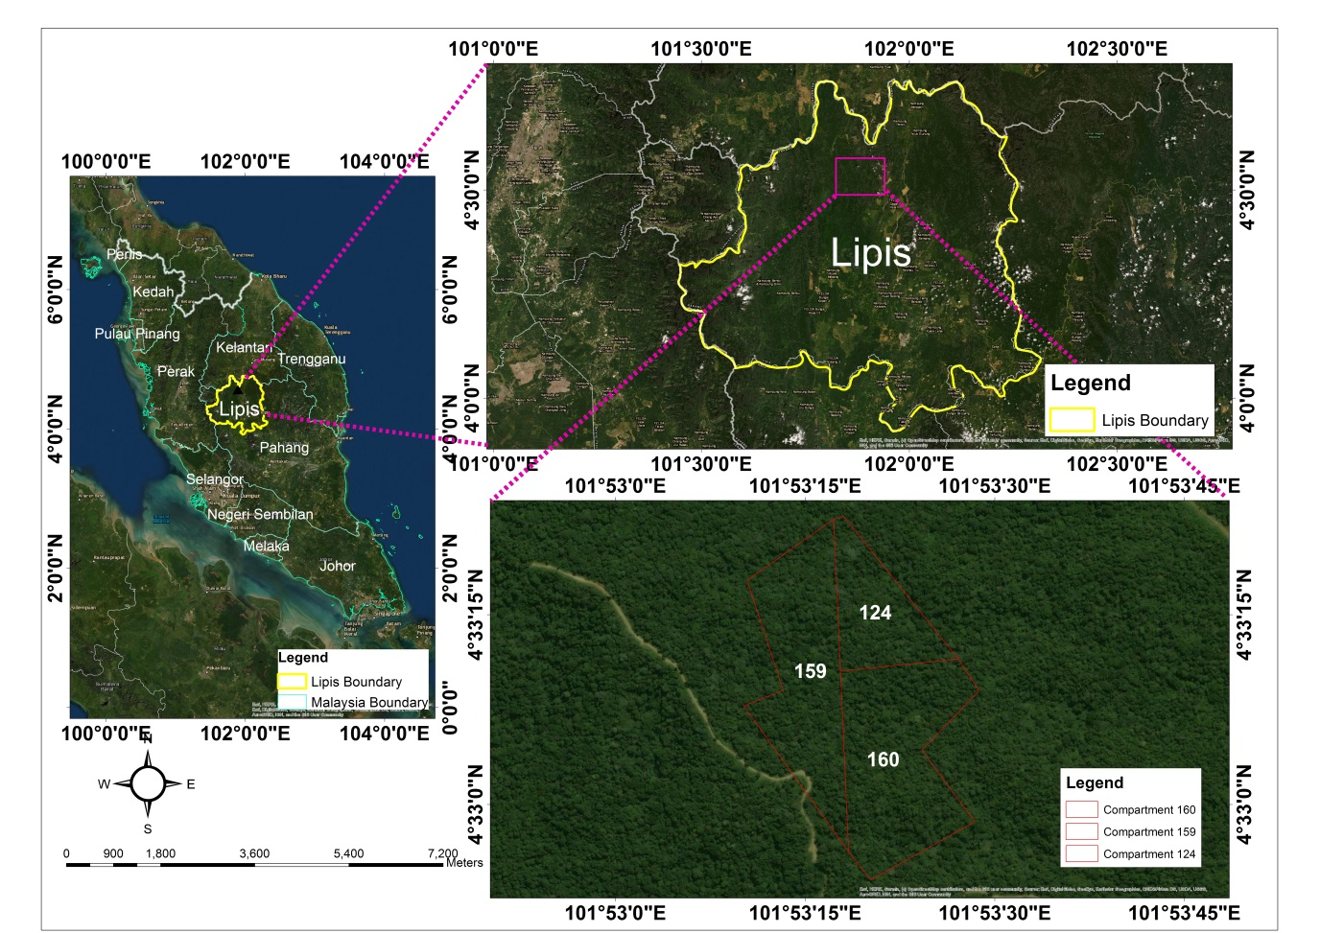

Figure 1. Study Area (Ulu Jelai, Lipis, Pahang).

Field data collection

Fieldwork was conducted in August 2019 in Ulu Jelai Area to acquire a single stump field data within compartments number 124, 159, and 160. The forest has been harvested using the RIL Logging SFM system for the harvest and extraction of timber. The plot's middle was measured using a Trimble GPS fitted with Real-Time Kinematic (RTK) correction live via GSM network. Furthermore, each tree-stump measurement includes GNSS positioning of the center of each tree stump and incidental damage surrounding it. Within these three compartments, 21 points of sample data were collected (single tree stump).

UAV image acquisition

On August 19, 2019, a single flight lasting about 45 minutes was undertaken in open-sky circumstances in the middle of the data centre to gather wall-to-wall UAV images for the area of interest at about 3 pm. On August 19, 2019, a DJI Phantom 3 drone with the sensor FC350 (3.61mm) was onboard. It was used to fly the UAV over the research location. The mission flight was set one day early as it had no cellular signal in the forested area itself, and on the mission day, Drone Deploy Software was used to control the mission. Because the study area's topography is mountainous, no exact topographic data is available then the flying height was modified to 90-110 meters above ground level. The resulted from high resolution were 0.06m above the ground, with 70-80% of images overlap. From the number of stumps detected by using object-based image analysis, distribution for the measured in between field and the number of stump detection results can be obtained. As we can see visually, Figure 2 shows the comparison between the normal stump on the UAV image and from the ground.

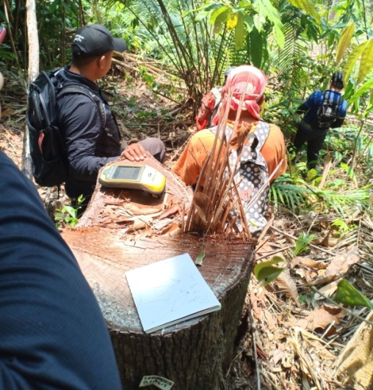 | 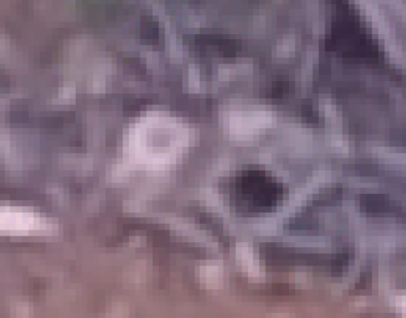

Figure 2. Normal stump image on the field and UAV image.

Overall workflow

The processes for detecting and segmenting the tree stump are shown in Figure 3. The following sub-sections describe the steps adopted to detect, segment, classify and measure trees stumps.
UAV Image Acquisition
Raster Image Processing using Agisoft Metashape Software (Aggressive and High Quality)

Object Based Image Analysis using Multiresolution Segmentation (eCognition Developer x64 Software)
- Merging and Feature Extraction in OBIA

Accuracy Assessment of Stump Detection

- Merging and Feature Extraction in OBIA

Selection of Training & Ground Truth Samples from Image
- Merging and Feature Extraction in OBIA

Segmented Image Classification using Support Vector Machine (SVM)
- Merging and Feature Extraction in OBIA

SVM Accuracy Assessment
- Merging and Feature Extraction in OBIA

Parameters on delineation of stump boundary
compactness: 0.5, shape: 0.1, scale: 20

Final Output Map of Stump Detection & SVM

Field Data
Observed Stump location, diameter and log information

Figure 3. Overall methodological framework.
- UAV image processing

The single raw images from the drone images were processed using Agisoft Metashape Professional Software. After adding all the single images, the coordinate system was being set by using camera positions. Agisoft will find matching points between overlapping images, estimate the camera coordinate for each photo, and build a sparse cloud model from the align processed. A point cloud was then build up by calculating the depth information from every single image. The quality selected for this selective logging area was high, and the depth filtering level of aggressive was chosen. The function is set to the highest resolution to minimize the mixed pixel over the UAV image for these three compartments in Ulu Jelai Area. The digital elevation model can be generated based on the dense cloud or mesh model. The next step will be building an ortho-mosaic image where pixel size will be suggested according to the average ground sampling resolution of the original images. The final output will then be exported using an export ortho-photo image, preferably in Tiff format.

- OBIA on multiresolution segmentation image and SVM classification

The segmentation was carried out using the eCognition Developer 64 software, which used red, green, and blue spectral bands to enhance the process (RGB). Trimble Germany GmbH's eCognition developer software was designed primarily for object-oriented image recognition. Despite knowing that eCognition is a unique combination of several contributing methods, certain fundamental elements of the underlying object-oriented approach are autonomous of the individual processes (Benz et al., 2004). Many details in the UAV image can affect stump detection. As a result, using a multi-resolution segmentation algorithm reduces the average uncertainty within an image object. It starts with a random pixel in the image during the process. The low fraction image object and pixel were then evaluated for heterogeneity and merged features.
The stumps from the scale parameter were described in this study as the objects based on the estimation of scale parameter (ESP) method, estimator shape, and compactness. The ESP tool calculates the local variation and rate of change for each dimension, allowing users to determine at which scale the image can be segmented for better feature extraction. The segmentation attributes were chosen to be included in the machine learning classification process after the image segmentation (Fc, 1996). Vector systems are used in eCognition not only for import and export but also for advanced classification. The stump attributes were exported to a polygons shapefile and converted to the region of interest (ROI) for the training classes in ENVI 5.2 software together with other classes generated by using ROI tools. These combinations of classes were used for the SVM classifier. The SVM classifier was selected because this method was tested to have the highest accuracy compared with the other non-parametric advanced classifiers such as Neural Network and conventional supervised classification methods in forestry applications.

- Accuracy assessment

A comparison with 21 field-measured tree stumps was used to validate the tree stump. When a segmented polygon is within the field measurement of the stump, it is considered a correct match. The overall classification accuracy for the three compartments in Ulu Jelai Area was measured using the confusion matrix of omission and commission error. The comparison of OBIA outputs and the ground truth was conducted using the following formula:

$$Overallaccuracy\left(\%\right)=\frac{numberof true positive}{number of ground truth} x 100$$

In addition to the accuracy assessment, the confusion matrix was conducted in SVM classification too. Hence the kappa coefficient can also be determined from the SVM result. In SVM, the confusion matrix measures the observed from image classification output and predicted from ground truths data to calculate the percentage of correlation of image output to absolute ground truths in terms of overall accuracy in percentage value. The overall accuracy is computed by adding the pixel count accurately to classified based on ground truth by the total pixel values over the image (Fc, 1996). The Kappa coefficient was used to double-check the overall accuracy.

Results and discussion

Pre-processing output

The image was geo-referenced to Geographic Longitude and Latitude Projection, while the datum for individual bands was set to WGS84. The resolution of the UAV image after being processed was0.0631 cm, and the point density shows the values of 251 points/m2. The total error after being geometrically corrected with the GCP points was 3.6m. The analysis in this study was accomplished by utilizing multi-bands of red, green, and blue (RGB). When compared to using a single band, these bands tend to improve classification accuracy.

Segmentation result in OBIA

The following presents the results of the automatic method from the Multiresolution Segmentation Algorithm generated from eCognition Developer x64 software. The results from MSA for the Ulu Jelai study area, including the parameters used, were summarised in Figure 4 below. The MSA parameters were the three weights of shape and compactness and the scale. Hence, the shape was set to 0.1, and compactness was set as 0.5. The scale for the stump detections was finally chosen as a scale of 20 where the stumps details were segmented as shown in Figure 4(a) and the same features polygons segmented exported were shown in Figure 4(b). The values were selected because they provide an excellent delineation of the individual tree stumps. While for Figure 4(c) shows that the actual pictures of the tree stump detected during the fieldwork campaign. This indicates that most stumps and logs were easily detected with the chosen scale. Hence the exported polygons of the stumps were selected as training data from the classification process after the segmentation process was done. The segmented polygons were used as input training data for the SVM classification.
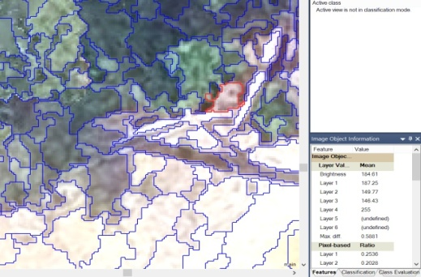  (a) | 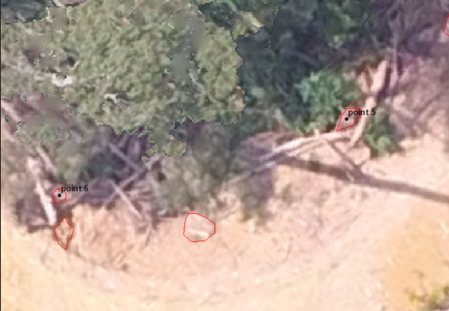  (b) | 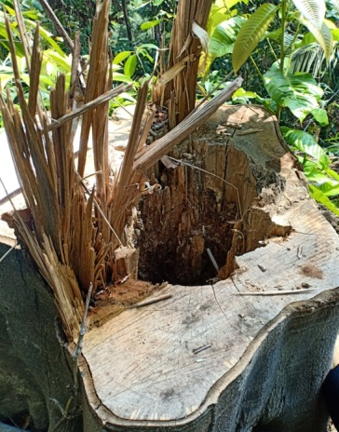  (c)
Figure 4. Segmentation results obtained from OBIA: a) Scale b) polygon segmented c) actual picture of a stump

Stump detection map by using multiresolution segmentation algorithm from UAV image

In this study, the UAV processing result has been produced, which is the mosaic UAV Image. The ortho-mosaic was created using ArcGIS 10.3 software, and the location of the resulted stump from the segmentation process in points, polygons, and GCP points data were mapped as in Figure 5. A total of 252 UAV images were used to produce orthophoto, resulting in an overall coverage of 0.483 km2.

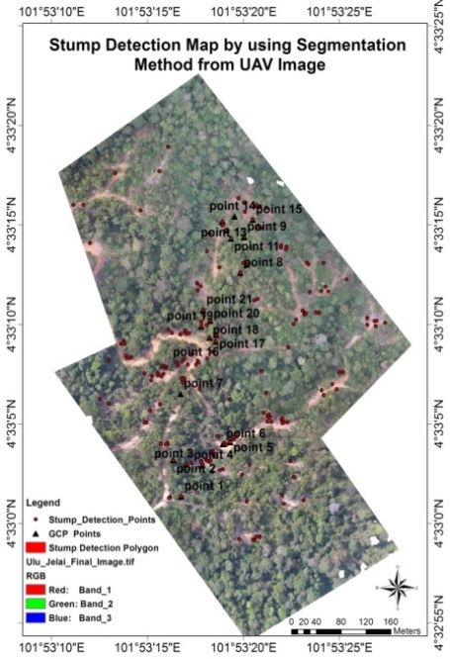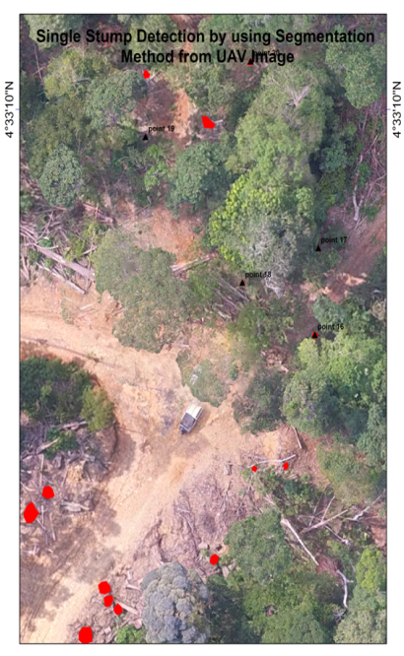

Figure 5. Stump detection map by using OBIA.
SVM classification

The training data was selected visually as Region of Interest (ROI) in ENVI 5.2. The training data were delineated focused on six classes: stumps, road, skid trail, felled log, forest, and car. The output images of SVM classification were presented in single layer images consisted of 8 classes of colours (Figure 6). The other objects and no pixel classes were excluded from this study and accuracy assessment as no significant results are needed. SVM classifier settings were determined by trial and error until a high level of classification accuracy was obtained. The parameters settings of this study were Radial Basis Function (RBF), the gamma in Kernel function was set to 0.25 with 100 penalty parameters. Other objects and no pixels were classified as a result of the study, hence reducing classification errors.

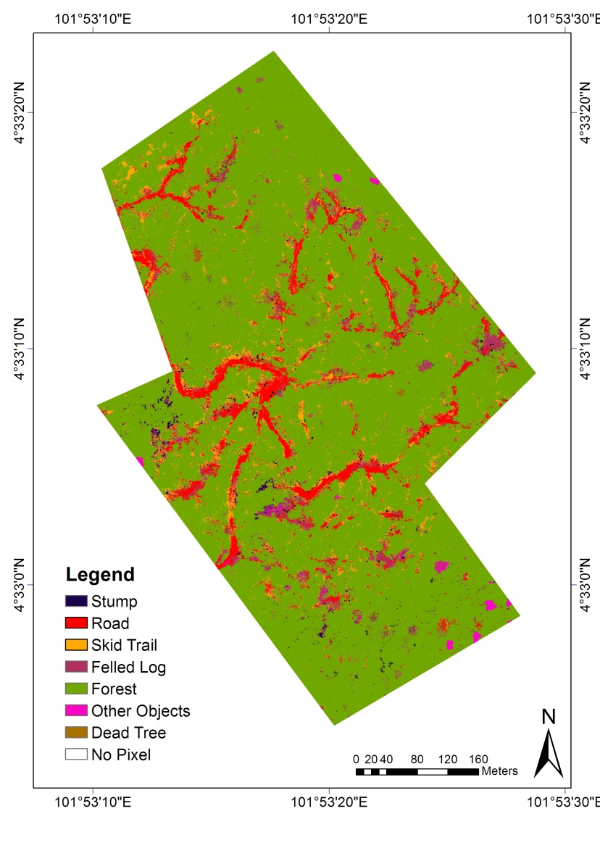
Figure 6. Support Vector Machine classification results.
Accuracy Assessment

a. Accuracy Assessment Stump Detection

The accuracy of tree-stump detection was assessed. Depending on the study area and compartments, the tree stumps were detected with an overall accuracy ranging from 66.67% in compartment number 160 to 71.43% in compartment number 159 (Table 1). The omission error decreased from compartment number 160 to 159, respectively. Out of 21 stumps measured from the field, only 14 stumps were detected, and seven stumps were not detected on the image. The total overall accuracy measured from these three compartments was 66.87%. This moderate accuracy result is because some of the stumps were located below the forest canopy, and the field data collection was conducted six months after logging.

Table 1. Error Matrix for Stump Detection by using OBIA.

Compartment (No) | Measured (n) | Detected (n) | Omitted (n) | Overall Accuracy(%) | Omission Error (%) | Commission Error (%)
159 | 7 | 5 | 2 | 71.43 | 28.57 | 40.00
124 | 8 | 5 | 3 | 62.50 | 37.50 | 60.00
160 | 6 | 4 | 2 | 66.67 | 40.00 | 50.00
 |  | Overall Accuracy: |  | 66.87%

b. Accuracy assessment from machine learning classification.

The classification outputs were assessed for accuracy by comparing the OBIA outputs with the ground truth in Tables 2 and 3. The results of stump detection from the SVM and segmentation image show relevant accuracy percentages, which has 65.71% and 66.87%, respectively. This is demonstrated by producing the segmentation results comparing with field data and delivering the classification results comparing with the ground truth data so that the values are relevant. Six classes were being chosen as training data while producing the SVM classification. Forest and roads made the highest accuracy, followed by skid trail, stump detection, fell log, and car (Table 3). The overall accuracy shown by SVM was 87.45%, with a Kappa coefficient of 0.774.

Table 2. Commission and omission error for the SVM classification.

Class | Commission (%) | Omission (%) | Commission Pixels) | Omission (Pixels)
Stump | 29.95 | 34.29 | 331/1105 | 12/35
Road | 14.89 | 3.70 | 6560/44045 | 1441/38926
Skid Trail | 24.30 | 55.44 | 1493/6145 | 5788/10440
Fell Log | 43.90 | 13.11 | 1935/4408 | 373/2846
Forest | 0.38 | 0.27 | 53/13954 | 37/13938
Car | 34.25 | 91.96 | 25/73 | 549/597

Table 3. User and producer accuracy for the SVM classification.

Class | Producer Accuracy (%) | User Accuracy  (%) | Producer Accuracy (Pixels) | User Accuracy (Pixels)
Stump | 70.05 | 65.71 | 774/1105 | 23/35
Road | 96.30 | 85.11 | 37485/38926 | 37485/44045
Skid Trail | 44.56 | 75.70 | 4652/10440 | 4652/6145
Fell Log | 86.89 | 56.10 | 2473/2846 | 2473/4408
Forest | 99.73 | 99.62 | 13901/13938 | 13901/13954
Car | 8.04 | 65.75 | 48/597 | 48/73
Overall Accuracy | 87.40%
Kappa Coefficient | 0.774

These results suggested a possibility for individual tree stump detection using UAV imagery by implying a multi-resolution segmentation approach. This represents that UAV is possibly one of the best remote sensing tools and cost-efficient with good access allowing such retrieval of detailed information with acceptable levels of accuracy at specific points in time following the logging activities.

Conclusion

In this study, the image from the UAV was analyzed using OBIA methods that integrate segmentation and merging with SVM classification to classify the stumps and selective logging impacts over the Ulu Jelai area. The results showed that the segmentation with field data showed moderate accuracy of 66.87%. The results from the overall SVM classification show good accuracy (<90%), but considering the stump accuracy only, it offers a slight difference from the segmentation result, which was 65.71%. Overall, this research suggests that UAVs could provide precise information on tree stump position and categorical properties.
The moderate accuracy is probably due to certain limitations, such as the tree stump below the canopy. The available image acquisition retrieval is six months after the logging activity. In this study, the assessment of various impacts due to post-harvest activities can also be done using OBIA and classification methods. This shows that the OBIA methods conducted to derive stump information over UAV image were significant. For future works, the extensive experiment of OBIA analysis with advanced classifiers can be undertaken to detect tree stumps in a selective logging area using a three-band combination of UAV images. As a result, the current study demonstrates how remote sensing and GIS were used together, and methods are essential technologies to assess the impacts of selective logging especially stump detection. This study's findings can also be used as a reference for related departments to effectively manage forest resources using the most up-to-date technology that would be both better and more cost-effective.

Acknowledgement

This study was supported by a research grant, GUP-2018-132 and GGPM-2020-034. The authors are grateful to the Pahang Forestry Department, Forest Research Institute Malaysia (FRIM), and Earth Observation Centre, Institute of Climate Change, Universiti Kebangsaan Malaysia (UKM) for providing the additional equipment data.

References

Afrasinei, G. M., Melis, M. T., Buttau, C., Bradd, J. M., Arras, C., & Ghiglieri, G. (2017). Assessment of remote sensing-based classification methods for change detection of salt-affected areas (Biskra area, Algeria). Journal of Applied Remote Sensing, 11(1), 016025. https://doi.org/10.1117/1.jrs.11.016025
Blaschke, T. (2010). Object based image analysis for remote sensing. ISPRS Journal of Photogrammetry and Remote Sensing, 65(1), 2–16. https://doi.org/10.1016/j.isprsjprs.2009.06.004
Blaschke, T., Hay, G. J., Kelly, M., Lang, S., Hofmann, P., Addink, E., Queiroz Feitosa, R., van der Meer, F., van der Werff, H., van Coillie, F., & Tiede, D. (2014). Geographic Object-Based Image Analysis - Towards a new paradigm. ISPRS Journal of Photogrammetry and Remote Sensing, 87, 180–191. https://doi.org/10.1016/j.isprsjprs.2013.09.014
Böttcher, H., Eisbrenner, K., Fritz, S., Kindermann, G., Kraxner, F., McCallum, I., & Obersteiner, M. (2009). An assessment of monitoring requirements and costs of “Reduced Emissions from Deforestation and Degradation.” Carbon Balance and Management, 4, 7. https://doi.org/10.1186/1750-0680-4-7
Gholami, R., & Fakhari, N. (2017). Support Vector Machine: Principles, Parameters, and Applications. In Handbook of Neural Computation (1st ed.). Elsevier Inc. https://doi.org/10.1016/B978-0-12-811318-9.00027-2
Hansen, M. C., Potapov, P. V., Moore, R., Hancher, M., Turubanova, S. A., Tyukavina, A., Thau, D., Stehman, S.V., Goetz, S. J., Loveland, T. R., Kommareddy, A., Egorov, A., Chini, L., Justice, C. O., & Townshend, J. R. G. (2013). High-Resolution Global Maps of of 21st-Century Forest Cover Change. 342(6160), 850–854. https://doi.org/10.1126/science.1244693
Happ, P., Ferreira, R., & Bentes, C. (2010). Multiresolution segmentation: a parallel approach for high resolution image segmentation in multicore architectures. … Object-Based Image …, June. http://www.isprs.org/proceedings/XXXVIII/4-C7/pdf/Happ_143.pdf
Hethcoat, M. G., Edwards, D. P., Carreiras, J. M. B., Bryant, R. G., França, F. M., & Quegan, S. (2019). A machine learning approach to map tropical selective logging. Remote Sensing of Environment, 221(December 2017), 569–582. https://doi.org/10.1016/j.rse.2018.11.044
Jaafar, W. S. W., Maulud, K. N. A., Muhmad Kamarulzaman, A. M., Raihan, A., Sah, S. M., Ahmad, A., Maizah Saad, S. N., Mohd Azmi, A. T., Syukri, N. K. A. J., & Khan, W. R. (2020a). The influence of deforestation on land surface temperature-A case study of Perak and Kedah, Malaysia. Forests, 11(6). https://doi.org/10.3390/F11060670
Jaafar, W. S. W. M., Said, N. F. S., Maulud, K. N. A., Uning, R., Latif, M. T., Kamarulzaman, A. M. M., Mohan, M., Pradhan, B., Saad, S. N. M., Broadbent, E. N., Cardil, A., Silva, C. A., & Takriff, M. S. (2020b). Carbon emissions from oil palm induced forest and peatland conversion in sabah and Sarawak, Malaysia. Forests, 11(12), 1–22. https://doi.org/10.3390/f11121285
Jackson, C. M., & Adam, E. (2020). Remote sensing of selective logging in tropical forests: Current state and future directions. IForest, 13(4), 286–300. https://doi.org/10.3832/ifor3301-013
Mitchell, M. (2018). The forest and the city: interpretative mapping as an aid to urban practice in sub-Saharan Africa. Journal of Urban Design, 23(4), 558–580. https://doi.org/10.1080/13574809.2017.1411186
Nitze, I., Schulthess, U., & Asche, H. (2012). Comparison of machine learning algorithms random forest, artificial neuronal network and support vector machine to maximum likelihood for supervised crop type classification. Proceedings of the 4th Conference on GEographic Object-Based Image Analysis – GEOBIA 2012, May, 35–40.
Pierzchała, M., Talbot, B., & Astrup, R. (2014). Estimating soil displacement from timber extraction trails in steep terrain: Application of an unmanned aircraft for 3D modelling. Forests, 5(6), 1212–1223. https://doi.org/10.3390/f5061212
Pinard, M. A., & Hall, B. (2017). Retaining Forest Biomass by Reducing Logging Damage Author ( s ): Michelle A . Pinard and Francis E . Putz Published by : Association for Tropical Biology and Conservation Stable URL : http://www.jstor.org/stable/2389193 JSTOR is a not-for-profit service . 28(3), 278–295.
Poudyal, B. H., Maraseni, T., & Cockfield, G. (2018). Evolutionary dynamics of selective logging in the tropics: A systematic review of impact studies and their effectiveness in sustainable forest management. Forest Ecology and Management, 430(August), 166–175. https://doi.org/10.1016/j.foreco.2018.08.006
Puliti, S., Talbot, B., & Astrup, R. (2018). Tree-stump detection, segmentation, classification, and measurement using Unmanned aerial vehicle (UAV) imagery. Forests, 9(3). https://doi.org/10.3390/f9030102
Saad, S. N. M., Abdul Maulud, K. N., Mohd Jaafar, W. S. W., Muhmad Kamarulzaman, A. M., & Omar, H. (2020). Tree Stump Height Estimation Using Canopy Height Model at Tropical Forest in Ulu Jelai Forest Reserve, Pahang, Malaysia. IOP Conference Series: Earth and Environmental Science, 540(1). https://doi.org/10.1088/1755-1315/540/1/012015
Saiful, I., & Latiff, A. (2014). Effects of selective logging on tree species composition, richness and diversity in a hilldipterocarp forest in malaysia. Journal of Tropical Forest Science, 26(2), 188–202.
Yamada, T., Moriwaki, Y., Okuda, T., & Kassim, A. R. (2016). Long-term effects of selective logging on dipterocarp populations in the Pasoh Forest Reserve, Malaysia. Plant Ecology and Diversity, 9(5–6), 615–626. https://doi.org/10.1080/17550874.2016.1185653

