

Azimuth and elevation factors correction for single station lightning electromagnetic field sensor

S A Mohammad¹, M R Ahmad², M Abdullah¹, S A S Baharin², S J Park³, V Cooray⁴

¹Institute of Climate Change, Universiti Kebangsaan Malaysia, Malaysia
² Atmospheric and Lightning Research Laboratory, Centre for Telecommunication Research and Innovation (CeTRI), Fakulti Kejuruteraan Elektronik dan Kejuruteraan Komputer,
Universiti Teknikal Malaysia Melaka, Malaysia
³ Korea Polar Research Institute, Incheon, Republic of Korea
⁴ Ångström Laboratory, Division for Electricity, Department of Engineering Sciences,
Uppsala University, Sweden

Correspondence: Mardina Abdullah (email: mardina@ukm.edu.my)

Received: 15 August 2021; Accepted: 13 October 2021; Published: 30 November 2021

Abstract

This study aims to find the location of lightning return strokes using a single station electromagnetic field sensor with the implementation of magnetic field Factor B correction to best match with a reliable lightning strike location reference from TNB Research (TNBR) that uses Vaisala lightning detector with ±500m tolerance. A parallel plate antenna was used to measure the electric fields while two orthogonal loop antennas were used to measure the magnetic fields from thunderstorms in Melaka. Based on the type of Cloud-to-Ground flash and its recorded magnetic field peak amplitude polarities, the general direction of the lightning source could be determined in four quadrants divided equally between the cardinal directions. Measurement of return stroke peak amplitudes from electromagnetic field waveforms, distance between lightning measurement station and lightning strike was determined. Factor B corrections varied between 53M to 69M where the separation distance between compared strikes averaged 3.22 km. From the varied Factor B, it was averaged to 60.1M that yield a separation distance between the same compared strikes between 0.75 to 15.02 km. From all the strikes compared, the average separation distance between compared strikes was 7.64 km. It was determined that the accuracy of our lightning measurement system lightning location were between 7.14 and 8.14 km.

Keywords: Azimuth, elevation, electromagnetic, lightning, localization, return stroke.

Introduction

Lightning is a natural phenomenon when electrical discharged occurred during a thunderstorm. Lightning could be discharged either between cloud to ground, cloud to cloud or within the clouds. Electromagnetic fields are radiated from lightning discharges produce during a thunderstorm in a wide frequency range from a few Hz to hundreds of MHz (Cummins et al., 1998). Lightning discharge could be classified into two types namely; Cloud-to-Ground (CG) discharges and discharges occurred inside the clouds. The CG flash could be either downward or upward positive and negative discharge. Meanwhile an in-cloud discharges could be either intra-cloud (IC) and cloud-to-cloud (CC) (Shao & Krehbiel, 1996; Rison et al., 1994; Thomas et al., 2001; Zhang et al., 2012; Sun et al., 2013). Due to the electromagnetic signal from the electrical discharge, the magnitude, types of discharge and location could be determined. Information of the location of the lightning such as the distance and direction could be determined either by multi-station or single station method. These multi-station techniques such as the time of arrival (TOA), magnetic direction finder (MDF), lighting mapping arrays (LMAs) and interferometer (ITF) that are widely used techniques around the world.
The TOA technique relies on locating the lightning based on the measurement of the time of arrival of radio pulse at several stations that are precisely synchronized using high accuracy GPS clock (Lewis et al., 1960). A known constant difference in arrival time between two stations is defined as a hyperbola where the intersections of multiple hyperbolae will give the lightning location. Under some geometrical conditions, curves from three-station hyperbola will give out two intersection points which result in the ambiguity of the location. With the use of the fourth station, then it could provide a precise lightning location. Typically, TOA technique uses VHF sensors can be used to observe accurate 3D measurement of locating radio frequency (RF) radiation sources (Tantisattayakul, 2005; Proctor, 1971; Proctor, 1984; Lennon & Maier, 1991). On the other hand, the ITF lightning location system capture electric field changes that emitted by lightning discharge in VHF band. The system usually composed of three to four VHF antennas that separated at a distance of several meters and operates at certain frequency range (Stock & Krehbiel, 2014; Abbasi, 2019). As mentioned in Rison (1999), ITF is more accurate compared to LMAs. This is due to the capabilities of ITF capturing more lightning events compared to LMAs by performing enhanced 2D visualization. The ITF determines lightning location based on direction of arrival (DOA) which was developed and improvise by past researchers for over 40 years (Warwick et al., 1979; Hayenga & Warwick, 1981; Rhodes & Krehbiel, 1989; Rhodes et al., 1994; Qiu et al., 2009). Recent development of ITF method can map lightning location with high accuracy (Stock & Krehbiel, 2014).
For the MDF multi-station technique, each of the stations consists of a plate antenna for electric field measurement and two orthogonal magnetic loop antenna that is used to obtain the lightning direction based on the ratio of signals in the two-loop is proportional to the tangent of the angle to the lightning location. To obtain the direction and elevation of the lightning source, the MDF network requires at least two stations that give out the intersection point. Interferometer radio could also be used to measure the azimuth and elevation angles of lightning sources at VHF frequencies (Hayenga & Warwick, 1981). This technique is further developed by (Rhodes et al., 1994; Shao et al., 1995) where it uses a single station interferometer to detect lightning flashes. Based on this technique, it could locate and map the source of VHF radiation in either two or three dimensions with high time resolution. This technique relies on the phase differences of the lightning signal where one interferometer could give the azimuth and elevation of the source while two can give the distance information. One method of estimating the distance of lightning is based on the amplitude lightning signal from the sferic waveforms which assumes that all lightning is the same and its amplitude decrease with distance (Ramachandran et al., 2007). Other than that, the time-to-thunder method could also be used to determine the lightning strike distance which requires the use of a broadband VHF antenna and microphone from a single station (Ibrahim & Malek, 2010). Based on the time difference between the detected electric signals by the broadband antenna and the acoustic signals, the lightning strike could be calculated. Additionally, based on (Alammari et al., 2020) findings, observation of VHF is the most common frequency band used in mapping lightning events. Based on that measurement, it could provide more comprehensive frequency components and accurate mapping compared to other frequency bands. One of the ways to improve lightning mapping system is to combine with multiple methods to build a hybrid system. Such example is the combination of MDF and TOA methods. Such configuration does require a large number of sensors that eventually comes at a higher cost.
Installing a multi-station lightning location system requires multiple high precision equipment that will cost vastly. In this paper we are motivated to locate lightning strike location using MDF technique based on a low-cost single-station electromagnetic lightning sensors. Based on this method, we compared the proposed sensor with well-established lightning strike location data provided by TNBR.

Method and study area

In this study, there were two sets of data were used together to determine the location of the lightning strike. First, lightning strike location data was provided by the TNB Research Sdn. Bhd. (TNBR) which had established a Lightning Detection Network (LDN) since 1994 and later upgraded in 2003 with continuous monitoring performance by the Lightning Detection System Laboratory operated by TNBR (Abdullah et al., 2008). The data provided by TNBR give us the precise time of lightning strikes occurred with its latitude and longitude coordinates based upon the requested radius of observation. Based on the LDN system, the network location accuracy is 0.5km with a network detection efficiency of 95%. The accurate time used by the system was provided by the GPS time server using NTS-200. With high accuracy of lightning strike location, the TNBR data were used as a reference to verify the location of lightning strikes for our lightning measurement system.
The second data used in this study was from our lightning measurement system that was operational since 2015 in Universiti Teknikal Malaysia Melaka (UTeM) (2°18'50.14" N, 102°19'6.84" E) on the rooftop of the Fakulti Kejuruteraan Elektronik dan Kejuruteraan Komputer (FKEKK) laboratory that is constantly monitored and maintained throughout the year. The lightning measurement system consists of electromagnetic field sensors which could detect electromagnetic fields produced by lightning that occurred in the vicinity of the sensors. The system consists of a fast and slow electric field sensor which is paired together with a single station magnetic field sensor. The electric field measurement of fast and slow uses parallel plate wideband antennas that are made from a circular aluminium plate with a radius of 0.25m and separation gap D, of 0.05m. At the middle of the bottom plate, a BNC port is mounted at the centre of the plate with a single-core copper wire connected to the top plate. The output of the antenna is directly connected to its respective buffer circuit of fast and slow electric field using a BNC converter.
The fast and slow electric field buffer circuit uses IC OPA633KP which is a monolithic unity gain high-speed buffer amplifier with a high slew rate and a very wide bandwidth. Using varied capacitor values connected to the IC, the decay time constant was set to 13ms and 1s for the fast and slow electric field, respectively (Ahmad et al., 2014; Ahmad et al., 2015). The power supply for the buffer circuit uses two units of Power over Ethernet (PoE) which supplies ±12V DC were used as a differential power supply to the buffer circuits. The buffer circuit output is connected to a PC-based oscilloscope known as Picoscope using a 10m 58Ω BNC cable where it converts the analogue signal captured by the antennas from lightning discharge radiation electric field to a digital signal and saved them in the computer. Based on the trigger level that was set in the Picoscope software, the waveforms of the lightning event will be auto-saved for further analysis.
Magnetic field measurement was also carried out simultaneously using single station magnetic field sensors that are equipped with two orthogonal loop antennas that capture magnetic fields generated from lightning discharged. These loop antennas allow measurement of magnetic fields in the orientation of North-South (NS) and East-West (EW) which operate between 400Hz to 400kHz (Zhang et al., 2016). The operation of the lightning measurement system is synchronized by a GPS clock using the Adafruit Ultimate GPS breakout that could provide precise timing and allow to compare with other captured data from a different system such as the TNBR lightning data. Both of the data were observed based on UTC time.
The estimation of the distance of lightning source (d) based on a flat Earth propagation model used in (Smith et al., 1999) with the relationship of radiation components of electric and magnetic fields (Nag et al., 2010), that is governed by the following equations:

$$E_{ɸ}=\left(\frac{V}{d_{eff}×C_{g}}\right)\left(C_{g}+C_{c}+C\right)$$ | (1)
$$C_{g}=\frac{ε_{o}A}{D}$$ | (2)
$$d_{eff}=0.148838×d_{phy}+0.039155$$ | (3)
The vertical electric field $E_{ɸ}$ could be calculated using Eq.1 where $V$ is the measured voltage of the total vertical electric field from fast field measurement, $C_{g}$ is the capacitance of antenna relative to the ground, $C_{c}$ is the capacitance value of 58Ω coaxial cable and C is the capacitor value of the filter circuit. To obtain the capacitance of the antenna, Eq. 2 was used where $ε_{o}$is the permittivity of free space, A is the area of the antenna based on its shape, and D is the gap between the antenna plates. The linear equation of effective height of parallel plate antenna (Galvan & Fernando, 2000) is calculated based on $d_{phy}$ (the physical height of the antenna to the ground).

$$B_{θ}=\frac{\sqrt{\left(V_{EW}^{2}+V_{NS}^{2} \right)}}{Factor B}$$ | (4)

On the other hand, azimuthal magnetic field amplitude, $B_{θ}$ is calculated based on the square root of the sum of the squares of two signals namely the EW and NS inputs over area of the loop antenna based on Eq. 4. Since this experiment uses multi-loop orthogonal antennas with a ferromagnetic material, area A, is a substitute with the uses of Factor B that comprise the area, number of loops, and the permittivity value of the ferromagnetic material of the orthogonal loop antenna.
$$d=\frac{h}{\tan{α}}$$ | (5)
$$α=\cos^{-1}\left(\frac{E_{ɸ}}{{cB}_{θ} }\right)$$ | (6)

The estimation distance of lightning source (d) is based on a flat Earth propagation model used in (Smith et al., 1999, Ahmad et al.2017) with the relationship of radiation components of electric and magnetic fields (Nag et al., 2010), which are governed by equations 5 and 6. Based on Eq. 5 (Nag et al., 2010), d is the distance from the measuring station to the lightning source where h is the estimated height of striking distance and $α$ is the elevation angle. Striking distance is defined as the distance to the leader tip from a grounded structure when connecting leader is initiated from this structure is called striking distance. Based on (Cooray et al. 2007), the estimation of striking distance, S (in meters) was 41 meter based on their equation. Meanwhile, traditional equation of distance estimation yields 91 meter striking distance. The elevation angle could be calculated based on Eq. 6 (Nag et al., 2010) from the ratio of vertical components of electric field intensity $(E_{ɸ})$, and azimuthal components of magnetic flux density $B_{θ}$ where c is the speed of light.

Table 1. Quadrant of lightning location based on its type of flash.

Quadrant | Positive CG |  | Negative CG
Quadrant | NS BF | EW BF | NS BF | EW BF
Q1 | + | + | - | -
Q2 | - | + | + | -
Q3 | - | - | + | +
Q4 | + | - | - | +
NS: north-south, EW: east-west, BF: B-field*

In this study, the identification of flash type uses the atmospheric sign convention while the magnetic field measurement uses the physic sign convention. The area surrounding the measurement station is divided equally into four quadrants namely Q1, Q2, Q3, and Q4 that cater for the North-South (NS) on the y-axis, while the East-West (EW) on the x-axis. Based on the quadrants, Q1 is located on the positive side of the x and y-axis while Q3 is on the negative side of the x and y-axis. Q3 is on the positive x-axis and negative y-axis while Q4 is on the negative x-axis and positive y-axis. Table 1 shown the quadrat of where the lightning strike is located, where it will differ based on the type of ground flash, and its magnetic field polarities. The measurement of electric fields allows us to identify the type of flash while the magnetic field measurement will be used to determine the direction of the occurred lightning strike.
From the electric and magnetic field measurement, the peak amplitude of the return strokes was measured with a filtration process of 300 Hz to 300kHz. The purpose of choosing these frequency range is to observed the desired return stroke which peak at these frequency range (MA Uman, 1985). With the peak amplitudes from all the measurements are known, the distance from the measurement station and the source lightning of ground flashes could be calculated using equations of 1 to 6 in Matlab software. In this study, 30 lightning strikes were identified from 14 negative CG from our lightning measurement system that occurred simultaneously with the TNBR data on 12 and 24 November 2019. The lightning occurred in the vicinity of the lightning measurement system less than 45 km based on the distance recorded by TNBR. To best match the lightning strike location from the TNBR system with our lightning measurement system, there are two unknowns to be found. Firstly, the B Factor of the magnetic field sensor was estimated where some elements are unknown while the height of striking distance h was also estimated. With the variation of Factor B, it would calculate the magnetic field amplitude B, which will be used for distance calculation.

Figure 1. Example of filtration process that was implemented on the electric field measurement. The top waveform in blue colour represents the signal without filtration process while the bottom waveform in red colour represents the signal after the filtration process of 300 Hz to 300 kHz using a band-pass filter.

Figure 1 is an example of the measured electric field shown before and after the filtration process. Without any filtration, it could be observed that the static component was present after the return stroke. After implementing the filtration process, the waveform could be seen without any static component and leave only the radiation components of the waveform as the example in (Baharin et al., 2019; Baharin et al., 2020). Based on Eq. 6, the equation could only be applied for radiation component of electromagnetic field. Additionally, the estimation distance d, which is similar to (Ahmad et al. 2017), is based on the flat Earth propagation model (that is true for distance less than 50 km), which provide relationship between radiation components of E and B fields. Therefore, filtration process is used to remove static components to obtain pure radiation components of the waveforms, while filtering between the range of return stroke frequencies for electric field and magnetic field waveforms.

Results and analysis

Table 2 shown 30 samples of TNBR lightning strike locations with their measured distance between the lightning strike and our lightning measurement station. From our lightning measurement station records, we found 30 samples with similar time. All of the return strokes peak amplitude for electric and magnetic field sensors were measured. The return stroke peak amplitudes were used in the calculation of the distance from the measurement station to the lightning source. Factor B was varied and estimated, resulting in the shift of lightning strike location after the calculation of distance.

Table 2. TNBR data and lightning measurement system measurement of magnetic field (B-field) and electric field. All of the samples were –CG flashes on 24 November 2019.

Time | Latitude | Longitude | TNBR Distance (km) | NS BF. Amp. (V) | EW BF. Amp. (V) | E Field Amp. (V) | B-Factor (M) | Strike Separation (km)
12 November, 2019
21:45:22.079 | 1.91 | 102.33 | 44.34 | 7.624 | -2.541 | 0.761 | 57 | 13.1
21:45:22.110 | 1.91 | 102.33 | 44.55 | 3.220 | -0.919 | 0.281 | 65 | 10.93
16:25:36.070 | 2.34 | 102.23 | 10.65 | -6.901 | 7.253 | 1.320 | 59 | 5.75
16:25:36.385 | 2.34 | 102.23 | 10.57 | -6.425 | 5.779 | 1.119 | 60 | 4.89
16:27:52.502 | 2.34 | 102.24 | 9.16 | -7.426 | 7.769 | 1.200 | 60 | 9.16
16:29:45.519 | 2.34 | 102.22 | 11.64 | -4.675 | 3.881 | 0.697 | 60 | 1.78
16:29:45.618 | 2.33 | 102.24 | 8.96 | -6.859 | 6.197 | 1.317 | 60 | 2.17
24 November, 2019
21:21:47.017 | 2.04 | 102.17 | 34.48 | 2.564 | 1.001 | 0.286 | 57 | 1.8
21:21:47.064 | 2.02 | 102.15 | 37.58 | 3.152 | 1.234 | 0.350 | 65 | 2.1
21:32:16.237 | 2.21 | 102.00 | 37.73 | 0.908 | 4.713 | 0.455 | 59 | 4.6
21:34:20.422 | 2.25 | 101.98 | 38.25 | 0.327 | 4.317 | 0.421 | 67 | 1.6
21:34:20.447 | 2.25 | 101.98 | 38.23 | 0.634 | 7.649 | 0.791 | 54 | 5.3
21:34:20.508 | 2.25 | 101.98 | 38.59 | 0.537 | 7.033 | 0.697 | 53 | 0.55
21:34:20.657 | 2.25 | 101.98 | 38.84 | 0.293 | 4.096 | 0.388 | 57 | 0.36
21:41:20.256 | 2.20 | 102.00 | 38 | 1.908 | 7.232 | 0.778 | 59 | 9.11
12:22:40.516 | 2.27 | 102.27 | 7.20 | 7.856 | 7.686 | 1.382 | 64 | 0.45
12:22:40.565 | 2.27 | 102.27 | 7.46 | 7.444 | 7.130 | 1.401 | 59 | 0.18
12:22:40.600 | 2.27 | 102.27 | 7.23 | 7.981 | 7.840 | 1.310 | 69 | 0.19
12:22:40.947 | 2.26 | 102.26 | 9.08 | 7.727 | 7.763 | 1.311 | 65 | 0.8
12:22:41.406 | 2.26 | 102.26 | 8.97 | 7.637 | 7.326 | 1.242 | 67 | 1.07
12:23:47.822 | 2.29 | 102.25 | 8.52 | 7.282 | 6.514 | 1.437 | 54 | 4.6
12:42:48.369 | 2.21 | 102.39 | 13.84 | 7.253 | -7.075 | 1.417 | 53 | 2.7
12:39:43.381 | 2.21 | 102.26 | 13.05 | 6.308 | 6.719 | 1.255 | 57 | 3.28
12:39:43.660 | 2.22 | 102.26 | 12.74 | 7.719 | 4.561 | 1.117 | 63 | 0.47
12:39:43.711 | 2.22 | 102.26 | 12.21 | 7.793 | 4.892 | 1.196 | 61 | 0.23
12:39:43.783 | 2.22 | 102.27 | 11.97 | 7.583 | 7.336 | 1.552 | 54 | 2.97
12:39:43.848 | 2.22 | 102.26 | 12.89 | 8.120 | 6.311 | 1.445 | 56 | 1.16
12:39:43.933 | 2.21 | 102.25 | 13.16 | 7.744 | 6.659 | 1.469 | 54 | 1.91
12:39:44.036 | 2.22 | 102.26 | 13.01 | 8.057 | 5.675 | 1.315 | 59 | 0.65
12:42:48.369 | 2.21 | 102.39 | 13.89 | 7.252 | -7.075 | 1.417 | 56 | 2.7
NS: north-south, EW: east-west, BF: B-field, amp.: amplitude.
Factor B was varied with a minimum value of 53M and a maximum value of 69M. In Table 2, strike separation is defined as the distance in kilometers between lightning strike of TNBR data to the calculated lightning strike location from our lightning measurement system. With the variation of Factor B resulting in the strike separation between the lightning strike location from our system with TNBR lightning location with minimum and a maximum distance of 0.18 km and 13.1 km, respectively. From the varied estimation, average value of Factor B was calculated to be 60.1M with a standard deviation of ±4.5M while the average strike separation was 3.22 km.
Based on the fixed average value of Factor B, the height of striking distance in Eq. 5 was varied between 41 and 100m. The striking distance were varied since our study was located in Malaysia which may differ from studies conducted by previous researcher (Cooray et al. 2007). Based on the fixed B-factor of 60.1M it was observed that 70m striking distance yields the closest separation distance to the TNBR lightning data locations. Therefore, it was chosen for this study.

Distance, d

Based on the average Factor B value and the estimated striking distance, the lightning location was determined and compared with the TNBR lightning location. Figure 2 to 8 shown some of the examples of lightning strike locations. Figure 2 shown strike example 1 on 24 November 2019 where location of the blue cross is marked as the location of the TNBR lightning strike while the lightning location from our system is marked as a red circle. The distance from the measurement station to the TNBR location is 13.05 km while the measurement station to its a calculated distance of 6.19 km. The separation between the strikes was 7.44 km which was in Q3 with both positive magnetic field polarities.

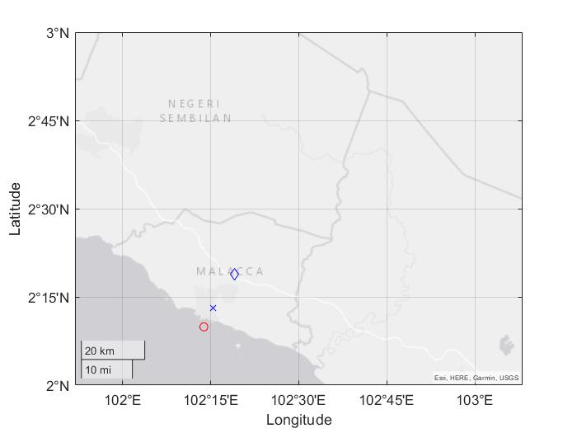
Figure 2. Strike example 1 dated 24 Nov 2019 at 12:39:43.381 with separation between strikes of 7.44 km. Lightning strike location for TNBR was marked as blue cross while our lightning measurement system was marked as a red circle. Measurement station location marked as a blue diamond shape.

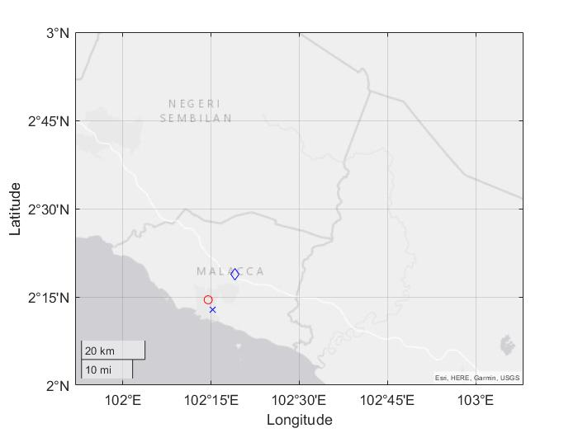
Figure 3. Strike example 2 dated 24 Nov 2019 at 12:39:43.660 with separation between strikes of 0.75 km.

Based on Figure 3, the distance from the measurement station to TNBR location is 12.74 km while the measurement station to its calculated distance of 13.37 km. The separation between the strikes was 0.75 km which was in Q3 with both positive magnetic field polarities.

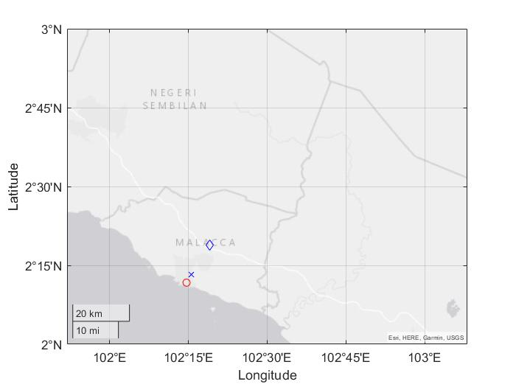
Figure 4. Strike 3 dated 24 Nov 2019 at 12:39:43.711 with separation between strikes of 2.31 km.

For strike 3 based on Figure 4, the distance from the measurement station to TNBR location is 12.21 km while the measurement station to its calculated distance of 9.91 km. The separation between the strikes was 2.31 km which was in Q3 with both positive magnetic field polarities.

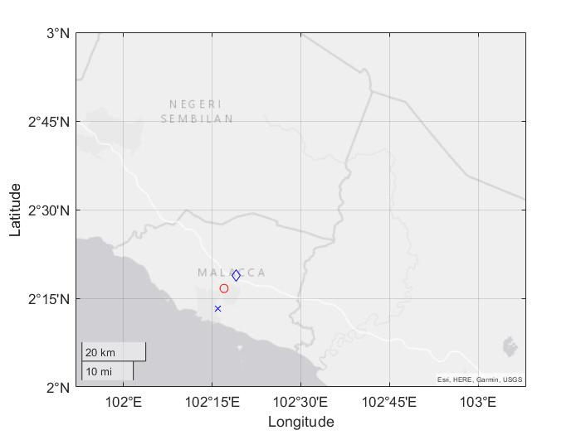
Figure 5. Strike 4 dated 24 Nov 2019 at 12:39:43.783 with a separation between strikes of 11.73 km.

For strike 4 based on Figure 5, the distance from the measurement station to TNBR location is 11.97 km while the measurement station to its calculated distance of 0.26 km. The separation between the strikes was 11.73 km which was in Q3 with both positive magnetic field polarities.

Figure 6. Strike 5 dated 24 Nov 2019 at 12:39:43.848 with a separation between strikes of 9.07 km.

For strike 5 based on Figure 6, the distance from the measurement station to TNBR location was 12.89 km while the measurement station to its calculated distance of 3.76 km. The separation between the strikes was 9.07 km which was in Q3 with both positive magnetic field polarities.

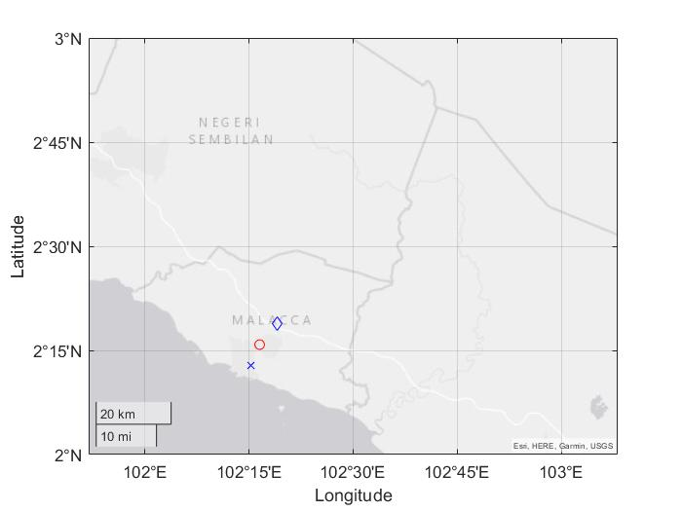
Figure 7. Strike 6 dated 24 Nov 2019 at 12:39:43.933 with a separation between strikes of 5.38 km.

For strike 6 based on Figure 7, the distance from the measurement station to TNBR location was 13.16 km while the measurement station to its calculated distance of 7.81 km. The separation between the strikes was 5.38 km which was in Q3 with both positive magnetic field polarities.

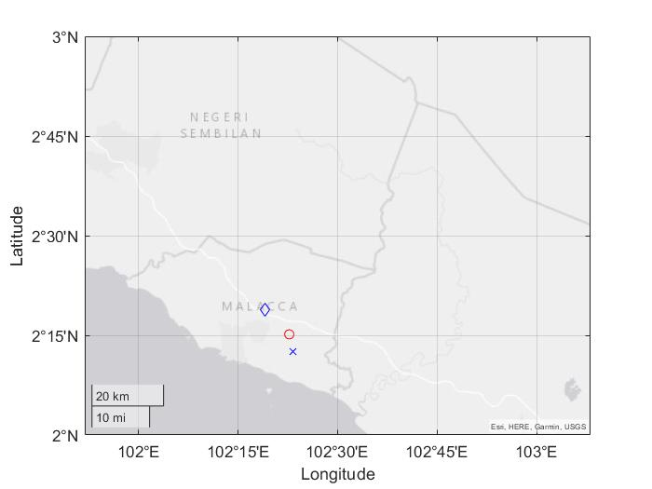
Figure 8. Strike 8 dated 24 Nov 2019 at 12:42:48.369 with a separation between strikes of 9.89 km.

For strike 7 based on Figure 8, the distance from the measurement station to TNBR location was 13.89 km while the measurement station to its calculated distance of 4.12 km. The separation between the strikes was 9.89 km which was in Q2 with positive NS and negative EW magnetic field polarities.

Table 3. Summary of lightning location based on the lightning measurement system.

Time (UTC)  (hh:mm::ss.000) | Latitude | Longitude | Separation distance (km)
12 November, 2019
21:45:22.079 | 1.975296172 | 102.4314 | 12.95
21:45:22.110 | 1.826304749 | 102.4578 | 14.9
16:25:36.070 | 2.368284479 | 102.2613 | 4.9
16:25:36.385 | 2.382133548 | 102.2571 | 5.68
16:27:52.502 | 2.45561634 | 102.1701 | 15.02
16:29:45.519 | 2.454980025 | 102.2013 | 13.42
16:29:45.618 | 2.331885932 | 102.3022 | 6.79
24 November, 2019
21:21:47.017 | 2.066850907 | 102.222 | 5.53
21:21:47.064 | 2.062416682 | 102.2199 | 7.7
21:32:16.237 | 2.246498933 | 101.9682 | 5.79
21:34:20.422 | 2.289023423 | 101.9902 | 4.02
21:34:20.447 | 2.291252483 | 102.0449 | 6.54
21:34:20.508 | 2.289960509 | 102.0049 | 5.51
21:34:20.657 | 2.288216543 | 101.9592 | 5.07
21:41:20.256 | 2.246255816 | 102.0619 | 6.87
12:22:40.516 | 2.232895211 | 102.2392 | 5.4
12:22:40.565 | 2.272629317 | 102.2789 | 1.12
12:22:40.600 | 2.194664324 | 102.2013 | 10.32
12:22:40.947 | 2.20820721 | 102.2122 | 7.62
12:22:41.406 | 2.194825412 | 102.2042 | 8.48
12:23:47.822 | 2.312004424 | 102.3168 | 8.27
12:42:48.369 | 2.287335991 | 102.3444 | 9.9
12:39:43.381 | 2.275781715 | 102.2779 | 7.44
12:39:43.660 | 2.210361363 | 102.2573 | 0.75
12:39:43.711 | 2.238362967 | 102.271 | 2.31
12:39:43.783 | 2.312207933 | 102.3169 | 11.73
12:39:43.848 | 2.287192949 | 102.2977 | 9.07
12:39:43.933 | 2.300419069 | 102.3069 | 10.87
12:39:44.036 | 2.25649501 | 102.278 | 5.38
12:42:48.369 | 2.287361558 | 102.3444 | 9.89

Table 3 shows the summary of the distance between the measurement station to the lightning source location. Based on the calculation, the closest separation between TNBR lightning location and our calculated lightning location using our system was 0.75 km and the farthest separation was 15.05 km. Thus, the calculated average separation value was 7.64 km. Since we are referencing the lightning location of our system to TNBR data which have the accuracy of ±0.5 km, we will add and subtract to the average separation distance which will obtain our average lightning strike location accuracy between 7.14 km and 8.14 km.
Conclusion

Implementing a multi-station lightning strike location system will cost vastly with the use of multiple precision equipment. Therefore, in this paper, the locations of lightning strikes could be determined by using a low-cost single-station lightning measurement system that consists of an electric field and magnetic field sensors. Based on the vertical component of electric field intensity and the azimuthal component of magnetic flux density on the ground surface, the location of the lightning source could be determined. A total of 30 lightning strikes detected within 45 km from our station were examined for their return stroke peak amplitudes where the polarities determine which quadrants they should appear. With the average corrected Factor B of 60.1M and the height of striking distance of 70 m, the average separation between the compared strike location was 7.64 km. Thus, the lightning measurement system has an accuracy between 7.14 to 8.14 km from the TNBR strike locations. In the future, this study could be expended with the use of more data of lightning events from different storms and location. Upgrading the lightning measurement station could be conducted as well by improving the sensitivity of the antenna. Thus, giving better understanding and determination of lighting strike locations.

Acknowledgment

This research was funded by Yayasan Penyelidikan Antartika Sultan Mizan (YPASM) through the YPASM Grant (ZF-2019-001). The authors would like to thank Institut Perubahan Iklim (IPI), Universiti Kebangsaan Malaysia (UKM) and Centre for Telecommunication Research and Innovation (CeTRI), Fakulti Kejuruteraan Elektronik dan Kejuruteraan Komputer (FKEKK), Universiti Teknikal Malaysia Melaka (UTeM) for their supports in this project. Also, the authors would like to acknowledge the financial and logistics support from Korea Polar Research Institute (KOPRI). This research uses data that are provided by the Lightning Detection Network managed by Lightning Detection System Laboratory, TNB Research Sdn. Bhd. The lightning data provided are locations of cloud-to-ground flashes within Peninsula Malaysia.

References

Abbasi, R. (2019). Cosmic ray detectors and observational breakthroughs in atmospheric electricity. PoS (ICRC2019), 18.
Abdullah, N., Yahaya, M. P., & Hudi, N. S. (2008, December). Implementation and use of lightning detection network in Malaysia. In 2008 IEEE 2nd International Power and Energy Conference (pp. 383-386). IEEE.
Ahmad, M. R., Esa, M. R. M., Cooray, V., & Dutkiewicz, E. (2014). Interference from cloud-to-ground and cloud flashes in wireless communication system. Electric Power Systems Research, 113, 237-246.
Ahmad, M. R., Esa, M. R. M., Cooray, V., Baharudin, Z. A., & Hettiarachchi, P. (2015). Latitude dependence of narrow bipolar pulse emissions. Journal of Atmospheric and Solar-Terrestrial Physics, 128, 40-45.
Ahmad, M.R., Periannan, D., Sabri, M.H.M., Aziz, M.Z.A.A., Lu, G., Zhang, H., Esa, M.R.M. & Cooray, V. (2017). Emission heights of narrow bipolar events in a tropical storm over the Malacca Strait. In 2017 International Conference on Electrical Engineering and Computer Science (ICECOS) (pp. 305-309). IEEE.
Alammari, A., Alkahtani, A. A., Ahmad, M. R., Noman, F. M., Esa, M. R. M., Kawasaki, Z., & Tiong, S. K. (2020). Lightning mapping: Techniques, challenges, and opportunities. IEEE Access, 8, 190064-190082
Baharin, S. A. S., & Ahmad, M. R. (2020). Electric Field Waveforms of Very Close Negative Cloud to Ground Flashes. Journal of Engineering and Scientific Research, 2(2), 115-120.
Baharin, S. A. S., Ahmad, M. R., Seah, B. Y., Yusop, N., Esa, M. R. M., Sidik, M. A. B., ... & Lu, G. (2019, October). Temporal Analysis of Microwave Radiation Emitted. In 2019 International Conference on Electrical Engineering and Computer Science (ICECOS) (pp. 137-140). IEEE.
Cooray, V., Rakov, V., & Theethayi, N. (2007). The lightning striking distance—Revisited. Journal of Electrostatics, 65(5-6), 296-306.
Cummins, K. L., Murphy, M. J., Bardo, E. A., Hiscox, W. L., Pyle, R. B., & Pifer, A. E. (1998). A combined TOA/MDF technology upgrade of the US National Lightning Detection Network. Journal of Geophysical Research: Atmospheres, 103(D8), 9035-9044.
Galvan, A., & Fernando, M. (2000). Operative characteristics of a parallel-plate antenna to measure vertical electric fields from lightning flashes.
Hayenga, C. O., & Warwick, J. W. (1981). Two‐dimensional interferometric positions of VHF lightning sources. Journal of Geophysical Research: Oceans, 86(C8), 7451-7462.
Ibrahim, W. I., & Malek, Z. A. (2010, November). Time-to-thunder method of lightning distance determination. In 2010 IEEE International Conference on Power and Energy (pp. 357-362). IEEE.
Lennon, C., & Maier, L. (1991, April). Lightning mapping system. In Proceedings of the International Aerospace and Ground Conference on Lightning and Static Electricity (Vol. 3106, pp. 89-1).
Lewis, E. A., Harvey, R. B., & Rasmussen, J. E. (1960). Hyperbolic direction finding with sferics of transatlantic origin. Journal of Geophysical Research, 65(7), 1879-1905.
Nag, A., Rakov, V. A., Tsalikis, D., & Cramer, J. A. (2010). On phenomenology of compact intracloud lightning discharges. Journal of Geophysical Research: Atmospheres, 115 (D14).
Proctor, D. E. (1971). A hyperbolic system for obtaining VHF radio pictures of lightning. Journal of Geophysical Research, 76(6), 1478-1489.
Proctor, D. E. (1984). VHF radio pictures of lightning flashes to ground. J. Geophys. Res., 89, 1403-1410.
Qiu, S., Zhou, B. H., Shi, L. H., Dong, W. S., Zhang, Y. J., & Gao, T. C. (2009). An improved method for broadband interferometric lightning location using wavelet transforms. Journal of Geophysical Research: Atmospheres, 114(D18).
Ramachandran, V., Prakash, J. N., Deo, A., & Kumar, S. (2007, July). Lightning stroke distance estimation from single station observation and validation with WWLLN data. In Annales Geophysicae (Vol. 25, No. 7, pp. 1509-1517). Copernicus GmbH.
Rhodes, C. T., Shao, X. M., Krehbiel, P. R., Thomas, R. J., & Hayenga, C. O. (1994).
Observations of lightning phenomena using radio interferometry. Journal of Geophysical Research: Atmospheres, 99(D6), 13059-13082.
Rhodes, C., & Krehbiel, P. R. (1989). Interferometric observations of a single stroke cloud‐to‐ground flash. Geophysical Research Letters, 16(10), 1169-1172.
Rison, W., Thomas, R. J., Krehbiel, P. R., Hamlin, T., & Harlin, J. (1999). A GPS‐based three‐dimensional lightning mapping system: Initial observations in central New
Mexico. Geophysical research letters, 26(23), 3573-3576.
Shao, X. M., Krehbiel, P. R., Thomas, R. J., & Rison, W. (1995). Radio interferometric observations of cloud‐to‐ground lightning phenomena in Florida. Journal of Geophysical Research: Atmospheres, 100(D2), 2749-2783.
Shao, X. M., & Krehbiel, P. R. (1996). The spatial and temporal development of intracloud lightning. Journal of Geophysical Research: Atmospheres, 101(D21), 26641-26668.
Smith, D. A., Shao, X. M., Holden, D. N., Rhodes, C. T., Brook, M., Krehbiel, P. R., ... & Thomas, R. J. (1999). A distinct class of isolated intracloud lightning discharges and their associated radio emissions. Journal of Geophysical Research: Atmospheres, 104(D4), 4189-4212.
Stock, M., & Krehbiel, P. (2014, October). Multiple baseline lightning Interferometry-Improving the detection of low amplitude VHF sources. In 2014 International Conference on Lightning Protection (ICLP) (pp. 293-300). IEEE.
Sun, Z., Qie, X., Liu, M., Cao, D., & Wang, D. (2013). Lightning VHF radiation location system based on short-baseline TDOA technique—Validation in rocket-triggered lightning. Atmospheric Research, 129, 58-66.
Tantisattayakul, T., Masugata, K., Kitamura, I., & Kontani, K. (2005). Broadband VHF sources locating system using arrival-time differences for mapping of lightning discharge process. Journal of atmospheric and solar-terrestrial physics, 67(11), 1031-1039.
Thomas, R. J., Krehbiel, P. R., Rison, W., Hamlin, T., Harlin, J., & Shown, D. (2001). Observations of VHF source powers radiated by lightning. Geophysical research letters, 28(1), 143-146.
Uman, M.A. (1985). Lightning return stroke electric and magnetic fields. Journal of Geophysical Research: Atmospheres, 90(D4), 6121-6130.
Warwick, J. W., Hayenga, C. O., & Brosnahan, J. W. (1979). Interferometric directions of lightning sources at 34 MHz. Journal of Geophysical Research: Oceans, 84(C5), 2457-2468.
Zhang, H., Lu, G., Qie, X., Jiang, R., Fan, Y., Tian, Y., ... & Feng, G. (2016). Locating narrow bipolar events with single-station measurement of low-frequency magnetic fields. Journal of Atmospheric and Solar-Terrestrial Physics, 143, 88-101.
Zhang, Y., Zhang, Y., Lu, W., & Zheng, D. (2012). An analysis of the initial breakdown pulses for positive cloud-to-ground flashes. IEEJ Transactions on Power and Energy, 132(6), 542-547.

