

Evaluation of coastal hydrodynamic performance using statistical analysis at the Kelantan coast, Malaysia

Nurul A’idah Abd Rahim^{1,2}, Khairul Nizam Abdul Maulud^{1,3,*}, Fazly Amri Mohd⁴, Lee Hin Lee², Wan Hanna Melini Wan Mohtar³

¹ Earth Observation Centre, Institute of Climate Change, Universiti Kebangsaan Malaysia.
²Coastal Management & Oceanography Research Centre, National Water Research Institute of Malaysia (NAHRIM), Ministry of Environment & Water, Seri Kembangan, Selangor,
³Department of Civil Engineering, Faculty of Engineering and Built Environment, Universiti Kebangsaan Malaysia
⁴Centre of Studies for Surveying Science and Geomatics, Faculty of Architecture, Planning and Surveying, Universiti Teknologi MARA Perlis, UiTM Arau, Perlis, Malaysia.

Corresponding: Khairul Nizam Abdul Maulud (e-mail: knam@ukm.edu.my)

Received: 23 August 2021; Accepted: 10 October 2021; Published: 30 November 2021

Abstract

Coastal zones are vulnerable to the effects of nature and man, as well as being physically volatile. The interaction of hydrodynamic conditions in coastal areas is a complex phenomenon. Considering the characteristics in this specific area, understanding its hydrodynamic behaviour should be obviously clarified. Thus, the hydrodynamic characteristics for Kelantan coast had been simulated using a numerical software of MIKE 21 Hydrodynamic FM. To assess the performance of the model, a combination of time series analysis and statistical evaluation were carried out against two weeks of observed data. Time series analysis shows a good agreement with the field measurements for both magnitude and phase. Statistical analysis using Root Mean Squared Errors (RMSE) and Regression analysis (R²) for current speed and water level were analysed. The results indicate that the RMSE for current speed are 8.97% and 8.00% for ADCP 1 and ADCP 2, respectively while the RMSE for water level is 8.89 %. Through the regression analysis, the output indicates that the numerical model is in a good performance as the R2 ranged from 0.72 to 0.9. Both time series and statistical approach were successfully utilised in the hydrodynamic model to determine the performance of the coastal hydrodynamic characteristics in Kelantan’s coastline. The output model can provide important information, especially on the coastal management and land-use planning for the developers, planners and state authority.

Keywords: Coastal, hydrodynamic, numerical modelling, regression analysis, RMSE

Introduction

Coastal hydrodynamics are controlled by many natural elements such as bathymetry, meteorological forcing, currents, and tides (Fitri et al., 2017; Department of Irrigation and Drainage, 2001). However, with the interference from human activities and development along the coastal zones resulting this area to become a dynamic system (Kulkarni, 2013). Hence, it is essential to study the dynamic of coastal zones and its responses towards these interference especially for many coastal engineering applications such as coastal erosion protection structures. Furthermore, monitoring and understanding the hydrodynamic characteristics are significant for coastal engineering related activities which can be performed using numerical and physical modelling. Physical and numerical modelling have been an important tools for researchers to mimic and solve the problem of coastal processes for many years.
Physical models are scale-down model into a smaller size to represent actual dominant forces in the correct proportion system. While, numerical models using a mathematical formulation that has been described as hydrodynamic processes to represent coastal processes well (Blacka et al., 2007). However, the performance of the coastal models need to be calibrated and verified with sufficient observed data because of the complex elements in the coastal area (De Vos et al., 2021; Prasetyo et al., 2018). Several numerical models have been demonstrated to identify the best approach for understanding hydrodynamics characteristics due to dynamic environment in coastal area; and these models are recently being used as an effective tool to help in decision making such as MIKE 21 developed by DHI, also known as Denmark Hydraulic Institute, (2011). The modules in MIKE 21 can be used in various applications such as design assessment, optimisation of coastal structures, environmental and ecological assessment in the coastal dynamics.
The human population and activities are increasing in the coastal regions. Therefore, numerical modelling is an effective tools in order to ensure that the coastal areas do not become hazardous to human life and economic interests, including sustainably managed (Ariffin, 2018; Ariffin et al. 2020; Ehsan et al. 2019; Gill et al., 2014; Mohamed Rashidi et al. 2021). Hence, it is crucial to understand the hydrodynamics and the transport of sediments on coastal areas and their effects (Haditiar et al. 2019; Tam et al. 2019; Zhang et al., 2009). Coastal hydrodynamics and sediment transport sudy using numerical modeling is a common way for assessing problems in Coastal Engineering (Sawczyński & Kaczmarek, (2014). Nevertheless, many numerical modelling techniques for coastal areas are being created, but not very much research on Kelantan Coast has been done, particularly on hydrodynamic model performance.Therefore, the main aim in this research is to assess the accuracy and performance of the hydrodynamic model simulation at Kelantan coastline by using unstructured hydrodynamic approach of the MIKE 21 FM (Version 2019; licensed ID 1002091) software (Denmark Hydraulic Institute, 2011).

Literature review

The coastal processes on the east coast of Peninsular Malaysia are influenced by the monsoonal system brought from East Asia, which delivers a high intensity of linked physical natural phenomena associated with current speeds, tides, waves, winds, and rainfall frequency during the winter season and has a significant impact on the cycle of beach erosion and accretion in Malaysia. Peninsular Malaysia has a coastline length of 1,972 kilometres out of a total length of 4,809 kilometres (Ehsan et al. 2019; Gill et al., 2014; Mohd et al. 2018; Razak et al. 2018), and more than half of the Peninsular coast is eroding.
Recent coastal development and land use change have required the creation of comprehensive numerical modelling software to calculate coastal erosion, the impact of engineering works, and the influence on the ecological environment ( Dunstan et al. 2019; Gill et al., 2014; Mohamed Rashidi et al. 2021; Razak et al. 2018; Tam et al. 2019; Tobergte and Curtis 2013). Because of the considerable diversity in physical forcing, geometry, hydrodynamics, and circulation of estuarine systems, a variety of numerical models have been developed, each designed for a specific purpose.
Time series and statistical output are often used to assess the model's simulation performance with data measurement. Time series analysis offers enormous helps in the calibration step, however this is not informative enough to minimise the discrepancies in the model. Hence statistical analysis are recommended to quantify the goodness of fit (Williams and Esteves, 2017; Mirzaei et al., 2013; Chu et al., 2004). The model's accuracy can be calculated using root mean square error (RMSE), which is the average squared difference between the measured and predicted values. The RMSE values indicate the less residual value between both two data set denote better model performance (Simon and Hashemi, 2018). However, RMSE analysis has greatly emphasized on large errors compared to small ones and it is also very sensitive with false or outlier in the data set (Kavuncuoglu et al., 2018). Therefore, a regression model using the coefficient of determination or R-squared (R²) is often used to represent the proportion of the variance in the dependent variable.
According to the previous study, there is a serious lack of knowledge about Kelantan Coastal regarding to historical records of physical marine data and hydrodynamic modelling studies. Mohtar et al., (2017) has conducted a numerical modelling study using the MIKE21 model suites to evaluate the hydrodynamic parameters in Kelantan Delta. The results indicate that the marine effects on the study region are intimately tied to the Monsoons, with the Northeast Monsoon having the highest sea and swell conditions (Ariffin, et al., 2018; Ehsan et al. 2019;Maruti et al., 2018; Samaras et al., 2013; Toriman et al., 2015). The study also suggests that there is a lack of a comprehensive strategy to guide an integrated and sustainable management, such as changes in land use that result in degradation and reduced size of the various wetlands habitats, which will consequently disrupt the economic value for the local population.
Another research conducted by Azad et al., (2016) mentioned that flood propagation could be better understood by employing hydrodynamic modelling to simulate velocity and water level. The spatial complexity of the schematization in 1D model and 2D model, can be used to identify hydrodynamic flood routing. Therefore, a flood mitigation strategy can be designed using hydrodynamic modelling for future flood protection.

Material and methods

MIKE 21 Flow Model FM is based on two dimensional modelling system that uses unstructured mesh approach. This model relies on the flexible mesh method and it is generally used for most coastal and marine approaches (Jusoh et al., 2014; Borgersen, 2016). The Hydrodynamic is a basis module in the MIKE 21 Flow Model modelling system (Denmark Hydraulic Institute, 2011). This module simulates various environmental application over geographic areas in lakes, river mouths, lagoons, bays, shallow water areas, and open seas. The flows of hydrodynamic in the coastal areas are calculated in x and y direction based on volume and momentum as shown on equations following:

Y-direction;
$$\frac{∂p}{δt}+ \frac{∂}{δy}\left(\frac{p^{2}}{h}\right) + \frac{∂}{δx}\left(\frac{pq}{h}\right) +gh\frac{δξ}{δy} + \frac{gp\sqrt{p^{2}+ q^{2}}}{C^{2 }. h^{2 } } - \frac{1}{p_{ω}}\left[\frac{δ}{δx}\left(hτ_{yy}\right)+ \frac{δ}{δx}\left(hτ_{xy}\right) \right]- Ω_{q }-fVV_{y }+ \frac{h}{p_{ω}}\frac{∂}{δy} \left(p_{a}\right)=0,$$

X- direction;
$$\frac{∂p}{δt}+ \frac{∂}{δx}\left(\frac{p^{2}}{h}\right) + \frac{∂}{δy}\left(\frac{pq}{h}\right) +gh\frac{δξ}{δx} + \frac{gp\sqrt{p^{2}+ q^{2}}}{C^{2 }. h^{2 } } - \frac{1}{p_{ω}}\left[\frac{δ}{δx}\left(hτ_{xx}\right)+ \frac{δ}{δy}\left(hτ_{xy}\right) \right]- Ω_{q }-fVV_{x }+ \frac{h}{p_{ω}}\frac{∂}{δx} \left(p_{a}\right)=0,$$

The equation of continuity:

$$\frac{∂ξ}{δt}+\frac{δρ}{δx} +\frac{δq}{δy}=\frac{δd}{δt}$$

Where x and y are direction components, (x,y,t) is surface elevation (m), h(x,y,t) is water depth (m), d is time variable water depth (m), g is gravity acceleration (m/s2), atmospheric pressure (kg/m/s2), $p_{ω}$ is the water density (kg/m3), and $τ$ is shear stress.

Data required for the hydrodynamic flow model from MIKE 21 consists of bathymetry and topography data, river discharge from the main connected river, meteorological parameters, sediment properties and bed resistance. Figure 1 depicted a location of the study area and situated facing the South China Sea which the tidal dynamic and circulation of current pattern in this area are mostly influenced by the geographical, topographical and monsoon winds which agreed by many previous studies (Wyrtki, 1961; Chu et al., 2004; Zu et al., 2008; Han et al., 2021).
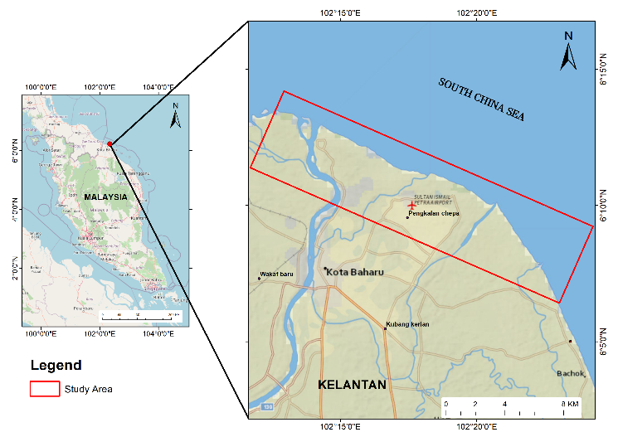
Figure 1. Study location at coastal area of Kelantan
A high-resolution bathymetry study was carried out concentrated along the Kelantan coast, covering an area from Sungai Kemasin to Sungai Kelantan which is approximately about 20 km x 5 km as shown on Figure 2. This survey was done during the spring tide in July 2018. The Temporary Bench Mark (TBM) was setup at the existing jetty for tidal correction. The detailed bathymetric data surrounding the study area will be referred to Cartesian coordinates in UTM 48N and reduced to Mean Sea Level (MSL) and Chart Datum (CD) for numerical modelling input. The survey depths recorded ranging from -0.01m to -11.54m relative to a chart datum. Furthermore, the bathymetry data apart from survey area was extracted using C-MAP digital chart which has been included in the DHI package. The bathymetric map was handled by MIKE Zero’s Bathymetry Editor and Mesh Generator (Denmark Hydraulic Institute, 2017) to produce a flexible mesh with spatial grid resolution ranging from 10 m along the shoreline to 3,000 m towards the open sea.

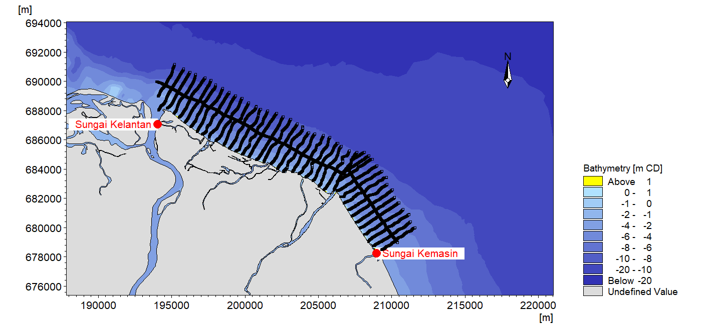
Figure 2. Conducted bathymetry survey along Kelantan Coast (from Sungai Kelantan to Sungai Kemasin)

For Kelantan Coast model, the computational domain is enclosed by four boundaries consists of the shoreline, an offshore boundary, and two open cross-sections in the lateral boundary (Ding et al, 2016). This task's goal is to allow water level energy to act as primary forcing across the model domain. Following that, the boundary information for each code is specified. A code value for the open water boundaries can be provided when the mesh was built using the MIKE Zero Mesh Generator. An offshore boundary for code 3(East) and lateral boundary for code 2 (South) and code 4 (North) are specified in the mesh file. Generated water levels are obtained from global tide model provided by DHI.
As illustrated in Figure 3, two units of Acoustic Doppler Current Profiler (ADCP) were installed at two places along the Kelantan coast, to collect a complete semidiurnal tidal periods. The ADCP were used to measure vertical current profile data to produce current speed and its directions which later to be used in calibration and verification processes. A tide gauge was installed at Kuala Besar Marine Department's Jetty and recorded the water level at 10-minute intervals. All the measured data were collected for 14 days from 27th to 9th August 2018 in the study area.

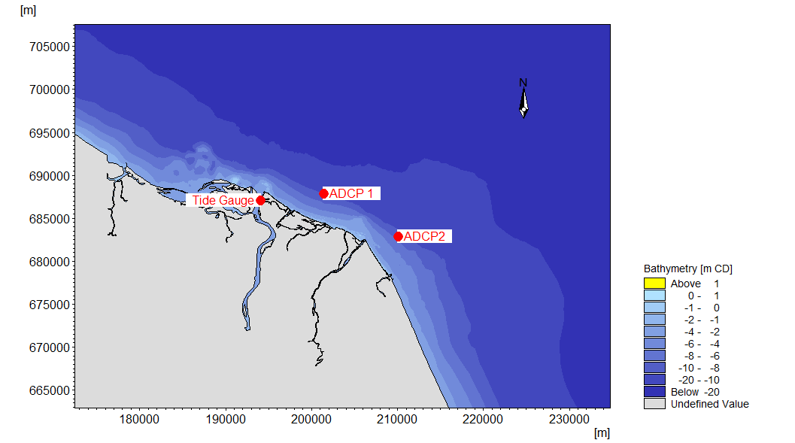
Figure 3. The Locations of Tide gauge, ADCP 1 and ADCP 2 installed at Kelantan Coast

Results and discussions

Time series analysis

The model simulation output were calibrated and validated with the water level, current speed, and its direction measured in real time (in-situ) at the northeast part of Peninsular Malaysia. Figure 4 shows the calibrated time series water level obtained from model simulation and water level measured at the jetty of Kuala Besar Marine Department, installed Tide Gauge, ADCP1 and ADCP2, which denotes a good agreement and corresponding shape with the field measurements. This finding is consistent with the findings of past studies by Azid et al., (2015), which found that the flow patterns around this study area correspond to the impacts of the semidiurnal tides, which have two high tides and two low tides on a lunar day. Zu et al.,(2008) found that the response of tidal dynamics in this area are greatly influenced by local geography and bathymetry.

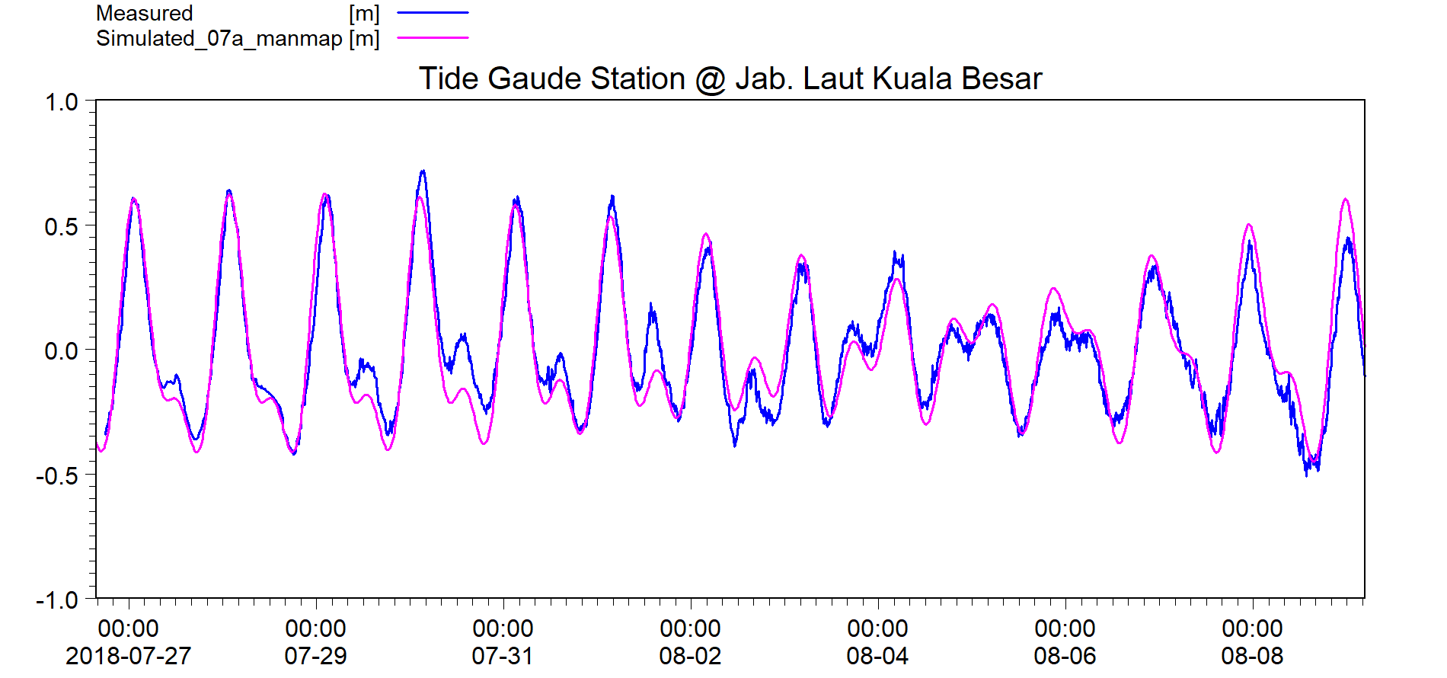
(a) Station Tide Gauge
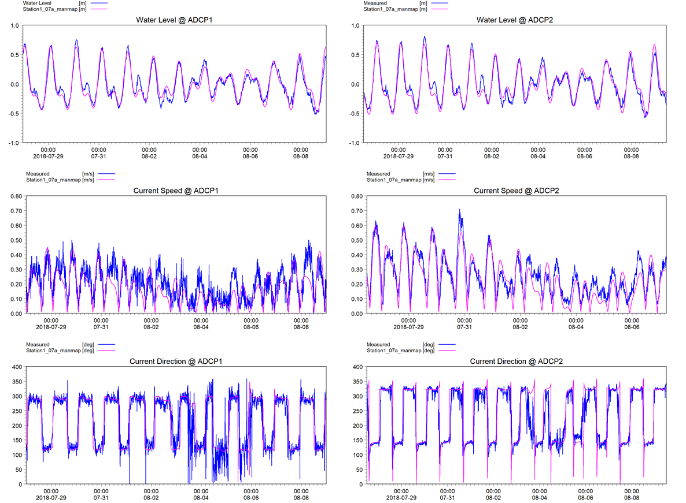
(b) Station ADCP1
(c) Station ADCP2

Figure 4. The pattern of water level at Jetty of Jabatan Laut Kuala Besar.

Figure 5 shows time series validation for current speed between simulation and field measurements at ADCP1 and ADCP2. The analysis shows a good agreement with current characteristics which is greatly influenced by tidal amplitude, phase and direction especially during peak flow for ebb and flood tides (Williams and Esteves, 2017). A research finding by Mohammad Noor et al., (2013) also mentioned that Kelantan coast is facing the South China Sea, and numerous anthropogenic activities such as human residences and recreational facilities had been constructed along the beach. Therefore, these activities would be affect the adjacent hydrodynamic characteristics. Kamarudin et al., (2017) demonstrated that the speed of water flows is the main factor which will effect the capacity to move and transport the sediment.

(a) Current Speed
(b) Current Direction
Figure 5. Time series comparison between observed and model simulated data at station ADCP1 and ADCP2

Statistical analysis
Table 1 shows the values of Root Mean Square Error (RMSE) and coefficient of determination (R²) in the model calibration and validation processes. The RMSE values for calibration and validation of water level at three stations indicate good performance based on the ‘Guidelines for Preparation of Coastal Engineering Hydraulic Study and Impact Evaluations, 5th Edition’ published in December 2001 and a piece of additional information published in 2013. According to the Hydraulic Guideline on the Department of Irrigation and Drainage (DID) on 2013, the standard error allowed for current speed should be no more than 20%. For the water level, the tolerance of DID requirement is not more than 10%. From the results, the RMSE value for all stations are comparable between current speed and water level with the value ranging from 8.0% to 8.89%. Since this model is only forced by pure tide conditions, the resulting RMSE value is almost similar.

Table 1. Statistical Methods using Root Mean Square Error (RMSE) and coefficient of
determination (R²) for water level and current speed parameters.
No | Hydrodynamic Parameters | RMSE (%) | R²
1 | Water Level (m) | 8.89 | 0.94
2. | Current Speed (m/s)  ADCP 1 | 8.97 | 0.72
2. | ADCP 2 | 8.00 | 0.87

Based on the regression method, the coefficient of determination (R²) has been obtained to assess on how good the model performance as a predictor. Figure 6 shows the regression test result of the water level and current speed for this research region, which is calculated to be exactly 1, showing that this simulation model provides a good prediction output. The results also produce a significance level of the correlation values with p<0.05 for all stations. The range of R² values for these hydrodynamic parameters is around 0.72 to 0.94. From the results, the R² values at ADCP2 is found to have a high correlation value compared to ADCP1, this might be due to high noise in the observed current speed data on ADCP1 which resulting to low R² value as shown in time series analysis. In the hydrodynamic parameter, high value of R² for water level compared to current speed is expected because the observed current speed is always much noisier than the water level. Hence, the water level parameter shown better performance compared to the current speed.
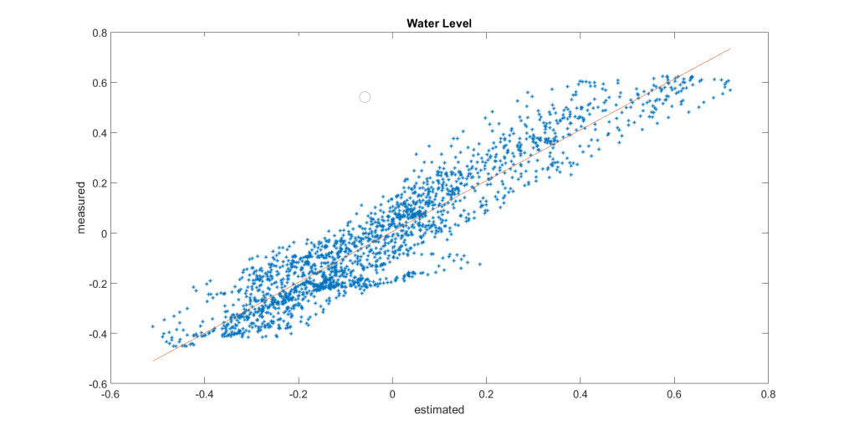
R² : 0.94
(a) Water level at tide gauge station
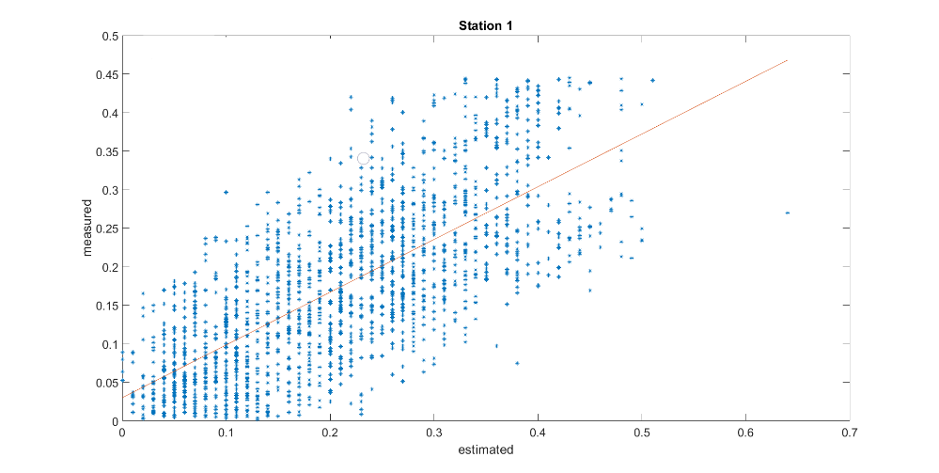
R² : 0.72
(b) Current speed at ADCP1
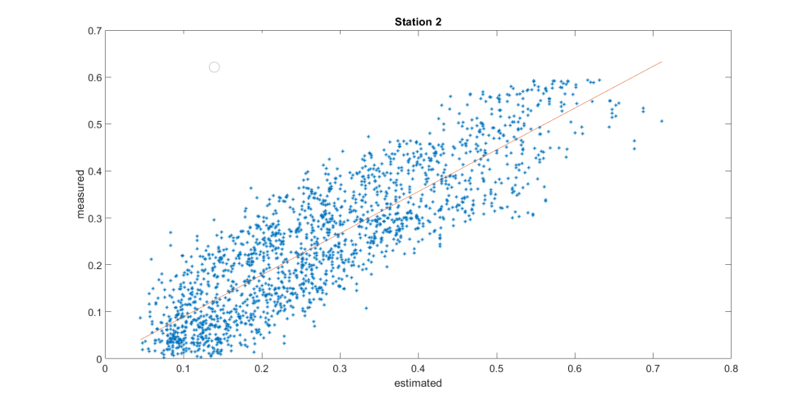
R² : 0.87
(c) Current speed at ADCP2
Figure 6. Regression model and calculated coefficient of determination (R²) at measuring stations.
Furthermore, since the model is forced by purely tide conditions, it is expected to get a high correlation value because tide is predictable compared to current except under the influence of extreme meteorology factors such as storm surge (Polagye et al., 2010). In terms of magnitude deviation, other factors (e.g. meteorological, river discharge) may play an important factor in the RMSE value. Hence, the RMSE value is higher for water level compared to the current speed.
To achieve the most accurate predictions, both statistical methods were tested. As a result, almost all statistical approaches used in this research showed that the model is well calibrated, validated and accepted. It is crucial to have an accurate model, especially along Kelantan coast where the hydrodynamic processes are complex and complicated. Furthermore, Radzir et al., (2018) stated that during the northeast monsoon, the Kelantan delta and coastline were impacted by numerous destructive waves that caused erosion at the higher beach and deposits the sediment at the offshore bars. Plus, a study by Zu et al., (2008) stated that the veracity of the coastal topography played an important role in order to determine model accuracy. Meteorological forcing such as wind and waves, dynamic morphology and complexity of the coastal processes in this area may not be well resolved, thus could be the reason why the current speed performance is lower than the water level. In addition, higher model grid resolution and accuracy of the bathymetry and topography survey are an important factor to improve the efficiency of the coastal modelling (Brown & Kraus, 2007; Reid et al., 2014). Plus, the study area is prone to high risk during the heavy rainfall season from December to February. Wan Ahmad & Abdurrahman (2015) reported that on 2014, eight Kelantan territories were affected severely due to heavy rains which caused massive flooding. During these events, a natural disaster may cause major damages to the community and existing infrastructures. Therefore, during the monsoon season, implementing meteorology forcing may be required to improve model performance for this study area.

Conclusions

The statistical approaches applied in the numerical model for this research show a high performance between the simulation and the observed data. The RMSE and regression method had been effectively assessed in the model for recognizing the accuracy of the hydrodynamic parameters at Kelantan Coast. The output indicates that the numerical model is in a good performance for the water level, current speed and current direction. Finally, the model output for Kelantan coast has been validated and can be used and help to provide important information, especially on the management and land-use planning for the developers, planners and state authority.

Acknowledgment

This paper has been financed by the Research University Grants from Universiti Kebangsaan Malaysia (DIP-2018-030). The authors would like to thank and acknowledge whomever involved in this study especially to Earth Observation Centre, Institute of Climate Change, UKM; Department of Survey and Mapping Malaysia (JUPEM) and National Water Research Institute of Malaysia (NAHRIM) in providing the facilities, informations, supports and field data.

References
Ariffin, E. H., Zulfakar, M. S. Z., Redzuan, Nurul., Mathew, M., Akhir, M. F., Baharim, N., Awang, N. & Mokhtar, N. (2020). Evaluating the effects of beach nourishment on littoral morphodynamics at Kuala Nerus, Terengganu (Malaysia). Journal of Sustainability Science and Management, 15(5), 29–42.
Ariffin, E. H., (2018). Effect of monsoons on beach morphodynamics in the East Coast of Peninsular Malaysia: Examples from Kuala Terengganu coast. PhD Thesis, Universite de Bretagne-Sud.
Ariffin, E. H., Mathew, M. J., Yaacob, R., Akhir, M. F., Shaari, H., Zulfakar, M. S. Z., Sedrati, M. and Awang, N.A. (2018). Beach morphodynamic classification in different monsoon seasons at Terengganu beaches, Malaysia. Journal of Sustainability Science and Management, (5), 65–74.
Azad, W., Sidek, L., Basri, H., Fai, C., Saidin, S., & Hassan, A. (2016). 2 Dimensional Hydrodynamic Flood Routing Analysis on Flood Forecasting Modelling for Kelantan River Basin. MATEC Web of Conferences, 87 . doi: 10.1051/matecconf/201787010162016.
Azid, A., Noraini, C., Hasnam, C., Juahir, H., Amran, M. A., Toriman, M. E., Kamarudin, A. (2015). Coastal erosion measurement along Tanjung Lumpur to Cherok Paloh, Pahang during the northeast monsoon season. Journal Teknologi, 1, 27–34.
Blacka, M., Carley, J. T., Cox, R. J. & Miller, B. (2007). The current use of physical and numerical models for coastal applications. University of New South Wales Coastal Conference, 2007.
Borgersen, B. T. (2016). Numerical modelling of Arctic coastal hydrodynamics and sediment transport. Master Thesis, Norwegian University of Science and Technology.
Brown, M. E., & Kraus, N. C. (2007). Tips for developing bathymetry grids for coastal modeling system applications. Coastal and Hydraulics Laboratory Engineering Technical Note ERDC/CHL CHETN-IV-69. Vicksburg, Mississippi: U.S. Army Engineer Research and Development Center, 15p.
Chu, P.C., Qi, Y., Chen, Y. Mao, Q., & Shi, P. (2004). South China Sea wave charcteristics. Part-1: Validation of wavewatch-III using TOPEX/Poseidon data. Journal of Atmospheric and Oceanic Technology, 21(11), 1718-1733.
De Vos, M., Vichi, M., & Rautenbach, C. (2021) Simulating the coastal ocean circulation near the Cape Peninsula using a coupled numerical model. Journal of Marine Science and Engineering, 9(359). https://doi.org/10.3390/jmse9040359
Denmark Hydraulic Institute (DHI). (2011). MIKE 21 FLOW MODEL FM. User Guide. Danish Hydraulic Institute, 2011.
Denmark Hydraulic Institute (DHI). (2017). MIKE C-MAP. Danish Hydraulic Institute, 2017.
Department of Irrigation and Drainage. (2001). Guidelines for Preparation of Coastal Engineering Hydraulic Study and Impact Evaluation Malaysia, pp 1-30.
Ding, Y., Jia, Y., & Wang, S. S. Y. (2016). Numerical Modeling of morphological processes around coastal structures. In: Proceedings World Environmental and Water Resource Congress May 21-25 2006. Sponsored by the Environmental and Water Resources Institute of ASCE. 10-20. Omaha, Nebraska.
Dunstan A. P., Aslinda N. A., Ahmad T.A., Yannie A.B., Zulazman M.L., Ikmalzatul A., Nurul A’idah A.R., Amir Hamzah A.R., Shahdy I., Siti Salihah M.S. & Roslina A.R. (2019). Morphodynamic of Marudu Bay during North East Monsoon (NEM ). Journal Earth Science & Climate Change, 10(4),1-13.
Ehsan S., Begum, R. A., Nor, N. G. M. & Maulud, K. N. A. (2019). Current and potential impacts of sea level rise in the coastal areas of Malaysia. IOP Conference Series: Earth and Environmental Science, 228(1).
Fitri, A., Hashim, R. & Motamedi, S. (2017). Estimation and validation of nearshore current at the coast of Carey Island, Malysia. Science and Technology, 25(3), 1009–1018.
Gill, J. Ainee, A. M. Anwar, and S. Omar K. (2014). Towards the Implementation of Continuous Coastal Vulnerability Index in Malaysia: A Review. Journal Teknologi, 71(4), 1-10.
Haditiar, Y., Putri, M. R., Ismail, N., Muchlisin, Z. A., & Rizal, S. (2019) Numerical simulation of currents and volume transport in the Malacca Strait and part of South China Sea. Engineering Journal, 23(6), 129–43.
Han, G., Tian, F., Ma, C. & Chen, Ge. (2021). The geometry of mesoscale eddies in the South China Sea: characteristics and implications. International Journal of Digital Earth, 14(4), 464-479.
Jusoh, W. H. W., Tangang, F., Juneng, L., & Hamid, M. R. A. (2014). Numerical modeling of hydrodynamic in southwestern Johor, Malaysia. In AIP Conference Proceedings, 665, 665–670).
Kamarudin, M. K. A., Toriman, M. E., Abd Wahab, N., Rosli, H., Ata, F. M., & Mohd Faudzi, M. N. (2017). Sedimentation study on upstream reach of selected rivers in Pahang River Basin, Malaysia. International Journal on Advanced Science, Engineering and Information Technology, 7(1), 35.
Kavuncuoglu, H., Kavuncuoglu, E., Ilter, S. M., Benli, B., Sagdic, O. & Yalcin, H. (2018). Prediction of the antimicrobial activity of walnut ( Juglans regia L. ) kernel aqueous extracts using artificial neural network and multiple linear regression. Journal of Microbiological Methods. 148. 10.1016/j.mimet.2018.04.003.
Kulkarni, R. R. (2013). Numerical Modelling of Coastal Erosion using MIKE21. Master Thesis, Norwegian University of Science and Technology.
Maruti, S. F., S. Amerudin, W. H.W. Kadir, and Z. M. Yusof. (2018). A hydrodynamic modelling of proposed dams in reducing flood hazard in Kelantan catchment. IOP Conference Series: Earth and Environmental Science, 140(1), 1-8.
Mirzaei, A., Tangang, F., Juneng, L., Ahmad Mustapha, M., Husain, M. & Akhir, M. Fa. (2013). Wave climate simulation for southern region of the South China Sea. Ocean Dynamics, 63. 10.1007/s10236-013-0640-2.
Mohamed Rashidi, A.H., Jamal, M.H., Hassan, M.Z., Mohd Sendek, S.S., Mohd Sopie, S.L., & Abd Hamid, M.R. (2021). Coastal structures as beach erosion control and sea level rise adaptation in Malaysia: A review. Water (Switzerland), 13(13), 1–34.
Mohammad Noor, N., Rahaida Harun, S. N., Zainab, M. L., Mukai, Y., Najma, T. M., & S. S. (2013). Diversity of phytoplankton in coastal water of Kuantan, Pahang, Malaysia. Malaysian Journal of Sciences, 32(1), 29–37.
Mohd, F.A., Maulud, K.N.A., Begum, R.A., Selamat, S.N., & Karim, O.A. (2018). Impact of shoreline changes to Pahang coastal area by using geospatial technology. Sains Malaysiana, 47(5), 991–97.
Mohtar, W. H. M. W., Bassa, S. A., & Porhemmat, M. (2017). Grain size analysis of surface fluvial sediments in rivers in Kelantan, Malaysia. Sains Malaysiana, 46(5), 685–93.
Polagye, B. L., Epler, J. & Thomson, J. (2010). Limits to the predictability of tidal current energy. OCEANS 2010 MTS/IEEE SEATTLE. pp. 1-9, doi: 10.1109/OCEANS.2010.5664588.
Prasetyo, A., Yasuda, M., Miyashita, T. & Mori, N. (2018). Physical modeling and numerical analysis of tsunami inundation in a coastal city. Front. Built Environ., 5, 46. doi:10.3389/fbuil.2019.00046
Radzir, N. A. M., Ali, C. A. & Mohamed, K. R. (2018). Physical characteristics and distribution of bottom sediments from the kelantan river delta towards the south China Sea continental Shelf, Malaysia. Bulletin of the Geological Society of Malaysia, 66(66), 89–97. doi:10.7186/bgsm66201812.
Razak, M. S. A., Suryadi, F.X., Jamaluddin, N., & Nor, N. A. Z. M. (2018). Shoreline planform stability of embayed beaches along the Malaysian Peninsular coast. Journal of Coastal Research, 85, 631–35.
Reid, S. K., Tissot, P. E., & Williams, D. D. (2014). Methodology for applying GIS to evaluate hydrodynamic model performance in predicting coastal inundation. Journal of Coastal Research, 297, 1055–1065. doi:10.2112/jcoastres-d-13-00160.1
Samaras, A., Matteo, V., Renata, A., and Alberto, L. (2013). Wave and Hydrodynamics Modelling in Coastal Areas with TELEMAC and MIKE21. (July 2014): 14–19. http://vzb.baw.de/publikationen/vzb_dokumente_oeffentlich/0/tuc_2013_gesamt_rgb_111013.pdf.
Sawczyński, S., & Kaczmarek, L. M. (2014). Modeling Bathymetry Changes in the Coastal Zone – State of Knowledge Analysis. Technical Science, 17(3), 219–233.
Simon P. N., & Hashemi, M. R. (2018). Chapter 8 - Ocean Modelling for Resource Characterization. Fundamentals of Ocean Renewable Energy. Academic Press. Pages 193-235. ISBN. 9780128104484.https://doi.org/10.1016/B978-0-12-810448-4.00008-2.
Tam, T. H., Abd Rahman, M. Z., Harun, S., Hanapi, M. N., & Kaoje, I. U. (2019). Application of satellite rainfall products for flood inundation modelling in Kelantan River Basin, Malaysia. Hydrology, 6(4).
Tobergte., David, R., & Shirley, C. (2013). Hydrodynamic and Sediment transport modeling of deltaic sediment processes. Journal of Chemical Information and Modeling, 53(9), 1689–99.
Toriman, M. E., Hashim, N., Kamarudin, M. K., Hassan, A. J., Gasim, M. B., Muhamad, A., & Aziz, N. (2015). Penilaian kemasinan air menggunakan pemodelan model berangka hidronamik di muara sungai Selangor, Malaysia. The Malaysian Journal of Analytical Sciences, 19, 1109-1119.
Wan Ahmad, W. I. & Abdurrahman, S. M. (2015). Kelantan Flood 2014: Reflections from Relief Aid Mission to Kampung Kemubu, Kelantan. Mediterranean Journal of Social Sciences, (2015). 6(3), 340 – 344. Doi:10.5901/mjss.2015.v6n3s2p340
Williams J. J., & Esteves, L. S. (2017). Guidance on setup, calibration, and validation of hydrodynamic, wave, and sediment models for shelf seas and estuaries. Advances in Civil Engineering, 2017, 5251902. https://doi.org/10.1155/2017/5251902
Wyrtki, K., (1961). Physical oceanography of the Southeast Asian water. In NAGA Report Vol. 2, Scientific Result of Marine Investigation of the South China Sea and Gulf of Thailand 1959–1961, Scripps Institution of Oceanography, La Jolla, California, 195pp.
Zhang, H., Sannasiraj, S. A., & Chan, E. S. (2009). Wind wave effects on hydrodynamic modeling of ocean circulation in the South China Sea. The Open Civil Engineering Journal, 3(1), 48–61.
Zu, T., Gan, J. & Erofeeva, S. Y. (2008). Numerical study of the tide and tidal dynamics in the South China Sea. Deep-Sea Research Part I: Oceanographic Research Papers, 55(2), 137–154.

