

Study of healthy architecture in integrated clinical architectural design

Aprodita Emma Yetti¹, Syazwani Ahmad², Jauharoh Pancawati¹

¹Universitas Aisyiyah Yogyakarta, Indonesia
² Universiti Teknologi MARA, Perak, Malaysia

Correspondence : Aprodita Emma Yetti (email: aproditaemma@unisayogya.ac.id)

Received: 31 August 2021; Accepted: 21 November 2022; Published: 30 November 2022

Abstract

This study examines the Healthy Architecture approach and its application in processing clinical architectural designs that respond to the pandemic. This study's results contribute to architectural ideas and reference materials that are easy to understand and can be used to consider the development of clinical architecture in Indonesia that responds to the pandemic. The issue behind this research is the existence of a global pandemic. The pandemic has had a significant impact on the architectural order, especially for the architecture of health facilities such as health centers, clinics, rehabilitation centers, and hospitals. The clinic is one of the health facilities that are the first level service center to improve the quality of public health. Currently, clinics are also the front line during a pandemic in Indonesia before patients deliver to advanced health facilities such as hospitals. This study uses a descriptive qualitative method that describes implementing the healthy architecture approach in clinical architectural design. In the research process, the researcher reviewed several relevant pieces of literature. Then, during the analysis process, the author tries to connect the relationships between the literature to conclude the variables used in producing research conclusions. Healthy architecture is applied to produce a healthy, effective, optimal architecture in its application to the clinic's environment and the patient's healing process. The scope of achievements from the implementation of the healthy architecture is the idea of a healthy and practical design, both physical comfort, user behavior, and social. This application aims to support the patient's healing process and support the performance of medical personnel at the clinic during a pandemic and in the future.

Keywords: Architecture, healing, healthy architecture, health facilities, pandemic, the clinic

Introduction

Healthy Architecture has an essential role in the performance and effectiveness of buildings and environmental performance in public facilities such as health facilities. The implementation of healthy architecture is considered a preventive and curative effort from an architectural standpoint so that the resulting health facility design products can meet expectations and needs following health facility regulations and the architect's contribution to realizing environmental health. According to the Regulation of the Health Social Security Administration No. 3 of 2017, The health facility system in Indonesia is classified based on the level of service into First Level Health Facilities (Fasilitas Kesehatan Tingkat Pertama, which is the acronym for FKTP) and Advanced Level Referral Health Facilities (Fasilitas Kesehatan Rujukan Tingkat Lanjutan, which is the acronym for FKRTL). First Level Health Facility (FKTP) is a group of health services at the primary level that provides non-specialist health services for observation, promotion, prevention, diagnosis, care, and treatment. The scope of FKTP consists of Community Health Centers (Puskesmas), Primary Clinics, Independent Doctor Practices, and Primary Class D Hospitals. Meanwhile, the Advanced Level Referral Health Facility (FKRTL) is a group of advanced-level health services. FKRTL serves more complex, specialized, or sub-specialized healthcare, including outpatient and inpatient services at advanced and particular levels. FKRTL receives patient referrals from FKTP if the patient feels he needs special care and the mayor.
The clinic is a first-level health facility service managed by the government, individuals, and private sectors. Currently, health clinics in Indonesia are experiencing population growth and increasing demand. Based on data from the Directorate General of Health Services of the Republic of Indonesia in 2018, 8,841 total clinics spread across Indonesia, consisting of 924 Main Clinics and 7,917 Primary Clinics (refer Figure 1). The data shows the need and distribution of clinics or other health facilities not evenly distributed in Indonesia. In line with other health facilities such as "puskesmas" and hospitals, clinics have an essential role in improving the quality of public health.

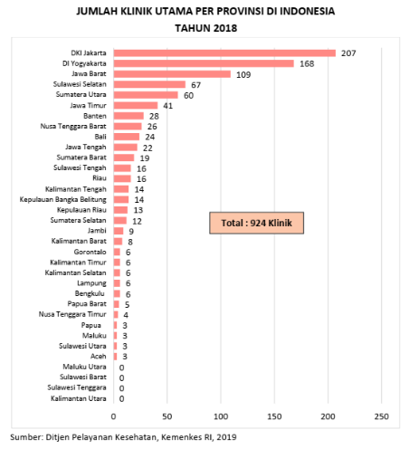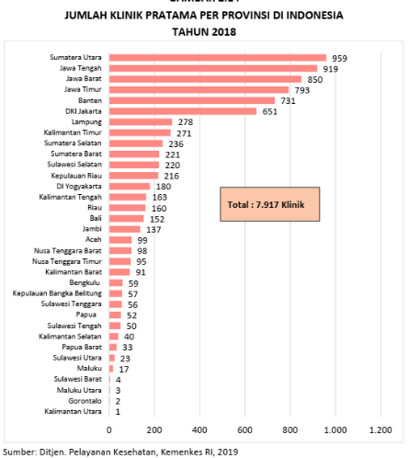
Source: Ditjen Pelayanan Kesehatan RI (2018)

Figure 1. Data on the total number of clinics in Indonesia in 2018.

In its development, in addition to medical services, the need for health facilities such as clinics is directly proportional to technological developments, consumer expectations, trends, operations to the challenges of the global situation that must be faced. Clinics are expected to be able to improve health services with existing challenges but remain optimal and efficient. Optimal and efficient clinical services supported by clinical planning and physical design can accommodate functions effectively applicable standards. Clinics also must answer the needs of trends, pay attention to the comfort and safety of users that support the patient recovery process, and optimize operations to the quality of clinical services.

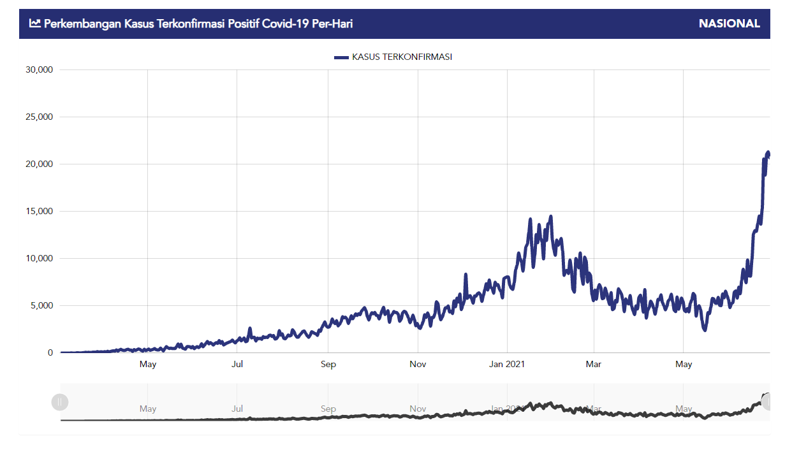
Source: covid19.go.id

Figure 2. The development of positive confirmed cases of Covid 19 Indonesia in 2021.

The Covid-19 pandemic has had many impacts in all sectors, as well as the architecture. Hopefully, we can adapt quickly to the current situation. The pandemic situation opened our awareness of the architectural need for clinics and health facilities than ever before. We are responding to temporary situations during the pandemic and adaptations that can continue to support health services, especially clinics that are more prime after the pandemic. Other health facility clinics operate 24 hours non-stop for seven days. Hence, many factors must be considered and improved from an architectural perspective in responding to a pandemic situation. Based on the Regulation of the Minister of Health of the Republic of Indonesia No. 9 of 2014 Clinic: Article 32 paragraph (2), Clinics provide health services that are promotive, preventive, curative, and rehabilitative. The clinic is one of the initial referrals in handling pandemics in Indonesia before patients are direct to health facilities at an advanced level is a basic need for conducting research.
Healthy architecture contributes to the buildings' overall physical, mental, and social condition (Rice, 2019). It does not only refer to that the disease is free from infection and other deficiencies assessed only from the physical. Healthy architecture is described as part of the science of architecture which focuses on the need for healthy and sustainable designs to impact humans and the environment (Yetti, 2021). This description is appropriate to support strategic steps in producing an optimal architectural clinical design. This scientific development applies in the design of a clinic that responds to future health issues and challenges, such as clinical design responses that accommodate pandemic prevention and control efforts as they are currently. The Healthy Architecture of Health Facilities implementation in Indonesia currently refers to the Regulation of the Minister of Health of the Republic of Indonesia Number 9 of 2014. The regulation explains that the technical aspects of the building and the environment in establishing a clinic must meet the requirements related to function, safety, comfort, and convenience in the service process. They explicitly detail the completeness of facilities and room functions and complete and adequate clinical infrastructure such as sanitation installations, electricity, fire prevention, transportation systems, medical gas, air conditioning, and lighting. In addition to building readiness, several assessments related to architectural aspects in Indonesian Health facilities were also reviewed through the Greenship rating tools new building assessment from the Green Building Council Indonesia. Several health facilities, especially hospitals in Indonesia, have been certified as green hospitals.

Literature review

There are several slices of themes about healthy architecture approaches that review by previous and ongoing research. Several literature studies include research studies on healthy building, healing architecture, health environment, and healing environment. Each focuses on architectural and environmental conditioning to achieve study outcomes applied in a healthy and effective architectural design. For this reason, the author conducted a literature study related to these approaches to assist the author in discussing a clearer and more accountable healthy architecture approach.
A healthy building is a design approach that is a condition of health and efficiency that supports users in carrying out activities (Anggawirya et al., 2019). The results of research that explain six perspectives related to healthy buildings that need to observe in the future (Allen et al., 2019) support the previous statement. The six perspectives are buildings as a medium for conveying the concept of environmental health, designed standards, safe and healthy materials from chemicals, changes to good habits from static to biological and ecological in space, and healthy building research. The six perspectives are interrelated and support to realize an effective, efficient, and healthy design. Implementation of the Healthy Building approach in the clinic building is to optimize the function of the building as medical services and patient recovery. The application of healthy buildings is emphasized by creating a clean building appearance, optimizing circulation, and creating a sterile interior (Anggawirya et al., 2019).
Nine healthy building foundations are arranged to be universally applied in all types of buildings (Allen et al., 2017). The nine foundations include:
- Ventilation, good air ventilation in the room to control the source of odours, chemicals, and carbon dioxide. It is essential to have good ventilation because of the negative effect of poor ventilation on room users. Several associations exist between poor health cases, such as respiratory tract infections, asthma, decreased productivity and occupant attention.
- Air Quality depends on the presence of pollution in the room. When residents are continuously exposed to poor air quality, residents can experience health problems such as asthma, allergies, bronchitis, chronic lung disease, irritation, fatigue, headaches, and other sensitive diseases. We can be exposed to pollutants from nitrogen oxides, carbon monoxide, ozone, particulates (PM), and volatile organic compounds (VOCs) such as formaldehyde, limonen, and benzen.
- Water Quality, Water is the primary need for life. Water quality is not only felt directly by the human body but also by the environment around humans. Decreasing water quality causes several environmental effects, especially in this discussion of buildings. Some examples are the appearance of metal in building service pipes which causes the water to have high and low mineral content, which is terrible for humans if consuming the water. Water contaminants are also very likely caused by poor maintenance of water distribution systems (drainage and sanitation) that pose a risk to human health. Some things that can be applied in maintaining water quality are paying attention to the water distribution system inside and outside the building, using an air purification system, and following air health standards tested by the government.
- Thermal Health, Thermal health includes all impacts of thermal conditions on the health of building users. Thermal comfort is influenced by factors such as air temperature, lighting, air velocity, and humidity, as well as internal occupant factors such as metabolic activity and thermal insulation of clothing. A study describes the health effects of thermal health effects. Occupants experience itching, watery eyes, headaches, and throat irritation when thermal factors such as ventilation, humidity, and heat are not good in a room. There are also health effects that will be faced if a room is too warm or cold. Thermal health can impact sick building syndrome symptoms if we, as designers, do not pay attention.
- Pests and dust often carry allergens into the indoor environment that can cause an immune response in both adults and children. Some mites have body anatomy faeces that create harmful allergens that, for some people with a high level of sensitivity, can have an allergen impact, such as asthma, allergic rhinitis, dermatitis, and other more severe responses. Thus, it is also necessary to anticipate and respond to potential pests and mites in designing dwellings and other buildings.
- Lighting and views are important to note because the level of light in the room (tens to hundreds of lux) can trigger non-visual responses. The designer needs to adjust the type of lighting according to the room and environmental conditions so as not to damage the eye health of the user in the room, especially if the user has a continuous rhythm of activities in the room.
- Noise, Noise exposure affects the functions and organ systems of the body. Previous studies have described the non-auditory effects of noise exposure, such as higher systolic-diastolic blood pressure, changes in heart rate, and hypertension. For children, environmental noise affects emotional symptoms, behavioural problems, high blood pressure, and increased stress hormones such as adrenaline and noradrenaline. Although still very limited, some of the effects of traffic noise at night often cause sleep disturbances, so adults risk cardiovascular disease, diabetes, high body mass index and obesity.
- Moisture, Some sources of moisture in a building can include leaks from drainage and sanitation pipes, roofs, and windows—flooding, condensation on walls, and landscaping or gutters directing the water into and around buildings. Excessive humidity in buildings can create mould growth. Mould can damage surfaces in buildings. Fungi can produce irritating substances, such as spores and volatile organic compounds (VOCs). Fungi often result in a musty odour and other health effects. Cladosporium, Penicillium, Alternaria, and aspergillus are the most common indoor fungi.
- Safety and Security, The architect and building manager must consider and address the various security risks in the building. Safety relates to the comfort of residents. Safety is not only limited to physical security from crime but also related to threats of chemical, biological, or radiological weapons of mass destruction and security related to fire and disaster safety.

Another approach that also intersects with healthy architecture is healing architecture. Healing architecture is an approach that can provide solutions to restore the balance between the patient's physical and psychological conditions. The method used is to process compositions and concepts in designs that represent nature and aesthetics (Purisari, 2016). The healing architectural components applied are the landscape, the intermediary space in the building, the interior consisting of floor coverings, walls, ceilings, wallpaper, paint, fabrics, furniture, lighting, door and window designs, building materials, human sensory factors, and decorations (Purisari, 2016). Another approach that also supports healing architecture is the healing environment. This approach to designing spaces in hospitals should improve the quality of safe, comfortable, and healing spaces (healing environments) for patients, families, and medical staff (Prakarya, 2014).
Yetti (2017) mentions several components that can be considered in applying the healing environment. The design components in question are the application of good circulation of outer and inner spaces, safe and comfortable lighting arrangements, implementation and application of natural elements in the design, and the provision of communal spaces inside and outside the building. The purpose of applying a healing environment, especially in health facilities, is to help the adaptation process of patients in health facilities, which is expected to reduce patient stress levels due to the physical environment. The ultimate goal of good adaptation to the environment is to help the patient's recovery process.
The American Institute of Architects-AIA describes six components that architects pay close attention to in designing a healthy design (Yetti, 2021), namely:
- Environmental Quality, preventive measures, reducing pollution and microbes that harm the community,
- Natural Systems, actions to manage and utilize existing ecosystems and natural conditions. The goal is to reduce stress, support recovery, and increase enthusiasm for physical and social activities,
- Physical Activity, there are efforts to support physical activities such as sports that aim to reduce the risk of heart disease and the risk of other diseases,
- Safety, efforts to prevent and handle crime in the surrounding environment. This is done by paying attention to the building and environmental security systems as well as the protection of the security,
- Sensory Environments, providing experience and stimulation of the five human senses in the interaction of buildings and the environment as a form of effort to improve the quality of life from an environmental aspect,
- Social Connectedness, efforts to form social spaces in the environment to support efforts to increase social interaction that can impact individual happiness.

Based on the Regulation of the Minister of Health of the Republic of Indonesia Number 24 of 2016 concerning Technical Requirements for Hospital Buildings and Infrastructure and the Regulation of the Minister of Health of the Republic of Indonesia Number 9 of 2014 concerning Clinics, the principles of the architectural design of health facilities with 4 (four) aspects (Yetti, 2021), namely:
- Functional Health Facilities must be able to have facilities that can accommodate the functions and activities of health services by applicable standards,
- Security. Health facilities must accommodate environmental security. The security in question is not limited to security from criminals. However, it is related to preventive measures and handling of medical security, such as virus transmission and infectious zones, as well as safety in the event of a disaster inside or outside the building,
- Convenience, the health facility environment must provide a sense of comfort for its users, both patients, health workers, managers, and visitors. A comfortable atmosphere is believed to support the patient's recovery process and reduce the effects of stress, which are common and felt by medical personnel, managers, and visitors,
- Universal design, implementing a universal design in the health facility environment so all groups can access the facilities easily, especially colleagues with disabilities, the elderly, children, and pregnant women.

Roessler (2012) concludes that there is a link between environmental psychology and architecture and psychology. Roessler (2012) reviews individuals influenced by architecture, examines the psychology of architecture and takes three architectural examples as illustrations, one of which is the healing garden in Sweden. The three samplings show the presence of psychological emotions, and the relationship between individuals and spatial reality is obtained. Parsia (2018) explained that healthcare management needs to pay attention to the layout design of the building to have good service quality in healthcare facilities. They focus on more than just costs, safety, risk protection, building security, cleanliness, sound insulation, environmental protection, and prevention of energy wastage. Citing Hussain and Babalghith (2014) explained that the term 'Healing Architecture" is a healing environment with proper physical design that reduces healthcare stay, improves patient health, increases patient satisfaction, reduces stress levels, and reduces the risk of infection, and others. Parsia (2018) adds the role of healing architecture, showing a positive effect on service quality factors.
State of The Art in the research "Study of Healthy Architecture in Integrated Clinical Architectural Design" is a study of studies that have been carried out previously by other researchers in the field of architectural science with a healthy architectural approach. The literature review from scientific publications of research previously done by other researchers has a comparative study to carry out.-This effort to strengthen research results and avoid plagiarism to achieve research novelty. The difference between the research conducted in this study and previous studies is that, in general, previous research achievements are (1) the application of health building with its supporting principles in clinical design. The application of health building emphasizes optimizing appearance and circulation in clinical design (Anggawirya et al., 2019). (2) focus on applying the healing architecture concept to optimize color composition and clinical design concepts (Purisari, 2016). In comparison, the author's research focuses on applying healthy architecture in macro and micro in the field, which will then be formulation as a policy direction and framework in the clinic design development that this research to complement the theories and concepts of architecture, especially the health environment, health architecture and technology, and behavioral architecture of health care facilities.

Method and study area

This type of research is descriptive qualitative research with research locus in health facilities. This research uses a literature study. The literature review is carried out systematically and using the narrative approach method. The literature was identified with searches in Scopus, Web of Science, Scholar in field of Healthy Architecture, healthcare facilities, healthy building, health environment, and clinic. This study examines the application of the Healthy Architecture approach in the clinic. It produces a coherent explanation regarding the application of design in the clinic based on the current pandemic situation and dialogue with the literature review.

Results and discussion

Architectural design for clinics in Indonesia refers to the Minister of Health Regulation (Permenkes) No. 9 of 2014. Clinics describe as health facilities with individual health services that provide primary and specialist medical services. There are two classifications, namely the leading clinic and the primary clinic. The difference between these two classifications is the ownership status of the clinic, the function of designation, and the supporting facilities of the clinic. The basic architectural needs in the clinic are on activities that are accommodation for patients, patient families, medical staff, and other support staff at the clinic. The discussion is a dialogue between architectural design principles in health facilities' previous studies with the design needs for clinics with a healthy architecture approach. This theoretical dialogue expects to produce architectural references to design healthy, effective, and safe clinics. From the previous studies related to architecture in health facilities, there are four aspects must be met in clinic design: function, safety, comfort, and friendly design (Yetti 2021). For this study, these four aspects were used as the basis of design requirements in clinics with a healthy architecture approach.

Functional

Describe with a design that meets the standards of space requirements, space programs, and function standards. The main results of the author on Permenkes No. 9 of 2014, observation and analysis of area needs for clinics are (1) reception area, (2) medical service (outpatient) area, (3) emergency department, (4) inpatient area, (5) area manager and public service, (6) supporting area. Discussion of the relationship between areas, territories, and space requirements explain in table 1.

Table 1. Zoning analysis, space requirements, and architectural requirements at the clinic

No | Area | Territory | Space requirement | Rooms detail
1 | Reception Area | Public | Receptionist | Receptionist, Registration Counter, Waiting Room, Administration-Medical Records
2 | Medical Service (outpatient) Area | Public | Basic medical services | The General clinic, Dental clinic, Maternal and Child Health, lactation room.
2 | Medical Service (outpatient) Area | Public | Specialis | Ear-Nose-Throat specialist, Internal Medicine, Pediatrician, Obstetrician, Dermatologist, and Venereologist.
2 | Medical Service (outpatient) Area | Semi Private | Laboratory | Waiting Room, Changing Room, Specimen Taking Room, Administration Room, Examination Room, Sterilization Room.
2 | Medical Service (outpatient) Area | Semi Private | Medical Rehabilitation | Physiotherapy room service, psychology, occupational therapy.
2 | Medical Service (outpatient) Area | Public | Pharmacy | Counter room, mixing room, raw material depot room, waiting room, staff room, administration room.
2 | Medical Service (outpatient) Area | Private | Delivery room | Preparation room, medical staff room, treatment room, observation room, central sterile supply department, baby cleaning room, instrument sterilization room, medical staff sterile room
3 | Emergency department | Public | Reception room, Administration, treatment room | Reception Room, Administration, decontamination room, Triage room, resuscitation room, minor surgery room, patient observation room, staff room.
4 | Inpatient area | Private | Inpatient room | Inpatient room with class classification (class 1, class 2, class 3, VIP, VVIP), nurse station.
4 | Inpatient area | Private | Baby room | Baby room, baby cleaning room
4 | Inpatient area | Private | Isolation room | Isolation room, nurse station
5 | Area manager and public service | Semi Public | Nutrition installation | Material acceptance room, storage room, food processing room, serving room, kitchen storage room, dishwasher, staff room, locker room
5 | Area manager and public service | Semi private | Management room | Head clinic room, finance staff room, file room, doctor and nurse room, meeting room, pantry
5 | Area manager and public service | Public | Prayer room | Prayer room, toilet
5 | Area manager and public service | Public | canteen | cash register, booth, kitchen, toilet, dining room
5 | Area manager and public service | Public | Automated teller machines | Booth
6 | Supporting area | Private | Laundry room | Laundry room
6 | Supporting area | Private | Medical gas room | Medical gas room
6 | Supporting area | Private | Security room | Security room
6 | Supporting area | Private | Generator room | Generator room
6 | Supporting area | Seni Private | Cleaning service Staff area | Ruang cleaning Service
6 | Supporting area | private | Wastewater Treatment plant | Wastewater treatment plant
6 | Supporting area | Public | Parking | Public patient parking, staff parking, ambulance parking
Source: author's analysis

The design also complies with local environmental regulations, such as paying attention to the Basic Building Coefficient, green area coefficient, and building lines to maintain the quality of local environments.

Safety

The aspects of safety standards in the clinic are divided into several criteria, namely:

- Enviromental Quality. The design must provide preventive the spread of infection and disease. As a health facility, the clinic has the opportunity to spread the infection to its users. From an architectural point of view, the design must be attending to the zoning, proximity, and accessibility of space. It is necessary to attend to infectious and non-infectious zoning in processing the program space. The infectious zone is a zone with a high and very high risk of virus and disease transmission. The infectious zoning also often includes private zoning because it is a sterile area, and not everyone can access it. In contrast, the non-infectious zone is a zone with low and moderate virus and disease transmission. The non-infectious zone can be freely accessed by users even though it is still under health protocols (refer Figure 3).

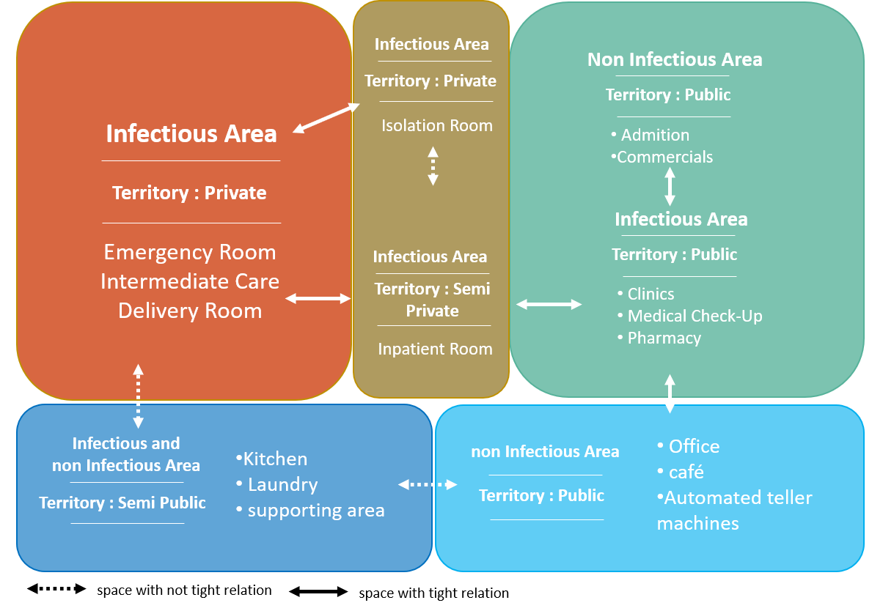
Source: author’s analysis

Figure 3. The relationship between spaces in the clinic.

From the results of the territory analysis and space requirements obtained, it can be seen that space zoning will assist in processing and dialogue with the literature related to healthy architecture in clinics. From these data, relationships between rooms in the clinic can be arranged, which will also be instrumental in answering research questions about safety. In general, the relationship between spaces can schematize as illustrated in Figure 4.

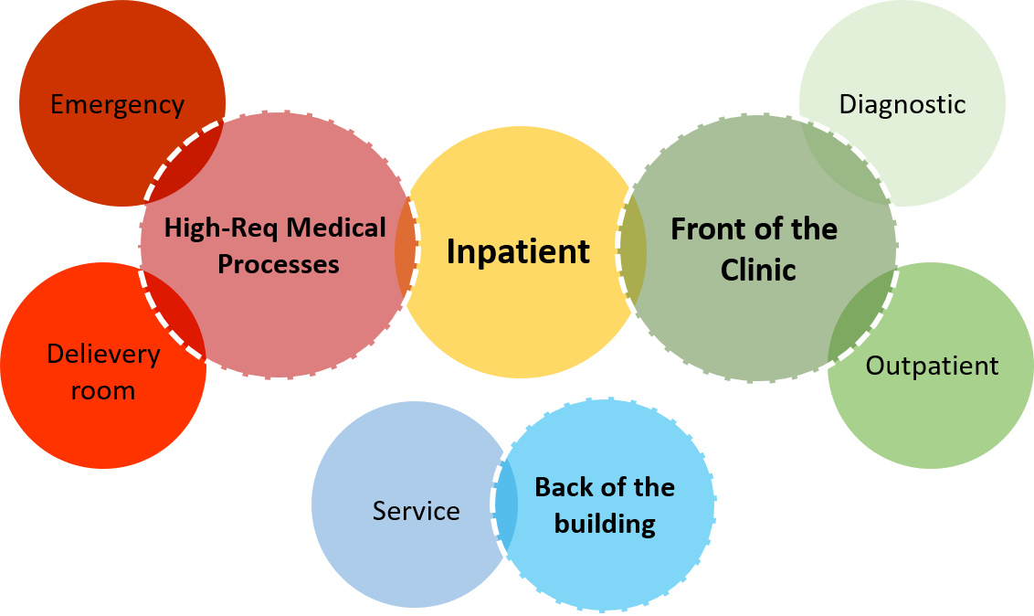
Source: author’s analysis

Figure 4. Illustration of room organization in clinic.

Zoning, which refers to infectious risk zoning, and territory will assist architects in designing to achieve space effectiveness and minimize the spread of infection in the clinic. Architects must also comply in preparing the amount of space by the users' capacity and the minimum standard for the amount contained in the regulation of The Ministry of Health. Scale-space that will impact on any discomfort space by building thermal and easy-to-spread of infection (refer Figure 5).

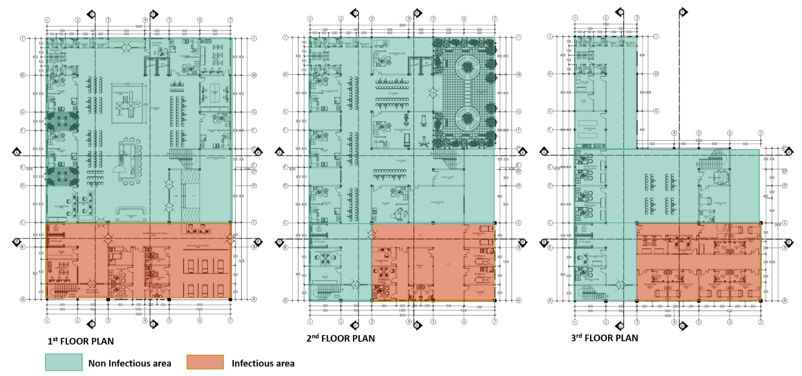
Source: author’s analysis

Figure 5. Illustration of floor plan design based on infectious and non-infectious zoning.

- Prepare the safety of the clinic building with the following criteria: (1) the building must ensure safe construction and is equipped with a control system by the structure and construction. (2) The building and the built environment in it are expected to have a notification system, disaster warning when a disaster occurs. (3) the clinic has control over the security of the building from criminal acts. (4) handling of medical waste, both liquid and solid, and non-medical waste.

Comfort

Recovery efforts can support by preparing physical activities, sensory environments, and social connectedness (Yetti, 2021). In architecture, manifest by processing exterior, interior, landscape, and thermal comfort of the building. Detail as follows:

- We can create thermal comfort in the clinic building. Firstly, adjusting the orientation of the building mass by the intensity of sunlight and wind direction. Secondly, adjust the intensity of artificial light within the building to comfort between 100-200 lux light. Thirdly, suppress noise to achieve acoustic comfort by setting a noise limit of 40-45 dBA, except for certain rooms such as dental health services, service rooms such as laundry, generator rooms, and kitchens. Fourth, optimizing open space in public areas to produce natural air conditioning, suppress the spread of infection, and reduce the use of electrical energy. However, with a note, areas with private-infectious territories remain with standards of air temperature, light, and acoustics by the needs of health service activities in them.
- It supports patient healing, reducing stress levels faced by patients' families, medical staff, administrative staff, and other users to achieve a comfortable quality clinical health facility environment. Firstly, the design can achieve by paying attention to the behavioral aspects of the user, namely by paying attention to the design that accommodates the relationship between human beings and humans and the environment. An example of its application is to provide a public space that facilitates human social relations and is close to nature. Second, creating the image and appearance of the building from the visual aspect. Technically, aspects of building performance can be processing designs that consider the support of settings and elements of the natural environment and the psychology of use—for example, selecting materials with natural elements, colors, and decorations in non-infectious-public and inpatient areas.

Friendly Design.
The friendly design translates into three references, namely:

- Good accessibility

As well as in the design of health care facilities, clinics design should have good visibility. Users can see the clinic environment both on the exterior and interior with 360º visibility. Good visibility intends to make it easier for users to orientate the space and the surrounding environment. In addition, good visibility and circulation can facilitate the movement and performance of medical staff when handling patients in the emergency department. It is also necessary to pay attention to circulation to function appropriately in accommodating space for patients and medical staff (refer Figure 6).

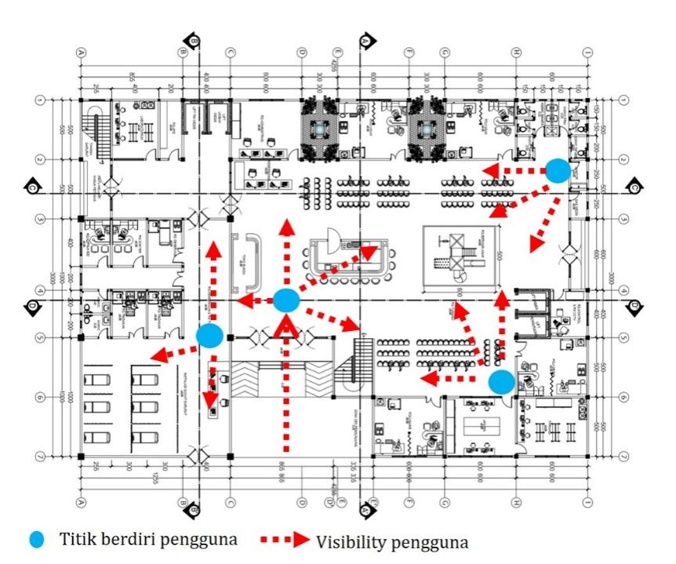
Source: author’s analysis

Figure 6. Implementation of visibility response in floorplan on clinic design.

- Application of universal design

In summary, universal design is the design of buildings that orient the design result that all people can use without age, physical, or psychological limitations. Implementation of Universal design in a clinic design is base on users of health facilities coming from various backgrounds with conditions. The universal design applies to the elements of indoor and outdoor spaces with design adaptations oriented towards convenience, safety, and design feasibility.
- Easy operation and maintenance

The technical and operational aspects of the building and the clinical environment must operate efficiently and with easy maintenance. Those technical aspects such as infrastructure, materials, utilities, and electrical base on the ease of regeneration of the tool if there is damage in the future to contribute to an excellent environmental control system and support sustainable buildings.

Conclusion

The issue of the needs and conditions of first-level health facilities, namely clinics in Indonesia, is the author's background in exploring this research. The Health Clinic is the initial referral for patients before being referred to an advanced level facility if they require further special treatment such as a hospital. Health clinic design is required to support the patient's healing process, reduce user stress levels, and support operational activities effectively, efficiently, and healthy. The Healthy Architecture approach becomes a reference and parameter in analyzing and assessing variables. To achieve the expected research results, the authors refer to research results that develop from journals and government regulations related to the technical standards of health clinic facilities. The keywords used in the dialogue and research analysis are healthy architecture parameters for health facilities, namely functional, security, comfort, and friendly design (Yetti, 2021), as well as six healthy building approaches, namely Environmental Quality, Natural Systems, Physical Activity, Safety, Sensory Environments, and Social Connectedness (AIA, 2014). This research shows that the design of health clinics expects to answer the first activity needs following existing functions and standards. Second, the design of the Health clinic has a security system that is well implemented and supported by standardization and health protocols to prevent the spread of diseases and viruses, building safety against disasters, security of building structures, and security related to criminal acts. Third, the design supports and creates a sense of comfort for users. Achievements can be pursued by creating thermal comfort inside and outside the building and accommodating the psychological aspects of users. Fourth, produce a friendly design to be used by many users and the achievement of buildings that have easy operation and maintenance systems. This research expects a design recommendation that can be understood and easily implemented in architectural design in health clinics. The author is aware that there are still many gaps in this research process. So, the authors expect further research to examine the results of the study. Health facilities continue to develop according to the needs and situations ahead from an architectural perspective. It is also necessary to adapt and contribute to achieving a good health facility environment. Further studies related to healthy architecture in health clinics and other health facilities can contribute to achieving an effective, efficient, and healthy design implementation.

Acknowledgement

The authors would like to express our appreciation to Universitas ‘Aisyiyah Yogyakarta, Indonesia. The research behind it would not have been possible without the support of Architecture Study Program Universitas ‘Aisyiyah Yogyakarta. Secondly, we would also like to thanks Town and Regional Planning Department, UiTM Perak Branch, Malaysia for publication collaboration.

References

Allen, Joseph G, Ari, B., Xiadong Cao, Erika, S.E., Skye, F., Maia. G., Julie M. G., Skylar. K., Lacey. K., Jose.G, C,L.,Steven W. L., Piers. M., Sepideh.P., Jack D. S., Jose, V., Augusta, W., Anna Young., Jie Yin. (2017). Building Evidence for Health - The 9 Foundations of Healthy Building. Boston. Massachusetts: Harvard T.H. Chan School.
Allen, Joseph G and Michael S.Waring. (2020). Harnessing the Power of Healthy Buildings Research to Advance Health for All. Journal of Exposure Science & Enviromental Epidemiology, 30, 217–218.
Anngawirya, Anak Agung Bagus Bayu, I Dewa Gede Agung Diasana Putra, dan I Wayan Yuda Manik. (2019). Klinik Utama Geriatri di Denpasar, Bal, Penerapan Tema Healthy Building Pada Perancangan Bangunan. e-Journal, Department Architecture, Universitas Udayana, 7(1), 217-222.
Hussain, M. and A.O. Babalghith. (2014). Quality of hospital design in healthcare industry: history, benefits and future prospect. IMPACT: Intenational Journal of Research in Applied Natural and Social Sciences, 2(5), 61-68.
Parsia, Yasaman and Puteri Fadzline Mohammad Tamyez. (2018). Role of Healthcare-Facilities Layout Design, Healing Architecture, on Quality of Services. International Journal of Civil Engineering and Technology (IJCIET), 9(4), 598-601.
Purisari, Rahma. (2016). Healing Architecture: Desain Warna Pada Klinik Kanker Surabaya. Jurnal Arsitektur NALARs, 15(1), 55-62

Regulation of the Minister of Health of the Republic of Indonesia Number 9 of 2014 concerning Clinics.
Regulation of the Minister of Health of the Republic of Indonesia Number 24 of 2016 concerning Technical Requirements for Hospital Buildings and Infrastructure.
Regulation Of Health Social Security Agency Regulation Number 3 Of 2017 Concerning Administrative Management Of Health Facility Claims In The Implementation Of National Health Security.
Rice, Louis and Mark Drane. (2020). Indicators of Healthy Architecture – a Systematic Literature Review. J Urban Health, 97, 899-911.
Roessler, Kirsten Kaya. (2012). Healthy Architecture! Can Environments Evoke Emotional Responses?. Global Journal of Health Science, 4(4), 83-89.
Yetti, Aprodita Emma, (2017). Kajian Konsep Healing Environment terhadap Psikologi Ruang Dalam Perencaan Ruang Rawat Inap di Rumah Sakit. Proceedings Health Architecture 1(1), 17-20.
Yetti, Aprodita Emma, (2021). Study of Healthy Architecture Approach in Architectural Design at Health Care Facilities. Proceedings of International on Healthcare Facilities, 1(1), 47- 55.

