

Typomorfology of building mass and lingkage in Malioboro, Yogyakarta

Indah Pujiyanti¹, Norainah Abdul Rahman²

¹ Program Study Architecture, Faculty of Science and Technology, Universitas 'Aisyiyah Yogyakarta, Indonesia
² Department of Built Environment Studies and Technology, Faculty of Architecture, Planning and Surveying, Universiti Teknologi MARA, Perak Branch, Malaysia

Correspondence: Indah Pujiyanti (email: indahpujiyanti@unisayogya.ac.id)

Received: 31 August 2021; Accepted: 27 August 2022; Published: 31 August 2022

Abstract

The Malioboro area of ​​Yogyakarta is one of the main tourist destinations in Yogyakarta, which has the potential for the rapid development of regional structural patterns. Its strategic location in the city center and the presence of historic buildings and first-class shopping centers in the area attract tourists and investors to build in the Malioboro area. On the other hand, Malioboro Street is the philosophical axis of Yogyakarta City which has also been designated as a Cultural Conservation Area. The pattern of regional structure development based on building mass and linkage in this area is the focus of this research. Changes in the Typology of this area were analyzed using a comparative method by comparing data on patterns of building mass and linkage from different 4-year periods. This study aims to find out how the pattern of changes in the typology of buildings in the Malioboro area and its influence on the role of the Malioboro area as a cultural heritage area. Based on the results of the study, it is known that the Typology of building mass and form changes in the Malioboro area there are five types, namely the gradual addition of building mass, the sudden addition, the reduction in building mass (total loss) and the change in the shape of the building without changing the building mass. Meanwhile, from the linkage typology, there is no change in the road network pattern from the 4 study year periods. Changes in building typology in the Malioboro area tend to be close to the Beringharjo market, while there is no change in building typology for the Agung building. However, near another historical building, namely the Vredeburg fort, there are indications of an additional building mass on the east side of the building. Its also that changes in the typology of buildings in this area are influenced by the location of the building on the road class .This needs to be considered so that policy references or directions can be given to control developments in cultural heritage areas.

Keywords: Building mass, linkage, malioboro, typology, transformation, urban

Introduction

The Malioboro Street area is one of the main tourist destinations in the city of Yogyakarta. The road corridor in the center of the city also has a unique feature because it is the philosophical axis of the Special Region of Yogyakarta, which is part of an imaginary line that stretches from the sea on the south side to Mount Merapi in the north of the city. This strategic location is a magnet for the growth of the surrounding area. According to Yasin et al. (2020), Urban sprawl has become a global issue and a threat to sustainable urban growth. Sustainable development is a practical modern development idea for address development and environmental conservation problems (Mahat et al., 2016). This rapid growth has caused a change in the Typology of buildings along Jalan Malioboro and the surrounding area.
The Malioboro area has been designated as a cultural heritage area in the Special Region of Yogyakarta based on the Decree of the Governor of DIY No. 186 of 2011 which stipulates 6 cultural heritage areas in the Special Region of Yogyakarta which have historical, scientific and cultural importance. Based on the Law of the Republic of Indonesia No. 11 of 2010 concerning Cultural Conservation, "The cultural heritage area is a geographical space unit that has at least 2 or more cultural heritage sites that are located close together and/or show distinctive spatial characteristics" (Hadiyanta, 2015). Local wisdom is knowledge accumulated in community practices in an area. However, there is no denying that an area has differences in terms of ethnicity, social, cultural assets and historical background (Kumalah et al., 2015). With the peculiarities of the Malioboro area, this is one of the research issues to analyze the level of change in the typology of regional space in Malioboro which can be used as a reference in efforts to control regional growth.
At the research location, three buildings are landmarks as well as magnets for the Malioboro street area. This is also considered one of the embryos in changing the Typology of the surrounding area apart from Malioboro Street itself. The three buildings are Beringharjo market, Vredeburg Fort and Gedung Agung. Beringharjo Market is the largest traditional shopping center in the city of Yogyakarta. This market is included in the class 1 market category, which many residents and tourists visit. Various complete commodities are traded in this market at relatively affordable prices, making this market a shopping center always crowded with visitors. The existence of this market also has an impact on the development of the surrounding area. Fort Vredeburg is a historical icon of Yogyakarta City, which is now functioned as a museum. This defensive fort has also become one of the popular tourist destinations in the Malioboro area, carrying the theme of tourism education; this museum building is crowded with domestic and foreign tourists. Its existence is also one of the magnets for regional development in Malioboro. Meanwhile, Gedung Agung is a Yogyakarta palace complex established in 1824 and functioned as the presidential palace. This presidential palace is used as the office and the residence of the President of the Republic of Indonesia while in the city of Yogyakarta. In addition, the Gedung Agung building is also often used as a place to receive or stay for state guests.
These three buildings with different functions are the magnets for the Malioboro street area. These three different functions in one main Malioboro street increase the visiting power of tourists and increase the vitality of the Malioboro area. This has caused the development of the area on Jalan Malioboro to change rapidly. This uniqueness underlies this typology research in the Malioboro area of ​​Yogyakarta. The problem issue of this area's typology change is the development of buildings that can impact the historical values ​​of the area, considering that the Malioboro area is a Cultural Conservation area that needs to be controlled by the arrangement of buildings and their environment. In this way, the identity of the area and the image of the area will be maintained.
According to Kojongian et al. (2017), historical areas with cultural images are priority areas for preservation in terms of areas and buildings because they are part of the story of the city's past travels and culture and tourism potential, and city assets. A historical area has a distinctive image because it generally meets the preservation criteria of an area, which include:
1. Aesthetics
2. Typology
3. Multiple
4. History
5. Supporters in the surrounding area
6. The specialty
The Typology that is the focus of this research is the changes in building mass and form that affect the solid voids of the area and the linkage of the area by observing its development from several periods. This study aimed to determine changes in the Typology of building mass and form and linkage in the Malioboro area. In addition, to determine the effect of these typological changes on the role of the Malioboro area as a cultural heritage area so that it can be used as a reference in the direction of development control in the Malioboro area in the future.

Literature review

According to Risdian et al. (2020), the development of the city center has a relationship with architecture and urban design, which also influences the face of the city. Meanwhile, according to Shirvani (1985) in his book The Urban Design Process, there are several elements of urban design consisting of land use patterns, building form, and mass, circulation and parking, open space. City ​​ (open space), pedestrian ways (pedestrian ways), activity support, signage, and preservation. In this study, the location of the Malioboro area, which is located in the city center, will impact the development of the surrounding area, and the elements that can be discussed for the pattern of development in this study are building form and massing, and circulation patterns.
According to Nurfansyah (2016), Typology and morphology are ways of categorizing in the field of architecture by studying the types of building forms by analyzing single buildings or all buildings in an area/city. The definition of type is a concept that describes a group of objects based on the similarity of formal structures. At the same time, Typology is a mechanism and an object composition of apology that emerges from the image/reconstruction of traditional Typology. Typology is also an introduction to the past by showing formal consistency that shows the consistency of building forms or parts of building elements as formal structures. Typology can also be interpreted as an instrument for classifying the results of typing something by referring to the typical qualities of people, objects, or events.
The Typology is divided into several parts as follows:
- Geographic Typology or location is a type study based on the geographical condition of the building itself. For example, coastal buildings, tropical, desert, and others.
- Typology of style (flow or style) is a type study based on the style used, such as modern, traditional, Neo-classical, and others.
- Functional Typology, which is a type study based on the use or use of the building, such as commercial buildings, residential buildings, industrial, public facilities, and others.
- Typology of form, namely the study of types based on the building form (building form/building mass), such as a series, single, group, and others. Typology of form usually leads to morphology.
According to Sulistijowati (1991), the typology of architecture is built in the form of archives of "given types", namely architectural forms that are simplified into geometric shapes. "Given types" can come from history and can also come from newly discovered. The introduction of typology will lead to efforts to classify, classify or classify based on certain aspects of rules. These aspects include:
- Function (covering the use of space, structural, symbolic, etc.);
- Geometric (includes form, order principle, etc.); and
- Style (including period, location or geography, politics or power, ethnicity and culture, etc.) (Ramadanta, 2010; Sulistijowati, 1991).
Typology according to Iswati (2003) is the study of types. A type is a group of objects with the same formal structure characteristics. Typology is the study of grouping object as a model, through the similarity of form and structure. Typology is the study of types with categorization and classification activities to generate types. Activity categories and types. At the same time, the diversity and uniformity can be seen (Santoso et al., 2011).
Morphology is the study of the development of forms. Morphology is an instrument to compare and classify buildings by understanding the evolution or transformation of a form. In the study of morphology, building development, and all aspects of the background can be traced so that can be studied the failures and successes of urban development in the past can be a reference for controlling developments in urban development in the future.
The concepts of morphological grouping include:
- Morphology is a basic level of study by looking at existing forms of organisms.
- Morphology is the study of the evolution of types and models.
- Morphology is a dynamic quality of transformation and metaphor.
- Morphology is a change of form with the study of Typology and metamorphosis of forms (Nurfansyah, 2016).
Morphology comes from the word morph which means shape, so morphology can be interpreted as a visible form or physical appearance of the area (Putri et al., 2017; James et al., 2009). Morphological changes can occur over time that give rise to social changes, these changes are manifested in the physical form of the area. The product of social change in the physical area is known as morphology. Morphology is the physical appearance of the area in terms of the structure that forms a certain form of appearance. Morphological physical appearance is not only shape but also the relationship between regions (Dahal et al., 2017).
According to Nurfansyah (2016), there are three typological analyzes, namely:
- Understanding history to find out the initial idea of ​​a composition or know the origin of an occurrence.
- It knows the function of an object under study.
- I am looking for a simple form of a building based on its basic form or basic properties.
There are three main theories of urban design, namely:
- Figure-ground is a study of the textural relationship between the built and open spaces through a two-dimensional solid void study. This analysis identifies the textures and patterns of an urban spatial plan and identifies the problem of the regularity of mass or urban space.
- Linkage is a study that discusses the relationship between one place and another from various aspects as an urban generator. This theory pays more attention to and emphasizes the relationships and movements (dynamics) of an urban spatial plan.
- Place, this theory pays more attention to the meaning of a place or urban space. (Widyatmika et al., 2017; Roger, 1986)
Figure-ground theories are understood from urban planning as a textural relationship between the built form (building mass) and open space (open space). Figure/ground analysis is an excellent tool for identifying the textures and patterns of the urban fabric and identifying the problem of urban mass/space irregularities. The figure-Ground theory is a theory that describes the total area of ​​an area. At the same time, the function of this theory is to show the texture of the city through the shape of the building mass as solid and open space as void (Roger, 1986).
According to Moudon (1994), Typomorphology is a method to find out architectural forms. Typomorphology is an approach to reveal physical and spatial structures which is a combination of typology and morphology studies. According to Santoso et al. (2011), typomorphology is described as a group of objects based on the similarity of basic properties in the form of sorting or classifying forms of diversity and similarity of types.

Method and study area

The analytical method used in this study is comparative analysis., The data were comparing by using aerial maps of the research area from several years. The main focus is to see the difference from the history and changes in the typology of solid voids and their linkages. The approach of this research is descriptive qualitative. In Nurjannah et al. (2019), theoretical descriptive is an analytical method in the form of logical assumptions and conclusions that relates a set of variables to one another.
According to Sarwono (2006), the targets of qualitative research are events, history, objects in the form of photos, relics of ancient civilizations, etc. Using this method and approach, it is hoped that it will produce a systematic and accurate research explanation.
The location of this research is about 458 m² and located in the southern side of the Malioboro area (Figure 1) with the following limitations of the research area:
North boundary : Jalan Pajeksan and Jalan Suryamajan
East boundary : Jalan Mayor Suryotomo
South boundary : Jalan K.H. Ahmad Dahlan and Jalan Bintaran Kulon
West boundary : Reksobayan Street and Bayangkara Street

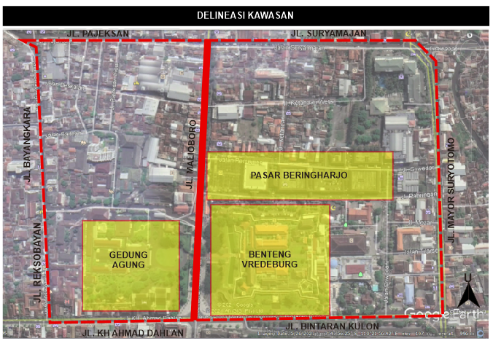
Source: Google earth 2021 and Author, 2021

Figure 1. Study area delineation (Yogyakarta Malioboro Area).

Results and discussion

According to Roger (1986), Figure-ground is a study of the textural relationship between the built form (building mass and form) and open space through a two-dimensional solid void study. This study observes the figure-ground by analyzing the typology changes from building mass and form. In addition, to observe the pattern of connectivity between urban units, it is done by analyzing changes in regional linkage. The two theories are analyzed comparatively from 2006, 2014, 2017, and 2021. Based on the aerial map of the Malioboro area, which is analyzed from year to year, there are several changes in the characteristics of the figure-ground with changes in building form and mass in the surrounding area as shown in Figure 2.

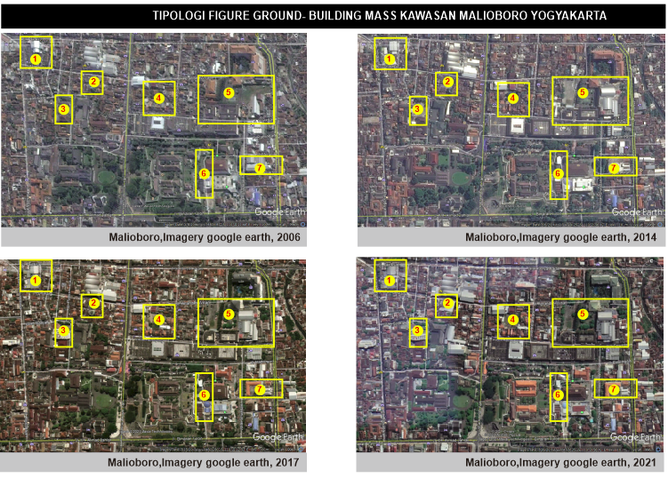

Legend:
- Cullinary area (warung kingkong)
- Parking area (ramai mall)
- Hotel area (pesonna hotel malioboro)
- Parking area malioboro
- Komersial area (progo store)
- Public area (Taman budaya Yogyakarta)
- Commercial area (sari kencana store)

Source: Author, 2021

Figure 2. Changes in the typology of building mass in Malioboro Yogyakarta Kawasan.

There are seven sites and buildings identified as having changes in shape in building mass and mass. These types of changes occur into several transformation categories with the following analysis (Table 1):

Table 1. Changes in the typology of building mass and form.

No | 2006 | 2014 | 2017 | 2021
1 | 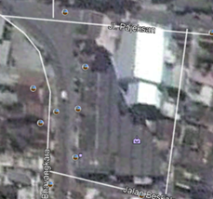 | 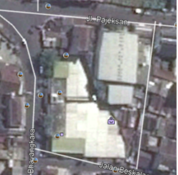 | 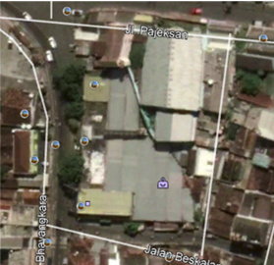 | 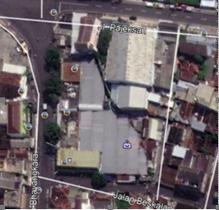
 | In case study building 1, changes were found from 2006 to 2014 with the addition of almost 50% building mass on the site. In 2006 there was 1 mass of buildings on the site, when 2014 it was identified that there was an increase in the mass of buildings on the site which almost filled the entire site. In 2017 there was no change in building mass from 2014 and it will remain the same until 2021 with a building mass of more than 50% of the site.
2 | 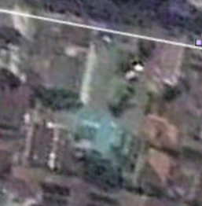 | 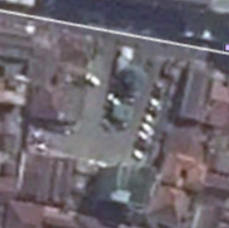 | 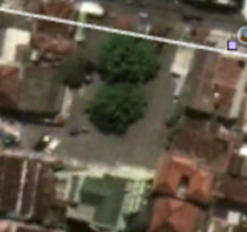 | 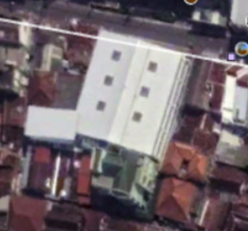
2 | In the second case study building, there was no change in the mass of the building from 2006, 2014 to 2017. Changes in the mass of new buildings occurred between 2017 and 2021 with a drastic change of more than 50% and almost filled the site.
3 | 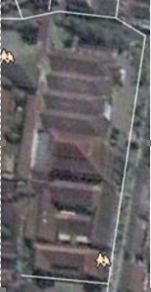 | 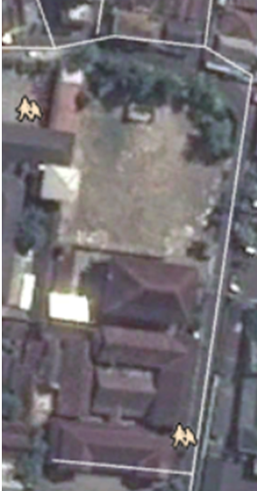 | 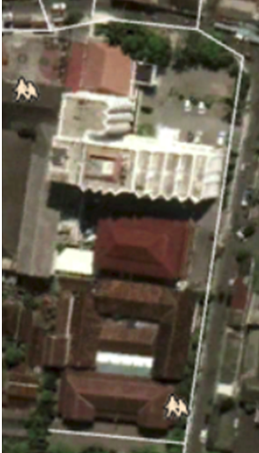 | 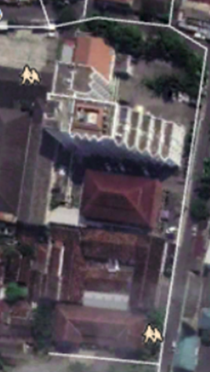
3 | In the third case study building, there was a significant change, namely with a reduction in the mass of the building between 2006 and 2014, after that between 2014 and 2017 there was a change with the addition of more than 50% buildings and it lasted until 2021. The shape of the building mass There are also changes from 2006 to 2021.
4 | 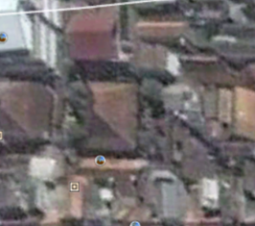 | 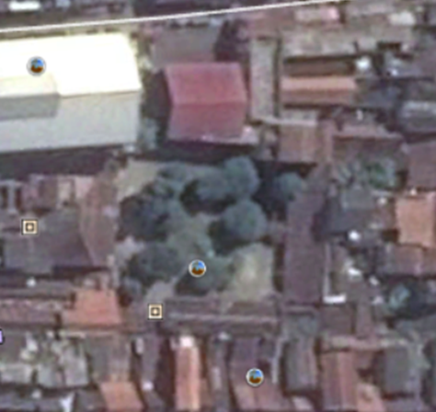 | 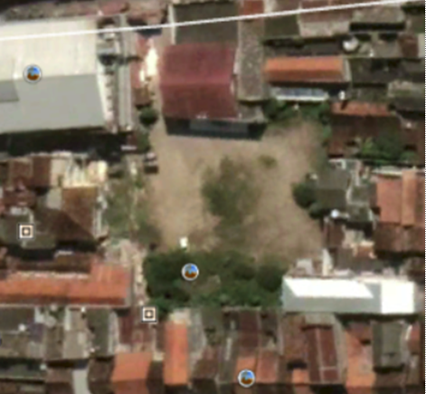 | 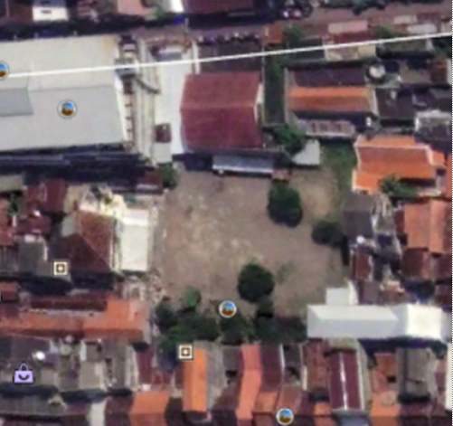
4 | In the fourth case study building, there was a change from 2006 to 2014 with a reduction in building mass (missing building mass) and until 2021 there was no new building mass.
5 | 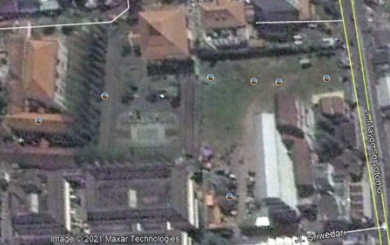 | 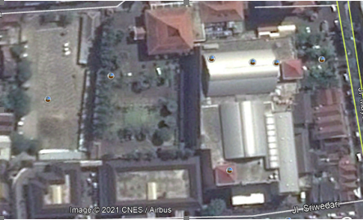 | 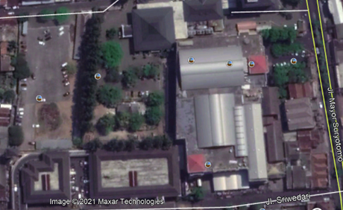 | 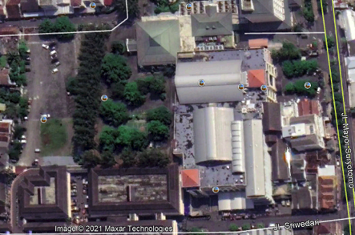
5 | In the fifth case study building, there were various changes, namely the reduction and addition of building mass from 2006 to 2014. After that, there was no change in the mass of the building again until 2021. There were differences in the type of building mass that increased from 2006 to 2014.
6 | 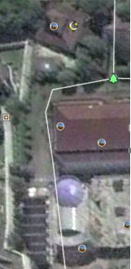 | 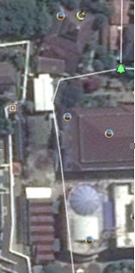 | 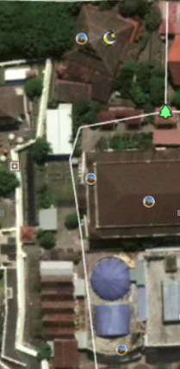 | 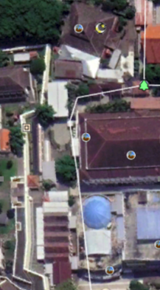
6 | In the sixth case study building, there was a gradual change from 2006 to 2021 with the addition of building mass in 2014 and increasing again in 2017 to 2021.
7 | 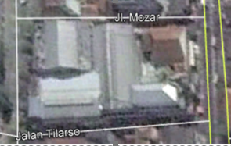 | 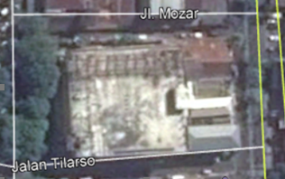 | 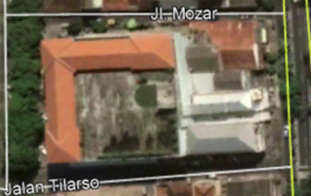 | 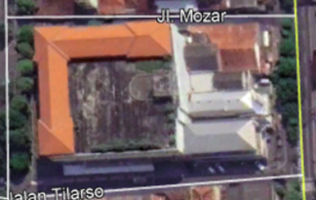
7 | In the seventh case study building there was a change in the shape of the building from 2006, 2014, 2017 to 2021 but did not change the solid void. Identified more dominant changes in the shape of the roof of the building.
Source: Google earth (2021) and Author (2021)

Based on the results of the analysis of changes in the typology of building mass and form above, it is known that there are several patterns of building changes in the Malioboro area, namely changes in building mass which is mainly around the Beringharjo market, which is the main commercial building of the area. There are also changes around the Vredeburg fort as a building with a tourism function. While around the presidential palace building or the grand building, no significant changes were found, but there were some changes in the typology of the building mass on the north side of the Agung building, which is also located on the west side of Beringharjo Market. So, there is a possibility that it will also be affected by the development of the shopping center. The following are the classifications of the pattern of changes in building mass and form in the Malioboro area:
- Gradual increase in building mass from 2006-2021 (case 1 and case 6)
- The sudden increase in building mass in 2021 (case 2)
- Significant reduction in building mass from 2014-2021 (total missing buildings, cases 4 and 5)
- The dynamic and changing shape of building mass from 2014-2021 (case 3)
- Changes in building form only without changing the mass of the building (case 7)

A clearer picture of the pattern of changes that occur in the typology of building mass and form in the Malioboro area can be seen in the figure 3.

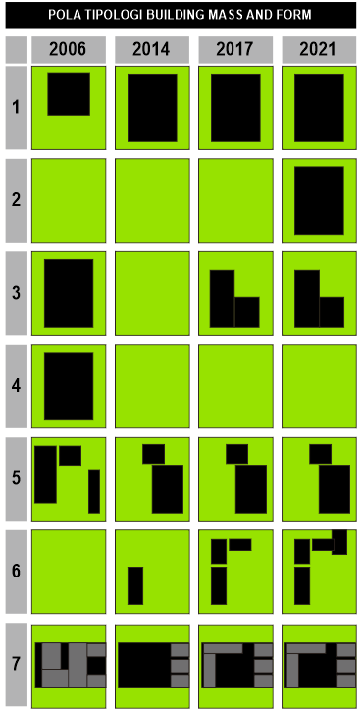
Source: Author, 2021

Figure 3. The pattern of changes in the typology of building mass and form in the Malioboro area.

In addition to building mass and form, this study also examines regional linkage pattern. Based on the results of aerial map observations from each period, it is known that the regional linkage pattern does not change from 2006 to 2021. From primary roads to environmental roads, all existing road networks are still the same, and there is no change. This indicates that the connectivity of urban units in the Malioboro area is still affordable with the current linkage pattern. The linkage pattern for the Malioboro area from 2014 to 2021 can be seen in the Figure 4.

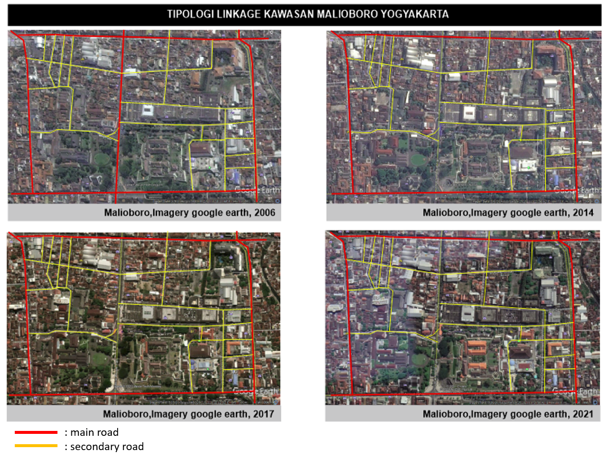
Source: Google Earth (2021) and Author, 2021

Figure 4. Malioboro area linkage typology pattern.

Based on the analysis results, it is known that changes in the typology of buildings in this area are influenced by the location of the building on the road class. Buildings near the main road experienced an increase in building mass, while buildings on the secondary road experienced a reduction in building mass (Figure 5). It is also known that in the Malioboro street area, there is no change in the typology of the building every year. This is possible because of the regulation of building guidelines along Jalan Malioboro, which is the philosophical axis of the city of Yogyakarta and has high cultural and philosophical values.
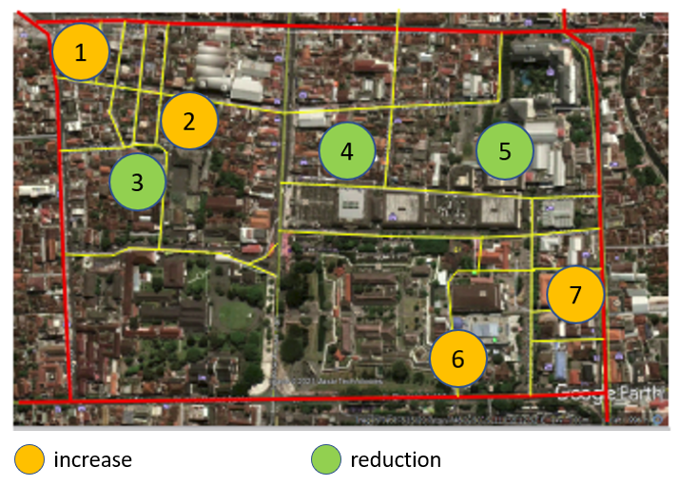
Source: Google Earth (2021) and Author, 2021

Figure 5. Building typology analysis.

Conclusion

This study indicates that the pattern of changes in the typology of buildings in the Malioboro area is very diverse. The pattern of changes that mainly occur close to commercial functions is the Beringharjo Market shopping center. The pattern of changes in building typology in the Malioboro area from 2006 to 2021 is quite significant with the addition of building masses in several places so that it forms a solid pattern on the area's figure-ground, but many buildings will also disappear in 2021 to form voids in the regional figure ground. There are also types of buildings that do not reduce the time of the building but only form the shape. Unlike the typological pattern of figure-ground in the area, which has undergone many changes, the linkage pattern in the Malioboro area has not changed from 2006 to 2021; this indicates that the connectivity between urban units in the Malioboro area is still affordable.
There are five types of the pattern of changes in the typology of building mass and form in the Malioboro area , namely the gradual addition of building mass, the sudden addition, the dynamic change in the shape and mass of the building, the reduction in building mass (total loss) and the change in the shape of the building without any changes and building mass. Meanwhile, from the linkage typology, there is no change in the road network pattern from the 4 years of study. Changes in building typology in the Malioboro area tend to be close to the Beringharjo market, while there is no change in building typology for the Agung building. However, near another historical building, namely the Vredeburg fort, there are indications of an additional building mass on the east side of the building. This needs to be considered so that policy references or directions can be given to control developments in cultural heritage areas. that changes in the typology of buildings in this area are influenced by the location of the building on the road class. Buildings near the main road experienced an increase in building mass, while buildings on the secondary road experienced a reduction in building mass. In addition, it is also known that in the Malioboro street area, there is no change in the typology of buildings every year. This is possible because of the arrangement of building guidelines along Jalan Malioboro, which is the philosophical axis of the city of Yogyakarta and has high cultural and philosophical values.

Acknowledgment

The author would like to thank and appreciate the support of the Architecture Study Program Universitas ‘Aisyiyah Yogyakarta. The author would also like to thank Town and Regional Planning Department, UiTM Perak Branch, Malaysia, for publication collaboration.

References

Dahal, K. R., Benner, S., & Lindquist, E. (2017). Urban hypotheses and spatiotemporal characterization of urban growth in the Treasure Valley of Idaho, USA. Applied Geography, 79, 11-25.
Google Earth Pro. (2021). Citra Satelit (online). Retrieved from https://www.google.com/earth/
Hadiyanta, E. (2015). Kawasan cagar budaya Di Yogyakarta: Citra, Identitas, dan branding ruang. Jurnal Widya Prabha, 4(4), 3-23.
Iswati, T. Y. (2003). Tipologi-tipologi morfologi ruang dalam rumah-rumah di Kampung Kudusan Kota Gede. Jurnal Arsitektur Komposisi, 1(2), 123-134.
James, P., & Bound, D. (2009). Urban morphology types and open space distribution in urban core areas. Urban Ecosystems, 12(4), 417-424.
Kojongian, J. O., Rondonuwu, D. M., & Tungka, A. E. (2017). Karakteristik kawasan Kota Lama Manado dengan pendekatan Teori Hamid Shirvani. SPASIAL, 4(2), 73-82.
Kumalah, M. J., Saat, G., Mapjabil, J., Hussin, R., Afrizal, T., & Talip, M. A. (2015). Kearifan tempatan dan potensinya sebagai tarikan pelancongan berasaskan komuniti: Kajian kes komuniti Bajau Ubian di Pulau Mantanani, Sabah. Geografia-Malaysian Journal of Society and Space, 11(12), 112-128.
Mahat, H., & Idrus, S. (2016). Education for sustainable development in Malaysia: A study of teacher and student awareness. Geografia-Malaysian Journal of Society and Space, 12(6), 77-88.
Moudon, V. (1994). Getting to know the built landscape: Typomorphology. In Franck, K.A., Franck, K.A., Schneekloth, L.H. (Eds), Ordering Space: Types in Architecture and Design (pp. 289–314). Van Nostrand Reinhold: New York, NY, USA.
Nurfansyah, N. (2016). Tipologi kawasan Jalan Pageran Antasari Banjarmasin. INFO-TEKNIK, 13(1), 50-56.
Nurjannah, I., & Dahrma, I. K. A. (2019). Tipologi ruang terbuka publik pada kawasan permukiman nelayan Desa Bajo Indah. Jurnal Malige Arsitektur (Media Arsitektur Lintas Generasi), 1(1), 8.
Putri, M. A., Rahayu, M. J., & Putri, R. A. (2017). Bentuk morfologi kawasan permukiman urban fringe Selatan Kota Surakarta. Jurnal Pengembangan Kota, 4(2), 120-128.
Ramadanta, A. (2010). Kajian tipologi dalam pembentukan karakter visual dan struktur kawasan (Studi kasus: Kawasan Ijen, Malang). SMARTek, 8(2).
Risdian, H., Sari, S. R., & Rukayah, R. S. (2020). Elemen perancangan kota yang berpengaruh terhadap kualitas ruang kota pada Jalan Jendral Sudirman Kota Salatiga. MODUL, 20(01), 10-17.
Roger, T. (1986). Finding lost space. Theories of urban design. Wiley.
Santoso, I., & Wulandanu, B. G. (2011). Studi pengamatan tipologi bangunan pada kawasan Kauffman Kota Malang. Local Wisdom, 3(2), 10-26.
Sarwono, J. (2006). Metode penelitian kuantitatif dan kualitatif.
Shirvani, H. (1985). The urban design process. Van Nostrand Reinhold Company.
Sulistijowati, M. (1991). Tipologi arsitektur pada rumah kolonial Surabaya (dengan kasus perumahan plampitan dan sekitarnya). Tidak dipublikasikan. Surabaya: Pusat Penelitian Institut Teknologi Sepuluh November.
Widyatmika, I. K. A., Wiriantari, F., & Arjana, B. M. (2017). Karakteristik elemen perancangan kota di jalur koridor Jalan Veteran Denpasar. Jurnal Anala, 5(1).
Yasin, M. Y., Yusoff, M. M., Abdullah, J., & Noor, N. M. (2020). Is urban sprawl a threat to sustainable development? A review of characteristics and consequences. Geografia-Malaysian Journal of Society and Space, 16(4), 56-68. https://doi.org/10.17576/geo-2020-1604-05

