

Spatial configuration between zoning area in simple residential houses at limited space post pandemic situation

Ardiansyah Rahmat Hidayatullah¹, Nor Eeda Haji Ali²

¹Program Studi Arsitektur, Fakultas Sains dan Teknologi, Universitas ‘Aisyiyah Yogyakarta
²Centre of Studies for Town & Regional Planning, Department of Built Environment Studies & Technology, Universiti Teknologi MARA, Perak Branch, 32610, Seri Iskandar, Perak

Correspondence: Ardiansyah Rahmat Hidayatullah (email: ardiansyah.rh@unisayogya.ac.id)

Received: 31 August 2021; Accepted: 22 August 2022; Published: 31 August 2022

Abstract

The prolonged COVID19 pandemic situation that began in 2019 has become a phenomenon that affects many aspects of life, including habits, behavior, and space requirements in residential facilities. A form of change that can feel is increasing or decreasing space based on its zoning. Both public and private areas have their roles in building function. Even the spatial preferences are transformed spatially. This need is undoubtedly a particular concern that needs to be considered in its approach to a dwelling with limited land. This study analyzes the forms of changes in space requirements in public, semi-public, semi-private, service, and private areas in a residential facility on limited land to produce recommendations for processing spatial configurations between areas. The research was conducted through an exploratory, descriptive approach by identifying user needs before and after the pandemic and then reviewing the relevance of the theory of spatial relations. In addition, experimental methods are used to find and respond to the utilization and division of space in dwellings on limited land. The need for housing, especially on limited land, remains a top priority for people with middle to lower economic levels. Efforts to fulfill this can only be achieved by housing ownership with limited land. However, this is contrary to the availability of land whose space capacity is not sufficient to meet the needs. The architectural solution is : vertical development strategy, create public awareness to have a healthy dwelling becomes an obligation, adjusting economic value preferences or expenses need to be invested wisely by considering appropriate building development strategies while maintaining health, function, and aesthetics, and Spatial configuration in responding to a pandemic is essential, namely through an organization or spatial arrangement. With the processing that is carried out, it can create a more effective and efficient spatial organization and provide a better quality of life, health, and psychology.

Keywords: Limited space area, post pandemic architecture, public-private area, residential houses, spatial configuration.

Introduction

The Covid-19 pandemic has a broad impact on every aspect of life on the earth's entire surface. Since its inception in 2019, the pandemic situation has affected every detail of human life. The most noticeable changes that can be felt are in the habits and behavior patterns of the world's people. Where daily activities that are usually carried out outside the home, now as a whole must be limited and can only move in their respective homes. Of course, many activities are forced to be productive at home, but these conditions are not prepared in response to new needs that suddenly must be met. Various public activities, such as work, school, and other social activities that were initially carried out outside the home, must now be carried out indoors with the function of the available space. The impact is, the shift in the position of space and space zones that were originally private has now turned into public. These events broke the spatial relationship between spaces and zoning and broke the boundaries of space that originally existed physically and non-physically.
This event is undoubtedly a global phenomenon that affects human space requirements in homes and other functions. Of course, it becomes something that does not significantly impact a residential process with a large area. However, this contrasts with the position of housing located on limited land, namely when all increased activities must be fulfilled on the function of available and limited space. The pattern of changes in behavior and habits becomes the basis for architectural thinking to find a residential typology that spatially has an excellent and healthy configuration between spaces.
This effort aims to obtain a post-pandemic housing typology formulation located on limited land but can meet increased space and activity needs. Especially in considering the relationship between public and private spaces, it is an area that is highly regarded for its safety against transmission and disease transmission from outside the home. With an excellent spatial configuration strategy, of course, it can provide good quality of spiritual and physical health. In addition, the development strategy also aims to provide an alternative typology of suitable housing for sectors of society with medium needs, where people aged 25-40 years are starting to focus on owning their housing with limited funds. So that one of the main goals is to buy petite or tiny land, then the architecture of residential buildings is designed simply to meet the needs of living.

Literature review

According to Sjarief (2020), in his research on pandemics and their impact on architecture, it was stated that pandemic situations could create personal spaces that meet physical and psychological needs, as well as biogenic balance. As is the case today, architecture reacts directly with the health sciences, especially on behavior change. Habits or behaviors that appear at this time are self-isolation or quarantine at home, physical distancing, light exercise, and healthy food consumption. In addition, there are also changes in mobility by minimizing access to mass transportation or even reducing activities outside the home. The focus of health in responding to a pandemic situation, people tend to try to increase immunity and maintain cleanliness (wash hands & bathe).
Through his research on the track record of previous pandemics (1820-present), Sjarief (2020) said that there was a comprehensive reaction to urban infrastructure, building material technology, layouts, and innovative forms in the interior, even giving rise to new building typologies. The residence as a private space has undergone several transformations in the function of space, including 1). The flexibility of play in place as an office and study room; 2). Area for washing hands/feet, bathing, even changing clothes before entering the core area of ​​the house; 3). Home as a center for physical and mental health. The other approaches to the aspect of residential design, according to Sjarief (2020), are described in Table 1.

Table 1. Creative thinking as a post-pandemic architecture approach strategy.

Architecture | Interior Design | Design Products
- Width of doors and corridors increases  - Stairs > Elevator  - Low-Medium rise> High Rise  - Home-office typology  - The place to wash hands before entering  - Prefabricated  - Modular second-hand construction as temporary shelter or clinic  - Urban farming at home for food needs | - More partitions in the office, with less open-plan layouts.  - The size of the workbench is enlarged.  - The distance between the seat to the seat increases. | - Contactless doors and locks with facial/voice recognition system  - Polymer technology development  - Anti-bacterial or easy-to-clean material  - Utilization of robot technology and the internet of things.
Source: Realrich Sjarief (2020)

Based on the understanding conveyed by Sjarief (2020), it can be understood some basic knowledge of the influence of the pandemic on architectural transformation and architectural needs by its users. The direct impact occurs in behavior and patterns of space requirements for activities in residential homes that are experiencing growth. So it is necessary to consider spatial configuration as a form of fundamental thinking in spatial processing in architecture. According to Rully (2014), the need for space in a residential house is divided into several areas that function specifically: bedrooms, bathrooms, toilets, dining rooms, kitchens, family rooms, living rooms, garages, and warehouses, terraces, and yards. These spaces are the basic needs of the residential function.
According to Francis D.K. In his book Theory of Architecture (1993), Ching is a configuration in the layout of the mass according to the nature of the relationship between the component forms following the design, namely: 1) Space in space; 2) The rooms are interlocked; 3) Adjacent rooms; 4) Areas connected by shared spaces. In addition, the form of spatial relations or spatial configuration of space is also explained, which is divided into six approaches, including 1) Organization of the compositional space; 2) Centralized space organization; 3) Linear Space Organization; 4) Radial space organization; 5) Tertiary space organization; and 6) Grid's space organization. The spatial configuration patterns described above become a fundamental approach in processing space in an architectural design which later, from the existing configuration, regulates the circulation pattern or spatial movement in the spatial arrangement. According to Aditya Dhika (2009), the relationship between areas is a pattern of mass arrangement at a site that is arranged based on zoning and based on circulation paths. The mass of the tread element is an arrangement of forms, among which some features make up outer space.
From the above understanding related to the spatial relationship and spatial configuration of the space in the dwelling, apart from that in its role, the areas in the home can be divided into several zones (Marlina, 2018) in residential houses, which are divided into four, namely public zones, semi-public zones, private zone, and service zone. However, based on the pandemic situation, the zones described are experiencing a condensation of functions that allow public and private zones to intersect. So it is necessary to identify strategies to delimit these zones physically.
Method and Study Area

This study applies qualitative methods with evaluation and experimental methods by reviewing case studies of residential architecture on limited land before the pandemic and after the pandemic. The identification results are then compared with relationships and spatial configurations to be grouped according to their zoning. The results of the analysis and discussion are then evaluated for their relevance in meeting the community's needs. The research sample used is a typology of residential houses with a minimum area that has been regulated in SNI 03-1733-2004. The regulation states that the minimum building area for housing that accommodates four adults is 36 m² or 9 m²/person with a site area or plot of 60-90 m². The minimum area requirement is calculated based on the need for fresh human air in indoor activities. The building area sample is considered ideal enough to be the standard design formulation.

Results and Discussion

Even though we are currently in the middle of a pandemic, the number of house purchases is still increasing significantly. Based on study research data submitted by PT Bank Tabungan Negara (Persero) Tbk through the Housing Finance Center (HFC) research team, the House Price Index (HPI) for the third quarter of 2020 grew 4.29 percent year on year (YoY). Even so, it is not as high as the third quarter of 2019, which reached 5.89 percent, but considering the pandemic conditions, the increase was quite significant. Reviewing the data, it can be understood that the urgency of the type 36 square meters building area residential development strategy as a homeownership strategy is the community's top priority. This phenomenon increases even in a pandemic that affects the economic value of the community, so houses type 32-36 square meters building area are the minimum standard for homeownership (Suryo, 2017). In addition, type 36 residential housing is a recommendation that is recommended as a minimum standard of available occupancy.
Based on several studies related to type 36 housing, the tread area or parcel for this type of house ranges from 60-90 m² with various size dimension ratios. So that in this study, the sample of the research object was taken based on several criteria, namely:
- The smallest footprint size is 6x10 meters. This area is considered feasible as a sample, based on the limited land area currently commonly used in the movement of low-cost housing and the like.
- There are two rooms or bedrooms to meet the standard composition of a family with two parents and 1-2 children.
- There is a kitchen and bathroom as the main supporting facilities for a residence in the service area.
- Availability of open space or garden, both in front and in the back area, as an absorption area and airy room for washing and drying.
To understand the basic concept of type 36 houses, a spatial configuration analysis was carried out based on several typologies of research samples, as follows:

Table 2. Analysis of space availability and spatial configuration of type 36 occupancy.

No | Sample Cases Study | Spatial Configuration | Discussion
1 | 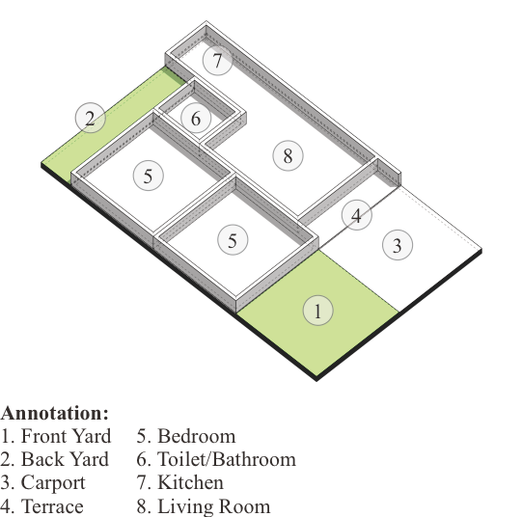 | 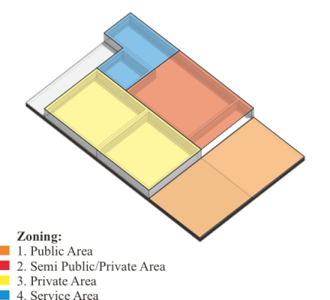 | - There is a small garden and a carport which is directly connected to the terrace.  - The family room area also functions as a living room area.  - The service area is located in the back area.  - The Private zone or bedrooms are lined up on the left side of the building connected to the living room.
2 | 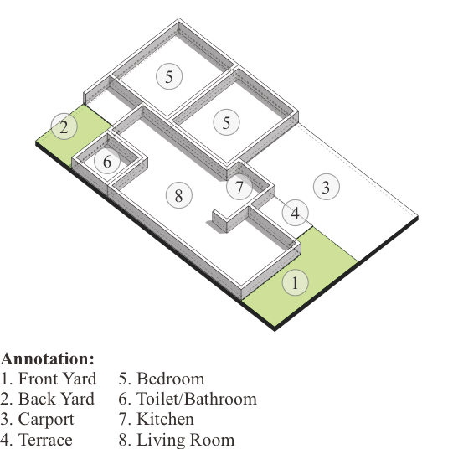 | 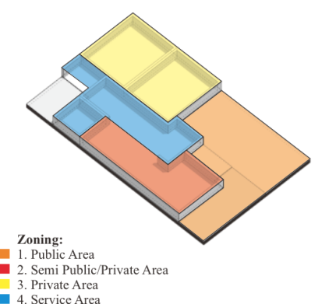 | - The public zone is a garden, carport, and small terrace.  - The rooms are located longitudinally on the right side of the building.  - The semi-public zone/family room and private zone are connected to the service area.  - The toilet is located in the back area.
3 | 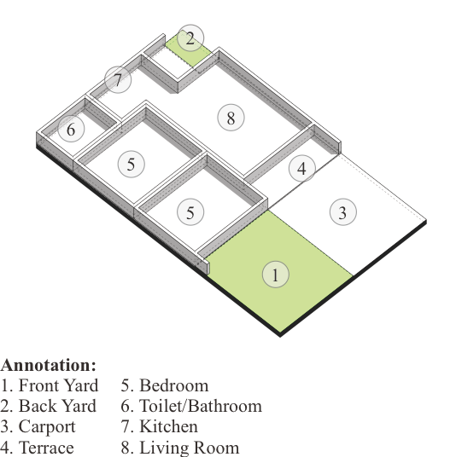 | 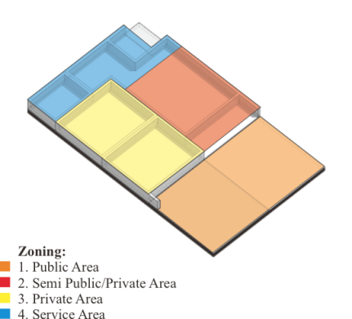 | - The public zone consists of a garden, carport, and terrace.  - The service zone is located in the back area.  - There is a small garden in the back area.  - The rooms or the Private Zone is on the left side of the building connected to the living room/family room.
4 | 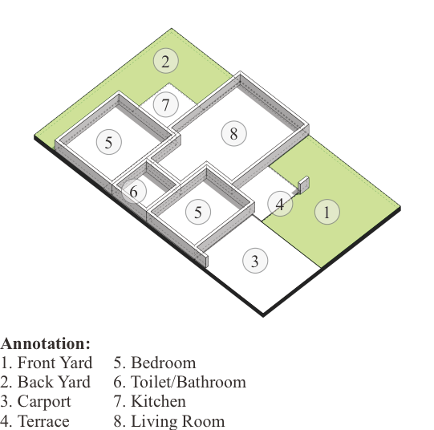 | 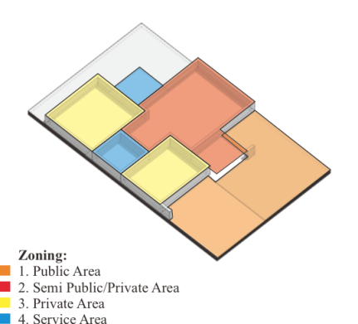 | - The Public Zone consists of a carport, terrace, and a reasonably large garden.  - Private Zone/rooms are on the left side of the building, separated by toilets and a Public Zone.  - The dimensions of the public zone are pretty small but are offset by a relatively large rear garden area.  - Kitchen in the back patio area.
5 | 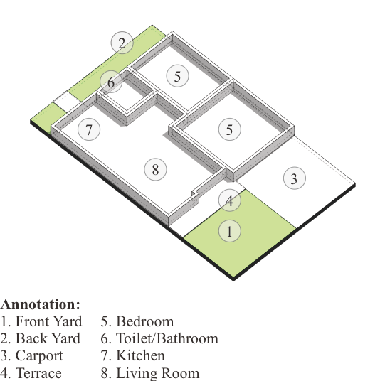 | 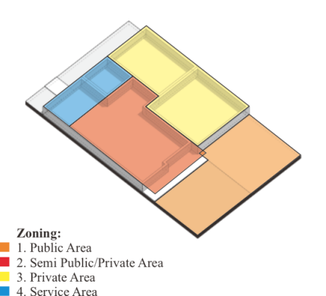 | - The public zone has a carport, terrace, and garden.  - The Private Zone or rooms are arranged on the right side of the building connected to the Semi-Public Zone or family room.  - There is a rear garden extending from the left to the right of the building.
6 | 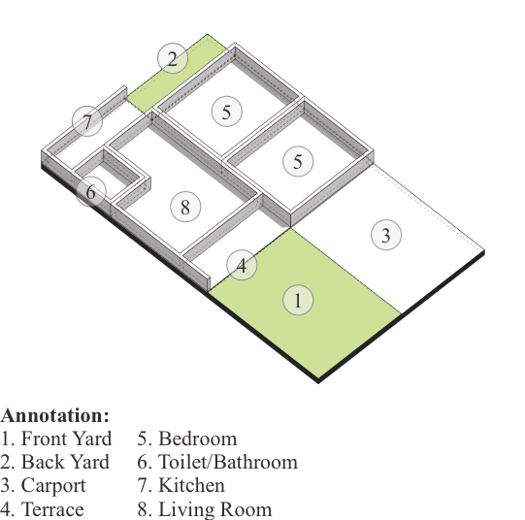 | 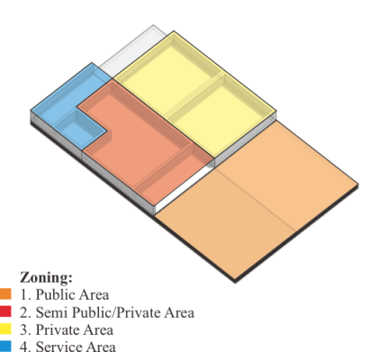 | - The public zone consists of a terrace, carport, and open garden.  - Private zones or rooms are arranged on the right side of the building connected to a semi-public area/living room.  - The service area is located at the back, including the kitchen connected to the rear garden.
Source: https://www.99.co/blog/indonesia/desain-rumah-6x10-fungsional/ and Author Analysis, 2021

The problems identified based on the six samples above can produce several justifications related to the availability and configuration of spaces and their impact on the quality of residential living after the pandemic, namely:
- There is no particular living room, wherein a type 36 house the family room function room still functions as a reception room. These conditions can increase the risk of transmission.
- Lack of openings (doors and windows) that support the process of changing air from room to room. This can affect the mood that cannot get out of the room, which allows the air to carry disease.
- The placement of an open space located on the front of the residence so that outdoor activities (sports, sunbathing, etc.) do not get privacy and are at risk from the influence of air from outside.
- The dimensions of communal spaces (kitchen, dining room, family room) are inadequate for home activities such as work from home, a study from home, etc.
- Access in and out is in one area, with no particular preference for maintaining the sterilization process or transition from outside the house.
With these conditions, to formulate an appropriate residential typology as a strategy for adjusting conditions before and after the pandemic on type 36 residential architecture, it can be explained as follows:

Table 3. Parameters of post-pandemic occupancy.

No | Past Condition | Present and Future Strategies (Post Pandemic) | Description
1 | 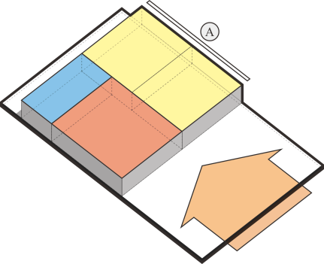 | 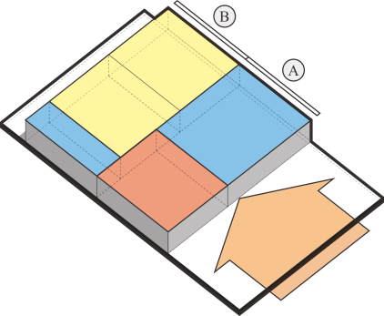 | Private zones or rooms arranged along the back are rotated to be placed in the back area (b). This is intended for access to have a linear sequence. Before entering the private zone, a sterilization area or service area (a) to clean their bodies after entering the house.
3 | 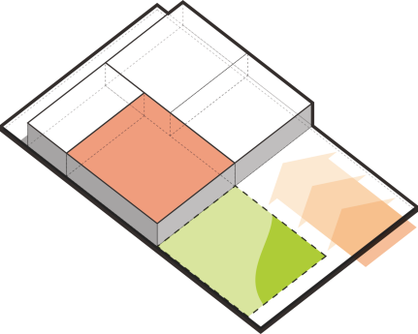 | 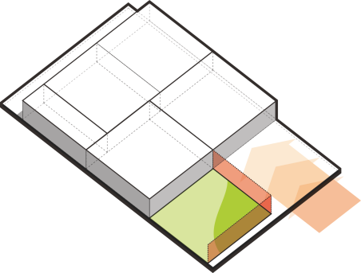 | The semi-public/private zone, which doubles as a family room and living room, needs to be clarified. A strategy to utilize a relatively large garden area in front of the site functioned as an open guest area by providing a "breathing wall" made of rooster material and the like. It aims to facilitate air changes and anticipate the transmission of viruses/bacteria.
4 | 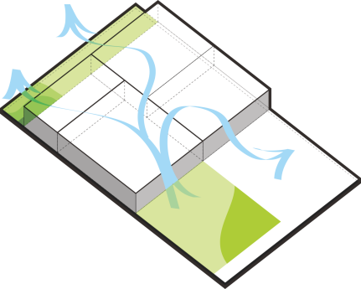 | 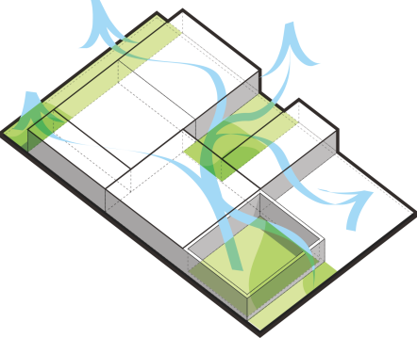 | The open/garden area is only found in the front and back areas in relatively small dimensions. The dimensions of this space do not meet the needs of physical activities such as sports and so on, besides that variation in air movement pretty quite hampered by the service area. So the appropriate strategy is to provide a space as a transition zone between service zones (bathroom/laundry) as an infectious area. With this open area, the air will move and change faster, and the light will enter the house more optimally.
5 | 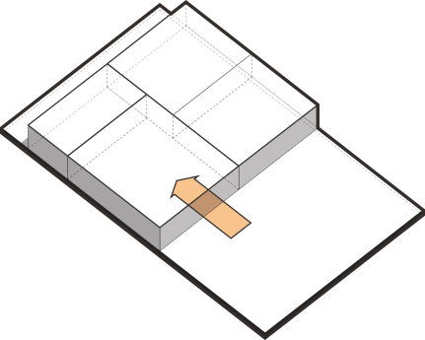 | 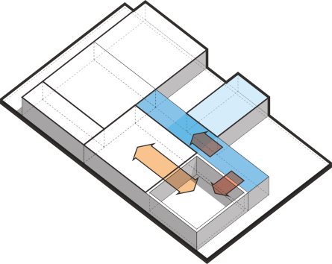 | Access to housing initially located only at one point in the semi-public/private/family room zone is at risk of transmission and hygiene control. So it is necessary to have different access, where access must be through the sterilization area to facilitate the cleaning and disinfection process.
Source: Author Analysis, 2021

Based on the discussion above, it can be concluded that a series of design parameters to determine the suitability of the spatial configuration of post-pandemic residences on limited land, including:

Table 4. Parameters of Post-Pandemic Occupancy

No | Parameter | Spatial Configuration Strategy | Healthy Shelter Approach Strategy
1 | Optimization of openings (window doors) to optimize air change and optimally enter light to kill bacteria/viruses in the room. | √ | √
2 | Recommend developing space vertically to provide optimal space for occupants (per person), including adequate air supply and physical distance between individuals. In addition, the availability of a large enough room can create a flexible space so that it can be used as a multifunctional area for work or study at home. | √ | √
3 | Recommend a linear configuration by opening a room in and out of one area, with the aim of carrying out control processes and efforts to prevent virus/bacterial transmission. | √ | √
4 | Recommend a linear configuration by opening a room in and out of one area to control processes and prevent virus/bacterial transmission. | √ | √
5 | Placing service rooms (bathroom, kitchen, laundry room) and the public in the outermost area of ​​the site as an isolation area (cleaning oneself) after leaving the house and placing the function of private/semi-private rooms as sterile areas | √ | √
6 | Availability of open space in a sterile area (back/middle/transition) for outdoor activities, getting light, exercising, and growing crops (food security/hobby). | √ | √
Source: Author Analysis, 2021

The above parameters are generated by comparing the typology of dwellings in limited land or samples against the theory of changes in architectural principles that are affected by the pandemic situation. To then be considered a post-pandemic residential typology formulation that is appropriate to respond to a pandemic. Spatial configuration, spatial relationships, and spatial configurations are interrelated aspects to improve the quality of healthy housing. The development strategy can be explained through Figure 1.

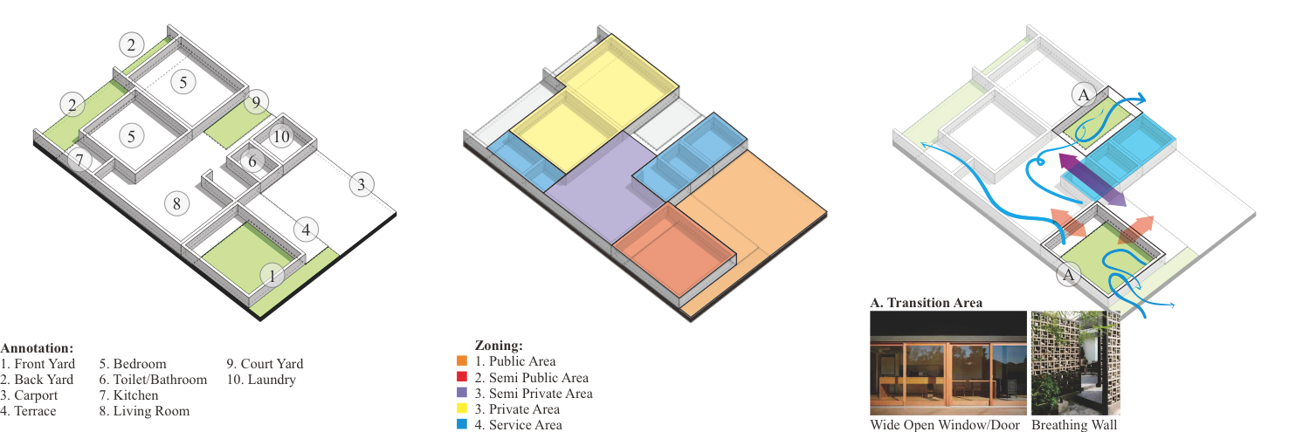
Source: Author Analysis, 2021

Figure 1. Design spatial configuration strategy for house building Type 36 in limited space

- Spatial configuration structuring strategies to distinguish infectious areas in public/semi-public zones need to be clarified. Boundaries can be in the form of massive walls and also the application of the sterilization area. The sterilization area is in the form of a service zone consisting of a bathroom and a laundry area. Residents, after activities outside the home, can clean themselves and undress in the laundry area. It aims to facilitate the process of disinfecting or regularly cleaning as a preventive measure.
- A relatively large garden area in the front area needs to be processed and used as a semi-public zone for the function of the living room. It aims to distinguish the living room and family room position which has been in one area. In addition, the principle of this application seeks to provide a faster air circulation space, thereby minimizing the carrying of viruses/bacteria from guests.
- To provide a more expansive activity space, especially for outdoor activities. Need to give a courtyard in the middle of the building and function as a transition zone between infectious areas (service zones) and sterile areas (private and semi-private zones). In addition, this principle aims to provide sufficient space for air transition, and optimal light can enter the entire room to reduce bacterial growth.
- Implementing a wide enough opening with large glass windows that are easy to open and slide closed is an excellent strategy to facilitate the change of air at any time. This method also provides a more comprehensive visual configuration, thus providing a positive psychological impact.

Conclusion

The need for housing, especially on limited land, remains a top priority for people with middle to lower economic levels. However, this condition also affects the needs of the community sector aged 25-40, who currently require affordable housing. Efforts to fulfill this can only be achieved by housing ownership with limited land. However, this is contrary to the availability of land whose space capacity is not sufficient to meet the needs. The vertical development strategy becomes the primary and essential choice as a post-pandemic residential preference. Public awareness to have a healthy dwelling becomes an obligation, and the architect's role is obliged to facilitate these needs.
Other architectural strategies to adjust economic value preferences or expenses need to be invested wisely by considering appropriate building development strategies while maintaining health, function, and aesthetics. Spatial configuration in responding to a pandemic is essential, namely through an organization or spatial arrangement. With the processing that is carried out, it can create a more effective and efficient spatial organization and provide a better quality of life, health, and psychology.

References

Ching, F. D. (2014). Architecture: Form, space, and order. John Wiley & Sons.

Fivanda, F., & Ismanto, A. ANALISIS PENGARUH KONSEP INTERIOR RUANG KERJA DI RUMAH TINGGAL PASCA PANDEMI COVID-19. Jurnal Muara Ilmu Sosial, Humaniora, dan Seni, 5(1), 251-260.

Marlina, R. (2018). Pembagian Zona Dalam Sebuah Ruangan-Rina Marlina. Retrieved from https://verdant.id/artikel/pembagian-zona-dalam-sebuah-ruangan/

Neufert, E. (1970). Architects' data (1st English language edition). Crosby Lockwood Samples.
Rully, R. (2014). Merencanakan Dan Merancang Rumah Tinggal Yang Optimal. Jurnal Teknik Sipil dan Arsitektur, 15(19).

Paramitha, N. W., & Salura, P. (2020). Relasi antara sakralitas ritual peribadatan berjamaah dengan konfigurasi spasial arsitektur Masjid Sulthoni Plosokuning. ARTEKS: Jurnal Teknik Arsitektur, 5(2), 143-152.

Romantiaulia, W. I., Dahrma, I. M. K. A., Al Ikhsan, A., & Hamundu, W. O. N. Model Desain Ruang Studio Arsitektur di Era New Normal. Jurnal Malige Arsitektur, 2(2).

Sjarief, R. (2020). Pandemi dan Pengaruhnya ke Arsitektur. Retrieved from https://real-rich.org/2020/07/31/pandemi-dan-pengaruhnya-ke-arsitektur/

Sugiarti, R. (2018). EFISIENSI TATA RUANG TERHADAP OPTIMASI TAPAK (Kajian Evaluasi Efisiensi Perancangan Tata Ruang Terhadap Bentuk Tapak pada Proyek Rumah Kost Kentungan, Sleman) (Master's thesis, Universitas Islam Indonesia).

Suryo, M.S. (2017). ANALISA KEBUTUHAN LUAS MINIMAL PADA RUMAH SEDERHANA TAPAK DI INDONESIA. Jurnal Permukiman Vol. 12 No. 2 November 2017: 116 – 123.

White, R (2021) TIPE RUMAH BERDASARKAN LUAS BANGUNAN UPDATE 2021.Retrieved from https://www.raywhite.co.id/news/105404tipe-tipe-rumah-berdasarkan-luas-bangunannya

Wibawa, D. G. A. (2017). Karakter Spasial dan Visual pada Bangunan Gedung Juang 45 Bekasi Jawa Barat (Doctoral dissertation, Universitas Brawijaya).

