

The space privatization: The forming process of social space in kampung, Prawirotaman, Yogyakarta

Tika Ainunnisa Fitria^{1.2}, Mohd Hisyam Rasidi², Ismail Said²

¹Universitas ‘Aisyiyah Yogyakarta
²Universiti Teknologi Malaysia

Correspondence: Tika Ainunnisa Fitria (email: tikafitria81@gmail.com)

Received: 2 September 2021; Accepted: 23 May 2022; Published: 31 August 2022

Abstract

Prawirotaman is an urban village called kampung that has changed into a tourist village since the 1980s. Tourism development has evoked changes in social spaces and the community. There has been a phenomenon of territorial deprivation leading to the privatization of space. Hence, this research used a qualitative approach to identify how the privatization of space influenced the forming of social spaces within the kampung. Data were collected through observation and interviews to understand the transformation of social space and residents’ social activities changes. These methods were conducted in the afternoon or after Asr prayer until before Maghrib prayer, focusing on transition areas. Next, the analysis used behaviour mapping assisted by ArcGIS to show the nodes of residents' social activities and visual-spatial analysis to understand the transformation of social spaces. This research resulted that the space privatization impacted the forming of kampung social spaces that were influenced by 1) residents' daily movement, 2) connectivity and openness of the transition area, 3) gathering habits, and 4) availability of social space in the transition area. The space privatization did not reduce residents' opportunities for social activities; nevertheless, it stimulated residents to form their social spaces continuously. The research found the important factors that form social space in the urban village. The finding also contributed to sustaining the urban villages, particularly those that have transformed into tourist villages.

Keywords: Kampung neighbourhood, social space forming, space privatization

Introduction

Kampung have been an urban neighbourhood in Yogyakarta since the Sultanate era and were developed during the Dutch colonization (Setiawan, 2006; Hutama, 2016). It was where the sultan’s servants and soldiers lived (Madden, 2015). Because of its history, the place is considered a part of the City of Yogyakarta that represents its people’s characters. Nowadays, it has become a district for community units, although many kampungs have experienced a dynamic transition process (Setiawan, 1998). At the same time, tourism has impacted most of the kampungs in the City of Yogyakarta. This sector has a significant impact on society, environment, infrastructure (Davidson & Maitland, 2001), culture (Hall & Jenkins, 2004), and economy (Yoon et al., 1999). For instance, it provides job opportunities and earnings for the locals in the City of Yogyakarta (Ferguson et., 2017). On the other hand, it has also caused the increasing construction of hotels, cafés, and restaurants (Hall & Jenkins, 2004; Hannam et al., 2014). These circumstances have led to struggling spaces and emerged as a spatial issue within the urban village, Prawirotaman included.
Prawirotaman was the Sultan servants’ settlement in the 19th century. From the 1960s until the 1970s, it was a centre of batik workshops in the City of Yogyakarta. After the batik industry declined in the 1970s, the locals moved away from the batik business to tourism accommodation. They renovated the batik workshop into rooms for rent (Sumintarsih & Adrianto, 2014). From interviews and initial observation, tourism in Prawirotaman started with around 8 (eight) homestays. Currently, there are 32 homestays and 49 tourism-supporting businesses. Prawirotaman has been converted into a tourist village where homestays, cafes, pubs, and other tourism businesses are developed (Figure 1).

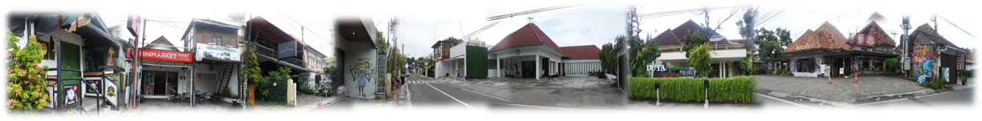

Figure 1. Prawirotaman becomes a tourism village

The ownership is no longer dominated by the locals but also by incomers and investors, which means that the growth of the tourism business in Prawirotaman is inevitable. However, applying rules and planning in urban villages sometimes create new problems (Raharjo, 2010) for example, it stimulates the process of space privatization. In contrast, an urban village is believed to be a place of community life with a strong relationship between its inhabitants (Hutama, 2018). Space privatization can be seen clearly by claiming public spaces, which leads to physical neighbourhood changes. Residents use the public spaces as their territory, for instance, to expand the activity area, build the boundary, and mark the public access (Figure 2). Domination and building power in public spaces seem commonplace in kampungs (Saptorini, 2006), and they are caused by economic pressure, expanded asset utilization, occupation of public spaces, and external expansion (Setiawan, 2006).

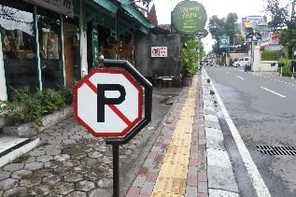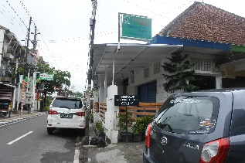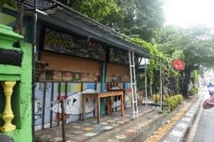

Figure 2. The privatization of shared spaces (from left to right: a “no parking” sign on a public street, using part of the street as parking space, and using a pedestrian walkway to expand commercial space).

Spatial transformation and community behaviour change in tourist neighbourhoods have become a serious issue today. Meanwhile, tourist village aims to strengthen community and culture (Brindley, 2003). It is indicated by modifying the physical elements and social activities, defined as a socio-spatial transformation process (Mills, 2012). The economic opportunity in the kampung is manifested through the privatization and commercialization of space. It forces the kampung to carry out processes of change that are not always in line with the last character of the village (Setiawan, 2006). Nevertheless, the residents still use the public spaces to accommodate their social activities (Figure 3). In short, Prawirotaman, which has been transformed into a tourism kampung, experiences physical and neighbourhood life changes in terms of forming privatized spaces, which contrasts with the community’s habit of using public spaces. Spatial changes encourage the shifted local’s behaviour settings in interaction (Liu, 2012). As a result, tourism development evokes changes in social spaces and the community. Because of the changes that have been taking place, this research explored how space privatization has influenced the social spaces in Prawirotaman.

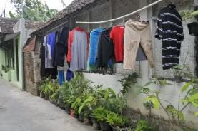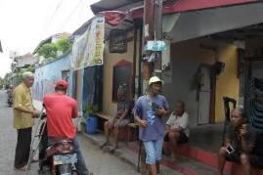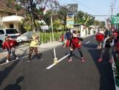

Figure 3. The social spaces within the kampung (left to right: an alley for hanging clothes, an alley for daily interactions, and the street for gathering).

Social space can be defined as the relationship between space and community in the specific circumstances where there are social activities (Schatzki, 1991; Osti, 2015), interaction activities, an environment, and social fabric (Madanipour, 1996; Setyohadi, 2007). Change in neighbourhood function causes locals’ dissatisfaction, leading to their social activity changes (Widyastomo, 2015) indicated through the space element and social activity (Mills, 2012). In the kampung, social activities happen in outdoor spaces (Gehl, 2010). In Prawirotaman, social activities occur in the transition areas, such as streets, terraces, and taverns. The street functions as a shared space that reminds the residents of experiences (Hadinata, 2017). It means that the social spaces in the kampung consists of space (e.g., element, function), social activities, and experiences. The privatization of space can be interpreted as a tendency to diminish the shared spaces.

Literature review

The urban neighbourhood is a social network related to the residents’ activities, transition spaces, and identity. It is encompassed by spaces and the elements that interact with the community’s daily life (Shawei et al., 2018). It influences the community’s dependency on mobility, feelings of belonging (Brindley, 2003), respect, and solidarity (Rahmi et al., 2001). It posits that the kampung represents the social relationship among the people in the community that neighbour each other. Thus, social space is a significant public space for the urban neighbourhood called kampung. It is a place where its community obtains social interaction experiences (Sunaryo, 2010). The residents have opportunities to function in the common spaces in their neighbourhood (Hickman, 2012).
Territories are the interpersonal boundaries that control the social interaction among neighbours in a neighbourhood (Scannell & Gifford, 2009). The community in the kampung perceive the territories as a manifestation of the public spaces, limited spaces, and leeway in land status (Saptorini, 2006), representing a level of privatization or defence from distractions (Kaya and Weber, 2003). The women tend to expand their house’s territory to develop informal interaction with their neighbours (Peters, 2010). This action is influenced by the community’s characteristics based on the environment and culture (Laurens, 2006). However, in the socio-culture context, social role correlates with the behaviour of the kampung people (Wirawan, 2012). Therefore, this activity interprets the residents’ relationship and physical environment. The changing in their environment determines their socio-behaviour. It means that the social space in the kampung neighbourhood constructs its community’s socio-activity. Further, social space is formed due to the community’s needs and emotions towards their neighbours. These factors create various social spaces (Hantono & Pramitasari, 2018), socio-behaviour, and spatial privatization (Abdul Rahim & Hashim, 2018). This finding is in line with Gehl’s (2018), where the correlation between space and activity patterns emphasizes the congruence and fit. It relates the space layout and individual activity (Pike & Ryan, 2004).
In addition, community dissatisfaction affects the spatial function changes of a neighbourhood (Widyastomo, 2015). However, the need for interaction creates an adaptation of space in their neighbourhood (Malek et al., 2015). Residents are creative in forming their social spaces even when there are limitations in their neighbourhoods (Rahmi et al., 2001). This behaviour is important in sustaining lives in the neighbourhood (Erfani, 2020). Moreover, the neighbourhood’s changes are influenced by motives and trends (Hadinata, 2017). Hence, the privatization in this study can be observed through people’s activities and the residents’ interpretations in a sequence of time.

Method and study area

A qualitative approach was used for this research to identify the privatization of space influencing the forming of social spaces within the kampung of Prawirotaman. The observation found detailed descriptions of the spaces (e.g., element, function), social activities, and experiences. In-depth interviews were conducted to learn about space privatization through the residents’ interpretation of history and present experiences. Moreover, interviews with key informants revealed space privatization during the kampung’s transformation. Key informants can ensure better data validity and verify interview results (Yücesoy, 2006).
This research used the Geography Informatics System (GIS) to redraw the satellite map and conduct spatial analysis to understand the various spots of residents’ social activities. Spatial data are the primary operational data of GIS that are represented in coordinate grid form (Budiyanto, 2019). Moreover, the visual analysis was aimed to understand the physical features (e.g., element, function) related to the forming of social spaces and to record the change for single-site variation through the street section (Tang & Long, 2019). To effectively understand the people’s social activities in Prawirotaman, observation, mapping, and interviews were conducted in the afternoon, after Asr prayer until before Maghrib prayer (03.30-05.30 pm) in random spaces along alleys. The primary data, such as privatization and social space, were documented through photographs and manual drawings that were redrew using SketchUp. The transition areas of kampung became the social spaces for the community, consisting of streets and alleys. The transition area is an intermediary space between indoor and outdoor areas that reduce the level of privacy (Yeang, 2007), controls privacy (Asadi et al., 2015), builds a social network (Titi & Darjosanjoto, 2015) and spontaneous interactions (Prayitno, 2013). Next, transition areas became the scope of observation in this research (Figure 4). Finally, this research was conducted qualitatively based on physical and social indicators; socio-space transformation, socio-space structure, and social interaction.

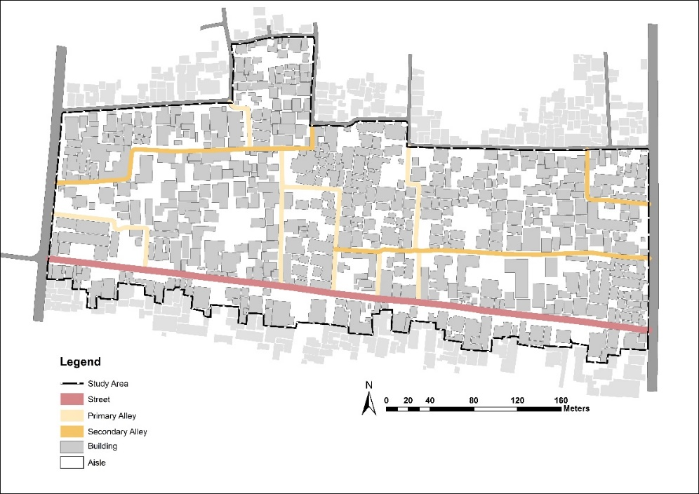 | 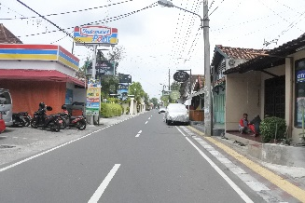  (a)
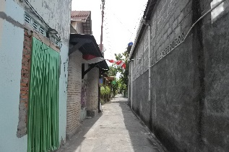
(b)
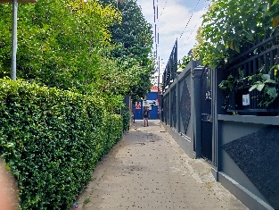
(c)

Figure 4. The transition areas in Prawirotaman: (a) street, (b) primary alley, (c) secondary alley

Results and discussion

Socio-space transformation and the social activity

The recognition of socio-space transformation and activity is aimed to reflect the appearance and changes of the spaces that functioned as places for interaction, while the movement activity is to find the tendency of residents to form new socio-spaces within the kampung. Space privatization influenced the transformation of social space and changes in social activities in Prawirotaman. Examples of spaces and activities included losing the traditional game of paseran, demolishing the night patrol post (cakruk), and access closure between alleys. Moreover, it was found that the socio-space transformation in Prawirotaman was followed by territorial shifting in the alley; namely, residents tended to look for a replacement space for the space that had been privatized. They spontaneously and independently formed their socio-space. In other words, privatizing space has led to the loss of several social activities in Prawirotaman; however, some activities still existed (Table 1).
The forming process of social space in Prawirotaman can be classified into several patterns: (1) using the private transition area (e.g., mantenan, pencak silat at the house yard) (Table 1 (b) and 1(e)), (2) adding the use of a public transition area by dividing the territory (e.g., ronda at the alley) (Table 1(c)), (3) limiting the territory of public area (e.g., walking access) (Table 1(d)), (4) moving a social space to another public area (e.g., pitulasan at the street) (Table 1(a)). It shows the social spaces formed in the kampung of Prawirotaman were a manifestation of a transition area to fulfil the residents’ need for interaction.

Table 1. Privatization and forming process of social space in Prawirotaman

No | Interaction activity | Transformation process
No | Interaction activity | Time | Space and the function | interaction activities | Previous | Present
(a) | Traditional games of Paseran and Pitulasan. | 1980s-1990s | House Yard | Playing paseran every sunday, playing volley, and pitulasan. | 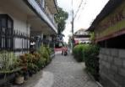 | 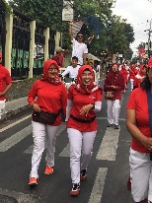
(a) | Traditional games of Paseran and Pitulasan. | Present | Homestay and Rented Room | Pitulasan moved to street.
(b) | Pencak Silat Traditional Martial Art | 1970s | Pocket space | Pencak Silat | 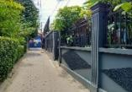 | 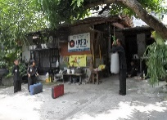
(b) | Pencak Silat Traditional Martial Art | 2000s-present | House yard (pocket space was built for the house) | Pencak Silat moved to a house yard
(c) | Ronda | 1990s | Patrol post (cakruk) and house yard | Night patrol (ronda) at patrol post | 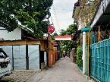 | 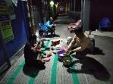
(c) | Ronda | 2006-present | Cakruk was demolished for the homestay’s parking lot | Ronda moved to the alley with a mat
(d) | Spontaneous encounter with neighbours | Before 2020 | Fully open access | Daily access for residents |  | 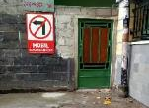
(d) | Spontaneous encounter with neighbours | 2020 (March) | Fully closed access | Closed access
(d) | Spontaneous encounter with neighbours | 2020 (October) – Present | Partially closed access | Restrictions on access and accompanied by time rules.
(e) | Community gathering | 1980s | House yard | Residents gathered and worked together on a particular event (e.g., a wedding ceremony). |  | 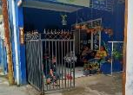
(e) | Community gathering | Present | House terrace (some part of the house area was built for homestay). | Used for monthly gathering (dasa wisma) and daily neighbour visits.

These findings indicate that the residents sustained their social activities by shifting the transition area for interaction. The residents controlled the privatization within the kampung by displacing or moving to every possible transition area, especially for social and religious activities. It means that space privatization stimulated the forming of social spaces achieved through controlling and claiming transition areas as public spaces. According to Setiawan (2006), social value sustains the continuity of a kampung’s social activities that may decrease due to the lack of public space. However, this research found that a lost public space would be replaced with other public spaces. The shifting of social spaces was a form of the kampung’s residents’ adaptation to their neighbourhood’s transformation by spontaneously forming the new social spaces.

Space privatization and the social space opportunity

The social space shifting within the kampung was influenced by the possibility of access between transition areas, such as from the alley to the yard or terrace house. Changing the space function reduced the social space placed in the private transition areas (e.g., yard and terrace). A resident named Hakso said that the privatization of land began due to the distribution of inherited land: “The house terrace can no longer be a gathering place”. This finding reveals that territorial separation caused space privatization due to the inheritance system. Moreover, space privatization occurred by constructing boundary elements that separated house terraces and alleys. This information was revealed by a resident named Tri, who changed the fence element from bamboo to iron: “In the past, I could greet my neighbour from my house terrace”. This finding shows that the privatization of space led to decreased transparency between transition areas, causing reduced interaction. The less privatization and the more transparency of the transition area, the more the social spaces would be formed in the kampung.
There was also temporal privatization. In Prawirotaman, a house with a high solid fence was opened temporarily for public access at certain hours. The owner lent the yard as a place for a peddler to sell vegetables (Figure 5). This result shows that space privatization could be removed by opening and closing a private space. The space negotiation formed the temporal space privatization within the kampung, forming a temporary gathering space.

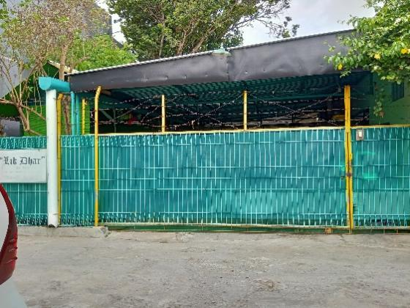 | 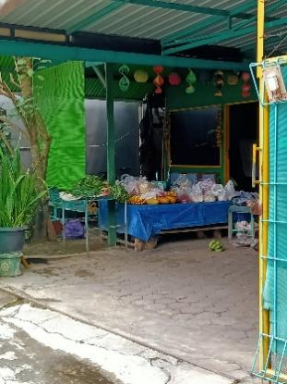

Figure 5. The forming of social spaces in Prawirotaman: space negotiation (left: the closing of a transition area became a private terrace, right: the opening of a transition area became a temporal tavern)

The rampant land construction for tourism affected the more space privatization in Prawirotaman. Yayuk explained her childhood experience that she and her friends went to vacant land with various trees for playing. Today, children utilise the transition space and its elements as a place to play. They gathered on the mosque veranda and climbed over its fence. It reveals that space privatization caused the loss of elements that functioned as a social space. Meanwhile, the forming of social spaces within the kampung occurred using building elements as a substitute for the former social space. In short, the privatization of space caused by territorial separation and the strength of territorial boundaries still provided opportunities for the forming of social space. It was encouraged by territorial negotiations and the leeway in using transitional space and its elements.
The privatization structure: The connectivity and openness of social space

The observation showed that some houses maintained the boundary elements to minimize public access connectivity and openness. There was no forming of social space, although the private transition area (e.g., yard) faced the public transition area (e.g., street, alley) directly. Likewise, the tourism facilities (e.g., homestay, café, restaurant) limited their access to the surroundings; by providing territorial boundaries such as high and solid fences. These findings reveal that space privatization in Prawirotaman was reflected by the lack of interconnection between transition areas. In contrast, some houses maintained privatization by not changing the boundary elements. Hence, there were three types of privatization structure in Prawirotaman: (1) space with no boundary elements between the public and private transition areas (Figure 6(a)), (2) space with solid boundary elements (Figure 6(b)), and (3) space that maintained the existing boundary element (Figure 6(c)).

(a) | 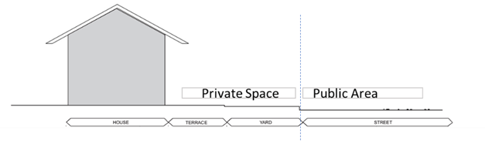 | 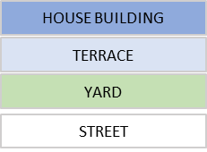
(b) |  | 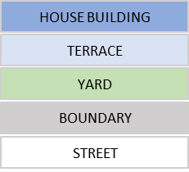
(c) | 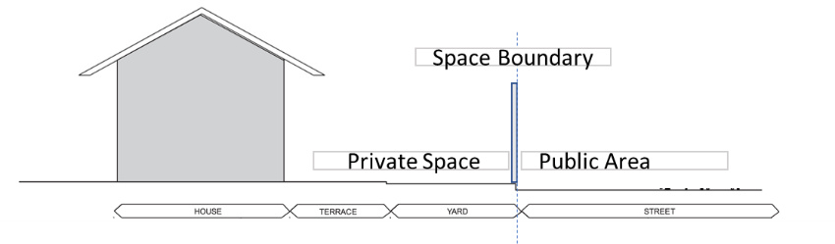

Figure 6. The privatization structure in Prawirotaman

This finding indicates that space connectivity and openness result in the formation of social space in the kampung. Nevertheless, space privatization stimulated the forming of social space. Residents continued to build their social space in another transition area within kampung. For example, the resident of Prawirotaman has moved night patrolling activities (ronda) to the house terrace since the patrol post (cakruk) was demolished for the homestay’s parking lot. Likewise, traditional martial art (pencak silat) has moved to house yard since the vacant land was sold, and a homestay was built.
The transition areas in Prawirotaman were formed by the various boundary elements whereby material and height determined the space privatization. It shows the personal closeness between the residents and their neighbourhood. For example, some residents opened their transition areas (e.g., yards and terraces) visually and physically (Figure 7(a)). The boundary element only functioned as a marker of space ownership. Meanwhile, non-locals tended to close their private space as privatization towards the surrounding transition area (Figure 7(b)). It means that the boundary element also influenced the forming of social spaces within the kampung.

(a) | 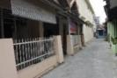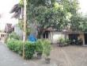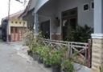
(b) | 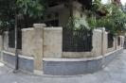

Figure 7. The boundary elements in Prawirotaman

Social activity and social space availability

During the observation, it was seen that the residents in Prawirotaman tended to form social spaces in transition areas, namely on streets and in alleys. The openness and connectivity of these areas allowed them to be accessed by the public, and a space for interaction between residents was formed simultaneously. The formation of this social space coincided with their daily activities in the kampung, which consisted of necessary, social, and religious activities (Figure 8).
In necessary activities, the activities are conducted daily to comply the life's needs (Gehl, 2010), residents of Prawirotaman interact with neighbours in local business spaces, such as traditional stall (warung) and traditional tavern (angkringan) (Figure 8(a)). A man named Adi told his experience: “Gathering at the angkringan is a habit for the residents, especially for men, in the afternoon after working”. Second, in social activities, most residents interacted on the edge of the alleys within kampung (Figure 8(b)). They gathered, sat, and chatted for various durations of time. Occasionally, there were temporal interactions with residents walking in the alley (Figure 8(c)). They just greeted or had a brief conversation. Meanwhile, this activity is also found in the house terrace (Figure 8(d)). A woman named Dewi revealed her and her neighbour's habit every afternoon, and their monthly gathering: “The women living surrounding my house often come here, just to sit and chat, as well as monthly gathering, we hold it on terrace”. Further, it found a religious activity on the mosque's veranda; a group of children recited the Quran (Figure 8(e)).

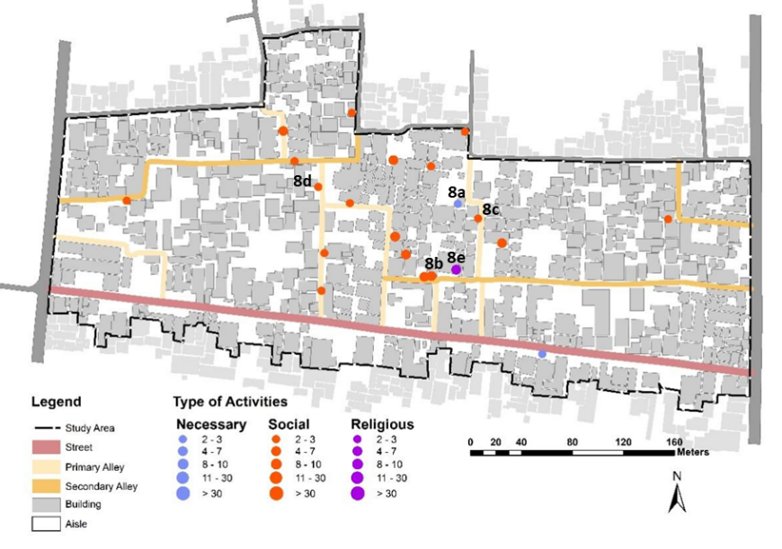
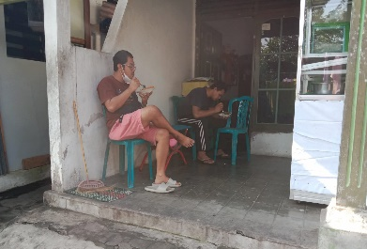 | 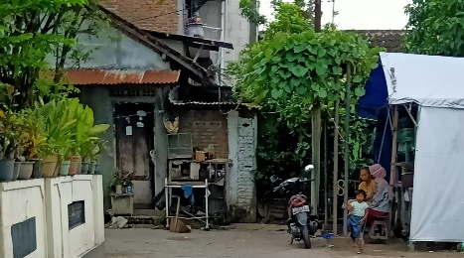 | 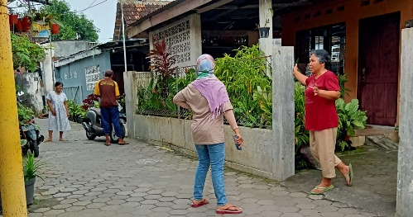
(a) | (b) | (c)
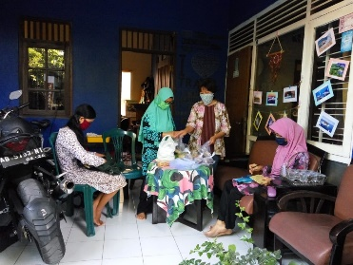 | 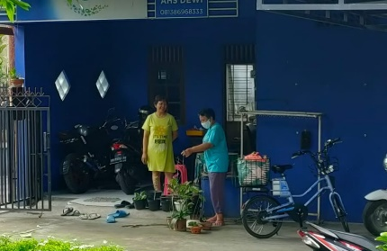 | 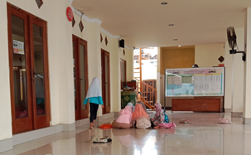
(d) |  | (e)

Figure 8. Resident’s daily activities and their interactions in the afternoon.

There were necessary (n=2), social (n=18), and religious (n=1) activities that formed social spaces of Prawirotaman in the afternoon, before Asr until Maghrib prayers. Therefore, the social space availability in Prawirotaman was influenced by the interaction patterns among neighbours, namely (1) encounters when using transition areas, (2) gathering in the transition areas, and (3) visiting neighbours. It means that the social space in Prawirotaman was formed by social interactions that occur while using the transition area; it could happen spontaneously, temporarily, and even linger. This finding infers that the privatization of space encourages people to form a social space in the transition area believed for public use.

Conclusion

Space privatization in Prawirotaman was caused by spatial transformation due to function change, an urban neighbourhood with overlapping land uses, namely residence and tourism. On the other side, forming social spaces in Prawirotaman occurred continuously. It was driven by the residents' need to interact and caused by influencing factors, such as 1) residents' daily movement, 2) connectivity and openness of the transition area, 3) gathering habits in the community, and 4) availability of social space in the transition area.
Moreover, the transition areas accommodated the various forms of life that stimulated the social behaviour in the kampung, which was interaction among neighbours. The transition areas in the kampung were believed to be public spaces without any specific ownership. It means that the transition areas were spaces that provided flexibility for the kampung residents to use and created them to be shared spaces. Residents formed their social spaces continuously. As a result, the limited social space due to privatization did not reduce the kampung residents’ opportunities for social activities. In other words, space privatization encouraged forming social spaces in the kampung neighbourhood. Furthermore, this research finding explains the importance of transition areas for the kampung community's social activities. It plays a role in forming social space and sustaining the neighbourly life of kampung from the rampant spatial transformation due to tourism. This research is expected to contribute to sustaining the urban villages, particularly those that have transformed into tourist villages, and become the basis for urban tourism planning.

Acknowledgement

The authors would like to thank the MPPLN doctoral scholarship of the Ministry of Higher Education of Republic Indonesia, the Department of Architecture, Universitas ‘Aisyiyah Yogyakarta, and the Department of Landscape Architecture, Universiti Teknologi Malaysia for supporting the research.

References

Abdul Rahim, Z., & Hashim, A. H. (2018). Behavioural adaptation of malay families and housing modification of terrace houses in Malaysia. Asian Journal of Environment-Behaviour Studies, 3(6), 49. https://doi.org/10.21834/aje-bs.v3i6.235
Asadi, M., Tahir, M. M., Shabani, M, & Arjmandi, H. (2015). Introduction to transition space in contemporary Iranian housing typology. Journal of Social Sciences and Humanities, 10(1), 184–194
Brindley, T. (2003). The social dimension of the urban village: A comparison of models for sustainable urban development. Urban Design International, 8, 53–65. https://doi.org/10.1057/palgrave.udi.9000093
Budiyanto, C., Prananto, A., & Tan, F. (2019). Designing embedded case study research approach in educational research. International Journal of Pedagogy and Teacher Education, 3(1), 1–18.
Erfani, G. (2020). Sense of place as an investigative method for the evaluation of participatory urban redevelopment. Cities, 99, 102648. https://doi.org/10.1016/j.cities.2020.102648
Ferguson, J. E., Dahles, H., & Prabawa, T. S. (2017). The Indonesia tourism industry under crisis: A bourdieuan perspective on social boundaries among small-scale business owners. Asia Pacific Business Review, 23(2), 171-191. https://doi.org/10.1080/ 13602381.2017.1281640
Gehl, J. (2010). Cities for people. Island Press.
Hadinata, I. Y. (2017). The characteristic of corridor street space case study: The corridor of Jalan Veteran Penggal Klenteng-Jalan Simpang Ulin. International Journal and Livable Space, 2, 11–20. https://doi.org/10.25105/livas.v2i2.2264
Hall, M. C., & Jenkins, J. (2004). Tourism and public policy. In A. A. Lew, C. M. Hall, & A. M. Williams (Eds.), A Companion to Tourism (1st ed., pp. 525–540). Blackwell. https://doi.org/10.1002/9780470752272.ch42
Hannam, K., Butler, G., & Paris, C. M. (2014). Developments and key issues in tourism mobilities. Annals of Tourism Research, 44(1), 171–185. https://doi.org/10.1016/j.annals. 2013.09.010
Hantono, D., & Pramitasari, D. (2018). Aspek perilaku manusia sebagai makhluk individu dan sosial pada ruang terbuka publik. National Academic Journal of Architecture, 5(2), 67–85. https://doi.org/10.24252/nature.v5i2a1
Hickman, P. (2012). “Third places” and socialinteraction in deprived neighbourhoods in Great Britain. Journal of Housing and the Built Environment, 28(2), 221–236. https://doi.org/10.1007/s10901-012-9306-5
Hutama, I. A. W. (2018). The hidden structure of organic informal-like settlements in Jogjakarta City: An investigation of socio-spatial relationship in an urban kampung. IOP Conference Series: Earth and Environmental Science, 158(1), 0–16. https://doi.org/10.1088/1755-1315/158/1/012003
Laurens, J. M. (2006). Pendekatan perilaku lingkungan dalam perancangan pemukiman kota. DIMENSI (Journal of Architecture and Built Environment), 34(1), 19–30. http://puslit2.petra.ac.id/ejournal/index.php/ars/article/view/16453
Liu, C. W. (2012). Challenges of tourism upon the local community: Behaviour settings in an old street in Tamsui, Taiwan. Procedia - Social and Behavioral Sciences, 68, 305–318. https://doi.org/10.1016/j.sbspro.2012.12.229
Madanipour, A. (1996). Design of urban space (1st ed.). John Willey& Sons.
Malek, N. A., Mariapan, M., & Rahman, N. (2015). Community participation in quality assessment for green open spaces in Malaysia. Procedia - Social and Behavioral Sciences, 168, 219–228. https://doi.org/10.1016/j.sbspro.2014.10.227
Mills, A. (2012). Urban space and social transformation in the Middle East. Journal of Urban History, 38(2), 379–384. https://doi.org/10.1177/0096144211427121
Osti, G. (2015). Socio-spatial relations: An attempt to move space near society. Poliarchie/Polyarchies., 4(April). https://www.researchgate.net/publication/282442154
Peters, K. (2010). Being together in urban parks: Connecting public space, leisure, and diversity. Leisure Sciences, 32(5), 418–433. https://doi.org/10.1080/01490400.2010.510987
Pike, S., & Ryan, C. (2004). Destination positioning analysis through a comparison of cognitive, affective, and conative perceptions. Journal of Travel Research, 42(4), 333–342. https://doi.org/10.1177/0047287504263029
Prayitno, B. (2013). An analysis of consolidation patterns of kampung alley living space in Yogyakarta, Indonesia. Journal of Habitat Engineering and Design, 5(1), 99–112.
Rahmi, D. H., Wibisono, B. H., & Setiawan, B. (2001). Rukun and gotong royong: Managing public places in an Indonesian kampung. In Pu Miao (Ed.), Public Places in Asia Pacific Cities (pp. 119–134). Kluwer Academic. https://doi.org/10.1007/978-94-017-2815-7_6
Saptorini, H. (2006). Teritorialitas permukiman Tepi Sungai code. DIMENSI (Journal of Architecture and Built Environment), 34(1), 55. https://doi.org/10.9744/dimensi.34.1.pp. 31-39
Scannell, L., & Gifford, R. (2009). Defining place attachment: A tripartite organizing framework. Journal of Environmental Psychology, 30(1), 1–10. https://doi.org/10.1016/j.jenvp.2009.09.006
Setiawan, B. (1998). Local dynamics in informal settlement development: A case study of Yogyakarta, Indonesia [Doctoral Dissertation, The University of British Columbia]. The University of British Columbia research repository. https://open.library.ubc.ca/media/ download/pdf/831/1.0099379/1
Setiawan, B. B. (2006). Ruang publik dan modal sosial: Privatisasi dan komodifikasi ruang di kampung. UNISIA, 59(I), 28–38.
Setyohadi, B. (2007). Permukiman Candi Baru. Jurnal Teknik Sipil Dan Perencanaan, 9(2), 97–106.
Shawei, Z., Dinghang, W., & Zhong, Y. (2018). Research on Traditional village based on spatial pattern system in Guangdong Province. IOP Conference Series: Earth and Environmental Science, 153(5). https://doi.org/10.1088/1755-1315/153/5/052039
Sumintarsih, & Adrianto, A. (2014). Dinamika Kampung Kota (1st ed.). Balai Pelestarian Nilai Budaya Daerah Istimewa Yogyakarta.
Sunaryo, R. G. (2010). Perubahan setting ruang dan pola aktivitas publik di ruang terbuka kampus UGM. Seminar Nasional Riset Arsitektur Dan Perencanaan 1, 175–182.
Tang, J., & Long, Y. (2018). Measuring visual quality of street space and its temporal variation: Methodology and its application in the Hutong area in Beijing. Landscape and Urban Planning, 191, 1–18. https://doi.org/10.1016/j.landurbplan.2018.09.015
Titi, E., & Darjosanjoto, S. (2015). Design Criteria for open space at the riverbank area in kampung Wonorejo Timur. International Journal of Education and Research, 3(4), 417–426.
Widyastomo, E. a. (2015). The Transformation of value and meaning of sentani residential tribe in Papua Indonesia. The International Journal of Engineering and Science, 21–32.
Wirawan, I. (2012). Teori-teori sosial dalam tiga paradigma: Fakta sosial, definisi sosial dan perilaku sosial (1st ed.). Prenadamedia Group.
Yeang, L. D. (2007). Urban Design Compendium (2nd ed.). English Partnership, The Housing Corporation.
Yoon, Y., Gursoy, D., & Chen, J. S. (1999). An investigation of the relationship between tourism impacts and host communities’ characteristics. Anatolia: An International Journal of Tourism and Hospitatlity Research, 10(1), 29–44. https://doi.org/10.1080/13032917. 1999.9686970
Yücesoy, E. Ü. (2006). Everyday urban public space: Turkish immigrant women’s perspective (1st ed.). Het Spinhuis.

