

A framework of institutional analysis toward an effective inter-state border delimitation and demarcation in Peninsular Malaysia

Shahril Azhari Jumari¹, Abdullah Hisam Omar¹, Khairulnizam M. Idris¹, Nazirah Mohamad Abdullah²

¹Department of Geoinformation, Faculty of Built Environment and Surveying, Universiti Teknologi Malaysia, 81310, Skudai, Johor, Malaysia

²Faculty of Civil Engineering and Built Environment, Universiti Tun Hussein Onn Malaysia, 86400 Parit Raja, Batu Pahat, Johor, Malaysia

Correspondence: Shahril Azhari Jumari (shahrilazhari@graduate.utm.my)

Received: 19 October 2021; Accepted: 14 July 2022; Published: 31 August 2022

Abstract

The determination of the inter-state border in Peninsular Malaysia is done through the process of allocation, delimitation, demarcation, and documentation. This process was organized by the Joint Boundary Committee (JBC) with the involvement of several agencies from the state and federal governments, coordinated by the Ministry, starting in 1993. This study analyzes the interaction of JBCs in decision-making and the effectiveness of rules-in-use of JBC formation. Data were collected through questionnaires, interviews, participant observations, and document reviews and then analysed using the Institutional Analysis and Development Framework (IAD) based on content analysis. The rules-in-use in the establishment of the JBC include position rules, boundary rules, choice rules, aggregation rules, scope rules, information rules, and pay-off rules that cannot direct interaction effectively. For enhancement, a configuration of seven types of rules can be used because the analysis results show that seven types of rules have found significant weaknesses in establishing existing JBCs. Therefore, the implementation of the IAD will effectively coordinate the management and administration of the JBC in making decisions to expedite the inter-state border delimitation and demarcation in Peninsular Malaysia in line with the 16th goal of the Sustainable Development Goals.

Keywords: Demarcation, institutional analysis, inter-state border, Joint Border Committee, Peninsular Malaysia, rules-in-use

Introduction

Determining and finalizing borders is very important, as it symbolizes the sustainability of the institution of national sovereignty. After the Anglo-Dutch Treaty, also known as the London Agreement, was signed in 1824 and the formation of Federated Malay States by the British Empire in 1896, the delineation of the inter-state border in Malaya was specified in the treaty as stated in the Land Code of 1926 in the Federated Malay States Government Gazette 1926. The basis for defining inter-state boundaries in Malaysia today is also based on concepts introduced by the British such as The Boundary Convention dated June 20, 1891 (signed in London), Bangkok Treaty of 1899 (Boundary Agreement), Bangkok Treaty of 1909, Federation of Malaya Government Gazettes, Memorandum of Understanding (MoU), exchange of correspondence between the Secretary of the Resident, Terms of References (ToR), the adjacent cadastral lots and main watershed. Delimitation and demarcation of the inter-state border in Peninsular Malaysia are divided into two (2) types of boundaries, namely artificial and natural boundaries. This artificial boundary involves boundary marking using a boundary mark that is very synonymous with this boundary demarcation work. For natural boundaries such as rivers, watersheds, and so on, those elements will be used as the basis for the inter-state borders as stated in the border treaty (Starke, 2007). The basis determination of the natural state border in Peninsular Malaysia is shown in Figure 1.

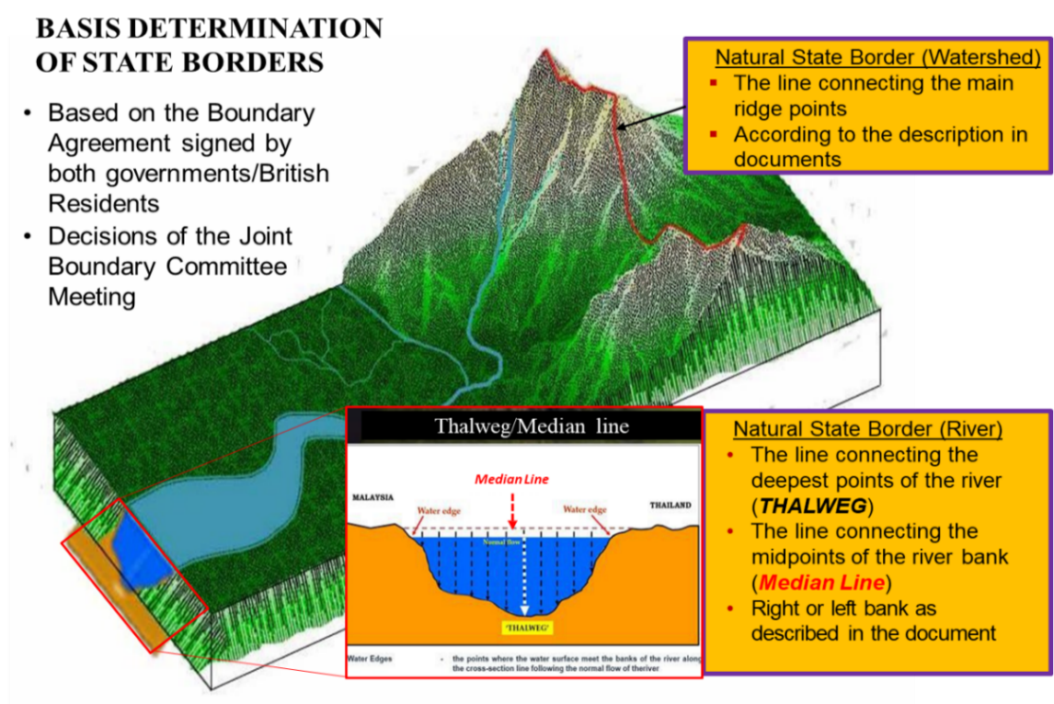
Source: DSMM (2021)

Figure 1. Basis determination of natural inter-state border in Peninsular Malaysia

The practice of determining the inter-state natural and maritime border in Peninsular Malaysia is done through the process of boundary allocation, delimitation, demarcation, and documentation of border area. This process was organized by the Joint Boundary Committee (JBC) with the involvement of several agencies from the state and federal governments, coordinated by the Ministry of Land and Cooperative Development. The decision of the Cabinet at its meeting on March 10, 1993, while considering a Memorandum from the Ministry of Land and Cooperative Development entitled “Delimitation and Demarcation of Inter-State Borders in Peninsular Malaysia,” has established and formed three (3) Joint Border Committee (JBC) which is National Joint Border Committee, State Joint Border Committee, and Joint Technical Committee. The purpose of this committee was established is aimed at coordinate the work of allocation, delimitation, and demarcation of inter-state borders with funding borne by the respective states (Cabinet Council, 1993). In line with this decision, the Trust Account Committee for the Delimitation and Demarcation of Inter-State Borders in Peninsular Malaysia was created on January 1, 1994, in the Ministry of Land and Cooperative Development under the provisions of Section 9 of the Financial Procedure Act 1957. This Trust Account was created specifically to receive donations from the state governments and subsequently used to finance all expenditures related to the state coordinated delimitation and demarcation work carried out by the Department of Survey and Mapping Malaysia (DSMM). Several issues causing delays in resolving the inter-state border in Peninsular Malaysia are as follows: -
- The selection of the river as the state border, as stated in the treaty by the British colonialists in the 19th century, is difficult to resolve due to river flow changing course that has not been following the treaty caused by accretion and avulsion (Donaldson, 2011, 2013; Srebro, 2006, 2018). This issue is discussed repeatedly in each meeting, with no decision leading to a specific solution.
- State Government does not prioritize the demarcation and delimitation of borders between states as the main agenda of state development (Hemananthani et al., 2018; Samadi Ahmad, 2022; Raja Hisyam, 2022; Mohd Azlim, 2022). The still blurred boundary lines it has slowed down local authorities' planning and development of inter-state border areas.
- The transition of state governance had a significant impact on the determination of inter-state borders. This government transition resulted in the postponement of the meeting to finalize the state border (Zahratulhayat, 2020; Mustakim, 2022). The role of both the chief minister and the state government is vital as the change in the state ruling politics will only delay the finalization of the inter-state border.
- There are no explicit policies on managing inter-state land borders and maritime borders or the need for coordination between agencies involved that manage the inter-state borders in different sectors (Ostrom, 2011; Nigussie, 2018). Specific guidelines need to be made because the border area is located above the common pool resource area to facilitate the governance of both state governments.
- Procrastination and delays in decision-making caused demarcation costs to overrun 211.85% from 1994 to 2006 and once again overrun 153% in 2016 for unavoidable reasons (Cabinet Council, 2006, 2016). The increased costs incurred due to delays in decision-making and demarcation will be to the detriment of both state governments.
To determine maritime boundaries, land boundaries (including natural borders such as rivers) must be finalized first. To establish a lead agency for finalizing maritime boundary, a list of rights, restrictions, and responsibilities need to be addressed among the committees of the state’s maritime boundary. Currently, in the JBC, Malaysia still lacks the expertise to finalize the inter-state border demarcation other than DSMM (Fairuz Zaidan, 2017; Mohd Noor Isa, 2018). Some of the practices and implementations of delimitation and delimitation of the inter-state border in Peninsular Malaysia produced by the JBC do not yet have the full capability and capacity (Nurul Huda Husain, 2020). The interaction of the actors in decision-making is still relatively slow because the appointment of the member elements involved is not based on expertise and experience so the problems raised drag on for quite some time, and there is no best solution. The rules-in-use in shaping the JBC has not yet taken into account elements such as norms, restrictions, and responsibilities; this case brings it into difficult enforcement (Yusmizal Dolah Aling, 2020). Restrictions and enforcement are required in the management of inter-state border determination. Thus, knowledge of the rules of JBC formation is interesting to study. This study aimed to find major weaknesses in the formation of existing JBCs, then formulate reform rules to improve the effectiveness of JBCs in decision making. This study will use the Institutional Analysis and Development (IAD) framework from Ostrom (2011) because the external variables group of a rules-in-use are the components that influence the action structure and behavioral situations of the actors in the interaction.

Literature review

In current practice, JBC in Peninsular Malaysia practices 4 process steps: allocation, delimitation, demarcation, and documentation, based on the theory of Stephen B. Jones (1945). This process has been going on since 1994 but was implemented rather slowly due to delays in the delimitation stage as there were mostly issues related to geographical physical changes in the area to be demarcated. According to Stephen B. Jones (1945), in the process of border making, in theory, boundary-making is included in the category of delimitation and demarcation. He divides the formation process into four parts: Allocation, Delimitation, Demarcation, and Administration (Donaldson & Williams, 2008). Among the issues of delay that arose was due to the state boundaries according to the treaty being set according to natural boundaries such as rivers. As a result of natural and man-made factors, the flow of the river has changed from the original agreement, as also discussed by scholars from around the world (Donaldson, 2011, 2013; Srebro, 2006, 2018). To solve this problem, agreement and bilateral consideration through the political will of both states are essential.
This study is based on the Rules-In-Use related to the Framework of Institutional Analysis and Development (IAD). Institutional Analysis and Development is a set of evaluation concepts for analyzing the institutions' social structure, positions, and rules. The political scientist introduced the analysis introduced by Elinor Ostrom (Ostrom, 2011) is the best option to study and understand how the institutions operate and change upon implementing specific projects. Generally, IAD is a systematic method for organizing policy analysis activities compatible with a wide variety of more specialized analytic techniques used in the physical and social sciences. Today it is widely practiced in common-pool resources governance such as forestry (Sinabutar, 2014; Suwarno et al., 2014; Brodrechtova et al., 2018), catchment areas (Nigussie et al., 2018; Ran et al., 2020), marine spatial planning (Rudd, 2017; Yatim, 2019), natural resources (Rahman et al., 2017), and collaborative governance (Brisbois et al., 2019).

Materials and methods

Study area

This research was conducted in the JBC along the interstate border of Peninsular Malaysia. Figure 2 depicts the demarcation process implemented by the Department of Survey and Mapping Malaysia (DSMM) for the nineteen (19) land boundary sectors, and Figure 3 depicts the demarcation process for the ten (10) maritime boundary sectors in peninsular Malaysia. On the basis of the situation as of July 11, 2019, the estimated total interstate boundary distance in Peninsular Malaysia is 2,540.6 kilometres. As of December 31, 2020, a total of 1,223.5 kilometres (47.8 percent) had been completed and demarcated. To date, only 7 border sectors have been finalised with boundary agreement which is Pahang-Terengganu, Perak-Pahang, Pahang-Negeri Sembilan, Pahang-Selangor, Kelantan-Terengganu, Negeri Sembilan-Melaka and latest is Selangor-Negeri Sembilan on July 4, 2022. This research focuses on inter-state border delimitation and demarcation in Peninsular Malaysia, especially in Selangor-Perak and Selangor-Negeri Sembilan borders. It has been chosen as the pilot study to enhance JBC practice in peninsular Malaysia.
As part of the research, a questionnaire with 44 validated close-ended questions was provided to 45 selected respondents, including the Technical Committee of the Joint Border Committee and the major institutions DSMM, Selangor, Perak, and Negeri Sembilan Land and Mines Office. The Director of Land and Mines of Selangor, Subject Matter Experts Officers, and Director of the Boundary Affairs Section of the Department of Survey and Mapping Malaysia were interviewed face-to-face to receive feedback and validation on the previously circulated closed-ended questionnaire. The goal of the interview was to determine their knowledge and understanding of how JBC meetings and decisions were conducted and the flaws of the regulations since the JBC's inception in 1993.

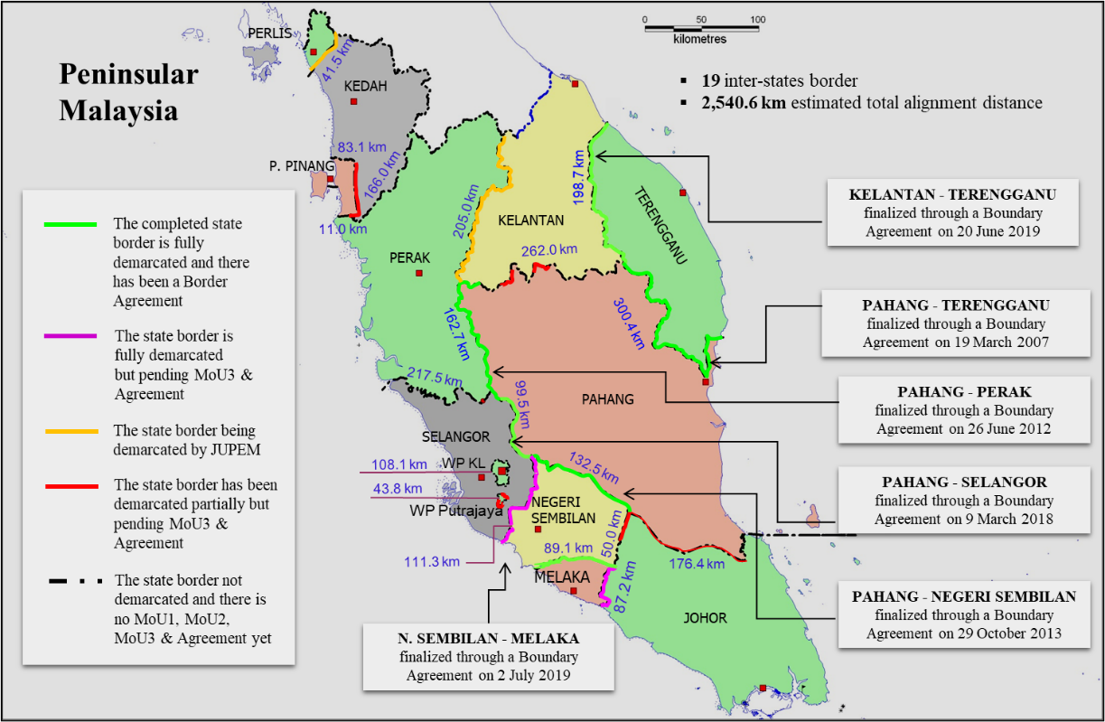
Source: DSMM Annual Report (2020)

Figure 2. Inter-States Border Delimitation and Demarcation Project Status in Peninsular Malaysia (land boundary)

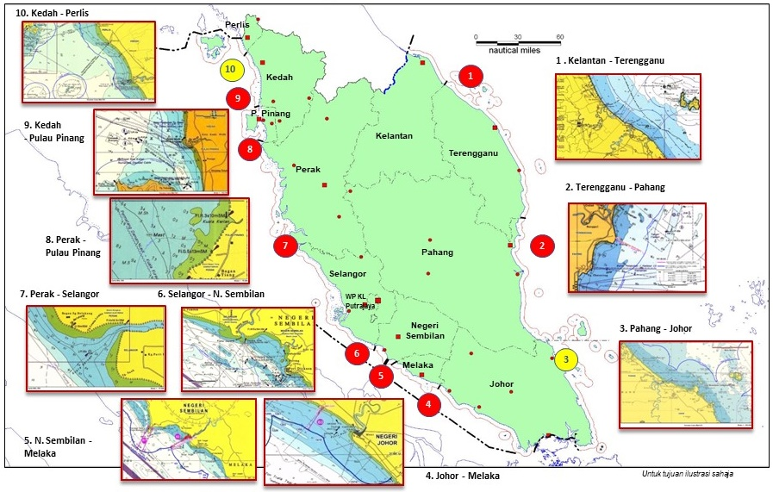
Source: DSMM (2017)

Figure 3. Inter-States Maritime Delimitation and Demarcation Sector Status in Peninsular Malaysia

Nine (9) maritime border sectors have not been demarcated and are in the process of finalizing the MoU. Accordingly, appropriate action should be taken by the State Authorities proactively to ensure that Memorandum of Understanding 1 (MoU 1) & Memorandum of Understanding 2 (MoU 2) are finalized and boundary demarcation can be implemented. Nevertheless, only one (1) MoU of the Maritime Boundary Treaty between the state of Melaka and Negeri Sembilan was signed on October 15, 2019. This was history because it was the first established sector of the maritime boundary in Peninsular Malaysia (Negeri Sembilan, 2019). In addition, not only do issues arise from technical perspectives, they are even more critical when it comes to the process of determining and finalizing the boundaries at the State Authority level.
The inter-state border that has not yet been demarcated are the natural boundaries that involve rivers located in Sanglang River (Perlis-Kedah border), Muda River (Kedah-Penang border), Kerian River (Kedah-Perak border), Bernam River (Perak-Selangor border), and Endau River (Pahang-Johor border). Two borders involving rivers have been demarcated but have not yet received approval from the state government because of some issues that are still under discussion, which are the Sepang River (Selangor-Negeri Sembilan border) and Kesang River (Melaka-Johor border). Only one river boundary that both state governments have agreed upon is at Linggi River (Negeri Sembilan-Melaka border) in 2019. The maritime boundary MoU for the two states was also completed in the same year (Negeri Sembilan, 2019).

Material

Standard Operating Procedure (SOP) of inter-states border delimitation and demarcation in peninsular Malaysia (NRE, 2014) pertaining to the roles in the formation of the JBC, and Terms of Reference (ToR) pertaining to the technical instructions are analyzed as part of this study (DSMM). The analysis will be limited to SOP and articles pertaining to the formation of JBCs, taking note of the implications for the former participants' behavior, performance, and impact.
The Ministry issued the Standard Operating Procedure (SOP) of Inter-States Borders Delimitation and Demarcation in Peninsular Malaysia in 2014, stating that the determination of inter-state borders in Peninsular Malaysia is based on the laws, treaties, government gazettes, letters, terms of reference (ToR), and memorandum of understanding (MoU) made between the states. This committee was established for the purpose of coordinating the allocation, delimitation, and demarcation of interstate boundaries, with funding split evenly between the two states. As depicted in Figure 4, the process of finalizing the state boundary involves multiple phases of MoU production, the Task Force (ToR), and the Agreement.

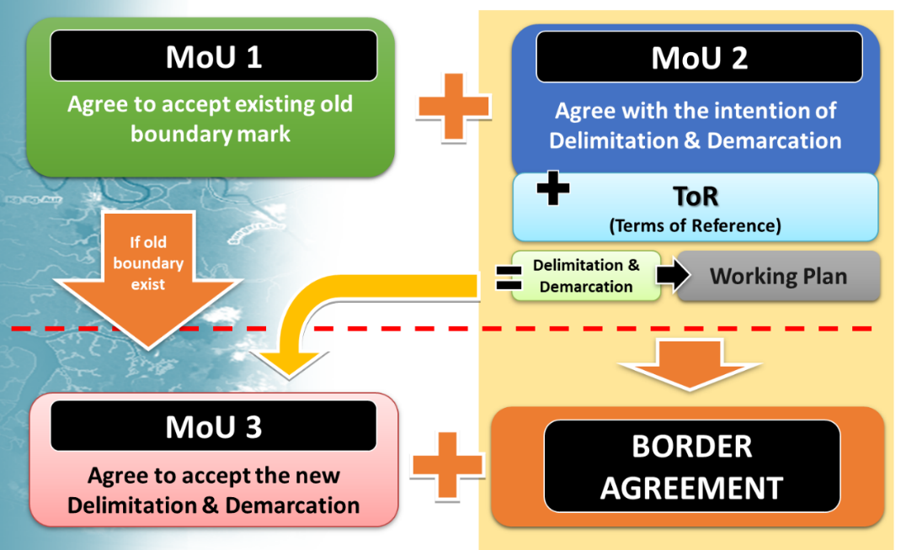
Source: Cabinet Council (1993).

Figure 4. flowcharts of Delimitation & Demarcation of Inter-state Border MoU

In addition, every approval for the Interstate's Border Delimitation and Demarcation must obtain the approval of the State Government Council and should be made known to His Excellency the Sultan or the Yang di-Pertuan Negeri for approval. The lists of government agencies involved with the inter-state border committees that will be covered in the research are shown in Table 1 below.

Table 1. Lists of Malaysian Government Agencies involved with the Joint Boundary Committee

No. | Institutions | Ministry/Agencies
- 1. | - Department of Survey and Mapping Malaysia | - Ministry of Energy and Natural Resources
- 2. | - Department of Director General of Lands and Mines | - Ministry of Energy and Natural Resources
- 3. | - Department of Forestry | - Ministry of Energy and Natural Resources
- 4. | - Land, Survey & Mapping Division | - Ministry of Energy and Natural Resources
- 5. | - National Security Council | - Prime Minister’s Department
- 6. | - Economic Planning Unit | - Prime Minister’s Department
- 7. | - Attorney General | - Attorney General’s Chamber
- 8. | - State Government Secretary | - State Government
- 9. | - State’s Land & Mining Department | - State Government
- 10. | - State Legal Officer | - State Government
- 11. | - State Finance Officer | - State Government
- 12. | - State Economic Planning Unit | - State Government
- 13. | - Secretary of the State Security Committee | - State Government
- 14. | - State Development Officer | - State Government
- 15. | - Land & District Office | - State Government
- 16. | - Local Authority | - State Government
- 17. | - Royal Malaysian Police | - Malaysian Armed Forces
- 18. | - Royal Malaysian Army | - Malaysian Armed Forces
- 19. | - Royal Malaysian Navy | - Malaysian Armed Forces
Source: Ministry of Energy and Natural Resources

Among the matters decided by the Cabinet in its meeting on March 10 1993 while considering the Memorandum from the Ministry of Land and Cooperative Development (now KeTSA) Paper No. 146/1865/93 entitled "Delimitation and Demarcation of Inter-state Borders in Peninsular Malaysia" agrees:
  - with guidelines (procedures) for the implementation of the delimitation and demarcation of the inter-state border in peninsular Malaysia;
- the cost of delimitation and demarcation of inter-state borders borne jointly by the state governments involved; and
- creating a Trust Account in the NRE for the delimitation and demarcation of the inter-state border in peninsular Malaysia can run smoothly.
In line with the decision, the Joint Border Delimitation and Demarcation Project Trust Account of the States of Peninsular Malaysia was established on January 1 1994 in the Ministry of Land and Cooperative Development under the provisions of Section 9, Financial Procedure Act 1957. This Trust Account is created specifically to receive contributions from the state governments and subsequently used to fund all expenses related to the work of inter-state border delimitation and demarcation carried out by DSMM. The roles in the formation of the Joint Boundary Committee (JBC), which have been established with the Cabinet's approval, are shown in Figure 5.

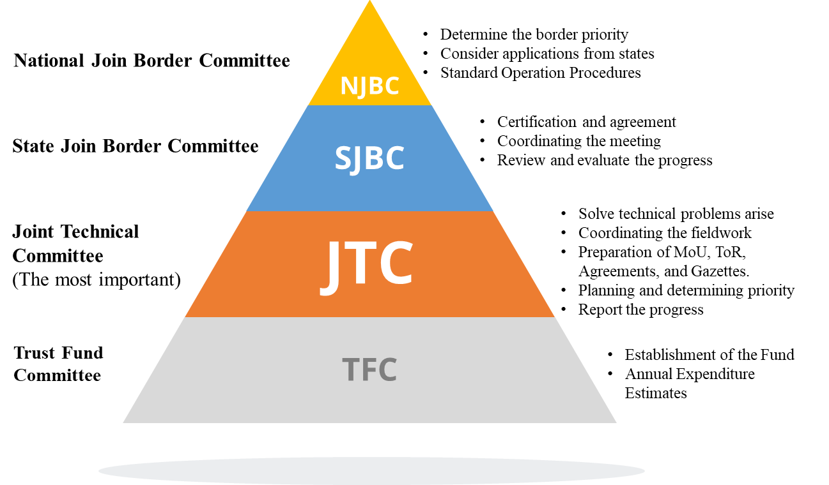

Figure 5. Roles in the formation of the Joint Boundary Committee
Below are the stages, actions, and responsibilities taken by JBC in Peninsular Malaysia summarized from Standard Operating Procedures as shown in Figure 6.
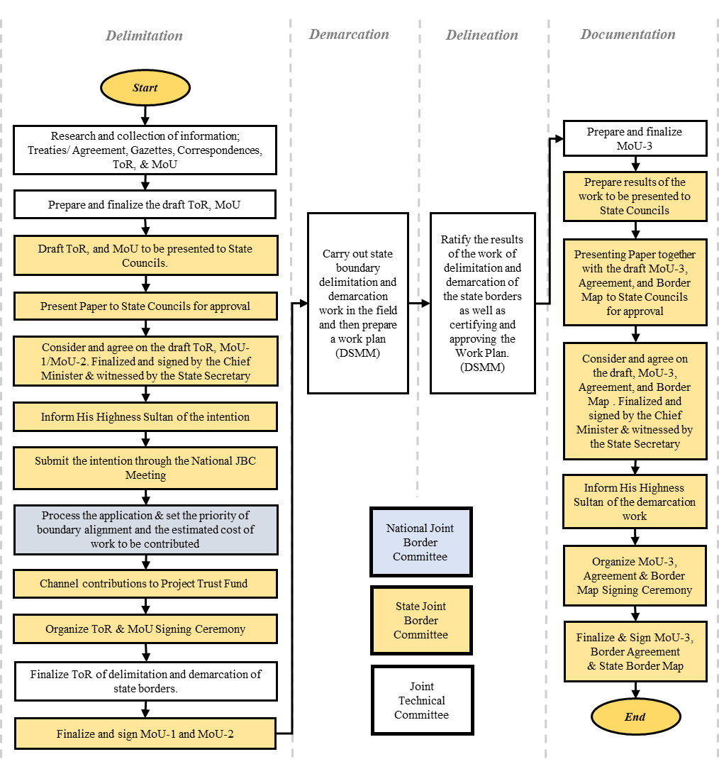

Figure 6. The stages flow, actions and responsibilities taken by JBC in Peninsular Malaysia summarized from Standard Operating Procedures

Data analysis

This study employs a quantitative and qualitative methodology with case study techniques (Creswell et al., 2011). Questionnaires, Document analysis, participant observations, and interviews were employed to collect data (Sinabutar, 2014). The study's objective was to identify informants, i.e., some JBC members, using snowball sampling techniques. Triangulation of sources and techniques is utilized to test data validity (Creswell et al., 2018). The data were then analyzed using content analysis following the IAD framework (Ostrom, 2011). Position rules, boundary rules, choice rules, aggregation rules, information rules, scope rules, and pay-off rules. This classification is directly related to the structural elements of the action situation, including participants, positions, authority actions, control, information, impact or results, and cost-benefit analysis. Figure 7 depicts the relationship between the elements of rules-in-use and the situation's action elements.

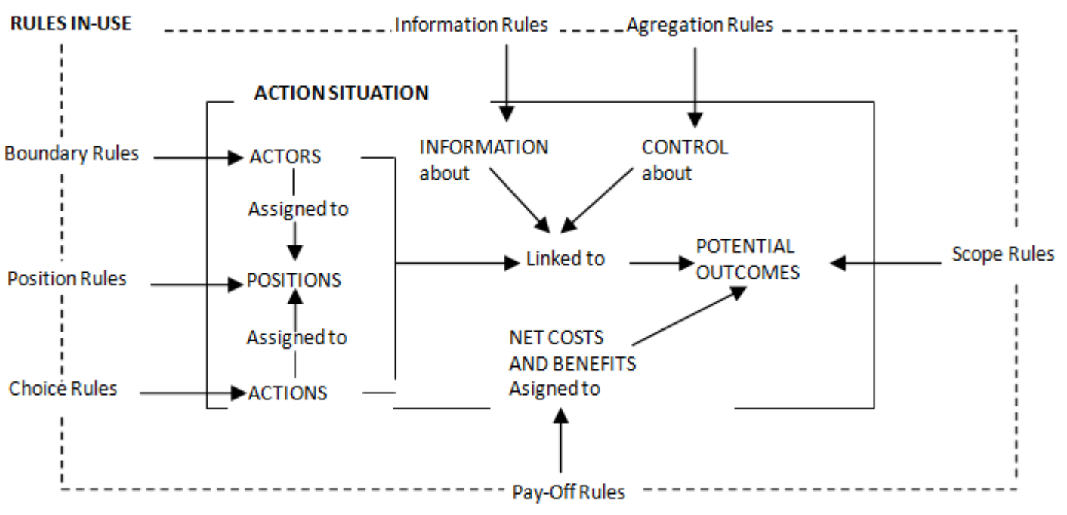
Source: Ostrom E (2011)

Figure 7. Linkage Rules-In-Use to action situation

On the basis of an analysis of the rules governing the interstate border delimitation and demarcation plan, the institutional behaviour of the committee is developing the rules for the policy of state border demarcation along the Selangor-Perak and Selangor-Negeri Sembilan borders. In addition, the Institutional Analysis and Development framework for the study of organizational behaviour incorporates the effectiveness components.
This study concludes by integrating the modified IAD framework with the effective practice of a joint border committee in order to propose a solution for the formation of institutional interstate border demarcation (Yatim, 2019). Using the Selangor-Perak and Selangor-Negeri Sembilan borders as a case study, this study investigates the relationship between the committees involved in the joint delimitation and demarcation of the borders. As the first stage of the study entails identifying the effective components of JBC practice, the framework focuses primarily on analyzing the rules influencing the Action Situations section. The Action Situations section clarifies the specific knowledge adapted by the framework, the actors, and the institutions involved in the activity, as well as their interaction patterns (Suwarno et al., 2014). Consequently, effective governance of joint border demarcation practice is being added to the external variable platform as a new variable. Figure 8 depicts the newly adopted framework for the research.
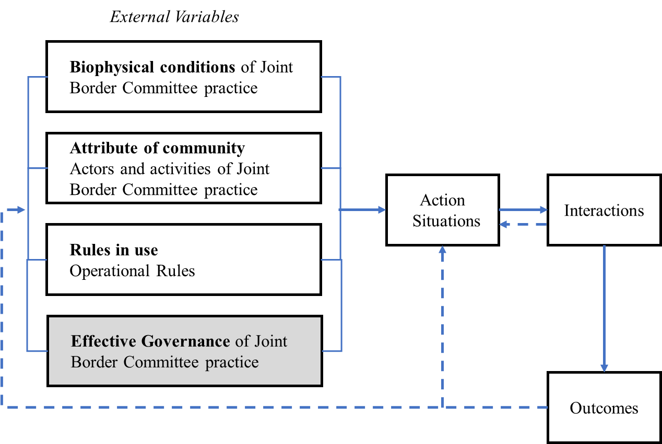
Source: Yatim M.H.M (2019)

Figure 8. Modified IAD Framework for the Research

Conceptual framework of research

According to Van Trung Ho et al. (2014), a conceptual framework for JBC is much needed but before that, some steps need to be streamlined to achieve the objectives to make the inter-state border demarcation progress to be more effective. Firstly, committees need to know more in-depth about the factors of effective border making as stated by Donaldson (2013) in Creating Effective Structures and Practice Boundary Commissions. There are five keys to forming an effective joint boundary commission: Constitutive Agreement, Mandate, Structure, Technical Specifications, and Dispute Resolution Mechanisms (Donaldson, 2013). By doing this, the federal and state government in charge of the JBC will focus not solely on the technical and legal aspects of border demarcation, but on the institutional and organizational behavioral aspects.
Second, institutional behavior assessment needs to be carried out on decision-making committees, especially the State Joint Border Committee and the Joint Technical Committee. Behavioral assessment analysis will be implemented according to the population consisting of individuals, groups, and organizations involved in the two committees. Thus, the expected outcome is individuals who are truly qualified in decision-making without delaying the process related to the implementation of state boundary demarcation. With behavioral analysis on the population involved, the organizations involved in the JBC are expected to provide more effective commitment among the committees
Finally, the JBC involved will go through Institutional Analysis and Development (IAD) to establish an updated integrated rule-in-use specifically focusing on the concept of effective state boundary demarcation by streamlining legal aspects, and pending development in border areas, which have not been implemented at the moment. The IAD also added to the state government's knowledge that involved the importance of expediting the demarcation of state boundaries and its impact on the state's economy. The author will deliver the conceptual framework into a scheme of thought as follows:

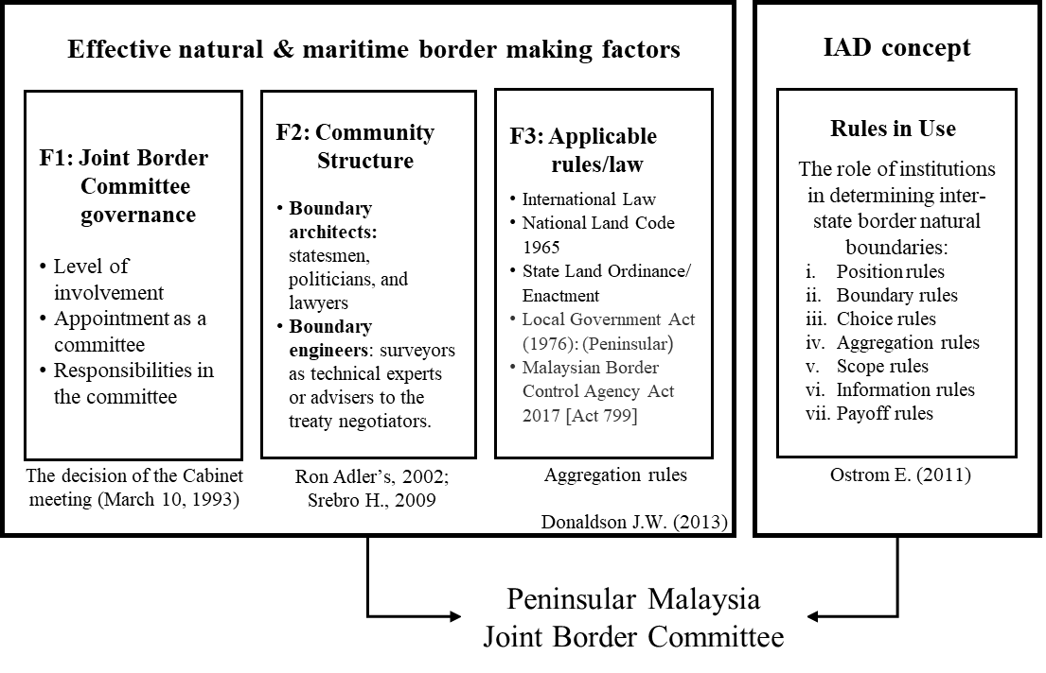

Figure 9. Conceptual framework for effective inter-state border delimitation and demarcation practice in Peninsular Malaysia

To make the JBC more effective, the state border scholar's recommendations for establishing the JBC should be implemented. Next, the effective factors must interact with the analysis of organizational behaviour and IAD implementation. As described in the results and discussion, the reorganization of the JBC produces the interaction outcomes.

Results and discussion

Interaction and the role of JBC

In several Joint Border Committee technical meetings conducted since 2014, problems related to river flow changes were the main cause of delays in border demarcation. The time taken was too long to investigate in the field and the administration. As a result, the MoU is not signed as long as a mutual agreement is not reached. The entire border sector could not be demarcated because as long as MoU 2 was not signed by both states, survey work for boundary demarcation in the field could not be carried out. Funds for demarcation using trust accounts will only be spent after MoU 1 is signed by both states (DSMM). State’s Border should not be influenced by the changing course of a river, MoU 1 or MoU 2 should be able to be signed so that the marking work can be started (Prescott & Triggs, 2008; Jerome Bouyjou, 2011, Donaldson, 2011; Srebro, 2018).
As the border demarcation work faced various problems related to issues in the field such as unpredictable geographical conditions, river flow shifted due to accretion and avulsion which no longer followed the original treaty, political transition resulted in a change of state government, bureaucratic problems, and several other factors, the process of demarcation between states has been slow (Kokha, 2019). The federal government is of the view that the delimitation and demarcation of state boundaries are very important (Hemananthani et al., 2018). Cabinet Council has approved a proposal that the entire cost of demarcation work will be borne by the state government in a ratio of 25:25:50. The Federal Government with the approval of the Cabinet Council will bear 50% of the total cost that has exceeded the earlier estimate. While the two adjacent states will bear the cost with a ratio of 25:25, which is 25% for each state. This will of course have enormous financial implications for the State and Federal Governments (Cabinet Council, 2016). Therefore, the longer the state boundary is delayed, the higher the operating costs will be borne by the Federal Government and the States Government involved.
Another major reason for the delay in finalizing the inter-states border was the state government's transition (Srebro & Shosany, 2006). This government transition resulted in the postponement of the meeting to finalize the state border MoU signed by the two Chief Ministers of the state. It is difficult to decide if the political situation is unstable because of the boundary process by the state led by the chief minister or Menteri Besar. The transition of ruling politics had a major impact on the determination of inter-state borders. For instance, the state border coordination meeting between Perak and Selangor has been postponed several times since 2018 as a result of the transition of the ruling political party in Perak (Zahratulhayat & Mohd Nasaruudin, 2020). Hence, decisions and solutions on issues that arise cannot be made and indirectly will increase the cost of inter-state border demarcation.
Based on these findings, the roles of JBC in the inter-state border committee have not effectively produced efficiency because the rules-in-use are inefficient due to conflict with the norms. Some roles are seen as overlapping. The rules will not be efficient if it goes against the norm, it can even lead to high transaction costs in its implementation in the future. Thus, the outcome of the JBC’s enhancements for demarcating the interstate border will also enable local authorities to carry out effective enforcement measures against land encroachment and illegal resource extraction. In addition, the management and distribution of natural resources in the border regions will be implemented efficiently for the benefit of the citizens of both states. This reorganization will provide a clear distinction for each discussion to carry out its functions. This clarity will expedite the inter-state border demarcation process in peninsular Malaysia following the 16th Sustainable Development Goal (SDGs).

Analysis of rules-in-use

Each variable in an action situation will be affected by the rules-in-use. In the IAD framework (Ostrom, 2011), the rules implemented will affect the structure and behaviour of the interaction's actors. Seven rules of action are used to construct situations and determine which actions occur (McGinnis, 2011; Ostrom, 2011). If rules are not formulated with common sense, there will be confusion regarding what actions are required, prohibited, or permitted (Ostrom, 2011). Therefore, it is crucial to comprehend the rules-in-use in an institution. In other words, the performance of institutional rules can be determined by analysing the seven configurations of rules currently in use. The performance of the delimitation and demarcation of interstate borders is determined by the interaction between JBC and the action situation. This interaction will ensure that the delineation of the interstate border complies with the decision and is also acknowledged by all parties. The effectiveness of these interactions will be influenced by the rules in play, including the rules that determine the members, positions and authorities, rights and responsibilities, funding, and accountability. The capability of the Government formed by the JBC is determined by analysing the acceptable aspects of any rules that will influence the outcome of the interstate border demarcation. In this instance, policy analysis can examine the extent to which the composition rules have been consistent and whether there is a discrepancy between the objective and the actuality. This paper will focus on the interstate border between Selangor-Perak and Selangor-Negeri Sembilan. It is necessary to identify significant flaws in the formation rules of existing JBCs. The outcomes are described in the subsequent paragraphs.

a. Position rules

Position rules create positions for participants and determine which institutions hold positions and what their responsibilities are. It is established at the national level as either a National JBC, State JBC, or Joint Technical Committee function. At the Peninsular Malaysia level, the Secretary-General of the Ministry determines the position of the JBC, including its approved authority and duties (Cabinet Council, 1993). There is no clearly defined mechanism for determining JBC's organizational structure. The position of the JBC is automatically determined by Cabinet decisions, with the Secretary-General of the Ministry serving as its head and officers from various departments at each level of work serving as component members. There is a lack of balance in decision-making due to the fact that a large number of government administration personnel lack expertise in the technical area of borders. Coordination is ineffectively facilitated by ministries, which are hindered by protocol and ranking levels. Ineffective coordination resulted, and the Ministry made some decisions unilaterally. The facts contained in the positional rules, namely:
(1) The JBC continues to adhere to the normative rules governing it. There should be an explanation for the position and contributions as well, for instance in terms of how the contributions of the institution and its head, as well as other members, are not cumulative;
(2) duties and responsibilities are still carried out normatively as the aforementioned rules must clarify the duties and responsibilities of the members of the appropriate elements as their duties and functions. Prior to the installation of placemarks, DSMM is responsible for preparing and providing information and evidence documents such as maps and aerial photographs. It will be described which division of the Department of Irrigation and Drainage is responsible for rivers in border regions. The National Archives contains historic border treaties and agreements from the past. Using a space plan, the Forestry Department evaluates the forest. The same applies to the roles and responsibilities of other members;
(3) there is no clear job description and mechanism for assigning positions. The position corresponds to the organizational structure position. Similar to their duties and authorities, the roles they are specifically responsible for are not specified.

b. Boundary rules

The boundary rules specify a set of requirements (such as the qualifications or qualifications of a member or director) that a participant must meet in order to hold office, and they directly influence the participant in an action situation. Mechanisms and criteria for determining who is qualified to serve in any position on the JBC are outlined in this section. They have not specified the conditions in detail. Although membership is stipulated in the JBC's Standard Operating Procedures, the requirements for membership have not been established, as each member is automatically assigned an officer attached to the structure or another officer authorized to be appointed as a member. Every level officer in an organizational unit or department automatically joins the JBC. In an ideal world, the rules under the Cabinet Council (1993) would have established the criteria and conditions for a person to become a member, as the aforementioned rules allow for the determination of members. According to the aforementioned rules, JBC members consist of elements that can be interpreted in order to select competent members with the necessary expertise. Consequently, JBC has no right to assert liability. Due to retirement or transfer, JBC membership is not associated with successor members. Automatic replacement occurs without the assignment of duties and responsibilities.

c. Choice rules

The types of actions or formal authority for each position are determined by choice rules. In other words, these rules determine the Ministry and regulate the JBC's rights and responsibilities as the organizer of the boundary. Rights and responsibilities remain normative. Each member's rights were not governed by the rules, which were more focused on stipulating obligations. This indicates that the rules impose fewer stringent obligations. The primary responsibility of the rule is to outline the steps to be taken to resolve issues relating to the interstate border, forest, river, and land in the border region. The completion and settlement mechanism has not been determined throughout the duration of the project's implementation. The choice and authority of the State Government are determined by the chief minister. In some states, the choice has not been implemented due to a change in the ruling political party. The Selangor-Perak border, for instance, has not been determined since 2011 and has been observed since then. Even since the British colonial era, there are 200.5 kilometers that have not been demarcated but have been mapped.

d. Aggregation rules

Regardless of whether individuals or organizations decide on actions individually or collectively, these rules governing decision-making mechanisms must be reached through consensus. This rule will govern matters related to the maximum amount of income that can be received or deducted for the set. If it meets the Department of Survey and Mapping Malaysia (DSMM) requirements for technical provisions, legal provisions, and complete documentation, the determination process will be completed. In the JBC, decision-making arrangements include: (1) a meeting chaired by the chairman, (2) if the chairman is unable to attend the meeting, he can delegate to the employee appointed by power of attorney and given full authority to make decisions and sign documents boundary, and (3) if the member is unable to attend the meeting, the member may delegate to the authority appointed by power of attorney and given full authority to make decisions and sign documents boundary. At least three times per year, national, state and JTC-level border meetings should be held. As its significance is consistently overlooked at both the state and federal levels, it is assumed that state boundaries do not generate revenue and return to state revenue. The same is true for the national border meeting, which is chaired by the Ministry's general secretary because the Ministry prioritizes other matters. The chairmanship cannot be assumed by a subordinate. Progress along the state border is ostensibly the responsibility of the state government, which is chaired by the State Secretary and reports to the Chief Minister. Nevertheless, political instability in the involved states can delay the completion of state borders. Due to the postponement of meetings and discussions regarding the determination of state boundaries, no decision could be made. Although the Joint Technical Team, chaired by the State Director of Lands and Mines, always engages in formal and informal discussions, the decision cannot be implemented because any decision made at the JTC level must be discussed at the State JBC and National JBC levels before a final decision can be made. This persisting procrastination requires immediate corrective action. As a result, there are 914.6 km (36 percent) of problematic state natural boundaries, such as rivers, that have been delineated in a previous treaty but have not been determined. It is proposed that boundary demarcation be conducted in non-problem areas, while problem areas are separated for discussion in the "Outstanding Boundary Problem" (OBP).

e. Information rules

The information rule specifies information about the expected output of an action performed by a participant in a position. These rules have a direct impact on the information provided to the JBC regarding situational actions. Although reporting rules and standards for the information have been established, it has not yet been established. The purpose of the information is to inform the state government regarding the development of the country's borders. Observe the situation on the ground to determine which rights could not be resolved by both parties when the boundary pillar was erected; mark boundary reference points at each distance specified in the ToR and MoU. Finally, the Director-approved work plan of the Survey & Mapping Department should be submitted to the involved state government in order to implement the planned development in the border region. Regarding the JBC's obligation to respond to and resolve disputes caused by the claims of both parties, only general provisions exist. In addition, neither deferral nor intentional penalties are stipulated by the rule; the responsibility is minimal.

f. Scope rules

Conditions are designated as mandatory, prohibited, or permissible by the scope rules. This rule determines the outcome of a situational action desired by the JBC. Permitting the formation of the JBC is delegated to the state's chief minister, and administrative preparations are made by the state government via the director of state lands and minerals. The SOP explains that the JBC is responsible to the Ministry for the implementation of state border demarcation. During the demarcation process, the JBC was allowed to determine measures to resolve issues at the state border. Consequently, such activities are only mentioned politely during progress meetings. No specific decisions were made to address the issues that arose. As a result of JBC interaction, a qualified state border area is produced. Those who do not qualify will be discussed multiple times without a defined scope of the solution. According to the Terms of Reference and Memorandum of Understanding for the Border Agreement, DSMM should be permitted to propose settlement measures that comply with the treaty.

g. Pay-off rules

The Pay-off rules establish costs and benefits for the committee, including incentives and restrictions. In 1994, DSMM estimated that Peninsular Malaysia's interstate border delimitation and demarcation project would cost a total of RM10,401,300.00 to operate (Cabinet Council, 1994). Nonetheless, at a meeting of the National Joint Border Committee on October 18, 2006, DSMM presented an updated estimate of these cost overruns due to unavoidable factors. The Cabinet Council agreed at the outset of the JBC's formation that the cost of delimitation and demarcation of the border would be shared equally by the two neighbouring states. On August 26 2006, JBC reported a 211.85% increase in costs due to several unavoidable factors, including increased equipment maintenance costs, fuel costs, transportation costs, and an increase in employee annual allowances. At that time, the Cabinet Council approved that the Federal Government would fund fifty percent of the total estimated cost (Cabinet Council, 2006). The process of demarcation between states has been sluggish due to a number of obstacles relating to issues in the field, such as the unpredictability of geographical conditions, river flow shifting due to accretion and avulsion that no longer followed the original treaty, political transition resulting in a change in state government, and bureaucratic issues, among others. The JBC reported once again on May 19 2016 that the cost of delimitation and demarcation of the inland to be demarcated had increased by 153 percent. In 2006, the cost of delineating developing areas was 102% higher than it was in 2017. (Cabinet Council, 2016). The federal government considers the delimitation and demarcation of state boundaries to be of the utmost importance (Hemananthani et al., 2018). Cabinet Council has approved a proposal that the state government will bear the entire cost of demarcation work in the proportion of 25:25:50. The Federal Government, with Cabinet Council approval, will bear fifty percent of the total cost that has exceeded the original estimate. While the two neighbouring states will bear the cost in the proportion of 25:25, or 25 percent each. Obviously, this will have significant financial ramifications for the State and Federal governments (Cabinet Council, 2016). Therefore, the Federal Government and the involved state governments will incur greater operating expenses the longer the state boundary is delayed.

Improving rules-in-use of JBC

In essence, reform policies establish norms, rights, and limitations. Reform is not meant to halt the sociological process during collective agreement-making. There will be obstacles, particularly for those who are typically overly strict with bureaucracy and view regulation as the black-and-white side. It is anticipated that Peninsular Malaysia's interstate border will be demarcated ineffectively by the JBC, which acts as a border regulator. The assignment policy will prioritize technical and administrative aspects, while the problem lies with the institutions that set the boundaries, followed by social and political concerns. In addition, the budget allocation is not based on social issues, but rather on estimates for the next five years. The structural officer is responsible for determining element members, and issues that arise are not resolved effectively and are delayed. This can reduce the effectiveness of demarcation. The DSMM will determine the success of interstate border demarcation. While the application of the restrictions will be determined by the rules they employ. The formation of the JBC is governed by rules that disregard values, norms, and constraints. Therefore, the rules do not effectively direct the JBC to collaborate during the decision-making process.
In light of this, the current structure of the committee under the JBC is complex, resulting in a diversion in the work scope of each progress meeting and inefficiency in the implementation of border making. The existence of the State Joint Border Committee overlaps with the function of the Joint Technical Committee, as both committees are solely concerned with the border marking and decision-making aspects in border regions. There will supposedly be no overlap between the roles of the two committees. The State Joint Border Committee will regulate aspects pertaining to legal advice, while the Joint Technical Committee will be in charge of making technical recommendations. This reorganization will provide a clear distinction for each discussion to carry out each of its functions, thereby accelerating the interstate border demarcation process in peninsular Malaysia. In contrast, from a technical and legal standpoint, it is essential to pay greater attention to the finalization of interstate borders. Therefore, SOPs and ToRs must be revised to facilitate this procedure.
On the basis of these findings, it can be concluded that the rules governing the implementation of prohibitions and restrictions for natural boundary areas, such as rivers, were implemented slowly due to unresolved issues. The actual results of the limit cannot be used to mitigate the problems posed by the time-dependent increase in demand. Improving performance necessitates additional rule modifications at the organizer level. The rules governing the use of JBCs are not yet effective, so decision-making interactions are typically slow to implement. Table 2 displays the repair guidelines utilized in the JBC's improvement.

Table 2. To improve rules-in-use of JBC

Component to improve rules-in-use | Criteria used to improve rules-in-use | Form of to improve rules-in-use
Position rules | assign a position based on the duties and functions rather than on the structure of the post. | Provide job descriptions and positions within the border organization.
Boundary rules | avoid direct appointments by the members of the institutions involved. | Develop criteria and mechanisms for assigning members.
Choice rules | strengthen the authority of the JBC in solving technical and administrative issues. | Formulate a mechanism to resolve the rights and claims of both parties.
Aggregation rules | establish prompt decision-making mechanism. | Reorganize Standard Operating Procedures (SOP) decision-making.
Information rules | determine the types of information needed to facilitate decision-making, for example, progress reports and problem-solving in the field. | Enforcement of the rules by prescribing penalties if the decision is not directed to achieve the restriction of progress within the specified period.
Scope rules | describe the outcome to be achieved from the interaction. | Develop an action plan for any interaction (criteria and indicators of the success of interstate border demarcation).
Pay-off rules | not only top-down funding from the states involved in the Trust Account in the open period. | Proposed funding through the federal government budget within a prescribed period to avoid cost overruns.

Conclusion

The interstate joint border committee must be well-organized, respectful, and able to ensure that the entitled and non-entitled parties meet the reality of their validity and legitimacy. In order to accomplish this objective, the government tasked the JBC with regulating border demarcation as the process of delineating state border areas. As a result, since 1993, only 47.8 percent have been demarcated. The results indicate that the rules-in-use from the JBC, but this situation presents an opportunity to restructure the SOPs, as they do not disclose factual issues transparently and their implementation involves role overlap. Position rules, boundary rules, choice rules, aggregation rules, information rules, scope rules, and pay-off rules have not been able to direct the JBC's decision-making interaction. During the implementation of the rule-in-use, JBC normatively applied them. To resolve social issues, JBC prefers to seek physical colour over open space and to conduct coordination and consultation of stated claims in a transparent manner. Therefore, enhancements are required for each component of the in-effect rules.
To avoid procrastination in interstate border demarcation work, decisions must be made by truly qualified parties. To prevent roles from duplicating between committees, the SOPs must be reorganized within the JBC. Adapting effective factors with institutional behaviour analysis and IAD is necessary in order to distinguish interactions. The formation of the JBC has not accounted for the participation of agency arrangements, authority and positioning, obligations and rights, and accountability arrangements. A configuration of seven types of rules can be used for improvement, as the results of the analysis indicate that seven types of rules have identified significant weaknesses in the formation of JBCs.

The outcome of the framework for demarcation of the inter-state border will also enable local authority enforcement activities to be carried out effectively to prevent land encroachment and illegal resource exploration. The management and distribution of natural resources in the border areas will also be able to be implemented efficiently for the benefit of the people in both states. This reorganization will provide a clear distinction for each discussion to carry out each of its functions, and such certainty will also assure to expedite the process of inter-state border demarcation in peninsular Malaysia in line with the 16th goal of the SDGs, namely Peace, Justice, and Strong Institutions that promote peaceful and inclusive societies for sustainable development provide access to justice for all and build effective, accountable, and inclusive institutions at all levels.

References

Astro Awani. (2022). 12 sektor negeri masih belum selesai isu persempadanan darat - Takiyuddin. https://www.astroawani.com/berita-malaysia/12-sektor-negeri-masih-belum-selesai-isu-persempadanan-darat-takiyuddin-369550
Astro Awani. (2022). Selangor dalam proses ukur sempadan dengan Kuala Lumpur, Perak. https://www.astroawani.com/berita-malaysia/12-sektor-negeri-masih-belum-selesai-isu-persempadanan-darat-takiyuddin-369550
Berita Harian. (2017). Melaka cadang JUPEM penyelaras sempadan negeri. https://www.bharian.com.my/taxonomy/term/2644/2017/06/292533/melaka-cadang-jupem-penyelaras-sempadan-negeri
Berita Harian. (2020). MB baharu penyelesaian kemelut politik di Perak. https://www.bharian.com.my/berita/nasional/2020/12/761668/mb-baharu-penyelesaian-kemelut-politik-di-perak
Berita Harian. (2022). Segerakan penentuan sempadan negeri - Takiyuddin. https://www.bharian.com.my/berita/nasional/2022/07/972960/segerakan-penentuan-sempadan-negeri-takiyuddin
Brisbois, M. C., Morris, M., & de Loë, R. (2019). Augmenting the IAD framework to reveal power in collaborative governance – An illustrative application to resource industry dominated processes. World Development, 120, 159–168. https://doi.org/10.1016/ j.worlddev.2018.02.017
Brodrechtova, Y., Navrátil, R., Sedmák, R., & Tuček, J. (2018). Using the politicized IAD framework to assess integrated forest management decision-making in Slovakia. Land Use Policy, 79, 1001–1013. https://doi.org/10.1016/j.landusepol.2016.10.015
Cabinet Council (1993). Delimitation and Demarcation of Inter-State Boundaries in Peninsular Malaysia. Ministry of Land and Cooperative Development (KPKT).
Cabinet Council (1994). Trust Account Committee establishment. Ministry of Land and Cooperative Development (KPKT).
Cabinet Council (2006). Trust Account 1st Review Meeting. Ministry of Natural Resources and Environment (NRE).
Cabinet Council (2016). Trust Account 2nd Review Meeting. Ministry of Natural Resources and Environment (NRE).
Creswell, J. W. (2018). Research design: Qualitative, quantitative, and mixed methods approaches. Sage publications.
Creswell, J. W., Plano Clark, V. L. (2018). Designing and conducting mixed methods research. Sage publications.
Creswell, J. W., Klassen, A. C., Plano Clark, V. L., & Smith, K. C. (2011). Best Practices for Mixed Methods Research in the Health Sciences. Bethesda (Maryland): National Institutes of Health. http://doi.org/10.1002/cdq.12009.
Cresswell, J. W., Plano-Clark, V. L., Gutmann, M. L., & Hanson, W. E. (2003). An Expanded Typology for Classifying Mixed Methods Research Into Designs. In A. Tashakkori & C. Teddlie (Eds.), Handbook of mixed methods in social and behavioral research (pp. 209–240). Thousand Oaks, CA: Sage.
Donaldson J. W. (2013). Chapter 3: Boundary Commissions: Creating Effective. Delimitation and Demarcation of Boundaries in Africa General Issues and Case Studies. African Union Border Programme (AUBP). 72-89.
Donaldson, J. W. (2011). Paradox of the moving boundary: Legal heredity of river accretion and avulsion. Water Alternatives, 4(2), 155–170.
Donaldson, J. W., & Williams, A. J. (2008). Delimitation and demarcation: Analysing the legacy of Stephen B. Jones’s boundary-making. Geopolitics, 13(4), 676–700. https://doi.org/ 10.1080/14650040802275503
Harian Metro. (2020). Selesaikan isu teknikal sempadan Wilayah Persekutuan, Selangor. https://www.hmetro.com.my/mutakhir/2020/08/613468/selesaikan-isu-teknikal-sempadan-wilayah-persekutuan-selangor-metrotvJerome Bouyjou, O. (2011). Applied Issues in International Land Boundary Delimitation & Demarcation practices.
Jones, S. B. (1945). Boundary-making: A guidebook for statesmen, treaty editors and boundary commissioners. Washington: Carnegie Endowment for International Peace.
Kokha, A. Y. H. (2019). Boundary Demarcation for A New State in International Law. The Journal of The University of Duhok, 22(1), 469–493. https://doi.org/10.26682/ hjuod.2019.22.1.27
McGinnis M. D. (2011). Networks of adjacent action situations in polycentric governance. J Policy Studies, 39(1), pp, 51-78. doi: 10.1111/j.1541-0072.2010.00396.x
Negeri Sembilan. (2019). Negeri Sembilan, Melaka Meterai Perjanjian Sempadan Maritim. https://www.negerisembilan.org/15-okt-2019-3
New Straits Times. (2020). Perak Political Crisis Reaches a Stalemate. https://www.nst.com.my/news/politics/2020/12/647972/perak-political-crisis-reaches-stalemate
Nigussie, Z., Tsunekawa, A., Haregeweyn, N., Adgo, E., Cochrane, L., Floquet, A., & Abele, S. (2018). Applying Ostrom’s institutional analysis and development framework to soil and water conservation activities in north-western Ethiopia. Land Use Policy, 71, 1–10. https://doi.org/10.1016/j.landusepol.2017.11.039
NRE (2014). Standard Operating Procedure (SOP) of inter-states border delimitation and demarcation in Peninsular Malaysia. Ministry of Natural Resources and Environment (NRE).
Ostrom, E. (2011). Background on the Institutional Analysis and Development Framework. Policy Studies Journal, 39(1), 7–27. doi:10.1111/j.1541-0072.2010.00394.x
Prescott, V., & Triggs, G. D. (2008). International frontiers and boundaries: Law, politics and geography. International Frontiers and Boundaries: Law, Politics and Geography (pp. 1–504). Brill. https://doi.org/10.1163/ej.9789004167858.i-504
Rahman, H. M. T., Saint Ville, A. S., Song, A. M., Po, J. Y. T., Berthet, E., Brammer, J. R., Hickey, G. M. (2017). A framework for analyzing institutional gaps in natural resource governance. International Journal of the Commons, 11(2), 823–853. https://doi.org/ 10.18352/ijc.758
Ran, A., Fan, J., Zhou, L., & Zhang, C. (2020). Geo-disaster governance under the IAD framework: The case study of Chongqing’s three Gorges Reservoir Region, China. Sustainability (Switzerland), 12(14). https://doi.org/10.3390/su12145517
Rudd, M. A. (2017). What a decade (2006-15) of journal abstracts can tell us about trends in ocean and coastal sustainability challenges and solutions. Frontiers in Marine Science, 4(MAY). https://doi.org/10.3389/fmars.2017.00170
Sinabutar, P. (2014). Analysis of Rules in Use the Formation of Committee Boundary (PTB) State Forest Area in Indonesia. Agriculture, Forestry and Fisheries, 3(4), 299. https://doi.org/10.11648/j.aff.20140304.22
Sinar Harian. (2018). Peta sempadan antara negeri sedang dikemaskini. https://www.sinarharian.com.my/article/726/BERITA/Nasional/Peta-sempadan-antara-negeri-sedang-dikemas-kini
Sinar Harian. (2020). Isu sempadan Wilayah Persekutuan – Selangor ambil tempoh lama. https://www.sinarharian.com.my/article/98057/BERITA/Nasional/Isu-sempadan-Wilayah-Persekutuan-Selangor-ambil-tempoh-lama
Sinar Harian. (2022). Jajaran sempadan darat Selangor, Negeri Sembilan selesai. https://www.sinarharian.com.my/article/209930/BERITA/Nasional/Jajaran-sempadan-darat-Selangor-Negeri-Sembilan-selesai
Srebro, H. (2018). Historical cartographic materials as a source for international and cadastral boundary management in rivers. Proceedings of the ICA, 1, 1–18. https://doi.org/ 10.5194/ica-proc-1-104-2018
Srebro, H., & Shoshany, M. (2006). Towards a Comprehensive International Boundary Making Model. In Shaping the Change: XXIII FIG Congress (pp. 1–20).
Starke, J.G. (2007). Pengantar Hukum Internasional, (edisi kesepuluh, Buku I), Penerjemah Bambang Iriana Djajaatmadja, PT. Sinar Grafika, Jakarta, 2007.
Suwarno, E., Kartodihardjo, H., M Kolopaking, L., & Soedomo, S. (2014). Institutional Obstacles on the Development of Forest Management Unit: The Case of Indonesian Tasik Besar Serkap. American Journal of Environmental Protection, 2(2), 41–50. https://doi.org/10.12691/env-2-2-3
The Star. (2018). State Governments Urged to Finalise Their Borders to Avoid Overlapping Claims. https://www.thestar.com.my/news/nation/2018/12/03/state-governments-urged-to-finalise-their-borders-to-avoid-overlapping-claims/
T. Van Trung Ho, S. Woodley, A. Cottrell et al (2014). A multilevel analytical framework for more effective governance in human-natural systems: A case study of marine protected areas in Vietnam. Ocean and Coastal Management. Vol. 90, 11-19: Elsevier
Yatim, M. H. M. (2019). Integrated Framework of Institutional Analysis Towards and Development on Effective Marine Spatial Planning in Malaysia. PhD Thesis. Universiti Teknologi Malaysia.

