

Assessment of landuse/landcover dynamics of Kaduna watershed, using remote sensing data and GIS techniques

J. Daramola^{1,2}, K.C. Lam¹, T.M. Ekhwan¹, J. Mokhtar¹, Y.M. Salihu², A.M. Babayahaya², J.A. Alakeji²

¹Geography Program, Centre for Research in Social, Development & Environment (SEEDS),
Faculty of Social Sciences & Humanities, Universiti Kebangsaan Malaysia, 43600, Bangi,
Selangor, Malaysia
²Surveying and Geoinformatics Department, School of environmental Studies
The Federal Polytechnic, P.M.B, 55, Bida, 912212, Niger State Nigeria.

Correspondence: Japheth Daramola (email: daramola.japheth@fedepolybida.edu.ng)

Received: 16 November 2021; Accepted: 21 February 2022; Published: 31 May 2022

Abstract

Watershed assessment and developmental strategy demands precise measurement of the past and present land use parameters. Failure of Shiroro dam in 1999 and 2004 was attributes to upstream soil erosion. Hence, the study of land use change within the corridors of the reservoir for proper understanding of the watershed dynamics becomes very crucial. These dynamics was studied for a period of 38 years (1975-2013) in the Kaduna watershed, north central Nigeria using Soil and Water Assessment Tool. The land-use land cover of the year 1975, 2000, and 2013 was reclassified into nine (9) classes in 1975 and eight (8) classes in 2000 and 2013, because of the extinction of Forest evergreen land use between 1975 and 2000. The classification shows the percentage land area of each of the land use type and the area in hectares. Findings revealed total extinction of the 0.03% of Forest evergreen land before 2000, in 2013 range grasses, forest-mixed and wetlands-forested land-use have lost 23.92%, 2.06%, 3.77%, watershed land area respectively while, wetlands-mixed, agricultural land, water, barren and built-up land gained 0.18%, 27.81%, 0.53%, 0.02% and 1.25% respectively as at 2013. The lost in land-use area was attributed to human activities such as clearing and degradation of the natural landscape to another land-use type which posed a stern threat to the Shiroro dam downstream and the environment. If this persists it might contribute to global warming problems and land exposure to agents of erosion. Thus, appropriate best management practice of the watershed become essential.

Keywords: Best management practice, dynamic, global warming, Kaduna watershed, land use and land cover, SWAT.

Introduction

Land-use has received significant global attention because changes in land-use often takes place at a very fast rate. According to the United Nations Population Fund (1999), 80% of the world’s population will live in cities by the year 2025. Land development such as residential and commercial development is replacing undeveloped land at a very fast rate in the most metropolitan area of the world. Change detection is the use of time-series satellite imageries and orthophoto maps of the area under study, from which land-use maps can be generated by visual interpretation or image processing.
FAO (1997) defined land-use as a task carried out to produce one or more goods and services. Therefore, it can be referred to as a function or purpose for which land is being used, e.g., residential, recreation, agriculture etc. Land cover, on the other hand, is observed physical cover as seen from remote sensing device or from the ground, it includes both natural and planted such as roads, buildings, water, ice or sand surface. Land cover data are captured either through field survey or analysis of remotely sensed imagery. With the advent of air and space borne remote sensing technique, it is possible to obtain data of the land use and land cover for any period of recent time (Adeniyi & Omojola, 1999). Yasodharan and Bindu (2015), submitted that remote sensing and Geographical Information System (GIS) techniques provide consistent and accurate base line information than any of the conventional surveys. Thus, the integration of the two have become very important to analyse the tendency, degree, nature, location, and extent of changes in land use and land cover (LULC) (Adeniyi & Omojola, 1999). Land cover maps give information that aid managers to best understand the current landscape, model water quality, assess urban growth, predict and assess impacts from storm surges and flood etc. (Ndulue et al., 2015). Thus, aerial photograph remains an essential source of LULC data (Cots-Folch, 2007).
LULC change studies have applied different methods, like obtaining historical records and statistics, Normalized Difference Vegetation Index (NDVI), satellite imagery, photogrammetry, scenarios from regression or process-based models and paired watershed approach (Githui et al., 2009). However, studies all over the world revealed that land-use change detection using Geography Information System (GIS) and remote sensing techniques has been used in many studies with amazing results to help planners, government and policymakers in planning and decision making (Olaleye et al., 2009; Haque & Basak, 2017; Burrough, 1986; Kamaruzaman & Senthavy, 2003; Hegazy & Kaloop, 2015). The combination of GIS tools and remote sensing have led to a new model in environmental studies (Chukwudi et al., 2017). Remote sensing and GIS have been extensively accepted in environmental resources management and widely applied in landuse and landcover change detection (Overmars et al., 2007; Pontius et al., 2001; Mas et al., 2014) and land classifications as well (Feranec, 2000; Lambin, 1997; Heymann, 1994; Ahmed et al., 2018; Daramola et al., 2022).
However, the use of GIS tool and SWAT (physically based) model to carry out change detection analysis, is now gaining prominence. SWAT is a physically based model that can simulate hydrological, physical and chemical processes, and integrate them with remote sensing and geographical information system, to predict runoff, sediment, the flow of nutrients and pesticides within a basin area. The proficient of SWAT land-use change detection has been tested by various authors in the literature acknowledging SWAT model as a capable model of land-use change detection. Most especially in the aspect of predicting hydrologic conditions over various temporal and spatial scales.
Different authors have used remote sensing data coupled with GIS tools and SWAT model to study, land use and land cover change. Singh et al. (2018), investigated the hydrological responses of a watershed to land cover dynamics for the period 2000 to 2010 and evaluate the impacts of land-use changes on streamflow using SWAT model with these inputs’ parameters; DEM, land-use map, soil map and weather attributes data. Zhimin Deng et al. (2015), examined the simulation of land-use/land cover change and its effects on the hydrological characteristics of the upper reaches of the Hanjiang basin, using SWAT model. Obiero and Hassan (2015), determined the effect of land-use change on streamflow Naro Moru River catchment Kenya, using Soil Water Assessment Tool model. Gabiri et al., (2019) studied modelling the impact of land-use management on water resources in a tropical inland valley catchment of central Uganda, East Africa. All these and many more proved the efficacy of SWAT model in LULC dynamics all over the world.
Dynamics in land use land cover is generally caused by clearing and degradation of the natural land cover to artificial land-use types such as agriculture and urban, which pose a serious threat to the ecosystem. These alterations, according to Reis (2018), do lead to environmental problems such as landslides and flood, impact on biodiversity and aquatic ecosystems (Turner et al., 2001), water quality and supply (Butt et al., 2015). Thus, the study area was selected for change detection to salvage the Shiroro dam downstream of the watershed from another failure, aside from the year 1999 and 2004 failure due to mud and sand (sediments) eroded upstream of the reservoir, an aftermath of soil erosion and excessive rainfalls (Jimoh et al., 2014; Lukman et al., 2011).
Abam (2001) confirmed that river Kaduna, a tributary of the Shiroro river (the study area) receives sediment influx of about 96 t/km² (66.6x10⁶) ton per year. While Daramola (2019) affirmed that Shiroro dam received annual sediment influx of about 84.1 t/ha/yr from the four reaches that supply water to the dam namely Kaduna, Gutalu, Sarkinpawa and Dinya. Adeogun, Sule and Salami (2018), corroborates this fact that information gathered on the three Nigeria hydropower reservoirs (Shiroro, Kanji and Jebba) confirmed that the storage capacities of these dams have been critically affected by substantial movement and deposition of sediment from upstream of the dams to the reservoirs.
These understanding of land use and the dynamics over a period of time is essential for better planning, development of control measures (Mirkatouli, 2015), and improved resources management and decision making (Lu et al., 2004; Seif & Mokarram, 2012), and for better understanding of interactions and relationships between human activities and natural phenomena (Seif & Mokarram, 2012). Hence, the need for change detection analysis using remote sensing data becomes very essential in any giving watershed.

Study area

The study area watershed is situated upstream of Shiroro dam herewith refers to as Kaduna watershed located in north-central Nigeria (Figure 1a), West Africa. Kaduna watershed is located amid latitude 9.35°N, 11.28°N and Longitude 6.45°E, 8.55°E with an estimated land area of 32,124.63 km². The elevation range of the watershed is between 377 m to 1544 m having a mean elevation of 683 m above sea level.
The major rivers that traverse the watershed (Figure1b) are rivers Kaduna, Sarkinpawa, Gutalu and Dinya. These four rivers constitute the sources of water supply to Shiroro reservoir. Rivers Kaduna is about 550 km in length, is the major source of water to Shiroro reservoir. River Kaduna is mostly used for transportation of local produce and fishing, while the Gbari (Gwari tribe) used the northern part of the river floodplains for swamp rice farming, the Nupe tribe used the southern plains for rice and sugarcane cultivation around Edozhigi, Bida and Badeggi (Figure 1b). Important places around the river are Kaduna, which is the largest city, Padambayi, Wuya, Wulot and Patigi.
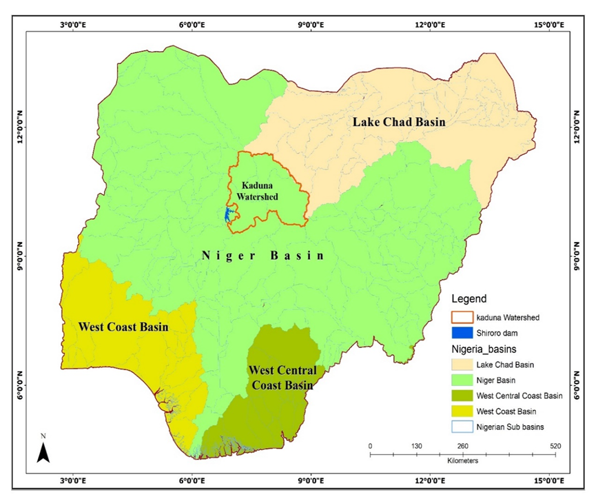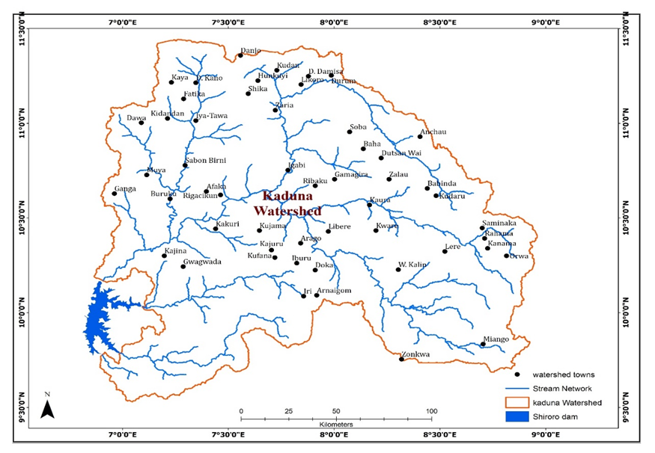
B
A
Source: Oshodi (2005).
Figure 1B. Kaduna watershed area with major towns and villages.

Figure 1A. Nigeria major basins and the study area sub-basins

Methods

The study integrated SWAT model with GIS tools using Digital Elevation Model (DEM) of 30m resolution obtained from Shuttle Radar Topography Mission (SRTM), and the 2 km resolution land-use land-cover map of West Africa obtained from U.S. Geological Survey Earth Resources Observation and Science (USGS EROS) (Table1). The 1 km resolution soil map of Nigeria (soil types and texture), from FAO Soil database 2012. Daily Weather data of Precipitation, Minimum and Maximum Temperature, Relative Humidity, Wind and Solar Radiation obtained from two stations Shiroro Dam Meteorological Station and Nigeria Meteorological Station (NIMET) were also used.
In ARCSWAT environment the spatial data (DEM, LULC map, Soil map) were projected to the Universal Transverse Mercator Zone 32 Northern Hemisphere (UTM Zone 32N) that matches the study area location, and all input files were in metres. Automatic watershed delineation (AWD), hydrologic response unit creation, and SWAT input tables were generated following standard modelling procedures for each of the year 1975, 2000 and 2013 separately and the three different results compared to draw conclusion. Detail information on ARCSWAT procedure can be referred from Winchell et al., 2010; Spruill et al., 2000; Arnold et al, 2012.

Table 1. SWAT model input data.

Data type | Description | Resolution | Source
Weather | Precipitation, Min. and Max. Temperature, Relative Humidity, Wind and Solar Radiation | Daily | Shiroro Dam Meteorological station and NIMET Kaduna
Topography | Digital Elevation Model | 30m | Shuttle Radar Topography Mission (SRTM)
Land Cover Map | Land cover classification  of 1975, 2000 and 2013. | 2km | U.S. Geological Survey Earth Resources Observation and Science (USGS EROS)
Soil Map | Soil types and texture | 1km | FAO Digital Soil database map of the World

The 30 m resolution DEM used for this study was extracted from the Shuttle Radar Topography Mission (SRTM) 1 Arc-Second Global elevation data, United State Geological Survey (USGS) portal. The LULC maps have 25 classes of land cover classification. The study area watershed reconnaissance survey was conducted to obtained information on the land-use and land cover of the area. Information obtained was used to arguments West Africa: Land-use and Land Cover Dynamics of 1975, 2000, and 2013 produced by U.S. Geological Survey Earth Resources Observation and Science (USGS EROS). The model automatically assigned unique values in the Grid-Field representing the land use. The second column contains the area of each type of land use. And the third column contains the land use names in the SWAT database corresponding to each index value. To fill correct values in the third column, the look-up table was imported to enable the SWAT Land-use Classification Table which gives room for the linking of land-use names in the SWAT database corresponding to each index value. In look-up table is the correct values, the userland (the watershed land-use prepared by the user) table which give room for the automatic assignment of the landcover classes, and it was reclassified using the Reclassify button (Winchell et al., 2010).
Results and discussion

Land-use land cover change in the year 1975

The LULC of the year 1975 was reclassified by SWAT model into nine (9) land-use types from the original twenty-five (25) classes, because of the linking of land-use names in the SWAT database corresponding to each index value of the userland table. The classification shows the percentage land area of each of the class types and the area in hectares. The range grasses have the highest watershed land area of about 56.65% of the total watershed land, followed by agriculture land-use, wetland forested, forest mixed, wetland mixed, barren, built-up, water and forest evergreen with 28.89%, 7.7%, 4.5%, 0.83%, 0.59%, 0.53%, 0.28%, 0.03% watershed land area respectively (Table 2).

Table 2. Watershed land-use types, land area and percentage watershed of the year 1975.

S/n | Land-use Types | Land-use Code | Area [ha] | %Watershed
1. | Forest-Evergreen | FRSE | 999.4483 | 0.03
2. | Range-Grasses | RNGE | 1819805.49 | 56.65
3. | Wetlands-Mixed | WETL | 26519.3566 | 0.83
4. | Agricultural Land-Generic | AGRL | 928049.858 | 28.89
5. | Water | WATR | 8847.5204 | 0.28
6. | Barren | BARR | 19069.0749 | 0.59
7. | Built-up | URBN | 16950.0125 | 0.53
8. | Forest-Mixed | FRST | 144708.671 | 4.5
9. | Wetlands-Forested | WETF | 247513.443 | 7.7

Land-use land cover change in the year 2000

The LULC of the year 2000 was reclassified by the SWAT model into eight (8) land-use types because of the extinction of the forest mixed land use between the year 1975 and 2000. The classification shows the percentage of the land area of each of the class types and the land area in hectares. However, the result revealed the extinction of forest evergreen between the year 1975 and 2000.

Comparing the 1975 results with that of 2000, the study revealed that some land use types gained more land while some loss land area to other form of land use. The agriculture land-use has the highest watershed land area of 44.4% as at the year 2000, gaining 15.51% watershed land area over the year 1975, followed by the range grasses with 42.72% watershed land area in the 2000 showing a 13.93% loss from the year 1975. In the year 2000, wetland mixed has 1.09% watershed land area, gaining 0.26% watershed land area, wetland forested has 6.31% watershed land area, loss 1.39% watershed area, forest mixed has 2.97% watershed land area, lost 1.53% watershed land area compared to the year 1975. Built-up has 1.32% watershed land area, gaining 0.79% of the watershed area. water has 0.61% watershed land area, gaining 0.33% watershed area, and barren has 0.58% of the watershed land area, loss 0.01% of its previous 1975 watershed area (Table 3).

Table 3. Watershed land-use types, land area and percentage watershed of the year 2000.

S/n | Land-use Types | Land-use Code | Area [ha] | %Watershed
1. | Range-Grasses | RNGE | 1372254.9 | 42.72
2. | Wetlands-Mixed | WETL | 35061.065 | 1.09
3. | Agricultural Land-Generic | AGRL | 1426407.7 | 44.4
4. | Water | WATR | 19708.463 | 0.61
5. | Barren | BARR | 18628.456 | 0.58
6. | Built-up | URBN | 42377.78 | 1.32
7. | Forest-Mixed | FRST | 95345.629 | 2.97
8. | Wetlands-Forested | WETF | 202678.84 | 6.31

Land-use land cover change in the year 2013

The LULC of the year 2013 was also reclassified by SWAT model into eight (8) land-use types. However, there are disparities in the percentage land area of each of the class types and the area in hectares compared with the year 2000. In the 2013 agriculture land-use has the highest watershed land area of 56.7%, gaining 12.3% watershed area over the year 2000, followed by the range grass with 32.73% watershed land area showing a 10% decrease from the year 2000. Wetlands mixed has a 1.01% watershed land area having 0.08% decrease in the watershed area compared with the year 2000. Wetland forested has 3.93% watershed land area having 2.38% decrease, forest mixed with 2.44% watershed land area, showing 0.53% decrease in the watershed area of the year 2000. Built-up has 1.78% watershed land area, gaining 0.46% of the watershed area, water has 0.81% watershed land area, gaining 0.2% watershed land area, and barren has 0.61% of the watershed area, gained 0.03% of their previous watershed area in the year 2000 (Table 4).

Table 4. Categories of Land-use, land area and percentage watershed of the year 2013.

S/n | Land-use Types | Land-use Code | Area [ha] | %Watershed
1. | Range-Grasses | RNGE | 1051344 | 32.73
2. | Wetlands-Mixed | WETL | 32286.05 | 1.01
3. | Agricultural Land-Generic | AGRL | 1821312 | 56.7
4. | Water | WATR | 25980.97 | 0.81
5. | Barren | BARR | 19593.87 | 0.61
6. | Built-up | URBN | 57211.34 | 1.78
7. | Forest-Mixed | FRST | 78382.1 | 2.44
8. | Wetlands-Forested | WETF | 126353.3 | 3.93

Examination of the three analysis shows that the major human activities that took place in the watershed is the conversion of forest evergreen, range grasses and wetlands mixed to mostly agriculture, urban and other forms of land-use types, corroborating other studies (Abbas, Bello & Abdullahi, 2018; Arowolo & Deng, 2018; CILSS, 2016) (Table 5).

Table Error! No text of specified style in document.. Land-use types and percentage watershed area in 1975, 2000 and 2013.

S/n | Land-use Types | Land-use Code | %Watershed 1975 | %Watershed 2000 | %Watershed 2013
1. | Forest-Evergreen | FRSE | 0.03 | 0 | 0
2. | Range-Grasses | RNGE | 56.65 | 42.72 | 32.73
3. | Wetlands-Mixed | WETL | 0.83 | 1.09 | 1.01
4. | Agricultural Land-Generic | AGRL | 28.89 | 44.4 | 56.7
5. | Water | WATR | 0.28 | 0.61 | 0.81
6. | Barren | BARR | 0.59 | 0.58 | 0.61
7. | Built-up | URBN | 0.53 | 1.32 | 1.78
8. | Forest-Mixed | FRST | 4.5 | 2.97 | 2.44
9. | Wetlands-Forested | WETF | 7.7 | 6.31 | 3.93

Forest evergreen land-use lost 0.03% watershed land area between the 1975 and 2000 to other land-use types most especially to urban (Aruofor, 2001; FAO, 2008; Ejemeyovwi, 2009; CILSS, 2016; Arowolo & Deng, 2018; Ezemedo & Igbokwe, 2013) (Table 6). This dynamic is a threat to global climate. Because the extinction of forest could lead to more carbon emission in the environment that will further increase the level of global warming.

Table 6. Land-use type and percentage watershed Loss and Gain

S/n | Land-use Landcover | 1975-2000  % Watershed  Land Area |  | 2000-2013  % Watershed  Land Area |  | Total  % Watershed  Land Area |  | % Balance  2013 | Remark
 | Land-use Landcover | Loss | Gain | Loss | Gain | Gain | Loss | % Balance  2013 | Remark
1. | Forest-Evergreen | 0.03 | 0 | 0 | 0 | 0 | 0.03 | 0 | Lost
2. | Range-Grasses | 13.93 | 0 | 10 | 0 | 0 | 23.92 | 32.73 | Lost
3. | Wetlands-Mixed | 0 | 0.26 | 0.08 | 0 | 0.18 | 0.08 | 1.01 | Gain
4. | Agricultural Land | 0 | 15.51 | 0 | 12.3 | 27.81 | 0 | 56.7 | Gain
5. | Water | 0 | 0.33 | 0 | 0.2 | 0.53 | 0 | 0.81 | Gain
6. | Barren | 0.01 | 0 | 0 | 0.03 | 0.02 | 0.01 | 0.61 | Gain
7. | Built-up | 0 | 0.79 | 0 | 0.46 | 1.25 | 0 | 1.78 | Gain
8. | Forest-Mixed | 1.53 | 0 | 0.53 | 0 | 0 | 2.06 | 2.44 | Lost
9. | Wetlands-Forested | 1.39 | 0 | 2.38 | 0 | 0 | 3.77 | 3.93 | Lost

Range grasses lost 13.93% of its watershed area between 1975 and 2000, lost additional 10% between 2000 and 2013 losing a total of 23.92% of its total watershed land area between 1975 and 2013. These losses were mostly gained by agriculture land-use that increased by 15.51% between the year 1975 and 2000 and gained additional increase of 12.3% between 2000 and 2013 making a total of 27.81% watershed land area gained (CILSS, 2016; Arowolo & Deng, 2018). Most of the places that were basically range grasses land-use type in the year 1975 have been taking over by agricultural land as at the end of 2013 this result validates Abbas et al. (2018); Arowolo & Deng (2018); CILSS (2016). Wetlands mixed gained 0.26% watershed land area between the year 1975 and 2000 and loss 0.08% of watershed land area between 2000 and 2013 however, as at the end of the 2013 wetlands mixed has gained a total of 0.18 watershed land area. Water gained 0.33% of the watershed area between 1975 and 2000 it equally gained another 0.2% between 2000 and 2013 making a total of 0.53% watershed land area gained by the end of 2013.
Barren land lost 0.01% watershed land area between 1975 and 2000 but gained 0.03% between 2000 and 2013 having 0.02% of watershed land area at the end of the year 2013. Built-up gained 0.79% of watershed land area between 1975 and 2000, gained addition 0.46% between 2000 and 2013 making a total of 1.25% watershed gained mostly from agricultural land-use type (Alaci et al., 2011; Atubi et al., 2018; Adeniyi & Omojola, 1999; Atubi, 2004). Forest mixed lost 1.53% watershed land area between 1975 and 2000 and loss additional 0.53% between 2000 and 2013 having a total loss of 2.06% to other land-use types. In a similar vein, Wetlands forested lost 1.37% of watershed land area between 1975 and 2000 and loss additional 2.38% between 2000 and 2013 making a total loss of 3.77% of watershed land area by the year 2013 (CILSS, 2016; Arowolo & Deng, 2018) (Figure 2).

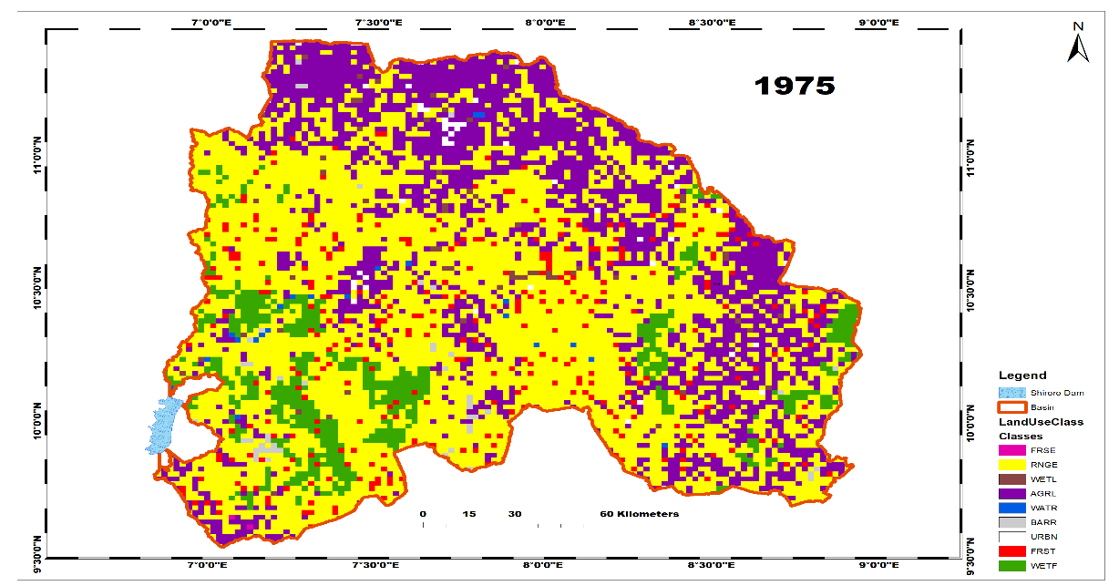
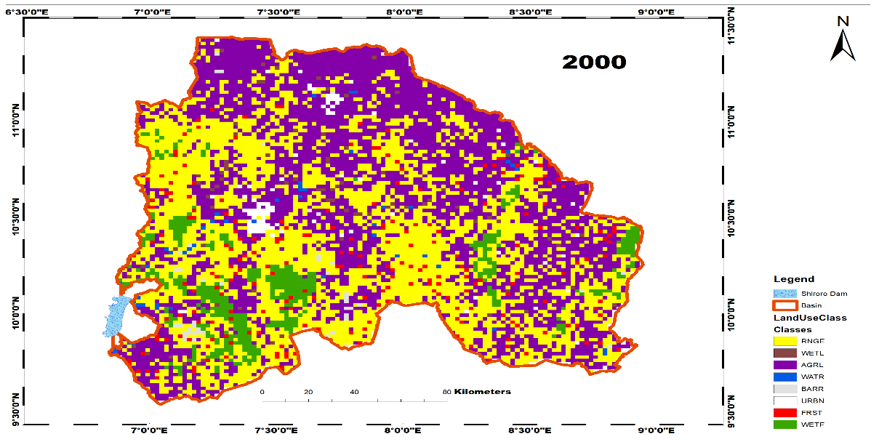
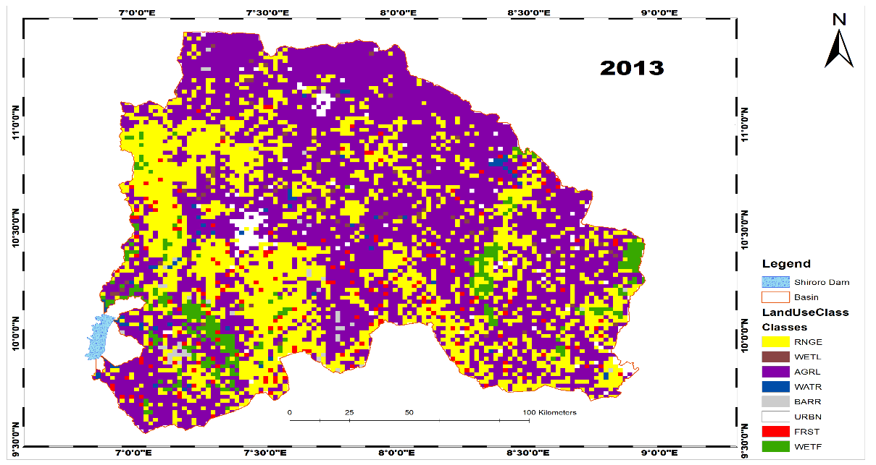

Figure 2. Kaduna watershed land-use changes 1975, 2000 & 2013

The extinction of forest evergreen land-use within the watershed corroborated Aruofor (2001), estimated that approximately 285,000 ha of land is annually deforested in Nigeria and postulated that at this rate of deforestation, 50% of the country’s relatively small forest land area of 10% would be eliminated by the year 2015. According to Food and Agriculture Organization of the United Nations (2008), Nigeria has the world's highest deforestation rate of primary forests as stated by the revised deforestation figures between 2000 and 2005, the country lost 55.7 per cent of its primary forests according to these FAO record.
Forest land losses have been attributed to the following causes: subsistence agriculture, logging and the collection of fuelwoods which are considered as the leading causes of a forest clearing in the West African country (FAO, 2008). Small farmers clear a few acres of land by cutting down trees and burning them (slash and burn) to farm and feed their families. Another factor is rural energy need for the domestic and commercial need that is an everyday affair in the study area because of its agrarian nature, hence, the wood used in every household became eminent.
More also, the study area is under serious degradation because of the commercialization of forest wood for revenue generation since 1983, when forestry department was re-allocated from social sector to economic sector to generate revenue for the states (Niger State Dairy, 1984). This brought about the formation of sawmills and timber dealer associations who are duly registered and recognized by the local government authority to have the legal right to exploit the forest and ardently give rise to illegal exploiters. This singular act by the government led to overexploitation of the forest product which can evidently be seen in the multiplication of timber dealer members and rapid increases in the number of sawmills.
Aigbe and Oluku (2012) connected the forest extinction to decrease in the natural regeneration due to constant reduction in rainfall, the scenario that now makes people exploit more formerly undisturbed land leading to forest cover reduction and increment in sand dunes deposit. Extinction of forest evergreen and reduction in other forest land-use types in the study area make the soil susceptible to soil erosion, due to direct rain impact because of the open nature of the vegetation and make the loose soil particles easily dislodge and wash off by rainfall. Also, the extinction of tropical forests will lead to more carbon emission in the environment that will further increase the level of global warming. Andrews et al. (2011) affirmed that tropical deforestation alone accounts for about fifteen percent of the world’s global warming these exceeded the one produced by every car, plane, ship, truck, and train on earth.
Principally agricultural land and Built-up area are the major beneficiaries of range grasses, forest evergreen, forest mixed, and wetlands forested watershed land area losses (CILSS, 2016). These lost means changed from the natural land cover to artificial land-use types through clearing and degradation of the natural landscape. These two land-use types (agriculture and Built-up) involve the destruction of the natural vegetation which further contributes to global warming problems and land exposure to agents of erosion. The high loss of agricultural land to urban land-use in Kaduna metropolis was confirmed by Saleh (2014) and CILSS (2016) that urban land-use deeply encroached into agriculture land. These were attributed to the city closeness to the Federal capital territory, the seat of Nigeria government (Abbas et al., 2010).

Summary

The LULC change detection was carried out using ArcSWAT 2012 with the land-use maps of the year 1975, 2000 and 2013. The analysis of the three years of study (Table 6) on land-use land area revealed extinction of forest land in between the year 1975 and 2000. The extinction of forest land-use (Figure 3) has been attributed to subsistence agriculture, logging, forest wood for revenue generation and collection of fuelwoods (FAO, 2008). This could further compound environmental problem because the extinction of forest could lead to more carbon emission in the environment that will further increase the level of global warming (Idowu et al., 2011). More also, there is a conversion of, range grasses and wetlands mixed (Figure 3) to mostly agriculture, urban and other forms of land-use types within the study area. Built-up land-use principally gained from agricultural land between the year 1975 and 2013. These land use land cover insight upstream Shiroro dam will provide adequate information that will guide the watershed manager in decision making on the best management practices within the watershed that will prolong the dam lifespan.

Figure 3. Watershed land area percentage gain and loss 1975-2013.

Conclusion

The LULC change detection was carried out using SWAT model with the land-use maps of the year 1975, 2000 and 2013. The analysis of the three years of study on land-use land area revealed the extinction of forest land in between the year 1975 and 2000. These was attributed to subsistence agriculture, logging, forest wood for revenue generation and collection of fuelwoods. The extinction of forest could lead to more carbon emission in the environment that will further increase the level of global warming, therefore, Governments should embark on enlightenment campaign against forest destruction and implement afforestation programme, to reduce climate change impact on the environment. Trees can trap carbon dioxide thereby reducing global warming gasses, it can also reduce storm effects and the impact of sea-level rise. Decision makers should also emphasis the need to change from the extensive (nomadic herding and shifting cultivation) to specific and permanent farming system such as terrace and compounds farming systems in other to reduce soil erosion. Relevant authorities should use the study results to set up a watershed databank that will help policymaker in decision making and the study results can act as a foundation for further studies within the watershed, Nigeria and Africa at large.

References

Abam, T. K. S. (2001). Modification of Niger Delta physical ecology: the role of dams and reservoirs. Hydro-ecology: Linking Hydrology and Aquatic Ecology (Proceedings of Workshop IIW2 held at Birmingham UK. July 1999). I AI IS Publ'. no. 266.
Abbas, I. I., Bello, O. M., Hannatu Abdullahi, H. (2018). Mapping and analyzing the land use–land cover of Nigeria between 2001 and 2009. Eco Environ Sci., 3(3):197‒205.
Adeogun, A. G., Sule, B. F., & Salami, A. W. (2018). Cost effectiveness of sediment management strategies for mitigation of sedimentation at Jebba hydropower reservoir. Nigeria. Journal of King Saud University-Engineering Sciences, 30, 141-149.
Adeniyi, P. O., & Omojola, A. (1999) Land Use and Land Cover Change in the Sokoto-Rima Basin of Northwest Nigeria Based on Archival Remote Sensing and GIS Techniques. In: Adeniyi, P. O., Ed., Geoinformation Technology Applications for Resource and Environmental Management in Africa (pp. 120-129.), African Association of the Environment (AARSE), Wura-Kay Prints, Lagos.
Adeniyi, P. O., & Omojola, A., (1999), Land use/Land cover Change Evaluation in Sokoto-Rima Basin of North-Western Nigeria on Archival Remote Sensing and GIS Techniques. Journal of African Association of Remote Sensing of the Environment, 1,142-146.
Andrews, T. Doutriaux-Boucher, M., Boucher, O., & Forster, P. M. (2011). A regional and global analysis of carbon dioxide physiological forcing and its impact on climate. Clim Dyn, 36,783–792.
Ahmed, A., Drake, F., Nawaz, R., & Woulds, C. (2018). Where is the coast? Monitoring coastal land dynamics in Bangladesh: An integrated management approach using GIS and remote sensing techniques. Ocean & Coastal Management, 151, 10-24.
Arowolo, A. O., & Deng, X. (2018). Land use/land cover change and statistical modelling of cultivated land change drivers in Nigeria. Reg Environ Change, 18, 247-251.
Arnold, J. G., Moriasi, D. N., Gassman, P. W., Abbaspour, K. C., White, M. J., Srinivasan, R., Santhi, C., Harmel, R. D., van Griensven, A., & Van Liew, M. W. (2012). SWAT: Model use, calibration, and validation. Trans. ASABE, 55, 1491–1508.
Aruofor. (2001). Forestry Outlook Studies in Africa (FOSA). Retrieved from http://www.fao.org/forestry/FON/FONS/outlook/Africa/AFRhom-e.stm.
Alaci, D. S. A, Amujabi, F. A., Baba, A. N & Daniel, O. (2011). Spatial Growth Assessment with Remote Sensing Data for Central Nigeria. Journal of Agriculture & Social Sciences, 7 (1),1–6.
Atubi, A. O. (2004). The application of remote sensing in monitoring urban land dynamics in Victoria Island, Lagos, Nigeria. Journal of Empirical Research, 1(2), 57-64.
Atubi, A. O., Awaritefe, D.O., & Toyon, A.B. (2018). Analysis of land use and land cover change characteristics in Warri metropolis, Nigeria. International Journal of Development and Sustainability, 7(3), 1143-1168.
Aigbe, H. I., & Oluku, S. O. (2012). Depleting forest resources of Nigeria and its impact on climate. Journal of Agriculture and Social Research (JASR), 12(2), 1-6.
Butt, A., Shabbir, R., Ahmad, S. S. & Aziz, L. N. (2015) Land use change mapping and analysis using Remote Sensing and GIS: A case study of Simly watershed, Islamabad, Pakistan. The Egyptian Journal of Remote Sensing and Space Sciences. 18, 251–259.
Burrough, P. A. (1986). Principles of Geographical Information for Land Resources Management. Clarendon Press, Oxford, UK. 87.
CILSS. (2016). Landscapes of West Africa. A Window on a Changing World. U.S. Geological Survey EROS, 47914 252nd St, Garretson, SD 57030, United States.
Cots-Folch R., Aitkenhead M. J., Martinez C.J.A., (2007): Mapping land cover from detailed aerial photography data using textural and neural network analysis. International Journal of Remote Sensing, 28, 1625-1642.
Chukwudi, N., Onyedikachi, J., Okeke, Olusola, O., Fadipe, Kehinde A. B., & Vilem, P. (2017). Is Nigeria losing its natural vegetation and landscape? Assessing the landuse-landcover change trajectories and effects in Onitsha using remote sensing and GIS. Open Geosci., 9, 707–718.
Daramola, J., Adepehin, E. J., Ekhwan, T. M., Choy, L. K., Mokhtar, J., Tabiti, T. S. (2022). Impacts of Land-Use Change, Associated Land-Use Area and Runoff on Watershed Sediment Yield: Implications from the Kaduna Watershed. Water, 14(3), 325. http://dx.doi.org/10.3390/w14030325
Daramola, J., Ekhwan, T. M., Mokhtar, J., Lam, K. C., & Adeogun, G. A. (2019). Estimating sediment yield at Kaduna watershed, Nigeria using soil and water assessment tool (SWAT) model. Heliyon, 5(7), e02106.
Ejemeyovwi, D. O. (2009). Land use and Land cover mapping and land use pattern in Abraka. Journal of Environmental Research and Policies, 4(3), 68-77.
Ezeomedo, I., & Igbokwe, J. (2013). Mapping and analysis of land use and land cover for a sustainable development using high resolution satellite images and GIS. FIG Working Week 2013 Environment for Sustainability Abuja, Nigeria 6-10 May 2013.
Feranec J., Suri M., Otahe J., Cebecauer T., Kolar J., & Soukup T. (2000). Inventory of major landscape changes in the Czech Republic, Hungary, Romania and Slovak Republic. International Journal of Applied Earth Observation and Geoinformation, 2, 129–139.
Food and Agriculture Organization / United Nations Environment Programme. (1997). Negotiating a Sustainable Future for Land. Structural and Institutional Guidelines for Land Resources Management in the 21st Century. FAO/UNEP, Rome 1-62.
Food and Agriculture Organization. (2008). Climate change and food security: a framework document food and agriculture organization of the United Nations Rome. Retrieved from http://www.fao.org/forestry/15538-079b31d45081fe9c3dbc6ff34de4807e4.pdf.
Githui, F., Mutua, F., & Bauwens, W. (2009). Estimating the Impacts of Land-Cover Change on Runoff Using. The Soil and Water Assessment Tool (SWAT): Case Study of Nzoia Catchment, Kenya. Hydrol. Sci. J., 54(5), 899-908.
Gabiri, G., Leemhuis, C., Diekkruger, B., Naschen, K., Steinbach, S., & Thonfeld, F. (2019). Modelling the impact of land use management on water resources in a tropical inland valley catchment of central Uganda, East Africa. Science of the Total Environment, 653,1052-1066.
Haque, I. M., & Basak, R. (2017). Land cover change detection using GIS and remote sensing techniques: A spatio-temporal study on Tanguar Haor, Sunamganj. The Egyptian Journal of Remote Sensing and Space Sciences, 20, 251–263.
Heymann, Y., Steenmans, C., Croissille, G., & Bossard, M. (1994). CORINE Land Cover. Technical Guide. Luxembourg: Office for Official Publications European Communities, 1994.
Hegazy, I. R., & Kaloop, M. R. (2015). Monitoring urban growth and land use change detection with GIS and remote sensing techniques in Daqahlia governorate Egypt. International Journal of Sustainable Built Environment, 4, 117-124.
Idowu, A. A., Ayoola, S. O., Opele, A. I., & Ikenweiwe, N. B. (2011). Impact of Climate Change in Nigeria. Iranica Journal of Energy & Environment, 2(2), 145-152.
Jimoh, H. I., Daramola, J., & Abubakar, E. O. (2014). The Role of Geographic Information System on Flood Predictions: A case Study of Asejire Dam, Oyo State of Nigeria. Contemporary Journal of Social Sciences, 4, 71-87.
Kamaruzaman, J., & Senthavy, S. (2003). Land use change detection using remote sensing and geographical information system (GIS) in Gua Musang district, Kelantan, Malaysia. Journal of Tropical Forest Science, 15(2), 303-312.
Lambin, E. F. (1997). Modelling and monitoring land-cover change processes in tropical regions. Progress in Physical Geography, 21, 375–393.
Lukman, S., Otun, J. A., Adie, D. B., Ismail, A., & Oke, I. A. (2011). A brief assessment of a dam and its failure prevention. Journal of Failure Analysis and Prevention, 11(2), 97-109.
Mas J. F., Perez-Vega A., Ghilardi A., Mart´ınez S., Loya-Carrillo J. O., & Vega E. (2014). A suite of tools for assessing thematic map accuracy. Geographical Journal, 372349, doi:10.1155/2014/372349.
Mirkatouli, J., Hosseini, A., & Nehsat, A. (2015). Analysis of land use and land cover spatial pattern based on Markov chains modeling, City, Territ. Architect, 2(4), 1–9.
Niger State government Dairy. (1984). Facts and figures on Niger state edition. State Bureau of Statistics, Niger State Planning Commission.
Ndulue, E. L., Mbajiorgu, C. C., Ugwu, S. N., Ogwo, V., & Ogbu, K. N. (2015). Assessment of land use/cover impacts on runoff and sediment yield using hydrologic models: A review. Journal of Ecology and the Natural Environment, 7(2), 46-55.
Lu, D., Mausel, P., Brondı´zio, E., Moran, E., (2004). Change detection techniques. Int. J. Remote Sens., 25, 2365–2407.
Olaleye, J. B. Abiodun, O. E., & Chinwe Igbokwe, Q. C. (2009). Land use change detection and analysis using remotely sensed data in Lekki Peninsula Area of Lagos, Nigeria. A paper presented at FIG Working Week 2009.
Obiero, J. P. O., & Hassan, M. A. (2015). Determined the effect of land-use change on stream flow using soil water assessment tool (SWAT) model. SWAT international conference, Sardinia, Italy.
Overmars K. P., Verburg P. H., & Veldkamp A., (2007). Comparison of a deductive and an inductive approach to specify land suitability in a spatially explicit land use model. Land Use Policy, 24(3), 584-599
Pontius Jr., R. G., Cornell, J. D., & Hall, C. A. S. (2001). Modeling the spatial pattern of land-use change with GEOMOD2: application and validation. Agriculture, Ecosystem, & Environment, 85, 191–203
Reis, S. (2008). Analyzing land use/land cover changes using remote sensing and GIS in Rize, north-east Turkey. Sensors, 8, 6188–6202.
Saleh, Y., Badr, A. M., Banna, F. E., & Shahata, A. (2014). Agricultural land-use change and disappearance of farmlands in Kaduna metropolis-Nigeria. Science World Journal, 9(1), 1-7.
Seif, A., & Mokarram, M. (2012). Change detection of Gil Playa in the Northeast of Fars Province. Iran Am. J. Sci. Res. 86, 122–130.
Singh, S. K., Laari, P. B., Mustak, S. K., Srivastava, P. K., & Szabó, S. (2018). Modelling of land use land cover change using earth observation data-sets of Tons River Basin, Madhya Pradesh, India. Geocarto International, 33(11), 1202-1222.
Spruill, C. A., Workman, S. R., & Taraba, J. L. (2000). Simulation of daily and monthly stream discharge from small watersheds using the SWAT model. Trans. ASAE, 43, 1431.
Turner, M. G., Gardner, R. H., & O'Neill, R. V. (2001). Landscape ecology in theory and practice: Pattern and process. Springer New York.
Winchell, M., Srinivasan, R., Di Luzio, M., & Arnold, J. (2010). ArcAWAT Interface for SWAT2009, User’s Guide. Retrieved from https://swat.tamu.edu/media/33774/swat2010-proceedings.pdf
Yasodharan, S., & Bindu, K. B. (2015). An analysis of land use / land cover in Kadalundi River Basin using remote sensing and GIS. International Journal of Geomatics and Geosciences, 6(2), 1442-1449.
Zhimin Deng, Xiang Zhang, Dan Li, & Guoyan Pan, (2015). Simulation of land use/land cover change and its effects on the hydrological characteristics of the upper reaches of the Hanjiang. Basin. Environ Earth Sci, 73, 1119-1132.

