

The influence of Free and Open-Source Software-Geographic Information System online training on spatial habits, knowledge and skills

Arif Ismail^{1,2}, Millary Agung Widiawaty³, Jupri Jupri²,
Iwan Setiawan², Nanin Trianawati Sugito¹, Moh. Dede^{3,4}

¹Vocational Program on Survey Mapping and Information Geographic,
Faculty of Social Sciences Education (FPIPS), Universitas Pendidikan Indonesia
²Department of Geography Education, Faculty of Social Sciences Education (FPIPS),
Universitas Pendidikan Indonesia
³Research Center for Nuclear Energy System (PKSEN), National Nuclear Energy Agency of Indonesia
⁴Center for Environment and Sustainability Science, Universitas Padjadjaran

Correspondence: Arif Ismail (email: arifismail@upi.edu)

Received: ; Accepted: ; Published:

Abstract

The era of regional autonomy after the 1998 reformation prompted the formation of a new formal administrative area in Indonesia as an effort to encourage the national development. Pangandaran Regency, after divided from Ciamis Regency, requires attention from higher education stakeholders in the spatial field to manage its natural and social-economic resources. Free and Open-Source Software-Geographic Information System (FOSS-GIS) training is the appropriate solution through the community service and empowerment program from university. This study aims to determine the effect of FOSS-GIS training on spatial habits, spatial knowledge, and spatial skills. The online training was attended by 24 participants who are officials from the government of Pangandaran Regency. To determine the effect, we used Wilcoxon's Test and Paired Sample T-Test on spatial habits and spatial knowledge. We analyzed the spatial skills of self-paced tasks and presentation of results by the participants. This study shows a positive effect of FOSS-GIS training which can be seen from the increase in scores between pre-test and post-test. The spatial habits increased 5.4 percent, whereas the spatial knowledge increased 6.1 percent. Participants were also able to demonstrate all their spatial skills to make a tsunami hazard map and present it. FOSS-GIS online training is effective for improving spatial habits, spatial knowledge, and spatial skills for participants in any background.

Keywords: FOSS-GIS, online course, spatial habits, spatial knowledge, spatial skill

Introduction

Regional development planning in Indonesia requires the availability of geospatial data and information according to the Law Number 4 of 2011 concerning Geospatial Information (Putra, 2017; Riqqi et al., 2018). The regulation regulates basic geospatial information (IGD) and thematic geospatial information (IGT). Both the IGD and IGT can serve as a basis for government stakeholders to plan, develop and control areas, accelerate the process of delineating regional boundaries and spatial planning, also monitoring development programs/interventions in order that they can be monitored spatially to the smallest administrative unit in Indonesia. – village/urban village (Siswanto & Hamidah, 2019). Currently, the availability of competent human-resources in the geospatial field is still lacking. The geospatial field must have competence in data acquisition, data processing, and presenting data in each task unit, which is necessary to ensure the proper management of regional potential (Putra et al., 2019; Smirnov, 2021).
GIS training is often a pragmatic choice for individuals and institutions to improve their knowledge and skills in the geospatial field. Based on previous research, GIS training has been carried out by various educational institutions and professionals have succeeded in improving spatial thinking and spatial skills (Romadlon et al., 2021). This condition was observed from the changes in the test scores of participants that GIS learning helps spatial thinking. GIS training encourage a strong correlation between participants' spatial thinking and their achievements in geospatial skills (Lee & Bednarz, 2009). Through this training, the assessment can be done to measure the effectiveness of the adapted approach. GIS training can also provide an overview of appropriate steps in improving the system and curriculum (Ciolli et al., 2017). Besides human resources, we have another constraint related to geospatial software which is not affordable. Quantum GIS (QGIS) is one of the free and open source software (FOSS-GIS) which has many advantages including user-friendly, complete features and provides results equivalent to the quality of paid applications for vector and raster data analysis (Flenniken et al., 2020). The use of FOSS-GIS in GIS training can be the best solution to gain geospatial knowledge and skills that is inexpensive, reliable and effective. The use of FOSS-GIS is problematic for those who are previously familiar with the subscribed geospatial software, even though the application is obtained under an illegal license (Mattivi et al., 2019; Maurya et al., 2015). Therefore, FOSS-GIS should be intensified so that the practice of using pirated software is no longer used.
This study aims to analyze the effect of FOSS-GIS training on spatial knowledge and skills. We also measured the spatial habits of the participants before they participated in this training, both from visualization, interpretation, and application of geospatial information in everyday life. The subjects of this FOSS-GIS training came from employees in the Pangandaran Regency government. This area is one of the district/city-level administrations in Indonesia that requires attention from higher education stakeholders in the spatial field (ICMA, 2017). Our FOSS-GIS training is presented as the community service and empowerment programs.

Methods

Participants and training setting

This research was conducted in live-online using Zoom Meeting platform due to limited physical-social mobility during the COVID-19 pandemic (Figure 1). The training participants were in the office/district offices located across Pangandaran Regency, while the trainers are at their respective campuses or residences. This training was attended by 24 participants from the Regional Apparatus Work Unit (SKPD) in Pangandaran Regency, whom have an interest in the use of spatial data for various development purposes. The software version that has been used is QGIS 3.16 (Hannover). This training was held for 3 (days) consisting of GIS theory and its usage, QGIS practices, and implementation of local-case studies by participants (Table 1). For the case study, we adjusted the characteristics of Pangandaran Regency as a tourism destination, agro-maritime resource development, and prone to hydrometerological disaster, earthquake and tsunami. (Nurhayati et al., 2019; Pancasilawan, 2020). All training materials and videos during practice can be accessed through Google Classroom.

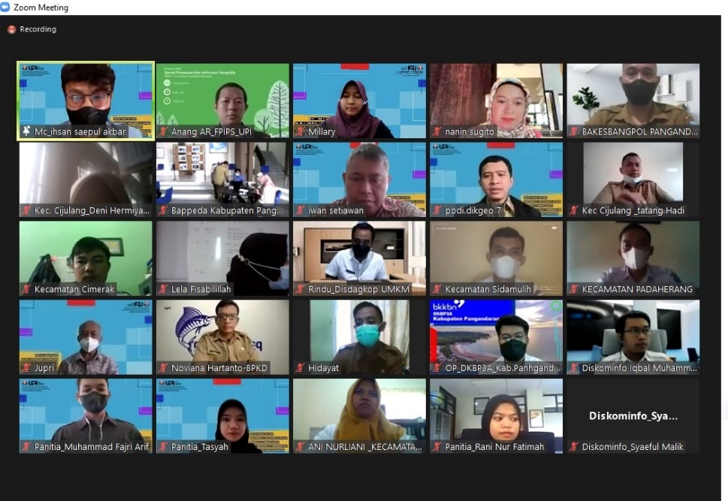
Figure 1. FOSS-GIS trainers and the participants in Zoom Meeting.

Table 1. Training activities.

First day | Second day | Third day
- The role of spatial data in regional development.  - Basic concept and GIS analysis.  - GIS application for spatial planning and land value. | - Introduction to FOSS-GIS software and the QGIS installation process.  - Inventory and download spatial data.  - Georeferencing of data.  - Digitizing the data (point, line, polygon).  - Filling attribute data. | - Geoprocessing and spatial data analysis (vector/raster).  - Application/case study using QGIS.  - Independent work and presentation of result by participants.

Before starting this training, allocated 30 minutes for participants to fill out the pre-test items on Google Form. These items consist of 2 parts, 1) spatial habits (pattern recognition, spatial description, visualization, usage of spatial concept, and usage of spatial tools); 2) spatial knowledge in multiple choice. After the training was completed, participants were again given post-test items similar to the pre-test. We completed the evaluation by observing participants' skills using QGIS through self-paced assignments and results presentation. QGIS provides geospatial processing algorithms from other tools, such as GDAL, GRASS, and SAGA (Vitalis et al., 2020). To trigger their enthusiasm in participating in our training, there are reward schemes for the best and most active participants (Jovanovic & Matejevic, 2014).

Data analysis

a. Test items analysis

Item analysis on spatial habits only includes validity and reliability tests. Specifically on spatial knowledge on spatial knowledge improvement added to the difficulty level and discrimination tests. The validity test is useful for measuring the accuracy of items presented, while the reliability can measure the consistency of a test (Taherdoost, 2016). Difficulty level can indicate whether the item is classified as hard, moderate or easy (Johari et al., 2011). On the other hand, discrimination test is useful to differentiate among students based on how well they know the material being tested (Friatma & Anhar, 2019). The validity test adapt the Spearman-Rank correlation method to observe the spatial habit type, meanwhile Pearson correlation has been used for spatial knowledge type, and Cronbach's Alpha to measure the reliability (Bonett & Wright, 2014; de Barros Ahrens et al., 2020). The items are considered appropriate if they meet the criteria for item analysis as presented in the Table 2. The validity test on all subcategories of spatial habit items showed a high level. Likewise, the reliability of all spatial habit items reached 0.797 (very high), thus the test items were consistent (Table 3). Meanwhile, items of spatial knowledge have varying validity with Cronbach's Alpha of 0.685 (high).

Table 2. Criteria of test items.

Validity | Reliability | Difficulty Level | Discrimination
0-0.25 (Very low) | 0.80 - 1.00 (Very reliable) | 0.00 - 0.20 (Hard) | 0.40-1.00 (Excellent)
0.26-0.49 (Low) | 0.60 - 0.79 (Reliable) | 0.20 - 0.55 (Moderate) | 0.30-0.39 (Good)
0.50-0.69 (Moderate) | 0.40 - 0.50 (Quite reliable) | > 0.55 (Easy) | 0.20-0.29 (Acceptable)
0.70-0.89 (High) | 0.20 - 0.39 (Rather reliable) |  | < 0.19 (Poor)
0.90-1.0 (Very high) | < 0.20 (Less reliable)

Table 3. Spatial habit reliability
.
Spatial Habits | Number of Items | Validity | Reability
Pattern recognition | 4 | 0.774 | 0.847
Spatial description | 2 | 0.708 | 0.782
Visualization | 4 | 0.789 | 0.777
Usage of spatial concept | 2 | 0.826 | 0.906
Usage of spatial tools | 2 | 0.771 | 0.839
 | 14 | 0.774 | 0.797
The analysis of items is based on mean value, from 10 items of spatial knowledge, there are three items classified as easy, five items as moderate, and two items as hard categories. The mean value is obtained from the average of participants who could answer correctly for each item (Jandaghi & Shaterian, 2008). For the discrimination, there were 3 (three) categories in accordance to Pearson's r-value, namely good, acceptable, and poor (Mitra et al., 2009). Majority of the items are categorized as excellent (7 items), good (1 item), acceptable (1 item), and poor (1 item) (Table 4). These items were used to measure the participants' basic GIS knowledge.

Table 4. Validity, difficulty level and discrimination of multiple-choice items.

No | r-value | Mean | Validity | Difficulty Level | Discrimination
1 | 0.525 | 0.5405 | Moderate | Moderate | Excellent
2 | 0.470 | 0.1892 | Low | Hard | Excellent
3 | 0.160 | 0.1081 | Very low | Hard | Poor
4 | 0.598 | 0.5946 | Moderate | Easy | Excellent
5 | 0.461 | 0.7297 | Low | Easy | Excellent
6 | 0.498 | 0.4595 | Low | Moderate | Excellent
7 | 0.262 | 0.3784 | Low | Moderate | Acceptable
8 | 0.534 | 0.2432 | Moderate | Moderate | Excellent
9 | 0.570 | 0.6757 | Moderate | Esay | Excellent
10 | 0.304 | 0.4054 | Low | Moderate | Good

b. Test statistic and correlation

Pre-test and post-test scores of the participants are required to determine the influence of FOSS-GIS training. We chose different tests to measure the significance by applying the Paired Sample T-Test and Wilcoxon's Test. Paired Sample T-Test aims to determine the difference in the average of two different and related samples (Dede et al., 2019), whereas Wilcoxon's Test is useful to find out the differences in ordinal scale data (Ross & Willson, 2017). Data must be normally distributed as a basic requirement for Paired Sample T-Test. The number of samples in this study was 24 participants, thus it is more appropriate to use Shapiro-Wilk for normality test (Razali & Yap, 2011). Normality data verdict refers to p-value (significance value) which is greater than 0.05. The significance value for pre-test and post-test on the spatial knowledge, respectively are 0.131 and 0.114 – normally distributed. Meanwhile, the spatial ability items does not need for normality test because it is a relative scale (Fitzgerald et al., 2001). Spearman-Rank correlation is used to determine the relationship between spatial habits and spatial knowledge (Setiawan et al., 2019; Zar, 2014), the level of interaction is obtained from the r-value and its significance (Sedgwick, 2014).

Results and discussion

Spatial habits reflect the individual's daily life related to spatial concepts consisting of pattern recognition, spatial description, visualization, usage of spatial concept, and usage of spatial tools. The maximum score of the spatial habit was 140 from 14 items. We can form the spatial habits and improve them through ideal learning stimulation. FOSS-GIS training is one way to improve spatial habits, thus participants will start and become aware of these habits. Spatial habits should be related to spatial knowledge (Kim & Bednarz, 2013b, 2013a). After FOSS-GIS training, the participants' post-test scores increased as shown in the Table 5. Spearman-Rank correlation test also shows that all sub-categories have a high correlation to the total score, both in before and after FOSS-GIS training (Table 6). After this training almost all sub-category has a high correlation – r-value is more than 0.70.

Table 5. Comparison of pre-test and post-test scores of spatial habits.

Pre-Test |  |  |  |  |  | Post-Test
Mean | Max | Min | Std. Dev. | Range | Mean |  | Max | Min | Std. Dev. | Range
96.67 | 126 | 72 | 13.040 | 54 | 104.208 |  | 133 | 75 | 16.696 | 58

Table 6. Correlation of sub-categories in spatial habit.

Pre-Test |  |  | Post-Test
Sub-category | Significance | Correlation | Sub-category | Significance | Correlation
Pattern recognition | 0.000 | 0.700 | Pattern recognition | 0.000 | 0.871
Spatial description | 0.002 | 0.598 | Spatial description | 0.029 | 0.445
Visualization | 0.000 | 0.740 | Visualization | 0.000 | 0.884
Usage of spatial concept | 0.000 | 0.744 | Usage of spatial concept | 0.000 | 0.709
Usage of spatial tools | 0.000 | 0.722 | Usage of spatial tools | 0.000 | 0.811

The improvement of spatial habits shows the stimulation provided during the FOSS-GIS training, through the presentation of learning materials and software practices, has provided new experiences for them that lead to better spatial thinking. Participants pay attention to each learning material and make them more aware of the spatial patterns. New terms in GIS and remote sensing, also best-practice from the trainers made participants interested in both. This phenomenon proves that GIS is able to visualize information that seems complicated becoming easier to be understand and simplified the presentation (Harvey, 2008). Explanations about the use of spatial tools in their daily life also encourage enthusiasm. The urgency of spatial thinking is very important and encourages improvement in post-test results. Increasing spatial habits is an early indication of participants' understanding of spatial phenomena that are expected to have an impact on spatial knowledge and spatial skills.

Table 7. Comparison of pre-test and post-test scores of spatial knowledge.

Pre-Test |  |  |  |  | Post-Test
Mean | Max | Min | Std. Dev. | Range | Mean | Max | Min | Std. Dev. | Range
51.41 | 72.50 | 15.00 | 14.25 | 57.50 | 64.43 | 85.00 | 25.00 | 14.12 | 60.00

Prior to the FOSS-GIS training, participants' spatial knowledge was still quite low at 51.41. We can see an increase to 64.43 on a 100 scale after this training (Table 7). Their percentage in answering items also increases when we compare the pre-test and post-test scores (Table 8). Almost all the score for multiple choice item increased during post-test, except for item number 10. During the training, almost all materials related to multiple choice items were given to participants. This proves that the learning process also improves cognitive abilities and increases their readiness to answer items (Jaafar, 2017; Mayalagu et al., 2019). The participants received teaching recordings from the trainers that made it easier for them to study independently. This improvement can also be driven by FOSS-GIS learning that combines symmetric and asymmetric methods (Donnelly, 2017). We facilitated an asymmetric approach to participants. Trainers created learning materials, training modules, video recordings, create chat-groups to facilitate the interaction.

Table 8. The percentage of items answered correctly.
Pre-Test |  |  |  | Post-Test
No | Percentage (%) | No | Percentage (%) | No | Percentage (%) | No | Percentage (%)
1 | 58.3 | 6 | 37.5 | 1 | 70.8 | 6 | 70.8
2 | 12.5 | 7 | 41.7 | 2 | 25.0 | 7 | 75.0
3 | 8.3 | 8 | 25.0 | 3 | 12.5 | 8 | 58.3
4 | 62.5 | 9 | 83.3 | 4 | 75.0 | 9 | 87.5
5 | 75.0 | 10 | 45.8 | 5 | 87.5 | 10 | 33.3

In our FOSS-GIS training, the participants able to get a rapid improvement in reading-matching the graphs of map descriptions and legends contained in item number 6. There was also an increase in item number 7 and 8, is presented the concept of overlay analysis. This concept was found in geoprocessing materials, when participants formulated various parameter maps for case studies using FOSS-GIS software. Besides the significant improvement, we found three items that received the lowest correct percentages in item number 2 and 3. The items observe about the knowledge on the representation of real-world object using spatial element such as points, lines, and areas. Basically, the participants were able to distinguish three types but the items are made complicated and varied so that participants find it difficult to choose the correct answers. Spatial knowledge must be accompanied by providing real world to make it more memorable (Singh et al., 2016). For item number 10, we found a decrease in score. The item contained the interpolation concept is considered abstract by the participants. Ideally they need to create contours from the available data manually (paper-based), also it requires the application of sufficient mathematical knowledge (Christophe, 2012). After they understood these concepts, the trainer asked them to interpolate using GIS software.
The training was not only able to increase knowledge and geospatial thinking, but also proved to make participants able to improve their skills in making maps. On the second and third day, the participants paid attention to the trainer and practiced using QGIS. The learning materials are made systematically thus participants can easily understand and achieve learning objectives (Howarth & Sinton, 2011). During this training, participants gain several skills such as 1) how to obtain spatial data for free and legally; 2) use of basic features in QGIS; 3) georeferencing map and imagery; 4) creating of spatial data (point, line, polygon); 5) filling in attribute data and its integration; 6) geoprocessing of data; 7) making maps (Figure 2). Besides that, we taught them how to determine the parameters for tsunami hazard analysis in Pangandaran Regency and the rules for giving the appropriate score and weight. This training also taught participants how to produce layout maps according to Indonesian standards.

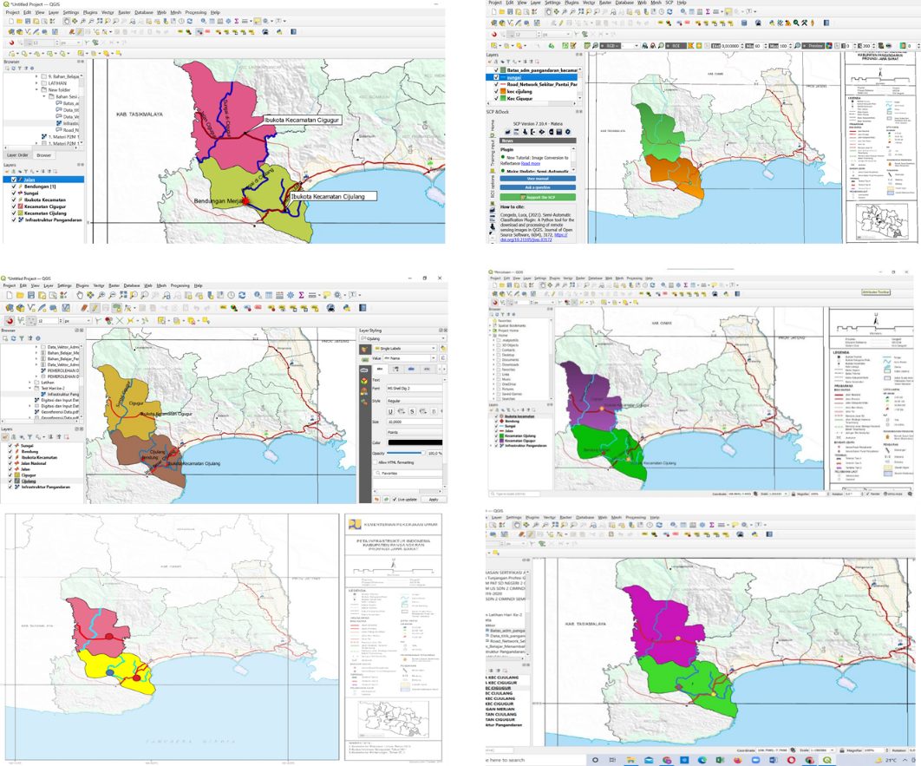

Figure 2. Some examples of day 2 self-employed tasks (map digitizing).

The FOSS-GIS training has been proven to improve the participants' spatial habits, spatial knowledge, and spatial skills (Figure 3). Based on Wilcoxon's Test, the spatial habits had a significant and positive increase with z-score of -2,945 and p-value of 0.003. Meanwhile, this online training had a positive impact in the spatial knowledge of participants as shown in r-value and p-value, 0.538 and 0.000 respectively (Table 9). Although this training is online-based, it was proven to have significant effectiveness for self-improvement for participants. Online training with some adjustments to the material and learning methods is able to maintain the output quality, even more efficiently and cheaply (Gherheș et al., 2021; Sun & Chen, 2016).
We obtained information about the participants' spatial habits and spatial knowledge, which did not have a significant correlation, both before and after the FOSS-GIS training. Spearman-Rank correlation test at the pre-test gave a value of -0.284 which indicates the low relationship and not significant (p-value 0.179). The same thing also occurred to the post-test which increasingly supports that the two are not related, where the correlation value is only -0.046 with a p-value of 0.830. An increase in spatial knowledge is not necessarily accompanied by increasing spatial habits, and vice versa. Although the results of pre-test and post-test of spatial habits in training showed an increase, spatial habits were very relative depending on individual experience (Kim, 2011). Even other factors such as gender and age can determine the difference (Voyer et al., 2007). Changes to answering the habits test is easier than daily habits that require a high awareness and need paying attention to the surrounding environment.

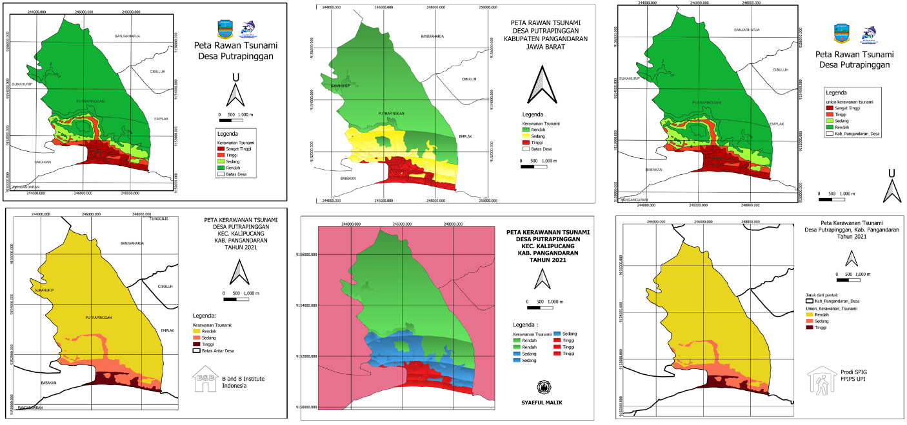

Figure 3. Some examples of individual tasks for day 3 (Creating and layouting of tsunami hazard maps).

Table 9. Wilcoxon’s Test and Paired Sample T-Test.

Wilcoxon’s Test |  | Paired Sample T-Test |  | Confidence level
Z-Score | -2.945 | Pearson’s r-value | 0.538 | 95.00 %
p-value (2-tailed) | 0.003 | p-value (2-tailed) | 0.000 | 95.00 %
Conclusion

The FOSS-GIS online training was successful in improving spatial habits, spatial knowledge, and spatial skills. This can be observed in Wilcoxon's Test and Paired Sample T-Test which shows significant difference in scores between the pre-test and post-test. Participants were able to improve their spatial skills as proven through map digitizing and making a tsunami hazard map in in Pangandaran Regency. Correlation between spatial habits and spatial knowledge also state that the relationship was not significant, which means that high scores of spatial knowledge were not necessarily aligned with spatial habits, and vice versa. Overall, this training was successfully carried out although there were obstacles that could be overcome, such as the punctuality of implementation time, inadequate computing facilities and internet networks, and administrative-tasks from the participants.

Acknowledgement

This training was held in collaboration with Universitas Pendidikan Indonesia and the Development Planning Agency (BAPPEDA) of Pangandaran Regency in 2021. We would like to thank students of Vocational Program on Survey Mapping and Information Geographic (SPIG), especially Rani Nur Fatimah, Tasyah Donita, Dian Hamidah, Afina Naila Nurfadhilah, and Ihsan Saepul Akbar for all their valuable assistance.

References

Bonett, D., & Wright, T. (2014). Cronbach’s alpha reliability: Interval estimation, hypothesis testing, and sample size planning. Journal of Organizational Behavior, 36. https://doi.org/10.1002/job.1960

Christophe, S. (2012). Cartographic Styles between traditional and original (towards a cartographic style model). Proceedings AutoCarto 2012, Columbus, Ohio, USA.

Ciolli, M., Federici, B., Ferrando, I., Marzocchi, R., Sguerso, D., Tattoni, C., Vitti, A., & Zatelli, P. (2017). FOSS Tools and Applications for Education in Geospatial Sciences. ISPRS International Journal of Geo-Information, 6(7), 225. https://doi.org/10.3390/ijgi6070225

de Barros Ahrens, R., da Silva Lirani, L., & de Francisco, A. C. (2020). Construct validity and reliability of the work environment assessment instrument WE-10. International Journal of Environmental Research and Public Health, 17(20), 7364. https://doi.org/10.3390/ijerph17207364

Dede, M., Pramulatsih, G., Widiawaty, M., Ramadhan, Y., & Ati, A. (2019). Dinamika suhu permukaan dan kerapatan vegetasi di Kota Cirebon. Jurnal Meteorologi Klimatologi Dan Geofisika, 6, 23–31. https://doi.org/10.36754/jmkg.v6i1.111

Donnelly, F. (2017). Introduction to GIS using open source software (8 th Edition). Baruch College CUNY.

Fitzgerald, S., Dimitrov, D., & Rumrill, P. (2001). The basics of nonparametric statistics. Work (Reading, Mass.), 16, 287–292.

Flenniken, J. M., Stuglik, S., & Iannone, B. V. (2020). Quantum GIS (QGIS): An introduction to a free alternative to more costly GIS platforms. EDIS, 2020(2), 7. https://doi.org/10.32473/edis-fr428-2020

Friatma, A., & Anhar, A. (2019). Analysis of validity, reliability, discrimination, difficulty and distraction effectiveness in learning assessment. Journal of Physics: Conference Series, 1387, 012063. https://doi.org/10.1088/1742-6596/1387/1/012063

Gherheș, V., Stoian, C. E., Fărcașiu, M. A., & Stanici, M. (2021). E-learning vs. face-to-face learning: Analyzing students’ preferences and behaviors. Sustainability, 13(8), 4381. https://doi.org/10.3390/su13084381

Harvey, F. (2008). A primer of GIS: second edition: Fundamental geographic and cartographic concepts. The Guildford Press.

Howarth, J. T., & Sinton, D. (2011). Sequencing spatial concepts in problem-based GIS instruction. Procedia - Social and Behavioral Sciences, 21, 253–259. https://doi.org/10.1016/j.sbspro.2011.07.042

ICMA. (2017). A guide for smart communities: Using GIS technology for local government management. The International City/County Management Association.

Jaafar, M. (2017). Keberkesanan GIS sebagai alat bantu mengajar konsep asas geografi kepada pelajar bukan-geografi (Effectiveness of GIS as a tool in teaching basic geographic concepts to non-geography students). Geografia-Malaysian Journal of Society and Space, 8(3), Article 3. http://ejournal.ukm.my/gmjss/article/view/18236

Jandaghi, G., & Shaterian, F. (2008). Validity, reliability and difficulty indices for instructor-built exam questions. Journal of Applied Quantitative Methods, 3(2), 151–155.

Johari, J., Sahari, J., Wahab, D. A., Abdullah, S., Abdullah, S., Omar, M. Z., & Muhamad, N. (2011). Difficulty index of examinations and their relation to the achievement of programme outcomes. Procedia - Social and Behavioral Sciences, 18, 71–80. https://doi.org/10.1016/j.sbspro.2011.05.011

Jovanovic, D., & Matejevic, M. (2014). Relationship between rewards and intrinsic motivation for learning – researches review. Procedia - Social and Behavioral Sciences, 149, 456–460. https://doi.org/10.1016/j.sbspro.2014.08.287

Kim, M. (2011). Effects of a GIS course on three components of spatial literacy. Texas A&M University.

Kim, M., & Bednarz, R. (2013a). Development of critical spatial thinking through GIS learning. Journal of Geography in Higher Education, 37(3), 350–366. https://doi.org/10.1080/03098265.2013.769091

Kim, M., & Bednarz, R. (2013b). Effects of a GIS course on Self-Assessment of Spatial Habits of Mind (SHOM). Journal of Geography, 112(4), 165–177. https://doi.org/10.1080/00221341.2012.684356

Lee, J., & Bednarz, R. (2009). Effect of GIS learning on spatial thinking. Journal of Geography in Higher Education, 33(2), 183–198. https://doi.org/10.1080/03098260802276714

Mattivi, P., Franci, F., Lambertini, A., & Bitelli, G. (2019). TWI computation: A comparison of different open source GISs. Open Geospatial Data, Software and Standards, 4, 6. https://doi.org/10.1186/s40965-019-0066-y

Maurya, S., Ohri, A., & Mishra, S. (2015). Open Source GIS: A Review. National Conference on Open Source GIS: Opportunities and Challenges.

Mayalagu, G., Jaafar, M., Choy, L. K., & Mahmud, M. I. (2019). Keberkesanan Geographic Information System (GIS) dalam mencungkil minat pelajar terhadap mata pelajaran Geografi di sekolah menengah (The effectiveness of Geographic Information System (GIS) in fostering student interest in Geography subject in secondary school). Geografia-Malaysian Journal of Society and Space, 15(4), 64-79.

Mitra, N. K., Haleagrahara, N., Ponnudurai, G., & Judson, J. (2009). The levels of difficulty and discrimination indices in type a multiple choice questions of pre-clinical semester 1 multidisciplinary summative tests. International E-Journal of Science, Medicine & Education, 3, 2–7.

Nurhayati, A., Aisah, I., & Supriatna, A. K. (2019). Model development of a synergistic sustainable marine ecotourism—A case study in Pangandaran Region, West Java Province, Indonesia. Sustainability, 11(12), 3418. https://doi.org/10.3390/su11123418

Pancasilawan, R. (2020). Mitigation of disaster risk reduction in Pangandaran Regency. Sosiohumaniora, 22. https://doi.org/10.24198/sosiohumaniora.v22i2.25774

Putra, W. K. E. (2017). Peran metadata dalam pencarian data geospasial melalui Infrastruktur Data Spasial Nasional (ISDN). Media Komunikasi Geografi, 16(1), Article 1. https://doi.org/10.23887/mkg.v16i1.10170

Putra, T. Y. D., Sekimoto, Y., & Shibasaki, R. (2019). Toward the evolution of national spatial data infrastructure development in indonesia. ISPRS International Journal of Geo-Information, 8(6), 263. https://doi.org/10.3390/ijgi8060263

Razali, N. M., & Yap, B. (2011). Power Comparisons of Shapiro-Wilk, Kolmogorov-Smirnov, Lilliefors and Anderson-Darling Tests. J. Stat. Model. Analytics, 2(1), 21–33.

Riqqi, A., Taradini, J., & Effendi, A. (2018). Pemodelan kualitas Informasi Geospasial Dasar di Indonesia. Seminar Nasional Geomatika, 24, 13. https://doi.org/10.24895/JIG.2018.24-1.773

Romadlon, R., Yusuf, Y., & Sarwono. (2021). Effect of learning project model-based learning on GIS spatial thinking skills students. IOP Conference Series: Earth and Environmental Science, 683, 012045. https://doi.org/10.1088/1755-1315/683/1/012045

Ross, A., & Willson, V. L. (2017). Paired Samples T-Test. In A. Ross & V. L. Willson (Eds.), Basic and Advanced Statistical Tests: Writing Results Sections and Creating Tables and Figures (pp. 17–19). SensePublishers. https://doi.org/10.1007/978-94-6351-086-8_4

Sedgwick, P. (2014). Spearman’s rank correlation coefficient. BMJ (Online), 349, g7327. https://doi.org/10.1136/bmj.g7327

Setiawan, I., Dede, M., Sugandi, D., & Widiawaty, M. (2019). Investigating urban crime pattern and accessibility using Geographic Information System in Bandung City. 3, 535–548. https://doi.org/10.18502/kss.v3i21.4993

Singh, S. S. B., Rathakrishnan, B., Sharif, S., Talin, R., & Eboy, O. (2016). The effects of geography information system (GIS) based teaching on underachieving students’ mastery goal and achievement. 15, 119–134.

Siswanto, F., & Hamidah, I. (2019). Perkembangan Informasi Geospasial Tematik tema transportasi setelah penetapan kebijakan satu peta (studi kasus tematik kementerian perhubungan). Seminar Nasional Geomatika, 3, 117. https://doi.org/10.24895/SNG.2018.3-0.935

Smirnov, S. V. (2021). Design and application of a specialized information system for monitoring and decision support. IOP Conference Series: Earth and Environmental Science, 839(3), 032031. https://doi.org/10.1088/1755-1315/839/3/032031

Sun, A., & Chen, X. (2016). Online education and its effective practice: A research review. Journal of Information Technology Education: Research, 15, 157–190. https://doi.org/10.28945/3502

Taherdoost, H. (2016). Validity and reliability of the research instrument; how to test the validation of a questionnaire/survey in a research. International Journal of Academic Research in Management, 5, 28–36. https://doi.org/10.2139/ssrn.3205040

Vitalis, S., Arroyo Ohori, K., & Stoter, J. (2020). CityJSON in QGIS: Development of an open-source plugin. Transactions in GIS, 24(5), 1147–1164. https://doi.org/10.1111/tgis.12657

Voyer, D., Postma, A., Brake, B., & Imperato-McGinley, J. (2007). Gender differences in object location memory: A meta-analysis. Psychonomic Bulletin & Review, 14(1), 23–38. https://doi.org/10.3758/BF03194024

Zar, J. H. (2014). Spearman Rank Correlation: Overview. In Wiley StatsRef: Statistics Reference Online. John Wiley & Sons, Ltd. https://doi.org/10.1002/9781118445112.stat05964

.

