
Mapping the operation of Airbnb in Sri Lankan cities

Lasika Madhawa Munasinghe, Terans Gunawardhana, N.C. Wickramaarachchi, R.G. Ariyawansa

Department of Estate Management and Valuation,
University of Sri Jayewardenepura, Nugegoda, Sri Lanka

Correspondence: Lasika Madhawa Munasinghe (email: lasika@sjp.ac.lk)

Received: 14 December 2021; Accepted: 23 April 2022; Published: 31 May 2022

Abstract

Airbnb is most famous as a part of the growing “sharing”, “peer-to-peer”, or “digital” economy where the platform transformed the traditional tourist accommodation services through its novel business model. In order to comprehend the influence of Airbnb on the tourism and hospitality landscape, it is critical first to understand the market and how Airbnb operates. Therefore, in this study, we explore the operation of Airbnb in Sri Lanka using descriptive statistics and maps by analysing the scrapped data of the Airbnb website. The study results show that Airbnb has been well established on Sri Lankan soil as an alternative accommodation service provider, and the listings have been scattered across the country. However, most listings tend to concentrate in the city centres of famous touristic districts and tourist resort regions in Sri Lanka. These findings will provide a valuable avenue for further investigation of the operation of Airbnb in Sri Lanka.

Keywords: Airbnb, digital disruption, sharing economy, Sri Lanka, tourism and hospitality industry

Introduction

Airbnb is regarded as a disruptive innovation or a digital disruption in the travel and tourism industry due to the company’s innovative internet-based commercial enterprise model and its unique appeal to tourists (So et al., 2018). Airbnb is now a part of a growing movement known as the “Sharing”, “Peer-to-Peer”, or “Digital” Economy (Botsman & Rogers, 2010; Gurran & Phibbs, 2017; Zervas et al., 2017). These platforms have revolutionised the travel and tourism industry in recent years, presenting potential threats and opportunities (Guttentag, 2015; Sigala, 2017). The rise of online peer-to-peer marketplaces and the massive popularity of sharing economy platforms (e.g., Uber, Airbnb) aided the informal economy’s growth in both developed and developing economies (Williams & Horodnic, 2017). While almost all traditional brick and mortar businesses are vulnerable to disruption from these innovative sharing economy business models, such processes’ supply and demand sides have benefitted significantly. This includes easy access to entrepreneurial opportunities that generate additional income and access to various listings with lower prices or costs (Koh & King, 2017; Zervas et al., 2017). These sorts of entrepreneurship are expected to provide the most outstanding single possible means of pulling people out of poverty in nations and regions during the next five to ten years (Si et al., 2018). There have been significant study efforts carried out specifically to investigate various aspects related to the important exchange actors within the peer-to-peer accommodation segment, such as tourist attributes (e.g. Tussyadiah & Zach, 2017), tourists appeal (e.g. Guttentag et al., 2018), tourists’ safety and legal issues surrounding (e.g. Williams & Horodnic, 2017). A furthermore substantial amount of research has also been conducted on the potential disruptive impact of the sharing accommodation sector on both traditional tourist accommodations (e.g. Zervas et al., 2017) and tourist destinations (e.g. Nieuwland and van Melik 2020).
Still, comparatively few research studies have looked at how the landscape of tourism has altered due to Peer-to-Peer accommodation rental services. Understanding the full effect of peer-to-peer sharing on the tourism and hospitality industry requires an in-depth understanding of the market first (Sainaghi & Baggio, 2020). There are sparse and selective comprehensive studies describing the operation of Airbnb in large cities and countries (Adamiak, 2018; Heo et al., 2019). Moreover, none have examined small island nations apart from large metropolises and middle-sized cities. Understanding the full effect of peer-to-peer sharing on the tourism and hospitality business requires an in-depth understanding of the market first. This study attempts to fill these two gaps by providing a generic descriptive and spatial analysis of the operation of Airbnb across Sri Lanka.

Literature review

Tourists and the city have a complicated relationship. Tourism has a positive impact on cities, and the importance of tourism for the local economy is emphasised in all cities. The tourism industry contributes to local revenue and employs many people (Gutiérrez et al., 2017). There are some cities where tourism is the primary source of economic activity and the only source of local economic development. Nevertheless, there are a number of cities that find themselves under much stress because of tourism. Pressure from tourism is becoming a significant source of contention between tourist stakeholders and locals in an increasing number of communities (Gutiérrez et al., 2017). Tourists are quite selective in their use of the city (Gutiérrez et al., 2017) and tend to be concentrated in specific parts of the city centre, where they make extensive use of the facilities and services offered (Shoval & Raveh, 2004). Tourists put much pressure on ancient city centres, which are already under much strain. This happens when the number of tourists exceeds a certain threshold. Specifically, crowding is viewed as a violation of the sociocultural carrying capacity (Neuts & Nijkamp, 2012).
Tourism has a profound impact on the character of city centres. Tourism’s inherent characteristics, such as its extensive use of central space, seasonal patterns, and “transversality” among industries, can significantly impact sensitive metropolitan regions (Gutiérrez et al., 2017). Furthermore, its downward impact on the value of urban facilities and premises encourages individuals and businesses to flee key locations (Russo, 2002). These developments are termed tourism gentrification. In the most extreme cases, it can be seen as the transformation of a middle-class neighbourhood into an affluent and exclusive area with many corporate entertainment and tourism venues (Gotham, 2005).
The majority of travellers prefer to stay in hotels close to the city’s most popular sights (Arbel & Pizam, 1977). It is possible to establish a hotel hierarchy based on geography, from luxury hotels of 4 or 5-star quality located in the city centre to budget hotels located on the outskirts of the city, because the average room rate for hotels falls with distance from the centre toward the periphery (Egan & Nield, 2000). The hotel’s location has a significant impact on tourist movements, as a considerable portion of the total tourist time budget is spent within walking distance of the hotel (Shoval et al., 2011). As a result, the concentration of hotels in the city centre increases tourist pressure and plays a crucial role in transforming the surrounding urban environment (Gutiérrez et al., 2017). Tourists spend more money in places close to hotels, and these regions adjust to meet their demands. As a result, the business structure of such regions changes, as evidenced by the increase in tourism-oriented stores and restaurants (Gutiérrez et al., 2017).
The availability of accommodation given through the emerging peer-to-peer platforms increases the pressure on city centres due to the influx of tourists in the area. Accommodation sharing between individuals has always existed informally, but the Internet, notably Web 2.0, has allowed it to spread enormously and take on new characteristics (Gutiérrez et al., 2017). There is much more to peer-to-peer platforms than just marketing and promotion in the accommodation industry. In addition to conducting background checks on all parties involved, they also have access to the inventories of the property owners, oversee rental bookings, collect payments, and insure rentals against damage caused by the tenants (Pizam, 2014). Among peer-to-peer platforms in the sphere of accommodation, Airbnb is by far the most successful (Gutiérrez et al., 2017). It brings together people who have extra room to spare (hosts) and people who are looking for a place to stay (travellers). Airbnb currently has over 2 million listings in 190 countries, the majority of which are entire apartments and homes and private rooms (Airbnb, 2021). Airbnb’s market capitalisation has surpassed that of well-known worldwide hotel brands like Hyatt, with over $10 billion (Zervas et al., 2017). Airbnb introduced a novel business model based on modern Internet technologies, and its unique appeal centred on cost savings, household amenities, and the promise of more authentic local experiences. Above all, Airbnb’s low prices appear to be a big selling point for the service (Guttentag, 2015). Airbnb has stated that its listings are more dispersed than hotels, which means that Airbnb visitors may be more likely to spend their money in areas that do not get a lot of tourists (Guttentag, 2015). However, as Zervas et al. (2014) points out, Airbnb has the ability to boost supply where houses and apartment complexes already exist, unlike hotels, which must be erected in compliance with local zoning rules. As a result, Airbnb would find it easier to grow in city centres than hotels, which necessitates the availability of entire buildings and the necessary permits from the authorities (Gutiérrez et al., 2017). If Airbnb demonstrates a clear tendency to expand in historical city centres, this could aggravate the problems of overcrowding and tourism gentrification in some historical cities (Neuts & Nijkamp, 2012).
There is very little academic research on Airbnb and its effects on the tourism industry and cities. Airbnb was investigated by Guttentag (2015) as a disruptive innovation in the accommodation industry. Research has also been done on the possible disruption to traditional tourist hotels (Zervas et al., 2017) and tourist destinations (Nieuwland, 2017). Zervas et al. (2017) focused on the competition between Airbnb and the traditional accommodation sector. Tussyadiah & Zach (2017) looked into the characteristics of visitors who stayed in peer-to-peer lodgings. Whereas So et al. (2018) focused on the tourist’s appeal for peer-to-peer accommodations. Williams & Horodnic (2017) focused on tourists’ safety and legal issues concerning peer-to-peer accommodations. None of this research looked into Airbnb listings’ operation and spatial distribution patterns.

Method and study area

Sri Lanka is a small island nation off India’s southern coast. Sri Lanka is bordered on three sides by the Indian Ocean, the Gulf of Mannar, the Palk Strait, and India and the Maldives. Despite its small size, Sri Lanka has a high level of biodiversity and wildlife resources and is one of the world’s 34 biodiversity hotspots and home to a diverse range of flora and animals (Miththapala, 2012). As a result, the island now possesses the world’s highest rate of biological endemism. In recent years, Sri Lanka has been an increasingly popular destination for international tourists and expatriates returning home to see family and friends. Sri Lanka was named the number one destination to visit by Lonely Planet in 2013 and 2019. Tourism is Sri Lanka’s third-biggest export earner after remittances, textiles, and garment manufacturing (Munasinghe et al., 2020).
Airbnb does not explicitly disclose data for research purposes on property listings listed on the platform for short-term rentals in various cities. However, since the information available on the Airbnb website is public, the web-scraping technique can be used to collect such information from a webpage. The AirDNA company operates the most advanced system for tracking Airbnb offers and bookings and provides vacation rental data and insights for various purposes (AirDNA, 2020). This study uses Property Performance Data for Sri Lanka acquired from the AirDNA in 2018. In order to support the analysis, tourism statistics from the Sri Lanka Tourism Development Authority (Sri Lanka Tourism Development Authority, 2018) and Housing Statistics from the Department of Census and Statistics (Department of Census and Statistics, 2019) were used. The data were descriptively analysed and further processed to prepare an interactive dashboard using Tableau 2021.1. The geocoded datasets were analysed using ArcGIS Pro to map locations and prepare choropleth maps to uncover spatial insights. The spatial outputs were further processed to design a Web GIS Dashboard using ArcGIS Online. The descriptive and spatial analysis focused on the distribution of listings, hosts, and performance of Airbnb properties in Sri Lanka while comparing with Sri Lanka Tourism Development Authority registered establishments. The data supporting this study’s findings are openly available at https://www.slairbnb.lk/.

Results and discussion

The distribution of Airbnb accommodations

- The location of properties

Sri Lanka Tourism Development Authority (SLTDA) is the official government institution responsible for regularising the tourism industry in Sri Lanka (Sri Lanka Tourism Development Authority, 2020). The Tourism Act, No. 38 of 2005 dictates that all institutions engaged in tourist accommodation must register under the Sri Lanka Tourism Development Authority (SLTDA) (Democratic Socialist Republic of Sri Lanka, 2016). As per the SLTDA statistics, there are only 1,367 registered tourist accommodation service providers (Figure 1). However, there are around 26,162 registered Airbnb listings in Sri Lanka (Figure 2). The number of Airbnb Listings is higher than the number of SLTDA registered tourist accommodation establishments in every district of Sri Lanka (Figure 2), and the highest difference is in Colombo and Galle Districts, where Airbnb Listings exceed by 2766 - 5558 listings.
Furthermore, the intensity of Airbnb listings is greater in Colombo and Greater Colombo Resort Region, South Coast Resort Region and Ancient Cities Resort Region. Colombo records the highest listing density of more than five listings per square kilometre (Figure 3). There is only one or fewer SLTDA registered tourist accommodation establishments per square kilometre in every district of Sri Lanka. The Airbnb Accommodation Ratio indicates the percentage of Airbnb listings to the number of households in a particular region. In Sri Lanka, it is around 0.44%. In terms of Districts, the highest Airbnb Accommodation Ratio is recorded in Galle and Matara Districts (0.76% - 1.84%) (Figure 4).
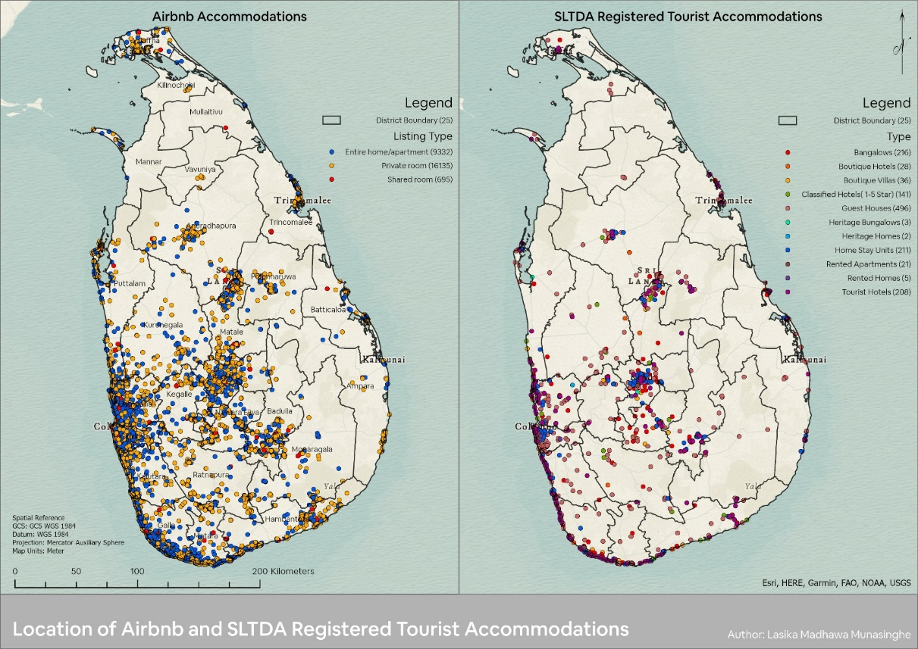
Source: Compiled by the Author

Figure 1. Location of Airbnb and SLTDA Registered Accommodation offers

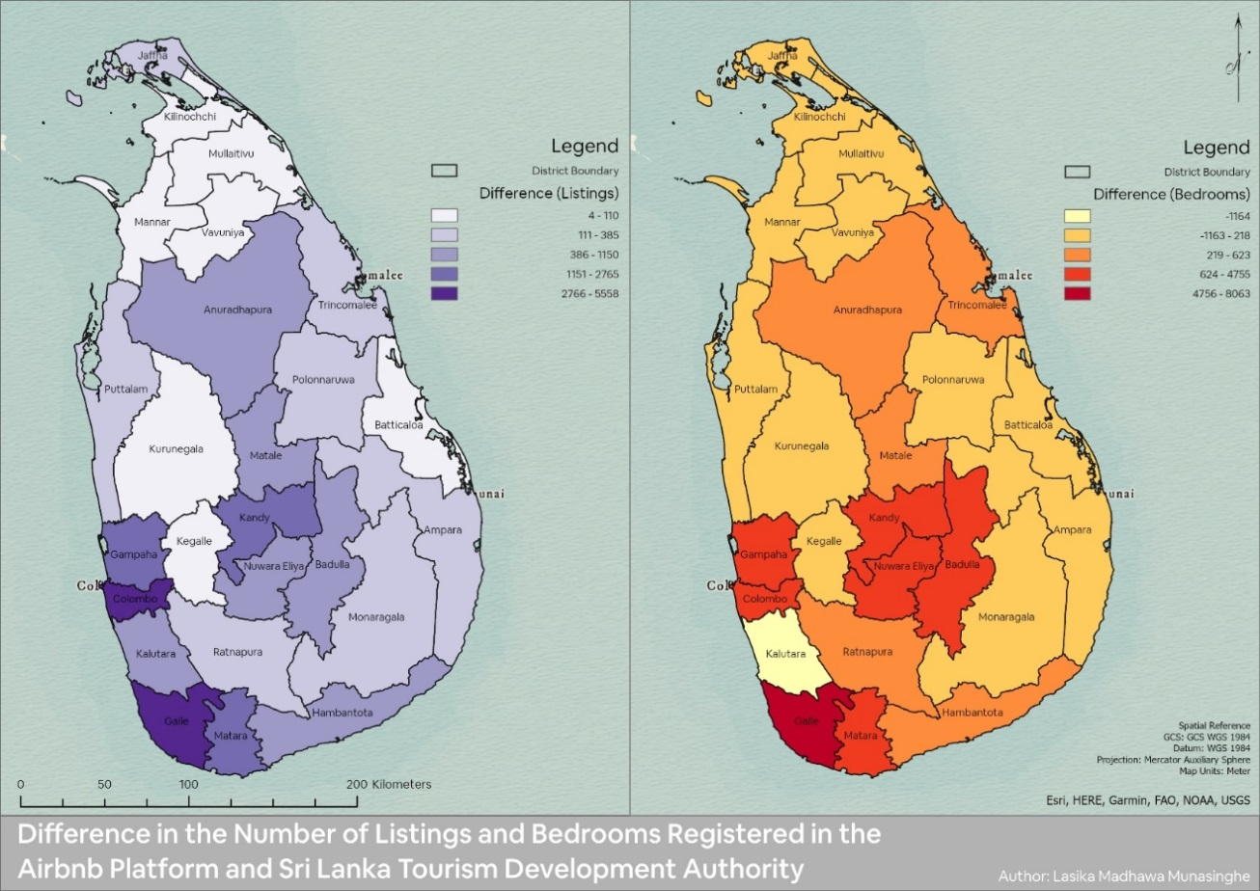
Source: Compiled by the Author

Figure 2. Difference in the number of listings and bedrooms offered by the Airbnb and SLTDA registered tourist accommodations
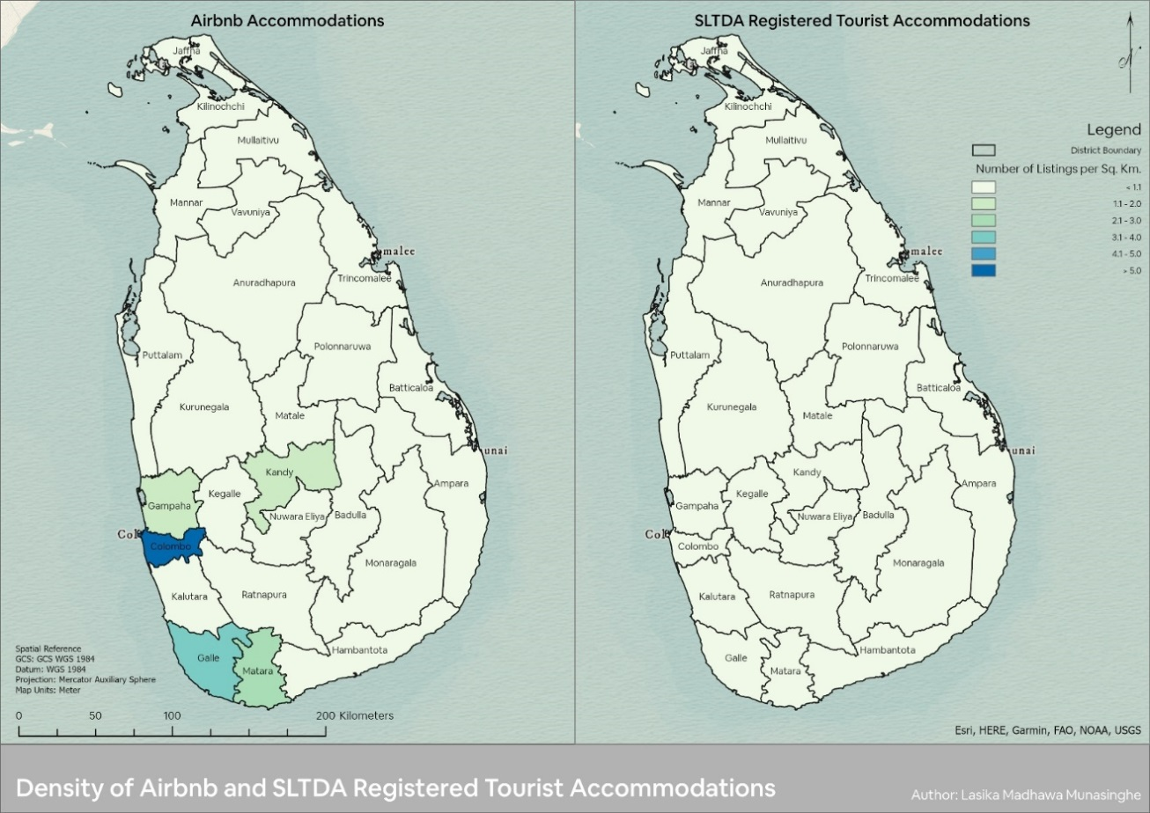
Source: Compiled by the Author

Figure 3. Percentage of Airbnb listings to the number of households in districts
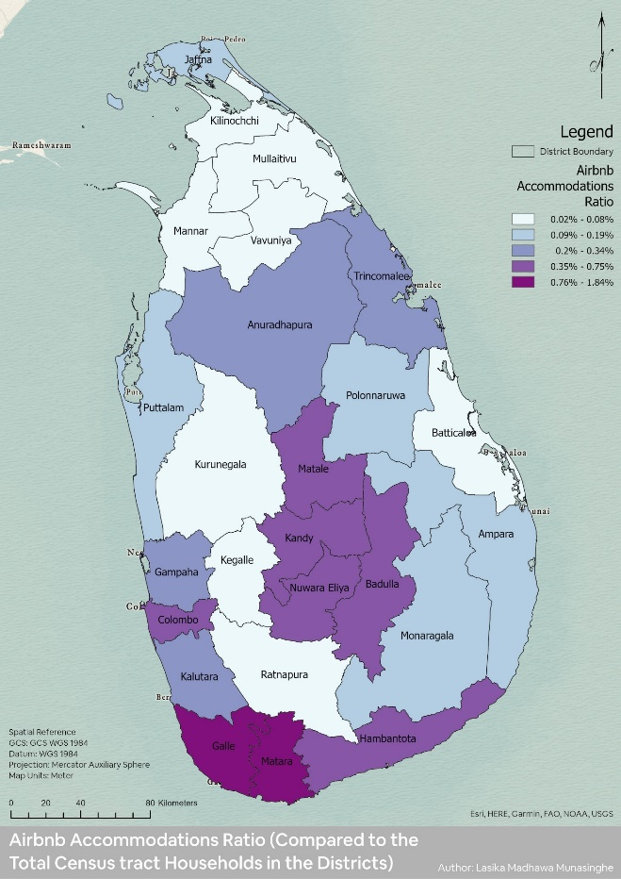

Source: Compiled by the Author

Figure 4. Percentage of Airbnb Listings to the Number of Households in Districts.

- Property hot spots

The Optimised Hot Spot Analysis tool identified statistically significant Airbnb listing areas and identified 192 hotspots in nine districts, namely Colombo, Gampaha, Kaluthara, Puttlam, Galle, Matara, Kandy, Nuwara Eliya and Badulla (Figure 5). These hotspot locations are located in and around City Centers, major tourist resort regions, and their immediate suburbs. This confirms that Airbnb listings mainly concentrate on city centres and major tourist districts or attractions (Guttentag, 2019).

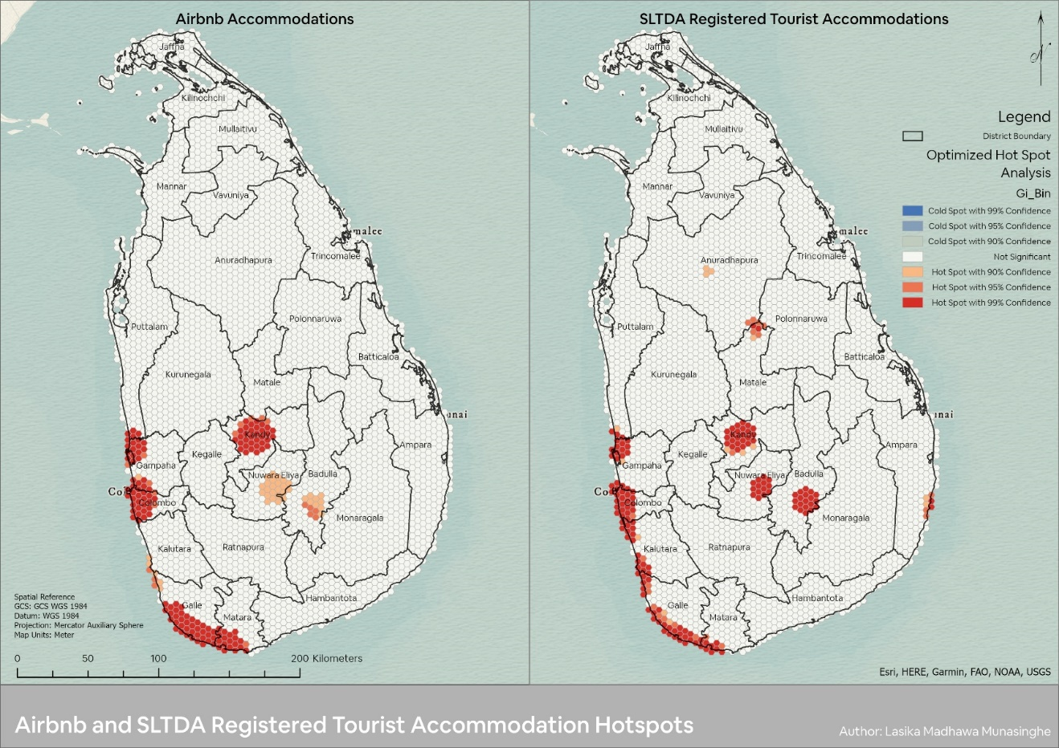
Source: Compiled by the Author

Figure 5. Airbnb and SLTDA Registered Tourist Accommodation Hotspots.

- Nature of properties

Airbnb mainly categorises its listings into three types: Entire Place, Private Room, and Shared Room (Airbnb, 2019a). The majority of the listings in Sri Lanka are Private Room rentals (62%), followed by Entire Place rentals (36%) and Shared Room rentals (3%) (Figure 1). The situation is similar for all Districts apart from Colombo, where most listings are Entire Place Rentals. The largest Airbnb rental market in terms of the number of listings is Galle (22%), followed by Colombo (17.30%), Kandy (11.10%) and Matara (10.78%). Airbnb listings can be further categorised by Property Type. Accordingly, there are around 109 types of properties available in Sri Lanka. Property types such as house, bed and breakfast, apartment, villa, guesthouse, bungalow, boutique hotel, hotel, nature lodge, and hostel can be identified as the top ten most listed property categories in Sri Lanka.
Instant Book listings allow a potential guest to book a property right away without any host and guest communication so that a typical reservation request to a host for approval is not necessary (Airbnb, 2019c). There are about 15,487 Instant Book enabled listings in Sri Lanka (Table 1), which is 59.19% of total Airbnb listings. Business Ready Properties are listings that Airbnb has recognised for business travellers to stay (Airbnb, 2019b). There are about 98 Business Ready Properties in Sri Lanka (Table 1).

- Distribution of bedrooms

In terms of Bedroom inventory, Airbnb Listings in Sri Lanka offers around 55,986 bedrooms (Table 1), close to twice as many as formal tourist accommodation establishments (30,198 bedrooms). Many of these bedrooms are from Private Room rentals (50.22%). Most of the Airbnb bedroom inventory is held by the district of Galle (22.73%). Colombo records the highest Bedroom Density value of more than 12 bedrooms per square kilometre (Figure 6). In terms of SLTDA registered tourist accommodation establishments, Colombo District records the highest Bedroom Density value of 9.1-12 Bedrooms per square kilometre. Out of 25 Districts, 15 districts have more Airbnb bedrooms than the number of bedrooms of SLTDA registered tourist accommodation establishments (Figure 2). Among those 15 Districts, the highest difference is recorded from Galle (4756-8063) (Figure 2).

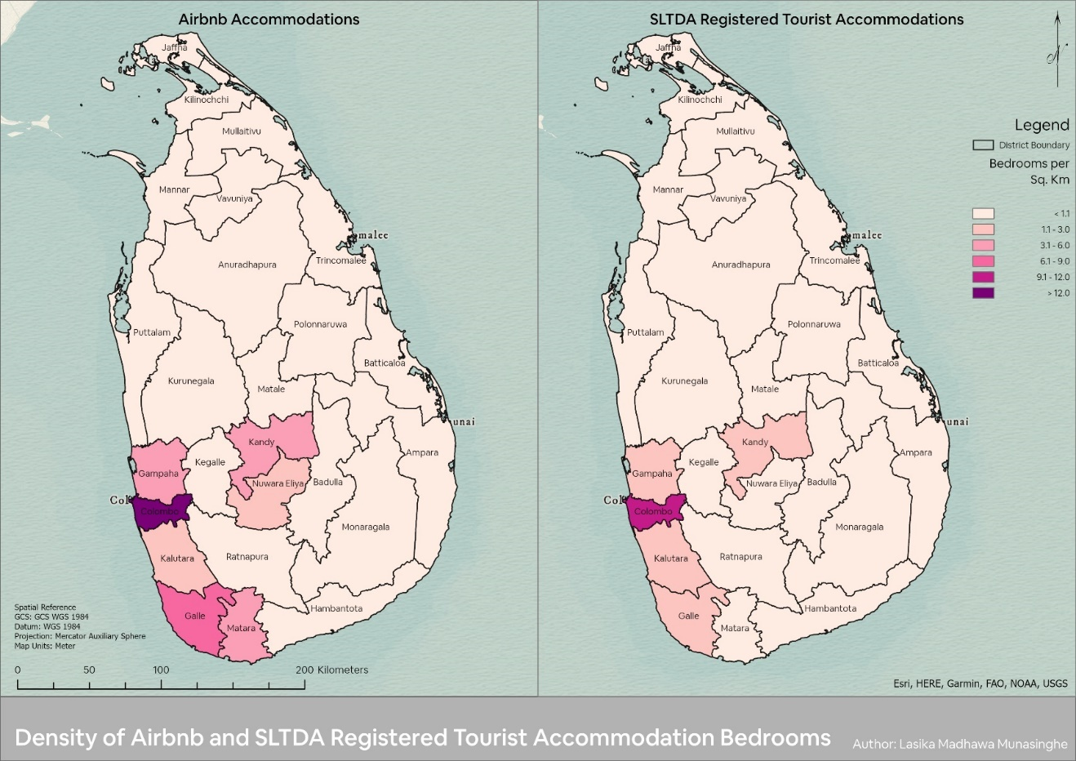
Source: Compiled by the Author

Figure 6. Number of Airbnb and formal tourist accommodation bedrooms per Sq. Km.

Table 1. Summary of Airbnb statistics

Description | Listing Type |  |  | Sri Lanka
Description | Entire home/apartment | Private room | Shared room | Sri Lanka
Number of Property Listings | 9,332 | 16,135 | 695 | 26,162
Number of Instant book Enabled Properties | 5164 | 9861 | 462 | 15,487
Number of Business Ready Properties | 44 | 46 | 8 | 98
Number of Bedrooms | 27,162 | 28,115 | 709 | 55,986
Average Bedrooms | 3 | 2 | 1 | 2
Number of Bathrooms | 21,885 | 28,219 | 1,231 | 51,335
Average Bathrooms | 2 | 2 | 2 | 2
Average Published Nightly Rate | $110 | $55 | $36 | $74
Average Published Weekly Rate | $767 | $386 | $270 | $519
Average Published Monthly Rate | $3,045 | $1,543 | $1,075 | $2,067
Total Annual Revenue | $22,941,904 | $12,681,706 | $119,235 | $35,742,845
Average Annual Revenue | $5,057 | $1,664 | $432 | $2,875
Average Occupancy Rate | 28% | 23% | 13% | 24%
Average Cleaning Fee | $19 | $9 | $9 | $14
Average Number of Available Days | 77 | 78 | 68 | 77
Average Number of Blocked Days | 20 | 14 | 8 | 16
Average Number of Reservation Days | 42 | 33 | 15 | 36
Average Minimum Period of Stay Required | 3 | 1 | 1 | 2
Average Extra People Fee | $18 | $18 | $14 | $18
Number of Reviews | 41,744 | 70,047 | 1,008 | 112,799
Average Overall Rating | 4.4 | 4.4 | 4.5 | 4.4
Number of Hosts | 5,944 | 7,808 | 466 | 12,407
Number of Super |Hosts | 569 | 841 | 23 | 1,433
Average Response Rate (%) | 92 | 95 | 93 | 94
Average Response Time (Hours) | 8 | 6 | 6 | 7
Source: Compiled by the Author
Note: $ refers to USD$

The distribution of Airbnb hosts

There are about 12,407 registered hosts who have listed properties in Sri Lanka (Table 1). The results indicated that the hosts manage multiple listings through the Airbnb Platform since the number of listings is higher than that of hosts. The majority of the hosts offer Private Room rentals (62.93%) (Table 1). Airbnb recognises and awards the “Super Host” designation to experienced hosts who set an excellent example for other hosts and provide exceptional experiences for their guests. There are around 1,433 Super hosts, and most of them offer Private Room rentals (58.69%). When responding to guest inquiries and reservation requests, a Sri Lankan host, on average respond to 94% of guest inquiries and reservation requests and typically takes 7 hours to respond (Table 1).

Hosting rules and policies set by hosts

Airbnb has allowed hosts to specify the Maximum Number of Guests they are willing to accommodate at one time. On average, Airbnb Listings in Sri Lanka allow a Maximum of 5 Guests (Table 1). The minimum night stay policy on Airbnb is the minimum number of nights that a potential guest can book an Airbnb rental, and the host entirely decides it. On average, Airbnb listings in Sri Lanka require a minimum of 2 nights of stay (Table 1). Cleaning Fees assist hosts in accounting for the additional cost incurred in getting their listing ready before the guests’ arrival or after their stay. Overall, an Airbnb Listing in Sri Lanka charges an Average Cleaning Fee of USD$14 (Table 1). Airbnb has allowed hosts to charge an extra guest fee when a reservation includes more guests. The fee can be used to offset the costs associated with higher occupancy, such as increased utility and material usage, such as toilet paper and soap, or additional cleanup. On Average, Airbnb Listings in Sri Lanka charge an Extra Guest Fee of $18 (Table 1). Some hosts request a security deposit to book their property. The Average Security Deposit required by an Airbnb listing in Sri Lanka is USD$196 (Table 1).
Airbnb allows hosts to set cancellation policies to operate their listings smoothly when guests may have to cancel their reservations for various reasons (Airbnb, 2019b). The host determines the cancellation policy for stays of less than 28 days. All stays of 28 days or more are subject to the long-term cancellation policy of Airbnb. Hosts may also offer a choice between a non-refundable or refundable rate for their listings. There are 11 variations of cancellation policies adopted by Airbnb Hosts (Table 2). Most listings in Sri Lanka have adopted a Flexible Cancellation Policy with Free cancellation for 48 hours (48.99%).

Table 2. Cancellation policy types

Cancellation Policy | Listing Type |  |  | Sri Lanka
Cancellation Policy | Entire home/apartment | Private room | Shared room | Sri Lanka
Flexible - Free cancellation for 48 hours | 3892 | 8535 | 390 | 12817
Flexible | 1747 | 2839 | 167 | 4753
Strict - Free cancellation for 48 hours | 1415 | 1766 | 38 | 3219
Moderate - Free cancellation for 48 hours | 1014 | 1490 | 38 | 2542
Strict | 609 | 542 | 20 | 1171
Moderate | 306 | 476 | 11 | 793
Flexible - Free cancellation within 48 hours | 175 | 377 | 29 | 581
Strict - Free cancellation within 48 hours | 71 | 48 | 1 | 120
Moderate - Free cancellation within 48 hours | 44 | 56 | 1 | 101
Super Strict 60 days | 49 | 1 | - | 50
Super Strict 30 days | 10 | 5 | - | 15
Grand Total | 9332 | 16135 | 695 | 26162
Source: Compiled by the Author

Performance of Airbnb accommodations

Each calendar day of a listing in the Airbnb Platform is classified as either Available, Blocked, or Reserved (AirDNA, 2019). The average number of available days of an Airbnb listing in Sri Lanka is recorded as 77 Days while being blocked for reservation for an average of 16 Days in a year (Table 1). At the same time, the average number of reservation days of an Airbnb listing in Sri Lanka is recorded as 36 days (Table 1). The Average Annual Occupancy Rate of Airbnb listings in Sri Lanka is around 24% (Table 1). As per analysis, the Average Published Nightly Rate Weekly Rate and Monthly Rate of the Airbnb Listings in Sri Lanka have been recorded as USD$74, USD$519 and USD$2,062, respectively (Table 1).
Tourism is the third-largest foreign exchange earner for Sir Lanka and recorded USD$4,380.6 million of tourist receipts in 2018 (Munasinghe et al., 2020; Sri Lanka Tourism Development Authority, 2019). Total Annual Revenue generated by Airbnb listing in Sri Lanka is recorded as USD$35.7 million, accounting for 0.81% of the total tourist receipts. The average annual revenue of an Airbnb listing in Sri Lanka is recorded as USD$2,875 (Table 1).
Host and guests who have completed a stay using Airbnb can submit reviews on Airbnb. As of August 2018, an average Airbnb Listing in Sri Lanka has 12 reviews (Table 1). In addition to written reviews, Airbnb asks guests to provide star ratings, which is a quick way to give feedback. In providing the star rating, guests are guided to assess the stay on attributes such as Overall experience, Cleanliness, Accuracy, Check-in, Communication, Location, Value and Amenities. Overall, Airbnb Listing in Sri Lanka has been rated 4.4 Out of 5 (Table 1).

Conclusion

Researchers have paid little attention to the emergence of peer-to-peer accommodation platforms in tourist cities, particularly concerning the location and their potential impact on the city. The present study aims to close this gap by providing a generic descriptive and spatial analysis of the operation of Airbnb and formal tourist accommodations using Sri Lanka as a case study. As per the study’s findings, Airbnb has been well established on Sri Lankan soil as an alternative accommodation service provider, and the listings have been scattered across the country. The distribution of the Airbnb accommodation offered in Sri Lanka follows the general patterns of population and hotel accommodation distribution, where listings tend to be concentrated in the city centres of districts. However, these listings also cover a broader service area than what is covered by formal tourist accommodation establishments. Moreover, they also extend to very central residential areas that are not covered by their formal counterparts. Airbnb accommodation rentals are popular in coastal regions where most rentals are private rooms or entire place listings, facilitating sun-and-beach residential tourism. This is also supported by the results of the optimised hotspot analysis.
Regardless of listing type, Airbnb rentals in Sri Lanka are concentrated in touristic areas, primarily in large and medium-sized cities. As a result, the spatial distribution of these listings reflects the dynamics of these cities’ housing markets as well as urban and cultural tourism models. The Airbnb platform is primarily used to commercialise vacation houses and second homes in cities for residential tourism. Because the majority of listings in Sri Lanka are for private room rentals, the platform is used in a way that is closer to the original sharing economy model. However, it is unclear whether all private and shared rooms on Airbnb are part of houses or apartments where all rooms are rented out or part of houses or apartments occupied by their owners.
Airbnb rentals may encourage the growth of the tourist accommodation supply in high-demand areas, resulting in a greater concentration of tourism activity in already-existing hotspots due to attractive revenue streams. However, as per the current spatial distribution of Airbnb listings, the contribution of Airbnb to expand tourism activities into rural and non-touristic areas of Sri Lanka is minimum. However, appropriate policies and intervention from relevant institutions could help to reap the benefits of Airbnb in promoting rural tourism. This will ease the pressure in tourism hotspots and potentially move individuals out of poverty in developing countries like Sri Lanka.
When developing regulatory responses to this phenomenon, it is essential to distinguish between distinct types of peer-to-peer rental activity based on location (cities, tourist destinations, and rural areas) and listing type (entire place, private room, and shared room). The scale, structure, and importance of Airbnb rental supply in different cities and tourist destinations must have distinct implications on the hospitality and housing sectors. Policies suited to regional and local circumstances should be used to address these effects. These policies must be supported by research that focuses on specific local contexts and addresses a variety of issues, including the impact on tourist destinations, formal tourism accommodation providers, the housing market, urban gentrification, the rural economy, regulation, and entrepreneurship.

Acknowledgement

This study was supported by the Research Grant awarded by the University of Sri Jayewardenepura (ASP/RE/MGT/01/2018/48) and the Center for Real Estate Studies (CRES).

References

Adamiak, C. (2018). Mapping Airbnb supply in European cities. Annals of Tourism Research, 71(February), 67–71. https://doi.org/10.1016/j.annals.2018.02.008
Airbnb. (2019a). What do the different home types mean? Help Centre. https://www.airbnb.ca/help/article/317/what-do-the-different-home-types-mean
Airbnb. (2019b). What is Airbnb for Work? - Airbnb Help Center. Help Center. https://www.airbnb.com/help/article/927/what-is-airbnb-for-work
Airbnb. (2019c). What is Instant Book? - Airbnb Help Center. Help Center. https://www.airbnb.com/help/article/523/what-is-instant-book
Airbnb. (2021). About Us. Airbnb Newsroom. https://news.airbnb.com/about-us/
AirDNA. (2019). Short Term Rental Data Glossary | AirDNA. Glossary. https://www.airdna.co/airdna-glossary-of-metric-definitions
AirDNA. (2020). AirDNA | Short-Term Rental Data & Analytics | Airbnb & Vrbo. https://www.airdna.co/
Arbel, A., & Pizam, A. (1977). Some Determinants of Urban Hotel Location: The Tourists’ Inclinations. Journal of Travel Research, 15(3), 18–22. https://doi.org/10.1177/004728757701500305
Botsman, R., & Rogers, R. (2010). What’s Mine Is Yours: The Rise of Collaborative Consumption. HarperBusiness.
Democratic Socialist Republic of Sri Lanka. (2016). The Gazette of the Democratic Socialist Republic of Sri Lanka - THE TOURISM ACT, No. 38 OF 2005 Order under Section 48(5). http://www.parliament.lk/files/pdf/constitution.pdf
Department of Census and Statistics. (2019). Census of Population and Housing. Population. http://www.statistics.gov.lk/Population/StaticalInformation/CPH2011
Egan, D. J., & Nield, K. (2000). Towards a Theory of Intraurban Hotel Location. Urban Studies, 37(3), 611–621. https://doi.org/10.1080/0042098002140
Gotham, K. F. (2005). Tourism Gentrification: The Case of New Orleans’ Vieux Carre (French Quarter). Urban Studies, 42(7), 1099–1121. https://doi.org/10.1080/00420980500120881
Gurran, N., & Phibbs, P. (2017). When Tourists Move In: How Should Urban Planners Respond to Airbnb? Journal of the American Planning Association, 83(1), 80–92. https://doi.org/10.1080/01944363.2016.1249011
Gutiérrez, J., García-Palomares, J. C., Romanillos, G., & Salas-Olmedo, M. H. (2017). The eruption of Airbnb in tourist cities: Comparing spatial patterns of hotels and peer-to-peer accommodation in Barcelona. Tourism Management, 62, 278–291. https://doi.org/10.1016/j.tourman.2017.05.003
Guttentag, D. (2015). Airbnb: disruptive innovation and the rise of an informal tourism accommodation sector. Current Issues in Tourism, 18(12), 1192–1217. https://doi.org/10.1080/13683500.2013.827159
Guttentag, D. (2019). Transformative experiences via Airbnb: Is it the guests or the host communities that will be transformed? Journal of Tourism Futures, 5(2), 179–184. https://doi.org/10.1108/JTF-04-2019-0038
Guttentag, D., Smith, S., Potwarka, L., & Havitz, M. (2018). Why Tourists Choose Airbnb: A Motivation-Based Segmentation Study. Journal of Travel Research, 57(3), 342–359. https://doi.org/10.1177/0047287517696980
Heo, C. Y., Blal, I., & Choi, M. (2019). What is happening in Paris? Airbnb, hotels, and the Parisian market: A case study. Tourism Management, 70(August 2017), 78–88. https://doi.org/10.1016/j.tourman.2018.04.003
Koh, E., & King, B. (2017). Accommodating the sharing revolution: a qualitative evaluation of the impact of Airbnb on Singapore’s budget hotels. Tourism Recreation Research, 42(4), 409–421. https://doi.org/10.1080/02508281.2017.1314413
Miththapala, S. (2012, September 12). Wildlife tourism in Sri Lanka. Financial Times. https://web.archive.org/web/20161113040633/http://www.ft.lk/2012/09/12/wildlife-tourism-in-sri-lanka/
Munasinghe, L. M., Gunawardhana, T., & Ariyawansa, R. (2020). Sri Lankan Travel and Tourism Industry: Recent Trends and Future Outlook towards Real Estate Development. SSRN Electronic Journal, 1–10. https://doi.org/10.2139/ssrn.3614984
Neuts, B., & Nijkamp, P. (2012). Tourist crowding perception and acceptability in cities. Annals of Tourism Research, 39(4), 2133–2153. https://doi.org/10.1016/j.annals.2012.07.016
Nieuwland, S. (2017). Help , Airbnb is taking over the City ! A study on the impacts of Airbnb on cities and regulatory approaches .
Nieuwland, S., & van Melik, R. (2020). Regulating Airbnb: how cities deal with perceived negative externalities of short-term rentals. Current Issues in Tourism, 23(7), 811–825. https://doi.org/10.1080/13683500.2018.1504899
Pizam, A. (2014). Peer-to-peer travel: Blessing or blight? International Journal of Hospitality Management, 38, 118–119. https://doi.org/10.1016/j.ijhm.2014.02.013
Russo, A. P. (2002). The “vicious circle” of tourism development in heritage cities. Annals of Tourism Research, 29(1), 165–182. https://doi.org/10.1016/S0160-7383(01)00029-9
Sainaghi, R., & Baggio, R. (2020). Substitution threat between Airbnb and hotels: Myth or reality? Annals of Tourism Research, 83, 102959. https://doi.org/10.1016/j.annals.2020.102959
Shoval, N., McKercher, B., Ng, E., & Birenboim, A. (2011). Hotel location and tourist activity in cities. Annals of Tourism Research, 38(4), 1594–1612. https://doi.org/10.1016/j.annals.2011.02.007
Shoval, N., & Raveh, A. (2004). Categorisation of tourist attractions and the modeling of tourist cities: based on the co-plot method of multivariate analysis. Tourism Management, 25(6), 741–750. https://doi.org/10.1016/j.tourman.2003.09.005
Si, S., Cullen, J., Ahlstrom, D., & Wei, J. (2018). Special issue: Business, entrepreneurship and innovation toward poverty reduction. Entrepreneurship and Regional Development, 30(3–4), 475–477. https://doi.org/10.1080/08985626.2018.1447241
Sigala, M. (2017). Collaborative commerce in tourism: implications for research and industry. Current Issues in Tourism, 20(4), 346–355. https://doi.org/10.1080/13683500.2014.982522
So, K. K. F., Oh, H., & Min, S. (2018). Motivations and constraints of Airbnb consumers: Findings from a mixed-methods approach. Tourism Management, 67, 224–236. https://doi.org/10.1016/j.tourman.2018.01.009
Sri Lanka Tourism Development Authority. (2018, June 11). Accommodation Information for Tourists | Open Data Portal - Sri Lanka. Open Data Portal. http://www.data.gov.lk/dataset/accommodation-information-tourists
Sri Lanka Tourism Development Authority. (2019). Annual Statistical Report 2018. www.sltda.lk/statistics
Tussyadiah, I. P., & Zach, F. (2017). Identifying salient attributes of peer-to-peer accommodation experience. Journal of Travel and Tourism Marketing, 34(5), 636–652. https://doi.org/10.1080/10548408.2016.1209153
Williams, C. C., & Horodnic, I. A. (2017). Regulating the sharing economy to prevent the growth of the informal sector in the hospitality industry. In International Journal of Contemporary Hospitality Management (Vol. 29, Issue 9). https://doi.org/10.1108/IJCHM-08-2016-0431
Zervas, G., Proserpio, D., & Byers, J. W. (2017). The Rise of the Sharing Economy: Estimating the Impact of Airbnb on the Hotel Industry. Journal of Marketing Research, 54(5), 687–705. https://doi.org/10.1509/jmr.15.0204

