

Bibliometric analysis on the implementation digitization technologies in cultural heritage in Malaysia

Siti Zuliana Salleh, A.R. Bushroa
Centre of Advanced Manufacturing and Material Processing (AMMP), Department of Mechanical Engineering, Faculty of Engineering, Universiti Malaya, 50603 Kuala Lumpur, Malaysia

Correspondence: A.R. Bushroa (email: bushroa@um.edu.my)

Received: 04 January 2022; Accepted: 22 April 2022; Published: 31 May 2022

Abstract

Malaysia is a rich country with significant tangible and diverse intangible cultural heritage assets. The cultural heritage information must be collected in order to transmit the information to future generations. In this digital era, knowledge transmission can be easily spread using digital platforms. Furthermore, the post-Covid-19 pandemic driven necessity of digital sharing platforms. However, the status of digital cultural heritage in Malaysia is unknown. Hence, this paper will be addressed the digitization of cultural heritage implementation in Malaysia based on the published research articles. The data extracted from the Web of Science and Scopus database has been analysed using bibliometric analysis. The search keywords related to the digitization of cultural heritage has extracted about 171 documents over 15 years of publication. This finding is significant to provide local researchers and related institutions with the potential of digital cultural heritage in a post-Covid-19 pandemic. The large potential of digital cultural heritage should motivate local researchers to increase the attention on digitization cultural heritage research area. Many potential applications which are benefited cultural heritage tourism, sustainability as well as contribution to the economy. The findings from this research indicate that the trend of digitization in the cultural heritage field needs to be strengthened.

Keywords: bibliometric analysis, cultural heritage, digitization, Malaysia, post-Covid-19 pandemic, publication analysis

Introduction

Cultural heritage is important for every society where the information from the past can be used to determine the identity of each society. Cultural heritage can be divided into two categories which are tangible and intangible. The tangible cultural heritage is the legacy of physical artefacts, while intangible cultural heritage such as various technologies features of some culturally-distinct groups that are inherited from the past generations, maintained in the present time and curated and nurtured for the benefit of future generations (Stapleton et al., 2019). Both categories are important and need to be preserved, conversed and transmittable for sustainable cultural heritage. The preserved cultural heritage can lead to survival traditions and can connect the society with history. The potential of heritage conservation also can give benefits for heritage tourism (Daeng Jamal & Ramli, 2021). The growth of the economy can drive better enhancement in innovations, creativity, prosperity and social values of cultural heritage (Kantor & Kubiczek, 2021).
In Malaysia, there are many tangible and intangible cultural heritage. Malaysian craftsmen are highly artistic and skilful to transform the traditional design elements into unique and aesthetically pleasing pieces which carry deeper philosophical and sacred meanings (Shuaib & Enoch, 2013). Malaysia had 12 tangible and intangible cultural heritage assets that have been awarded by international bodies such as United Nations Educational, Scientific and Cultural Organization (UNESCO) (Suaib et al., 2020). Recently, songket is the latest and become the sixth National Heritage recognized by UNESCO in intangible cultural heritage. The weaving skills for making traditional songket are endangered due to factory-based weaving (Zhang et al., 2018). Hence, the protection for songket was submitted to UNESCO in 2021. A year later, the Malaysian songket obtained international recognition for intangible cultural heritage.
In fact, the sustainability of the cultural heritage still questionable (Hua, 2015). The risk of extinction of cultural heritage assets are related to the modernization and physical development (Yusoff et al., 2013), natural disasters (Matusin et al., 2019) or the impact induced by tourism activities and the background of the visitors (Mohamad et al., 2015). Malaysia government actively protect cultural heritage asset at the national level by introducing several plans or acts such as Malaysian architectural history (Khairul et al., 2021), Malaysian Urban-Rural National Indicators Network for Sustainable Development (MurniNet 2.0) (Idris et al., 2021) and National Heritage Act 2005 (Daeng Jamal & Ramli, 2021).
The other protection ways of cultural heritage are via the implementation of digitization technologies. The digital cultural heritage can ensure the sustainability of cultural heritage and become a powerful tool to avoid the complete loss of the memory of cultural heritage assets. Digital technologies enable reconstruction and reproduction in creative ways. Furthermore, the digitization of cultural heritage is also included in the Twelfth Malaysia Plan (RMK-12). The RMK-12 accelerates technology adoption where the country’s economic sector can be revived with the implementation of advanced technology, specialized capabilities as well as digitization technologies. The reuse content of digital cultural heritage can generate new business models for economic growth.
The global scale of the Covid-19 pandemic and its sustained duration has negative impacts on museums and related institutions. The post-Covid-19 regulated a new standard of operations that restrict many physical activities. For instance, a limited number of participants for visiting the museums, exhibitions, as well as any conferences. During the pandemic, the digital cultural heritage has become a source of virtual activities that can provide a continuous approach in connecting society with cultural heritage. The digital cultural heritage can be extensively applied with various creative ways as ways to preserve, conserve and sustain the cultural heritage. The dynamic combination of digitization technologies enables a precise reconstruction of heritage objects and photo-realistic 3D model reconstruction (Obradović et al., 2020).
Previously, a survey regarding the state of digitization initiatives by cultural institutions in Malaysia was reported in 2007 (Abd, 2007). Since then, digitization technologies have advanced to the point where it can be used to digitise cultural heritage. However, no further publication has reported on the current state of digital cultural heritage in Malaysia. Hence, the purpose of this work is to investigate the status of cultural heritage digitization through bibliometric analysis. This analysis can assist in updating the current states, the progress of digitization research as well as the research directions.
Method and study area

The analysis of the literature using bibliometric analysis can assist the investigation regarding the trend of the literature. The analysis can visualize the mapping of literature by extracting the database collected from the search engines particularly from Web of Science, Scopus or Dimensions. The analysis of the literature database is valuable in giving reliable information.
The analysis via bibliometric can establish the quantitative as well as quantitative aspects of the research development. The analysis can be divided into various variants such as based on the document, keywords, and collaboration of the research fields.
This paper utilized the bibliometric analysis via the Biblioshiny package available in the R-Studio tool. The paper aims to investigate the current status of digitization technologies implementation in cultural heritage fields in Malaysia. The analysis is based on the published literature associated with digitization technology, cultural heritage, and Malaysia for future research directions.
The bibliometric analysis has several steps which started with collecting the database from eligible search engines. In this study, a database from Web of Science and Scopus were extracted for revealing the related facts from published literature. The database was collected until January 2nd, 2022. The main search keywords are “cultural heritage”, “digital*”, and “Malaysia” with the Boolean operators AND and OR as tabulated in Table 1. The details of the database will be used to map the trend. The Biblioshiny package in R-Studio will be used to analyse the database (Aria & Cuccurullo, 2017). The R-Studio also assist in combining and deleting any duplicated literature in the database before further analysis. In this study, the total number of duplicates is 301.

Table 1. Main search keywords.

Main search keywords | Number
Web of Science
ALL=(digital* OR digitization) AND TI=("cultural heritage") AND CU=(Malaysia) | 15
ALL=(digital* OR digitization) AND AB=("cultural heritage") AND CU=(Malaysia) | 48
ALL=(digital* OR digitization) AND AK=("cultural heritage") AND CU=(Malaysia) | 26
ALL=(digital* OR digitization) AND ALL=("cultural heritage") AND CU=(Malaysia) | 58
Scopus
ALL (digital* OR digitization) AND TITLE-ABS-KEY (cultural AND heritage) AND AFFILCOUNTRY (Malaysia) | 162
ALL (digital* OR digitization) AND TITLE-ABS-KEY (cultural heritage) AND AFFIL (Malaysia) | 163

Results and discussion

The overview of the digitization of cultural heritage in Malaysia based on the published literature is reviewed. The collected database included all types of documents and was restricted to English only. The main information of the database collected from Web of Science and Scopus can be extracted. For instance, the extracted database showed that 171 published literatures are related to the search keywords as listed in Table 1. The collected database showed that the earliest literature is published in 2007. Within the 15 years of publications, the literature was published in 133 different sources.

Document analysis

Under the document analysis, the type of documents extracted from the Web of Science and Scopus can be analysed. The extracted detail of the document is shown in Figure 1. Based on the analysis, the article type is highly published by researchers followed by the conference paper with 49.71% and 42.11%, respectively. The combination of the article, conference paper and proceedings paper is recorded 96.50% from document types. This indicates that the original research works regarding the digital cultural heritage are the highest compared to the other type of documents such as the review or book chapter. Within the 15 years of publications, 85 articles have been published by local researchers.

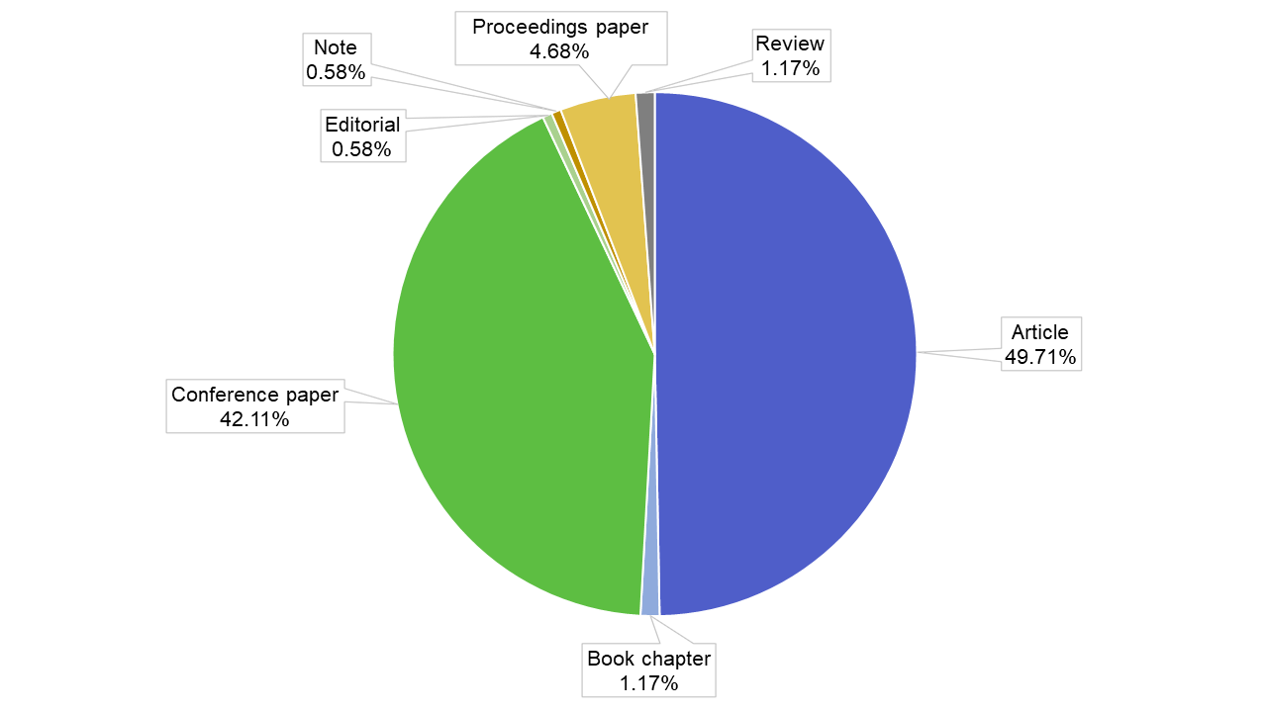
Figure 1. Type of documents extracted from the Web of Science and Scopus.

The number of published literatures between 2007 until 2021 is shown in Figure 2. The trend of published documents showed that the year 2019 shows a reduction as compared to the previous year. However, the number of published documents keep increasing. The number of documents in the year 2021 is recorded at 25. Meanwhile, the mean total citation per article (MeanTCperArt) showed the highest number in 2009 with 23.00 MeanTCperArt. The other years showed MeanTCperArt is lower than 6.33.
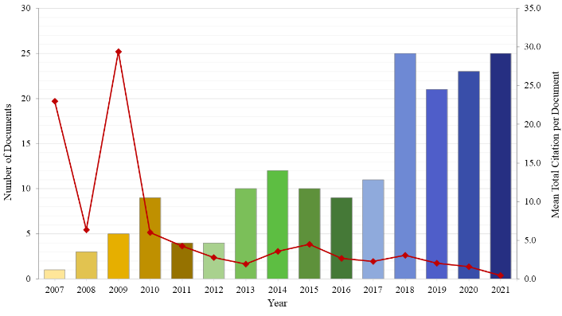
Figure 2. Number of published literature and mean total citation per year between 2007 until 2021.
The published documents in 2007 and 2009 with significant number of total citations are listed in Table 2. The increment number of document started from 2007 are related to the adoption of the UNESCO Charter on the Preservation of Digital Heritage was adopted in 2003. Then, the National Heritage Act 2005 also prompted the Malaysian initiatives in digitizing cultural heritage in Malaysia. In 2007, a document published by Abd showed the second number of citations. A document is considered a highly cited article when the number of citations is >100 times (Zhang et al., 2019). Although it cannot be categorized as a highly cited document, this document showed a significant contribution to the digitization of cultural heritage. This published article indicates that the researcher in Malaysia already started to pay interest in the digitization of cultural heritage since 2007. The highest cited article is contributed by Noh in 2009. The document is published for Lecture Notes in Computer Science where the total citation is recorded at 109. The document gained attention from other researchers because the document was well-written that contained information about the overview of augmented reality for cultural heritage. This document compiled virtual heritage projects and also provided a thorough explanation of the techniques used to reconstruct virtual heritage systems.

Table 2. Published documents in 2007 and 2009

Authors | Title | Year | Source | Total Citation
Abd M Z | The State of Digitisation Initiatives by Cultural Institutions in Malaysia an Exploratory Survey | 2007 | Library Review | 23
Noh Z; Ismail A;Sunar M | Exploring the Potential of Using Augmented Reality Approach in Cultural Heritage System | 2009 | Proceedings of the 2nd International Conference on Advanced Computer Theory and Engineering, ICACTE 2009 | 2
Noh Z; Sunar M; Pan Z | A Review on Augmented Reality for Virtual Heritage System | 2009 | Lecture Notes in Computer Science (Including Subseries Lecture Notes in Artificial Intelligence and Lecture Notes in Bioinformatics) | 109
Razali S; Md N N; Wan A W | Structuring the Social Subsystem Components of the Community Based Emuseum Framework | 2009 | Lecture Notes in Computer Science (Including Subseries Lecture Notes in Artificial Intelligence and Lecture Notes in Bioinformatics) | 3
Samad A; Bahari S; Abd R S; Hashim K | Image Processing for Facade Mapping Using Digital Close Range Photogrammetric DCRP Approach | 2009 | Proceedings Of 2009 5th International Colloquium on Signal Processing and Its Applications, CSPA 2009 | 4

Keywords analysis

In bibliometric analysis, keywords are important word analysis to reveal the trend of the research area. In keywords analysis, it can be categorized into two groups which are Author’s Keyword and Keyword Plus. The Author’s Keyword is recorded at 529 meanwhile the number of Keyword plus is recorded at 716. The number of keywords for Keyword Plus is higher than Author’s Keywords because the Keyword Plus considered the keyword from the entire content of documents including the title of the article itself (Tripathi et al., 2018). The top Author’s Keyword with high occurrence can give indications of the research are priorities and researchers interests (Zhang et al., 2019).
Based on the Keywords analysis, the word of keywords can be accumulated and grouped into the WordCloud. Figure 3 (a and b) shows the WordCloud formation using Author’s Keyword and Keyword Plus from the collected database, respectively. From both keywords, it can be stated that the digitization of cultural heritage in Malaysia started to look more into the potential applications of digital cultural heritage. For instance, the keywords of virtual reality, augmented reality, virtual heritage are among the largest sized for Author’s Keywords. The WordCloud of Author’s Keyword also shows the importance of online user perspective. The enjoyable informal learning and also the user experience are included. In comparison with Keyword Plus, the main keyword is historic preservation which indicates the main aims of digitizing cultural heritage. Similarly, Keywords Plus has also proven to involve the point of view of online users. For instance, the keywords consist of the user experience, younger generations, Malaysian, as well as user interfaces.

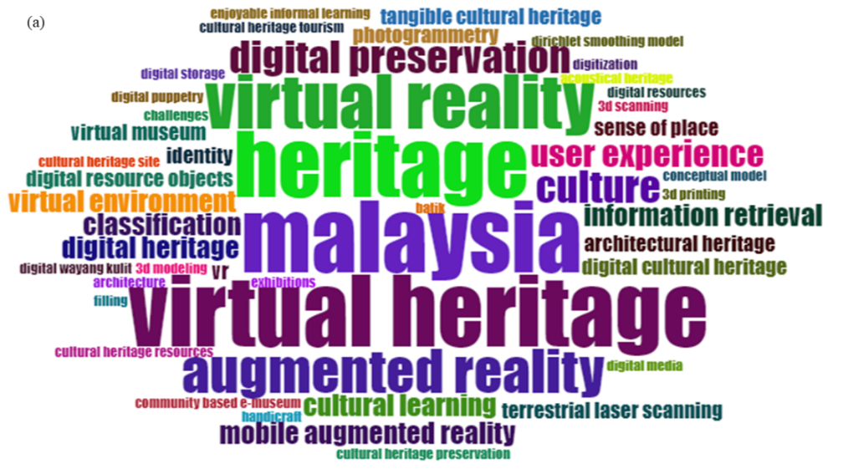
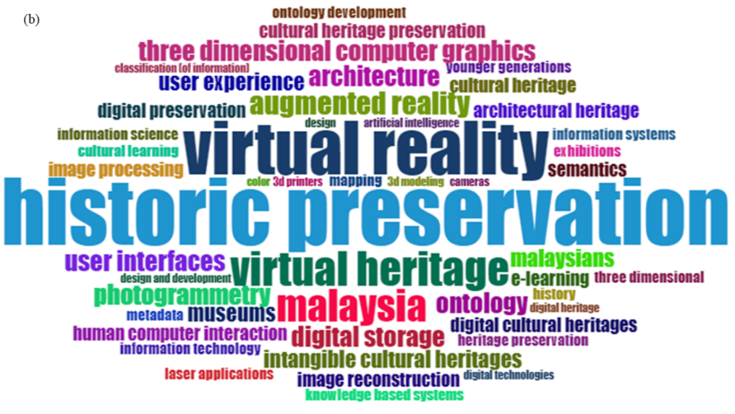
Figure 3. WordCloud from (a) Author’s Keyword and (b) Keyword Plus.

The details for both keyword types are tabulated in Table 2. The number of frequencies counted from the Keywords Plus is higher than Author’s Keywords. This pattern is related to the method used to count keywords for Keywords Plus. Keywords Plus is created by combining the title, abstract, and reference lists from the article (Aria & Cuccurullo, 2017). As a result, Keywords Plus represents a broader set of keywords than the Author's Keyword.

Table 2. Details for both keyword types.

Author’s Keywords |  |  | Keywords Plus
Frequency | Terms | Cluster | Frequency | Terms | Cluster
30 | cultural heritage | cultural heritage | 51 | cultural heritages | cultural heritages
2 | 3d printing | cultural heritage | 23 | historic preservation | cultural heritages
2 | 3d scanning | cultural heritage | 7 | digital storage | cultural heritages
15 | intangible cultural heritage | intangible cultural heritage | 18 | virtual reality | virtual reality
6 | digital preservation | intangible cultural heritage | 12 | virtual heritage | virtual reality
3 | tangible cultural heritage | intangible cultural heritage | 7 | architecture | virtual reality
13 | Malaysia | Malaysia | 11 | Malaysia | Malaysia
12 | heritage | Malaysia | 6 | Malaysians | Malaysia
6 | culture | Malaysia | 5 | cultural heritage | Malaysia
13 | virtual heritage | virtual heritage | 8 | augmented reality | augmented reality
10 | virtual reality | virtual heritage | 6 | museums | augmented reality
4 | classification | classification | 5 | human computer interaction | augmented reality
2 | filling | classification | 7 | ontology | ontology
2 | image processing | classification | 6 | intangible cultural heritages | ontology
4 | information retrieval | information retrieval | 5 | cultural heritage preservation | ontology
3 | digital resource objects | information retrieval | 6 | photogrammetry | photogrammetry
4 | mobile augmented reality | mobile augmented reality | 5 | image processing | photogrammetry
2 | conceptual model | mobile augmented reality | 3 | mapping | photogrammetry
2 | cultural heritage site | mobile augmented reality | 7 | three-dimensional computer graphics | three-dimensional computer graphics
3 | photogrammetry | digital cultural heritage | 5 | image reconstruction | three-dimensional computer graphics
3 | terrestrial laser scanning | digital cultural heritage | 4 | laser applications | three-dimensional computer graphics
3 | virtual museum | digital cultural heritage | 2 | conceptual frameworks | conceptual frameworks
3 | identity | identity | 2 | cultural heritage information | conceptual frameworks
2 | batik | identity | 2 | knowledge-sharing | conceptual frameworks
2 | challenges | identity
2 | 3d modeling | 3d modeling
2 | cultural heritage tourism | cultural heritage tourism
2 | penang | cultural heritage tourism
2 | digital puppetry | digital puppetry
2 | malaysian shadow play | digital puppetry
2 | wayang kulit kelantan | digital puppetry
2 | information technology | information technology
2 | tourist satisfaction | information technology

Further analysis on the keywords showed that the number of clusters for Author’s Keywords is higher than the Keywords Plus. As listed in Table 2, the clusters are divided into 13 different clusters for Author’s keywords while only 8 clusters for Keywords Plus. In general, both keywords’ categories are related to the cultural heritage(s), Malaysia as well as the digital cultural heritage applications. Again, applications such as virtual heritage, augmented reality, or mobile augmented reality are among the main keywords in the literature. In Author’s Keywords, the digitization of cultural heritage is important for information retrieval which is believed to assist museums or related institutions to preserve the identity of Malaysian society as well as to contribute to heritage tourism or cultural heritage tourism. The other important clusters indicate that the information technologies, 3D modeling, as well as digital puppetry, are related issues with the implementation of digitization technologies in cultural heritage.
The Keywords Plus also highlighted the digitization technologies such as photogrammetry, three-dimensional computer graphics which are required for the enhancement in image processing procedures. Furthermore, the conceptual framework which is related to the quality of 3D reconstructed models also is emphasized in Keywords Plus. Similar to the Malaysian identity, Keywords Plus extended the cluster with ontology which can be used to guide the analysis process and supports the detection of certain concepts defined in the domain ontology (Sharma & Siddiqui, 2016). According to the literature, digital cultural heritage has been proven to benefit both cultural heritage and society (Bekele et al., 2018). For instance, Europeana is the great European digital library that contains over 30 million objects which represent 10% of the available digital cultural heritage in Europe (Bachi et al., 2014). EuropeanaPhotography (Truyen & Waelde, 2016), Europeana Space, RICHES, and PREFORMA (Bachi et al., 2014) were among the funded projects by the European Commission to digitize the cultural heritage. The projects are beneficial for society with easy access. Such projects should be initiated in Malaysia which also can attract society to learn more about cultural heritage and maintain the identity of various ethnicities in Malaysia.
The co-occurrence network of the most frequently used Author’s Keywords is illustrated in Figure 4. The network can be analysed according to the bubble size and the line thickness as well as the colour. In general, the bubble size refers to the total number of highly cited documents while the line thickness and colour refer to the link strength and cluster, respectively (Zhang et al., 2019). Figure 4 showed that there are more research works can be done according to the bubble size and line thickness. For instance, 3D printing, virtual environment, mobile augmented reality, digital storage, digital cultural heritage, filing, digital resource objects, architectural heritage or tangible cultural heritage. The digitized cultural heritage versions facilitate new means of access and enable the use of materials that are not possible with the analogue form (Xie & Matusiak, 2016).

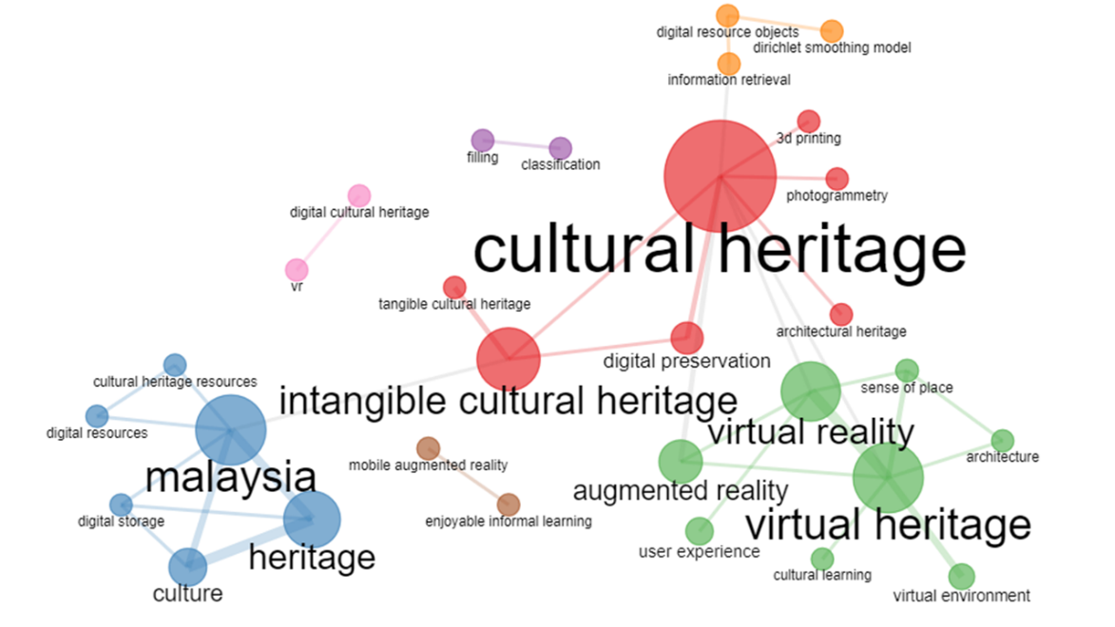
Figure 4 The co-occurrence network for Author’s Keywords

Themes analysis

The keywords analysis based on the cluster of the Author’s Keywords can be expanded to identify the themes of the digitization of cultural heritage in Malaysia. The themes analysis is illustrated by plotting the development degree (Density) against the relevance degree (Centrality) as shown in Figure 5. Centrality is the degree of interaction of the research theme with other research themes while density is the internal strength of research themes (Callon et al., 1991).
Based on the four themes, it can be used to predict the status and future research areas for the digitization of cultural heritage in Malaysia. The future of digital cultural heritage research areas can be identified by analysing the topics in Emerging and declining Themes. Digital puppetry (Cluster 12) is in this theme which might be an important theme in the nearest future, or it can be neglected when more research has been conducted. This is because the topic listed in this theme is weakly developed (low density) and marginal (low centrality) (Herrera-Viedma et al., 2016).
The theme in Basic Theme is low density and high centrality indicates that the research topic under this theme is weakly developed but considered important themes in the research field. For instance, the clusters such as intangible cultural heritage (Cluster 2), virtual heritage (Cluster 4), information retrieval (Cluster 6) and mobile augmented reality (Cluster 7) are presented in this theme. Based on Figure 5, the clusters in Basic Theme required further research works which need to provide better research value in digitization cultural heritage. In addition, the capability of digital cultural heritage as real-photorealistic models increases the potential applications (Abdelhafiz & Mostafa, 2020).
Motor Theme is considered the unification of the knowledge and journal due to high density and centrality (Della Corte et al., 2019). The clusters in this theme are a cultural heritage (Cluster 1), Malaysia (Cluster 3), digital cultural heritage (Cluster 8), identity (Cluster 9), and cultural heritage tourism (Cluster 11). The niche Theme is in the high density and low centrality. This indicates that the Niche theme is only limited to the research field (Della Corte et al., 2019). This theme is less important in the digitization of cultural heritage, but the many works show high strength in the internal ties. For instance, the cluster of classification and information technology in Cluster 5 and 13, respectively.

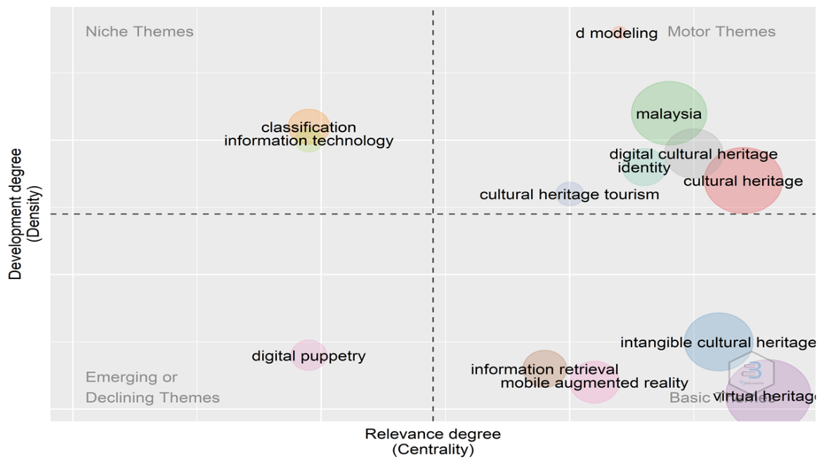

Figure 5. Themes analysis based on the cluster of Author’s Keywords.

Based on the theme analysis using the Author’s Keywords, it is important to monitor the research trends frequently. The Author’s Keywords are essential types to obtain the research trends which is useful for monitoring the research development (Chen et al., 2021). The clusters present in the themes will continually change over time as the research continues.

Network analysis

Network analysis is performed to map the scope and structure of the discipline while discovering key research clusters (Fahimnia et al., 2015). Two important network analyses are the co-citation of the authors as well as the institution collaboration as shown in Figure 6 and Figure 7, respectively.
The co-citation of the authors with a minimum of at least 2 papers is shown in Figure 6. Tan K, Lim C, Woods P and Thwaites H are among the top 4 authors in co-citation analysis regarding the digitization of cultural heritage. The main principle of co-citation is that more than two documents are co-cited, which likely discuss the same research issue (Farrukh et al., 2020).
The most active institution collaborations are between Universiti Teknologi Mara, Multimedia University and Universiti Kebangsaan Malaysia. These three universities had a large size of bubbles that indicates a high number of occurrence of institutions collaborations with other institutions. In general, Figure 7 also shows that almost all universities in Malaysia had involved in the digitization of cultural heritage research. However, the small size lines signify the collaboration networks between each institution are still low. The low strength line thickness on the digitization of cultural heritage indicates that this research area hasn’t reached full maturity in terms of scientific knowledge.
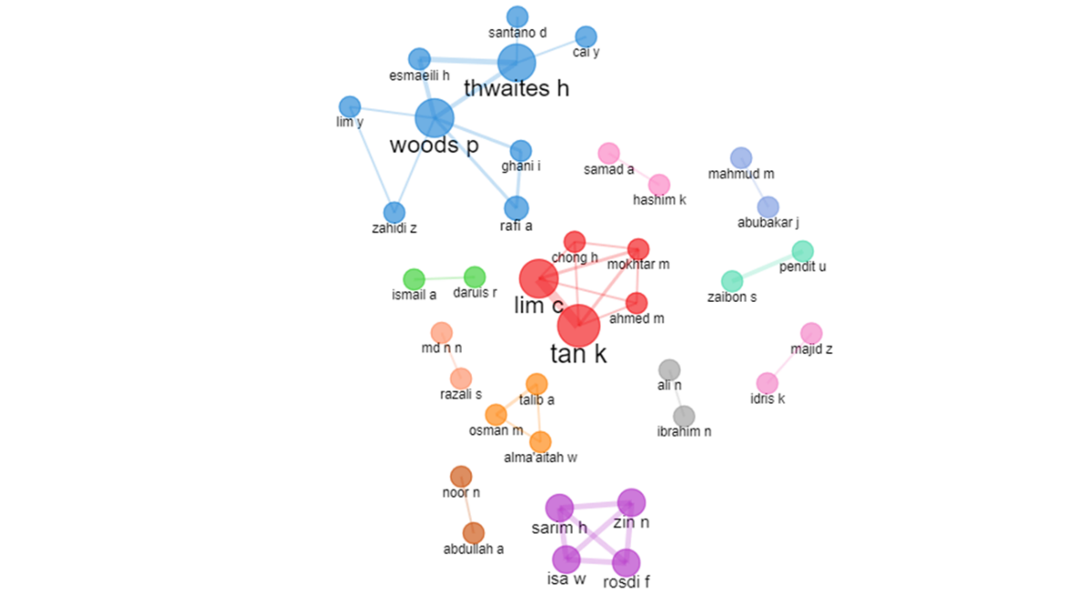
Figure 6. Network analysis of co-citation of the authors.

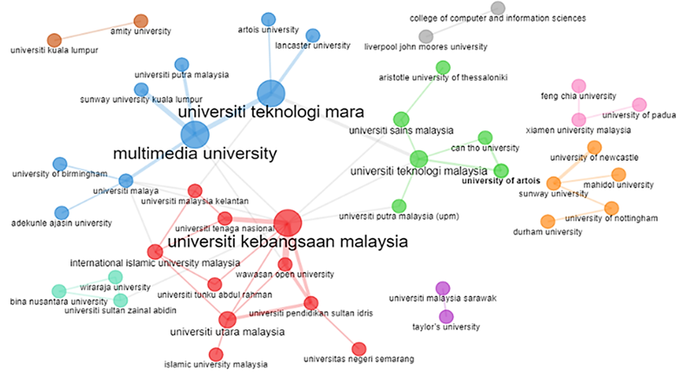
Figure 7. Network analysis of institutions collaboration.

Future recommendations: post-Covid-19

The Covid-19 situation causes the digitization implementation in cultural heritage to become significant. The economic system and mindset due to the Covid-19 has been guiding and shaping the response and recovery strategies of governments, institutions, businesses and related peoples for post-Covid-19 (Sigala, 2020). This becomes an opportunity to introduce diverse digital applications which is beneficial to museums and related institutions as well as to enhance the promotion of cultural heritage. Digital cultural heritage applications such as virtual reality, augmented reality in a virtual environment for digital tourism can be an alternative solution to continue the tourism and also hospitality industry. Furthermore, these digital interaction formats will be part of a new regime in academic sharing or exchange. For instance, this new digital interaction format has successfully substituted physical activities such as conferences during the Covid-19 pandemic (Schwarz et al., 2020). Future research should create digital applications with valuable end-user benefits. Finally, it is important to ensure the digital cultural heritage still can retain the original criteria of cultural heritage.

Conclusion

This paper investigated the academically published articles on the implementation of digitization in cultural heritage in Malaysia. Bibliometric analysis was used to assist the assessment of the status of the research. Web of Science and Scopus database enables the mapping of digital cultural heritage trends within 15 years of publication. The findings show that the digitization in cultural heritage started in 2007 and the quantity of publications is kept growing since then. The database analysis on the document, keywords, networks revealed more details about the research. The analysis can determine the preferable type of document, highly cited articles, co-citation articles and institutions in Malaysia as well as from abroad involved with the digitization cultural heritage. Based on the bibliometric analysis, the current status of digitization of cultural heritage in Malaysia needs to be strengthened in order to protect the cultural heritage as well as the museum institutions themselves. The current Covid-19 pandemic negatively impacts physical activities but the implementation of digitization in cultural heritage provides new applications for post-Covid-19 recovery plans. The successful digitization projects funded by European Commission are proven evidence and should motivate the Malaysian government and local researchers in digitization cultural heritage. The digitised projects are benefited to cultural heritage tourism, sustainability as well as contribution to the economy.

Acknowledgements

This study was financially supported by Universiti Malaya Impact-Oriented Interdisciplinary Research Grant Programme (IIRG) under the sub-program IIRG034B-2019. The authors would like to sincerely thank Mr Abd Aziz Abdul Rashid (Curator of the Museum Asian Art, Universiti Malaya) for providing the Kendi samples as the subject for this study.

References

Abdelhafiz, A., & Mostafa, Y. (2020). Quantitative quality measure for photorealistic three dimensional models. Survey Review, 52(371), 183–189. https://doi.org/10.1080/00396265. 2018.1543928
Abd M. Z. (2007). The state of digitisation initiatives by cultural institutions in Malaysia: An exploratory survey. Library Review, 56(1), .45-60. https://doi.org/10.1108/ 00242530710722014
Aria, M., & Cuccurullo, C. (2017). bibliometrix : An R-tool for comprehensive science mapping analysis. Journal of Informetrics, 11(4), 959–975. https://doi.org/10.1016/j.joi.2017. 08.007
Bachi, V., Fresa, A., Pierotti, C., & Prandoni, C. (2014). The Digitization Age: Mass culture is quality culture. Challenges for cultural heritage and society. Lecture Notes in Computer Science (Including Subseries Lecture Notes in Artificial Intelligence and Lecture Notes in Bioinformatics), 8740, 786–801. https://doi.org/10.1007/978-3-319-13695-0
Bekele, M. K., Pierdicca, R., Frontoni, E., Malinverni, E. S., & Gain, J. (2018). A survey of augmented, virtual, and mixed reality for cultural heritage. Journal on Computing and Cultural Heritage, 11(2), 1–36. https://doi.org/10.1145/3145534
Callon, M., Courtial, J. P., & Laville, F. (1991). Co-word analysis as a tool for describing the network of interactions between basic and technological research: The case of polymer chemsitry. Scientometrics, 22(1), 155–205. https://doi.org/10.1007/BF02019280
Chen, W., Ahmed, M. M., Sofiah, W. I., Isa, N. A. M., Ebrahim, N. A., & Hai, T. (2021). A Bibliometric Statistical Analysis of the Fuzzy Inference System - based Classifiers. IEEE Access, 9, 77811–77829. https://doi.org/10.1109/ACCESS.2021.3082908
Daeng Jamal, D. H., & Ramli, Z. (2021). Pemuliharaan beberapa bangunan bersejarah di Kelantan: Tinjauan ke atas penglibatan komuniti setempat dalam suai guna semula. Geografia-Malaysian Journal of Society and Space, 2(2), 461–474. https://doi.org/10.17576/geo-2021-1702-35
Della Corte, V., Del Gaudio, G., Sepe, F., & Sciarelli, F. (2019). Sustainable Tourism in the Open Innovation Realm: A Bibliometric Analysis. Sustainability, 11(21), 6114. https://doi.org/10.3390/su11216114
Fahimnia, B., Sarkis, J., & Davarzani, H. (2015). Green supply chain management: A review and bibliometric analysis. In International Journal of Production Economics (Vol. 162, pp. 101–114). Elsevier. https://doi.org/10.1016/j.ijpe.2015.01.003
Farrukh, M., Meng, F., Raza, A., & Tahir, M. S. (2020). Twenty-seven years of Sustainable Development Journal: A bibliometric analysis. Sustainable Development, 28(6), 1725–1737. https://doi.org/10.1002/sd.2120
Herrera-Viedma, E., Martinez, M. A., & Herrera, M. (2016). Bibliometric tools for discovering information in database. In H. Fujita, M. Ali, A. Selamat, J. Sasaki, & M. Kurematsu (Eds.), Lecture Notes in Computer Science (including subseries Lecture Notes in Artificial Intelligence and Lecture Notes in Bioinformatics) (Vol. 9799, Issue 61272374, pp. 193–203). Springer International Publishing. https://doi.org/10.1007/978-3-319-42007-3_17
Hua, A. (2015). Malacca as a world tourism centre: is it sustainable?. Geografia-Malaysian Journal of Society and Space, 11(9), 75-85
Idris, N., T.S., T. I. S., & Mohammad, L. M. (2021). The preservation of provincial identity in baroque influenced artistic architectural structure at Kampung Cina, Terengganu. Geografia-Malaysian Journal of Society and Space, 2(2), 432–446. https://doi.org/ 10.17576/geo-2021-1702-33
Kantor, A., & Kubiczek, J. (2021). Polish Culture in the Face of the COVID-19 Pandemic Crisis. Journal of Risk and Financial Management, 14(4), 181. https://doi.org/10.3390/ jrfm14040181
Khairul, M., Ghazali, A., Saleh, Y., & Mahat, H. (2021). Design of a sustainability construct framework for heritage city in Malaysia. Geografia ; Malaysian Journal of Society and Space, 1(1), 211–226. https://ejournal.ukm.my/gmjss/article/view/43170
Matusin, A.M.R.A., Siwar, C., & Halim, S.A. (2019). Vulnerability framework of tourism to natural disasters. Geografia-Malaysian Journal of Society and Space, 15(4), 137-150. https://doi.org/10.17576/geo-2019-1504-10
Mohamad, D., Rahman, S., Bahauddin, A., & Mohamed, B. (2015). Physical environmental impacts of island tourism development: A case study of Pangkor Island. Geografia-Malaysian Journal of Society and Space, 11(11), 120-128
Obradović, M., Vasiljević, I., Durić, I., Kićanović, J., Stojaković, V., & Obradović, R. (2020). Virtual reality models based on photogrammetric surveys-a case study of the iconostasis of the serbian orthodox cathedral church of saint nicholas in Sremski Karlovci (Serbia). Applied Sciences (Switzerland), 10(8). https://doi.org/10.3390/APP10082743
Schwarz, M., Scherrer, A., Hohmann, C., Heiberg, J., Brugger, A., & Nuñez-Jimenez, A. (2020). COVID-19 and the academy: It is time for going digital. Energy Research and Social Science, 68(June), 0–2. https://doi.org/10.1016/j.erss.2020.101684
Sharma, M. K., & Siddiqui, T. J. (2016). An Ontology Based Framework for Retrieval of Museum Artifacts. Procedia Computer Science, 84, 169–176. https://doi.org/10.1016/ j.procs.2016.04.083
Shuaib, A. A., & Enoch, O. F. (2013). Integrating Malay Tangible Cultural Heritage into Furniture Design: An Approach to Enhance Product through Emotional and Spiritual Contents. Tojsat, 3(4), 77–85
Sigala, M. (2020). Tourism and COVID-19: Impacts and implications for advancing and resetting industry and research. Journal of Business Research, 117(June), 312–321. https://doi.org/ 10.1016/j.jbusres.2020.06.015
Stapleton, L., O’Neill, B., Cronin, K., McLnerney, P., Hendrick, M., & Dalton, E. (2019). A Semi-Automated Systems Architecture for Cultural Heritage, Sustainable Solutions for Digitising Cultural Heritage. IFAC-PapersOnLine, 52(25), 562–567. https://doi.org/ 10.1016/j.ifacol.2019.12.606
Suaib, N. M., Ismail, N. A. F., Sadimon, S., & Yunos, Z. M. (2020). Cultural heritage preservation efforts in Malaysia: A survey. IOP Conference Series: Materials Science and Engineering, 979(1), 0–10. https://doi.org/10.1088/1757-899X/979/1/012008
Tripathi, M., Kumar, S., Sonker, S. K., & Babbar, P. (2018). Occurrence of author keywords and keywords plus in social sciences and humanities research : A preliminary study. COLLNET Journal of Scientometrics and Information Management, 12(2), 215–232. https://doi.org/ 10.1080/09737766.2018.1436951
Truyen, F., & Waelde, C. (2016). Copyright, cultural heritage and photography: A gordian knot? In K. J. Borowiecki, N. Forbes, & A. Fresa (Eds.), Cultural Heritage in a Changing World. Springer International Publishing. https://doi.org/10.1007/978-3-319-29544-2_5
Xie, I., & Matusiak, K. K. (2016). Digitization of text and still images. In I. Xie & K. K. Matusiak (Eds.), Discover Digital Libraries (pp. 59–93). Elsevier. https://doi.org/10.1016/b978-0-12-417112-1.00003-x
Yusoff, Y. M., & Dollah, H. (2013). Perlindungan harta warisan: Keberkesanan usaha pemuliharaan dan pemeliharaan dalam pembangunan negara (National development and the protection of heritage property: An appraisal of the Malaysian experience). Geografia, Malaysian Journal of Society and Space, 9(2). 64-77
Zhang, M., Sas, C., & Ahmad, M. (2018). Design for Songket Weaving in Malay Cottage Industry. Conference on Human Factors in Computing Systems (pp. 1-6). https://doi.org/10.1145/ 3170427.3188579
Zhang, X., Estoque, R. C., Xie, H., Murayama, Y., & Ranagalage, M. (2019). Bibliometric analysis of highly cited articles on ecosystem services. PloS ONE, 14(2), e0210707. https://doi.org/10.1371/journal.pone.0210707

