

Adaptation of traditional Malay house design towards housing comfort and satisfaction

Syazwani Ahmad¹, Aprodita Emma Yetti^{2,} Nor Eeda Ali¹, Mohamad Sofiyuddin Sanusi¹, Puteri Yuliana Samsudin¹

¹Universiti Teknologi MARA, Perak, Malaysia
²Universitas Aisyiyah Yogyakarta, Indonesia

Correspondence: Syazwani Ahmad (email: syazw860@uitm.edu.my)

Received: 9 January 2022; Accepted: 11 August 2022; Published: 31 August 2022

Abstract

Prioritizing of environmental and socio-cultural factors of the community in housing design will be able to create a home that is natural and flexible with various conditions and lives of its occupants from time to time. Thus, will be able to provide comfort and satisfaction of housing to its occupants. This study aims to review and identify the design and concept of traditional Malay houses that suitable to be applied in modern housing development towards improving the occupant’s comfort and satisfaction aspects The literature review has identified several factors in comfort and satisfaction of the housing occupants such as house design, house and space size, space flexibility, space arrangement, space allocation, lighting and ventilation. Traditional Malay houses design are referred as a comparison factor for this study as a basic element of housing comfort and satisfaction. The approach of the study involves a quantitative and a qualitative approach. The analysis led to the discovery of the problems of modern house design from various aspects which including design, size, space arrangement, lighting and ventilation. Therefore, the recommendation is to adapt potential traditional Malay house design elements in modern housing development. The study concludes that the adaptation of potential elements of traditional Malay house design can produce a sustainable housing, offering comfort and satisfaction, improve the quality of life and gives good implications for housing development.

Keywords: Housing comfort, housing design, housing development, housing satisfaction, quality of life, traditional Malay house

Introduction

Comfort and satisfaction are one of the important factors that must be given priority in the provision of housing for all sections of society. This is because housing is not only developed as one of the elements that influences the composition and image of urban design from the aspect of planning as well as architecture alone. It is one of the most important life components giving shelter, safety and warmth, as well as providing a place to rest (Henilani, 2016). On the other hand, it has a huge role in perfecting human life as one of the most basic needs. It not only exhibits physical structure, but it also translates things involving deep feelings that can have an impact on its occupants. According to Abdullahi (2021), adequate housing is one of the necessities of a quantitative life. Without a quality house as a place to live, human beings will not achieve a perfect life wherever they are, especially for those who work and have to live in the city for a period of time. To meet the needs and demand for housing in the city, those involved in the housing sector, whether private or public, try to offer various types of housing to attract buyers. However, although the provision has exceeded the target, there is a situation where the housing provided cannot meet the needs of residents, especially from the aspect of internal comfort of the house such as poor lighting and ventilation, inappropriate space layout, limited space size, etc. These existing housing problems is due to lack of emphasis on sustainable design elements that usually take into account the natural climatic and socio-cultural factors of the local community. According to Hamidon Abdullah (2008), most houses in Malaysia tend to be built by imitating other countries' building models that do not necessarily suit the environment in Malaysia, which will result in houses being designed ignoring climatic factors and causing the house to be adapted to the local climate.
Referring to Ali, Taki and Painter (2020), traditional houses are often well adapted to local climate and environmental conditions, including sociocultural circumstances. Thus, it will be able to produce designs that suit the needs of the local community. Successful design will be able to balance the elements of function, form, economy, and time because architecture is a branch of knowledge that emphasizes the human aspect. Man will be happy with his presence at a certain time in a comfortable and peaceful space. According to Chuah (2022), traditional Malay houses have their own form of geomancy. It was designed and built by former community highlighting the expertise in particular aspects of creativity and aesthetic Malay community at the time. The design is almost perfect including suitability to the climate, variety of space uses, flexible design and sophisticated prefabricated systems such as houses can be grown according to the increasing number and needs of the family. In addition, it is also designed based on the needs of the real estate and the result of the aspirations of the Malays. Residential development is also in line with the socio-economic, cultural and environmental needs of the community.

Literature review

Housing comfort and satisfaction has a big role in perfecting human life as one of the most basic needs. Good development planning is very important to ensure the needs of residents and the community, especially in terms of housing comfort and satisfaction. Many studies show that satisfaction of housing is one of the important components that influence the quality of life, and indirectly produce a balanced and harmonious society. However, the achievement of housing comfort and satisfaction would not have been possible without sustainable housing, which is driven by two main key’s location and design. That mean these two main keys should be blend together in planning the residential development to contribute the maximum comfort and satisfaction to its occupants. Ortiz, Kurvers and Bluysse (2017) state that comfort is a reaction to the environment that is strongly influenced by cognitive and behavioral processes. Aspects of comfort include personal factors, health and wellbeing, thermal comfort, indoor air quality, visual comfort, noise nuisance, ergonomics, and so on. In the other words, housing comfort describes the comfort of the occupants towards thermal comfort, design, which must take into consideration of local weather factors, interior design of the house, satisfaction with the environment that includes the provision of facilities in the environment and the accessibility of occupants to such facilities (Haryati Shafii, 2018). Besides that, orientation and forms of buildings also have an important role in providing better indoor thermal comfort (Pathirana, Rodrigo & Halwatura, 2019).
Referring to Mohammad Abdul Mohit and Adel Mahfoud (2014), residential satisfaction defined as the feeling of contentment when one has or achieves what one needs or desires in a house. Residential satisfaction can also be defined as an indicator of homeowners’ view of the general quality of their life. It can be mean that an individual’s housing expectation is met (Tan, 2016). To develop a house that can meet the satisfaction and comfort of occupants, there are several factors referenced from the design of traditional Malay houses, noteworthy in terms of house design, house and space size, space flexibility, space arrangement, space allocation and lastly the lighting and ventilation (Syazwani, 2011) (figure 1).



Sources: Syazwani (2011)

Figure 1. Factors of housing comfort and satisfaction.

According to Seo, Saari and Young (2012), traditional Malay houses are buildings for common living, built with local materials and techniques, in which an owner can participate. They were designed and built by the people themselves to meet specific needs, accommodating the values, economies and ways of life of the culture that produced them. In addition, it is also designed based on the housing needs through the aspirations of the Malays. The housing development is also in line with the socio-economic, cultural and environmental needs of the community. Basically, traditional Malay house is a timber house raised on stilts. It is a post and lintel structure with wooden or bamboo walls and a thatched roof. The design is essentially the combination of physical and physiological factors. Physical factors such as terrain, climate and building materials. The physiological factor is that the house erected must be able to meet the needs of society as a place to rest, a place to gather, and a place that provides a lot of peace and comfort. According to Ariffin, Behaz and Denan (2018), traditional houses have a better ability to provide indoor thermal comfort for more extended periods than the modern houses in the same condition. Low thermal conductivity due to thinner walls and the use of non-local building materials such as concrete in the modern houses create higher temperature variations compared to traditional houses.
There are several types of traditional Malay house designs in Malaysia. The design of the house influenced by the local socio-culture of their community to highlight a certain identity and aesthetic value, especially the design of the roof. However, the basic house form and construction method are similar (refer figure 2).

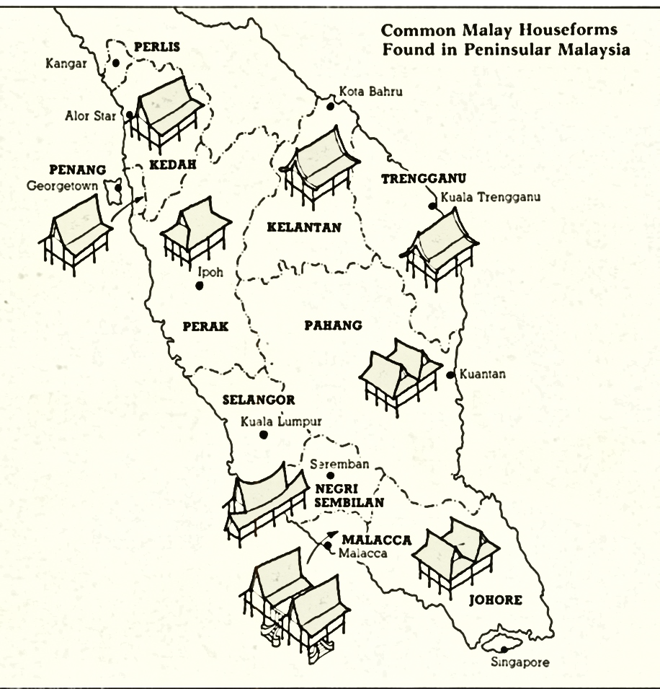
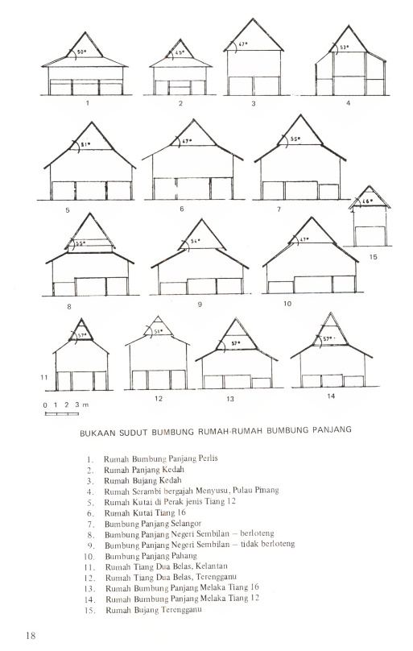

Sources: Lim (1987)

Figure 2. Roof design and basic house form of traditional Malay house.

The concept and design of traditional Malay house can be detailed referring to 11 elements which is building material, layout, orientation, ventilation of roof space, ventilation of body level, cross ventilation, wind velocity gradient, vegetation, overhangs and exposed vertical area, glare and lighting level (table 1).

Table 1. Concept and design of traditional Malay house.

No. | Elements | Description
1. | Building Material | Use lightweight construction of wood and another natural materials.  The lightweight construction of low thermal capacity holds little heat and cools adequately at night.
2. | Layout | Randomly arranged. Ensures wind velocity in the house.
3. | Orientation | The east-west orientation minimizes areas exposed to solar radiation.
4. | Ventilation of roof space | Properly ventilated by the provision of ventilation joints and panels in the roof construction.
5. | Ventilation of body level | Allows ventilation at the body level by having many full-length fully openable windows and doors at body level
6. | Cross ventilation | Allows easy passage of air and good cross ventilation due to minimal interior partitions
7. | Wind velocity gradient | The design of the Malay house allows for good air circulation as it is not obstructed by trees that restrict wind movement.
8. | Vegetation | The use of coconut trees and other tall trees in the kampung not only provides good shade but also does not block the passage of winds at the house level.
9. | Overhangs and exposed vertical area | Large overhangs and the low exposed vertical areas in the house provide good protection against driving rain, and allow the windows to be left open for ventilation. Large overhangs also controlled the glare in the house and provide good shading.
10. | Glare | Controlled by large roof overhangs and low windows which exclude the open skies from the visual fields. Glare also lessened by the less reflective natural ground covers and wooden walls of neighbouring houses.
11. | Lighting level | The traditional Malay house tends to be underlighted. This gives the psycological effect of coolness. The underlighting, can be remedied by artificial lighting.
Source: Lim (1987) & Syazwani (2011)

According to Utaberta et al. (2015), Malay houses are also designed in such a good way that it accommodates with the various types of space needed by the people thus showing its expressed quality for its consumer’s way of life. The space in the traditional Malay house can be used for variety of activities at different times (figure 3 and table 2). Basically, the traditional Malay house can be divided into 5 main spaces namely, 1) covered porch, 2) verandah, 3) core house, 4) passageway, and 5) kitchen .
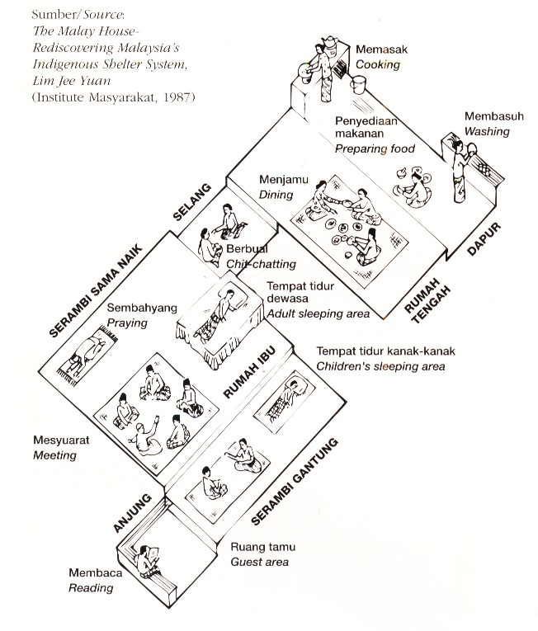

Source: Lim (1987)

Figure 3. Interior space in the traditional Malay house.

Table 2. Concept and function of space in traditional Malay house.

No. | Space | Description
1. | Covered Porch | This space is the first space located in front of the house. It is located on the ground floor and serves as a receptionist. Its position is between the stairs and the foyer. It is roofed and usually without wall. According to Ku Azhar (1990), the porch space has a semi-open wall surface and seating to relax. Its design emphasizes open space and is always brightly lit.  It is a transition room between public space and the owner’s own domain. Act as the starting point for entering a house. From this porch, one will enter the hanging verandah (Utaberta et al., 2015).
2. | Verandah | This space located between the covered porch and the core house. The verandah is usually lower than the floor level of the core house and has windows that can be opened to the floor level (Ku Azhar, 1999). The design also emphasizes open space and is always brightly lit. Lim (1987), classifies the verandah into 2, namely the hanging verandah and the same rising verandah. The hanging verandah is located next to the covered porch and is a transitional space between the core house and the covered porch. The same porch up is the porch that flanks the core's house and is another air circulation space. Generally, it is used as a family lounge. Usually, the verandah floor is the same level as the floor of the core's house on the verandah. This space is also a men’s space where it is used for relaxing and as a bed for the boys. In addition, it is the main space that is often used to conduct a ceremony such as a wedding ceremony, ‘tahlil’ and so on. It is also a space to celebrate male guests who come to the house (Zulkifli, 1985).
3. | Core House | The core house is the most basic house for a traditional Malay house. It is located in the middle room between the front room (covered porch and verandah) and the back room (‘kelek anak’ and kitchen). This space is the family's personal space and is the largest space in a Malay house. It is usually separate from the other parts. This is where the whole family eats, sleeps and prays. Feasts were also held here (Putrajaya Holdings Sdn. Bhd., 2002).
4. | Passageway | The passageway is a closed passage that connects the core’s house with the kitchen. Usually there is a door that is used as the main route of family members going in and out of the house (Zulkifli, 1999). In addition to increasing the airflow and the entry of light into the house, the interval is also a gathering place for women to chat and so on.
5. | Kitchen | In addition to serving as a place to carry out cooking and washing activities, this space can also be used as a place to celebrate female guests. It’s known as the women’s space. The position of the floor is lower than the floor of the middle room, which is the core's house and also the foyer.
Source: Zulkifli (1985); Lim (1987); Ku Azhar (1990); Putrajaya Holdings Sdn. Bhd. (2002); Utaberta et al. (2015)

Method and study area

For this research, the mixed-method which involves quantitative and a qualitative approach is employed. The quantitative approach involves a questionnaire that is divided into several sections referring to the factors that affect the comfort and satisfaction of the occupants. While the qualitative approach involves collecting and analyzing non-numerical data to understand concepts, opinions, or experiences to gather in-depth insights into a problem or generate ideas for research. In this study, traditional Malay houses design is referred to as a basis for comparison in identifying comfort and housing satisfaction factors.

Results and discussion

This study has identified that housing design is the main factor affecting the level of comfort and satisfaction of the occupants. Among the discomforts experienced is the poor lighting and ventilation in the house due to inappropriate design. However, this inconvenience can be overcome through the provision of appropriate housing design. By referring to the development of traditional Malay house and taking into account the criteria emphasized in its development will be able to help the formation of better and more sustainable house design in order to offered comfort and satisfaction of housing. The summary of the findings for this study is as follows:

Housing design elements

a. Roof design

Roof design can help in contributing good ventilation through air circulation in the roof space. The establishment of a traditional Malay house roof is formed by a combination of panels which allow good ventilation because the air had the opportunity to come and go freely. This situation is in contrast to the roof design of a modern house where the roof space in a modern house is insulated by trapped wind in lieu of ventilation. Therefore, modern house design requires high ceilings in order to get effective air.

b. Stilt floor

The height of the floor level of the house is not only to reduce the effects of soil moisture but can affect the level of ventilation. This is because, wind speed increases with altitude. Therefore, the design of a traditional Malay house provide the ability to capture the wind speed at a high level. This design is very suitable for overcoming ventilation problems in areas where there are trees that limit wind movement. Modern housing schemes are built on land with low floor levels. therefore, wind reception is at low velocities. In addition, small trees and strong walled fences built around the house for ‘privacy’ also block the wind and form a very minimal wind speed.

c. Openings

Upon consideration of the comfort level of the human body, many traditional Malay house design elements apply openings such as doors and wide windows to promote air circulation. This situation is very different from modern housing design. Ventilation in modern housing is usually focused for the comfort of the upper part of the human body only. This concept can be seen through the placement of windows and open spaces located in a high place for the purpose of 'privacy' to the occupants.

d. Overhangs

Large overhangs have a specific function in providing maximum comfort to the occupants of the house. For traditional Malay house, roof construction with overhangs and long and short side walls reduce the wall and windows from being exposed to excessive glare of the sunlight. In addition, its can provide good protection while rainings and also form shade. This allows the windows to be open at all times for good ventilation. In contrast to the traditional Malay house, the windows of modern houses usually exposed as a result of the high walls and windows and roofs without overhangs design accordingly. This causes direct penetration of sunlight and causes discomfort in the house. Walls that protect from sunlight store heat that is absorbed during the day and releases heat into the house in the evening.

e. Building material

The use of building materials from lightweight materials with low thermal capacity such as roofing will be able to reduce heat. In addition, it also contributes to cold ventilation at night. Building materials for modern housing consist of bricks, concrete, tiles, tiles and so on. The materials used have different properties than natural materials used for the construction of a traditional Malay house. Although it is permanent and durable, it has shortcomings in terms of the ability to contribute thermal comfort to the occupants. This is because such materials have a high thermal capacity.

f. Housing layout

Traditional Malay house does not have a fixed layout position as modern homes laid out in the form of blocks. It is erected scattered to facilitate the movement of wind which contributes to good ventilation inside and outside the house. The rigid layout in modern housing development causes wind movement to be obstructed, in turn minimizing good ventilation. In addition, the prescribed layout for modern homes also limits space for tree planting purposes. Only hedge trees and small trees can be planted. This causes a very minimal wind movement and wind reception at the house level. The situation is very different compared to the layout of traditional Malay houses which are not bound by arrangements which limit the space. This independent layout creates a comfortable space for planting tall trees that not only contributes good shading but also promotes good wind movement at house level.

Space arrangement

The division of space in traditional Malay house is very minimal. This makes the layout of the space in the house very simple compared to the modern house which is set by the space plan in the house. Usually, this plan creates an intricate shape and the division of space into different rooms and spaces limits the movement of wind and minimizes the internal ventilation of the house. While the traditional Malay house, the rooms in the house are elongated and facilitate the movement of wind and broad encourage good ventilation. Referring to the layout of space in a modern house, shows that many divisions can limit the movement of wind in the house.

Lighting levels

The level of lighting in modern housing is higher than in traditional Malay house as a result of the placement of windows at a high level. In addition, it is also due to the use of bright paints. This condition contributed to the excessive lighting and uncontrollable glare. The situation is very different from traditional Malay houses that are more prone to the formation of shading in the house which will provide a psychological effect on the cool atmosphere.
As summary for the findings, referring to the attributes or characteristics of sustainable design in the traditional Malay houses, it is very detrimental if it is not applied to the current housing development as an action to improve the quality of housing developed. This is because, traditional methods have shown that a suitable interior atmosphere can be produced through the optimization of the use of materials and the design of the building.

Conclusion

In conclusion, it is found that there are some shortcomings in modern house design such as the problem of storing heat and trapping it in the house to cause thermal discomfort due to the use of building materials such as bricks, concrete, tiles, tiles, and glass coatings. From the aspect of the layout of the house, it shows that the arrangement in the form of blocks prevents the movement of wind. Meanwhile, the space arrangement in the house also limits the movement of wind. Ventilation in modern housing is usually focused on the comfort of the human body in relation to traditional Malay house where ventilation is more comfortable for promoting air circulation for comfort of the human body as a whole. The provision can see this of different windows between these two types of houses. In terms of building orientation, modern housing does not pay attention in an effort to reduce the reception of scorching sunlight. This is because, the development needs to be adapted to the shape of the development area within the allowable density. As a result of inappropriate orientation causes the reception of excessive solar glare occurs in modern housing. In addition, the consequences of high and large walls also cause direct penetration of sunlight and cause internal discomfort of the house. The adaptation of potential elements of a traditional Malay house design hopefully can produce a sustainable housing to the occupants, offering comfort and satisfaction of housing, improve the quality of life and gives good implications for housing and urban development.

Acknowledgement

We would like to thank and express an appreciation to Town and Regional Planning Department, UiTM Perak Branch and Universitas ‘Aisyiyah Yogyakarta, Indonesia for publication collaboration.

References

Abdullahi, O. L. (2021). Social welfare and access to housing among the middle and low-income earners in Nigeria: A review of frameworks for housing delivery. Public Policy and Administration.Research, 11(1), 90-97.
Ali, N., Taki, A., & Painter, B. (2020). Comparative study of traditional and contemporary Islamic dwelling design: The case of Benghazi, Libya. Glob. Dwell. Approach. Sustain. Des. Particip. 193, 39.
Ariffin, N.A.M., Behaz, A., & Denan, Z. (2018). Thermal comfort studies on houses in hot arid climates. In IOP Conference Series: Materials Science and Engineering; IOP Publishing: Bristol, UK, Volume 401, p. 012028.
Berita Harian. (2008). Rumah tradisional Melayu contoh terbaik bagaimana tukang tukang kayu dulu memahami kehendak alam sekitar. Kuala Lumpur. https://oarr.uitm.edu.my/id/eprint/12531/
Broderick, Á., Byrne, M., Armstrong, S., Sheahan, J., & Coggins, A. M. (2017). A pre and post evaluation of indoor air quality, ventilation, and thermal comfort in retrofitted co-operative social housing. Building and Environment, 122, 126-133.
Chuah, A. (2022). Evocations of Serenity. https://museumvolunteersjmm.com/2022/02/14/malay-architecture-traditional-houses/
Haryati Shafii. (2018). Keselesaan perumahan sebagai kriteria penilaian kualiti hidup masyarakat bandar: Satu kajian awalan. https://www.researchgate.net/publication/327280698
Henilane, I. (2016). Housing Concept And Analysis Of Housing Classification. Baltic Journal of Real Estate Economics and Construction Management, 4, 168-179
Ku Azhar Ku Hassan. (1990). Pengenalan rumah-rumah tradisional Melayu di utara Malaysia. Penyelidikan USM.
Ku Azhar Ku Hassan. (1990). Perumahan kos rendah: Penggunaan alternatif bahan binaan untuk meningkatkan tahap keselesaan dalaman. Universiti Sains Malaysia, Pulau Pinang.
Ku Azhar Ku Hassan. (1999). Pengaruh amalan sosial, agama dan kebudayaan ke atas pembinaan rumah tradisional Melayu. Journal of HBP, VI, 46-55
Lee, C. S., & Muna Hanim Abdul Samad. (2006). Sustainable housing design: Proposed redevelopment of Ladang Mengabang Kuala Terengganu, A Project for Future Architect, Proceeding of International Conference on Sustainable Housing. 18-19 September. Pulau Pinang. Universiti Sains Malaysia.
Lim, C. K. (1997). Design research for better housing. Persidangan Perumahan dan Komuniti Ke Arah Abad Ke-21. Pulau Pinang.
Lim, J. Y. (1987). The Malay House – Rediscovering Malaysia’s Indigenous Shelter System. Pulau Pinang. Institut Masyarakat.
Mohammad Abdul Mohit & Adel Mahfoud Mubarak Al Khanbashi Raja. (2014). Residential satisfaction - Concept, theories and empirical studies. PLANNING MALAYSIA: Urban Planning and Local Governance, III (2014), 47-66.
Nangkula Utaberta, Nik Farah Elina, Mohd Tajuddin Mohd Rasdi, Mohd Yazid Mohd Yunos, Nor Atiah Ismail, & Sumarni Ismail. (2015). Assessing spaces in Malay traditional house. Adv. Environ. Biol., 9(5), 438-444.
Ogu, V.I, (2002). Urban residential satisfaction and the planning implications in a developing world context: The example of Benin City, Nigeria, International Planning Studies, 7(1), 37-53.
Ortiz, M.A, Kurvers, S.R, & Bluysse, P.M. (2017). A review of comfort, health, and energy use: Understanding daily energy use and wellbeing for the development of a new approach to study comfort, Netherland, Elsevier B.V
Parker, C., & Mathews, B. P. (2001). Customer satisfaction: Contrasting academic and consumers’ interpretations. Marketing Intelligence & Planning, 19(1), 38-46.
Pathirana, S., Rodrigo, A., & Halwatura, R. (2019). Effect of building shape, orientation, window to wall ratios and zones on energy efficiency and thermal comfort of naturally ventilated houses in tropical climate. Int. J. Energy Environ. Eng., 10, 107–120.
Putrajaya Holdings Sdn. Bhd. (2002). Seri Perdana Putrajaya – Satu penghayatan kerja seni bina, lanskap dan hiasan dalaman kediaman rasmi Perdana Menteri Malaysia. Putrajaya Holdings Sdn. Bhd.
Seo, R. J., Saari, O., & Young, E. K. (2012). Modernization of the vernacular Malay house in Kampong Bharu, Kuala Lumpur. Journal of Asian Architecture and Building Engineering, 11, 95-102.
Syazwani Ahmad. (2010). Persepsi penghuni rumah bandar kos sederhana terhadap keselesaan dan kepuasan berasaskan kepada elemen rekabentuk lestari. [Tesis Doktor Falsafah, Universiti Sains Malaysia]. Eprints.usm.my.
Tan, T. H. (2016). Residential satisfaction in gated communities. Property Management, 34(2), 84-99.
Teck-Hong T. (2012). Housing satisfaction in medium-and high-cost housing: the case of Greater Kuala Lumpur Malaysia. Habitat Int., 36(1), 108-116.
Zulkifli Hanafi. (1985). Kompedium sejarah seni bina Timur. Pulau Pinang. Universiti Sains Malaysia.

