Glocalizing creative hub concept for malaysian creative city development: A conceptual review

Khoo Suet Leng¹, Lim Yoke Mui², Nurwati Badarulzaman²

¹School of Social Sciences, Universiti Sains Malaysia
²School of Housing, Building & Planning, Universiti Sains Malaysia

Correspondence: Khoo Suet Leng (email: slkhoo@usm.my)

Received: 28 January 2022; Accepted: 13 December 2022; Published: 24 February 2023

Abstract

The creative hub concept is gaining popularity globally as a tool within the creative economy to generate socio-economic and cultural values for societal and community development. Though the concept is nascent and the creative hub itself can be manifested in variegated forms, the notion is oftentimes linked to urban development particularly the way creative hubs are found to be subsumed and contribute towards the growth of creative industries en route the formation of a creative city. Against this backdrop, this paper aims to explore the creative hub concept and the way this global concept it is being understood, adopted and adapted locally amidst Malaysian local nuances. Based on secondary data sources, a systematic literature review was conducted to review global definitions, concepts, examples and illustrate how creative hubs are linked to creative city development and sustainable urban development. Literature review based on similar themes for the Malaysian context showed that the creative hub concept is also variegated, and each hub is shaped by the initiators, funding model and formation purpose of either commercial, social or culture and artistic. The paper concludes that reconceptualization of Malaysian creative hubs is timely and apt by taking into consideration also elements like location, culture-specificity and the influence of ICT as the creative hub concept, its form and operations morph and navigate in response to the current global COVID-19 pandemic. The implications that derive from this study will have conceptual, practical and policy implications when adopting and adapting the creative hub concept for the Malaysian context.

Keywords: Creative cities, creative hubs, concept, Malaysia

Introduction

In recent years, the nascency of the creative hub concept in global literature has garnered much attention (Dovey, Pratt, Moreton, Virani, Merkel & Lansdowne, 2016; Virani, 2015) where creative hubs are increasingly being recognized as a tool to be embedded within the creative economy to produce economic and social values for sustainable development of local and global societies and communities (Kalitova, Durankova & Kovac, 2019). Gradually, this concept is gravitating to the developing world where the concept is increasingly being adopted and adapted. While there are many manifestations and permutations of a creative hub (Dovey et al., 2016), to a large extent, the concept is oftentimes intertwined to urban development and planning. For example, studies have widely recognized that the agglomeration of creative hubs in the urban milieu forms the subset and will collectively support the growth and sustainability of creative industries, creative economy and eventually the development of a sustainable creative city (AuthentiCity, 2008). Additionally, at the organizational level, the study is significant towards capacity building (i.e. development of socio-cultural values, intrinsic values, organizational values), content development enhancement and also towards fostering collaborations, joint ventures and networking among creatives and cultural practitioners. In particular, the novel significance would be to decipher the concept of creative hubs externally and from within (the hub) at macro, meso and micro levels.
On the Malaysian front, the creative hub concept is not entirely new. While attempts and efforts have existed to introduce the creative hub concept to the local setting by British Council Malaysia (Turner, 2020), Think City (urban regeneration think-tank), private sector (i.e. Hin Bus Depot, Rex KL) and selected local authorities, but its conceptualization, upsides and downsides are still inadequately understood. The concept is further compounded as being still minimally explored in the Malaysian academic domain. No doubt, a review of past literature has identified an array of Malaysian creative cities literature looking particularly in the aspects of culture-led urban regeneration (Khoo, Badarulzaman, Samat & Dawood, 2014; Khoo, 2016), the viability of cities going along the UNESCO Creative Cities pathway (Khoo & Badarulzaman, 2014a; 2014b) and debates pertaining a socially-inclusive creative city (Khoo, 2020a). However, these past studies have left out creative hubs in the equation and the role of creative hubs as deemed a missing link that is under-studied. Hence, this paper serves to fill this huge research gap. Due to the dearth of past Malaysian literature on creative hubs, this paper will start from basics by providing a systematic literature review to identify, decipher and position the emerging and nascent creative hub concept within the broader discourse. For any new global concepts to be adopted and adapted successfully at the local level, it is foremost and of utmost importance to first fathom the concept holistically from a multi-faceted perspective – an attempt pitched in this paper. The deliberations from this paper are significant to implicate theory, policy and real-life functionality of a creative hub as the concept permeates and gradually anchors itself deeper on Malaysian soils.
In an overview, this paper is organized into four sections. The first section will sketch the background and raise the research enquiry for this paper. Given that the paper is conceptual in nature, the subsequent sections will then review the global definitions, concepts, examples and canvass the way creative hubs are intertwined to creative city development and sustainable urban development. A review of literature based on similar themes will follow for the Malaysian context. The paper concludes by comparing and contrasting scenarios globally and locally in the attempt to comprehend and re-conceptualize a creative hub concept that is nuanced and embedded within the Malaysian local context.

Literature review

Creative hub – definitions and concept

Broadly, a hub is understood as a node that is densely connected in a network (Shiach, Nakano, Virani & Poli, 2017). As an approach to reorganize work, a hub is oftentimes perceived as a vibrant space convening of variegated expertise, disciplines and knowledge to escalate innovation (Dovey et al., 2016). The hub concept is not novel though, and has been adapted in various fields with the emergence of labels like knowledge hub (Evers, 2011), transportation hub (Elshater & Ibraheem, 2014), innovation hub (Glaccone & Longo, 2015) and increasingly a creative hub (Chen, 2010), which is popularly linked to concepts like the creative city and creative economy (Dovey et al., 2016). With the creative hub agenda making much headway in the United Kingdom and also Europe, a literature synthesis has shown that the UK notions of a creative hub are oftentimes being referred to although scholars argue that the concept itself is slippery, nebulous and non-universal (Dovey et al., 2016). The diverse forms, sizes and agendas of a creative hub (Dovey et al., 2016) deem that there cannot be a one-size-fits-all creative hub concept across geographies or contexts (Kalitova et al., 2019).
According to the London Development Agency, creative hubs are perceived as “…places that provide a space for work, participation and consumption. Within its neighborhood, the hub may occupy one space, but its support activities will range across a variety of local institutions and networks. Creative Hubs will form a network that will drive the growth of creative industries at the local and regional level, providing more jobs, more education and more opportunities…” (2003: 34-35). Along the same vein, the British Council has deciphered a creative hub as either being a physical or virtual place that attracts creative talent to cluster. Essentially, the creative hub is a ‘convenor’ that provisions space and assistance for networking purposes, entrepreneurship expansion and community development within the creative, cultural and technology sectors (British Council, 2015).

Varying models of creative hubs

As elucidated above, creative hubs literature indicates that currently there is not a single definitive definition or form that can be used to describe creative hubs. Examples from many places (i.e. UK, France, Spain, USA, Australia) showed that hubs are not only confined to arts and cultural activities. For instance, Duchesneau & Deziel (2019) explain that creative hubs take the forms of the stakeholders that composed them. To this end, O’Hara & Naik (2021) highlight the various forms that creative hubs can portray which include networks, retail platforms, open access print studios, libraries, makerspaces and fab labs (The Making Rooms hub; Fab lab Blackburn), co-working spaces (Duke Studios and Sheaf Street, Leeds, Hackney Bridge by Make Shift), incubators, community hubs, arts venues, indie artist studios, studio providers, and more.
Interestingly, creative hubs such as Atlantic Youth Creative Hubs, High House Production Park in Purfleet, and Creative Folkestone provide for live events industry and dedicated to make their locality better working and living places. Hubs such as Ideas Hub Chelmsford, The Edge in Birmingham and The Net Community Hub in Chatham create community spaces which provide a range of services for local creatives and the wider community. While Makerspaces offers free public access, commercial prototyping and machining hire. There are also national networks and advocacy bodies such as CVAN, Voluntary Arts and Design Nation that operate as a combination or hybrid of the abovementioned forms.
In the effort to look at creative hubs in a more systematic manner despite its variegated forms, Duchesneau & Deziel’s (2019) creative hub ecosystem paints a clearer anatomy of creative hubs. Their study posits that creative hubs are divided into three (3) types of creative hub ecosystems which are (i) commercial-purpose hubs, (ii) social-purpose hubs, and (iii) artistic and cultural-purpose hubs, respectively. Commercial-purpose hubs are focused on the production of tangible goods and propel the innovative projects of high-potential start-ups to market. Examples of such hubs include Espace CDPQ, tech accelerators like Capital Innovation and FounderFuel and the Execution Lab. As the term indicates, social-purpose hubs are created in response to societal challenges and focus mainly around the social innovation and research poles. Examples of such hubs are HEC Montréal’s Mosaic, Techno Culture Club or the Quartier de l’innovation. The artistic and cultural-purpose hub hosts an ecosystem of artists-in-residence, cultural mediators, businesspeople, broadcasters and coproducers, social science researchers (research-creation) and private citizens. Examples are the Société des arts technologies, La Piscine, the Bang Centre, Zù, Artscape, 104factory and Gaîté Lyrique. The artistic and cultural-purpose hub combines giving mentoring and financial support, infrastructure as well as fostering civic participation in the arts and culture through educational activities (Duchesneau & Deziel, 2019).
Existing within the three (3) ecosystems, creative hubs play distinct roles depending on the stakeholders that compose them. A creative hub in Dundee helped to gather opinions about the cultural city for Dundee, playing the role of advocate and voice for cultural cities. Another creative hub in Tunisia brings social entrepreneurs in one place to help design the country’s transformation (British Council, 2016) by helping creatives to save costs by just renting table space instead of the entire unit. The roles of creative hubs are not clear-cut and may overlap, making it even harder to classify hubs into clear silo. According to O’Hara & Naik (2021), creative hubs tend to play roles such as a) Community Convenor and Builder, b) Co-creator, Co-producer, and Co-curator (i.e. HQ Can, Leicester), c) Enabler and Facilitator (i.e. Hackney Bridge by Make Shift, London; Project Space Pilipinas, Manila), d) Activator and Change Agent (i.e. ‘a space arts’, Southampton; 98B, Manila), e) Broker and Anchor (HQ Can), f) Leader and Advocate (‘a space arts’) and g) Connector (i.e. Site Gallery, Sheffied).
The role that each hub plays can be more than one role such as HQ Can where it plays the role of co-producer as well as broker and anchor at the same time. As a co-producer, it is a one-stop shop for emerging musicians and artists. As broker and anchor, it is a trusted partner with funders, national charities, universities, and local providers. It also plays a role as enabler and facilitator for people recovering from drug abuse, mental health or unemployment (O’Hara & Naik, 2021). It is by playing diverse roles, creative hubs contribute to the development of the social-economic sector in communities.
Creative hubs may not only serve the local community but also regionally, nationally, and internationally. At times, creative hubs may only serve a specific community of interest. Then there are entities that identify as creative hubs, but may not entirely fall within the adopted definition such as a) Cultural Education Partnerships, b) Creative Sector Development Agencies, c) Forums, consortiums and compacts, d) Theatres, galleries, museums and festivals, and e) Makers markets and retail hubs. These are places that not only support economic, social, cultural, or artistic projects but also band together different expertise and resources to enable growth of the sector. Despite creative hubs’ diversity, the main commonality amongst all hubs is that hubs are people focus (British Council, 2016) and they foster community building through creativity where creative social enterprise, creativity for social change and everyday creativity were reoccurring drivers expressed by many hubs and can be considered as defining characteristics in this context (O’Hara & Naik, 2021).

Linking creative hubs, creative city development and sustainable urban development

Creative hubs also play a pivotal role towards creative city development as seen in Figure 1 (AuthentiCity, 2008) and subsequently in sustainable urban development (Kalitova et al., 2019). The notion that creative cities must also be smart (or intelligent) and sustainable have been the subject of much deliberations (Rodrigues & Franco, 2018). Adopting a multidisciplinary model of combined indices of urban creativity, economic and digital intelligence, thus, sustainability may present a new approach of developing and managing our future cities. This is especially pertinent as cities strive to respond innovatively to address increased environmental challenges (MIT, 2021). A creative, intelligent and sustainable city supports inclusivity for social justice, technological changes towards zero-carbon building innovation and multi-modal commuting as well as behavioral changes incorporating healthy and green lifestyle.

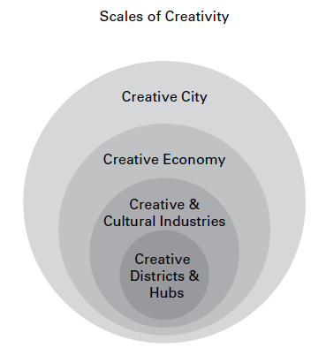
Source: AuthentiCity, 2008: 23

Figure 1. Scale of creativity and the position of creative hubs subsumed within creative cities.

Creative hubs are considered as enablers of the creative cities. In creative cities, talented human capital (the creative class) with their diverse cultural and creative backgrounds can engage on an intelligent platform via business networks and smart technology to stimulate innovations in the creative cities, which in turn contribute to sustainable urban development (SUD). Creative hubs are physical and virtual work space and infrastructure which are utilized by multi-groups of private and public organizations for purposes of networking, developing and operating business in the cultural and creative industry sector (British Council, 2015). People in creative hubs work and grow together in their creative environment. The creative spaces are used for experimentation, expression, peer learning and idea incubation - be it in clusters, co-working spaces, studios, creative centers, networks and online platforms, or alternative places (British Council, 2018). Technological advancement in the past decades have witnessed an increased profiling of the creative hubs and their socio-economic contribution to the community. The creative hubs can be propagated in strategic policy framework such as the UNESCO Creative City Network to achieve SUD. The New Urban Agenda (NUA) emphasizes that culture and cultural diversity are the key contributors to sustainable urban development, including Goal no. 11 of making cities and human settlements inclusive, safe, resilient and sustainable.
Hence, creative hubs are considered as propellers of Creative Cities and sustainable urban development (SUD). Creative hubs have made valuable contributions to SUD in many ways including stimulate knowledge and employment growth, foster sustainable management of environmental resources, protect heritage property and facilitate participatory decision-making (Kalitova et al., 2019). At an international front, creative hubs also play a major role in harnessing economic and social changes through dialogues across cultures (British Council, 2018). Positive social impacts include flourishing creative industries, increased community engagement and regeneration of urban neighborhoods. Thus, it is important to identify the success factors of creative hubs due to its potential collaborative effects with that of the cultural sector. These success factors are well linked to age and size of operation, type of activity, profit-making, workspace, inclusion of diverse community and support for the local development. A total of six (6) criteria are identified as indicator guidelines to gauge the performance of creative hubs (see Table 1). Admittedly, success cannot be measured in equal terms for all (British Council, 2015). Interpretations of study results cannot be generalized to all situations and must be treated with consideration.
Currently, the creative hubs are lacking in empirical evidence to fully appreciate its context, structure, operation, and finance. Diversified business types, varied organisational models and low public funding are possible explanations on poor insights into the creative hub’s local ecosystem. Differing from mainstream business models, many creative hub operations engage with freelancers or independent service providers as a way to support local creative industry (British Council, 2015). Creative hubs have alternative organisational models, objectives and values. Additional investment is also a requirement by creative hubs to improve their services and for better marketing and branding. Creative hubs are indeed complex entities with complex needs. Hence, it is imperative that more research is geared towards examining the potentials of creative hubs for creative city development and sustainable urban development.

Table 1. Indicators of successful creative hubs

- Local economy | How do the creative hubs support local businesses, create job opportunities and boost the local economy?
- Sustainability | Do the creative hubs develop sustainable business models and activities with positive impact in the future?
- Inclusion, empowerment and competency | Do the creative hubs support the development of entrepreneurship skills for everyone?
- Local community | Do the creative hubs engage with the local community?
- Public recognition | Are the creative hubs recognized by the local community they are working in?
- Self-rated success | Do the creative hubs think they are successful in their tasks?
Source: Kalitova et al., 2019

Methodology

To address the research enquiry of this paper, a systematic literature review was undertaken to review global definitions, concepts, examples and elucidate how creative hubs are related to creative city development and sustainable urban development. Keywords like ‘creative hubs’ were typed into the Google search engine, and subsequently phrases like ‘creative hubs Malaysia’ were also used. While the results returned many interesting ‘short articles’ and ‘news blogs’, those articles related to academia were minimal, mostly limited to the works by British scholars (i.e. Pratt, Virani, Dovey). Academic databases and journals were also searched. In Malaysia, due acknowledgement is given to British Council for mooting the creative hub idea where the concept is advocated through workshops, blogs and technical reports. In the academic realm, however, only one (1) academic writing (Kadir et al., 2022) is found on creative hub thus far - indicating a clear research gap in this area. The search for creative hub concepts for this study started in November 2021 and has been ongoing. Though this paper utilized predominantly secondary resources (i.e. journals, books, technical reports, website resources, etc.) for the review, but the visuals (Figures 2-7) are gathered from earlier studies conducted between 2017-2019 respectively. When analyzing the themes and contents from past literature to be contextualized for the Malaysian context, it was found that Malaysian creative hubs are also variegated, and each hub is shaped by the initiators, funding model and formation purpose of either commercial, social or culture and artistic, which will be further discussed in the following sections.

Discussion

Creative hub and creative city development in Malaysia

Based on the systematic literature review above, these sections are organized to chronicle the concept of creative hub and its relationship to Malaysian creative city development. In Malaysia, the creative hub concept is gradually making a marked presence particularly in urban settings like Kuala Lumpur, George Town, Ipoh, Johor Bahru, just to name a few. While the concept is all-encompassing to involve all creative and non-creative sectors and occupations, but in Malaysia the creative hub notion predominantly refers to places and spaces for creative and cultural professionals/employees belonging to the arts, creative, culture and heritage sectors. Arguably, the creative hub’s existence and functionalities might have been present and permeated Malaysian soils for a long time but it is due to its less formalized, fluid and fuzzy structure that might have caused it to be somewhat ‘invisible’ and gone unnoticed. To address this, efforts to identify, map and formalize Malaysian creative hubs have been undertaken by the British Council (Malaysia) since 2020. A most commendable initiative is the development of the ‘Creative Hubs Malaysia’ website (creativehubs.my) which is a digital platform created through the ‘Hubs for Good’ programme. The website was launched on 27 August 2020 with the main purpose to connect Malaysian creative hubs and to heighten their visibility to the general public and policy-makers. Essentially, Creative Hubs Malaysia endeavours to facilitate the clustering of creative networks to develop long-term benefits for communities. By building connections, the creative hub is viewed as an avenue for innovative and imaginative ideas to develop by ‘not just being at the right place and right time, but also meeting the right people’ through the hubs. Besides establishing connections, the creative hub also functions to nurture a support system among and across Malaysian creative hubs.
The ‘Malaysian Hubs for Good’ programme showcases a fine example of collaborative efforts between the British Council, Yayasan Sime Darby and the Culture Centre of Universiti Malaya. Under the three-year programme, a myriad of interrelated projects was undertaken. These include: i) a country-wide mapping and research, ii) a toolkit for the use of creative hub leaders and creative platforms, iii) a digital platform; iv) capacity building initiatives to address skills and knowledge needs of domestic creative hub leaders (Creative Hubs Malaysia website). Insofar under the programme, several studies and mapping exercises were conducted to map, locate and understand creative hubs in Malaysia. The studies are listed here:

- Understanding creative hubs in Malaysia: Collectives, entanglements & ecologies
- Hubs for good toolkit

The Hubs Directory is particularly interesting and useful where classifications of Malaysia creative hubs are divided into three, namely, (i) hub type, (ii) location, and (iii) category. Under ‘hub type’, it is further sub-divided into three (3) hub types, namely, i) physical, ii) transient, and iii) online. The hub location sub-heading refers to creative hubs in Malaysian states such as Kedah, Kelantan, Kuala Lumpur, Malacca, Negeri Sembilan, Pahang, Penang, Perak, Perlis, Sabah, Sarawak, Selangor and Terengganu. Malaysian creative hubs are further divided into categories such as Collection/Archive, Community, Craft, Creative Education, Culinary Arts, Design, Event Organizer/Producer/Curatorial Services, Fabrication Spaces/Makerspace, Film/Broadcasting/Digital Video Content, Literature/Publication/Online Content, Music, Performing Arts, Venue/Event Space Management, and Visual Art.

Selected sterling exemplars of Malaysian creative hubs

While the aforementioned British Council’s Creative Hubs Malaysia website is a resourceful repository to obtain information related to Malaysian creative hubs under one roof, nonetheless, it is worthy to selectively depict several sterling exemplars of physical creative hubs in Malaysia. The creative hubs mentioned in this sub-section is non-exhaustive where due to constraint of space, only three sterling exemplars of key physical creative hubs in Peninsular Malaysia will be briefly mentioned here.

- Zhongshan building

No doubt, as Malaysia’s premier and capital city, Kuala Lumpur (KL) is labelled as the de facto Creative and Cultural City of the nation. Kuala Lumpur’s creative and cultural endowments and prowess are comprehensively documented in government blueprints like the ‘Kuala Lumpur as a Cultural & Creative City’ report and also the ‘Kuala Lumpur Creative and Cultural District Strategic Master Plan’ (2019). Sterling examples of creative hubs in Kuala Lumpur are like the Zhongshan Building, The Godown, REXKL, just to name a few. In particular, the Zhongshan Building is a key exemplar where the endeavor to resuscitate and revitalize this creative hub involved a Public-Private Partnership approach. Originally a run-down and derelict old block of flats owned by a local KL family, the owners managed to obtain funds from urban regeneration think-tank (i.e. Think City) to restore and refurbish the building, and subsequently each flat unit is rented out to creatives and cultural practitioners as their SOHO (Small Office, Home Office)/SOFO (Small Office, Flexible Office) spaces. The refurbished Zhongshan Building is currently a prominent creative hub in Kuala Lumpur where its spaces are well-sought by local creatives due to its strategic location right smack in the center of the city. The flat block currently provides spaces for creatives to do business (i.e. gallery, book shop, studio, archive, etc.) and showcase their creations. It is also a unique creative hub that nurtures homegrown creative talents where the presence of non-global and non-designer’s brands are showcased here. Local brand names like Balai Buku Raya, Ana Tomy, Atelier Fitton, Malaysia Design Archive, Naiise Malaysia, Piu Piu Piu, to name a few, signify the novelty and functionality of creative hubs like Zhongshan Building to serve as a platform to acknowledge and promote Kuala Lumpur’s domestic and homegrown creative talents (Khoo & Chang, 2021). Based on Duchesneau & Deziel’s (2019) creative hub ecosystem taxonomy, Zhongshan Building will be a hybrid of all three representing a creative hub that is driven by commercial, social and cultural & artistic purposes.

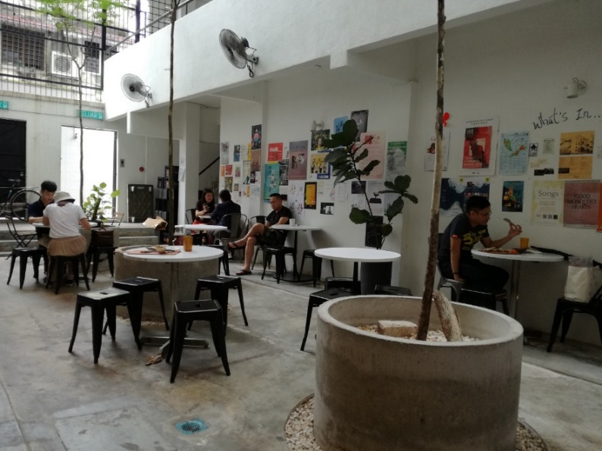
Source: Khoo Suet Leng, 2019

Figure 2. Café bistro inside the refurbished Zhongshan Building.

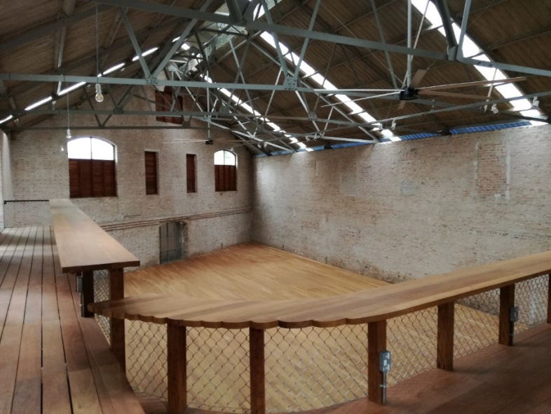
Source: Khoo Suet Leng, 2019

Figure 3. Godown, new art space in the heart of Kuala Lumpur.

- The Hin Bus Depot

In the Northern Region, a famous creative hub is none other than the famed Hin Bus Depot located in George Town, Penang. Formerly an abandoned and defuncted bus depot, the space has been restored and refurbished to become a creative community hub in George Town. Besides housing a gallery, Hin Depot also provides spaces for arts, cultural events and creative businesses, underpinned by the philosophy of working towards a sustainable community and providing an avenue for artistic execution. Albeit initially run by independent artists, the hub has since morphed into a community project executed on the conviction that art is borderless and there should be no boundaries and limitations to artistic expressions (Hin Depot website). A testament of a successful creative hub, Hin Depot was used as case study in a myriad of academic research that showcased Hin’s successful role as a social enterprise of sorts, for instance the Depot’s famous Sunday Pop-Up Market, that positively gentrified the neighborhood (Chan et al., 2019). The way creative entrepreneurship is inculcated in Hin Depot towards local economic development and creative-city making was also documented in a recent study (Khoo & Chang, 2021). Apart from propagating business entrepreneurship, Hin Depot’s socially-inclusive role to provide a creative space and include all and sundry to the hub is evidenced in Khoo’s (2020b) study. Rather similar to Zhongshan Building, the hybridized and tripartite notions of commercial, social as well as cultural and artistic purposes also underscore Hin Depot’s creative hub ecosystem.

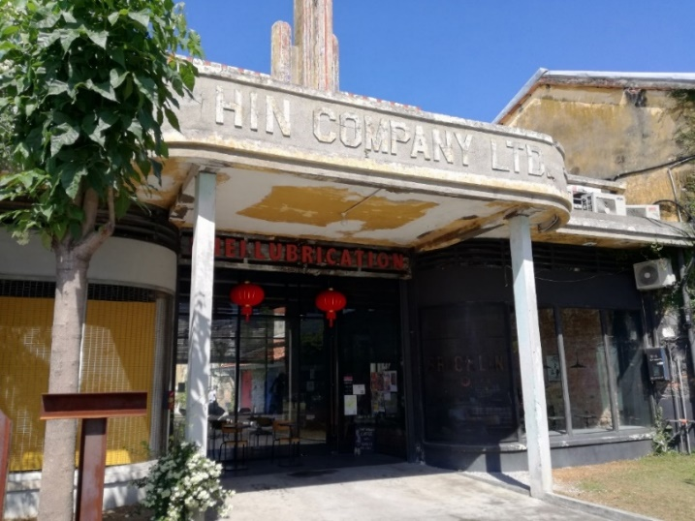
Source: Khoo Suet Leng, 2019

Figure 4. The Hin Bus Depot in George Town, Penang.

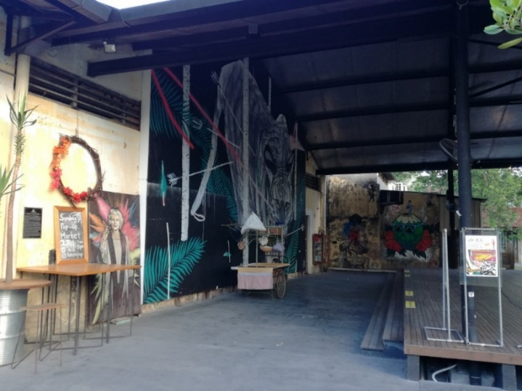
Source: Khoo Suet Leng, 2019

Figure 5. Spaces in and within Hin Depot are used for art production and consumption.
- Sekeping Kong Heng

In the Center Region, there is the Sekeping Kong Heng creative hub of sorts located in former tin mining city, Ipoh, Perak. The hub is the brainchild of several Ipoh natives who were pioneers in introducing and utilizing creative contents to revitalize a deteriorating Ipoh old town. In this case, the old building of local famous Kong Heng Kopitiam (coffee shop in Hokkien) was restored and adaptively reused to become Sekeping Kong Heng where the first floor consists of hotel rooms with rustic architecture (Tunyaporn, 2018). Very interestingly, it is not just the old coffee shop alone but the old buildings and structures around it were also adaptively reused. The adjoining warehouse was converted into a restaurant chain and several close-by shop-houses were retrofitted as spaces for local start-ups. Just like Hin Depot, there is also an artisan market for domestic creative entrepreneurs to sell and showcase their art, crafts and cultural products. As the maiden creative cluster (or hub), Sekeping Kong Heng soon became the ‘hang-out spot’ for creative production, consumption, distribution and aspiration, and the process soon spurred local economic growth and development. Local creative and cultural practitioners subsequently organized themselves to kickstart and propagate art and culture-led place-making initiatives to regenerate Ipoh old town which is proving to be successful in charting Ipoh’s pathway as an imminent creative city (Khoo & Chang, 2021). Resonating the models by Zhongshan Building and Hin Bus Depot, the creative ecosystem for Sekeping Kong Heng is also driven by commercial, social and artistic & cultural purposes.

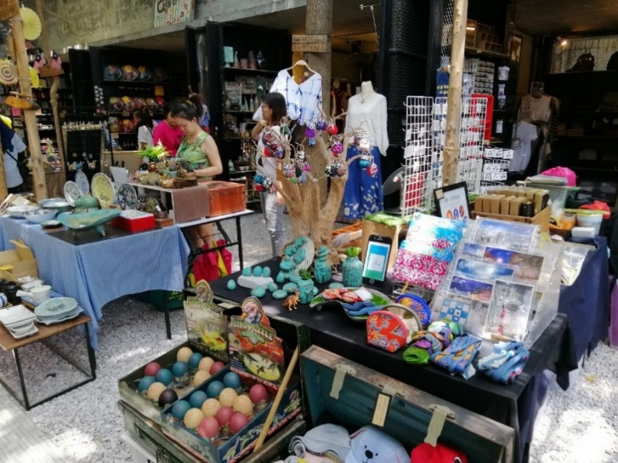
Source: Nicole Chang, 2019

Figure 6. The art market within the Sekeping Kong Heng cluster.

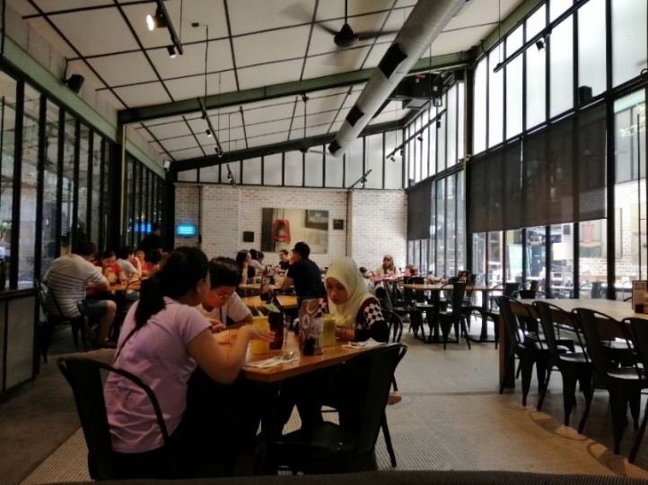
Source: Nicole Chang, 2019

Figure 7. Space at Sekeping Kong Heng that has been adaptively reused as a café bistro.

Conclusion

As the creative hub concept and form begin to make a marked presence in Malaysia, more organized and systematic research to fathom the concept for the local context is required. The systematic literature review in this paper has established the diverse definitions, variegated forms, models and deciphered how a creative hub is integral towards economic, social and cultural development. In particular, the way a creative hub is subsumed under and within a creative district which in turn stimulates the wider creative industries/creative economy are integral towards the making of a creative city. As propounded by the UNESCO Creative Cities Network, the link between creative hubs, creative cities and sustainable urban development are congruent and the Malaysian case studies as manifested in the Hin Depot, Zhongshan Building & Sekeping Kong Heng have illustrated this as derelict urban neighborhoods are positively gentrified and revitalized.
While acknowledging that the creative hub concept is nebulous, slippery and even contested, there is certainly no one size that can fit all as attested globally and also the Malaysian context as shown in this paper. The conceptual plurality is particularly obvious for a pluralistic society like Malaysia where creative hubs will tend to be location-driven and culture-specific to a certain extent. The conceptualization of a Malaysian creative hub will also be driven and ascertained by the form and the six indicators of creative hubs by Kalitova et al. (2019) and the three purposes of commercial, social and culture & artistic (Duchesneau & Déziel, 2019) which collectively serve as good analytical frameworks to guide and shape the reconceptualization for the Malaysian concept based on each city’s context, nuances and idiosyncrasies.
Although the myriad of existing creative hub concepts are useful referrals, but this is also an opportune time to re-invent, re-imagine and re-conceptualize novel creative hub notions given the way ICT has permeated into all realms of human life amidst Covid-19. While this paper might be merely conceptual in nature, but the deliberations serve as good enquiries and point of departure to further investigate the creative hub in a more systematic fashion. The viewpoints and insights derived from this paper are integral towards shaping and implicating theory, policy and practice en route towards developing a sustainable creative hub as more and more Malaysian cities aspire to transform into creative cities.
Acknowledgement

The authors would like to acknowledge grant number (FRGS/1/2021/SSI02/USM/02/3) from the Ministry of Higher Education, Malaysia, for funding this research.

References

AuthentiCity. (2008). Creative City Planning Framework. A supporting document to the agenda for prosperity: Prospectus for a Great City. Prepared for the City of Toronto by AuthentiCity (pp. 1-44), Toronto, Canada. Retrieved from http://www.torontocreativecity.ca/wp-content/uploads/2018/02/2008-Creative-City-Planning-Network.pdf
British Council. (2018). Creative Hubs – Opportunities and Challenges for Intercultural Dialogue. Retrieved from https://connectforcreativity.eu/wp-content/uploads/2020/01/200107 _Report_EN_Digital.pdf
British Council. (2016). Creative Hubs Report. Retrieved from https://creativeconomy.britishcouncil.org/projects/hubs
British Council. (2015). Creative HubKit. Retrieved from britishcouncil.my/sites/default/files/ creative-hubkit.pdf
Chen, A. X. (2010). Understanding Creative Hubs: The Agglomeration of Creativity in Toronto (Master dissertation). Retrieved from Ryerson University, Toronto, Canada.
Dovey, J., Pratt, A.C., Moreton, S., Virani, T., Merkel, J., & Lansdowne, J. (2016). Creative Hubs: Understanding the New Economy, City University of London (in association with University of West England, REACT, Creativeworks London, and The Watershed).
Duchesneau, M.-O., & Déziel, G. (2019). The Creative Hub, An Emerging Organizational Entity with Great Potential for Arts and Culture. Retrieved from https://cmf-fmc.ca/now-next/articles/creative-hub-report-telefilm-canada-guillaume-deziel/
Elshater, A.M., & Ibraheem, F. (2014). From Typology Concept to Smart Transportation Hub, Procedia – Social and Behavioral Sciences 153, 531-541.
Evers, H. D. (2011). Penang as a knowledge hub. Penang Economic Monthly, 36-39.
Frost & Sullivan, MyPAA (My Performing Arts Agency) and TFCC (Tom Fleming Creative Consultancy). (n.d.). Kuala Lumpur as a Cultural & Creative City. A Project Report. Cultural Economy Development Agency (CENDANA), Malaysia. Retrieved from https://www.cendana.com.my/clients/asset_7133D9E8-5529-4477-AE06-9B65BE281DE3/contentms/img/Library/Report/CendanaReport_Option-2_FA_For-Web(190220).pdf (Accessed on 25 January 2022).
Glaccone, S.C., & Longo, M.C. (2015). Insights on the innovation hub’s design and management. International Journal of Technology Marketing , 11(1), 97-119.

Hin Bus Depot website. (n.d.). Our Story. Retrieved from https://hinbusdepot.com/story.html
Kadir, S.A., Aris, N.N., & Ginting, N. (2022). Social and Creative Hubs as the Third Places of Post-Covid Era. Environment-Behaviour Proceedings Journal, 7(21), 103-109. https://doi.org/10.21834/ebpj.v7i21.3754
Kalitova, A., Durankova, K., & Kovac, N. (2019). The role of successful creative hubs in fostering sustainable development. 2018=2019 RAUN Papers. "Innovations for Development: Towards Sustainable, Inclusive and Peaceful Societies" United Nations Industrial Development Organization (UNIDO), Regional Academy of United Nations (RAUN). Retrieved from http://www.ra-un.org/uploads/4/7/5/4/47544571/4_unido_the_role_of_ successful_creative_hubs_in_fostering_sustainable_development.pdf
Khoo, S.L., & Badarulzaman, N. (2014a). Branding George Town world heritage site as a city of gastronomy: prospects of creative cities strategy in Penang. International Journal of Culture, Tourism and Hospitality Research , 8(3), 322-332.
Khoo, S.L., & Badarulzaman, N. (2014b). Factors Determining George Town as a City of Gastronomy. Tourism Planning & Development, 1(4), 371-386.
Khoo, S.L., Badarulzaman, N., Samat, N., & Dawood, S.R.S. (2014). Capitalising on urban cultural resources for creative city development: A conceptual review and the way forward for Malaysia’s George Town. GEOGRAFIA Online Malaysia Journal of Society and Space, 10(5), 20-29.
Khoo, S.L. (2016). Understanding culture and creativity in urban development: what it means for George Town, Penang? Geografia-Malaysia Journal of Society and Space, 12(13), 1-11.
Khoo, S.L. (2020a). Towards an inclusive creative city: How ready is the Historic City of George Town, Penang? City, Culture and Society, 23, 100367.
Khoo, S.L. (2020b). Towards A Socially-Inclusive Creative City: What George Town World Heritage Site Can Learn From Japan? Technical Report prepared for the Sumitomo Foundation, Japan.
Khoo, S.L., & Chang, N.S.F. (2021). Creative City as an Urban Development Strategy. The Case of Selected Malaysian Cities. Singapore, Palgrave Macmillan.
London Development Agency (LDA). (2003). Creative London: Vision and plan. London: London Development Agency. Retrieved from https://creativeindustrieslondon.files.wordpress. com/2014/11/creative-london.pdf
MIT Technology Review Insights (2021). 21st century cities: Asia Pacific’s urban transformation. Retrieved from https://mittrinsights.s3.amazonaws.com/21stCenturyCities.pdf
O’Hara, E., & Naik, D. (2021). Mapping Creative Hubs in England. Retrieved from https://creativeconomy.britishcouncil.org/media/resources/Mapping_Creative_Hubs_In_England_.pdf
Rodrigues, M.M., & Franco, M. (2018). Measuring the Performance in Creative Cities: Proposal of a Multidimensional Model. Sustainability, 10(11), 1-21.
Think City Sdn. Bhd. (2019). Kuala Lumpur Creative and Cultural District Strategic Master Plan. Prepared by Kuala Lumpur City Hall and Think City in Collaboration with Ministry of Tourism, Arts and Culture Malaysia and National Heritage Department. Retrieved from https://thinkcity.com.my/publications/KLCCD-Strategic-Masterplan-EN/#page=1
Turner, R. (2020). Situational Analysis of Creative Hubs in Malaysia. Hubs for Good Malaysia. Report prepared for the British Council, Universiti Malaya and Yayasan Sime Darby.

Tunyaporn, H. (2018, August). Ipoh: An attempt to bring back life of Malay Peninsula’s once thriving economic city. Retrieved from https://tunyaarticle.wordpress.com/2018/08/20/ ipoh-an-attempt-to-bring-back-life-of-malay-peninsulas-once-thriving-economic-city/
Virani, T.E. (2015). Re-articulating the creative hub concept as a model for business support in the local creative economy: the case of Mare Street in Hackney, Creativeworks London Working Paper No. 912, Arts & Humanities Research Council and Queen Mary University of London, United Kingdom.

