

Sea reclamation in XLIV urban area, Central Malacca District, Malacca: From the perspective of Heritage Impact Assessment study

Asyaari Muhamad, Amir Husaini Saiffuddin

Institute of The Malay World and Civilization (ATMA), Universiti Kebangsaan Malaysia,
43600 Bangi, Selangor, Malaysia

Correspondence: Asyaari Muhamad (email: asyaari@ukm.edu.my)

Received: 08 January 2022; Accepted: 09 May 2022; Published: 31 May 2022

Abstract

On the coast of Central Malacca, a 75-acres sea reclamation project site has merged with the National Heritage Gazette area. From July to October 2020, a Heritage Impact Assessment (HIA) study was conducted at the reclamation project site to decide whether the reclamation project shall continue or need to be relocated to another location. Based on several previous survey studies and historical writings, it has been concluded that the area of the project site might contain a significant number of valuable findings from the aspect of the state heritage. This study was performed by applying several research methods, namely interviewing informants, scientific survey studies, and scuba diving, to ensure any findings' accuracy and validity based on previous studies' literature review and historical writings. Some historical results were discovered during the research, and this was brought into several discussions regarding how the developer should adhere to regulations set by the National Heritage Department (JWN) to ensure that any development of sea reclamation projects in the state should comply with the importance of heritage, environment, and preserving areas with Outstanding Universal Value (OUV) in the state of Malacca.

Keywords: heritage impact assessment, historical sites, outstanding universal value, sea reclamation project, underwater archaeology, underwater heritage

Introduction

In 2020, the National Heritage Department (JWN) and the Malacca State Museum Corporation (PERZIM) have ordered a heritage impact study (HIA) to be conducted on a 300-acre sea reclamation project area in the city of XLIV, Central Malacca. Thus, as the developer, the Konsortium Pembangunan Tanah Laut (Malacca) Sdn. Bhd. has appointed a consulting company, JK Hidro & Oceanography Consultant Sdn. Bhd. to carry out the survey. A HIA consultant from the Institute of The Malay World and Civilization (ATMA), National University of Malaysia was later appointed by the consulting company to lead the study. This study should follow the guidelines set by JWN and PERZIM. However, there are HIA guidelines from the International Council on Monuments and Sites (ICOMOS) under the auspices of the United Nations Educational, Scientific and Cultural Organization (UNESCO) which must also be adhered to so that the implementation of HIA studies in the area will comply with international standard rules and guidelines (ICOMOS, 2011).
The HIA study conducted between July to October 2020 covers several processes. The study began with a visit to the project site, preparation of a proposal paper, scope of work, schedule, and timing of the study. Researchers also need to go through other processes such as literature review, oral history review, a survey using scientific equipment, scuba diving on-site, collecting, compiling, and analysing data to strengthen the findings of the study. Finally, this study should produce a final report about the findings as well as provide recommendations and mitigation that need to be complied with by the Consortium.
Generally, the HIA study covers two main areas divided between the studies on land areas and water areas. The land area includes areas where there is the architecture of old buildings such as administrative buildings, settlements, houses of worship, and heritage sites such as fortifications that have their history, heritage, and archeological value. All locations and types of buildings are considered to have a universal value of excellence or Outstanding Universal Value (OUV) that can be seen and known to the community and aged over 100 years old. For example, A Famosa Fort is located in Bukit Malacca, Bastion Middleburgh, Porte de Santiago, Tengkera Mosque, Peringgit Mosque, Kampung Keling Mosque, Christ Church, Stadhuys building, Malacca Sultanate Palace, and many more (Asyaari Muhamad, 2001).
Meanwhile, the sea areas mainly cover the coastal areas and the estuary of the Malacca River which has evidence of the remains of shipwreck sites, old ports, and thousands of artifacts such as coins, foreign ceramics, cannons, cannonballs, rifles, precious metals, beads, and others from the 15th to 19th century. The results of underwater archaeological surveys conducted around the early 2000s have found 30 to 40 ancient shipwrecks on the coast of Malacca. However, further study on these shipwrecks sites has not been done due to multiple constraints faced by the authorities in the past.
The discovery of such evidence either through the survey of ancient shipwrecks, land archaeological excavations, or from written historical sources has proven that Malacca is undeniably rich in cultural, historical, archeological, and heritage relics since the 15th century. Therefore, the HIA study needs to be done in this area given its importance in terms of heritage, history, and cultural values ​​of the state of Malacca.
The importance of HIA study becoming more significant as Malacca was recognized as a World Heritage City by UNESCO on July 7, 2008. This recognition means that there are highly important areas or places that are very sensitive to the heritage and historical value of Malacca that have been identified. The recognition for heritage sites in Malacca involves a massive area of ​​214.6 hectares covering two zones, namely the main zone and the buffer zone. The main zone includes the area around Bukit St. Paul and Jalan Tun Tan Cheng Lock, Jalan Hang Jebat (Jonker Walk) and several other roads to Jalan Kampung Pantai. The buffer zone is around Jalan Merdeka, Jalan Kota Laksamana, Jalan Munsyi Abdullah, Banda Kaba village and several other areas including Bukit China (Solihah et al., 2015).
As for the state coastal zone along the Straits of Malacca, two areas are considered sensitive to historical values as well as to maritime and underwater heritage. These areas are located between the coast of Tanjung Keling to the coast of Merlimau. Protection zone gazettement by JWN and PERZIM for the coastal area throughout the state of Malacca are assessed based on the existence of characteristics of universal values ​​of excellence (OUV), importance to historical value, heritage, and maritime archeology along the zone. Aspects that are considered to have the value of the OUV such as the remains of ancient shipwrecks, ancient port sites, artifacts from shipwreck cargo as well as any old structures found underwater. These facts are supported by several primary and secondary sources which include written historical documents such as manuscripts, articles, books, and underwater archaeological survey studies that were conducted around 2005 to 2011.
The sensitivity of the sea reclamation project needs to be taken into account from various aspects, especially the impact on the environment and heritage in the area. This is because the reclamation project area and its surroundings might contain some significant numbers of the highly valuable heritage of underwater cultural resources that have great potential to be explored especially the 75-acres area that overlapped within the National Heritage Gazette area.

Literature Review
The literature review was conducted on several sources of writing such as journals, past research reports, and books related to shipping and trade activities in the past. Among them are the Malay Trade and Shipping in the Straits of Melaka (Ahmad Jelani Halimi, 2006), History in the Straits of Melaka (Abdul Latiff Abu Bakar, 1984), report on archaeological excavations in Malacca (Asyaari Muhamad, 2001), survey report and underwater archaeological salvage within the coast of Malacca in 2005 and 2007 as well as several other reference sources (Flecker, 2005).
These sources mentioned above concluded that the project site location was once part of a global trade route since the 15th century AD. This area is also close to the estuary of the Malacca River which is busy with various trade and shipping activities such as tax collection and ship dock operations. According to records in various reference sources, there was a stopover for traders from the East and West at the port of Malacca to trade. Among them are Chinese, Gujarat, Arab traders as well as from the Malay region (Mills & Cheah, 1997).
The position of the strait of Malacca which is protected from the monsoon winds has made the port of Kota Melaka as the main transit centre to refill the supply of merchant shipping as well as the collection of trade commodities from around the world (Nordin Husin, 2008). This situation continued even after the fall of the Malacca Sultanate until the establishment of the Straits Settlements beginning in the late 18th century where Malacca continued to play its role as a trading center in the region. All of these historical references have told about the past glories of Malacca from the Malacca Sultanate during the 15th century to the modern era of Japanese Military Administration in the state (Armando Cortesao, 1944).
Several survey reports such as ‘Report Brief Shipwreck Survey Near Pulau Upeh’ by external researchers and local agencies have revealed that they manage to detect some images of shipwreck skeletons, cannons, cannonballs and other artifacts near the Pulau Upeh in 2005 (Flecker, 2005). These discoveries of several shipwreck sites filled with weapons have been the evidence of wars in several historical books and journals. However, follow-up studies such as salvage and underwater archaeological excavations could not be continued due to certain factors (Maritime Explorations (M) Sdn. Bhd., 2005; National Heritage Department, 2007).
The first HIA study was conducted during the construction of a hotel at the mouth of the Malacca River. However, this project was done on the land area and was the first-ever project that involves HIA studies in the state. In 2005, a survey study was conducted in collaboration between a private company, Maritime Explorations (M) Sdn. Bhd. with the Department of Museums and Antiquities, PERZIM, and the Malaysian Marine Department. For a week, the company conducted scientific survey work and scuba diving near Pulau Upeh at a depth between 27 to 42 meters. As a result, several images such as shipwreck shapes and several types of artifacts have been successfully detected. However, this work was not continued due to certain problems faced by the agencies involved.
In 2007, another survey study was carried out in collaboration with several government agencies namely JWN, PERZIM, Royal Malaysian Navy (RMN), and the Marine Department in the Straits of Malacca. As a result of the study, the research team has detected approximately 33 historic shipwreck sites on the coast of the Straits of Malacca, especially between Malacca and the border of Negeri Sembilan (Survey Project Report, 2007). The study also brought the discovery of several types of artifacts beneath the seafloor. These artifacts were successfully detected and among them are ceramics, metal materials, and wood from China and Europe. Thirteen years later, the HIA study which required the involvement of the underwater archaeological survey was to be conducted again in the same area which is now has become the site of the reclamation project. This survey must be done to salvage any potential finds that may be found in the area.

Method and study area
Three research methods were used in conducting the study on the impact of underwater heritage at the project site namely interviewing informants, scientific survey study, and scuba diving. These methods are applied in areas suspected of potentially having an impact on underwater cultural heritage.
This research method begins with personal interviews session of selected informants that have encountered any artifacts findings or have any historical knowledge regarding trade and shipping activities that had existed near the reclamation project site in the past. Next is to conduct a scientific survey study using scientific equipment to detect any shape or image at the site. Finally, a scuba diving method will be performed at any area that potentially contain findings through the detection of image and sonar readings by scientific survey before.
Figure 1 and Figure 2, show that there is an overlap of areas where 75 acres of the total 300 acres (red square) of the project site are within the gazetted and protected zone by JWN since 2010. The JWN gazette area covers from the coast of Tanjung Keling (2°12'.8.96" N, 102°91'17.35" E) to the coast of Merlimau, Malacca (2°6'11.95" N, 102°25'0.00" E), heading northwest (2°3'44.99" N, 102°9'.14.48" E) and southwest (2°0'55.49" N, 102°23'20.14" E). This overlap issue had become a problem between the Consortium and JWN as well with the Malacca State Economic Planning Unit. Thus, any development activities such as sea reclamation, salvage study, and archaeological excavation in the gazetted area must obtain prior permission from the authorities such as JWN, PERZIM, Marine Department, and APMM.

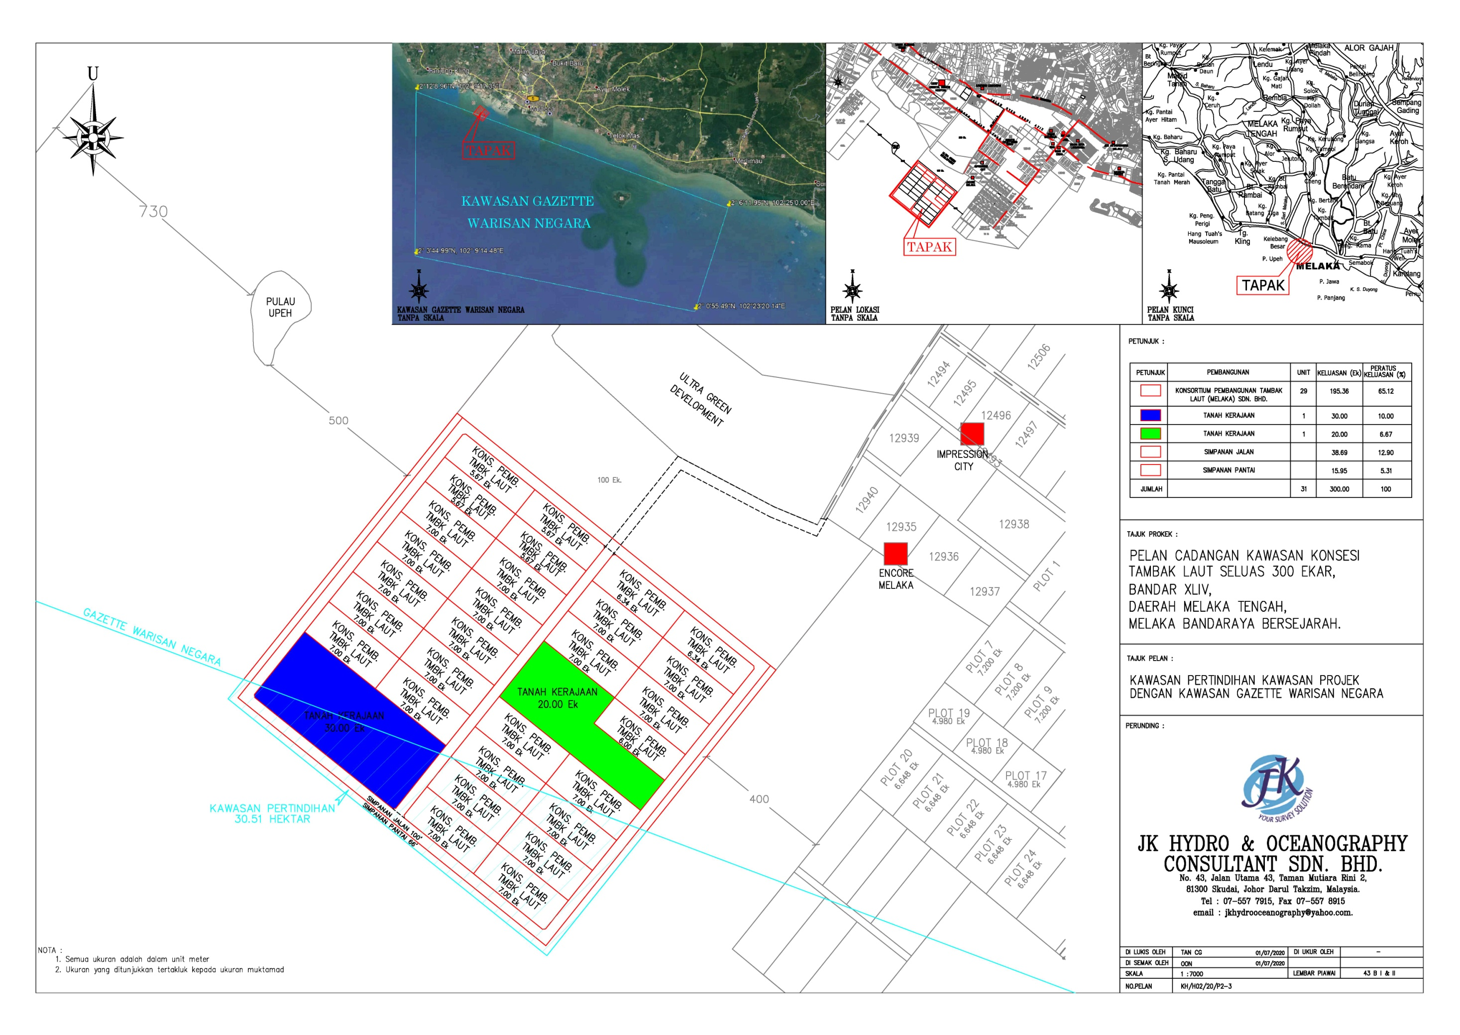

Figure 1. A light blue rectangular line shows the National Heritage gazette area. There is an area of ​​75-acre (red cubics) that has overlapped into the National Heritage gazette area.

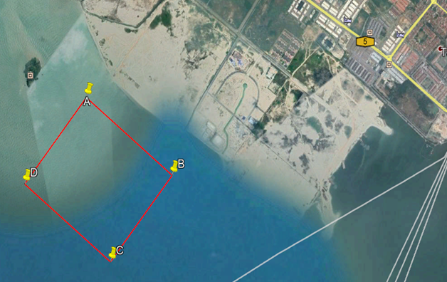

Figure 2. The proposed sea reclamation project area of ​​300 acres (red square) as well as the National Heritage gazette area (blue square).
The location of the proposed sea reclamation project area is also close to Pulau Upeh where the surrounding coastal area of the island resembles high historical value for the state of Malacca because the laterite rock formation structure found on the island was used to build the city of Malacca since the 15th century (Mills & Cheah, 1997). Therefore, to enable this sea reclamation work to continue, the HIA study needs to be done on the proposed project area to ensure that any sunken heritage and culture can be retrieved first.

Results and discussion
The research methods applied throughout this HIA study have led to several results that will be discussed in detail according to the division of each research method which includes interviewing informant, scientific survey, and scuba diving.
The process of interviewing informants began with the General Manager of PERZIM, namely Drs. Mohd. Nasruddin Rahman. According to him, this project site must go through the HIA review process. This is because of the position of this project area which lay on an important trade route and near to the ancient port of the Sultanate of Malacca. This means that the potential for the existence of any artifacts and skeletons is very likely. In the PERZIM exhibition gallery, there are several examples of artifacts from shipwreck surveys that were conducted around 2005 and 2007.
Next, data collected by the researcher's interviews with fishermen who carry out fishing activities near the project site found that almost all the fishermen have found ancient artifacts from the seabed. One of the fishermen, 45 years old Baharom Abu (2020) once had found 7 types of artifacts in the form of porcelain ceramics, glazed stone pottery, and a copper jug at the project site. The accidental discovery of this artifact happened while he was fishing in the area. One other informant who is also a fisherman, Rashid Mad Zain (2020) has informed that he often finds artifacts during fishing activities (Figure 3). Among the artifacts he found were ceramic items such as glazed stone and blue and white porcelain. The analysis on the materials, glazings and designs on these artifacts have concluded that most of these artifacts came from China (blue and white porcelain plates and bowls from the 15th to 18th centuries) (Figure 4) and Europe (glazed stone pottery bottles from around the 19th century). Most of the collection of artifacts he found were covered with sea coral as well as there were several marks of cracks and fragments in certain parts.

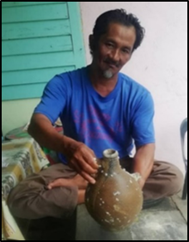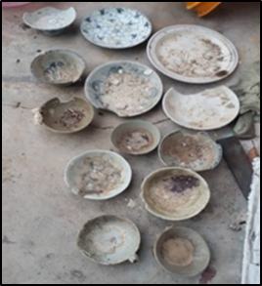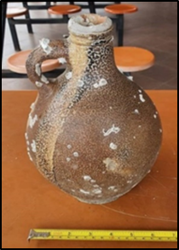

Figure 3. Interview with third informant Rashid Mad Zain and a collection of artifacts found by him near the project site area.
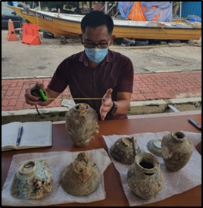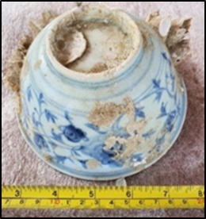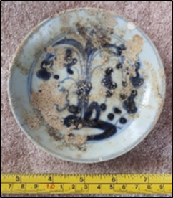

Figure 4. The researcher is analyzing the artifacts found by the informant.

The results of the scientific survey research method using two main instruments namely Multi-beam Ecosounder Survey or MBES (sea-floor surface scanning) and Sub-bottom Profiling or SBP (sea sediment penetration) greatly help the detection of some images or artifacts that might have historical, heritage, and archaeological value during the HIA study. Through the implementation of these two scientific survey methods have greatly reduced the time, cost, and manpower consumed because the subsequent focus will only be on areas that have images or signals that have the worthy potential for further investigation. MBES imaging through a detection and recognition system will be followed by a second survey using the SBP method so that the accuracy of the study data becomes more accurate.
The survey using the MBES method at the 300-acre project site area has successfully detected several images stranded at a depth between 6 to 21 meters on the seabed (Figure 5). However, the results of these scanning images or structures found in the project seabed through the MBES method can not precisely identify the actual type, color, and material of the detected object because it can only give a rough idea of ​​the size and shape of the detected object.
Next, the SBP survey method comes to use. This second method will only be conducted in areas where the size and shape of the object have been detected through the MBES survey method earlier. However, this SBP survey method can detect any shape and size of objects submerged in sludge or sand below the surface of the seafloor. It can detect objects embedded or submerged as deep as 8 meters below the surface of the seabed, giving the researchers more details on all the foundings beneath the seafloor layer.
The combined results of these two scientific surveys have revealed that there are a total of 10 areas that have the potential to be surveyed further through scuba diving. This scuba diving survey into these 10 potential areas are to identify the true appearance of these objects that have been detected through previous scientific survey methods. Figure 6 and Figure 7 showing locations or traces of images suspected of having historical, heritage, and archaeological value in the project site area.

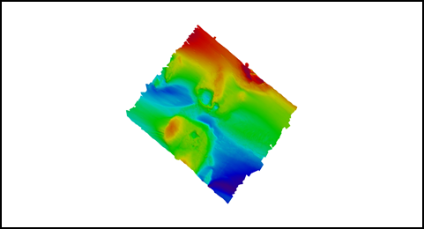
Source: JK Hidro & Oceanography Consultant Sdn. Bhd.

Figure 5. The results of the scan of the entire project area after being surveyed through the MBES method

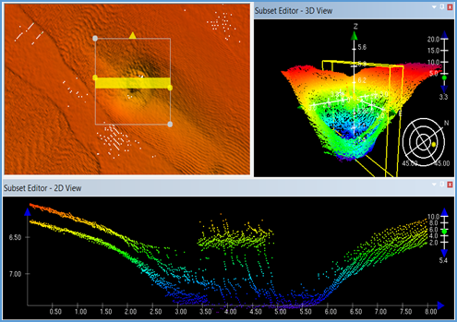

Figure 6. One of the images displays an unidentified object using the MBES survey method.

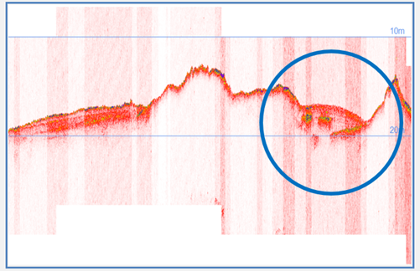

Figure 7. SBP survey method that successfully detects an unidentifiable object at a depth of 18 meters on the seabed.

The last method applied in this study is scuba diving performed by a group of professional divers. A total of 10 potential areas were investigated where each area was marked with labels from SO01 to S010. The scuba diving activities in each of these potential areas were performed twice to ascertain and detect any objects visible in the image through MBES and SBP surveys. However, these scuba divers face some difficulties due to the low level of underwater visibility as well as weather resistance and erratic tide currents.
The results of the survey from this rotating scuba diving found that only areas SO01, SO06, and SO08 had significant and identifiable objects. At the location, SO01 was seen in the form of a sunken ship's platform or 'barge' as well as fragments of the barge's iron. Meanwhile, at location SO06, a new iron anchor was found which is believed to belong to fishermen who carry out fishing activities in the area. A rather exciting find was at the SO08 location, where a glazed jar as in nearly perfect condition and some ceramic fragments in the form of glazed stone pottery were found. Meanwhile, in locations other than those mentioned above, divers did not find any traces of historical objects or artifacts. Figure 8-9 and Table 1 shows the dive locations, whereas Figure 10 shows objects found by the diver.

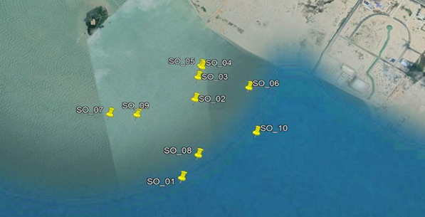
Source: JK Hidro & Oceanography Consultant Sdn. Bhd.

Figure 8. Position of 10 dive locations to identify objects detected earlier by the results of scientific survey study and interview with the informants.

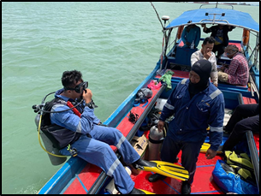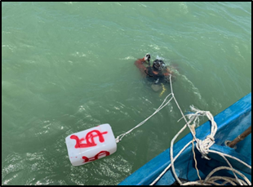

Figure 9. Divers ready to dive at locations SO-05 and SO-06.

Table 1. The coordinate positions of potential areas for scuba diving.

Dive Site | UTM 48N-WGS 84 |  |  | Geographical-WGS84
Dive Site | North | East |  | Latitude | Longitude
SO01 | 241298.4 |  | 189540.6 | 2° 10’ 49.7561” N | 102° 12’ 32.6891” E
SO02 | 241928.9 |  | 189639.7 | 2° 11’ 10.2700” N | 102° 12’ 35.8542” E
SO03 | 242119.2 |  | 189664.2 | 2° 11’ 16.4627” N | 102° 12’ 36.6372” E
SO04 | 242208.9 |  | 189695.5 | 2° 11’ 19.3823” N | 102° 12’ 37.6427” E
SO05 | 242222.3 |  | 189688.1 | 2° 11’ 19.8190” N | 102° 12’ 37.4022” E
SO06 | 242017.9 |  | 190035.1 | 2° 11’ 13.1896” N | 102° 12’ 48.6349” E
SO07 | 241820 |  | 189027 | 2° 11’ 06.6915” N | 102° 12’ 16.0492” E
SO08 | 241473 |  | 189656 | 2° 10’ 55.4414” N | 102° 12’ 36.4100” E
SO09 | 241810 |  | 189222 | 2° 11’ 06.3780” N | 102° 12’ 22.3555” E
SO10 | 241640 |  | 190070 | 2° 11’ 00.8990” N | 102° 12’ 49.7875” E
Source: JK Hidro & Oceanography Consultant Sdn. Bhd.

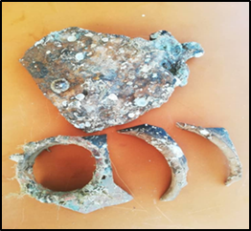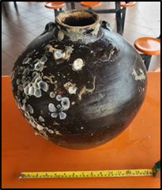

Figure 10. Findings of fragments of glazed stone pottery and Chinese glazed stone jars from the 17th to 18th centuries at the SO-08 dive site.

Discussions
- Impact assessment, recommendations, and mitigation
Before the impact assessment, proposal, and mitigation for this 300-acre marine reclamation project can begin, several important aspects need to be considered as a guide or example of impact assessment on heritage in a place must be done first. Aspects that need to be taken into account are such as local conditions, especially if there are any remnants of objects, artifacts, ecofacts, monuments, or any building structures that symbolize the excellence of the universal heritage of Outstanding Universal Value (OUV) within the area. In addition, if the area to be developed does not have any impact on the heritage value of universal excellence, the aspect of heritage or local historical impact still needs to be given proper assessment before proposals and mitigation can start.
The location of the project site is estimated to be between 5 to 10 kilometers from the area with universal heritage value, meaning that the site is outside the main zone area and the buffer zone with the OUV value. The assessment, proposal, and mitigation in this reclamation area should take into account the factors of site excellence and local heritage based on several criteria as stated below:
- Impact on historical heritage (historical value, relics of underwater cultural heritage resources, shipwrecks, and archaeological artifacts).
- Impact on the tourism industry based on historical and heritage site resources.
- Impact on heritage sites (shipwreck sites, underwater archaeological sites - building s tructures, artifacts, and ecofacts).
- Impact on the environment.

Table 2 and Table 3 display the findings and evaluation of historical, heritage, and archaeological effects based on the above evaluation criteria.

Table 2. Summary of findings of underwater cultural heritage findings.

Methods  Findings | Literature Review | Informants | Scientific Survey | Scuba Diving
30-40 shipwreck sites | √
21 artifacts |  | √
Barge |  |  | √ | √
1 almost perfect jar |  |  | √ | √
5 pottery fragments |  |  |  | √
Chunks of cement concrete blocks |  |  | √ | √
Iron pipe rods |  |  | √ | √
Anchor rod |  |  |  | √
Television Frame |  |  | √ | √

Table 3. Assessment of impact (underwater archeology, heritage, tourism, and environment).

Impact  Value | Value Heritage / Archeology | Tourism Industry | Heritage / Archaeological Sites | Effect on Environment
Very important | 30-40 shipwreck sites | 30-40 shipwreck sites | 30-40 shipwreck sites
Important
Mediocre | 21 artifacts |  |  | 30-40 shipwreck sites
Low | 1 almost perfect jar,  5 pieces of pottery | 1 almost perfect jar,  5 pieces of pottery,  21 artifacts | 1 almost perfect jar,  5 pieces of pottery,  21 artifacts | 1 almost perfect jar,  5 pieces of pottery,  21 artifacts
No Interest | Barge, Chunks of cement concrete blocks, Iron pipe rods, Anchor rod, and Television Frame | Barge, Chunks of cement concrete blocks, Iron pipe rods, Anchor rod, and Television Frame | Barge, Chunks of cement concrete blocks, Iron pipe rods, Anchor rod, and Television Frame | Barge, Chunks of cement concrete blocks, Iron pipe rods, Anchor rod, and Television Frame

- Impact assessment (phases before, during, and after sea reclamation)
The evaluation of the quality and impact of the HIA study needs to take into account several factors and criteria. The effectiveness of quality assessment on HIA studies can be illustrated through Figure 11.

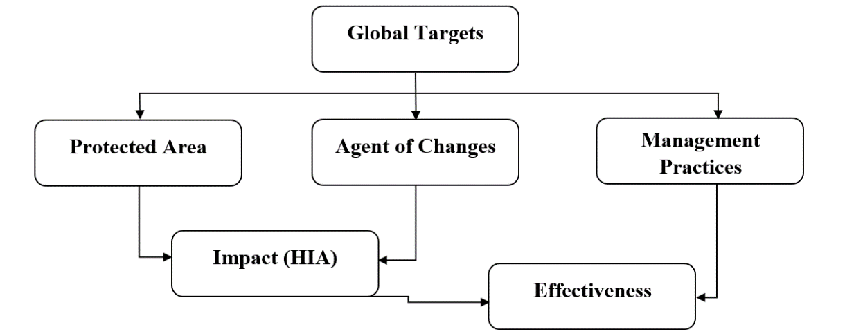
Source: Ana Pereira Roders et al. (2013).

Figure 11. Effectiveness of the HIA Study Framework and the relationship between five additional evaluation factors.

Figure 11 shows the proposed framework to help determine the effectiveness of management practices including HIA practices. It can be used as a guide to evaluating HIA and assessing the relationship between the five main sub-assessments. Among the subs are protected urban areas, agents of change, and management practices.
The assessment of the impact of agents of change as well as the effectiveness of management practices applied in the protected urban areas requires input from three previous assessments. The assessment of a protected area is also known as an assessment of cultural importance and is often contained in a Statement of Interest (Statements of Outstanding Universal Value for World Heritage property). All of these factors are used to determine the cultural significance covering cultural heritage properties as well as to monitor the state of their preservation promptly.
Assessment of agents of change relates to known and potential factors found to influence protected areas and is often considered a threat or cause of deterioration of cultural heritage property conservation conditions. The evaluation of management practices focuses on the effectiveness of procedures, especially the stakeholders involved, their actions, and conditions.
The HIA study, as described earlier, considers assessments to determine the impact of agents of change on protected areas designated as cultural heritage. Whereas, effectiveness evaluation refers to the contribution of selected management practices including HIA, to achieving targeted objectives in protected areas and agents of change (Ana Pereira Rodgers et al., 2013).
In general, the evaluation of the proposed 300-acre sea reclamation project site in Klebang Tengah, Malacca did not show important clues from the aspect of underwater archeology, the discovery of shipwreck sites, and valuable artifacts such as porcelain, coins, beads, old structures, and so on. Although the shipwreck survey study in 2005 and 2007 had recorded statistics of the findings of 30 to 40 shipwreck sites on the coast of Malacca, it is not included in the 300-acre project site.
Meanwhile, the discovery of 21 samples of artifacts in the form of ceramics and metals by fishermen there in terms of value on the impact of local heritage and history did not give any significant contribution, impact, and importance to the history of Malacca. This is because most of the artifacts are just ceramics originating from China which has been a commodity traded in the Southeast Asian region for centuries. Most of the artifacts found were not considered as local heritage, but rather of universal heritage value. Meanwhile, the discovery of a jar of glazed stone pottery from China aged from the 17th or 18th century as well as some fragments of stone pottery also did not have a big impact on the history and heritage of the state of Malacca.
The discovery of waste materials such as new ship platforms made of iron (barges), lumps of cement blocks, pipes, modern anchors, and television set frames at the project site also did not give meaning and impact on the heritage and history of Malacca. Nevertheless, all the evidence of the findings has been carefully analyzed, recorded, and recorded and some have been submitted to PERZIM for further action.
However, if evaluated from the point of view of archaeological importance about the record of the discovery of 30 to 40 sites of the shipwreck, then it is important and needs to be done comprehensively in the future. However, the findings were not in the area of ​​the marine reclamation project site. This means that there is no risk of destruction of archaeological sites if the reclamation project is carried out.
The impact on the value of the importance of the tourism industry in Malacca is also predicted not to have a significant impact from this project. This is because, the discovery of historical, archaeological, and heritage effects at the project site does not bring significant and interesting meaning to the tourist attraction. Similarly, the impact on environmental pollution is also not expected to have any impact on the environment and marine biology in the area because salvage work or underwater archaeological excavations are not carried out in the sea reclamation project site.
However, two important issues need to be considered, namely the recognition of the state of Malacca as a World Heritage City by UNESCO since 2008 (Rohayah Che Amat, 2019) and the issue of overlapping protection zones of 75 acres in the proposed reclamation project area. This is because the distance of the project site with the main zone and buffer zone is only about 5 to 10 kilometers. Therefore, sensitivity to any discovery of artifacts related to the cultural heritage of underwater resources such as shipwrecks, ancient structures, and artifacts that contain local historical value needs to be saved, recorded, and preserved. Marine reclamation work should be stopped temporarily if there is the discovery of any such valuable finds. In this case, the developer should seek views and advice from JWN or PERZIM to take the next step whether to conduct a comprehensive underwater archaeological study in the affected area.
Meanwhile, regarding the issue of a protection zone of 75 acres in the sea reclamation project area, the developer must consult with the agency involved, namely JWN, whether to move the maritime heritage protection zone to another area or conduct a more detailed study before obtaining permission from JWN to continue the reclamation work. The developer must obtain a letter of approval and consent for the exemption of the 75 -acre area from the protected maritime heritage zone or the area of ​​the zone is relocated elsewhere. In this case, the developer also needs to consult with the Malacca State Government for that purpose.

- Operation phase
There are no traces of site relics, structures, artifacts, and shipwrecks that are considered important from the point of view of maritime archeology or underwater archeology at the project site. On the other hand, many finds of waste materials such as ship rigs, scrap metal, anchors, and television set frames. The discovery of some ceramics and ceramic fragments by fishermen in the area was once just a random find and it was scattered across the coast of Malacca. There are no related finds or encounters in ‘Archaeological Contacts’. Therefore, there is no significant impact on the history, heritage, and underwater archaeological sites during the marine reclamation project.

- Mitigation Measures
Since there are no traces of shipwreck remains or significant artifacts, there is no need for mitigation action on the sea reclamation process. However, developers are advised to be careful during the reclamation stage as a precautionary measure. If there are any signs of the possible discovery of any artifacts, shipwrecks, etc., should be reported immediately to PERZIM and JWN. This is because there is a law stated in the National Heritage Act 2006, Part IX: Underwater Cultural Heritage (National Heritage Act 645, 2006) which states:
- Any person who finds an underwater cultural heritage in Malaysian waters shall, as soon as practicable, give notice of the discovery to the Commissioner or port officer.
- The port officer upon receipt of the notice shall as soon as practicable notify, and if possible hand over the underwater cultural heritage to, the Commissioner.
- The Commissioner may, when satisfied that the underwater cultural heritage has a significant cultural heritage, cause it to be listed in the register.
- Any person who fails to give notice under subsection (1) commits an offense.

- Impact of Environmental Waste and Environmental Monitoring and Audit
Since there is no predictable environmental waste impact from this HIA study, there is no need for any recommendation of environmental monitoring and audit requirements for underwater cultural heritage.

Conclusion
During the two weeks HIA study conducted at the site of the proposed sea reclamation project of 300-acres from October 6, 2020 - October 14, 2020, researchers have found several findings of artifacts and non-artifacts. According to the records of the findings, only one jar of complete stone pottery type and 5 pieces of fragments of jar fragments were found in the study site area. Another finding of 21 ceramics (blue and white porcelain, glazed and non-glazed stone pottery, bottles, and copper jugs) were found by fishermen fishing around the waters.
Meanwhile, records of historic shipwreck surveys conducted by private companies and government agencies (PERZIM, JWN, Marine Department, and RMN) from 2005 to 2007 have found between 30 to 40 images of ancient shipwrecks that sank in the waters of Malacca (Jabatan Warisan Negara, 2007). Evidence of all these findings is quite important if evaluated from the point of view of historical remains and maritime archeology in Malacca. However, it is not an obstacle for the company to carry out sea reclamation projects in the designated area. This is because the discovery of this reported hull image is located far away from the project area. No findings of exceptional universal heritage value were found at the study site.
The proposed development will not infringe on any area of ​​archaeological interest and will not have a direct or indirect impact on any underwater archaeological site along with the site of the marine reclamation project. However, it is emphasized here that if there are any findings either intentionally or unintentionally during the project, the contractor must report the findings to the authorities in advance before proceeding with the sea reclamation work.

Acknowledgment
I would like to express my special thanks and gratitude to the National Heritage Department and Malacca State Museum Corporation for giving me this opportunity to lead this project on the topic Sea Reclamation in XLIV Urban Area, Central Malacca District, Malacca: From the Perspective of Heritage Impact Assessment Study (HIA). Hopefully, this project will provide a useful guide regarding the importance of heritage, environment, and preservation areas with Outstanding Universal Value (OUV) in the state of Malacca.

References
Abdul Latiff Abu Bakar. (1984). Sejarah Di Selat Melaka. Institut Kajian Sejarah dan Patriotisme Malaysia dan Persatuan Sejarah Malaysia Cawangan Negeri Melaka.
Ahmad Jelani Halimi. (2006). Perdagangan dan Perkapalan Melayu Di Selat Melaka Abad ke-15 Hingga Ke-18. Dewan Bahasa dan Pustaka.
Ana Pereira Roders, Aland Bond & Jacques Teller. (2013). “Determining Effectiveness in Heritage Impact Assessments” in, IAIA 13 Conference Proceedings: Impact Assessment the Next Generation, 33rd Annual Meeting of the International Association fo Impact Assessment 13-16 May 2013.
Armando Cortesao. (1944). The Suma Oriental of Tom Pires. (Vol. 1). Hakluyt Society.
Asyaari Muhamad. (2001). Laporan Kajian Arkeologi Kota Melaka. Jabatan Muzium & Antikuiti.
Asyaari Muhamad. (2008). “Kegemilangan Arkeologi Melaka”. Dalam, Persidangan Kebangsaan Melaka Agong Sejak Azali 2008, (ASAL). Astro Awani.
Baharom Abu (2020, August). Oral interview.
Flecker, M. (2005). Final Report Malacca Shipwreck Survey 1. Maritime Explorations (M) Sdn. Bhd.
Flecker, M. (2005). Report Brief Shipwreck Survey Near Pulau Upeh. Maritime Explorations (M) Sdn. Bhd.
ICOMOS. (2011). Guidance on Heritage Impact Assessments for Cultural World Heritage Properties. ICOMOS and World Heritage Centre.
Jabatan Warisan Negara. (2007). Laporan Akhir Projek Survei Kapal Karam Bersejarah Selat Melaka. Jabatan Warisan Negara, Kementerian Kebudayaan, Kesenian dan Warisan.
JK Hidro & Oceanography Consultant Sdn. Bhd. (2020). Survey Report (KH/H02/20/P2/Report/v1.1. 6 October 2020.
Mills, J. V., & Cheah, B. K. (1997). Eredia’s description of Malacca. Journal of the Malaysian Branch of the Royal Asiatic Society, 71, 137-141.
National Heritage Act 645. (2006). Part IX: Underwater Cultural Heritage. The Commissioner of Law Revision, Malaysia.
Nordin Husin. (2008). Geografi dan perdagangan: kepentingan Selat Melaka kepada perdagangan dunia, Asia dan dunia Melayu 1700-1800. Akademika. 73, 3-26.
Rashid Mad Zain. (2020, August). Oral interview.
Rohayah Che Amat. (2019). Historic cities of the Straits of Malacca UNESCO world heritage site: threats and challenges. Journal Of World Heritage Studies. (Special Issue 2019). 9-15. https://doi.org/10.15068/00157680
Solihah Mustafa, Ruzanna Syamimi Ramli, Jabil Mapjabil, Mohammad Kadir Zainal Abidin, & Mohamad Pirdaus Yusoh. (2015). Pengurusan bandar warisan UNESCO dan penglibatan komuniti tempatan: Kajian kes di George Town. Geografia-Malaysian Journal of Society and Space, 11(12), 87-99.

