

A review of behaviour mechanisms between government and society in bargaining water pollution issues

Yijuan Jiao, Mou Leong Tan*, Nooriah Yusof, Suriati Ghazali

GeoInformatic Unit, Geography Section, School of Humanities, Universiti Sains Malaysia, 11800 Gelugor, Pulau Pinang, Malaysia.

Correspondence: Mou Leong Tan (email: mouleong@usm.my)

Received: 18 February 2022; Accepted: 23 June 2022; Published: 31 August 2022

Abstract

Water pollution causes serious damage to people's lives, health and safety. As a prominent issue impacting social stability and development, protests to water pollution issues have become a great challenge for governments at all levels in recent years. This study aims to analyze the complex behaviour mechanism between participants and government, which is of great significance to the prevention and treatment of such incidents. This paper also discusses the cooperative and interactive relationship between government and society in the governance structure. In order to clarify the research progress of water pollution protest in the past decade, a systematic review has been used to identify 40 research papers related to social and governmental environmental negotiation mechanisms of water pollution events from the CNKI, SCOPUS, EIVL-LAGE2 and other databases. As a single management subject, a government can neither realize the efficiency and fairness of water resources allocation, nor effectively coordinate the contradictions among stakeholders such as the government, enterprises and the public. In order to protect the public's right to know, government must improve information disclosure, which also provides theoretical support for the government and relevant departments to control such events. Finally, the cooperative governance between government and society in water pollution events should be strengthened to improve the democratic governance ability of the government and achieve social governance innovation. Therefore, society-government cooperation should be taken as the breakthrough point, establish the concept of effective participation between government, enterprises and the public in the joint treatment of water pollution events. The study can be act as a reference for local authorities to better manage water pollution incidents with the public.

Keywords: Behaviour mechanisms, clean water, government and society, water pollution protest

Introduction

In recent years, in pursuit of short-term profits, enterprises cause water pollution by directly discharge pollutants to river. This action leads to mass protests surrounding the enterprises, including mass incidents like parades, sitting still, and collective trouble, thus seriously impacting the stability and development of Chinese society (Wang et al., 2022). The structure of crowd behaviour is complex, and the peculiar characteristics of complex evolution lack effective emergency measures in practice. Moreover, interest disputes caused by the uneven distribution or suspension of "minimum living allowances" have aroused the dissatisfaction of the masses. Group emergency caused by the crisis has had a tremendous negative impact on society. This kind of environmental protest requires the cooperation of water pollution enterprises, surrounding people, and the government, including interest coordination, water pollution control plan, and government subsidies (Perri et al., 2002). Therefore, it is of great significance to deeply analyse the occurrence mechanism and evolution law of such incidents to control such mass emergencies fundamentally.
As stated in the website of North China Inspection Bureau Ministry of Ecology and Environment, 108 major pollution events have been reported based on the summary of recent environmental pollution protest events, 40% of which involving air pollution, 15% involving water pollution, and 21% involving comprehensive water pollution. Altogether, the news volume pertaining to water pollution, garbage treatment, and pollution status has significantly increased since the past few years. Figure 1 illustrates the specific investigation results of environmental pollution protest survey in 2020.

Figure 1. Environmental pollution protest survey in 2020

The types of environmental pollution are relatively diversified. For instance, in addition to air pollution, water pollution is gradually concerned by the public and involves several fields such as public health literacy. From Table 1, the number of environmental bargaining proposals of the National People's Congress and the Political Consultative Conference undertaken by environmental bargaining systems at all levels has been increasing with each passing day, with the total number of the above two cases increasing by about twice as much.
Generally, with the enhancement of public ecological and participation awareness, the public has long been unsatisfied with passively responding to the government's call. They are not only participating in some environmental bargaining publicity and education activities, but are more actively participating in the relevant activities of ecological civilization construction as the main body, particularly in the government's ecological governance activities and substantially deepening ecological legislation and environmental bargaining. These indicate that since the beginning of the 21st century, the Chinese public has become a necessary force to construct ecological civilization. Their participation in constructing ecological civilization has realized a qualitative leap.
Table 1. Environmental bargaining proposals undertaken by environmental bargaining agreements at all levels in China

Year | Number of proposals
2016 | 538
2017 | 651
2018 | 652
2019 | 536
2020 | 564

Water pollution protest and environmental negotiation mechanism research is still rare in China. Although some research results have been obtained (Krtali et al., 2020), due to the relatively short history of relevant aspects, it is still in the primary stage of development. There is a lack of analysis on the perceived value of profit and loss between domestic water pollution enterprises and surrounding people. At present, most studies are limited to theory and lack the implementation of practical application. In addition, foreign experience and schemes cannot be applied to China's national conditions. The study aims to analyse the behaviour mechanism between participants and government as well as their relationships. In order to understand the research progress of water pollution protest in academia in the past decade, we have selected and reviewed 40 research articles from CNKI, SCOPUS, EivIL-LAGe2 and other databases. Such a severe situation has aroused people's great attention and research on accidental water pollution events. Among them, the governance model, control system and control technology of accidental water pollution events have been the focus and hotspot of Chinese scholars' research in recent years. This study also review the research status of accidental water pollution events in China from the above three aspects. The findings of this study are useful for local stakeholders to understand better the environment bargaining mechanism in water pollution protest in China. With the phenomenon of "government failure" and "market failure" that appeared in Western society in the 1970s, social organizations began to develop rapidly as the third sector to make up for the lack of government and market. As a result, more attention has been paid to the research on the relationship between government and social organizations, especially strengthening of cooperation between the two. Cooperative governance does not simply put multiple subjects together. Cooperative governance is complex. Different subjects have differences in interests, objectives, attention, preferences, capabilities and resources, which determines that the practice of cooperative governance will inevitably overcome these differences. The process of cooperative governance is easily challenged by conservatism, goal balance, incentive, steering, cultural construction and so on. In the practice of political and social cooperation in water pollution control in some places, there have been problems such as insufficient willingness to cooperate, unclear responsibilities, unstable cooperative relations and high transaction costs, which not only damage the social mass foundation of water pollution control, but also affect the credibility and image of the government. A total of 320 research articles related to the "accidental water pollution events" were available in the CNKI platform. On the other hand, in the SCOPUS database, 852 literatures related to "accidental water pollution events" were found. Lastly, 40 articles on the governance model, control system and control technology of accidental water pollution events in China have been identified and used for this study.

Accidental water pollution events in China

Accidental water pollution events refer to accidents that occur accidentally and are caused by man-made or natural factors. Pollutants intervene in rivers, lakes and other surface and underground water bodies, leading to water quality deterioration. This situation affects the effective utilization of water resources, normal economic and social activities, and water ecological environment. Accidental water pollution events have the characteristics of insufficient precursor, unclear inducement, difficult to predict, difficult to control, dangerous damage, serious loss, complex treatment, and so on. In a short period of time, it is likely to cause pollution of water source, water cut-off, industrial production and other problems as well as easy to cause a huge impact and harm to the production and life of the society. In recent years, accidental water pollution accidents have a gradually rising trend. In China as an example, a total of 1176 major accidental water pollution accidents have occurred (Ai & Liu, 2013). The harmful effects of these events are often severe as listed in Table 2 and Figure 2.

Table 2: Examples of accidental water pollution event in China

 | Cause | Through | Effect
2005 | Songhua River water pollution incidents | An explosion occurred in the aniline workshop of CNPC Jilin Petrochemical Company's diphenyl plant. Therefore, about 100t benzene, aniline and nitrobenzene and other organic pollutants inflow The Songhua river | Millions of people live along the Songhua River Lives were severely affected, resulting in a total of 8 deaths and 60 injuries, straight economic losses reached 69.08 million yuan.
2006 | Dead fish incident in Baiyangdian Lake | Water pollution is serious, resulting in water dissolved oxygen content is too low, the end the result was mass suffocation of fish | Renqiu city caused 6000hm² of water by serious pollution, part the water grass turned black and died. In addition to the cage aquaculture fish all died, lake wild fish have also been decimated.
2007 | Taihu lake water pollution incident | The water level of Taihu lake has reached its lowest level in 50 years, coupled with continued high levels of lukewarm rain, causing severe eutrophication and large area outbreak of cyanobacteria. | Cause tap water quality accidental change, accompanied by difficult smell with serious threat to Wuxi city people's drinking water safety
2008 | Water pollution incident in Gaode Garden, Taiping District, Fuxin, Liaoning province | The poor drainage of the downpipe in the community, coupled with the failure of the water stop valve in the overflow pipe of the reservoir, caused the sewage to flow back into the reservoir. | More than 1000 residents of the community appeared vomiting and diarrhea poisoning symptoms, a total of 2636 households involved, 1139 people have been outpatient treatment, 59 people hospitalized.
2009 | The incident of excessive blood lead in children in Fengxiang, Shanxi | Villagers suspect that the local large zinc smelting enterprises discharge of waste water, waste gas caused | More than 850 children were found to have high levels of lead in their blood and crop yields were severely affected
2010 | Dalian oil pipeline explosion | A PetroChina pipeline caught fire and exploded near Dalian's Xingang port, spilling some crude oil | At least 50 km² of nearby sea surface is contaminated by crude oil. There were even open fires on the sea in Dalian Xingang Port area, covering an area of 80 ~ 100m²
Source: Guangdong provincial government portal (http://www.gd.gov.cn/), Review of some major water pollution incidents in China in recent years.
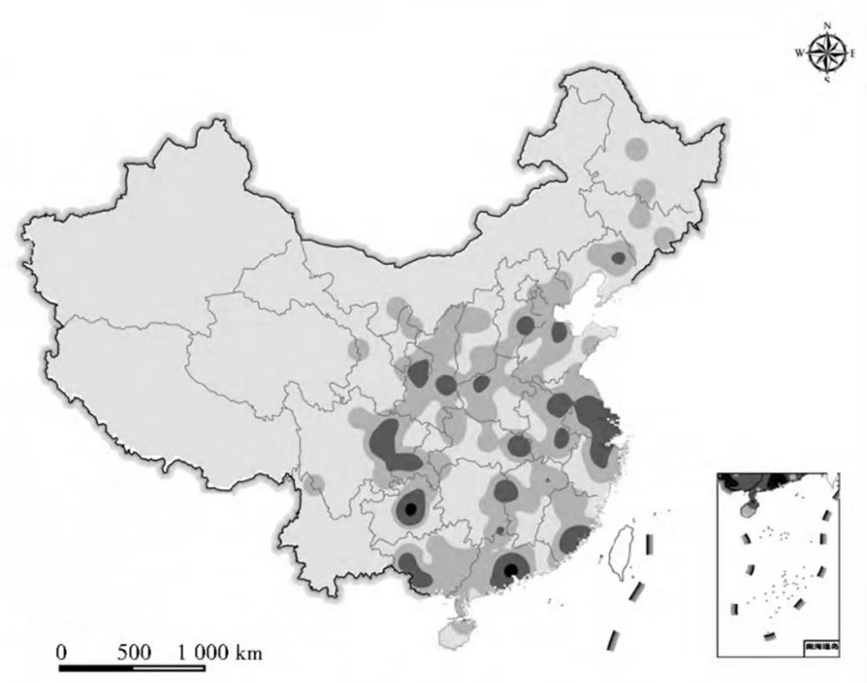

Source: Geng et al., (2022)

Figure 2. Density distribution of water pollution incidents in China

Governance model

Helfand (1991) pointed out that the control order does not need to consider the corresponding cost differences in water pollution control for enterprises to share the corresponding pollution control. This is a traditional type of governance of water pollution (Helfand, 1991). However, Portney et al., (2004) believed that market-based economic incentive governance has superior technology, higher efficiency, and lower cost in water pollution control, which has more advantages than control-based governance. In addition, Stavins (1998) has conducted an in-depth research on the emission trading system, including the corresponding definitions of the total market, control objectives, supervision and implementation, market behaviour, emission permits, allocation, and political issues. Meanwhile, Huntley et al., (2001) considered that the fundamental purposes of implementing the pollution charge system are to balance pollution prevention and environmental damage and to achieve Pareto Optimality.
Since the mid-20th century, fecal pollution has brought significant threats to the ecological environment, particularly water. To solve this problem, foreign countries have adopted mandatory policy tools, including a combination of agriculture and animal husbandry, control of breeding scale, sewage permits, punishment and payment of sewage treatment fees, and regional breeding control to treat sewage, reflecting the goal orientation of effective prevention and regulation of water pollution at the source. To control the scale of aquaculture is to determine it in strict accordance with the capacity of environmental facilities of treatment in aquaculture to ensure that the environmental treatment facilities can effectively figure out the faeces generated in aquaculture. The United States, the Netherlands, and other countries have widely applied this method. In addition, punishment appertains to the means of punishing the behaviour of environmental pollution caused by illegal discharge in breeding and paying. Manure treatment fee refers to farmers paying a certain fee to have an institution of qualified treatment and carry out professional and harmless treatment or resource utilization of manure. Japan, Sweden, and other countries have extensively applied this method.

Water pollution control system

A "River Manager & District Manager" system has been widely used in China’s water pollution control and has achieved remarkable results. This system puts forward the specific objectives of rivers in the aspects of basin water resource protection, water shoreline management, water pollution prevention, water environment treatment, and ecological water restoration, including analysing and discussing the corresponding management and protection measures (Wang & Zhang, 2020). Regarding how to improve this system, researchers have proposed to promote its continuous improvement from the aspects of building a three-dimensional legal system and relying on a "system of water control" (Tao, 2019). At the management level, some investigators studied the characteristics of water environment information disclosure at the present stage from the aspects of content, platform construction, and cultural atmosphere of environmental information disclosure. Significantly, they put forward some suggestions to further improve the information disclosure system on the water environment, then increased such disclosure of enterprises and institutions, together with enhancing social service functions of the platform, while also strengthening multi-party information communication and interaction (Wang et al., 2018).
The bio-augmentation technology that widely applied in water pollution control has been deeply studied. Its functions have been introduced in detail from the aspects of action mechanism, the application strategy, and precautions. Water pollution control can be tackled from four aspects such as sewage interception and diversion technology, sediment dredging technology, chemical algae removal technology, and heavy metal fixation technology (Yan, 2019). Then, the technology of water purification with powdered activated carbon (PAC) was also studied by Yan (2019), together with its positive effect on water pollution control. Finally, from the perspective of chemical technology, some researchers examined China's significant environmental pollution problems, demonstrated the advantages of chemical technology in treating ecological and environmental pollution, and introduced its practical application in treatment processes.
Zhu (2019) has elaborated the effective ways to improve the quality of water pollution monitoring. In comparison, the role of monitoring methods of heavy metals in the treatment of factory water pollution and put forward inhibition measures for heavy metals in factory water pollution treatment was discussed by Zhang (2019). Then some researchers designed a model of birth-state sewage dam and explored the effective methods for controlling water pollution in a small watershed. In contrast, Wu (2019) has conducted in-depth research on GIS technology and pointed out that this technology can provide accurate digital maps and other information for water pollution control and significantly improve efficiency in water pollution control.
One of the major causes of water pollution in China's rural areas is due to people's misunderstanding. Therefore, we should have a society prioritize the problem of rural water pollution and to strengthen the efforts to control this problem (Peng & Li, 2019). While by combining the concept of sponge city planning, we can make full use of the infiltration and retention of rainwater using the ecological water system of a "sponge" city to protect and make rational use of water resources, alongside improving the urban water ecological environment.
Current research on water pollution events in China are mainly focused on risk assessment and regionalization, pollution event early warning simulation, and accident emergency management decision-making (Ding et al., 2015; Zhou et al., 2020; Xu et al., 2019). Some other studies have analyzed the change frequency, types of pollution and types of risk sources of water pollution events, highlighting the descriptive characteristics of water pollution events (Ji et al., 2019. However, related research mostly focusses on the pollution sources and harms caused by water pollution events, and there are few studies on the spatial and temporal distribution characteristics of water pollution events, and only some scholars have discussed them. For example, Xu et al., (2018) and Wang et al., (2019) have analyzed the spatial and temporal distribution characteristics of water pollution incidents in China. They found that the spatial distribution of water pollution incidents was significantly difference, where most of serious incidents were occurred in the developed coastal areas and major cities of China.

Environmental bargaining mechanism of water pollution in China

Decision-making mechanism, monitoring system, information release, stakeholder role and third party management are the entry points of accidental water pollution management. Domestic academic circles have put forward specific research ideas after in-depth study of accidental water pollution events. Weng (2008) pointed out that the frequency of accidental water pollution accidents in China in recent years. It is considered that accidental water pollution has become an important factor affecting ecological water environment. Water safety has become the focus of attention from all sides, and the causes of accidental water pollution accidents in China are put forward because mainly lies in the early warning system is unreasonable, the response mechanism is not perfect and so on causes the comparison to the social and economic development of our country.
Some scholars believe that there are still accidents in the treatment of accidental water pollution accidents. Emergency processing mechanism is not perfect, where information timeliness and effectiveness are to be improved. The treatment of water pollution events causes certain negative effects (Lou et al., 2010). In view of the above problems, there are abundant literatures on Environmental Bargaining countermeasures for accidental water pollution. The literature materials are abundant, including studies that take the whole as the breakthrough point and those carried out from a separate perspective. Liu et al., (2008) pointed out that in order to solve the problems of Environmental Bargaining in all aspects of accidental water pollution events, China needs to establish a more efficient automatic monitoring system for accidental water pollution events. It covers water sample collection, water quality monitoring, data control, information transmission, information management and early warning and forecast, so as to provide more timely and effective warning for accidental pollution events and establish a multi-point and cross-section sampling system (Liu et al., 2008).
Through the analysis of the above research status, it can be found that the domestic and foreign academic circles take different perspectives as the research breakthrough point. A series of studies are conducted on environmental bargaining of accidental water pollution events respectively. The research results and literature are helpful to promote the construction of environmental bargaining theory system in China. It is also of great significance to improve the level of environmental bargaining of accidental water pollution events in China. However, we know that different environmental bargaining processes should be adopted for accidental water pollution events caused by different reasons. Existing research results show that there are few studies on environmental bargaining processes in China as listed in Table 3. Most studies on environmental bargaining process optimization in the current literature are qualitative. In general, there are lack of effective quantitative indexes in environmental bargaining process and performance analysis is not conducive to improving emergency process system.

Table 3. Environmental bargaining mechanism of water pollution in China

Author | Theme | Main Findings
Weng (2008) | Accidental water pollution has become an important factor affecting ecological water environment | It is concluded that accidental water pollution has become an important factor affecting ecological water environment, and water safety has become the focus of extensive attention from all sides. The main causes of accidental water pollution accidents in China are unreasonable early warning system and imperfect coping mechanism
Xu et al., (2009) | Problems existing in domestic environmental bargaining system of accidental water pollution | Based on the experience of accidental water pollution environmental bargaining system in developed countries has carried on the induction, and combined with the Songhua river pollution accident on the empirical analysis of the domestic existing problems of accidental water pollution environmental bargaining system in-depth research, and in the construction of the rule of law, organization coordination, accident early warning information release and put forward practical and feasible strategies
Yao (2009) | Establish an organization for accidental water pollution incidents | Synthesize all aspects of factors to formulate relevant laws and regulations for emergency treatment of accidental water pollution events, establish organizations for accidental water pollution events, establish water situation information transmission system and rapid and accurate assessment mechanism of accident losses
Yu et al., (2010) | The coping mechanism of major accidental water pollution events is a system engineering | It is the basic guarantee for the government to calmly respond to major accidental water pollution events by constructing the system for dealing with accidental public events, reasonably decompressing all kinds of specific affairs to each link, and ensuring the mutual connection and effective operation of different links
Wang et al., (2018) | Framework of rapid simulation system for watershed water environment | In view of the randomness in time and space of emergencies, the framework of rapid simulation system for water environment of watershed is proposed, and the key technical problems of rapid simulation of water environment in areas with and without data are discussed
Guo & Long (2019) | Choosing the best emergency plan is the key to deal with accidents | The evaluation system of emergency plan for accidental water pollution events was established based on the benefit index and cost index, and the optimal plan was determined based on the improved TOPSIS method and the social coordinated development degree model (CDDM)

Current situation of environmental conflict in China

At present, most scholars in China focus on the following aspects: the characteristics of environmental conflicts, the causes of environmental conflicts, the problems existing in the governance of environmental conflicts and the countermeasures. Many scholars have found that the main causes of environmental conflicts in China are the government's one-sided pursuit of economic interests and insufficient attention to environmental protection; Enterprises excessively pursue economic profit and neglect corporate social responsibility; Channels for people to appeal are limited; Disordered utilization of public resources; Lack of participation of environmental NGOs and so on. Table 4 lists the current situation of environmental conflict in China.

Table 4. Current situation of environmental conflict in China

Author | Theme | Main Findings
Yu et al., (2010) | Characteristics of environmental conflicts in China | First, the region is strong, and most conflicts occur in developed areas. Second, the membership is complex. The members are not only limited to the lowest vulnerable groups, but some of the participants are often highly educated. Third, demands are concentrated, mostly on the right to environmental survival and health. Fourth, it is reasonable, that is, survival is threatened; Fifth, the occurrence of environmental conflicts is relatively slow, which means that the outbreak of environmental conflicts has a long brewing and accumulation process.
Zhong (2009) | Causes of environmental conflicts in China | Discuss the causes of environmental conflicts in China. Their analysis focused on three stakeholders: the government, enterprises and the public. They believed that environmental conflicts were caused by the conflict of values and interests of the three stakeholders.
Shang (2009) | Countermeasures to manage environmental conflicts in China | The government should change its concept, pay equal attention to economic development and environmental protection, and strive to build an ecological government. Strengthening the independence of environmental management departments; Strengthening environmental legislation; Enterprises should improve their social responsibility while pursuing profits. Increase citizen participation, broaden citizen appeal channel; The government, enterprises and the public should jointly govern; Increasing the participation of environmental ngos; Using consultative democracy to resolve environmental conflicts.

Policy formulation

Dealing with water pollution protests is important in environmental negotiations. To analyze the characteristics of the public policy process in the form of Western democratic representative governments, this process has four aspects: policy decision-making, policy implementation, policy evaluation, and policy supervision (Tran et al., 2020) as shown in Figure 3. It essentially reflects the policy capacity, with each process link corresponding to the government capacity, and the output being the modernization level and performance of water pollution control. Therefore, it is essential to assess and measure the modernization level of water pollution control with the government capacity on policy decision-making, policy implementation, policy evaluation, and policy supervision.

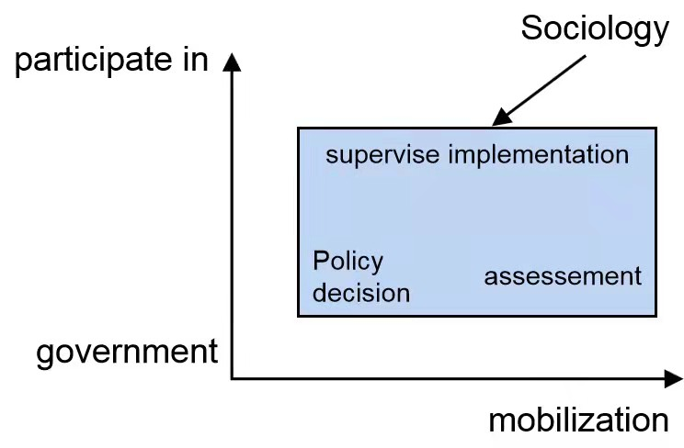

Figure 3. Modernization capacity of water pollution control

Water pollution control connotes the interaction between government and society. Only when the policy process is scientifically, open, fair, and democratic can public power win the people's trust, which is the essence of "power for the people, feelings for the people, interests for the people." Local governments respond to social needs and maintain local social stability by adjusting their decisions. In essence, decision-making is a passive response. According to the standard of media public reporting, generally no and unsuccessful events cannot be called environmental protests; however, often through news media or social media reports, they usually have an impact on the government. As long as these events bring about changes in local government policies, including decision-making, the local government's behavior is a passive response. Figure 4 depicts the underlying structure.

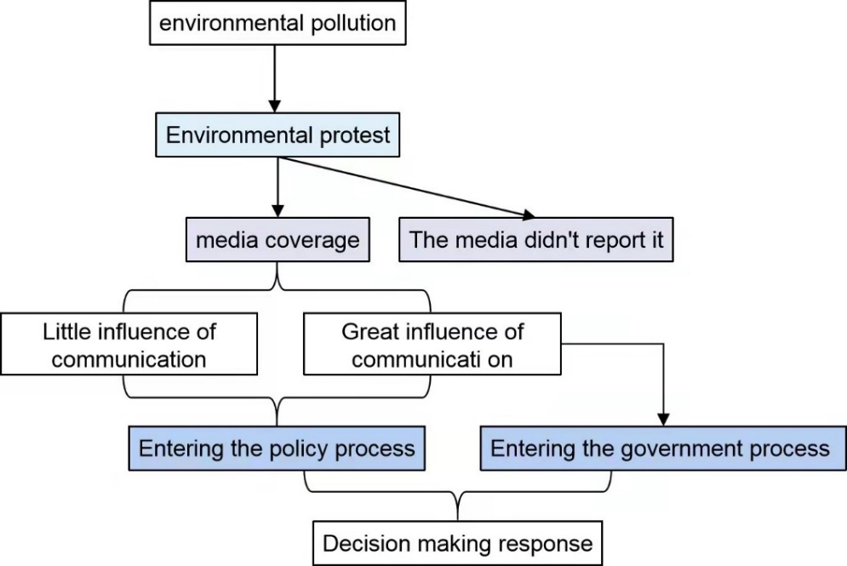

Figure 4. The logical structure of a decision response

There are four situations in the interaction between the government and society under the two-dimensional test of mobilization and participation: closed and restrained governance at the decision-making level, mobilization participation governance at the implementation level, mobilization access governance at the evaluation level, and participation in the leading governance at the supervision level (Godoy et al., 2019). Therefore, the mobilization and participation levels can be arranged clockwise into four quadrants, as shown in Figure 5.

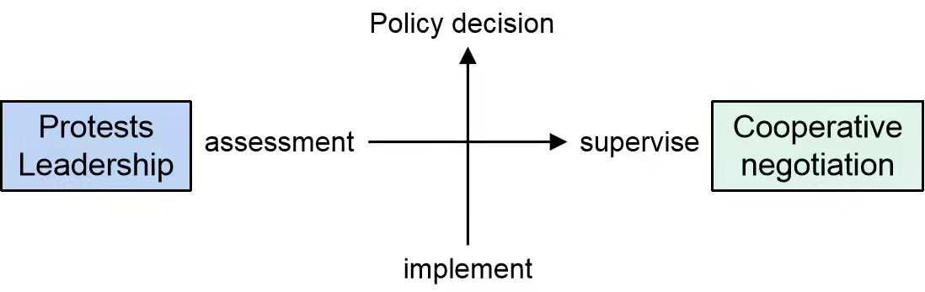

Figure 5. The interaction between government and society in the governance structure

As shown in Figure 5, the mobilization and participation in the decision-making field are the lowest; then, the evaluation and implementation fields are in a clockwise direction, gradually enhancing in mobilization degree. Based on the anti-clockwise direction of gradually increasing participation, the supervision and implementation areas are in turn (Suneel et al., 2019). Therefore, the second and third quadrants are strong mobilization and weak participation governance, referred to as "mobilization leading governance" orientation. On the other hand, the first and fourth quadrants are weak mobilization and strong participation governance, denoted "cooperative and consultative governance" orientation. If cooperative and consultative governance is the requirement of modernization of water pollution control, none of the four fields can undoubtedly meet the requirements.
Information disclosure has made significant progress, but the existing problems remain outstanding. Therefore, to protect the public's right to know, the government must improve information disclosure. First, we should improve the legal system of information disclosure. It is necessary to improve pertinent laws and regulations, such as improving transparency by making relevant laws. Second, we should strengthen the awareness of government information disclosure. After obtaining and analyzing information comprehensively, the public can actively disclose it. The public can accurately and comprehensively understand the relevant information of an event and avoid information asymmetry between the public and the government. Third, we must establish a crisis information management organization. Fourth, the information disclosure standard must be clarified. The government needs to timely disclose the relevant information of various environmental group events according to the specified scope and time of information disclosure. Fifth, we must enrich the information disclosure channels. Finally, the government can strengthen the use of new media and enrich the way of information disclosure.

Cooperative relationship between government and society

The cooperation between society and government in water pollution events is mainly divided into participation in authoritative cooperation and democratic cooperation (Tang, 2011). It is the cooperative management of public affairs between the state and society. Social organizations have become indispensable subjects in the co-governance of river basin pollution due to their motivation in the participation. Social organizations are used in the same sense as non-profit organizations, non-governmental organizations, voluntary organizations or the third sector. In essence, they are non-governmental organizations (NGOs) or non-profit organizations (NPO) that "provide public welfare through volunteering", mainly including social groups, foundations, private non-enterprise units and various grassroots organizations. In terms of organizational nature, social organizations are designed to satisfy the public or society.
From the perspective of environmental protection investment theory, Wang (2020) constructed a capital investment framework for rural water environment governance by multiple subjects and clearly defined the investment responsibilities of government departments, local enterprises, village collectives and other social forces. Through clarifying the grass-roots governance authority, social forces participation channels, innovation project operation mechanism, subject assessment and evaluation mechanism, enterprise incentive mechanism and other ways to build a multi-collaborative governance pattern.
In the participative authority cooperative mode, the government and social organizations are an "authority-dependent" cooperative relationship. The formulation, implementation and supervision of public policies are still carried out authoritatively from top to bottom under the leadership of the government, and the participation of social organizations plays an auxiliary, supporting and serving role of the government. Social power is difficult to effectively intervene in the process of public policy making, and social organizations are still weak in the awareness and ability to participate in or express public interests and lack a dialogue platform for equal communication and consultation in the process of public policy making. But compared with the traditional authoritative governance mode which takes the government as a single subject, it has obvious advantages. Social organizations absorb and integrate social resources from outside the political system to make up for the defects and deficiencies of the traditional model, which is helpful to resolve the problem of "untreatable rationality".

Conclusion

In this study, three important aspects of environmental bargaining, the government response, water pollution event control system and environmental bargaining technology have been discussed. The progress of the research on the spontaneous water pollution events is reviewed. A comprehensive analysis of the emphases and trends of the research should put forward the research on the future accidental water pollution events key directions.
The establishment of insurance system and compensation mechanism for accidental water pollution incidents. Into disaster insurance and compensation mechanism, strengthen the government, enterprises, social cooperation, through the study sets up a special fund or the corresponding insurance system, to reduce disasters occur government and relevant departments of the relief pressure, make the daily life of people, and can timely access to the corresponding damages, minimize the impact of water pollution event.
Disaster situation and risk assessment of accidental water pollution events. Through the systematic analysis of the disaster impact of typical water pollution events, the evaluation index system of accidental mass events was established to classify the severity of water pollution events. In the future, information technology can be used to timely predict and assess the disaster situation and provide early warning and support for the response to accidental protests.
In addition, strengthening and innovating social management, properly dealing with and avoiding all kinds of mass emergencies, the significant challenges faced by governments at all levels in China, and accurately analyzing the relationship and evolutionary equilibrium characteristics between enterprises, surrounding people, and the government in water pollution protests are of great significance for the government and management departments for preventing and dealing with such mass emergencies effectively. Future research should focus on the clarification and development of the concept of cooperative governance in water pollution protests to strengthen the collaboration between government and society in this issue.

Acknowledgement

This research was funded by the Ministry of Higher Education Malaysia (MOHE) under the Fundamental Research Grant Scheme (FRGS), Project Code: FRGS/1/2018/SS07/USM/02/2 and 203.PHUMANITI.6711695. We would like to thank all editors and reviewers for their constructive comments.

References

Ai, H., & Liu, T. (2013). Statistics of major sudden water pollution incidents in China from 2000 to 2011. Journal of safety and environment, 31(4), 284-288.
China Central Government Portal: Guangdong provincial government portal. Some major water pollution in China in recent years dye event callback. www.dg.gov.cn/cndg/s36006/201211/590026.htm.2014-03-29.
Ding, L, Huang, Y, & Liu, Y. (2015). Temporal and spatial evolution characteristics and influencing factors of sudden environmental pollution events in China from 1995 to 2012. Advances in geography, 34(6).
Godoy, B. S., Faria, A., & Juen, L. (2019). Taxonomic sufficiency and effects of environmental and spatial drivers on aquatic insect community. Ecological indicators, 107, 105624.
Guo, W., & Long, Y. (2019). Study on comprehensive evaluation method of emergency plan for sudden water pollution Events. China Rural Water and Hydropower, (12), 110-114.
Geng, Y.N, Dai, E.H, Wang, G.L, Jin, Z.H., & Zhang, J. (2022). Spatial-temporal Distribution, Evolution and Influencing Mechanism of Water Pollution Events in China. Environmental Pollution and Prevention volume, 22(3),413-419.
Helfand, G. E. (1991). Standards versus Standards: The Effects of Different Pollution Restrictions. American Economic Review, (3), 622-634.
Huntley, D., Lceks, G. & Walling, D. (2001). Land ocean Interaction: Measuring and Modelling Fluxes from River Basins to Coastal Seas. London: IWA Press, 241-279.
Ji LI, Liu Jing, & Li Zhiwei, et al. (2019). Water pollution incidents and causes in China from 2011 to 2015. Journal of ecology and rural environment, 33(9), 775-782.
Krtali, A., Baji, M., Ivelja, T. (2020). The AIDSS Module for Data Acquisition in Crisis Situations and environmental bargaining. Sensors, 20(5), 1267.
Liu, X., Lu J., & Hao H. (2008). Monitoring, early warning and prediction of sudden water pollution events and emergency management. Chinese Hydraulic Society annual Conference 2008, Haikou, Hainan, China.
Lou, Y., Yan, S., & Wang, H. (2010). Analysis of current situation of emergency management of sudden water pollution accident. Zhihuai River, (12), 38-39.
Peng, H., & Li, Y. (2019). Countermeasures and importance of prevention and control of rural water pollution. Resource conservation and environmental bargaining, (10), 107.
Perri, Leat, D, Selter, K., & Stoker, G. (2002). Towards Holistic Governance: The New Reform Agenda. New York: Palgrave.
Portney, P. R., & Stavins, R. N. (2004). Public policy of environmental bargaining. Shanghai: Shanghai People's publishing house, 42-43.
Shang, L. (2009). Causes and Solutions of Mass Disturbances caused by Environmental Problems, Journal of Capital Normal University, (5)
Stavins, R. (1998). What can we Lean from the grand policy experiment? The Journal of Economic Perspectives, (3), 69-88
Suneel, V., Saha, M., & Rathore, C. (2019). Assessing the source of oil deposited in the surface sediment of Mormugao Port, Goa -A case study of MV Qing incident. Marine Pollution Bulletin, 145, 88-95.
Tao, L. (2019). Organic integration of administrative measures and legal system: Rational Thinking on the continuous improvement of "river head system". Journal of Guangxi Vocational and technical college, (04), 130-135.
Tran, J., Divine, L.M., & Heffner, L.R. (2020). "What are you going to do, Protest the Wind?": Community Perceptions of Emergent and Worsening Coastal Erosion from the Remote Bering Sea Community of St. Paul, Alaska. Environmental Management, 23(5), 1-24.
Tang, Wenyu. (2011). Cooperative Governance: Authoritative cooperation and democratic Cooperation. Journal of Wuhan University (Philosophy and Social Science edition), 30(6). 1-11
Wang, Y., Zhang, X., & Zhang, W. (2018). Rapid simulation and early warning system of sudden water pollution accident in watershed. Environmental Science and Technology, 41(7), 164-171
Wang, K., & Zhang, X. (2020). The Effect of Media Coverage in Disciplining Firms' Pollution Behaviors: Evidence from Chinese heavy polluting listed companies. Journal of Cleaner Production, 280(1), 123035.
Wang, M., Janssen, A. B. G., Bazin, J., Strokal, M., Ma, L., & Kroeze, C. (2022). Accounting for interactions between Sustainable Development Goals is essential for water pollution control in China. Nature Communications, 13(1), 730.
Wang, J., Zhao, J., & Yang, H. R. (2019), Temporal and spatial distribution characteristics of water pollution emergencies in Chongqing. Journal of Yangtze River Scientific Research Institute, 38(4), 25-29.
Weng, S. (2008). Study on the early warning and Prediction system of sudden water pollution accident in the lower Pearl River (Master's Thesis). Retrieved from Sun Yat-sen University
Wu, M. (2019). Application of GIS in hydrology and water resources. Jilin agriculture, (21), 38.
Xu, R., Wang, Z., & Chen, Y. (2009). Study on emergency management system of sudden water pollution accidents. Hebei Industrial Science and Technology, 26(04), 218-220.
Xu, J., Wang, Y.G, & Yang, Y.Q. (2019) Risk Assessment and Early Warning system for Sudden Water Pollution in China: A review of research progress. Environmental pollution and control, 41(4), 474-478.
Xu, J., Wang, Y.G, & Chen, Y. (2018). Temporal and spatial distribution of water pollution emergencies in China. China environmental science, 38(12).
Wang, X., Guo, H., Liang, H., & Li, X. (2018). Research on water environment information disclosure system and practice in China. Environment and sustainable development, (06), 84-88.
Yan, G. (2019). Application of powdered activated carbon water purification technology in industrial water treatment. Chemical engineering design communication, (10), 192-193.
Yao, B. (2009). Analysis on emergency management of sudden water pollution events in China. Business Situation, (2), 185.
Yu, G., Tao, J., Yuan, K., & Li, Z. (2019). Solutions to Environmental Mass Incidents, (19) Environmental Protection and Circular Economy, (19), 63-67
Yuan ,H., & Li, N. (2010). Study on coping mechanism of major sudden water pollution events. Journal of Law, 31(07), 100-102.
Zhang Z. (2019). Heavy metal monitoring and control measures in environmental treatment of factory water pollution. World nonferrous metals, (16), 239-240.
Zhong, Q. (2009). Environmental Damage and Mass Incidents in Zhejiang Province since the new century. Resources and Habitant Environment, (12),102-105.
Zhu, Y. (2019). Ways to improve the quality of water pollution monitoring in environmental monitoring. Science and technology horizon, (30), 176-177.
Zhou, X.F., Yu, F., & Liu, Q. (2020). Study on risk zoning of sudden water pollution in Dongjiang River Basin. Acta ecologica sinica, 40(14), 4813-4822.

