

Trajectory-geospatial approach using HYSPLIT Model in determining air pollution sources at Pasir Gudang industrial areas

Nor Diana Abdul Halim¹, Mohd Shahrul Nizam Mohd Ariffin², Khairul Nizam Abdul Maulud^{1,2}

¹ Earth Observation Centre, Institute of Climate Change, Universiti Kebangsaan Malaysia,
43600 Bangi, Selangor, Malaysia
² Department of Civil Engineering, Faculty of Engineering & Built Environment, Universiti Kebangsaan Malaysia, 43600 Bangi, Selangor, Malaysia

Correspondence: Khairul Nizam Abdul Maulud (email: knam@ukm.edu.my)

Received: 10 March 2021; Accepted: 8 October 2022; Published: 30 November 2022

Abstract

Industrial air pollutants emissions can be hazardous to human health and the environment. This study aims to determine the source of air pollution exposure in Malaysia's busiest industrial area, Pasir Gudang by using the trajectory-geospatial approach. The Hybrid Single-Particle Lagrangian Integrated Trajectory (HYSPLIT) model was used to determine the pathway of air backwards-trajectory. While the geospatial analysis for air pollution sources identification in Pasir Gudang was conducted using Geographic Information System (GIS). Three days of air mass backwards-trajectories were successfully obtained, where the dominant air mass pathways direction came from West Sumatra, Indonesia, influenced by the Southwest monsoon wind. The air mass backwards-trajectories also show there are influenced by nearby factories' emissions. From the geospatial buffer analysis, about 17 to 60 factories were identified to be possible sources of air pollution exposure since the location of factories are within a 1 km buffer zone of six affected schools in Pasir Gudang. The meteorological factors that influence the flow of high emissions of air masses pollutant from nearby factories have worsened the exposure level of air pollution until impacted the health of school’s students. From the findings, a standard of procedure (SOP) for air pollution source identification using a trajectory-geospatial approach has been developed as a guideline for all the stakeholders involved and essential in understanding better strategies in monitoring and mitigating industrial air pollution, particularly in Pasir Gudang as the buffer zones required by the authorities are not actively functioning to mitigate the air pollution exposures.

Keywords: Air pollution, buffer zones, HYSPLIT, industrial area, Pasir Gudang, trajectory-geospatial approach

Introduction

Air pollutants are known to affect human health severely and lead to high mortality rates around the world. According to World Health Organization (2022), the world is estimated to lose about seven million people worldwide annually due to poor air quality that affect the human respiratory system that increases the risk of cardiovascular disease and lung cancer (Guo et al., 2019; Lelieveld et al., 2020). The severity of air pollution issues has caught global attention when there is a strong relationship between the impact of air pollution exposure and the health of children. Children are more prone to the effects of air pollution than adults, making them a vulnerable group that requires good air quality to live healthily. Unfortunately, the trends of air quality levels around the world are declining, which resulted in the deaths of 543 000 children under the age of five in 2016 and the emergence of the trends of premature babies mortality rate globally (Khomenko et al., 2021; World Health Organization, 2018). Although many mitigation actions have been taken to improve the air quality level, more than 90% of children around the world still live with toxic air every single day as most of the areas around the world have failed to meet the healthy level of air quality guidelines (World Health Organization, 2018).
Nowadays, when the current economic development is driven by the industrial sector, it becomes more difficult to prevent air pollution from occurring. Based on the previous studies, industrial areas have become the main hotspot of air pollution sources. According to Munsif et al. (2021), massive volumes of organic substances such as carbon monoxide, hydrocarbons, and chemicals are released into the atmosphere as a result of industrial processes. The emissions of CO₂ and nitrous oxide also contribute to industrial pollution, which increases human mortality by causing pollution-related diseases (Bauleo et al., 2018; Fareed et al., 2020; Rahman et al., 2021). Another study by Dai et al. (2015) shows ambient particulate matter in the industrial regions consisted of a variety of heavy metals like Cd, Zn, Fe, Pb and Cu that may cause adverse effects on human health, especially in the respiratory system. In recent decades, regulatory initiatives have resulted in significant improvements in air quality in the United States and Europe, and emerging research evidence suggests that these huge improvements benefit public health because air pollutants have a dominant influence on public health. However, some areas, particularly those with dense populations in Asia, continue to have poor air quality, with emissions of several major pollutants expected to rise in the future (Jerrett, 2015).

Literature review

Malaysia was ranked third in Southeast Asia in terms of pollutant emissions, trailing only Indonesia and Thailand, where major sources of air pollution include power plants, automobiles, industrial activity, and other sources (Department of Environment, 2017; Salahudin et al., 2013; Sentian et al., 2019). The increase in demand for motor vehicles between 1996 and 2015, as well as the rapid industrialization of the Malaysian Peninsula, has increased air pollutant emissions that affect local and regional air quality (Abdullah et al., 2012; Afroz et al., 2003). Pasir Gudang is a prime example of rapid industrialization in Malaysia. Pasir Gudang is a well-developed industrial area with a range of industrial operations, including a port. As a result, Pasir Gudang became one of the industrial areas with poor air quality levels which was largely influenced by PM₁₀ (Dominick et al., 2012). Despite 24-hour daily monitoring by government agencies such as the Malaysian Meteorological Department (MET) and the Department of Environment (DOE), the situation has worsened by 2019 due to the rapid development and excessive industrial activities, and no proper and sufficient action has been taken to determine the cause of the air pollution (Rahman, 2017). The residents of Pasir Gudang have endured heartbreaking incidents throughout 2019, including illegal toxic dumping in March 2019 that polluted the Kim Kim River, which affected nearly 2000 public health facilities and forced the closure of 111 schools (Bernama, 2019). The situation in Pasir Gudang is deteriorating as severe air pollution occurred again in June 2019, causing victims to experience shortness of breath, sore eyes, dizziness, and nausea due to strong gas odours, all of which are symptoms of air pollution exposure (Idris, 2019).
The combination of high air pollution and large populations has a significant impact on human health, but little is known about the sources of pollution that cause an increase in mortality risk (Jerrett, 2015). Identification of air pollutant sources is a critical component of air pollution control, particularly in high-risk regions such as industrial zones (Cheremisinoff, 2018). Many approaches to help identify the source of air pollution have been devised as a result of the global level of air pollution exhibiting a serious warning. A Hybrid Single-Particle Lagrangian Integrated Trajectory model (HYSPLIT) by The National Oceanic and Atmospheric Administration (NOAA) Air Resources Laboratory’s (ARL) is one of the models that have been used frequently in sources identification in the atmospheric sciences community. The HYSPLIT model is a complete system for the easy calculation of airways, as well as complex transport, dispersion, chemical transformation, and sedimentation where one of the most common model applications is a back-trajectory analysis to determine the origin of air masses and establish source–receptor relationships (Bodor et al., 2020; Fleming et al., 2012; Yerramilli et al., 2012). Over the last three decades, the HYSPLIT model has evolved from estimating single trajectories based on radiosonde observations to a system that accounts for many interacting pollutants transported, dispersed, and deposited on local to global scales (ARL, 2019; Stein et al., 2015).
The HYSPLIT model has been used in a variety of simulations to model the atmospheric transport, deposition, and dispersion of pollutants and hazardous chemicals, including radioactive materials (Hernandez-Ceballos et al., 2020), wildfire smoke (Kim et al., 2020), haze (Yang et al., 2017; Zainal et al., 2021), pollutants from various point and mobile emission sources (Halim et al., 2018), allergens (Celenk, 2019), and volcanic ash (Hurst & Davis, 2017). Although the HYSPLIT model can identify the dispersion pathway of air pollutants, the need for geographical information is required to adequately understand the origin of pollution based on the spatial patterns of land use. Most air pollution models use pollutant distribution simulations to determine the air pollution trajectory, which takes into account physical features of the pollution such as wind direction, speed, temperature, and so on. Integrating these air pollution models with a geographical component in a Geographic Information System (GIS) gives a geographic dimension to air quality data by connecting actual pollution in that area (Pardakhti & Qadi, 2019; Yerramilli et al., 2011). Hence, this study is attempting to determine the source of air pollution from a series of unfortunate air pollution incidents that riskily harmed the health of residents in Pasir Gudang, one of Malaysia's most rapidly industrialised areas, using a trajectory-geospatial approach.

Study area and methodology

Location of study

This study was carried out at Pasir Gudang, Johor that located in the southern part of Peninsular Malaysia (Figure 1). Pasir Gudang with a coordinate of 01°28.225 N, 103°53.637 E, covers an area of 359.57 km². Pasir Gudang was formerly a fishermen's village that has now been turned into an industrial zone that becomes one of the busiest industrial areas in Malaysia, with petrochemicals, telecommunications, food productions and electronic goods being the primary industries (Abdullah et al., 2012). The rapid development and industrialization phase in Pasir Gudang has caused the rise of its population from 46,728 in 2000 to 64,400 in 2010 and up to 300,000 in 2019 (Abdullah et al., 2012; Yap et al., 2019). A red line zone in Figure 1 shows the zone area that is known as Pasir Gudang Industrial Zone. The land use of Pasir Gudang mainly consists of transportation, industrial and residential areas The Pasir Gudang Industrial Zone is surrounded by residential areas, commercial areas, and schools. The transportation areas which are referred to as highways and roads around Pasir Gudang plays an important role in industrial areas to transport goods using mostly the heavy duties vehicles to the nearest port. Although the residential area did not cover a large land use area in Pasir Gudang, residents of Pasir Gudang are prone to environmental pollution as the residential area is located at the north of the industrial area that is close to the main highways of Pasir Gudang (Abdullah et al., 2012; Ibrahim et al., 2021). Furthermore, the effects of industrialization in Pasir Gudang have contributed to polluted rivers in Johor Bahru, where a high concentration of total polycyclic aromatic hydrocarbons (PAHs) was discovered on the surface of the Kim Kim River, potentially raising the risk of developing cancer (Alkhadher et al., 2016; Keshavarzifard et al., 2018).

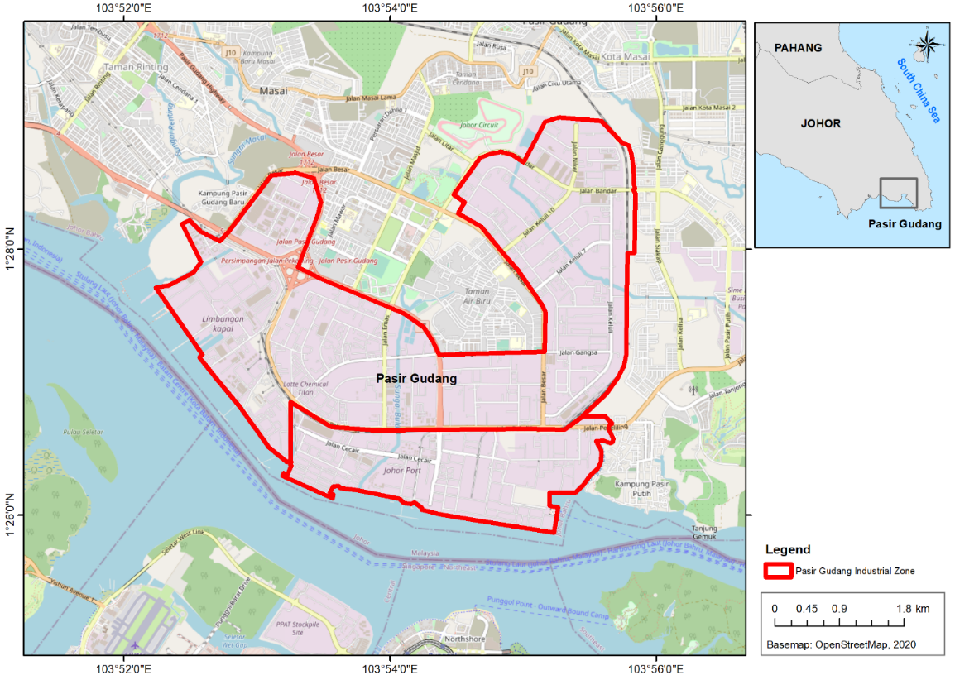

Figure 1. A location of Pasir Gudang Industrial Region in Pasir Gudang, Johor
The area is marked with a red line zone on the map

Model origin and study period selection

Rapid industrialization in the absence of proper waste and emission control will result in severe pollution, particularly air pollution, which has always had negative consequences for the local population. The first pollution incident in Pasir Gudang was identified from the illegal toxic waste dumping in Kim Kim River in March 2019 (Ibrahim et al., 2021). Unfortunately, the series of pollution incidents recurred in June 2019, with the sources remaining unknown. On 20 June 2019, 15 students of Sekolah Agama Taman Mawar experienced vomiting, shortness of breath and dizziness due to air pollution exposure. On 22 June 2019, three more schools and two kindergartens were closed. Lastly, on 23 June 2019, 13 victims were referred to the hospital, another 49 victims were receiving treatment at the clinic and another 14 schools were closed for a few days (Isa, 2019). This study focused on three critical days (study period) at selected schools (model origin) as described in Table 1. The schools as listed in Table 1 have been chosen based on the severity of the student's health conditions after being exposed to air pollution (Academy of Sciences Malaysia, 2019). The three-day study period was chosen based on the date that students from the affected schools in Pasir Gudang had been exposed to the air pollution effects of another environmental pollution incident in 2019 until compelled the Johor Education Department to close nearly all school districts and public placements (Berita Harian, 2019).

Table 1. List of schools involved with severe air pollution incidents in Pasir Gudang 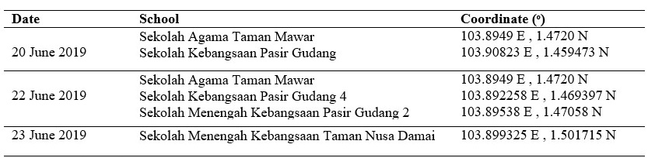
Source: Academy of Sciences Malaysia (2019)

Trajectory-geospatial approach

This study used a trajectory-geospatial approach to identify air pollution sources in the Pasir Gudang industrial area. The methodology of this study was described in the flowchart in Figure 2. HYSPLIT and GIS will be used to incorporate the data obtained and present it in a more interesting and easy-to-understand map diagram from the generated high-frequency backward trajectory coverage (Freitag et al., 2014). The trajectory-geospatial approach was started with trajectory modelling by using HYSPLIT. The HYSPLIT model computes the advection of a single pollutant particle, or simply its (Yerramilli et al., 2012). The HYSPLIT model developed by NOAA ARL was used to compute air mass trajectories in this study (Draxler & Rolph, 2003). The dispersion of a pollutant is calculated by assuming particle dispersion. The mean wind field and a turbulent component advect a fixed number of initial particles around the model domain in the particle approach. The model calculation method is a hybrid of the Lagrangian approach, which uses a moving frame of reference to calculate advection and diffusion as trajectories or air parcels move away from their initial location, and the Eulerian methodology, which uses a fixed three-dimensional grid as a frame of reference to compute pollutant air concentrations (Stein et al., 2015). Each backward trajectory was calculated for 24 h duration with 100 m above ground level (AGL). The meteorological input for the trajectory model was the GFS meteorological data (0.25 degrees, global, 06/2019 – 05/2020). Backward trajectory analysis is used to determine the source of air movement and the origin of the air mass. The GFS meteorological data was used because it is suitable for global applications and the most recent dataset, ensuring that the input data for calculating and generating trajectory models are up to date and covers the entire Pasir Gudang area.
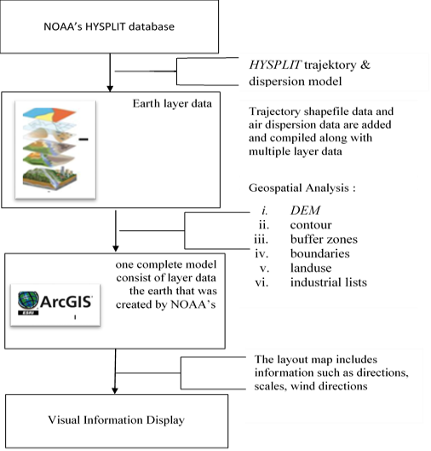
Figure 2. A flowchart of the study methodology to determine the air pollution sources in Pasir Gudang.

As illustrated in Figure 2, after the air mass backwards-trajectory modelling, a geospatial analysis was performed next by using GIS. GIS can be used to access, visualize, manipulate and analyze geospatial data using spatial data. There are four types of spatial data required to carry out the geospatial analysis, which are school lists, land use, area boundaries and industry lists. After all four spatial data are entered, the map is generated, and the process proceeds to the next step, geospatial analysis. Buffer analysis is a geospatial analysis used in this study to determine the sources of air pollution in Pasir Gudang. Through Modelbuilder shown in Figure 3, a geoprocessing analytic tool called a buffer toolbox was used to generate buffer zones in the Pasir Gudang area where affected schools acted as an origin. Buffer zones can be applied for a variety of purposes from the environment to socioeconomic and military use (Schou & Hansen, 2019). The buffer zone is a measurement of pollution control that helps reduce pollution while preserving the environment (WIM, 2016). The buffer zone is an area of ​​isolation provided to control for possible contamination, especially in residential areas (Kozlowski, 1997). Buffer zones are made to reduce noise and air pollution in contaminated areas that can be designed in many forms such as recreational parks, forest reserve areas and barrier walls. A buffer zone is usually created to separate the sound source from the affected area (Hilmi & Abd, 2014) and the presence of air pressure due to wind circulation helps to reduce the concentration of contaminated air before it reach the receiver.

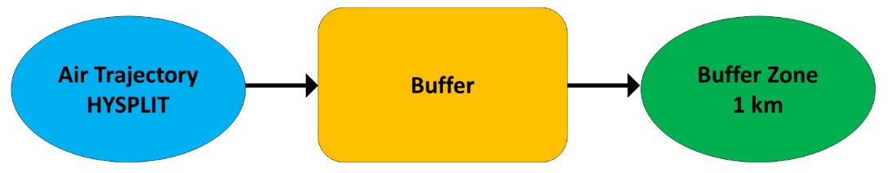

Figure 3. Flowchart of ModelBuilder produced in ArcGIS software
Results and discussion

Air mass backwards trajectory generation

On selected dates in June 2019, the HYSPLIT model was programmed to run for a backward trajectory, referring to severe days of air pollution exposure occurrences in Pasir Gudang until it affected surrounding school students. The result of the backward trajectory is presented in Figure 4 where (a) to (f) show the different start points of the air mass trajectories modelling. A red line in Figure 4 indicates air trajectories below 500 m AGL, which is 10 m. The total model generation is based on the number of schools with the greatest critical impact over the three days. There are five schools involved, which served as the starting point for developing air trajectory models. The backward trajectories on 20 June 2019 show the movement of air pollutants from southeast, Bangka Island, Indonesia to the Pasir Gudang where Sekolah Agama Taman Mawar (Figure 4a) and Sekolah Kebangsaan Pasir Gudang (Figure 4b) are located. Meanwhile, after the two-day interval on 22 June 2019, the movement of air pollutants illustrated in air trajectories in Figure 4 shows different air directions coming from southwest, area of ​​Tembilahan, Indonesia to the location of Sekolah Agama Taman Mawar (Figure 4c), Sekolah Kebangsaan Pasir Gudang 4 (Figure 4d) and Sekolah Menengah Kebangsaan Pasir Gudang 2 (Figure 4e) in Pasir Gudang. However, there is a slight change in the air movement shown in Figure 4(f) for the location of Sekolah Menengah Kebangsaan Taman Nusa Damai dated 23 June 2019, where the air backward trajectory shows that air moving to the school started from south, a small area part of Merlung, Indonesia. Judging by the pattern of air movement studied, all air trajectory movement began in the West Sumatra Area in Indonesia due to the geographical position of Malaysia influenced by the Southwest monsoon affected from May to September every year, as stated in previous research (Dahari et al., 2020; Halim et al., 2018; Latif et al., 2018). Although the movement of air masses to impacted schools in Pasir Gudang is influenced by the direction of monsoon winds, the air pressure factors at a different level of height also play a big role in the distribution of air pollution. A previous study by Bodor et al. (2020) stated that simulation of air masses at 10 m AGL travelled at shorter and slower pathways may have been influenced by the nearby local sources.
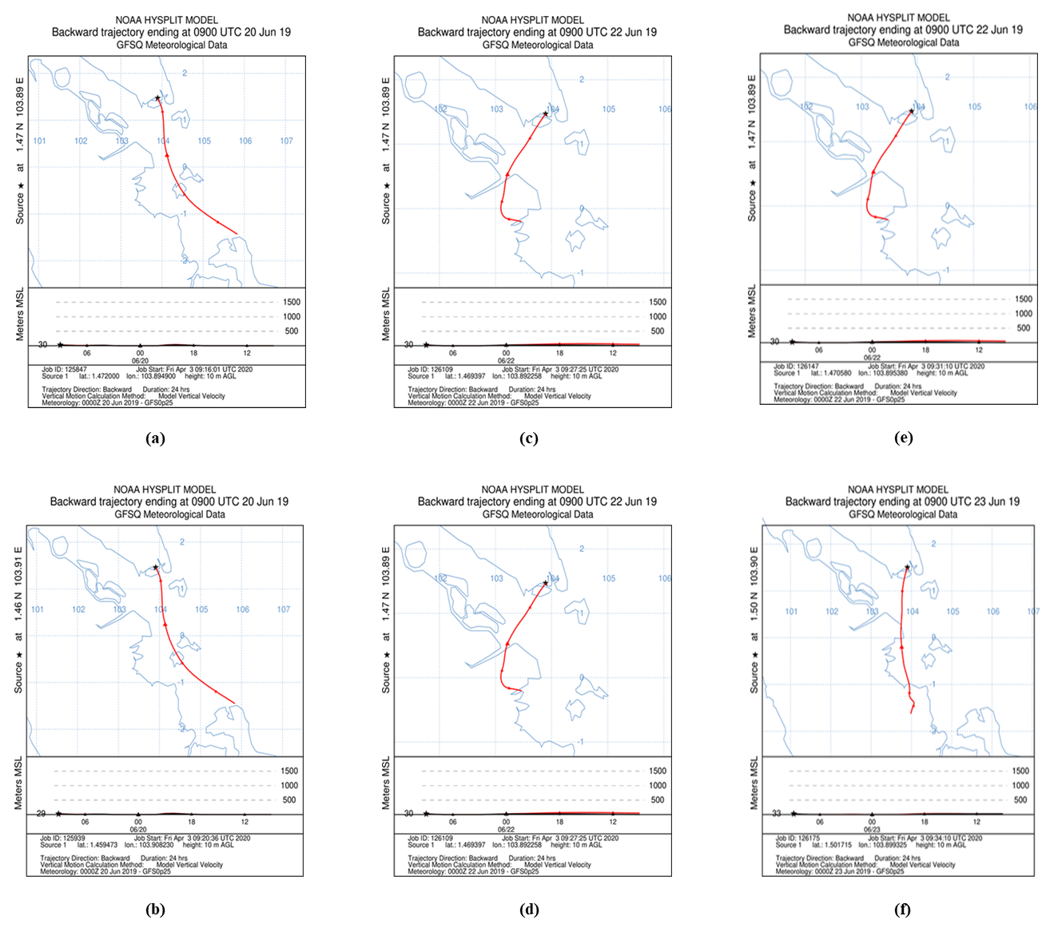

Figure 4. Air trajectories pathways for three different days. (a) to (f) show the start point of air trajectories modelling
FIGURE 4. Air trajectories pathways for three different days. (a) to (f) show the start point of different schools.
Population buffer and exposure

After the HYSPLIT backward trajectory model effectively identified the orientations of air masses pathways during the dates of the severe air pollution occurrence at Pasir Gudang in June 2019, the buffer analysis was carried out. Generation of 1 km buffer zones from the start point (affected schools) and following the direction of air trajectories pathway, will aid in determining the source of air pollution that affected the health of school students in Pasir Gudang. The land use activities and the distance of the different land use activities areas such as residential, schools and industrial are calculated and investigated. All of these aspects can provide beneficial information and understanding to particularly stakeholders about the impacts of air pollution exposures and sources. According to the buffer zones guidelines by the Department of Environment (2012), buffer zones with a minimum distance of 1 km were used to identify the sources of pollution in the most critical situations. A buffer zone of less than 5 km is a good selection to represent the dispersion characteristics of air masses pollutants (Miranda et al., 2011).
The result of air pollution exposures that affected schools in Pasir Gudang on three different days is shown in Figure 5 to Figure 7. The 1 km buffer zone is illustrated in yellow and in line with the air masses backwards-trajectories that was generated before. A map in Figure 5 shows an air trajectory pathway buffer zones on 20 June 2019 from Sekolah Agama Taman Mawar (Figure 5a) and Sekolah Kebangsaan Pasir Gudang (Figure 5b). There are a total of 77 factories identified within a 1 km buffer zone from Sekolah Agama Taman Mawar (Figure 5a) where the closest factory distance is located about 681 m from the school. While there are a total of 60 factories within a 1 km buffer zone from Sekolah Kebangsaan Pasir Gudang (Figure 5b) where the closest factory to the school is with a distance of 392 m. Figure 6 shows a map of air trajectories of air buffer zones on 22 June 2019 from three different schools in Pasir Gudang. There are a total of 40 factories within a 1 km buffer zone of Sekolah Agama Taman Mawar (Figure 6a) where the closest factory distance is 681 m, similar to the exposure findings on 20 June 2019. There are also a total of 40 factories within a 1 km buffer zone of Sekolah Kebangsaan Pasir Gudang 4 (Figure 6b) where the pipe insulation engineering-based factory is the closest to the school with a distance of 502 m. Figure 6c shows a map of air trajectories buffer zones from Sekolah Menengah Kebangsaan Pasir Gudang 2. There are about 42 factories identified within a 1 km buffer zone and the closest factory to the school with a distance of 786 m. While, Figure 7 shows shows a map of air trajectories buffer zones from Sekolah Menengah Kebangsaan Taman Nusa Damai on 23 June 2019. There are about 17 factories identified within a 1 km buffer zone where the nearest industrial building is located about 2.12 km from the school. From the observation, there is a range between 17 to 60 industrial factories located in the 1 km buffer zone from the affected schools, which is considered a high volume of industrial areas compared to school and residential areas in Pasir Gudang. This finding shows a high possibility of nearby factories located within a 1 km buffer zone to contribute to the air pollution exposure, especially the ones that are classified as Category 1 High-Risk Industry and Category 2 Heavy Industry that emit high volume of air pollutants (Department of Environment, 2017).
The local authorities have taken an action in reducing and mitigating the impact of industrial air pollution exposure in Malaysia through the Environmental Essential For Siting of Industries in Malaysia (EESIM) guidance that focused on buffer zoning to separate between industrial areas and residential areas. Although the distances of buffer zones are a significant factor to consider in monitoring and mitigating air pollution management since schools are categorised as sensitive public facilities that require main buffer zones that begin from the outside of the factory regions, the buffer zone is only considered as an added measure to assist in minimising off-site impacts (Department of Environment, 2017). Active management of buffer zones will not affect the atmospheric deposition and dispersion of pollutants directly derived from industrial factories areas because of the influence of other factors such as meteorological factors (wind speed, wind direction, humidity and temperature) and volume level of air pollutants emissions (Kim et al., 2015; Munsif et al., 2021).
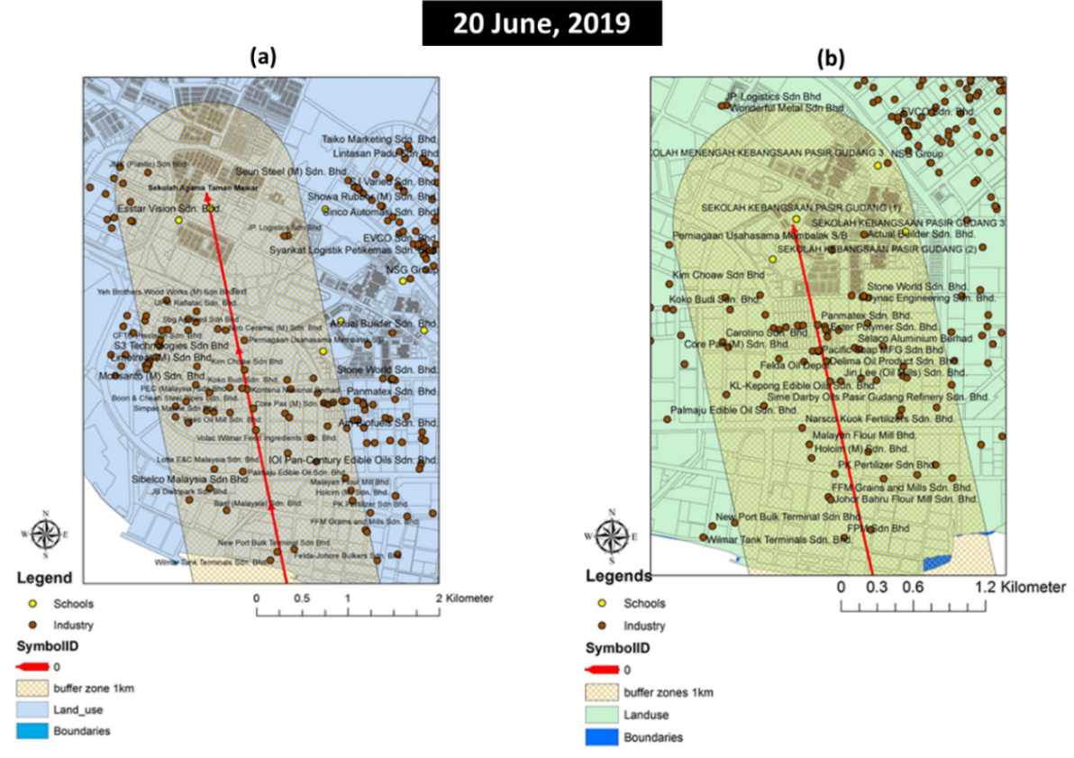

Figure 5. Air trajectory buffer zone of (a) Sekolah Agama Taman Mawar and (b) Sekolah Kebangsaan Pasir Gudang 4 on 20 June 2019.

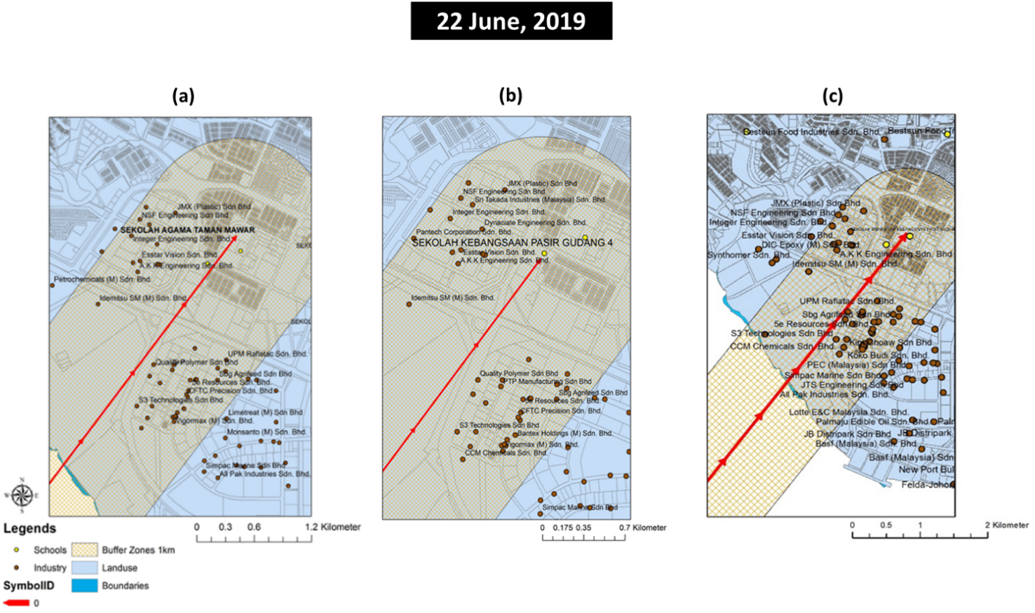

Figure 6. Air trajectory buffer zone of (a) Sekolah Agama Taman Mawar, (b) Sekolah Kebangsaan Pasir Gudang 4 and (c) Sekolah Menengah Kebangsaan Pasir Gudang 2 on 22 June 2019.
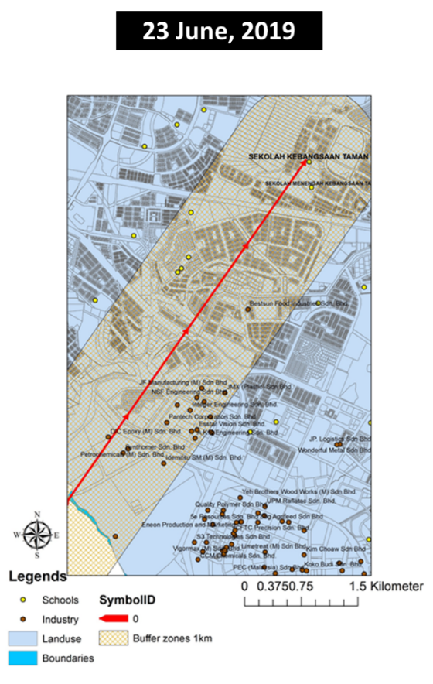
Figure 7. Air trajectory buffer zone of Sekolah Menengah Kebangsaan Taman Nusa Damai on 23 June 2019.

Standard of procedure (SOP) for air pollution source identification

Based on the trajectories-geospatial approach that has been conducted, the possible source of air pollution can be identified specifically since the geospatial information has been taken into account as spatial information are essential in determining the air pollution emissions (Halim et al., 2020). Figure 8 shows a flowchart of action plans in identifying sources of air pollution that need to be complied with by the local authorities, especially for incidents involving public places such as schools. There are few stakeholders involved in the unfortunate air pollution exposure in Pasir Gudang consisting of the local authorities, the school and the factory operators. Stakeholders play an important role in monitoring and mitigating the environmental pollutant issues like air pollution. Hence, a standard of procedure (SOP) for air pollution source identification is important as a guideline for all the stakeholders involved and essential in understanding better strategies in monitoring and mitigating industrial air pollution (Sofia et al., 2020).
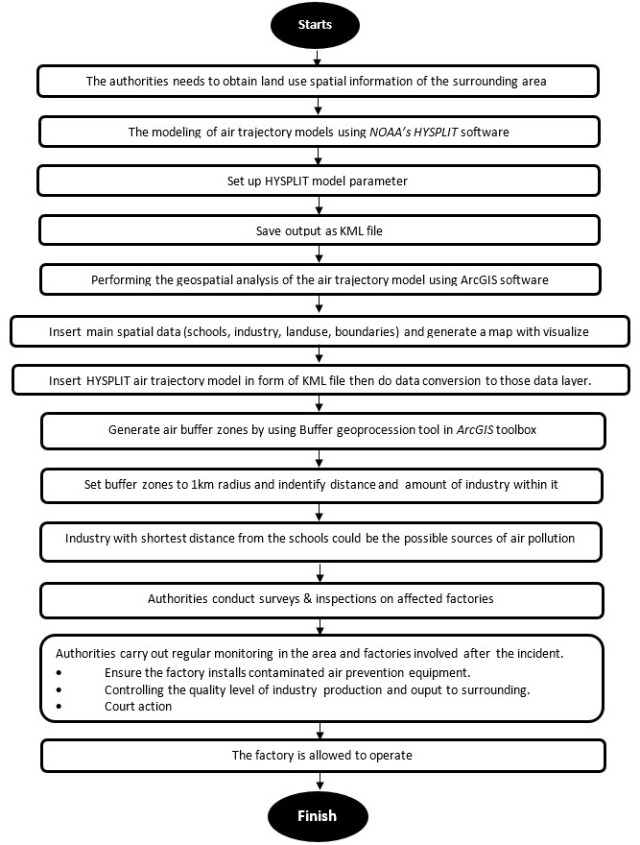
Figure 8. The flow chart in identifying locations of possible causes of air pollution in Pasir Gudang.

Conclusion

The occurrence of air pollution exposure in Pasir Gudang has led to severe impacts on five schools in Pasir Gudang in June 2019. The approach of trajectory-geospatial was used to determine the source of air pollution exposure of the affected schools in Pasir Gudang by invading the spatial elements in source identification. Three days of air mass backwards-trajectories were successfully obtained, where the dominant air mass pathways direction came from West Sumatra, Indonesia. The air mass backwards-trajectories was influenced by the Southwest monsoon winds that are dominant during May to September. As a result, the air mass flow to the southwest of Peninsular Malaysia. The air mass backwards-trajectories also show there are influenced by nearby factories' emissions. The geospatial analysis was performed by applying the buffer geoprocessing tool in ArcGIS to identify the number of factories within the air trajectory buffer zones of the school area. From the geospatial buffer analysis, about 17 to 60 factories were identified to be possible sources of air pollution exposure since the location of factories are within a 1 km buffer zone of six affected schools in Pasir Gudang. The meteorological factors (wind speed, wind direction, humidity and temperature) that influence the airflow of high emissions of air mass pollutants from nearby factories have worsened the exposure level of air pollution until impacted the health of school students. From the findings, a standard of procedure (SOP) for air pollution source identification using a trajectory-geospatial approach has been developed as a guideline for all the stakeholders involved. This SOP is necessary if this situation recurs again so that the authorities can identify the source of air pollution quickly to reduce the impact of exposure. Regular monitoring is important to control emissions as fewer emissions will reduce the impact on social communities despite the low buffer distance and the influence of meteorological factors. strong wind direction. The implementation of this SOP is also essential in understanding better strategies in monitoring and mitigating industrial air pollution, particularly in Pasir Gudang as the buffer zones required by the authorities are not actively functioning to mitigate the air pollution exposures.

Acknowledgement

The authors want to acknowledge the NOAA Air Resources Laboratory (ARL) for the provision of the HYSPLIT transport and dispersion model and READY website (http://www.arl.noaa.gov/ready.html) that used in this publication.

References

Abdullah, A. M., Samah, M. A. A., & Jun, T. Y. (2012). An overview of the air pollution trend in Klang Valley, Malaysia. Open Environmental Sciences, 6, 13-19.

Abdullah, J., Ahmad, Z., Shah, R. N. H. R. A., & Anor, N. (2012). Port city development and quality of life in Pasir Gudang Port, Johor, Malaysia. Procedia Social Behaviour Sciences, 35, 556-563.

Academy of Sciences Malaysia, 2019. Lessons From Sungai Kim Kim, Pasir Gudang, ASM Report 2019. Kuala Lumpur.

Afroz, R., Hassan, M. N., & Ibrahim, N. A. (2003). Review of air pollution and health impacts in Malaysia. Environmental Research, 92(2), 71-77.

Alkhadher, S. A. A., Zakaria, M. P., Yusoff, F. M., Kannan, N., Suratman, S., Magam, S. M., Masood, N., Keshavarzifard, M., Vaezzadeh, V., Sani, M. S. A. (2016). Distribution and sources of linear alkylbenzenes (LABs) in surface sediments from Johor Bahru Coast and the Kim Kim River, Malaysia. Environmental Forensics, 17(1), 36-47.

ARL, N. (2019). Introduction to HYSPLIT.

Bauleo, L., Bucci, S., Antonucci, C., Sozzi, R., Davoli, M., Forastiere, F., & Ancona, C. (2018). Long-term exposure to air pollutants from multiple sources and mortality in an industrial area: a cohort study. Occupational and Environmental Medicine, 76, 1-10.

Berita Harian. (2019). Kronologi Pencemaran Udara Di Pasir Gudang. Retrieved from https://api.bharian.com.my/image/infografik-kronologi-pencemaran-udara-di-pasir-gudang?page=2

Berita Harian. (2019). Gejala sesak nafas di Pasir Gudang sah akibat pencemaran toksik. Retrieved from https://www.bharian.com.my/berita/nasional/2019/06/576836/gejala-sesak-nafas-di-pasir-gudang-sah-akibat-pencemaran-toksik.

Bernama, A. A. (2019). Kronologi terkini pencemaran kimia di Sungai Kim Kim, Pasir Gudang. Retrieved from https://www.bernama.com/bm/news.php?id=1704462.

Bodor, Z., Bodor, K., Keresztesi, A., & Szep, R. (2020). Major air pollutants seasonal variation analysis and long-range transport of PM₁₀ in an urban environment with specific climate condition in Transylvania (Romania). Environmental Science and Pollution Research, 27, 38181-38199.

Celenk, S. (2019). Detection of reactive allergens in long-distance transported pollen grains: Evidence from Ambrosia. Atmospheric Environment, 209, 212-219.

Cheremisinoff, P. N. (2018). Air pollution control and design for industry. New York, USA, Marcel Dekker.

Dahari, N., Latif, M. T., Muda, K., & Hussein, N. (2020). Influence of meteorological variables on suburban atmospheric PM_{2.5} in the southern region of Peninsular Malaysia. Aerosol and Air Quality Research, 20(1), 14-25.

Dai, Q. L., Bi, X. H., Wu, J. H., Zhang, Y. F., Wang, J., Xu, H., Yao, L., Jiao, L., & Feng, Y. C. (2015). Characterization and source identification of heavy metals in ambient PM₁₀ and PM_{2.5} in an integrated iron and steel industry zone compared with a background site. Aerosol and Air Quality Research, 15, 875-887.

Department of Environment. (2012). Guidelines for siting and zoning of industry and residential areas.

Department of Environment. (2017). Environmental essentials for siting of industries in Malaysia (EESIM).

Department of Environment. (2017). Environmental Quality Report 2017. Department of Environment Malaysia.

Draxler, R., & Rolph, G. (2003). HYSPLIT (Hybrid Single-Particle Lagrangian Integrated Trajectory). Retrieved from http://www.arl.noaa.gov/ready/hysplit4.html.

Fareed, Z., Iqbal, N., Shahzad, F., Shah, S. G. M., Zulfiqar, B., Shahzad, K., Hashmi, S. H., & Shahzad, U. (2020). Co-variance nexus between COVID-19 mortality, humidity, and air quality index in Wuhan, China: New insights from partial and multiple wavelet coherence. Air Quality, Atmosphere and Health, 13, 673-682.

Fleming, Z. L., Monks, P. S., & Manning, A. J. (2012). Review: Untangling the influence of air-mass history in interpreting observed atmospheric composition. Atmospheric Research, 104-105, 1-39.

Guo, L., Luo, J., Yuan, M., Huang, Y., Shen, H., & Li, T. (2019). The influence of urban planning factors on PM_{2.5} pollution exposure and implications: A case study in China based on remote sensing, LBS, and GIS data. Science of The Total Environment, 659, 1585-1596.

Halim, N. D. A., Latif, M. T., Ahamad, F., Dominick, D., Chung, J. X., Juneng, L., & Khan, M. F. (2018). The long-term assessment of air quality on an island in Malaysia. Heliyon, 4(12), E01054.

Halim, N. D. A., Latif, M. T., Mohamed, A. F., Maulud, K. N. A., Idrus, S., Azhari, A., Othman, M., & Sofwan, N. M. (2020). Spatial assessment of land use impact on air quality in mega urban regions, Malaysia. Sustainable Cities and Society, 63, 102436.

Hernandez-Ceballos, M. A., Sangiorgi, M., Garcia-Puerta, B., Montero, M., & Trueba, C. (2020). Dispersion and ground deposition of radioactive material according to airflow patterns for enhancing the preparedness to N/R emergencies. Journal of Environmental Radioactivity, 216, 106178.

Hurst, T., & Davis, C. (2017). Forecasting volcanic ash deposition using HYSPLIT. Journal of Applied Volcanology, 6, 5.

Ibrahim, M. F., Hod, R., Toha, H. R., Nawi, A. M., Idris, I. B., Yusoff, H. M., & Sahani, M. (2021). The impacts of illegal toxic waste dumping on children's health: A review and case study from Pasir Gudang, Malaysia. International Journal of Environmental Research and Public Health, 18, 2221.

Jerrett, M. (2015). Atmospheric science: The death toll from air-pollution sources. Nature, 525(7569), 330-331.

Keshavarzifard, M., Zakaria, M. P., Keshavarzifard, S., & Sharifi, R. (2018). Distributions, composition patterns, sources and potential toxicity of polycyclic aromatic hydrocarbons (PAHs) pollution in surface sediments from the Kim Kim River and Segget River, Peninsular Malaysia. Pertanika Journal of Science & Technology, 26(1), 95-120.

Khomenko, S., Cirach, M., Pereira-Barboza, E., Mueller, N., Barrera-Gomez, J., Rojas-Rueda, D., De Hoogh, K., Hoek, G., & Nieuwenhuijsen, M. (2021). Premature mortality due to air pollution in European cities: a health impact assessment. Lancet Planet Health, 5, e121-134.

Kim, H. C., Chai, T., Stein, A., & Kondragunta, S. (2020). Inverse modelling of fire emissions constrained by smoke plume transport using HYSPLIT dispersion model and geostationary observations. Atmospheric Chemistry and Physics, 20, 10259-10277.

Kim, K. H., Lee, S.-B., Woo, D., & Bae, G.-N. (2015). Influence of wind direction and speed on the transport of particle-bound PAHs in a roadway environment. Atmospheric Pollution Research, 6(6), 1024-1034.

Latif, M. T., Othman, M., Idris, N., Juneng, L., Abdullah, A. M., Hamzah, W. P., Khan, M. F., Nik Sulaiman, N. M., Jewaratnam, J., Aghamohammadi, N., Sahani, M., Xiang, C. J., Ahamad, F., Amil, N., Darus, M., Varkkey, H., Tangang, F., & Jaafar, A. B. (2018). Impact of regional haze towards air quality in Malaysia: A review. Atmospheric Environment, 177, 28-44.

Lelieveld, J., Pozzer, A., Poschl, U., Fnais, M., Haines, A., & Munzel, T. (2020). Loss of life expectancy from air pollution compared to other risk factors: a worldwide perspective. European Society of Cardiology, 116, 1910-1917.

Miranda, M. L., Edwards, S. E., Keating, M. H., & Paul, C. J. (2011). Making the environmental justice grade: The relative burden of air pollution exposure in the United States. International Journal of Environmental Research and Public Health, 8, 1755-1771.

Munsif, R., Zubair, M., Aziz, A., & Zafar, M. N. (2021). Industrial air emission pollution: Potential sources and sustainable mitigation. IntechOpen https://www.intechopen.com/chapters/72766#:~:text=DOI%3A%2010.5772/intechopen.93104

New Straits Times. (2019). 5 students admitted to hospital with breathing difficulties. Retrieved from https://www.nst.com.my/news/nation/2019/06/497881/5-students-admitted-hospital-breathing-difficulties

Pardakhti, A., & Qadi, E. M. (2019). Introduction and application of new GIS_AQI model: Integrated pollution control in Tehran. Journal of Pollution, 5(4), 789-801.

Rahman, R. A. 2017. Meteorological Malaysia Department: Annual Report 2017. 90.

Rahman, M. M., Alam, K., & Velayutham, E. (2021). Is industrial pollution detrimental to public health? Evidence from the world's most industrialised countries. BMC Public Health, 21, 1175.

Salahudin, S. N., Abdullah, M. M., & Newaz, N. A. (2013). Emissions: Sources, policies and development in Malaysia. International Journal of Education and Research, 1(7), 1-12.

Sentian, J., Herman, F., Yih, C. Y., & Wui, J. C. H. (2019). Long-term air pollution trend analysis in Malaysia. International Journal of Environmental Impacts, 2(4), 309-324.

Sofia, D., Gioiella, F., Lotrecchiano, N., & Giuliano, A. (2020). Mitigation strategies for reducing air pollution. Environmental Science and Pollution Research, 27, 19226-19235.

Stein, A. F., Draxler, R. R., Rolph, G.D., Stunder, B. J. B., Cohen, M. D., & Ngan, F. (2015). NOAA'S HYSPLIT Atmospheric transport and dispersion modelling system. Bulletin of the American Meteorological Society, 96(12), 2059-2078.

World Health Organization. (2018). Air pollution and child health: Prescribing clean air. World Health Organization.

World Health Organization. (2022). Air pollution. Retrieved from https://www.who.int/health-topics/air-pollution#tab=tab_1.

Yang, W., Wang, G., & Bi, C. (2017). Analysis of long-range transport effects on PM_{2.5} during a short severe haze in Beijing, China. Aerosol and Air Quality Research, 17(6), 1610-1622.

Yap, C. K., Peng, S. H. T., & Leow, C. S. (2019). Contamination in Pasir Gudang area, Peninsular Malaysia: What can we learn from Kim Kim River chemical waste contamination?. Journal of Humanities and Education Development, 1(2), 82-87.

Yerramilli, A., Dodla, V. B. R., Challa, V. S., Myles, L., Pendergrass, W. R., Vogel, C. A., Dasari, H. P., Tuluri, F., Baham, J. M., Hughes, R. L., Patrick, C., Young, J. H., Swanier, S. J., & Hardy, M. G. (2012). An integrated WRF/HYSPLIT modelling approach for the assessment of PM_{2.5} source regions over the Mississippi Gulf Coast region. Air Quality, Atmosphere and Health, 5, 401-412.

Yerramilli, A., Dodla, V. B. R., & Yerramilli, S. (2011). Air pollution, modelling and GIS based decision support systems for air quality risk assessment. IntechOpen. DOI: 10.5772/22055

Zainal, S., Zamre, N. M., & Khan, M. F. (2021). Emission level of air pollutants during 2019 pre-haze, haze, and post-haze episodes in Kuala Lumpur and Putrajaya. Malaysian Journal Of Chemical Engineering & Technology, 4(2), 137-154.

