The implementation of COVID-19 health protocol: A higher students’ perspective

Siti Nurbayani¹, Moh. Dede², Nindita Fajria Utami¹, Millary Agung Widiawaty³

¹Faculty of Social Sciences Education (FPIPS), Universitas Pendidikan Indonesia
²Environmental Science Program, Postgraduate School (SPS), Universitas Padjadjaran
³Directorate of Developmental Policy for Environment, Maritime, Natural Resources and Nuclear Energy,
National Research and Innovation Agency of Indonesia (BRIN)

Correspondence: Siti Nurbayani (email: s.nurbayani@upi.edu)

Received: 11 April 2022; Accepted: 3 February 2023; Published: 24 February 2023

Abstract

Over two million Indonesians have been exposed to COVID-19. Every day, thousands of new confirmed cases continue to infect people and form local transmission, even though the guidelines for implementing health protocols in efforts against this pandemic have been rolled out. This study aims to reveal how COVID-19 health protocols are being implemented in Indonesia. We collected information from 289 students to observe the surrounding environment by distributing online questionnaires that include parameters for wearing masks and physical distancing. This study used a mix-method approach, in which the statistical and descriptive analysis were carried out sequentially. This study showed that the presence of positive cases does not affect the implementation of health protocols. Mann-Whitney's test also confirmed that there were no significant differences between the COVID-19 transmitted area and the green zone. This condition was caused by a lack of socialization, social exemplarity, mutual reprimand, and enforcement of the rules. The experience of people telling others to wear a mask has a low, significant, and positive correlation with the intensity of reprimanding others. This phenomenon shows that social awareness of implementing health protocols can continue to increase if they are accustomed to self-awareness. The implementation of the health protocol requires assessment to avoid inconsistencies that reduce the compliance of people.

Keywords: Health policy, higher students, Indonesia, pandemic

Introduction

SARS-CoV-2, which is the cause of Coronavirus disease 2019 (COVID-19) was first detected in Wuhan, the People's Republic of China at the end of December 2019 (Ahmadi et al., 2020). This virus widely spread into various countries and finally the WHO declared it a pandemic in March 2020. Currently, the COVID-19 pandemic has caused more than 162 million people to be positively exposed, and the case fatality rate is 2.1 percent (Indonesian Ministry of Health, 2021). Although many countries are carrying out vaccination, the number of new cases per day continuously increases which may trigger the second and third waves of attacks (Fisayo & Tsukagoshi, 2021). The government, from the central to the regional level, is a key factor in controlling this pandemic thus confirmed cases do not exceed the capacity of the healthcare facilities and their personnel. The main control, apart from vaccination and lockdown, is the implementation of the health protocols in accordance with directives from the government that can be updated relative to risk zoning status (Houvèssou et al., 2021).
The implementation of health protocols is very important because SARS-CoV-2 can spread through droplets which under certain conditions are classified as airborne viruses (Baraniuk, 2021). The COVID-19 pandemic continues to be a concern for many countries, especially in Indonesia, it has been recorded as one of the highest fatality rates in the world, which is 2.8 percent higher than the global average (Ahmadi et al., 2020). Indonesia recorded an average of more than 10,000 new cases per day during early 2021. One of these conditions could be due to the non-optimal implementation of health protocols in the community such as wearing masks, maintaining physical distance, and cleaning hands (Widiawaty & Dede, 2021). The increase in cases occurred when the government was still restricting educational activities, offices, tourism, and inter-regional migration. Some residents are ignorant of this pandemic and assume that it was a fabrication, so they do not want to obey health protocols or get vaccinated (Miller, 2020). This reason is further strengthened because most of the COVID-19 cases only trigger mild or asymptomatic symptoms, also an adverse event of special interest (AESI) from vaccine injections.
Health protocols are the determining factor to control COVID-19. Many activities can go back close to normal if all residents adhere to them, and the new daily cases remain under control (Sulyok & Walker, 2021). Previous research stated that the use of masks can reduce exposure to virus particles by up to 70 percent (Brooks & Butler, 2021). Physical distancing can also reduce exposure to SARS-COV-2 because this virus is contained in human saliva and falls to the surface due to the earth’s gravity (Pratomo, 2020). A combination of masks wearing, eye protection, and applying physical distancing will reduce the exposure to COVID-19 to a very low level, even though the social interactions take place indoors, as long as the room gets an ideal air circulation, temperature, and ultraviolet light (Chu et al., 2020; Seres et al., 2021). The spread of COVID-19 can be decreased by washing our hands with soap or hand sanitizer after holding objects in public facilities (Daverey & Dutta, 2021). The implementation of health protocols is very important to tackle daily cases and prevent a ‘tsunami’ of COVID-19 that can paralyze the national health system.
The implementation of health protocols is a shared obligation, and the community must not be complacent even though the vaccination program continues. Understanding the implementation is very necessary to formulate and evaluate policies for handling the COVID-19 pandemic. The interaction of each region can affect the distribution of COVID-19 cases, thus social restrictions cannot be ignored in determining the application of health protocols (Muazir et al., 2021). We can take advantage of student networks from various regions to review this phenomenon in their environment as long as the online learning system is still ongoing (Dhawan, 2020). Therefore, this study aimed to reveal the implementation of health protocols to deal with COVID-19 in Indonesia. This disclosure refers to the student’s observations surrounding the environment, and also implementing health protocols for themselves. This implementation protocol is based on COVID-19 infection in their neighborhood, wearing masks, reprimanding others for not wearing a mask, crowding, and physical distancing.

Methods

Research design and respondents

This research was carried out from April to June 2021 during the Delta variant of the COVID-19 pandemic, which involving 289 students from Universitas Pendidikan Indonesia (UPI) spread across various regions (Figure 1). There are many methods for collecting data, one of which is online data collection which can be used as an alternative mode (Mulder & Bruijne, 2019). In this study, we collected data using the online Google Form platform with the selection of respondents referring to non-random sampling and their willingness to fill out a questionnaire. The questionnaire contains several questions consisting of the incidence of confirmed cases of COVID-19, masks wearing, and physical distancing as the implementation of health protocols. We did not include hand washing parameters. Currently, in Indonesia, there are many public services that provide a place to wash hands or free hand sanitizers according to government instructions (Indonesian Ministry of Health, 2020; Suswati & Maulida, 2020). In addition, hand washing habit also has a close correlation with community obedience in wearing masks and applying the physical distance, thus the parameter does not have to be included in this study.

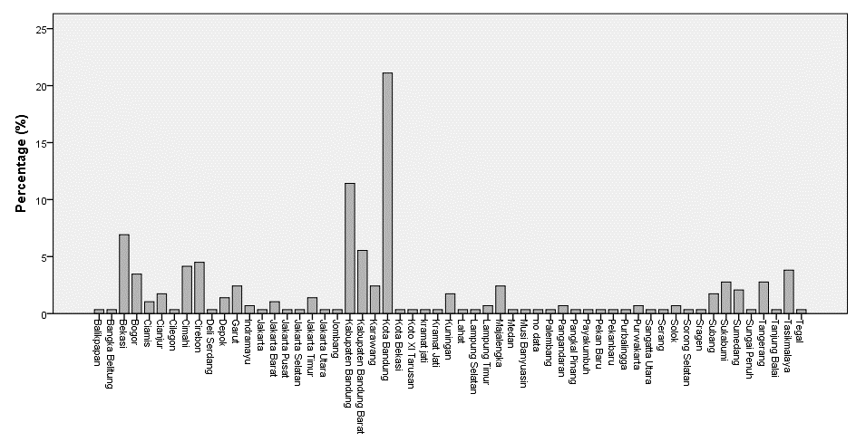
Figure 1. The distribution of respondents in each province of Indonesia

Data analysis

As a quantitative research, each respondent's answer requires coding for quantification and facilitates statistical analysis (Lacey & Luff, 2007; Saldana, 2016; Ismail et al., 2022). Each question has a different level of coding depending on its type and characteristics (Table 1). The data characteristics require the use of three statistical analysis tests, such as chi-square (X²), Mann-Whitney (U-test) and Spearman-Rank correlation, which refers to Equations 1-4 (Nor et al., 2016; Dede et al., 2020). The correlation between these parameters can refer to the r-value and p-value (Setiawan et al., 2018), the test is intended to know the implementation of health protocols and strengthening the efforts from the community. The chi-square test aims to reveal the effect of confirmed cases of COVID-19 with the protocol’s implementation, whereas the U-test is useful to know the differences in the implementation of the areas that have cases or not.
From this analysis, we can find out the implementation of health protocols in dealing with the pandemic. Correlation analysis intends to see whether the presence of the confirmed cases of COVID-19 in their surrounding has a correlation with masks wearing and the application of social distancing. Meanwhile, the U-test aims to know variations in the data. In the evaluation of health protocol, we only use descriptive analysis to reveal some suggestions from respondents who are classified as open-ended questions – qualitative stages (Grenier, 2021; Popping, 2015). Thus, this research refers to a sequential approach that uses two research methods (Berman, 2017).

Table 1. Questions coding

Question | Answer coding
Q1, Q2, Q3, Q5 | 1 (no); 2 (yes)
Q4 | 1 (less reprimanded); 2 (enough reprimanded); 3 (intense reprimanded)
Q6 | Nothing, this is an open question

$$X^{2}\text{ = }\sum{\frac{{(O-E)}^{2}}{E}}$$ | (1)

Where O is the observed frequency (actual in the research sample), E is the expected frequency.

$$U_{1}\text{ = }n_{1}×n_{2}+\left[\frac{n_{1}\left(n_{1}+1\right)}{\text{2}}\right]-\sum{R_{1}}$$ | (2)
$$U_{2}\text{ = }n_{1}×n_{2}+\left[\frac{n_{2}\left(n_{2}+1\right)}{\text{2}}\right]-\sum{R_{2}}$$ | (3)

where U is the Mann-Whitney test value, n is the number of samples, and R is the number of rankings. The difference is declared significant (take the lowest value from U₁ or U₂) if U-count < U-table.

$$\text{r}\text{ =}\frac{6 \sum{d_{i}^{2}}}{\text{n (}n^{2}-1)}$$ | (4)

where indicates the level of correlation, n is the number of observed data, and d is the difference value of the paired data. The correlation is declared significant if the r-value of r-count > r-table.

Results and discussion

COVID-19 has spread in almost all regions of Indonesia within the scope of regency/city administrational levels. A total of 64 percent of UPI students informed that their neighborhood had confirmed cases of COVID-19 (Figure 2). The presence of positive confirmed cases causes an area will get a red, orange, or yellow risk zone for the COVID-19 pandemic – compiled from epidemiological factors, public health surveillance, and health services capacity (Apresian, 2020). This should lead to regional restrictions (lockdown) and stricter implementation of health protocols, which status determination will be updated weekly or adjusted to the government policies (WHO, 2020). Furthermore, the implementation is only applied at the micro level, such as at formal institutions or hamlets. In some cases, the government at the village level will cover up news of positive confirmed cases. This is related to the performance of the government, which protecting survivors and their families from persecution, and also to keep social cohesion.

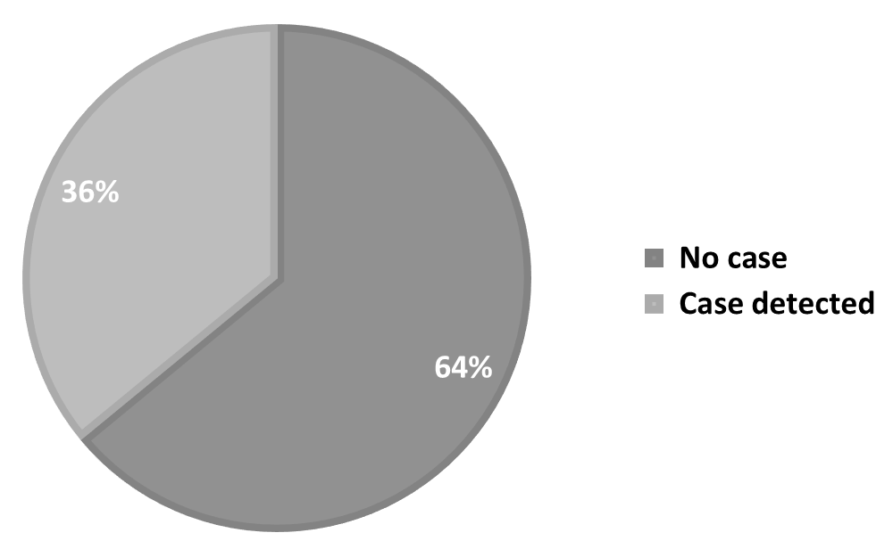

Figure 2. Report of COVID-19 confirmed cases

Public trust regarding COVID-19 is quite high. This can be seen from the masks wearing when they are doing outside activities. We received information that the masks wearing has become a habit in the new normal period. More people wear it than those who are reluctant (67 percent) (Figure 3a). Some people who do not wear masks have several reasons, such as feeling stuffy, easy to lose, and complicated. Masks wearing will increase when there is enforcement of rules (through raids) in public places and the obligation to wear them when they are entering public facilities (Irfan et al., 2021). Respondents stated that half of them had warned others to always wear masks (Figure 3b). This is because the potentials for crowds were high (Figure 3c). Without active supervision from the community, physical distancing is very difficult for the gemeinschaft community, despite the social motivation from political, religious, and party activities (Faturochman et al., 2018).

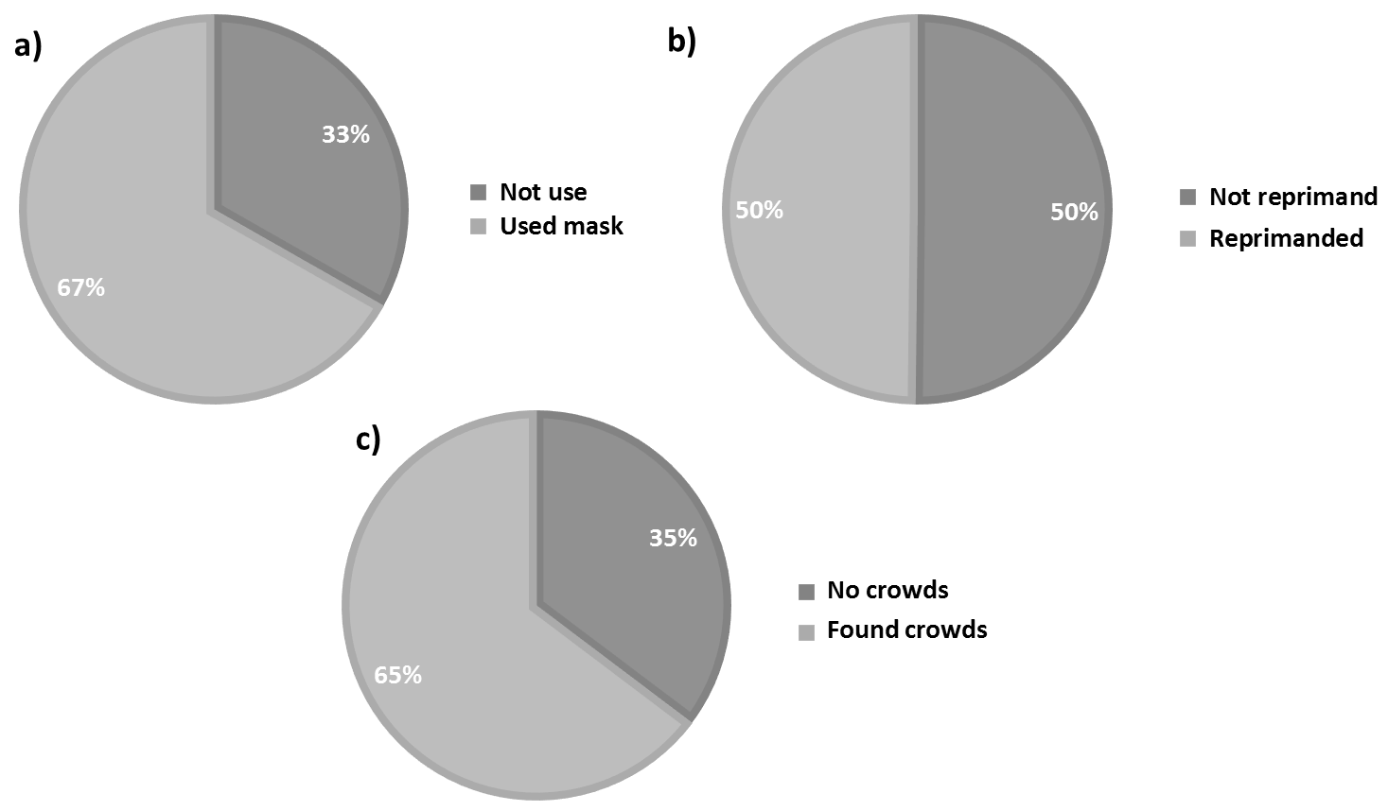

Figure 3. Implementation of health protocols. a) Masks wearing; b) Reprimand to wear masks;| c) People crowds
Among the three aspects of health protocols, the use of masks has the greatest effect in decreasing the risk of COVID-19 as an airborne disease (Li et al., 2020). Physical distancing, sometimes, cannot be applied under certain conditions, for example when shopping at traditional markets, stuck in traffic, or trapped in a crowd. Meanwhile, other people’s habit of washing hands cannot be observed, except when we want to use or enter public facilities at the same time. Although it is easy to observe, in fact reminding others to keep wearing masks is quite difficult. Our respondents revealed that they rarely reprimand others (75 percent), which does not mean that they have never carried out such actions (Figure 4). They generally feel reluctant, ashamed, and worried about getting a negative response, and only a small percentage (8 percent) dare to reprimand them intensively if they encounter mask violators.
The use of masks for each person is more based on a sense of willingness (Kaine, 2020). The lack of the protocol's implementation to tackle COVID-19 in Indonesia requires input from the community as part of the bottom-up evaluation. Community compliance can be increased through socialization, reminding each other, exemplary, and enforcing rules. Inadequate socialization causes miscommunication, the spread of hoaxes, and social rejection (Setiawan et al., 2021). The community should also be able to remind each other to comply with the health protocols, because this has a collective impact, and we can start with the people closest to us. Individuals who are aware of the pandemic can set an example for others to wear masks, applying physical distancing, and wash their hands routinely – especially for those who act as governmental leaders, community leaders, and educated groups. It is quite common that the protocol implementation is less than optimal due to weak, inconsistent, and violated enforcement of rules and sanctions by the enforcers themselves (Althouse et al., 2020). Thus, rule enforcement is a fundamental element in dealing with the pandemic.

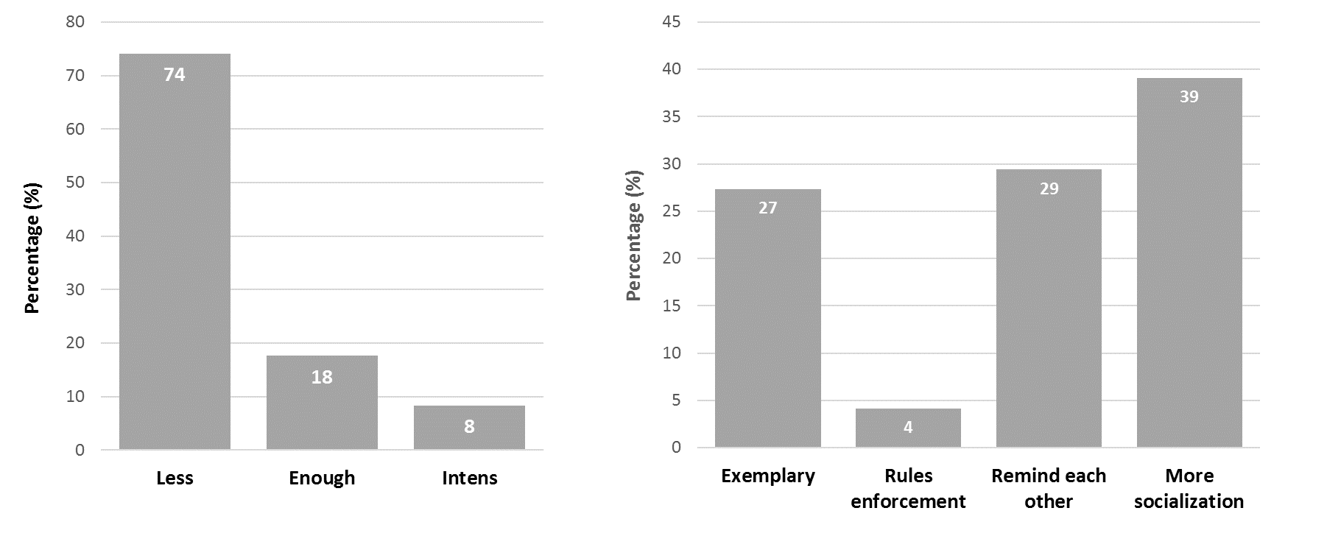
Figure 4. The controlling intensity of masks wearing (Left) and strengthening health protocols (Right)

Table 2. Chi-Square results and P-value on the health protocol parameters

Parameter | Q1 | Q2 | Q3 | Q5
Q1 (COVID-19 in the neighborhood) | - | 0.81 (0.37) | 0.00 (0.96) | 2.96 (0.08)
Q2 (Wear a mask) | 0.81 (0.37) | - | 13.73 (0.00) | 13.16 (0.00)
Q3 (Reprimanded others for not wearing a mask) | 0.00 (0.96) | 13.73 (0.00) | - | 6.28 (0.01)
Q5 (People crowding around) | 2.96 (0.08) | 13.16 (0.00) | 6.28 (0.01) | -
Even though the number of cases of the COVID-19 pandemic is increasing, not everyone follows the health protocol by wearing a mask or avoiding crowds (Widiawaty et al., 2022). Table 2 shows the results of the chi-square test, where the implementation of health protocols was not significantly affected by the occurrence of confirmed cases – very low X² value and high p-value. Significant interactions arise between the experience of admonishing others to wear masks and do physical distancing. It can be seen that caring for others to be safe from the pandemic would be actualized by strengthening social awareness and individual awareness. Selfish attitude creates havoc in the form of the presence of local clusters or transmission of the virus (Olivia, 2021). At the beginning of the COVID-19 pandemic, after the official announcement from the Indonesian government, panic buying was happening, which is characterized by massive purchases of basic necessities, hand sanitizers, masks, and disinfectants, which leads to scarcity and rising prices. Statistically, as shown in Table 3, it is stated that there is no significant difference in the implementation of health protocols in areas with confirmed or non-confirmed COVID-19 cases based on the p-value that is more than 0.05 (Ismail et al., 2020).

Table 3. U-test results in different areas according to the status of COVID-19 confirmed cases

Parameter | Mann-Whitney U | p-value
Q2 (Wear a mask) | 9121 | 0.37
Q3 (Reprimanded others for not wearing a mask) | 9594 | 0.96
Q4 (reprimand others to wear masks) | 9452.5 | 0.75
Q5 (People crowding around) | 8651 | 0.09

Table 4. Correlation between the health protocol parameters

Parameter | Q4 (r-value) | p-value
Q1 (COVID-19 in the neighborhood) | -0.02 | 0.75
Q2 (Wear a mask) | 0.11 | 0.07
Q3 (Reprimanded others for not wearing a mask) | 0.37 | 0.00
Q5 (People crowding around) | 0.05 | 0.41

This study also found that personal experience of reprimanding others to wear masks has a low and significant positive correlation with the reprimand intensity (Table 4). Although the majority rarely reprimand others, this correlation shows that social awareness is still there and will continue to increase if they have self-awareness (Alsukah et al., 2020). The power to control others to wear masks will increase when they are close with each other and not older. The experience of getting a good response from other people to implement the health protocols also increases this effort, because it is a form of expected social interaction (Betsch et al., 2020; Suppawittaya et al., 2020). The implementation of health protocols has many challenges, such as hoaxes, inconsistencies in regulations, the lack of supporting facilities (hand sanitizers and hand washing facilities), the covering up of the confirmed cases of COVID-19, and the loss of public trust in the government.

Conclusion

Health protocols are the essential element for a successful response to COVID-19. The implementation often encounters various social obstacles that cause an increasing number of confirmed cases. This study shows that the implementation of health protocols is not optimal, even though the area is not in a green zone. Masks wearing has not become an awareness for everyone when doing activities outside the house, even though crowds of people are still found in some places such as markets, places of worship, and other public facilities. This condition is caused by the lack of socialization, social exemplarity, enforcement of rules, and attitude of reminding each other. Lower public awareness to implement the health protocols has resulted in the reluctance to reprimand and obey together. The relationship between the parameters in implementing the health protocols is only shown by the experience of admonishing others to wear masks and physical distancing. Thus, self-awareness has an impact on promoting mutual awareness. Furthermore, in-depth disclosure is needed to understand the context of the lower implementation of the health protocols through qualitative research.

Acknowledgement

We would like to thank for Universitas Pendidikan Indoensia (UPI) for providing research funding through the internal grant scheme. The authors would also like to thank UPI students who have acted as respondents and contributed to distribute this research questionnaire.

References

Ahmadi, M., Sharifi, A., Dorosti, S., Jafarzadeh Ghoushchi, S., & Ghanbari, N. (2020). Investigation of effective climatology parameters on COVID-19 outbreak in Iran. Science of The Total Environment, 729, 138705. https://doi.org/10.1016/j.scitotenv.2020.138705

Alsukah, A. I., Algadheeb, N. A., Almeqren, M. A., Alharbi, F. S., Alanazi, R. A., Alshehri, A. A., Alsubie, F. N., & Ahajri, R. K. (2020). Individuals’ self-reactions toward COVID-19 pandemic in relation to the awareness of the disease, and psychological hardiness in Saudi Arabia. Frontiers in Psychology, 11, 588293.

Althouse, B. M., Wallace, B., Case, B., Scarpino, S. V., Allard, A., Berdahl, A. M., White, E. R., & Hebert-Dufresné, L. (2020). The unintended consequences of inconsistent pandemic control policies. MedRxiv. https://doi.org/10.1101/2020.08.21.20179473

Apresian, S. R. (2020). Responding to the COVID-19 Outbreak in Indonesia: Lessons from European Countries and South Korea. Jurnal Ilmiah Hubungan Internasional, 53–57. https://doi.org/10.26593/jihi.v0i0.3868.53-57

Baraniuk, C. (2021). Covid-19: What do we know about airborne transmission of SARS-CoV-2? BMJ, 373, n1030. https://doi.org/10.1136/bmj.n1030

Berman, E. (2017). An exploratory sequential mixed methods approach to understanding researchers’ data management practices at UVM: Integrated findings to develop research data services. Journal of eScience Librarianship, 6(1), e1104. https://doi.org/10.7191/jeslib.2017.1104

Betsch, C., Korn, L., Sprengholz, P., Felgendreff, L., Eitze, S., Schmid, P., & Böhm, R. (2020). Social and behavioral consequences of mask policies during the COVID-19 pandemic. Proceedings of the National Academy of Sciences of the United States of America, 117(36), 21851–21853. https://doi.org/10.1073/pnas.2011674117

Brooks, J. T., & Butler, J. C. (2021). Effectiveness of mask wearing to control community spread of SARS-CoV-2. JAMA, 325(10), 998–999. https://doi.org/10.1001/jama.2021.1505

Chu, D. K., Akl, E. A., Duda, S., Solo, K., Yaacoub, S., Schünemann, H. J., Chu, D. K., Akl, E. A., El-harakeh, A., Bognanni, A., Lotfi, T., Loeb, M., Hajizadeh, A., Bak, A., Izcovich, A., Cuello-Garcia, C. A., Chen, C., Harris, D. J., Borowiack, E., … Schünemann, H. J. (2020). Physical distancing, face masks, and eye protection to prevent person-to-person transmission of SARS-CoV-2 and COVID-19: A systematic review and meta-analysis. The Lancet, 395(10242), 1973–1987. https://doi.org/10.1016/S0140-6736(20)31142-9

Daverey, A., & Dutta, K. (2021). COVID-19: Eco-friendly hand hygiene for human and environmental safety. Journal of Environmental Chemical Engineering, 9(2), 104754. https://doi.org/10.1016/j.jece.2020.104754

Dede, M., Widiawaty, M. A., Nurhanifah, N., Ismail, A., Artati, A. R. P., Ati, A., & Ramadhan, Y. R. (2020). Estimasi perubahan kualitas udara berbasis citra satelit penginderaan jauh di sekitar PLTU Cirebon. Jambura Geoscience Review, 2(2), 78–87. https://doi.org/10.34312/jgeosrev.v2i2.5951

Dhawan, S. (2020). Online learning: A panacea in the time of COVID-19 crisis. Journal of Educational Technology Systems, 49(1), 5–22. https://doi.org/10.1177/0047239520934018

Faturochman, R., Nurbayani, S., & Iqbal, M. (2018). Cemetery pilgrimage tradition of Mahmud custom village to establish social motivation. International Journal Pedagogy of Social Studies, 3(1), 109–118. https://doi.org/10.17509/ijposs.v3i1.13479

Fisayo, T., & Tsukagoshi, S. (2021). Three waves of the COVID-19 pandemic. Postgraduate Medical Journal, 97(1147), 332. https://doi.org/10.1136/postgradmedj-2020-138564

Grenier, L. (2021). How to analyze open-ended questions in 5 steps (template included). https://www.hotjar.com/blog/analyze-open-ended-questions/.

Houvèssou, G. M., Souza, T. P. de, & Silveira, M. F. da. (2021). Lockdown-type containment measures for COVID-19 prevention and control: A descriptive ecological study with data from South Africa, Germany, Brazil, Spain, United States, Italy and New Zealand, February - August 2020. Epidemiologia E Servicos De Saude: Revista Do Sistema Unico De Saude Do Brasil, 30(1), e2020513. https://doi.org/10.1590/S1679-49742021000100025

Indonesian Ministry of Health. (2020). Panduan pencegahan penularan COVID-19 di tempat dan fasilitas umum (TFU). Direktorat Jenderal Kesehatan Masyarakat Kemenkes RI.

Indonesian Ministry of Health. (2021). Situasi terkini perkembangan Coronavirus Disease (COVID-19). Dirjen Pencegahan dan Pengendalian Penyakit Kemenkes RI.

Irfan, M., Akhtar, N., Ahmad, M., Shahzad, F., Elavarasan, R. M., Wu, H., & Yang, C. (2021). Assessing public willingness to wear face masks during the COVID-19 Pandemic: Fresh insights from the theory of planned behavior. International Journal of Environmental Research and Public Health, 18(9), 4577. https://doi.org/10.3390/ijerph18094577

Ismail, A., Dede, M., & Widiawaty, M. A. (2020). Urbanisasi dan HIV di Kota Bandung (perspektif geografi kesehatan). Buletin Penelitian Kesehatan, 48(2), 139–146. https://doi.org/10.22435/bpk.v48i2.2921

Ismail, A., Widiawaty, M. A., Jupri, J., Setiawan, I., Sugito, N. T., & Dede, M. (2022). The influence of Free and Open-Source Software-Geographic Information System online training on spatial habits, knowledge and skills. Geografia – Malaysian Journal of Society and Space, 18(1), 118-130.

Kaine, G. (2020). Willingness to wear masks, self-isolate and test for COVID-19 and implications for compliance. Manaaki Whenua-Landcare Research.

Lacey, A., & Luff, D. (2007). Qualitative research analysis. The NIHR RDS for the East Midlands/Yorkshire & the Humber.

Li, T., Liu, Y., Li, M., Qian, X., & Dai, S. Y. (2020). Mask or no mask for COVID-19: A public health and market study. PloS One, 15(8), e0237691. https://doi.org/10.1371/journal.pone.0237691

Miller, B. L. (2020). Science Denial and COVID conspiracy Theories: Potential neurological mechanisms and possible responses. JAMA, 324(22), 2255–2256. https://doi.org/10.1001/jama.2020.21332

Muazir, S., Lestari, L., Alhamdani, M. R., & Nurhamsyah, M. (2021). Interaksi antarwilayah dan sebaran COVID-19 di Provinsi Kalimantan Barat. Jurnal Wilayah dan Lingkungan, 9(1), 18–33. https://doi.org/10.14710/jwl.9.1.18-33

Mulder, J., & Bruijne, M. de. (2019). Willingness of online respondents to participate in alternative modes of data collection. Survey Practice, 12(1), 8356. https://doi.org/10.29115/SP-2019-0001

Nor, N. G. M., Bhuiyan, A. B., Said, J., & Alam, S. S. (2016). Innovation barriers and risks for food processing SMEs in Malaysia: A logistic regression analysis. Geografia – Malaysian Journal of Society and Space, 12(2), 167-178.

Olivia, A. Y. (2021). Suatu analisis faktor-faktor transmisi lokal COVID-19 di praktek dokter gigi. Jurnal Ilmiah PANNMED (Pharmacist, Analyst, Nurse, Nutrition, Midwivery, Environment, Dentist), 16(1), 143–149. https://doi.org/10.36911/pannmed.v16i1.1017

Popping, R. (2015). Analyzing open-ended questions by means of text analysis procedures. Bulletin of Sociological Methodology/Bulletin de Méthodologie Sociologique, 128(1), 23–39. https://doi.org/10.1177/0759106315597389

Pratomo, H. (2020). From social distance to physical distance: A challenge for evaluating public health interventions against COVID-19. Kesmas: Jurnal Kesehatan Masyarakat Nasional (National Public Health Journal), 1. https://doi.org/10.21109/kesmas.v15i2.4010

Saldana, J. (2016). The coding manual for qualitative researchers. SAGE Publication.

Seres, G., Balleyer, A. H., Cerutti, N., Danilov, A., Friedrichsen, J., Liu, Y., & Süer, M. (2021). Face masks increase compliance with physical distancing recommendations during the COVID-19 pandemic. Journal of the Economic Science Association, 7(2), 139–158. https://doi.org/10.1007/s40881-021-00108-6

Setiawan, I., Dede, M., Sugandi, D., & Widiawaty, M. A. (2018). Investigating urban crime pattern and accessibility using geographic information system in Bandung City. KnE Social Sciences.

Setiawana, A., Nurm, A., & I, E. P. P. (2021). Disinformation and miscommunication in government communication in handling COVID-19 pandemic. Webology, 18(1), 203–218. https://doi.org/10.14704/WEB/V18I1/WEB18084

Sulyok, M., & Walker, M. D. (2021). Mobility and COVID-19 mortality across Scandinavia: A modeling study. Travel Medicine and Infectious Disease, 41, 102039. https://doi.org/10.1016/j.tmaid.2021.102039

Suppawittaya, P., Yiemphat, P., & Yasri, P. (2020). Effects of social distancing, self-quarantine and self-isolation during the COVID-19 pandemic on people’s well-being, and how to cope with it. International Journal of Science and Healthcare Research, 5(2), 12–20.

Suswati, I., & Maulida, A. P. (2020). Handwashing promotion and the use of hand sanitizer as a preventative measure on the development of bacteria. Journal of Community Service and Empowerment, 1(1), 31–36. https://doi.org/10.22219/jcse.v1i1.11510

WHO. (2020). Coronavirus disease 2019 (COVID-19) Situations Report.

Widiawaty, M. A., & Dede, M. (2021). Pemuatan konten pandemi dalam pembelajaran IPS. In N. Supriatna (Ed.), Peranan Pendidikan IPS dalam Menghadapi Pandemi COVID-19. UPI Press.

Widiawaty, M. A., Lam, K. C., Dede, M., & Asnawi, N. H. (2022). Spatial differentiation and determinants of COVID-19 pandemic spread in Indonesia. BMC Public Health, 22, 1030. https://doi.org/10.1186/s12889-022-13316-4

