

Evaluation of conventional and industry 4.0 manufacturing work design factors for performance based on personal characteristics

Salman Abubakar Bugvi^{1,2}, Khurram Hameed Mughal^{1,2}, Ayesha Siddiqa Bugvi^{3,4}, Muhammad Fawad Jamil^{1,2}, Qaisar Mehmood⁵

¹Department of Mechanical Engineering, The University of Lahore, Lahore, Pakistan
²University of Engineering and Technology, Lahore, Pakistan
³Institute of Social and Cultural Studies, University of the Punjab, Lahore, Pakistan
⁴School of Social Sciences, Universiti Sains Malaysia, Malaysia
⁵University of Bahrain, Kingdom of Bahrain.

Correspondence: Salman Abubakar Bugvi (salman.bugvi@me.uol.edu.pk)

Received: 15 April 2022; Accepted: 06 August 2022; Published: 31 August 2022

Abstract

Performance of workers can be improved by effective design of work. Several work design factors, physiological, psychological, technological, organizational and social, have been identified in research literature. These factors influence the work in different forms, especially in combination with personal characteristics of workers. Manufacturing technologies are also changing with adoption of industry 4.0 practices. The objective of the research was to test whether workers with different personal characteristics had different relationships with work design factors in the conventional setting. The findings for the current conventional setup are extrapolated on an industry 4.0 work design model with important insights and observations. Managerial implications were inferred from the results which indicated age, education and family size as important variables affecting supervision (Mean $μ=4.29)$ HSE ($μ=4.23)$, training ($μ=4.35$), aptitude ($μ=4.29)$, pay and welfare ($μ=3.58$), job rotation$(μ=3.91)$, feedback$(μ=4.47)$, pace of operations$(μ=4.19)$, in conventional manufacturing. Old, experienced, educated and married workers with children give certain initiatives to management, which should be utilized for better performance in industry 4.0 production work.

Keywords: Human Resource, industry 4.0, personal characteristics, production worker, work design

Introduction

Industrial revolution changed the entire concept of factory work, introducing division of labor, mechanization, minimizing the employee skills, increasing employee efficiency through formulation of scientific management (Taylor, 1911). Work design affects the structure and functions of the organizations. How work is related to human activity and structure affects every aspect of the organization. Work design means how the work is conceived, translated and structured for units and individuals (Torraco, 2005). Design of work is getting enlarged from an intra organization focus to development of inter organization Supply Chain, moving forward towards Supply Webs (Bugvi et al., 2021).
The future of industry 4.0 will bring radical change in the way manufacturing factories will work. These will range from increased automation, higher education in worker, shorter product life cycles, low design lead time, increased complexity in production and product, work design, cognitive skills needed and flexibility. With changing demographics of the developed world in terms of age and experience, the way of doing work through industry 4.0 will be impacted. The psychological, physical, cognitive and sensory capacities will change as a result of the changing work design through industry 4.0. With the changing demographics and adoption of industry 4.0, skilled workforce will be required, training levels will increase, support and assisting technology will be needed, human resource management models will change, operational knowledge will decrease and new markets will be penetrated. The required skills for the workers especially the elderly include learning ability, IT competence, innovation, interdisciplinary thinking, problem solving, system knowledge, coordination, teamwork and decision making. It will be necessary to identify age appropriate work design, support, technologies, learning, career development, salaries, assistance and working norms (Wolf et al., 2018).
Continuous changing work and technology lead to employee problems with morale, working conditions and safety. The effort of human resource experts is to design work resulting in efficiency as well as satisfaction for the workers. It is also established that different forms of employee participation and demographics have a relationship with other factors such as creativity, performance and motivation (Hamid et al., 2020). With the changing technology, knowledge levels, integration, demographics, the way work is designed, performed and managed is facing increasing variations. Training, supporting facilities, career development, skills, competencies and benefits, all face evolution changes from conventional to smart manufacturing factories.
A detailed model of work design factors explains the relationship between the internal characteristics such as personal, task and machine. It also elaborates on the external characteristics of work design such as physiological, psychological, organizational, social and technological factors with further identification of sub factors. These work design factors result in performance of workers and outcomes for management (Das, 1999). The work design Model for industry 4.0 work structure has also been developed and presented in literature. This model is a combination of steps and mechanisms from lean practices, work design, ergonomics and continuous improvement (Kadir et al., 2019). The comprehensive work design model framework has been used to measure the work characteristics in conventional manufacturing. The findings ae integrated through developing understanding under the lens of work design model for industry 4.0.
Production workers are a diverse group having different gender, age, education, experience and marital status. The variation in perception of work design factors may be different for production workers having different personal characteristics. There is a need to investigate the initiatives which workers bring to the manufacturing line due to their personal characteristics. How these initiatives can be used for the evolving futuristic industrial revolution 4.0 will be investigated.

Literature review

Modern industrial management

The design of work is an important component of any organization. The work tasks, elements and micro motions are classified as being manual or mental. The complete description of the job is formulated (Davis et al., 2005). Once the job is completely specified and analyzed the worker requirements, qualification, skills and attitudes are matched with the job. This is the analysis of internal environment for the effective design of jobs. The external environment and factors also influence the effective design of jobs (Parker et al., 2017a; Waschull et al., 2020).
The researchers emphasize the changes which occur in the organizational design in the face of implementation of industry 4.0. In terms of physical work, the manual steps become easier with less labor intensive work. The shift is towards development of more cognitive skill development involving electronic and computing devices. The job variety for each worker increases involving more collaboration and teamwork between the industry 4.0 line and technical workers. The organizational layers of the manufacturing organization exhibit disintegration of boundaries across the horizontal and vertical levels. The managerial control and the managerial coordination between the management and worker increases. The monitoring, tracking and controlling of worker performance becomes better through industry 4.0 technologies implementation. The role of middle management increases along with the level of process formalization. The middle management is empowered, redesigned and reformed for more effective work in industry 4.0. The standardization of work also occurs resulting in better efficient performance in manufacturing process. Automation and industry 4.0 have reduced the need to have manned stations resulting in deskilling however at the same time the transversal skills in relation to IT, computing, electronics and manufacturing have become more complex and relevant. The abstraction perspective gives a holistic view to the design of the physical, cyber and digital system. The decision making perspective is of importance as it gives options to workers regarding initiatives and options towards adding value in the system and its components. The innovative perspective takes into account the aspects of work in industry 4.0 which involves the unique creative and innovative thinking of the worker. In the developed industry 4.0, the social interaction of humans will have an impact on how to perform work. Rather than the traditional social interaction norms, workers will interact in new ways and manner.
Industry 4.0 manufacturing is at an early state of evolution and the transition from conventional to smart manufacturing has to be managed with the development of understanding and integration (Fantini et al., 2020). The complete picture of a manufacturing setting can be obtained by developing understanding of current and future state of the operations, resources, processes and outputs (Bugvi et al., 2021). The modern development of work based on industry 4.0 technologies requires comparison between base and optimized scenario through Value Stream Mapping (VSM).

Approaches in industrial work design

There are three approaches in industrial work design. The technology centered approach which gives the concept of increased automation and the human centered approach which places reliance on humans. The middle ground is taken by the socio technical approach. To compensate for technological limitations a human centered approach to designing production systems can provide most benefit for productivity, reliability, economy and flexibility. Increased automation results in extensive capital investment which has to be recovered (Altmann et al., 2017). Despite advancement of technology in production the role of humans cannot be neglected and has to be developed further to increase productivity (Mital & Pennathur, 2004; Bødker, 2016; Paruzel et al., 2020).
Biman Das formulated the Comprehensive Work Design Model which shows the relationship among many factors that affect the design of industrial work. A thorough understanding of the various factors affecting Industrial Work Design is necessary for improving worker productivity, job satisfaction, safety, health and well – being. The model proposed is one of the most complete works on work design and involves multiple factors which are exhibited in the internal and external work design environment. The study of the comprehensive work design model gives direction on the multifaceted relationships which can be investigated through varying research methodologies. The factors discussed are human, machine, job, workspace and work design factors—social, psychological, physical/physiological, organizational, technological and economical. The sub factors are also identified (Das, 1999).
This Comprehensive work design model has been created after extensive analysis of literature and other work design models. With the initial development of scientific management theory, motion study, the quality revolution, techniques and inventions during world war II, numeric controlled manufacturing, computing power, internet, automation, flexible manufacturing, computer integrated manufacturing and now industry 4.0, work design is continuously evolving in the manufacturing factory and new research models are being proposed (Kadir et al., 2019). The researchers presented a comprehensive solution providing selection and analysis framework for industry 4.0 technologies and work. The tool or framework is iterative, systematic, comprehensive and consisting of Macro, Meso and Micro levels to define the industry 4.0 technological improvement and formulate into a work design mechanism to carry out at the floor level. The framework developed comprises of lean practices, work design, ergonomics and continuous improvement mechanisms and is presented in Figure 1.

Performance shaping factors

Some factors are internal to the system and more easily controlled by management. After jobs have been scientifically analyzed, humans with their characteristics are specified to perform the job. The Comprehensive work design model has identified these characteristics as age, sex, education, experience, physique, marital status and intelligence. The correct machines, equipment and tools are specified to perform the job. The job, with all its tasks is specified, all preparatory, main and auxiliary tasks are identified along with the work pacing (Das, 1999). The workspace is of importance and should have neat and efficient machinery layout and environment.
There are a number of work design factors which are inherently external and are generally less controllable by the manager designing the job. These factors are social, psychological, physiological, organizational, technological and economical. The sub factors of these work design factors are given in Comprehensive Model of Industrial Work Design in Figure 2.

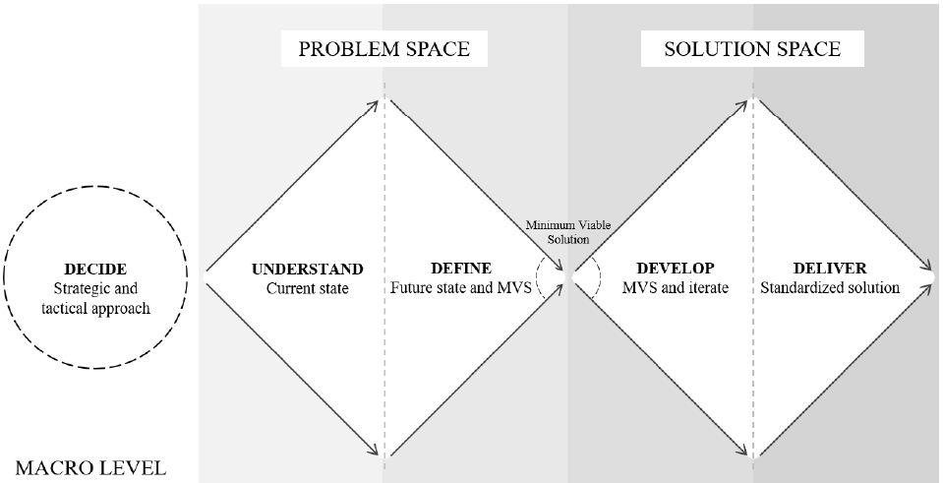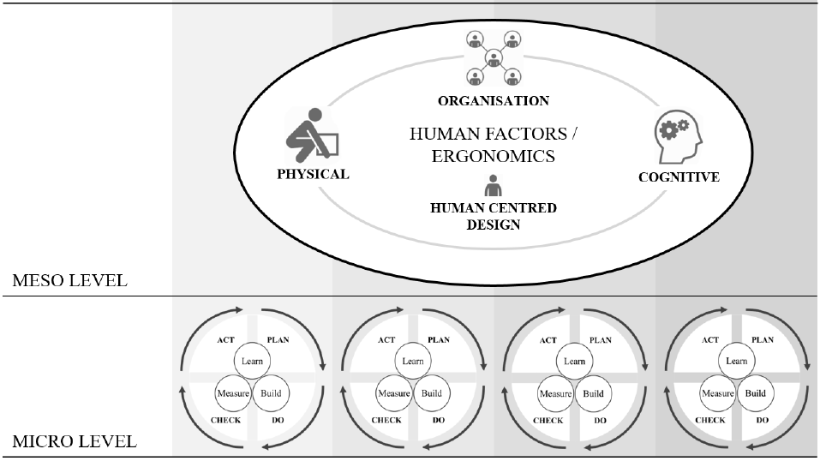
Source: Kadir et al., (2019)

Figure 1. Industry 4.0 work design model framework

Workspace
Work Design Outcomes
Human
Sex, Age, Size, Physique, Intelligence and Experience.
Job
New and Different Tasks, Cycle Time, Auxiliary and Preparatory Tasks
Workspace
Machine Size, Adjacent Machines, Dimensions.
Social Factors
Work Group, Cohesiveness, Communication, Supervision, Pay and Welfare, Shift Conditions, Type of Industry, Union and Neighborhood.
Economics Factors
Total Economic Cost, Utilization of Manpower and Material, Specialization of Labor, Capital Requirement
Technological Factors
Plant Size, Product Design and Quality, Workflow and Methods, Machine and Equipment Design, Quality of Raw Material.
Organizational Factors
Job Rotation, Choose Work Method, Organize Work, Set Goals, Participate in Design of Work Area, Equipment and Environment, Problem Solving, Group Working for safety Procedures, Flexible Hours, Incentives, Job Security and Feedback.
Physiological Factors
Temperature, Humidity, Air Movement, Contaminants, Noise, Vibration, Pace of Operation, Sustained Attention, Fast Altering Maneuvers, Safety Responsibility
Psychological Factors
Aptitude, Skill, Knowledge, Morale, Motivation, Satisfaction, Perception of Situation, Aspiration and Attitude.
Work Design Attributes
Work Variety, Use of Skills and Abilities, Meaningful Work, Contribution to Product Utility, Promotion Prospects, Social Interaction, Responsibility and Accountability, Decision Making and Autonomy.
Work Design Outcomes
Production Quantity, Quality, Job Satisfaction, Worker Safety, Health and Well Being, Turnover, Absenteeism, Slowdown and Strike.
Machine
Equipment, Tools, Displays, Controls and Panel Layouts
Work Design Factors
Work Design Attributes

Source: Das (1999)
Figure 2. The comprehensive industrial work design model.

Outcomes of effective work design

The Work Design factors are taken into consideration while designing work and have an impact through certain outcomes (Bakker & Albrecht, 2018). Effective design of work through maximizing the benefits of these factors and using them in an optimal way will result in increased production quantity, quality, job satisfaction, worker safety, health and well-being, lower turnover and absenteeism, while avoiding strike and slowdown by workers (Das, 1999; Malik, 2018; Parker, 2017). Corporate Social Responsibility towards employees is an established way to enhance employee response, performance and motivation. The unionization of the industrial unit has an effect on the Corporate Social Responsibility dimension towards employees (Rahman et al., 2020).

Relationships of personal characteristics and work design factors

It is scientifically and medically established that human beings have different abilities, perceptions and skills based on the differences in gender and generation. The upbringing, education and experience give different human beings different perspective towards life and work (Basha & Maiti, 2017; Peiró et al., 2020). With the advent of increased automation, IT Technology, internet of things, industry 4.0 and environmental concerns at the workplace increasing understanding is required of modern work design (Thatcher, 2013; Duarte & Cruz-Machado, 2017; Fantini et al., 2020).
It will be important to retain older workers in the workplace for longer periods and ensure that they remain healthy and productive. Researchers and managers should establish life span models of work design rather than age free models. Older workers have different experiences, abilities, values and perceptions (Zacher & Schmitt, 2016). The stress and physical strain felt by different generation of workers is different (Cadiz et al., 2019). Job satisfaction, organizational commitment and motivation are different for different generation of workers (Basha & Maiti, 2017). The nature of work may change with seniority. Certain aspects of work may become more or less valued with age. How people perceive their work with the passage of time and age is an area to explore (Warr et al., 1998; Hommelhoff et al., 2020).
Organizational job factors such as job rotation, work method, training, problem solving and goal setting are related with personal characteristics of workers (Dawal et al., 2009). Older, married and experienced workers are found to be more satisfied with their work. Job satisfaction increases with age and older workers are found to be more able to adjust their expectations to the return of their work. Companies should consider the personal characteristics of workers before setting goals or conversely other organizational job factors (Dawal et al., 2009). Workers having different personal characteristics, have different ranking of job motivators, exhibit high or low organizational commitment and expectations of reward (Linz, 2004). Human workers have personal characteristics alongside the worker attitudes. Humans give the input of personal characteristics and attitude to the task. The task itself has certain characteristics. The result is performance and outcomes of the task.

Focus on improving work design

It is the task of managers to improve work design for increased efficiency and to gain competitive advantage in the marketplace. Humans with their creativity and versatility are a source of gain rather than loss in the industry (Bakker & Albrecht, 2018; Velada et al., 2007). Utilized effectively in a socio technical system human beings can cause substantial gain in productivity and performance. Meaningful work is a source of satisfaction and economic benefit to the worker (Cassar & Meier, 2018). It is difficult for designers to predict how the combination of human and technical system will work when integrated together (Taghavi & Woo, 2017). It has been established that worker attitudes do not affect productivity and performance. The variation in performance might be due to task characteristics. However it has been proposed that the relationship between personal characteristics and productivity be investigated in future (Fletcher et al., 2008; Shantz et al., 2013). This relationship is exhibited in Figure 3. The industry 4.0 revolution will change work design and will impact the worker through deskilling vs upskilling, human centered vs technology replacement theories. The work will demand more decision making, problem solving, innovation, complexity, advanced technological skills and will be focused on core features of importance (Waschull et al. 2017).

Personal Characteristics
Attitudes
Task Characteristics
Task Performance

Figure 3. Model of personal characteristics and attitudes effect on task performance

Methodology

The research presented was an exploratory investigative study, which was based on a questionnaire survey given to a group of production workers in industrial units of Pakistan. The methodology in flow chart form is presented in Figure 4. Manufacturing organizations of Pakistan in the garment, textile and agricultural machinery were evaluated with all respondents being male. The medium level enterprises were included in the survey as large and small industries exhibit decidedly different culture and organizations norm.
The independent variables were the personal characteristics of production workers such as Age, Education, Marital Status, Experience and Family Size. The dependent variables were the work design factors which were presented in the earlier research of the comprehensive work design model presented by Biman Das and listed in Table 1. A pilot study was conducted on 40 manufacturing workers to check the reliability, validity and quality of survey questionnaire, which was found to be adequate.
The population of the research study was determined to be the production workers. The worker questionnaire was answered by 230 respondents. These workers were a diverse group with different ages, education levels, and experience in years; some were unmarried, others married and having different number of children. The final data set contained 190 cases after consideration of missing data, outliers, univariate and multivariate errors removal.

Identification of Work Design Theory & Models
Identification of theory variables
Formulation of Hypothesis
Aims & Objectives
Development of Questionnaire Survey
Pilot Study – Reliability Analysis
Selection of Organizations - Sampling
Data Collection & Analysis
Descriptive – Graphics- Non-Parametric Tests
Managerial Implications - Conclusion

Figure 4. Methodology flowchart of the work design study.

Analysis

Personal characteristics of workers

The worker below 30 years of age was considered to be young and assigned a label value of 1 while the worker above 30 years was considered to be elderly and assigned label value 2. Pareto Analysis was done to infer the cutoff limit for old and young workers. The workers with education less than 10 years in school were considered as uneducated with label value 1 and workers with more than 10 years of classwork considered as educated, label value 2. Workers with less than 3 years’ experience were considered as Low experience group (Label value 1), between 3 to 8 years’ experience considered as medium experience group (Label value 2) and worker experience with more than 8 years considered as high experience group (Label value 3). Pareto analysis was done to determine the levels of differentiation of the worker experience. Unmarried workers were given a label value of 1 while married workers were given a value of 2. The family size of the workers was divided into groups of workers with no children, small family and large family. Small family group consisted of workers having less than two children and large family had more than 2 child dependents.

Data analysis

The data was tested for normality through histograms and normality tests. Histograms indicated that the data was mostly right skewed and the normality tests also indicated significance values for data which were not normal. The data was considered to be Non-Parametric. The Kruskal Wallis Non Parametric ANOVA Technique was considered to be the relevant technique to gauge the difference across groups of workers divided in age, education, experience, marital status and family size sub groups (Chavaillaz et al., 2019).
Kruskal Wallis Non-Parametric ANOVA – Analysis of variance is a technique applied on non-normal data groups where the variance levels of both groups are observed for significant difference from each other. The ranks of the data are calculated and its distribution checked to observe the significance obtained (Alharbi et al., 2019; Field, 2013).
The mathematical equation used for calculating Kruskal Wallis Non-Parametric ANOVA test statistics ($H$) is given by (1). Where $N$ is total sample size, $R_{i}$ is group sum of ranks and $n_{i}$ is the group sample size. Significance tests are carried out on the test statistics to infer difference in the groups according to $p<0.05$.

$$H=\frac{12}{N\left(N-1\right)}\sum_{i=1}^{k}{\frac{R_{i}^{2}}{n_{i}}}-3\left(N+1\right)………\left(1\right)$$

The null hypothesis is that there is no difference in the variance across groups. The hypothesis is observed at 95% confidence interval. If the value of significance is found to be below 0.05 the alternate hypothesis is inferred to be true which means the variance of the two groups is significantly different across the population of two groups (Field, 2013).

Results and discussion

Descriptive statistics of work design factors

Table 3 exhibits the descriptive statistics of the dependent Work Design variables. The sample Size (N) for each of the 31 variables excluding missing data is given in the first column. The measure of central tendency is exhibited by the mean.
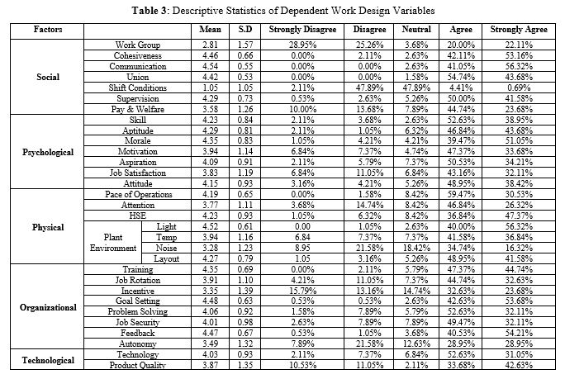

The variation in work design factors perception due to age

The comparison of means across age groups is shown in Figure 5. The perception of old Production Workers about the Pace of Operations in the Factory (Mean Rank = 100.34, N = 101) differs significantly from the perception of Young Production Workers (Mean Rank = 84.18, N = 84) after the survey was conducted, U Test Statistic = 4983.0, z = 2.329, p = 0.020, p < 0.05, significant result.

Figure 5. Significant results of age on work design factors.
The perception of old Production Workers about the Feedback in the Factory (Mean Rank = 101.54, N = 102) differs significantly from the perception of Young Production Workers (Mean Rank = 84.95, N = 85) after the survey was conducted, U Test Statistic = 5104.5, z = 2.368, p = 0.018, p < 0.05, significant result. The quantitative comparison of age groups with pace of operations and feedback is shown in Figure 6.

Figure 6. Comparison of age groups with a) Pace of operations and b) Feedback.

The variation in work design factors perception due to education

Education is an in dependent variable which causes a significant change in the work design factors. These changes are presented in Figure 7.

Figure 7. Significant results of education on work design factors
The perception of educated Production Workers about the Pay & Welfare in the Factory (Mean Rank = 99.39, N = 152) differs significantly from the perception of uneducated Production Workers (Mean Rank = 70.34, N = 35) after the survey was conducted, U Test Statistic = 3508.5, z = 3.023, p = 0.003, p < 0.05, significant result.
The perception of educated Production Workers about the Motivation Levels in the Factory (Mean Rank = 99.39, N = 152) differs significantly from the perception of uneducated Production Workers (Mean Rank = 70.57, N = 35) after the survey was conducted, U Test Statistic = 3480.0, z = 3.066, p = 0.002, p < 0.05, significant result.
The perception of educated Production Workers about the HSE in the Factory (Mean Rank = 99.25, N = 155) differs significantly from the perception of uneducated Production Workers (Mean Rank = 78.87, N = 35) after the survey was conducted, U Test Statistic = 3294.5, z = 2.157, p = 0.031, p < 0.05, significant result.
The perception of educated Production Workers about the Job Rotation in the Factory (Mean Rank = 98.97, N = 152) differs significantly from the perception of uneducated Production Workers (Mean Rank = 72.40, N = 35) after the survey was conducted, U Test Statistic = 3416.0, z = 2.796, p = 0.005, p < 0.05, significant result.
The perception of educated Production Workers about the Product Quality in the Factory (Mean Rank = 101.07, N = 155) differs significantly from the perception of uneducated Production Workers (Mean Rank = 70.83, N = 35) after the survey was conducted, U Test Statistic = 3576.0, z = 3.129, p = 0.002, p < 0.05, significant result. The quantitative comparison of education groups with job rotation, motivation, pay & welfare, HSE and product quality is shown in Figure 8.

Figure 8. Comparison of education groups with a) Job rotation, b) Motivation, c) Pay & Welfare, d) HSE and e) Product quality.

The variation in work design factors perception due to experience

The comparison of means of significant work design variables across experience is shown in Figure 9.

Figure 9. Significant results of experience on work design factors.

Figure 10. Comparison of experience groups with temperature.

The perception of medium experienced production workers about the temperature in the factory (N = 187) differs significantly from the perception of low and high experience production workers (N = 187) after the survey was conducted, Test Statistic = 9.524, p = 0.009, p < 0.05, significant result. The quantitative comparison of experience groups with age, marital status and temperature is shown in Figure 10.

The variation in work design factors due to marital status

The results exhibit that the married group of workers have a better perception towards supervision. Also the two groups differ in the perception towards acceptability of Pay and Welfare offered by the Production organization as exhibited in Figure 11.
The perception of married Production Workers about the Supervision in the Factory (Mean Rank = 95.94, N = 122) differs significantly from the perception of unmarried Production Workers (Mean Rank = 75.47, N = 56) after the survey was conducted, U Test Statistic = 4201.5, z = 2.741, p = 0.006, p < 0.05, significant result.
Perception of married Production Workers about the Pay & Welfare in the Factory (Mean Rank = 96.07, N = 122) differs significantly from the perception of unmarried Production Workers (Mean Rank = 74.83, N = 56) after the survey was conducted, U Test Statistic = 4277.0, z = 2.066, p = 0.039, p < 0.05, significant result. The quantitative comparison of marital status with supervision and pay & welfare is shown in Figure 12.

Figure 11. Significant results of marital status on work design factors.

Figure 12. Comparison of marital status with a) Supervision and b) Pay & Welfare.

The variation in work design factors due to family size

The comparison of means across family size groups is shown in Figure 13. Significant Results were obtained for the work design factors of Aptitude, Supervision, Pay & Welfare, HSE and Training.

Figure 13. Significant results of family size on work design factors.
The post-hoc tests conducted after Kruskal Wallis Non-Parametric ANOVA confirm that the group of Production workers having large family show better perception towards work design variables of Supervision, Pay & Welfare, Training and Aptitude. The post-hoc tests conducted after Kruskal Wallis Non-Parametric ANOVA confirm that the group of Production workers having small family show better perception towards work design variable of HSE. The quantitative comparison of family size with HSE, pay & welfare, aptitude, supervision and training is shown in Figure 14.

Figure 14. Comparison of family size with a) HSE, b) Pay & Welfare c) Aptitude, d) Supervision and e) Training

Managerial implications

It is inferred that the elder workers are having better understanding and idea about the pace of operations. Age brings wisdom and understanding. The elder workers are more aware of the strategic and operational factors of work rather than focusing on day to day details. Elder workers are also more receptive to feedback. These trends and results point to the importance of elder workers taking a leadership or mentoring role. They are receptive to feedback and listen to their supervisors and management. They understand the macro approach to work. They have knowledge and idea to make comparisons in terms of pace of operations and targets. These individuals can offer solutions to practical problems and be a source of improvements in terms of technology, process, environment and tasks. Based on the industry 4.0 work design model, the elder workers can better understand the macro approach. The vision, mission, targets and selection of technology can be better understood. For the Blue collar worker, this is an important factor and may result in more compatibility and ease in coordination between senior, middle and junior levels of staff in organization. It is foreseen that the competent and skilled elder workers in terms of IT competence, electronic and computing skills will serve better in the middle management. In industry 4.0, the complete hierarchy would be revamped and the structured work will be decidedly different from conventional manufacturing practices. It is foreseen that the deskilling will occur more rapidly in elder workers and the young workers will adopt the new practices and technologies with more ease and flexibility due to higher and latest education. The elder workers have high maturity levels, experience and confidence. If willing to upgrade their skills and be a positive part of change management for industry 4.0, these elder workers will definitely be considered valuable assets.
It is also evaluated that education is one of the most important variables which impact the work design factors. Educated workers perceive job rotation technique in a positive fashion. Uneducated workers perceive job rotation as additional work while educated workers consider it a source of learning and reducing monotony. Educated workers are more motivated, willing to learn and adopt new changes. Job rotation and health, safety and environment sub factors are perceived and adopted in a positive manner by educated workers. The key to the change in mindset to modern production practices is high education levels. These workers learn new philosophies and techniques. They are early adopters of new technology, innovation and practices of lean, green and agile manufacturing. As recognition of this result, one of the case study organization has decided to engage only educated workers since the past two years. The two groups of workers differing in education levels also have differing perceptions towards pay and welfare. Since all the sample organizations were doing export of products, it is inferred that education is a factor which enables worker to recognize quality levels of their product being manufactured. In terms of industry 4.0, education is perhaps the most important personal characteristic. The young people and workers have more exposure to industrial revolution technologies like, internet, electronics, mobile phones, computers and other systems. The modern curriculum, skill development, knowledge growth and information sharing all are building tech savvy individuals who are joining the workforce. These educated individuals are more conscious about quality, new technologies, knowledge available and information sharing. The cognitive and physical skills are more aligned with young workers in terms of industry 4.0.

HSE
Attitudes
Personal Characteristics
C

Task Characteristics
Task Performance
Age
Education
Experience
Marital Status
Family Size
Pace of Work
Feedback
Pay & Welfare
Motivation
Job Rotation
Product Quality
Temperature
Supervision
Pay & Welfare
HSE
Supervision
Pay & Welfare
Training
Aptitude
*The Factors of Personal Characteristics are in direct relationship with significant Work Design Variables as indicated by arrows.

Figure 15. Model of work design factors related to human personal characteristics
It is also inferred from the result that experience plays a part in understanding physical environment of the factory. The highly experienced workers recognized the improvement required on the factory floor. Experience makes them more aware of their environment. Married workers give certain initiatives to workers in terms of being responsive to supervision and monitoring. They are accommodating and easier to manage by supervisors. Also the married and unmarried groups of workers differed in their perception of adequacy of pay and welfare schemes. The sense of responsibility, motivation and commitment is higher for workers with family and these factors enable them to be highly dependent and committed workers.
The second most important independent personal characteristic after education is family size. Raising a family places certain responsibilities, checks and plans in the mind of the employee. Workers who are married with large family show better inclination to be supervised and accept the pay levels at the workplace. Workers with large family consider themselves to be better trained for the job. The aptitude of large family workers is also determined to be better as compared to other groups. Hence the large family worker offers certain initiatives regarding aptitude, supervision, pay and perceived training levels. An interesting finding is that small family workers perceive HSE policy and mechanisms in a better light. This is perhaps understandable with care being taken by employees of themselves to support young family. These individuals could tend to be more concerned about the community, environmental concerns and welfare of all stakeholders. A model depicting various findings and results inferred from the study to give overall, encompassing view is given in Figure 15.
The management should be ready to provide training, build a learning culture, provide technological assistance and support system for the old workers. Coordination, cohesion and teamwork should be ensured with the demographic boundaries faded away. The ergonomics, performance benefits, salaries, privileges and bonuses should all be aligned to achieve motivation and outcomes. The role of the human resource department will be to focus on changing models, demographics and technologies. It is proposed that a socio – technical model should be developed which will enhance manufacturing performance. At the tactical level, elder and experienced workers will perhaps perform better in the plan and study phase of the improvement intervention of industry 4.0 technologies. While, young educated workers would perhaps perform better in do and act phase. However close coordination and teamwork will ensure more cohesive streamlined performance. At the meso level, the physical experience of young workers in terms of physical capacities would be needed to be developed while the elder workers would need more relevant cognitive thinking capacities.

Conclusions

It is important for production organizations to have a mix of workers in terms of skill and personal characteristics, which channeled in a production system will produce value added output. Human resource should be procured keeping the company strategy, systems and work environment in mind. The workers should complement the system and organization and if used wisely, ethically and professionally can be a source of gain in socio-technical work design system.
As a step towards new research ideas and question formulation there is increasingly greater use of technology, automation and computerization augmented by the internet of things. How worker demographics are going to impact the work design in the industry 4.0 era is an interesting question. The age, education, experience coupled with learning, skills and work design for such technologies should be further investigated. Advanced technology on one end is also being counter balanced by environmental concerns. It is an interesting proposition to investigate the role of manufacturing work design in terms of green initiatives, smart factories, global supply chains as well as e-commerce based business to business setups more empirically.

References

Alharbi, M. F., Alahmadi, B. A., Alali, M., & Alsaedi, S. (2019). Quality of nursing work life among hospital nurses in Saudi Arabia: A cross‐sectional study. Journal of Nursing Management, 27(8), 1722-1730.
Altmann, N., Kohler, C., & Meil, P. (2017). Technology and work in German industry (Vol. 1). Taylor & Francis.
Bakker, A. B., & Albrecht, S. (2018). Work engagement: current trends. Career Development International.
Basha, S. A., & Maiti, J. (2017). Assessment of work compatibility across employees’ demographics: a case study. International journal of injury control and safety promotion, 24(1), 106-119.
Bødker, S. (2016). Rethinking technology on the boundaries of life and work. Personal and Ubiquitous Computing, 20(4), 533-544.
Bugvia, S. A., Hameeda, K., Hussain, A., & Tabassum, S. A. (2021). The CPEC supply web framework in context of modern manufacturing. Jurnal Kejuruteraan, 33(1), 39-46.
Bugvi, S. A., Hameed, K. Jamil, F. Irfan, A. Murtaza, S. Qaisar, M. & Bilal, M. (2021). performance improvement through Value Stream Mapping – A manufacturing case study. Jurnal Kejuruteraan, 33(4), 1007-1018.
Cassar, L., & Meier, S. (2018). Nonmonetary incentives and the implications of work as a source of meaning. Journal of Economic Perspectives, 32(3), 215-38.
Chavaillaz, A., Schwaninger, A., Michel, S., & Sauer, J. (2019). Work design for airport security officers: Effects of rest break schedules and adaptable automation. Applied Ergonomics, 79, 66-75.
Das, B. (1999). Development of a comprehensive industrial work design model. Human Factors and Ergonomics in Manufacturing & Service Industries, 9(4), 393-411.
Davis, M. M., Aquilano, N. J., Balakrishnan, J. & Chase, R. B. (2005). Fundamentals of operations management. McGraw-Hill Ryerson.
Dawal, S. Z., Taha, Z., & Ismail, Z. (2009). Effect of job organization on job satisfaction among shop floor employees in automotive industries in Malaysia. International Journal of Industrial Ergonomics, 39(1), 1-6.
Duarte, S., & Cruz-Machado, V. (2017, July). Exploring linkages between lean and green supply chain and the industry 4.0. In International conference on management science and engineering management (pp. 1242-1252). Springer, Cham.
Fantini, P., Pinzone, M., & Taisch, M. (2020). Placing the operator at the centre of Industry 4.0 design: Modelling and assessing human activities within cyber-physical systems. Computers & Industrial Engineering, 139, 105058.
Field, A. P., & Miles, J. (2009). Discovering statistics using SPSS:(and sex and drugs and rock'n'roll). Sage.
Field, A. (2013). Discovering statistics using IBM SPSS statistics. Sage.
Fletcher, S. R., Baines, T. S., & Harrison, D. K. (2008). An investigation of production workers’ performance variations and the potential impact of attitudes. The International Journal of Advanced Manufacturing Technology, 35(11), 1113-1123.
Hamid, R. A., Rahid, M. R., & Ab Hamid, S. N. (2020). The effects of employee participation in creative-relevant process and creative self-efficacy on employee creativity. Geografia-Malaysian Journal of Society and Space, 16(2), 179-191.
Hommelhoff, S., Schröder, C., & Niessen, C. (2020). The experience of personal growth in different career stages: An exploratory study. Organisationsberatung, Supervision, Coaching, 27(1), 5-19.
Kadir, B. A., Broberg, O., da Conceição Carolina, S., & Jensen, N. G. (2019). A framework for designing work systems in industry 4.0. In Proceedings of the Design Society: International Conference on Engineering Design (Vol. 1, No. 1, pp. 2031-2040). Cambridge University Press.
Linz, S. J. (2004). Motivating Russian workers: Analysis of age and gender differences. The Journal of Socio-Economics, 33(3), 261-289.
Malik, A. (2018). Strategic human resource management and employment relations. Springer Nature Singapore Pte Ltd.
Mital, A., & Pennathur, A. (2004). Advanced technologies and humans in manufacturing workplaces: An interdependent relationship. International journal of industrial ergonomics, 33(4), 295-313.
Parker, S. K. (2017). Work design growth model: How work characteristics promote learning and development. In J. E. Ellingson & R. A. Noe (Eds.), Autonomous learning in the workplace (pp. 137–161). Routledge/Taylor & Francis Group. https://doi.org/10.4324/ 9781315674131-8
Parker, S. K., Morgeson, F. P., & Johns, G. (2017). One hundred years of work design research: Looking back and looking forward. Journal of applied psychology, 102(3), 403.
Parker, S. K., Van den Broeck, A., & Holman, D. (2017). Work design influences: A synthesis of multilevel factors that affect the design of jobs. Academy of Management Annals, 11(1), 267-308.
Paruzel, A., Bentler, D., Schlicher, K. D., Nettelstroth, W., & Maier, G. W. (2019). Employees first, technology second. Zeitschrift für Arbeits-und Organisationspsychologie A&O.
Rahman, M. R. C. A., Ibrahim, I. A., & Madinah, D. (2020). Are highly unionised industries socially responsible to their employees?. Geografia-Malaysian Journal of Society and Space, 16(2), 215-227.
Sauter, S. L., Brightwell, W. S., Colligan, M. J., Hurrell, J. J., & Katz, T. M. (2002). Changing organization of work and the safety and health of working people. Cincinnati: National Institute for Occupational Safety and Health.
Seixas, A., Ferreira, T., Silva, M. V., & Rodrigues, M. A. (2018). The impact of shift work on burnout syndrome, depression, anxiety and stress: A case study in the metalworking industry. International Journal of Occupational and Environmental Safety, 2(1), 1-8.
Shantz, A., Alfes, K., Truss, C., & Soane, E. (2013). The role of employee engagement in the relationship between job design and task performance, citizenship and deviant behaviours. The International Journal of Human Resource Management, 24(13), 2608-2627.
Taghavi, A., & Woo, C. (2017). The role clarity framework to improve requirements gathering. ACM Transactions on Management Information Systems (TMIS), 8(2-3), 1-16.
Taylor, F. W., (1911). The principles of scientiﬁc management. New York, 202.
Thatcher, A. (2013). Green ergonomics: definition and scope. Ergonomics, 56(3), 389-398.
Torraco, R. J. (2005). Work design theory: A review and critique with implications for human resource development. Human resource development quarterly, 16(1), 85-109.
Velada, R., Caetano, A., Michel, J. W., Lyons, B. D., & Kavanagh, M. J. (2007). The effects of training design, individual characteristics and work environment on transfer of training. International journal of training and development, 11(4), 282-294.
Warr, T. D., Corbett, J. M., Clegg, C. W., Jackson, P. R., & Martin, R. (1990). Advanced manufacturing technology and work design: Towards a theoretical framework. Journal of Organizational Behavior, 11(3), 201-219.
Warr, P., Schaie, K. & Schooler, C. (1998). Impact of work on older adults. New York: Springer.
Waschull, S., Bokhorst, J. A., & Wortmann, J. C. (2017). Impact of technology on work: Technical functionalities that give rise to new job designs in industry 4.0. In IFIP International Conference on Advances in Production Management Systems (pp. 274-281). Springer, Cham.
Waschull, S., Bokhorst, J. A., Molleman, E., & Wortmann, J. C. (2020). Work design in future industrial production: Transforming towards cyber-physical systems. Computers & industrial engineering, 139, 105679.
Wolf, M., Kleindienst, M., Ramsauer, C., Zierler, C., & Winter, E. (2018). Current and future industrial challenges: demographic change and measures for elderly workers in industry 4.0. Annals of the Faculty of Engineering Hunedoara, 16(1), 67-76.
Zacher, H., & Schmitt, A. (2016). Work characteristics and occupational well-being: the role of age. Frontiers in psychology, 7, 1411.

