

Spatial econometrics and spatial hedonic model in property valuation: A bibliometric analysis

Siti Maryam Abdul Wahab¹, Ernieza Suhana Mokhtar², Mohd Hasrol Haffiz Aliasak³

¹ Institute of Graduate Studies, Faculty of Architecture, Planning, and Surveying
Universiti Teknologi MARA, Perlis Branch
² College of Built Environment, Faculty of Architecture, Planning, and Surveying
Universiti Teknologi MARA, Perlis Branch
³ College of Built Environment, Faculty of Architecture, Planning, and Surveying
Universiti Teknologi MARA, Perak Branch

Correspondence: Siti Maryam Abdul Wahab (email: sitimaryam@uitm.edu.my)

Received:10 May 2022; Accepted: 16 November 2022; Published: 30 November 2022

Abstract

The econometric and hedonic analysis offers reliable input in property valuation, primarily for economic studies and the country’s revenue. However, the lack of spatial reliability in statistical analysis has become a serious debate among researchers. This research is carried out to review the current trend and pattern of literature and visualize the network of the authors, countries, and keywords applied in property valuation by emphasizing the application of spatial analysis in econometric and hedonic using bibliometric analysis. The increment of documents related to spatial analysis, especially the approach of Spatial Econometric (SE) and Spatial Hedonic (SH) in property valuation, has indicated the current interest of researchers around the globe. A few bibliometric analyses are done on the Hedonic Pricing Method (HPM) and property valuation issues. Still, the attention of the review on emphasizing the spatial element is limited. Three hundred ten (310) documents are involved in the bibliometric analysis related to the property valuation issue from the Scopus database. The methodology was according to the modified Preferred Reporting Items for Systematic Reviews and Meta-Analyses (PRISMA) to provide clarity in screening and filtering documents. VOSviewer, Harzing’s Publish or Perish (PoP), and Microsoft Excel are used to ease the analysis process. This research will provide a basis to unlock new research opportunities for scholars and assist property valuation practitioners with an efficient valuation approach with spatial application. An efficient property valuation approach would drive a comprehensive insight into supporting sustainable economic and living quality.

Keywords: Bibliometric, property valuation, spatial econometric, spatial hedonic

Introduction

A commonly used model in residential property valuation is Hedonic Pricing Model (HPM) (Hu et al., 2011; Marrouch & Sayour, 2021; Jim & Chen, 2009; Mittal & Byahut, 2019), which originated by Lancaster (1966) based on consumer theory then formally formulated by Rosen (1974), with the concept of determining the price in equilibrium market. The HPM is the mathematical analysis determined based on the actual behavior with robust statistical and analytical tools (Aladwan & Ahamad, 2019). HPM can decompose the variables included in the model into quantifiable prices and quantities so that the comparisons of identical properties between various types of houses in different areas can be made (Norhaya Kamarudin et al., 2008). However, the limitation of the hedonic approach is the neglection of spatial information in the model, which caused it to be only a data-driven analysis instead of a model-driven (Anselin, 1988; Wen et al., 2017; Wen et al., 2020). Even though the houses are locationally immobile, the spatial neighbourhood and environment are strongly related to their value. The characteristics of spatial data consist of spatial dependence and heterogeneity, which will drive bias, inconsistency, and inefficient results when modeling it using standard linear regression (Anselin, 2001). Thus, spatial econometrics (SE) has been introduced by Anselin (1988), by emphasizing the spatial dependence and heterogeneity in spatial data. The econometric term is a statistical analysis of the economic trends to give practical substance to financial relationships (Spanos, 1986). In addition, the emergence of the neighborhood effect and the Geographical Information System (GIS) ability to provide geocoded data has opened broader reliability to spatial dependence and heterogeneity (Anselin, 2001). Therefore, the application of SE theory has been extensively used as a sub-set model to HPM in property valuation studies due to the limitation of the hedonic approach (Anselin & Lozano-Gracia, 2009). The application of SE in traditional HPM opened a new getaway to the Spatial Hedonic (SH) approach for an individual assessment in property valuation practice since the ability to accurately reflect the spatial dependence and optimize the traditional hedonic price model (Wen et al., 2020).

Property valuation is establishing a market value of immovable property in the exchange. Market Value (MV), defined by International Valuation Standard (IVS), is “the estimated amount for which an asset or liability should exchange on the valuation date between a willing buyer and seller in an arm’s length transaction, after proper marketing and where the parties had each acted knowledgeably, prudently and without compulsion” (International Valuation Standard, 2022). A valuation can be referred to as the act or process of determining an asset or liability value estimate by applying the valuation standard (International Valuation Standard, 2022). Properties are valued for taxation, purchases, and investment. From the government’s perspective, taxation has been established as a vital source of the country’s revenue. According to OECD Tax Statistics, on a yearly average from 2010 to 2020, the percentage of revenue contributed by property tax in the US, UK, Canada, Australia, Japan, and Germany was around 12.9%, 12.3%, 11.9%, 9.7%, 9.2%, and 2.7% respectively of the total Gross Domestic Product (GDP) (Organization for Economic Co-operation and Development, 2021). The statistic demonstrated the substantial dependencies of many countries on property revenues; thus, it shows its importance in our daily life.

This study is established to keep track of the published documents regarding spatial data and econometrics in the property valuation study. Among literature studies, the bibliometric analysis explores the prevailing knowledge base (Aria & Cuccurullo, 2017). Bibliometric analysis can provide a quantitative study using manuscript databases, journal collection, and worldwide search engines such as Scopus, Google Scholar, PubMed, Web of Science, and many more. It can provide a general overview and visualize the patterns and trends (Chen et al., 2016) in any field of study. Bibliometric analysis has been published in many areas, such as health, tourism, bioeconomy, and geopolymer (Sweileh, 2022; Atsız et al., 2022; Ranjbari et al., 2022; Yang et al., 2022). A few examples of bibliometric analysis of land development and valuation are also published, such as property valuation (Binoy et al., 2022), real estate rental market (Liu et al., 2021), HPM (Jayantha & Oladinrin, 2020) as well as urban development (Lu & De Vries, 2021). However, no comprehensive bibliometric analysis of SE and SH as the application of the property valuation approach has been found and published in the literature review until now. Therefore, this article is prepared to establish a bibliometric analysis and study with the objectives of providing the following:

i. the descriptive analysis of SE and SH in property valuation literature in trends and impact.

ii. visualization analysis on the distribution of authors’ collaborations, countries, and keywords co-occurrence.

This article is organized by presenting a literature review followed by a review protocol, methodology, result, discussion, and conclusion. At the end of this article, the evolution through time and visualization results can be demonstrated to deliver the knowledge domain.

Literature review

Property valuation approach

The most practical approach applied for individual residential by valuation practice is the comparison method globally and locally due to simplicity, a single unit of the subject property involved, and ease to be understanding (Kim et al., 2020; Abidoye et al., 2019; Rohana Abdul Rahman & Taher Buyong, 2012). However, this approach is vulnerable to human bias due to selecting other similar characteristics of properties to be compared with the subject property because it will depend on the experiences and knowledge of the valuer (Newell et al., 2010; Hishamuddin Mohd Ali et al., 2020). Thus, advanced methods/models were introduced to minimize human involvement but simultaneously imitate the process with the aid of computers and statistical procedures for decision-making. According to Pagourtzi et al. (2003), Artificial Neural Network (ANN), Hedonic Pricing Method (HPM), Spatial Analysis, Fuzzy Logic, and Autoregressive Integrated Moving Average (ARIMA) are considered the advanced valuation methods with the integration of mathematical and machine learning for the valuation process.
Based on the literature, one of the commonly used models used in residential property valuation is HPM (Hu et al., 2011; Marrouch & Sayour, 2021; Mittal & Byahut, 2019), which originated from Lancaster (1966) based on consumer theory then formally formulated by Rosen (1974), with the concept of determining the price in equilibrium market. The review on HPM has received wide attention from many previous researchers (Usman et al., 2020; Owusu-Ansah, 2013; Herath & Maier, 2010; Xiao, 2017). The applications of HPM are popular due to their simplicity, successfully decomposed price attributes as well, and identification of how people are willing to pay for each of the property’s features (Jim & Chen, 2007; Jim & Chen, 2009; Jiang & Chen, 2015; Hu et al., 2011). However, the neglection of spatial dependence and heterogeneity has become a crucial issue due to the theory that each property may vary over space (Wen et al., 2017; Anselin, 2001), and the significance of spatial dependence has been empirically proven in terms of neighbourhood spillover (Skevas et al., 2018) and the existence of clustered market segment rather than randomly distributed (Zhang et al., 2017; Ozyurt, 2014). It stands with the theory in Geography by Tobler (1970), based on the likelihood model where nearby units are more likely to be related than distant ones.
The evolution in econometrics literature has endlessly improved from time to time. Considering spatial effect has been one of the developments resulting in the spatial econometrics model. Due to that, Usman (2021) narratively reviewed SE theory and stressed that spatial dependence and heterogeneity in the property market severely influence property pricing approximation. However, the trends and patterns of SE or SH studies have yet to be revealed, especially in property valuation applications. Therefore, this study is essential to provide descriptive network analysis and visualization of publications and year trends.

Database and software selection

The online literature database is viral in the digital and internet of thing (IoT) era. Many literature search databases exist, such as Scopus, Web of Science (WoS), Google Scholar, Science Direct, and many more. For bibliometric research, Scopus has been commonly acknowledged as one of the best online databases (Baas et al., 2019) due to its ability in advanced profiling algorithms and manual curation, which confirms high precision. The employed review manuscripts with the Scopus engine can be found in (Binoy et al., 2022; Sweileh, 2022; Yang et al., 2022), which portrays its ability for descriptive analysis as well as spatial visualization. It also provides a high-quality data source by introducing internal review processes to continually monitor the quality focus, such as processing, profile quality, completeness, and accuracy of source data (Baas et al., 2019). Scopus offer access by Elsevier for scholarly materials in the field of life sciences, social sciences, physical sciences, and health sciences and consist of many types of sources such as book series, journals, conference articles, and trade journals. Although Aghaei Chadegani et al. (2013) did mention the competitiveness and comprehensiveness between Scopus and WoS, however Aghaei Chadegani et al. (2013) and Meho (2019) agree that Scopus provides more recent data than WoS. Therefore, the Scopus database will be used for this bibliometric analysis regarding SH or SE in the property valuation study.
A few software can be employed for literature analysis to ease the process. The selection of the software should be dependent on the objective of the research. For instance, the bibliometric application software of VOSviewer, Microsoft Excel, Publish or Perish, Bibliometrix, and many more. Table 1 shows the bibliometric analysis that previous researchers have done by presenting the selected database, the number of analyzed manuscripts, and the application software for the study.
Table 1. Example of bibliometric analysis by previous researchers

Author/s | Scholar database | Number of Scholar materials | Bibliometric analysis software employed | Field of study
Chen et al. (2016) | WoS | 637 (1996-2014) | Citespace | Emergy
Sweileh (2022) | Scopus | 509 (1980-2020) | Microsoft Excel,VOSViewer | Health
Atsız et al. (2022) | WoS | 60 | VOSviewer | Tourism
Yang et al. (2022) | Scopus | 6776 | VOSviewer | Geopolymer
Binoy et al. (2022) | Scopus | 1400 (1964– 2019) | Bibliometrix R | Property Valuation
Liu et al. (2021) | WoS | 790 (2010-2020) | CiteSpace | Real Estate
Jayantha & Oladinrin (2020) | Scopus | 269 (1970- 2019) | CiteSpace | Marketing (HPM)
Lu & De Vries (2021) | WoS | 6968 (1957- 2020) | HistCite™, CiteSpac, VOSviewer, Map and Alluvial Generator | Rural Development
Tamala et al. (2022) | Scopus | 547 (1994-2021) | VOSviewer | Oil & Gas
Assad & Bouferguene (2022) | Scopus | 184 (2000-2021) | Gephi, VOSviewer | Water Distribution
Source: Own study

The use of Microsoft Excel, Harzing’s Publish or Perish (Harzing’s PoP), and VOSviewer in this article is for representing the results as established in the objectives. The application of PoP is helpful because it is easy to install and can be downloaded freely for the website (www.harzing.com/resources/publish-or-perish). It was developed by Anne Wil Harzing (Harzing, 2007) and can be installed on Windows, macOS, or Linux. The software can obtain information related to citation and score index. VOSviewer will aid the function of constructing and visualising the networks. It is also a free downloaded software from the website (www.vosviewer.com) and requires Java version 8 or higher to be installed on the computer.

Review protocol and methodology

Review protocol

In the application of systematic literature review (SLR) or metadata analysis, the Preferred Reporting Items for Systematic Reviews and Meta-Analyses (PRISMA) diagram is fit to explain the research process (Moher et al., 2009; Glor, 2021). A transparent process should also be disclosed in the standard protocol for bibliometric review. Since the application of PRISMA is not limited to SLR (Moher et al., 2009), the authors proposed to use a modified version of PRISMA to establish clarity in the review protocol. Therefore, Figure 1 shows the research methodology employed for this study.
Records included in bibliometric analysis
Topic selection
Keyword and search string
Scope and coverage
Records identification and screening
Records removed and finalised

Figure 1. Research methodology for article extraction
The focus topic is Spatial Econometric (SE) or Spatial Hedonic (SH) in the application of property valuation. The Boolean operator of “OR” is used to maximise the searching subset within SE and SH. In Scopus, a search has been done using the Article Title, Abstract, and Keyword. The first result found in the search came to 486 articles. The data was extracted on 1st March 2022. This strategy would allow the keywords found not only in the title but also in the abstract and keyword stated by the author/s of the articles and maximised the finding records. The full keywords that have been used to perform searching manuscript are:

TITLE-ABS-KEY ( ("spatial econometric" OR "spatial hedonic" ) AND ( "Property Valuation" OR "real estate" OR valuation OR hous* OR residential) )

During the list’s extraction in the Scopus database, there was no limitation on the duration of the year of publication applied, but the language was set to only English manuscripts. This would allow full coverage of terms in the topic in a globally accepted language. The document types included articles, conference papers, book chapters, books, and reviews. Conference review, editorial, and erratum were removed due to the minimal empirical content and only related to the introduction to the conference or proceeding. The first publication was found in 1996 by Meen G. in the Journal of Housing Studies. Hence, 444 articles are saved for scoping, identification, and screening to reveal the SE and SH application in property valuation.
Then, the identification and screening were made by reading through the abstracts. The unrelated issues, for instance, in the study of household income, wages, forest, or waste management, which were not related to property valuation, were removed from the list even though they used SE or SH. After a thorough abstract reading, 310 manuscripts were found and finalised for the bibliometric analysis. The refined list of 310 is exported to **.csv format for analysing using VOSviewer and **.ris format for Harzing’s PoP bibliometric analysis application.

Results and discussion

The results are prepared for achieving the objectives based on the descriptive analysis in the final documents by presenting the yearly publications trend, top twelve (12) in the most active author/s, affiliation, countries, and publication’s impact. Visualizing co-authorship, countries, and keyword networking provide the visualization analysis results.

Descriptive analysis

Based on Figure 2, the active publication was found within the current decades, which involved 15 and above publications. The highest publication was in 2018, followed by 2020, with 30 and 28 manuscripts published. In 2022 alone, until March, there are already ten (10) documents, which might indicate the positive prospect for increasing publication in the coming months.

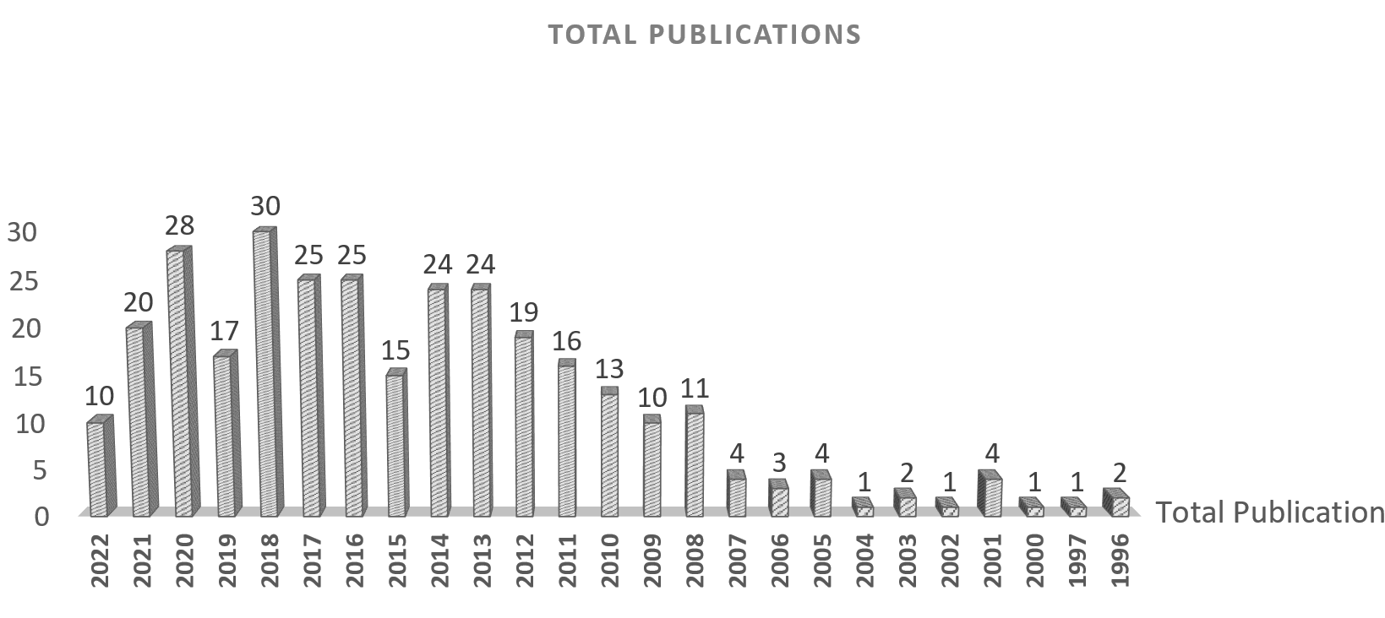
Source: Own study

Figure 2. The yearly trend of publications

a. Top authors and institutions

From the analysis of the most active authors, it was found that twelve (12) authors are listed as the most active by a tiny gap. The highest number of total documents published was five (5) are Herath S. (2013 [2], 2015 [2], 2021[1]), Legros, D.(2014[3], 2016[1], 2017[1]), Polyakov, M. (2013[2], 2014[1], 2015[1], 2016[1]), Wen, H. (2014[1], 2017[1], 2018[1], 2020[2]), and Yang, L (2018[1], 2019[2], 2020[2]) which represents 1.61% of document from the total 310. Whereas another seven (7) authors had published four (4) documents, whose are Anselin, L. (2001[1], 2008[1]. 2009[1], 2010[1]), Cho, S.H. (2005[1], 2011[2], 2012[1]), Dube, J. (2012[1], 2014[1], 2016[1], 2017[1]), Li, W. (2014[1], 2015[1], 2016[1], 2017[1]), Paez, A. (2008[1]. 2009[2], 2010[1]), Theriault, M. (2003[1], 2012[1], 2014[1], 2017[1]) and Zhang, L (2014[1], 2017[1], 2018[1]. 2020[1]) which represents 1.29% from the entire documents. Interestingly, Herath S. published two out of five documents as a single author.
From all twelve (12), the contribution of the top three authors is discussed. Herath S. had shown interest in the implication of various types of distance to be considered in identifying the proximity to the property values. The finding contributed to the effective transportation infrastructure planning in the urban area. He also highlighted the Spatial Durbin Model (SDM) as the best among Spatial Lag Model (SLM) and Spatial Error Model (SEM) in 2015’s articles when addressing the problem of omitted variable bias in Vienna, Austria because of the ability to allow small scale neighbourhood effects. Herath S. is found to focus on the issue of spatial dependence in hedonic analysis. Legros, D., on the other hand, had published documents as the co-author and concentrated on the spatial-temporal elements in SH to evaluate the neighbourhood and spillover effects. His contribution to the finding is also towards effective transportation infrastructure planning. Besides, Polyakov, M. focused on the marginal benefits of environmental assets such as natural parks, forest land, and urban tree canopy to the property values. Evaluation of the preference in the environmental matter would provide information in increment of the property value when located on adjacent public space and vice versa. The spatial reliability information benefits all the important hedonic information of the property values.
Table 2 shows the result of the top twelve (12) authors in the SE and SH approach related to proper valuation publication and their affiliation and origin country.

Table 2. Top twelve authors

AN | TD | % | Affiliation | Country
Herath, S. | 5 | 1.61 | University of Technology Sydney, Architecture & Building, Sydney | Australia
Legros, D | 5 | 1.61 | Laboratoire d'Économie de Dijon (LEDi), Dijon | France
Polyakov, M. | 5 | 1.61 | Manaaki Whenua - Landcare Research, Lincoln | New Zealand
Wen, H. | 5 | 1.61 | College of Civil Engineering and Architecture Zhejiang University, Center for Real Estate Studying, Hangzhou | China
Yang, L. | 5 | 1.61 | Southwest Jiaotong University, Department of Urban and Rural Planning, Chengdu | China
Anselin, L. | 4 | 1.29 | Center for Spatial Data Science, Chicago | United States
Cho, S.H | 4 | 1.29 | The University of Tennessee, Knoxville, Department of Agricultural and Resource Economics, Knoxville | United States
Dubé, J. | 4 | 1.29 | Université Laval, Quebec | Canada
Li, W. | 4 | 1.29 | Texas A&M University, College Station | United States
Páez, A. | 4 | 1.29 | McMaster University, School of Earth, Hamilton | Canada
Thériault, M. | 4 | 1.29 | Université Laval, Quebec | Canada
Zhang, L. | 4 | 1.29 | Zhejiang University, Department of Civil Engineering, Hangzhou | China
AN= Author’s name
TD= Total document
Source: Own study

The most active institution recorded on this topic was the University of Hong Kong which contributed ten (10) documents, followed by Arizona State University, Universite de Bourgogne, McMaster University, and Universite Laval with six (6) documents. Another six institutions had five (5) contributed documents: Zheijiang University, University of Tennessee, Heriot-Watt University, Texas A&M University, UNSW, and University of Western Australia. Table 3 shows the result of the top 11 institutions with the number and percentage of the contributed documents.

Table 3. Top 11 institutions
Institution | TD | % | Country
1. University of Hong Kong | 10 | 3.22 | China
2. Arizona State University | 6 | 1.94 | United States
3. Universite de Bourgogne | 6 | 1.94 | France
4. McMaster University | 6 | 1.94 | Canada
5. Universite Laval | 6 | 1.94 | Canada
6. Zheijiang University | 5 | 1.61 | China
7. University of Tennessee | 5 | 1.61 | United States
8. Heriot-Watt University | 5 | 1.61 | United Kingdom
9. Texas A&M University | 5 | 1.61 | United States
10. UNSW | 5 | 1.61 | Australia
11. University of Western Australia | 5 | 1.61 | Australia

TD= Total document
% of the contributed documents out of 310
Source: Own study

b. Publication impact

Harzing’s PoP is beneficial for analysing the publication’s impact. It is essential to acknowledge the date of Scopus data collection since the citations counted are subjected to the Scopus updates. Table 4 shows the citation metrics for the 310 filtered documents.

Table 4. Citation metric
Citation metrics
Publications years | 1996-2022
Citation years | 26
Papers | 310
Citations | 7113
Cites per year | 273.58
Cites per paper | 22.95
Authors per paper | 2.70
h-index | 44
g-index | 71

Source: Own study

All filtered documents are gathered from 1996-March 2022, which took about 26 citation years. The total citations from all the documents are 7113, on average, 273 and 23, cites per year and cite per paper, respectively. On average, 2-3 authors are involved in contributing one piece of paper, which indicates the authors’ networking. H-index and G-index for the articles are 44 and 71, respectively. The H-index displays the level metric that measures the productivity and citation impact of the publications initially used for an individual scientist or scholar. At the same time, the G-index is a rank of a set of articles in decreasing order of the number of citations they received (Harzing, 2007).
Figure 3 shows the number of authors per contributed document. The highest total number of authors per document is seven (7). The highest number of authors in one document was duo authors, which were about 107 documents, and the single author published 50 documents.

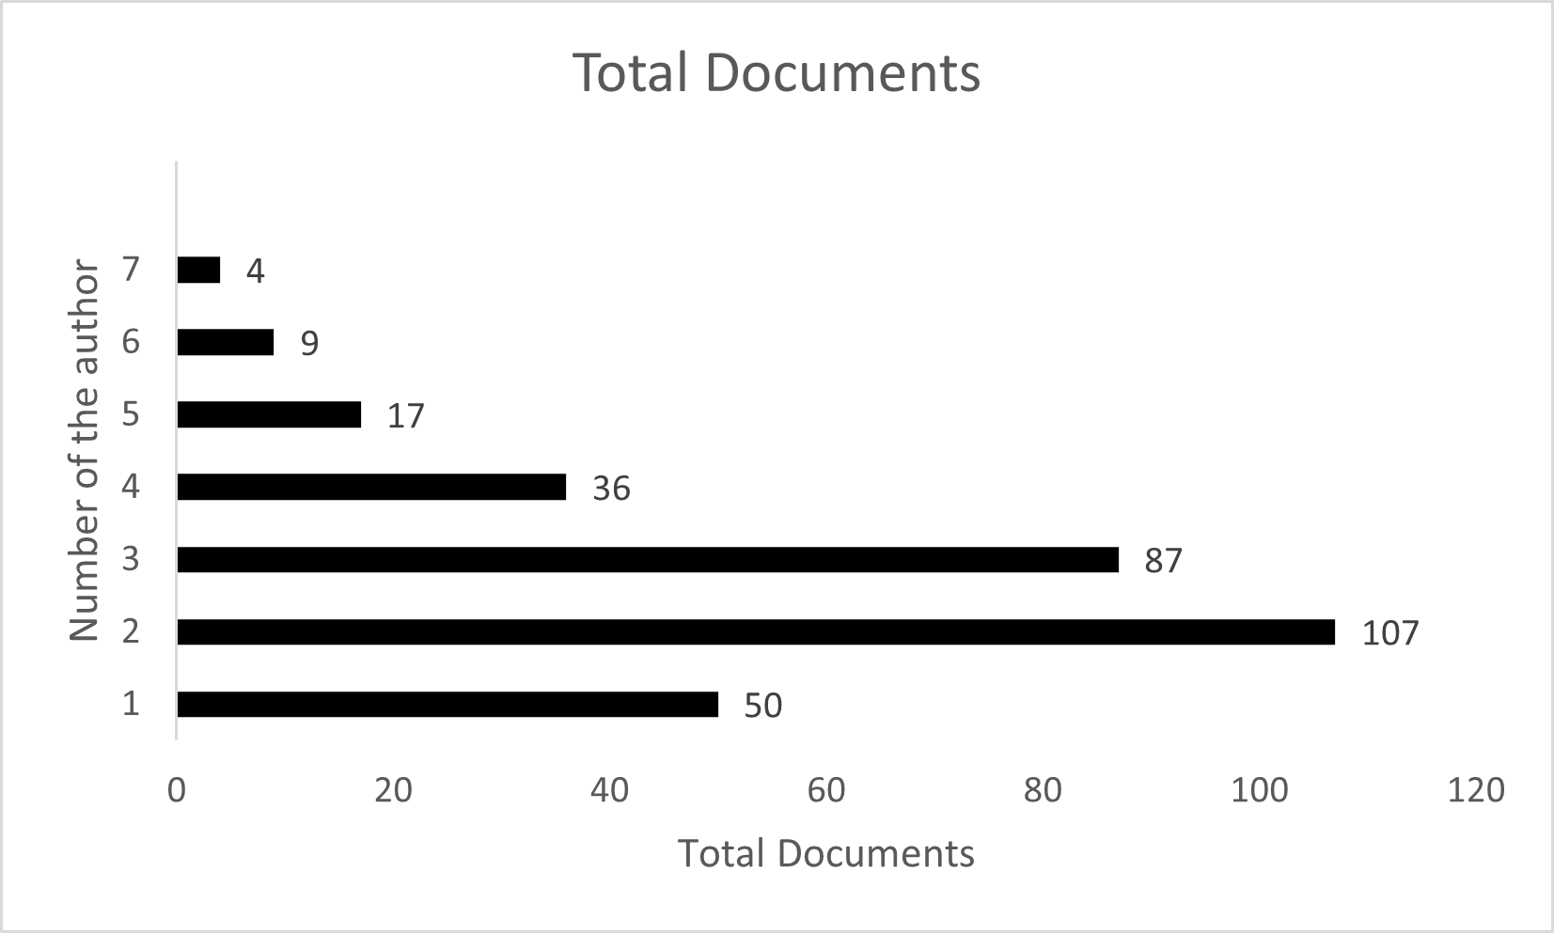
Source: Own study

Figure 3. Number of authors in contributed documents

The highly cited documents were also determined with their total citation and citation per year, as shown in Table 4. It was found that J. Geoghegan, L.A. Wainger, and N.E. Bockstael (1997) had the highest total citation, with 421 and 16.84 citations per year on average, which empirically highlighted the result of SH application. They highlighted the spatial heterogeneity in traditional hedonics with the application of GIS and landscape indices developed by landscape ecologists to provide a better model of how people value the land around their homes. On the other hand, L. Anselin got the highest citation in applying SE in the valuing environment as the economic resource and about the spatial effect in the econometrics model. Based on Table 5, seven (7) out of ten (10) documents are related to the application of SH, and three (3) others are regarding SE.

Table 5. Highly cited documents

No | Authors | Title | Model | Year | Publication | TC | C/Y
1 | J. Geoghegan, L.A. Wainger, N.E. Bockstael | Spatial landscape indices in a hedonic framework: An ecological economics analysis using GIS | SH | 1997 | Ecological Economics | 421 | 16.84
2 | D.M. Brasington, D. Hite | Demand for environmental quality: A spatial hedonic analysis | SH | 2005 | Regional Science and Urban Economics | 236 | 13.88
3 | L. Anselin, N. Lozano-Gracia | Errors in variables and spatial effects in hedonic house price models of ambient air quality | SH | 2008 | Empirical Economics | 189 | 13.5
4 | L. Anselin | Spatial effects in econometric practice in environmental and resource economics | SE | 2001 | American Journal of Agricultural Economics | 177 | 8.43
5 | J.P. LeSage | What regional scientists need to know about spatial econometrics | SE | 2014 | Review of Regional Studies | 157 | 19.63
6 | J.P. Cohen, C.C. Coughlin | Spatial hedonic models of airport noise, proximity, and housing prices | SH | 2008 | Journal of Regional Science | 130 | 9.29
7 | W.-C. Liao, X. Wang | Hedonic house prices and spatial quantile regression | SH | 2012 | Journal of Housing Economics | 114 | 11.4
8 | J.M. Grove, D.H. Locke, J.P.M. O'Neil-Dunne | An ecology of prestige in New York City: Examining the relationships among population density, socio-economic status, group identity, and residential canopy cover | SE | 2014 | Environmental Management | 108 | 13.5
9 | R.J. Armstrong, D.A. RodrÃguez | An evaluation of the accessibility benefits of commuter rail in Eastern Massachusetts using spatial hedonic price functions | SH | 2006 | Transportation | 105 | 6.56
10 | A. Atreya, S. Ferreira, W. Kriesel | Forgetting the flood? An analysis of the flood risk discount over time | SH | 2013 | Land Economics | 103 | 11.44
TC=Total citation
C/Y=Citation per year
Source: Own study

Visualization analysis

The visualization of networks was carried out by using VOSviewer software. According to (Sonnenwald, 2007), collaboration is driven by the opportunity to open new knowledge and seek expertise for the problems or issues. This study has visualized the network by co-authorship, countries, and keywords.
a. Co-authorship networking
For co-authorship networking, the counting method is set where each author weighs one (1). The threshold of the minimum number of documents for an author is set to 1 to represent the full links of the authors, even if the author only produced one document. The highest number of links are found, consisting of 36 authors with total link strength of 90. Link is referred to the co-occurrence between the items. Figure 4 represents the highest consisted authors in the link connection. The variety of sizes of the circle depicts the number of produced documents. Yang. I, who had published five, and Li. W, with four documents (among the active authors), had collaborated with another three and four clusters, respectively. The thickness of the line in Figure 4 shows the link strength. There are eight (8) total clusters were found in the connection, represented by eight different colors.
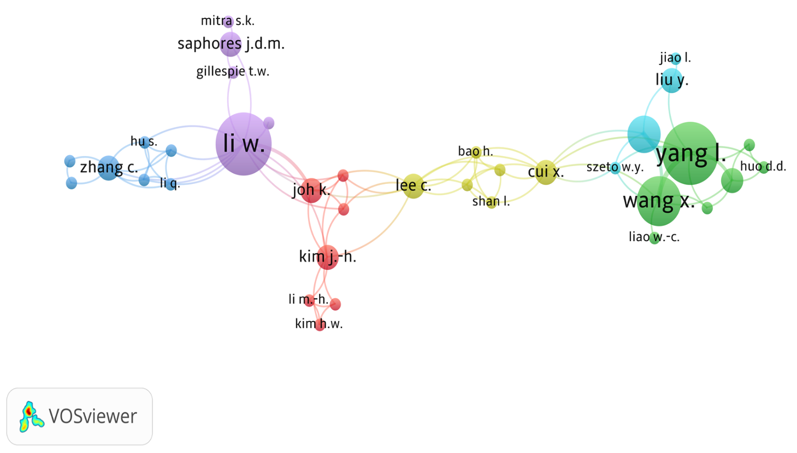
Source: Own study

Figure 4. Co-authorship visualization network

b. Countries’ networking
On the other hand, Figure 5 shows the countries networking within the dataset. Using one (1) minimum number of documents of a country and zero (0) minimum number of citations per country as the thresholds, all 47 countries are counted for the country networking calculation. United States (US), China, and Canada show the top three total link strengths with 29, 17, and 14, respectively. They also provided the highest number of documents in the dataset, 114, 37, and 22, respectively. The evolution of Hedonic and SE was initiated by Sherwin Rosen (1974) and Luc Anselin (1988) from the US and received remarkable attention from many researchers, especially in economic and valuation studies. Personally, Sherwin Rosen had been listed as the sixth most cited in the Journal of Political Economy’s history with the article entitled “Hedonic Prices and Implicit Markets: Product Differentiation in Pure Competition” in 1974, which offers the fundamental understanding of the fields of economy, environmental, labor, and public by matching buyers and sellers of multidimensional goods (Greenstone, 2017). On the other hand, according to Google Scholar, Luc Anselin’s citation records are more than 83000 with a 95 h-index, making him listed among the most influential person in the spatial and econometric issue of studies. His book entitled “Spatial Econometrics: Methods and Models” alone, published by Springer Science and Business Media in 1988, had received more than 15000 citations which shows the significant impact on the body of knowledge. Even though both manuscripts are not listed among 310 filtered documents from Scopus used in this bibliometric analysis, the effect of both might be the reason behind the most significant influence of the US in the SE and SH fields.
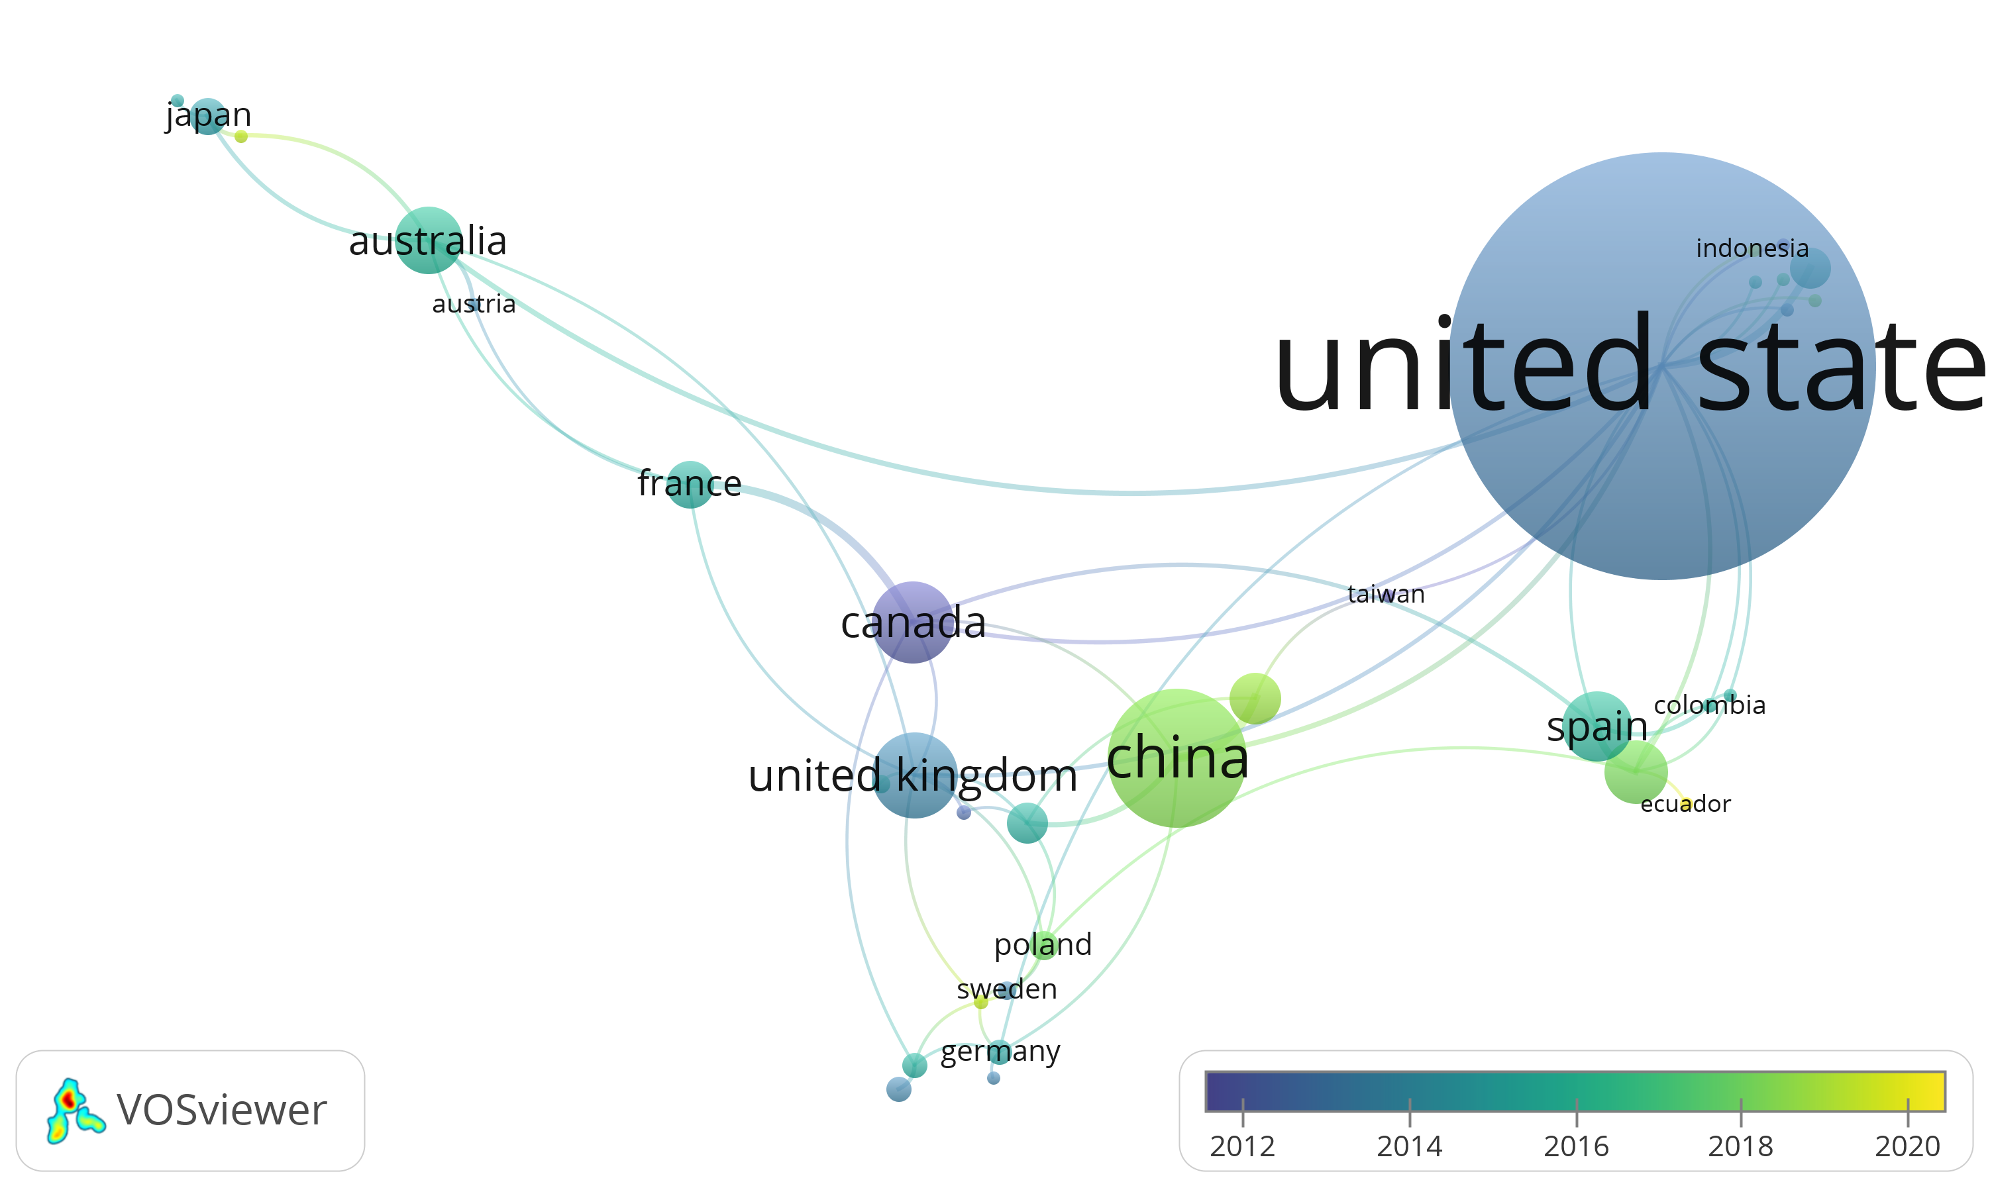
Source: Own study

Figure 5. Countries networking

c. Keywords networking
The co-occurrence of the keywords is analyzed to visualize the authors’ listed keywords. Before examining the keywords, the standardization of the terms is essential. The variety of keywords for the same definition is avoided to enhance the clarity in the network later. For example, “hedonic pricing method, HPM, hedonic pricing regression, hedonic price model or hedonic pricing approach” are changed to “hedonic pricing” to standardise the keywords used. “Spatial econometric or Spatial econometrics” are also standardized to “spatial econometric.” The process is done to all 310 documents. When analyzing the keywords, the threshold is set to five (5), then two previous visualization analyses. This is done to avoid too many clusters which had low co-occurrence. It was found that 23 out of 871 keywords met the tolerance. Table 6 shows the top ten of the highest total link strength calculated in VOSviewer with the occurrence number.
Table 6. Keywords co-occurrence
Keyword | Total link strength | Occurence
Hedonic Pricing | 185 | 123
Spatial econometric | 156 | 142
House price | 109 | 64
Spatial hedonic | 70 | 78
Real estate | 44 | 26
Spatial autocorrelation | 34 | 23
Spatial analysis | 28 | 16
Spatial dependence | 19 | 14
Spatial error model | 17 | 9
Spatial heterogeneity | 16 | 7

Source: Own study

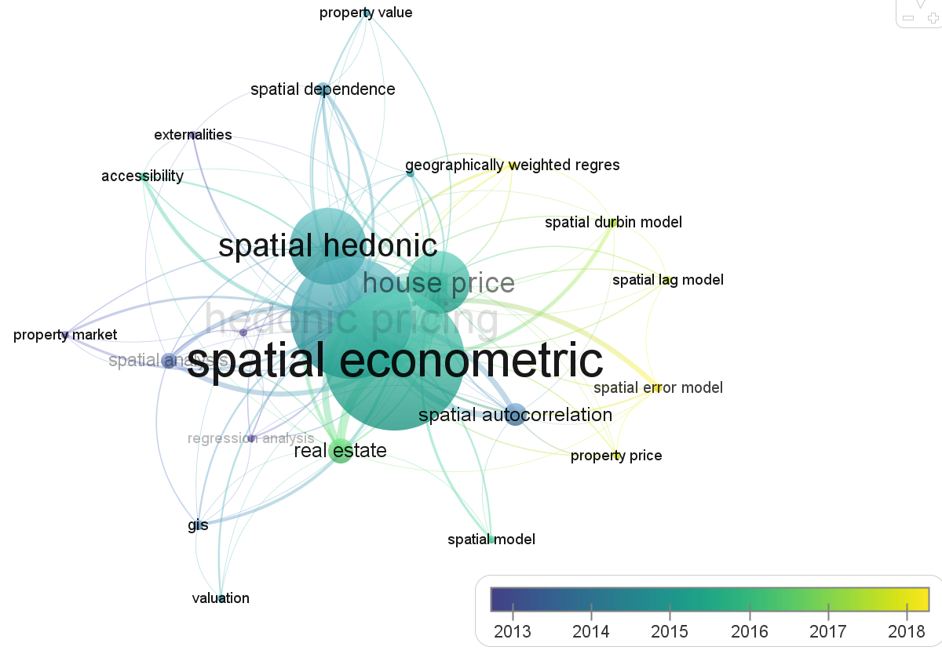
Source: Own study

Figure 6. Keywords networking

Figure 6 represents the keywords networking in the SE and SH field-related studies in property valuation applications. The figure indicates the evolution of the hedonic pricing interest to the spatial application among researchers. The earliest subfield established by hedonics evolved by considering the spatial element represented in yellow colors (meaning the latest subfield) that emphasized the interest in the current issues.

Conclusion

The application of hedonic pricing has shown a significant impact in understanding the preference of buyers and sellers in the context of economic interaction. Even though hedonic pricing is said to be an intelligent and validated analysis (Agimass et al., 2017; Hausman, 2012), yet is facing serious debate among spatial and regional key players. The application of spatial elements cannot be left behind due to the problem of spatial autocorrelation, heteroscedasticity, spatial heterogeneity, and spatial bias (Haniza Khalid, 2015; Suriatini Ismail, 2006). Through the concept of spatial econometrics introduced by Anselin in 1988, the foundation to deal with the understanding of spatial heterogeneity and dependence brought more accuracy in econometrics valuation application. The empirical evidence of spatial dependence and spatial heterogeneity can be seen in many published articles (Ozyurt, 2014; Wang et al., 2019; Laszkiewicz et al., 2022; Wen et al., 2017; Hui et al., 2016; Foelske & van Riper 2020) where they had successfully examined the positive spatial correlation toward the property values. Suriatini Ismail et al. (2008) and Nur Asyikin Mohd Sairi et al. (2021) proved the critical existence of spatial autocorrelation/dependence in hedonic analysis in Malaysian house price studies and suggested that the appropriate statistical steps must be taken when applying hedonic regression. The bibliometric analysis that has been conducted showed the limitation of spatial studies for hedonic property valuation applications, especially in Malaysia, although it received wide attention worldwide. The finding from this would encourage more research opportunities by providing a new gateway, particularly in the contribution of spatial analysis to provide more effective property valuation, especially in understanding the market demand and forecasting appropriate valuation market for property key players, investors as well as property buyers especially in tailoring supply and demand in the property field.

References

Abidoye, R. B., Junge, M., Lam, T. Y. M., Oyedokun, T. B., & Tipping, M. L. (2019). Property Valuation Methods in Practice: Evidence from Australia. Property Management, 37(5), 701–718.
Aghaei Chadegani, A., Salehi, H., Md Yunus, M. M., Farhadi, H., Fooladi, M., Farhadi, M., & Ale Ebrahim, N. (2013). A Comparison Between Two Main Academic Literature Collections: Web of Science and Scopus Databases. Asian Social Science, 9(5), 18–26.
Agimass, F., Lundhede, T., Panduro, T. E., & Jacobsen, J. B. (2017). The Choice of Forest Site for Recreation: A Revealed Preference Analysis using Spatial Data. Ecosystem Services, 31, 445–454.
Aladwan, Z., & Ahamad, M. S. S. (2019). Hedonic Pricing Model for Real Property Valuation via GIS - A Review. Civil and Environmental Engineering Reports, 29(3), 34–47.
Anselin, L. (1988). Spatial Econometrics: Methods and Models. Kluwer Academic Publishers, Springer Science Business Media Dordrecht.
Anselin, L. (2001). A Companion to Theoretical Econometrics Spatial Econometrics. B. H. Baltagi (Ed.), Chapter 14: Spatial Econometrics. (pp. 311–329). Blackwell Publishing Ltd.
Anselin, L., & Lozano-Gracia, N. (2009). Spatial Hedonic Models. (pp. 1213–1250). Palgrave Handbook of Econometrics.
Aria, M., & Cuccurullo, C. (2017). Bibliometrix: An R-tool for Comprehensive Science Mapping Analysis. Journal of Informetrics, 11(4), 959–975.
Assad, A., & Bouferguene, A. (2022). Resilience Assessment of Water Distribution Networks – Bibliometric Analysis and Systematic Review. Journal of Hydrology, 607.
Atsız, O., Ogretmenoglu, M., & Akova, O. (2022). A Bibliometric Analysis of Length of Stay Studies in Tourism. European Journal of Tourism Research, 31(2022), 3101.
Baas, J., Schotten, M., Plume, A., Côté, G., & Karimi, R. (2019). Scopus as a Curated, High-quality Bibliometric Data Source for Academic Research in Quantitative Science Studies. Quantitative Science Studies, 1(1), 377–386.
Binoy, B. V., Naseer, M. A., Anil Kumar, P. P., & Lazar, N. (2022). A Bibliometric Analysis of Property Valuation Research. International Journal of Housing Markets and Analysis, 15(1), 35–54.
Chen, D., Liu, Z., Luo, Z., Webber, M., & Chen, J. (2016). Bibliometric and Visualized Analysis of Emergy Research. Ecological Engineering, 90, 285–293.
Foelske, L., & van Riper, C. J. (2020). Assessing Spatial Preference Heterogeneity in a Mixed-use Landscape. Applied Geography, 125(July), 102355.
Glor, E. D. (2021). Can the PRISMA Protocol be used to Guide a Systematic Literature Review of Antecedents of Policy Innovation Trailblazing and Adoption? The Innovation Journal: The Public Sector Innovation Journal, 26(2), 1–21.
Greenstone, M. (2017). The Continuing Impact of Sherwin Rosen’s “Hedonic Prices and Implicit Markets: Product Differentiation in Pure Competition.” Journal of Political Economy, 125(6), 1891–1902.
Haniza Khalid. (2015). Spatial Heterogeneity and Spatial Bias Analyses in Hedonic Price Models: Some Practical Considerations. Bulletin of Geography. Socio-Economic Series, 28(28), 113–129.
Harzing, A. (2007). Publish or perish. Retrieved from http://www.harzing.com/pop.htm. Retrieved on 15th March 2022.
Herath, S., & Maier, G. (2010). The Hedonic Price Method in Real Estate and Housing Market Research. A Review of the Literature. Institute for Regional Development and Environment (pp.1-21), Vienna, Austria.
Hishamuddin Mohd Ali, Hoh, G. T. L., Sipan, I., Mustafa Omar, & Kamalahasan Achu. (2020). Effects of Behavioural Uncertainties in Property Valuation. International Journal of Built Environment and Sustainability, 7(3), 69–79.
Hu, X., Chulasai, L., & Phuangsaichai, S. (2011). Hedonic Pricing Model for Housing Market in City of Kunming, the People’s Republic of China. Journal of Economics, 143–165.
Hui, E. C. M., Zhong, J., & Yu, K. (2016). Heterogeneity in Spatial Correlation and Influential Factors on Property Prices of Submarkets Categorized by Urban Dwelling Spaces. Journal of Urban Planning and Development, 142(1).
International Valuation Standard. (2022). International Standard for International Market. https://www.ivsc.org/standards/. Retrieved on 10th January 2022.
Jayantha, W. M., & Oladinrin, O. T. (2020). Bibliometric Analysis of Hedonic Price Model using CiteSpace. International Journal of Housing Markets and Analysis, 13(2), 357–371.
Jiang, H., & Chen, S. (2015). Dwelling Unit Choice in a Condominium Complex: Analysis of Willingness to Pay and Preference Heterogeneity. Urban Studies, 1–20.
Jim, C. Y., & Chen, W. Y. (2007). Consumption Preferences and Environmental Externalities: A Hedonic Analysis of the Housing Market in Guangzhou. Geoforum, 38(2), 414–431.
Jim, C. Y., & Chen, W. Y. (2009). Value of Scenic Views: Hedonic Assessment of Private Housing in Hong Kong. Landscape and Urban Planning, 91(4), 226–234.
Kim, Y., Choi, S., & Yi, M. Y. (2020). Applying Comparable Sales Method to the Automated Estimation of Real Estate Prices. Sustainability (Switzerland), 12(14), 1–19.
Lancaster, K. J. (1966). A New Approach to Consumer Theory. The Journal of Political Economy, 74(2), 132–157.
Laszkiewicz, E., Heyman, A., Chen, X., Cimburova, Z., Nowell, M., & Barton, D. N. (2022). Valuing Access to Urban Greenspace using Non-Linear Distance Decay in Hedonic Property Pricing. Ecosystem Services, 53(2021).
Liu, Y., Wang, P., He, Z., & Dong, J. (2021). Real Estate Rental Market: A 10-year Bibliometric-based Review. Economic Research, 34(1), 1752–1788.
Lu, Y., & De Vries, W. T. (2021). A Bibliometric and Visual Analysis of Rural Development Research. Sustainability (Switzerland), 13(11).
Marrouch, W., & Sayour, N. (2021). Hedonic Housing Prices and Environmental Quality in Lebanon. International Journal of Housing Markets and Analysis, 14(5), 953–968.
Meho, L. I. (2019). Using Scopus’s CiteScore for Assessing the Quality of Computer Science Conferences. 13(2019), 419–433.
Mittal, J., & Byahut, S. (2019). Scenic Landscapes, Visual Accessibility and Premium Values in a Single-Family Housing Market: A Spatial Hedonic Approach. Environment and Planning B: Urban Analytics and City Science, 46(1), 66–83.
Moher, D., Liberati, A., Tetzlaff, J., & Altman, D. G. (2009). Reprint-Preferred Reporting Items for Systematic Reviews and Meta-Analyses: The PRISMA Statement. Physical Therapy, 89(9), 873–880.
Newell, G., Mohamed Razali, M. N., & Juanil, D. M. (2010). Assessing Client Perceptions of the Quality of Commercial Valuation Reports in Malaysia. Pacific Rim Property Research Journal, 16(4), 458–476.
Norhaya Kamarudin, Suriatini Ismail, Hishamuddin Mohd Ali, Ibrahim Sipan, & Rosadah Mahamud. (2008). Modeling of the Property Market: The Malaysian Experience. International Real Estate Research Symposium (IRERS) 2008, 1–15.
Nur Asyikin Mohd Sairi, Burhaida Burhan, & Edie Ezwan Mohd Safian. (2021). Spatial Autocorrelation Analysis of Housing Distribution in Johor Bahru. Planning Malaysia, 19(3), 363–374.
Organisation for Economic Co-operation and Development. (2021). OECD Tax Statistics. Retrieved from https://www.oecd-ilibrary.org/taxation/data/oecd-tax-statistics_tax-data-en. Retrieved on 14th August 2021.
Owusu-Ansah, A. (2013). A Review of Hedonic Pricing Models in Housing Research. Journal of Real Estate and Construction Studies, 1, 17–38.
Ozyurt, S. (2014). Spatial Dependence in Commercial Property Prices Micro Evidence from the Netherlands (Issue 1627).
Pagourtzi, E., Assimakopoulos, V., Hatzichristos, T., & French, N. (2003). Real Estate Appraisal: A Review of Valuation Methods. Journal of Property Investment and Finance, 21(4), 383–401.
Ranjbari, M., Shams Esfandabadi, Z., Quatraro, F., Vatanparast, H., Lam, S. S., Aghbashlo, M., & Tabatabaei, M. (2022). Biomass and Organic Waste Potentials Towards Implementing Circular Bioeconomy Platforms: A Systematic Bibliometric Analysis. Fuel, 318.
Rohana Abdul Rahman, & Taher Buyong. (2012). Automated Valuation Model: An Alternative Property Valuation Procedure. Journal of Techno-Social, 4(1), 1–10.
Rosen, S. (1974). Hedonic Prices and Implicit Markets: Product Differentiation in Pure Competition. Journal of Political Economy, 34–55.
Skevas, T., Skevas, I., & Swinton, S. M. (2018). Does Spatial Dependence Affect the Intention to Make Land Available for Bioenergy Crops? Journal of Agricultural Economics, 69(2), 393–412.
Sonnenwald, D. H. (2007). Scientific Collaboration. Annual Review of Information Science and Technology, 41, 643–681.
Suriatini Ismail. (2006). Spatial Autocorrelation and Real Estate Studies: A Literature Review. Malaysian Journal of Real Estate, 1(1), 1–13.
Suriatini Ismail, Abdul Hamid Mar Iman, Norhaya Kamarudin, Hishamuddin Mohd Ali, Ibrahim Sipan, & Navaneethan, R. (2008). Spatial Autocorrelation in Hedonic Model: Empirical Evidence from Malaysia. International Real Estate Research Symposium (IRERS) 2008, April.
Sweileh, W. M. (2022). Health-related Research Publications on Religious Mass Gatherings of Muslims: A Bibliometric Analysis (1980–2020). Tropical Diseases, Travel Medicine, and Vaccines, 8(1), 1–10.
Tamala, J. K., Maramag, E. I., Simeon, K. A., & Ignacio, J. J. (2022). A Bibliometric Analysis of Sustainable Oil and Gas Production Research using VOSviewer. Cleaner Engineering and Technology, 7.
Tobler, W. R. (1970). A Computer Movie Simulating Urban Growth in the Detroit Region. Economic Geography, 46, 234.
Usman, H., Lizam, M., & Burhan, B. (2020). Review of Issues in the Conventional Hedonic Property Pricing Model. International Conference on Industrial Engineering and Operations Management, 59, 2806–2816.
Usman, H., Lizam, M., & Burhan, B. B. (2021). A Review of Spatial Econometrics in Explicit Location Modelling of Commercial Property Market. Planning Malaysia, 19(3), 438–448.
Wang, W. C., Chang, Y. J., & Wang, H. C. (2019). An Application of the Spatial Autocorrelation Method on the Change of Real Estate Prices in Taitung City. ISPRS International Journal of Geo-Information, 8(6).
Wen, H., Gui, Z., Zhang, L., & Hui, E. C. M. (2020). An Empirical Study of the Impact of Vehicular Traffic and Floor Level on Property Price. Habitat International, 97(2019).
Wen, H., Jin, Y., & Zhang, L. (2017). Spatial Heterogeneity in Implicit Housing Prices: Evidence from Hangzhou, China. International Journal of Strategic Property Management, 21(1), 15–28.
Xiao, Y. (2017). Hedonic Housing Price Theory Review. In Urban Morphology and Housing Market (pp. 11–40). Tongji University Press and Springer Nature Singapore Pte Ltd.
Yang, H., Liu, L., Yang, W., Liu, H., Ahmad, W., Ahmad, A., Aslam, F., & Joyklad, P. (2022). A Comprehensive Overview of Geopolymer Composites: A Bibliometric Analysis and Literature Review. Case Studies in Construction Materials, 16.
Zhang, W., Wrenn, D. H., & Irwin, E. G. (2017). Spatial Heterogeneity, Accessibility, and Zoning: An Empirical Investigation of Leapfrog development. Journal of Economic Geography, 17(3), 547–570.

