Knowledge and practice on green purchasing of personal care products among undergraduate students in Universiti Putra Malaysia

Hana Fateha Hashim¹, Haliza Abdul Rahman^{1,2}, Izzah Nadhirah Mohamed Zain¹
¹Department of Environmental and Occupational Health, Faculty of Medicine and Health Sciences, Universiti Putra Malaysia, 43400 Serdang, Selangor.
²Institute for Social Science Studies, Putra Infoport, Universiti Putra Malaysia, 43400 Serdang, Selangor.

Correspondence: Haliza Abdul Rahman (email: dr.haliza@upm.edu.my)

Received:16 June 2022; Accepted: 21 January 2023; Published: 24 February 2023

Abstract

Skincare products, hair care, oral care, cosmetics, and products for feminine hygiene are included in the Personal Care Products (PCP). This study was conducted to determine the level of knowledge and practice in the purchase of green personal care products (PCP). A cross-sectional study was done by distributing a modified set of questionnaires containing five sections among undergraduate students at UPM. Respondents (n=276) were obtained through the multistage cluster sampling method. The data were analyzed by using SPSS version 25.0. The results showed that the majority of respondents had high knowledge (48.0%) of green personal care products (PCP). Based on this study, the buying practice of green personal care products was still at a moderate level (73.0%). Chi-square analysis shows that there was a significant relationship between gender with knowledge and practice with p<0.05, (p=0.0001), and (p=0.004) respectively. In addition, there was also a relationship between knowledge and practice (p<0.05). In conclusion, youth are only aware of the importance of choosing green products, but they still continue to buy conventional products, which will negatively affect the environment in the long run. This issue needs to be highlighted to ensure environmental sustainability in the future. Furthermore, the Ministry of Higher Education and Universiti Putra Malaysia needs to strengthen environmental education in university to create more awareness of environmental protection and conservation among undergraduate students.

Keywords: Environmental awareness, environment sustainability, green purchase, knowledge, personal care product, practice

Introduction

The environmental challenges faced by communities around the world are causing people to become more concerned about environmental issues. The rapid growth in the human population leads to rapid urbanization and development, which leads to an increase in the production of non-biodegradable products. Some people are aware of environmental concerns such as waste pollution. Therefore, they recognize that the purchase of their green products can help the world move towards sustainability. The purchase of green products refers to the purchase of consumer ecologically friendly products or sustainable products that are harmless to the environment (Kilbourne & Pickett, 2008). These products are usually made from natural or recycled materials and have less impact on the ecosystem. Biodegradable products are products that help replenish our earth (Mansvelt, 2011). Many countries have raised awareness to buy green products with greater environmental benefits for society. Therefore, in Malaysia, the government has taken decisive action against environmental protection. For example, to encourage the use of environmentally friendly goods, the availability of green and environmentally friendly goods in the market as desired by customers is being ensured. Green companies such as The Body Shop and Starbucks have also brought green goods products to market. It is a move to increase green brand awareness among consumers (Moeliono et al., 2020). Starbucks also encourages consumers to bring their own containers when purchasing coffee and other drinks at their outlets by giving them coupons as an encouragement toward environmental sustainability (Tsai et al., 2020).
There is a significant gap between environmental concerns and ecological products. Research by Young et al. (2010) stated that even though the consumer already has a highly favorable attitude toward the green purchase, it does not guarantee the actual purchase of the green product. Moreover, a lack of studies focusing on the environmental knowledge and practice of green purchasing behavior, especially PCP in Malaysia (Saleki & Seyedsaleki, 2012). Previous studies showed that the knowledge, attitudes, and environmental awareness among students in higher institutions in Malaysia are at a reasonable level (Mei, Wai & Ahamad, 2016). A study was conducted in the Philippines on the safe use of cosmetics and personal care products among journalists, but the results should not be generalized to university students due to different groups (Serrano, 2015). Based on the current literature, the number of studies on the knowledge and practice of green purchases is very limited. In Malaysia, there is a limited of studies related to the purchase of PCP green among undergraduate students. There is a need to provide baseline data on the level of knowledge and the level of PCP green purchasing practice among undergraduate students. This is to ensure that students develop awareness and form consistent environmental behaviors. The study is also expected to encourage students to make more sustainable consumption decisions as well as purchase toxic-free and environmentally harmless goods in their daily lives.

Literature review

Green purchasing awareness

Green purchasing becoming more important in ensuring the protection against climate change and other ecological problems. In this study, the researcher decided to focus on consumers of university students because students are the most influential and profitable section of consumer spending in the green market (Mokhlis, 2009). A study by Ansu-Mensah (2021) proves that there is an impact of green product awareness among university students the intention of buying green is driven by price, high value, and the product’s quality. Students are among the customers concerned about environmental issues because they are exposed to such issues on a regular basis. It also reported students were aware of environmental concerns, but in practice, they had not yet changed (Chan et al., 2015). Awareness of environmental concerns and environmental conservation awareness has increased in the community, but the level of involvement of individuals in environmental protection activities is still weak (Wahida et al., 2004). Soonthonsmai (2007) stated that green consumers are described as consumers who are concerned with environmental issues. They often have a strong attitude that they are responsible for protecting the environment and thinking about environmental problems. Therefore, green consumers usually buy products that have fewer environmental effects. Renfro (2010) also describes green consumers as people who endorse companies that trade in an environmentally sustainable. They are buying green products and participating in the manufacturing process and environmental protection, and they believe there is a link between product consumption and environmental conservation (Tamer & Popescu, 2016).

Personal care products as a green product

Green products are products that use recyclable, reduce waste, reduce adverse effects on the environment, and produce fewer harmful contaminants (Mazar & Zhong, 2010). In other words, green products known as environmentally friendly or sustainable products have fewer adverse effects on humans and the environment and, from a social and economic perspective, provide more opportunities for long-term practical growth. In the development of Malaysia's industry, knowledge of green products is significant. The green products sector has expanded significantly in line with My HIJAU, which is more sustainable under the Malaysian Government's policy to enable local manufacturers, producers, and suppliers to manufacture green products and services. Green products became increasingly popular because it is safer, hygienic, and environmentally friendly (Ali, Noraziah & Mohd Azlan, 2012). Personal care product (PCP) is one of the by-products of green products. There are one of the main elements that we often see in drug and department stores that are used for health and beauty. PCP includes skincare, haircare, oral care, cosmetics, toiletries, and products for feminine hygiene (Ezlika et al., 2017). It was used by communities in Malaysia for personal health, hygiene, or cosmetics (Davis, 2010). However, most of the packaging used by PCP is plastic which can cause environmental threats. With the increased population in the country, today's rise in PCP has been one of the threats to the environment. The study concerned on purchasing of green products among PCP rather than food and electrical products. The problems regarding the use of PCP were plastic waste disposal and harmful chemical ingredients which can cause environmental pollution and eventually can also affect humans such as endocrine disruption and reproductive effects (Srinivasan et al., 2019).

Consumerism and environmental pollution

With the increased population in the country, today's rise in PCP has been one of the threats to the environment. The study concerned on purchasing of green products among PCP rather than food and electrical products. The problems regarding the use of PCP were plastic waste disposal and harmful chemical ingredients which can cause environmental pollution and eventually can also affect humans such as endocrine disruption and reproductive effects (Srinivasan et al., 2019). The toxic chemical added in the plastic production of PCP can transfer into animal tissue. At the end of the life cycle, it will enter the human food chain. When marine organisms consume it, the toxins absorb from the water accumulate up the food chain causing seafood potentially hazardous for human consumption (Earth Day Network, 2018). The existence of microplastics in the stomach of the Manila shell, Venerupis Philippinarum was proven by one of the studies carried out in the Philippines (Davidson & Dudas, 2016.). Microplastics are a matter of marine pollution since they are tiny, and during the water treatment process, they cannot be filtered out, which then flowed into the marine waterways (Westphalen & Abdelrasoul, 2018).

Green product purchasing among students

Using green products is unusual among students because students' needs for environmentally friendly products are not high on their priority list. Green product prices higher than regular product prices are also a source of concern since they make it difficult for students to satisfy their needs. Students tend to buy items that are less expensive because their income is unstable. Green product companies face a difficult task in providing environmentally friendly things that are also cost-effective and popular among students (Nam, Dong & Lee, 2017). Beckford et al. (2010) claim that attitude is a crucial factor in green product quality. This study supports the findings of a previous study by Paco et al. (2009), which found that consumers' environmental attitude influences their decision to buy a green product, even if it is not a primary motivation for them to buy green items. A study among Generation Y in Thailand reveals that attitude towards green packaging and green marketing awareness have the strongest effects on purchasing intention while environmental concern seems to have the weakest effect on purchasing intention for green personal care products (Moslehpour et al., 2021). A study in India showed that eco-knowledge and peer influence of consumers play a vital factor that inducing consumers to purchase green personal care products (Hariharan & Suresh, 2016). A study by Mohammad (2017) among consumers in Klang Valley showed that quality perceptions of organic personal care items are not significant in influencing consumers' intention to purchase organic personal care products. Young consumers in Malaysia who act in a greener way claim that government has the basic and necessary responsibility to conserve the environment, even though individuals are highly aware and concerned about their environment (Abdul Wahid & Abustan, 2002). Abdul Wahid et al. (2000) revealed that every agency has an equally important role in building a positive environmental attitude. Therefore, many businesses on green products have recently begun to stress their environmental obligation through environmentally friendly products created and to keep track of environmental changes.

Method and study area

Study design and sample size

This study has used a cross-sectional research design that focuses on determining PCP green purchase knowledge and practices among undergraduate students at Universiti Putra Malaysia. The study was conducted at Universiti Putra Malaysia, Serdang, Selangor from 22 March 2021 to 8 May 2021. UPM was chosen as a study location as it ranked first in Malaysia as the top university in the UI-Green Metric World University Ranking. A study done by Hassan et al. (2011) stated that undergraduate students in Malaysia had a 79.72% level of knowledge of the environment. According to the Corporate Strategy & Communication office (CoSComm), the number of undergraduate students in UPM as of June 2020 is 15 000. The sample size was calculated using the Open Epi, a website statistical calculator for proportion for one group formula (Sullivan et al., 2009). The sample size calculated is 251. However, 10% of the sample size was added if any likelihood of dropout among respondents occurs. From the calculation of sample size, the optimum sample size needed was 276 respondents to answer the questionnaires. Since this study involves five courses, the total number of respondents for each course was 55 respondents. Approval from the Ethics Committee of Universiti Putra Malaysia (UPM) was obtained before the study was conducted. This research was conducted on a voluntary basis where all respondents were given a brief on how the study was conducted and filled in the consent form provided. All identities and personal information obtained from the research remain private and confidential. The data obtained was also used only for the purpose of the study. The ethics reference number of this study is JKEUPM-2020-485.

Study instrumentation (questionnaire)

A questionnaire was modified from another research by Serrano (2015). The questionnaire is comprised of five sections. The first section, Section A consists of the socio-demographics of the respondents which are age, gender, and race. The second section, Section B consists of general questions regarding the green purchase of PCP. Next, Section C consists of knowledge about the green purchase of PCP. Section D consists of practice on the green purchase of PCP. Lastly, Section E consists of questions on suggestions for improvement of green purchase on PCP. The level of knowledge and practice on green purchase of PCP among respondents were evaluated by using a self-administrated questionnaire. Furthermore, to ensure the reliability of the questionnaire, a pilot study was conducted among 27 respondents from undergraduate students from other universities who had similar characteristics to the sample subject. Connelly (2008) recommends that a pilot study sample be 10% of the sample project for the larger parent study. Sample size from 10 to 40 per group is evaluated for their adequacy in providing estimates precise enough to meet a variety of possible aims (Hertzog, 2008). The Cronbach alpha obtained from the pilot study was 0.783. Thus, the questions were considered reliable.

Data collection and analysis

The data were collected by distributing the questionnaire to the respondents and requiring them to fill in the information. In this study, a multistage cluster sampling technique was used to select samples. In the first stage, the cluster sampling method was used where the faculty was divided into three disciplines, namely Medicine and Health Sciences, Science and Technical, and Arts and Social Sciences. A total of five faculties were selected from 15 faculties at UPM. In the second sampling stage, one department was selected randomly from each of the faculties which means only selected students from chosen department were involved in this study. Then, one department was chosen randomly from each of the faculties by using random tables to get a specific study sample. The sampling population was conducted among undergraduate universities at UPM. The number of samples in this study was 276 students. This study was divided into three different clusters, which are Medicine and Health Sciences, Science and Technical, and Art and Social Sciences. At UPM, there are only a Faculty of Medicine and Health Sciences under the cluster of Medicine and Health Science, thus, the (Department of Environmental and Occupational Health), was chosen as a course in this study. This was followed by a cluster of Science and Technical (Department of Electrical and Electronic Engineering and Department of Physics), and Arts and social sciences cluster (Department of Accounting and Finance and Department of Food Science). Since this study involves a total of five courses, the total number of respondents for each course was 55. The questionnaires were collected and analyzed by using ‘Statistical Package for Social Sciences (SPSS) Version 25.0. Descriptive statistics were used to determine the mean and standard deviation. Chi-square was used to determine the association between two different groups. The level of knowledge and practice on green purchase of PCP was evaluated using the scoring method based on Table 1.

Table 1. The scoring method for knowledge and practice

Scoring method | Number of questions | Level of score |  |  | Mean of score | Standard deviation
Scoring method | Number of questions | Low | Moderate | High | Mean of score | Standard deviation
Knowledge | 15 | 0-11 | 12-13 | 14-15 | 13.13 | 1.42
Practice | 20 | 0-46 | 47-69 | 70-80 | 58.85 | 12.02

To determine the knowledge and practices of the respondents on the purchase of PCP green 35 questions were given. Each correct answer was given a score of 1 and 0 for the wrong answer. According to Ajit and Chapman (2011), the overall score was changed in terms of score level and classified into 3 levels which were low, medium, and high. Each correct answer on the knowledge assessment was given a score of 1 and 0 scores for the wrong answer. The overall score was converted in terms of score level and was classified into three levels (low, moderate, and high knowledge). For the knowledge assessment, a mean score of 13.13 and a standard deviation of 1.42 was used to classify the subjects into three groups as follows (Ajit & Chapman, 2011). A score of 0 to 11 was classified as low level, a score between 12 to 13 was classified as moderate level and a score of 14 to 15 was classified as high level. The practice scoring method followed these scoring criteria a strongly agree answer with 4 points, agree with the answer with 3 points, disagree answer with 2 points, and a strongly disagree answer with only 1 point. The overall score was converted in terms of score level and was classified into three levels (low, moderate, and high practice). A mean score of 58.85 and standard deviation of 12.02 used to classify the subjects into three groups with a score of 0 to 46 as low level, a score of 47 to 69 was classified as moderate level and a score of 70 to 80 was classified as high level.

Results and discussion

Socio-demographic and general questions on the purchase of PCP

From all socio-demographic characteristics parameters, only the gender and race of the respondents were chosen to be analyzed since the age of the respondents is almost the same aged between 19-25 years. For gender distribution, out of 276 respondents, most of the students are female that are 182 respondents, which represents 66% of the total respondents. While there are only 34 % of males participated in the survey which equates to 94 respondents. For the race distribution, the majority of the respondents were Malay (66.0%). There were only 18.0% of the respondents Chinese and the remaining were Indian (7.0%) and other races (9.0%) respectively. The respondents had been asked six questions. Descriptive statistics were done to get the frequency and percentage of respondents’ chosen answers. Regarding the questions about hearing about the terms of green purchasing, 100% of students heard about that. On the components of how often they use PCP question, 84.1% of students chose they always use PCP, followed by sometimes (14.8%), seldom (1.1%), and none of the students ever use PCP. For the third question, they were asked about the type of PCP that they use. The frequency of student’s preference for PCP showed was sunscreen (74.7%), followed by hair dye (14.1%), deodorants (81.9%), powder (60.6%), shampoo (98.9%), nail polish (15.5%), shower gel (93.1%), makeup (56%), hair gel (22%), perfumes (82.3%) and hand sanitizer (94.2%). Moreover, 23.5% of students spend less than RM 50 on PCP and 46.6 % of students spend between RM50 – RM100 a month, followed by 18.1% of students who spend between RM100 – RM200 and the rest of 11.9% spend between RM100 – RM200. Besides, regarding their preference when buying PCP, the majority of the students prefer the ingredients (244-88.1%), followed by the availability of the products (166-59.9%). Another preference is the cheaper price (157-56.7%), and environmental packaging (100-36.1%). Meanwhile, only 84.1% of students agreed that PCP can cause a problem.

Knowledge of green purchase of PCP

As for the level of knowledge, 132 students had a good level of knowledge (48.0%),104 students had moderate level knowledge (38.0%) and 38 students had poor knowledge (14.0%). Figure 1 shows the level of knowledge on the green purchase of PCP.

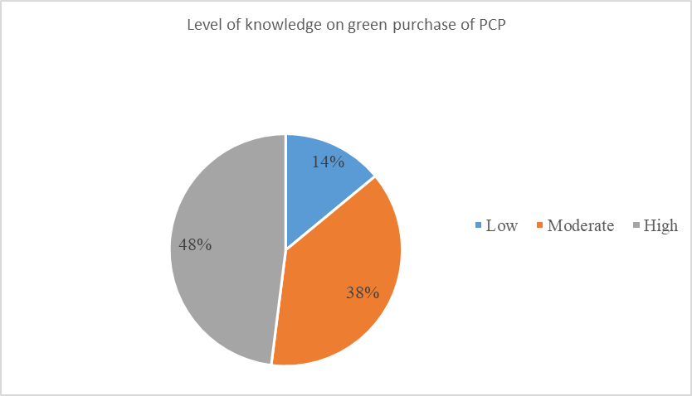

Figure 1. Level of knowledge on green purchase of PCP

This result for this study is in line with a study done by Ahmad et al. (2011) showing that the low level of knowledge of respondents on air pollution and noise shows that the public's attitude towards the environment is relatively low. The findings of this study are similar to previous research conducted among UKM students showing that there is a high level of knowledge, awareness, and attitude followed by a moderate level of environmental practice (Hassan et al., 2011). This study proves that most respondents show appropriate knowledge and are already concerned about environmental issues regarding PCP. Many sources of information related to the environment are readily available. They might know or read about the eco-label PCP, and the information on the packaging reaches the level that catches their attention to what is inside the PCP (Shahnaei, 2012). When this information about PCP is available, it usually turns into knowledge for the consumers (Kaufmann et al., 2012). A previous study proved environmental knowledge and environmental concerns increase customers' green purchase intentions directly green purchase behavior on personal care products in Indonesia (Syadzwina & Astuti, 2021). As recommended by Aman et al. (2012), environmental knowledge does significantly influence students’ behavior on green PCP. Their level of environmental care positively influences a higher level of knowledge and concern toward the environment, and this attitude can lead to their green purchase intentions.

Practice on green purchase of PCP

For the practice level category, a total of 201 students had moderate levels of practice (73.0%). For the higher level, 44 students had high practice (16.0%) while 30 students had poor practice (11.0%). Figure 2 shows the level of practice on the green purchase of PCP.

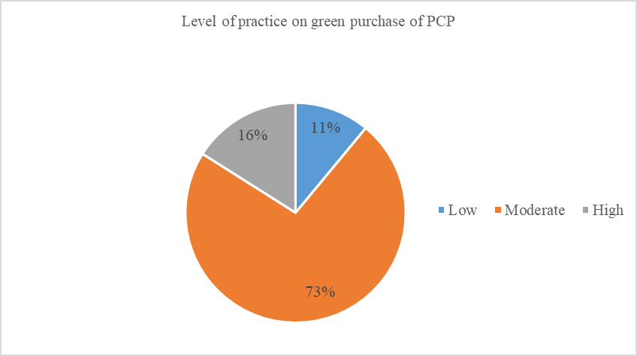

Figure 2. Level of practice on green purchase of PCP

Almost half of the total respondents scored a moderate level for the PCP green purchasing practices level. Zurina and Norjan (2003) showed similar findings, stating that environmental awareness among university students is at a high level, but the practice of environmental sustainability is still at a moderate level. Despite the fact that students have a good level of environmental care, they still lack the practice of preserving the environment (Hadi et al., 2003). This is because most students tend not to purchase the environmentally PCP because the price is higher. They think that other commercial products are cheaper and readily available. D’souza et al. (2006) also stated that if green products are more expensive, consumers are less likely to buy them. A study conducted by Mohamad (2014) also stated students’ involvement and practices in environmental-related activities are moderate as young people do not participate in environmental protection even though they understand the need for environmental conservation.

Association between socio-demographic with student’s knowledge and practice

The association between gender with students’ knowledge and practice were analyzed by using the Chi-square test (Table 2 & 3). There was a relationship between gender and student knowledge and practice on the green purchase of PCP because the p-value is less than 0.05.

Table 2. The association between gender with student knowledge (n=276)

Variables | Knowledge level |  |  | $$X^{2}$$ | p-value
Gender | Low | Moderate | High
Male | 4 | 34 | 56
Female | 34 | 73 | 75 | $${13.474}^{a}$$ | 0.001*
* p is significant when <0.05

Table 3. The association between gender with student practice (n=276)

Variables | Practice level |  |  | $$X^{2}$$ | p-value
Gender | Low | Moderate | High
Male | 18 | 60 | 16
Female | 12 | 143 | 25 | $${11.158}^{a}$$ | 0.004*
* p is significant when <0.05

There was an association between gender and the knowledge level of the green purchase of PCP among respondents. A previous study by Hariharan & Suresh (2016) stated that there was a gender influence on the purchase of green PCP. As for the gender category, women show they are easier to adapt to purchasing products eco-labeled than males (Thogersen et al., 2010). Tikka et al. (2000) also stated that females express more positive attitudes toward the environment than males. Thus, it shows that gender has an association with the knowledge of the green purchase of PCP as women are more likely to use organic products. Besides, one of the previous studies by Bryunina and Khodadad (2011) showed that respondents with higher educational levels also tend to concern more and have higher knowledge levels on green purchasing. However, the information on the level of education was not included in the questionnaire of this study because the respondents have the same level of education.

Association between knowledge and practice on green purchase of PCP

About 85(30.8%) students had high knowledge and moderate practice during green purchase on PCP. Meanwhile, only 25(9.0%) of students had a high level of knowledge and a high level of practice. The Chi-square test obtained was 17.260 and the p-value was 0.001. Therefore, there was an association between knowledge and practice in the green purchase of PCP. Table 4 below shows the association between knowledge with the practice of green purchase of PCP.

Table 4. The association between knowledge with student practice (n=276)

 | Practice level, N (%) |  |  | $$X^{2}$$ | p-value
Knowledge | Low | Moderate | High
Low | 3 | 34 | 1
Moderate | 5 | 84 | 17
High | 22 | 85 | 25 | 17.260 | 0.001*
* p is significant when <0.05

Bokhari et al. (2012) show that consumers with high knowledge of environmental interests will be more likely to practice environmentally friendly purchases. This is supported by a study in Vietnam showed consumers with higher levels of green cosmetics knowledge are directly associated with higher levels of purchase intention (Limbu et al., 2022). However, this study showed different results. Similar to studies by Srinivasan et al. (2019) on knowledge and practice in assessing professional students on plastic knowledge and practice at Annamalai University, Tamil Nadu which shows there is a significant relationship between knowledge and environmentally friendly purchasing practices. This is supported by Bakar et al. (2013) study among students at UPM, finding that there was a significant relationship between the level of awareness of green environmental behavior, although relatively weak. This shows that, although students have a high level of environmental knowledge, they do not always adopt an environmentally friendly lifestyle in their daily lives. Although knowledge of health behaviors is very useful in preserving the environment, it does not indicate that this younger generation was following it thoroughly (Wang et al., 2014).

Recommendation on green purchase of PCP

It shows that 54.0% of the respondents suggest increasing awareness among the community through education to improve the green purchase of PCP. Respondents suggest environmental education should be taught in schools (27.1%) and only 18.8% of the respondents suggest purchasing environmentally friendly products. Figure 3 shows the recommendation of the respondents regarding the green purchase of PCP.

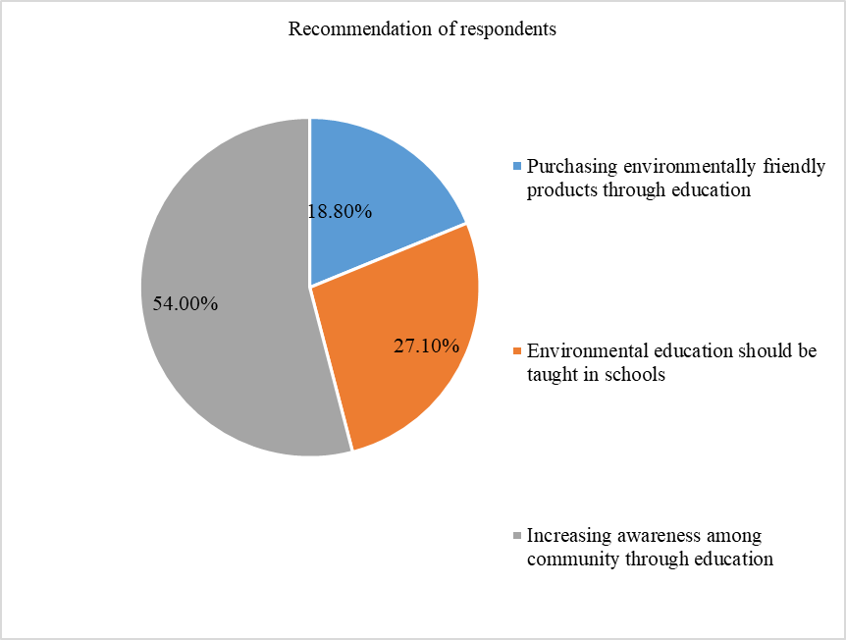

Figure 3. Recommendation of respondents on the green purchase of PCP

Wahida et al. (2004), indicated that while community knowledge and understanding of the need to conserve the environment has improved, individual involvement in ecological preservation initiatives remains low. It proves that knowledge does lead to practices, but it has often forgotten shortly after it is acquired. Therefore, a high level of knowledge of students about environmental sustainability must be maintained to increase their environmental awareness and influence them in practicing environmentally friendly purchases, especially green PCP products. About 149 respondents suggested increasing awareness among the community to improve on green purchase of PCP. The community level of awareness and participation in environmental programs is vital to improving the green purchase of PCP. As suggested by Shen (2012), a community that perceives awareness shows more environmentally conscious and is willing to purchase eco-friendly products. This is also supported by previous research, which reveals that having alone awareness does not always equate to pro-environmental behavior (Kollmus & Agyeman, 2002; Steg et al., 2014). Thus, the concept of sustainable development emphasizes environmental well-being needs to be improved through community participation.

Conclusion

In conclusion, this study showed that undergraduate students have a high level of knowledge about the purchase of green Personal Care Products (PCP). This shows that the younger generation in Malaysia already has a high awareness of the importance of green purchases as part of a strategy to maintain environmental sustainability. However, based on this study, the level of green buying practices is moderate. This issue must be addressed as soon as possible because it shows that youth are only aware of the importance of choosing green products, but they still continue to buy conventional products, which may have a negative impact on the environment. The Ministry of Higher Education (MOHE) and Universiti Putra Malaysia need to strengthen environmental education in universities to create more awareness of environmental protection and conservation. In applying good practices to achieve sustainable goal development, it must be supported by consumers having a good knowledge of sustainable products. The study also shows that marketers have the greatest influence on the personal care products (PCP) market. Marketers can emphasize more green purchases on social media, especially to potential customers such as university students. The intention to buy green goods will increase among consumers and they will change habits by creating a good attitude toward preserving the environment.

Acknowledgement

The authors would like to thank all respondents who have been voluntarily involved in participating throughout the data collection process of this study.

References

Abdul Wahid, N., & Abustan, I. (2002). Environmental concern: between consumers’ awareness and willingness for attitude change. Realizing Agenda21: International Conference on Environmental Management: Universiti Kebangsaan Malaysia, Bangi, Selangor, 579-590.
Abdul Wahid, N., Abustan, I., & Karwi, A. B. (2000). Environmental concern: how do young Malaysian fare? Advances in international businesses. Hong Kong SAR, PRC China, Oliver H. M. YAU, City University of Hong Kong, 482-494.
Ahmad, J. H., Mustafa, H., Hamid, H. A., & Wahab, J. A. (2011). Pengetahuan, sikap dan amalan masyarakat Malaysia terhadap isu alam sekitar (knowledge, attitude and practices of Malaysian society regarding environmental issues). Akademika, 81(3), 103-115.
Ajit, S. & Chapman, R. (2011). Knowledge, Attitude, and Practices (KAP) on Disposal of Sharp Waste, Used for Home Management of Type-2 Diabetes Mellitus, in New Delhi, India. Journal of Health Research, 25(3), 135-140.
Ali, Noraziah, & Mohd Azlan Abdullah. (2012). The food consumption and eating behavior of Malaysian urbanites: Issues and concerns. Geografia: Malaysian Journal of Society, 8(6),157-165.
Aman, A. H. L., Harun, A., & Hussein, Z. (2012). The influence of environmental knowledge and concern on green purchase intention the role of attitude as a mediating variable. British Journal of Arts and Social Sciences, 7(2), 145–167.
Ansu-Mensah, P. (2021). Green product awareness effect on green purchase intentions of university students’: an emerging market’s perspective. Future Business Journal, 7(1), 1-13.
Bakar, H. A., Abd Aziz, N., Narwawi, N. A. M., Abd Latif, N., Ijas, N. M., & Sharaai, A. H. (2013). kajian perhubungan antara kesedaran alam sekitar dengan tingkah laku mesra alam sekitar dalam kalangan pelajar universiti; Kajian kes: pelajar tahun satu Universiti Putra Malaysia (UPM). Journal of Chemical Information and Modeling, 53(9), 1689-1699.
Beckford, C.L., Jacobs, C., Williams, N. & Nahdee, R. (2010). Aboriginal Environmental Wisdom, Stewardship and Sustainability: Lessons from the Walpole Island first nations, Ontario, Canada. The Journal of Environmental Education, 41(4), 239-248.
Bokhari, M., Hassan, S. N. S., & Saadan, R. (2012). The Relationship between Understanding, Awareness, and Ethics of Confidentiality Practice among Malaysian Counsellors. Journal of Human Capital Development, 5, 63-73.
Bryunina, D., & Khodadad Safaei, S. (2011). The Influence of Eco-labeled Products on Consumer Buying Behavior: By focusing on eco-labeled bread. (PhD Dissertation). Mälardalen University.
Chan, L. M., Chalupka, S. M., & Barrett, R. (2015). Female college students awareness of exposure to environmental toxins in personal care products and their effect on preconception health. Workplace Health & Safety, 63(2), 64-70.
Connelly, L. M. (2008). Pilot studies. Medsurg nursing, 17(6), 411.
D ́Souza, C., Taghian, M., & Lamb, P. (2006). “An empirical study on the influence of environmental labels on consumers”, Corporate Communications: An International Journal, 11(2), 162-173.
Davidson, K., & Dudas, S. E. (2016). Microplastic Ingestion by Wild and Cultured Manila Clams (Venurupis Philippinarum) from Baynes Sound, British Columbia.
Davis, M.P., (2010). DDT spray is safe. Retrieved from http://www.thestar.com.my/story/?File=%2F2010%2F8%2F12%2Ffocus%2F6844126&sec=focus.
Earth Day Network. (2018). Plastic Pollution Primer and Action Toolkit [Ebook]. Retrieved from https://www.earthday.org/wp-content/uploads/Plastic-Pollution-Primer-and-Action-Toolkit.pdf.
Ezlika, G., Pat, C. S., Dilip, S. M., & Bang, N. (2017). Health and cosmetics: Investigating Consumer’s values for buying organic personal care products. Journal of Retailing and Consumer Services, 39, 154-163.
Hadi, M. Y. A., Yunos, J. M., & Esa, A. (2003). Enhancing Knowledge, Practice and Attitudes towards Natural Education among Students. In Prosiding Seminar Kebangsaan Pengurusan Persekitaran, 187-194.
Hariharan, G., & Suresh, P. (2016). Green Purchasing of Personal Care Product, Journal Advances in Economics and Business Management (AEBM), 3(1), 58-63.
Hassan, A., Rahman, N. A., & Abdullah, S. I. S. S. (2011). The level of environmental knowledge, awareness, attitudes and practices among UKM students. University Kebangsaan, Malaysia, 13, 5-8.
Hertzog, M. A. (2008). Considerations in determining sample size for pilot studies. Research in nursing & health, 31(2), 180-191.
Kaufmann, H. R., Panni, M. F. A. K., & Orphanidou, Y. (2012). Factors affecting consumers' green purchasing behavior: An integrated conceptual framework. Amfiteatru Economic Journal, 14(31), 50-69.
Kilbourne, W., & Pickett, G. (2008). How materialism affects environmental beliefs, concern, and environmentally responsible behavior. Journal of Business Research, 61(9), 885-893.
Kollmuss, A., & Agyeman, J. (2002). Mind the gap: why do people act environmentally and what are the barriers to pro-environmental behavior? Environmental education research, 8(3), 239-260.
Limbu, Y. B., Pham, L., & Nguyen, T. T. T. (2022). Predictors of Green Cosmetics Purchase Intentions among Young Female Consumers in Vietnam. Sustainability, 14(19), 12599.
Mansvelt, J. (Ed.). (2011). Green consumerism: an A-to-Z guide (Vol. 6). SAGE.
Mazar, N., & Zhong, C. B. (2010). Do green products make us better people? Psychological Science, 21(4), 494–498.
Mei, N.S., Wai, C.W. & Ahamad, R. (2016). ‘Environmental awareness and behaviour index for Malaysia’, Procedia-Social and Behavioral Sciences, 222, 668–675.
Moeliono, N., Fakhri, M., Sari, D., Kurnia, B., & Anindita, D. A. (2020). Green brand awareness factors on the body shop product. In Proceedings of the International Conference on Industrial Engineering and Operations Management (pp. 932-938).
Mohamad, N. (2014). Penglibatan dalam aktiviti kitar semula kertas terpakai dalam kalangan pelajar Fakulti Pendidikan Teknikal dan Vokasional, Universiti Tun Hussein Onn Malaysia (Doctoral dissertation). Retrieved from Universiti Tun Hussein Onn Malaysia.
Mohammad, N. (2017). Intention to purchase organic personal care product. Advanced Science Letters, 23(8), 7367-7369.
Mokhlis, S. (2009). An investigation of consumer decision-making styles of young adults in Malaysia. International Journal of Business and Management, 4(4), 140-148.
Moslehpour, M., Chaiyapruk, P., Faez, S., & Wong, W. K. (2021). Generation Y’s Sustainable Purchasing Intention of Green Personal Care Products. Sustainability, 13(23), 13385.
Nam, C., Dong, H., & Lee, Y. A. (2017). Factors influencing consumers’ purchase intention of green sportswear. Fashion and Textiles, 4(1), 1-17.
Paco, A. D. & Raposo, M. (2009), “Green” segmentation: An application to the Portuguese consumer market. Marketing Intelligence & Planning, 27(3), 364-379.
Renfro, L. A. (2010). Green business operations and green marketing. Gatton Student Research Publication, 2(2), 1-8.
Saleki, Z. S., & Seyedsaleki, S. M. (2012). The main factors influencing purchase behaviour of organic products in Malaysia. Interdisciplinary Journal of Contemporary Research in Business, 4(1), 98-116.
Serrano, M., (2015). Knowledge, Attitudes, Practices (KAP) and Sources of Information on Safe Cosmetics and Personal-care Products Among Journalists in a Major Philippine Newspaper.
Shahnaei, S. (2012). The impact of individual differences on green purchasing of Malaysian consumers. Int. J. Bus. Soc. Sci. 16(3), 132-14.
Shen, J. (2012). Understanding the determinants of consumers’ willingness to pay for eco-labeled products: An empirical analysis of the China Environmental Label. Journal of Service Science and Management, 5(1), 87-94.
Soonthonsmai, V. (2007). Environmental or green marketing as a global competitive edge: Concept, synthesis, and implication. EABR (Business) and ETLC (Teaching) Conference Proceeding, Venice, Italy.
Srinivasan, N., Swarnapriya, V., Felix, A. J. W., & Pravin, T. (2019). Assessment of knowledge and practice on plastics among the professional course students of Annamalai University, Tamil Nadu. International Journal of Community Medicine adefrand. Public Health, 6(2), 510-514.
Steg, L., Bolderdijk, J. W., Keizer, K., & Perlaviciute, G. (2014). An integrated framework for encouraging pro-environmental behaviour: The role of values, situational factors and goals. Journal of Environmental Psychology, 3(38), 104-115.
Sullivan, K. M., Dean, A., & Soe, M. M. (2009). On Academics: OpenEpi: A Web-Based Epidemiologic and Statistical Calculator for Public Health. Public Health Reports, 124(3), 471–474.
Syadzwina, M. N., & Astuti, R. D. (2021). Linking green skepticism to green purchase behavior on personal care products in Indonesia. In IOP Conference Series: Earth and Environmental Science, 716(1), 012045.
Tamer, B., & Popescu, C. (2016). Generation Z Attitudes Toward Green Marketing: A Cross Country and Gender Analysis. Economy Series, 3, 6-9.
Thøgersen, J., Haugaard, P., & Olesen, A. (2010). Consumer responses to eco-labels. European Journal of Marketing, 44, 1787-1810.
Tikka, P., Kuitunen, M. & Tynys, S. (2000). Effects of educational background on students’ attitudes, activity levels, and knowledge concerning the environment. The journal of environmental education, 31(3), 12-19.
Tsai, P. H., Lin, G. Y., Zheng, Y. L., Chen, Y. C., Chen, P. Z., & Su, Z. C. (2020). Exploring the effect of Starbucks' green marketing on consumers' purchase decisions from consumers’ perspective. Journal of Retailing and Consumer Services, 56, 102162.
Wahida, A., Ismail, H. & Tuan Rokiyah, S. H. (2004). Sokongan dan Penglibatan Masyarakat ke arah Pemantapan Pengurusan Alam Sekitar Mampan. In Seminar Kebangsaan Geografi dan Alam Sekitar, Bangi: Universiti Kebangsaan Malaysia.
Wang, S. (2014). Consumer characteristics and social influence factors on green purchasing intentions, Journal of Marketing Intelligence and Planning, 32(7), 738-75.
Westphalen, H., & Abdelrasoul, A. (2018). Challenges and Treatment of Microplastic in Water. Water Challenges of an Urbanizing World, 5, 71-82.
Young, W., Hwang, K., McDonald, S., & Oates, C. J. (2010). Sustainable consumption: green consumer behaviour when purchasing products. Sustainable development, 18(1), 20-31.
Zurina, M., & Norjan, Y. (2003). Kesedaran alam sekitar: Tinjauan awal di kalangan pelajar Universiti Kebangsaan Malaysia. Proceedings of the Seminar Kebangsaan Pengurusan Persekitaran, 8-9.

