Wetlands estimation survey using DotS method: The case of Paya Indah Wetlands (PIW), Malaysia

Nurul’ Ain Jamion^{1,2}, Khai Ern Lee^{1,3}, Mazlin Mokhtar^{1,3}, Thian Lai Goh⁴, Norbert Simon⁴, Rodeano Roslee⁵

¹Institute for Environment and Development (LESTARI), Universiti Kebangsaan Malaysia, Bangi, Selangor, Malaysia.
²Universiti Teknologi MARA, Cawangan Negeri Sembilan, Kuala Pilah Campus, Kuala Pilah, Negeri Sembilan, Malaysia.
³Jeffrey Sachs Center on Sustainable Development, Sunway University, Bandar Sunway, Selangor, Malaysia.
⁴Faculty of Science and Technology, Universiti Kebangsaan Malaysia, Bangi, Selangor, Malaysia.
⁵Natural Disaster Research Centre, Faculty of Science and Natural Resources, Universiti Malaysia Sabah, Kota Kinabalu, Sabah, Malaysia

Correspondence: Khai Ern Lee (email: khaiernlee@ukm.edu.my)

Received: 21 June 2022; Accepted: 19 January 2023; Published: 24 February 2023

Abstract

Climate change poses a detrimental impact on the environment due to increasing carbon dioxide concentration in the atmosphere. In mitigating climate change, wetlands play a significant role in optimising the function of the earth's ecosystem for carbon sequestration and water resources rehabilitation. However, the effectiveness of wetlands management depends on an ecologically and statistically adequate dataset. Unfortunately, it is difficult for developing countries to implement area frame methods based on established sampling methods for data collection and monitoring. Thus, in this study, the dot sampling (DotS) method was adopted as it is simple, efficient, reliable and does not need a sample frame or high cost. DotS method uses the readily available platform, i.e., integration between Microsoft Excel-Macro (EM) and Google Earth (GE). This method systematically distributes the sample dots in GE's target area according to the locations generated by the EM. The field survey was then conducted at the sample dots of the target area in Paya Indah Wetlands (PIW) to ratify the site location. During the first stage, 72 dot sample locations were generated systematically, distributed across the target area, and 47 dot sample locations were located within the PIW. After the preparatory stage, 10 dot sample locations were eliminated. After the fieldwork inspection and evaluation, only 28 dot sample locations were selected as study stations. Hence, this study provides comprehensive data and examples applying the established DotS method with high reliability, accuracy, and rapidity in determining the number of study stations of wetlands. Based on the advantages, this study recommends the DotS method as a reliable survey method suitable for all study locations, especially in the ecology field. Applying the Dots methods as a surveying tool enables rapid land assessment in planning and suits the assessment of ex-mining constructed wetlands.

Keywords: Climate change, constructed wetland, DotS method, estimation survey wetland, excel-macro, google earth
Introduction

Climate change is a global problem encountered by the world today (Belay et al., 2017), attributed to the increasing concentration of carbon dioxide (CO₂). According to Dunn et al., (2020), the global average CO₂ concentration at the troposphere surface was recorded at 409.8 ± 0.1 ppm, which had increased by 2.5 ± 0.1 ppm from 2018. An increase in CO₂ concentration has a detrimental effect on the economy, social and the most worrying is the environment, especially the availability of water resources is threatened by climate change (Jamion et al., 2022a; Moss et. al., 2010). Therefore, urgent action is needed to combat climate change and its impact on water resources by 2030 as set out in SDG 6 and SDG 13 of the Sustainable Development Goals (SDGs) (Masi et al., 2018). Various actions are being implemented to address and reduce CO₂ emissions in the atmosphere and conserve water resources through technology and innovation approaches (Bellamy, 2015; Davis et al., 2010). In this context, maximising the function of the earth's ecosystem for carbon sequestration and rehabilitation of water resources, such as wetlands, are significant and effective in reducing climate change (Lorenz & Lal, 2018).
Wetlands are often described as the ‘kidneys of the earth’ because of their services and functions towards the earth's ecosystem (Mitsch et al., 2013). In recent years, there has been an increase in concern about the state of wetland cover, either at the regional or global levels as well as the importance of monitoring improvements for environmental sustainability (Jamion et al., 2022b; Pinke et al., 2017; Tran et al., 2018). Due to the rising need for spatially explicit wetlands management approaches, geospatial information is a prerequisite for establishing the wetland ecosystem as a vital role in climate change mitigation (Margules & Pressey, 2000). Moreover, Rosli et al. (2017) reviewed that wetlands are of high potential ecosystems for capturing and storing carbon (carbon sink) with a very high carbon storage capacity (an average of 830 Tg y⁻¹), making up 20% of the landscape in boreal regions with large swaths of peatland. Therefore, wetlands are expected to play a key role in global climate change by sequestering and releasing a significant amount of fixed carbon into the biosphere. However, globally, wetlands have experienced significant losses due to the agricultural transition (Bhomia et al., 2016). Identifying the wetland ecosystem's physical, spatial and temporal characteristics has become the most challenging task (Takashina et al., 2018) whereby undervaluation of the ecological services rendered by wetlands is a foremost impediment to their protection, conservation and restoration (Pinke et al., 2017). Thus, wetlands must be managed to protect the wetlands' ecological resources to attain the sustainability of the ecosystem.
In developing countries, establishing a reliable and cost-effective survey system for wetlands surveys is essential, whereby the effectiveness of management depends on the development of an ecologically and statistically adequate dataset. Unfortunately, it is difficult for developing countries to implement the area frame method based on established sampling methods because of its high cost and requires a lot of labour, even during the sampling survey preparation stage, where it is necessary to construct area frames (Takashina et al., 2018). Even the point sampling method seems to be time-consuming because this method needs two-stage sampling and stratification. Furthermore, the established techniques using geographic information systems (GIS) apply the latest remote sensing technology, requiring expensive software and sophisticated instruments besides needing expert, qualified and well-trained staff to handle the instruments and interpret the data (Chawla et al., 2020; Salari et al., 2014). Nevertheless, there is a chance that the interpretations carry the possibility of several biases in the analysis of the data, such as inaccurate results during the drawing of boundaries of the polygon.
In contrast, the DotS sampling method is simple, efficient, reliable and does not need a sample frame or high cost. This method can also overcome one form of bias in digitising field boundaries which are systematic errors. Even though this method is still new and not popular in the field of ecology, this method is seen to have more advantages than other earlier developed and published methods in surveying land use such as cropland and wetlands, especially for developing countries with incompetent personnel and lack of resources (Elham & Mahdavi, 2019; FAO, 2019; Kadarmanto, 2018; Srivastava, 2014). Hence, this study attempts to adopt the DotS method (Jinguji, 2012) to determine the study stations for water sampling and soil purposes at Paya Indah Wetlands (PIW), Malaysia, as a case study to determine the potential of PIW as a water resource and carbon storage. The assessment of the performance of the PIW and its potential use in carbon sequestration and as water resources are one of the key components of the nature values for the PIW evaluation process. Thus, the use of the Dots method as a surveying tool in this study area will provide rapid appraisal in planning for such ex-mining constructed wetlands, to ensure the resources and their nature values could be sustained over the long term. Plus, the Dots method is suitable for field surveys in a large-scale area and authorities facing a lack of resources (both financial and human) but need the evaluation that considers both the natural environment and different land uses.

Overview of the Dot sampling (DotS) method

DotS method was developed by Jinguji and Yuksel from 2011 to 2013 (Kamikura, 2012) using the available platform to improve conventional statistics and the latest information technology, which are Microsoft Excel-Macro (EM) and Google Earth (GE). This method systematically distributes the sample dots on GE's target area according to the locations that are generated in the EM. Then, the field survey can be conducted at the sample dots in the target area to ratify the site location. The DotS method is easy to use and learn, even for an unskilled person in the field of surveying. Besides, it has high reliability where non-sampling error can be avoided as the field survey can be conducted to check the accessibility or feasibility of the area on the sample dot (Jinguji et al., 2019). The DotS method is also efficient as it is applied to statistical activities, automating the area dot generation in the processing steps; thus, it can save cost, resources and time (Jinguji, 2014). Furthermore, this method has been established in the agricultural field and has recently been incorporated into a survey guideline for planning rice cultivation by the Food and Agriculture Organisation of the United Nations (FAO, 2019). This method has been widely used in Japan, Ghana, Bolivia, Thailand, and Indonesia mainly to monitor crop yields and fields (Degefie, 2018; Hanasaka, 2019; Jinguji et al., 2019; Manurung, 2018) (News, 2017). The DotS method procedure consists of four sampling stages as illustrated in Figure 1.

Method and study area

In this study, the former tin mining lake, Paya Indah Wetlands (PIW), was chosen as a case study for its past historical background which might contribute to the escalation of the level of carbon sequestration and as water resources. Paya Indah Wetlands (PIW) (2° 51'35.1 "N 101° 38'03.4" E) is an eco-tourism wetland attraction located in the district of Kuala Langat, Selangor, Malaysia. PIW is easily accessible by visitors due to its location, located only 8km from Dengkil, 20km from Kuala Lumpur International Airport (KLIA), and approximately 50km from the capital Kuala Lumpur. PIW area is about 3050 hectares, but only 450 hectares are managed by the Department of Wildlife and National Parks (PERHILITAN). Paya Indah (which translates to 'beautiful wetlands') is an artificial wetland area established in 1998 which was severely degraded by tin mining and sand dredging. Fish, lotus, water lilies and some exotic animals, such as crocodiles and hippos, now live in the lakes created by the mining operations. The land area of a former mine shows historical and cultural values, which can be classified as a legacy and preserved for tourism purposes (JPBD Malaysia, 2014).

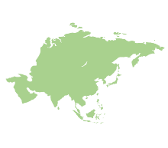
Stage 1: DotS sampling
Stage 2: Preparation work (desktop work)
Stage 3: Fieldwork
Start
  - Decide the target area and sample size.
  - Generate the sample DotS in EM.
  - Put sample DotS on GE.
  - Survey on land use through desktop study, such as list the sample DotS in the target area.
  - Estimate the sample DotS as a sample location.
End
3.1 Visit the location of a dot sample that can potentially be used as a study station.
3.2 Carry out sampling at the study station.

Stage 4: Estimation (Outcome)
Source: Jinguji, 2012
Figure 1 . Procedure of the DotS method

Overall, PIW consists of 14 lakes and can be categorised into three zones, which are the recreation zone, education zone, conservation and research zone. Figure 2 shows the location map of the PIW study area. Visitors can enjoy a few activities at the recreation zone, such as fishing and watching wildlife like crocodiles, rhinos, ducks, hedgehogs, turtles and many more. Through observation, various types of bird species make the lakes in this zone a habitat. Among them are Black-throated, Blue-tailed, Flycatcher, Kingfisher, Green Pigeon and others. A study conducted by Rajpar et al. (2014) recorded that there were 100 species of birds from 38 types of families found in PIW, with 18 species being migratory birds and the rest being native species. However, through an unstructured interview session with staff and rangers at PIW, the number of birds has fallen drastically last few years since the land-use change takes place for more development surrounding the PIW.
The list of lakes in PIW by zone is shown in Table 1 and it is noted that the Teratai lake covers all three zones due to its largest area. This study categorised PIW according to its habitat by physical landscape characteristics, such as plant diversity. The categories are open area, bush, marsh swamp, lotus swamp and lake area, where the description of each class is given in Table 2. Habitat classification based on plants in PIW is essential and sufficient in determining the lake's carbon uptake potential and water quality (Peh et al., 2017). Additionally, the carbon absorption mechanism also depends on its plant landscape factors (Fennessya et al., 2018).

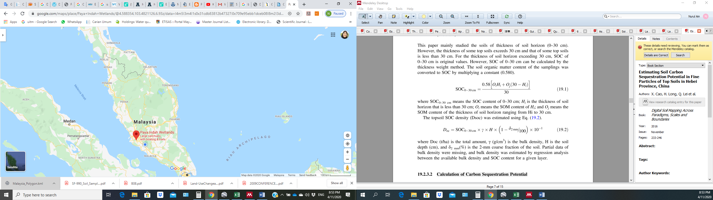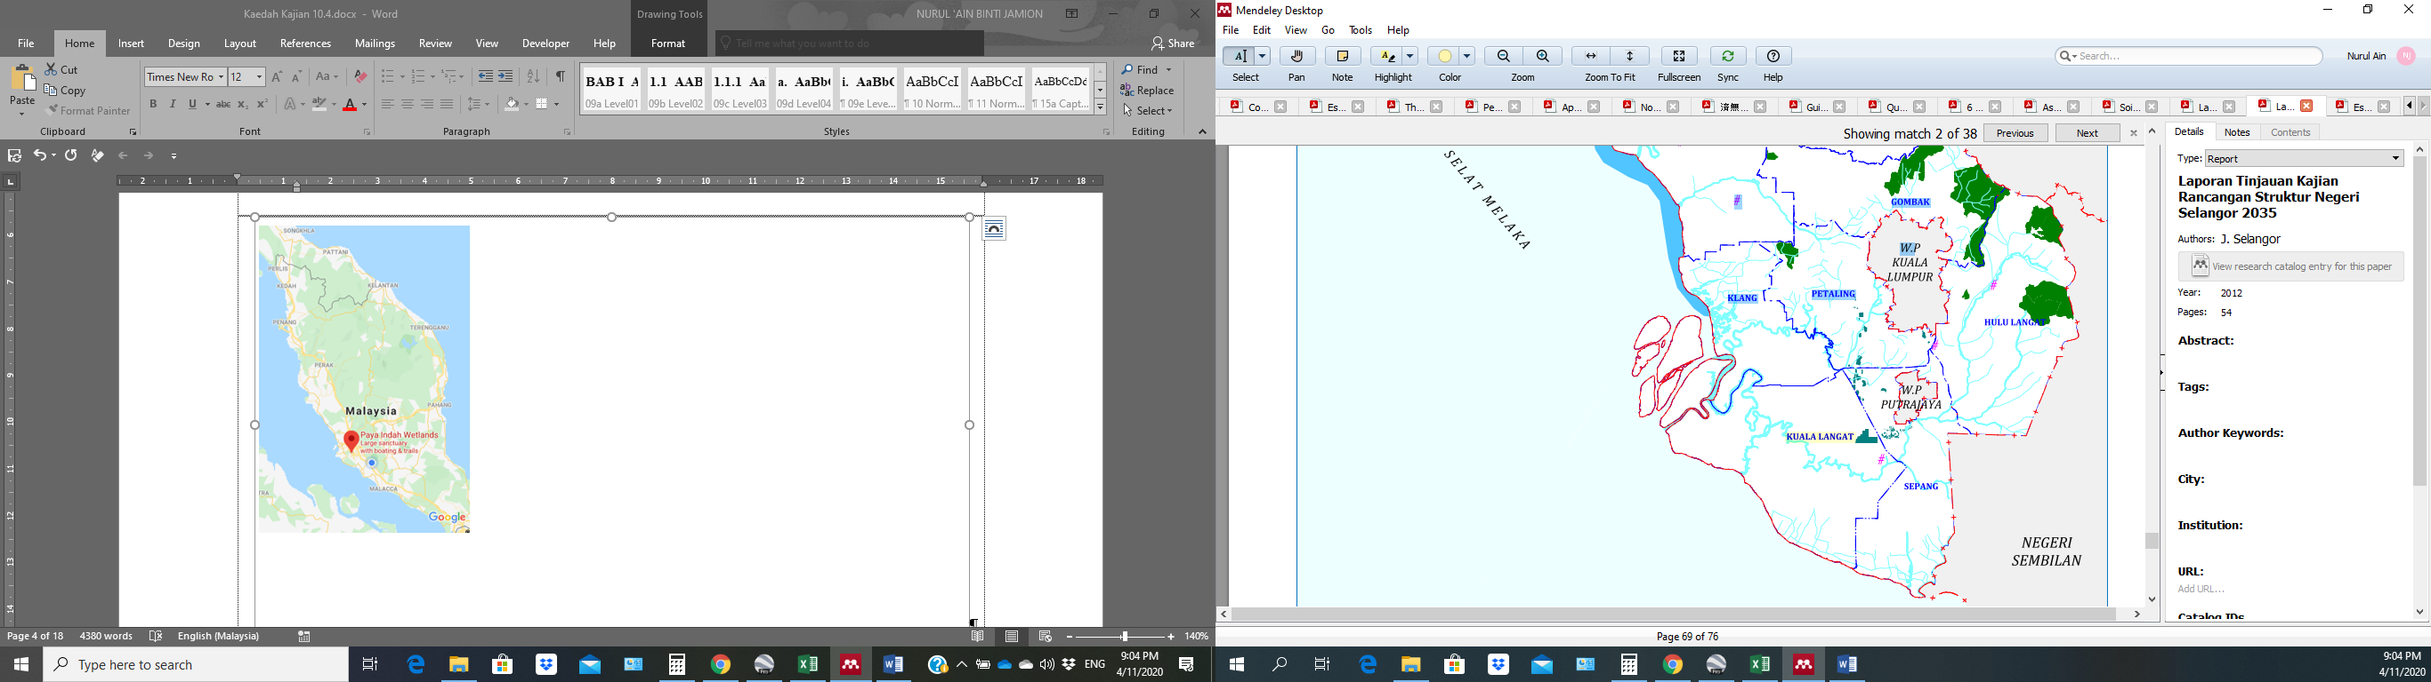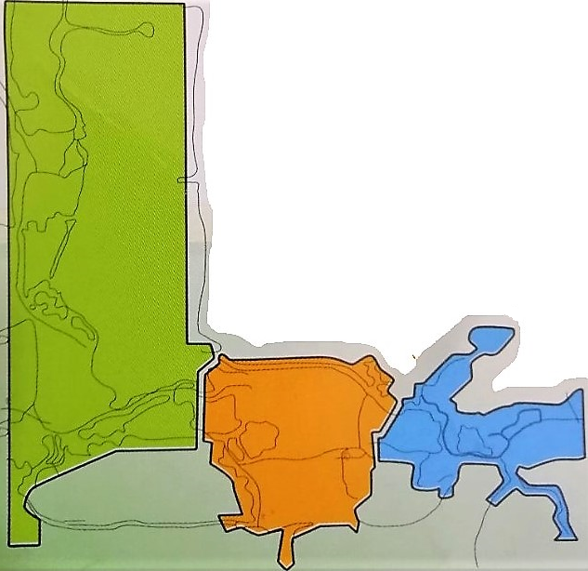
Paya Indah Wetlands (PIW)
Area: 450 hectares

Research and Conservation Zone
Education Zone
Recreation Zone

Source: JPBDS, 2017

Figure 2 . Location of the study area, Paya Indah Wetlands

DotS Method

As shown in Figure 1, the DotS method consists of three stages where the first stage is dot sampling, the second stage is preparation work, and the last stage is fieldwork. The first and second stages are the desktop work that needs to be done before going to the actual fieldwork for survey estimation. Figure 3 shows the lakes and areas of PIW as a study location (in blue) taken by GE.
The first stage was conducted using EM and GE platforms to estimate the number of study stations at PIW by estimating the dot sample. Table 3 (a) shows the data entered into EM and the programme will generate the dot sample location automatically according to the latitude and longitude of the target area as shown in Table 3 (b). The target area's size and the estimated number of dot samples size required in this study are 7.10 km² and 57, respectively. The target area's size was taken from the rectangular measurements of GE data (Figure 3) and the PIW area is approximately 63.5% of the target area. The estimated number of dot samples required was calculated based on Equation 1 with the aimed precision of 10% which is the maximum accurate value.

Table 1. List of lakes in PIW by zone.

Zone | Lake
Recreation | Typha
Recreation | Rusiga
Recreation | Kuning
Recreation | Teratai
Recreation | Purun (Rhino)
Recreation | Kemuning (Crocodile)
Education | Palma
Education | Resam
Education | Teratai
Conservation & Research | Sendayan
Conservation & Research | Telipok
Conservation & Research | Driftwood
Conservation & Research | Teratai

Table 2. PIW’s habitat classification

Category | Information | Code
Open Area (KT) | The open area is the land where woody trees are grown and the main species are cinnamon (Cinnamonum iners), acacia (Acacia auriculiformis and A. mangium), banyan fig (Ficus rubiginosa, F. benjamina), guava (Syzygium grande and S. polyanthum), betel nut (Caryota mitis), red flame (Delonix regia) and various species of bamboo (Bambusa multiplex). There are also oil palm trees, Pithecellobium jiringa, Aglaia humilis king and stink bean. | 1
Bush (B) | The land area is overgrown with dense shrubs, such as melastoma malabathricum, Dillenia suffruticosa and acacia. | 2
Marsh swamp (P) | Shallow lake area dense with macrophyte aquatic plants. The main species are water chestnut (Eleocharis dulcis), tube sedge (Lepironia articulate), fern (Stenochlaena palustris, Philydrum lanuginosum and Scleria purpurascens). | 3
Lotus swamp (PT) | The Lake area is covered with dense aquatic plants, lotus (Nelumbo nucifera) and purun (E. dulcis). This swamp edge area is covered with water grass and reed beds. | 4
Lake (T) | Areas are extensively covered by submerged aquatic plants. The main species are water hyacinth (Utricularia spp., Salvinia molesta). The lakeshore is dense with aquatic growth, such as aquatic grasses (E. dulcis, S. purpurascens and Phragmites australis) and sedges. | 5

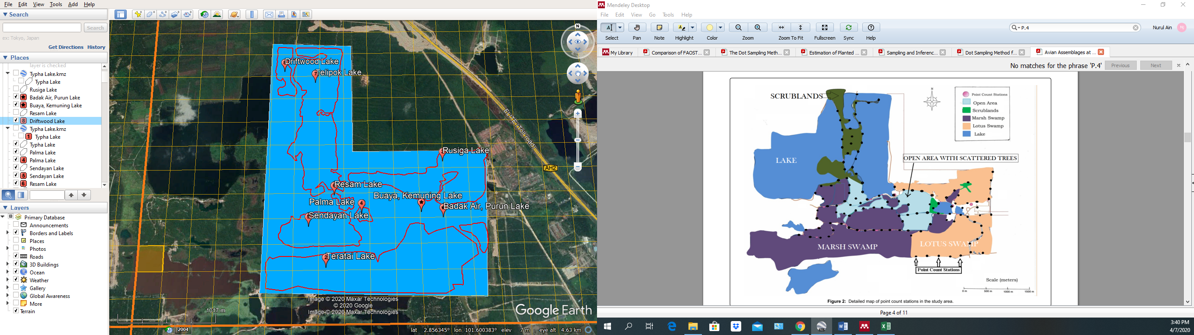

Figure 3 . Lake at PIW and area of PIW (image taken by GE) acquired in May 2020

Table 3. (a) Data to generate DotS sample location, (b) A dot sample location that combines latitude and longitude coordinates.
(a)

Target area (1) | Size of the target area km2 (2) | Sample size (3) | Starting point (latitude) (4) | Starting point (longitude) (5) | Finishing point (latitude) (6) | Finishing point (longitude) (7)
PIW (10%) | 7.1 | 57 | 2.87875 | 101.61375 | 2.85375 | 101.63375
(b)

$Estimated number of dot sample size=\frac{{\left(population CV\right)}^{2}}{{\begin{aligned}\left(\frac{aimed precision}{100}\right) \\ \end{aligned}}^{2}}$ (Equation 1)
Where,

population CV = $\frac{\sqrt{p×(100-p)}}{p}$
p % = percentage of PIW area within the estimated target area
CV % = aimed precision

Based on the coordinate values that have been generated in the EM sheet, the dot sample was directly autogenerated in GE, as shown in Figure 4. Each dot sample location in GE was named according to the EM sheet's row and column values referring to the location's coordinate.

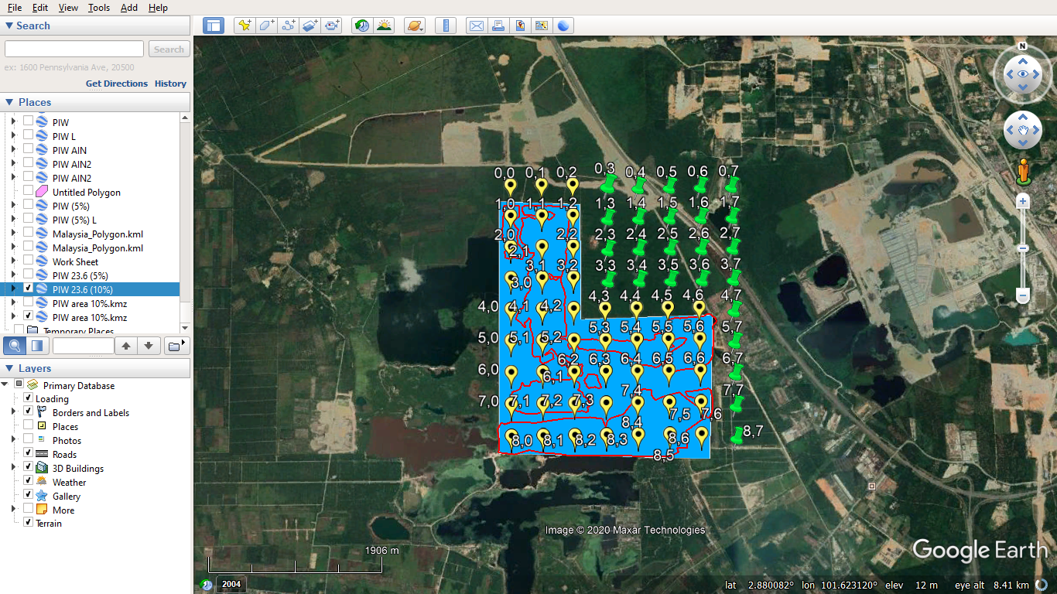

Figure 4 . Dot sample locations autogenerated from ME to GE

Next, once the dot sample location was known through GE, the second stage of field study preparation was carried out. The second stage is a desktop work step where the interpreter needs to survey all the generated dot samples' locations listed in the GE's images via visual interpretation and code the dot sample. The identification by eye was based on the distinctiveness and homogeneity of the surrounding habitat vegetation. The dot sample location was coded based on the habitat's classification as shown in Table 2, where the possible number of dot sample locations identified as the study stations is easier. Before the fieldwork visit for inspection, the ArcGIS10.5 software was also used to verify the accuracy of the images obtained and validate the DotS method.
The last stage of the DotS method is fieldwork. The dot sample locations generated from GE and the result from the preparatory stage were used as references in this stage. All the potential dot sample locations that have been coded were undergone inspection and evaluation on 13th August 2020 to ensure the feasibility of sampling so that it can be conducted at the locations and selected as study stations.

Results and discussion

In the first stage, 72 dot sample locations were generated systematically, distributed across the target area, and 47 dot sample locations were located within the PIW study area (yellow-coloured markers in Figure 4). The interval between dot sample locations was 350m x 350m with the same grid pattern whereby these estimated sample location points were generated on the entire PIW study area covering 444.5ha.
Next, through the preparation stage, those dot sample points that were observed to be not suitable for study stations were categorised as tentative reserves (TR). For instance, the areas are crocodile and rhino ponds, buildings, parking spaces, roads, or drains marked with code 6. The DotS sample points that are not under the PERHILITAN management area are coded with an "X". Table 4 presents the DotS sample points according to the codes and elements, either on soil or in the water area and Table 5 illustrated the DotS sample points categorised according to code depicted in the study area.

Table 4. Dot sample according to the element of each category

Element | Category | Code
Soil | KT | 1
Soil | B | 2
Water | P | 3
Water | PT | 4
Water | T | 5
Tentative reserves | TR | 6
 | Not under PERHILITAN management | X

Table 5. The DotS sample list that has been categorised according to the code depicted in the study area

Longitude →  Latitude ↓ | 0 | 1 | 2 | 3 | 4 | 5 | 6 | 7
0 | 6 | 6 | 6 | X | X | X | X | X
1 | 3 | 5 | 2 | X | X | X | X | X
2 | 2 | 5 | 2 | X | X | X | X | X
3 | 2 | 5 | 2 | X | X | X | X | X
4 | 2 | 5 | 2 | 2 | 2 | 6 | 6 | X
5 | 1 | 5 | 2 | 2 | 6 | 6 | 6 | X
6 | 1 | 5 | 5 | 2 | 1 | 6 | 6 | X
7 | 2 | 3 | 4 | 2 | 4 | 4 | 4 | X
8 | 3 | 3 | 3 | 3 | 4 | 4 | 4 | X

The preparation stage's results are tabulated in Table 6, which shows dot sample locations' frequency by the element, category and code. The statistical calculations show that the DotS method has a very high probability of 99% in survey estimating locations (Table 6) and has high reliability to avoid a non-sampling error. In addition, a similar result was reported by Bauer et al. (2016) in their case study on mapping for illicit crop monitoring in Bolivia. Furthermore, the estimated percentage of land use in PIW is also summarised in the bar chart (Figure 5). The majority of PIW areas are covered by water bodies at 42%, followed by land and reserve areas at 35% and 23%, respectively. The preparation stage found that 47 dot sample locations in the PIW study area cover an area of 444.50 ha. A total of 10 dot sample locations are categorised as reserves (23%), while 37 dot sample locations are estimated to have the potential to be study stations (77%) in which the 37 recorded dot sample points are divided into the elements, soil and water, 17 and 20 dots, respectively.

Figure 5. The estimated percentage of land use in PIW

Table 6. Results of the preparation stage

Element/  sample | Category | Code | Frequency | Share | Estimated area (ha) | % Estimated area | Estimated land used, PIW (%)
Element/  sample | Category | Code | n=72 | (p) | 710 x p | % Estimated area
Soil | KT | 1 | 5 | 0.06 | 42.60 | 6.00 | 9.47 | 35.27
Soil | B | 2 | 12 | 0.17 | 120.70 | 17.00 | 25.80 | 35.27
Water | P | 3 | 6 | 0.08 | 56.80 | 8.00 | 12.12 | 42.42
Water | PT | 4 | 7 | 0.13 | 92.30 | 13.00 | 19.70 | 42.42
Water | T | 5 | 7 | 0.07 | 49.70 | 7.00 | 10.60 | 42.42
 | TR | 6 | 10 | 0.15 | 106.50 | 15.00 | 22.73 | 22.73
 | Outside PIW | X | 25 | 0.35 | 248.50 | 34.00 | N/A | N/A
 | Total |  | 72 | 1.00 | 710.00
 | PIW |  |  |  | 444.50 | 66.00 | 100.00 | 100.00
 |  |  |  |  | 99%

Simultaneously, verification from the ArcGIS10.5 software, land use was classified into barren, developed areas, land, island, marsh, plantation and water bodies as shown in a thematic map depicted in Figure 6. As a result, the percentage accumulation of barren, developed areas, land and island is 53%, while the marsh and water bodies are 47%. The result shows a similar land-use percentage as that of the DotS method, where water bodies are 42% and the total land areas (soil and reserve) are 58%. Thus, it shows that the field observation stage was accurate and verified.

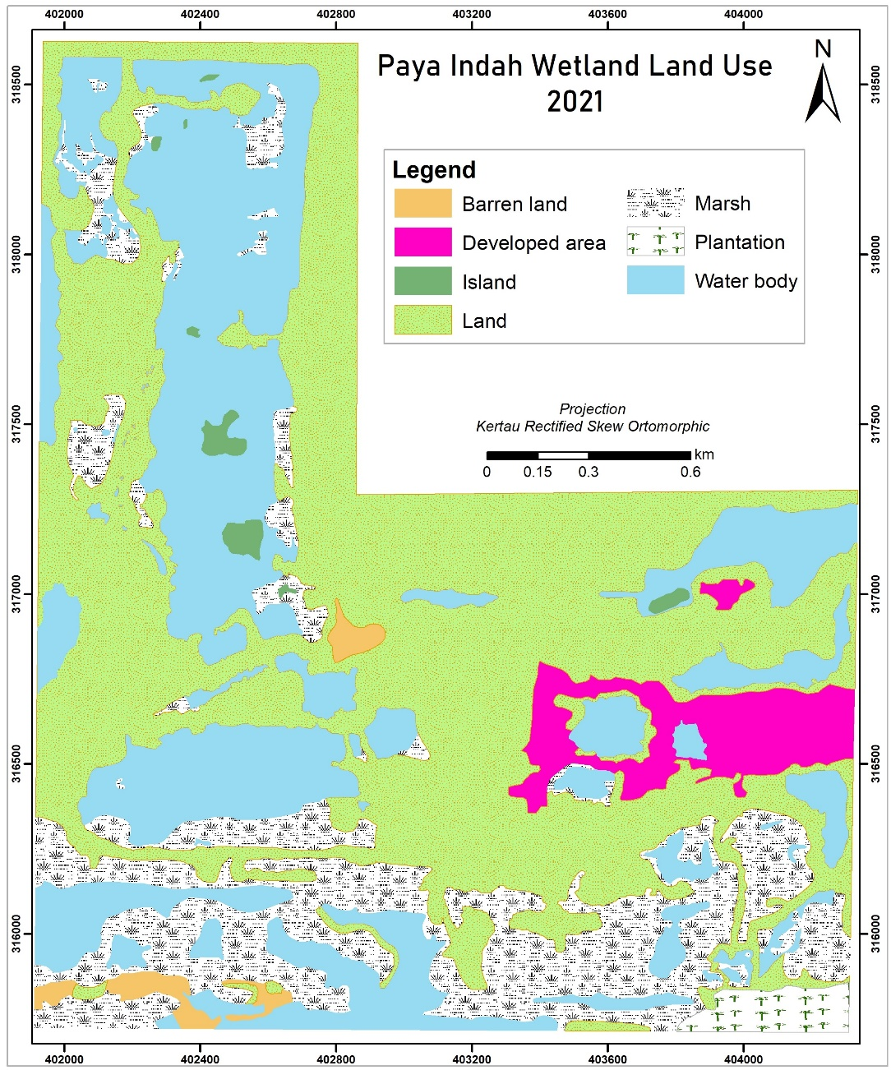

Figure 6. Thematic map of classification land-use in PIW

Figure 7 illustrates the percentage of land used in ArcGIS classification. These preparation stages provide preliminary information on the study areas to identify the dot sample location's suitability for the study station before the fieldwork is conducted. This stage not only displays the area's actual sample size to survey but also statistically presents the land use. Thus, it makes the fieldwork stage more efficient and saves available resources such as time, cost, labour, and expertise.

Figure 7. Percentage of land used in PIW from ArcGIS10.5

Lastly, after the inspection and evaluation by fieldwork, from the 37 dot sample locations, only 76% (n=28) of dot samples are suitable to be selected as study stations, which are 11 and 17 soil and water stations, respectively, as shown in Table 5. The red colour indicates the dot sample location that is not suitable for a study station. The sampling study station's determination was done after considering several factors, such as safety during sampling work based on the dot sample locations’ landscape, sampling and analysis costs, equipment, and human resources. Next, soil and water sampling work at PIW was then carried out to determine the potential of PIW for carbon storage and water resources.
In conclusion, the DotS method is suitable for this study because it has high reliability in determining the number of sample study stations. Besides, this method avoids errors (systematic and random) compared to the manual determination of stations. The DotS method uses an automated grid sampling technique systematically providing high accuracy in sampling location. Moreover, this survey method provides the data to determine and select study area stations accurately and rapidly. Landscape information and land-use statistics of the study area are also easily collected and recorded for reference. Furthermore, the DotS method combines accessible existing technology and software (Microsoft Office-Excel and Google Earth), creating more efficient and practical fieldwork to save resources, such as energy, time and cost-effectiveness. The advantages of the DotS method for this study are summarised in Table 7.

Table 7. Advantages of DotS method

Items |  | Advantages of the DotS method | Output
Programme | Technique  Microsoft Excel  Google Earth | Simple statistic  No sampling frame or measuring  Avoid sampling error  Accurate web maps (coordinate, category) | Easy  Quick  Simple  Reliable  Accurate  Save resources
Stage | Dot sampling | On Microsoft Excel, Google Earth | Easy  Quick  Simple  Reliable  Accurate  Save resources
Stage | Preparation | On Google Earth– coding by category | Easy  Quick  Simple  Reliable  Accurate  Save resources
Stage | Fieldwork | Solving feasibility problems in survey areas, such as complicated land. | Easy  Quick  Simple  Reliable  Accurate  Save resources
Outcome | Fieldwork | Easy, fast and reliable results. | Easy  Quick  Simple  Reliable  Accurate  Save resources
Conclusion

To conclude, based on the advantages listed and the application that has been done, this study recommends the DotS method as a reliable survey method that is suitable for all study locations, especially in the ecology field. This recommendation is made after considering several suitability factors and benefits, specifically (1) it is almost impossible to measure and determine the location of study stations that consist of various extensive landscape categories systematically by manual method, (2) this technique has been proven to give high accuracy while reducing sampling errors (Kamikura, 2016) because it combines several approaches such as observation techniques, statistics and information technology, (3) estimated sampling locations cover all study areas and do not overlap each other hence, allowing a high chance for each location to be selected as a study station, (4) Microsoft Excel Macro and Google Earth Pro is free software that is easy to access and use, and last but not least (5) this technique saves resources, for instance, time, energy, cost and human resources.

Acknowledgement

This work is supported by the Fundamental Research Grant Scheme (FRGS) from the Ministry of Higher Education, Malaysia (FRGS/1/2019/WAB05/UKM/02/2). The authors also would like to acknowledge Professor Kenji Kamikura, one of the DotS method pioneers, Senior Statistician at the Statistics Department Ministry of Agriculture, Forestry and Fisheries of Japan, for sharing and guiding the use of Microsoft Excel Macro sheet as well as encouraging us to adopt this method in other fields of study.

References

Bauer, T., Schneider, W., Bussink, C. and Catari, H. (2016). Comparing dot grid sampling versus full area mapping for illicit crop monitoring in Bolivia, in Seventh International Conference on Agricultural Statistics (ICAS VII), 384–390. doi:10.1481/icasVII.2016.b09
Belay, A., Recha, J., Woldeamanuel, T., & Morton, J. F. (2017). Smallholder Farmers’ Adaptation to Climate Change and Determinants of their Adaptation in the Central Rift Valley of Ethiopia", in Proceedings of the International Conference on Impact of El Niño on Biodiversity, Agriculture, and Food Security, 63–73. Research and Extension office of Haramaya University, Ethiopia.
Bellamy, R. (2015). A Sociotechnical Framework for Governing Climate Engineering. Science Technology and Human Values, 41(2), 135–162. doi:10.1177/0162243915591855
Bhomia, R. K., Kauffman, J. B., & McFadden, T. N. (2016). Ecosystem carbon stocks of mangrove forests along the Pacific and Caribbean coasts of Honduras. Wetlands Ecology and Management, 24(2),187–201. doi:10.1007/s11273-016-9483-1
Chawla, I., Karthikeyan, L., & Mishra, A. K. (2020). A review of remote sensing applications for water security: Quantity, quality, and extremes. Journal of Hydrology, 585(March), 124826. doi:10.1016/j.jhydrol.2020.124826
Davis, S. J., Caldeira, K., & Matthews, H. D. (2010). Future CO₂ emissions and climate change from existing energy infrastructure. Science, 329(5997), 1330–1346. doi:10.1126/science.1188566
Degefie, D. T. (2018). Feasibility of Dot Sampling Method for Crop Area and Production Estimation: the case of rice in Fogera district.
Dunn, R. J. H., Stanitski, D. M., Gobron, N., & Willett, K. M. E. (2020). State of the climate in 2019. Bulletin of the American Meteorological Society, 101, S17–S184. doi:10.1175/BAMS-D-20-0105.1
Elham, E., & Mahdavi, M. (2019). Land suitability assessment using ANP in a GIS environment for Tourism Development Site (Case study: Lavasan-e Kuchak Rural District, Tehran province, Iran). Journal of Tourism & Hospitality Research, 7(1), 5–17.
Food and Agriculture Organization (FAO) of the United Nations. (2019). Guidelines on planning rice production survey. 9-10.
Hanasaka, J. (2019). Results of retrospective survey of cultivated land area and abandoned cultivated area on Google Earth Pro using the archive function and the dot sampling method. pp 1-2.
Jabatan Perancangan Bandar dan Desa (JPBD) Malaysia, Kementerian Kesejahteraan Bandar, Perumahan dan Kerajaan Tempatan, (2014), Garis Panduan Perancangan Pemuliharaan Dan Pembangunan Kawasan Sensitif Alam Sekitar (KSAS) Dataran Banjir, Tanah Lembap, Bekas Lombong, Tasik & Sungai (GP007-A(5)), pp. 19-21.
Jabatan Perancangan Bandar dan Desa (JPBDS). (2017). Laporan Tinjauan Kajian Rancangan Struktur Negeri Selangor 2035, B14: Alam Sekitar dan Pengurusan Sumberjaya, pp. 7.
Jamion, N. A., Lee, K. E., Mokhtar, M., Goh, T. L., & Simon, N. (2022a). The integration of nature values and services in the nature-based solution assessment framework of constructed wetlands for carbon-water nexus in carbon sequestration and water security. Environmental Geochemistry and Health. In Press.
Jamion, N. A., Lee, K. E., Mokhtar, M., Lai Goh, T., & Simon, N. (2022b). Evaluation of the content validity of the intrinsic-instrumental assessment tool for assessing the nature values of constructed wetlands. Geografia-Malaysian Journal of Society and Space, 18(1), 101– 117. doi:10.17576/geo-2022-1801-08.
Jinguji, I. (2012). How to Develop Master Sampling Frames using Dot Sampling Method. Japan. pp. 1-15.
Jinguji, I. (2014). Dot Sampling Method for Area Estimation. Kamakura City, Japan. pp. 1-21.
Jinguji, I., Masaaki, I., Kozo, Y., & Yoshida, Y. (2019). Results of Land Use Estimation Using Satellite Image Recognition Using Deep Learning. Japan. pp. 1-16.
Kadarmanto. (2018). Improvement of Indonesian Rice Statistics Using Area Sample Frame (ASF) Approach. pp 1-40.
Kamikura, K. (2012). Estimation of Planted Area using the Dot Sampling Method, in 24th Session Asia and Pacific Commision on Agricultural Statistics, Da Lat, Vietnam, pp. 1-7.
Kamikura, K. (2016). The Dot Sampling Method, Ministry of Agriculture, Forestry and Fisheries, Japan, pp. 1-48.
Kementerian Sumber Asli dan Alam Sekitar. (2013). Paya Indah Wetlands 1–9. Retrieved from http://www.nre.gov.my/Malay/EkoPelancongan/Pages/PayaIndahWetlands.aspx
Lorenz, K., & Lal, R. (2018). Carbon Sequestration in Wetland Soils. Carbon Sequestration in Agricultural Ecosystems, 211- 234. doi:10.1007/978-3-319-92318-5_5.
Manurung, J. W. (2018.) BPS gunakan metode KSA dapatkan data pertanian yang berkualitas. Antara Kalteng. pp. 1-2.
Margules, C. R., & Pressey, R. L. (2000). Systematic conservation planning. Nature, 405(May), 243–253.
Masi, F., Rizzo, A., & Regelsberger, M. (2018). The role of constructed wetlands in a new circular economy, resource oriented, and ecosystem services paradigm. Journal of Environmental Management, 216, 275–284. doi:10.1016/j.jenvman.2017.11.086
Mitsch, W. J., Bernal, B., Nahlik, A. M., Mander, Ü., Zhang, L., Anderson, C. J., Jørgensen, S. E., et al., (2013). Wetlands, carbon, and climate change. Landscape Ecology, 28(4), 583–597. doi:10.1007/s10980-012-9758-8
Moss, R. H., Edmonds, J. A., Hibbard, K. A., Manning, M. R., Rose, S. K., Van Vuuren, D. P., Carter, T. R., et al., (2010). The next generation of scenarios for climate change research and assessment. Nature, 463(7282), 747–756. doi:10.1038/nature08823
News, A. (2017). AfricaRice News blog. AfricaRice News blog.
Pinke, Z., Kiss, M., & Lövei, G. L. (2017). Developing an integrated land use planning system on reclaimed wetlands of the Hungarian Plain using economic valuation of ecosystem services. Ecosystem Services, 30(B), 299-308.
Rajpar, M. N., & Zakaria, M. (2014). Effects of Habitat Characteristics on Waterbird Distribution and Richness in Wetland Ecosystem of Malaysia. Journal of Wildlife and Parks, 28, 105–120.
Rosli, F. A., Lee, K. E., Goh, C. T., Mokhtar, M., Latif, M. T., Goh, T. L., & Simon, N. (2017). The use of constructed wetlands in sequestrating carbon: An overview. Nature Environment and Pollution Technology, 16(3), 813-819.
Salari, A., Zakaria, M., Nielsen, C. C., & Boyce, M. S. (2014). Quantifying tropical wetlands using field surveys, spatial statistics and remote sensing. Wetlands, 34(3), 565–574. doi:10.1007/s13157-014-0524-3.
Srivastava, M. K. (2014). Crop yield estimation surveys in India in Crops Monitoring for Improved Food Security. 209-218.
Takashina, N., Beger, M., Kusumoto, B., Rathnayake, S., & Possingham, H. P. (2018). A theory for ecological survey methods to map individual distributions. Theoretical Ecology, 11(2), 213–223. doi:10.1007/s12080-017-0359-7
Tran, H., Nguyen, Q., & Kervyn, M. (2018). Factors influencing people’s knowledge, attitude, and practice in land use dynamics: A case study in Ca Mau province in the Mekong delta, Vietnam. Land Use Policy, 72(January), 227–238. doi:10.1016/j.landusepol.2017.12.009

