

The distribution of the ancient Malay Kingdoms in Indochina from the first century to the fourteenth century from the context of the spatial and ethnoarchaeology

Asyaari Muhamad, Amir Husaini Saiffuddin

Institute of The Malay World and Civilization (ATMA), Universiti Kebangsaan Malaysia,
43600 Bangi, Selangor, Malaysia

Correspondence: Amir Husaini (email: arhusaini97@gmail.com)

Received: 25 June 2022; Accepted: 31 October 2022; Published: 30 November 2022

Abstract

The demographics of the Malayo-Polynesian people are not only spread within the Malay Archipelago but also into the Indochina Peninsula. The arrival of Hindu-Buddhist influence has led to the emergence of a system of kingship in the mainland of Southeast Asia, witnessing the emergence of several early kingdoms based on agrarian and maritime activities. Among these kingdoms were the Funan and Champa. These kingdoms were the earliest Malayo-Polynesian kingdoms to exist in the region, where both appeared at about the same time as early as the first century AD. These kingdoms dominated the Southeast Asian mainland for almost 1,500 years from their founding period in the first century AD until their demise in the 15th century. Following the collapse, their existence was forgotten by history until it was rediscovered by French scholars at the turn of the 20th century. However, efforts to rebuild knowledge about these two kingdoms still have many aspects that can be implemented such as from the perspective of spatial and ethnoarchaeological studies. This article will briefly discuss the history of Funan and Champa before discussing the impact of Indianization and its correlations with the artifacts and monumental remains, and the sociocultural practices of the Cham community today that have been passed down from the two early kingdoms through the lenses of spatial and ethnoarchaeology.
Keywords: Champa, Ethnoarchaeology, Funan, Indochina, Malayo-Polynesia, Spatial archaeology

Introduction

The demographics of the Malayo-Polynesian people not only spread widely throughout the Malay Archipelago but also scattered into Indochina. The fertile land area surrounded by several rivers and lakes such as the Mekong River, Tonle Sap, Irrawaddy Delta, and Menam Chao Phraya made possible the existence of various aspects of human civilization at that time. In addition to the rivers and lakes that produce fertile land, the geography of this land is also surrounded by oceans and all these criteria are complementary to the dynamic factors of early civilizations in this area. Thus, this makes the ​​Southeast Asia mainland a potential area for the establishment of early human civilization.
In Indochina, the Malayo-Polynesian people had established an early administrative entity (Nik Hassan Shuhaimi, 2005) that unified several small polities of local governments and formed a central government based on a federation system. Among these polities were the kingdoms of Funan and Champa which were founded by the Cham Malays who are the original inhabitants who settled around the coastal areas of Indochina (Vietnam) down to the Mekong River delta. These early kingdoms have left a political and cultural legacy to this day indicating that this ancient community at that time already had an organized social and political structure within Indochina.
The existence of a language, writing system, art, culture, and beliefs developed from Indian influences mixed with local identity shows that this early Cham community has left clear evidence of existence in terms of architecture and culture (Nik Hassan Shuhaimi, 2005). The evidence of the material cultural relics of this community in the era of Funan and Champa can still be seen clearly through the construction of temples, sculptures, and inscriptions throughout Vietnam. For example, there are over 206 Cham and Sanskrit inscriptions related to the Cham civilization (Nik Hassan Shuhaimi, 2005). However, there are still many Cham relics that have yet to be studied. Therefore, the kingdoms of Funan and Champa were long lost until it was rediscovered by French archaeologist such as Pierre Paris in the early 20th century.
The study to reconstruct the lost kingdoms of Funan and Champa will be based on spatial and ethnoarchaeology. Spatial archaeology is the sub-method used by archaeologists to deal with the use of space in the past, especially to determine the sphere of influence of certain kingdoms in an unknown area. Also, another main objective of spatial study in archaeology is to seek the correlation between spatial patterning of artifacts, monuments, and architecture in sites and the way that past societies functioned as systems (Paz, 2012). Meanwhile, ethnoarchaeology is another research technique that involves using information from living cultures (ThoughtCo, 2019). The implementation of this technique will allow another perspective on how the cultural, arts, and economic activities of the ancient Cham people are based on the modern presentation that is still practiced today. Therefore, through these studies, it can be concluded from this introduction that these kingdoms have left a deep legacy in the history of the Chams community and the country of Vietnam itself.

Funan

Records of the existence of the Funan kingdom are mainly obtained from the 3rd-century Chinese emissaries’ records of Kantai and Zhuying which describe Funan’s wealth (The Phuket News, 2019). At least 26 Funannese emissaries were sent to China from the time of the Wu dynasty in the 3rd century to the Sui dynasty in the 6th century AD (Stark, 2006). The founding legend of this kingdom can be linked to the Chinese records from the 240s AD about the marriage of Kaudinya, an Indian Brahmin, to a ruler from the Mekong River named Linyeh (Hall, 2011). Their descendants became the ruling dynasty of the Funan kingdom in Indochina. Yet, in Chinese records, only the name Jayavarman was first identified as the ruler of Funan beginning in 478 AD (Stark, 2006).
Geographically, this federal government is based in Vyadhapura which is in the southern part of Indochina. Yet, the most important location that was crucial to the kingdom’s fame is the port city of Óc Eo which plays a role as an entrepot trading center between India and China (Nasha Rodziadi Khaw et al., 2009). The rapid development of Óc Eo at that time was driven by Funan's pacification policy over other cities under its control where these cities only served as suppliers to Óc Eo (Nasha Rodziadi Khaw et al., 2009). The Funan’s expansion of power extending from the coast of the Siamese Gulf to the Malay Peninsula was to ensure the dominance of the trade route with China (Stark, 2006). Funan’s dominance over the Mekong River delta allowed the government to produce surplus crops to meet the needs of its people as well as traders who stayed in Óc Eo while waiting for the change of monsoon winds. This makes trade activities in Óc Eo always run throughout the year.
Among the famous rulers of Funan was Fan-Shih-Man who was considered the greatest Funannese King. His control over the Mekong River delta, Cam Ranh Bay, and the Kra Isthmus allowed Funan to control trade routes in the north of the Malay Archipelago. He also mobilized efforts to build a large naval fleet in the Gulf of Siam to further expand Funan's control over the north of the Malay Peninsula. According to Chinese records, he managed to control 10 kingdoms, but only 3 can be identified, namely Ch’u-tu-k’un, Chiu-chih, and Tien-sun which were located in the northern Malay Peninsula which was a strategic location on the Maritime Silk Road. Even Kedah Tua once fell under the rule of Funan (Nasha Rodziadi Khaw et al., 2009). Chinese records state that Fan-Shih-Man managed to expand Funan province to reach an area of ​​2,400 square kilometers (Khoo, 2003).
However, the golden age of Funan occurred during the reign of King Jayavarman (484 - 514 AD). In his era, Funan enjoyed an overflow of economic commodities thanks to trade activities. Funan sourced tin from Malaya, spices from Maluku, silk, and ceramics from China, sandalwood from Timor, incense, and myrrh from the Middle East, copper from Siam, and camphor from Sumatra. The result of this trade prosperity also enabled the Funan citizens to pay taxes in various forms such as gold, pearls, silk, perfumes, and even slaves, increasing the kingdom’s tax revenue.
Funan began to decline shortly after the death of King Rudravarman where the dominance of the central government had begun to weaken over his subordinate. These lesser kingdoms under Funan’s influence started to send their own envoys to China where which made it appear as if these kingdoms were on par with Funan itself and caused Funan to lose its prestige as the central government in Indochina. Kedah Tua, for example, sent a delegation to China in 638 AD (Nasha Rodziadi Khaw et al., 2009). This might indicate that Kedah Tua was free from Funan's influence at that time.
This declination was also caused by a change in trade routes where foreign traders no longer sail through the Kra Isthmus but instead through the Malacca Strait without having to transit at Óc Eo. This situation resulted in Funan losing its source of income from maritime trading activities, and at the same time, its subordinate kingdoms began to strengthen and free themselves from Funan’s influence. One of the kingdoms was the Chenla which later took control and absorbed Funan into its domain around 600 AD.

Champa

The existence of Champa was also known through Chinese sources (Nik Hassan Shuhaimi, 2005) which record the existence of a kingdom named Lin Yi in the south of the country as early as 192 AD. The Champa kingdom was the second kingdom to exist after Funan and managed to survive for 1,500 years before finally collapsing in the 14th century AD. It is widely accepted that Champa was never a unified kingdom, but the name of a collection of loose confederate polities (Hall, 2011).
The founding of this kingdom is associated with the legend of Goddess Po Nagar who married a prince from China which does not show any solid evidence or narration about the emergence of Champa. In fact, the emergence of this kingdom can be attributed to the rebellion by a local officer known as Khu Lien who succeeded in liberating the Lin Yi or Lam Ap kingdom in Hue province from the declining Han Chinese influence around the second century AD (Vella, 1975). However, Chinese records only mention the first ruler of the Champa kingdom was identified as Bhadravarman I who ruled from 380 to 413 AD.
The first administrative center of Champa was in Kandapura, yet the capital of this kingdom was constantly changed as a tactic to avoid enemy attacks. For example, My-son (Vella, 1975), Simhapura, Virapura, and Inderapura. The city of Inderapura which served as the main port had begun to enter its period of prosperity in the 7th and 10th centuries AD due to its strategic position and its dominance over the Spice Route and Maritime Silk Route in Southeast Asia. The Champa government was also actively involved in armed conflict with its neighboring states, especially Đại Việt in the north and Angkor in the west. These kingdoms competed to seize hegemony as the central government in mainland of Southeast Asia.
Champa reached its zenith during the reign of King Che Bunga or Chế Bồng Nga (Po Binasour) who reigned from 1360 to 1390 AD. His policy of territorial expansion was aggressive, especially when against the northern adversary, the Đại Việt. He succeeded in expanding his kingdom from the province of Đại Việt in the north to the Red River Valley. Only after his death in 1390, Champa ceases its territorial expansion and began to retreat south, thus the era of declination begins. The Đại Việt kingdom regained its strength and began to invade Champa territories beginning in 1402. Meanwhile, the Champa kingdom itself has begun to show a process of decline after the death of King Indravarman in 1441 which triggered a civil war between the Champa royalties. This opportunity was used by the Đại Việt to invade and conquer Champa. The remnants of the Cham people had retreated to southern Vietnam and continued to survive until the mid-19th century before being completely conquered by the Nguyễn dynasty. Although the Chams kingdoms are no longer in existence as a result of the Vietnamese expansion and colonization, the remnants of these once-great kingdoms can still be found as far as Quảng Bình province in the north all the way down to the south-central coast (Bình Thuận) and Cambodia’s border (Phương & Lockhart, 2011). The spatial spread of these kingdoms will later be explained through several aspects and figures below.

Spatial archaeology

The Indianization of Funan and Champa

The existence of Funan and Champa in the Southeast Asia mainland for a long period of time allowed these kingdoms to shape significant culture and arts brought from India which establish relationships with the locals through commerce. The evidence of these relations can be seen through the findings of Indic statuary, Sanskrit-derived scripts, and brick monuments (Stark, 2006). There are various methods of cultural acceptance by these kingdoms, for example through trade activities and marriage.
Trade activities allow for interaction between the Cham community and foreign traders, especially from India and China who visit the local port. The ports of Óc Eo and Inderapura (Figure 1) both play important roles in bringing foreign cultures and subsequently spreading that culture to the locals. In addition, intermarriage between foreign traders and the local people also to some extent helped the absorption and spread of this foreign culture into local society.
The concept of spatial archaeology in the Indianization and architectures of Funan and Champa can be seen in several aspects such as the implementations of the cosmic Mandala concept, the modifications of Indian deities and ancient Cham rulers in sculptures and artifacts, and the spatial distribution of Champa’s temples throughout modern-day Vietnam.

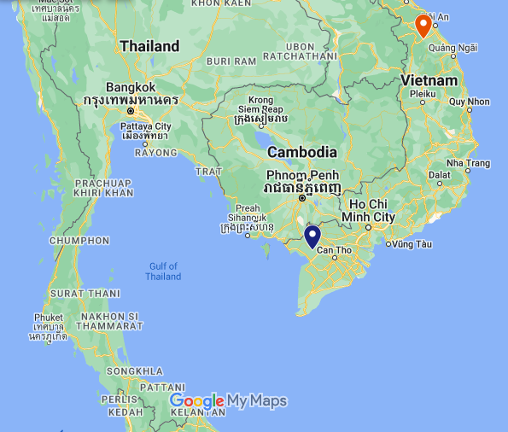
Champa
Funan
Source: Google Maps (2022)

Figure 1. The ports of Oc-Eo (blue-pin) within the Siamese Gulf and Indrapura (red-pin) near the Tonkin Gulf played important roles as these kingdoms main trading ports

One aspect exhibited in the cultures of these kingdoms was the influence of Indianization. The factor of this Indianization influence can be attributed to the maritime culture as trade and shipping became the main economic activities. The arrival of Indian traders not only brought trade commodities but also influenced the locals both in political and cultural aspects such as administrative systems, beliefs, writing systems as well as building architecture.
This enabled the spread of Hindu Buddhism widely among the locals, especially within the ruling class. The aristocracies of Funan and Champa took the initiative to embrace Hindu Buddhism as a strategic step to strengthen their prestige and political power. For example, the influence of Hinduism saw the use of Indianized ruling names in their monarchs such as Rudravarman, Bhadravarman, Kaudinya, and so on.
Another important aspect of Hindu Buddhism is the concept of the Mandala where the centralization of power is on the King and his relatives. The rulers fused themselves with this Indic topographical formula that provided a design for the integration of village or lineage-based groups into more complex centralized polities (Hall, 2011). The base idea of the concept is circular which represents the distribution of power among polities that are united by the center of the circle which is central to the king and the most powerful polity through the suzerain-tributary relationships (Figure 2). The relationship benefits both the patron and client through several aspects as shown in figure 2 (The Indianisation of Southeast Asia, 2022). This concept is important for a federation structure to ensure that subordinate kingdoms give allegiance to the central polity (Phương, 2006).

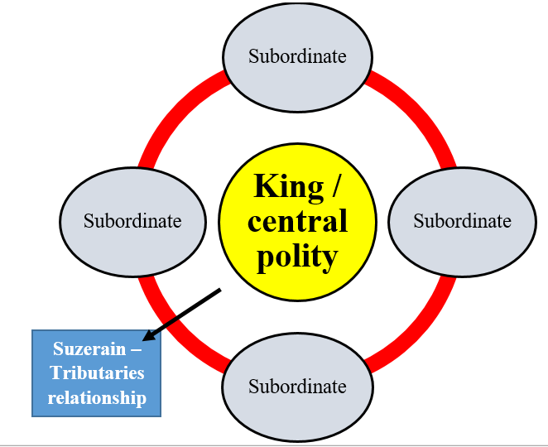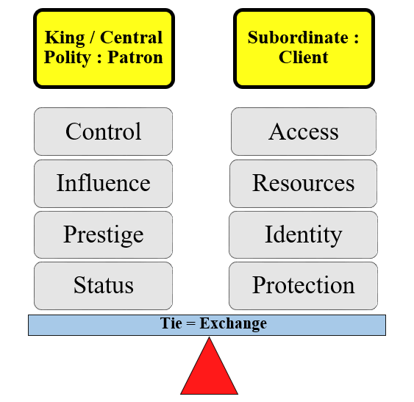
Source: Compiled by the author (2022)

Figure 2. The Mandala is a circular concept (left) where the center of power is on the king or central polity, surrounded by his subordinates applied by Funan and Champa in maintaining control and influence on their subjects with benefits to both sides

The rulers also used the concept of Dewaraja where the king was depicted as a sacred entity and worshiped by the people. In fact, there is a Cham inscription of the 9th-century Uroja, the founder of the royal dynasty, which is said to have been a son of Shiva (Heine-Geldern, 1956). This indicates that the concept of Dewaraja is either an incarnation of a god or a descendant from a god or both. Among the rulers who were worshiped were Po Klong Garai (1167–1192) and Po Romê (1627–1651) who were the great Chams kings in Panduraga that contribute a lot of infrastructure development and fought against Angkor and Đại Việt. The Po Romê temple as well as a statue of the king (Figure 3) at Ninh Thuận were built to be dedicated as a place of worship after the king’s death in 1651 (Son, Q.V. et al., 2020). Annual worship of the king is continued by the Cham community to this day during the Kate Festival.
Apart from politics, Indian influence can also be seen in the monuments and sculptures. Champa Kingdom for example is very synonymous with numerous temple monuments almost throughout ​​Vietnam. One of the most prominent locations is Mỹ Sơn, a complex of Hindu temple towers located in Central Vietnam. This complex was built within the span of ten centuries, beginning in the 4th century AD. This complex was dedicated to various Hindu deities, including Vishnu, Krishna, and Shiva depicted in the form of Shiva Lingam. This shows how deep the influence of Indianization was in the structure of this early Malay kingdom society.
However, this did not mean that the locals of Champa and Funan accepted these foreign influences without any modifications, instead, they applied their own local influence with these foreign cultures. From the aspect of belief, the concept of dualism brought by Hindu-Buddhist teachings has been blended with the original Champa belief which is cosmologically elemental of dualism; men and women, fathers and mothers, mountains and oceans as well as the legend of Champa where the northern region was ruled by the Pinang tribe (men), while the Kelapa tribe (women) ruled the south (Phương, 2006). This mixture of Hindu-Buddhism and local beliefs eventually influenced the construction of the Mỹ Sơn temple in the north dedicated to the god Bhauresvara, while the Po Nagar temple in the south to the goddess Bahagavati (Nik Hassan Shuhaimi, 2005). In fact, the local goddess Po Nagar herself was believed to be the Cham’s own depiction of the goddess Bahagavati.

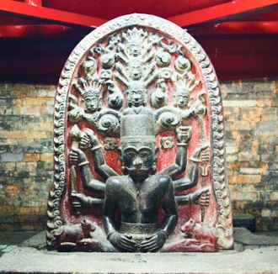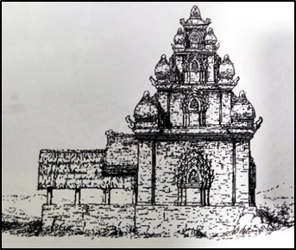
Source: Ku (2007)

Figure 3. The Statue of King Po Romê contains elements of divinity and sketches of the Po Romê Temple in
Ninh Thuận

Meanwhile, the element of local details also influenced the aspect of the calling and carving of Hindu-Buddhist deities which saw the use of names and carvings that were more in line with the local culture of Champa at that time. For example, Shiva is called Pônìntri, Vishnu as Pôpachơn, and Brahma as Pôdêpadrơn (Tú, 2014). Shiva is the most revered Hindu deity of the three deities and has nearly hundreds of sculptures built throughout the Champa region.
The figure of the Shiva’s head (figure 4) shows a modification where the face of the god is described as having a puffy nose, thick lips, and slit eyes that resembled a Cham face rather than the Indians themselves (Ancient Origins, 2015). This situation shows that the teachings of Hinduism have been adapted to be more in line with the culture and norms of the local community of Champa at that time.
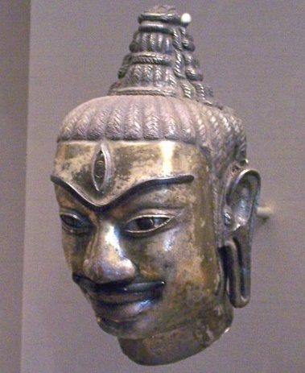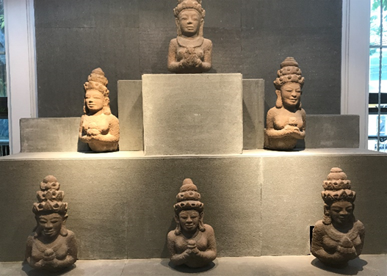
Source: Ancient Origins (2015); Asyaari Muhamad (2017)

Figure 4. The bronze head of Shiva and statues in the Da Nang Museum of Cham. Sculpture were made by the Chams showing the modifications made to resemble the appearance of Champa men such as a puffy nose and
slit eyes
The structural remains of Funan and Champa

As explained earlier, the influx of Hindu-Buddhism in Funan dan Champa has led to the construction of temples in these kingdoms. The construction of the temple is the most obvious evidence highlighting the architectural skills possessed by a society. Funan was able to leave a prolonged legacy of their material cultural relics namely the Óc Eo temple which continued to be used by the Chenla and Angkor kingdoms after the demise of Funan. Several findings such as the engraving of the Surya (sun god) and Buddha sculptures were found in the temple’s complex such as in Go Thap (Figure 5), showing the Indian influence on the complex (Le, 2016). Funan as the earliest kingdom to exist in Southeast Asia has shown the influences of Indianization not only in the form of government structure but also in the construction of sculptures and monuments (Stark, 2006). The remains of the Óc Eo temple clearly show the beliefs of Hinduism and Buddhism which had become the official religions of the kingdom. This religion was brought in through the interaction between the local people of Funan with the Indian traders who conducted the trading activities in Óc Eo.

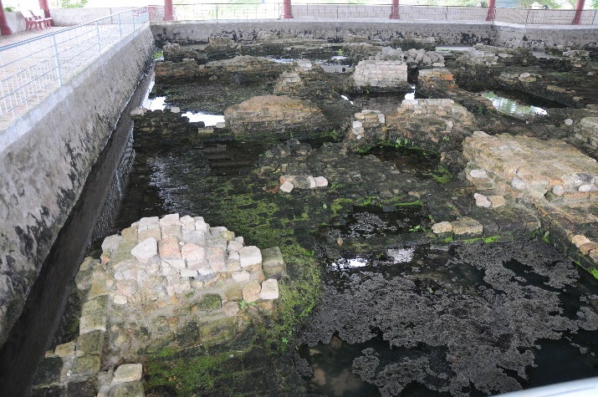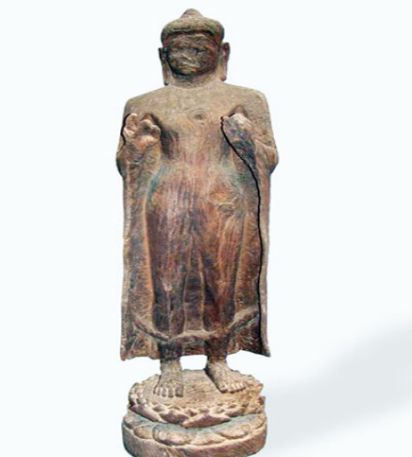
Source: Asyaari Muhamad (2017); Le, (2016)

Figure 5. The ruins of Oc-Eo were only rediscovered by Pierre Paris in the 1930s and Buddha wooden statue
was found in one of the complexes in Go Thap along with several other religious relics

The Champa Kingdom which lasted for almost 1,500 years has left hundreds of material cultural relics in the form of temples and sculptures. Almost all historic areas in central and southern Vietnam have relics of this early kingdom, demonstrating the advanced and sophisticated construction skills of its society. The spatial distribution of Champa’s temples is mostly centered in Quảng Nam (Indrapura), Bình Định (Vijaya), Quy Nhon, Na Thrang (Kauthara), Ninh Thuận, and Phan Rang (Panduraga). The characteristics of Champa-built temples at that time are characterized by their towering buildings with carvings and decorated with a brick arrangement that has a high artistic value. All the temples built during its period have displayed a mixture of Hinduism structures which are mixed with local Champa architectural designs such as the rectangular building structure, false doors, and rectangular pillars that stand out on the outside of the temple as presented in the Thap Doi temple in Figure 8 (Ku, 2007).
One of the most famous Cham structural relics is the Mỹ Sơn Shrine Complex (Figure 7) which contains over 70 temples (Ku, 2007). The discovery of this complex is important evidence of the existence of the past glory of the Champa Kingdom from the 5th to 14th century AD in Vietnam. It was first discovered in 1898 by a French scholar named M. C. Paris. He found many temple bricks here, temple towers stranded in the valley and around the hillsides in Mỹ Sơn. A year later, two researchers named L. Finot and E. Lunet de la Jonquiere conducted a further study on the discovery of inscription artifacts there. From 1901 to 1904, H. Parmentier and C. Carpeaux conducted architectural, sculptural, and archaeological excavations (Hardy, 2009; & Asyaari Muhamad, 2017).
The complex was once severely damaged during the Vietnam war but was later repaired in 1978. In 1908, a team of conservation experts from Poland in collaboration with the Cultural Heritage Conservation Center from the Vietnamese Ministry of Culture and Information carried out conservation work on the complex. Finally, in December 1999, the Mỹ Sơn Temple complex was gazetted as a World Cultural Heritage by UNESCO (Nik Hassan Shuhaimi, 2005).
Although all these temples have been abandoned for centuries, most of them remain intact. To this day, the Champa community of the Balamon tribe will still be present on certain days to perform their religious ceremonies and customs. This shows the long-standing legacy of faith that has taken root in modern Champa society. Most of the temples or monuments of the Champa Kingdom were almost destroyed due to age, war, and maintenance. However, since the 1990s until now, the Government of Vietnam and NGOs from abroad channeled funds to repair the temple to preserve the value of heritage, history as well as tourist attractions.
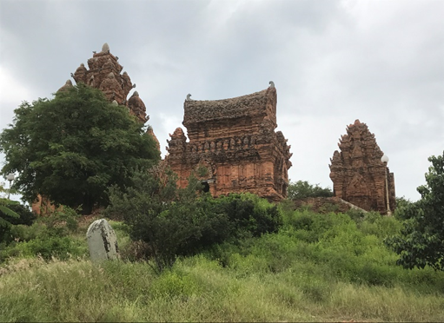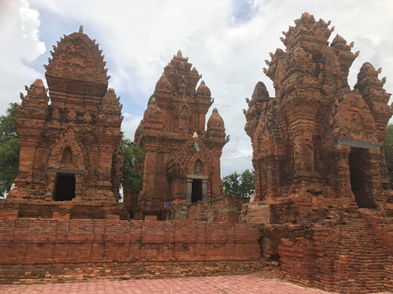
Source: Asyaari Muhamad (2017)

Figure 6. The temple of Po Klong Garai built on a hilltop by King Jaya Sinhavarman III between the 13th–14th centuries is characterized by unique architecture, simple, elongated, square, and full of details that are dedicated to Shiva as their main deity
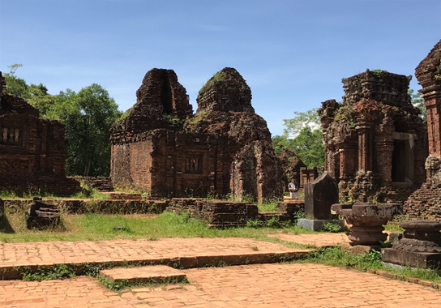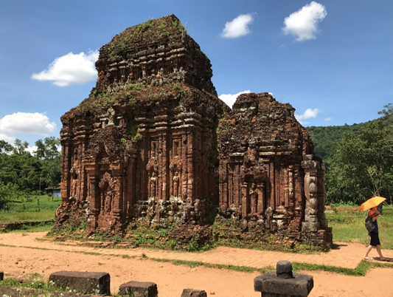
Source: Asyaari Muhamad (2017)

Figure 7. The Mỹ Sơn complex was built from the 4th – 14th centuries AD. It is the largest archaeological complex in Vietnam with over 70 temples
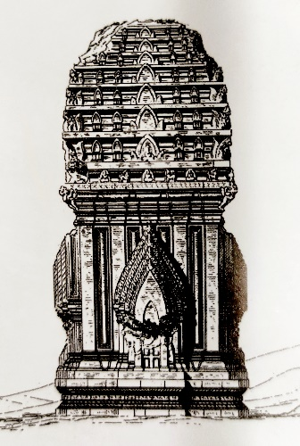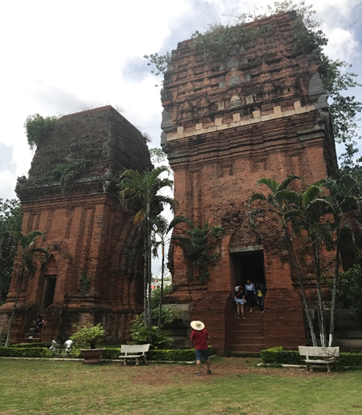
Source: Ku, (2007); Asyaari Muhamad, (2017)

Figure 8. Thap Doi temples (12th to 13th century AD) are in the city of Quy Nhon. These religious structures were built with high-quality materials that resembled the attractive architectural features of Champa such as rectangular building shapes, and false doors

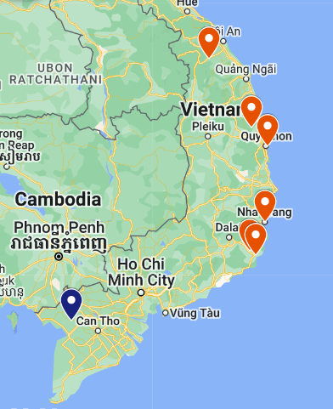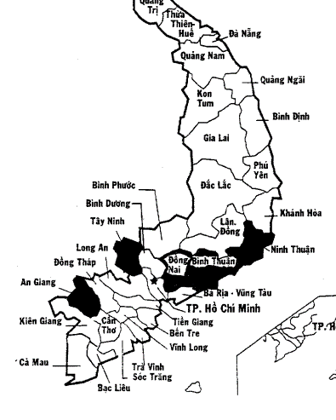
Source: Google Maps, (2022); Nakamura, (2020)

Figure 9. The spatial distribution of Funan and Champa’s temples is mostly centered from central to south Vietnam, defining these kingdoms’ sphere of influence (Quảng Nam – Bình Định – Quy Nhon – Na Thrang – Ninh Thuận – Phan Rang – Óc Eo) and (left) modern Chams community can still be found in the black area, showing the correlations with their ancestral distribution

Ethnoarchaeology

Cham cultural and arts

The Indianization of Funan and Champa that happened in the past centuries have heavily influenced the locals in term of culture and arts. Since then, the Cham community has maintained its unique artistic combination of the local culture with Indian influences. Some of the cultures are still practiced today.
Among the old Cham art that can still be seen and practiced to this day is the Kate Festival dance which is held on the first three days of October at the three main Cham temples are the Po Nagar (Figure 10), Po Klong Garai, and Po Romê temples. The festival is held to celebrate the kings and warriors of ancient Cham, namely Po Klong and Po Romê, in addition to commemorating the deaths in the family as well as the opportunity to relax and get to know each other within the ethnic (Vietnam Economic Views, 2021). Po Klong and Po Romê are remembered as Cham warrior-kings who fought against Angkor and Đại Việt, while Po Nagar is remembered as the matriarch founder of Champa.
There is also another ritual dance that resembled the identity of the Cham people which is the Apsara dance (Figure 10). This dance was inspired by the Hindu-Buddhist teachings that are also practiced by the neighboring Khmers and Thais. The dance is a ritual associated with female fertility and seduction. The Apsara carvings found in Cham or other cultural archaeological sites are often depicted in the form of beautiful female angels whose role is to entertain and seduce the protective deities (Gandharvas) as well as humans. Through the ethnoarchaeology method, it is possible to determine that these cultural dances that are still practiced today are shreds of evidence of the correlations between the modern Chams society with their ancestral traditions in the past.
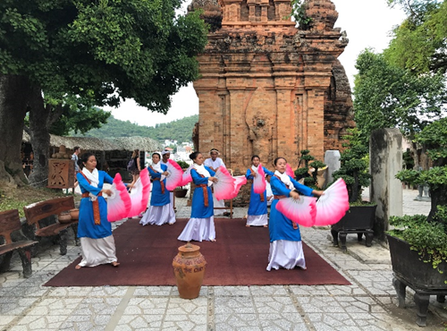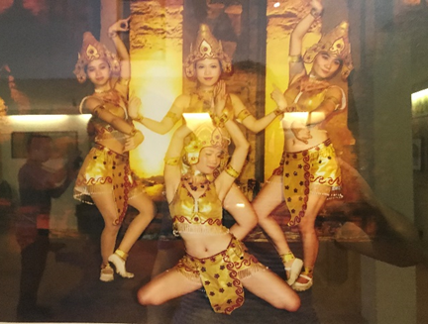
Source: Asyaari Muhamad, (2017)

Figure 10. The Cham women perform the ancient dance during the Kate Festival in Po Nagar temple in present-day Nha Trang (left) and the Apsara dance is an icon of the unique dance art of the Malay Cham community that is still practiced today

Present-Day Malay Cham community & economic activities

Field observations and photography of ancient Funan dan Champa heritage sites such as Óc Eo and Po Klong Garai temple as well as interviews of the present-day Cham communities in certain regions in Vietnam served as legacy and evidence of the existence of the once great kingdoms and society that have ruled the land (Asyaari Muhamad, 2017). In fact, the early Cham community has existed in the region mentioned above since the 7th century AD. The studies on the Chams’ demography and their economic involvement can also be seen as another ethnoarchaeological method in creating the bridge to connect them with their ancient cultures.
In Vietnam, there are two distinct groups of Cham people based on their place of residence, historical background, and religion. One group lives on the south-central coast, specifically in Ninh Thuận and Bình Thuận Provinces. The second group lives in the Mekong Delta, primarily around Châu Đốc city in An Giang Province, near the Cambodian border as shown in Figure 9 above (Nakamura, 2020). In its early stages, the Cham practiced both local animism and Hindu-Buddhist teachings as the main spiritual beliefs before the teachings of Islam were introduced in the 14th century. The present-day Cham community can be divided into several sub-ethnic or tribes. Among them are the Cham Balamon/Belamo, Cham Bani, Cham Jahe/Cheive, Cham Hroi, and Cham Islam who practice the true teachings of Islam.
Nevertheless, most of the Cham community that still exists in the region of Panduranga or Phang Rang are the Cham of Balamon and Cham Bani tribes. Cham Balamon practiced indigenized Hinduism (Nakamura, 2020), where Shiva, Ganesha or Vishnu, and other Hindu deities are worshipped as their main god, much like the Balinese Hindus of Indonesia. Meanwhile, Cham Bani practiced indigenized form of Islam. However, they also celebrate certain days that are associated with the local animism rituals, such as rice harvest, death ceremonies, and so on. If there are any deaths in this community, they will cremate the deceased and bury the ashes of the corpses in certain areas. The rituals originated in the 6th – 7th century and are well preserved by their descendants to this day as their ancestral heritage.
There is also a small group of people known as Cham Hroi who are classified as one of the Cham ethnic group's sub-groups. They live in Phú Yên, north of Ninh Thuận. The Cham Hroi appears to be a Champa population that remained after the majority of the Cham had moved south. They have been isolated, with no contact with other Cham communities, and have undergone acculturation with neighboring ethnic groups (Nakamura, 2020).
Meanwhile, of the Cham Islam community who practice the true Islamic teachings of Sunnah Wal Jamaah, most of them live in the southern region of Vietnam such as in the province of An Giang, namely in Châu Đốc (Asyaari Muhamad, 2017). The Cham Islam who live in southern Vietnam has the same way of life and cultural practices as other Muslims in the archipelago. However, there is another Cham community known as Cham Jahe who have their own unique version of Islam that differed from the Cham Islam in southern Vietnam. For example, the Cham Jahe tribe only practices prayer/prayer only once a week whereas Islam teachings required five times daily prayers.
As for the economic sectors, most of the Cham men engaged themselves in fishery activities along the main river or were involved in the agriculture sector such as paddy plantation. Meanwhile, handicraft making and clothes weaving (Figure 11) served as the main activities for their women. However, the Cham is most well-known for producing ceramicware (Ku, 2007) on a large scale for commercial purposes. Ceramics was among the most important commodities in trade between Champa and traders (Southeast Asian Ceramic Society, 2013). The Cham ceramicware skill is unique because it was made mainly by hand only without using any turning table or pottery enamel. This rare skill was inherited since the old days of the Champa Kingdom and mainly can be seen in Bàu Trúc village, Ninh Thuận province, and Đức Bình village in Bình Thuận province.

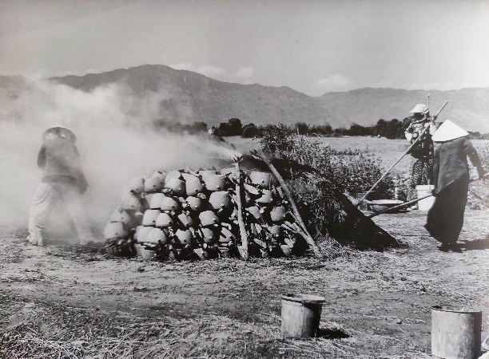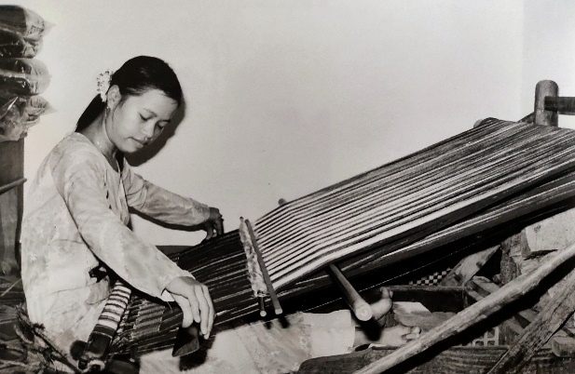
Source: Ku, (2007)

Figure 11. Outdoor burning of Champa pottery in an open area in Bình Thuận province (left) and Cham woman working on cloth-weaving in My Nghiep (right) are among the economic activities that are inherited since the old days of the Champa Kingdom

Conclusion

Although the kingdoms of Funan and Champa have long since vanished, their legacy lives on through the remains of material culture in the form of arartifactsnd monuments. The spatial archaeology approach allows the distribution of Funan and Champa relic temple sites to be identified, as well as how aspects of Indianization can be seen in influencing the political distribution of these two kingdoms via the Mandala concept and devaraja belief. The discovery of temple sites and artifacts also assists researchers in determining the domain of political influence of these two kingdoms, which span from the central region to the south of Vietnam.
Ethnoarchaeological studies have also assisted researchers in identifying the Cham society's economic and demographic activities, which can still be seen today. The study of the modern Cham population aided researchers in understanding their socio-culture, particularly in the art and cultural aspects of this community's life that have been passed down since the days of the two ancient kingdoms thus identifying their historical correlations.

Acknowledgments

I would like to express my gratitude to the authority of the Danang Museum of Cham Sculpture for cooperating with me in my study. Also, I would like to give my special thanks to the Chams community in Vietnam for presenting me with hospitality and being very informative in providing useful knowledge that allow me to produce a research study and to some extent this article writing.

References

Ancient Origins. (2015). The ancient kingdom of Champa: an enduring power that lasted over 1500 years in Southern Vietnam. Retrieved from https://www.ancient-origins.net/ancient-places-asia/ancient-kingdom-champa-enduring-power-lasted-over-1500-years-southern-vietnam-020598
Asyaari Muhamad. (2017). Laporan kajian lapangan the lost kingdom (Vietnam). Institut Alam dan Tamadun Melayu.
Google Maps. (2022). Retrieved from https://www.google.com/maps/d/edit?hl=en&hl= en&mid=1in6qYE5WsE8zjtBesoshCKowR0H618E&ll=12.88427587579254%2C106.58711860000001&z=7
Google Maps. (2022). Retrieved from https://www.google.com/maps/d/edit?hl=en&hl= en&mid=1yjLnzYa372tvNqzZ21apnJs6_GMRYLM&ll=12.985189469603029%2C104.00681397610678&z=6
Hall, K.R. (2011). A history of early Southeast Asia: maritime trade and societal development, 100–1500. United Kingdom, Rowman & Littleﬁeld Publishers
Hardy, A. D. et al. (2009). Champa and the archaeology of Mỹ Sơn (Vietnam). Singapore, NUS Press.
Heine-Geldern, R. (1956). Conceptions of state and kingship in Southeast Asia. The Far Eastern Quarterly 2, 15-30.
Khoo, J.C.M. (2003). Art & archaeology of Fu Nan: Pre-Khmer kingdom of lower Mekong Valley. Bangkok, Orchid Press.
Ku, N.V. (2007). Cham: heritage of Cham culture. Hanoi, The Gioi Publishers.
Le, H. (2016). Indian values in Oc Eo culture case study – Go Thap, Dong Thap province. American Scientific Research Journal for Engineering, Technology, and Sciences 25, 169-180.
Nakamura, R. (2020). A journey of ethnicity: in search of the Cham of Vietnam. Newcastle, Cambridge Scholars Publishing.
Nasha Rodziadi Khaw et al. (2009). Kesan kebangkitan dinasti Sung-Yuan kepada perkembangan Kedah Tua: satu analisis sosioekonomi. Dlm. Persidangan Antarabangsa Pengajian Melayu Beijing 2009. 31 Mei – 3 Jun 2009. Beijing Foreign Studies University.
Nik Hassan Shuhaimi. (2005). Penyelidikan arkeologi seni dan sejarah tamadun Cam. Jebat: Malaysian Journal of History, Politics and Strategic Studies 32, 89-99.
Paz, F.D. (2012). Spatial archaeology: theoretical and conceptual approaches in the study of space in archaeology. Archaeo 202: History of Archaeological Theory. 1-11.
Phương, T.K. (2006). Cultural Resource and Heritage Issues of Historic Champa States in Vietnam: Champa Origins, Reconfirmed Nomenclatures, and Preservation of Sites. Asia Research Institute. No. 75.
Phương, T.K. & Lockhart, B. (2011). The Cham of Vietnam: history, society and art. Singapore. NUS Press.
Son, Q.V. et al. (2020). The monumental architecture of Po Ramé in Ninh Thuan Province, Vietnam. IOP Conference Series: Materials Science and Engineering.
Southeast Asian Ceramic Society. (2013). Ports, shipwrecks, and ceramics: a maritime history of the ancient Champa kingdom. Retrieved from https://www.seaceramic.org.sg/a-maritime-history-of-the-ancient-champa-kingdom/
Stark, M. (2006). From Funan to Angkor: collapse and regeneration in ancient Cambodia. In. Glenn M. Schwartz and John J. Nichols (eds.). After Collapse: The regeneration of complex societies. (pp. 144-167). Tucson, University of Arizona Press.
The Indianisation of Southeast Asia. (2022). Exhibit 2: Mandala. Retrieved from http://sea-indianisation-museum.weebly.com/mandala.html
The Phuket News. (2019). The kingdom of Funan: the first great Southeast Asian empire. Retrieved from https://www.thephuketnews.com/the-kingdom-of-funan-the-first-great-southeast-asian-empire-69988.php
ThoughtCo. (2019). Ethnoarchaeology: blending cultural anthropology and archaeology. Retrieved from https://www.thoughtco.com/ethnoarchaeology-cultural-anthropology archaeology-170805
Tú, P.A. (2014). The Shiva image in Champa iconography. In. B.B. Kumar (ed.) Dialogue: quarterly. (pp. 109-128). Delhi, Astha Bharati.
Vella, W.F. (1975). The Indianized states of Southeast Asia by George Coedès. Canberra, Australian University Press.
Vietnam Economic Views. (2021). Unique Kate festival of the Cham people. Retrieved from http://ven.vn/unique-kate-festival-of-the-cham-people-44745.html

