Rocket launching site selection in Ethiopia using Weight Decision Matrix analysis

Lijalem Gebrehiwot, Eden Abeselom, Bethelhem Girma, Bethelhem Nigussie, Abenezer Zegeye, Yisehak Abraham, Yeshurun Alemayehu, Gedlu Solomon

Aerospace Engineering R&D Directorate, Ethiopian Space Science and Technology Institute, Addis Ababa, Ethiopia

Correspondence: Lijalem Gebrehiwet (email: lijalemgg2013@outlook.com)

Received: 8 July 2022; Accepted: 29 December 2022; Published: 24 February 2023

Abstract

The term rocket launch site is used in any facility from which rockets are launched and contains one or more launch pads. Development in Space Science and Technology is a critical issue for any country it is a guarantee for security and sustainable development. Research is taking place on sounding rockets, micro, nano and can-type satellite technologies that require huge foreign currencies to launch overseas. The purpose of this research paper is to determine specific rocket launching sites in Ethiopia. The weighted decision matrix is used as a tool to analyze valued criteria and to rank the alternatives. In the first phase, the whole regions are analyzed and three regions are selected, which are located at 6º Latitude North and 41º Longitude East. Similarly, in the second phase, the weighted decision matrix tool is applied to three selected regions at Woreda (Districts) and Kebele (Cluster) level. The selected sites are from Somali Warder Zone, identified as Boh 1 and 2 with a value of 231. In Oromia identified as Borena-1 with a value of 195 and the rest with lower value are rejected. A site map is prepared for the best sites selected. A spaceport is an important source of income for launching companies. There are opportunities of leasing to international launching operators for launching rockets and research rockets. It can also benefit African countries for rocket research related issues since no country in east Africa has their own functional launch site.

Keywords: Economy, launching site, map of Ethiopia, rocket, selection criteria, WDM

Introduction

A location where spacecraft are launched into orbit is known as a rocket launch site. This comprises several launch pads and appropriate places to mount a launch pad (EA, 2000). The kind of launch vehicle determines the size and kind of launching pad (Selvidge, 2010; Vieth, 2011). Traditional vertical launch sites for vertical take-off and landing vehicles are among the many types of launching sites (Selvidge, 2010). Feasibility studies are must before deciding on the optimal location to avoid needless cost increases (Yoon, 2018). The Futron consultancy company looked into the viability of building a commercial spaceport in Florida (Chris Shove, 1989). A district can be selected using the Analytic Hierarchy Process (AHP) based on technological operations, economics, security, weather, and the environment (Diana et al., 2018).
This study’s objective is to determine the optimal launch sites using Weighted Decision Matrix (WDM) tool to examine all regions, sub regions, districts, and clusters. Ethiopian Remote Sensing Satellite (ETRSS-1) was launched into Low Earth Orbit (LEO) by the Ethiopian Space Science and Technology Institute (ESSTI) in December 2019 as shown in the Figure 1 (Skyrocket, 2019). Ethiopia's first satellite, ETRSS-1, will supply information on climate and weather-related phenomena that will be used to support the nation's primary goals in agriculture, forestry, and activities to safeguard natural resources. To advance space scientific technology, there are other initiatives in ESSTI to launch various satellites and sounding rockets. Recent advances in small satellites is an attractive,low-cost potential solution for space weather research and operational need (Caspi et al., 2022).

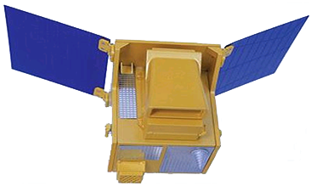
Source: space. Skyrocket, 2019

Figure 1. ETRSS-1 remote sensing satellite of Ethiopia

In the next 10 years, the institute intends to launch at least three satellites (ESSTI 2020 annual report). Along with these initiatives, ESSTI also had plans to work with foreign companies to construct a satellite Manufacturing, Assembly and Integration (M-AIT) centre. The multi-mission data receiving ground station also planned and it will be finished by the beginning of April 2021(Novascotia Online, 2019). In WDM tool, five levels measures such as highly important, important, very necessary, necessary, and not required, are used with the percentage score. The grades on the levels scale range from (5) to (1), with a drop from extremely important to not required (Olabanji & Mpofu, 2014).

Literature review

The selection requirements for a desirable natural and social environment are related to spaceport location parameters. In addition to these researches cited AHP data analysis is employed to get judgments regarding the regions chosen for supporting the development planning of spaceports (Perwitasari, 2018). The site selection procedures involve a thorough analysis of the project's requirements, which are then compared to the qualities of alternative locales (Steyn & Buys, 2017). When there are multiple possibilities and factors to rank the alternatives, WDM can be helpful in a variety of ways (Dachyar & Purnomo, 2018). In order to decrease and control the cost as well as the risk, the development of a launch site is largely dependent on the assumptions of technical viability, security, and reliability. Any launch site must meet five essential requirements: transportation, testing, assembly, transfer, and launch (Jun-xin Zhang et al., 2020). There are various site descriptions and selection criteria worldwide such is site selection using a decision-making analytical hierarchy approach (Vieth, 2011; Dachyar & Purnomo, 2018). Using the AHP technique to compare districts with high economic performance and contributions to local economic growth, the location of the spaceport in Indonesia was chosen (Diana et al., 2018).
Weighting strategies are used in Vietnam to select locations for industrial parks. Secondary sources and expert interviews are used to acquire data on site selection for the 33 industrial parks that have been shortlisted. This information is utilized through a three stage site selection process (Kaltiainen, 2010). Site criteria are rated for each of the prospective sites in a decision matrix in order to be able to make an objective site selection (Steyn & Buys, 2017). Listing all possible adverse effects for each of the candidate sites compels the decision-making group to consider more important concerns. Thus, the site that is suggested will be the one that has the fewest adverse effects (Greyhill Advisors, 2017). Varied countries have different regulations for rocket launch locations, such as those used in the USA to regulate the usage of model rockets and put into place in specific states like the Michigan Act for Rocket launch, commonly known as Act 333. The law established guidelines for model rocket launch facilities, as well as minimal specifications for the dimensions, configuration, and location of the flight regions, which should not jeopardize the safety of adjacent inhabitants and visitors (Act 333, 2021). The Japanese rule is set up for safety in order to avoid mishaps and lessen harm that comes from launch site operations for orbital insertion launch vehicles and payloads (JAXA, 2019). There are guidelines for conformity certification for launch sites and it intends to obtain a compliance certification for the launch site if it conforms to type-specific site safety standards and ensures the existence of prohibited areas (NSPS, 2018).

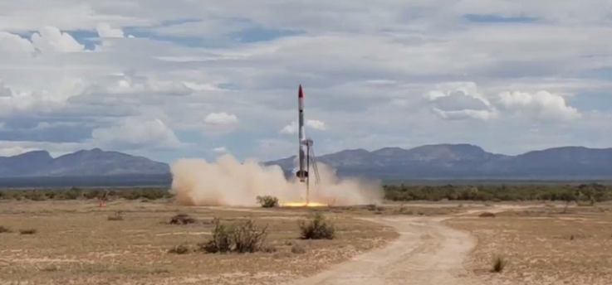
Source: Exos Aerospace

Figure 2. Suborbital sounding rocket launch from New Mexico

For Federal projects, detailed site selection procedures normally take nine months, where as they take between four and six for private sector initiatives (US GSA, 2011). The scientific community values sounding rockets because they allow quick, cheap, recoverable suborbital flights into microgravity despite not receiving much media attention which require less space (EA, 2000). Since there are no comparable sites or fields for aerospace-related purposes, the major goal of this study is to choose a rocket launch site in Ethiopia. The Weighted Decision Matrix methodology is used to identify impartial sites more easily than with any other selection method. Following environmental investigation, ESSTI will perform a feasibility study to determine the best location for Ethiopian space port locations.

Methods and study parameters

WDM analysis is used in this study's research approach, which comprises multiple stages from phase 1 to phase 2, to help come to a decision. This uses quantitative studies, statistical data, and descriptive maps and tables that pertain to each of the selected regions or sites in Ethiopia. In order to choose longlists and shortlists for a certain launching location, the study is divided into two phases that are conducted in quick succession. The entire geographic area of Ethiopia is studied during the first phase of the project in order to get long lists. A specific site is chosen from a group of three regions based on an analysis using WDM and Excel templates of each region’s weighted value.

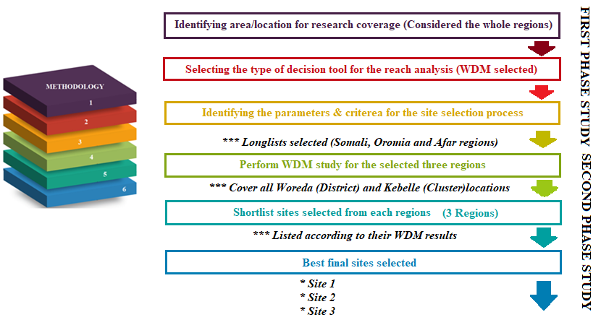

Figure 3. Research method flow chart

Phases one and two of the procedures we followed in choosing the rocket launch site are clearly depicted in Figure 3. First, all regions are chosen nationwide specifying parameters, and establishing criteria using a WDM. Locations in ‘Woreda’ and ‘Kebele’ have been chosen. Geographical locations that are unacceptable for rocket launch sites make up as rejecting criteria. The criteria are listed out as primary and secondary parameters. Long lists are chosen in the first phase of the study, while shortslists and final sites are chosen in the second phase. The importance of each criterion and the average score of the 20 staff members are used to determine the weight for each criterion which is similar procedures followed by other articles (Dachyar & Purnomo, 2018).
First phase studies to select longlists (suitable locations)
- Primary parameter

Since they are critical in choosing the optimum launching site, these parameters are regarded as mandatory parameters (Vieth, 2011; Olabanji & Mpofu, 2014). Lists of primary parameter criteria are provided below;

Coffee production areas

Estimated values of 15 million people depend on coffee production for their livelihood. Coffee accounts for about 60% of Ethiopia’s foreign income (Chauhan et al., 2015; Keyzer et al., 2000; David et al., 2013). Therefore, for economic reasons, the coffee-producing regions are completely excluded.

Flight corridors

The rocket launch sites shouldn’t be situated within 50 kilometer radius of any airport in order to prevent conflicts, collision, and disruptions to the airspace of existing airport (Selvidge, 2010; FAA, 2016; Flightradar24, 2021). The current national aviation corridors are taken into consideration for rejection in this analysis.

National conservation

It is not advised to use national conservations like national parks and forests as launch sites.

Cities and towns

Cities, towns and surrounding areas have a higher population density, which makes them less desirable.

Population density

For two main reasons, it is not advisable to use densely populated areas as launch sites. First, with the launch sound levels, this shouldn’t exceed160 dB in cities, towns, or other populated regions. The second concern is safety issues of the launch location from inhabited regions, which relies on the impulse and motor type. These statistics are accessible at the Code of Federal Regulation and the US national Association of Rocketry’s rocket safety range (NAR, 2022; CFR. 2022).

Geological phenomena

The Ethiopian Rift Valley Papers (2016) report that 50 volcanic edifices are situated in the northeastern region of Ethiopia, making the sites less attractive. Ethiopia is divided diagonally by the rift valley.

Distribution of industries

Due to the size of their expenditure, industrial areas are not advised as launch sites.
Cultivated land

The mainstay of Ethiopia’s economy is agriculture (Amede et al., 2017). Locations with plantations, irrigated land, and commercial agriculture sites are disallowed.

Expansion areas

The location of rocket launch sites is less favorable in areas that are intended to be extended for agriculture, industrial parks, grazing settlements, and infrastructure development.

Table 1. Parameter 1 for the first phase studies

Parameter 1 Criteria for the first phase studies (Initial comparison)
  - Population density

  - Cities and towns
1.3 Cultivated lands
- Commercial crop sites
- Coffee production areas
- Irrigated lands
- Plantation areas
  - Distribution of industries (industry areas)
1.5 National conservation
- Forestry
- National parks
1.6 Flight corridors (airport airspace) (Air force airspaces)
  - Geological phenomena
1.8 Advantage of the equator
1.9 Advantage of earth’s rotation
Note: Each criterion is evaluated with WDM for all regions with different tables. The result is shown in Table 2

The next step after determining the site selection parameters is to give each criterion a weighted factor. The criteria chosen and weights assigned will vary from case-to-case. In order to make a thoughtful choice, a WDM can assist us in analyzing a number of related possibilities. The final and tabulated results of the parameters for each region are shown in Table 2.
The primary parameter result of Somali 239.70, Afar 204.5, and Oromia 192.60 indicates that the three regions have places that are acceptable for launching sites. The outcome will be an input to parameter-2 to determine the final likely regions for the following stage of research.

Table 2. WDM summary result of parameter-1

Criteria | Weight | Options
Criteria | Weight | Tigray | Afar | Amhara | Oromia | SNNP | Benishangul | Gambela | Somali
1.1 | 5 | 6 | 21 | 6.5 | 16 | 10.5 | 14.5 | 17.5 | 22.5
1.2 | 5 | 7 | 22 | 7.5 | 14.5 | 12 | 16 | 18 | 23
1.3 | 4 | 42.8 | 83.6 | 57.8 | 54.8 | 43.6 | 50.8 | 48.8 | 84.8
1.4 | WDM not required for this parameter
1.5 | 4 | 24.1 | 29.7 | 20.6 | 24.2 | 10.8 | 29.3 | 12.2 | 31.3
1.6 | 4 | 10 | 13.2 | 12.4 | 14.8 | 8.8 | 14.8 | 9.6 | 18.4
1.7 | 3 | 18 | 12.8 | 19.8 | 23.4 | 13.2 | 23.4 | 18 | 27.3
1.8 | 3 | 1.5 | 4.2 | 3.6 | 14.1 | 14.4 | 2.1 | 3.9 | 13.2
1.9 | 4 | 12.4 | 18 | 14 | 16 | 12.8 | 3.2 | 4 | 19.2
TOTAL |  | 121.8 | 204.5 | 142.2 | 192.6 | 126.1 | 154.1 | 132 | 239.7

- Secondary parameter

A secondary parameter is considered to filter a rocket launch locations. Different factors must be taken in to account while choosing a rocket launch site, geographical factors including altitude, earth’s rotation, closeness to the equator, azimuth e.t.c (Arcaleanu, 2020). In some papers they use Infrastructure, Population density, Weather, Geographical location, Tourism industry e.t.c. for site selection (Dachyar & Purnomo, 2018). The following list are the secondary factors which the parameter takes into account.

Arid climates

Arid climates are noted for having high temperatures and little precipitation, making them unsuitable for having agricultural areas. In addition to this they are not advised for future population growth or relocation which made them more suitable as rocket launch site.

Low altitude

Although high altitude is technically preferred for rocket launch sites, Ethiopian landscapes with such peaks make them less appropriate.

Less cross winds

The launch vehicle would face difficulties due to cross winds changing the dynamic pressure. Locations with fewer cross winds at higher altitude are better for rocket launching sites since these impacts the aerodynamic forces of a rocket when ascending (Air Command & Staff College, 2009).

Infrastructure (transportation roads)

In the early stages of a rocket launching site’s construction, nearby roads and other nearby infrastructures are more acceptable.

Advantage of the earth rotation

At the equator, anything on the Earth’s surface is already travelling at a rate of 1670 kilometers per hour from West to East (Launching from Florida, 2016). The spacecraft is able to maintain a sufficient speed to remain in orbit thanks to the earth’s rotational motion (Malekshahi & Monge, 2019).

Advantage of the equator

Equatorial latitudes are best suited to utilize the Earth’s 1,035 mph west-to-east rotation rate for a jump start and need less energy to enter low-inclination orbits, which allow them to carry out heavier payloads with the same amount of propellant (SICSA, 2016). The secondary parameter is indicated in Table 3;

Table 3. Parameter 2 for the first phase studies

Parameter 2 for the first phase studies (Additional criteria to filter locations)
2.1 Arid climates
2.2 Country elevation (Altitude)
2.3 Climates (Annual rainfall)
2.4 Agro ecological zones
2.5 Cross winds
2.6 Average temperature
2.7 Infrastructure (transportation, roads e.tc…
2.8 Expansion areas
2.9 Soil map

Table 4. WDM Summary results of parameter-2

Criteria | Weight | Options
Criteria | Weight | TIG | AFA | AMH | ORO | SOU | BEN | GAM | SOM
2.1 | 5 | 30.5 | 45.5 | 26.5 | 24 | 25.5 | 26 | 27 | 47
2.2 | 5 | 10 | 24 | 9 | 14.5 | 13.5 | 17.5 | 19.5 | 21.5
2.3 | 4 | 11.6 | 15.2 | 10.8 | 7.6 | 8 | 9.2 | 8.4 | 17.6
2.4 | 3 | 10.2 | 17.4 | 12.6 | 16.2 | 9 | 6.6 | 7.2 | 15.0
2.5 | 3 | 6 | 8.4 | 5.7 | 6.9 | 5.1 | 3.6 | 4.5 | 8.7
Total |  | 68.3 | 110.5 | 64.6 | 69.3 | 61.1 | 62.9 | 66.6 | 109.8

Table 5. WDM summary results for parameters 1 and 2

Criteria | Weight | Options
Criteria | Weight | TIG | AFA | AMH | ORO | SOU | BEN | GAM | SOM
Parameter-1 |  | 121.8 | 204.5 | 142.2 | 192.6 | 126.1 | 154.1 | 132 | 239.7
Parameter-2 |  | 68.3 | 110.5 | 64.6 | 69.3 | 61.1 | 62.9 | 66.6 | 109.8
TOTAL |  | 190.1 | 315 | 206.8 | 261.9 | 187.2 | 217 | 198.6 | 349.5

From the above result, suitable launching sites are found mainly in three regions Somali, Oromia and Afar.

Second phase studies to select shortlists (final sites)

The ultimate outcome of parameter 1 and 2 reveals that the final launch sites are in the Somali, Afar, and Oromia areas. Locations are further examined at the Zonal, district, and cluster levels using WDM to obtain shortlists. Finding low-value sites that might be candidates for rejection and/or high ranking sites that might be candidates for selection is the method’s principal benefit (Dachyar & Purnomo, 2018; Ibrahim, 2022).
Table 6. WDM criteria and weight

S/N | Criteria | Weight | Remark
1 | Population density | 1 | For all regions
2 | Cities and towns | 1 | For all regions
3 | Cultivated lands | 2 | For all regions
4 | Flight corridors | 1 | For all regions
5 | Commercial crop sites | 2 | For all regions except Oromia
6 | Plantation areas | 2 | For all regions except Oromia
7 | Irrigated lands | 2 | For all regions except Oromia
8 | Vegetation (Forestry) | 2 | For all regions except Oromia
9 | National parks | 2 | For all regions
10 | Distribution of industries | 1 | For all regions except Oromia
11 | Geological phenomena | 2 | For all regions
12 | Advantage of the equator | 5 | For all regions
13 | Advantage of earth’s rotation | 5 | For all regions
14 | Arid temperature | 4 | For all regions
15 | Low altitude | 4 | For all regions
16 | Less rainfall | 4 | For all regions
17 | Bare land | 5 | For all regions
18 | Less cross winds | 4 | For all regions
19 | Plain and terrains | 5 | For all regions
20 | Expansion areas | 2 | For all regions
21 | Infrastructure | 3 | Only for Somali
22 | Livestock production and productivity | 2 | Only for Somali

- Primary results to get shortlists

The primary results of the second phase demonstrate the prospective rocket launching sites at the zonal or Woreda level in each region, and the primary WDM results are further examined to identify the best individual sites.

Afar Region

Afar region is divided into 39 woredas and five administrative zones (Goshu et al., 2021). Only seven Woredas are included in the phase I results. Afdera, Elidar, Dubti, Aysaita, Afambo, Mile, and Gewane are the chosen Woredas for WDM. The key WDM results for Afar region are shown in Table 7.

Somali Region

The Somali Regional State is organized into 47 woredas and nine regional zones, including Liben, Afder, Korahe, Warder, Fik, Degehabur, Gode, Shinile, and Jijiga (PEFA, 2020). Table 8 displays the key WDM results for the Somali region.
Table 7. Afar region primary WDM results

Criteria | Weight | Afdera | Elidar | Dubti | Aysaita | Afambo | Mille | Gewane
Criteria 1 | 1 | 5 | 5 | 2 | 1 | 3 | 3 | 1
Criteria 2 | 1 | 5 | 3 | 1 | 1 | 2 | 2 | 3
Criteria 3 | 2 | 10 | 10 | 6 | 2 | 4 | 6 | 6
Criteria 4 | 1 | 5 | 4 | 1 | 3 | 3 | 4 | 4
Criteria 5 | 2 | 10 | 8 | 8 | 6 | 6 | 8 | 8
Criteria 6 | 2 | 10 | 8 | 4 | 2 | 2 | 6 | 6
Criteria 7 | 2 | 10 | 10 | 4 | 2 | 2 | 4 | 4
Criteria 8 | 2 | 10 | 10 | 15 | 2 | 4 | 4 | 4
Criteria 9 | 2 | 4 | 6 | 2 | 4 | 4 | 2 | 2
Criteria 10 | 1 | 1 | 3 | 1 | 1 | 1 | 3 | 3
Criteria 11 | 2 | 2 | 4 | 6 | 10 | 10 | 4 | 4
Criteria 12 | 5 | 5 | 5 | 10 | 15 | 15 | 25 | 25
Criteria 13 | 5 | 10 | 25 | 15 | 20 | 20 | 5 | 5
Criteria 14 | 4 | 20 | 12 | 16 | 16 | 16 | 20 | 20
Criteria 15 | 4 | 20 | 16 | 12 | 12 | 12 | 4 | 4
Criteria 16 | 4 | 20 | 16 | 20 | 20 | 20 | 20 | 20
Criteria 17 | 5 | 25 | 25 | 10 | 5 | 5 | 10 | 10
Criteria 18 | 5 | 20 | 12 | 12 | 20 | 20 | 4 | 4
Criteria 19 | 4 | 25 | 20 | 15 | 20 | 20 | 15 | 15
Criteria 20 | 5 | 25 | 20 | 15 | 20 | 20 | 15 | 15
Total |  | 202 | 202 | 160 | 162 | 169 | 155 | 148

Table 8. Somali region primary WDM results

Criteria | Weight | Liben | Afder | Korahe | Warder | Fik | Degehabur | Gode | Shinile | Jijiga
Criteria 1 | 1 | 4 | 4 | 4 | 4 | 3 | 4 | 3 | 3 | 1
Criteria 2 | 1 | 3 | 4 | 3 | 5 | 3 | 3 | 2 | 4 | 1
Criteria 3 | 2 | 2 | 6 | 4 | 10 | 10 | 8 | 4 | 8 | 4
Criteria 4 | 1 | 4 | 4 | 1 | 4 | 2 | 2 | 1 | 4 | 1
Criteria 5 | 2 | 2 | 3 | 5 | 2 | 6 | 6.4 | 4 | 5.6 | 5
Criteria 6 | 2 | 8 | 8 | 4 | 6 | 4 | 4 | 4 | 8 | 8
Criteria 7 | 2 | 8 | 8 | 4 | 2 | 4 | 4 | 4 | 8 | 8
Criteria 8 | 2 | 5 | 7 | 7 | 5 | 5 | 7 | 7 | 8 | 7
Criteria 9 | 2 | 2 | 4 | 10 | 10 | 10 | 10 | 10 | 10 | 10
Criteria 10 | 1 | 3 | 4 | 3 | 5 | 3 | 3 | 2 | 4 | 1
Criteria 11 | 2 | 4 | 6 | 6 | 6 | 6 | 6 | 5 | 6 | 4
Criteria 12 | 5 | 20 | 20 | 15 | 15 | 10 | 10 | 15 | 5 | 5
Criteria 13 | 5 | 10 | 15 | 20 | 25 | 10 | 20 | 17.5 | 10 | 10
Criteria 14 | 4 | 12 | 12 | 16 | 16 | 12 | 16 | 16 | 16 | 12
Criteria 15 | 4 | 16 | 12 | 12 | 12 | 16 | 12 | 12 | 16 | 16
Criteria 16 | 4 | 12 | 8 | 16 | 16 | 8 | 16 | 10 | 16 | 12
Criteria 17 | 5 | 15 | 20 | 20 | 20 | 17.5 | 20 | 17.5 | 20 | 10
Criteria 18 | 5 | 10 | 15 | 20 | 20 | 10 | 15 | 12.5 | 17.5 | 10
Criteria 19 | 4 | 12 | 16 | 14 | 12 | 8 | 12 | 16 | 6 | 4
Criteria 20 | 5 | 12.5 | 15 | 20 | 20 | 15 | 20 | 15 | 20 | 20
Criteria 21 | 2 | 6 | 8 | 6 | 10 | 6 | 6 | 4 | 8 | 2
Criteria 22 | 3 | 6 | 6 | 9 | 6 | 6 | 6 | 6 | 4.5 | 9
Total |  | 176.5 | 205 | 219 | 231 | 174.5 | 210.4 | 187.5 | 207.6 | 160

Oromia Region

The entire East Harerghe, a portion of the West Harerghe, and the eastern and southern portions of Bale are included in the study area. The majority of Borena and Guji are also covered by the study. Primary WDM results for the Oromia region are included in Table 9.

Table 9. Oromia region primary WDM results

Criteria | Weight | Guji | Borena | Bale | East Hararge | West Hararghe
Criteria 1 | 1 | 4 | 4 | 3 | 1 | 2
Criteria 2 | 1 | 4 | 1 | 4 | 1 | 4
Criteria 3 | 2 | 4 | 2 | 10 | 4 | 2
Criteria 4 | 1 | 4 | 2 | 1 | 4 | 4
Criteria 9 | 2 | 2 | 8 | 8 | 2 | 2
Criteria 11 | 2 | 4 | 2 | 8 | 2 | 4
Criteria 12 | 5 | 15 | 25 | 15 | 5 | 5
Criteria 13 | 5 | 15 | 25 | 10 | 20 | 20
Criteria 14 | 5 | 20 | 20 | 10 | 20 | 20
Criteria 15 | 4 | 4 | 20 | 20 | 4 | 8
Criteria 16 | 4 | 12 | 16 | 12 | 4 | 4
Criteria 17 | 5 | 10 | 25 | 10 | 25 | 25
Criteria 18 | 4 | 20 | 16 | 8 | 20 | 20
Criteria 19 | 5 | 15 | 25 | 5 | 10 | 10
Criteria 20 | 2 | 2 | 4 | 6 | 6 | 2
Total |  | 135 | 195 | 130 | 128 | 130

- Secondary Results to get final sites

From the initial WDM results, potential areas are chosen at the zonal or Woreda level for the Afar, Somali, and Oromia regions. For further comparison and final selection, data from ESSTI's satellite operation and Google Earth map are employed.

Afar Region

Table 10 shows the secondary results obtained in Afar region. The chosen locations' area, perimeter, and coordinates are provided along with some remarks.

Table 10. Afar secondary results

S/N | Selection site | Zone | Location size | Coordinates | Remarks
1 | Debure | Zone 1, Afdera Woreda | Area = 120.67 km²  Perimeter = 32.79 km | GPS Co:  40º08’00’’E/13º40’00’’N | Possible Seismic action and industrial expansion area
2 | Meskana Geleblu | Zone 2, Elidar Woreda | Area = 84.63 km²  Perimeter = 36.56 km | GPS Co:  41º13’00’’E/12º13’00’’N | Archeological and research site location should be determined

Somali Region

Table 11 shows the secondary results obtained in Somali region.
Table 11. Somali secondary results

S/N | Selected site | Zone | Location size | Coordinates | Remarks
1 | Boh1 Woreda | Warder | Area = 3241.12 km²  Perimeter = 243.84 km | GPS Co: 7º46’59’’N/47º15’39’’E | Vast areas of bare lands are available in this location
2 | Boh2 Woreda | Warder | Area = 2966.89 km²  Perimeter = 227.96 km | GPS Co: 7º24’59’’N/46º52’12’’E | Vast areas of bare lands are available in this location
Oromia Region

Table 12 shows the secondary results obtained in Oromia region.

Table 12. Oromia secondary results

S/N | Selection Site | Zone | Location Size | Coordinates | Remarks
1 | Borena1 (Arero) | Borena | Area = 115.63 km2  Perimeter = 43.11km | GPS Co:  4º15’28”N, 39º16’59”E | Closest to the equator but westward locations
2 | Borena2 (Dehas) | Borena | Area = 47.31km²  Perimeter = 28.29 km | GPS Co:  4º10’15”N, 39º08’41” E | Closest to the equator but westward locations

Results and discussion

Phase I Possible site selected locations (longlists)

Under the initial stage of the analysis, potential places are broadly chosen. Ethiopia is a Federal state composed of 9 National Regional States (NRS). The study takes place in Afar, Amhara, Tigray, Oromia, Somali, Benishangul-Gumuz, Southern Nations, Nationalities and Peoples Region (SNNPR), Gambella, Harari and two administrative councils such as Addis Ababa and Dire Dawa. 62 zones and 523 woredas make up the remaining divisions of the NRS and administrative councils (Embassy of Ethiopia Online, 2022). The two administrative councils and the Harari regional state are not covered by this study because they are populated areas. The first phase study's highest WDM result and real-time map surveys indicate that Somali, with a WDM score of 349.50, will likely be one of the finest sites. With the exception of occasional volcanic activity in the Region, more sites will be anticipated in Afar with a WDM value of 315.00 than Oromia. Whereas in Oromia, where the WDM score is 261, best locations are only likely to be found in the south of the region as shown in Table 13.

Table 13. WDM result of phase one study

Regions | Final Higher WDM results
Regions | WDM value | Remark
Somali | 349.50 | Best sites are expected
Afar | 315.00 | Best sites are expected except volcanic activities
Oromia | 261.00 | Best sites are expected to the south of the region

As depicted in Figure 4, the territories at 6° Latitude North and 41° Longitude East are acceptable for rocket launch sites in Ethiopia. Even though the SNNP region is shown on the map as part of the chosen area, its WDM result is poor; therefore it is not taken into account in the second phase.

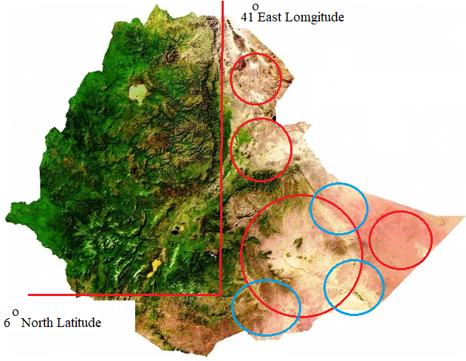
Source: Google Earth

Figure 4. Selected locations from phase one study

Phase II Specific sites selected (shortlists)

In step two, additional research is conducted to identify certain areas in the regions that were chosen in phase one. In the zonal and Woreda levels, specific localities are located initially. The places chosen from each region are identified along with their coordinates. From the final regional findings, the best site is then chosen.

Table 14. WDM result of phase two study

S/N | Selected site | Zone | Region | Location size | Coordinates | Remark
1 | Boh Woreda | Warder | Somali | A2=3241.12 km² | A₁=7º46’59’’N/47º15’39’’E | There is vast areas of bare lands in this location
2 | Boh Woreda | Warder | Somali | A₁=2966.89km² | A₂=7º24’59’’N/46º52’12’’E | There is vast areas of bare lands in this location
3 | Borena1  (Arero) | Borena | Oromia | Perimeter = 43.11km  Area = 115.63 km² | GPS Co:  4 15’ 28” N, 39 16’ 59” E  Altitude: 1,169m  Distance from Moyale: 83 km (Arero) | Closest to the equator but westward locations
4 | Borena2  (Dehas) | Zone 2, Elidar Woreda | Oromia | Perimeter = 28.29 km  Area = 47.31km² | GPS Co: 4 10’ 15” N, 39 08’ 41” E  Altitude: 1,223m  Distance from Moyale: 71 km | Closest to the equator but westward locations
5 | Meskana Geleblu | Warder | Afar | 9.1 km X 9.3 km | Lat₁=41º13’00’’E  Lat₂=41º18’00’’E  Lat₁=12º13’00’’N  Lat₁=12º18’00’’N  Perimeter = 36.6 km  Area = 84.04km² | Archeological and research site location should be determined
6 | Boh Woreda | Zone 1, Afdera Woreda | Somali | A₁=2966.89km² | A1=7ºN 47ºE and 7ºN 46ºE | Selected site for launching site compared to other regions of Ethiopia
7 | Debure |  | Afar | 7.3 km X 16.53 km | Lat₁=40º08’00’’E  Lat₂=40º12’00’’E  Lat₁=13º40’00’’N  Lat₁=13º45’00’’N  Perimeter = 32.98 km  Area = 67.21 km² | Possible Seismic action and industrial expansion area

Final selected locations for rocket launching sites

Analysis is carried out in two stages to narrow down the nine regions of Ethiopia to particular areas. The WDM results of the three regions that were chosen in the phase one study are 349.50 for Somalia, 315 for Afar, and 261.90 for Oromia. Finally, the country's 6°N Latitude and 41°E Longitude are chosen based on research data, maps, and additional study of long lists. In each location, the short lists are chosen based on additional WDM analysis. Along with WDM analysis, several departments and organizations choose the finest launching sites to provide short lists. The places that were ultimately chosen are listed in Table 15.

Table 15. Final selected locations for rocket launching sites

S/N | Selected site | Zone | Region | Location size | Coordinates
1 | Boh1 Woreda | Warder | Somali | Area = 3241.12 km²  Perimeter = 243.84 km | GPS Co: 7º46’59’’N/47º15’39’’E
2 | Boh2 Woreda | Warder | Somali | Area = 2966.89 km² Perimeter = 227.96 km | GPS Co: 7º24’59’’N/46º52’12’’E
3 | Borena1 (Arero) | Borena | Oromia | Area = 115.63 km2 Perimeter =43.11km | GPS Co: 4º10’15”N, 39º08’41” E

Table 15 lists the coordinates for the chosen sites in the Somali and Oromia regions. Boh-1 and Boh-2 are the chosen sites in the Somali Region. Arero Woreda is chosen from the Borena Zone in the Oromia. The three areas are determined by phase two assessment to be the ideal locations for rocket launching site. Finally, as seen in figure 5, the top rocket launch sites were created through collaboration between ESSTI and the Geospatial Information Institute of Ethiopia.

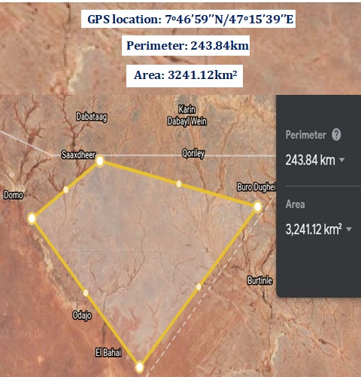

Figure 5. Boh Woreda 1 Google earth Site perimeters

Figure 6 depicts the Boh1 Woreda final site map that was generated in the ESSTI office using the WDM results. Figure 8 displays the region of the Boh2 Woreda site. Figure 9 and figure 10 depicts the site map in Borena Woreda.

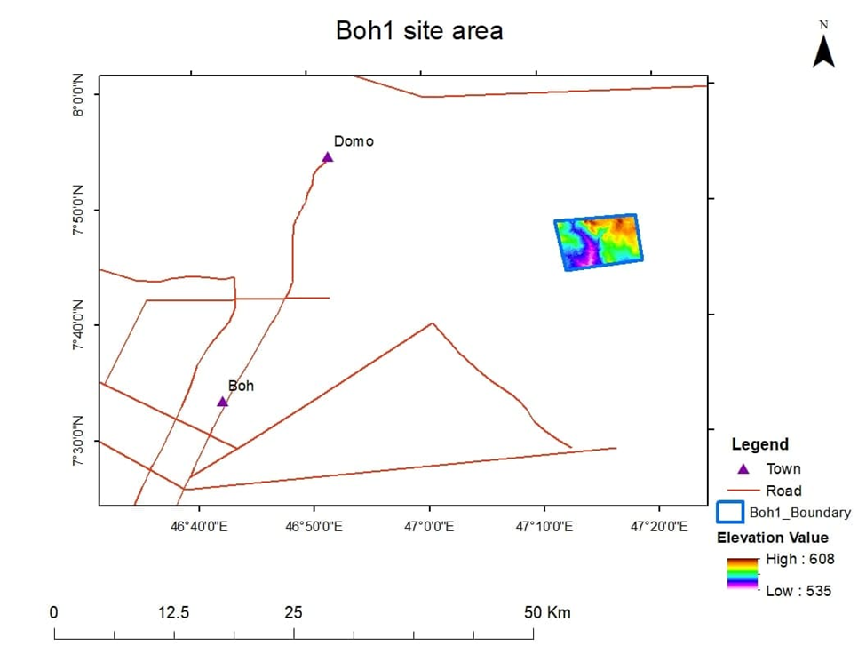

Figure 6. Boh 1 site map

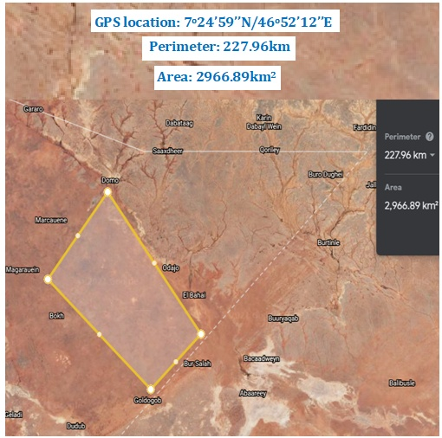

Figure 7. Boh Woreda 2 Google earth Site perimeters

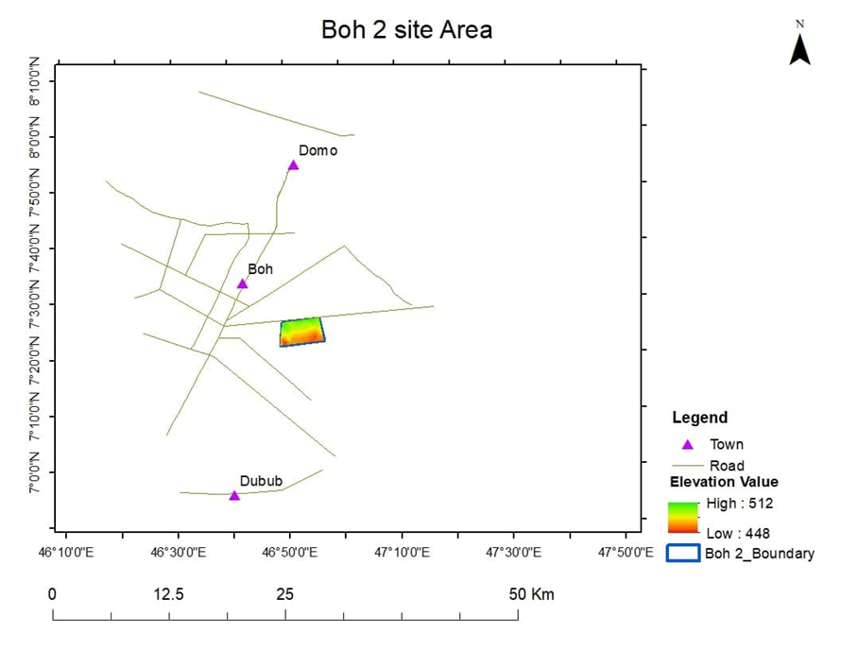

Figure 8. Boh 2 site map

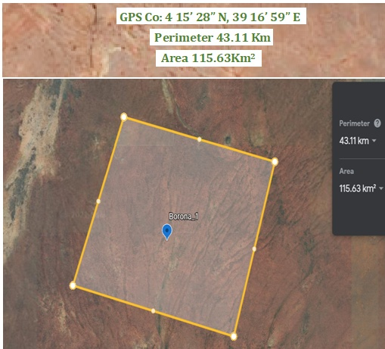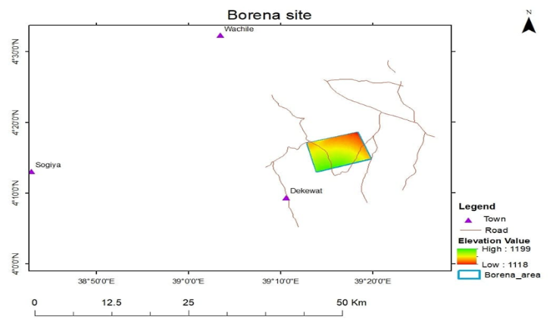

Figure 9. Borena Google earth Site perimeters Figure 10. Borena site map

Conclusion

In this study, dividing the approach into phases helps to narrow down the study from the whole geographic area to specific ones and it is found that using WDM is convenient and appropriate for criteria based selection processes. According to the analysis, three distinct site locations—Boh1, Boh2, and Borena—were chosen in that order. The AHP tool can be used to enhance this research for many places within specific region; however, the project will cost a lot of money. We were unable to evaluate aerial survey, mapping, and actual site visits for the chosen locations due to a lack of project funding. The results demonstrate that WDM may be used for a large geography with ease and economy. The availability of launch pads demonstrates the potential for programs involving rocket research testing. This study is the first of its kind in the country and could serve as a space development roadmap for the selected rocket launch sites. This in turn might spur other African nations to conduct research for their own nations. As a result, Ethiopia in particular and Africa as a whole will benefit greatly from additional research and the creation of an infrastructure for rocket launch sites.

Acknowledgement

This research paper's completion would not have been feasible without the Ethiopian Space Science and Technology Institute, who provided funding for the study. The institute's assistance in completing the project in two phases is greatly valued. The Geospatial Information Institute (GII), who created our final site map, has our sincere gratitude.

References

Act 333. (2021). Michigan Compiled Laws Chapter 259 – Aviation Act 333 of 1965. Retrieved from https://law.justia.com/codes/michigan.
Air Command and Staff College (2009). AU-18 Space Primer.
Amede, T., Auricht, C., Boffa J.M., Dixon, J., Mallawaarachchi, T., Rukuni, M., & Teklewold- Deneke, T. (2017). A farming system framework for investment planning and priority setting in Ethiopia. Food Policy, 3. 1–109.
Arcaleanu, R. (2020). Study of the feasibility of “Rocket launching consultancy” through the analysis of the propulsion system’s requirements to reach LEO and MEO orbits with payload up to 1000 kg (Thesis). Retrieved from Aerospace Vehicle Engineering Department, Cataluniya Polytechnic University, Spain.
Caspi, M., Barthelemy, C. D., Bussy-Virat, I. J., Cohen, C. E., DeForest D. R., Jackson, Vourlidas, A., & Nieves-Chinchilla, T. (2022). Small satellite mission concepts for space weather research and as pathfinders for operations. Space Weather Journal, 20(2). https://doi.org/10.1029/2020SW002554.
CFR (2022). Code of Federal Regulations. Retrieved from https://www.govinfo.gov/ app/collection/cfr.
Chauhan, J., Hooda, M. S., & Agena Anjulo Tanga (2015). Coffee: The backbone of Ethiopian economy. International Journal of Economic Plants, 2(1), 018-022.
Chris Shove (1989). Paper Session III-C - Spaceport Florida and Other State-Sponsored Space Development Initiatives in Florida and other Space Development Initiatives in Florida, USA. The Space Congress Proceedings, 5 (26th).
Dachyar, M., & Herry Purnomo (2018). Spaceport Site Selection with Analytical Hierarchy Process Decision Making. Indian Journal of Science and Technology, 11(10).
David, H. S., & Thomas, P. O. (2013). Historical Dictionary of Ethiopia. (2nd ed.). Maryland, Scarecrow Press. https://doi.org/10.17485/ijst/2018/v11i10/96506.
Diana, Farida Farida, & Ida Musdafia. (2018). Selection of Spaceport Site in Indonesia: Good Economic Efficiency and Contribution to Local Economic Development, Journal of Arts Science & Commerce IX (4), 65. https://doi.org/10.18843/rwjasc/v9i4/09.
EA ( 2000). Proposal to construct and operate a satellite launching facility on Christmas Island. Environment Australia Technical Report.
ESSTI Planning Department. (2020). Ethiopian Space Science and Technology Institute annual report.
Embassy of Ethiopia Online. (2022). Overview About Ethiopia. Retrieved from https://ethiopianembassy.org.
EXOS online. (2019). Aerospace Systems & Technologies, Inc. Payload User Guide (PUG), Rev 3. Retrieved from https://exosaero.com.
FAA online. (2016). Pilot’s Handbook of Aeronautical Knowledge. Retrieved from https://www.faa.gov.
Flightradar24. (2021). Live Flight Tracker-Real Time Flight Tracker Map. Retrieved from https://www.flightradar24.com.
Google Earth. (2022). Map of Ethiopia. Retrieved from https://earth.google.com.
Goshu, D., Mengistu, K., Semeneh, B., Aemro, T., & Dawit, T. (2021). Socioeconomic Development in Afar Region. Ethiopian Economic Association.
Greyhill Advisors. (2017). Site Selection Process. Retrieved from http://www.greyhilladvisors.com.
Ibrahim, OZ. (2022). Decision making in evaluation and selection of launch site with the best and worst method. Gazi University, Journal of Science, 35(4), 1521-1533. https://doi.org/10.35378/gujs.721823
JAXA. (2019). Safety regulation for launch site operation, Japan Aerospace ExplorationAgency. Retrieved from https://sma.jaxa.jp.
Jun-xin Zhang, Zhong Wen-an, YE Xin, Jia Hong-liang, Wang Yu-chao, & Zhu Xiao-le. (2020). Planning and Design Method for Heavy Launch Vehicle Launch site for Manned Mars Exploration Mission. Journal of Physics: Conference Series, 1639. https://doi.org/ 10.1088/1742-6596/1639/1/012004
Kaltiainen, K. (2010). Site selection in Vietnam, Kevät (Thesis), Retrieved from International business, Lahti University of applied sciences.
Keyzer, M. A., Merbis M. D., & Overbosch, G. B. (2000). Agriculture and Developing Countries: The Case of Ethiopia.VU research portal, FAO, Rome Centre for World Food Studies (SOW-VU), Amsterdam.
Launching From Florida (2016). Life in the Fast Lane! Retrieved from https://www.nasa.gov.
Malekshahi & Monge, L. D. (2019). Introducing a technical feasibility framework for acommercialized, low-latitude spaceport. Proceeding International Astronautics Congress, IAC.
National Association of Rocketry (NAR). (2022). Safety range. Retrieved from https://www.nar.org/
Novascotia Online. (2019). Canso spaceport facility project. Retrieved from https://novascotia.ca.
National Space Policy Secretariat (NSPS). (2018). Guidelines on Type Certification for Launch Vehicles. Retrieved from https://www8.cao.go.jp.
Olabanji, O. M., & Mpofu, K. (2014). Comparison of weighted decision matrix and analytical hierarchy process for CAD design of reconfigurable assembly fixture. Procedia CIRP, (23), 264–269. https://doi.org/10.1016/j.procir.2014.10.088
Perwitasari, I (2018). Indonesia spaceport selection based on Multicriteria analysis study on relative importance and priority regarding spaceport selection location attributes utilizing AHP. 3rd international conference on Indonesian social and political enquiries, 366.
Rogers, R. M. (2015). Commercial Spaceports - Building the Foundation of a Commercial Space Transportation Network. TR news, 300, 9-14.
Selvidge, P. (2010). From airport to spaceport: Designing for an aerospace revolution. Retrievd from http://scholarcommons.usf.edu/etd/1764/
SICSA Online. (2016). Space Mission and Facility. Retrieved from https://sicsa.egr.uh.edu/lectures.
Skyrocket. (2019). Retrieved from https://space.skyrocket.de/doc_sdat/etrss-1.htm
Steyn, J., & Buys, C. (2017). Site Selection for Process Plants. Owner Team Consultation. Retrieved from https://www.ownerteamconsult.com/site-selection-for-process-plants
The Ethiopian Rift Valley-Papers. Retrieved from http://ethiopianrift.igg.cnr.it/papers.htm
US GSA. (2011). The Site Selection Guide. General Service Administration US Chief Archit. Office.
Vieth D. L. (2011). Site description and selection process. MRS Online Proceeding Library Archive, 26 (279). https://doi.org/10.1557/PROC-26-279
Yoon, D. (2018). The policy research of preliminary feasibility study for the government R&D innovation strategy. International Journal of Engineering Bussiness Management, 10, 1-11. https://doi.org/10.1177/1847979018778696

