Spatial modelling of papaya dieback disease occurrence

Nurul Hawani Idris¹, Marliana Azman¹, Sazlieya Saupi Teri¹, Erneeza Mohd Hata², Mohamad Hafis Izran Ishak³

¹Department of Geoinformation, Faculty of Built Environment and Surveying,
Universiti Teknologi Malaysia 81310 Johor Bahru Johor
²Department of Plant Protection, Faculty of Agriculture, Universiti Putra Malaysia,
43400 UPM, Serdang, Selangor, Malaysia
³Department of Control and Mechatronics, Faculty of Electrical Engineering,
Universiti Teknologi Malaysia 81310 Johor Bahru Johor

Correspondence: Nurul Hawani Idris (email: hawani@utm.my)

Received: 20 July 2022; Accepted: 27 August 2023; Published: 30 August 2023

Abstract

The incident of papaya dieback disease has resulted in huge losses due to the decrement in crop yield. The disease is affecting papaya production in Malaysia, putting papaya production at risk, primarily to accommodate the national and export trading needs. Abiotic factors have been identified as agents influencing the occurrence of papaya disease, however, little study includes the possible influence of landscape features on disease occurrence. Therefore, using a spatial model, this study aims to investigate the influence of weather variables and the surrounding landscape on papaya dieback disease in Batu Pahat district, Johor, Malaysia. This study applied an Ordinary Least Square (OLS) regression to identify the dominant abiotic factors influencing the papaya disease incident. The main finding revealed that the distance of disease incidents significantly influences the rate of papaya dieback disease based on the affected points (crop) to the nearby road; the percentage area of papaya dieback disease incidence was negatively related to the distance from the road. In other words, being closer to road features may increase the size of the affected area. This research could benefit stakeholders in strategising agricultural practices including planning suitable landscape and topographic characteristics of newly planted areas to reduce the occurrence of such disease.

Keywords: Abiotic factors, ordinary least square, papaya dieback disease, spatial epidemiology, spatial model, tropical climate

Introduction

Papaya (scientific name Carica papaya Linn) is one of the tropical fruit plants widely consumed all over the world. It is rich in antioxidants and nutrients such as vitamin C and folate fibre, improving digestion (Boshra & Tajul, 2013). Malaysia’s papaya production was estimated at 60,980 metric tonnes in 2021 with 37,882 metric tonnes was produced in Johor; the Batu Pahat district of Johor alone produced 24,420 metric tonnes (DOA, 2021). The worldwide demand for papaya has steered Malaysia to increase papaya production and quality. Papaya is the second national fruit commodity after the watermelon, having been exported to Singapore, Hong Kong, Europe, and the Middle East countries. Malaysia is now improving its target of exporting papaya fruits to compete with neighbouring countries such as Indonesia, the Philippines, and Thailand. Nevertheless, papaya production in Malaysia has decreased over the years as it has been exposed to various diseases such as papaya dieback, papaya Ringspot Virus, Anthracnose and papaya mosaic virus, and pests such as Bactrocera spp., Tetrarynchus spp. and Thrips parvispinus (JPNPP, 2019).
The papaya dieback disease was first reported in Malaysia by the Johor State Department of Agriculture in Batu Pahat, Johor in 2003 and later it continued to spread to Perak, Melaka, Negeri Sembilan, Perlis (Eng, 2011) and other states including Sabah and Sarawak. Several papaya varieties affected by this disease are eksotika, sekaki, solo and hong kong. The papaya dieback disease in Malaysia has caused losses up to RM 30 million from 806 ha affected area (DOA Terengganu, 2019).
The papaya dieback disease is also known as Bacterial crown rot and Bacterial canker disease (Mohd Khairil & Muhammad Munzir, 2014). This disease is caused by a few species of bacteria from Enterobacteriaceae and the genus Erwinia (Eng, 2011). Maktar et al. (2008) have stated Erwinia papayae as one of the causal agents of papaya dieback disease in Malaysia. It is an ordinarily facultative anaerobic, gram-negative bacterium that brings peritrichous flagella. Further studies by Amin et al. (2010) confirmed that Erwinia mallotivora was the main agent for papaya dieback disease spreading in Peninsular Malaysia. Chai et al. (2017) confirmed Erwinia psidii as a causal agent to papaya dieback incident in Sabah. This bacterium has been identified as soil-borne; it spreads to different areas via soil and water.
According to DOA Terengganu (2019), the symptoms of papaya dieback disease can be seen in each part of a papaya plant: shoot, leaves, stem, and fruit. An affected papaya plant may show water-soaked lesions on shoots, leaves, and fruit skin. Black spots may appear on its outer fruit skin. This disease is easily identifiable through the hanging-leaf or ‘flag-leaf’ symptom. In its severe stage, total loss of the crown and death of trees occurs (Mohd Khairil & Muhammad Munzir, 2014).
According to Jabatan Pertanian Negeri Pulau Pinang, (JPNPP) (2019), a papaya plant grows in evenly distributed rain (annual rainfall 1200 mm) to support pollination processes and in tropical climates around 21 to 33 degrees Celsius. A suitable soil pH is between 5.0 – 5.5. It also requires appropriate drainage to prevent water-logged areas. A papaya plant is unsuitable in continuous windy areas as it easily gets damaged by the strong wind.

Spatial epidemiology

Agriculture is changing fast to meet the current demand of the global population. However, agriculture continues to be confronted with new and recurrent epidemics. Plant disease epidemics result from the interactions between three elements known as the disease triangle: (i) virulent pathogens, (ii) susceptible host, and (iii) favourable environment. The occurrence of a disease is highly dependent on all three elements; a disease may not occur where one element is absent (Scholthof, 2007).
Environmental factors, including climatic, soil and landscape variables, significantly influence the host and pathogen life cycles as well as the development of a disease (Chakraborty & Newton, 2011). These characteristics include air temperature, humidity, rainfall and wind directions, soil pH and water content. Spatial dimensions such as elevation and distance to roads, rivers, and urban areas have been identified as abiotic factors influencing many plant disease epidemics. The temporal dimension, such as the duration of each event and its timing, is also essential.
The spatiotemporal variations of biotic and abiotic factors that could be associated with the geographical dynamics of a disease occurrence might be different within and between regions. Geospatial technology and spatial models have been used in collecting pest and disease data and modelling to understand spatial patterns and predict future incidents (Sabtu et al., 2018). There are many crop epidemiological models that have been used, such as to predict the effects of control strategies on the spatial and temporal dynamics of a disease, pesticide resistance, and the spatial structure of susceptible host populations and environments, which have been studied individually but not always at the same scale, time, and region. There is a need to understand the factors between host-pathogen and environment influencing the disease occurrence, abundance and spread. Furthermore, it is imperative to understand the factors that control the variability of epidemics between one location and another and from one season to another (Gilligan, 2008).
Several studies focus on biotic and abiotic factors that cause papaya plant pests and disease occurrence. For example, Bunawan and Baharum (2015) and Supian (2015) have investigated several papaya varieties’ defence responses to the Erwinia mallotivora strain. Research also focuses on developing biological control agents, such as silicon, to increase papaya crop resistance (Yamanludin, 2015). Most existing models use climatic factors in their predictions yet omit other essential environmental (abiotic) elements, including land management and topography characteristics that influence disease occurrence. For example, Lasin et al. (2015) have identified the influence of papaya dieback disease severity due to the relative humidity and crop age. Meanwhile, Mohd Khairil and Muhammad Munzir (2014) have indicated the effect of wind-blown rain on the spread of papaya dieback pathogens.
Nevertheless, relatively little attention has been given to the influence of landscape on disease incidence, abundance and spread. According to Gilligan (2008), pathogens are dispersed through the landscape, including human interventions through the movement of machinery and the importation of seeds. The dispersal may occur on local (within and adjacent fields) and global scales (longer distance). Sabtu et al. (2019) have reviewed the spatial methods and models that have been used to investigate distribution patterns and relationships between abiotic factors including weather and landscape variables on plant pests and disease occurrence data, particularly in a tropical climate. Landscape structure (i.e., topographical effects) has a particular influence on pathogen dispersal (Plantegenest et al., 2007) and spatial dynamics of crop pathogens and weeds (Tamburini et al., 2016). For example, Mora-Aguilera et al. (1993, 1996) analysed the papaya ring-spot virus’s temporal and spatial distribution pattern and papaya dieback disease (Mohd Khairil & Muhammad Munzir, 2014). Still, the dominant landscape factors that influenced the spread of the disease were not discussed (Mora-Aguilera et al., 1993; 1996). Therefore, the landscape and topographic factors influencing the papaya dieback disease incident still require further investigation. Therefore, this paper aims to investigate the influence of abiotic factors on papaya dieback disease incidents in Batu Pahat Johor Malaysia using spatial modelling.

Method and study area

Study area

The study area was in the Batu Pahat, Johor region, where the total area was approximately 1,873 km². The study area was selected based on the distribution of papaya dieback disease incidence records in two mukim in Batu Pahat – Minyak Beku and Simpang Kanan. From the data, the incidents were located in Banang, Koris, Sungai Ayam, Parit Tariman and Taman Senggarang areas. Figures 1 and 2 show the distribution and records of papaya dieback disease incidence in this study.

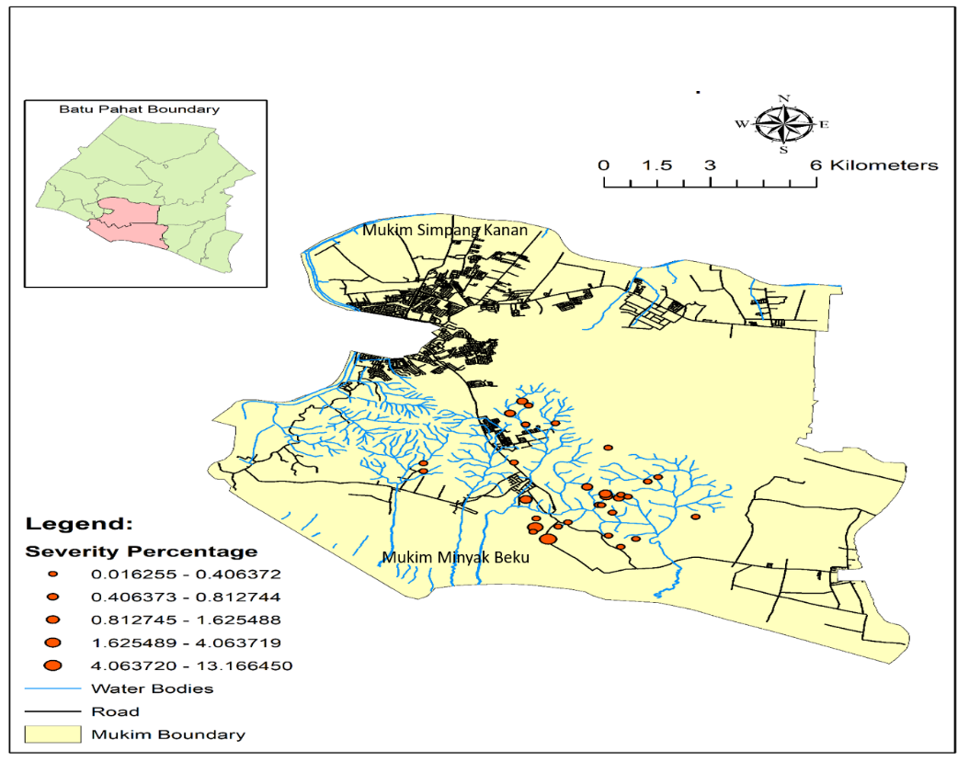

Figure 1. Distribution of papaya dieback disease in Batu Pahat district for the year 2012-2014

Figure 2. The records of disease incidents in Batu Pahat District
Secondary data

This study uses several secondary data, as shown in Table 1. All data were initially in different coordinate systems such as World Geodetic System 1984 (WGS 84) and Cassini Soldner Johor map projection.

Table 1. Secondary data

Data | Data descriptions
Papaya dieback incidence records  (in percentage) | Papaya dieback diseases report is derived from census data and diagnostic from the year 2012 until 2014  (Source: Plant Biosecurity Division of Johor)
Maximum temperature  (unit degree Celsius) | The maximum temperature in the Batu Pahat area from the year 2012 until 2014  (Source: Malaysian Meteorological Department)
Minimum temperature  (unit degree Celsius) | The maximum temperature in the Batu Pahat area from the year 2012 until 2014  (Source: Malaysian Meteorological Department)
Relative humidity  (unit %) | Daily relative humidity in the Batu Pahat area from the year 2012 until 2014  (Source: Malaysian Meteorological Department)
Mean wind speed  (unit meter per second) | Daily mean wind speed in at Batu Pahat area from the year 2012 until 2014  (Source: Malaysian Meteorological Department)
Rainfall  (unit millimetre) | Daily rainfall in the Batu Pahat area from the year 2012 until 2014  (Source: Department of Irrigation and Drainage of Johor State)
Road  (unit meter) | Road features for the entire Batu Pahat  (Source: Open Street Map)
River  (unit meter) | River features for the entire Batu Pahat  (Source: Department of Irrigation and Drainage of Johor State)
Elevation  (unit meter) | Elevation data is extracted from SRTM 30 meters  (Source: SRTM)

Then, the data was transformed into the Malayan Rectified Skew Orthomorphic (MRSO) Kertau map projection. Papaya dieback disease incidence records (location), road, river and irrigation were in vector shapefile format. The elevation data was extracted from the Digital Elevation Model data of the SRTM and was converted from raster to vector format before generating the 20-meter contour lines to obtain the elevation value for the papaya disease incidence. The data was divided into spatial or attribute data. Spatial data was used to describe a location on the earth’s surface, whereas attribute data described a spatial object in the database. Roads, water bodies and elevation data were included in the spatial data, while the other data were included in the attribute data. The maximum temperature, relative humidity and wind data were gathered and displayed in Shapefile format according to their coordinates using the “Add XY Data” function in ArcGIS 10 software. A total of nine data, as shown in Table 1, were extracted to analyse the factors that influenced papaya dieback disease using linear regression analysis. The papaya dieback disease incidence records obtained are not normally distributed. One of the criteria to make an OLS analysis is the data needed to be normally distributed. The data needs to undergo a normalisation process to achieve the normal distribution. This research used SPSS software to normalise and remove outliers from the data obtained for data normalisation.
To meet the criteria for using OLS model, data normalization was conducted due to the non-normality of the variable data. The transformation log-normal distribution method was used in this study on the eight independent and one dependent variable to transform the skewed data to approximately conform to normality. SPSS was utilised to perform the transformation, and Minitab was used for normality testing.

Tools used in data analysis

Several analyses have been used in this study, including the Kernel density tool to map the hotspot pattern, Pearson correlation to determine the correlation between variables, and the Ordinary Least Square (OLS) to identify the dominant factors that influenced the disease incident.
The Kernal density tool (ESRI, 2019a) was applied to map the hotspots of disease occurrence. The tool calculated the density of input features from the number of incidents within a neighbourhood. The density surfaces demonstrated where the point or line features were concentrated in the subject area. A radius of 1000m between points with 50-pixel raster resolution was chosen to form the density hotspot. The value of density is in kilometre square.
The proximity distance tool was used to extract the distance between papaya dieback disease incidence records with the nearby targeted feature. This study used the Near tool incorporated in ArcGIS software. This tool calculated the length based on the geometry type and coordinate systems. This tool was executed on the road and river features to generate ‘distance’ values. The output from this tool was in meters (ESRI, 2019b).
Pearson’s correlation coefficient is a statistical measure of the strength of a linear relationship between paired data. The calculation of Pearson’s correlation coefficient and subsequent significance testing of it requires the following data assumptions: interval or ratio level, linearly related and bivariate normally distributed. Data assumption needs both variables to be individually normally distributed and sensitive to skewed distributions and outliers (Statstutor, 2019).
Ordinary Least Square (OLS) regression in ArcGIS was used to analyse the relationship between dependent and independent variables, as shown in Table 2. The dependent variable was papaya dieback disease incidence records (in the percentage of the total affected area). All independent variables were regressed against the dependent variable to identify which factor most influenced papaya dieback disease incidents.

Table 2. Dependent and independent variables

Types of variables | Parameters
Dependent variable | Affected area per hectare (papaya dieback disease occurrence) (in percentage)
Explanatory (Independent variables) | 1. Maximum temperature  2. Minimum temperature  3. Relative humidity  4. Mean wind speed  5. Distance to road  6. Distance to river  7. Elevation  8. Rainfall

Results and discussion

The hotspot map of the papaya dieback disease incidents

A total of 32 papaya dieback disease incidents were reported in Batu Pahat, Johor between 2012 and 2014. Figures 1 and 2 show the distribution of reported papaya dieback incidents in two mukim in Batu Pahat, namely Minyak Beku and Simpang Kanan. From Figure 1, the highest rate of papaya dieback incidents recorded by Plant Biosecurity was in the Koris locality with 21 cases. Banang locality demonstrated the second highest with 6 cases, followed by Sungai Ayam (2 cases), Parit Tariman (1 case) and Taman Senggarang (1 case).

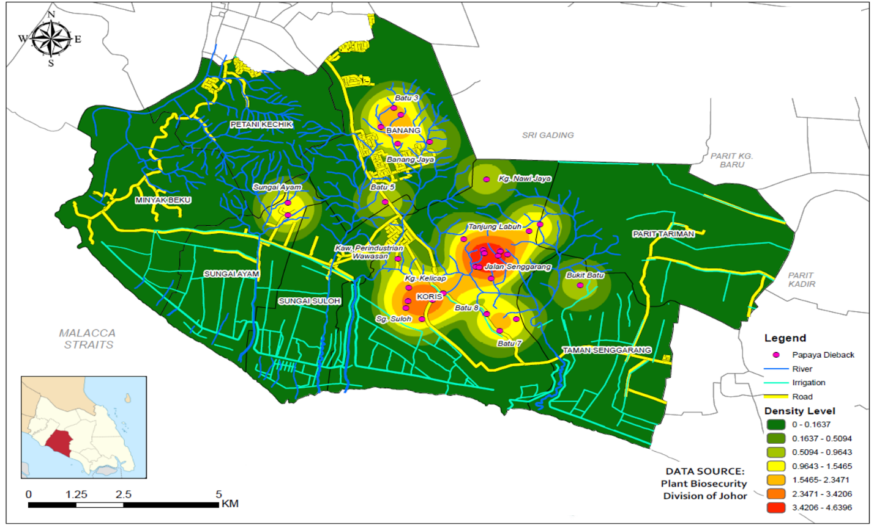

Figure 3. The hotspots of papaya dieback disease incidents in Batu Pahat district

In Figure 3, the colour gradient from pale green to red illustrates papaya dieback disease distribution density. Red-coloured cells indicate that the disease incidence is higher in that area compared to the pale-green cells. The higher the density value, the higher the concentration of disease occurrence. During these four years, papaya dieback disease frequently occurred in the Batu Pahat district’s Koris, Banang and Sungai Ayam localities.

The relationship between disease incidence and tested variables

Table 3 shows that maximum temperature, minimum temperature, humidity, and road and river distance variables were negatively associated with papaya dieback disease. Therefore, the relationship was inversely proportional to the size of the affected area. Bivariate two-tailed Pearson correlation in SPSS was used to test whether the linear relationship between two continuous variables was statistically significant. The result of the Pearson correlation is shown in Table 3. The direction of the relationship was positive for humidity and minimum temperature, wind and maximum temperature, rain and maximum temperature, and rain and wind, meaning that these variables tended to increase together. Meanwhile, rain, maximum temperature, and rain and wind relationship were negative because these variables were negatively correlated and tended to decrease.

Table 3. Pearson correlation of dieback disease incidence versus independent variables

Correlations | AffcArea | Max temp | Min temp | Humidity | Wind | Rain | Elevation | Road | River
AffcArea |  | -0.057  0.755 | 0.222  0.223 | 0.161  0.379 | -0.084  0.649 | -0.144  0.568 | 0.214  0.240 | -0.280  0.121 | 0.038  0.838
Max temperature | -0.057  0.755 |  | -0.242  0.813 | -0.291  0.106 | .453**  0.009 | .674**  0.002 | 0.249  0.17 | 0.033  0.86 | 0.041  0.823
Min temperature | 0.222  0.223 | -0.242  0.183 |  | .906**  0 | -.841**  0 | -0.155  0.54 | -.421*  0.016 | 0.328  0.067 | 0.046  0.803
Humidity | 0.161  0.379 | -0.291  0.106 | .906**  0 |  | -.851**  0 | 0.215  0.392 | -.413*  0.019 | 0.284  0.115 | 0.195  0.285
Wind | -0.084  0.649 | .453**  0.009 | -.841**  0 | -.851**  0 |  | .645**  0.004 | 0.344  0.054 | -0.209  0.251 | 0.105  0.566
Rain | -0.144  0.568 | .674**  0.002 | -0.155  0.54 | 0.215  0.392 | .645**  0.004 |  | 0.167  0.508 | 0.402  0.099 | .554*  0.017
Elevation | 0.214  0.240 | 0.249  0.17 | -.421*  0.016 | -.413*  0.019 | 0.344  0.054 | 0.167  0.508 |  | -0.026  0.886 | -0.05  0.785
Road | -0.280  0.121 | 0.033  0.86 | 0.328  0.067 | 0.284  0.115 | -0.209  0.251 | 0.402  0.099 | -0.026  0.886 |  | 0.168  0.357
River | 0.038  0.838 | 0.041  0.823 | 0.046  0.803 | 0.195  0.285 | 0.105  0.566 | .554*  0.017 | -0.05  0.785 | 0.168  0.357
** Correlation is significant at the 0.01 level (2-tailed) (yellow-coloured)
* Correlation is significant at the 0.05 level (2-tailed) (brown-coloured)

The linear regression between disease incidents and tested variables

Table 4 shows the linear regression results for the dependent variable (i.e., papaya dieback disease incidence (total percentage of the affected area)) versus the independent variables. From the model, the dependent variable (i.e., the size of the affected area) had a significant relationship with the distance to roads. The p-value of the road variable was substantial (p < 0.05), while other independent variables did not show any significant relationship with the dependent variable. The regression model showed that the maximum temperature, minimum temperature, relative humidity, mean wind speed, elevation, river, and rainfall variables were insignificant. From Table 4, the distance to road variable was negatively associated with papaya dieback disease incidence. The relationship was inversely proportional to the size of the affected area. In other words, being closer to road features may increase the size of the affected area. This finding is in line with Mohd Khairil and Muhammad Munzir (2014) study. They demonstrated that the temporal dispersion of dieback pathogens started from plants close to road features in the observation sites and then spread out to the inward areas, affecting other papaya plants. This is similar to a study by Idris et al. (2023) that proximity to roads might have certain influences on the occurrence of crop disease.

Table 4. Ordinary least square regression results of papaya dieback disease incidence versus independent variables

Variables | Coefficient (a) | t-test | Significant | VIF
Maximum temperature | -7.465 | -0.473 | 0.648 | 2.932
Minimum temperature | -1.084 | -0.0586 | 0.955 | 2.741
Humidity | -2.209 | -0.123 | 0.905 | 2.284
Wind | 5.057 | 1.346 | 0.211 | 4.826
Rain | 0.136 | 0.230 | 0.824 | 4.378
Elevation | 1.567 | 2.0234 | 0.0737 | 1.623
Road | -0.691 | -2.646 | 0.027* | 1.464
River | -0.342 | -0.874 | 0.405 | 4.845
* t-test is significant at the 0.05 level (2-tailed).

The VIF values measure redundancy between independent variables; according to ESRI (2019c), explanatory variables associated with VIF values larger than 7.5 should be removed (one by one) from the regression model. Based on Table 4, all the VIFs are below 7.5, meaning the redundancy does not happen in this regression model.
In Figure 4, the red points demonstrate the locations where the number of incidences is higher than predicted, the blue points illustrate the number of occurrences that were lower than anticipated, and the yellow points indicate the accurately predicted events. The percentage of red points is 29 per cent; yellow points is 39 per cent, while blue coloured is 32 per cent.

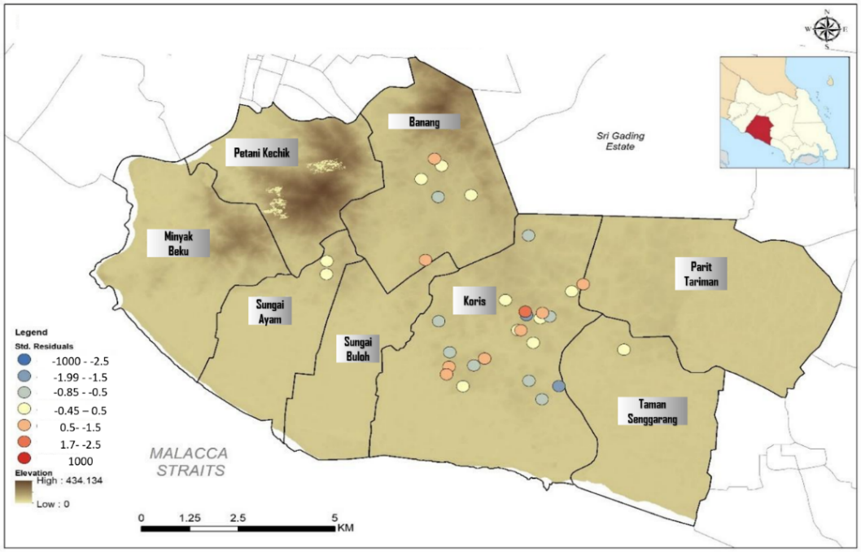

Figure 4. OLS Standard Residuals map of papaya dieback disease incidents

Conclusion

This paper discusses the effect of abiotic factors that influence the occurrence of papaya dieback disease. Based on the findings, it can be concluded that the distance from roads was the dominant factor influencing the affected size of papaya dieback disease incidence. From the analysis, the distance from the road was inversely proportional to the total percentage area of papaya dieback disease incidence. The result also showed the Pearson correlation between humidity and minimum temperature, wind and maximum temperature, wind and minimum temperature, wind and humidity, rain and maximum temperature, and rain and wind had a statistically significant linear relationship (p < 0.001). At the same time, the correlation between elevation and minimum temperature, elevation and humidity and river and rain had a statistically significant linear relationship (p < 0.05).
The limitations of this study were the lack of temporal data on the papaya dieback disease occurrence. Furthermore, the lack of detailed weather data that recorded rainfall data in the incidence area hindered further analysis of the variables. Hence, this study used the annual rain instead of the average rainfall on the incident date. The model can be validated in different samples and areas for future research.

Acknowledgement

We thank the Department of Agriculture, Plant Biosecurity Division Johor, and Jabatan Pengairan dan Saliran for providing relevant data to complete this study. We thank the Ministry of Higher Education and Universiti Teknologi Malaysia for the UTMFR (vote 22H25) and the FRGS Grant Awarded to the first author (Mygrant no: FRGS/1/2021/WAB04/UTM/02/2; UTM vote 5F485).

References

Amin, N. M., Bunawan, H., Redzuan, R. A., & Jaganath, I. B. S. (2010). Erwinia mallotivora sp., a new pathogen of papaya (Carica papaya) in Peninsular Malaysia. International Journal of Molecular Sciences, 12(1), 39-45. https://doi.org/10.3390/ijms12010039
Boshra, V., & Tajul, A. Y. (2013). Papaya – An innovative raw material for the food and pharmaceutical processing industry. Health and the Environment Journal, 4(1), 68-75.
Bunawan, H., & Baharum, S. N. (2015). Papaya dieback in Malaysia: A step towards a new insight of disease resistance. Iranian Journal of Biotechnology, 13(4), 1-2.
Chai, W., Jualang, A. G., Atong, M., Jugah, K., Poili, E., & Chong, K. (2017). First report of Erwinia psidii associated with papaya dieback disease in Malaysia. Malaysian Journal of Microbiology, 13(1), 20-25. https://doi.org/10.21161/mjm.89816
Chakraborty, S., & Newton, A. C. (2011). Climate change, plant diseases and food security: An overview. Plant Pathology, 60(1), 2-14. https://doi.org/10.1111/j.1365-3059.2010. 02411.x
Department of Agriculture Terengganu (DOA Terengganu). (2019). Awas penyakit mati rosot betik (Papaya dieback). Retrieved from http://www.terengganu.gov.my/maxc2020/ appshare/widget/mn_img/76682file/awas%20mati%20rosot%20betik.pdf
DOA. (2021) Statistik tanaman buah-buahan 2021. Accessed from http://www.doa.gov.my/index/resources/aktiviti_sumber/sumber_awam/maklumat_pertanian/perangkaan_tanaman/statistik_tanaman_buah_2021.pdf
Eng, L. (2011). Bacterial dieback of papaya trees. New Sunday Tribune. Retrieved from http://www.doa.sarawak.gov.my/modules/web/pages.php?mod=webpage&sub=page&i=245
ESRI. (2019a). How kernel density works. Retrieved from http://desktop.arcgis.com/ en/arcmap/10.3/tools/spatial-analyst-toolbox/how-kernel-density-works.html
ESRI. (2019b). How proximity tools calculate distance. Retrieved from http://desktop.arcgis.com/ en/arcmap/latest/tools/analysis-toolbox/how-near-analysis-works.html
ESRI. (2019c). Interpreting OLS result. Retrieved from http://desktop.arcgis.com/en/ arcmap/10.3/tools/spatial-statistics-toolbox/interpreting-ols-results.html
Gilligan, C. A. (2008). Sustainable agriculture and plant diseases: An epidemiological perspective. Philosophical Transactions of the Royal Society B: Biological Sciences, 363(1492), 741-759. https://doi.org/10.1098/rstb.2007.2181
Idris, N. H., Hata, E. M., Adnan, N., Saupi-Teri, S., Osman, M. J., Md Din, A. H., & Ishak, M. H. I. (2023). The influence of abiotic factors on the occurrence of jackfruit dieback disease. Pertanika Journal of Science & Technology, 31(5), 2487-2503. https://doi.org/10.47836/pjst.31.5.24
Jabatan Pertanian Negeri Pulau Pinang (JPNPP). (2019). Jabatan Pertanian Negeri Pulau Pinang -Keterangan Am: Betik. Retrieved from http://jpn.penang.gov.my/index.php/teknologi-tanaman-2/buah-buahan/33-betik
Lasin, S., Sijam, K., & Awang, Y. (2015). Occurrence and distribution of papaya dieback disease in Peninsular Malaysia. International Journal of Advanced Multidisciplinary Research, 2(7), 42-48.
Maktar, N. H., Kamis, S., Mohd Yusof, F. Z., & Hussain, M. H. (2008). Erwinia papayae causing papaya dieback in Malaysia. Plant Pathology, 57(4), 774–774. https://doi.org/10.1111/ j.1365-3059.2008.01877.x
Mohd Khairil, J., & Muhammad Munzir, M. (2014). Experiences in managing bacterial dieback disease of papaya in Malaysia. Acta Hortic. 1022, 125-132. https://doi.org/10.17660/ ActaHortic.2014.1022.16
Mora-Aguilera, G., Nieto-Angel, D., Campbell, C. L., Téliz, D., & García, E. (1996). Multivariate comparison of papaya ringspot epidemics. Phytopathology, 86(1), 70-78. https://doi.org/ 10.1094/Phyto-86-70
Mora-Aguilera, G., Nieto-Angel, D., Teliz, D., & Lee Campbell, C. (1993). Development of a prediction model for papaya ringspot in Veracruz, Mexico. Plant Disease, 77(12), 1205-1211. https://doi.org/10.1094/PD-77-1205
Plantegenest, M., Le May, C., & Fabre, F. (2007). Landscape epidemiology of plant diseases. Journal of the Royal Society Interface, 4(16), 963-972. https://doi.org/ 10.1098/rsif.2007.1114
Sabtu, M., Ishak, M. H. I., & Idris, N. H. (2018). The role of geospatial in plant pests and diseases: an overview. IOP Conference Series: Earth and Environmental Science, Volume 169, 9th IGRSM International Conference and Exhibition on Geospatial & Remote Sensing (IGRSM 2018) 24–25 April 2018, Kuala Lumpur, Malaysia. Doi 10.1088/1755-1315/169/1/012013
Sabtu, M., Ishak, M. H. I., & Idris, N. H. (2019). The spatial epidemiology of jackfruit pest and diseases: A review. International Journal of Built Environment and Sustainability, 6(1-2), 169–175. https://doi.org/10.11113/ijbes.v6.n1-2.395
Scholthof, K. B. G. (2007). The disease triangle: Pathogens, the environments and society. Nature Reviews Microbiology, 5(2), 152-156. https://doi.org/10.1038/nrmicro1596
Statstutor. (2019). Pearson’s correlation. Retrieved from http://www.statstutor.ac.uk/resources/ uploaded/pearsons.pdf
Supian, S. (2015). Antioxidant-mediated defense response of Carica papaya L. Var. Eksotika against a compatible Erwinia mallotivora strain BT-MARDI (Thesis Master of Science, Universiti Putra Malaysia).
Tamburini, G., De Simone, S., Sigura, M., Boscutti, F., & Marini, L. (2016). Soil management shapes ecosystem service provision and trade-offs in agricultural landscapes. Proceedings of the Royal Society B: Biological Sciences, 283(1837), 20161369. https://doi.org/10.1098/ rspb.2016.1369
Yamanludin, N. S. (2015). Physiology of Erwinia mallotivora-infected papaya seedlings (Carica papaya L.) treated with silicon (Thesis Master of Science, Universiti Putra Malaysia).

