Landscape characterization using GIS-Based Landscape Character Assessment in Hulu Langat district, Malaysia

Masbiha Mat Isa¹, Nor Atiah Ismail², Abdul Rauf Abdul Rasam³, Mohd Zulhaili Teh⁴

¹Centre of Studies for Landscape Architecture, College of Built Environment, Universiti Teknologi MARA Selangor
²Landscape Architecture Department, Faculty of Design and Architecture, Universiti Putra Malaysia
³Centre of Studies for Surveying Science and Geomatics, Faculty of Architecture, Planning, and Surveying, Universiti Teknologi MARA Shah Alam
⁴Centre Study of Landscape Architecture, Department of Built Environment and Technology, Universiti Teknologi MARA Perak

Correspondence: Masbiha Mat Isa (email: masbiha125@uitm.edu.my)

Received: 3 August 2022; Accepted: 17 July 2023; Published: 30 August 2023

Abstract

Landscape Character Assessment (LCA) is rising in significance as the demand for efficient methods to manage and monitor landscapes increases around the world. LCA entails the procedure of creating maps at the desktop mapping stage to describe and assess landscapes according to the arrangement of landscape features. This study aims to pilot the mapping techniques used in the LCA desktop study, in accordance with the Malaysian Landscape Character Assessment guidebook, in the rapidly growing Hulu Langat district of Selangor. Secondary data and satellite images were used to interpret local geomorphology, hydrology, and land cover maps. The study employs the Geographical Information System (GIS) weighted sum analysis, which allows for a more accurate assessment of the spatial landscape. Six (6) landscape character types were identified in this study: (i) high-hill forest; (ii) low-hill agriculture; (iii) valley-agriculture; (iv) undulating low-land agriculture; (v) undulating low-land settlements; and (vi) low-hill settlements. These six (6) landscapes character types are important information and communication material for discussion among stakeholders in the decision-making stages for landscape development. When contemplating any kind of landscape change, the LCA mapping can be a source of guidelines and references to manage the landscape character. This study has contributed to the creation of a preliminary landscape-type map for the Hulu Langat district. For future studies, it is recommended that the interpretation of landscape elements in the assessment be carried out after the evaluator has gained an understanding of the visual mapping context to avoid discrepancies for better mapping outcomes.

Keywords: GIS, Landscape Character Assessment, landscape-types, weighted sum analysis

Introduction

Landscape characters reveal distinct features in the current environment and provide information about their traits to users (Koç & Yılmaz, 2020). Since the early 1940s, the Landscape Character Assessment (LCA) framework has been used to assess the landscape character to protect and preserve unique landscapes (Yang et al., 2023). Several countries have implemented LCA using methods that combine spatial resolution and policy orientation, resulting in impressive monitoring and reporting products at the national level (Terkenli et al., 2021). It has contributed significantly to the formulation of planning policies, the allocation of land for development, and the regulation of all development activities. When contemplating any kind of landscape change, the LCA mapping can be a source of guidelines and references to manage the character of the landscape. This includes opportunities to maintain the existing character or improve character, as well as opportunities to develop a new character that conforms to the existing conditions.
In its early stages, LCA concentrated primarily on visual assessments based on the observations and experiences of individual participants. As technology has evolved, LCA approaches have been integrated with Geographic Information Systems (GIS) to analyze landscape characters using mapping techniques (Erdoğan et al., 2020; Koç & Yılmaz, 2020). The use of GIS techniques enables improved decisions regarding landscape protection and planning (Asma & Soumia, 2021). The majority of LCA procedures involve using a GIS to map the land cover, which includes both the natural and cultural aspects of the landscape. It is believed that the GIS mapping outcome can: 1) describe a landscape in terms of the characteristics that continue to distinguish a place; 2) provide spatial reference to baseline information via a landscape-type map; 3) inform understanding of key characteristics, sense of place, and unique qualities that enable informed decision-making; and 4) assist in monitoring landscape changes (Tudor, 2014).
In 2012, the Malaysian National Landscape Department under the Ministry of Housing and Local Government introduced the Malaysian Landscape Character Assessment Guide (National Landscape Department, 2012; Teh et al., 2020). The GIS mapping procedure was referred to in the guidebook as part of the LCA process known as the desktop study/desk phase (Koblet & Purves, 2020), which is a preliminary mapping process of landscape character in the respective region. However, there is still ongoing discussion among landscape professionals. These debates revolve around the challenges to standardize the mapping method as handling GIS data requires not only technical skill but also contextual understanding (Erdoğan et al., 2020; Simensen et al., 2018). In this regard, the objective of this paper is to pilot the mapping methods of the LCA desktop study following the Malaysian Landscape Character Assessment guidebook. This study's findings focused on developing a draft of landscape characterization in the form of a preliminary landscape character-type map for an early idea of spatial planning of Hulu Langat, especially its urban, and suburban areas. This study is important in highlighting some adjustments that may need to be addressed in the GIS procedures from the researcher’s mapping experience. Nonetheless, an ongoing LCA process following this desktop study is required to generate a final landscape-type map that can be used to help make decisions that are tailored to local needs.

Literature review

Tudor (2014, as cited in Koblet & Purves, 2020) defined landscape character as "a distinct and recognizable, consistent pattern of elements, or traits, in the landscape that distinguishes one landscape from another, rather than indicating whether one is better or worse". The notion of landscape character has become a priority in the planning of European countries, particularly toward sustainable development. According to Antrop (2004), many new structures have been constructed in European countries, obscuring the distinctiveness of traditional landscapes in rural and suburban areas. As widespread changes occur in European rural landscapes, (Haines-Young et al., 2008) stressed the need to address threats to landscape functions associated with a sense of place, proved by the concept of landscape character. At present, NatureScot (2023) applies the Landscape Character Assessment (LCA) framework for policymakers and practitioners to determine what makes a given area unique and what conditions should be established for its growth and changes in European countries. Other countries have begun and continue to incorporate LCA into their research and planning processes (Brown & Brabyn, 2012; Kim & Pauleit, 2009; Menasra & Bouzaher, 2021; Wu et al., 2021).
In Peninsular Malaysia, physical development in the majority of Malaysia's townships, for example, Selangor, Penang, and Johor have been successful with the growth of industrial areas and good infrastructure networks (Grunsven & Benson, 2020). However, intense development puts pressure on Malaysia's urban and suburban areas to develop without reflecting on natural characteristics (Yaacob et al., 2022). Similar to the situation in Europe (Weith et al., 2021), many man-made elements and structures have been imposed upon the landscape of Malaysia, leading to a loss of diversity, coherence, and identity in the existing landscape. Over the last decades, urbanization, demographic alterations, and industrialization have changed Malaysia's inherent character and qualities, particularly in suburban areas. New designs in the built environments have been debated for their potential to alter the scenery, which later changed the character, particularly in Kuala Lumpur and the surrounding cities (Ujang, 2016).
In general, the Malaysian Landscape Character Assessment method in the guidebook has provided a very well-defined step. The method aims, ultimately, to produce a landscape-style map that will be used as guidelines for managing the landscape resources. Before any new development, LCA can help to identify what types of landscapes are suitable for the sustainability of existing natural and cultural resources, especially in rural and metropolitan edge areas. The character of the landscape will be coordinated with the strategy for developing the landscape based on the quality, strength, and uniqueness of the existing elements. In the study of suburban, Mazlan et al. (2022) have suggested that sustainability should not be confined to the protection of natural resources; it should also include the preservation of landscape identity as a form of cultural landscape. The changing landscape needs constant attention to manage growth sustainably and to ensure that the landscape can continue to be appreciated. Taking into consideration the current state of the landscape in Malaysia, there is an immediate need for direction regarding the process of monitoring changes using LCA (Zakariya et al., 2019). To overcome any difficulties that planners, landscape architects, and researchers might encounter, it is crucial to pilot the LCA desktop mapping procedures described in the Malaysian Landscape Character Assessment guide.
Incorporating GIS into the LCA approach has become common due to the method's well-established efficacy in the realm of map-based analysis (Zhao et al., 2023). Desktop research of satellite images provides the raw data for basic LCA mapping, which later relies on visual interpretation, comprehension, and perception of the experts. In the normal LCA desktop mapping phase, landscape architects with geospatialists, geologists, or ecologists are among crucial members of the main research team. Expert interpretation of the data is a key part of the evaluation, as is the use of geographic information system (GIS) software to graphically display the findings and guarantee precision in the final map. According to Terkenli et al. (2021), the procedure for map interpretation in the desktop study is considered to be subjective because the method that is described is dependent on the perception of the researcher. What is important at the desktop stage is that the data on the physical characteristics of the landscape are collected, and distinct regions (LCA areas) are described (Koblet & Purves, 2020). Gkoltsiou & Paraskevopoulou, (2021) describes that the process entails tracking, registering, collecting, and evaluating data. Since the information is still descriptive and in the process of re-evaluation, the final landscape's character is not yet revealed at this stage.

Material and methods

Study area

This study's location is the Hulu Langat district (2.9936° N, 101.7892° E) in Selangor, Malaysia's southeast region (Figure 1). The landform is hilly in the northwest, covered with forest at altitudes between 100 meters and 1360 meters above sea level. The 2022 census estimated its population of 1,417,500 with an area of 84,000 hectares (Department of Statistics Malaysia, 2022). The area's major land use type is natural forests in the northwest covering almost 60% of the district, while the other 40% is the built-up area in the southeast. Hulu Langat is the fifth largest Selangor district, comprising seven Mukim (sub-districts): Ampang, Cheras, Kajang, Hulu Langat, Semenyih, Hulu Semenyih, and Beranang. Hulu Langat communities consist of 55.1% Bumiputera (Malay and aboriginal people), 33.3% Chinese, 10.7% Indian, and 1.0% others. Some still practice daily agricultural activities and traditional lifestyles despite varied socioeconomic activities. The settlements are concentrated in urban, suburban, and rural, which include traditional and indigenous villages. This region possesses an abundance of natural resources like forests, natural hillside terrain, and rivers, as well as mixed heritage and traditional architectural values. Rapid urbanization from neighbouring Kuala Lumpur is causing significant changes to the landscape. Therefore, it is crucial for long-term sustainability to protect the distinctive identities, cultural traditions, and aesthetic qualities of the local landscape by preparing the landscape-type map following the existing LCA procedure.

Figure 1. Hulu Langat district map consists of seven Mukim as the study area
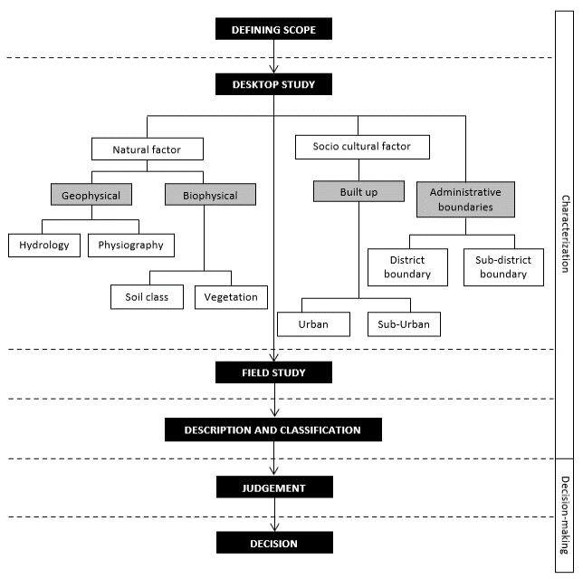
This desktop study method was largely influenced by McHarg (1967) in identifying the map layers and map overlay, which is a vital process before study and stakeholder evaluation to interpret the land cover characteristics (Sari & Munandar, 2020; Tudor, 2014). Within the scope of this desk study, the landscape is broken down into three categories: natural factors, socio-cultural factors, and management factors (Figure 2). The natural factor is further subdivided into geophysical and biophysical components, whereas the sociocultural factor is concerned with the built environment (buildings and infrastructures). The administrative boundaries are included in the management factor. Under natural factors, the term "geophysical" refers to methods concerning physical processes and phenomena that occur within the earth's atmosphere and surrounding environment (soil, hydrology, climate), whereas "biophysical" refers to the material content of a landscape (both natural and man-made elements). The socio-cultural, which is considered equally important refers to the major built environment (urban and suburban) areas such as human settlements (Harun et al., 2021; Mazlan et al., 2022). This study defines administrative boundaries, or discrete boundaries, as a management factor. According to Freeman et al. (2015), landscape boundaries can be either discrete (administrative boundaries) or fuzzy (determined by the extent of community activities or ecological units), resulting in the absence of clearly delineated boundaries. In total, seven-factor maps were created (Figure 3), which were then overlaid onto the preliminary map of landscape types.

Figure 2. LCA desktop study overall flowchart (National Landscape Department, 2012). The steps outlined in red indicate the procedures involved in this study

Data collection

Data and information based on maps were compiled into a GIS database in ArcGIS 10.3 software. Data used in this study have been categorised based on analysis needs, including data types showing how they will be displayed in the mapping with the data properties descriptions (Table 1). For this study, the land use/land cover data were obtained from the Malaysian Department of Agriculture (DOA) and digitized in shape file format. The first information required for this LCA mapping is the geophysical component, which requires contour data to create a slope map and a Digital Elevation Model (DEM). Under the geophysical component, the hydrology map consists of the location of rivers specified into river networks, water bodies, and river basins. Biophysical components consist of forest and plantation data and the built environment represents settlement areas which were all derived from land use/land cover data. Other maps include the administrative boundaries.

Table 1. Database structure for LCA desktop study in Hulu Langat district. Data types show only maps that involve in the weighted sum analysis be converted into the raster format.
Component |  | Data | Data types | Description
Geophysical | Physiography | Slope | Grid cell (raster) | Slope degree value
 |  | Elevation | Grid cell (raster) | Soil Elevation value
 |  | Digital Elevation Model (DEM) | Grid cell (raster) | Soil Elevation value in 3 Dimension
 | Hydrology | Location of the waterbody | Polygon (vector) | Types of water bodies (e.g., lakes & ponds)
 |  | River network | Polyline (vector) | River names
 |  | River basin | Grid cell (raster) | River basin names
Biophysical | Forest | Natural Vegetation | Grid cell (raster) | All types of forests
 | Plantation | Agriculture | Grid cell (raster) | All types of agriculture
Built environment | Settlement | Urban  Suburban (including rural) | Grid cell (raster) | Build up areas including urban and suburban, commercial, and industrial areas.
Administrative boundaries | Boundaries | District Boundary  Sub-districts’s boundaries | Polygon (vector) | State area  District area  Sub-district areas

Mapping procedures

From Figure 3, three separate maps—one each for geomorphology, hydrology, and land cover—were generated by analysing all available data using the GIS. There were five steps taken to arrive at these results for this study.

- The shape files of contour, river, forest, agriculture, and urban (in yellow rectangles) were edited/clipped to confirm that it lies within the district boundaries.
- Digital Elevation Model (DEM) and slope map were generated from the contour data. These two different format maps were layered for verification and digitalization to identify the repeated patterns and dominant landform types to produce geomorphology maps. Expert verification including geologists, ecologists, or landscape architects is suggested for the data to be precisely identified and interpreted.
- The verified map is digitized to produce the geomorphology map.
- Other shape files of river, forest, agriculture, and urban were displayed in maps accordingly. Maps of rivers remain in vector format to display, while forest, agriculture, and urban vector are converted to raster format for analysis.
- All three main maps of geomorphology, hydrology, and land cover maps were overlaid using the weighted sum tool in the spatial analyst tool in ArcGIS 10.3. Figure 3 summarized the entire map production procedure.
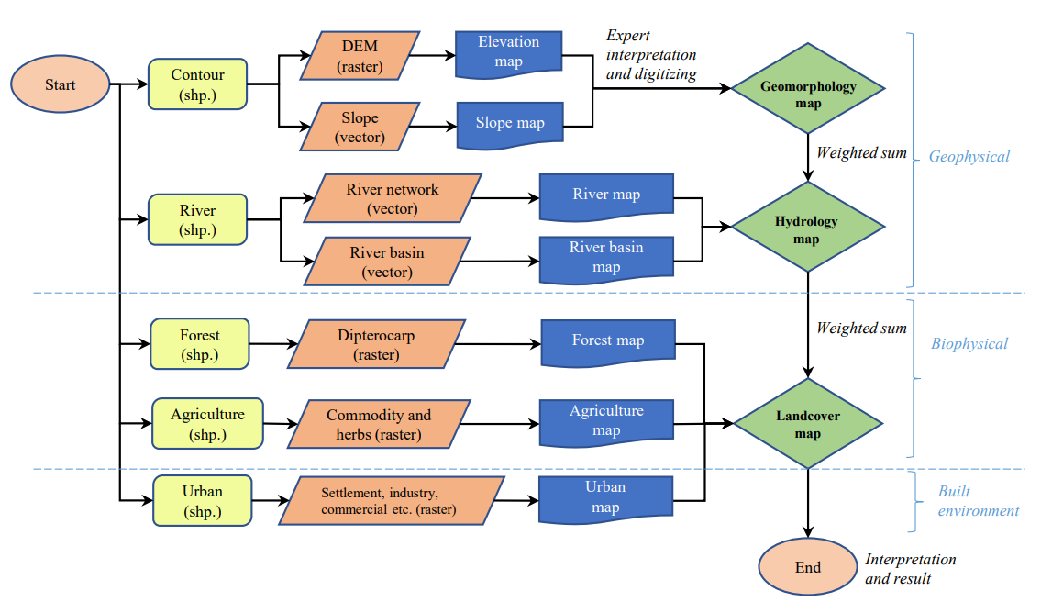

Figure 3. GIS flowchart for the processes involved in the LCA desktop study of Hulu Langat.

Results

Geophysical component mapping

Physiography and hydrology are essential components of geophysical that deal with contours, water, other substances, and forms related to land (Butler & Marston, 2017). Landforms, which can be thought of as distinct shapes and positions in the landscape, are the primary factor in geomorphologic characterization. The landform was specified into distinct landform units such as slope, aspect, and altitude in this process. The DEM and slope map were generated using primary data that consisted of contour lines in shape file format. In this mapping, the land surface of Hulu Langat was described as hills, valleys, and flat areas in elevation (height of land); and slope (gradient or steepness of land) (Figure 4). The elevation of the site study varies from 20 to 1360 meters, and the slope ranges from 1º to 30º. Half of the study area is classified as hilly, with elevations ranging from 169 to 1360 meters.
The river system, which includes the river network and river basin, is one of the components of hydrology for the study. Major river basins and water bodies also serve as a source of water supply to satisfy various end-uses, such as those in households, businesses, farms, schools, and factories. In the context of LCA, the study of hydrology focuses on its physical features and aesthetic qualities that influence the observer's emotional response to the whole landscape's unique local character. Hydrological maps show that several different geological and geomorphological factors contribute to the development of a small river network; in reality, this feature's presence is directly tied to its ability to reflect and create harmony within its surrounding built environment.

(c)
(b)
(a)
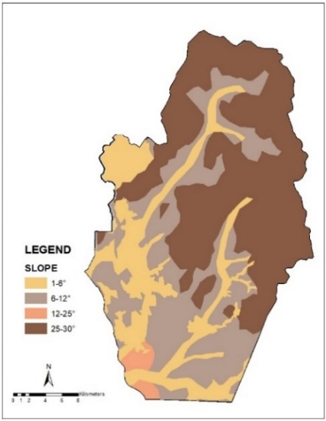
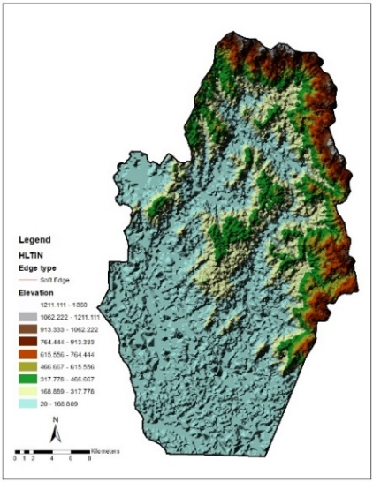
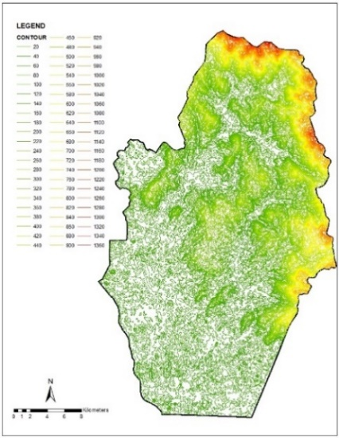

Figure 4. Components of the physiography include (a) a contour map, (b) an elevation map (DEM) and (c) a slope map.

The Hulu Langat River has catchment areas that feed the Langat River, Semenyih River, and Labu River, which flow from the main range of Banjaran Titiwangsa in the northeast of Hulu Langat district to the southwest, draining into the Malacca Strait (Ali et al., 2014). Both the Langat and Semenyih Rivers flow from hilly landforms in the forested areas on the western slope of Banjaran Titiwangsa, northeast of Hulu Langat. The Department of Irrigation and Drainage (DID) was the source of information to verify data regarding the river network and river basin. References from satellite images were also used in the digitization process to ensure that the information was accurate. There are two reservoirs identified within the Langat Catchment (Sg. Langat Dam and Sg. Semenyih Dam) and included in the river network map. A map of significant river networks and a map of river basins were created in response to this study's hydrology maps (Figure 5).

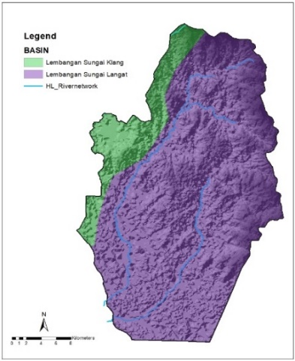
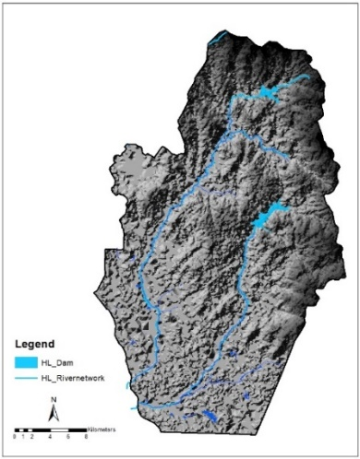
(b)
(a)

Figure 5. Components of the hydrology include (a) a river network map and (b) a river basin map.

Biophysical component mapping

Biophysical, in broad terms refers to an environment's abiotic and biotic conditions which changes could affect the landscape’s character (Görmüş et al., 2021). This research links the biophysical features of the land to aspects of vegetation and agricultural plantation. For Hulu Langat, the natural vegetation or forests were classified according to their altitude characteristics, flora composition, habitat, climate, soil, and biotic elements. According to Adnan & Mamat (2020), the presence of many native forest species in the Hulu Langat forest is noteworthy. Seraya, Keruing, and Meranti are among the species found in the forest, known as Peninsular Malaysia's largest forest class. This study generalized the forest layer into the hill dipterocarp forest located at altitudes between 300 - 750 meters and the upper dipterocarp forest located at elevations of 750 - 1,200 meters above sea level (Figure 6 a).
The terms used to describe agricultural plantations in an LCA study will vary depending on the region (Terkenli et al., 2021). Plantations of various kinds can be found in Hulu Langat; these include mixed orchards, rubber plantations, palm oil plantations, and others. According to the LCA guide published by the National Landscape Department in 2012, the plantation was divided into two categories: commodity crops (palm oil, rubber, etc.) and mixed agriculture (orchards, small orchards, cleared land, etc.). Crops, parts of crops, animals, or animal products produced by farmers, ranchers, aquaculture, floriculture, orchards, oil palms, rubber plantations, coconuts, or something similar that are prioritized for sale, consumption, reproduction, and other uses by humans and animals are referred to as "agricultural commodities" (FederalRegister.gov website, 2023). It is a large-scale industry that is organized and managed systematically. Plants with non-woody stems predominate in mixed agriculture, which is characterized by smaller-scale production compared to commodity crops. These crops are important economic resources for locals because they are typically processed into local food products. This study combines both categories into a single agricultural map under the biophysical components (Figure 6 b).

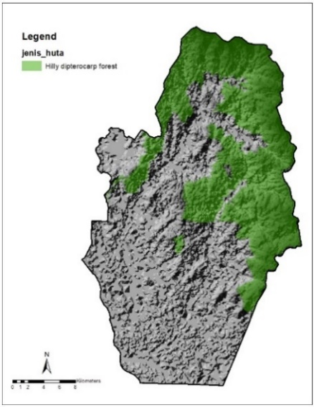
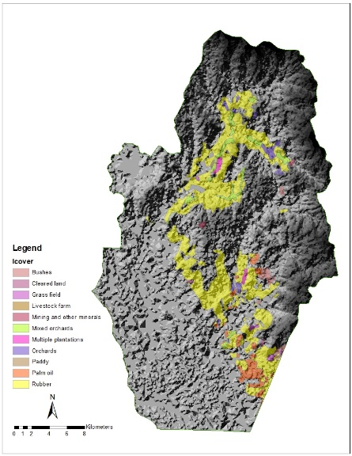
(a)
(b)

Figure 6. Components of the land cover map include (a) forest map and (b) agriculture map.

Built environment component mapping.

The built environment includes all physical components that influence physical activities, such as residences, buildings, industrials, commercials, and infrastructure (Batista e Silva et al., 2020). LCA procedure entails documenting every aspect of the built environment in urban and suburbs alike, including aspects like the people who live there, what they do, and how they feel about the area that represents a broad range of physical locations such as houses, streets, specific buildings, and non-residential indoor neighbourhoods (Bartuska & Young, 1994). The Hulu Langat district is home to a large number of new communities, as can be seen by the abundance of built housing projects in the region (Majid et al., 2018). Forest and agricultural land in some of these areas have been converted to residential or commercial use. Within the scope of this research, the components of the built environment included urban and suburban (with rural settings) which include settlements, businesses, and industrial development areas in Hulu Langat. In this study, built environment components were mapped into a single built-up map (Figure 7 a).

Administrative boundaries mapping

For proper map delineation, the boundary is required. This is useful for LCA studies because it defines projected urban growth for future planning requirements. The urban extent in major cities is typically defined by political boundaries (also called administrative boundaries) to simplify land management and administration (Mortoja et al., 2020). Administrative decisions have a significant impact on how planning trends are intertwined with a wide range of functional and spatial relationships (Wilkosz-Mamcarczyk et al., 2020). Statistics from the census are also linked to administrative boundaries in the planning process. This allows planners to gain valuable insight into the socioeconomic characteristics of various types of communities, such as urban, suburban, and rural areas. The Town and Country Planning Department of Malaysia website was referred to in establishing the boundary map of the Hulu Langat district so that more precise information on the limits of the study area could be obtained (Figure 7 b)

(a)
(b)

Figure 7. Components of the built environment (a) built-up map and components of administrative boundaries (b) boundary map
Landscape character types-the preliminary map

The data presented in this study is part of the preliminary process of the entire LCA. This result contributes to the detailed process of testing the step provided in the LCA guidebook. After all of the component maps have been created, the next step is to overlay them using the weighted sum tools that are available in the ArcGIS software. Figure 8 (a) shows the layer of the geomorphology map, created by interpreting primary information from contour lines, DEM, and slopes. Figure 8 (b) is the hydrology map, created by combining the river network and river basin data. Figure 8 (c) is the land cover map, a combination of forest, agriculture, and urban maps. For overlay analysis, all maps were transformed into a raster format before they can be layered. This overlay of raster datasets combines pixel-based calculations or Map Algebra (cell by cell), known as straightforward and efficient data set operations. The datasets for this study are specified by 30 x 30-meter values, which apply to the analysis that will be performed. In the weighted sum process, the raster data of the geomorphology map, hydrology map, and land cover map were summed up to get the output of overall landscape types. Figure 8 (e) shows a new layer of values is produced from each pair of coinciding cells after all grids are aligned. Figure 8 (f) shows the raster data principle used for the added value data cell, and the result of the calculation of how the landscape type map is produced in the output cell (ESRI, 2023). In Figure 8 (d), the boundary map layer is still in vector data format and is displayed on the output raster as well as the DEM layer to improve elevation visualization. This can be done after the overlay process has been completed. Figure 9 shows the result of the preliminary landscape-type map for the Hulu Langat district from the overlay process. Table 2 shows six landscape character types interpretation from the analysis, which are (1) high-hill forest; (2) low-hill agriculture; (3) valley agriculture; (4) undulating low-land agriculture; (5) undulating low-land settlements; and (6) low-hill settlements. The guidebook's citation of Swanwick, (2002) served as the foundation for this assessment's definition of landscape types, which is based on variations in landform, geology, land cover, and the spatial patterns of man-made interpretation. The outcome of landscape type from this process serves as the basis for a study map that will be used in discussions with stakeholders as well as during field research.

Table 2. Landscape-type interpretation

Landscape types |  | Descriptions
1 | High-hill forest | Dipterocarp forest at high altitudes (above 300meters)
2 | Low-hill agriculture | Agriculture (oil plantation, rubber, orchards, coconut, etc.) at low altitudes (below 300meters)
3 | Valley agriculture | Agriculture (oil plantation, rubber, orchards, coconut, etc.) in the valley (area between low hills)
4 | Undulating low-land agriculture | Agriculture (oil plantation, rubber, orchards, coconut, etc.) in areas with small hills (<100meters elevations) from a low land area
5 | Undulating low-land settlements | Areas explored for development purposes (urban, settlement, commercial, etc.) at sites with small hills (<100m elevations) from low land areas.
6 | Low-hill settlements | Areas explored for development purposes (urban, settlement, commercial, etc.) at low slopes (below 10º)

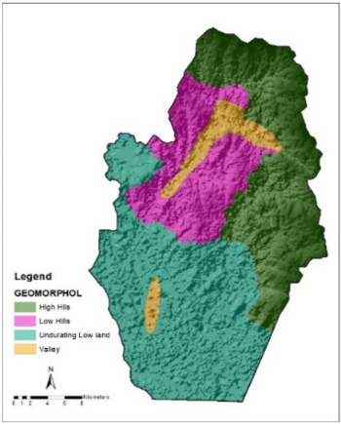
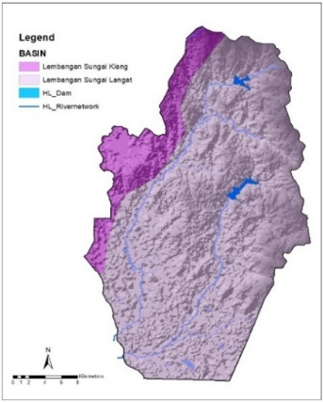
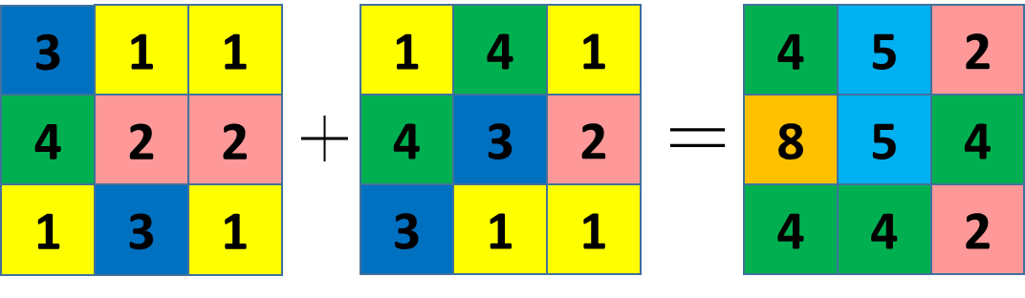
InRas1 (Weight=1)
InRas2 (Weight=1)
OutRas = CellStatistics ([InRas1, InRas2],"SUM")
(a)

(b)

(c)
(e)

(d)

OutRas1

(f)

Figure 8. Overlaying process of (a) geomorphology map, (b) hydrology map, (c) land cover map, (d) boundary map, and (e) Landscape type map of Hulu Langat as shown in the illustration and (f) raster data principle (Modified after ESRI, 2023)
1

3

2

4
5

6

Figure 9. A landscape-type map (preliminary map) for the Hulu Langat district

Conclusions

When determining the landscape-type map, the use of GIS, remote sensing techniques, and the detailed method all contribute to a significant improvement in the accuracy of the information. The increased knowledge of technical skills of handling the software among landscape architects with collaboration and knowledge sharing with experts in the process of identifying, describing, and analyzing the map will lead to a proper assessment of the landscape’s character. In the context of the challenges of standardizing the method to be replicable for producing all landscape character type-maps for Malaysia, this mapping procedures of the LCA desktop study for the Hulu Langat district demonstrate that it is replicable, provided that some of the processes do require expert verification. From the guidebook, we discovered that the geomorphology map cannot be generated automatically using GIS tools. It can only be made after expert verification either by geologists, ecologists, or landscape architects to define the spatial line before it goes through the digitalization process. In the LCA guidebook, this step was not explained in writing. This early technique may be uncertain to the map developer since the weighted sum analysis only involve after all three primary maps of geomorphology, hydrology, and land cover were generated.
For future study, it is recommended that the interpretation of landscape elements in the assessment be carried out after the evaluator has gained an understanding of the visual mapping context to avoid discrepancies. This is important as the next field survey stage involves the rating section for character strength, where the subjective view on sensitivity and visual unity will be interpreted into the assessor's perspectives. This study has revealed that from the mapping procedure, there is a possibility that some of the findings will lead to assumptions, which will need to be scrutinized for variables that need to be thoroughly investigated. This study also suggests that difficulties encountered during desktop mapping were related to the availability of relevant data. The process of creating the landscape component map with all of the data and the most recent information is crucial and critical because the character landscape in the map must be precise with reality. The use of high-resolution satellite images is proposed as a possible solution to this issue; this would reduce mapping time while preserving the quality of the final product. High-resolution maps not only provide accurate data but also simplify the process of distinguishing between various landforms and land cover. Other geospatial analysis software, such as ENVI, can offer reliable and accurate information, and be incorporated alongside ArcGIS to enhance the process.
The LCA method as outlined in the guidebook is useful in a wide variety of contexts, including sustainable landscape planning, development regulation, sensitive landscape protection, landscape character preservation, distinctive area preservation, long-term sense of place, and biodiversity preservation. Malaysia has made considerable strides in recent years toward defining its distinctive landscape character. This study has contributed to the creation of a preliminary landscape type-map for the Hulu Langat district. However, a physical inventory is necessary as baseline information to facilitate the development analysis and judgment processes before making decisions about the mapping of a particular area. Therefore, after the desk research has been completed, the field survey should include specifics about the systematic landscape classification based on the unique landscape character inherited from the local context. This includes the ground truthing process of rating the visual quality and sensitivity assessment of the landscape so that the LCA can provide a holistic approach to protecting both natural and cultural landscapes.

References

Adnan, N., & Mamat, M. P. (2020). Spatial Analysis Model Assessing Habitat Quality of Selangor. IOP Conference Series: Earth and Environmental Science, 549(1), 012049. https://doi.org/10.1088/1755-1315/549/1/012049
Ali, M. F., Saadon, A., Faiza, N., & Rahman, A. (2014). An Assessment of Water Demand in Malaysia Using Water Evaluation and Planning System. InCIEC 2013, 743-755. https://doi.org/10.1007/978-981-4585-02-6
Antrop, M. (2004a). Landscape change and the urbanization process in Europe. Landscape and Urban Planning, 67(1–4), 9–26. https://doi.org/10.1016/S0169-2046(03)00026-4
Asma, M., & Soumia, B. (2021). GIS tools for landscape character assessment: the case of Ziban region in Algeria. Geomatics, Land Management, and Landscape, 4(4), 19–29. https://doi.org/10.15576/gll/2021.4.19
Bartuska, T. J., & Young, G. (1994). The built environment: Definition and scope. The Built Environment. A Creative Enquiry into Design and Planning, 3–14.
Batista e Silva, F., Freire, S., Schiavina, M., Rosina, K., Marín-Herrera, M. A., Ziemba, L., Craglia, M., Koomen, E., & Lavalle, C. (2020). Uncovering temporal changes in Europe’s population density patterns using a data fusion approach. Nature Communications, 11(1), 1–11. https://doi.org/10.1038/s41467-020-18344-5
Brown, G., & Brabyn, L. (2012). An analysis of the relationships between multiple values and physical landscapes at a regional scale using public participation GIS and landscape character classification. Landscape and Urban Planning, 107(3), 317–331. https://doi.org/10.1016/j.landurbplan.2012.06.007
Butler, D. R., & Marston, R. A. (2017). Landforms and Physiography. International Encyclopedia of Geography: People, the Earth, Environment and Technology, 1–5. https://doi.org/10.1002/9781118786352.wbieg1144
Department of Statistics Malaysia. (2022). Anggaran Penduduk Semasa Selangor. In Jabatan Perangkaan Malaysia (Issue July). https://www.dosm.gov.my/v1/index.php? r=column/cthemeByCat&cat=155&bul_id=aWJZRkJ4UEdKcUZpT2tVT090Snpydz09&menu_id=L0pheU43NWJwRWVSZklWdzQ4TlhUUT09
Erdoğan, N., Carrer, F., Tonyaloğlu, E. E., Çavdar, B., Varinlioğlu, G., Şerifoğlu, T. E., Jackson, M., Kurtsan, K., Nurlu, E., & Turner, S. (2020). Simulating change in cultural landscapes: the integration of historic landscape characterisation and computer modelling. Landscapes, 21(2), 168–182. https://doi.org/10.1080/14662035.2021. 1964767
ESRI. (2023). Weighted Sum (Spatial Analyst). https://doi.org/https://pro.arcgis.com/en/pro-app/latest/tool-reference/spatial-analyst/weighted-sum.htm
FederalRegister.gov website. (2023). Code of Federal Regulations. https://www.ecfr.gov /current/title-7/subtitle-B/chapter-XLII/part-4284/subpart-J/subject-group-ECFR1b402652da9cc7c/section-4284.902
Freeman, O. E., Duguma, L. A., & Minang, P. A. (2015). Operationalizing the integrated landscape approach in practice. Ecology and Society, 20(1), 24.
Gkoltsiou, A., & Paraskevopoulou, A. (2021). Landscape character assessment, perception surveys of stakeholders and SWOT analysis: A holistic approach to historical public park management. Journal of Outdoor Recreation and Tourism, 35, 100418.
Görmüş, S., Oğuz, D., Eşbah Tunçay, H., & Cengiz, S. (2021). The use of landscape character analysis to reveal differences between protected and nonprotected landscapes in Kapısuyu basin. Tarim Bilimleri Dergisi, 27(4), 414–425. https://doi.org/10.15832/ ankutbd.640159
Grunsven, L. V., & Benson, M. (2020). Urban Development in Malaysia: Towards A New Systems. Thinkcity.
Haines-Young, R. H., Langanke, T., & Potschin, M. B. (2008). Landscape character as a framework for the assessment of environmental change. In Use of landscape sciences for the assessment of environmental security (pp. 165–174).
Harun, N. Z., Jaffar, N., & Mansor, M. (2021). the Contributions of Public Space To the Social Sustainability of Traditional Settlements. Planning Malaysia, 19(5), 192–205. https://doi.org/10.21837/pm.v19i19.1071
Kim, K., & Pauleit, S. (2009). Landscape metrics to assess the ecological conditions of city regions: Application to Kwangju City, South Korea. International Journal of Sustainable Development & World Ecology, 12(3), 37–41. https://doi.org/10.1080/ 13504500509469634
Koblet, O., & Purves, R. S. (2020). From online texts to Landscape Character Assessment: Collecting and analysing first-person landscape perception computationally. Landscape and Urban Planning, 197(July 2019), 103757. https://doi.org/10.1016/ j.landurbplan.2020.103757
Koç, A., & Yılmaz, S. (2020). Landscape character analysis and assessment at the lower basin-scale. Applied Geography, 125, 102359. https://doi.org/10.1016/j.apgeog.2020.102359
Majid, N. A., Rainis, R., & Mohamed, A. F. (2018). Spatial analysis of development pressure in the Langat Basin, Selangor, Malaysia. IOP Conference Series: Earth and Environmental Science, 169, 012016. https://doi.org/10.1088/1755-1315/169/1/ 012016
Mazlan, M., Ismail, N. A., Yusof, M. J. M., & Aziz, F. A. (2022). The Dilution of peri-urban socio-cultural identity: An insight into policies and strategies in Malaysia and the European Commission. In Resilient and responsible smart cities (pp. 15–30). https://doi.org/10.1007/978-3-030-86499-6_2
McHarg, I. (1967). Design with nature. The American Museum of Natural History.
Menasra, A., & Bouzaher, S. (2021). GIS tools for landscape character assessment: case of Ziban region in Algeria. Geomatics, Land management and Landscape, 4(4), 19–29. https://doi.org/10.15576/gll/2021.4.19
Mortoja, M. G., Yigitcanlar, T., & Mayere, S. (2020). What is the most suitable methodological approach to demarcate peri-urban areas? A systematic review of the literature. Land Use Policy, 95, 104601. https://doi.org/10.1016/j.landusepol.2020.104601
National Landscape Department. (2012). Manual Penilaian Karakter Landskap Malaysia.
NatureScot. (2023). What is Landscape Character Assessment? Find out how Landscape Character Assessment is carried out. https://www.nature.scot/professional-advice/landscape/landscape-character-assessment/what-landscape-character-assessment
Sari, D. C., & Munandar, A. (2020). Characteristic assessment and cultural landscape conservation of Urug indigenous village. IOP Conference Series: Earth and Environmental Science, 501(1). https://doi.org/10.1088/1755-1315/501/1/012045
Simensen, T., Halvorsen, R., & Erikstad, L. (2018). Methods for landscape characterisation and mapping: A systematic review. Land Use Policy, 75, 557–569. https://doi.org/10.1016/j.landusepol.2018.04.022
Swanwick, C. (2002). Topic paper 1: Recent practice and the evolution of Landscape Character Assessment.
Teh, M. Z., Ghani, I., Abdullah, M., & Ahmad Pugi, N. (2020). Landscape Character: Relationship between existing Acts, Policies and Guidelines in Malaysia. Environment-Behaviour Proceedings Journal, 5(14), 165–170. https://doi.org/10.21834/ebpj. v5i14.2259
Terkenli, T. S., Gkoltsiou, A., & Kavroudakis, D. (2021). The interplay of objectivity and subjectivity in landscape character assessment: Qualitative and quantitative approaches and challenges. Land, 10(1), 1–19. https://doi.org/10.3390/land10010053
Tudor, C. (2014). An Approach to Landscape Character Assessment. Natural England.
Ujang, N. (2016). Transforming the Historical Urban Village of Kampong Bharu into a New Urban Centre in Kuala Lumpur. Malaysia Sustainable Cities Program, Working Paper Series.
Weith, T., Barkmann, T., Gaasch, N., Rogga, S., Strauß, C., & Zscheischler, J. (2021). Sustainable Land Management in a European Context. Springer.
Wilkosz-Mamcarczyk, M., Olczak, B., & Prus, B. (2020). Urban features in rural landscape: A case study of the municipality of Skawina. Sustainability (Switzerland), 12(11), 1–24. https://doi.org/10.3390/su12114638
Wu, Y., Wang, H., & Zhang, B. (2021). Landscape Character Diversity and Zoning Management: Case of Wuhan Metropolitan Area. Journal of Urban Planning and Development, 147(1), 1–12. https://doi.org/10.1061/(ASCE)up.1943-5444.0000655
Yaacob, M., So, W. W. M., & Iizuka, N. (2022). Exploring Community Perceptions of Climate Change Issues in Peninsular Malaysia. Sustainability (Switzerland), 14(13), 1–23. https://doi.org/10.3390/su14137756
Yang, X., Zhou, Q., & Tian, D. (2023). Improved landscape sampling method for landscape character assessment. Frontiers of Architectural Research, 12(1), 118–128. https://doi.org/10.1016/j.foar.2022.05.009
Zakariya, K., Ibrahim, P. H., Amirah, N., & Wahab, A. (2019). Conceptual Framework of Rural Landscape Character Assessment to Guide Tourism Development in Rural Areas. 24(1), 85–99.
Zhao, S., Yang, D., & Gao, C. (2023). Identifying Landscape Character for Large Linear Heritage: A Case Study of the Ming Great Wall in Ji-Town, China. Sustainability (Switzerland), 15(3), 1–21. https://doi.org/10.3390/su15032615

