City Densification and Temporal Dynamics of Traditional Inner Core of Ibadan, Nigeria

Abstract
The conversion of vegetation land cover contributes to the retention of solar radiation in the environment, resulting in the formation of the urban heat island. This study analyses the distribution pattern of urban heat island in the traditional core of Ibadan amidst the rapid urbanization experienced. The remote sensing tool was used to analyse the trend of land surface temperature, normalized difference built-up index, and normalized difference vegetation index for the traditional Ibadan's core between the year 2000 and the year 2020. This reveals that increasing built-up areas will continue to strengthen the effects of urban heat island in the traditional core of Ibadan, while vegetated land covers will weaken the effects of urban heat island. The maximum average land surface temperature of 35.34⁰C, 36.62⁰C, and 31.86⁰C were record for the years 2000, 2013, and 2020, respectively. This study further recommends that urban greening and proper urban planning should be encouraged in the traditional core of Ibadan.

Keywords: Traditional Core, Land Surface Temperature, Normalized Difference Built-up Index, Normalized Difference Vegetation Index, Urban Heat Island

Introduction
Cities in the world are experiencing rapid urbanization; it envisaged that by the year 2030, the world’s urban population would have increased to 5 billion and 6.4 billion by 2050 (UN-Habitat, 2009). To meet the demand of the increasing urban population, urban infrastructures and physical developments need to be put in place in order to meet the demand of the increasing urban population (Senanayake et al., 2013). Rapid urbanization is often accompanied by adverse environmental impacts, ranging from environmental pollution, replacement of natural landscape with various built-up structures, breakdown of ecological cycles, and climate change (Senanayake et al., 2013).The latter (climate change) environmental impacts of rapid urbanization have always been a major source of concern to urban planners, governments, and significant stakeholders (Anibaba et al., 2019).

This is because urbanization is a significant propellant of climate change and the conversion of the natural landscape into other land uses (Fashae et al., 2020; Kaplan et al., 2018; Senanayake et al., 2013). The removal of land cover as a result of increase anthropogenic activities which are brought about by rapid urbanization is a significant contributor to urban heat island (Fabeku et al., 2018; Folorunsho et al., 2017; Kaplan et al., 2018; Senanayake et al., 2013;). Urbanization, both in the human population and geographical extent, often transforms the land covers from its natural state into various impervious surfaces (Kafi et al., 2014). These impervious surfaces increase the retention of solar radiation, decrease in evapotranspiration, increase runoff, release anthropogenic heat, and heat conductivity, which in turn causes urban heat island in the centre of the city (Weng et al., 2004; Zhang et al., 2011).
This phenomenon is not farfetched from the experience of the core of Ibadan, Oyo State, which is characterized by high residential density and intensive commercial activities. Over the years, the core of Ibadan, Nigeria, has experienced unprecedented urbanization, which has resulted in the conversion of different land covers into various impervious surfaces by the increasing anthropogenic activities in the core. The increase in impervious surfaces tends to increase the thermal stress in the core of Ibadan because the buildings in the core were built with no regard for planning hence giving little or no space for ventilation (Fashae et al., 2020). The unplanned state of the core of Ibadan has intensified the relative warmth of the core as compared to the peri-urban areas (Folorunsho et al., 2017). The relatively high surface temperature in the urban centre compared to the rural surrounding is referred to as urban heat island (Anibaba et al., 2019; Schwarz et al., 2011; Yamamoto, 2006).

Several studies (Abegunde and Adedeji, 2015; Adetoro and Salami, 2018; Anibaba et al., 2019; Fashae et al., 2020) on urban heat island have been carried out in Ibadan but all these studies focus on the metropolitan Ibadan and its sub-hubs. Also, these studies emphasized the relationship between the land uses, land cover and its relationship with land surface temperature. This gap was filled in this study using normalised difference built-up area index which was effectively used as a quick alternative for mapping built-up areas in the core of Ibadan. This study aims at analysing the distribution pattern of the land surface temperature of traditional core of Ibadan between 2000 and 2020. The specific objectives were:
- to determine the normalized difference built-up index for the traditional core of Ibadan between 2000 and 2020
- spatially identify the urban heat island formation in the traditional core of Ibadan between 2000 and 2020
- determine the normalized difference vegetation index for the traditional core of Ibadan between 2000 and 2020
- determine the relationship between LST, NDBI, and NDVI for traditional core of Ibadan between 2000 and 2020.

Study Area
The traditional core of Ibadan is referred to as the largest indigenous city in sub-Saharan Africa (Onibokun and Kumuyi, 1999). The traditional core of Ibadan is located within latitudes 7º 20ʹN and 7º 30ʹN of the equator and longitudes 3º 45ʹE and 4º 00ʹ E of the Greenwich meridian (See figure 1). The population of the traditional core of Ibadan was reported to be 1,338,659 by the National Population Commission in 2006 with the growth rate of 0.5 percent (NPC, 2006). The traditional core of Ibadan, which may also be referred to as the urban core of Ibadan, consists of five local government areas (Ibadan North, Ibadan Northeast, Ibadan Northwest, Ibadan Southeast, and Ibadan Southwest) with a land area of 135.95Km². Since 2006, the traditional core of Ibadan has had a significant growth and it was envisaged that the growth of the traditional core will increase from 1.3m to 5.03 by the year 2025 (Adelekan, 2016).

Figure 1: Ibadan Core and its Peri-Urban Area
Source: Department of Urban and Regional Planning Federal University of Technology, Minna, 2019

The rapid urbanization experienced within the traditional core of Ibadan is associated with socio-economic problems which increases the various planning problems in the core (Adelekan, 2016). The traditional core of Ibadan is predominantly occupied by the indigenes (Adelekan, 2016; Fourchard, 2003). The traditional core of Ibadan can be described as informal (organic) settlement which grew by the process of densification (Adelekan, 2016). The traditional core of Ibadan is densely populated and characterized by the presence of slum, poor landscape elements, poor housing, non-existence of drainages and sewages (Adelekan, 2016; Fourchard, 2003). According to Arimah (1994), 70 – 80 percent of the households in the traditional core of Ibadan reside in slums. Natural spaces in the houses in the traditional core of Ibadan are often provided for future expansion for more dwelling housing as family units grew larger (Adelekan, 2016). Some of the prominent political wards in the traditional cord of Ibadan are: Bere, Oje, Bode, Oke-Ado, Olorun sogo, Orita Merin, Ide Arere, Esu Awole, Oja Oba, Oke-Irefin, Eleka, Agban Gban (See Figure 2).
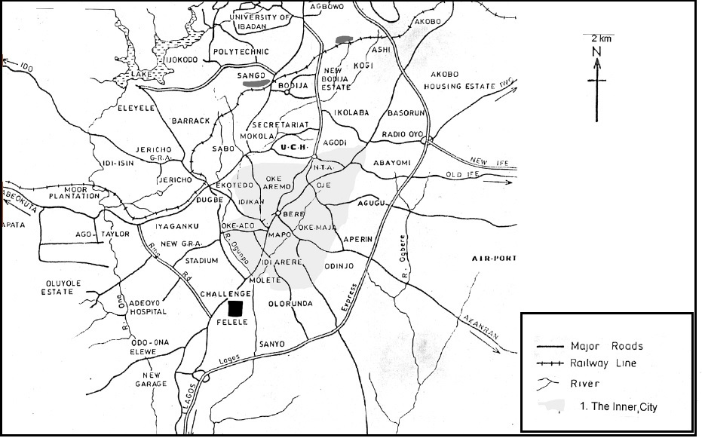
Figure 2: The Traditional Core of Ibadan
Source: Fourchard, 2003

Methodology

Data Collection and Post Processing

The data sets used for this study are the Landsat enhance thematic mapper for the year 2000 and the Landsat operational land imager for the year 2013 and the year 2020. These data sets were downloaded from the United States Geological Survey website on path 191 and row 055(See table 1). The data sets downloaded from the United States Geological Survey website were all cloud-free. On each of these data sets, the area of interest (the traditional core of Ibadan) was clipped out (Figure 3). On the clipped imageries of the study area, the normalized difference built-up area index, average land surface temperature, and the normalized difference vegetation index were deduced for the three epochs (2000, 2013, and 2020) understudy.

Table 1: Properties of Data Sets
Sensor | Year | Path and Row | Resolution | Date Acquired
Enhance thematic mapper (ETM) | 2000 | P191/R055 | 30M | 06/02/2000
Operational Land Imager (OLI) | 2013 | P191/R055 | 30M | 05/03/2013
Operational Land Imager (OLI) | 2020 | P191/R055 | 30M | 05/02/2020
Source: United States Geological Survey, 2020

To calculate the normalized difference built-up area index, the short wave infrared band and the near-infrared band (bands 6 and 5 for Landsat 8 and bands 5 and 4 for Landsat 7) used. The mathematical expression for the computation of normalized difference built-up area index was:
$$NDBI=\frac{SWIR-NIR (Near Infrared)}{SWIR+NIR (Near Infrared)}$$

The thermal band (band 6) was used to estimate the average land surface for the year 2000, while the thermal bands 10 and 11 at different wavelengths were used to estimate the average land surface temperature for the year 2013 and the year 2020. At the first stage, the digital numbers were converted to spectral radiance using the equation L_{λ} = M_{L}Q_{cal} + A_{L} where L_{λ}is top of atmosphere spectral radiance (Watts/(m2 * srad * µm)), M_{L}is band-specific multiplicative rescaling factor from the metadata, Q_{cal} is quantized, and calibrated standard product pixel values (DN), and A_{L} is band-specific additive factors from the metadata. At the second stage, spectral radiance of the clipped imageries of the year 2000, 2013, and 2020 was converted to “At-Satellite brightness temperature” in Kelvin (T_{B}) by using the inverse of the Planck function(NASA, 2012; Weng et al., 2004) which is expressed as:
$$TB=\frac{K2}{ln\left({\begin{aligned}K \\ _\end{aligned}1 \atop Lλ}+1\right)}$$

Where: T_{B}is “At-Satellite brightness temperature”, L_{λ}is top of atmosphere spectral radiance (Watts/(m2 * srad * µm)), K_{2,}and K₁ are band-specific thermal conversion constant from the metadata (See table 2). At the third stage, the land surface emissivity of the core of Ibadan was computed using the mathematical model expressed as E = 0.004 (Proportion of Vegetation) + 0.986, where PV is (NDVI - NDVImin /NDVImax - NDVImin)²
Table 2: Metadata for Landsat 7 and Landsat 8
Year | Landsat 7 | Band 6 | Band 6
2000 | Radiance Multiplier (M) | 0.067087 | 0.037205
2000 | Radiance Add (A) | -0.06709 | 3.16280
2000 | K₁ | 666.09 | 1282.71
2000 | K₂ | 666.09 | 1282.71
 | Landsat 8 | Band 10 | Band 11
2013 and 2020 | Radiance Multiplier (M) | 0.0003342 | 0.0003342
2013 and 2020 | Radiance Add (A) | 0.1 | 0.1
2013 and 2020 | K₁ | 774.89 | 480.89
2013 and 2020 | K₂ | 1321.08 | 1201.14
Source: Source: United States Geological Survey, 2000, 2013, and 2020

At the fourth stage, the land surface temperature of the core of Ibadan was computed using the signal window algorithm, which is expressed as LST=BT/1 + W* (BT/P) * ln (e) where BT is at Satellite temperature, W is the wavelength of emitted radiance (11.5µ), and P is h*c/s (1.438* 10˄- 2 m k)/14380
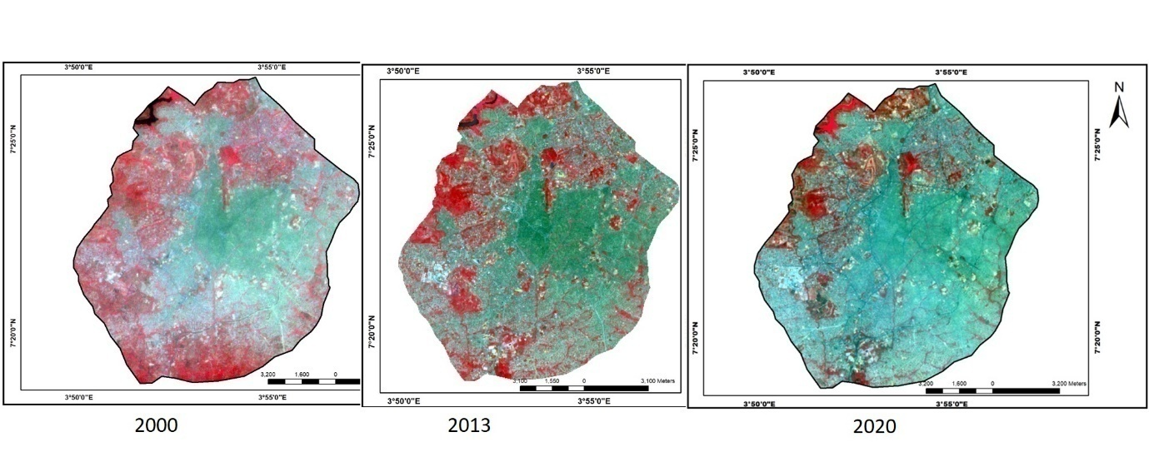
Figure 3: clipped Imageries of the Core of Ibadan
Source: United States’ Geological Survey, 2020

The NDVI for this study was calculated by finding the ratio between the red (R) or the visible spectrum and the near infrared (NIR) values. The equation used for the calculation of the NDVI is as:
$$NDVI=\frac{NIR \left(Near Infrared\right)-RED}{NIR \left(Near Infrared\right)+RED}$$
Where NIR is the near infrared and Red is the visible spectrum. Bands 4 (Near infrared) and 3 (Red/visible spectrum) were used to compute the NDVI of the core of Ibadan in the year 2000. For the epochs 2013 and 2020, bands 5 (Near infrared) and 4 (Red/visible spectrum) were used to calculate the NDVI
Normalized Difference Built-up Index
Table 3: Statistical results of NDBI for the Core of Ibadan between 2000 and 2020
Year | Minimum | Maximum | mean | Standard Deviation
2000 | 0.0450 | 0.4726 | 0.2716 | 0.0382
2013 | -0.3080 | 0.3879 | 0.0001 | 0.0687
2020 | -0.2267 | 0.2082 | 0.0289 | 0.0355
Source: Authors’ Analysis 2020

The statistical results of the normalized difference built-up index of the core of Ibadan between the year 2000 and the year 2020 are presented in Table 3. Areas with high values NDBI signifies a large concentration of built-up areas in the core of Ibadan (Figure 4). The difference in NDBI in the three epochs were 0.4276, 0.6959, and 0.4349, respectively. The difference in NDBI indicates varying urban growth in the traditional core of Ibadan. The difference in NDBI also indicates that between the year 2000 and the year 2013, built-up areas in the core increased significantly.
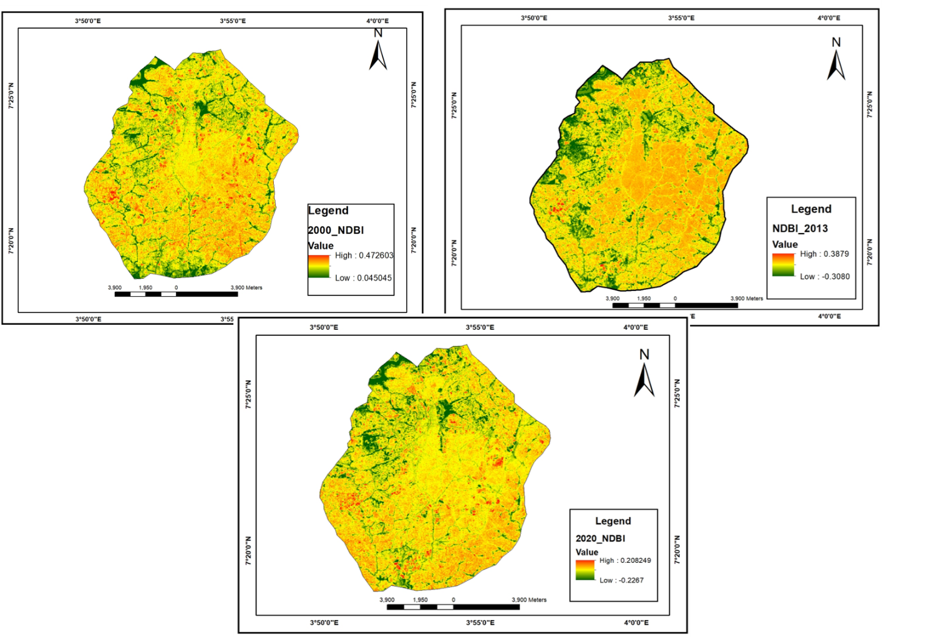
Figure 4: NDBI for the Traditional Core of Ibadan between 2000 and 2020
Source: Authors’ Analysis 2020

Land Surface Temperature of the Traditional Core of Ibadan between 2000 and 2020
The study revealed that high land surface temperature was recorded in the innermost core of Ibadan compare to the relatively low average land surface temperature recorded in the periphery of the study area (Figure 4). The high average land surface temperature recorded in the innermost core was attributed to the compact urban form, population density, and high built-up density inherent in the innermost core of Ibadan. This assertion was affirmed by various empirical studies (Anibaba et al., 2019; Folorunsho et al., 2017; Nuruzzaman, 2015;Weng, 2004; Zahabi and Pradhan, 2017) that the land surface temperature in the heart of the city is higher than that of the edge or the periphery.

The study revealed that the average land surface temperature of the traditional core of Ibadan in the year 2000 range from 16.91ºC – 35.34ºC. Figure 5 shows that high average land surface temperature of above 30⁰C was more pronounced in Ibadan North, Ibadan Northeast, Ibadan Southwest, and Ibadan Northwest, while the average land surface temperature of the fringe of the five local government areas was between 16.1ºC - 26.01ºC. The difference between the minimum average land surface temperature (LST) and the maximum average land surface temperature was 18.43ºC. The difference in land surface temperature in the year 2000 signifies the effect of urban heat island in the core of Ibadan because the difference in the land surface temperature of the innermost core and the periphery is above 12ºC (Senanayake et al., 2013; Voogt, 2002).
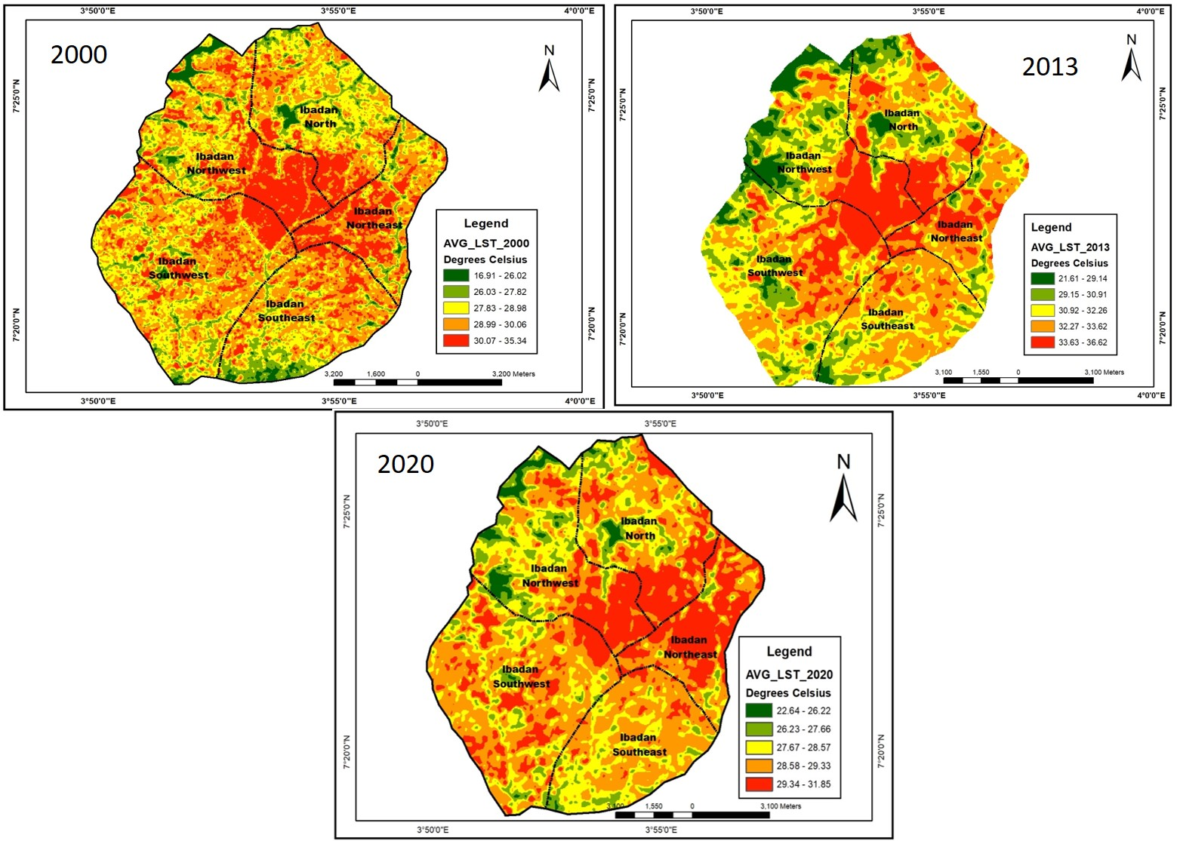
Figure 5: Average Land Surface Temperature of the Traditional Core of Ibadan between 2000 and 2020
Source: Authors’ Analysis 2020

In the year 2013, an increase in the land surface temperature was recorded in the core of Ibadan. The average land surface temperature in the core of Ibadan range from 21.62^{O}C - 36.62⁰C with a difference of 15^{O}C (Figure 5). In this epoch (2013), an average land surface of above 33.63 ⁰C was recorded in the innermost core of four local government areas (Ibadan North, Ibadan Northeast, Ibadan Northwest, and Ibadan Southwest) of the core of Ibadan. The high average land surface temperature recorded in these four local government areas was characterised by high built-up areas, urban cluster patterns, and an increase in urban population. The high average land surface temperature recorded in the innermost core also signifies the effect of urban heat island in the heart of the city. Ibadan Southeast was the only local government area with a relatively low average land surface temperature of between 32.26 ⁰C and 33.00 ⁰C, while patches of very low average land surface temperature (below 26 ⁰C) were recorded at the edge of the core of Ibadan (Figure 5).

A dynamics in the average land surface temperature in the traditional core of Ibadan was observed in the year 2020, with an average land surface temperature of 22.64 ºC - 31.86 ºC and a difference of 9.22 ºC. Figure 5 reveals that a high average land surface temperature of 29.33ºC and above was recorded innermost core of Ibadan Northwest, Ibadan North, and Ibadan Northeast. The spatial areas of the average land surface temperature of 29.33ºC and above were more evident in Ibadan Northeast. This implies that the effect of urban heat island will be felt more in Ibadan Northeast. An increase in urban population and an increase in built-up area density was attributed to this phenomenon. The status quo in the average land surface temperature in Ibadan Southeast in the year 2020 was still the same as that of the year 2013. An average land surface temperature of 28.57 ºC – 26.22ºC was recorded for Ibadan Southeast.

This study further revealed a strong positive correction between the average maximum land surface temperature and the population density of the traditional core of Ibadan within the study epoch (see figure 6). The figure reveals that population density of the core of Ibadan is also a driver and an important indicator that has affect the average maximum land surface temperature of the study areas. This findings also assert Chen et al (2016); Li et al (2014) assertion that population density has an effective on the average land surface temperature of a residential area. The coefficient of determinant (r²) recorded within the study period were 0.5382, 0.0044, and 0.03053 for the year 2000, 2013 and 2020 respectively.
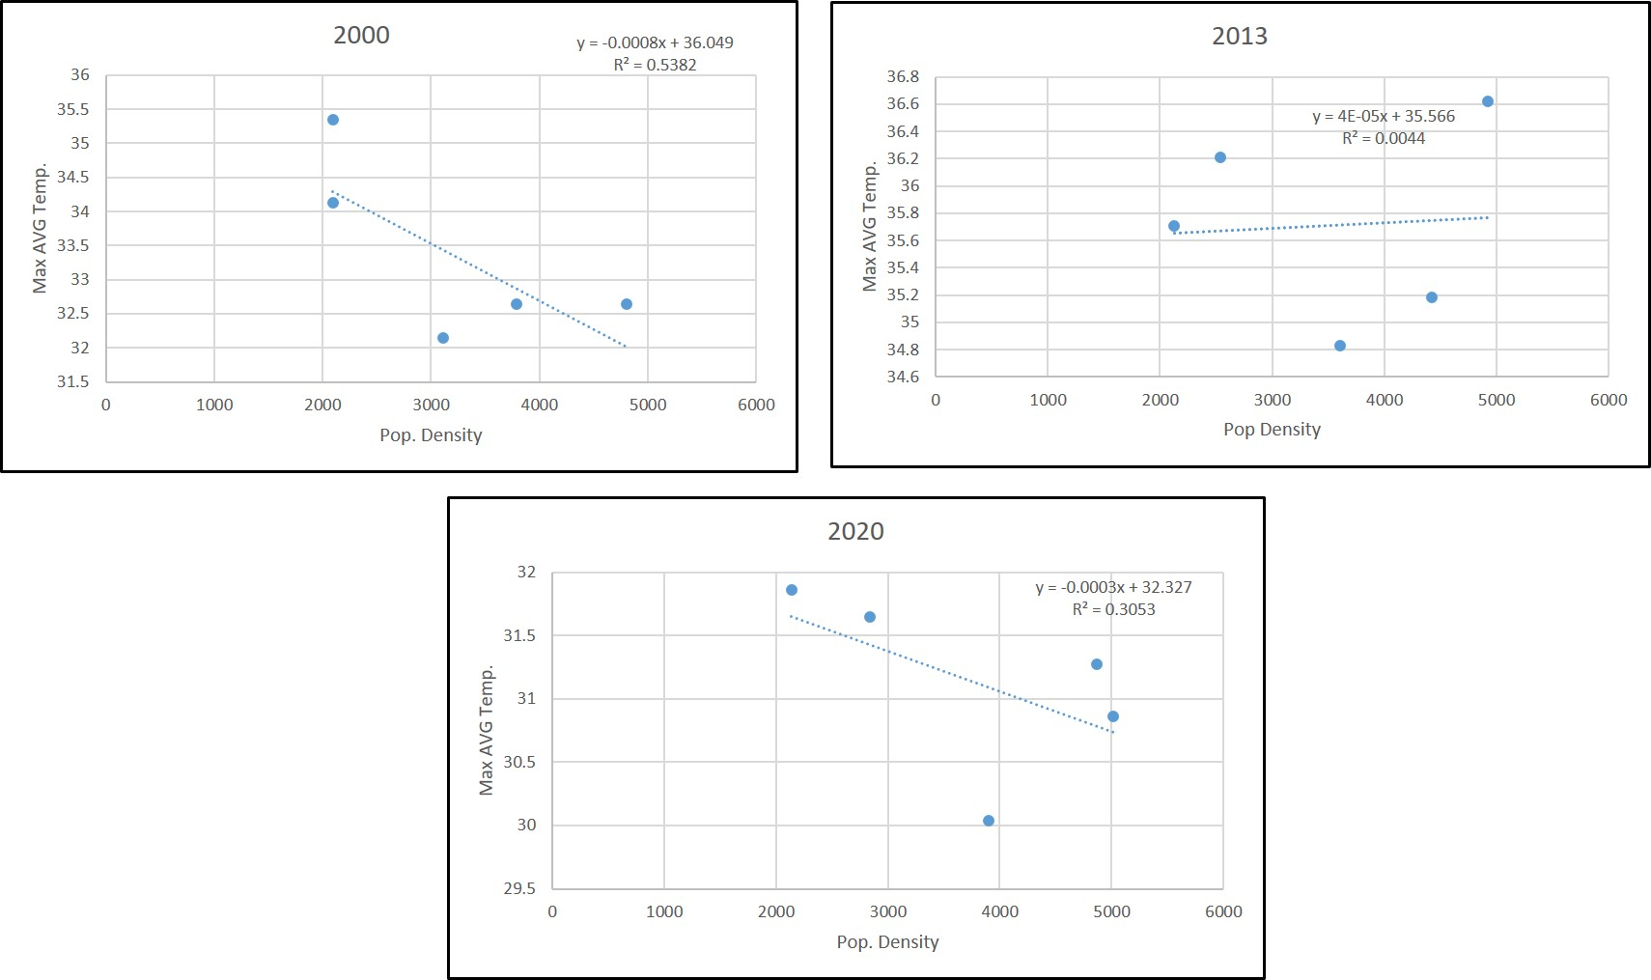Figure 6: Correction between Population density and LST for the study epoch
Source: Authors’ Analysis 2020

Normalized Difference Vegetation Index (NDVI)
Several vegetation indices are available for vegetation extraction, but the most widely used vegetation index is the Normalized Difference Vegetation Index (Jensen, 2000; Taufik and Ahmad, 2016; Kaplan et al., 2018). The Normalized Difference Vegetation Index range from -1 to +1 with 0 indicating bare surfaces or areas with no vegetation. Areas with green vegetation show an NDVI value close to + 1, while non-vegetated areas show a value of – 1 (Senanayake et al., 2013).The three epoch understudy reveals the NDVI values range from 0.4726 to 0.0450, 0.5096 to - 0.0412, and 0.3476 to 0.0149 for the years 2000, 2013, and 2020 respectively (See figure 7). The NDVI values show that as the anthropogenic activities increases in the traditional core of Ibadan, significant vegetated areas are loss. This result affirmed Folorunsho et al. (2017) assertion that NDVI values decrease with an increase in urban development.

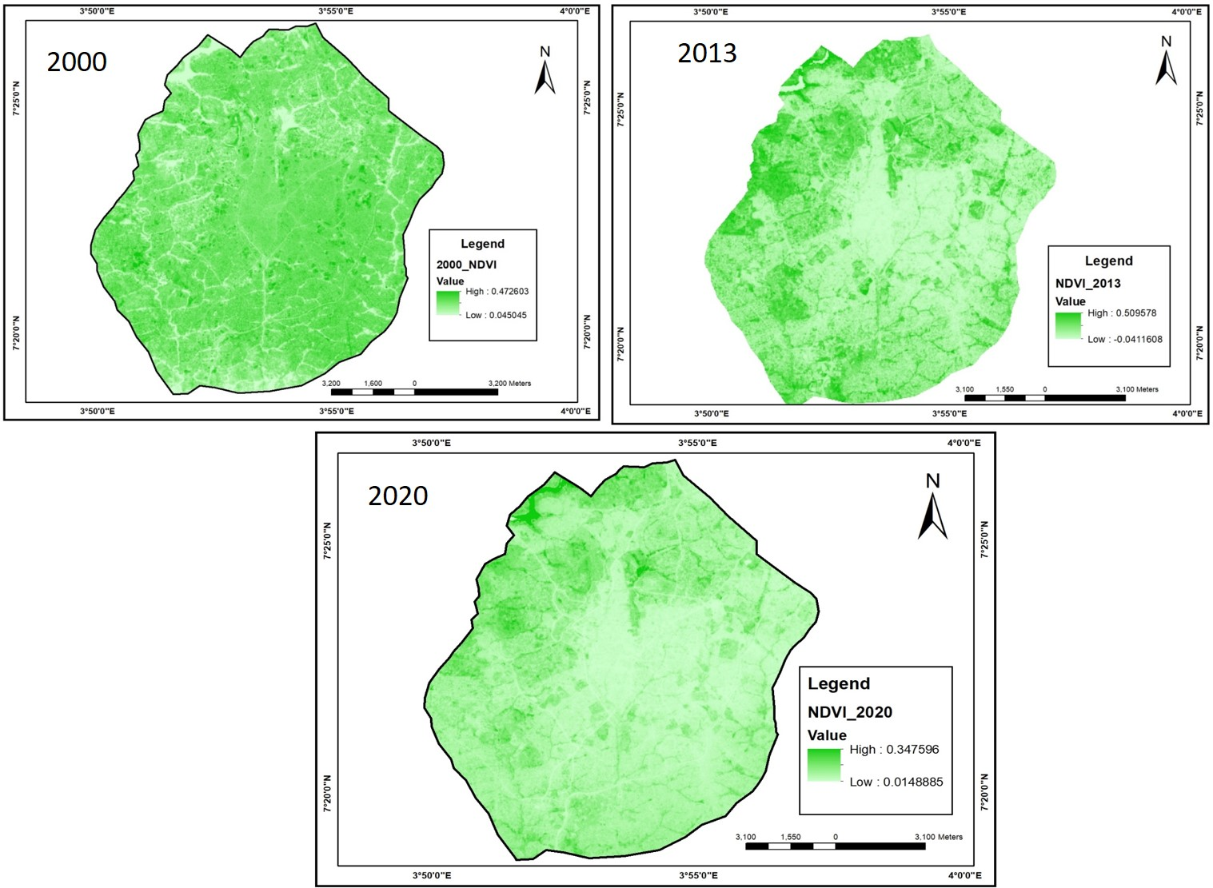
Figure 7: NDVI of the Core of Ibadan in year 2000, 2013, and 2020
Source: Authors’ Analysis 2020

Relationship between Land Surface Temperature, Normalized Difference Built-up Index, and the Normalized Difference Vegetation Index

Table 4: Relationship between LST and NDBI index, LST and NDVI index
 | LST Versus NDBI |  | LST Versus NDVI
Year | Coefficient of  Correlation (r) | Coefficient of  Determinant (r²) | Coefficient of  Correlation (r) | Coefficient of  Determinant (r²)
2000 | 0.9997 | 0.9995 | - 0.9752 | - 0.9511
2013 | 0.9764 | 0.9534 | - 0.9942 | - 0.9885
2020 | 0.9640 | 0.9293 | - 0.9496 | - 0.9018
Source: Authors’ Analysis 2020

The correlation was used to determine the relationship between average land surface temperature and normalized difference built-up index, average land surface temperature, and normalized difference vegetation index of the study area (Table 4). The relationship between average land surface temperature and the normalized difference built-up index shows a strong positive correlation (See Figure, 8). The strong positive correlation implies that the increasing built-up areas in the traditional core of Ibadan will strengthen the adverse effects of urban heat island experienced in the heart of Ibadan core. The coefficients of determinants of the three epochs (2000, 2013, and 2020) understudy are 0.9995, 0.9534, and 0.9293, respectively.
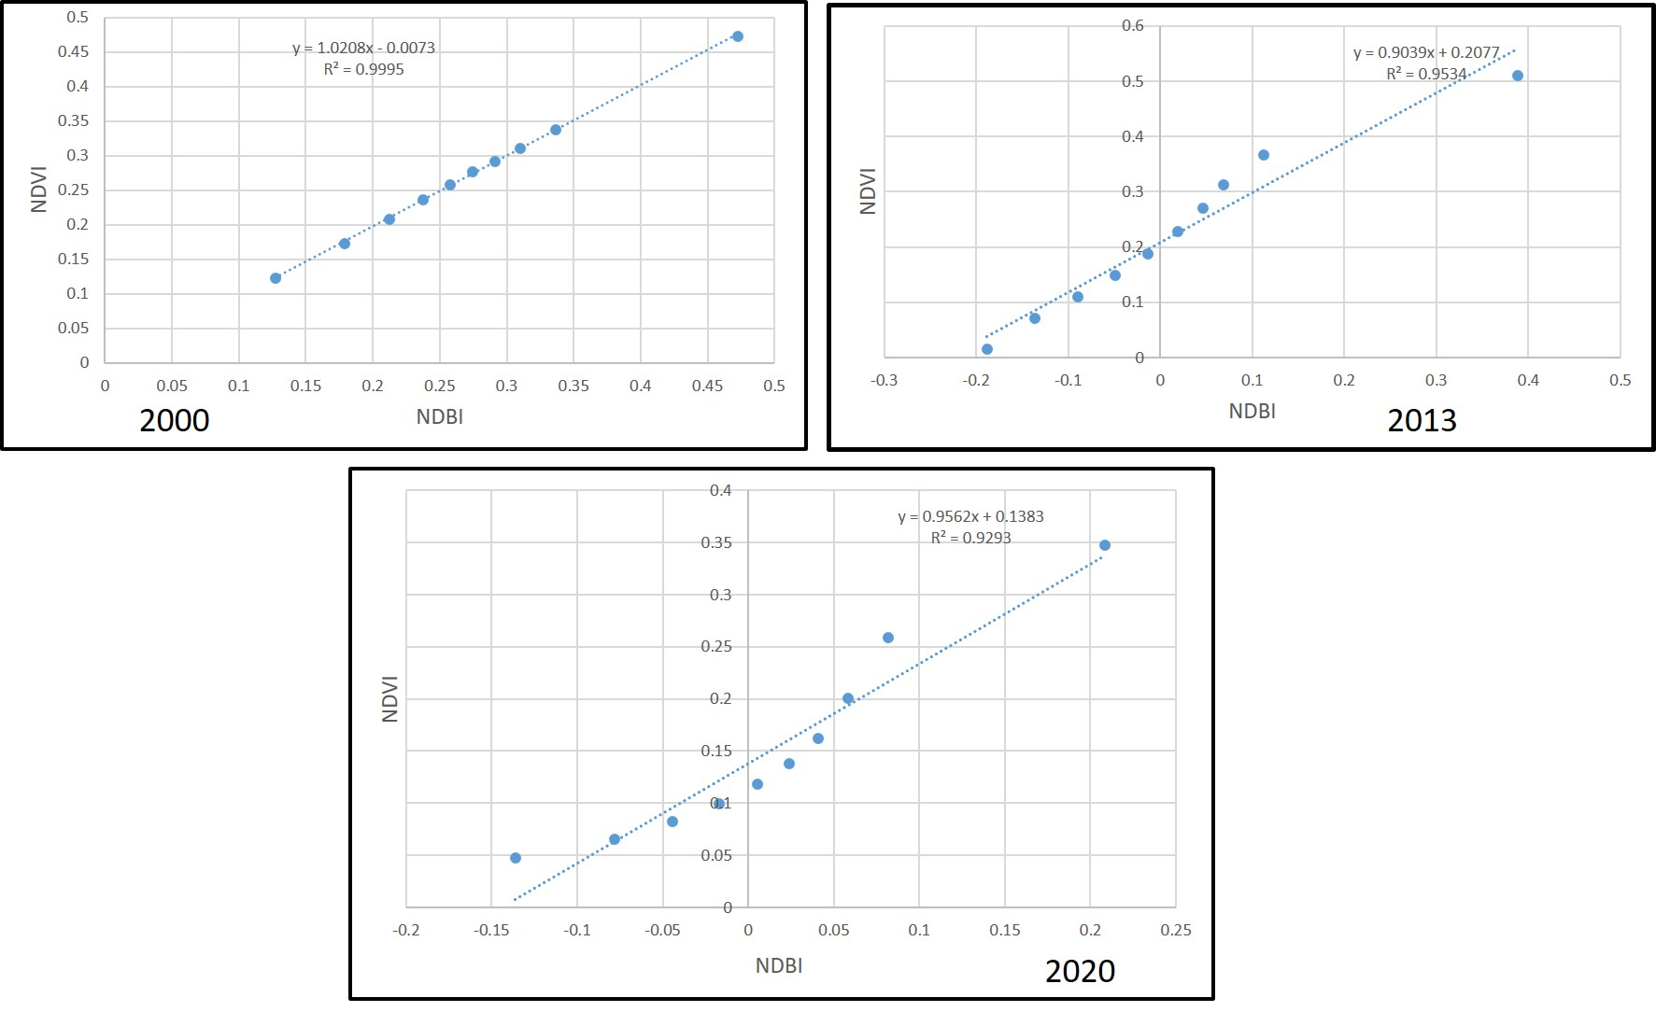
Figure 8: correction between NDVI and NDBI for the year 2000, 2013, and 2020
Source: Authors’ Analysis 2020

Elevated land surface temperature and the removal of vegetated land cover adversely affect the surrounding environment (Senanayake et al., 2013). The relationship between average land surface temperatures and the normalized difference vegetation index was a strong negative correlation in the epochs of the study (Table 5). The negative correlation between average land surface temperatures and the normalized difference vegetation index in the core of Ibadan LST reveals that vegetated land cover can weaken the effects of urban heat islands experienced in the inner core (See figure 9). This finding affirmed Fabeku et al.’s (2018) claims that improved vegetated land cover/greening in a geographical location will reduce the adverse effects of land surface temperature within the region.
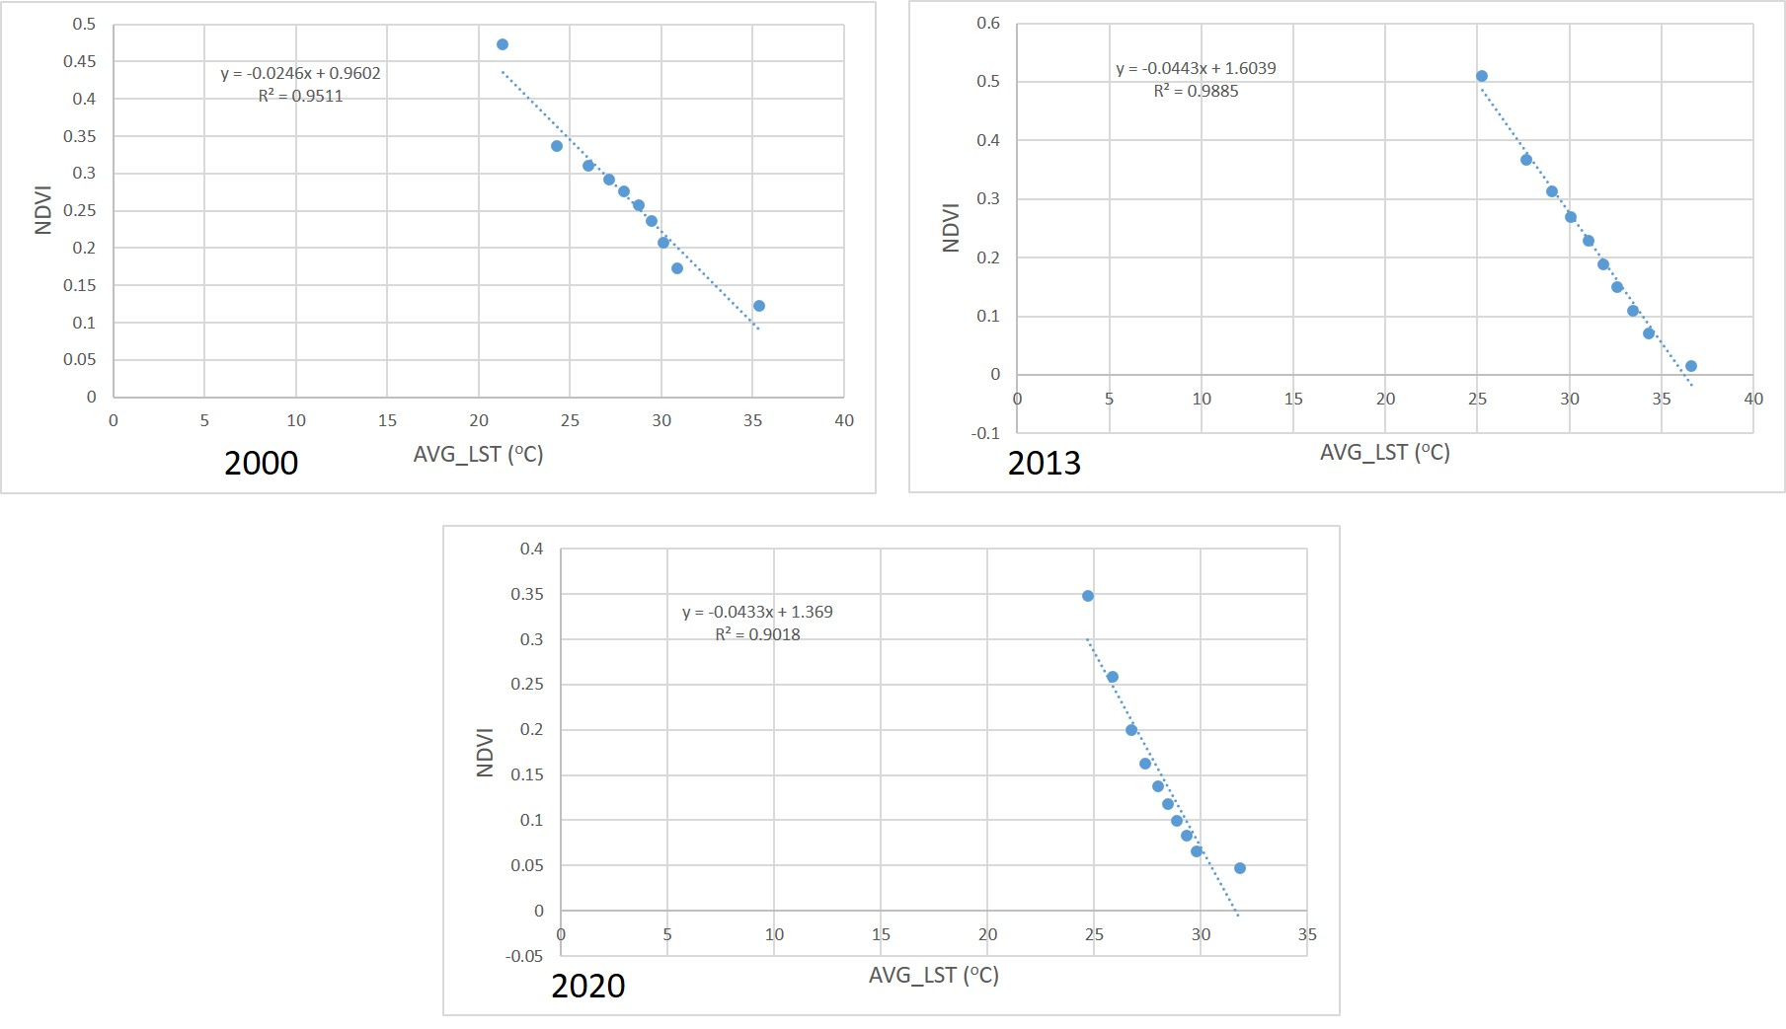
Figure 9: Correction between NDVI and AVG_LST for the year 2000, 2013, and 2020
Source: Authors’ Analysis 2020

Conclusion

An increase in anthropogenic activities resulting from rapid urbanization has adversely altered the natural landscape in the traditional core of Ibadan. This alteration manifest in the conversion of vegetation land covers into physical developments and other impervious surfaces by the increasing urban population which in turn contribute to the magnitude of urban heat island in Ibadan’s core. This study has effectively determined the normalized difference built-up area indexes and normalized difference vegetation indexes of the traditional core of Ibadan between the years 2000 and 2020. The relationships between the average land surface temperature and NDBI, NDVI were also ascertained. This study recommends that tree planting, roof top gardens, and other soft landscape elements should be encouraged to minimise the effects of urban heat island experienced in the inner core of Ibadan.

Authors Contribution
Conceptualization of the manuscript was done by Bamiji Adeleye and Ayobami Popoola; Data curation was done by Nanpon Zitta and Bamiji Adeleye; Formal analysis and Visualisation was done by Bamiji Adeleye., Ayobami Popoola and Funke Jiyah, drafting of the manuscript was done by all authors and the revision and paper update was done by all the authors as Ayobami Popoola handled the correspondence

Authors Declaration, Ethical Statement, Funding and Data availability
This research has taken into consideration ethical approval. The imagery used in the study remains an open data source with the necessary citations provided. The researchers declare no conflict of interest. The data used in this research is of open source and globally available.
References
Abegunde, L. & Adedeji, O. (2015). Impact of Land use Change on Surface Temperature in Ibadan, Nigeria. International Journal of Environmental and Ecological Engineering. 9 (3): 1- 7
Adelekan, I. O. (2016).Urban Africa Risk Knowledge: Ibadan City Diagnostic Report. Working Paper No.4, 1-21
Adetoro, O. and Salami, A. (2018). Assessment of Land Surface Temperature and LULC Changes and the Antecedent Flood Hazard in Ibadan, Nigeria. Journal of Ecology & Natural Resources. 2 (2): 1-11
Arimah, B. C. (1994). The nature and determinants of inequalities in housing amenities in an African city. In: Albert, I. O. et al (Eds.) Urban Management and Urban Violence in Africa. Ibadan: IFRA, 119-131.
Chen, L., Jiang, R., & Xiang, W. (2016). Surface Heat Island in Shanghai and Its Relationship with Urban Development from 1989 to 2013. Advances in Meteorology, Vol. 2016, 1-15
Fabeku, B. B., Balogun, I. A., Adegboyega, S. A., &Faleyimu, O. I. (2018). Spatio-Temporal Variability in Land Surface Temperature and Its Relationship with Vegetation Types over Ibadan, South-Western Nigeria. Atmospheric and Climate Sciences, (8): 318-336
Fashae, O. A., Adagbasa, E. G., Olusola, A. O., &Obateru R. O. (2019). Land use/land cover and Land Surface Temperature of Ibadan and environs, Nigeria. Environ Monit Assess 192:109 https://doi.org/10.1007/s10661-019-8054-3
Folorunsho, A. F., Balogun, I. A., Adediji, A. T., Olumide, A., & Abdulkareem S.B. (2017). Assessment of Urban Heat Island over Ibadan Metropolis Using Landsat and Modis. International Journal of Environment and Bioenergy, 12(1): 62-87
Fourchard, L. (2003). Urban Slums Reports: The case of Ibadan, Nigeria. In: Understanding Slums:Case Studies for the Global Report on Human Settlements 2003.
Jensen, J. R. (2000) Remote Sensing of the Environment: An Earth Resource Perspective.Pearson Education, Inc., Delhi, 361-365.
Kafi, K.M., Shafri, H.Z.M. &Shariff, A.B.M. (2014). An Analysis of LULC ChangeDetection Using Remotely Sensed Data; A Case Study of Bauchi City. IOP Conference Series: Earth and Environmental Science, 20, 12-56.
Kaplan, G., Avdan, G., &Avdan, Z. Y. (2018). Urban Heat Island Analysis Using the Landsat 8 Satellite Data: A Case Study in Skopje, Macedonia. Proceedings (2) 358: 1-5
Lin, L.,Yongbin, T., Shen, Y., Zhonghai Y., Zhen, L., & Honghao, L. (2014). Impact of Land Cover and Population Density on Land Surface Temperature: Case Study in Wuhan, China. Journal of Applied Remote Sensing Vol. 8, 1-19
NASA, 2012. Landsat 7 Science Data Users Handbook. NASA. Available at: <http://landsathandbook.gsfc.nasa.gov/pdfs/Landsat7_Handbook.pdf> (accessed 2/2/2020)
Nuruzzaman, M. D. (2015). Urban Heat Island: Causes, Effects and Mitigation Measures - A Review. International Journal of Environmental Monitoring and Analysis. 3 (2): 67-73
Onibokun A.G. &Kumuyi A.J. (1999). Ibadan, Nigeria. In: Onibokun AG (ed.) Managing theMonster: Urban Waste and Governance in Africa. International Development ResearchCentre, Ottawa. pp 49–100. https://idl-bnc.idrc.ca/dspace/bitstream/10625/26364/1/114247_p49-100.pdf
Senanayake, I.P., Welivitiya, W.D.D.P.,& Nadeeka, P.M. (2013). Remote sensing based analysis of urban heat islands with vegetation cover in Colombo city, Sri Lanka using Landsat-7 ETM+ data. Urban Climate (5):19–35
Taufik, A. &Ahmad, S. S. S. (2016). Land covers classification of Landsat 8 satellite data based on Fuzzy Logic approachIOP Conf. Ser.: Earth Environ. Sci. (37) 1-7
United Nations Human Settlements Programme (UN-Habitat), (2009). Planning Sustainable Cities: Global Report on Human Settlements. Earthscan publishes in association with the International Institute for Environment and Development
Voogt, J. 2002. Urban Heat Island. In Munn, T. (ed.)Encyclopedia of Global Environmental Change,Vol. 3. Chichester: John Wiley and Sons.
Weng, Q., Lub, D. and &Schubring, J. (2004). Estimation of Land Surface Temperature Vegetation Abundance Relationship for Urban Heat Island Studies. Remote Sensing of Environment, 89, 467-483.
Zahabi, M. &Pradhan, B. (2017). Effect of Urban Expansion on Land Surface Temperature in Putrajaya City, Malaysia. In Pradhan, B. (ed) Spatial Modeling and Assessment of Urban Form, Analysis of Urban Growth: From Sprawl to Compact Using Geospatial Data: Springer Pp 61 -92
Zhang, D., Shou, Y., Dickerson, R. R., & Chen, F. (2011). Impact of Upstream Urbanization on the Urban Heat Island Effects along the Washington–Baltimore Corridor. Journal of Applied Meteorology and Climatology. (50): 2012 -2029

