

The Factors and Effects of the Changes in the Spatial Layout of Iban Dwelling in Sarawak

Salfarina Abdul Gapor¹, Muhammad Oliver Ensor Silini², Daniel Ugih Echoh³, Haris Fadzilah Abdul Rahman⁴

^{1,2&4}Centre for Borneo Regionalism and Conservation, University of Technology Sarawak
³Faculty of Social Sciences and Humanities, Universiti Malaysia Sarawak

Correspondence: Salfarina Abdul Gapor (salfarina@uts.edu.my)

Received: ; Accepted: ; Published:

Abstract

Iban is the largest ethnic group in Sarawak. A typical stereotype of the Iban longhouse as perceived by outsiders is a communal dwelling made from timber with compact linear building composition. However, this has changed overtime due to several factors. Longhouses have become shorter with less households. Therefore, the main objective of this paper is to find out the factors that cause changes in the spatial layout of longhouse and impacts of the changes. This study is conducted using a case study method of two longhouses in Kapit and Sebuyau, Sarawak. Data collection includes in-depth interview and observation. Data analysis is done using building spatial analysis and historical timeline analysis. The findings show that although the Iban are still living in communal longhouses but there is an increasing trend showing their preferences to build and live in individual houses like the Malays and Melanaus in Sarawak. The changes in the spatial layout of the two longhouses are due to increasing number of household members, difficulty to access traditional building materials, especially timber, natural and fire hazard and characteristics of site topography that posed difficulty to maintain a linear extension of households.

Keywords: Communal dwelling, Iban, Longhouse, Sarawak, Settlement pattern, Vernacular dwelling

Introduction (Times New Roman, font size 12 Bold)

An Iban longhouse is also known as ‘rumah panjai’ locally, which is a unique traditional communal vernacular dwelling of the rural ethnic groups in Borneo, including Sarawak. In Sarawak, these include the natives Dayak like the Iban, Bidayuh, Orang Ulu, and other sub ethnic groups. A longhouse housed the members of an extended family, clan, or moiety within a village (Beynon, 2013). The design of the longhouse is a terrace typology of separate dwellings. There are many longhouse variants in Borneo but generally follow similar lines in terms of siting, plan, and section (Ting, 2005). A longhouse consists of several sections, i.e. the ‘tanju’ (veranda) and ‘ruai’ (communal space) as open space and ‘bilik’ as a personal family space with living room, bedroom, and kitchen. The longhouse is headed by a headman called ‘tuai rumah’, who is responsible to lead the administration and solve any social problems in the longhouse.
In Sarawak, the support from the federal and state government in the construction of new longhouses through financial assistance has contributed to the continuity of the dwelling concept (Chang, 2006). However, this does not necessarily means that the longhouses remain authentic and the characteristics of the vernacular design and building material are maintained. Therefore, nowadays the traditional longhouse is a threaten typology, which inevitably also diminishes traditional identity. Most longhouses have been transformed into a modern looking longhouse, adapting new modern design and built using bricks and concrete as the main building materials. This changes have led to the concern that someday the traditional communal vernacular longhouse might be lost together with the distinct identity of the Iban. This research explores the causes and effects of changes in the dwelling spatial layout of the Iban community in Sebuyau and Kapit.

Literature review

Changes of vernacular architecture due to modernization can distort traditional relations, rules and traditions (Stern, 2009) and also affect the social and cultural life of people (Syamir & Arayici, 2020). For example, changes in internal spaces especially marked by boundary and wall will lead to lack of socio-cultural activity within the buildings. Besides, the changes of the spatial layout are also problematic in terms of safety, functionality and aesthetics (Kuloğlu, & Durmus, 2014). Traditionally, people lived in a house, which had a yard and small garden and with minimum furniture without having facilitative and entertaining utensils such as washing machine, television, fan and other household equipment. In contrast, modern lifestyle as represented by the modern housing, people are facing dramatic changes with regards to internal design and changes in the arrangement and the position of furniture (Saeideh Feizi, et al., 2013). In Malaysia, traditional houses or vernacular architecture were modernised due to the environmental, cultural, and historical context in which they lived (Soe Ryeung et al, 2012). In Kerala, the transformation of the traditional to modern architecture had led to the changes of local norms, landscaping style and the traditional residential form (Gini & Kulkarni, 2014). The landscaping had changed to improve aesthetics rather than functional, such as planting trees to protect biodiversity, for consumption and for safety purposes.
There are two fundamental types of rural settlement pattern that are still relevant today such as the grouped or clustered dwelling form and the dispersed form (Rubenstein, 1992). The first type consists of dwellings concentrated together with their farmland outlying their clustered dwellings or village. The Iban’s settlement is of the grouped or cluster type, with a compact building, rectangular floor plane and cuboid form. In terms of design, the longhouse has its own spatial layout that is influenced by their socio-culture. The spatial layout is also related to structure and functions of the longhouse and has a positive impact on the residents’ environmental quality (Gehl, 2011). The buildings can affect the quality of spaces and well-being of the occupants living in the building. The structure, which is on stilt, reflects the harmonisation with the local environment and climate conditions, which contributes to the comfort of the occupants (Siti Akhtar et al., 2017).
In the context of the longhouse typology, the designs are different between the ethnic groups, depending on the structure of the society and the geographical locations of the longhouse. Today, the settlements of the Iban community have changed from facing the river basins to roadsides due to economic opportunities and social factors. A study conducted by Ichikawa (2019) found that many Iban built their longhouses along the roadsides due to economic opportunities, infrastructure and utilities development. When roads are available, it is also easier for the government to provide treated water supply and electricity to rural and semi-urban areas. In addition, a study by Faridah, Anna and Spencer (2016) on the Orang Ulu in the Sungai Asap Resettlement scheme of Belaga, Sarawak, found that the changes of physical landscape due to development projects in the region had caused a scarcity in traditional construction materials, both in quantity and diversity. Besides affecting the making of traditional dwellings, these factors also affected the traditional culture among the rural community, such as traditional craft-making activities, local knowledge, and other economic activities.

Method and study area

This research employs a qualitative approach through in-depth interviews, focus group discussion and observation. The observation focuses on the structure, arrangement, location, and size of the houses. A comparative study of spatial layouts of the two longhouses was also done through sketch drawing based on the historical interview. A total of two Iban longhouses were selected for this study. These are Rumah Emperan Pisang in Kapit and Rumah Blawan Anak Busang, Kg. Jeragam in Sebuyau (refer to Figure 1). These two longhouses were selected because of the different changes that they had experienced. The longhouse in Sebuyau maintain its authentic characteristics, however the one in Kapit has completely changed. In addition, the longhouses also have different geographical settings. The one in Kapit is located along a river, while the one in Sebuyau is located in a hilly interior site. For the in-depth interview, six respondents were interviewed, three each in Kapit and Sebuyau. For the focus group discussion 20 respondents were involved, ten each in Kapit and Sebuyau. Most of the issues observed were the history of the village and the longhouse, the design and main characteristics of the original longhouses, evolution of the longhouses, issues related to safety, challenges in protecting the traditional longhouse design, and the impact of changes. The statements from the interview were identified for clarity and each transcript was reviewed several times for clarity. It was written in the Iban language, the native language of the respondents. For the purposes of clarification and reducing the influence of the researcher’s biases, the transcripts were then translated to English. The data were analysed using thematic content analyses. The sketches, picture and spatial layout were analysed by identifying latent changes and implications to fire hazard and changes in socio-cultural and socio-economic practices.

Results and discussion

This section discusses the factors and effects of changes in the spatial layout of the two longhouses in Sebuyau and Kapit, Sarawak. Rumah Panjang Emperan Pisang is located in Kapit. It was chosen because of the physical dynamic changes that the longhouse experienced since 1988. The longhouse was founded by Tuai Rumah Tuan in the 1960s, an original wooden longhouse located along the Balleh River (refer to figure 1).
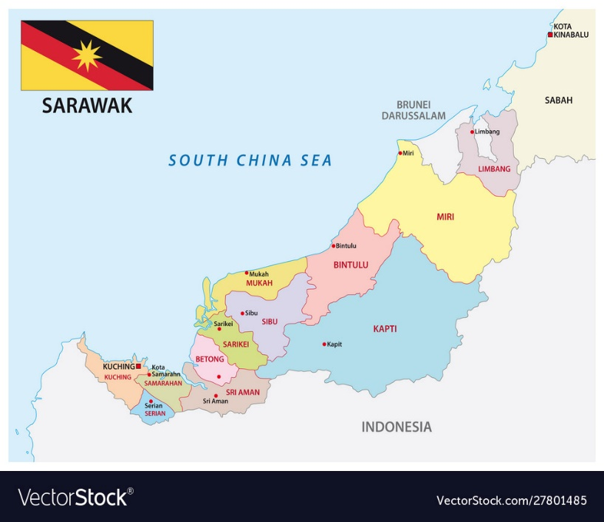
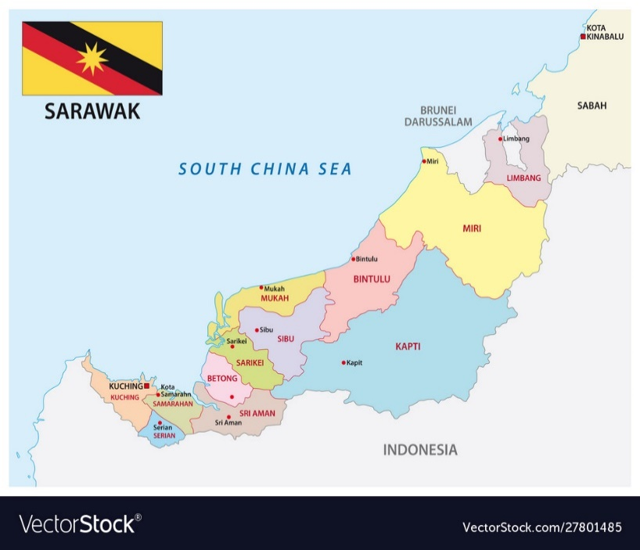
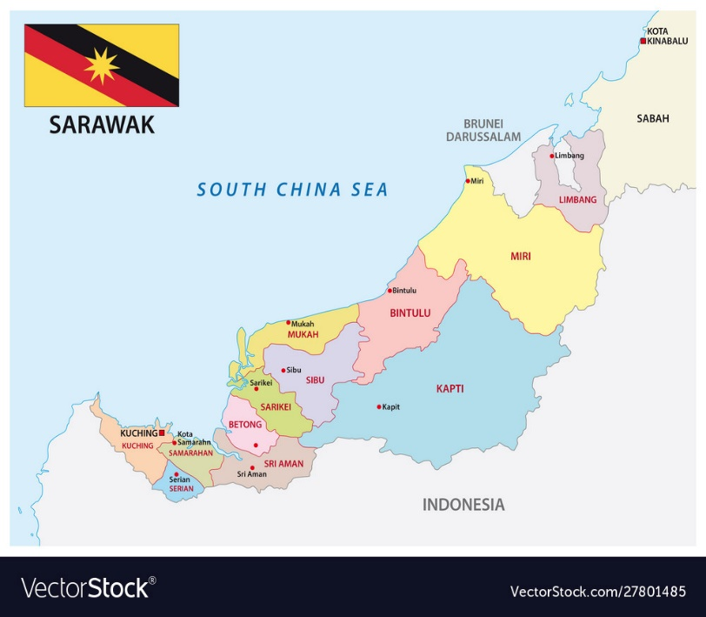
SEBUYAU
KAPIT

Source: https://www.vectorstock.com/royalty-free-vector/administrative-map-sarawak-malaysia-vector-27801485

Figure 1. Sarawak map showing Kapit and Sebuyau

In August 1998, the longhouse was engulfed by fire, which resulted in the division of the original longhouse into three longhouses, under Tuai Rumah Gawan, Tuai Rumah Juin and Tuai Rumah Tuan. On 28 December, 2006, the three longhouses collapsed due to landslide. It was suspected that causes of the landslide is related to logging activities around the area. From the period between 2006 until 2009, occupants of the three longhouses lived in a temporary shelters provided by a logging company, Shin Yang. In 2009, each of the household started to build new permanent houses after they have received compensation from Shin Yang (refer to figure 2). The compensation were between RM 12, 000 to RM 80, 000, depending on the loss of the households. In addition, Shin Yang also provided water supply. The three longhouses also received RM 2, 000 per household from the Minister, YB James Masing. Starting 2010 until 2011, the households started to move to their new houses. The two events, fire and massive landslide have completely changed the physical layout of Emperan Pisang.

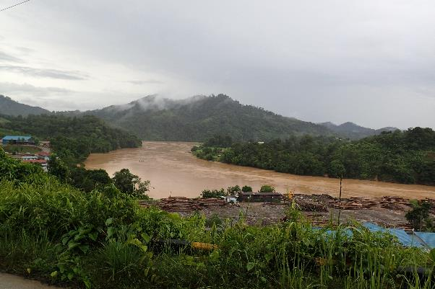
Source: Haris Fadzilah Abdul Rahman, 2021

Figure 2. Setting of Rumah Emperan Pisang along Balleh River, Kapit

Refer to figure 4, which clearly shows the spatial changes of Rumah Emperan Pisang as a result of the fire and landslide tragedies. In the 1960s the shape was a typical Iban longhouse, with a linear, cubic form and spatial organisation that represented the public, semiprivate and private spaces, representing by the tanju, ruai and bilik respectively. As time moved on, the longhouses were divided into three due to space and topographic constraint, making them shorter. By 2020, the whole spatial organisation had changed with a mixture of individual and communal dwellings. This is due to affordability, which is also related to the amount of compensation received by each household and the location of individual land to ensure easy access to their farmlands.

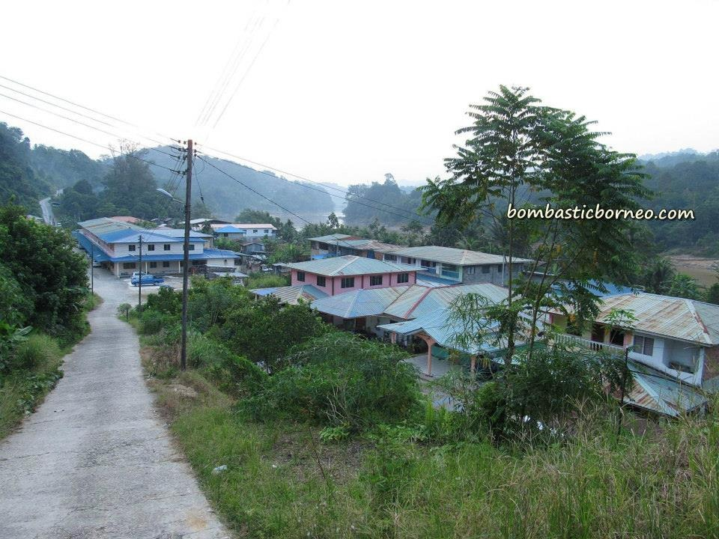
Source: Bormbastic Borneo.com

Figure 3. The new modern longhouse design at Rumah Tuan Emperan Pisang, Kapit
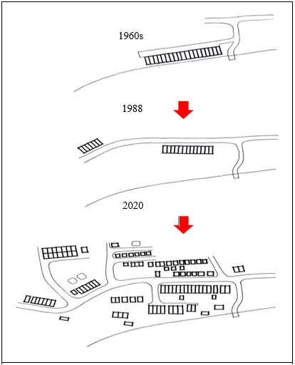
Source: Haris Fadzilah Abdul Rahman, 2021

Figure 4. Spatial Layout Evolution of the longhouse in Kapit

Rumah Blawan Anak Busang, Kg. Jeragam is located in Sebuyau. The first Tuai rumah was Tuai Rumah Umam. Currently, the longhouse is headed by Tuai Rumah Blawan. It is one of the oldest longhouses in this district, and perhaps in Sarawak as well. It is made of timber and most of the structures and building materials are still original, except for minor modification due to repair and maintenance (Refer to figure 5). Unlike, Rumah Emperan Pisang, with a background of a river, the longhouse is located on a hill, surrounded with fruit orchards and farms (refer to Figure 6). The longhouse has been a favourite destination for both local and foreign tourists due to its authentic design. They even received visitors from South Korea, who stayed there to conduct a community project as well as building a church for them.
In the 1950s, the longhouse was a typical Iban longhouse. Major changes happened in the 1980s, whereby the longhouse was extended, as indicated by the expansion of floor areas of each households to the rear part of the longhouses. By 2020, the households could no longer expand to the rear, left nor right sides of the longhouse due to topographical and building material constraints. As a result, the extended families had no other choice but to expand on the open sloping site in front of the longhouse. The houses are no longer built as a typical communal longhouse but as individual houses in a sporadic layout, although still in cluster (refer to figure 7).

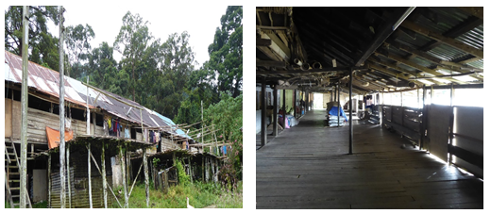
Source: Muhammad Oliver Ensor Silini, 2021
Figure 5. Original Design of the Longhouse in Sebuyau

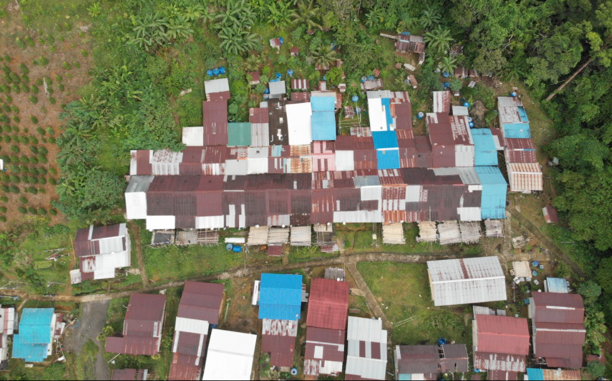
Source: Muhammad Oliver Ensor Silini, 2021

Figure 6. Current Spatial Layout in Sebuyau

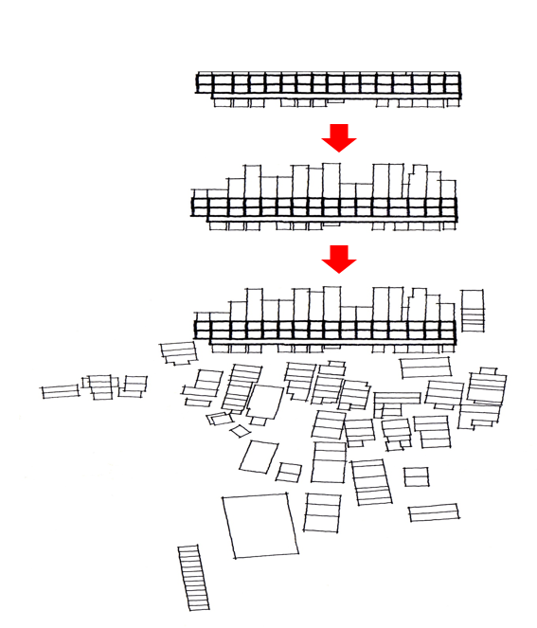
1950s
1980ss
2020

Source: Haris Fadzilah Abdul Rahman, 2021

Figure 7. Spatial Layout Evolution of the longhouse in Kampung Jeragam, Sebuyau.

The Factors that cause Changes in the Spatial Layout of the Dwellings

The changes in the spatial layout of the two longhouses were due to increasing number of household members, difficulty to access traditional building materials, especially timber, natural and fire hazard and characteristics of site topography that posed difficulty to maintain a linear extension of households.

- Increasing number of household members

The increasing number of households has led to the increase demand of a new bilik for the new family. Bilik refers here to the separate household representing a separate family unit. This has led to the extension of the current number of bilik in both longhouses in Sebuyau and Kapit. Several head of households have opted to extend their house towards the rear part of the current longhouse, to accommodate extended family members, as can be seen in Sebuyau in the 1980s. However, many new families choose to live separately from their parent or in-laws. The trend is also similar in Rumah Panjang Emperan Pisang, Kapit, instead of building a new longhouse they are building individual houses. For the case of Kapit, the decision to build individual houses are for privacy and also to be nearer to their respective lands, hence, facilitating them to tend their orchards, farms and livestock. In addition, when building separately, it is easier for them to decide on the design, materials and cost of the building, which again is influenced by the amount of compensated money that they have received from the logging company (refer to figure 9). Furthermore, any communal gatherings can still be done at the longhouses that still maintain the “ruai”. Alternatively, most social gatherings now are also conducted in the community hall provided by the government and churches, as most of them, especially the new generation have converted to Christians.

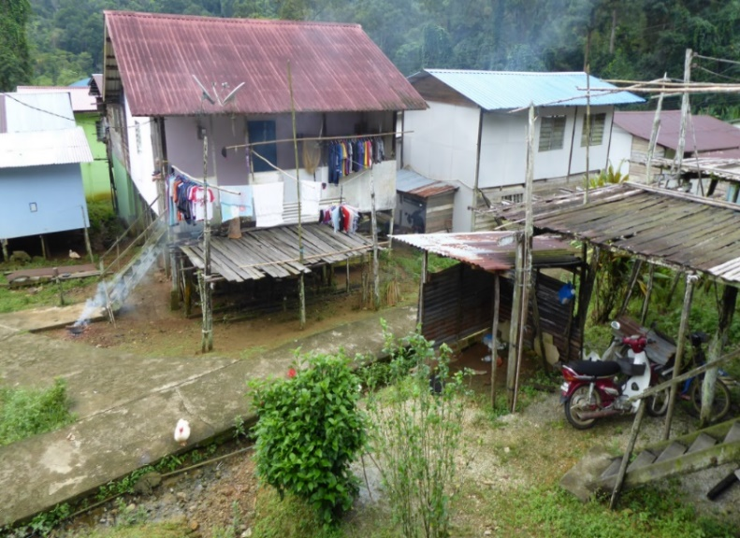

Source: Muhammad Oliver Ensor Silini, 2021

Figure 8. New Individual Houses Built in front of the Old Longhouse in Sebuyau

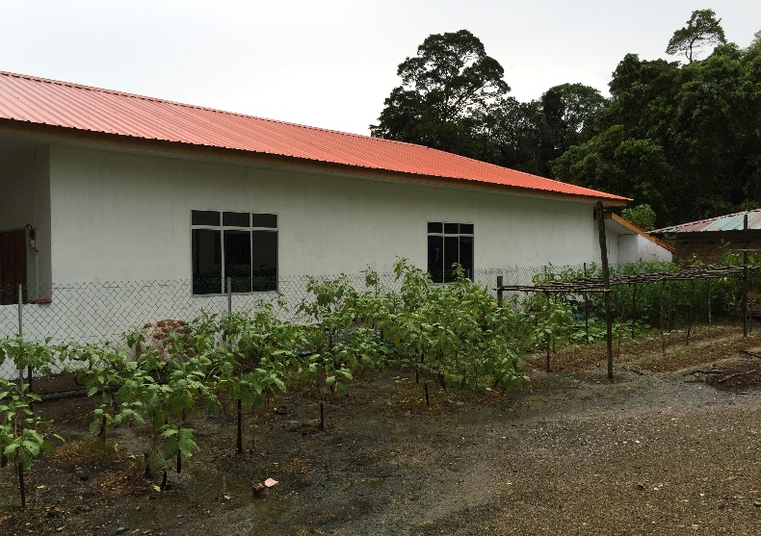

Source: Haris Fadzilah Abdul Rahman, 2021

Figure 9. New Modern Individual House Built in Rumah Panjang Emperan in Kapit

- Difficulty to access traditional building materials

Another reason for not able to extend the new bilik from either left and right sides of the traditional longhouse is the difficulty to access traditional building materials like timber. This was the case in Sebuyau. The Tuai Rumah also emphasises that, if a new household is interested to build a new bilik by connecting with the old longhouse, the new household is required to follow the current typology and materials. The rational is to maintain the original design of the old longhouse. Hence, most new families prefer to opt building separate houses in front of the original longhouse. In Kapit, there was no longer a need to build by extending to the original longhouse because it was already destroyed by fire and a landslide. Hence, new generation do not have any reference of the old longhouse and choose to design their new houses according to their own personal taste. In addition, it is more convenient to buy building materials like brick, concrete, glass, plywood, zinc, and etc., which are readily available in the market and much cheaper compared to timber. Besides, the preparation of traditional materials takes a longer time. Another problem is to find experience artisanal builders to meet the requirement from the committee of the old longhouse for the case of Sebuyau. Similarly for Kapit, there is no longer a reference of the traditional longhouse design, as well as absence of artisanal builders that have the indigenous knowledge to build using timber and the traditional techniques such as mortise and tenon. Figure 7 and 8 show the new houses built using modern materials in Sebuyau and Kapit.

- Natural and fire hazard
The spatial organisation of Rumah Panjang Emperan Pisang changed due to fire and landslide hazards. In August 1998, the longhouse was engulfed by fire, which resulted in the division of the original longhouse into three longhouses while in December, 2006, the three longhouses collapsed due to landslide. These two events have resulted to the total transformation of the previously compact and grouped spatial organisation to a more loose and sporadic organisation. By 2011, two events, fire and massive landslide have completely changed the physical layout of Rumah Panjang Emperan Pisang in Kapit. Although there is no historical case of fire in Sebuyau but from observation, there are many potential fire hazards elements. Firstly, the longhouse in Sebuyau is still maintaining wood as materials for the main structure, wall and floor.
The woods were not treated with fire retardants making them low level fire resistance, hence the issue of the building materials, which potentially contribute to fire hazard has also changed the perception of using traditional material for the new dwellings. The preference of using modern material for the new dwellings, which was not consistent with the old longhouse, has forced the new units to be separated. The typology of the traditional longhouse, which is elongated and individual bilik separated by minimal means of partition wall may also contribute to rapid fire spread. Figure 10 shows a bilik in the old longhouse in Sebuyau, which is separated using timber plank and plywood. The materials used will not be efficient to contain fire from spreading throughout the whole longhouse. Having separated individual dwelling units will lower the risk of rapid fire spread between units.

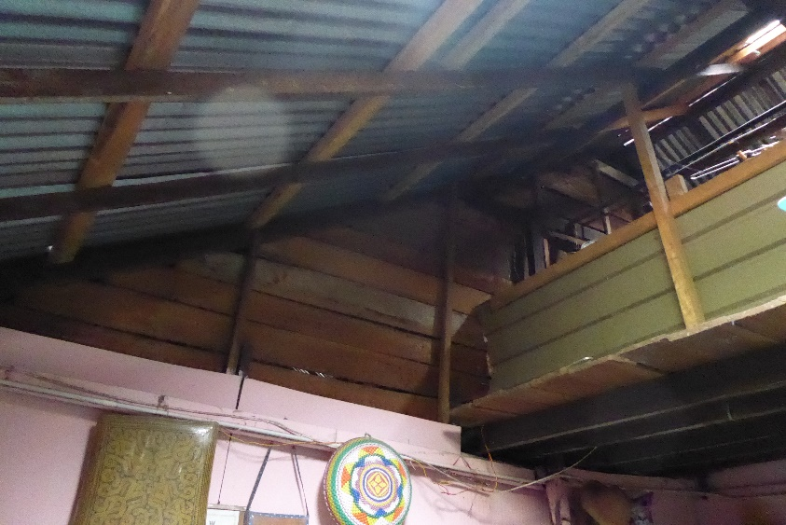
Source: Muhammad Oliver Ensor Silini, 2021

Figure 10. Timber plank and plywood used as partition wall in the Old Longhouse in Sebuyau

The traditional longhouse has only two main entrance and exit, which are located at the end of each side of the ruai as shown in figure 11. The travel distance to the means of escape from the bilik will be too far for the longhouse with many connected units. There will be a risk for the occupants to safely escape from the spreading fire. In contrast, a new separated individual house has a direct escape from their own unit.

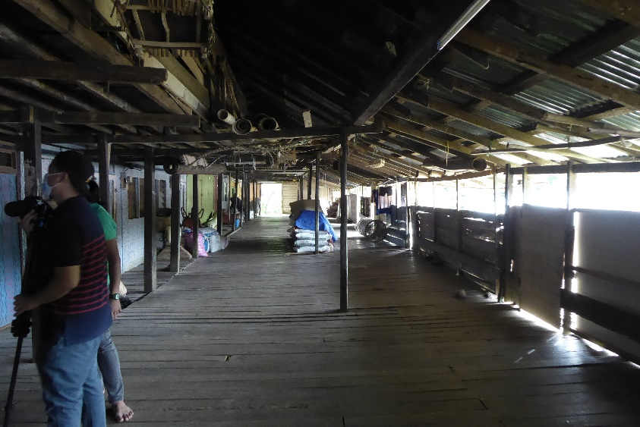
Source: Muhammad Oliver Ensor Silini, 2021

Figure 11. The main entrance and exit located a the end of a ruai in the Old Longhouse in Sebuyau

The longhouse in Sebuyau is located uphill with limited access for fire appliances. The only access which is available in front of the longhouse is narrow and not sufficient for access as shown in figure 12. This will pose a high risk of complete loss in the event of fire. The separate dwellings will have lower risk for fire to spread to the rest of the dwellings, provided that the setbacks between the houses are sufficient.

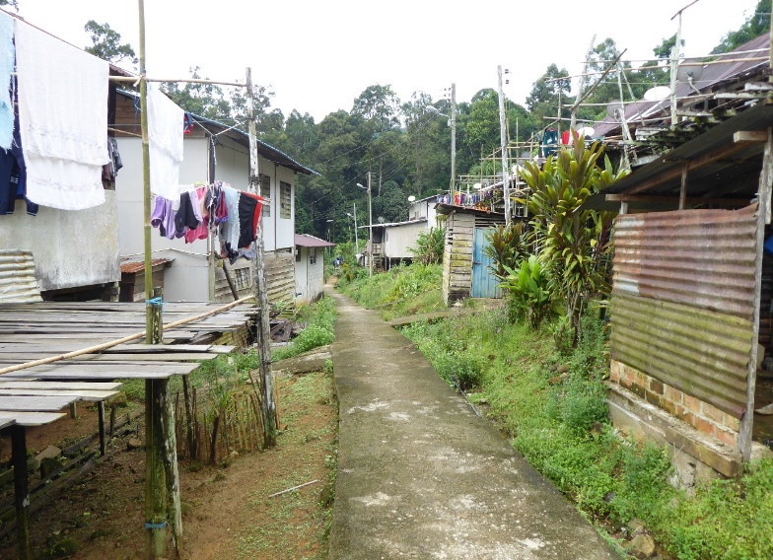
Source: Muhammad Oliver, 2021

Figure 12. The narrow access in front of the Old Longhouse in Sebuyau.

Another factor that can be a potential to fire hazard in the old longhouse is the use of aging electrical wiring and unsafe usage of electrical appliances. In contrast, the new dwellings, which were built separated from the old longhouses, will have new and proper wiring installed by a certified electrician.

- Topographical constraints

Topographical constraints refer to the physical conditions of the land where the longhouses are located. In Sebuyau the back part of the longhouse is hilly and quite steep, thus limiting them the option to build new houses. This leaves only at the front part of the original longhouse as an option, which is slightly sloppy but still a manageable site (Refer to figure 7). Most of them prefer to build individual houses now, instead of a longhouse. In Kapit, as the longhouse move further from Balleh River, it is more difficult to build in a linear group design, similar to the original one. It is easier to build a longhouse on a flat land along the river bank. Hence, this topographical changes also contributes to the more sporadic spatial organisation of the dwellings. There is no doubt that physical factor is one the most influential elements affecting the formation of their new dwellings.

The Effects of the Changes in the Spatial Layout of Iban Dwelling

The changes in spatial layout has affected the socio-cultural aspects of the community. These include loss of traditional architectural design, loss of traditional architectural knowledge, method and skills, and loss of some of the traditional culture and identity.

- Loss of traditional architectural design

The traditional design of the old longhouse in Sebuyau is shaped strongly by culture, safety, weather, and geographical location. However, the design of the new individual houses are shaped mainly for basic shelter. The architectural elements that are loss as a result of these changes include the distinct division between the public space as represented by the tanju and the semi-public space as represented by the ruai. Other architectural elements loss are the rustic and authentic effects from the timber materials. The new houses built in Emperan Pisang, Kapit for example are no longer built on stilt. The changes in the structure also completely change the traditional vernacular identity of the longhouse. To a certain extend the new longhouse now resembles more of a terrace house that is typical in urban housing. This also applies to the roof of the new houses; the typical pitch roof is no longer common, since several of the new houses even opt for a flat roof or even a hipped roof resembling the Malay roof design.

- Loss of traditional architectural knowledge, method and skills
The traditional architectural knowledge, method and skills in the construction of the traditional longhouse will be completely lost in the future due to the changes of the design and materials of the new houses. In both case studies, there are no artisanal builders who are experts in the traditional jointing methods without using nails, i.e. the traditional mortise and tenon methods. In addition, knowledge of selecting good timber, traditional treatment methods and construction are also lost with the declining practice. Many social taboos and local customs that are associated with traditional construction will also be lost.
- Loss of traditional culture and identity

Based on the respondents in Sebuyau, the construction of the old longhouse is usually initiated by the ritual ceremony, such as miring and also referring to social taboos related to their immediate environmental factors such as the sound and appearance of birds and dreams. However, this practices was no longer implemented by the new generation in the construction of the new house. Culture is one of the major factors that defines identity as it is related to the people that created this culture. In the context of the traditional culture related to the space layout of the traditional longhouse, the ruai is an important space for social activities such as entertaining visitors, meetings and celebrating festival such as Gawai Dayak (the harvest festival). It is also used daily as a gathering spot for evening conversation to enhance social cohesion and solidarity between the households. Figure 13 and 14 shows the difference between a traditional and a modern ruai. The modern ruai despite still maintaining its function is much shorter compared to the traditional ruai.

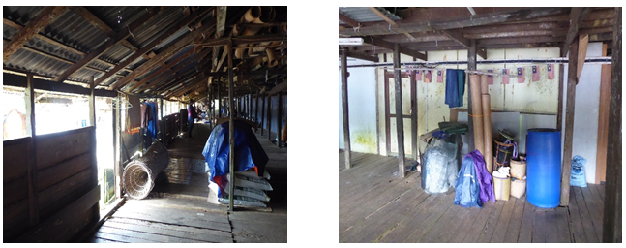
Source: Muhammad Oliver, 2021

Figure 13. Traditional Ruai used to stores goods, handicrafts and agricultural materials in Sebuyau

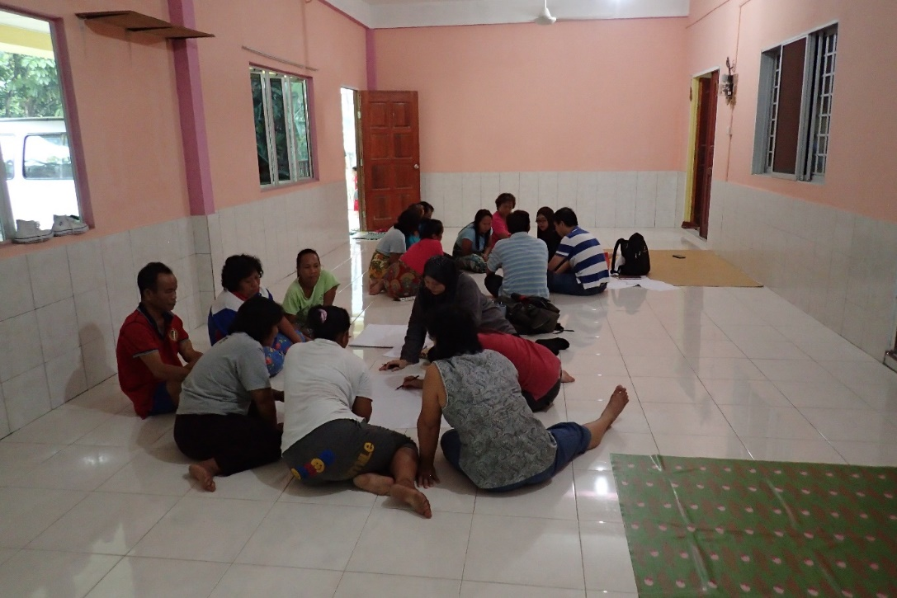
Source: Haris Fadzilah Abdul Rahman, 2021

Figure 14. Modern Ruai in Kapit

Besides, there is no tanju built for the new house. Traditionally the tanju was used as drying areas, especially for agricultural products like paddy, and rattan. With the changes in employment, the function of tanju has changed as part of the utility areas to dry clothes, to park cars and motorcycles or to hold an outdoor barbeque activities. With the changes of employment, especially among the younger generation, as more are now employed in either the public or privates sectors, other additional structures associated with the longhouse has also lost, such as the granaries.

Conclusion

The changes of the spatial layout of the Iban’s dwelling has led to dramatic effects to the Iban vernacular architecture, culture and identity. The changes in the spatial layout of the two longhouses were due to increasing number of household members, difficulty to access traditional building materials, especially timber, natural and fire hazard and characteristics of site topography that posed difficulty to maintain a linear extension for new households. The changes in spatial layout has affected the socio-cultural aspects of the community. These include loss of traditional architectural design, loss of traditional architectural knowledge, method and skills and loss of some of the traditional culture and identity. The effort by the tuai rumah in Sebuyau to make sure that his residents follow the original typology of their longhouse can be seen as a good example in conserving the heritage value of the longhouse, although in the end many opt to build separate individual houses. In the future, the declining number of traditional artisanal builder will affect the effort to sustain the traditional vernacular longhouse. Potential further research include examining the different psychological impacts of living in a traditional longhouse compared to modern individual house and to expand the case studies in other areas and ethnic groups.

Acknowledgements

The authors would like to thank UCTS for funding the research under the UCTS Research Grant “Assessing the Compliance with the Uniform Building by Laws (UBBL 1984) on Longhouses in Sarawak” (1/2018/02).

References

Ansari, H. (2004). Pluralism in Iranian modern architecture. The Journal of Architecture and Civil Science, 20: 10-14.
Beynon, D. (2013). The Contemporary Iban Longhouse: The Sustenance and Applicability of a Socio-spatial Culture. The International Journal of Social Sustainability in Economic, Social, and Cultural Context, 9 (1): 1-18. https://www.researchgate.net/publication/290520430_The_contemporary_Iban_longhouse_The_sustenance_and_applicability_of_a_socio-spatial_culture
Chang. (2006). History of Iban Settlements around Kuching City Sarawak, The Sarawak Press Sdn Bhd, Kuching.
Emperan Pisang Photos, Available at: Bormbastic Borneo.com https://www.facebook.com/media/set/?set=a.736342393048564.1073741888.161366760546133Access on 20 October, 2021
Faridah, S., Anna, D., & Spencer, E.S. (2016). Cabaran dan peranan pembuat kraf dalam pelestarian budaya benda masyarakat Orang Ulu di Belaga Sarawak [Craftmakers’ challenges and roles in sustaining material culture among the Orang Ulu in Belaga Sarawak]. Borneo Research Journal, 10, 111-126. https://borneojournal.um.edu.my/index.php/BRJ/article/view/9856
Gehl, J. (2011) Life between buildings: using public space. Island Press.
Gini G., & S.Y. Kulkarni. (2014). The Impact of Socio-Cultural Factors on the Transformation of the Residential Architecture of Kerala. International Journal of Research (IJR) Vol-1, Issue-5, June 2014, 526-530. https://1library.net/document/q01k5kgz-impact-socio-cultural-factors-transformation-residential-architecture-kerala.html
Kuloğlu, Nilgün & Durmus Ozturk, Serap. (2014). The Trace of Change: Traditional House. https://www.researchgate.net/publication/291351235_The_Trace_of_Change_Traditional_House
Ichikawa, Masahiro. (2019). Immigration and adaptation of the Iban from rural to urban outskirts in Sarawak, Malaysia. Tropics. 28. 39-48. 10.3759/tropics.MS18-14.
Rubenstein, H. (1992). Migration. Development and Remittances in Rural Mexico. International Migration 30(2): 1992.
Saeideh Feizi Azarshahr, Alireza Motamadniya, Mostafa Basiri. (2013). New Technologies in Modern Architecture and its Interaction with Traditional Architecture. Res. J. Chem. Env. Sci., Vol 1 Issue 3: 70-80. http://www.aelsindia.com/vol1august_2013/13.pdf
Sarawak Map, Available at: https://www.vectorstock.com/royalty-free-vector/administrative-map-sarawak-malaysia-vector-27801485, Access on 12 October 2021.
Seo Ryeung Ju, Saari Omar & Young Eun Ko (2012) Modernization of the Vernacular Malay House In Kampong Bharu, Kuala Lumpur, Journal of Asian Architecture and Building Engineering, 11:1, 95-102, DOI: 10.3130/jaabe.11.95. https://www.tandfonline.com/doi/pdf/10.3130/jaabe.11.95
Siti, Akhtar. M., Wan, A. Z. W. Z., Siti Norlizaiha, H., & Balkhiz, I. (2017). Assessment of Building Typology and Construction Method of Traditional Longhouse. Procedia Engineering 180: 1015 – 1023. https://www.sciencedirect.com/science/article/pii/S187770581731768X
Stern, R (2009). The Doubles of Post-Modern. In: Architecture on the Edge of Postmodernism: Collected Essay 1964-1988, Stern, R.M.A. and C. Davidson (Eds.). Yale University Press, Yale, ISBN: 13: 9780300153972, pp: 1-216.
Syamir, Hamed & Arayici, Yusuf. (2020). The Influence of Modern Architecture in Transforming Iraqi City Identity. Proceeding in the 2th International Postgraduate Research Conference (IPGRC 2015), 10-12 June 2015, Salford Quays. https://www.researchgate.net/publication/338558050_The_Influence_of_Modern_Architecture_in_Transforming_Iraqi_City_Identity
Ting, J. (2005). ‘The Egalitarian Architecture of the Iban Longhouse’ in Leach, A. & Matthewson, G.‘Celebration. Proceedings of the 22nd. Annual Conference of the Society of Architectural Historians, Australia and New Zealand’, Napier, New Zealand (SAHANZ). https://www.academia.edu/165882/The_Egalitarian_Architecture_of_the_Iban_Longhouse

