Factors and effects of changes in the spatial layout of Iban dwelling in Sarawak

Salfarina Abdul Gapor¹, Muhammad Oliver Ensor Silini¹, Daniel Ugih Echoh²,
Haris Fadzilah Abdul Rahman¹

¹Centre for Borneo Regionalism and Conservation, University of Technology Sarawak
²Faculty of Social Sciences and Humanities, Universiti Malaysia Sarawak

Correspondence: Daniel Ugih Echoh (email: edugih@unimas.my)

Received: 22 August 2022; Accepted: 16 May 2023; Published: 31 May 2023

Abstract

A typical stereotype of the Iban longhouse as perceived by outsiders is a communal dwelling made from timber with compact linear building composition. However, this has changed over time due to several factors. The main objective of this paper is to find out the factors that cause changes in the spatial layout of longhouse and impacts of the changes. Understanding root causes of these changes are paramount to conservators and policymakers, enabling them to determine constraints in the event of conserving traditional longhouses architecture. The conservation of traditional longhouse is important for cultural tourism activities, as most of the foreign tourists prefer to experience the unique ambience of the traditional vernacular architecture together with the cultural activities related to its spaces, such as the ruai and tanju. This study is conducted using a case study method of two longhouses in Kapit and Sebuyau, Sarawak. Data collection includes in-depth interview and observation. Data analysis is done using building spatial analysis and historical timeline analysis. The findings show that although the Iban are still living in communal longhouses, there is an increasing trend showing their preferences to build and live in individual houses like the Malays and Melanaus in Sarawak. The changes in the spatial layout of the two longhouses are due to increasing number of household members, difficulty to access traditional building materials, especially timber, natural and fire hazard and characteristics of site topography that posed difficulty to maintain a linear extension of households. The implications of losing communal living will affect the sustenance of Iban cultural heritage, as most of the activities are related to distinct spaces in the longhouse. This will consequently lead to the loss of traditional identity and weaken social cohesion in the community.

Keywords: Communal dwelling, Iban, longhouse, Sarawak, settlement pattern

Introduction

An Iban longhouse is also known as ‘rumah panjai’ locally, is a unique traditional communal vernacular dwelling of the rural ethnic groups in Borneo, including Sarawak. In Sarawak, these include the natives Dayak like the Iban, Bidayuh, Orang Ulu, and other sub-ethnic groups. A longhouse housed the members of an extended family, clan, or moiety within a village (Beynon, 2013). The design of the longhouse is a terrace typology of separate dwellings. There are many longhouse variants in Borneo but generally follow similar lines in terms of siting, plan, and section (Ting, 2005). A longhouse consists of several sections, i.e., the ‘tanju’ (veranda) and ‘ruai’ (communal space) as open space and ‘bilik’ as a personal family space with living room, bedroom, and kitchen (Figure 1). The longhouse is headed by a headman called ‘tuai rumah’, who is responsible to lead the administration and solve any social problems related to the occupants of the long house.

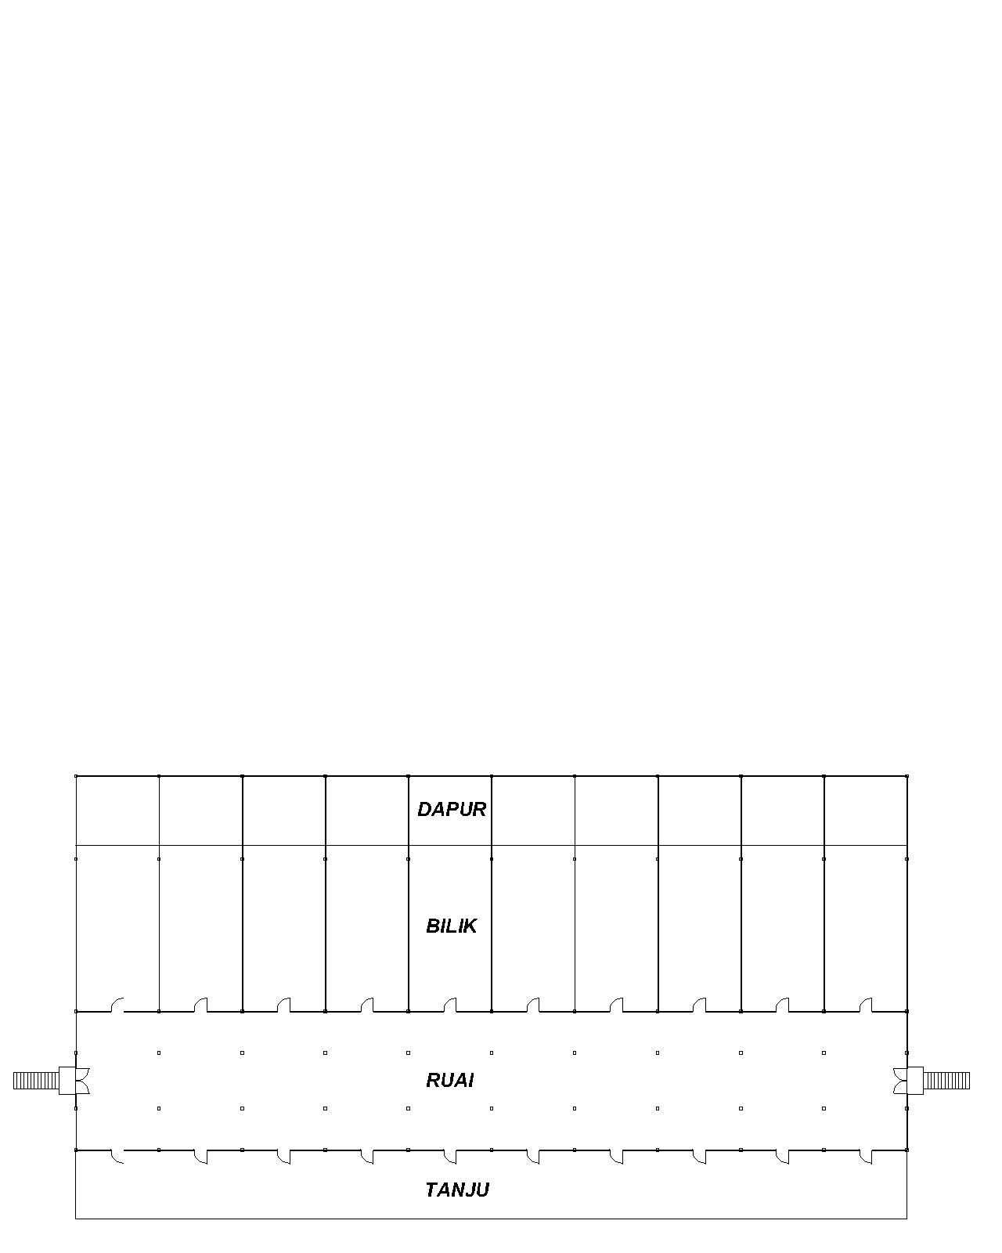
Source: Muhammad Oliver Ensor Silini, 2022

Figure 1. Typical floor plan of a traditional longhouse

In Sarawak, the support from the federal and state government in the construction of new longhouses through financial assistance has contributed to the continuity of the dwelling concept (Chang, 2006). There are no housing policies for communal dwellings in Sarawak. However, the Sarawak government has introduced the Longhouse Loan Programme (PPRP) to help ease the burden of residents in building their new longhouses. In 2022, the state government has approved RM50 million, set to benefit villagers of many longhouses across the state. Each door receives a loan of RM30,000 with residents only paying instalments as low as RM100 over a period of 25 years (Borneo Post, 2022). Some longhouses also receive fund aid from their local Member of Parliament (MP) and member of the Sarawak State Legislative Assembly (ADUN).
However, this does not necessarily mean that the longhouses remain authentic and the characteristics of the vernacular design and building material are maintained. Nowadays, the traditional longhouse is a threatened typology, which inevitably also diminishes traditional identity. Most longhouses have been transformed into a modern looking longhouse, adapting to a new modern design and built using bricks and concrete as the main building materials. These changes have led to the concern that someday the traditional communal vernacular longhouse might be lost together with the distinct identity of the Iban. The main concern here is on the implications of favouring “individual” dwellings over communal dwellings. If this trend persists, there is a likelihood that in the future, communal dwelling will be just part of history in Sarawak. This has actually happened to the Melanau ethnic groups who have totally abandoned their communal dwellings in favour of individual dwellings. The last communal dwelling standing in Kampung Sok, Matu was abandoned in 2018, resulting to the loss of local indigenous practices and knowledge in building construction and communal activities (Abdul Gapor et al., 2022). Vernacular dwelling in this context is not only restricted to Bernard Rudofsky’s “architecture without architect”. It also refers to building materials, building technology and the space and site planning that are in line with the authentic traditional Iban longhouses. Hence, the paper does not focus on analysing hybrid or new typology of vernacular Iban dwelling but comparing between communal and individual dwellings and how these two types affect the socio-cultural, socio-economic and religious practices of the dwellers.
This research explores the causes and effects of changes in the dwelling spatial layout of the Iban community in Sebuyau and Kapit. Previously, most study focused more on analysing the main spaces and the socio and anthropological functions of each space in the traditional Iban longhouses (Sim, 2010). Beynon (2013) studied the effects of modernity to Iban longhouse and how the Iban’s socio-culture managed to adapt to global changes. However, he only observed those who still live in the longhouse, without comparing to those who had moved into individual dwellings. Viviellenie et al. (2021) observed the passive design qualities of the traditional Iban longhouse and how it successfully adapted to bioclimatic factors. This paper differs because it examines the evolution of Iban longhouse through case studies, based on historical accounts, reasons for the changes and impacts of the changes.

Literature review

Architecture is associated to socio-culture, where the organization and form of a house is strongly influenced by the cultural background to the community. For example, architectural forms are based on the needs of the community such as for safety, privacy, culture, social activities and others. Rapoport (1969) referred vernacular dwelling as primitive buildings and acknowledged that they were built by primitive societies, which had a diffuse knowledge of everything by their own elementary technology. King (1980) also supported the close link between culture and buildings and settlements as social cultural products arising from the need to accommodate socio-cultural functions. Rapoport (1969) explained that the size, location, form and appearance of traditional dwellings were governed by socio-cultural factors like family and clan structure, religious, beliefs, social relationship, economic organization, symbolism, historical circumstances, and others. Meanwhile, a study by Van Nes (2022) found that spatial layout of the timber buildings of the traditional Norwegian farms was influenced by topological factors and the type of landscape where the farms were located. A study by Saad (1991) found that the influence of socio-cultural and religious elements on dwelling varies from one group to another. He also mentioned that current trends in dwelling forms were succumbing to the pressure exerted by Islam and Christianity upon traditional religious systems. Modern technology and new materials were making a tremendous mark on the forms of the house. Besides, the change from subsistence economy to cash economy also caused the changes of both social structure and house form.
Several previous studies had shown the implications of modernization on vernacular architecture. In Tehran, the traditional houses are mainly evacuated and abandoned by their residents who want to live in modern houses. The changing of their lifestyle was the main reason for the inefficiency of such houses to be inhabited (Islami et al., 2016). Changes of vernacular architecture due to modernization could distort traditional relations, rules and traditions (Stern, 2009) and also affected the social and cultural life of people (Syamir & Arayici, 2020). For example, changes in internal spaces especially marked by boundary and wall will lead to lack of socio-cultural activity within the buildings. Besides, the changes of the spatial layout are also problematic in terms of safety, functionality and aesthetics (Kuloğlu & Durmus, 2014). Traditionally, in Borneo, people lived in a house, which had a yard and small garden and with minimum furniture without having facilitative and entertaining utensils such as washing machine, television, fan and other household equipment. For example, in the context of the Dayak longhouse or known locally as Huma Bentang in Kalimantan, Indonesia, the yard is used for family gathering, social activities and for guest reception activity (Maria et al., 2012).
In contrast, modern lifestyle as represented by modern housing, people are facing dramatic changes with regards to internal design and changes in the arrangement and the position of furniture (Saeideh Feizi et al., 2013). In Malaysia, traditional houses or vernacular architecture were modernised due to the environmental, cultural, and historical context in which they lived (Soe Ryeung et al, 2012). In Kerala, the transformation of the traditional to modern architecture had led to the changes of local norms, landscaping style and the traditional residential form (Gini & Kulkarni, 2014). The needs of the extended family demanded separation of spaces between the nuclear families. Changes in lifestyle had led to a demand for bigger houses to accommodate modern facilities. Several spaces were combined for multi-use, such as the storeroom, where the grains and valuables are stored and the prayer room, were combined together. The roofing structure like the timber frame and the Mangalore tile were replaced with concrete because of the strength and large spanning capabilities of the new materials. The landscaping had changed to improve aesthetics rather than functional, whereby previously, the purpose of planting trees was to protect biodiversity, for consumption and for safety purposes.
There are two fundamental types of rural settlement patterns that are still relevant today, such as the grouped or clustered dwelling form and the dispersed form (Rubenstein, 1992). The first type consists of dwellings concentrated together with their farmland outlying their clustered dwellings or village. The Iban’s settlement is of the grouped or cluster type, with a compact building, rectangular floor plane and cuboid form. In terms of design, the longhouse has its own spatial layout that is influenced by their socio-culture. The spatial layout is also related to the structure and functions of the longhouse and has a positive impact on the residents’ environmental quality (Gehl, 2011). The buildings can affect the quality of spaces and well-being of the occupants living in the building. The structure, which is on stilt, reflects harmonisation with the local environment and climate conditions, which contributes to the comfort of the occupants (Siti Akhtar et al., 2017).
The designs of the longhouse typology are different between the ethnic groups, depending on the structure of the society and the geographical locations of the longhouse. Today, the settlements of the Iban community have changed from facing the river basins to roadsides due to economic opportunities and social factors. Ichikawa (2019) found that many Iban built their longhouses along the roadsides due to economic opportunities, infrastructure and utilities development. When roads are available, it is also easier for the government to provide treated water supply and electricity to rural and semi-urban areas. In addition, a study by Faridah, Anna and Spencer (2016) on the Orang Ulu in the Sungai Asap Resettlement scheme of Belaga, Sarawak, found that the changes of physical landscape due to development projects in the region had caused a scarcity in traditional construction materials, both in quantity and diversity. Besides affecting the making of traditional dwellings, these factors also affected the culture among the rural community, such as traditional craft-making activities, local knowledge, and other economic activities.

Method and study area

This research employs a qualitative approach through in-depth interviews, focus group discussion and observation. The observation focuses on the structure, arrangement, location, and size of the houses. A comparative study of spatial layouts was also done through sketch drawing based on the historical interview. A total of two Iban longhouses were selected for this study. The total population of the two longhouses is 630, with a total of 550 households (including bilik and individual dwellings). In Sebuyau there are 25 households, while in Kapit there are 101 households. These are Rumah Emperan Pisang in Kapit and Rumah Blawan Anak Busang, Kg. Jeragam in Sebuyau (Figure 1). These two longhouses were selected because of the different changes that they had experienced. The longhouse in Sebuyau maintains its authentic characteristics, however the one in Kapit has completely changed. In addition, the longhouses also have different geographical settings. The one in Kapit is located along a river, while the one in Sebuyau is located in a hilly interior site. For the in-depth interview, six respondents were interviewed, three each in Kapit and Sebuyau. For the focus group discussion 20 respondents were involved, ten each in Kapit and Sebuyau. Most of the issues observed were the history of the village, which had not been documented elsewhere and the longhouses in terms of their design and main characteristics of the original longhouses, evolution of the longhouses, issues related to safety, challenges in protecting the traditional longhouse design, and the impact of changes.
The statements from the interview were identified for clarity and each transcript was reviewed several times for verification. The interviews were conducted by the researchers with the help of student research assistants. It was written in the Iban language, the native language of the respondents. There are no issues on the reliability because most of the researchers and student research assistants are fluent in Iban. For the purposes of clarification and reducing the influence of the researcher’s biases, the transcripts were then translated to English. The data were analysed using thematic content analyses. The sketches, picture and spatial layout were analysed by identifying latent changes and implications to fire hazard and changes in socio-cultural and socio-economic practices.

Results and discussion

This section discusses the factors and effects of changes in the spatial layout of the two longhouses. Rumah Panjang Emperan Pisang is located in Kapit. It was chosen because of the physical dynamic changes that the longhouse experienced since 1988. The longhouse was founded by Tuai Rumah Tuan in the 1960s, an original wooden longhouse located along the Balleh River (Figure 2).

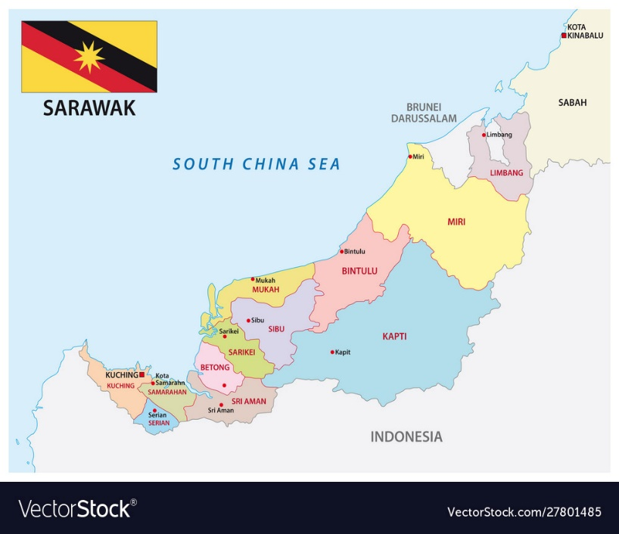
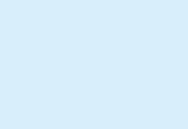
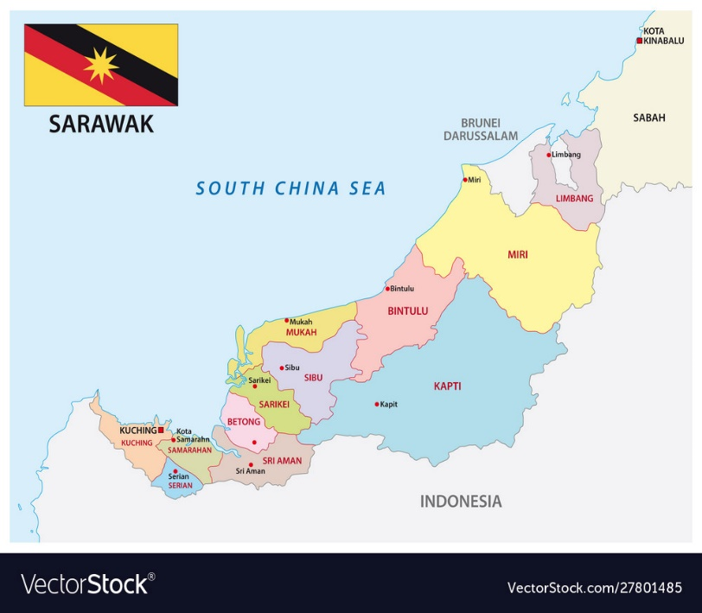
SEBUYAU
KAPIT

Figure 2. Sarawak map showing Kapit and Sebuyau

In August 1998, the longhouse was engulfed by fire, which resulted in the division of the original longhouse into three longhouses, under Tuai Rumah Gawan, Tuai Rumah Juin and Tuai Rumah Tuan. On 28 December 2006, the three longhouses collapsed due to landslide. It was suspected that causes of the landslide is related to logging activities around the area. From the period between 2006 until 2009, occupants of the three longhouses lived in a temporary shelter provided by a logging company, Shin Yang. In 2009, each of the household started to build new permanent houses after they have received compensation from Shin Yang (Figure 3). The compensation was between RM 12,000 to RM 80,000, depending on the loss of the households. In addition, Shin Yang also provided water supply. The three longhouses also received RM 2,000 per household from the Minister, YB James Masing. Starting 2010 until 2011, the households started to move to their new houses. The two events, fire and massive landslide have completely changed the physical layout of Emperan Pisang (Figure 4).
Figure 5 shows the spatial changes of Rumah Emperan Pisang as a result of the fire and landslide tragedies. In the 1960s the shape was a typical Iban longhouse, with a linear, cuboid form and spatial organisation that represented the public, semiprivate and private spaces, represented by the tanju, ruai and bilik respectively. As time moved on, the longhouses were divided into three due to space and topographic constraint, making them shorter. By 2020, the whole spatial organisation had changed with a mixture of individual and communal dwellings. This is due to affordability, which is also related to the amount of compensation received by each household and the location of individual land to ensure easy access to their farmlands.

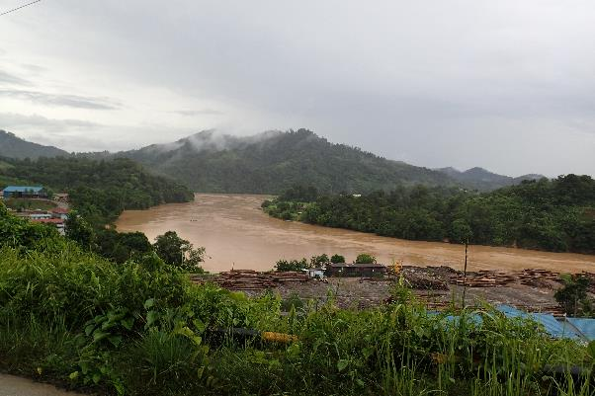  Source: Haris Fadzilah Abdul Rahman, 2021  Figure 3. Setting of Rumah Emperan Pisang along Balleh River, Kapit | 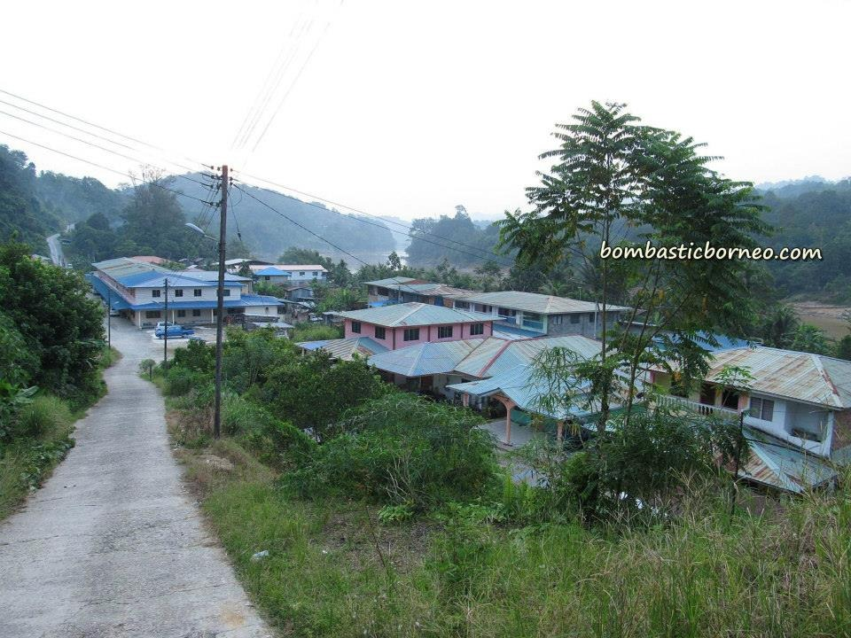  Source: Bormbastic Borneo.com  Figure 4. The new modern longhouse design at Rumah Tuan Emperan Pisang, Kapit

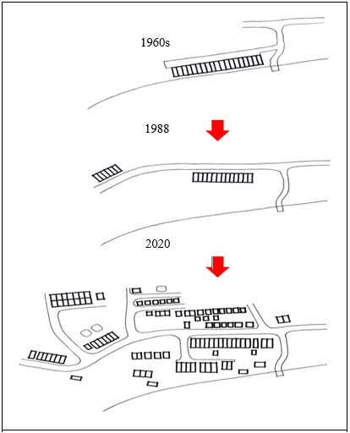
Source: Haris Fadzilah Abdul Rahman, 2021

Figure 5. Spatial Layout Evolution of the longhouse in Kapit
Rumah Blawan Anak Busang, Kg. Jeragam is located in Sebuyau. The first Tuai rumah was Tuai Rumah Umam. It is one of the oldest longhouses in this district, and perhaps in Sarawak as well. It is made of timber and most of the structures and building materials are still original, except for minor modification due to repair and maintenance (Figure 6 & 7). The longhouse is located on a hill, surrounded with fruit orchards and farms (Figure 8). The longhouse has been a favourite destination for both local and foreign tourists, such as from South Korea due to its authentic design.

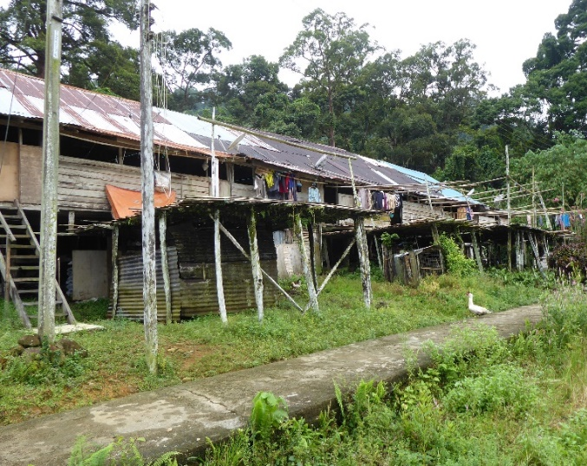  Source: Muhammad Oliver Ensor Silini, 2021  Figure 6. Exterior view of the original longhouse in Sebuyau | 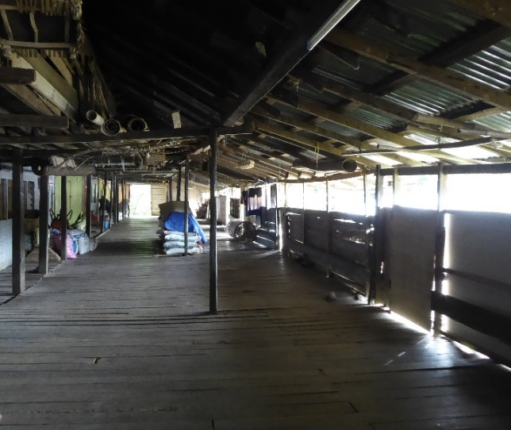  Source: Muhammad Oliver Ensor Silini, 2021  Figure 7. View of ruai in the original longhouse in Sebuyau

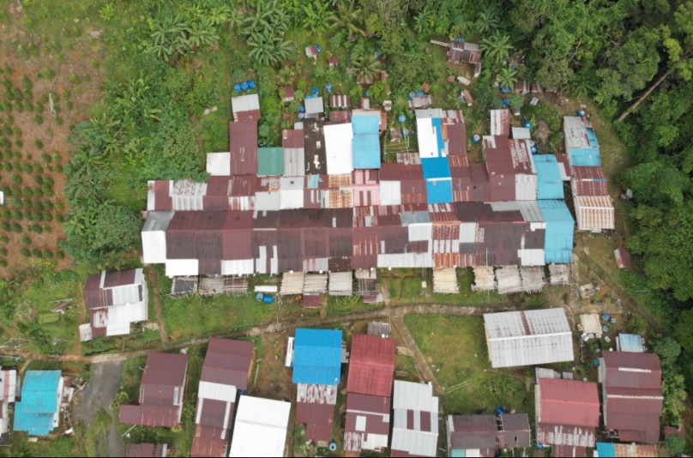
Source: Muhammad Oliver Ensor Silini, 2021

Figure 8. Current Spatial Layout in Sebuyau

In the 1950s, the longhouse was a typical Iban longhouse. Major changes happened in the 1980s, whereby the longhouse was extended, as indicated by the expansion of floor areas of each household to the rear part of the longhouses. By 2020, the households could no longer expand to the rear, left nor right sides of the longhouse due to topographical and building material constraints. As a result, the extended families had no other choice but to expand on the open sloping site in front of the longhouse. The houses are no longer built as a typical communal longhouse but as individual houses in a sporadic layout, although still in cluster (Figure 9).
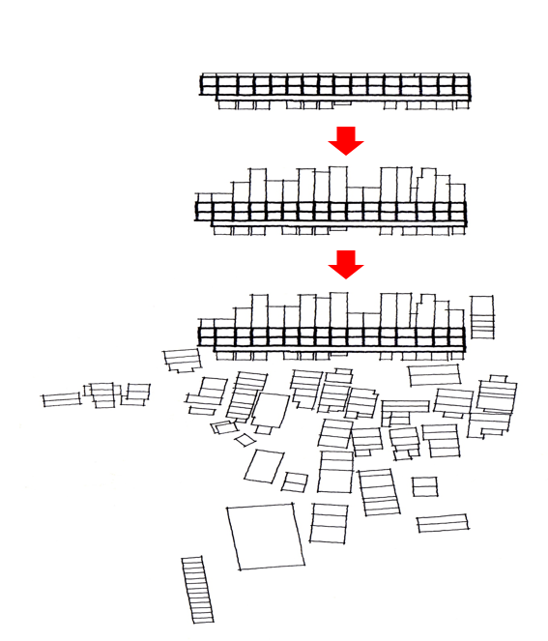
1950s
1980ss
2020
Source: Haris Fadzilah Abdul Rahman, 2021

Figure 9. Spatial Layout Evolution of the longhouse in Kampung Jeragam, Sebuyau

The factors that caused changes in the spatial layout of the dwellings

The changes in the spatial layout of the two longhouses were due to increasing number of household members, difficulty to access traditional building materials, especially timber, natural and fire hazard and characteristics of site topography that posed difficulty to maintain a linear extension of households.

- Increasing number of household members

The increasing number of households led to the increase in demand of a new bilik for the new family. Bilik refers here to the separate household representing a separate family unit. This has led to the extension of the current number of bilik in both longhouses. Several head of households have opted to extend their house towards the rear part of the current longhouse, to accommodate extended family members, as can be seen in Sebuyau in the 1980s. However, many new families choose to live separately from their parent or in-laws. The trend is also similar in Rumah Panjang Emperan Pisang, Kapit, instead of building a new longhouse they are building individual houses. Their decision to build individual houses are for privacy and also to be nearer to their respective lands, hence, facilitating them to tend their orchards, farms and livestock. In addition, when building separately, it is easier for them to decide on the design, materials and cost of the building, which again is influenced by the amount of compensated money that they have received from the logging company (Figure 10). Furthermore, any communal gatherings can still be done at the longhouses that still maintain the “ruai”. Alternatively, most social gatherings now are also conducted in the community hall provided by the government and churches, as most of them, especially the new generation have converted to Christians.
- Difficulty to access traditional building materials

Another reason for not able to extend the new bilik from either left or right sides of the traditional longhouse is the difficulty to access traditional building materials like timber. This was the case in Sebuyau. The Tuai Rumah also emphasises that, if a new household is interested to build a new bilik by connecting with the old longhouse, the new household is required to follow the current typology and materials. The rational is to maintain the original design of the old longhouse. Hence, most new families prefer to opt building separate houses in front of the original longhouse. In Kapit, there was no longer a need to build by extending to the original longhouse because it was already destroyed by fire and a landslide. Hence, new generation do not have any reference of the old longhouse and choose to design their new houses according to their own personal taste. In addition, it is more convenient to buy building materials like brick, concrete, glass, plywood, zinc, and etc., which are readily available in the market and much cheaper compared to timber. The preparation of traditional materials takes a longer time. Another problem is to find experience artisanal builders to meet the requirement from the committee of the old longhouse for the case of Sebuyau. Similarly, for Kapit, there is no longer a reference of the traditional longhouse design, as well as absence of artisanal builders that have the indigenous knowledge to build using timber and the traditional techniques such as mortise and tenon. Figure 10 and figure 11 shows the new houses built using modern materials in Sebuyau and Kapit.

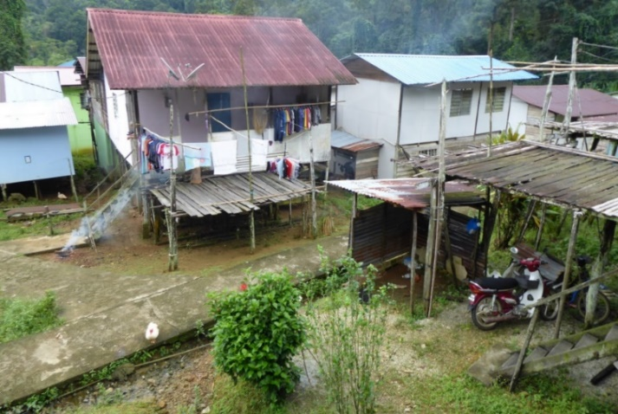  Source: Muhammad Oliver Ensor Silini, 2021  Figure 10. New Individual Houses Built in front of the Old Longhouse in Sebuyau | 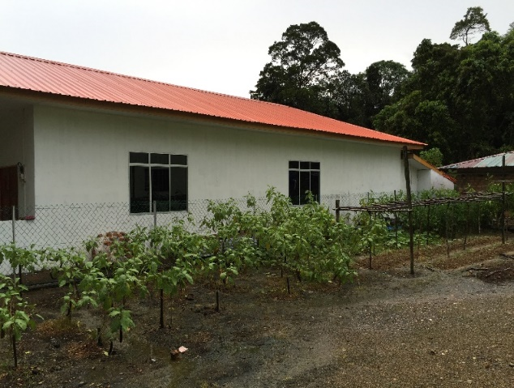  Source: Haris Fadzilah Abdul Rahman, 2021  Figure 11. New Modern Individual House Built in Rumah Panjang Emperan in Kapit

- Natural and fire hazard

The spatial organisation of Rumah Panjang Emperan Pisang changed due to fire and landslide hazards. In August 1998, the longhouse was engulfed by fire, which resulted in the division of the original longhouse into three longhouses while in December 2006, the three longhouses collapsed due to landslide. These two events have resulted to the total transformation of the previously compact and grouped spatial organisation to a looser and more sporadic organisation. By 2011, two events, fire and massive landslide have completely changed the physical layout of Rumah Panjang Emperan Pisang in Kapit. Although there is no historical case of fire in Sebuyau but from observation, there are many potential fire hazards elements. Firstly, the longhouse in Sebuyau is still maintaining wood as materials for the main structure, wall and floor.
The woods is not treated with fire retardants making them low level fire resistance, hence the issue of the building materials, which potentially contribute to fire hazard has also changed the perception of using traditional material for the new dwellings. The preference of using modern material for the new dwellings, which was not consistent with the old longhouse, has forced the new units to be separated. The typology of the traditional longhouse, which is elongated and individual bilik separated by minimal means of partition wall may also contribute to rapid fire spread. Figure 12 shows a bilik in the old longhouse in Sebuyau, which is separated using timber plank and plywood. The materials used will not be efficient to contain fire from spreading throughout the whole longhouse. Having separated individual dwelling units will lower the risk of rapid fire spread between units.
The traditional longhouse has only two main entrances and exit, which are located at the end of each side of the ruai as shown in Figure 13. The travel distance to the means of escape from the bilik will be too far for the longhouse with many connected units. There will be a risk for the occupants to safely escape from the spreading fire. In contrast, a new separated individual house has a direct escape from their own unit.

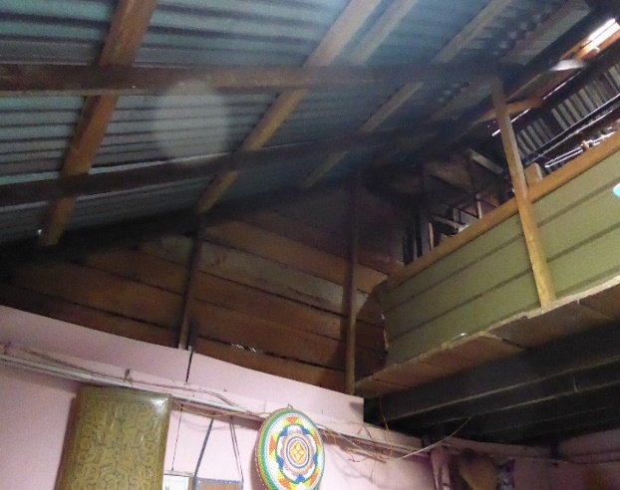  Source: Muhammad Oliver Ensor Silini, 2021  Figure 12. Timber plank and plywood used as partition wall in the Old Longhouse in Sebuyau | 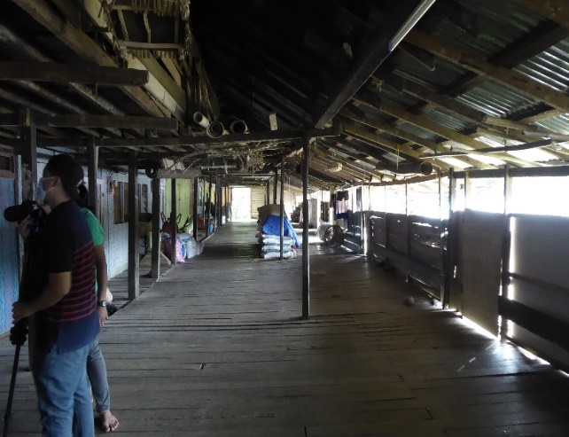  Source: Muhammad Oliver Ensor Silini, 2021  Figure 13. The main entrance and exit located at the end of a ruai in the Old Longhouse in Sebuyau

The longhouse in Sebuyau is located uphill with limited access for fire appliances. The only access which is available in front of the longhouse is narrow and not sufficient for access as shown in Figure 14. This will pose a high risk of complete loss in the event of fire. The separate dwellings will have a lower risk of fire spreading to the rest of the dwellings, provided that the setbacks between the houses are sufficient.

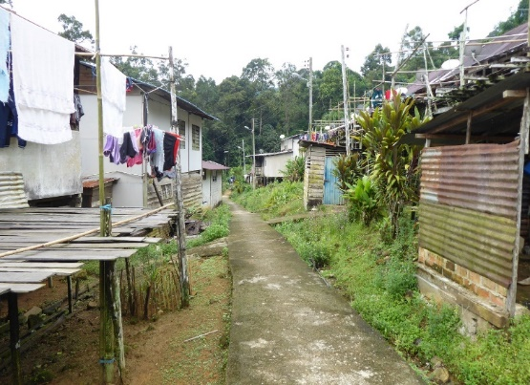
Source: Muhammad Oliver, 2021

Figure 14. The narrow access in front of the Old Longhouse in Sebuyau
Another factor that can be a potential fire hazard in the old longhouse is the use of aging electrical wiring and unsafe usage of electrical appliances. In contrast, the new dwellings, which were built separate from the old longhouses have new and proper wiring installed by a certified electrician.

- Topographical constraints

Topographical constraints refer to the physical conditions of the land where the longhouses are located. In Sebuyau the back part of the longhouse is hilly and quite steep, thus limiting the option to build new houses. This leaves only the front part of the original longhouse as an option, which is slightly sloppy but still a manageable site (Figure 4). Most of them prefer to build individual houses now, instead of a longhouse. In Kapit, as the longhouse moves further from Balleh River, it is more difficult to build in a linear group design, similar to the original one. It is easier to build a longhouse on flat land along the riverbank. Hence, these topographical changes also contribute to the more sporadic spatial organisation of the dwellings. There is no doubt that physical factors are one of the most influential elements affecting the formation of their new dwellings.

The effects of the changes in the spatial layout of Iban dwelling

The changes in spatial layout have affected the socio-cultural aspects of the community. These include loss of traditional architectural design, loss of traditional architectural knowledge, method and skills, and loss of some of the traditional culture and identity.

- Loss of traditional architectural design

The traditional design of the old longhouse in Sebuyau is shaped strongly by culture, safety, weather, and geographical location. However, the design of the new individual houses is shaped mainly for basic shelter. The architectural elements that are loss as a result of these changes include the distinct division between the public space as represented by the tanju and the semi-public space as represented by the ruai. Other architectural elements loss are the rustic and authentic effects from the timber materials. The new houses built in Emperan Pisang, Kapit for example are no longer built on stilt. The changes in the structure also completely change the traditional vernacular identity of the longhouse. To a certain extent the new longhouse now resembles more of a terrace house that is typical in urban housing. This also applies to the roof of the new houses; the typical pitch roof is no longer common, since several of the new houses even opt for a flat roof or even a hipped roof resembling the Malay roof design.

- Loss of traditional architectural knowledge, method and skills

The traditional architectural knowledge, method and skills in the construction of the traditional longhouse will be completely lost in the future due to the changes of the design and materials of the new houses. In both case studies, there are no artisanal builders who are experts in the traditional jointing methods without using nails, i.e. the traditional mortise and tenon methods. In addition, knowledge of selecting good timber, traditional treatment methods and construction are also lost with the declining practice. Many social taboos and local customs that are associated with traditional construction will also be lost.

- Loss of traditional culture and identity

Based on the respondents in Sebuyau, the construction of the old longhouse is usually initiated by the ritual ceremony, such as miring and also referring to social taboos related to their immediate environmental factors such as the sound and appearance of birds and dreams. However, these practices were no longer implemented by the new generation in the construction of the new house. In the context of the traditional culture related to the space layout of the traditional longhouse, the ruai is an important space for social activities such as entertaining visitors, meetings and celebrating festival such as Gawai Dayak (the harvest festival). It is also used daily as a gathering spot for evening conversation to enhance social cohesion and solidarity between the households. Figure 15 and 17 shows the difference between a traditional and a modern ruai. The modern ruai despite still maintaining its function is much shorter compared to the traditional ruai.

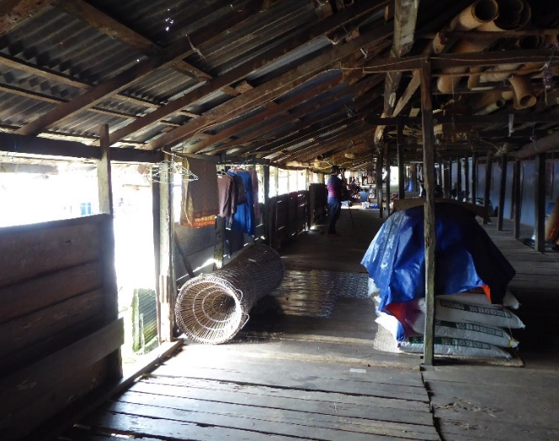  Source: Muhammad Oliver, 2021  Figure 15. Traditional Ruai used to store goods and agricultural materials in Sebuyau | 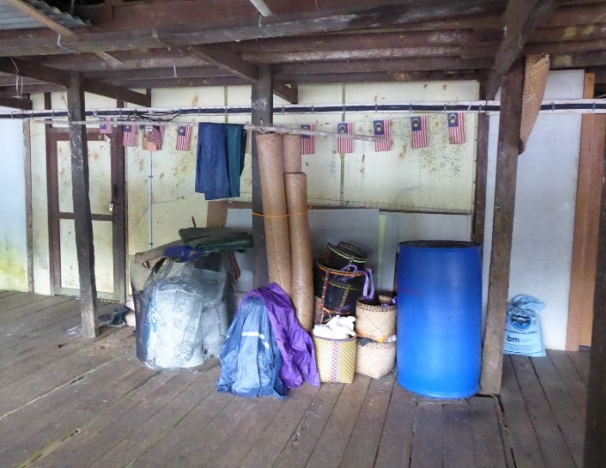  Source: Muhammad Oliver, 2021  Figure 16. Traditional Ruai used to store handicrafts in Sebuyau

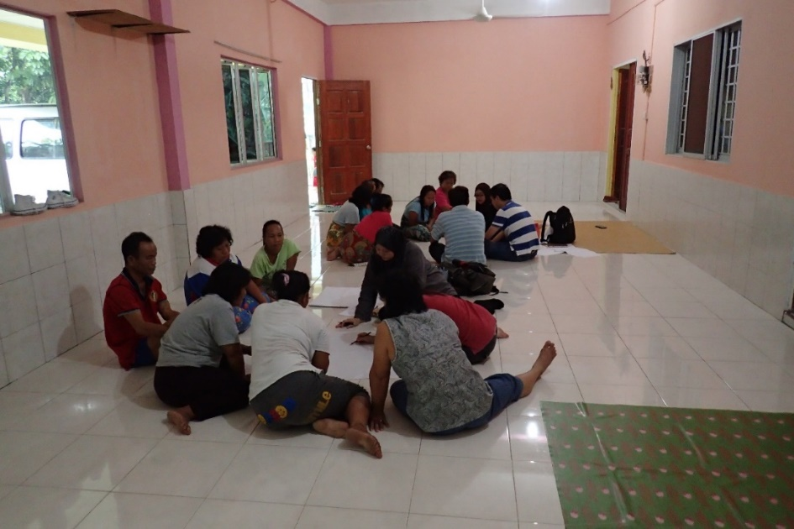
Source: Haris Fadzilah Abdul Rahman, 2021

Figure 17. Modern Ruai in Kapit
Besides, there is no tanju built for the new house. Traditionally, the tanju was used as drying areas, especially for agricultural products like paddy, and rattan. With the changes in employment, the function of tanju has changed as part of the utility areas to dry clothes, to park cars and motorcycles or to hold an outdoor barbeque activity. With the changes in employment, especially among the younger generation, as more are now employed in either the public or privates’ sectors, other additional structures associated with the longhouse has also lost, such as the granaries.

Conclusion

The changes of the spatial layout of the Iban’s dwelling have led to dramatic effects to the Iban vernacular architecture, culture and identity. The changes in the spatial layout of the two longhouses were due to increasing number of household members, difficulty to access traditional building materials, especially timber, natural and fire hazard and characteristics of site topography that posed difficulty to maintain a linear extension for new households. The changes in spatial layout have affected the socio-cultural aspects of the community. These include loss of traditional architectural design, loss of traditional architectural knowledge, method and skills and loss of some of the traditional culture and identity. The effort by the tuai rumah in Sebuyau to make sure that his residents follow the original typology of their longhouse can be seen as a good example in conserving the heritage value of the longhouse, although in the end many opt to build separate individual houses. The declining number of traditional artisan builders will affect the effort to sustain the traditional vernacular longhouse. Potential further research includes examining the different psychological impacts of living in a traditional longhouse compared to modern individual house and to expand the case studies in other areas and ethnic groups.

Acknowledgements

The authors would like to thank UCTS for funding the research under the UCTS Research Grant “Assessing the Compliance with the Uniform Building by Laws (UBBL 1984) on Longhouses in Sarawak” (1/2018/02).

References

Ansari, H. (2004). Pluralism in Iranian modern architecture. The Journal of Architecture and Civil Science, 20, 10-14.
Abdul Gapor, S & Moriat, Rahmat & Abdul Rahman, Haris Fadzilah & Saruan, Muhammad. (2022). Physical Evolution of the Last Melanau Communal Dwelling in Kampung Sok, Matu, Sarawak, Malaysia. International Journal of Environment, Architecture, and Societies, 2(1), 55-72. DOI: 10.26418/ijeas.2022.2.1.55-72.
Beynon, D. (2013). The Contemporary Iban Longhouse: The Sustenance and Applicability of a Socio-spatial Culture. The International Journal of Social Sustainability in Economic, Social and Cultural Context, 9(1), 1-18.
Borneo Post. (2022). Longhouse Loan Scheme benefits 51 households in Selangau. https://www.theborneopost.com/2022/10/07/longhouse-loan-scheme-benefits-51-family-units-in-selangau/
Chang. (2006). History of Iban Settlements around Kuching City Sarawak. The Sarawak Press Sdn Bhd, Kuching.
Faridah, S., Anna, D., & Spencer, E.S. (2016). Cabaran dan peranan pembuat kraf dalam pelestarian budaya benda masyarakat Orang Ulu di Belaga Sarawak [Craftmakers’ challenges and roles in sustaining material culture among the Orang Ulu in Belaga Sarawak]. Borneo Research Journal, 10, 111-126. https://borneojournal.um.edu.my/ index.php/BRJ/article/view/9856
Gehl, J. (2011). Life between buildings: Using public space. Island Press.
Gini G., & S.Y. Kulkarni. (2014). The Impact of Socio-Cultural Factors on the Transformation of the Residential Architecture of Kerala. International Journal of Research (IJR), 1(5), 526-530. https://1library.net/document/q01k5kgz-impact-socio-cultural-factors-transformation-residential-architecture-kerala.html
King, A.D. (1980). Buildings and Society: Essays on the Social Developoment of the Built Environment. Routledge & Kegan Paul, London.
Kuloğlu, Nilgün & Durmus Ozturk, Serap. (2014). The Trace of Change: Traditional House. Proceedings of the 2nd ICAUD International Conference in Architecture and Urban Design Epoka University, Tirana, Albania, 285, 08-10.
Maria, H. I., & Chandra, J. (2012). Tirta Dharma Weaving House, is representation from Huma Betang in West Kalimantan, Indonesia. as an architectural respond the present challenges. Proceeding of Conference: 6th International Seminar on Vernacular Settlements, Contemporary Vernaculars: Places, Processes and Manifestations, Famagusta, North Cyprus, 6.
Ichikawa, Masahiro. (2019). Immigration and adaptation of the Iban from rural to urban outskirts in Sarawak, Malaysia. Tropics, 28, 39-48. 10.3759/tropics.MS18-14.
Islami, S.Gh., Dehghan, D., & Sadeghi Naeini, H. (2016). A Model Development to Adaptive Reuse of Iranian Qajar Houses: An Approach to Sociocultural Concept (A Case: Nasir Al-Din Mirza House). American Journal of Civil Engineering and Architecture, 4(3), 84-89. doi: 10.12691/ajcea-4-3-3
Rapoport, A. (1969). House form and culture. Englewood, N J, 1, Cliffs: Prentice-Hall.
Rubenstein, H. (1992). Migration. Development and Remittances in Rural Mexico. International Migration, 30(2), 1992.
Saad, H. T. (1991). Folk culture and architecture in North Eastern Nigeria. Paideuma: Mitteilungen zur Kulturkunde, 37, 253-289.
Saeideh Feizi Azarshahr, Alireza Motamadniya, Mostafa Basiri. (2013). New Technologies in Modern Architecture and its Interaction with Traditional Architecture. Res. J. Chem. Env. Sci., 1(3), 70-80.
Sarawak Map, Available at: https://www.vectorstock.com/royalty-free-vector/administrative-map-sarawak-malaysia-vector-27801485
Seo Ryeung Ju, Saari Omar & Young Eun Ko. (2012). Modernization of the Vernacular Malay House In Kampong Bharu, Kuala Lumpur, Journal of Asian Architecture and Building Engineering, 11(1), 95-102. DOI: 10.3130/jaabe.11.95
Sim, S. (2010). Redefining the Vernacular in the Hybrid Architecture of Malaysia. (Master dissertation). Retrieved from Victoria University of Wellington.
Siti, Akhtar. M., Wan, A. Z. W. Z., Siti Norlizaiha, H., & Balkhiz, I. (2017). Assessment of Building Typology and Construction Method of Traditional Longhouse. Procedia Engineering, 180, 1015-1023.
Stern, R (2009). The Doubles of Post-Modern. In R.M.A., Stern & C. Davidson (Eds.), Architecture on the Edge of Postmodernism: Collected Essay 1964-1988. Yale University Press, Yale.
Syamir, Hamed, & Arayici, Yusuf. (2020). The Influence of Modern Architecture in Transforming Iraqi City Identity. Proceeding in the 2th International Postgraduate Research Conference (IPGRC 2015), 10-12, Salford Quays.
Ting, J. (2005). The Egalitarian Architecture of the Iban Longhouse. In, A., Leach & G., Matthewson (Eds.). Celebration. Proceedings of the 22nd. Annual Conference of the Society of Architectural Historians, Australia and New Zealand. Napier, New Zealand (SAHANZ).
N. Viviellenie, B. Azhaili, AB. Ruzanah, Hashim Awang, & Imran Ali. (2021). Passive Building Design Approach in Iban Long Houses. International Journal of Applied Science and Research, 4(6), 56-63.
Van Nes, A. (2022). Phenotypes and Genotypes of traditional Norwegian wooden farms. Proceedings of the 13th Space Syntax Symposium, 1-21.

