Analyzing of global mapping research trends on firefly tourism and fireflies (Coleoptera: Lampyridae) from the year 2000 – 2022: A literature review and bibliometric analysis

Muhammad Fakruhayat Ab Rashid

Geoinformatic Unit, Geography Section, School of Humanities, Universiti Sains Malaysia, 11800 USM, Pulau Pinang, Malaysia

Correspondence: Muhammad Fakruhayat Ab Rashid (email: muhammadfakruhayat97@gmail.com)

Received: 5 October 2022; Accepted: 11 February 2023; Published: 24 February 2023

Abstract

Fireflies are very attractive insects that have obtained a lot of attention from nature tourists in recent years and firefly tourism has the potential to bring in a lot of income for local communities, states, regions, and even countries. Therefore, this study presents a literature review and bibliometric analysis of firefly tourism and fireflies Coleoptera Lampyridae research around the world from 2000 to 2022 to provide researchers and scholars around the world with a visualization or analyzing of the global mapping research trends results using RStudio 4.2.0 and Biblioshiny. A textual query on two databases; Scopus (643 articles), and Web of Science (78 articles) was performed on 12 June 2022 retrieving 721 scholarly articles from 2000 to 2022 for in-depth analysis. According to the findings of the analysis, there is a significant inconsistency of global trends in annual scientific production, with the number of publications increasing and decreasing. The United States of America (USA) has the highest number of scientific productions, as the most relevant author is Viviani VR (Scopus) and Lewis SM in Web of Science (WoS) database, while the most relevant journal is Zootaxa in Scopus and Web of Science database, and the most frequent word is “bioluminescence” in Scopus database but the word “Lampyridae” is the most used word in the Web of Science database. USA with Japan and China have the highest collaboration among other countries in this field of research topic.

Keywords: Bibliometric analysis, Biblioshiny, fireflies, Lampyridae, RStudio, tourism

Introduction

Tourism-based development has a significant impact on various aspects of the local community, particularly in terms of socioeconomic issues. Tourism has developed significantly in most countries throughout the world and has become a major sector (Habibi, 2017; Mastura et al., 2015; Norlida et al., 2011). The tourism industry plays an important role in a country’s development by encouraging foreign exchange activities, creating investment opportunities, generating business opportunities, contributing to job creation, infrastructure development, and creating multiplier effects that impacts a country’s economic development (Noor et al., 2019; Ernawati et al., 2018; Zhang, & Gao, 2016; Andraz, 2015; McCombes, 2015). Apart from contributing to the country’s economic growth, tourism sector development may also contribute to the advancement of political, socio-cultural, community development, environmental, and living lifestyle (Habibi, 2017; Nunkoo & Gursoy, 2012; Aref, 2010). To make progress in the development of the tourism industry, the quality of infrastructure, amenities, and the diversity of tourism products must be upgraded. An effective strategy for this is to fulfill the unique desire and needs of tourists, particularly those interested in nature tourism.
Nature-based tourism that incorporates insects is referred to as “entomological ecotourism” or “entomotourism”. Ecotourism or entomotourism of fireflies initiatives have been a backbone to Malaysia’s tourism industry for decades. Insect like fireflies-related ecotourism is a one kind of nature-based tourism. This ecotourism has used insects as a product to attract people who is interested in seeing the natural beauty of insects or having them as souvenirs (Lewis, 2016; Woon, 2003). Fireflies insects with variable size, shape, and colour have the potential to become a new tourist attraction due to their physical characteristics (Maryati et al., 2013; Woon, 2003). Fireflies ecotourism activities have become one of the products that promotes the growth of socioeconomic development in ecotourism areas. Habitats of fireflies are usually on berembang trees or crabapple mangrove (Sonneritia caseolaris) as they are comfortable in humid weather conditions and swampy environments in order to live and breed.
In Malaysia, there are several firefly ecotourism areas such as Penang, Perak, Selangor, Negeri Sembilan, Melaka, Pahang, Terengganu, Kelantan, Johor, Sabah and Sarawak. However, the most popular location for firefly watching is along the Selangor River near Kuala Selangor (Kirton & Nada, 2010). From 2011 to 2016, 473,761 tourists visited the Firefly Park in Kampung Kuantan, contributing over RM6 million to the state’s economy (Kuala Selangor District Council, 2017). Tourists visiting Japan, Malaysia, Mexico, Thailand, and the United States’ Great Smoky Mountains National Park have had several opportunities to engage with these firefly beetles (Frierson-Faust, 2017; Manning et al., 2017). Despite a decreasing firefly population, global interest in firefly habitats has risen. According to Shahwahid et al. (2013), the number of firefly visitors in Malaysia grew from 24,000 to 40,000 between 1995 and 2010.
Fireflies are considered to be among the most charismatic insects on earth because of their spectacular bioluminescent displays (Owens et al., 2021; Lewis, 2016; Ohba, 2004). There are approximately 2,200 species of fireflies, which belong to the family Lampyridae and can be found all over the world (Martin et al., 2019). Firefly tourism has the opportunity to generate economic benefits at several levels, including local communities, states, countries, and regions, in the form of employment and income. Observing fireflies is a once-in-a-lifetime experience, especially for urban residents who do not spend much time outdoors. In many cultures and ways of living, fireflies evoke pleasant childhood memories associated with rural life (Haugan, 2019; Lewis, 2016). Visitors frequently express transforming sensations of joy and even spiritual wonder in reaction to the luminous landscapes that they experience at firefly areas (Schreiber, 2017; Lewis, 2016). Firefly encounters may have a long-term and widespread therapeutic consequences, including improved mental health and wellbeing, as well as more positive attitudes toward biodiversity conservation (Buckley et al., 2019). In other words, these fascinating insects serve as attractive tourism product for invertebrate biodiversity conservation and charitable conservation activities.
Hence, the purpose of this work is to analyze the visualization, trends and status of global research mapping on firefly tourism and fireflies Coleoptera Lampyridae from the year 2000 to 2022 using bibliometric analysis and providing a literature review of firefly tourism. This analysis can assist in updating the current status, progress of firefly tourism and fireflies Coleoptera Lampyridae research. This study can also assist researchers or academics who are new to fireflies research by showing information on which publications and authors to refer while conducting fireflies research.

Literature review

In Malay, fireflies (Lampyridae) popularly known as “Kelip-kelip”, “Api-api” or “Kunang-kunang” are part of the largest order of Coleoptera, from the family of Lampyridae beetle (Lewis, 2016; Rahayu, 2007). In English, fireflies are also known as lightning bugs and glow worms. There are four genera of fireflies belonging to the family Lampyridae: Pteroptyx, Luciola, Colopthia, and Lychnuris (Nada & Kirton, 2004). However, Pteroptyx tener Olivier is the scientific name for fireflies (Nada & Kirton, 2004). Like caterpillars that transform into butterflies, fireflies begin as larvae called glow worms. Luminous worms usually live on dead leaves and on plants in humid environments. The larvae eat snails, worms, and other invertebrates (Jusoh et al., 2018; Nada et al., 2012; Jusoh et al., 2010). These insects are known as firefly due to their distinctive ability to emit flashes of light. According to research, there are between 1,900 to 2,000 species of firefly in the world (Lewis et al., 2020).
There are approximately around 120 to 125 recognised species found across North America (Frierson-Faust, 2017; J. Lloyd, 2008), including three species of firefly found in the Nanacamilpa area, Macrolampis X, Macrolampis chapinguensis, and Macrolampis palaciosi (Zaragoza-Caballero, 2012). However, a number of firefly species found across in Mexico have yet to be recognised and reported (Vance & Rios Kuri, 2017). Malaysia has recorded a total of 13 species of Pteroptyx, whereas Peninsular Malaysia has reported a total of 9 species of Pteroptyx that are highly concentrated and inhabit the mangrove vegetation region (Norela et al., 2017; Shahara et al., 2017 Norela et al., 2016).
The fireflies are less active during the day and prefer to rest beneath the leaves of the berembang tree (Sonneratia caseolaris) (Jusoh et al., 2018; Shahara et al., 2017; Sulaiman et al., 2017). This might be impacted by environmental circumstances and unpleasant weather for active firefly during the day, as opposed to at night. Meanwhile, numerous firefly larvaes inhabit at the base of tree roots region, particularly those of mangrove trees (Riza et al., 2017). Populations of fireflies are especially sensitive to the destruction of their habitats, as well as fluctuations in water tables and pollution.
Firefly tourism has grown to become one of the most well-known products of ecotourism all around the world since it was first implemented in 1980 (Mahadimenakbar & Saikim, 2016; Gray & Campbell 2007; Syed et al., 2001). Firefly ecotourism activities such as watching fireflies may be separated into two categories: far away by watching and monitoring the flight route and light patterns of fireflies’ bodies, and at close range to distinguish the type and sex by investigating the body segments of fireflies (Observing Fireflies, 2021). When watching fireflies, avoid using flashlight or bright lights in their environment since fireflies require light to communicate. A light’s intense can disrupt their communication and habit, causing the fireflies to run. If the surrounding is dark, we can use a red flashlight to find the way to their habitat. However, when the fireflies are visible, the red lamp should be switched off so that the environment darkens and allows for a better sight (Observing Fireflies, 2021). The activity of watching fireflies is also considered important since it may generate incomes and contribute to the local economy (Arthur Y.C. Chung, 2021). This is due to the uniqueness of fireflies, which is a tourist attraction.
Fireflies are commercially significant in many countries because they play a role as a developing ecotourism attraction (Lewis et al., 2020). However, fireflies like many other invertebrates, have received little attention in worldwide conservation efforts (Napompeth, 2009). In certain regions, fireflies provide a new experience in the products of an ecotourism activity that attracts a large number of people to a specific location to watch fireflies in their natural environment. This phenomenon has only been reported in South Asia and the Western Pacific, stretching from East India through Thailand, Malaysia, and Indonesia to the Philippines and Papua New Guinea (Hogarth, 1999). Fireflies ecotourism based has grown quite popular, which led to a significant number of tourists (Nallakumar, 2003). The tourism business has profited from the synchronised fireflies, and local fishermen and communities have seen an increase in their income. Communities in the area have worked together to make firefly ecotourism centres, and some of these centres provide tours that focus on watching fireflies. The average amount of money that boat operators and tour guides make each month is between RM 400 and RM 600 (Jaafar et al., 2010). The income generated by these activities provides additional money to local communities, assisting in the improvement of the villages’ financial situation and quality of life (Shahwahid et al., 2016, 2013; Jamil and Suzana, 2004). Local communities participate in ecotourism activities with full support from the local governments, who provide infrastructure such as jettys and boats for tourists to use. As a consequence, it is of highest concern for us to preserve and restore firefly habitats (Basyuni et al., 2018; Foo and Dawood, 2015). The importance of protecting these fireflies has led to an increase in firefly watching as a tourism activity in mangrove management plans.
Lampyridae is a family of fireflies that is found all over the world. It has eight subfamilies, 100 genera, and more than 2,000 species that found in tropical regions across the world (Hu & Fu, 2018; Shahara et al., 2017; Mu et al., 2016; Da Silveira & Mermudes, 2014). There are numerous species of fireflies, and they are widespread in tropical countries such as Thailand, Malaysia, Cambodia, Indonesia, the Philippines, New Guinea, and Sulawesi (Jusoh et al., 2018; Sartsanga et al., 2018; Ballantyne & Lambkin, 2001; Ballantyne & McLean, 1970). Over 400 species have been discovered in Southeast Asia and the Indo-Pacific region, with the most of fireflies species belonging to the Luciolinae family (Ballantyne et al., 2015). The most well-known firefly in Southeast Asia are Pteroptyx, which belong to the Coleoptera order and Lampyridae family (Seri & Rahman; 2021). Seri and Rahman (2021) were able to identify 145 species of fireflies in Southeast Asian countries such as Malaysia, the Philippines, Indonesia, Cambodia, Myanmar, Singapore, Sri Lanka, Papua New Guinea, Laos, Thailand, and Vietnam. Malaysian and Thailand researchers have conducted the most studies on fireflies in the Southeast Asian region compared to other Southeast Asian countries. P. malaccae, Luciola pupilla, and P. tener are the most common firefly species in Southeast Asian countries, such as Malaysia, Thailand, Indonesia, Vietnam, and the Philippines (Abdul Razak & Sulaiman, 2016). Figure 1 illustrates the lifecycle of the P. tener species as shown by Cheng et al. (2021).

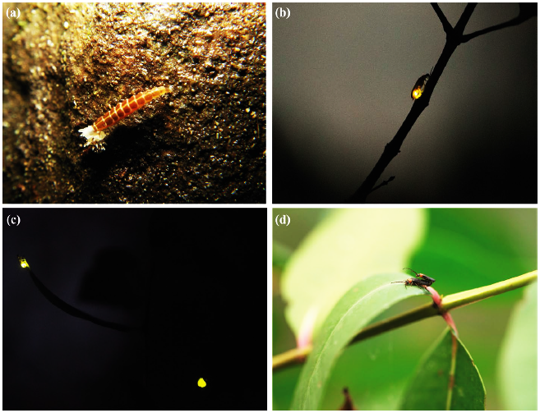
Source: Cheng et al., 2021
Figure 1. (a) Pteroptyx tener larva; (b) solitary Pteroptyx malaccae on a mangrove tree; (c) Pteroptyx tener pair flashing synchronously on a mangrove tree; (d), Pteroptyx tener mating in Sonneratia caseolaris.

Method

Data source and Search strategy

On 12th of June, 2022, a comprehensive systematic search was conducted using the online database Scopus and Web of Science (WoS). Data searches were performed on a single day to avoide any potential for bias caused by daily changes to the database. For this retrospective analysis, the researcher chose to focus on the firefly tourism and fireflies Coleoptera Lampyridae articles that were indexed by Scopus and WoS databases between the year 2000 to 2022. The search strategy of Boolean operators OR in the two databases (Table 1).
Researcher downloaded two sample articles in the *CSV format from Scopus and in *Text Document format from Web of science so that researcher could analyze all of the essential information about the publications databases, such as the paper title, author name and affiliation, abstract, keywords, and references. After that, it was processed using RStudio software version 4.2.0 in order to analyze the data. The databases publications acquired that was downloaded after the refinement result is 643 articles for Scopus, and 78 articles for Web of Science. Biblioshiny for bibliometrix has been used to see and evaluate trends in the form of bibliometric maps. Figure 2 shows a flowchart research methodology for databases extraction.
Table 1. The search string
Database search string | Search string strategy Boolean operators | No. Articles
Scopus | ALL(“firefl* tourism” OR “firefl* ecotourism” OR “entomotourism firefl*” OR “firefl* coleoptera lampyridae”) AND ( LIMIT-TO ( PUBYEAR,2022) OR LIMIT-TO ( PUBYEAR,2021) OR LIMIT-TO ( PUBYEAR,2020) OR LIMIT-TO ( PUBYEAR,2019) OR LIMIT-TO ( PUBYEAR,2018) OR LIMIT-TO ( PUBYEAR,2017) OR LIMIT-TO ( PUBYEAR,2016) OR LIMIT-TO ( PUBYEAR,2015) OR LIMIT-TO ( PUBYEAR,2014) OR LIMIT-TO ( PUBYEAR,2013) OR LIMIT-TO ( PUBYEAR,2012) OR LIMIT-TO ( PUBYEAR,2011) OR LIMIT-TO ( PUBYEAR,2010) OR LIMIT-TO ( PUBYEAR,2009) OR LIMIT-TO ( PUBYEAR,2008) OR LIMIT-TO ( PUBYEAR,2007) OR LIMIT-TO ( PUBYEAR,2006) OR LIMIT-TO ( PUBYEAR,2005) OR LIMIT-TO ( PUBYEAR,2004) OR LIMIT-TO ( PUBYEAR,2003) OR LIMIT-TO ( PUBYEAR,2002) OR LIMIT-TO ( PUBYEAR,2001) OR LIMIT-TO ( PUBYEAR,2000) ) AND ( LIMIT-TO ( LANGUAGE,"English" ) ) | 643
Web of Science | ALL=(“firefl* tourism” OR “firefl* ecotourism” OR “entomotourism firefl*” OR “firefl* coleoptera lampyridae”) and English (Languages) and 2022 or 2021 or 2020 or 2019 or 2018 or 2017 or 2016 or 2015 or 2014 or 2013 or 2012 or 2011 or 2010 or 2009 or 2008 or 2007 or 2006 or 2005 or 2004 or 2003 or 2001 or 2000 (Publication Years) and English (Languages) | 78
Source: Author, 2023

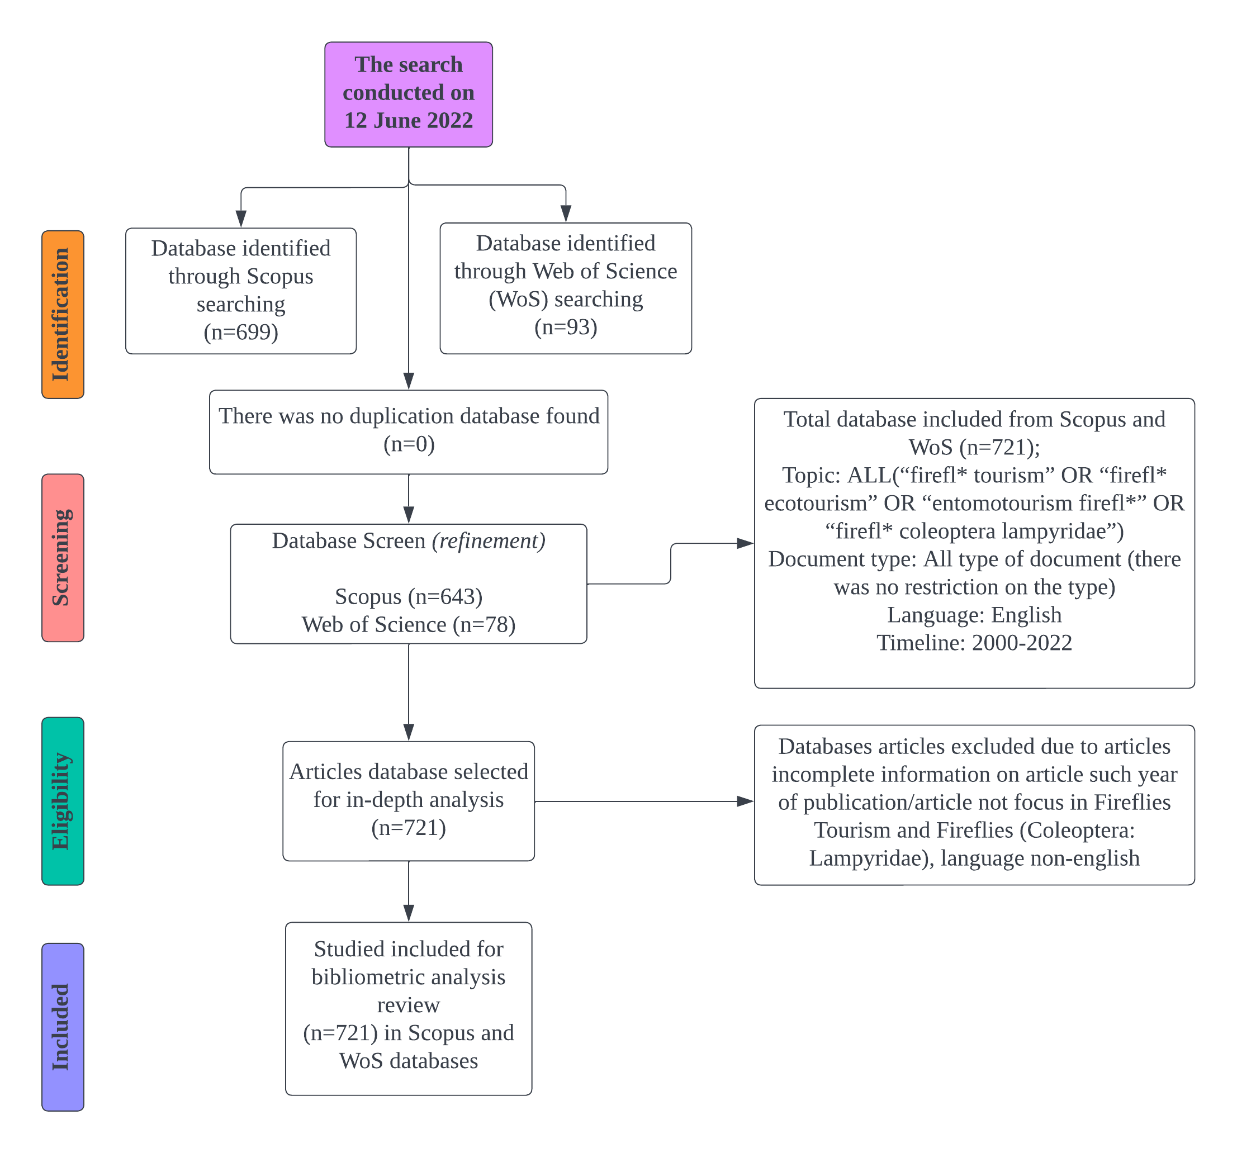
Source: Author, 2023
Figure 2. Flowchart research methodology for databases extraction
Eligibility criteria and study selection

Only articles published between 2000 to 2022 with a research focus on firefly tourism and fireflies Coleoptera Lampyridae. Moreover, there was no restriction on the type of articles that were included, but only restriction on English language. Researcher choose to include all types of articles in this bibliometric analysis because want to discover the global growth trend of firefly tourism and fireflies Coleoptera research. To visualize the database of research trends, researcher want to know about all types of articles related to the research topic to be analyzed. This will be useful for novice researchers who wish to conduct research on fireflies in the future. Other researchers may do bibliometric analysis in this research topic for future suggestions, which is only limited to types of articles journals.

Data analysis

The researcher used RStudio latest version 4.2.0, which was installed on Windows 8.1. The bibliometrix application may be installed by researcher by opening RStudio and then typing >install.packages(“bibliometrix”) into the command prompt. In the RStudio command prompt, the researcher then type > library(bibliometrix) and Biblioshiny(bibliometrix) in order to initiate the Biblioshiny web-interface. The researcher was using the Biblioshiny web-interface in order to import the files that were obtained from the Scopus and Web of Science databases into the Biblioshiny application to analyze the data (Fakruhayat et al., 2022). Figure 3 below shows the features of Biblioshiny web-interface that can be used to analyze the data.

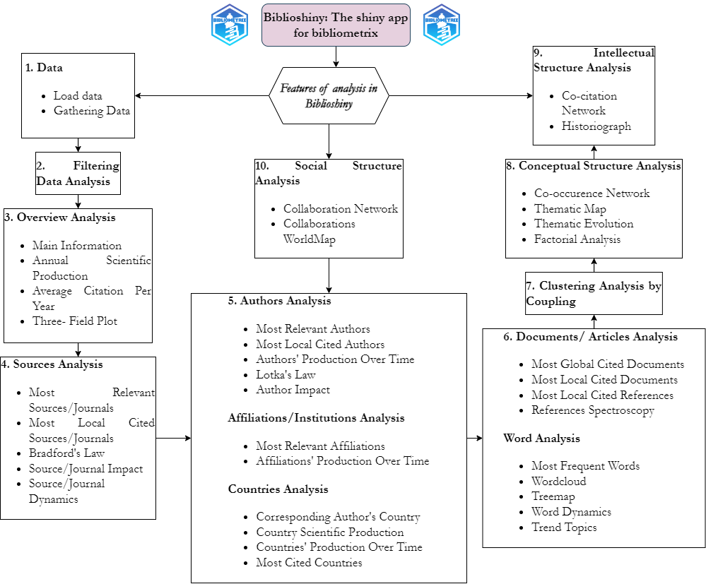
Source: modified from Fakruhayat et al., 2022
Figure 3. Features of Biblioshiny app for bibliometrix
Results and discussion

Based on the published literature, an overview of firefly tourism and fireflies Coleoptera Lampyridae is presented. From 2000 to 2022, the gathered database comprised of all types of papers and was limited to English language only. The database information gathered from Scopus and Web of Science has been retrieved. Researcher obtained 721 databases of articles from two different indexes such as Scopus and WoS on relevant topics such as firefly tourism and fireflies Coleoptera Lampyridae from 2000 to 2022.

Annual scientific production
In the topic of firefly tourism and fireflies Coleoptera Lampyridae research articles, 721 article databases were successfully retrieved from Scopus (643 articles) and Web of Science (78 articles) from the year 2000 to 2022. Table 2 displays the findings of an annual scientific production analysis in firefly tourism and fireflies Coleoptera Lampyridae research using the bibliometric app Biblioshiny. The result of analysis in the Scopus database revealed that 2021 had the highest number of article publications with 88 articles, followed by 2019 with 50 articles, and the least publication was recorded between year 2000 and 2001 with 9 articles. The growth trend of article publication in Scopus from 2000 to 2022 is growing eventhough it has minor inconsistencies. Furthermore, according to the Scopus database, the annual growth rate is 4.36%. According to Web of Science’s annual scientific production, highly articles were published in 2021 (15 out of a total of 78 articles), while the least articles were published in 2002 with no publications were registered for that year. Furthermore, between 2000 to 2022, there was a lack of consistency in the global trend of annual scientific production. In addition, the annual growth rate was calculated to be 5.37% (WoS).
Table 2. Annual scientific production (Scopus & WoS)
Year | Scopus | Web of Science
2000 | 9 | 1
2001 | 9 | 1
2002 | 13 | 0
2003 | 12 | 2
2004 | 14 | 3
2005 | 14 | 1
2006 | 19 | 8
2007 | 27 | 4
2008 | 27 | 4
2009 | 24 | 3
2010 | 25 | 2
2011 | 32 | 3
2012 | 28 | 3
2013 | 24 | 1
2014 | 33 | 4
2015 | 20 | 2
2016 | 29 | 2
2017 | 39 | 4
2018 | 36 | 2
2019 | 50 | 3
2020 | 48 | 6
2021 | 88 | 15
2022 | 23 | 3
Source: Author, 2023
Most relevant authors

In 643 articles founded in the Scopus database which were relevant to the firefly tourism and fireflies (Coleoptera Lampyridae) topic, a total of 1502 authors were discovered. The top ten authors in the field of research subject are shown in the table 3 below. According to the findings of the analysis, an author named Viviani VR contributed the most article publications with a total of 41 articles, followed by researcher Lewis SM, who had published 34 articles. Branham MA, and Oba Y had recorded a publication of 21 articles, and De Cock R, who is ranked top ten author, published 14 articles.

Table 3. Top ten most relevant authors (Scopus)
Authors | Articles | Articles fractionalized | Percentage (%)
Viviani VR | 41 | 13.35 | 6.4
Lewis SM | 34 | 11.65 | 5.3
Branham MA | 21 | 8.33 | 3.3
Oba Y | 21 | 6.60 | 3.3
Fu X | 19 | 6.22 | 3
Da Silveira LFL | 16 | 4.94 | 2.5
Ohmiya Y | 16 | 4.95 | 2.5
Bocak L | 15 | 4.24 | 2.3
Mermudes JRM | 15 | 4.86 | 2.3
De Cock R | 14 | 5.44 | 2.2
Source: Author, 2023

There is a total of 200 authors that have been identified throughout the 78 articles published in the Web of Science database in the field of firefly tourism and fireflies Coleoptera Lampyridae research. The Table 4 provided below shows a list of the top 10 authors. According to findings of the analysis, Lewis SM was the author who had published the most papers overall, with a total of 13 different articles being published under his name. The top ten most influential authors in firefly tourism and fireflies Coleoptera Lampyridae research publications are as follows; Author Cratsley CK, who had published 7 articles, author Ballantyne L and Fu X, who had published 6 articles respectively, and author South A, who had published 4 articles at rank number 10.

Table 4. Top ten most relevant authors (WoS)
Authors | Articles | Articles fractionalized | Percentage (%)
Lewis SM | 13 | 4.22 | 16.7
Cratsley CK | 7 | 2.75 | 9
Ballantyne L | 6 | 2.37 | 7.7
Fu X | 6 | 2.12 | 7.7
Branham MA | 5 | 2.33 | 6.4
Owens ACS | 5 | 1.74 | 6.4
Ballantyne LA | 4 | 1.83 | 5.1
De Cock R | 4 | 0.72 | 5.1
Martin GJ | 4 | 1.25 | 5.1
South A | 4 | 0.98 | 5.1
Source: Author, 2023
Most relevant journals (sources)

Based on an analysis of the most relevant journal articles on firefly tourism and fireflies Coleoptera Lampyridae, the Scopus database has 302 journals identified with a total of 643 publications database. In Table 5, the top ten most relevant journals are shown. Based on the analysis results, Zootaxa journals which has 42 articles, is the most popular journal. Coleopterists Bulletin came in second place with 17 articles. The Photochemical and Photobiological Sciences journal came in third with 16 articles. Lastly, the journal located in tenth place is Insect Physiology with 8 articles.

Table 5. Top ten most relevant journals (Scopus)
Sources | Articles | Percentage (%)
Zootaxa | 42 | 6.5
Coleopterists Bulletin | 17 | 2.6
Photochemical and Photobiological Sciences | 16 | 2.5
Scientific Reports | 11 | 1.7
Insects | 10 | 1.6
Morphology and Systematics (Elateroidea Bostrichiformia Cucujiformia Partim) | 10 | 1.6
Annales Zoologici | 9 | 1.4
Proceedings of The Royal Society B: Biological Sciences | 9 | 1.4
Journal of Experimental Biology | 8 | 1.2
Journal of Insect Physiology | 8 | 1.2
Source: Author, 2023

Forty nine journals were identified among the 78 publications relevant to firefly tourism and fireflies Coleoptera Lampyridae research published in the Web of Science database. Table 6 below is a list of the top 10 journals. Zootaxa journals have published 10 publications, showing the largest number of articles published. Coleopterists Bulletin and Journal of Integrative and Comparative Biology is ranked second and third with 5 articles published respectively. Furthermore, the Molecular Phylogenetics and Evolution journal ranks at tenth, with 2 publications published.

Table 6. Top ten most relevant journals (WoS)
Sources | Articles | Percentage (%)
Zootaxa | 10 | 12.8
Coleopterists Bulletin | 5 | 6.4
Integrative and Comparative Biology | 5 | 6.4
Insects | 4 | 5.1
Journal Of Insect Physiology | 3 | 3.8
Annals of The Entomological Society of America | 2 | 2.6
Biological Journal of The Linnean Society | 2 | 2.6
Chemoecology | 2 | 2.6
Ethology | 2 | 2.6
Molecular Phylogenetics and Evolution | 2 | 2.6
Source: Author, 2023

Most frequent words and co‑occurrence network

Keywords is one of the most essential criteria in defining a topic of research and can show scientific trends. The analysis of keyword co-occurrence networks will offer a clear overview of the author’s keyword that has been used. In the 643 publications relevant to firefly tourism and fireflies Coleoptera Lampyridae research published in the Scopus database, 1647 keywords were used in firefly tourism and fireflies Coleoptera Lampyridae research, and 323 author’s keywords were used in 78 articles published in the Web of Science database globally. The table 7 shows the top 20 most frequently used keywords in firefly research, filtered by author’s keyword in Scopus and Web of Science database publication. In Scopus database, the most frequently used key words is “bioluminescence” that recorded 86 the number of occurrences, followed by“Lampyridae” (69 occurrences), “firefly” (52 occurrences), “fireflies” (35 occurrences), “Coleoptera” (28 occurrences), “taxonomy” (24 occurrences), and so on. In Web of Science database, the result of analysis found the most frequent words that has been used is “Lampyridae” with 20 occurrences, followed by “bioluminescence” (14 occurrences), “firefly” (10 occurrences), “photuris” (6 occurrences), “phylogeny” (6 occurrences) and so on.

Table 7. Top 20 frequently utilized keywords (Scopus & WoS)
Scopus |  | Web of Science
Words | Occurrences | Words | Occurrences
bioluminescence | 86 | Lampyridae | 20
Lampyridae | 69 | bioluminescence | 14
firefly | 52 | firefly | 10
fireflies | 35 | photuris | 6
Coleoptera | 28 | phylogeny | 6
taxonomy | 24 | Coleoptera | 5
sexual selection | 23 | sexual selection | 5
new species | 22 | taxonomy | 5
luciferase | 21 | new species | 4
phylogeny | 19 | courtship | 3
morphology | 17 | fireflies | 3
neotropical | 14 | lampyrinae | 3
conservation | 13 | light pollution | 3
elateroidea | 12 | morphology | 3
evolution | 12 | neotropical | 3
spermatophore | 12 | nuptial gifts | 3
elateridae | 11 | amydetinae | 2
lampyrinae | 11 | artificial light at night | 2
light pollution | 11 | aspisoma | 2
luciolinae | 11 | australia | 2
Source: Author, 2023

Country scientific production

The table 8 shows the findings of a global analysis of a country’s scientific production. The top 10 countries in the world in terms of scientific articles on the topic of firefly tourism and fireflies Coleoptera Lampyridae were identified in this study. The databases Scopus and Web of Science showed the world’s top ten countries in terms of country’s scientific productivity between 2000 and 2022. In Scopus database, there are 49 countries around the world that had contributed, whereas in Web of Science there are 23 countries that had contributed according to the results of analysis. There have been approximately 652 articles relating to this subject in the Scopus database from the United States of America (USA). Brazil which has 299 articles came in second position; China (282 articles) came in third; whereas the 10th-placed Finland with 58 article published. In addition, according to Web of Science, the United States of America (USA) is the country with the most published articles in the world, with 121 articles. China came next with about 37 articles, followed by Brazil with 23 articles and Thailand in 10th position with only 7 articles. Figures 4 and 5 below show a visualization of global mapping around the world related to fireflies research that has been indexed in Scopus and Web of Science.

Table 8. Top ten country scientific production (Scopus & WoS)
Scopus |  | Web of Science
Country | Frequency | Country | Frequency
USA | 652 | USA | 121
Brazil | 299 | China | 37
China | 282 | Brazil | 23
Japan | 236 | Australia | 19
Malaysia | 127 | Japan | 16
Australia | 86 | Malaysia | 15
UK | 72 | Mexico | 10
Czech Republic | 70 | Germany | 8
Thailand | 70 | Portugal | 7
Finland | 58 | Thailand | 7
Source: Author, 2023

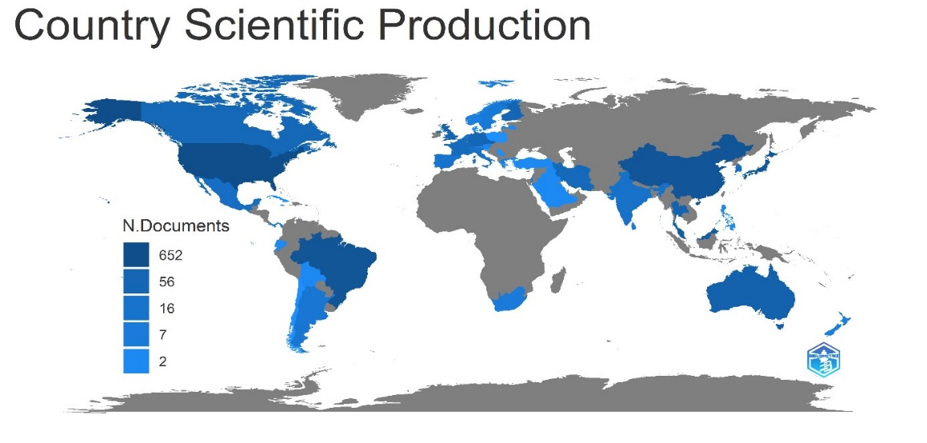
Source: Author, 2023
Figure 4. Visualization of global mapping around the world (Scopus)
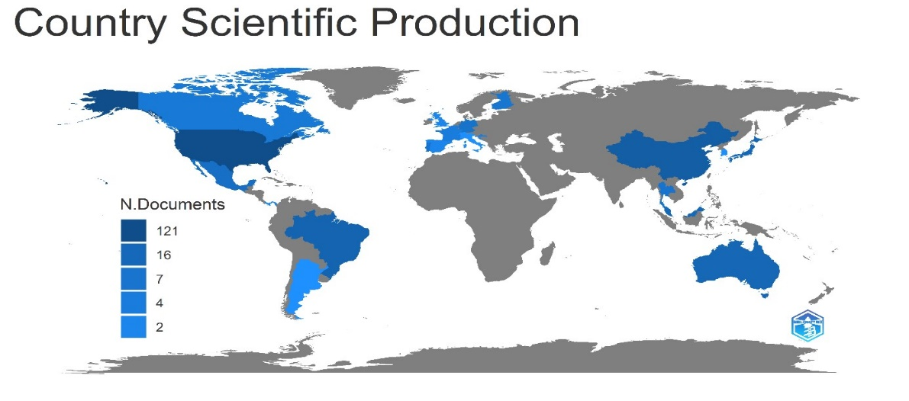
Source: Author, 2023
Figure 5. Visualization of global mapping around the world (WoS)
Collaboration among countries

Table 9 below show a top ten collaborations among countries in Scopus and Web of Science databases. Researcher analyze global collaboration trends at the country level throughout the world. According to the researcher’s findings, the Scopus database has 193 collaborations between countries in firefly tourism and fireflies Coleoptera Lampyridae research, while the Web of Science database contains 80 collaborations between countries that were discovered. In Scopus database, the United States of America (USA) collaborated with three other countries which recorded the most highest collabarations that is between (USA-Japan; 24 frequency), (USA-China; 21 frequency), and (USA-Brazil; 20 frequency), followed by collaboration between Brazil and Japan (15 frequency). Furthermore, in the Web of Science database, the highest frequency of collaboration countries was between the United States (USA) and China, with a frequency of 6, followed by China and Australia, with a frequency of 5, and collaborations between China and Finland, with a frequency of 2, placing it in 10th position among countries worldwide.

Table 9. Top ten collaboration among countries (Scopus & WoS)
Scopus |  |  | Web of Science
From | To | Frequency | From | To | Frequency
USA | Japan | 24 | USA | China | 6
USA | China | 21 | China | Australia | 5
USA | Brazil | 20 | USA | Brazil | 4
Brazil | Japan | 15 | USA | Japan | 4
China | Japan | 13 | USA | Canada | 3
USA | United Kingdom | 13 | USA | Portugal | 3
China | Australia | 11 | Brazil | Canada | 2
USA | Australia | 10 | Brazil | Portugal | 2
USA | Canada | 9 | China | Belgium | 2
USA | Germany | 8 | China | Finland | 2
Source: Author, 2023
Discussion

Firefly could produce bioluminescent light at the buttom of its abdomen, which is utilized for communication, evading predators, and as a signal to copulate (Veronica, 2018). In addition, fireflies can be seen as important to the growth of ecotourism, since their uniqueness can attract tourists. Therefore, this article has provided a visualization and overview of research trends on firefly tourism and fireflies Coleoptera Lampyridae to see the progress growth in the topic research of fireflies. This study assists new researchers in the topic of fireflies by presenting an overview of the overall information, including the most important authors, relevant journals, annual scientific production, and so on.
Utilizing bibliometric analysis to analyze the research can aid in the analysis of the research’s trend. Bibliometric analytics is the application of research that uses statistical analysis of scientific articles to uncover citation links between publications and research trends in a particular field (Şenel & Demir, 2018). To the best of our knowledge, this study was carried out to fill the gaps from previous study of bibliometric analysis on the global research on fireflies using the Scopus, and Web of Science databases.
The number of scientific publications is an attractive bibliometric indication that may show the development of a disciplinary research topic. The current research indicates that the number of annual scientific publications in Scopus is growing, despite the fact that there are some inconsistencies in the data. On the other hand, the number of annual scientific articles in the Web of Science databases is not consistent between the years of 2000 to 2022. There are just a few aspects that have impact on the yearly article production research trends, such as the conditions and technology of the laboratory, the number of researchers, and the policies of the government that support firefly research (Sharma et al., 2018).
In order to evaluate the present status of firefly tourism and firefly Coleoptera Lampyridae research all over the world, bibliometric and visualisation analysis was carried out. To the best of our knowledge, this is the first study of bibliometric analysis to be conducted. Evaluations were made on research works that were related to firefly tourism and fireflies belonging to the family Coleoptera Lampyridae. It is possible that this will shed light on some of the most key aspects and developments in this field. As in the situation with previous bibliometric analysis of a similar kind, some limitations are unavoidable. First, while looking for sources from which to collect relevant research materials, only the Scopus and Web of Science databases were taken into consideration. As a direct consequence of this, certain relevant research documents from various other research databases could be removed. Second, this research analysis has taken all types of documents for consideration. Third, the present research does have several limitations. In the first step of the process, the input data were retrieved from databases using a search strategy. The databases included articles written in English languages.
In the field of firefly tourism and firefly Coleoptera Lampyridae, the purpose of this study is to analyze current trends and conduct a status review in order to get a better understanding of the most important topics, core groups, and key patterns of collaboration in worldwide research. The significance of this study is it has fill the present lack of research on firefly tourism and firefly Coleoptera Lampyridae globally. It will assist researchers and policymakers in understanding the future of firefly tourism and Coleoptera Lampyridae study.

Conclusion

This article presents a literature review and bibliometric analysis of research on firefly tourim and fireflies Coleoptera Lampyridae to determine the areas within which the annual scientific publication growth, the most productive authors, most frequent key word that has been used, most popular journal name, and which countries has the highest collaboration with other country around the world. According to the bibliometric analysis, the United States of America (USA) has the highest number of scientific production, the most relevant author is Viviani VR (Scopus) and Lewis SM (WoS) database, the most relevant journal is Zootaxa in Scopus and Web of Science database, and the most frequently used word is “bioluminescence” in Scopus database but the word “Lampyridae” is the most commonly used word in the Web of Science database. As a result, researcher recommend that for future studies, other researcher can evaluate and focus on other databases to determine, as well as other topic keywords of research studies in fireflies such as environmental factors, abundance fireflies, bioluminescence fireflies, taxonomy of fireflies, fireflies behaviour, or artificial illumination. Fireflies are incredibly attractive insects that have gained popularity among nature enthusiasts. Researcher has detail the popularity of firefly tourism and fireflies Coleoptera Lampyridae in this extensive research. Firefly tourism has attracted over 1 million visitors coming to firefly places in at least 12 countries each year to enjoy this unique nature experience. The fast expansion of this business emphasizes the need of developing, disseminating, and implementing techniques that might aid in the revolution from tourism to ecotourism.

References

Arthur Y.C. Chung. (2021). Fireflies of Sabah, Malaysia. Conference: CTRE Course, Borneo Tourism Institute, Kota Kinabalu (Virtual). Retrieved from ResearchGate. https://www.researchgate.net/publication/347945767_Fireflies_of_Sabah_Malaysia?cha nnel=doi&linkId=5fe9719945851553a0fb3e2c&showFulltext=true. Retrieved on 11
November 2022.
Abdul Razak, F., & Sulaiman, N. (2016). Synchronization of Malaysian fireflies: The case of
Pteroptyx tener at Kampung Kuantan, Selangor, Malaysia. Malayan Nature Journal,
68(Part 1 & 2), 223–228.
Andraz, J. M., Norte, N. M., & Gonçalves, H. S. (2015). Effects of tourism on regional
asymmetries: Empirical evidence for Portugal. Tourism Management, 50, 257-267.
Aref, F., Gill, S. S., & Aref, F. (2010). Tourism development in local communities: As a
community development approach. Journal of american Science, 6(2), 155-161.
Basyuni, M., Fitri, A., & Harahap, Z. A. (2018). Mapping and analysis land-use and
land-cover changes during 1996-2016 in Lubuk Kertang mangrove forest, North
Sumatra, Indonesia. In IOP Conference Series: Earth and Environmental Science (Vol.
126, No. 1, p. 012110). IOP Publishing.
Ballantyne, L., Lambkin, C. L., Boontop, Y., & Jusoh, W. F. A. (2015). Revisional studies on the
Luciolinae fireflies of Asia (Coleoptera: Lampyridae): 1. The genus Pyrophanes Olivier
with two new species. 2. Four new species of Pteroptyx Olivier and 3. A new genus Inflata
Boontop, with redescription of Luciola indica (Motsch.) as Inflata indica comb. nov.
Zootaxa, 3959(1), 1-84. https://doi.org/10.11646/ zootaxa.3959.1.1
Ballantyne, L. A., & Lambkin, C. (2001). A new firefly, Luciola (Pygoluciola) kinabalua, new
species (Coleoptera: Lampyridae), from Malaysia, with observations on a possible
copulation clamp. The Raffles Bulletin of Zoology, 49(2), 363-378.
Ballantyne, L. A., & McLean, M. R. (1970). Revisional studies on the firefly genus Pteroptyx
Olivier (Coleoptera: Lampyridae: Luciolinae: Luciolini). Transactions of the American
Entomological Society (1890-), 96(2), 223-305.
Buckley, R., Brough, P., Hague, L., Chauvenet, A., Fleming, C., Roche, E., ... & Harris, N.
(2019). Economic value of protected areas via visitor mental health. Nature
communications, 10(1), 1-10.
Cheng, S., Faidi, M. A., Tan, S. A., Vijayanathan, J., Malek, M. A., Bahashim, B., & Isa, M.
N. M. (2021). Fireflies in Southeast Asia: knowledge gaps, entomotourism and
conservation. Biodiversity and Conservation, 30(4), 925-944.
Da Silveira, L. F. L., & Mermudes, J. R. M. (2014). Systematic review of the firefly genus
Amydetes Illiger, 1807 (Coleoptera: Lampyridae), with description of 13 new species.
Zootaxa, 3765(3), 201-248. https://doi.org/10.11646/ zootaxa.3765.3.1
Ernawati, N. M., Sudarmini, N. M., & Sukmawati, N. M. R. (2018). Impacts of Tourism in Ubud Bali Indonesia: a Community-Based Tourism Perspective. Journal of Physics: Conference Series, 953.
Fakruhayat, M., Rashid, A., Rahman, A. A., Masayu, S., & Abdul, R. (2022). Research Related
To Fireflies ( Coleoptera : Lampyridae ) Around The World Over The Year 2000 –
2021 : An Overview And Guidelines. e-bangi, 19(3), 123–150.
Firefly Monitoring. (2021). EcoReach Odum School of Ecology. Retrieved 11 November 2022
from https://ecoreach.ecology.uga.edu/virtual-activities/firefly-monitoring/.
Frierson-Faust, L. (2017). Fireflies, glow-worms, and lightning bugs: identification and natural
history of the fireflies of the eastern and central United States and Canada. University
of Georgia Press.
Foo, K., & Dawood, M. M. (2015). Diversity of Fireflies (Coleoptera: Lampyridae) of Sungai
Teratak, Sabah, Malaysia. Journal of Tropical Biology & Conservation (JTBC), 12, 1-11.
Gray NJ, Campbell LM (2007). A decommodified experience? Exploring aesthetic, economic and
ethical values for volunteer ecotourism in Coasta Rica. Journal of Sustainable Tourism,
15(5), 463-482.
Haugan, E. B. (2019). ‘Homeplace of the Heart’: Fireflies, Tourism and Town-Building in
Rural Japan (Master’s thesis). Retrieved from Department of Culture Studies and Oriental Languages (IKOS), University of Oslo
https://www.duo.uio.no/handle/10852/70274?show=full.
Habibi, F. (2017). The determinants of inbound tourism to Malaysia: a panel data analysis. Current
Issues in Tourism, 20(9), 909-930. https://doi.org/10.1080/13683500.2016.1145630
Hu, J., & Fu, X. (2018). The complete mitochondrial genome of the firefly, Abscondita anceyi
(Olivier) (Coleoptera: Lampyridae). Mitochondrial DNA Part B, 3(1), 442–443.
https://doi.org/10.1080/ 23802359.2018.1456373
Hogarth, P. J. (1999). The biology of mangroves. Oxford University Press (OUP).
Jaafar, M., Ahmad, A., & Sakawi, Z. (2010). Kemandirian industri eko-pelancongan: Kes
tarikan pelancong kelip-kelip Kg. Kuantan (The survival of an eco-tourism industry:
Evidence from the Kg. Kuantan’s firefly tourist attraction). Geografia-Malaysian Journal of Society and Space, 6(3), 89-97.
Jamil, H., & Suzana, M., (2004). The Kampung Kuantan firefly reserve. Retrieved from
(http://www.ramsar.org/sites/default/files/documents/pdf/lib/hbk4-07cs11.pdf). Retrieved
on 17 February 2021.
Jusoh, W. F. A., Ballantyne, L., Lambkin, C. L., Hashim, N. R., & Wahlberg, N. (2018). The
firefly genus Pteroptyx Olivier revisited (Coleoptera: Lampyridae: Luciolinae). Zootaxa,
4456(1), 1-71. https://doi.org/10.11646/zootaxa.4456.1.1
Jusoh, W. F. A. W., Hashim, N. R., & Ibrahim, Z. Z. (2010). Distribution and abundance of
Pteroptyx fireflies in Rembau-Linggi estuary, Peninsular Malaysia. Environment
Asia, 3(special issue), 56-60.
Kirton, L.G., & Nada, B. (2010). Firefly ecotourism in Malaysia. World Atlas of Mangroves
1048 (Ed. by Spalding, M., Kainuma, M., & Collins, L.), pp. 115. Earthscan Ltd.,
London.
Kuala Selangor District Council. (2016). Total arrival of tourists to tourist destinations in the
Kuala Selangor District for the years 2011-2016. Retrieved from the ticketing sales of
trams and boats, Treasury Department, MDKS.
Lewis, S. M., Wong, C. H., Owens, A., Fallon, C., Jepsen, S., Thancharoen, A., ... & Reed, J.
M. (2020). A global perspective on firefly extinction threats. BioScience, 70(2), 157
-167.
Lewis, S. (2016). Silent sparks: The wondrous world of fireflies. Princeton, NJ: Princeton
University Press.
Lloyd, J. (2008). Fireflies (Coleoptera: Lampyridae). In J. L. Capinera (Ed.), Encyclopedia of
entomology (1429-1452). Springer.
Martin, G. J., Stanger-Hall, K. F., Branham, M. A., Da Silveira, L. F., Lower, S. E., Hall, D.
W., ... & Bybee, S. M. (2019). Higher-level phylogeny and reclassification of
Lampyridae (Coleoptera: Elateroidea). Insect Systematics and Diversity, 3(6), 11.
Manning, R. E., Anderson, L. E., & Pettengill, P. R. (2017). Let there be light in Great Smoky
Mountains. Managing outdoor recreation: case studies in the national parks, (Ed. 2),
62-65.
Mahadimenakbar, M. D., & Saikim, F. H. (2016). Studies on congregating fireflies (Coleoptera;
Lampyridae; Pteroptyx sp.) in Sabah, Malaysia: a review. Journal of Tropical Biology &
Conservation (JTBC), 13.
Mastura Jaafar, Munira Mhd Rashid, & Norziani Dahalan. (2015). Enhancing the
competitiveness of rural heritage tourism destination through SMEs development: The
case of the Lengggong Valley. Geografia-Malaysia Journal of Society and Space,
11(2), 43-54.
McCombes, L., Vanclay, F., & Evers, Y. (2015). Putting social impact assessment to the test as
a method for implementing responsible tourism practice. Environmental Impact
Assessment Review, 55, 156-168.
Mu, F.-J., Ao, L., Zhao, H.-B., & Wang, K. (2016). Characterization of the complete mitochondrial
genome of the firefly, Luciola substriata (Coleoptera: Lampyridae). Mitochondrial DNA
Part A, 27(5), 3360–3362. https://doi.org/10.31 09/19401736.2015.1018221
Nada B, Kirton LG, Norma-Rashid Y, Cheng S, Shahlinney L, Phon CK (2012) Monitoring the
Fireflies of The Selangor River. Mangrove and Coastal Environment of Selangor,
Malaysia. University of Malaya Press. 153–162
Nada, B., & Kirton, L. G. (2004). The secret life of fireflies. IRBM Updates, 3(December 2004),
2-4.
Nallakumar, K. (2003). The synchronously flashing aggregative fireflies of Peninsular
Malaysia. Biodiversity, 4(2), 11-16.
Napompeth, B. (Ed.). (2009). Diversity and conservation of fireflies. Queen Sirikit Botanic
Garden, Botanical Garden Organization.
Noor, A. Y. M., Mokhtar, A. M., Sharif, S. M., Long, A. S., Ab Rahman, Z., & Wahab, N. A. A.
(2019). Main Tourism Sectorsin Malaysia: A Contribution Towards Economic Growth.
Norela, S., Shahril, M. H., Mohd Noh, A., Maimon, A., & Khairunnisa, S. (2016). Abundance
of Lampyridae in relation to the vegetation and abiotic conditions along the Sungai
Johor, Johor, Malaysia. Malayan Nature Journal, 67(4), 395-402.
Norlida Hanim Mohd Salleh, Redzuan Othman, & Tamat Sarmidi. (2011). An Analysis of the
Realationship between Tourism Development and Foreign Direct Investment: An
Empirical Study in Selected Major Asian Countries. International Journal of Business
& Social Science, 2(17), 250-250.
Nunkoo R., & Gursoy, D. (2012). Residents’ support for tourism: An identity perspective.
Annals of Tourism Research, 39(1), 243-268.
Owens, A., & Lewis, S. M. (2021). Narrow‐spectrum artificial light silences female fireflies
(Coleoptera: Lampyridae).
Observing Fireflies. (2021). Retrieved 4 January 2021, from
https://www.massaudubon.org/learn/nature-wildlife/insects-arachnids/fireflies/observing
-fireflies
Ohba, N. (2004). Mystery of fireflies. Yokosuka City Museum, Yokosuka (2004, in Japanese).
Rahayu, R. (2007). Mengenal Kunang-kunang Melalui Habitat dan Ciri-Ciri
Morfologi. Jurusan Biologi FMIPA Universitas Andalas.
Riza, I., Aliya, S., & Sagaff, S. (2017). Fireflies Population And The
Aquaculture Industry (Coleoptera: Lampyridae) Of The Sungai
Sepetang, Kampung Dew, Perak, Malaysia. Centre for Insects
Systematic, 22(2), 217–237.
Sartsanga, C., Swatdipong, A., & Sriboonlert, A. (2018). Distribution of the firefly genus
Pteroptyx Olivier and a new record of Pteroptyx asymmetria Ballantyne (Coleoptera:
Lampyridae: Luciolinae) in Thailand. The Coleopterists Bulletin, 72(1), 171.
https://doi.org/10.1649/0010-065x-72.1.171
Seri, N. A., & Rahman, A. A. (2021). Fireflies in South East Asia: Species diversity, distribution,
and habitat (2015-2021). Pertanika Journal of Tropical Agricultural Science, 44(4), 713
-743. https://doi.org/10.47836/ pjtas.44.4.02
Şenel, E., & Demir, E. (2018). Bibliometric analysis of apitherapy in complementary medicine
literature between 1980 and 2016. Complementary therapies in clinical practice, 31,
47-52.
Shahwahid, H. O., Mohd-Iqbal, M. N., Amiraras-Ayul, A. M., & Farah, M. S. (2013).
Assessing service quality of community-based ecotourism: A case study from Kampung
Kuantan Firefly Park. Journal of Tropical Forest Science, 25(1), 22-33,
https://www.jstor.org/stable/43595372
Shahwahid, H. O., Mohd-Iqbal, M. N., Amiraras-Ayul, A. M., Rahinah, I., & Mohd
Ihsan, M. S. (2016). Network analysis of Kampung Kuantan Firefly Park, Selangor and
the implications upon its governance. Journal of Tropical Forest Science, 28(4), 490
-497. https://www.jstor.org/stable/43956815
Shahara, A., Nura, A. M. R., Abdullah, M., & Sulaiman, N. (2017). Assessment of firefly
abundance at a new ecotourism site of Sungai Bernam, Selangor, Malaysia. Malayan
Nature Journal, 69(2), 67–74.
Sharma, N., Bairwa, M., Gowthamghosh, B., Gupta, S. D., & Mangal, D. K. (2018). A
bibliometric analysis of the published road traffic injuries research in India, post
-1990. Health research policy and systems, 16(1), 1-11.
Sun, J., Guo, Y., Scarlat, M. M., Lv, G., Yang, X. G., & Hu, Y. C. (2018). Bibliometric study
of the orthopaedic publications from China. International orthopaedics, 42(3), 461-468.
Sulaiman, N., Loo, M. C., & Abdullah, M. (2017). Association between the firefly population and
some biotic and abiotic factors along the Sungai Sepetang river banks at Kampung Dew,
Taiping, Perak, Malaysia. Malayan Nature Journal, 69(3), 110–118.
Vance, E., & Kuri, S. R. (2017). How fireflies are keeping this tiny Mexican town
alive. National Geographic, Retrieved 4 January 2021 from www. nationalgeographic.
com/photography/proof/2017/08/firefly fields-mexico-tourism-ecotourism.
Veronica, K. S., (2018). The Effect of Artificial Illumination on The Display Behaviour of The
Firefly Pteroptyx tener Olivier (Coleoptera: Lampyridae). Retrieved from University Sains
Malaysia.
Woon, H. Y. (2003). Potensi Serangga sebagai Produk Pelancongan Alam Semulajadi di
Kolam Air Panas Poring, Ranau, Sabah. Diakses di Universiti Malaysia Sabah: Tesis
Sarjana Muda (tidak diterbitkan).
Zaragoza-Caballero, S. (2012). Macrolampis palaciosi a new species (Coleoptera: Lampyridae:
Photininae), from Tlaxcala, México. Dugesiana, 19 (2), 117-121. 1405-4094.

