Health issues of large dams: The case of Soum in the West Central region of Burkina Faso

Sanou Korotimi, Yanogo Pawendkisgou Isidore, Yaméogo Joseph, Zongo Richard

Norbert ZONGO University, Koudougou, Burkina Faso

Correspondence: Joseph Yaméogo (email: josephyameogo10@gmail.com)

Received: 18 October 2022; Accepted: 8 February 2023; Published: 24 February 2023

Abstract

This study analyses the sanitary stakes of the watering of the Soum dam. To do so, a review of the literature on the subject of research, surveys of 165 farmers, interviews with three health agents and direct observations were carried out. The study shows that the Soum dam contributes to the improvement of farmers' health conditions. Indeed, their attendance at the HSPC (Health and Social Promotion Center) increased from 36.13% before the construction of the dam to 62% after its effective operation. As a result, the use of traditional medicine decreased by 12.9% after the installation of the dam. In addition, the classes of money invested in the purchase of medicines increased. There were three classes of annual amounts ranging from 5,000 FCFA/household to 75,000 FCFA/household before the installation of the dam. After the installation of the dam, there are four, with amounts ranging from 5,000 FCFA/household/year to 100,000 FCFA/household/year. However, the dam creates a humid environment favourable to the proliferation of mosquitoes, particularly female anopheles. As a result, 95.48% of the respondents are exposed to malaria. Also, socio-economic activities such as market gardening and the consumption of untreated water from the dam present health risks that the authorities in charge of the management of the dam must take into account by raising awareness and providing continuous support through the distribution of mosquito nets. This study also showed that the health aspect is important and must be taken into account in the same way as the economic and food aspects.

Keywords: Health risks, malaria, Soum dam

Introduction

After the advent of droughts in the 1970s and 1980s, with their attendant famines and migrations, governments in West African countries opted to build large dams on their rivers to regulate the rivers and increase water storage capacity to support economic development in the region (Skinner et al., 2009). However, climate change is now pushing some states, such as Burkina Faso, to look more closely at the construction of large dams. Thus, hydro-agricultural structures have been built, including the Soum and Samandeni dams in Burkina Faso, which were impounded in 2003 and 2019, respectively. The Soum dam attracts particular attention. Indeed, it has been exploited by local populations before the allocation of plots of land for exploitation planned by the authorities. Thus, several young people from the North, Center-West and Central Plateau regions of Burkina Faso converge there to exploit the dam's water resources. As a result, the various agricultural practices and the economic income that this generates for riverside communities such as Soaw, Nanoro and Soum have experienced a significant increase in recent years (Zongo, 2022). This meets the objectives assigned to the Soum dam, which is to reduce poverty and contribute to achieving food security through the development and allocation of 368 hectares to the population in 2020. The socio-economic benefits of the dam therefore overshadow the potential health problems inherent in hydro-agricultural infrastructure. According to Lerer and Scudder (1999), large dams influence human health through changes in water and food security, increases in communicable diseases, and social disruption caused by construction and involuntary resettlement of project-affected people. Hence the interest in looking at the health impact of hydro-agricultural developments such as the Soum Dam. This research aims to highlight the health issues following the development of the large Soum dam in the central-western region of Burkina Faso.
The objective of this paper is to: Determine the factors favourable to the impoundment of the Soum dam, analyse the economic impact induced by the exploitation of the dam on access to health care, and determine the health risks and waterborne diseases after the impoundment of the Soum dam.

Method and study area

It consists of identifying the geographical framework of the study, the methods of data collection and processing.

Study areas

The Soum dam is located in the Boulkiemdé province, particularly between the communes of Kordié, Nanoro and Soaw (Figure 1). The dam has a depth of 12 m, a seawall of 1,517 m, a spillway of 150 m with a capacity of 155 million m³.

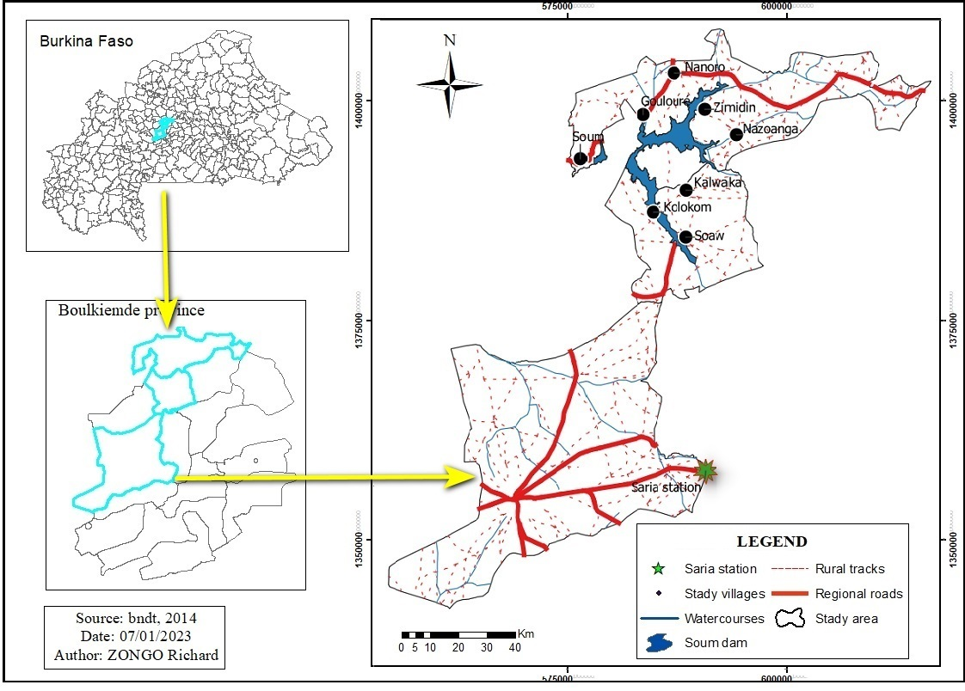

Figure 1. Geographical location of the Soum dam

Data collection methods

They consisted of a combination of secondary and primary data collection. The secondary data collection involved a literature review. This provided an overview of the factors that influence the construction of large dams, and the impact of dams on the well-being of rural populations. In addition, the analysis of the literature also allowed us to identify health problems resulting from the construction of large dams. The collection of secondary data was possible thanks to the physical libraries of the Norbert ZONGO University of Koudougou and the virtual libraries available on the Internet. Various documents such as books, scientific articles, master's theses and dissertations were consulted.
Three techniques and tools were used to collect the primary data. These techniques are surveys, interviews and direct observations in the field. Indeed, the surveys consisted in visiting the Soum dam exploitation sites to administer questionnaires to farmers during four months (December 2020-March 2021). The questionnaires administered to them concerned: income generated per year, economic accessibility to health care, frequency of malaria peaks before and during the dam impoundment, attendance at health centres before and after the dam impoundment, and health problems observed with the dam impoundment. The interview concerned health workers and the topics of the interview focused on the diseases observed on the dam operators, the number of operator frequencies in the health centres, and the health risks related to the consumption of the dam water. As for the observations, they allowed us to see for ourselves how the populations experience health problems. The tools used in the field are respectively the survey forms, the interview guides and the observation grid.
For the field survey phase, a preliminary study was conducted to determine the total population in July 2020. This made it possible to count one thousand (1000) farmers on the basis of three criteria, including the use of water from the dam, the distance of the farms from the easement strip and the choice of cropping system. The villages concerned by the studies are those that are closest to the market gardening farms along the Soum dam. However, due to the unavailability of some farmers on the site, the Fisher formula cited by Tuo and Coulibaly (2017) was used to determine the sample size such that:

$$n=t^{2}.p(1-p)/e^{2 …(1)}$$

n : represents the target population to be studied;
t : the 95% confidence level (standard value of 1.96);
p: corresponding to the proportion of the elements of the parent population that exhibit a given property. Note that p was set at 12.2% in order to better collect the data. After calculation, we have 164.60 or 165 farmers to be surveyed in five riverside villages (Table 1).

Table 1. Distribution of respondents by village

Villages studied |  | Number of farmers | Number of farmers surveyed | Distance of the farms from the easement strip
Soum | 309 |  | 51 | 500 m
Zimidin | 182 |  | 30 | 500 m
Nazoanga | 200 |  | 33 | 300 m
Goulouré | 188 |  | 31 | 500 m
Kolonkom | 121 |  | 20 | 1000 m
Total | 1000 |  | 165
Source: Field surveys, December 2020-March 2021
Among these 165 farmers, there are 155 market gardeners and 10 fishermen. In addition to the surveys, 31 people were interviewed, including village chiefs, political advisors, VDC (Village Development councils’ presidents), technical services for the environment, livestock, water and forestry, community leaders, and head nurses from the villages of Nazoanga, Soum, Kolonkom and Zoétgomdé.

Methods of data processing and analysis

They concern climate data, surveys and interviews. The climatic variable used is rainfall over a 30-year period (1991-2020). The rainfall data were obtained from the National Institute of Environment and Agricultural Research (NIEAR) Saria station in the village of Villy (in the central-west region of Burkina Faso), which covers the study area. The rainfall data was processed using descriptive statistics such as sum and mean in the excel 2019 spreadsheet. This allowed the results to be presented in tabular form.
The survey data were first coded in the Excel 2019 spreadsheet. Then they were transferred to the Sphinx software. Finally, the processing of the survey data was done using descriptive statistical methods such as sum, mean and frequency included in the Sphinx software. This made it possible to present the results in tables, graphs and percentages. ArcGIS 10.3.1 software was used to map the site and relief of the Soum dam environment by taking each of the elevation points around the dam environment. These points were then transferred to ArcGIS 10.3.1 and with the extrapolation tool, the elevation map was produced.

Results and discussion

Factors favourable to the impoundment of the Soum dam

These are essentially the physical and human factors that conditioned the realization of the Soum dam.

a. Physical factors favourable to the development of the dam

In the communes of Nanoro and Soaw, where the dam is located, there is a succession of gentle ridges and splayed valleys, with a few isolated buttes or a group of hills with steep slopes that rise a few dozen meters above the plateau. This gives a topography suitable for the implantation of the dam. Indeed, the areas in which the dam is installed at altitudes ranging from 271 m to 285 m (Figure 2). These elevations provide a favourable slope for the installation of the dam (Yanogo,2006).
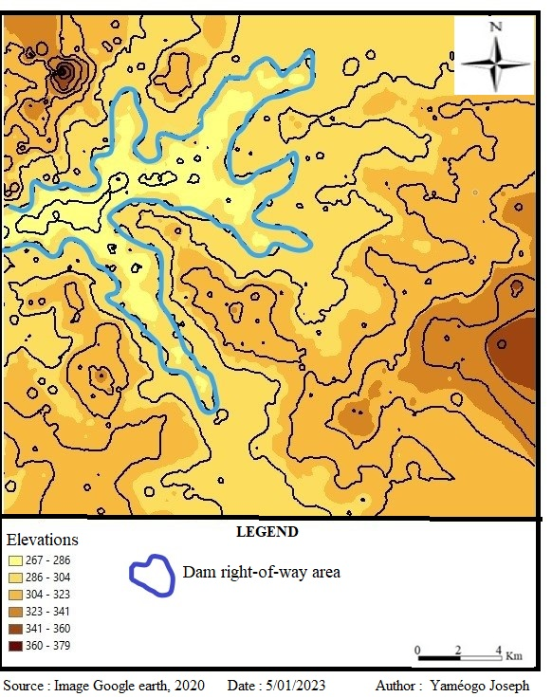

Figure 2. Topography of the Soum dam area and its environment

The soil types in the area are poorly developed erosional soils on gravelly material, poorly leached tropical ferruginous soils, and hydromorphic soils on clayey-sandy materials (Nanoro CDP, 2014-2018; Soaw CDP, 2018-2022).
It should be noted that the average amount of water that has fallen in the area over the past 30 years is 848.96 mm, which is relatively high compared to the national average of between 500 mm and 700 mm (Directorate of National Meteorology of Burkina Faso, 2012, cited by Sanou, 2015). However, water amounts fluctuate from year to year over the last 30 years (Figure 3). The four wettest years are 2016; 2020; 1994 with 998.8 mm; 1045.8 mm and 1218.8 mm respectively. The lowest rainfall amounts are 626.4 mm; 716.7 mm; 723.1 mm and 781.1 mm in 2013; 2002; 2001 and 2006 respectively. These rainfall amounts, with an overall stable trend, were a stimulating factor for the construction of the Soum dam. However, the two-year moving averages in red in Figure 3 show a downward and upward fluctuation over the last 30 years in the region.

Source: INERA, Saria, 2020

Figure 3. Variation in rainfall between 1991 and 2020 in the Soum dam area
b. Human factors favorable to the construction of the Soum Dam

The socio-demographic profile of farmers living near the Soum Dam shows a male population (88.40%). The average number of dependent children is 5 per household surveyed.
Agriculture is rainfed and dominated by crops such as small millet, white sorghum, red sorghum and legumes such as cowpeas, Voandzou, groundnuts and sesame (field surveys). However, with the variability of the climate, pockets of drought have become recurrent. These climatic hazards contribute to a decline in harvests, which affects farmers' income. As a result, the incidence of poverty is higher there, with a rate of 51.7% of the population (NESDP, 2016-2020). All these conditions led to the construction of the dam in the area. Thus, the presence and functioning of the dam favours the practice of agriculture in all seasons (Sanou et al., 2015; Zongo, 2022). This presence of the dam leads to health issues that are rarely mentioned in the studies, because the dam is primarily intended to solve food and economic problems.

Soum Dam: between economic benefits and access to health care for farmers

The impoundment of the dam has led to a massive production of vegetables in the area. Vegetables such as tomatoes and onions (Figure 4) are grown in the area, due to the incessant demand for these products both in the country and in the West African sub-region. Other vegetables such as eggplant and cabbage are also grown near the dam. However, their demand is lower than for tomatoes and onions.

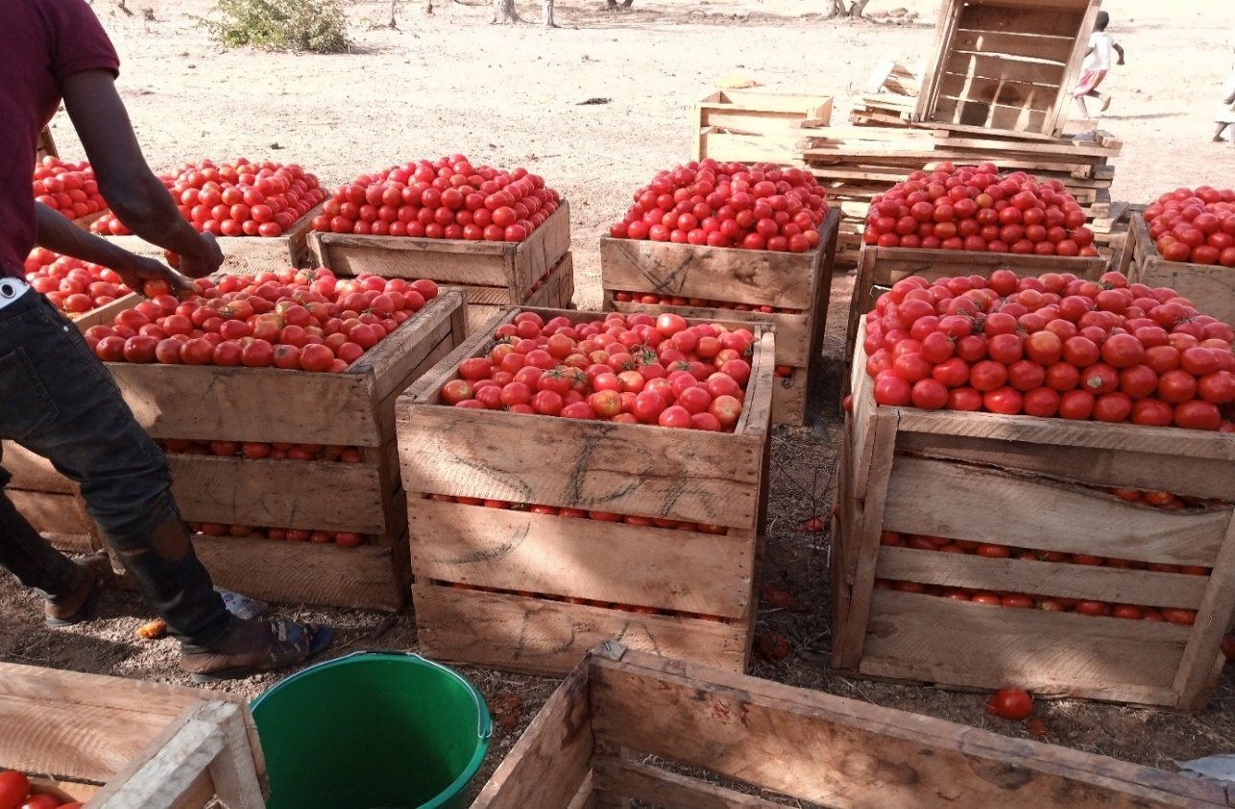
a
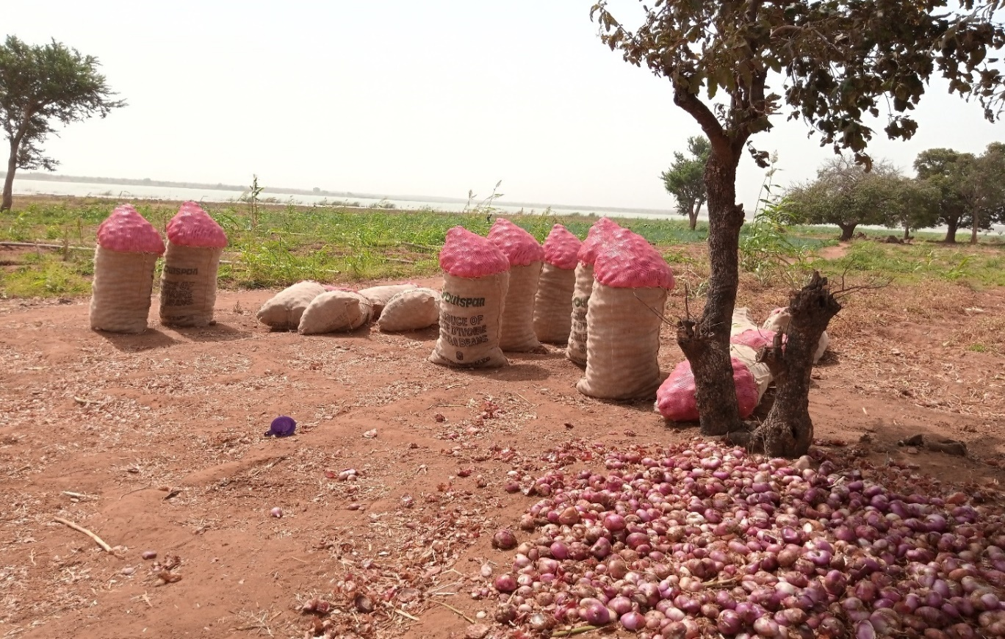
b
Source: ZONGO Richard, march, 2021

Figure 4. Tomato in crates (a) and onion bags packed for sale (b)

These market garden products are sold on local (Nanoro, Soaw), provincial (Kordié, Boussé), national (Koudougou, Ouagadougou, Bobo Dioulasso) and international (Côte d'Ivoire, Ghana, Togo) markets. This activity generates income for the farmers, their families and the landowners who have benefited from the lease of their land. In sum, the total profit margin of the 155 farmers is 150,223 FCFA in 2020. This income allows 62% of farmers to have 408,880 FCFA to 613,325 FCFA above the poverty line of 153,530 FCFA/adult/year (INSD, 2015; MINEFID, 2017). However, it varies according to the cropping system. Indeed, producers have opted to combine crops to avoid falling into poor sales. For them, depending on the year, the supply of certain crops can exceed market demand, which can lead to a drop in prices with repercussions such as the loss of investments. Thus, from experience, combining crops allows the recovery of the shortfall on the others and to make more profit in case all of them are bought well. In this logic, several crops have been combined on the farms, among which the onion-tomato combination is the most produced. This is due to the fact that these crops are in high demand on the markets throughout the year, according to 90% of respondents (Table 2).

Table 2. Profit margin by cropping system

Crop system | Area (Ha) | Investment and operating costs | Net income (FCFA*) | Profit margin (FCFA)
Onion-Tomato-Aubergine-Cucumber | 1 | 676,030 | 1,860,000 | 1,183,970
Cabbage-tomato-onion-pepper-eggplant | 1 | 695,880 | 1,900,000 | 1,204,120
Tomato -onion -cabbage -  cucumber | 1 | 676,030 | 1,900,000 | 1,223,970
Tomato, onion, bell pepper and eggplant | 1.5 | 1,008,170 | 3,345,000 | 2,336,830
Cabbage-carrot-chive | 1.75 | 720,180 | 2,082,500 | 1,362,320
Onion-pepper-pepper-eggplant-cabbage | 2 | 1,754,400 | 4,180,000 | 2,425,600
Tomato and eggplant | 3 | 2,073,500 | 4,889,500 | 2,816,000
Tomato-onion-cabbage | 3.5 | 1,831,000 | 7,721,500 | 5,890,500
Onion-tomato-sprout-cabbage | 4 | 3,370,500 | 11,442,500 | 8,072,000
Onion-eggplant | 4.75 | 4,920,800 | 12,657,500 | 7,736,700
Tomato | 13.75 | 18,444,630 | 33,117,500 | 14,672,870
Tomato, onion, eggplant | 20.25 | 10,116,945 | 42,258,500 | 32,141,555
Onion | 30.25 | 20,740,745 | 45,831,750 | 25,091,005
Onion-tomato | 38.75 | 27,898,475 | 71,964,500 | 44,066,025
Total | 126.5 | 94,927,285 | 245,150,750 | 150,223,465
Source: Field surveys, December 2020-March 2021
*1dollar US is equivalent to 675.50 FCFA

The income generated is invested in food but also in access to health services for appropriate care. As a result, there has been a radical change in the use of the various Health and Social Promotion Centers (HSPC) located near the project (Figure 5).

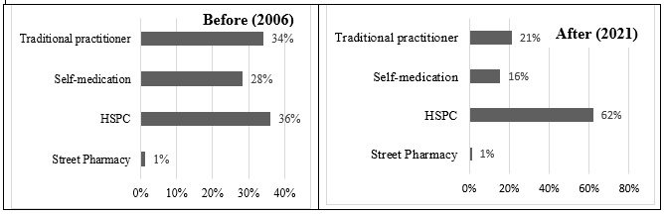
Source: Field surveys, November 2020-April 2021

Figure 5. Attendance at HSPC’s before and after the impounding of the Soum dam

Figure 5 shows a significant increase in the number of people (62%) attending the HSPC after the dam was impounded, i.e., after the market gardening activities. This indicates that economic means are a motivating factor in the use of modern medicine, since it can be seen that the use of traditional practitioners decreased by about 12.9% after the dam was put in place. The amount of money spent on medicines also changed. In fact, 91% of the operators inject financial resources into health. The amount of money devoted to the purchase of medicines changed before and after the dam was put in place (Figure 6).

Source: Field surveys, November, 2020; April, 2021

Figure 6. Financial resources invested in medicines

According to Figure 6, the development of the dam has increased the expenditure on medicines by 49.3% of respondents from one (class: 5,000-25,000) to twice (class: 25,000-50,000). In addition, 27.1% of respondents are now able to spend more than CFAF 50,000 per year on medicines. McCartney et al. (2001) estimate that the change in economic status brought about by the activities related to the operation of the dam has led to an improvement in health care for the populations living near the Soum dam. In the Yitenga watershed in Burkina Faso, Yonkeu et al. (2003) note that the increase in farmers' income increases their ability to access health services and drinking water.

Soum Dam: between health risks and waterborne diseases among operators

The income generated by the dam-related activities increases the use of local health structures such as the HSPC and pharmacies for health care. According to the field surveys and interviews with the head nurses, there are two types of health problems resulting from the installation of the dam.
The first is indirect and comes from socio-economic activities such as market gardening induced by the presence of the dam. Indeed, through the arduous work and the consumption of vegetables exposed to pesticides, the farmers are exposed to health risks. These are general fatigue, digestive diseases, chest pains and aches. However, general fatigue is more frequent than the other risks (Figure 7).
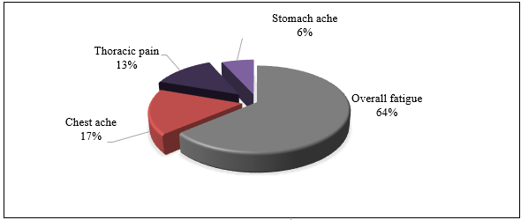
Source: Field surveys, November 2020 - April 2021

Figure 7. Health risks induced by market gardening around the Soum dam

The second type is a direct consequence of the presence of the water body. The latter results from the humid environment induced by the presence of the dam, which favours the development of mosquitoes such as the female anopheles and other parasites responsible for diarrhoea. This case was perceived in the riparian areas of the Boura Dam (Sanou, 2016).
As a result, 95% of medical examinations in the HSPCs revealed malaria during consultations and 5% of these consultations also showed cases of diarrhoea. Moreover, we note, that malaria is more widespread over several months than before the dam was impounded (Figure 8). The work of Sanou (2016) shows that diarrhoea and especially malaria became permanent after the installation of the Boura dam, in the center-western Burkina Faso.

Before  (2006) | After  (2020)
Source: Field surveys, November 2020 - April 2021

Figure 8. Evolution of malaria periods before and after dam impoundment

Figure 8 shows that the occurrence of malaria was high in July, August and September before the dam was impounded. However, after the dam was impounded, the frequency of cases also increased in April, May and June. This means that farmers are more affected by malaria throughout the year. Farmers located 500 m from the dam are more affected by malaria than those located 1000 m away. On the other hand, the presence of large dam-related diseases such as malaria is mentioned by other authors. For Gioda (1993), the presence of dams creates an ecological imbalance that leads to the proliferation of biological species, including disease vectors. Also, Jobin, 2004, notes that in tropical regions, water-related diseases such as malaria, yellow fever, schistosomiasis, cholera, typhoid fever and river blindness are frequently observed in people living near dams. In Burkina Faso, Zoungrana (2002) and Sanou (2015), make the same observations and note the occurrence or resurgence of some water-related diseases, including malaria and schistosomiasis, among dam operators. Conant and Fadem (2008) also show that the new environment created by the dam favours the proliferation of black flies that spread river blindness and snails that carry blood fluke. Yewhalaw et al. (2013) further note that villages along the Gilgel-Gibe hydroelectric dam in Ethiopia face an increased risk of malaria incidence and/or extension of the malaria transmission period. For example, in sub-Saharan Africa, between 0.7 and 1.6 million cases of malaria per year are attributable to large dams (Kibret et al., 2019). Endo and Eltahir, (2018) note, however, that the presence of the dam is not the only factor in the increase of malaria, but that the wind direction also contributes to the occurrence of malaria, for example in areas along the Koka Dam in Ethiopia. However, in Nigeria, the dam adjacent to the University of Ilorin does not have a significant negative impact on the health of the university community (Bilewu and al., 2017). Thus, Sanou (2016) believes that in addition to climatic conditions, the perception and behaviour of the population are also explanatory factors of health risk in Boura in the Sissili province of Burkina Faso.
The wells around the dam dry up between February and June of each year. The other nearest wells are located between 1 and 3 km from the houses. Since they do not have the means of transport to travel these distances to obtain water from the borehole, the available and accessible water from the dam becomes the palliative solution for the women. This distance from the drinking water supply of the Soum dam leads to risky behaviours that can cause illness among farmers.
Indeed, the market gardeners around the Soum Dam use water from the dam for irrigation, but also for washing, washing dishes, cooking and drinking without prior treatment to eliminate possible disease germs. Of the 155 market gardeners interviewed, 95.48% stated that they quench their thirst and wash themselves with water from the dam, which they consider to have no effect on their health (Figure 9).

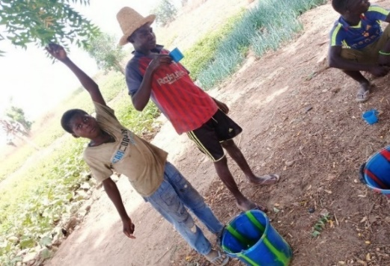 | 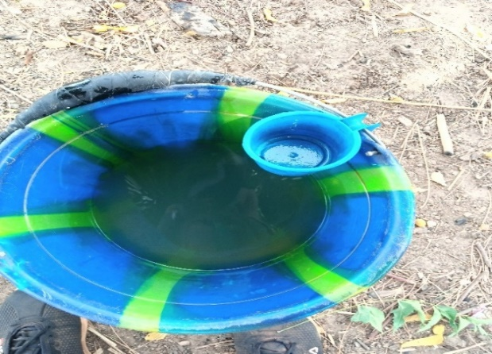
Source: Field survey

Figure 9. Child drinking water from the dam without prior treatment

Domestic use, consumption and swimming in dam water present health risks for users. According to Lévêque (2005), calm, micronutrient-rich waters such as those of dams are home to blue-green algae or cyanobacteria. These cyanobacteria produce cyanobacterial toxins that can cause skin irritation, stomach cramps, vomiting, nausea, diarrhoea, fever, angina, headaches, muscle and joint pain, blisters around the mouth, and liver damage in children who bathe and in families who drink this contaminated water. In the Yali Falls and Lower Sesan 2 dams in northeastern Cambodia and the Central Highlands of Vietnam, respectively, poor dam water quality is causing health problems, and sometimes death (Soukhaphon et al., 2021).

Conclusion

The construction of the Soum Dam is supposed to reduce poverty and ensure food security for the local population. However, health issues are overlooked. Thus, the impounding of the dam has contributed to an increase in the use of the HSPC and the purchase of medicines. This evolution is the result of the income received by the local residents, which allows them to attend the health centres and to purchase pharmaceutical products. The fact remains that the humid environment induced by the presence of the dam leads to waves of malaria among the farmers.
Despite free health care for children under 5 years of age, there is a need for continuous distribution of mosquito nets to help households living near the dam to fight malaria. The authorities involved in the management of the works should encourage the use of biological products in order to limit the uncontrolled use of chemicals that expose dam users to health risks. The influx of migrants to the Soum dam could constitute a risk of sexually transmitted infections (STIs) in the villages bordering the dam. Awareness campaigns must therefore be initiated among the users of the dam.

References

Bilewu, S. O., Ayanshola, A. M., & Salami, A. W. (2017). A rapid health impact assessment of the university of ilorin dam. Nigerian Journal of Technology, 36(1), 235-240.
CDP Soaw, 2018-2022. Municipal Development Plan, 234p.
CDP Nanoro, 2014-2018, Communal Development Plan, 215p.
Conant, J., & Fadem, P. (2008). Large Dams Damage Health. Dans A Community Guide to Environmental Health (pp. 169-173). California: Hesperian Foundation.
Endo, N., & Eltahir, E. A. (2018). Prevention of malaria transmission around reservoirs: an observational and modelling study on the effect of wind direction and village location. The Lancet Planetary Health, 2(9), 406-413.
Gioda, A. (1992). The same causes do not produce the same effects: water works, health and development. Science and Global Change/Drought, 3(4), 227-234.
Kibret, S., Lautze, J., McCartney, M., Nhamo, L., & Yan, G. (2019). Malaria around large dams in Africa: effect of environmental and transmission endemicity factors. . Malaria journal, 18(1), 1-12.
Lerer, L. B., & Scudder, T. (1999). Health impacts of large dams. Environmental impact assessment review, 19(2), 113-123.
Lévêque, C. (2005). Consequences of dams on the environment. The symposiums of the French Academy of Agriculture. irrigation and sustainable development, 1, 33-34.
McCartney, M. P., Sullivan, C., Acreman, M. C., & McAllister, D. E. (2001). Ecosystem impacts of large dams. Background paper, 2. Prepared for IUCN / UNEP / WCD.
National Economic and Social Development Plan (NESDP),2016-2020,88p
Recensement général de la population et de l’habitation (RGPH). (2006). Poverty Measurement and Mapping. Ministry of Economy and Finance.
Sanou, K. (2016). The health risk around the Boura dam in Sissili, Burkina Faso. Dans E. W. Vissin, H. S. Totin Vodounon, & C. S. Houssou, Climate Risks and Disasters: Vulnerability and Adaptation in West Africa, Volume 1: Climatology and Environment, Laceede (pp. 375-383). Bibliothèque Nationale du Bénin, 3ème trimestre.
Sanou, K., Dipama, J.-M., Fusiller, J.-L., & Cecchi, P. (2015). Contribution of small dams to food security in Burkina Faso: the case of the Boura dam. Dans G. Baba, (dir), What contribution of universities to development in Africa? African Studies (pp. 577-593). Paris: L’Harmattan, Comité Scientifique et Comité de Rédaction, Vol. 1.
Skinner, J., Niasse, M., & Haas, L. (2009). Sharing the benefits of large dams in West Africa. London: International Institute for Environment and Development (IIED).
Soukhaphon, A., Baird, I. G., & Hogan, Z. S. (2021). The impacts of hydropower dams in the Mekong River Basin: A review. Water, 13(3), 1-18.
William, J. (2004). Prediction of health hazards in tropical reservoirs and evaluation of low-cost methods for disease prevention . UNHYDRO, Beijing, 1-8.
Yanogo, P. I. (2006). Large-scale hydraulic developments and food security in Burkina Faso
: Farmers' strategies for adaptation, the case of the upstream part of the Bagré dam. DAS thesis, Geography, University of Abomey Calavi, Faculty of Arts and Humanities, multidisciplinary doctoral school, "Spaces, Cultures and Development".104p
Yewhalaw, D., Getachew, Y., Tushune, K., Kassahun, W., Duchateau, L., & Speybroeck, N. (2013). The effect of dams and seasons on malaria incidence and anopheles abundance in Ethiopia. BMC Infectious Diseases, 13(1), 1-9.
Yonkeu, S., Maïga, A. H., Wethé, J., Mampouya, M., & Maga, G. P. (2003). Socio-economic conditions of populations and disease risks: The Yitenga dam watershed in Burkina Faso. VertigO- la revue électronique en sciences de l'environnement, 4(1), 1-15.
Zongo, R. (2022). Hydro-agricultural development and sustainable development of the villages along the Soum dam in Boulkiemdé, Burkina Faso (Master's thesis). Retrieved from Geography, Regional planning and local governance, Norbert Zongo University
Zoungrana, T. P. (2002). The impact of hydro-agricultural development on the health of populations in Burkina Faso: the case of Bagré. Cahiers de géographie du Québec, 46 (128), 191-212.

