Culture-based economy of the border town: A case study of Tumpat, Kelantan

Yap Sui Chai¹, Ng Kah Choon²
¹ Center for Housing Study, Building and Planning, University of Science Malaysia
² Department of Geography, Faculty of Arts & Social Sciences, University of Malaya

Correspondence: Ng Kah Choon (email: kahchoon.15@gmail.com)

Received: 6 November 2022; Accepted: 6 August 2023; Published: 30 August 2023

Abstract

A culture-based economy is a form of an economic sector that is particularly important in rural areas of many Southeast Asia countries. However, this industry has received limited attention within the research community. There are many culture-based economic sectors worldwide, but for this study, we focused on three main sectors, which are traditional food products, handicraft products, and cultural products. This study aimed to discover the factors and importance of these sectors in Tumpat, Kelantan. We conducted semi-constructed interviews with local entrepreneurs in the study area. Data were analyzed using the inductive content analysis method. We extracted the interview result based on two main categories: the factor of starting a business and the importance of the clustered pattern of culture-based business. The result demonstrated that the factors influencing business location in the study area were family heritage land, accessibility to resources, easiness of transportation, and readiness of potential workers. This study also revealed that these businesses were in the clustered pattern to reduce the production cost, share information and technology, and improve market size. The study provides an overview on the factors and significance of culture-based economic activities in Tumpat. Moreover, we also encourage more stakeholders to support and promote these culture-based economic activities in developing countries.

Keywords: Cultural economy, factors, importance, local community, Tumpat

Introduction

Every community has its own culture. Culture comprises tangible and intangible concepts that reflect human viewpoints, principles, and perspectives in everyday life (Haviland, 2002). The presence of multiple cultures in a region brings positive impacts to the economic growth of the suburban area residents. Furthermore, creative tourism can generate revenue to improve the living standards of the local community (Dias et al., 2021). Handicraft-based products, traditional food, and art are culture-based economic activities in the local tourism industry (Mitchell et al., 2007). We can understand this industry by using the sectoral delineation of the cultural economy, the labor market and production organization approach, the creative index definition, and the convergence of formats as defining features of the cultural economy (Gibson & Kong, 2005). Cultural activities and heritage can forge a distinct sense of regional identity (Raagmaa, 2002; Mitchell et al., 2007).
The concept of a culture-based economy, developed by Ray and Sayer (1999), provides a framework for identifying natural resources or cultural knowledge available for regional economic growth. According to Crang (1997), the economy is embedded in the culture and represented through social media. Factors influencing the location of a business include the suitability of the place and the availability of resources. Lack of infrastructure and access to skilled labor could hinder the development of cultural industries in developing countries.
Tumpat is a Kelantan province on the east coast of Peninsula Malaysia, known for its rich culture, natural resources, local traditions, and traditional foods (Hanan et al., 2017). This district has cultural activities like shadow puppetry (Yousof & Khor, 2017), kite-flying (Nihau & Radzuan, 2019), and woodcarving (Shaffee & Said, 2013), as well as musical performances like Mak Yong (Harwick, 2020) and Dikir Barat (Shuaib & Olalere, 2013), which contribute to the economic growth of Kelantan. This state is also well known for producing batik and songket fabric for traditional and modern fashion industries of Southeast Asia. The preservation of these industries is critical because they provide income for the local people while also preserving their culture and legacy for young generations (Yusof et al., 2013).
Tumpat district is unique in terms of cultural products resulting from Malays and Siamese assimilation. The close association of these races produces a distinct culture, particularly the production of traditional foods (Ahmad, 2011). Most of the residents in this district speak Thai and have a mixed Kelantan accent, as pointed out by Ismail and others (2021). This circumstance distinguishes Tumpat and draws the attention of researchers during the research process. In terms of art, a few Siamese locals practice the Thai tradition and perform Siamese dance. The assimilation of different cultures has resulted in the Tumpat area's uniqueness as a study location. This research can provide information on the factors and significance of culture-based economic activities in Tumpat. It also brings more tourists to visit this location. Furthermore, it can encourage more investors to invest and state government agencies to support the expansion of these economic activities. The study aimed to investigate the factors of location choice for culture-based economy and the importance of clustered culture-based economy in Tumpat, Kelantan.

Materials and method

This study focused on the Tumpat province of Kelantan on the east coast of Peninsular Malaysia (Figure 1). The data collection was conducted during the period of September 2019 to February 2020. The culture-based economy in Kelantan is more focused on handicraft products, arts, and traditional food. The researchers obtained these data from the Kelantan State Economic Department and the Kelantan State Arts and Culture Department. After getting culture-based economy data, the researchers contacted these entrepreneurs in the Tumpat district to screen the data so that only entrepreneurs who are actively involved in the culture-based economy as respondents for the study.
After getting the entrepreneur details, the researchers formulated interview questions for entrepreneurs actively involved in the cultural economy and conducted the interview process. During the data screening process, the researchers found that as many as 25 entrepreneurs were actively in the culture-based economy in Tumpat, but only 20 respondents were willing to participate in the interview. The researchers used content analysis to analyze the interview transcripts. Coded scripts were categorized based on different themes. When analyzing the pattern of the location of these businesses, the researchers noticed similar types of culture-based businesses near each other. Therefore, we also used the coded scripts to analyze the importance of the clustered patterns for these culture-based businesses.

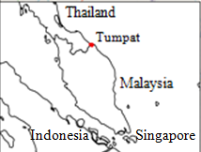
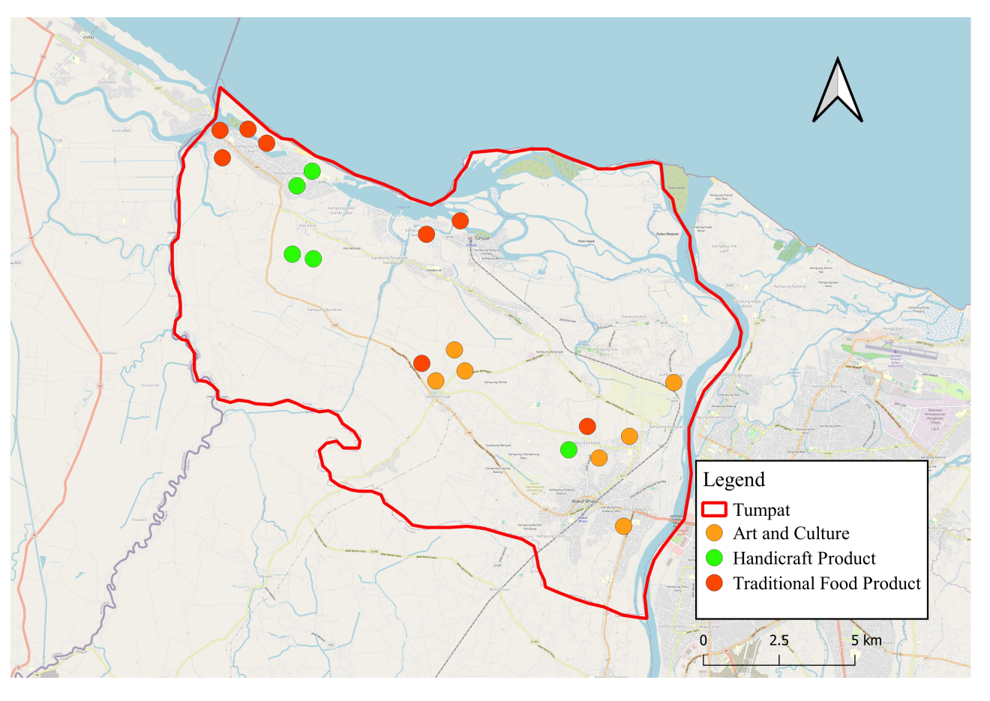

Figure 1. Location of art and culture, handicraft product, traditional food product business in Tumpat, Kelantan.

Tumpat district borders Thailand and the northern part of the state of Kelantan. Kelantan is a state well known for its distinct culture and traditional values (Ahmad, 2011). Tumpat was chosen as the study location because it is different from other districts in the state of Kelantan in terms of traditional and cultural practices. The total population was about 143,793 people in the study area based on the 2010 census (Department of Statistics Malaysia 2010). The uniqueness of the local economy, culture, and traditions has resulted from the specialty of this location. In terms of traditional food, the types and methods of preparation of traditional food in Tumpat have more in common with Thai society. Traditional foods in the Tumpat area include lekor chips, budu, dried fish, mango glutinous rice, mango kerabu, and smoked etok salai.

Results and discussion

This study aimed to investigate the factors of location choice for culture-based economy and the importance of clustered location of culture-based economy in Tumpat, Kelantan. In the study, 20 respondents from culture-based companies were interviewed in Tumpat, Kelantan. The study includes 8 respondents from the traditional food sector, 7 from the art and culture industry, and 5 from the handicraft industry. Respondents’ age ranged from 35 to 89 years. In terms of educational background, 80% have not received tertiary degree. The motivations for beginning a business are as follows: interest (10 respondents), family business (6 respondents), and support family (4 respondents). Their monthly earnings ranged from RM1000 to RM30000. The reasons of choosing location includes family land/inheritance (6), labor available (3), near to beach (2), near to port (2), own land (2), near to forest (2), and near to road/industrial area (2). Table 1 further emphasizes the importance of the location in which they choose to establish their businesses.
A fried fish business in Kelantan involves preparing and selling fried fish dishes, which are popular in the region due to its coastal location and fishing culture. Drying fish is a traditional method of preserving fish and is commonly practiced in coastal regions as shown in Figure 2. In Kelantan's sunny climate, sun drying is a common method. Place the drying rack in direct sunlight. The heat and airflow will gradually remove the moisture from the fish. The coastal area of this state is known for its unique culinary traditions, and fried fish is a staple in many local dishes.
Fish crackers, known as "keropok lekor" in Kelantan and other parts of Malaysia, are a popular traditional snack made from fish paste and other ingredients (Figure 3). They are a popular snack in the region and have become a significant part of Kelantan's culinary culture. The main ingredient in keropok lekor is fish, often a combination of mackerel and sardines. The fish is cleaned, deboned, and minced to create a paste. Other ingredients typically include sago flour or rice flour, salt, and sometimes additional flavorings such as pepper or spices. While keropok lekor is still made in homes using traditional methods, it is also widely available in markets, food stalls, and specialty shops throughout Kelantan and other parts of Malaysia.

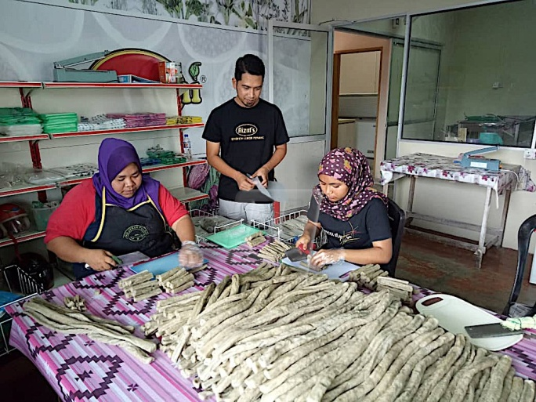
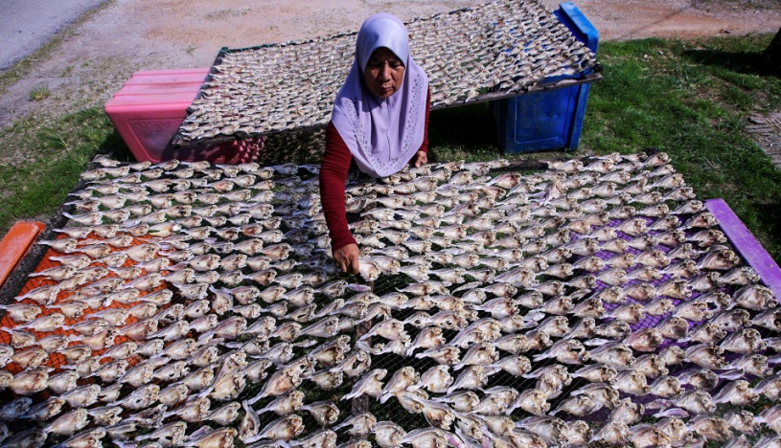

Source: Aid, 2021 Source: Ramli, 2019

Figure 2. Ikan kering (dried fish) Figure 3. Keropok (fish cracker)

Table 1. Summary of participant’s characteristics (N=20; F-traditional food product, A-art and culture, and H-handicraft)

No. | Product | Age | Education level | Reason for starting business | Net monthly income (RM) | Total worker | Reason choosing location | Satisfied to the location | Importance of location
F1 | Dried fish | 56 | Form 3 | Interest | 4,000 | 6 | Near to beach | Yes | Near to beach
F2 | Dried fish | 43 | Form 3 | Family business | 3,500 | 4 | Near to port | Yes | Customers can find this place easily
F3 | Dried fish | 65 | No | Interest | 3,700 | 8 | Near to port | Yes | Customers can find this place easily
F4 | Fish cracker | 78 | No | Support family | 8,000 | 18 | Family inheritance | Yes | Spacious land and there is no need to pay rent
F5 | Fish cracker | 74 | No | Support family | 5,000 | 7 | Family land | Yes | Customers can find this place easily
F6 | Budu | 78 | Primary school | Interest | 6,000 | 7 | Near to local villagers | Yes | No need to pay rent
F7 | Budu | 56 | Form 3 | Support family | 30,000 | 50 | Many employees | Yes | Easy to get employees
F8 | Laksam | 70 | No | Support family | 2,800 | 5 | Family land | Yes | Near to the main road
A1 | Rebana Kercing | 71 | Standard 6 | Interest | 1,000 | 20 | Family inheritance | Yes | Near to home
A2 | Traditional music instrucment seller | 79 | Bachelor’s degree | Interest | 1,000 | 15 | Near to road | Yes | No
A3 | Shadow puppetry | 60 | Bachelor’s degree | Interest | 2,000 | 20 | Near to road and industrial area | Yes | No
A4 | Shadow puppetry | 35 | Secondary school | Family business | 2,500 | 5 | Own land | Yes | Near to resources
A5 | Serunai | 85 | Primary school | Family business | 2,000 | 2 | Near to forest | Yes | Accessible to new machines
A6 | Menora | 87 | Bachelor’s degree | Interest | 2,500 | 20 | Labor available | Yes | Students can easy find this place
A7 | Dikir barat | 40 | Secondary school | Interest | 1,000 | 20 | Labor available | Yes | Many charcoals and costumers can find this place easily
H1 | Batik | 56 | Diploma | Family business | 5,000 | 25 | Family heritage land | Yes | Accessible to new marketing strategy
H2 | Krat Buluh | 42 | Secondary school | Family business | 3,000 | 3 | Family heritage land | Yes | Easy to obtain resources
H3 | Jebak Puyuh | 89 | Primary school | Interest | 3,000 | 4 | Near to forest | Yes | Customers can find this place easily
H4 | Wau | 76 | Primary school | Interest | 3,500 | 2 | Near to beach | Yes | Customers can find this place easily
H5 | Batik | 46 | Secondary school | Family business | 4,000 | 16 | Own land | Yes | Easy to get employees

Budu is a traditional Malay condiment composed of fermented fish sauce that is widely used in Kelantanese cuisine and has a distinct flavor. It holds cultural importance in Kelantanese cuisine and considered a traditional delicacy that has been enjoyed for generations. The preparation and use of Budu are passed down through families and communities, preserving the culinary heritage of the region, which can be found in local markets, traditional food stalls, and households across Kelantan. In general, it is made from anchovies or other small fish that are salted and fermented. The fermentation process can take several months. Figure 4 shows the preparation of fermentated anchovies sauce in a homebase workshop. The fish are layered with salt in large containers, usually earthenware jars, and left to ferment in a warm and humid environment. During fermentation, the fish break down and release their flavors into the liquid. When preparing a budu dipping sauce, the fermented liquid is often mixed with lime juice, chilies, and sometimes shallots or other aromatics to balance and complement the intense flavor.
Figure 5 illustrates the traditional Laksam of Kelantan. Laksam is a Malaysian dish that is particularly popular in the state of Kelantan. It is a type of noodle dish that features wide rice noodles served in a rich and creamy coconut milk-based gravy. Laksam consists of wide rice noodles, coconut milk-based gravy, aromatics and herbs. The Laksam noodles are thicker and wider than typical rice noodles and are the base of the dish. For gravy, it is coconut milk-based gravy which is made with coconut milk, fish, herbs, and spices. It's what gives Laksam its creamy and flavorful character. The fish used in Laksam is often flaked and incorporated into the gravy. The dish is also eaten with aromatics and herbs like turmeric, galangal, lemongrass, and sometimes shrimp paste are used to create the aromatic and flavorful gravy.

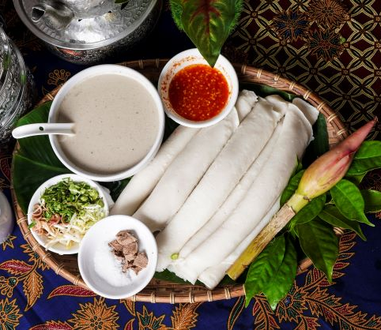

Source: (Nadzi, 2021)*

Figure 4. Budu (fermented anchovies sauce)* Figure 5. Laksam

Rebana Kercing is a type of traditional drum performance that holds cultural significance in Malaysia and other parts of Southeast Asia (Figure 6). It's commonly used in various cultural and religious performances, particularly in Malay and Islamic contexts. The term "rebana" generally refers to a type of frame drum, and "kercing" refers to the jingles or cymbals attached to the drum. The frame of the drum is circular or oval in shape and is equipped with ropes or cords to tighten the drum head. It is often associated with Islamic religious practices, such as during the celebration of Eid al-Fitr or other festive occasions. The performance is often played in groups, with multiple drummers coming together to create synchronized rhythms and patterns. In addition to its cultural significance, the drum also plays a role in fostering a sense of community and unity during performances and celebrations.
The authors interviewed a wayang kulit (shadow puppetry) maker, who works in this traditional industry for twenty-two years (Figure 7). The performance is a a captivating art form that is unique to the state of Kelantan in Malaysia. It is a cultural performance that combines storytelling, music, and visual art, and it has a significant place in Kelantanese heritage. It involves the use of intricately crafted leather puppets that cast shadows on a backlit screen. The puppeteer, known as a "Tok Dalang," manipulates the puppets behind the screen to create characters and scenes. The puppets used in Wayang Kulit Kelantan are carefully crafted from buffalo hide or cowhide. They are intricately carved with fine details, allowing for complex and expressive silhouettes. They are manipulated using rods and sticks, and the movements are synchronized with the narrative.
The performances are based on traditional narratives, often drawing from historical epics, legends, religious stories, and local folklore. Tok Dalang uses a combination of vocal narration, dialogue, and songs to tell the story, bringing the characters to life through their movements and interactions. It is not only a form of entertainment but also a cultural expression that reflects the heritage, values, and beliefs of the Kelantanese community.

Figure 6. Rebana Kercing (traditional dance)* Figure 7. Wayang kulit (shadow puppetry)*

In Kelantan, serunai refers to a traditional musical instrument that holds cultural significance in the region (Figure 8). The serunai is a double-reed instrument made of bamboo that produces distinctive melodic and rhythmic sounds. It is commonly used in various cultural and ceremonial contexts. The serunai is a wind instrument made from bamboo. It consists of two bamboo tubes, one serving as the main body of the instrument and the other acting as a resonator. It is often played during various ceremonies, such as weddings, cultural festivals, religious processions, and other celebratory events. Figure 8 shows a serunai performer, known as a "penggawa serunai," is skilled in playing melodies and rhythms on the instrument. The instrument and its players hold cultural significance as they contribute to the overall atmosphere of cultural events and help preserve traditional practices.
Figure 9 shows Kelantan Menora dance that is characterized by its vibrant costumes, rhythmic movements, and incorporation of elements from local folklore and Islamic traditions. It is a traditional dance drama that combines dance, music, storytelling, and acting. It is typically performed by a group of male dancers, accompanied by traditional musical instruments such as drums, gongs, and other percussion instruments. The dancers wear elaborates and colorful costumes, often with ornate headgear and accessories. The costumes are designed to reflect the characters and themes of the performance. They can include outfits representing both humans and supernatural beings from local folklore. Some Menora performances are considered ritualistic and are performed as part of religious ceremonies and cultural festivals and it is sometimes believed to have protective and spiritual qualities.



Figure 8. Serunai (traditional musical instrument)* Figure 9. Menora (Azlan, 2021)

Dikir Barat is a traditional form of group singing and musical performance that originated in Kelantan, Malaysia (Figure 10). It is a distinctive cultural expression that involves rhythmic chanting, singing, and percussion instruments. It is not only a form of entertainment but also a means of fostering community spirit, cultural identity, and social cohesion. Dikir Barat involves a group of performers who sing in unison, accompanied by percussion instruments such as the "rebana" (a type of drum) as shown in Figure 9 and "gong" (a metal percussion instrument). The lyrics of Dikir Barat often revolve around themes of praise, religious devotion, cultural pride, and community values. The songs can be based on a variety of topics, including historical events, legends, and local folklore. Dikir Barat is often performed during cultural events, religious ceremonies, festivals, weddings, and other celebrations.
According to the interviewer who works in batik production (Figure 11), Kelantan batik is characterized by its intricate motifs and vibrant color combinations. The designs often draw inspiration from nature, local flora and fauna, geometric patterns, and cultural elements. It is a traditional form of batik textile art that originates from the state of Kelantan, Malaysia. Batik is a technique of creating intricate patterns and designs on fabric using wax resist and dyeing processes, it is well known for its unique patterns, vibrant colors, and cultural significance.

Figure 10. Dikir barat (traditional performance)* Figure 11. Batik (colored cloth)*
Kraf buluh (bamboo craftsmen) in Kelantan use traditional techniques to transform rattan into a wide range of products (Figure 12). Bamboo handicraft in Kelantan refers to the traditional craft of creating various products using rattan, a type of flexible and durable palm that is native to Southeast Asia. Bamboo is known for its strength and versatility, making it a popular material for crafting furniture, accessories, and decorative items to represent the heritage and craftsmanship of the region.

Figure 12. Kraf buluh (bamboo handicraft)* Figure 13. Jebak Puyuh (Quail Trap)*

The interviewer has created traditional Malay kite for his whole life as shown in Figure 14. Kelantan wau are traditionally made using bamboo for the frame and lightweight paper or cloth for the kite surface. 'Wau' or 'kite flying' is a traditional game that was classified as a national hertiage site in 2009. It is a traditional pastime with distinct artistic elements. The season of kite flying is the preparation for the fishermen's community to know whether the weather is good or not to go fishing (Bakar et al., 2022).

Note: * Pictures taken by researchers, 2017

Figure 14. Wau (traditional kite)*

Factors influencing business location selection

Family heritage land

Inheritance land, also known as family heritage land, is land passed down from ancestors to the next generation. According to interviews with respondents, the following factors influence the location of the entrepreneur:

a) Inheritance land/family gifted land
b) The original site of the family business
c) Own land

- Inheritance land/family gifted land

Most culture-based business owners said choosing its location because it was family land. This business premise was inherited by family members, making it simple for them to use the land as a business location. Respondents K4 who are involved in the art business stated that

“...this is family-owned land, so it is easy to start my own business...” [A4, 35 years old].
“...Since childhood, I have been interested in rebana kercing following my uncle, since then I have followed his footsteps until I am over 34 years old now...” [A1, 71 years old].

- The original site of the family business

The choice of location as a culture-based economic enterprise site in the study area was influenced by several factors, one of which was the location of the family business location. Three respondents (F8, F4, and F2) informed that they are continuing this family business due to the business location. These respondents included people who worked in traditional food businesses like laksa and dried fish. The following quotes demonstrated that the respondent has been in business for more than 30 years at the current location and has carried on a family tradition.

“...I started just assisting the family, but as time went on, I got accustomed to the task of processing dried fish and carried on the family business...” [F2, 43 years old].
“...this business has been operating for more than 30 years and was originally family-owned...” [F8, 70 years old].

- Own land

The land is private property, so the land owner can easy to modify the business scope, such as by expanding the business.

“...I chose this location because it is my land, making it simple for me to expand the business size in the future...” [F4, 78 years old].

In addition, some respondents thought that the location selection factor was also due to private land policy, which can reduce their land rental costs.

“...because the land site is our property, this location is suitable for a cracker company. We do not have to worry about the rental cost on our land site...” [F4, 74 years old].

According to these land owners, they have to take full responsibility for the land and property. Although this area is prone to severe monsoon flooding annually, these Kelantanese landowners claimed that there was no evidence of property value decline following flood events. Despite having a flood risk in their immediate surroundings, there was evidence that property values in those neighborhoods had continued to rise over time (Abd Hamid et al., 2020).

Near to resources

Natural resources are a feature that contributes to the growth of culture and the economy (Porter, 1996; Scott, 1999). According to the study's findings, five entrepreneurs said that because the location is near raw materials, they chose this place for their businesses.

- Resources are available

Resources are substances created from natural substances and provided by the earth. Resources are a special agent and a form of economic development in the context of cultural economy. Forest and marine resources are two examples of natural resources that contribute to the development of the cultural economy. For instance, businesses engaged in traditional foods, crafts, and the arts frequently use natural resources as their primary raw materials.

“...I could get rattan sources in the backyard of my house...” [H2, 79 years old].

According to this quotation, the resources required to produce goods are easily accessible and located nearby the business owner. This circumstance has the potential to accelerate product processing, which agreed with the conclusion reached by Cissé and others (2020) in the study that location decisions for new primary sector businesses are related to the presence of benefits arising from the existence of natural resources as raw materials for the entrepreneur.

- Resources near the port

The proximity of marine resources to economic activities facilitates the processing activities required to produce goods like dried fish and budu. Respondents M6 and M3 said that the location near a beach or fishing pier is more likely to be picked as a suitable business location. It may be simpler for the dried fish business owners to obtain a selection of fresh fish at a lower cost if it is close to the port jetty.

“...the place of business needs to be close to the jetty so that fish can be easier to get for budu processing...” [F6, 78 years old].

“ ...close to the jetty to get a wide selection of fresh fish for our business...” [F3, 65 years old].

This result agreed with the research done in the coastal area of Kejawan in Indonesia, stating fishing ports are one component of a centralized supply chain system for local fish businesses (Gumilang & Susilawati, 2019).

Transportation network

According to the analysis, the accessibility of the transportation system affected the location for starting a business.

“...the location close to the road makes it easier for suppliers to send traditional musical instruments to the business location...” [A2, 79 years old].

This respondent works for a traditional musical instrument business believing that choosing the business location close to a road network area will make it easier to transport products.
Furthermore, some respondents believed that the choice of locations for economic enterprises in Tumpat Kelantan was affected by infrastructures such as roads and boats. Respondent K3 claimed that those actively involved in wayang kulit believe that the location of the business is crucial for wayang kulit promotion, particularly in terms of a public relations strategy.

“...Locations with access to roads will make it simpler to attract more audiences...” [A3, 60 years old].

Therefore, the ease of the road network can support businesses in transporting resources and marketing strategies, and the choice of the economic and cultural location in Tumpat Kelantan.

Availability of labour/students

The factor in the progression of culture-based economic development is the labor force. The presence of a labor force, particularly in operations involving the local population, can accelerate the economy and culture. Tumpat district of Kelantan, culture-based economic enterprises typically employ local workers who reside nearby, according to the study's analysis.

- Easy to recruit labour/students

Locals and inhabitants of neighboring villages make up the labor force used in the economic and cultural activities of Tumpat. Due to the diversity of its communities and races, Tumpat has developed its own distinctive culture, particularly in its artistic endeavors. The development of Siamese villages, particularly in Kampung Kok Seraya and Kampung Jong Bakar, is a result of the proximity to the Thai border. The residents of these rural areas are mainly of low-income families, which are suitable human resources in the study area because they understand the local cultures and need a job to earn money. At the same time, these business operators need more workers to support the business.

- Lower labour cost

Additionally, the lower living cost of the suburban area also causes local employees to be satisfied with a lower income compared to big cities such as Kuala Lumpur. Therefore, low labor costs influence where businesses locate their operations in the study area. For instance, the average monthly wage for employees at the budu factory is only RM650, and the maximum is no more than RM1,000.

The importance of the clustered culture-based economy

When analyzing the pattern of the location of these businesses, the researchers noticed similar types of culture-based businesses near each other. Therefore, we suspected that there could be some reasons and importance for having clustered patterns in the study area.

Reduce production costs

The distribution pattern of the clustered cultural economy in the Tumpat district of Kelantan is significant for businesses, particularly in reducing the costs associated with product production. Production costs are expenses incurred while processing the goods.

“…many forest products, including rattan and bamboo, are available in Kampung Talak, and the majority of those who collect them are elderly people and young men from the community…” [H2, 42 years old].

Moreover, they also shared information and resources with nearby businesses to reduce material and production costs.

Figure 15. The Budu fermentation business is close to the jetty port

Additionally, the involvement of the traditional food businesses gathered around the port jetty increased the supply of marine resources like anchovies and gelama fish at more affordable prices (Figure 15). Because labor and resource costs are low, businesses can control their production costs. According to F7, the average net profit of producing one big budu is RM1000, and the monthly net return is over RM5000.

“... compared to the wet market, the price of fish is lower at the port pier...” [F5, 74 years old].
“ ... the daily wage of dry fish processing is RM30...” [F2, 43 years old].
“... many villagers collect forest products as a side income...” [H2, 42 years old].
“…the price of fish near the jetty is more reasonable, there are many options…” [F7, 56 years old].

These responses illustrated that the price of fisheries is lower at the port compared to the wet market because of the logistic and human costs incurred in the price of these fisheries at the wet market. Apart from producing dried fish and other local works, they also collect edible natural resources from forests and sell them to the neighborhood that needs these forest products. They often did this in a group to save transportation costs.

Technology and information exchange

The distribution of information and technology is convenient in the presence of a transportation network. As a result of the economic and cultural distribution pattern in Tumpat being more concentrated in areas near the road network, information and technology are more easily spread. According to Quah (2002), an economic cluster will lead to increased competition between businesses and then promote the use of new technology and innovation.
Due to the intense competition, business owners had to invest money to upgrade equipment and production techniques.

“…the introduction of Lekor cracker processing machines has changed innovation and technology. Lekor crackers by hand; however, with the emergence of competition and the spread of information, machine use has become more popular. Due to this circumstance, more and better products are available now” [F4, 78 years old].

These machines can produce standardized food products in a short time. Furthermore, they reduce labor costs and reliance on labor because fewer workers are needed to operate these machines in the workplace. Quah (2002) stated that the clustering of the cultural economy led to increased competition between businesses and encourage the use of new technology and innovation. However, they also shared knowledge, raw materials, and products with their business friends nearby.

Figure 16. The introduction of keropok lekor processing machine

“…Changes in the result of strong competition, entrepreneurs need to spend capital for machine tools and processing methods. For example, there is a change in innovation and technology for producing lekor crackers. In the beginning, we produced lekor without using machines, but with competition and information, the use of budu marketing machines has been encouraged.” [F4, 78 years old], (Figure 3).
“…ideas for packaging changes occur when there is consumer demand...” [F6, 78 years old].

New machines and technology in the study area enhanced the production scale and revenue as shown in Figure 16.

Figure 17. Changes of budu packaging shown by business owner

The uses of new machines and technology enhanced the production scale and revenue of the businesses in the study area. Additionally, the advancement of technology and information has enhanced product marketing strategies. For example, the packaging for traditional food items has been improved by using new technology, for instance, the packaging of budu was switched from bottle packaging to tube packaging (Figure 17).
When information exchange of ideas occurs, the purpose of this new packaging, according to F6, is to make it simpler for users to transport budu when traveling. As a result, the conversion of information and technology by the clustered culture-based economic distribution. Entrepreneurs have benefited from this situation in increased marketing and product production.

Increase market size

The findings revealed that cultural economy businesses have been in operation for more than 30 years, and their locations have long been known for their uniqueness. The specialness of this location has increased the functionality and enhanced the local economy. Traditional food businesses in the Genting Tumpat neighborhood are close to the port pier and beach area, such as the clustered distribution pattern in the Kampung Laut and Kampung Morak areas. The businessmen nearby cooperated to promote products and built friendship with each other. The region has become well-known for its distinct purpose and serves as a business marketing tool.
Once customers or buyers are familiar with the location, this can expand the market. For example, if there is a demand for dried fish products in Tumpat, customers or buyers will travel directly to Kampung Genting to buy dried fish. These business owners have a marketing plan to increase consumer demand.

“...this area makes it easier for shoppers to find this place...” [F1, 56 years old].
“...the company is more than 30 years old, buyers are familiar with this area...” [F3, 65 years old].
“...this location is suitable for promoting and introducing Pak Daim wayang kulit to the audience and understand this place better...” [A3, 60 years old].
“...although the location is far from town but buyers are used to and know this place...” [A5, 85 years old].

As a result, this clustered cultural-based economic activity is critical to the development of the business, particularly in terms of lowering production costs, sharing information among business owners, and expanding market size. According to Porter (1996) and Quah (2002), government agencies have less influence on the economic distribution of culture in small towns such as Tumpat. State authorities, such as the Kelantan State Fisheries Department in Tumpat, only provided financial and physical assistance, such as fish and budu storage bins, and did not interfere with government policies such as zoning.

Recommendation

The associated state agencies can improve accessibility and upgrade quality infrastructure in rural areas to close the urban-rural development gap in developing culture-based economies. For example, regional road projects such as the East Coast Expressway Project should be encouraged and promoted to widen the existing central spine federal road and upgrade existing coastal roads to attract more visitors and investors to the region.

Conclusion

Tourism activities are expanding in the studied culture-based economy in Tumpat, Kelantan. Culture-based economy is critical to assisting the local economic development process. The location and willingness of locals to participate in these businesses have impacted the existence and development of economic growth. According to the study findings, the main factors influencing economic and cultural distribution are family heritage land ownership, resource accessibility, and labor availability. In terms of the importance of clustered pattern, they can reduce production costs, encourage information and technology exchange and increase market size. This study can provide an overview of the current state of the culture-based economy in the study area. We hope that state agencies will put more effort into supporting the development of these industries by planning and implementing more adequate development plans for these small towns, particularly those prone to monsoon floods.

Acknowledgment

The authors would like to thank the University of Sains Malaysia for its research and administrative assistance with this project. We are also grateful to the respondents who agreed to be interviewed for the study.

Ethics Approval and Consent to Participation

The researchers used the research ethics guidelines provided by the Universiti Sains Malaysia Research Ethics Committee. Permission and consent following the study was also obtained from all study participants. All procedures performed in this study involving human subjects were carried out in accordance with the ethical standards of the institution's research committee.

References

Abd Hamid, A. A. A., Mar Iman, A. H., & Sathiamurthy, E. (2020). Flood Risk and Its Effect on Property Value in Kuala Krai, Kelantan. IOP Conference Series: Earth and Environmental Science, 549, 012074. http://doi:10.1088/1755-1315/549/1/012074
Ahmad, H., Jusoh, H., Siwar, C., Buang, A., Noor, M. S. H., Ismail, S. M., & Zolkapli, Z. A. (2011). Pelancongan budaya di koridor Ekonomi Wilayah Pantai Timur (ECER): Isu dan cabaran. Geografia-Malaysian Journal of Society and Space, 7(5), 180-189. http://www.ukm.my/geografia/images/upload/15.geografia-2011-4-sp-HABIBAHdkk-2.pdf
Aid, A. R. 2021. “Ikan masin pun susah nak jual ketika PKP”–Mak Cik Milah. https://utusantv.com/2021/02/01/ikan-masin-pun-susah-nak-jual-ketika-pkp-mak-cik-milah/
Azlan, N. (2021). Tak kenal seni manora maka tak cinta. https://baskl.com.my/tak-kenal-seni-manora-maka-tak-cinta/
Bakar, W. N. W., Awang, J., & Hasbullah, M. S. M. (2022). Wau bulan motifs on Kelantanese batik: An ethnomathematics study. Journal of Islamic, 7(47), 213-219.
Cissé, I., Dubé, J. & Brunelle, C. (2020). New business location: how local characteristics influence individual location decision. The Annals of Regional Science, 64, 185–214. https://doi.org/10.1007/s00168-019-00968-1
Crang, P. (1997). Geographies of Economies. Routledge.
Department of Statistics Malaysia. (2010). Total population by ethnic group, Local Authority area and state, Malaysia. Retrieved from https://mdtumpat.kelantan.gov.my/images/ Download/Info%20Penduduk%20Tumpat/pbt_kelantan.pdf
Dias, Á., González-Rodríguez, M. R., & Patuleia, M. (2021). Developing poor communities through creative tourism. Journal of Tourism and Cultural Change, 19(4), 509-529. https://doi.org/10.1080/14766825.2020.1775623
Getz, D. & Carlsen, J. (2005). Family business in tourism: State of the Art. Annals of Tourism Research, 32(1), 237-258. https://doi.org/10.1016/j.annals.2004.07.006.
Gibson, C., & Kong, L. (2005). Cultural economy: A critical review. Progress in Human Geography, 29(5), 541-561. https://doi.org/10.1191/0309132505ph567oa
Gumilang, A. P., & Susilawati, E. (2019). Supply Chain Analysis in the Distribution of Leading Commodity-Based Catches in PPN Kejawanan. Jurnal Ilmu dan Teknologi Kelautan Tropis, 11(3), 809-816. https://doi.org/10.29244/jitkt.v11i3.27408
Hanan, H., Aminudin, N., & Ahmid, A. Z. (2017). Perception of Kelantan Food Image among Tourists Visiting Kelantan. Celebrating Hospitality and Tourism Research Hospitality and Tourism Conference. Malaysia 7-8 October.
Hardwick, P. A. (2020). Mak Yong, a UNESCO" Masterpiece": Negotiating the Intangibles of Cultural Heritage and Politicized Islam. Asian ethnology, 79(1), 67-90. https://asianethnology.org/articles/2253
Haviland, W. A. (2002). Cultural anthropology. Wadsworth Publishing Company.
Ismail, M. B. M., & Ariffin, R. N. B. R. (2021). Challenges in accessing rural area and managing sub-culture differences in Kuala Krai, Kelantan, Malaysia. In Field Guide for Research in Community Settings (pp. 194-200). Edward Elgar Publishing.
Mitchell, J., Joshua, M. A., Bleecker, M., Carmen, J. L., Lee, A. R., & Billy, J. U. (2007). The economic importance of the arts and cultural industries in albuquerque and bernalillo county. Bureau of Business and Economic Research, University of New Mexico.
Mohamed Nihau, M. R. (2018). Traditional games: A study of Malaysian kites of Wau Bulan in Kelantan (Doctoral dissertation, Universiti Teknologi MARA). https://ir.uitm.edu.my/id/ eprint/21827/
Nadzi, N.I.I., (2021). Resipi laksam mudah dan sedap. https://www.utusan.com.my/premium/2021/08/resipi-laksam-mudah-dan-sedap/
Porter, M. E., (1996). Competitive advantage, agglomeration economies, and regional policy. International regional science review, 19(1-2), 85-90. https://doi.org/10.1177/ 016001769601900208
Raagmaa, G. (2002). Regional identity in regional development and Planning1. European planning studies, 10(1), 55-76. https://doi.org/10.1080/09654310120099263
Quah, D., (2002). Spatial agglomeration dynamics. American Economic Review, 92(2), 247-252. https://doi.org/10.1257/000282802320189348
Ramli, S. (2019). Keropok lekor Penang semakin dapat sambutan. https://www.utusan.com.my/nasional/2019/01/keropok-lekor-penang-semakin-dapat-sambutan-2/
Ray, L. & Sayer, A. eds., 1999. Culture and economy after the cultural turn. Sage. https://dx.doi.org/10.4135/9781446218112
Scott, A. J. (1999). The cultural economy: Geography and the creative field. Media, Culture and Society, 21, 807-817. https://doi.org/10.1177/016344399021006006
Shaffee, N., & Said, I. (2013). Types of floral motifs and patterns of Malay woodcarving in Kelantan and Terengganu. Procedia-Social and Behavioral Sciences, 105, 466-475. https://doi.org/10.1016/j.sbspro.2013.11.049
Shuaib, A., & Olalere, F. (2013). The Kelantan traditional arts as indicators for sustainability: an introduction to its Genius Loci. Journal of Social Sciences, 2(2), 87-100. https://ssrn.com/abstract=2246406
Strickland, P., Smith-Maguire, J. & Frost, W. (2013). Using family heritage to market wines: A case study of three “New World” wineries in Victoria, Australia. International Journal of Wine Business Research, 25(2), 125-137. https://doi.org/10.1108/IJWBR-2012-0009
Throsby, D., & Throsby, C. D. (2001). Economics and culture. Cambridge University Press.
Yusof, F., Abdullah, I. C., Abdullah, F., & Hamdan, H. (2013). Local Inclusiveness in Culture Based Economy in the Development of ECER, Malaysia: Case study from Kelantan. Procedia-Social and Behavioral Sciences, 101, 445-453. https://doi.org/10.1016/ j.sbspro.2013.07.218
Yousof, G. S., & Khor, K. K. (2017). Wayang kulit Kelantan: A study of characterization and puppets. Asian Theatre Journal, 34(1), 1-25. http://doi:10.1353/atj.2017.0002.

