Land cover changes in Bandar Lampung City, Indonesia 2016-2021

Dedy Miswar¹, Agus Suyatna², Wan Abbas Zakaria³, Endro P. Wahono⁴, Annisa Salsabilla¹, Robby Anzilni Mubarok¹, Yazid Saleh⁵, Suhendro⁶

¹Department of Geography Education, University of Lampung, Indonesia
²Department of Physical Education, University of Lampung, Indonesia
³Department of Agricultural Economy, University of Lampung, Indonesia
⁴Department of Civil Engineering, University of Lampung, Indonesia
⁵Department of Geography and Environment, Faculty of Human Sciences,
Universiti Pendidikan Sultan Idris, Malaysia
⁶Department of Geography Education, Universitas Pendidikan Indonesia, Indonesia

Correspondence: Dedy Miswar (email: dedy.miswar@fkip.unila.ac.id)

Received: 4 December 2022; Accepted: 29 August 2023; Published: 30 November 2023

Abstract

Land cover changes are a persistent occurrence in both urban and rural areas, currently deemed inevitable. This study delves into the transformations in land cover within Bandar Lampung City from 2016 to 2021, employing Geographic Information Systems (GIS) and remote sensing techniques. The data were procured through documentation, field surveys, and interpretation of Landsat 8 imagery using the maximum likelihood classification method. Encompassing the entire span of Bandar Lampung City between 2016 and 2021, the study site was subjected to a comprehensive analysis. The technique for sample selection employed purposive sampling, encompassing a total of 60 ground checkpoints for land cover assessment in both 2016 and 2021. The process of data collection encompassed observation, documentation, and subsequent analysis. This analysis entailed image interpretation through image analysis, spatial assessment, and descriptive analysis. The study's results revealed land cover changes in Bandar Lampung from 2016 to 2021, with the most significant changes occurring in vegetated and built-up areas, totaling 12.361 km². Meanwhile, the land type that underwent the most significant alteration was vegetated land, experiencing a reduction in area by 6.813 km². Vacant land exhibited the least change, with an additional area of 2.345 km². This research holds significant implications for local governments in devising future plans that align with the prevailing trends in urban development. The findings can serve as a reference model for enhancing urban spatial planning.

Keywords: GIS, land cover changes, remote sensing, spatial modelling

Introduction

Humans are inseparable from land due to certain basic needs (Buraerah et al., 2020). According to Lillesand et al. (2015), information on land cover is important for its planning and management activities. It is defined as artificial vegetation and construction that covers the land surface (Lindgren, 1985). Land cover is categorized into four groups, namely water bodies, vegetated, vacant, and built-up lands (Malingreau, 1977). Land cover is dynamic, meaning it can change at any time (Husnah et al., 2022). These unavoidable changes tend to be triggered by various elements, namely natural and human factors (Miswar et al., 2021). However, this usually occurs when there is an increase in the demand for land while its supply, both in terms of quantity and quality, is limited (Purwadhi & Sanjoto, 2008). In the 21st century, changes in land cover triggered by human factors continue to experience a more rapid increase than in previous years (Giri, 2012). The rapid demand for development has put pressure on land resources (Ritohardoyo, 2013).
The maximum likelihood classification is a supervised method to assess land cover changes (Purwadhi & Sanjoto, 2008). This procedure calculates the probability of pixels belonging to a pre-determined set of classes. However, these are further assigned to the class with the highest probability (Tso & Mather, 2009; Heydari & Mountrakis, 2018). Maximum likelihood classification employs the Bayesian Decision Rule, a theory used to calculate the probability of an event based on its causes and impact realized through observation (Otukei & Blaschke, 2010). This method produces accurate values for land cover identification compared to other techniques (Myint et al., 2011; Chughtai et al., 2021). The maximum likelihood classification method involves using two or more multi-temporal images located in the same area, although recorded at different time intervals (Purwadhi & Sanjoto, 2008). One of the images utilized is Landsat 8 imagery, a satellite launched by NASA and USGS with a spatial resolution of approximately 30 meters and carries 11 bands (United State Geological Survey, 2019).
The maximum likelihood classification method can simultaneously utilize remote sensing and GIS (Rozenstein & Karnieli, 2011). Remote sensing is a field of study related to extracting information from an object without physically contacting the presumed item (Schott, 2007). It is also used to identify land cover by storing and manipulating geographic information (Aronoff, 1989), such as land cover changes detected through overlays. Some experts stated that it has four primary functions, namely mapping, modeling, monitoring, and measuring (Briggs et al., 1997; Foda & Osman, 2010; Jat et al., 2008; Wijaya et al., 2022). Remote sensing and GIS have contributed immensely to studying existing land cover changes in Indonesia (Batubara et al., 2019; Pattilouw et al., 2019; Rotinsulu et al., 2018; Sugiatno et al., 2016).
Lampung Province is situated in the southern part of Sumatra Island, Indonesia. Based on the outcome of the census conducted by the Central Statistics Agency in 2020, it was reported that this province has a total population of 9,007,848 (Badan Pusat Statistik Provinsi Lampung, 2021). In accordance with this large population, the residents were forced to acquire more land for residential purposes, which led to land cover changes. Based on data released by the Indonesian Ministry of Environment and Forestry, this incident was reportedly witnessed in Lampung Province from 2014 to 2018, including a built-up area of 37.6 thousand hectares (Kementerian Lingkungan Hidup & Kehutanan, 2020). The increasing need for built-up areas has led to a decrease in vegetative and vacant lands.
Bandar Lampung City, the capital of Lampung Province, is one of the busiest cities in Indonesia. In addition, there are various centers for human activities such as the economy, trade, settlements, and education. The occurrence of land cover changes in this province cannot be used as a benchmark to measure its manifestation in Bandar Lampung City. Based on the data acquired in 2018, it is difficult to ascertain the current field conditions in Bandar Lampung City. In accordance with existing doubts, this research aims to examine the occurrence of land cover changes in Bandar Lampung City from 2016 to 2021, using spatial modeling procedures such as the maximum likelihood classification method and satellite imageries, including GIS and remote sensing.

Methodology

Study area

Bandar Lampung City is the capital of Lampung Province, located in the southern part of Sumatra Island. Interestingly, various events are held in this urban area and are also the center of government, educational, political, social, and economic activities. Geographically, it occupies an area of 197.22 km² or 19,722 ha, Bandar Lampung city consists of 20 districts and 126 urban villages. In 2020, it was reported that this metropolis has a population of 1,166,066 people spread over 20 sub-districts.

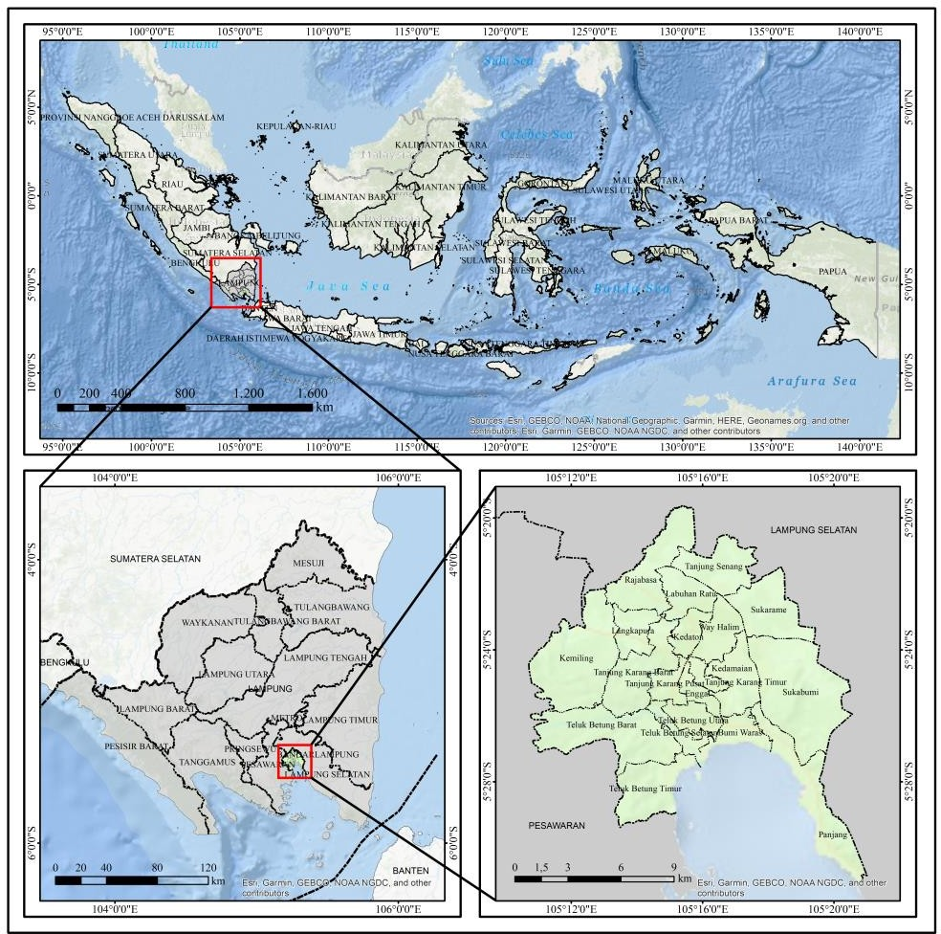

Figure 1. Map showing the study area

Research method

This involves several stages, including (1) the purpose of this study was to examine land cover changes in Bandar Lampung City from 2016 to 2021, (2) image pre-processing, which involves image correction, layer stacking, and masking of the research area, (3) image composite, selection of training areas and land cover classification, (4) field survey, (5) data interpretation check, (6) accuracy test, (7) spatial analysis to determine changes in land cover, types, and area of the affected region. Finally, a map of LULC occurrence in Bandar Lampung City from 2016 to 2021 was generated. The flowchart of the stages is shown in Figure 2.

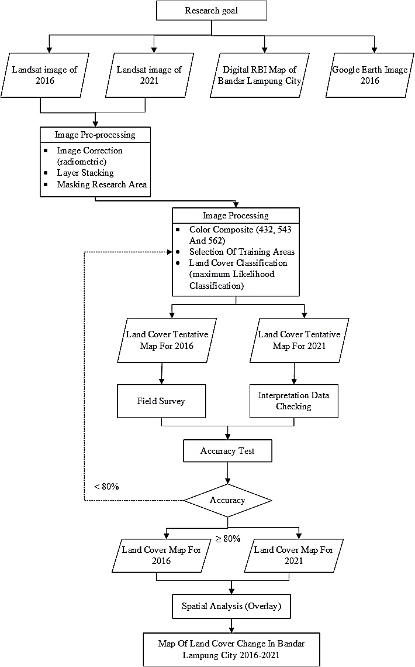

Figure 2. Research procedure

Research site samples

This research employed a purposive sampling technique, acquiring samples by categorizing them and making specific considerations. During the selection process, several aspects are considered, including (1) whether or not the sample is a ground checkpoint for land cover, (2) it represents all types of land and cloud covers in Bandar Lampung City, (3) it depicts all sub-districts in this urban area, (4) the sample can be used to clarify certain doubts arising from the results of the interpreted images, (5) it also depicts the land and cloud covers, and (6) the sample site is easily accessible.
The number of samples in the study area was determined as 120 checkpoints with a distribution of the same ground checkpoints relatively 60 for land cover in 2016 and 2021. These were realized through field surveys carried out in 2021. It involved visiting the study site in respect to the ground checkpoint. In 2016, the 60 ground checkpoints were obtained through an observation process using Google Earth imagery of Bandar Lampung City. Furthermore, the study site is represented as a distribution map of ground check points discovered in 2016 and 2021, as shown in Figure 3. This sampling was conducted at 50 similar and ten different points in 2016 and 2021, respectively. This is due to the location of land and cloud covers in Bandar Lampung City.

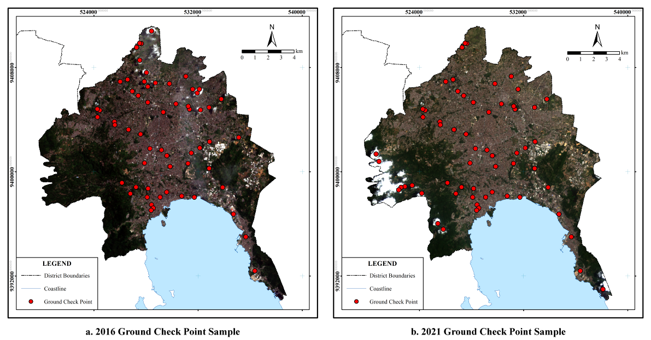
2016 2021

Figure 3. The distribution map ground check point of Bandar Lampung in 2016 and 2021

Raw data and image processing

The data used in this study are Landsat 8 satellite images obtained from the United States Geological Survey. It has a spatial resolution of 30 m, and the image was taken in 2016 and 2021. The acquisition date, path and row of the images used are shown in Table 1. In addition, the Landsat 8 images obtained from Google Earth were recorded in July 2016.

Table 1. Satellite image used in the study

Acquisition date | Image | Path/Row
02/04/2016 | LC08_L1TP_123064_20160402_20200907_02_T1 | 123/64
09/10/2021 | LC08_L1TP_123064_20211009_20211019_02_T1 | 123/64

The first step is image pre-processing, where all of the Landsat 8 images used in this study were radiometrically corrected. Several bands of the Landsat had the same spatial resolution of 30 m (band 2, 3, 4, 5, 6, and 7). These bands are merged through layer stacking which aims to make it easier to perform color composites. In addition, part of the area in the satellite image was used for masking. This was followed by image processing, which is realized through color composites first. Several preliminary tests made use of natural and infrared colors composite to helps in identifying the land use land cover.
Color composites aim to make the image brighter, ensuring the object is easily recognized. The item or object that needs to be easily discerned in this research is land cover. A group of training samples are selected from the pre-determined Area of Interest to represent each land cover classes. The training sample is entered according to the data obtained from the Area of Interest. After the selection process, the land cover is grouped using the maximum likelihood classification method.
To generate a map portraying land cover changes from 2016 to 2021, the results of the Landsat 8 image classification were converted from raster to vector data. The purpose is to make it easier to apply Geoprocessing Intersect function in ArcGIS 10.8 software. After the conversion procedure, the two vectorized land use land cover data are overlayed to generate the change map. Land cover change modeling is shown in Figure 4.

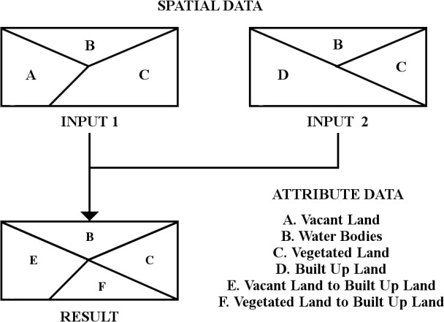

Figure 4. Land cover change modeling using GIS

Results and discussion

The occurrence of land cover changes in Bandar Lampung City from 2016 to 2021 was detected using Landsat 8 image and the maximum likelihood classification method. The results must be further evaluated to determine the error rates and accuracy of the image classification. This can be calculated using several procedures, such as producer, user, overall, and Kappa accuracies. Meanwhile, the results of the Kappa formulation or calculation for the land cover map of Bandar Lampung City in 2016 and 2021 are shown in Table 2.

Table 2. Producer’s accuracy & user accuracy in 2016 and 2021

Land cover | 2016 |  | 2021
Land cover | Producer’s accuracy | User accuracy | Producer’s accuracy | User accuracy
Vegetated Land | 94.74% | 100% | 88.24% | 100%
Built-up Land | 95% | 95% | 95.24% | 100%
Vacant Land | 100% | 85.71% | 100% | 70%
Water Bodies | 100% | 100% | 100% | 100%
Source: Results of data processing, 2021

Based on the calculated results, it is evident that in 2016, the accuracy level of land cover in Bandar Lampung City was 94.09%, which can be grouped in the almost perfect agreement category (Viera & Garrett, 2005). Therefore, the ability of the maximum likelihood classification method to categorize Landsat 8 images was good. With a Kappa accuracy of 94.09%, a tentative map of land cover was generated from the interpreted image. Based on this, the area of each land cover and the map of the ground checkpoint in Bandar Lampung City are shown in Table 3 and Figure 5, respectively.

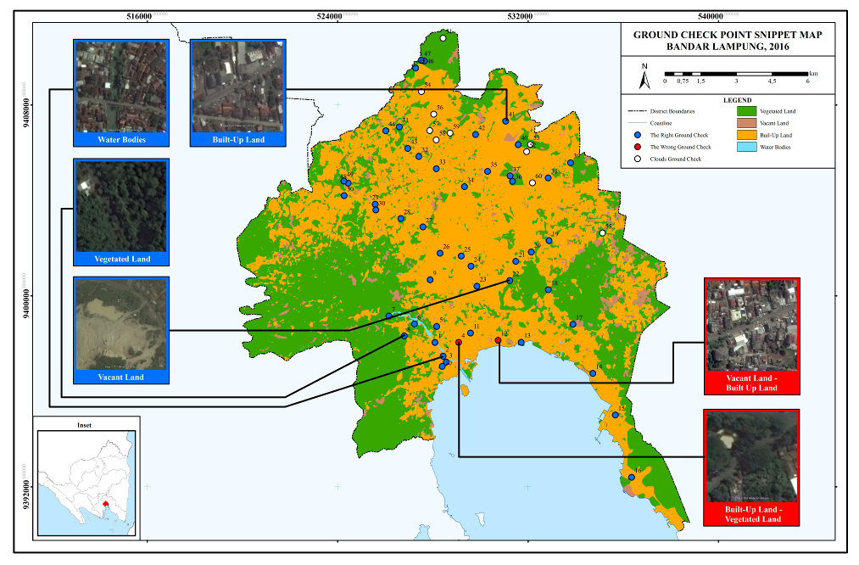
Figure 5. Map of Bandar Lampung City land check points in 2016

The results of the calculations were obtained using kappa accuracy, and it is evident that in 2021, the accuracy level of land cover in Bandar Lampung City was 91.33%, grouped in the Almost Perfect Agreement category (Viera & Garrett, 2005). Therefore, the maximum likelihood classification method used to categorize the Landsat 8 image was good. With a kappa accuracy of 91.33%, a tentative map of land cover was generated from the interpreted image classification. Based on this, the area of each land cover and the map of the ground checkpoint are shown in Table 4 and Figure 6, respectively.

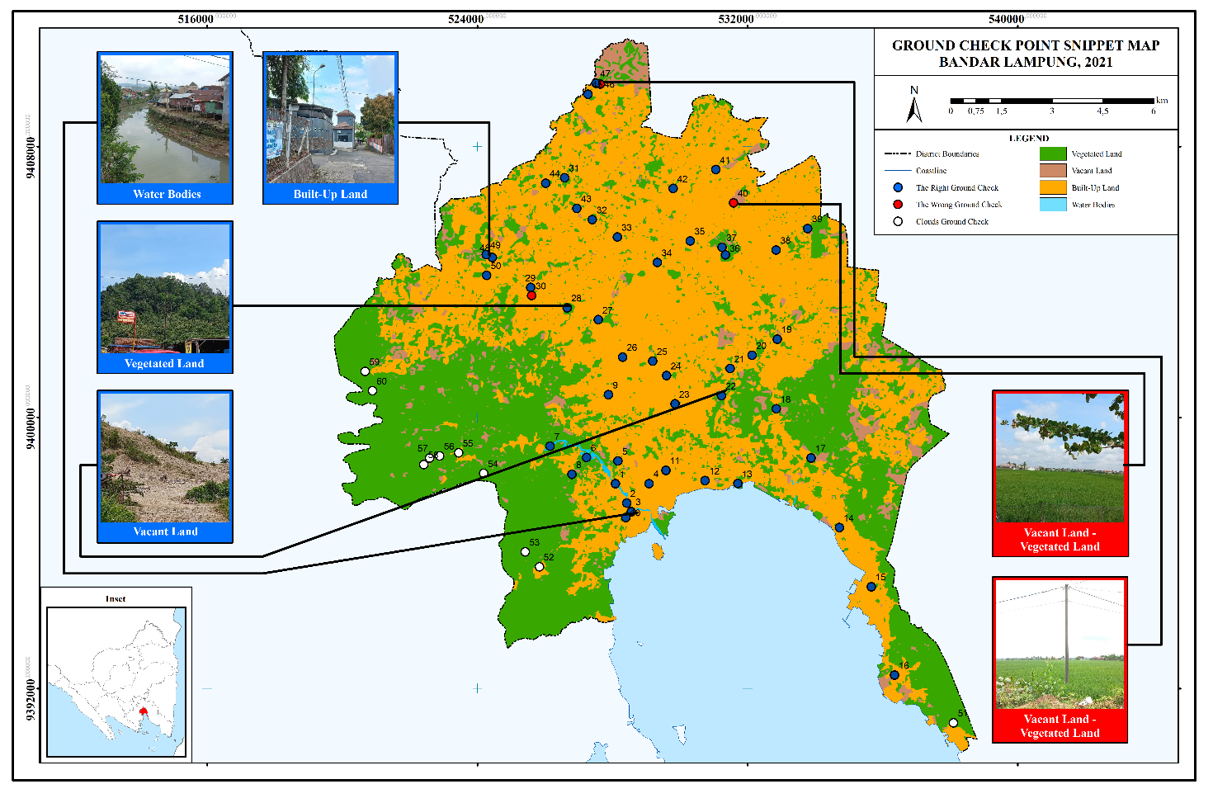
Figure 6. Map of Bandar Lampung City land check points in 2021

Land cover changes in Bandar Lampung City from 2016 to 2021 were detected based on the results of the modeling technique shown in Figure 7. After overlaying the two data, there were changes in the land cover type, as shown in Table 3, besides these can be visually seen in (Figure 7).

Table 3. Land cover type changes in Bandar Lampung City, 2016-2021

No. | Land cover | 2016 |  | 2021 |  | Total
No. | Land cover | VaL | WB | VeL | BL | Total
1 | VaL | 1.298 | 0 | 1.718 | 3.451 | 6.467
2 | WB | 0 | 0.2375 | 0 | 0 | 0.2375
3 | VeL | 5.472 | 0 | 61.160 | 12.361 | 78.993
4 | BL | 2.039 | 0 | 9.305 | 100.071 | 111.415
Total |  | 8.809 | 0.2375 | 72.183 | 115.883 | 197.1125
Description: Vacant Land (VaL); Water Bodies (WB); Vegetated Land (VeL); Built Up Land (BL)

Table 3 shows that vegetated to built-up lands, which cover an area of 12.361 km², experienced the largest changes. Meanwhile, the vacant to vegetated lands with an area of 1.718 km² experienced the most minor changes. In simple terms, the area of land cover changes is shown in Table 4.

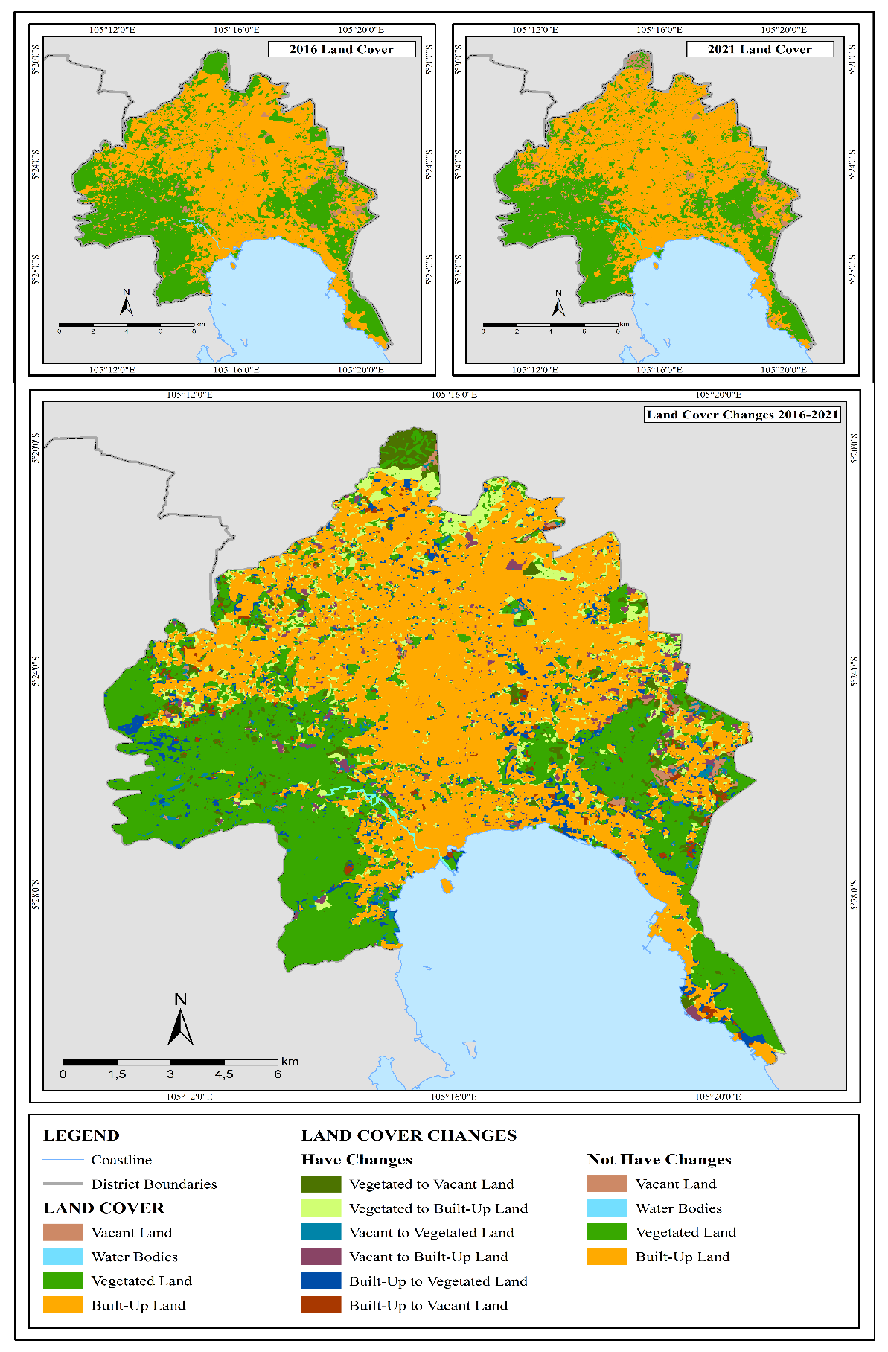
Figure 7. Land cover changes in Bandar Lampung City

Table 4. Land cover changes in Bandar Lampung City, 2016-2021

No. | Type of land cover | Area 2016 (km²) | Area 2021 (km²) | Area changes
1 | Vacant Land | 6.467 | 8.809 | + 2.342
2 | Water Bodies | 0.2375 | 0.2375 | 0.000
3 | Vegetated Land | 78.993 | 72.183 | - 6.81
4 | Built Up Land | 111.415 | 115.883 | + 4.468
Total |  | 197.1125 | 197.1125

Source: Results of data processing, 2021

Table 4 shows that vegetated land experienced a reduction in size. The types of land cover that experienced an increase in area were built up and vacant lands. Interestingly, water bodies did not experience any changes. Changes in land cover are defined as a shift from one type to another within a specific time in space. Table 5 shows that four ground checkpoints experienced these changes. Dynamic land cover tends to indicate that these changes cannot be ascertained. All regions have the potential to change, especially land covered by vegetation. Specifically, the occurrence of this incident in the past five years and the 10 categories of initial (2016), and final land changes (2021), are shown in Table 6.

Source: Results of data processing, 2021

Figure 8. Changes in land cover of Bandar Lampung City in 2016-2021 according to each district

Similarly, development activities in the Bandung metropolitan area have led to significant changes, where agricultural land and forests are converted mainly into residential land use (Atharinafi & Wijaya, 2021). Liu et al. (2009), and Pandiangan et al. (2017) reported that land use and cover changes always have ecological consequences, such as loss of biodiversity and decreased ecological carrying capacity. Population growth is the main factor that triggers the need for housing, and the formation of a settlement triggers the development of a city (Vitriana, 2017).
Land cover changes in Bandar Lampung City are influenced by several factors, which can be group into natural and human factors. Natural factors include slopes, soil types, and rainfall. Bandar Lampung City is dominated by flat slopes (0 to 8%), covering an area of 63.88%. This tends to support the development of land use for human activities. The soil type in this city is mainly dominated by Latosol-Podsol, which is insensitive to erosion. Therefore, certain areas can be used as a settlement. The average rainfall in Bandar Lampung City for the past 10 years has been 1,788.72 mm/year and grouped in the low category. Humans usually prefer to carry out most activities during low rainfall because there is little or no rain.
Human factors influencing land cover changes are population and region, social and cultural, economic and technological factors, including government (Lambin & Meyfroidt, 2010; Ejaro & Abdullahi, 2013). This urban area is the center of all human activities, such as the economy, trade, settlements, and education (Dickinson, 2013). These activities are carried out by the majority of the residents in Bandar Lampung City, including those residing in neighboring towns. The increasing population aligns with development, resulting in excessive demand for land. Its low availability causes a change in land cover that humans did not previously use to land that is used by humans (Newbold et al., 2015).
The erection of adequate facilities in urban areas is a social and cultural factor that triggers land cover changes. As a result, most of those residing outside the city started settling in it, thereby triggering the need for housing. In addition, humans tend to be closer to existing jobs, which triggers land conversion (Newman & Jennings, 2012). As the capital of Lampung Province, Bandar Lampung City has the highest regional minimum wage compared to other regions. The technology used in urban areas tends to be better than in rural communities. With higher wages and better technology, there is a tendency for people to start and develop businesses in this area, thereby converting the land into an area used for diverse human activities (Sachs, 2012; Massey, 2019).
The governments in both urban and rural areas are instrumental in regional spatial plans. Indonesia has a regional spatial plan regulation, which commences with the use of the area, city service center system, transportation network, and infrastructure (Surya et al., 2020). Due to this, the government intends to implement development and control programs and improve regional spatial planning (Boonstra & Boelens, 2011). With this effort, it will be able to change the existing arrangement of land cover in Bandar Lampung City.

Conclusion

This research reported land cover change in Bandar Lampung from 2016 to 2021, with the largest being vegetated and built-up lands of 12.361 km². Meanwhile, the type that experienced the greatest change is land, with a reduced area of 6.813 km². Vacant land experienced the least change with an additional area of 2.345 km². Several factors influence changes in land cover; the existing ones are natural and human factors. Natural factors that affect land cover changes in Bandar Lampung City are slopes, soil types, and rainfall. Human attributes include population and region, social and cultural, economic and technological factors, as well as government.

References

Aronoff, S. (1989). Geographic Information Systems: A Management Perspective. WDL Publications.
Atharinafi, Z., & Wijaya, N. (2021). Land use change and its impacts on surface runoff in rural areas of the upper citarum watershed (case study: Cirasea subwatershed). Journal of Regional and City Planning, 32(1), 36-55. doi: 10.5614/jpwk.2021.32.1.3
Badan Pusat Statistik Provinsi Lampung. (2021). Hasil Sensus Penduduk 2020 di Provinsi Lampung. (Berita Resmi Statistik No.07/01/18/Th.I 21 Januari 2021).
Batubara, W. S., Zaitunah, A., & Muhdi. (2019). Perubahan penutupan lahan hutan di Cagar Alam Dolok Sibualbuali Tahun 2006 dengan 2013. Peronema Forestry Science Journal, 5(2), 204–209.
Boonstra, B., & Boelens, L. (2011). Self-organization in urban development: Towards a new perspective on spatial planning. Urban Research & Practice, 4(2), 99-122.
Briggs, D. J., Collins, S., Elliott, P., Fischer, P., Kingham, S., Lebret, E., Pryl, K., Van Reeuwijk, H., Smallbone, K., & Van Der Veen, A. (1997). Mapping urban air pollution using GIS: A Regression-Based approach. International Journal of Geographical Information Science, 11(7), 699–718. Retrieved from https://doi.org/10.1080/136588197242158
Buraerah, M. F., Rasyidi, E. S., & Sandi, R. (2020). Pemetaan Perubahan Penggunaan Lahan di Wilayah Kabupaten Takalar tahun 1999-2019 menggunakan Sistem Informasi Geografis. Ecosystem, 20(1), 68–75.
Chughtai, A. H., Abbasi, H., & Karas, I. R. (2021). A review on change detection method and accuracy assessment for land use land cover. Remote Sensing Applications: Society and Environment, 22, 100482.
Dickinson, R. E. (2013). City, Region and Regionalism: A geographical contribution to human ecology. Routledge.
Ejaro, S. P., & Abdullahi, U. (2013). Spatiotemporal analyses of land use and land cover changes in Suleja local government area, Niger State, Nigeria. Journal of Environment and Earth Science, 3(9), 72-83.
Foda, M., & Osman, A. (2010). Using GIS for measuring transit stop accessibility considering actual pedestrian road network. Journal of Public Transportation, 13(4), 23–40. Retrieved from https://doi.org/10.5038/2375-0901.13.4.2
Giri, C. P. (Ed.). (2012). Remote Sensing of land use and land cover: Principles and applications. CRC Press.
Heydari, S. S., & Mountrakis, G. (2018). Effect of classifier selection, reference sample size, reference class distribution and scene heterogeneity in per-pixel classification accuracy using 26 Landsat sites. Remote Sensing of Environment, 204, 648-658.
Husnah, N., Rusdi, M., & Karim, A. (2022). Analisis penggunaan lahan eksisting (Studi kasus: Kabupaten Simeulue). Jurnal Ilmiah Mahasiswa Pertanian, 7(1), 642–648.
Jat, M. K., Garg, P. K., & Khare, D. (2008). Monitoring and modelling of urban sprawl using remote sensing and GIS techniques. International Journal of Applied Earth Observation and Geoinformation, 10(1), 26–43. Retrieved from https://doi.org/10.1016/j.jag.2007.04.002
Kementerian Lingkungan Hidup dan Kehutanan. (2020). Petunjuk Teknis Penafsiran Citra Satelit Resolusi Sedang untuk Update Data Penutupan Lahan Nasional.
Lambin, E. F., & Meyfroidt, P. (2010). Land use transitions: Socio-ecological feedback versus socio-economic change. Land use policy, 27(2), 108-118.
Lillesand, T. M., Kiefer, R. W., & Chipman, J. W. (2015). Remote Sensing and Image Interpretation. John Wiley & Sons, Ltd.
Lindgren, D. T. (1985). Land use planning and Remote Sensing. Springer.
Malingreau, J. (1977). A Proposed land cover/land use classification and its use with Remote Sensing data in Indonesia. The Indonesian Journal of Geography, 7(33), 5–28.
Massey, D. S. (2019). Economic development and international migration in comparative perspective. In Diaz-briquets, S. Determinants of Emigration from Mexico, Central America, and the Caribbean (pp. 13-47). Routledge.
Miswar, D., Halengkara, L., Sugiyanta, I. G., & Al Azhari, A. S. (2021). Study of changes in geospatial based land use in Ambarawa District, Pringsewu Regency. International Journal of Multicultural and Multireligious Understanding, 8(2), 94– 107.
Myint, S. W., Gober, P., Brazel, A., Grossman-Clarke, S., & Weng, Q. (2011). Per-pixel vs object-based classification of urban land cover extraction using high spatial resolution imagery. Remote sensing of environment, 115(5), 1145-1161.
Newbold, T., Hudson, L. N., Hill, S. L., Contu, S., Lysenko, I., Senior, R. A., ... & Purvis, A. (2015). Global effects of land use on local terrestrial biodiversity. Nature, 520(7545), 45-50.
Newman, P., & Jennings, I. (2012). Cities as sustainable ecosystems: Principles and practices. Island press.
Otukei, J. R., & Blaschke, T. (2010). Land cover change assessment using decision trees, support vector machines and maximum likelihood classification algorithms. International Journal of Applied Earth Observation and Geoinformation, 12(1), S27-S31.
Pandiangan, E., Ardiansyah, M., & Rusdiana, O. (2017). Analysis of changes in land cover to support the management of Gunung Leuser National Park. Journal of Regional and City Planningvol, 28(2), 81-98.
Pattilouw, I. R., Mardiatmoko, G., & Puturuhu, F. (2019). Analisis perubahan tutupan lahan hutan di IUPHHK-HA PT. Gema Hutan Lestari Kabupaten Buru Provinsi Maluku. Jurnal Hutan Pulau-Pulau Kecil, 3(2), 127–135.
Purwadhi, S. H., & Sanjoto, T. B. (2008). Pengantar interpretasi citra penginderaan jauh. LAPAN & UNES.
Ritohardoyo, S. (2013). Penggunaan dan tata guna lahan. Penerbit Ombak.
Rotinsulu, W., Walangitan, H., & Ahmad, A. (2018). Analisis perubahan tutupan lahan DAS Tondano, Sulawesi Utara Selama Periode Tahun 2002 dan 2015. Journal of Natural Resources and Environmental Management, 8(2), 161–169.
Rozenstein, O., & Karnieli, A. (2011). Comparison of methods for land-use classification incorporating Remote Sensing and GIS inputs. Applied Geography, 31(2), 533-544.
Sachs, J. D. (2012). From millennium development goals to sustainable development goals. The lancet, 379(9832), 2206-2211.
Schott, J. R. (2007). Remote Sensing: The image chain approach. Oxford University.
Sugiatno, Zaitunah, A., & Samsuri. (2016). Analisis perubahan tutupan lahan Kota Lubuk Pakam antara tahun 2012 dengan 2015. Peronema Forestry Science Journal, 5(2), 150–162.
Surya, B., Ahmad, D. N. A., Sakti, H. H., & Sahban, H. (2020). Land use change, spatial interaction, and sustainable development in the metropolitan urban areas, South Sulawesi Province, Indonesia. Land, 9(3), 95.
Tso, B., & Mather, P. M. (2009). Classification methods for remotely sensed data. CRC Press.
United State Geological Survey. (2019). Landsat 8 (L8) Data Users Handbook Version 5.0.
Viera, A. J., & Garrett, J. M. (2005). Understanding interobserver agreement: The kappa statistic. Family Medicine, 37(5), 360–363. Retrieved from https://pubmed.ncbi.nlm.nih.gov/15883903/
Vitriana, A. (2017). Increase in land value due to spatial transformation in the Northern Part of the Bandung–Cimahi Peri-urban region. Journal of Regional and City Planning, 28(1), 70-80. doi: 10.5614/jrcp.2017.28.1.5

