Content validation through expert judgement of web-based megalithic culture visualization

Sri Yanti Mahadzir¹, Zurina Muda¹, Siti Aishah Hanawi¹, Zuliskandar Ramli²

¹Faculty of Information Science & Technology, Universiti Kebangsaan Malaysia, 43600 Bangi Malaysia
²Institute of the Malay World and Civilization, Universiti Kebangsaan Malaysia, 43600 Bangi Malaysia

Correspondence: Zurina Muda (email: zurinam@ukm.edu.my)

Received: 13 December 2022; Accepted: 19 May 2024; Published: 31 May 2024

Abstract

The lack of information disclosure and weaknesses in delivering information related to megalithic treasures in Malaysia, especially in Negeri Sembilan, limit the sharing of information about this tradition and culture with the general public. It also means that this megalithic heritage is, to some extent, increasingly forgotten by the current generation. This study was conducted after developing the Negeri Sembilan megalithic web application. In this light, the accuracy, appropriateness, and validity of any information should be verified before sharing it with other parties. Therefore, this study aimed to validate information contents based on the expert judgement of the web-based visualization of megalithic culture information for Negeri Sembilan. Accordingly, content validation was conducted with 7 experts in related fields. The data obtained were analyzed using the Statistical Package for Social Science (SPSS). Overall, the results of the content validity assessment in this study have successfully demonstrated that all seven experts provided a high interpretation assessment score with an average mean (M) of 4.61. The experts have agreed that the web application is suitable and ready to be shared with users and the public in its current state because the quality of the web application is very satisfactory. In addition, this analysis proves that the Negeri Sembilan megalithic web application meets the criteria for content validity as assessed by experts. Therefore, this indirectly validates the ability of the web application to convey valid information contents.

Keywords: Content validity, cultural heritage, information visualization, megalithic, Negeri Sembilan, web application

Introduction

A web application is one of the most accessible digital-based sources of information. Its use allows users to find and access information regardless of time or location. Using web-based information resources can also assist users to widely and effectively obtain the desired information. Furthermore, the spread of information through digital applications is appropriate and coincides with current developments. However, there is a concern about whether all shared information on the digital platform is appropriate or relevant to the highlighted topic. In this regard, everyone who conveys information, including informants, application developers, and even the researcher, must be responsible for providing accurate information to users. Therefore, this study was conducted as a content validation to verify the content of the Negeri Sembilan megalithic cultural information visualization based on the web-based application developed.

Negeri Sembilan Darul Khusus is one of Malaysia's states with its unique cultural heritage, one of which is the megalithic culture. Notably, the traditional political system of Negeri Sembilan's Adat Perpatih is divided into four regions: Luak Tanah Mengandung, Luak Berundang, Luak Beradat, and Luak Tampin (Khan, 2017; Korporat SUKNS, 2019). As such, this study focuses on the megalithic culture of Luak Tanah Mengandung, which includes Luak Inas, Ulu Muar, Jempol, Gunung Pasir, and Terachi, as shown in Figure 1. Correspondingly, the megalithic site found at Luak Tanah Mengandung is shown in Figure 2.

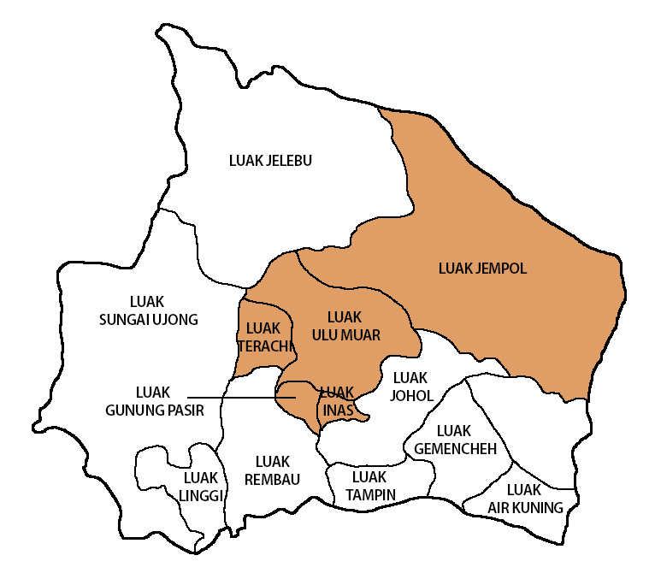

Figure 1. Map of Luak Tanah Mengandung, Negeri Sembilan, Malaysia

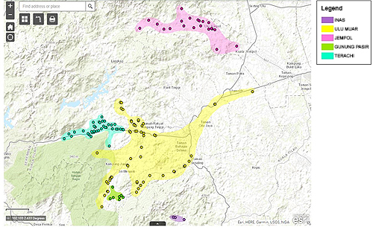
Source: Author

Figure 2. Megalithic Sites in Luak Tanah Mengandung, Kuala Pilah

Literature review

Megalithic cultural heritage of Negeri Sembilan

Megalith refers to one or more large stones used to build specific-shaped building structures that serve a particular purpose in the lives of a society (Masdey et al., 2019; Ramli et al., 2019; Sabin et al., 2018; Samsudin et al., 2015). The megalithic culture, which has been practised worldwide since the Neolithic period, represents a particular community associated with its practice in the use of large stones. Nonetheless, this megalithic culture did not emerge naturally, as it originated from the culture and traditions of the ancient people who practised it (Masdey, 2021; Ramli et al., 2019).

Cultural heritage includes customs, practices, places, artistic expressions, and values which express the way of life from one generation to another (Mat Zin et al., 2016). Megalithic culture, for example, has become a part of the socio-cultural heritage of communities worldwide, including in the Malay world. The evolution of this culture through time has left its influence on the local community. However, some of these sites have been destroyed and forgotten (Jusoh et al., 2018).

According to Roslan et al. (2021), raising awareness among the local community is important in preserving cultural heritage. Furthermore, there is a need to educate future generations so that they can understand and appreciate their cultural heritage. This can also contribute to environmental preservation and awareness. In this regard, there is a need to create awareness of the importance of preserving cultural heritage, particularly among local communities, as cultural heritage artifacts reflect one’s cultural identity.

However, there is no denying that tangible cultural heritage around the world is often endangered by natural and anthropogenic threats (Dhonju et al., 2018). As shown in Figure 3, the threat of damage and the state of megalith stones seen in some Negeri Sembilan areas are not well maintained. This situation is consistent with the statement by Manuho et al. (2018), and unfortunately, some people today are unaware of the cultural heritage in their locality.

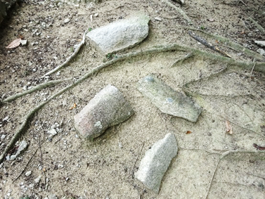 | 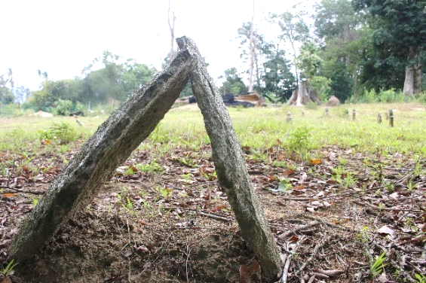
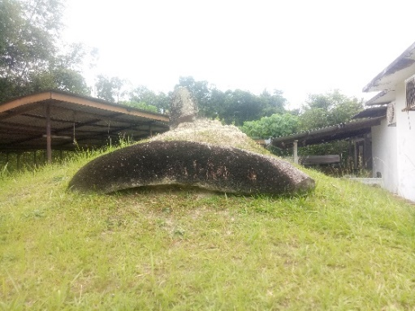 | 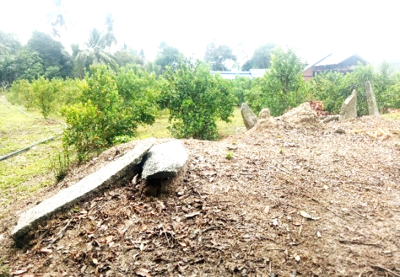
Source: Author

Figure 3. Megalithic stones in some areas in Negeri Sembilan have been poorly cared for

Furthermore, due to a lack of exposure to these priceless treasures, knowledge of this tradition and culture is less widely disseminated among the general public. The lack of complete and up-to-date sources of information and limitations in information transmission has caused the megalithic cultural heritage to be increasingly forgotten (Samsudin et al., 2015). Therefore, for cultural history to remain permanent and sustainable, the documentation and sharing of information about this heritage must be properly conducted, especially in today's digital world. With the ability to store data digitally, data manipulation and analysis related to megalithic cultural heritage can be done quickly and efficiently.

Web-based visualization of megalithic cultural heritage

Nowadays, information transmitted digitally has a greater reach than using traditional methods. This advantage enables information to be visualized in various media, including text, graphics, maps, videos, and more. One of the digital platforms that can support the visualization of cultural heritage information is through web applications. A web application is an information system that can be reached widely and quickly and has become a popular trend as one of the usage and strategic communication tools for organization and promotion (Alsulami et al., 2021; Halim & Othman, 2017). This is because the web application has a wider interactive network with dynamic features, functions, and content (Kiruthika et al., 2017). Furthermore, using the internet, especially Web 2.0, has empowered users greatly and created collaborative or integrated online platforms that allow various parties to connect (Cristobal-Fransi et al., 2019). Therefore, using web application offers in the digital environment can help users increase their interest and understanding of something they want to highlight.
Information visualization can provide many benefits in disseminating knowledge and information in various fields in today's digital world. Its significance is undeniable in light of the rapid development of information technology in everyday life. Therefore, in order for megalithic cultural knowledge to be freely available to modern culture, it must also be updated to reflect the current era, particularly in the digital realm, as part of the nation's cultural heritage. Correspondingly, the development of digital information resources from this research could improve understanding and information sharing about the megalithic culture, particularly in Negeri Sembilan. Integrating technology to transform data sources in a megalithic culture based on oral, text, and existing documents to a digital medium will be more interesting, meaningful, and productive with multimedia. This web application's development can also highlight the use of information technology in digitizing the megalithic cultural heritage information in Negeri Sembilan.
This effort is also compatible with Samat (2015) who has stated that visualization could help provide an attractive database system and improve the understanding of other users and researchers. Thus, a web application was developed in this study as an online information source with details of the megalithic sites that still exist in Negeri Sembilan to facilitate the search and access of information about the megalithic culture in this state before it is destroyed by current development. With the development of a web application in this study, it is expected to become a source of research information that stores heritage treasures to be shared with the community and cultural researchers.

Web application content validity

Content Validation by expert judgement considers an expert's opinion in the relevant field. This process can provide information, evidence, judgement, and evaluation in a specific field, forming the basis for clarifying, supplementing, or changing the necessary aspects (Fernández-Gómez et al., 2020). According to Ghazali et al. (2018) and Mohajan (2017), this method can determine the extent to which the required methods, dimensions, and elements of a concept can be accurately and successfully defined and followed, as well as the ability to improve the quality of the information itself (Yogarajah et al., 2021). Once a web application has been developed, the expert review and verification process should be performed on the application to evaluate the design based on the suitability and consistency of the content displayed through the user interface.
Expert review and validation in this study involved experts’ assessment of the validity of the web application’s contents based on their experience and knowledge and then recommending views to improve the usability of the developed website (Ghazali et al., 2018; Mohajan, 2017). In the application development process, a module will not be considered complete if it does not go through the validation process. This step is crucial to ensure that each module in the built application is of high quality and meets the intended objectives.
Therefore, the Negeri Sembilan megalithic web application developed requires expert verification to ensure that the application fulfils the purpose of its development and that the content displayed is valid and usable. The evaluation process involves experts in culture and heritage, archaeological science, psychology, and information technology to evaluate the design and content elements related to their respective fields. The provided content's design elements are inspected and verified, including the provided information, the created digital map, the illustration, and the displayed visual data. The expert evaluation can confirm the developed content to ensure that the development objective is achieved. Expert opinions are also considered to correct existing errors, improve the design's quality, and review the developed content to ensure the development objectives are met.

Research methodology

This descriptive study describes the application's content validity based on experts’ opinions. This study used a mixed-methods research approach. A questionnaire was used to collect data, and expert interviews were conducted to obtain further information. Questionnaires are a low-cost and highly effective tool for measuring the user experience of an application system (Sudana et al., 2020). The expert evaluation process was conducted to determine the level of content validity through a work process, as shown in Figure 4.

Relevant items from the literature were identified
Assessment items were developed
A panel of experts is identified and selected
The content validity form was given to a panel of experts, evaluation feedback was given
Feedback from the expert panel is collected
Content validity analysis was conducted

Figure 4. Research methodology

Expert involved

Seven professional experts were involved in the content validity, including lecturers, management and professional staff from the Universiti Kebangsaan Malaysia (UKM), Universiti Pendidikan Sultan Idris (UPSI), and Lembaga Muzium Negeri Sembilan (LMNS). These experts are experienced and have been directly involved in research and preservation efforts of heritage sites, have an appropriate academic qualification certificate, social recognition, expert consistency, and have attended adequate professional training, which is in line with the view of (Ghazali et al., 2018; Idros et al., 2019; Izwani et al., 2020). The details of the experts who are involved in this study are presented in Table 1.

Table 1. List of experts involved

Expert | Academic  qualifications | Field/ Position | Agency | Experience (Years)
E1 | PhD | - Senior Research Fellow  - Member of the Expert Committee on the Heritage of Archaeological and Underwater Cultural Sites | UKM | 21
E2 | PhD | - Senior Research Fellow  - Member of the Custom Heritage Expert Committee  - National Heritage Award Figures (Tokoh Orang Hidup) | UKM | 30
E3 | PhD | - Senior lecturer  - History & Archaeology | UPSI | 25
E4 | Masters | - Director  - Senior Curator  - Museum | LMNS | 29
E5 | PhD | - Lecturer  - Information and Communication Technology  (Remote monitoring, Image Processing) | UKM | 3
E6 | Bachelor  Degree | - Senior Information Technology Officer  - Web Designer  - Graphic designer | UKM | 12
E7 | Masters | - Senior Information Technology Officer  - Geospatial Specialist  (Geospatialist, Gs.) | UKM | 21

Research methods and instruments

These experts were chosen based on purposive sampling, specifically expert sampling (judgemental sampling) as the validity assessor. The sampling process refers to the selection of individuals who are experts in a particular field as a study sample (Surip et al., 2019). Content validity evaluation studies are commonly conducted quantitatively and qualitatively and involve questionnaires and interviews. In contrast to qualitative assessment, which seeks to collect expert opinions and experiences that may not be explicitly stated in the set of quantitative questions, quantitative evaluation strives to confirm the findings through instruments with the value of the data obtained.
The research instrument was developed by adapting items from previous research, i.e., by Arip et al. (2013), Izwani et al. (2020), and Karnain (2020), to fit this study's needs. The questionnaire instrument set consists of 22 questions divided into four sections: A. Interface Design, B. Information Visualization Techniques & Elements, C. Style and Use of Language, and D, which is the Overall Perception, based on a 5-point Likert scale range, 1- Strongly disagree, 2- Do not agree, 3- Somewhat Agree, 4- Agreed, 5-Strongly Agree.
The collected data were analyzed using the Statistical Package for the Social Science (SPSS) software version 28. The data were analyzed descriptively, with the mean score, standard deviation, percentage, and frequency used to measure the validity of the content by experts and interpret the level of expert agreement. Table 2 presents the interpretation of the level of validity of the mean score adjusted in this study to determine the level of agreement and validity based on the expert assessment by Mohd Khaidir and Mohd Rashid (2016) and Nazir and Deris (2019).

Table 2. Interpretation of content validity mean scores

Score | Interpretation | Level of agreement
1.00 - 2.49 | Low | Unsatisfactory or unnecessary
2.50 - 3.79 | Moderate | Somewhat satisfactory or somewhat necessary
3.80 - 5.00 | High | Very satisfactory or very necessary

Results and discussion

The findings of this study will be discussed descriptively to analyze data related to content validity assessment with the experts involved. The experts also provided feedback and suggestions for improving the Negeri Sembilan megalithic web application. Accordingly, Mohd Matore et al. (2017) emphasize that content validity is typically measured by expert judgement and is not solely measured by numbers. The experts were also interviewed, and all comments, opinions, and suggestions were recorded for future updates and improvements to the web application.

Content validity analysis

The data from the content validity assessment performed with seven experts (n=7) on the developed web application for Negeri Sembilan megalithic cultural information are presented in Table 3.

Table 3. Mean and interpretation of each content validity category

Category | Items | Mean (M) | Interpretation | Level of expert consent
A. Interface design | 8 | 4.66 | High | Very satisfactory or  very necessary
B. Information visualization techniques & elements | 6 | 4.54 | High | Very satisfactory or  very necessary
C. Style and  use of language | 3 | 4.57 | High | Very satisfactory or  very necessary
D. Overall perception | 5 | 4.68 | High | Very satisfactory or  very necessary
Total / average | 22 | 4.61 | High | Very satisfactory or  very necessary
The first dimension assessed is ‘Interface Design’, which contains eight items with an average mean of 4.66 (M = 4.66, n = 7), which shows that the level of expert validity agreement for this web application's interface design category is high. The ‘Information Visualization Techniques & Elements’ dimension, which contains six items, has a mean score of 4.54 (M = 4.54, n = 7) and indicates a high level of expert agreement. Besides that, ‘Style and Use of Language’, which has three items, shows a mean of 4.57 (M = 4.57, n = 7), reflecting high expert agreement. Lastly, the ‘Overall Perception’ dimension category scored a mean of 4.68 (M = 4.68, n = 7), indicating a high agreement towards the developed web application.
The content validity of the four dimensions comprising 22 items received a mean score of 4.61. Based on the interpretation proposed by Mohd Khaidir and Mohd Rashid (2016) and Nazir and Deris (2019), the score is considered high and indicates a high level of agreement (M≥ 3.80). In this light, the level of expert agreement on the developed web application is very satisfactory, therefore, this application can be used in an actual environment and launched to the public.

Content validity analysis for each item

The findings for each item in the evaluation dimension are interpreted in Table 4 to Table 7.

Table 4. Mean value of interface design category

 | Statement | 1 | 2 | 3 | 4 | 5 | M | SD | Interpretation
- Interface design | - The title of the website application describes the content of the information | - | - | 1  14.3% | - | 6  85.7% | 4.71 | .756 | High
- Interface design | - The text and graphics used are presented clearly and easily read | - | - | - | 2  28.6% | 5  71.4% | 4.71 | .488 | High
- Interface design | - The content is easy to follow and track | - | - | - | 4  57.1% | 3  42.9% | 4.43 | .535 | High
- Interface design | - The colours used are appropriate | - | - | - | 2  28.6% | 5  71.4% | 4.71 | .488 | High
- Interface design | - Application access and execution times are appropriate | - | - | - | 3  42.9% | 4  57.1% | 4.57 | .535 | High
- Interface design | - Navigating the interface is easy to navigate | - | - | - | 2  28.6% | 5  71.4% | 4.71 | .488 | High
- Interface design | - The presentation style of information is consistent | - | - | - | 1  14.3% | 6  85.7% | 4.86 | .378 | High
- Interface design | - The display interface is user friendly | - | - | 1  14.3% | 1  14.3% | 5  71.4% | 4.57 | .787 | High

Expert validation of content begins with statements about Interface Design. Table 4 shows that the recorded mean score in this section is relatively high, ranging from 4.43 to 4.86. The item that recorded the highest score (M = 4.86, SD = .378, n = 7) in the expert validity assessment is item A7 indicating that ‘The presentation style of information is consistent’. Although the arrangement of A3’s content is easy to follow and track, it has received the lowest score (M = 4.43, SD =.535, n = 7). Nevertheless, the item still has a high mean score (M≥3.80). In this section, the findings also showed that no item received a low mean score (M < 3.80). Thus, items on interface design generally received high scores and a very satisfactory level of expert agreement.

Table 5. Mean value of information visualization techniques & elements constructs

 | Statement | 1 | 2 | 3 | 4 | 5 | M | SD | Interpretation
- Information visualization  techniques & elements | - Megalith culture information is organized according to the appropriate classification | - | - | 1  14.3% | 2  28.6% | 4  57.1% | 4.43 | .787 | High
- Information visualization  techniques & elements | - The displayed image is suitable for use | - | - | 1  14.3% | 1  14.3% | 5  71.4% | 4.57 | .787 | High
- Information visualization  techniques & elements | - The mapping of megalithic stone sites is clear and easy to understand | - | - | 1  14.3% | 2  28.6% | 4  57.1% | 4.43 | .787 | High
- Information visualization  techniques & elements | - Visualization of the displayed data coincides with the represented data | - | - | - | 2  28.6% | 5  71.4% | 4.71 | .488 | High
- Information visualization  techniques & elements | - The illustrations of the drawings displayed represent the meaning of the narrative conveyed | - | - | - | 3  42.9% | 4  57.1% | 4.57 | .535 | High
- Information visualization  techniques & elements | - The information presented is able to increase the user's understanding of megalithic culture | - | - | 1  14.3% | 1  14.3% | 5  71.4% | 4.57 | .787 | High

Table 5 presents the evaluation scores for items under ‘Information Visualization Techniques & Elements’. There are two items with high mean scores of 4.71 and 4.57. Item B4, 'Visualization of the displayed data coincides with the represented data,' has the highest score (M = 4.71, SD =.488, n = 7), followed by item B2 (M = 4.57, SD = .535, n = 7, ‘The displayed images are suitable for use,’ item B5 which refers to ‘The illustrations of the drawings displayed to represent the meaning of the narrative conveyed’ and B6 which refers to ‘The information presented can increase the user's understanding of megalithic culture, all of which scored a mean of 4.57. The findings for each item in the information Visualization techniques and elements section show that none of the items reported has a low mean score, and all mean scores are relatively high (M≥3.80). This indicates that all items have received satisfactory expert agreement.

Table 6. Mean value of style and use of language

 | Statement | 1 | 2 | 3 | 4 | 5 | M | SD | Interpretation
(C) Style and use of language | - The language used is ap-propriate and easy to understand | - | - | - | 3  42.9% | 4  57.1% | 4.57 | .535 | High
(C) Style and use of language | - The style of delivery is easy to follow | - | - | - | 2  28.6% | 5  71.4% | 4.71 | .484 | High
(C) Style and use of language | - The web writing style is easy to read and suitable for various levels of users | - | - | 1  14.3% | 2  28.6% | 4  57.1% | 4.43 | .787 | High

Content validity findings for Style and Language Use are shown in Table 6. As in the previous section, items under Style and Language Use received high scores between 4.57 and 4.71. The item with the highest score is item C2, ‘The style of delivery is easy to follow’ (M = 4.71, SD=0.484). In addition, item C1, ‘The language used is appropriate and easy to understand’ scored M = 4.57, SD = 0.535, and C3 indicates that ‘The web writing style is easy to read and suitable for various levels of users’ with M = 4.43, SD=0.787. Generally, the mean score for each item in Style and Language Use is high (M≥3.80), indicating a very satisfactory level of expert agreement, and no item scored a low mean (M<3.80).

Table 7. Overall perception construct mean value

 | Statement | 1 | 2 | 3 | 4 | 5 | M | SD | Interpretation
- Overall perception | - The delivery and presentation of the website application fulfill the purpose of the development | - | - | - | 1  14.3% | 6  85.7% | 4.86 | .378 | High
- Overall perception | - The content of the Negeri Sembilan megalithic website application is appropriate | - | - | - | 1  14.3% | 6  85.7% | 4.86 | .378 | High
- Overall perception | - The style and use of language are suitable for all users | - | - | 1  14.3% | 2  28.6% | 4  57.1% | 4.43 | .787 | High
- Overall perception | - This Negeri Sembilan megalithic website application meets the user's target | - | - | - | 3  42.9% | 4  57.1% | 4.57 | .353 | High
- Overall perception | - The Negeri Sembilan mega-lithic website application is easy to use for user understanding | - | - | - | 2  28.6% | 5  71.4% | 4.71 | .488 | High

The scores for experts' agreement on overall perception can be seen in Table 7. Overall, all seven experts provided a high evaluation score, with a mean score between 4.43-4.86. The items that have recorded the highest scores (M = 4.86, SD = .378, n = 7) are D1, 'The delivery and presentation of the website application meet the purpose of development,' and D2 indicating ‘The content of this Negeri Sembilan megalithic website application is appropriate’. This is followed by item D5, 'The Negeri Sembilan megalithic website application is easy to use for user understanding' (M = 4.71, SD = .488, n = 7). Item D3, 'The style and use of language are suitable for all users,' has a slightly lower mean score than the other items (M = 4.43, SD =.787, n = 7). However, the overall findings show a high score (M≥3.80). This indicates a high and very satisfactory level of expert agreement.
In conclusion, the expert evaluation shows that the level of content validity of the Negeri Sembilan megalithic web application is very satisfactory. The application’s contents are relevant for use in actual conditions. In general, the mean scores are relatively high (M ≥ 3.80) between 4.43-and 4.860, and none of the items has scored a medium or low mean score (M <3.80). This shows that the web application developed has high content validity from the expert perspective and is suitable for implementation in an actual environment.

Recommendations and expert views

Apart from giving an evaluation score, experts also shared their views and suggestions to improve the Negeri Sembilan megalithic web application. Every comment, opinion, and suggestion made during the questionnaire session or the interview was written down and recorded for updating and improvement. The feedback and comments received were grouped into five related themes, (i). Expert satisfaction, (ii). Addition or enrichment of other sites' data, (iii). Interface updates, (iv). Application branding and promotion, and (v). Monitoring and preservation. Indeed, the comments, opinions, and suggestions provided can contribute to the improvement of the content of the Negeri Sembilan megalithic web application.
In addition to the content validity, interviews were conducted during the questionnaire session. This is intended to collect important information, such as expert opinions, suggestions, and experiences that are not explicitly stated in the questions. The comments and suggestions from the interviews were recorded, and Table 8 shows a summary of the interviews.

Table 8. Expert comments and suggestions

Theme | Comments and suggestions | E1 | E2 | E3 | E4 | E5 | E6 | E7
Expert satisfaction | - Overall very good
Expert satisfaction | - The web is ok
Expert satisfaction | - The presentation style is quite interesting
Expert satisfaction | - A good effort for being able to spread information about megalithic to the uninitiated.
Addition/  enrichment of data | - Add the data of other megalithic sites in Negeri Sembilan.
interface update | - Include a reference at the end as confirmation of the information.
interface update | - Organize information about District by seniority among the district.
interface update | - Include explanations and views on the function of megalithic stones to make them more informative and scholarly.
interface update | - Maximize the image for a lot of space and adjust the alignment.
interface update | - Add or adjust the zoom effect function during mouse-over for all pictures.
interface update | - The overview scale on the GIS map screen is shown comprehensively first so that the user can see the entire data acquisition before zooming / clicking further, slightly reducing the scale of the map display.
Application branding and promotion | - Add an English version (bilingual).
Application branding and promotion | - Promotion through other media such as the latest social media and others.
Application branding and promotion | - Add captions or subtitles to the video during the dialogue session.
Application branding and promotion | - Shorten the URL to something catchier.
Monitoring and preservation | - Enter related questions and answers (FAQ) and Contact Form so that people can connect, feel, appreciate and preserve.
Monitoring and preservation | - Provide more interactive main attractions, such as 3D elements, 360º images that can be viewed from various angles, etc.
Monitoring and preservation | - There should be recommendations for monitoring this rock physically and digitally.
Monitoring and preservation | - This requires ongoing research.

Most of the experts’ recommendations and suggestions are aimed at enhancing and strengthening the development of the web application, one of which is data enrichment. E2 and E3 suggest that the application includes data on other megalithic sites in Negeri Sembilan. Notably, the inclusion of data on megalith sites in each district will provide more comprehensive information about Negeri Sembilan's megaliths.
Other suggestions include updating, organizing, and adjusting the interface to make it more interesting by detailing the image, i.e., position or alignment, maximizing related space, and using the zoom effect function when the mouse is over the image. Moreover, as suggested by P1, the addition and collection of information for the position of the district in the Negeri Sembilan community are organized according to their seniority hierarchy. In contrast, Expert E7 opined that from a GIS point of view, it is recommended that the default display scale on the GIS map screen be fully displayed first, reducing the scale so that users can see the entire data before reacting by zooming or clicking on the map for more information.
E2, E3, and E4 have also recommended that the Negeri Sembilan megalithic web application be created with two language options, Malay and English, to refine the app's branding and increase dissemination. Moreover, to promote and strengthen the dissemination of information, Experts E4 and E6 suggest that promotions should be done through other platforms according to current developments, such as social media, including Facebook, Instagram, YouTube, TikTok, and others. This is in line with the current era of social relationships, where people are becoming more eager to interact, share and collaborate using online collaborative media (Liu et al., 2020). E6 experts, on the other hand, have suggested that the web address 'http://…/megalitiknegerisembilan' be shortened to something simpler and catchier.
Several experts suggested adding or providing some new elements, among which E1 and E4 suggested that a Frequently Asked Questions (FAQ) section be provided on the Negeri Sembilan megalithic web application. Apart from that, Expert E4 has suggested providing more interactive information, such as 3D elements and 360° images that can be viewed from various angles as the main attraction for the visitors. This is in line with Harun and Mahadzir (2021), who stated that a 360° virtual tour is one of the ways to showcase the uniqueness and richness of the local heritage through digital technology.
Overall, Expert E3 had rated the Negeri Sembilan megalithic web application as good and effective. Although no comments were made, he anticipates that the data for this web application will be expanded to other megalithic sites for completeness and sustainability. Similarly, Expert E7 stated that developing this web application is a good effort because it can spread information about megalithics to users and the community who do not know about it. Based on the evaluation, all the experts are satisfied and agree that the megalithic web application should be implemented in a real environment and shared with the general public.

Content improvement based on expert validity assessment

Based on the experts’ comments, views, and suggestions, improvements were made to the user interface and contents of the Negeri Sembilan megalithic web application as suggested. Part of the given input by the experts has been considered in refining the application and ensuring that the web application can deliver information effectively to users. Nonetheless, some comments and suggestions cannot be executed as this phase only focuses on the scope and main objectives of the current study. Thus, the input from experts outside the study's scope will be incorporated into future research recommendations. This is because all the inputs that have been provided by experts are valuable suggestions and recommendations that can be further explored by researchers in the future.
Overall, the research findings for this study's content validity evaluation phase had successfully demonstrated that all seven experts had given a high score and agreed that this web application is suitable and ready for use. Expert validity indicates that the developed web application is very satisfactory and should be launched in an actual environment that is shared with the public. In addition, this evaluation also proves that the validity of the content of the Negeri Sembilan megalithic web application by experts has been fulfilled, indirectly proving that this web application can convey information with the validity of the content according to the way it should be delivered.
This study's findings align with developments in digital media and current information technology that have led to several innovations in user interface design and created the need to test the validity of the information in the presented content. Expert validation testing is an important element before product release that can determine its validity and create a more user-friendly and beneficial effect for the end user. Even so, it should be noted that although the expert's validity assessment at this stage of the study received a high rating from the experts, it needs to be constantly reviewed, monitored, and improved from time to time.

Conclusion and future work

Content validity is an important aspect to consider when developing an application or system in a study. Although content validity is subjective, its implementation is useful for measuring agreement among experts in the field and can contribute to validating the developed application's content. Implementing this content validity study is the beginning before implementing the developed application in the virtual environment. The content validity of experts obtained through this study shows that the developed application provides high interpretation value, and all experts agree to provide a high level of performance with a very satisfactory level of expert agreement. This shows that it is necessary to implement the Negeri Sembilan megalithic web application and use it in an actual web environment.
Furthermore, the preservation of physical heritage sites should also be emphasized along with efforts to digitise web applications. Successful digital engagement will come from activities that promote a sense of community and encourage public engagement through developing content that establishes the interconnectedness of on-site and online interactivity. It is recommended that this study be expanded with more comprehensive information covering all areas in Negeri Sembilan related to the remains of megaliths, as well as adding new elements or the latest features in the web application to preserve and develop megalithic cultural information holistically in the future. However, all information must be constantly updated, including information on the latest discoveries and related conservation and preservation activities and using the latest platforms to ensure that the information remains relevant and is not outdated.
Furthermore, information that is shared through web applications will have a more widespread reach. The sharing of megalithic cultural information can be extended to other platforms such as mobile applications, gamification, augmented reality, and other platforms with the development of today's digital world. Future web applications and digital devices will surely generate more haptic responses involving the integration of various motions and gestures. This will create new communication paths for disseminating and sharing megalithic cultural information that can benefit researchers, heritage lovers, students, visitors, and general users.

Acknowledgement

This project is financially supported by the External Funded Grant (National) II-2019-003 received from the Negeri Sembilan Museum Board, Malaysia. Special thanks to the Research Center of Software Technology & Management, Faculty of Information Science & Technology and Institute of the Malay World and Civilization, Universiti Kebangsaan Malaysia, for all the support and the opportunity given for further this study.

References

Alsulami, M. H., Khayyat, M. M., Aboulola, O. I., & Alsaqer, M. S. (2021). Development of an approach to evaluate website effectiveness. Sustainability, 13(23), 13304.
Arip, M. A. S. M., Bakar, R. B. A., Ahmad, A. B., & Jais, S. M. (2013). The development of a group guidance module for student self-development based on gestalt theory. Procedia - Social and Behavioral Sciences, 84, 1310–1316.
Cristobal-Fransi, E., Hernández-Soriano, F., Ferrer-Rosell, B., & Daries, N. (2019). Exploring service quality among online sharing economy platforms from an online media perspective. Sustainability, 11(13), 3690.
Dhonju, H. K., Xiao, W., Mills, J. P., & Sarhosis, V. (2018). Share our cultural heritage (SOCH): Worldwide 3D heritage reconstruction and visualization via web and mobile GIS. ISPRS International Journal of Geo-Information, 7(9), 360.
Fernández-Gómez, E., Martín-Salvador, A., Luque-Vara, T., Sánchez-Ojeda, M. A., Navarro-Prado, S., & Enrique-Mirón, C. (2020). Content validation through expert judgement of an instrument on the nutritional knowledge, beliefs, and habits of pregnant women. Nutrients, 12(4), 1136.
Ghazali, N., Nordin, M. S., Hashim, S., & Hussein, S. (2018). Measuring content validity: Students’ self-efficacy and meaningful learning in Massive Open Online Course (MOOC) Scale. Advances in Social Science, Education and Humanities Research, 115, 128–133.
Halim, H. A., & Othman, Z. (2017). Strategi promosi melalui laman web: Kajian kes di Sri Lovely Farm. Symposium on Technology Management & Logistics (STML–Go Green) 2016, 6th-7th December, Universiti Utara Malaysia, Sintok, Malaysia.
Harun, N. Z., & Mahadzir, S. Y. (2021). 360° virtual tour of the traditional malay house as an effort for cultural heritage preservation. IOP Conference Series Earth and Environmental Science, 764(1), 012010.
Idros, N. A. N. M., Mohamed, H., & Jenal, R. (2019). The use of expert review in component development for customer satisfaction towards E-hailing. Indonesian Journal of Electrical Engineering and Computer Science, 17(1), 347–356.
Izwani, N., Shapri, M., Nidzam, C., & Ahmad, C. (2020). Kesahan Modul Berkonsepkan Gamifikasi (Biogamyx) untuk pengajaran dan pembelajaran biologi. International Journal of Education, Psychology and Counseling, 5(35), 21–30.
Jason, B. (2021, July 12). Expert reviews vs usability testing vs user research. Infragistics https://www.infragistics.com/community/blogs/b/jason_beres/posts/expert-reviews-vs-usability-testing-vs-user-research
Jusoh, A., Sauman @ Sabin, Y., Arbi, R., & Ramli, Z. (2018). Kebudayaan Megalith di Semenanjung Malaysia dari perspektif sosiobudaya dan etnoarkeologi. Jurnal Arkeologi Malaysia, 31(1), 1–18.
Karnain, R. (2020). Pembangunan dan kebolehgunaan Modul Latihan Kemahiran Metakognitif Guru (M-PA21) dalam pengajaran dan penerapan kemahiran asas abad ke-21 [Doctoral dissertation, Universiti Kebangsaan Malaysia].
Khan, A. (2017). SeNanti@SeriMenanti: Pengertian dan senarai luak-luak dalam Negeri Sembilan. http://serimenanti.blogspot.com/2018/12/pengertian-dan-senarai-luak-luak-dalam.html
Kiruthika, J., Khaddaj, S., Greenhill, D., & Francik, J. (2017). User experience design in web applications. Proceedings - 19th IEEE International Conference on Computational Science and Engineering, 642–646.
Korporat SUKNS. (2019). Istiadat ulangan penghulu luak mengadap. https://www.ns.gov.my/en/51-berita-2019/349-istiadat-ulangan-penghulu-luak-tanah-mengandung-mengadap-menjunjung-duli
Liu, C., Wang, S., & Jia, G. (2020). Exploring e-commerce big data and customer-perceived value: An empirical study on chinese online customers. Sustainability, 12(20), 8649.
Manuho, R., Rindengan, Y. D. Y., & Sinsuw, A. A. E. (2018). Aplikasi Sistem Informasi E-Culture Kabupaten SITARO berbasis web. Jurnal Teknik Informatika, 13(2), 1–10.
Masdey, S. S. (2021). Pemetaan dan fungsi tapak Megalitik di luak tanah mengandung Negeri Sembilan [Master's dissertation, Universiti Kebangsaan Malaysia].
Masdey, S. S., Ramli, Z., Bakar, N. A., & Ahmad, S. (2019). Megalithic site in Negeri sembilan. International Journal of Mechanical Engineering and Technology (IJMET), 10(1), 1159–1170.
Mat Zin, N. A., Mat Noor, S. F., & Muda, Z. (2016). Teknologi maklumat dan komunikasi (TMK) untuk pemeliharaan dan pemuliharaan warisan budaya digital. In Kelestarian Warisan Budaya Melalui Teknologi Maklumat dan Komunikasi (pp. 13–23). Penerbit UKM.
Mohajan, H. K. (2017). Two criteria for good measurements in research: Validity and reliability. Annals of Spiru Haret University Economic Series, 17(4), 59-82.
Mohd Khaidir, A. W., & Mohd Rashid, M. I. (2016). Interpretasi guru bahasa melayu terhadap penyerapan elemen falsafah bahasa untuk penyatupaduan nasional: Satu kajian analisis keperluan. Jurnal Pendidikan Bahasa Melayu; Malay Language Education (MyLEJ), 6(1), 1-15.
Mohd Matore, M. E. @ E., Idris, M., Abdul Rahman, N., & Khairani, A. Z. (2017). Kesahan kandungan pakar instrumen IKBAR bagi pengukuran AQ Menggunakan nisbah kesahan kandungan. Proceeding of International Conference On Global Education V, 979–997.
Nazir, N., & Deris, K. (2019). Penilaian kebolehgunaan aplikasi mudah alih DM Ezzy. Perkongsian Pintar Amalan Terbaik Dalam Perkhidmatan (PPATDP) Antarabangsa 2019, 1386–1400.
Ramli, Z., Ahmad, S., Edreena Mohamad Nasruddin, N., Salina Masdey, S., Farriehah Azizan, N., & Shafiq Mohd Ali Abstrak, M. (2019). Pemetaan tapak Megalitik di Luak Tanah Mengandung, Negeri Sembilan Darul Khusus. Jurnal Arkeologi Malaysia, 32(2), 77–126.
Roslan, Z., Ramli, Z., Razman, M. R., Asyraf, M. R. M., Ishak, M. R., Ilyas, R. A., & Nurazzi, N. M. (2021). Reflections on local community identity by evaluating heritage sustainability protection in Jugra, Selangor, Malaysia. Sustainability,13(16), 8705.
Saludin, M. R., & Ahmad, F. D. (2021). Falsafah cerita dan maknanya yang tersirat pada batu Megalitik di Luak Tanah Mengandung (The philosophy of the story and its implicit meaning in the Megalithic stone in Luak Tanah Mengandung). Jurnal Arkeologi Malaysia, 34(2), 31–47.
Sabin, Y. S., Jusoh, A., Hasni, M. T., & Ramli, Z. (2018). Penemuan terkini bukti kebudayaan Megalitik dan pengebumian tempayan di Sabah. Jurnal Arkeologi Malaysia, 31(2), 1–16.
Samat, N. (2015). Aplikasi Sistem Maklumat Geografi dalam pengurusan data tapak arkeologi: Lembah Bujang, Kedah. In Teknologi Maklumat Ruangan dalam Arkeologi (pp. 157–170). Penerbit Universiti Sains Malaysia.
Samsudin, A., Mohd Rapi, R. W., Damsi, S. F. H., Abdullah, J., & Molijol, P. (2015). Analisis ruangan taburan Megalit di Penampang dan di Kinarut. In Teknologi Maklumat Ruangan dalam Arkeologi (pp. 61–76). Penerbit Universiti Sains Malaysia.
Sudana, O., Suryadana, A., & Bayupati, A. (2020). Rancang bangun sistem informasi rumah tradisional bali berdasarkan Asta Kosala-Kosali berbasis web. Jurnal Teknologi Informasi & Ilmu Komputer, 7(5), 869-1088.
Surip, N. A., Abdul Razak, K., & Tamuri, A. H. (2019). Kesahan Dan kebolehpercayaan instrumen pengurusan pendidikan dakwah di sekolah. Journal of Islamic, Social, Economics and Development (JISED), 4(19), 108–118.
Yogarajah, T., Kuhaneswaran, B., & Vasanthapriyan, S. (2021). Evaluation and Validation of subfertility ontology and decision support system. 5th SLAAI - International Conference on Artificial Intelligence and 17th Annual Sessions, SLAAI-ICAI .

