The assessment of Royal Belum State Park as a World Heritage Site

Rohaslinda Ramele Ramli¹, Norashikin Ahmad Kamal², Nur Nazihah Kamarul Zafik³

^{1,3}College of Built Environment, Universiti Teknologi MARA
²College of Engineering, Universiti Teknologi MARA

Correspondence: Norashikin Ahmad Kamal (email: norashikin7349@uitm.edu.my)

Received: 10 January 2023; Accepted: 12 May 2024; Published: 31 May 2024

Abstract

This research aims to reveal the history of the Royal Belum State Park from its inception to pre-war times, the evolution of the area's status from a forest reserve to its nomination as a World Heritage Site, the conservation and tourism measures that the Perak State Government has implemented through the Perak State Parks Corporation, tourist arrivals and income generated, the uniqueness and potential which has been selected as having the Outstanding Universal Value (OUV) for a World Heritage Site, and issues at the Royal Belum State Park. Previous studies on the Royal Belum State Park, the official portals of the UNESCO's Tentative Lists, the Perak State Parks Corporation (PTNP), the Forestry Department of Peninsular Malaysia (JPSM), the Friends of the Earth Malaysia (FOE), and the Gerik District Council (MDG) were reviewed, field observation focusing on tourism activities at the houseboat parking area and Pulau Banding Jetty was carried out, and interviews with a houseboat owner/operator/tour boat driver, a restaurant owner, and a representative from Perak State Parks Corporation were conducted. This research found that the Royal Belum State Park has a unique and intriguing history linked to the entrance of the Patani or Siamese government in Thailand, the exploits of the Perak Malay Sultanate, British control, and communist guerilla hideouts, and cultural heritage values, such as the Orang Asli community engagement in their traditional villages and the RPS Sungei Banun, that should be highlighted as a form of exclusive tourism.

Keywords: Exclusive tourism, natural conservation, Royal Belum State Park, state park, World Heritage

Introduction

The Royal Belum State Park is a natural habitat for flora and fauna, including endangered living species (Ibrahim et al., 2015). This area is also a settlement area for indigenous peoples, notably the Jahai tribe, making the area a source of attraction for heritage and cultural tourism, besides the ecotourism. Starting as a forest reserve, the state park has been nominated to the United Nations Educational, Scientific and Cultural Organization (UNESCO) Tentative List in 2017 as a World Heritage Site in the nature category (Official Portal of PTNP, 2022). Located in the Hulu Perak District, it borders the Bang Lang National Park and Hala Bala Wildlife Sanctuary in Thailand on the north, sharing the endemic species of flora and fauna between the two countries’ forest. The state park also attracts researchers, and diverse research has been conducted, particularly in ecotourism, biodiversity, and flora and fauna conservation.
Nevertheless, the Royal Belum State Park is exposed the unprotected neighbouring Temengor area, where the status and categorization of forest land, the prioritization of conservation and the presence of a lead institution significantly affected the ecotourism governance of a locality between these two areas (Gan et al., 2019). The rampant poaching, uncontrolled logging activities and mismanagement issues are some of the other challenged that could destroy the protected state park (Abdullah et al., 2011). Local community in this area are also left behind development, with poor social improvement and limited facilities provided for both every day and tourism needs (Rani et al., 2015). Business operators among the local community in the state park also face challenges to stay afloat due to seasonal pattern, and lack of marketing and promotion at international platform (Omar et al., 2012).
The state park's formation history has not been thoroughly investigated. There are also emerging environmental issues, local community income, tourist safety, and exclusive tourism direction that should be discussed. The management of Belum-Temengor for biodiversity conservation continues to face three significant issues: the need for actions that would strengthen the protection status of Royal Belum and expand protection to include not only the rest of Belum-Temengor but also, at a larger scale, forests that connect it to Taman Negara and Endau-Rompin; the ongoing loss of flora and fauna, and the development of ecotourism in a way that is environmentally, economically, and socially sustainable (Schwabe et al., 2015). The readiness of the local community, focusing on the indigenous people, in the ecotourism sector is also questioning, where ecotourism in the state park has great potentials but the Orang Asli community earned little of the tourism benefits (Abdullah, 2013).
This study thus has three objectives. The first objective is to reveal the history of the Royal Belum State Park from its inception to pre-war times and the evolution of the area's status from a forest reserve to its nomination as a World Heritage Site. The second objective is to explore the conservation and tourism measures that the Perak State Government has implemented through the Perak State Parks Corporation. The final goal is to identify the uniqueness and potential of the Royal Belum State Park, which has been selected as having the Outstanding Universal Value (OUV) for a World Heritage Site.

National and State Parks in Malaysia

National and state parks are important assets in conserving biodiversity and ensuring the preservation of habitats and wildlife (Fennel & Nowaczek, 2010). According to the Compendium of Environment Statistics, Peninsular Malaysia has a total land area of 13.22 million hectares. The total size of forested areas and other forestry statistics in Peninsular Malaysia are presented by the Forestry Department of Peninsular Malaysia (JPSM) (Official Portal of JPSM, 2022). These forested areas are termed wildlife forest parks, further subdivided into wildlife reserves and national parks, state parks, and other forested reserves. State parks include conservation parks termed 'state parks' in legislation, although different laws have established them. State parks in Peninsular Malaysia network among three major protected areas, covering approximately three million hectares, and managed by the JPSM and other state parks corporations, which include the area of: a) State Parks in Kedah, Kelantan, Perlis, Selangor, and Terengganu; b) The Endau Rompin State Park, Pahang; and c) The Royal Belum State Park, Perak.
However, Malaysia's management of national and state parks often invokes considerable controversy. Eagles (2014) stated that firm government action is needed to ensure responsible and sustainable management of these parks. It is important to supply sufficient tourist facilities and an increased range of activities to attract new tourists (Huang et al., 2008). National and state parks must balance the conflict between economic growth and tourism and promote conservation efforts to protect natural resources.
In Perak, besides the Royal Belum State Park, the Pulau Sembilan State Park and the Alam Kinta State Park are also protected and managed by the Perak State Parks Corporation (Official Portal of PTNP, 2022). The Pulau Sembilan State Park consists of nine islands, well known for their rich marine life, and location for diving and snorkelling activities. Meanwhile, the Alam Kinta State Park is well known as a traveling spot for more than 150 species of migratory birds and shows potential of an ecotourism destination among tourists. The Perak State Parks Corporation is responsible to manage tourism activities, tourist arrivals, and tourists’ infrastructures in the state parks.

The Royal Belum State Park

Despite the challenges in protecting forestland from logging, mining, and conversion into rubber and oil palm plantations (Vincent & Rozali, 2005), the Perak State government established a new forest park, the Royal Belum State Park, in 2007, which has become the second-largest protected area in Peninsular Malaysia after the National Park of Pahang. Today, the Perak State Parks Corporation (PTNP) manages the Royal Belum State Park as a part of the development area in the Northern Corridor Economic Region (NCER) (Official Portal of PTNP, 2022). The state park has an area of 117,500 hectares and is part of a larger area that includes the Belum Forest Reserve and the Temengor Forest Reserve, both of which have an area of 300,000 hectares. The park is situated at the peak of the Belum Forest Reserve and is designated as a safe area. Plants at the bottom of the Belum Forest Reserve can grow wild as a natural reserve for research purposes, with sugarcane forests surrounding them. Meanwhile, the river system includes Sungai Perak, Sungai Kenarong, Sungai Tiang, and Sungai Kejar (Figure 1).

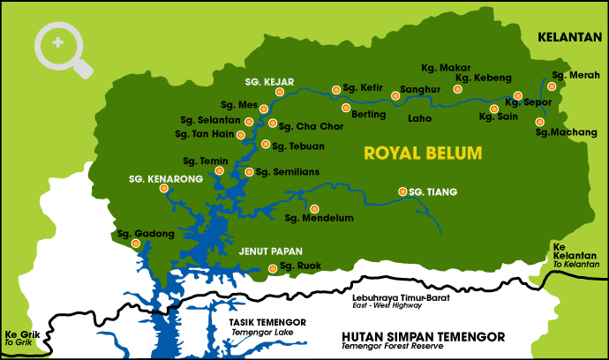
Source: Official Portal of PTNP, 2022

Figure 1. Location of Royal Belum State Park

Royal Belum State Park is 192 kilometres from Ipoh, 410 kilometres from Kuala Lumpur, and 200 kilometres from Penang. It is accessible via the North-South Highway and Jalan Ipoh-Kuala Kangsar-Gerik-Banding (Official Portal of PTNP, 2022). It is also located in Hulu Perak and borders Thailand's Hala Bala National Park and Banglang National Park to the north, Kelantan Forest to the east, and Ulu Muda Forest Reserve to the west Kedah. This state park contains Perak's largest artificial lake and Peninsular Malaysia's second-largest lake, after Tasik Kenyir in Terengganu. This area is also a part of the Central Forest Spine (CFS), which has been designated by the National Physical Plan (NPP) through Policy NPP 23 as the backbone of Peninsular Malaysia's network of Environmentally Sensitive Areas (ESAs) (Official Portal of JPSM, 2022).
Ibrahim et al. (2015) studied the strengths, weaknesses, opportunities, and risks in Royal Belum State Park' using the SWOT approach to establish its feasibility as an ecotourism product. Landform, tourist attraction areas, tourism policy, services, social infrastructure, Environmentally Sensitive Areas (ESAs), transportation and traffic, and area of sustainability evaluation are among the criteria that have been examined for this purpose. In addition, the study also manages to identify the issues and challenges in the state park, such as the influx of immigrants and illegal forest product harvesting and logging activities; passive government policies and management, particularly toward the indigenous people community; and inadequate social infrastructure and utility facilities.

Methodology

This research continues authors’ previous studies conducted, which included the 'assessment on the impact of tourism activities on water quality at the Royal Belum State Park' and 'assessment on the houseboat tourism implementation at the Royal Belum State Park.' The assessment method and parameters used in both previous studies are explained in Table 1.

Table 1. Assessment methods and parameters used in previous studies

Title of Study: | Assessment on the Impact of Tourism Activities on Water Quality at the Royal Belum State Park | Assessment on the Houseboat Tourism Implementation at Royal Belum State Park
Assessment Method: | 1. In-situ analysis on the quality of water sample taken from few selected points of activities within Royal Belum State Park catchment area | 1. Interviews with houseboat owners/operators
Assessment Method: | 2. Water sample collection and laboratory analysis | 2. Measuring work on selected houseboats
Parameter: | 1. In-situ parameter (pH, Dissolve Oxygen (DO), turbidity, temperature, Total Dissolve Solid) | 1. Demographic profile of houseboat owners/operators, houseboats’ design, construction, operation and management, and issues
Parameter: | 2. Laboratory analysis parameter (Biological Oxygen Deman (BOD), Chemical Oxygen Demand (COD), Ammoniacal Nitrogen (AN) and Total Suspended Solids) | 2. Houseboats’ floor plan and elevation
Source: Author, 2023

Previous studies on the Royal Belum State Park were then reviewed for this study. Aside from the published research papers, the official portals of the UNESCO's Tentative Lists, the Perak State Parks Corporation (PTNP), the Forestry Department of Peninsular Malaysia (JPSM), the Friends of the Earth Malaysia (FOE), and the Gerik District Council (MDG), related articles whether published or not, including mythical stories told by the local community were reviewed. This is to reveal the history of the Royal Belum State Park, number of tourist arrivals, and income generated by the tourism operators.
Two visits to the state park was carried out on 24 March 2021and 26 July 2022. During the visits, field observation focusing on the tourism activities carried out at the houseboat parking areas and Pulau Banding Jetty were carried out. Interviews with one houseboat owner/operators/tour boat driver, one restaurant owner, and a Wildlife Assistant from the Forest Rangers (Royal Belum Enforcement Unit), Perak State Parks Corporation were conducted. Interview questions were focusing on the evolution of the area’s status, conservation and tourism measures, number of tourist arrivals and income generated, and the uniqueness and potential of the Royal Belum State Park.
Nevertheless, based on the nomination area as the World Heritage Site (category: nature) currently listed in the UNESCO Tentative List, only the Royal Belum area is limited as the primary study area. Moreover, the Temengor area is excluded from the study due to loose enforcement on the development, compared to Royal Belum.

Results and discussion

This research aims to reveal the history of the Royal Belum State Park from its inception to pre-war times, the evolution of the area's status from a forest reserve to its nomination as a World Heritage Site, the conservation and tourism measures that the Perak State Government has implemented through the Perak State Parks Corporation, number of tourist arrivals and income generated, the uniqueness and potential of the Royal Belum State Park, which has been selected as having the Outstanding Universal Value (OUV) for a World Heritage Site.

History of the Royal Belum State Park

The name 'Belum' is derived from the sound of giant locusts or wood insects in this forest area (Official Portal of MDG, 2022). Although numerous versions of the stories told by the local community can be linked to the history of the Royal Belum State Park, less resolution or publication has been produced by any researcher or author. According to some sources, the state park has existed for 130 years. It is an older rainforest than the Amazon Rainforest in South America and the Congo Forest in Central Africa (Official Portal of UNESCO, 2022). Although no solid evidence has been found to support this claim, the rock formations here are said to be more than 400 million years old, according to a study conducted by researchers from the Malaysian Nature Society (MNS). A change in the geology of the soil occurred 220 million years ago, resulting in the landscape we see today (Figure 2). These changes have also played a role in developing the biodiversity in this rainforest. Although some sources claim that MNS researchers invented this claim, it has become part of the effort to elevate this rainforest as a state park protected from development.

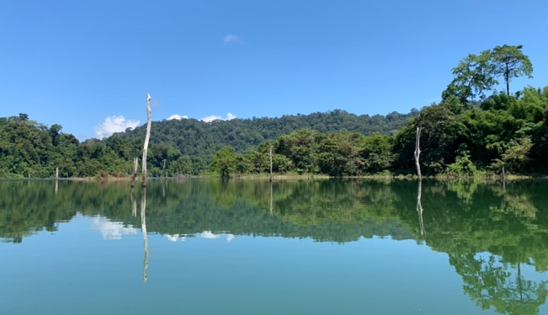

Figure 2. Old trees that can be seen in the lake at the Royal Belum State Park

The state park is a part of the original Kampung Belum Lama area, built 200 years ago. The village is thought to have been established by a royal couple from Thailand's Pattani or Siamese kingdom during the reign of Raja Reman or Rahman, also known as Wan Agas, Tok Mekong Gas, or Tok Pulang Hari. Tok Pulang Hari was named after the ability to travel from this village to Pattani, Thailand, on the same day. There is also a myth that the community evolved here due to the marriage of a human, namely the son of Tok Pulang Hari and Princess Saadon, an elf princess, passed down by the older occupants. The villagers also inherited the legend of a gold mine still believed to exist in the area, even though no one has uncovered it. The Sultan of Perak was given control of the Belum Lama province during the British administration. The state began to manage it based on the Anglo-Siamese Treaty of 1909, a treaty signed by the British and the Siamese governments (Official Portal of PTNP, 2021). Nonetheless, communist rebels formed during the British administration have used the area as a hideaway since the 1950s, getting supplies and training camps. As a result, residents of Kampung Belum Lama were compelled to relocate to Kampung Belum Baru, which opened in 1953 in a location near Pekan Gerik and remains occupied today.
The Jahai people, one of six Negrito tribes who moved to Southeast Asia around 60,000 years ago, live in the state park (Roddin et al., 2019). However, the arrival of communist rebels in the area also impacted the community. As a result, the Malaysian government undertook the Orang Asli resettlement scheme, RPS Sungei Banun in Kampung Sungai Kejar and Kampung Sungai Tiang, which aims to house the Orang Asli community and safeguard them from communist influence and threat while also improving their socio-economic situations (SUHAKAM, 2010). RPS Sungei Banun has successfully relocated 4,784 Orang Asli people, with the government providing annual appropriations to oversee and develop essential services through the Department of Orang Asli Development. Administrative offices, school, hostel, teachers' houses, kindergarten, surau, public hall, playground, and visitor's house are available here. There is also access to safe drinking water and power.
The Malaysian government built a dam in the area in the 1970s as a part of the Temengor Dam Project. After the Lenggong area, Sungai Perak is the fastest river in Peninsular Malaysia and cannot be navigated by sea transport such as ships. As a result, this area was chosen as the best location for constructing a dam, making Sungai Perak the only river in Malaysia with a dam.

The evolution of the Royal Belum State Park’s status

In 1971, the area was designated as a Permanent Reserved Forest named the Belum Forest Reserve by the Perak State Forest Department (Official Portal of UNESCO, 2022). The core conservation area of the area had been protected under the provision of the National Foresty Act 1984, where no part of the area had been degazetted except a small and central part which was inundated by the Temengor reservoir in 1978 and the buffer zones all around the area are more than adequate and remained undisturbed ever since. Later, the Colombo Plan Report, the 3rd Malaysia Plan (1976-1980), and PERHILITAN Semenanjung Malaysia designated the park as a biodiversity protection area in 1988. In addition, Birdlife International, a global collaborative conservation organization dedicated to preserving birds, bird habitat, and biodiversity, designated the region as an Area of Birds and Biodiversity in 2004. Under the 2005 National Physical Plan, Royal Belum was designated as an Environmentally Sensitive Area (ESA) or Environmentally Sensitive Area Rank 1. As a result of this acknowledgement, the National Forestry Act of 1984 was implemented to govern and safeguard all operations and development in the area. As a result, development, planting, and logging are prohibited, leaving only low-impact tourism, education, and research as viable options.
The Perak State Parks Corporation was then formed in 2001 in line with the establishment of the 2001 Perak State Parks Corporation (Section 6) Enactment (Official Portal of PTNP, 2022). This corporation is a statutory body of the Perak State Government and was built as an initiative by the state government to protect flora and fauna in the state parks by advising the state authorities in matters related to the care, use, monitoring, management and development of the state parks, to start, streamline and regulate activities formed under the corporation, and to protect and care the nature in the state parks according to international standards. It began operating as a corporation in 2004 with an appointed general manager to manage all state parks in Perak including the Royal Belum. In 2007, the Perak State Forestry Enactment 2001 Section 6 upgraded the status of Royal Belum from a forest reserve to a state park. This initiative aims to provide more comprehensive facilities to researchers in the country, particularly biodiversity, and to develop ecotourism facilities through the establishment of the Belum-Temengor Integrated Master Plan 2013 and the Perak Forest Management 2006-2015.
The National Heritage Department, under the Ministry of Tourism, Art and Culture Malaysia was then designated the state park as a National Heritage Site in 2012, bringing the state park into the national level, as an early initiative to nominate it as a World Heritage Site. In addition, the state park was nominated by the Permanent Delegation of Malaysia for inclusion in the World Heritage Site (UNESCO Tentative List) in the natural heritage category in 2017 (Official Portal of UNESCO, 2022). This nomination was based on a study of the diversity of ecosystems and habitats for diverse species of flora and animals designated as having Outstanding Universal Value (OUV), as well as recognizing the Lenggong area, which located next to the state park and falls under the 'cultural' category. The OUV highlighted the state park as a part of the Peninsular Malaysian Central Forest Spine and considered as the hotspot for biodiversity in Malaysia as it hosts diverse ecosystems and habitats for the many species of flora and fauna of which many of them are endemic, rare, vulnerable, or threatened in Malaysia.

Conservation and tourism measures of the Royal Belum State Park

The Perak State Parks Corporation has implemented numerous measures to turn the state park into an Exclusive Tourism Area, where the tourism sector is operated with a limited number of guests. All land areas within 1 kilometer of the lake are available to tourists as part of this policy and to assure their safety. The Houseboat Association was formed to register houseboats in the area, demand the construction of sewage tanks within houseboats, and set a restriction on the number of houseboats that can operate in the area (Ramele Ranli et al., 2022). As a result, only 35 houseboats are permitted to operate nowadays to minimize houseboat overcrowding and contamination of the environment. This association was established to make sure all houseboats are operated according to the regulations enforced by the Perak State Parks Corporation and avoid any issues related to the tourist's safety and environmental protection. Members of the association are responsible for helping the local authority during health and safety inspections on the houseboats and for attending training and workshops provided by the local authority related to environment and hospitality. The corporation also stated that only 35 houseboats could be operated to avoid congestion and pollution at the Pulau Banding Jetty, where all houseboats are parked, and the surrounding lake area.
This state park is also used as a research facility by PTNP as part of its efforts to conserve flora and wildlife. The Banding Island Rainforest Research Center was created in 2008 by the Emkay Group of Companies to perform studies on terrestrial and aquatic biodiversity. In addition, several public universities, notably Universiti Teknologi MARA (UiTM), have also established research facilities in the area. Furthermore, any development or advancement plans involving the state park must be submitted to the Sultan of Perak to give the state park more control over development. Several recommendations were also proposed by Latip et al. (2020) to manage and control tourist activities for conserving and protecting the area: essential stakeholders should be included in the park's future development and management, and park management should be prepared to explore new rules and procedures to resolve various environmental challenges and improve visitor satisfaction.

Tourist arrivals and income generated at Royal Belum State Park

Number of tourist arrivals is recorded by the Perak State Parks Corporation from the tourists’ entrance permit application (Official Portal of PTNP, 2022). Since 2012, all tourists are required to apply through the Perak State Parks Corporation by registering their details on total number of visiting people, names, identity card numbers, addresses, telephone numbers of next-of-kin, purpose and entry date. All tourists are regulated to follow rules carried out by the corporation regarding their safety and security during their visit and protection of the flora and fauna, and the indigenous people settlements in the state park. Tourists are also required to pay regulated fees to the corporation such as the tour guide fee, entry permit fee, boat transporting fee, tourism camp rental fee, and researcher fee (for research purpose).
From 2015 to 2019, the number of domestic and foreign tourists visiting the state park, and the generated income have increased slightly (Table 2). However, 90% of these visiting tourists were domestic tourists, with a minority of 10% of foreign tourists documented. It is believed that foreign tourists may prefer to visit other national parks, such as The National Park in Pahang, which is more recognized globally and has superior tourism amenities. Most of the domestic tourists consist of groups of friends visiting the state park for leisure, namely for water activities such as sport fishing, canoeing, swimming in the lake and waterfalls, bamboo rafting and island hopping, and forest activities such as jungle trekking, visiting Orang Asli and Belum Lama villages, animal watching, hiking, camping and rafflesia watching. The state park also attracted groups of families, students, volunteers, and researchers.

Table 2. Tourist Arrivals from 2015 until 2019

Year | Number of domestic tourists | Number of foreign tourists | Total number of tourists | Income (RM)
2015 | 19,187 | 1,303 | 20,490 | 308,012
2016 | 21,450 | 1,925 | 23,375 | 391,706
2017 | 24,796 | 2,427 | 27,223 | 531,274
2018 | 24,937 | 2,868 | 27,805 | 588,894
2019 | 25,272 | 3,586 | 28,672 | 610,488
Source: PTNP, 2022

Accommodations like hotels, chalets, tourist camps, and, most recently, houseboats have been established in the state park for the convenience of tourists. There are four tourism camps provided at the state park: Sungai Kejar Camp, Sungai Tiang Camp, Sungai Papan Camp and Sungai Kenarong Camp, which usually attracted group of young tourists. The houseboat business began in 2000 when houseboats were built as an alternative to current lodging and transportation in the Banding Island Jetty region. Houseboats are the newest attraction for tourists travelling in groups as a place to stay and travel to locations with rafflesia, hornbills, waterfalls, and fishing (Figure 3). It can be a single-storey or double-storey houseboats made of steel and timber, operated by the local community, renovated from previously used logging boats, or newly constructed by local craftsmen. These houseboats are ideal alternatives to current hotels and chalets, as they are less expensive and allow visitors to go closer to nature. There are now 26 houseboats registered with the Houseboat Association, along with 48 companies, which consists of 64 tour guides and 141 houseboat and speedboat drivers, listed on the Perak State Parks Corporation's official portal.

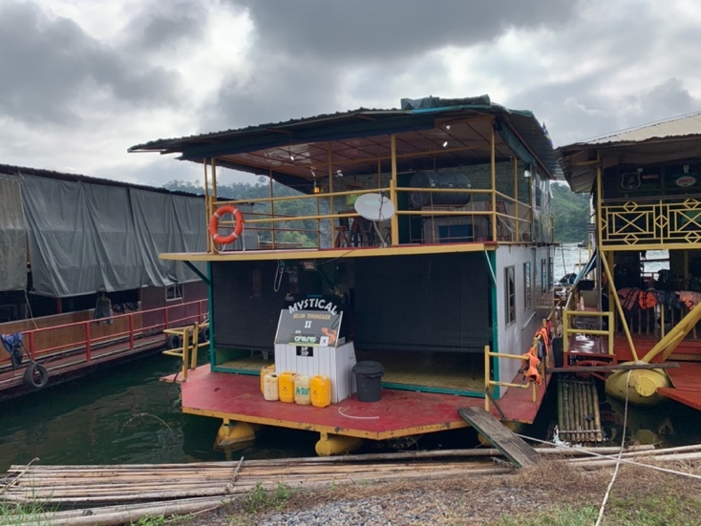

Figure 3. Double story houseboat provided as an accommodation at the Royal Belum State Park

Uniqueness and potential of the Royal Belum State Park

The Royal Belum State Park has certain distinguishing features and benefits that have earned it an OUV and the possibility of being designated as a World Heritage Site. The state park is also known as the Virgin Forest since development only began here when communist insurgents fled the forest region after 1990. Compared to other state and national parks, it is the latest state park to be investigated and accessible to the public for tourism activities. It also represents the largest undisturbed and pristine habitats and ecosystems for in situ conservation of both the terrestrial and freshwater river and lake biodiversity in the country.
The alliance between flora, fauna and Orang Asli migration between this state park and Thailand's Halabala National Park is unusual. There are also ten iconic hornbill species and four endemic rafflesia species here, which are claimed to have the most species compared to rainforests in Borneo and Asia, and the most significant for biodiversity conservation in the world (Official Portal of UNESCO, 2022). In addition, 3,500 seed plant species in the state park are not seen in other national or state parks, in addition to more than 89 moss species and more than 374 species of flowering plants. Furthermore, there are 80 mammals, including Asian elephants, Malayan tigers, and Malayan tapirs, 18 species of frogs, 67 species of snakes, 132 species of beetles, 28 species of crickets, 97 species of butterflies and 41 species of dragonflies. These statements illustrated the significance of biodiversity conservation and scientific value of the state park not only to Malaysia, but southeast Asia and to the tropical old world.
Tourists and researchers alike are drawn to the Orang Asli of Jahai traditional village inside the state park (Figure 4). The Jahai are the most populous ethnic group in this region, with 600 to 800 individuals from various communities and races (Roddin et al., 2019). In addition, 35 Jahai households reside in Kampung Klewang, located on the river's edge, and are migratory, moving between Malaysia and Thailand due to disputes or a shortage of food. Tourists buy kelulut, agarwood, and tongkat ali from the Orang Asli that live here. They also engage in sustainable tourism by entertaining guests with sewang dances, menyumpit, medicinal herb farming, and handicrafts.

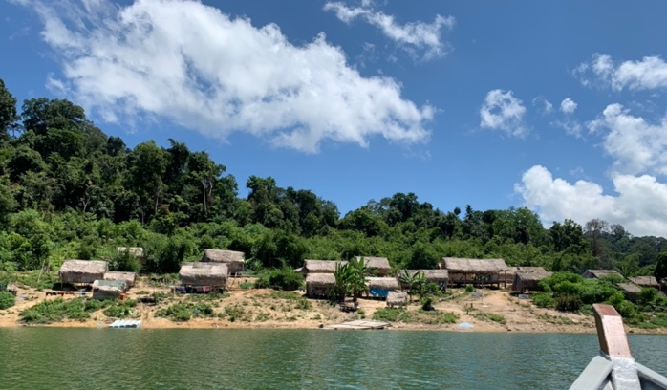
Figure 4. One of the indigenous people (Orang Asli) traditional villages at the Royal Belum State Park

In addition to the traditional Orang Asli communities, visitors and researchers are drawn to the RPS Sungei Banun in Sungai Tiang and Sungai Kejar (Awang et al., 2021). In 1933, 1,058 Orang Asli people arrived, including 64% of the Jahai tribe, 34.5% of the Temiar tribe, and 0.4% of the Semai tribe. In 1996, 1,196 Orang Asli people, with 70% belonging to the Jahai tribe and 30% belonging to the Temiar tribe. Agriculture activities (paddy and cassava plantation) are the area's most common activities of the Orang Asli people. A few work as soldiers, forest police or rangers, and staff at the Department of Orang Asli Development (JAKOA). Most of the Orang Asli in this town still maintain their traditional beliefs, with 133 Bahais and 282 Muslims among them. The establishment of Jahai Enterprise Sdn. Bhd. and Lampai Enterprise and a 60-acre rubber plantation project in Kampung Semelor are examples of the residents' progress. However, due to a lack of economic resources and customary land disputes preventing diverse tribes from coexisting, some indigenous families have returned to their homelands.

Issues at the Royal Belum State Park
As a result of the site studies, researchers have discovered several issues related to the environment, tourist safety and the future direction of the Royal Belum State Park, and the impact of the Covid-19 pandemic. The study results on water quality in this area showed relatively poor conditions, especially in the houseboat parking area at Pulau Banding Jetty, in fishing areas and in water activities carried out near villages of Orang Asli people, and in tourist camps. These poor water quality conditions could be due to the daily activities nearby the villages, activities on the houseboats, smoking or littering, and due to static and non-flowing conditions of the water. The water quality is also said to be affected by the tilapia fish cages located in the Temengor area, where the waste from these cages flows directly into the lake. The same goes for the kelah fish sanctuary located at Sungai Tiang; a development project carried out for the Orang Asli people, where it has caused unpredicted water-tied season and affected the accessibility of the speedboat and houseboat.
In terms of visitor safety, there is a lack of number of rangers to monitor an area as large as this state park. The number of rangers has been expanded from 20 to 60 people; nevertheless, their supervision is concentrated on the Malaysia-Thai border to prevent smuggling activities and border encroachment. In addition, Orang Asli people are being taught as rangers based on their knowledge of the ins and outs of forest travel.
Like most other tourist sites, Royal Belum State Park was impacted by the Covid-19 epidemic, which also impacted the local community's income. Tourism in this state park peaked in 2015 and dropped significantly in 2020 (Table 3). Some hotels and chalets ceased operations, whether permanently or temporarily. Due to the Movement Control Order (MCO) in 2020 and 2021, hotel owners, houseboats, and tourist boats only accepted local visitors from Perak. They began carrying out alternative professions, such as selling fish, food, and rubber tapping.

Table 3. Tourists Arrivals from 2019 until 2021

Year | Number of domestic tourists | Number of foreign tourists | Total number of tourists | Income (RM)
2019 | 25,272 | 3,586 | 28,672 | 610,488
2020 | 8,609 | 500 | 9,105 | 254,301
2021 | 4,787 | 33 | 4,819 | 147,170
Source: PTNP, 2022

The trend of exclusive tourism becomes a concern when the cost of tourism in this state park is said to be higher than in other national and state parks. In addition to lodging and speedboat fees, tourists and researchers must also pay for tourist licenses and research permits. The speed boat to surround the lake area costs RM700 for a maximum of 10 people, a permit fee costs RM25 per entry for tourists, and a research permit costs RM100 per year for researchers. Although this is an essential conservation precaution in this area, it has decreased the number of tourists, affecting the local communities' incomes.

Conclusion

In conclusion, this research found that The Royal Belum State Park has various uniqueness and advantages, in addition to its biodiversity designated as an OUV in the UNESCO World Heritage Site. The location has a unique and intriguing history linked to the entrance of the Patani or Siamese government in Thailand, the exploits of the Perak Malay Sultanate, British control, and communist guerilla hideouts that should be investigated, further gazetted and publicized. The Perak State Parks Corporation should also use the most recent techniques to guarantee that the state park can reopen as Perak's top tourism product during the endemic while preserving flora and fauna, and the indigeneous settlement as an exclusive tourism. Finally, cultural heritage, such as the Orang Asli community engagement in their traditional villages and the RPS Sungei Banun, should be highlighted as a form of a heritage and cultural tourism. This step is critical for the tourism industry to balance the protection of natural and cultural assets.

Acknowledgement

The researchers would like to thank UiTM for supporting the LESTARI research grant (600-RMC/MyRA 5/3/LESTARI 122/2020) and a representative from PTNP, houseboat operators, tourist boats drivers, and tourists in Royal Belum State Park.

References

Abdullah, A. R., Weng, C., & Som, A. (2011). The potentials and perils of ecotourism in Belum Temengor forest complex. World Applied Sciences Journal, 12(9), 1-9.
Abdullah, A. R., Weng, C. N., & Mohamed, B. (2013). Potential and Challenges of Involving Indigenous Communities in Ecotourism in Belum-Temengor Forest Complex, Perak Malaysia. In Proceedings of International Conference on Tourism Development: Building and Future of Tourism, Sustainable Tourism Research Cluster (pp. 332-344).
Awang, S. N., Fadzil, K. S., Edo, J., Zainol, R., & Mustafa, F. B. (2012). 50 tahun berlalu ke mana Jahai dan Temiar di hutan hujan Belum-Temenggor - Perancangan dan Pembangunan Komuniti. Penerbit UUM.
Eagles, P. F. J. (2002). Trends in park tourism: Economics, finance and management. Journal of Sustainable Tourism, 10(2), 132-153.
Gan, J. E., Nair, V., & Hamzah, A. (2019). The critical role of a lead institution in ecotourism management: A case of dual governance in Belum-Temengor, Malaysia. Journal of Policy Research in Tourism, Leisure and Events, 11(2), 257-275.
Huang, Y., Deng, J., Li, J., & Zhong, Y. (2008). Visitors’ attitudes towards China’s national forest park policy, roles and functions, and appropriate use. Journal of Sustainable Tourism, 16(1), 63-84.
Ibrahim, W. S. W., Zainol, R., Awang, S. N., Fadzil, K. S., & Edo, J. (2017). Pelancongan dan pembangunan setempat di Malaysia: Satu analisis SWOT Royal Belum sebagai produk ekopelancongan (Tourism and local development in Malaysia: A SWOT analysis of the Royal Belum as an eco-tourism product). Geografia-Malaysian Journal of Society and Space, 11(13), 115-130.
Latip, N. A., Jaafar, M., Marzuki, A., Roufechaei, K. M., & Umar, M. U. (2020). Spectacle of conservation and tourism in protected areas: Analysis of management, issues and tourist satisfaction. Planning Malaysia, 18(4), 477-498.
Official Portal of FOE: Friends of the Earth Malaysia (2022). Statistical data on forested and conservation areas in Malaysia. https://foe-malaysia.org/articles/statistical-data-on-forested-and-conservation-areas-in-malaysia-2/
Official Portal of JPSM: Forestry Department of Peninsular Malaysia (2022). Hutan Lipur & Hutan Taman Negeri. https://www.forestry.gov.my/my/perkhidmatan/info-perhutanan/hutan-lipur-hutan-taman-negeri
Official Portal of MDG: Gerik District Council (2022). Pulau Banding. http://www.gerik.gov.my/ms/pelawat/destinasi-menarik/pulau-banding
Official Portal of PTNP: Perak State Parks Corporation (2022). Royal Belum: Pengenalan. https://www.royalbelum.my/bm/
Official Portal of United Nations Educational, Scientific and Cultural Organization (UNESCO) (2022). Royal Belum State Park: Description. https://whc.unesco.org/en/tentativelists/6176/
Omar, S. R., Kamarudin, K. H., Razak, K. A., & Robani, A. (2014). Business Practices among Tour Boat Operators in Royal Belum-Temenggor, Perak. Conference: National Conference on Royal Belum 2014, Gerik, Perak.
Rani, W. W. M., Kamarudin, K. H., & Ismail, M. N. (2015). Balancing the urban-rural development: Assessment on local services and facilities for community of Royal Belum forest complex. Conference: ASEAN Forum on ICT for Sustainable Rural Development and Cross-Fertilization 2015, Kuala Lumpur.
Ramele Ramli, R., Ahmad Kamal, N., Abdul Adis, A., & Amir, A. (2022). Houseboat as a new tourism product in Royal Belum State Park. Built Environment Journal, 19(2), 102-110.
Roddin, R., Yusof, Y., Mukhtar, M. I., Awang, H., Bakar, F. D. A., & Hariri, T. I. A. A. (2019). Pemeliharaan dan pemuliharaan budaya komuniti Orang Asli melalui pelancongan lestari. Jurnal Dunia Pengurusan, 1(2), 8-16.
Schwabe, K. A., Carson, R. T., DeShazo, J. R., Potts, M. D., Reese, A. N., & Vincent, J. R. (2015). Creation of Malaysia’s Royal Belum State Park: A case study of conservation in a developing country. The Journal of Environment & Development, 24(1), 54-81.
SUHAKAM: Human Rights Commission of Malaysia (2010). Orang Asli rights problems solutions. Publisher Human Rights Commission of Malaysia.
Vincent, J. R., & Rozali, M. A. (2005). Managing natural wealth: Environment and development in Malaysia. Routledge.

