Unveiling linguistic dynamic: Exploring the Pahang dialect and its historical significance

Muhammad Norsyafiq Zaidi¹, Rahim Aman², Shahidi A.H.², Nurul Shuhada Shafie²

¹Curriculum of Malay Language and Malay Studies, Faculty of Humanities and Social Sciences,
Prince of Songkla University, Thailand
²Pusat Kajian Bahasa, Kesusasteraan dan Kebudayaan Melayu, Fakulti Sains Sosial dan Kemanusiaan, Universiti Kebangsaan Malaysia

Correspondence: Muhammad Norsyafiq Zaidi (email: muhammad.n@psu.ac.th)

Received: 15 January 2023; Accepted: 20 August 2023; Published: 30 August 2023

Abstract

Since 1912, the investigation of the Pahang dialect has intrigued scholars, and its significance has gained prominence in recent times. Previous research has primarily focused on linguistics, employing various approaches within this domain. This systematic literature review aims to provide a comprehensive understanding of the ongoing developments in the dialectal study in Pahang, Malaysia. By collecting, scanning, reviewing, and synthesizing information on this location-focused topic, we employ the Preferred Reporting Items for Systematic Reviews and Meta-Analyses (PRISMA) flowchart and methodology. Our qualitative literature review included the analysis of sixteen (16) eligible full texts, resulting in the identification of three (3) key themes. Our findings emphasize the importance of expanding phonological and historical linguistic research along the Pahang River, shedding light on the linguistic aspects of human migration waves. A deeper exploration of phonological patterns and historical linguistic dynamics within the region will provide a more comprehensive understanding of migration patterns. Consequently, further research is imperative to illuminate the intricate relationship between language, migration, and the Pahang River region.

Keywords: Dialect, historical linguistic, Pahang River, PRISMA, systematic literature review

Introduction

Pahang is a Malaysian state in the west peninsula (Refer to Figure 1) and the largest state in the region. Early human settlements in Pahang were centred on the coast and around river basins (Collins, 1999). Based on the reports of Linehan (1926, 1928, 1930, 1951a, 1951b), the population of native people here has already started thousands of years ago. The remains of archaeological materials such as carpentry tools and pots (among the examples) show that civilization has existed in this area for a long time, could be more than 50,000 years.
The wide and hilly terrain of the region results in a random distribution of population, which in turn affects the presence of dialects. Ismail Hussein (1973) has argued that the complex nature of dialectal characteristics in this state is almost inevitable as a result. The state’s topography and population distribution are the primary contributors to this phenomenon. The differences in speech between the various communities in Pahang are understandable despite their proximity, especially when considering the native population between them and the surrounding tropical forest environment.
The issue has caught the interest of previous researchers, who have used numerous ideas and techniques to decipher the definition of the “Pahang dialect”. A.J Sturrock (1912) was one of the first to describe the basic characteristics of the Pahang dialect. Ismail Hussein (1973) comprehensively analysed the “Malay Peninsula” dialect using structuralist methods in subsequent decades. His study has served as a catalyst for studying dialects in most of the peninsula, including Pahang. After Ismail Hussein’s significant contribution to the field, many researchers began to follow in his steps. Numerous dialect studies have been conducted in Pahang since then. Hence, this study was undertaken to identify themes from previous research on a dialectological study in this state. In addition, a literature review was undertaken to integrate all prior research to provide a new viewpoint for future research.

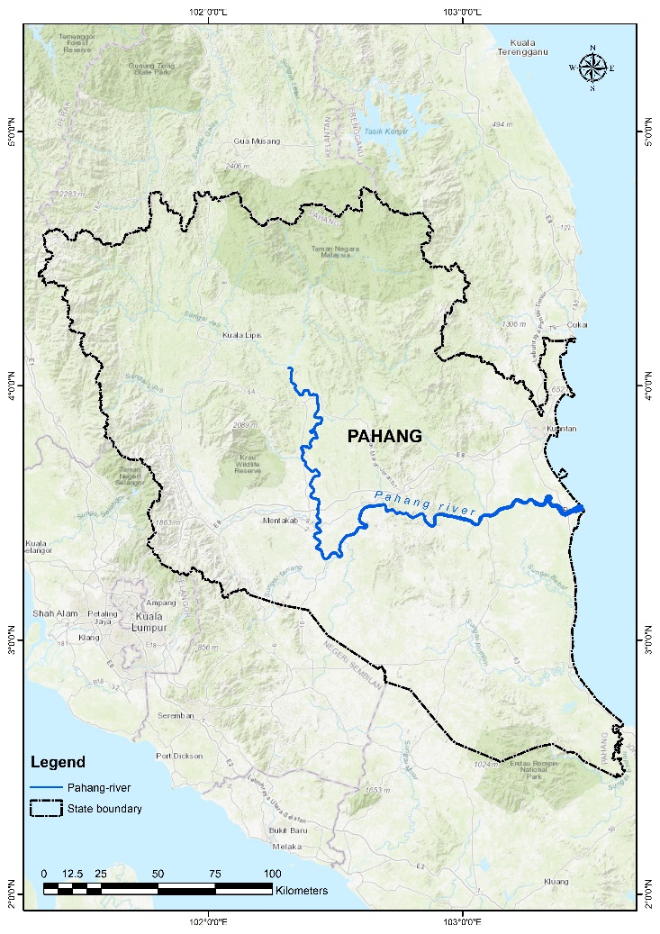
Figure 1. The physical map of Pahang

Objective and design

This systematic review paper aims to comprehensively explore the historical evolution and linguistic characteristics of the Pahang dialect. Trough an analysis of previous research studies, phonological variations, and historical contexts, we seek to provide insights into the development of the dialect within the Pahang River region. The objective is to unveil the distinct phonological patterns, historical migration influences and the unique linguistic dynamic that have shaped the Pahang dialect (in a region of Pahang River) over time. The review concentrates on elucidating the intricate linguistic nuances while acknowledging the broader context of language shift and maintenance within the community. This study utilised a systematic qualitative review based on the methodology of Okoli (2015) and Xiao and Watson (2019).

Methodology

The principles of Okoli (2015) were used to conduct this review. A single research question was followed by applying four principles: planning, selection, extraction, and execution. Each of the four principles depicted in Figure 2 has its own stages. The planning section includes creating a purpose and establishing a protocol. The principle’s second layer is the selection process, including screening and search phases. The extraction, the third principle, extracts data and assesses its quality. The final step is execution, which entails synthesising and writing an idea acquired from the reading process.

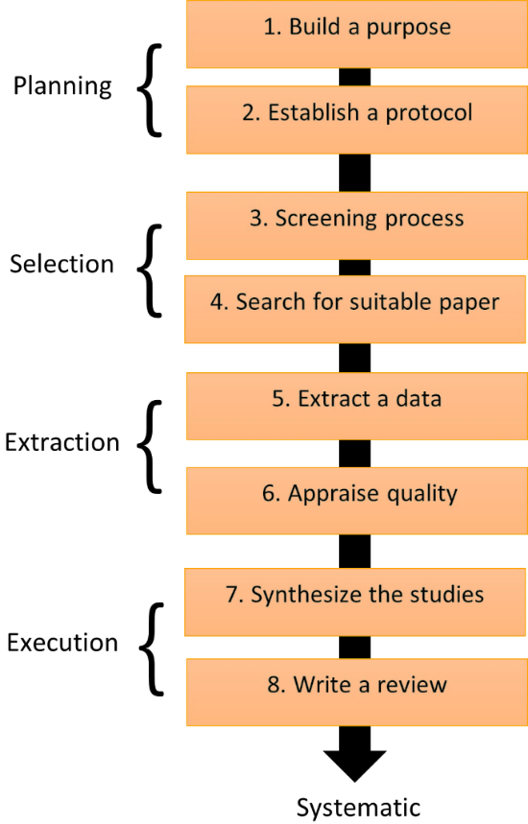
Source: Okoli, 2015

Figure 2. Schematic planning of a systematic literature review

Search method

A comprehensive literature search utilising many databases was undertaken. Google Scholar, Science Direct, Journal Storage (JSTOR), Asian Citation Index and MyCite are among the most popular academic databases among scholars. The publication date limitations were expanded from 1912 to 2021 to collect sufficient material for the present study as the knowledge base lacks insufficient research. Although the time frame was possibly extended to a feasible period, “just enough” papers were available for review. Nevertheless, a distinct number existed between databases during the initial searches. Table 1 displays the number of literatures systematically found in the databases.

Table 1. Number of literatures found

Google Scholar | Science Direct | JSTOR | Asian Citation Index | MyCite
76 | 31 | 5 | 1 | 13

The Boolean operators ‘AND’ and ‘OR’ were employed in the Google Scholar database to search for English and Malay language literature. The keyword was consistently represented as “Pahang dialect” or “dialek Pahang” in other databases. Resultantly, 76 articles were discovered in Google Scholar, 34 articles in Science Direct, 11 articles in MyCite, five in JSTOR, and one in the Asian Citation Index (ACI) database. In addition, a few non-digitised Dewan Bahasa dan Pustaka articles and two scholarly books were also included. Rather than depending on full-text journals, an upgraded version of Preferred Reporting Items for Systematic Reviews and Meta-Analyses (PRISMA) was employed, permitting the researchers to add other literature sources (Page et al., 2021). As indicated in Figure 3, 134 papers and four academic books were listed.
In the first phase, 138 publications were available for the screening process. The second phase is the screening process, which contains two stages. The initial mechanism for categorising relevant articles is only based on article titles. A mismatch between the title and a predetermined keyword would result in the exclusion of the article. Therefore, a manuscript lacking specified keywords in the title was disqualified. The inclusion and exclusion criteria for the second phase are detailed in Table 2. Any content that does not fit the criteria was removed.

Table 2. Inclusion and exclusion criterion
Criterion | Details
Inclusion criterion | Only research conducted in Pahang with information relevant to dialectology has been included. Hence, this review has selected academic books and journal articles, both available in full-text and hard-copy format, as two distinct forms of scholarly writing for analysis. Plus, only publications in English and Malay were accepted as a language of acceptance.
Exclusion criterion | Several publications were omitted, including theses, conferences, government reports, literature reviews, duplicated articles, and quantitative research found during the search phase. Furthermore, research focusing on non-Malay dialects will be excluded because the goal of this research is to focus solely on Malay dialect spoken in this area. There was also research about Austroasiatic language communities in Pahang, but it was decided to exclude it for that reason.

Full-text identified from:
Google Scholar (n = 75)
MyCite (n = 13)
JSTOR (n = 5)
Science Direct (n = 31)
Asian Citation Index (n = 1)
Full text removed before the screening:
Duplicate records removed
(n = 12)
Full-text screened
(n = 115)
Full-text excluded
Irrelevant topic (n = 86)
Thesis (n = 10)
Proceedings (n = 2)
Review article (n = 5)

Full-text not retrieved
(n = 4)
Full-text assessed for eligibility
(n = 12)
Other studies identified from:
Journal (n = 8)
Academic books (n = 4)

Paper assessed for eligibility
(n = 9)
Paper excluded:
Irrelevant (n = 3)
New studies included in the review
(n = 15)

Identification of new studies through databases and registers
Identification of new studies through other methods
Identification
Screening

Included
Total included papers
(n = 15)
Paper sought for retrieval
(n = 12)
Paper not retrieved
(n = 0)
Figure 3. Flow chart of literature search

Search outcome

The first search phase identified 138 full-text and academic books published between 1912 and 2021 using a predefined keyword and physical collection. Nonetheless, only 16 of the 138 publications were accepted for this review based on the last criterion. All the research was categorised into themes shown in Table 3, Table 4, and Table 5.
The first topic of this discussion revolves around the historical standpoint of a variant in Pahang. Although the time range was expanded to include more articles from more than 100 years, Table 3 shows the limited number of studies compared to Table 4. The phonological descriptions of a selective variant and sociolinguistic viewpoint of language usage in Pekan, Pahang are shown in Table 4. Information regarding the historical linguistic approach can be found below.

Table 3. Historical linguistic approach
No. | Authors (year) | Aim | Method (data) | Findings
1. | Mohd Tarmizi Hasrah et al. (2013) | This research sought to investigate the characteristics of innovation and retention in the upstream Tembeling dialect using a historical linguistic approach. | These qualitative studies opted to use Crowley’s framework (1997) as the primary set of tools for their analysis. The data was obtained through the process of organising a fieldwork excursion. In each of this research, the reconstructed proto-Austronesian language that Adelaar (1992) developed was used as a frame of comparison. | The first finding the research uncovered is that the Hulu Tembeling dialect only has one innovative trait. Second, discernible distinctions exist between the three primary places based on the linguistic characteristics of the local dialects. Nevertheless, the study could not comprehensively explain the circumstances that contributed to the major change in the Tembeling dialect upstream compared to the characteristics of the Kuala Tembeling and upstream dialects along the Pahang River.
2. | Mohd Tarmizi Hasrah et al. (2014) | The goal of this research is to describe the variation form of the “Hulu Sungai Pahang” (upstream of Pahang River) dialect, reconstruct the ancient form of this dialect, and finally, use Adelaar’s (1992) reconstructed proto-language as a comparison medium. In addition, this study aimed to classify the relationship between ancient languages spoken upstream of the Pahang River and Malayic-Purba and classify them at the level of kinship. | These qualitative studies opted to use Crowley’s framework (1997) as the primary set of tools for their analysis. The data was obtained through the process of organising a fieldwork excursion. In each of this research, the reconstructed proto-Austronesian language that Adelaar (1992) developed was used as a frame of comparison. | The investigation results demonstrated considerable disparities between the two groups of big variations. The classification established further reinforces the idea presented by Ismail Hussein (1973, p. 78) regarding the gradual change of dialect traits according to the terrain of the river. Nevertheless, this study covers only a particular area of the Pahang River.
3. | Norfazila Ab et al. (2017) | This study compares the vowels, diphthongs, and consonants of the Tioman-Aur-Pemanggil Malay dialect with Proto-Malayic. This study also aimed to evaluate the degree of innovation and retention in this dialect. | These qualitative studies opted to use Crowley’s framework (1997) as the primary set of tools for their analysis. The data was obtained through the process of organising a fieldwork excursion. In each of this research, the reconstructed proto-Austronesian language that Adelaar (1992) developed was used as a frame of comparison. | This research aimed to reconstruct the ancient forms of dialect variants on a Pahang island. Based on phonetic comparisons with Proto-Malayic, the study’s outcome refutes the notion of human waves emanating from Mainland China and Taiwan.
4. | Muhammad Norsyafiq Zaidi et al. (2021) | This study attempted to characterise, reconstruct, and classify ancient dialect variants in the middle of the Pahang River basin. This study also aimed to analyse the link between language kin variations using the evidence for innovation. | These qualitative studies opted to use Crowley’s framework (1997) as the primary set of tools for their analysis. The data was obtained through the process of organising a fieldwork excursion. In each of this research, the reconstructed proto-Austronesian language that Adelaar (1992) developed was used as a frame of comparison. | In the central basin of the Pahang River, two major variants are present. On the other hand, this study implicitly and directly contradicts the theory proposed by Ismail Hussein (1973, page 78) regarding the gradual alteration of linguistic characteristics per the river currents based on evidence of its classification of Proto-Central Pahang River’s kinship. The “theory” in question suggests that river currents were responsible for gradually altering linguistic characteristics.

At least eight different items concentrating on the phonological aspects of variants were included in this theme. Numerous studies concentrate on specific locations. Nevertheless, very few studies explore more than one district. Reviewing each study is interesting and offers in-depth knowledge on the topic. Table 4 displays the phonological descriptions of specific variants.

Table 4. Phonological descriptions of specific variants
No. | Authors (year) | Aim | Method (data) | Findings
5. | A.J Sturrock (1912) | This study focused on describing the phonological aspect of certain regions in Kelantan, Perak, and Pahang. | Data acquisition details were insufficient, while data interpretation was skewed. The study’s findings were presented in note-form rather than in a scientific report format. | As indicated in his study, the Pahang dialect is identical to the written form of Bahasa Melayu. His report used words to differentiate between the three dialects he studied. This discovery offered a starting point to a deeper comprehension of the Pahang dialect.
6. | Ismail Hussein (1973) | The study’s subject was a phonological component of a select number of regions in Malaysia and Pattani, Thailand. In addition to states, a district was included in the study due to its interesting phonological characteristics. | The researcher employed a brief questionnaire to discuss his isolated lexical items. He opined that phonological differences exist between these dialects. | This study examined the differences in the phonological variation characteristics of Malaysia’s major states. This study implicitly identified Pahang as a variant with a significant degree of diversity in the distribution of phonological variance. Nevertheless, one of the study’s most essential aspects is the concept of gradual changes in phonology variation of the river’s topographic area.
7. | Nik Safiah Karim and Ton Ibrahim (1977) | This research aimed to fulfil two objectives:  To characterise the phonology of the indigenous people along the Ulu Tembeling River  To describe the characteristics of the Malay dialect spoken by the local Malay population | This research employed a qualitative method to fulfil the suggested research objectives. Data was obtained through the fieldwork undertaken in the region surrounding the Tembeling River. The phonological perspective was discussed in the data presented. | According to the study’s findings, the phonological characteristics of Malay speakers in the Ulu Tembeling area are comparable to speakers in the Kelantan-Terengganu region. The researchers deduced that there had been a significant potential population movement out from the northern region (Kelantan-Terengganu).
8. | Raja Masittah Raja Ariffin (1987) | This research is an exemplification of a meta-analysis. The findings were drawn from a multitude of other research. | This study classified dialects based on the consonant and vocal systems using data from prior studies. | In accordance with the Johor and Melaka dialects, the Pahang dialect is categorised as a southern dialect. The study provided a radical classification, considering only the vocal and consonant systems.
9. | Asiah Idris (1987) | In this study, an attempt was made to characterise the segmental phonemes of Sentang village located in the district of Maran, Pahang, while expanding dialect studies in Malaysia. | Data were acquired during an interview. The researcher posed unstructured queries. The interview with the respondent was audio-recorded. | This dialect is distinguished from Malay by a single consonant, the soft palate friction sound with the sounds /ɣ/, and the vowels of /ae/ and /ʉ/. In addition, both diphthongisation and monophthongisation are present in this dialect.
10. | Collins (1983a, 1983b) | This publication, published in two series, attempted to describe the six phonetic characteristics of the Pahang dialect, | Eight locations were selected for data collection. The data was shown by comparing a significant distinction between the eight locations. | In various regions, the nasal suffix has several characteristics that do not conform to the standard pattern. Second, the author maintained his stance on the discovery that the effect of
 |  | particularly the Temerloh district dialect. |  | stating /ɣ/ on a closed final syllable is one of the weakening factors rather than obliteration. The third phenomenon is the transition from CaCa# to CaCɨ# at the end of a syllable, but this characteristic is only present in certain locations. Finally, the phrase “consonant germination” can occasionally be referred to as either an independent lexeme or a muted prefix.
11. | Ajid Che Kob et al. (2009) | This study attempted to elucidate concerns associated with voice sound adaption prior to the coronal sound. | Ten locations in the vicinity of the Jelai and Lipis rivers were studied. | This study concluded that the characteristic described for Temerloh also occurred in Jelai and Lipis rivers. Nevertheless, the characteristic does not occur in every ten locations. Some were modulated differently.
12. | Asmah Haji Omar (2015) | This book contains massive information. Nevertheless, the researcher’s attempt to characterise the phonology characteristic in this state was the most important Pahang-related issue. | This qualitative discussion focused on phonological concerns of a few important sites in Pahang and how their words are pronounced. The author presented her findings by contrasting them with a Malay language and by contrasting the differences and similarities between a sub-dialect itself. The data collection was limitedly explained. | Based on the most recent historical information, the researcher suggested that the Pekan area should be considered the birthplace of all Pahang dialects. Furthermore, Asmah explained the phonological feature common to most people’s speech in Pahang. She revealed that other regions in Malaysia, such as Kelantan, Selangor, and Johor, have characteristics in common with dialects spoken in Pahang.
13. | Jamal Rizal Razali and Imaduddin Abidin (2016) | This research collected relatively uncommon words for five actions or tasks, including farming, cooking, carpentry and laundry. | In this qualitative study, the researcher conducted interviews in Relong village, Kuala Lipis, with three female informants who were 70 years old and above. In their years of living, they had never been outside the village except to perform Hajj in Mecca. The researcher attempted to use appropriate Malay words, but most lacked an accurate translation, and some were left blank. | According to the study’s findings, the Relong community employs many vocabularies. The majority of words lack a precise Malay equivalent. According to the researcher, the Relong community’s way of life is strongly tied to the five previously listed activities.
14. | Mohd Tarmizi Hasrah (2019) | This study describes the nasal vocal phonological abnormalities present in the Kampung Budu variant. | The only site mentioned as a potential research topic in this qualitative study is Kampung Budu. In addition to relying solely on research data, he also conducted a meta-analysis review using data from earlier research as a basis for comparison. The review was undertaken in addition to depending solely on research data. | Based on the nasal vocal characteristic /a/ in the last position of the open word, this study summarises that the Kampung Budu variant is an extremely rare and distinctive form of the dialect. This distinguishing feature sets it apart from the group of Malay dialects spoken upstream of the Pahang River. In his opinion, the distinguishing factor is this characteristic’s absence in any dialect of Pahang besides the dialect spoken in Kelantan and the variant spoken in Kedah-Langkawi.

This section only has one research filtered from the scientific database search engine. The only study was from Marlyna Maros (2010), as shown in Table 5. The primary focus of this study is to examine the degree of inclination that native speakers have towards utilizing their mother tongue and their aptitude to comprehend their own language when it is spoken in their dialect. The research delves deeper into this subject matter and aims to provide a comprehensive understanding of the topic at hand. More about this research as follows:

Table 5. Language usage
No. | Authors (year) | Aim | Method (data) | Findings
15. | Marlyna Maros (2010) | This sociolinguistic study aimed to investigate the degree to which native speakers of the Pekan dialect use their native dialect. | Thirty beginning lexemes were collected from second-year students. Subsequently, the researcher collected an additional 130 lexemes by interviewing ten young adults. A total of 50 people responded.  Thirty were from Pekan, Pahang and the remaining 20 were from within a radius of 40 minutes around Kuala Lumpur.  Online interviews account for 85% of all respondents from Kuala Lumpur interviews. A quantitative methodology was utilised for the study. | According to the study’s findings, two distinct groups of young people exist in terms of using their native dialect. The first group comprises young people who are not exposed to the outside world. The second group entails young people exposed to the outside world. Individuals who have had prior experience with the broader community are more likely to speak Malay than their own local dialect. Therefore, most of them could not comprehend their local dialect’s lexemes. The elderly is the third demographic. In terms of the numerous ways, they utilise language throughout the day, they do not constitute a complex group.

Discussions

This section comprises two parts. The first part entails topics concerning research on historical linguistics and language usage, while the second covers topics regarding research on phonology in and around the state of Pahang.

A study based on a historical linguistic point of view and language usage.

At least four research on the Pahang dialect used the same methodology and general structure. Only one study was concerned with a dialect spoken in the area of the island, while the other three concentrated on the dialectal occurrences in the Pahang River region. Nevertheless, only two studies adequately described the historical relationship between proto language (Proto-Malayic) with a recent reconstructed proto language spoken in this area. These studies were conducted by Mohd Tarmizi Hasrah et al. (2013) and Muhammad Norsyafiq Zaidi et al. (2021).
The research by Mohd Tarmizi Hasrah et al. (2014) on the Tembeling River was one of the early studies to employ Crowley’s (1997) framework and utilise Adelaar’s (1992) rebuilt data as a comparative model. The researchers conducted their study along the Tembeling River. This study is analogous to a trigger study, in particular concerning the research of Pahang since it has been highlighted as a model study in other research in the same field in the following years.
The field of study remains in infancy, particularly in analysing the historical relationship of dialects in Pahang. Nevertheless, it has significantly contributed to picturing the real occurrences in the Pahang River region, particularly the use of Pahang dialects. First, the dialects spoken in the upstream region contain features comparable to those found in the dialects spoken in the downstream region. This comparable feature is known as the downstream-upstream comparison. Second, a theory lends some weight to the argument, as one site somewhat undermines the “probability” of these progressive shifts.
Taking an effort to document, recreate, and categorise the entire region surrounding the Pahang River to tackle this issue of overlapping perspectives is necessary. By considering the phenomenon that occurred in Pekan, Pahang during the study by Marlyna Maros (2010), an extensive study must be undertaken soon as it is feasible to avoid the possibility of this dialect being harmed by younger speakers’ inability to converse in this dialect.

The phonological viewpoint of the Pahang dialect.

Undoubtedly, since post-independence, researchers have strived to record the characteristics of dialects in most places in the country, including the pioneer, Ismail Hussein. At least eight studies focus entirely on phonological features related to the Pahang dialect. Among the earliest studies is by A.J Sturrock (1912), who briefly examined the phonology in three Malaysian states, namely Kelantan, Perak, and Pahang. Although the discussion related to Pahang is limited, the issues discussed were focused on the form of speech and interesting vocabulary that can be studied in-depth. This study is a steppingstone for further research in most places in Pahang.
The study was followed by the study of Ismail Hussein (1973) a few decades later. He examined most dialects in Malaysia and the Pattani area, Thailand. This study indirectly adds to the corpus of knowledge at the time, as stated by Collins (1983b). The most interesting view regarding the Pahang dialect is that it has a periodic change feature, especially in the Pahang River area. Dialects along the river areas have many variations. For that reason, he considered the Pahang dialect among the most complex dialects with too many variations.
Ismail Hussein’s (1973) views were further explored by Asmah Haji Omar (2015). The latter directly marked Pekan as the centre of dialect dissemination in Pahang. Asmah took the evidence of the site of the old rule as an argument, in line with Collins’ (1999) hypothesis, regarding the location of the early rule. In this writing, Asmah compared many variations of Pekan with variations found in Pahang, such as variations of Ulu Tembeling, Raub, Kuala Lipis, Temerloh, and several other districts.
The phonological performance in the Pahang River area subsequently continued. Nik Safiah Karim and Ton Ibrahim continued their research in Ulu Tembeling to document the forms of Malay speech in the area. The research found that the speakers’ speech no longer resembled h the speakers of Pekan even and “...mengekalkan beberapa daripada ciri dialek Kelantan dan Terengganu” (Nik Safiah & Ton, 1977). Hence, Ulu Tembeling is possibly a hub of its own waves that have not been studied. Thus, Pahang has two characteristics of waves of large phonological variations.
Several studies focus on specific issues. For example, the issue of nasal vowels that commonly exist in Kelantan and Langkawi but are uncommon in Pahang was found in a sub-dialect here (Hasrah, 2019). Hence, Pahang is indeed a complex state, as claimed by Ismail Hussein (1973, p. 78).

Direction for future research

The systematic literature analysis that has been conducted as a part of this study, as presented in Table 3, Table 4, and Table 5, has aimed to explore the previous research studies on the portrayal of the Pahang dialect as a whole. This analysis is highly beneficial for future studies that wish to assess the methods that have been undertaken in the past and also raise new concerns in this discipline. As elucidated earlier in this discourse, scholars in the field have predominantly adopted a phonological perspective in their investigations of casting phenomena. Nevertheless, these studies have remained confined to select "hotspot" locations, thus warranting further attention and investigation. The performance viewed from the vantage point however has a significant impact on the knowledge library that we have on Pahang dialect’s phonology.
A notable study has employed the field of sociolinguistics to gain a comprehensive understanding of language usage and its interplay with society. One such study, conducted by Marlyna Maros in 2010, serves as a valuable example of this approach. Her research provides a useful highlight of phonological and dialectology-related studies, particularly in terms of enhancing efforts to document and preserve the Pahang dialect for future works. Unfortunately, recent evidence which depicted by Marlyna Maros (2010) in her study has unveiled a disheartening trend among the younger generation, indicating a warning interest in the documentation of their native dialect. This situation is particularly concerning due to the repercussions it has on the preservation and transmission of the dialect to the subsequent generations within the community. When younger individuals who exposed to the outside world are unfamiliar with the lexicon and expressions of their own dialect, the task of documenting the language becomes significantly more challenging.
In conclusion, the dialect of the Pahang River holds a significant scholarly interest for linguists across various linguistic disciplines. Phonology is the primary focus, while applied linguistics encompasses historical linguistics and sociolinguistics. Through the analysis of a phonology database compiled from previous field studies, notable regional changes in the Pahang River area have been identified, ranging from Pekan (Asmah, 2008) to the upstream regions investigated by Mohd Tarmizi in his multiple studies of Hulu Sungai Pahang and Sungai Tembeling.
Mohd Tarmizi's research provides valuable insights into the phonological transformations occurring in the local dialect spoken along the Pahang River. This historical perspective aligns with Ismail Hussein's earlier studies during the early stages of linguistic research in Malaysia, which support the notion of gradual phonological changes within the Pahang River dialect. These gradual changes implicitly indicate patterns of local migration in the area, particularly pertaining to the first wave of immigration, although specific origins and subsequent destinations remain undisclosed. Nonetheless, the linguistic evidence presented here is still insufficient to fully comprehend the magnitude of this human movement.
A potential avenue for forthcoming research involves systematically gathering dialectal instances spoken across the entire geographic stretch of the Pahang River. This encompasses areas downstream, the riverine centre, and upstream regions, as there are still gaps in prior research coverage. The systematic literature review has primarily focused on locations like Pekan, Jerantut, Hulu Sungai Pahang, and the Tembeling River. However, numerous locations along the Pahang River remain undocumented in terms of their dialectal characteristics. By amassing data through on-site data collection, the aim is to discern discernible patterns within these dialects. Through this endeavour, a comprehensive comprehension of dialectal patterns will ideally emerge, shedding light on the historical movements of human populations within the area.
While the primary objective is to elucidate the remarkable historical migration of early humans, it is also recommended to engage in a historical discourse concerning the proto form of the Pahang River dialect. This discipline holds significant interest as it not only seeks to comprehend the foundational patterns of human migration but also deciphers a language code reminiscent of earlier forms of human communication - a proto-form with antiquity at its core.

Conclusions

This study aimed to determine the scope of previous research on Pahang Malay dialect’s variant. The earliest research for this systematic study was conducted in 1912. The study of regional linguistic variations in the state is still in its infancy. Three main topics were discussed in this article. One of the topics is the analysis of historical linguistics on the Pahang dialect. Another topic is concerned with the phonological performance of the Pahang dialect. The third topic focused on the application of dialect.
Previous research has predominantly exhibited a specific focus on segments of the Pahang River region, impeding our comprehensive understanding of human migration patterns. To rectify these limitations, it is proposed that an on-site data collection endeavour be undertaken along the entirety of the Pahang River. By meticulously examining the phonological patterns evident in the local dialect spoken by the Malay community residing along the Pahang River, a deeper comprehension of their behavioural characteristics can be attained. Hence, it is recommended to initiate a macroscopic research initiative in the Pahang area, encompassing the systematic collection, analysis, and comparative study of dialectal patterns among the present-day speakers, facilitating a comprehensive exploration of the subject matter.
As previously mentioned, our research interest extends to the exploration of a proto form of the Pahang River dialect. We posit that significant evolutionary changes have transpired within this dialect, which can be elucidated by comparing prior studies' data with Adelaar's reconstruction of Proto-Malayic. By adopting a historical standpoint, we hypothesize that the unique topography of the region has expedited the evolution of the dialect, resulting in its distinct form. In simpler terms, the environmental factors specific to this area exert a direct influence on the phonological patterns observed in the speech of the local Malay population. Through synthesizing these discussions, we aim to provide a comprehensive understanding of the intricate interplay between the geographic characteristics of the region and the phonological aspects of the dialect spoken by the Malays residing therein.

Acknowledgement

Acknowledgment to the Ministry of Higher Education of Malaysia for its financial contribution towards research endeavours under the ambit of the Fundamental Research Grant Scheme (Code: FRGS/1/2022/SSI09/UKM/02/16).

References

Adelaar, K. A. (1992). Proto-Malayic: The reconstruction of its phonology and parts of its lexicon and morphology. Pacific Linguistics.
Ajid Che Kob, & Mohd Tarmizi Hasrah. (2009). Dialek melayu Pahang: Tinjauan di Sungai Jelai. Jurnal Persatuan Linguistik, 9, 61–76.
Asiah Idris. (1987). Fonologi dialek Pahang: satu kajian awal di Kampung Sentang [Pahang dialect phonology: A preliminary study in Kampung Sentang]. Jurnal Dewan Bahasa, 6(32), 415–431.
Asmah Hj. Omar. (2015). Susur galur bahasa Melayu (2nd ed.). Dewan Bahasa dan Pustaka.
Collins, J. T. (1983a). Dialek Pahang: Rangka pengenalan (Bahagian Akhir). Jurnal Dewan Bahasa, 27(1), 99–118.
Collins, J. T. (1983b). Dialek Pahang: Rangka pengenalan (Bahagian Pertama). Jurnal Dewan Bahasa, 27, 7–29.
Crowley, T. (1997). An Introduction to Historical Linguistics (3rd ed.). Oxford University Press.
Google Maps. (n.d.). [Map of Pahang River]. Retrieved on 15th August2023, from https://www.google.com/maps/d/u/0/edit?mid=1laZW6lLfO-PxIe-avIdY2emEN9wzonk&usp=sharing.
Ismail Hussein. (1973). Malay Dialect in the Malay Peninsula. Jurnal Nusantara, 3, 69–79.
Jamal, R. R., & Imaduddin, A. (2016). Dialek keturunan Tok Linggi dalam kerangka kearifan tempatan Jamal Rizal Razali Imaduddin Abidin. International Journal of Humanities Technology and Civilization (IJHTC), 1(2), 92–105.
Maros, M. (2010). Dialek Pekan: Penggunaan dan pengekalan [Pekan Malay dialects: use and retention]. Jurnal Bahasa, 10(1), 81–94.
Mohd Tarmizi Hasrah. (2019). Penasalan vokal dalam dialek Melayu Hulu Pahang (Vowel nasalization in the Hulu Pahang dialect). Jurnal Bahasa, 19(2), 199–230. https://doi.org/10.37052/jb.19(2)no2
Mohd Tarmizi Hasrah, Aman, R., & Shahidi, A. H. (2014). Fosil dialek Melayu hulu Pahang. Penerbit Universiti Kebangsaan Malaysia.
Mohd Tarmizi Hasrah, Shahidi, A. H., & Aman, R. (2013). Inovasi dan retensi dalam dialek Hulu Tembeling [Innovation and retention of Hulu Tembeling dialect]. Gema Online Journal of Language Studies, 13(3), 211–222.
Muhammad Norsyafiq Zaidi, Rahim Aman, & Shahidi A. H. (2021). Genetik purba dialek Melayu: Di lembangan tengah Sungai Pahang [Ancient Genetics of Malay Dialects: In the central basin of the Pahang River]. Penerbit Universiti Kebangsaan Malaysia.
Nik Safiah, K., & Ton, I. (1977). Penyelidikan Bahasa di Ulu Tembeling. Jabatan Pengajian Melayu.
Norfazila, Ab. H., Rahim Aman, & Shahidi A. H. (2017). Varian Dialek Melayu Tioman-Aur-Pemanggil: Analisis linguistik bandingan (Tioman-Aur-Pemanggil Malay Dialect Variants: A Comparative Linguistics Analysis). GEMA Online Journal of Language Studies, 17(2), 219–244. https://doi.org/10.17576/gema-2017-1702-13
Okoli, C. (2015). A guide to conducting a standalone systematic literature review. Communications of the Association for Information Systems, 37(1), 879–910. https://doi.org/10.17705/1cais.03743
Physical map of Pahang. (2011). http://www.maphill.com/malaysia/pahang/maps/physical-map/
Raja Masittah, R. A. (1987). Pemerian tentang kajian fonologi: dialek Melayu [Characterization of the study of phonology: Malay dialects]. Jurnal Dewan Bahasa, 31(4).
Sturrock, A. J. (1912). Some notes on the Kelantan Dialect and some comparisons with the Dialects of Perak and Central Pahang. Journal of the Straits Branch of the Royal Asiatic Society, 62, 1–7. https://www.jstor.org/stable/41561157%0A
Xiao, Y., & Watson, M. (2019). Guidance on conducting a systematic literature review. Journal of Planning Education and Research, 39(1), 93–112. https://doi.org/10.1177/ 0739456X17723971

