Analysis the carrying capacity of high school educational facilities needs in Bandung Regency

Berry El Hamdi, Iwan Setiawan, Nandi

Universitas Pendidikan Indonesia, Bandung, Indonesia

Correspondence: Berry El Hamdi (email: Berry.elhamdi7@upi.edu)

Received: 15 January 2023; Accepted: 18 June 2023; Published: 30 August 2023

Abstract

Bandung Regency is the district with the largest population in Greater Bandung in 2021. The population is predicted to increase during Indonesia's golden momentum in the coming 2045. To prepare for this, an analysis is needed to see the carrying capacity of the current high school education needs facilities with a population in 2045. Data can be presented with WEBGIS. The aim of the research is to analyze high school educational facilities through capacity and capacity referring to Permendikbud No. 23 of 2016, and the carrying capacity of high school education facilities in 2045 refers to SNI 03-1733-20041, visualizing the required data through WEBGIS. The data uses residents aged 16-18 years obtained through the Sprague Multiplier method, and then uses the geometric projection method of the population to predict the population in 2045. The results of the study found that high schools in Bandung Regency in 2022 had discrepancies between groups and classrooms. Thus, the occupancy capacity exceeds the existing capacity (inefficient, and quite efficient). In addition, the existing Senior High School cannot optimally accommodate residents aged 16-18 years. For the carrying capacity of Senior High School needs in 2045, comment on the addition of 4 educational facilities (schools) for Cileunyi, Kutawaringin, Ketapang and Rancabali.

Keywords: Capacity, Bandung Regency, occupancy capacity, population aged 16-18, WEBGIS

Introduction

One of the ongoing and future phenomena in Indonesia today is the demographic bonus or window of opportunity. That is a phenomenon that describes a shift in the concentration of the Indonesian population based on a certain age (Tjiptoherijanto, 2001). So that the Indonesian population has experienced a shift in the non-productive population (age population 0-14 years & > 65 years) to the productive population (age 15-64 years) with an additional population of 2 times more than the non-productive population which resulted in the ratio of dependents to the figure below 50 or good value (Munawaroh et al., 2019). This is supported by data on Indonesia's population based on a population survey in 2020 (BPS, 2021), namely the total population of Indonesia is 270.20 million people with a population growth rate of 1.25% of which 70.72% are productive residents (aged 15-64 year). In addition to the above data, the population of Indonesia has increased every year. Based on research conducted by Sulistyastuti (2017) that the projected population of Indonesia in 2025 is 284.84 million people with a population growth rate of 1%. Among them occurred in Bandung Regency which occupies the first position in population. Bandung Regency has a population of 3,717,291 million people with a growth rate of 1.56% (BPS, 2020). So it can be said that cities and regencies in Indonesia have a large population potential, especially in the productive age population. In addition, with the existing population growth rate, every year the population will continue to increase, especially at the age of 100 years of Indonesian independence in 2045.
In responding to these challenges, an analysis is needed to see whether current educational facilities can serve the needs of the population in the future, especially the population in 2045. Due to the increase in the population, especially the school-age population, it will have an impact on an increase in facilities or infrastructure. The facilities needed specifically to increase the number of educational facilities or existing educational facilities, both kindergarten, elementary, junior, and high school (Munawaroh et al., 2019). In addition, today one of the challenges and a need that is needed by the community is the availability of various available information quickly and accurately, not forgetting educational information, especially in presenting data on the number of current educational facilities and the need for educational facilities in the future by utilizing internet. One of the answers in responding to the challenges of existing technological advances is a WEB-based geographic information system. The opinion Aronoff (1989) in Donya et al. (2020) states that geographic information systems can be understood and interpreted by the use of technology that can provide information that can visualize various spatial and non-spatial data through existing attributes in the form of colors, symbols and size through the internet so that it can be conveyed to the wider community.
Based on this, it can be stated that this study is important because of them. The first is that the population will increase every year, especially in the 100th anniversary of independence in 2045, so an analysis of the carrying capacity of the current needs for high school education facilities with a population in 2045 is needed. Second is the use of information technology in disseminating educational information data at this time, via WEBGIS. Based on the statement above, there are several theoretical foundations in studying this matter namely the National Education System Law Number 20 of 2003. The analysis of occupancy and capacity which refers to research Gewab et al. (2015) and Uang et al. (2017) which uses the basis of the Ministry of Education and Culture Regulation Number 22 of 2016 related to study group standards in looking at the current availability of high school education facilities to accommodate the population aged 16-18 years. Analysis of the carrying capacity of educational facilities, especially high school, refers to SNI 03-1733-2004 which is also stated in Law No. 24 of 2007 (Munawaroh et al., 2019). As well as the WEBGIS usability assessment that refers to research (Hermawan et al., 2017; Kesuma, 2021; Pangestu et al., 2020; Supriyatna, 2018).
So based on the explanation above, the writer formulates the problem of the study as follows. How is the analysis of the standardization of the current availability of educational facilities and the carrying capacity of the need for high school education facilities in Bandung Regency in 2045 and how to visualize data on the availability and needs of high school education facilities in Bandung Regency through WEBGIS.

Literature review

This research has similarities with research that has been done previously by other researchers. In reviewing the analysis of capacity and occupancy, this study refers to research Tahiya et al. (2016) and Uang et al. (2017) which explains how to see the current availability of educational facilities based on study group standards.
In other studies, in assessing the availability of educational facilities, there are other indicators in addition to the analysis of capacity and occupancy capacity, such as utilizing geographic information systems to see the potential of existing educational facilities by overlaying several scores of indicators of accessibility, services and educational facilities (Rosaliani, 2017). This was done because the different methods and the number of high school education facilities in the research area had a smaller number than this study.
In looking at the analysis of the needs of educational facilities in the future. This research refers to research based on SNI 03-1733-2004. The research that has been carried out based on SNI 03-1733-2004 include Tahir and Nahdatunnisa (2020), Munawaroh et al. (2019) and Shalihati and Nirwasnyah (2017). This research refers to the research above in terms of the form of the calculation formula, and the threshold. However, for indicators of the use of population data, the three studies above use the population as a whole which is different from that in the study in this study. In addition to the research above, research on data visualization through WEBGIS has been carried out by other studies such as Rizky et al. (2015) namely population data visualization through XAMPP and research Lestari (2019) on tourism data visualization through ArcGIS Online.

Method and study area

The research study uses a quantitative descriptive method by describing and explaining the various findings found, where the findings are in the form of figures related to the capacity of high school education facilities in Bandung Regency in 2022, the occupancy of high school education facilities in Bandung Regency in 2022 and carrying capacity the need for high school education facilities in Bandung Regency in 2045.
Then for the results of the WEBGIS visualization assessment that has been made, an assessment of the results of the usability score is carried out. Where the assessment is carried out by distributing questionnaires to the respondents as many as 60 respondents. The respondents who were sampled were based on the purposive sampling technique which refers to Rescoe (1975) in Pradana et al. (2018), where the respondent's criteria are divided into two categories, each category is 30 respondents. The criteria for the respondents are the general public and education practitioners (West Java Education Office & Geography Teachers in Bandung Regency).
The study location of this research is Bandung Regency which has the largest population potential in the Greater Bandung area where the focus is on high school education facilities. In addition, this research was conducted from November 2021 to June 2022. The data used in this study were population data from the Central Statistics Agency, spatial data from Inageoportal, and educational data from the Basic Education Data and respondent data regarding WEBGIS assessment.
The stages of research that have been carried out are pre-research (collecting & processing data for occupancy, capacity, carrying capacity for educational facility’s needs, visualizing data by making WEBGIS, and conducting validity and reliability tests of questionnaires), and post-research (distribution of questionnaires) and make research reports in the form of theses and journals.

Sprague Multiplier Method for population aged 16-18 years (Solving 5-year population data):

Fa 16-18 years old = Fa¹⁾ + Fa⁾² + Fa⁾³

The details are as follows:
Fa¹⁾²⁾³⁾ = $(S1a × f-2)+(S2a×f-1 )+(S3a ×f0)+(S4a×f1)+( S5a×f2 )$
(Usman, 2010 inside Kurniawan, 2011)

Information:
Fa= Population age 16¹⁾, 17²⁾, 18³⁾ years old
S1a= Population 0-4 years old
S2a= Population 5-9 years
S3a= Population 10-14 years old
S4a= Population 15-19 years old
S51= Population 20- 24 years old
f-2, f-1, f0, f1 & f2 = Sparague multiplier coefficient
F-2 Sparaque Multiplier Coefficient:
For ages 16 years (-0.0016), 17 years (0.0064), & 18 years (0.0064)
F-1 Sparaque Multiplier Coefficient:
For ages 16 years (0.0144), 17 years (-0.0336) & 18 years (-0.0416)
Sparaque Multiplier Coefficient f0:
For ages 16 years (0.2224), 17 years (0.2544), & 18 years (0.2224)
F1 Sparaque Multiplier Coefficient:
For ages 16 years (-0.0416), 17 years (-0.0336) & 18 years (0.0144)
F2 Sparaque Multiplier Coefficient:
For ages 16 years (0.0064), 17 years (0.0064), & 18 years (-0.0016)

Geometric Population Projection Age 16-18 years old

$Pn={P0 (1+r)}^{n}$
(Nuranti, 2017)

Information:

Pn = Population of the year studied aged 16-18 years
P0 = Population aged 16-18 years old studied
R = Population growth rate in percent of each sub-district
Capacity
$DT=\frac{JK x RMB }{JPu16-18} x 100$
(Gewab et al., 2015; Uang et al., 2017)

Information:
DT= Capacity of each sub-district
JK = Number of classes owned by educational facilities (schools) in each sub-district
RMB= Study group standard is 36
Jpu16-18= total population aged 16-18 years in each sub-district

Occupancy capacity
$Dk=\frac{JPD}{JK x RMB }x100$
(Gewab et al., 2015; Uang et al., 2017)

Information:
Dk = occupancy capacity of each sub-district
JPD = number of students in each sub-district
JK= Number of classes owned by educational facilities (schools) in each sub-district
RMB= Study group standard is 36

Supporting Capacity for High School Education Facilities
$DiDfi=\frac{Si}{Di}$ where $Di=\frac{Jp}{Thi}$
(Munawaroh et al., 2019; Shalihati & Nirwasnyah, 2017)

Information:
DiDfi = Supporting capacity of educational facilities needed for elementary, junior high or high school levels
Di = demand (carrying capacity of educational facilities needs to be calculated)
Si = Supply (availability of existing educational facilities at this time)
Di = demand (carrying capacity for educational facilities in the nth year)
Jp = Total population of the sub-district (Population aged 16-18 in 2045)
Thi = Minimum service threshold for residents for each level (for SMA 4,800)

The projection of the need for educational facilities or educational facilities can use the following formula based on Mutua'Ali (2015) in Shalihati and Nirwasnyah (2017):
$Di-t\left(n\right)=\frac{Jptn}{Thi}$ where $Jptn=\frac{P0 (1+r)}{Thi}$

Information:
Di-t(n) = Need for educational facilities in year n (projected need for educational facilities)
Jptn = Total population aged 16-18 projected in the nth year (each sub-district)
Thi = Threshold for educational facilities or facilities at a certain level (for SMA 4,800 residents)
P0 (1+r) = geometric population projection formula for each sub-district
Meanwhile, to find out the addition of educational facilities in the next few years, the following formula can be used:
$$Jtf=\left(Ditn-Si\right)$$

Information:
Jtf = Additional needs for educational facilities at a certain level
Ditn = Need for educational facilities in the nth year (projected needs for school facilities at a certain level)
Si = availability of educational facilities at a certain level in the current year

Classification used

In looking at the capacity, the occupancy capacity required data on the number of study groups and classrooms based on Permendikbud No. 23 of 2016. Which was then analyzed by the researchers as follows:
1. Appropriate if each high school has the same number of classrooms and groups and does not exceed 36 classrooms or groups
2. Not suitable if each school has different classrooms and study groups but does not exceed 36 classrooms or groups
3. Not suitable if the school has more than 36 classrooms or groups.

The other classifications that support this research are as follows in Table 1 to 3.

Table 1. Classification of supporting capacity needs for high school educators

DDFI | Criteria
=1 | There is a balance between existing or existing high school education facilities and the service needs of the population
<1 | There has been a (surplus) or the service is sufficient for the population's needs for existing high school education facilities
>1 | There has been a shortage, and it is hoped that there will be additional high school education facilities. Because the existing facilities are not able to meet the service needs of the existing population
Source: Munawaroh et al., 2019

Table 2. Classification of the capacity of teaching facilities in accommodating the population aged 16-18 years

Classification | Criteria
Good or Efficient | The current high school level education facilities in Bandung Regency, namely the 2021-2022 academic year, have a percentage of capacity or accommodate residents aged 16-18 years of 80-100%
Quite Efficient | High school level education facilities in Bandung Regency currently, namely the 2021-2022 academic year, have a percentage of capacity or accommodate residents aged 16-18 years of >100%
Not efficient | High school education facilities in Bandung Regency currently, namely the 2021-2022 academic year, have a percentage of capacity or accommodate residents aged 16-18 years of <80%
Source: Tahiya et al., 2016; Uang et al., 2017

Table 3. Classification of student occupancy in teaching facilities in viewing classrooms with existing study groups

Classification | Criteria
Good or Efficient | The current high school level education facilities in Bandung Regency, namely the 2021-2022 academic year, have a percentage of occupancy capacity or accommodate residents aged 16-18 years of 80-100%
Quite Efficient | High school level educational facilities in Bandung Regency currently, namely the 2021-2022 academic year, have a percentage of occupancy >100%
Not efficient | The current high school level educational facilities in Bandung Regency, namely the 2021-2022 academic year, have a percentage of occupancy <80%
Source: Tahiya et al., 2016; Money et al., 2017
Results and discussion

Based on the five-year population data processing using the Sprague Multiplier method from the publication of Bandung Regency in Figures in 2022 (BPS), it was found that the population aged 16-18 years in 2021 was 201,783 people with various percentages of population and different population growth rates for each sub-district. The next step will be the geometric population projection in 2045. All data used comes from local government sources, namely the Central Statistics Agency BPS (2020), BPS (2021), BPS (2022).
The collaboration of population data and educational data such as the distribution of high school level schools in Bandung Regency, the number of students, the number of classes and the number of study groups were obtained from DAPODIK in March 2022. The data was used to analyze the capacity, occupancy and carrying capacity of high school education facilities in the year 2045.

Capacity of education facilities for Bandung Regency Senior High School in 2022

The calculation of the capacity is to see whether the population aged 16-18 years has been accommodated by the school. This can be seen through the number of students and the number of high school education facilities in each sub-district through the number of classrooms and the number of study groups. The following is the result of the calculation of the capacity analysis (Table 4).

Table 4. Capacity of high school education facilities in Bandung Regency in 2022

Districts | Population Age 16-18 (2021) | Student | High School Facilities 2021-2022 | Clasroom | Capacity
Soreang | 6,489 | 2,870 | 5 | 91 | 50%
Solokanjeruk | 4,826 | 1,376 | 2 | 43 | 32%
Rancaekek | 10,314 | 2,822 | 5 | 78 | 27%
Rancabali | 2,829 | 369 | 2 | 13 | 17%
Pasirjambu | 5,080 | 177 | 1 | 4 | 3%
Paseh | 7,589 | 1,197 | 6 | 36 | 17%
Pangalengan | 8,571 | 2,642 | 3 | 51 | 21%
Pameungpeuk | 4,736 | 875 | 3 | 27 | 21%
Pacet | 6,409 | 659 | 2 | 23 | 13%
Nagreg | 3,267 | 1,253 | 1 | 35 | 39%
Margahayu | 6,694 | 2,924 | 6 | 87 | 47%
Margaasih | 8,257 | 1,752 | 3 | 54 | 24%
Majalaya | 8,885 | 2,939 | 7 | 90 | 36%
Kutawaringin | 5,713 | 286 | 1 | 9 | 6%
Kertasari | 3,950 | 1,081 | 2 | 30 | 27%
Katapang | 7,302 | 1,151 | 1 | 37 | 18%
Ibun | 4,852 | 993 | 3 | 30 | 22%
Dayeuhkolot | 5,900 | 2,400 | 3 | 70 | 43%
Ciwidey | 4,833 | 2,721 | 3 | 70 | 52%
Ciparay | 9,618 | 5,307 | 11 | 174 | 65%
Cimenyan | 6,364 | 122 | 2 | 9 | 5%
Cimaung | 4,811 | 877 | 2 | 24 | 18%
Cileunyi | 10,408 | 2,393 | 3 | 67 | 23%
Cilengkrang | 3,139 | 285 | 2 | 11 | 13%
Cikancung | 5,407 | 1,241 | 2 | 36 | 24%
Cicalengka | 6,795 | 4,489 | 5 | 114 | 60%
Cangkuang | 4,474 | 208 | 2 | 9 | 7%
Bojongsoang | 6,255 | 1,156 | 2 | 39 | 22%
Banjaran | 7,375 | 3,715 | 5 | 95 | 46%
Baleendah | 14,747 | 3,904 | 8 | 110 | 27%
Arjasari | 5,893 | 2,713 | 6 | 62 | 38%
Source: Research results, 2022

The occupancy capacity of education facilities for high school in Bandung Regency 2022

The occupancy capacity can describe how the state of high school education facilities in each sub-district is to see a comparison between the number of existing students and the standards of classrooms and study groups. So it will be seen whether each sub-district has over capacity between the number of students and the classrooms they have (Table 5).

Table 5. The occupancy capacity of high school education facilities in Bandung District in 2022

Districts | Student | High School Facilities 2021-2022 | Clasroom | Occupancy Capacity
Soreang | 2,870 | 5 | 91 | 88%
Solokanjeruk | 1,376 | 2 | 43 | 89%
Rancaekek | 2,822 | 5 | 78 | 100%
Rancabali | 369 | 2 | 13 | 79%
Pasirjambu | 177 | 1 | 4 | 123%
Paseh | 1,197 | 6 | 36 | 92%
Pangalengan | 2,642 | 3 | 51 | 144%
Pameungpeuk | 875 | 3 | 27 | 90%
Pacet | 659 | 2 | 23 | 80%
Nagreg | 1,253 | 1 | 35 | 99%
Margahayu | 2,924 | 6 | 87 | 93%
Margaasih | 1,752 | 3 | 54 | 90%
Majalaya | 2,939 | 7 | 90 | 91%
Kutawaringin | 286 | 1 | 9 | 88%
Kertasari | 1,081 | 2 | 30 | 100%
Katapang | 1,151 | 1 | 37 | 86%
Ibun | 993 | 3 | 30 | 92%
Dayeuhkolot | 2,400 | 3 | 70 | 95%
Ciwidey | 2,721 | 3 | 70 | 108%
Ciparay | 5,307 | 11 | 174 | 85%
Cimenyan | 122 | 2 | 9 | 38%
Cimaung | 877 | 2 | 24 | 102%
Cileunyi | 2,393 | 3 | 67 | 99%
Cilengkrang | 285 | 2 | 11 | 72%
Cikancung | 1,241 | 2 | 36 | 96%
Cicalengka | 4,489 | 5 | 114 | 109%
Cangkuang | 208 | 2 | 9 | 64%
Bojongsoang | 1,156 | 2 | 39 | 82%
Banjaran | 3,715 | 5 | 95 | 109%
Baleendah | 3,904 | 8 | 110 | 99%
Arjasari | 2,713 | 6 | 62 | 122%
Source: Research results, 2022
Supporting capacity for high school education facilities in Bandung Regency in 2045

The calculations to be processed can produce data that describes the services of high school education facilities to the population of each district. Is the current number of high school education facilities (existing) in 2022 in Bandung Regency able to serve the population of each sub-district, especially the population aged 16-18 years based on SNI 03-1733-2004.
The following is the result of data processing that produces data on the carrying capacity of the needs for high school education facilities in Bandung Regency by looking at the potential of the population at the momentum of Indonesia Emas in 2045 (Table 6).

Table 6. Supporting capacity for high school education facilities in Bandung Regency in 2045

Districts | Projection of Population Age 16-18 Years 2045 | High School Facilities 2021-2022 | Standar Threshold SNI 03-1733-2004 | DidFi
Soreang | 9,453 | 5 | 4,800 | 2.5388547
Solokanjeruk | 7,031 | 2 | 4,800 | 1.3654017
Rancaekek | 15,026 | 5 | 4,800 | 1.5972772
Rancabali | 4,122 | 2 | 4,800 | 2.3292287
Pasirjambu | 7,401 | 1 | 4,800 | 0.6485739
Paseh | 11,055 | 6 | 4,800 | 2.6050771
Pangalengan | 12,486 | 3 | 4,800 | 1.1533285
Pameungpeuk | 6,899 | 3 | 4,800 | 2.0872103
Pacet | 9,337 | 2 | 4,800 | 1.0281433
Nagreg | 4,760 | 1 | 4,800 | 1.0084509
Margahayu | 9,752 | 6 | 4,800 | 2.9532903
Margaasih | 12,028 | 3 | 4,800 | 1.1971817
Majalaya | 12,943 | 7 | 4,800 | 2.595943
Kutawaringin | 8,322 | 1 | 4,800 | 0.5767809
Kertasari | 5,754 | 2 | 4,800 | 1.6683993
Katapang | 10,638 | 1 | 4,800 | 0.4512129
Ibun | 7,068 | 3 | 4,800 | 2.0372758
Dayeuhkolot | 8,595 | 3 | 4,800 | 1.6753173
Ciwidey | 7,041 | 3 | 4,800 | 2.0451405
Ciparay | 14,012 | 11 | 4,800 | 3.7681761
Cimenyan | 9,271 | 2 | 4,800 | 1.035497
Cimaung | 7,009 | 2 | 4,800 | 1.3696032
Cileunyi | 15,162 | 3 | 4,800 | 0.9497354
Cilengkrang | 4,573 | 2 | 4,800 | 2.0991522
Cikancung | 7,876 | 2 | 4,800 | 1.2188674
Cicalengka | 9,898 | 5 | 4,800 | 2.4246132
Cangkuang | 6,518 | 2 | 4,800 | 1.4728487
Bojongsoang | 9,112 | 2 | 4,800 | 1.0535381
Banjaran | 10,743 | 5 | 4,800 | 2.2339398
Baleendah | 21,483 | 8 | 4,800 | 1.7874453
Arjasari | 8,585 | 6 | 4,800 | 3.3546088
Source: Research results, 2022
In addition to the DiDfi value obtained, data processing in seeing how many high school education facilities (schools) are needed is based on the reference from the assessment above. The results are as follows in Table 7.

Table 7. Need for high school education facilities in Bandung Regency in 2045

Districts | High School Facilities 2021-2022 | Need for High School Education Facilities 2045 | Additional Education Facilities | High School Education Facilities 2045
Soreang | 5 | 2 | -3 | 5
Solokanjeruk | 2 | 1 | -1 | 2
Rancaekek | 5 | 3 | -2 | 5
Rancabali | 2 | 1 | -1 | 2
Pasirjambu | 1 | 2 | 1 | 2
Paseh | 6 | 2 | -4 | 6
Pangalengan | 3 | 3 | 0 | 3
Pameungpeuk | 3 | 1 | -2 | 3
Pacet | 2 | 2 | 0 | 2
Nagreg | 1 | 1 | 0 | 1
Margahayu | 6 | 2 | -4 | 6
Margaasih | 3 | 3 | 0 | 3
Majalaya | 7 | 3 | -4 | 7
Kutawaringin | 1 | 2 | 1 | 2
Kertasari | 2 | 1 | -1 | 2
Katapang | 1 | 2 | 1 | 2
Ibun | 3 | 1 | -2 | 3
Dayeuhkolot | 3 | 2 | -1 | 3
Ciwidey | 3 | 1 | -2 | 3
Ciparay | 11 | 3 | -8 | 11
Cimenyan | 2 | 2 | 0 | 2
Cimaung | 2 | 1 | -1 | 2
Cileunyi | 3 | 3 | 1 | 4
Cilengkrang | 2 | 1 | -1 | 2
Cikancung | 2 | 2 | 0 | 2
Cicalengka | 5 | 2 | -3 | 5
Cangkuang | 2 | 1 | -1 | 2
Bojongsoang | 2 | 2 | 0 | 2
Banjaran | 5 | 2 | -3 | 5
Baleendah | 8 | 4 | -4 | 8
Arjasari | 6 | 2 | -4 | 6
Source: Research results, 2022

Visualization through WEBGIS

The next step is to visualize the data into a WEB-based geospatial information or better known as WEBGIS. The aim is to provide information to the general public via the internet. The steps in visualizing data in the form of WEBGIS are as follows (Figure 1).
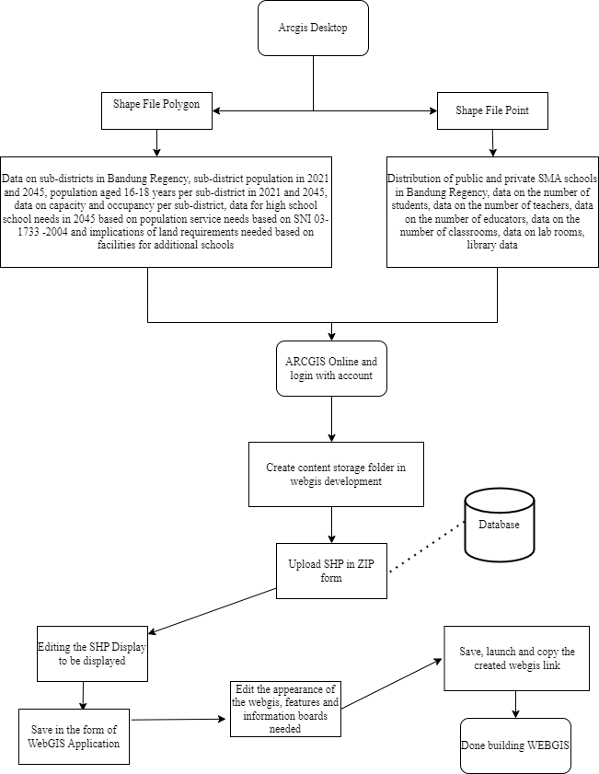
Source: Research results, 2022

Figure 1. Flow stages of visualizing in WEBGIS form

Based on the flow of steps in creating a WEBGIS as part of visualizing data, a plan is generated for what display will be displayed in a WEBGIS. The following is a WEBGIS display plan that will be realized (Figure 2).
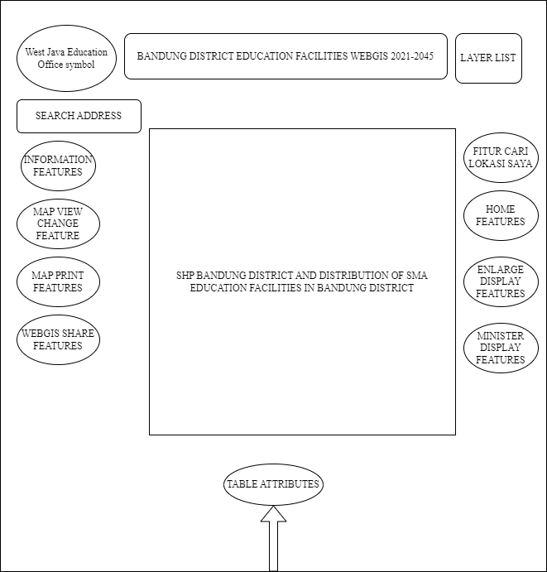
Source: Research results, 2022
WEBGIS that has been realized can be visited by clicking the following link https://bit.ly/webgisSMAkabBandung

Figure 2. WEBGIS visualization planning

The display of WEBGIS that has been realized in visualizing data is divided into several layers. Where the layer focuses on the population data layer, data capacity, occupancy capacity and carrying capacity for high school education facilities. The following is a display of WEBGIS (Figure 3-8).
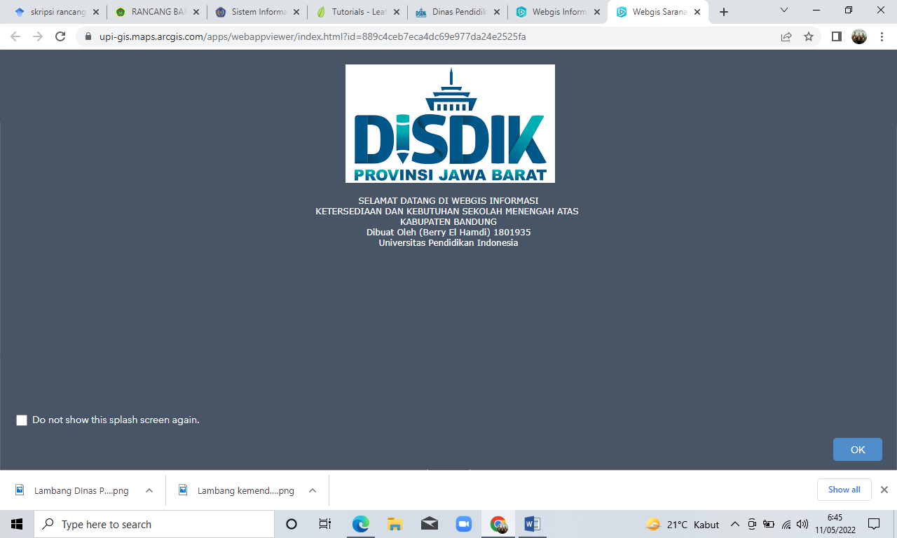
Source: Research results, 2022

Figure 3. WEBGIS preview

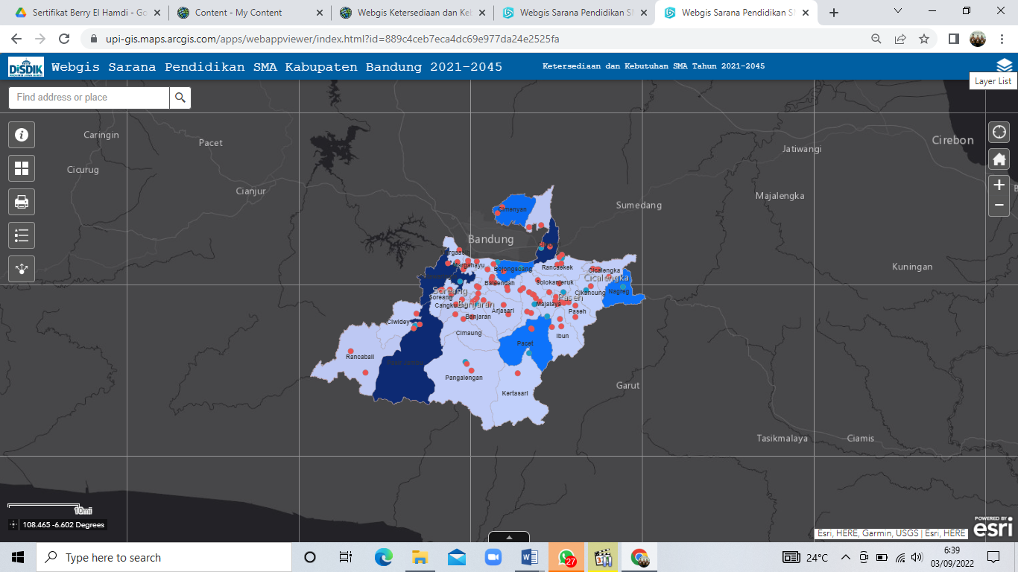
Source: Research results, 2022

Figure 4. Display of supporting capacity layer for Bandung Regency high school education facilities in 2045

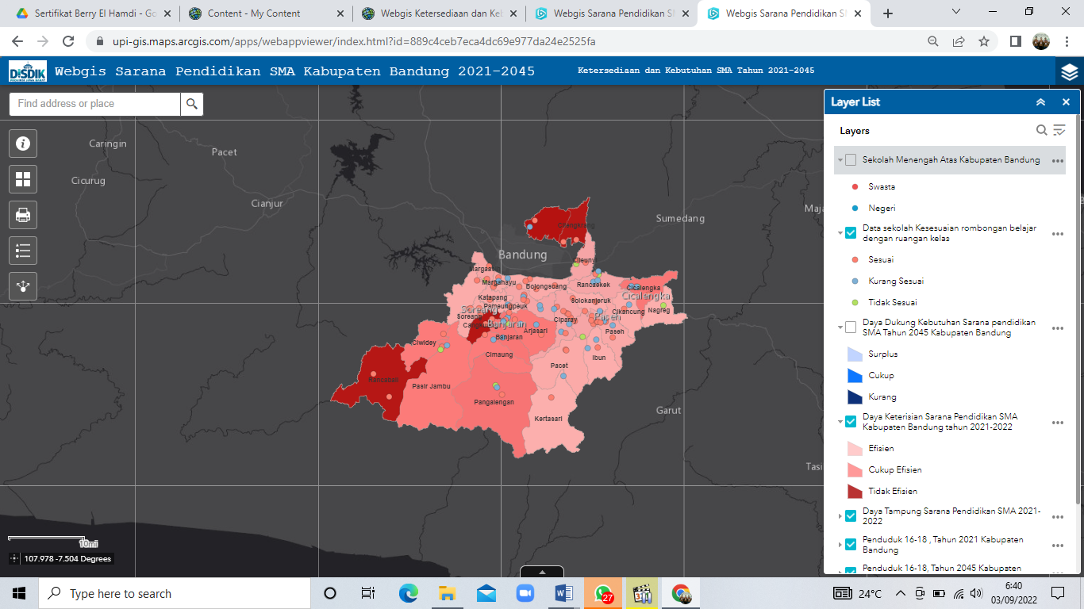
Source: Research results, 2022
Figure 5. Layer display of the occupancy capacity of Bandung Regency senior high school education facilities

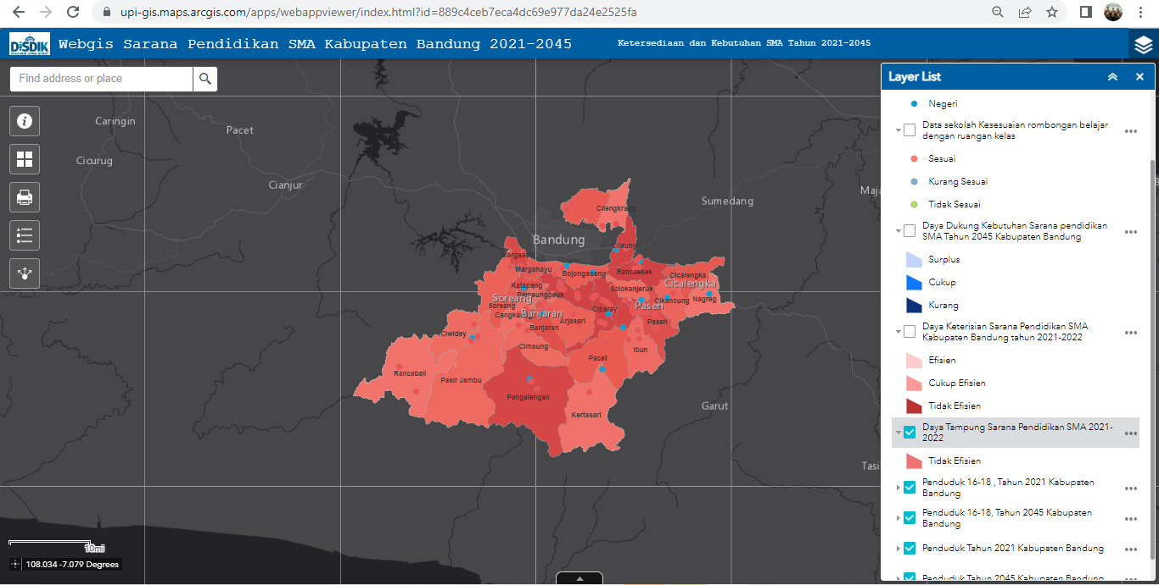
Source: Research results, 2022
Figure 6. Layer display of the capacity of Bandung Regency senior high school education facilities

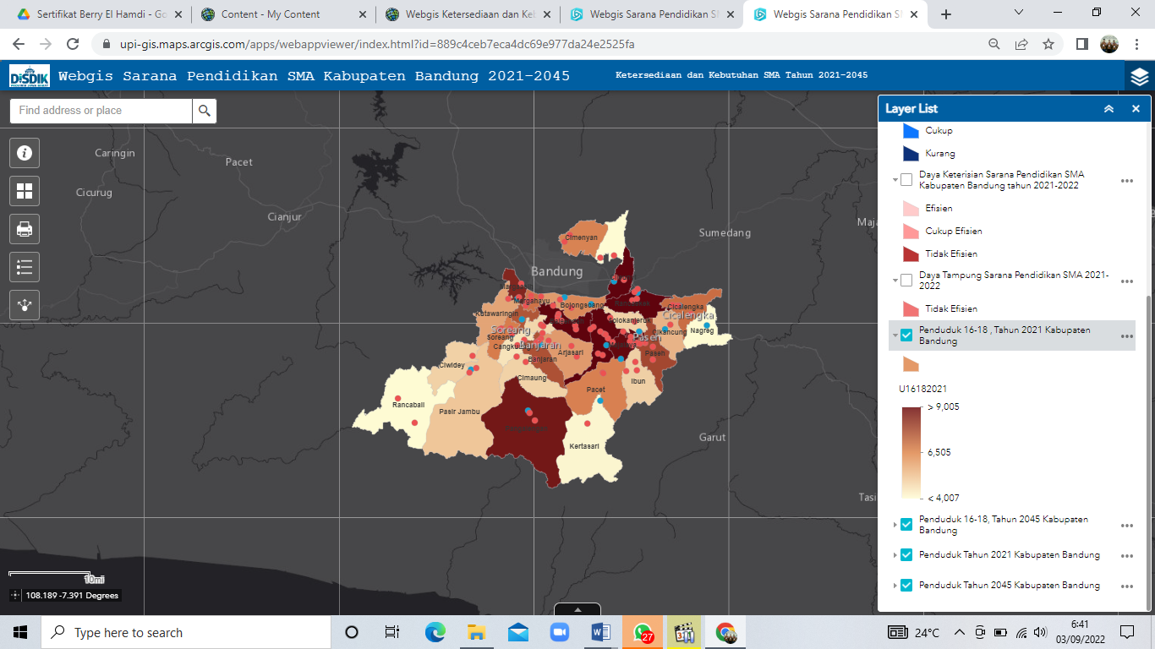
Source: Research results, 2022
Figure 7. Layer display of population distribution aged 16-18 years in 2021
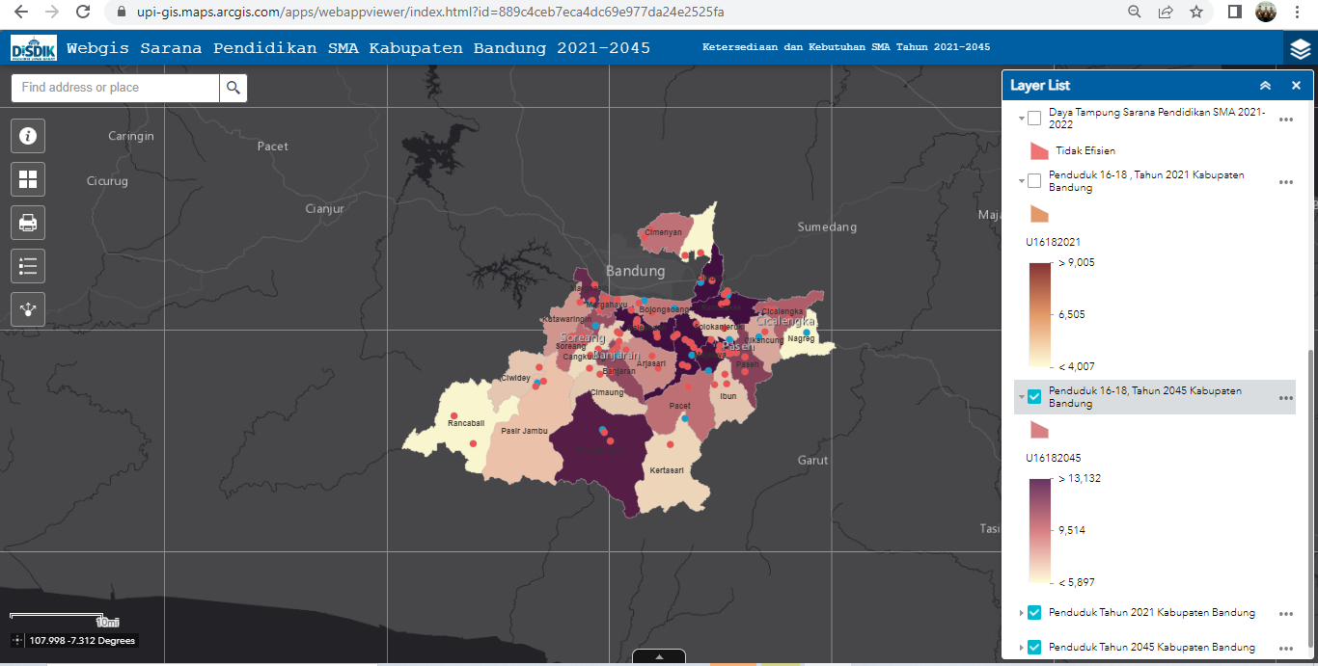
Source: Research results, 2022
Figure 8. Layer display of population distribution age 16-18 years in 2045

Discussion of the analysis of supporting capacity for high school education facilities in Bandung Regency in 2045 (Visualization through WEBGIS)

In looking at the interpretation of the various findings, the capacity and occupancy data can describe the current state of high school education facilities in Bandung Regency. Where the current high school education facilities have not been able to effectively accommodate the population aged 16-18 years. This is because there are still many educational facilities that have not maximized the number of classrooms. So it is hoped that the West Java Education Office can maximize building classrooms in several educational units in various districts.
In addition, the occupancy capacity illustrates that there are several high school education facilities in several sub-districts that are overloaded or inefficient. This is because the classrooms have exceeded the existing standards of 36 classrooms. In addition, there are several educational units that do not match between the study group and the classroom.
To analyze the current carrying capacity of high school education facilities with a population aged 16-18 years in each sub-district in Bandung Regency at the momentum of Indonesia Golden Era in 2045, the government and the West Java Education Office must be able to maximize the existing population potential. There are 4 sub-districts that require new high school education facilities, because the current high school cannot meet the needs of the population aged 16-18 years in 2045. The sub-districts are Cileunyi, Ketapang, Kutawaringin, and Pasir Jambu, each of which requires an additional high school level education facility. The following is a table of data interpretation of the capacity, occupancy and carrying capacity of the needs for high school education facilities.

Table 8. Interpretation of capacity, occupancy and DiDfi data

District | Capacity | Capacity | DDFI High School Education Facility 2045
Soreang | Not efficient | Efficient | Surplus
Solokanjeruk | Not efficient | Efficient | Surplus
Rancaekek | Not efficient | Efficient | Surplus
Rancabali | Not efficient | Not efficient | Surplus
Pasirjambu | Not efficient | Quite Efficient | Not enough
Paseh | Not efficient | Efficient | Surplus
Pangalengan | Not efficient | Quite Efficient | Surplus
Pameungpeuk | Not efficient | Efficient | Surplus
Pacet | Not efficient | Efficient | Enough
Nagreg | Not efficient | Efficient | Enough
Margahayu | Not efficient | Efficient | Surplus
Margaasih | Not efficient | Efficient | Surplus
Majalaya | Not efficient | Efficient | Surplus
Kutawaringin | Not efficient | Efficient | Not enough
Kertasari | Not efficient | Efficient | Surplus
Katapang | Not efficient | Efficient | Not enough
Ibun | Not efficient | Efficient | Surplus
Dayeuhkolot | Not efficient | Efficient | Surplus
Ciwidey | Not efficient | Quite Efficient | Surplus
Ciparay | Not efficient | Efficient | Surplus
Cimenyan | Not efficient | Not efficient | Enough
Cimaung | Not efficient | Quite Efficient | Surplus
Cileunyi | Not efficient | Efficient | Not enough
Cilengkrang | Not efficient | Not efficient | Surplus
Cikancung | Not efficient | Efficient | Surplus
Cicalengka | Not efficient | Quite Efficient | Surplus
Cangkuang | Not efficient | Not efficient | Surplus
Bojongsoang | Not efficient | Efficient | Enough
Banjaran | Not efficient | Quite Efficient | Surplus
Baleendah | Not efficient | Efficient | Surplus
Arjasari | Not efficient | Quite Efficient | Surplus
Source: Research results, 2022
In addition to the above data, the results of the usability assessment found that learnability (good), efficiency (good), memorability (good), error (very good) & satisfaction (good).

Conclusion

In welcoming Indonesia Gold era 2045, careful preparation is needed to realize this momentum. Among them is preparing high school education facilities in Bandung Regency to be able to serve the needs of the population in the future. In addition, the use of information technology is a challenge that must be overcome. Through WEBGIS, it is hoped that the dissemination of educational information will be prioritized, especially in utilizing ArcGIS Online in making WEBGIS. Based on this, some conclusions obtained in this research study are as follows.
The preparation of high school education facilities must continue to be considered in preparing to realize the 2045 Golden Indonesia in Bandung Regency. Especially in fulfilling the lack of classrooms in the education unit. There is even a "Negri" high school education unit which exceeds 36 study groups with less classrooms. This results in inefficient capacity and occupancy capacity. In addition, new high school education facilities are needed to meet the population aged 16-18 years in 2045 in several sub-districts.
To visualize existing data in a WEBGIS. It is carried out in two core stages, namely the use of ArcGIS 10.8 and ArcGIS Online. In ArcGIS 10.8 the focus is on processing the required SHP data. While in ArcGIS Online is to build a database, map display and also present it in WEB form.
It was found that WEBGIS displays population and education data. Especially in the theme of the availability and need for high school education facilities in Bandung Regency 2045, the information on WEBGIS can be disseminated to the general public.

Acknowledgement

This research was not funded by any party. However, the researcher is very grateful to the Geography Education study program, especially to Dr. Iwan Setiawan, S.Pd., M.Si and Dr.rer.nat. Nandi, S.Pd, M.T, M.Sc especially to those who have helped in this research. To the West Java Provincial Education Office, the National Unity and Political Agency of the Republic of Indonesia, the Head of High School in Bandung Regency and great teachers, especially Geography teachers who have helped, provided permission and various inputs so that this research could be completed.

References

Aronoff, S. (1989). Geographic Information Systems: A management perspective. WDL Publications.
Badan Pusat Statistik (BPS) Kabupaten Bandung. (2022). Bandung Regency in Figures 2022. Kabupaten Bandung, Indonesia.
Badan Pusat Statistik (BPS) Kabupaten Bandung. (2021). Bandung Regency in Figures 2021. Kabupaten Bandung, Indonesia.
Badan Pusat Statistik (BPS) Kabupaten Bandung. (2020). Bandung Regency in Figures 2020. Kabupaten Bandung, Indonesia.
Donya, M. A. C., Sasmito, B., & Nugraha, A. L. (2020). Visualization of the public facility map for the Sumurboto Village with ArcGIS Online. Jurnal Geodesi UNDIP, 9(4), 52–58.
Gewab, H. C., Malik, A. A., Karongkong, H. H. (2015). Analysis of needs and distribution of educational facilities at the junior and senior high school levels in Tambrauw District, West Papua Province. Spasial: Perencanaan Wilayah dan Kota, 2(3), 43–52.
Hermawan, A., Awaluddin, M., & Bambang, D. Y. (2017). Development of tourism information WEBGIS applications and supporting facilities in Kudus Regency. Jurnal Geodesi UNDIP, 6(4), 51–59.
Kesuma, D. P. (2021). The use of the system usability scale method to measure usability aspects of online learning media at XYZ university. Jurnal Teknik Informatika dan Sistem Informasi, 8(3), 1615-1626.
Kurniawan, E. (2011). Study of the need for educational space facilities at the secondary school level in Gunungpati District, Semarang City (Unpublished thesis). Universitas Negri Semarang, Semarang, Indonesia.
Lestari, R. P. (2019). WEBGIS-based tourism information system for Kudus Regency. (Unpublished thesis). Universitas Negri Semarang, Semarang, Indonesia.
Munawaroh, L., Pramulatsih, G. P., & Hikmah, N. I. (2019). Evaluation of social adequacy and projection of needs for junior secondary education facilities. Seminar Nasional Official Statistics 2019: Pengembangan Official Statistics dalam mendukung Implemetasi SDG’S, May, 631–639. https://doi.org/10.34123/semnasoffstat.v2019i1.218
Mutua'Ali. (2015). Regional analysis techniques for regional, spatial and environmental planning. Badan Penerbit Fakultas Geografi Universitas Gadjah Mada.
Nuranti, D. (2017). Analysis of the needs of elementary school classrooms based on projected growth of the school-age population in the city of Cirebon. Jurnal Administrasi Pendidikan UPI, 24(1), 107-118.
Pangestu, A. Y., Safe, R., Darmawan, A., & Kaskoyo, H. (2020). Evaluation of usability on Web GIS monitoring forest health using the system usability scale (SUS) method. Jurnal Manajemen, Teknik Informatika, dan Rekayasa Komputer, 20(1), 19-26.
Pradana, G. D., Suprayogi, A., & Sukmono, A. (2018). WEBGIS determines the nearest hotel path from the tourism area using the Dijkstra algorithm (Case study: Semarang City). Jurnal Geodesi UNDIP, 7(2), 97-106.
Puspitasari, S. R., Awaluddin, M., & Firdaus, H. S. (2018). Making a WEBGIS application for information on the distribution of health facilities and facilities in Kudus Regency. Jurnal Geodesi UNDIP, 7(3), 1-10.
Roscoe, J. (1975). Fundamental research statistics for the behavioural sciences. Holt Rinehart & Winston.
Rizky, yuliansyah R. N., Nugraha, A. L., & Wijaya, A. P. (2015). Web-based Geographic Information System application for high school distribution (Case study: Semarang City). Jurnal Geodesi UNDIP, 4, 172–182.
Rosaliani, R. (2017). Mapping of high school education facilities in Dumai City by utilizing Geographic Information Systems. (Unpublished thesis). Universitas Pendidikan Indonesia, Bandung, Indonesia.
Shalihati, S., & Nirwasnyah, A. (2017). Implications of the need for space for service facilities to welcome the demographic bonus in Purbalingga District. Prosiding Seminar Nasional Geografi UMS 2017.
Sulistyastuti. (2017). Indonesia's challenge to optimizing demographic bonuses. Jurnal Studi Pemuda, 6(1), 538–547.
Supriyatna, A. (2018). Application of usability testing to measure the level of usability of web media of knowledge. Jurnal Ilmiah Teknologi-Informasi dan Sains (TeknoIS), 8(1), 1-16.
Tahir, M. A., & Nahdatunnisa. (2020). Analysis of the availability and fulfillment of housing infrastructure and facilities needs in urban areas (Case study: Availability and demand for educational facilities in Kendari City). Jurnal Malige Arsitektur, 2(1), 20-29.
Tahiya, T., Franklin, P. J. C., & Takumansang, D. (2016). Planning for high school level education facilities in Merauke Regency. Spasial, 3(3), 207-217.
Tjiptoherijanto, P. (2001). Labor, and the role of trade unions in increasing welfare. Majalah Perencanaan Pembangunan, 23, 1–10.
Uang, O. L., Rengkung, M. M., & Sembel, A. S. (2017). Evaluation of the availability of junior high school education facilities in Mapanget District. Spasial, 4(3), 234-244.

