Evaluation of CHIRPS and CFSR precipitation products over the Mujib Basin, Jordan

Suheir Alsalal¹, Mou Leong Tan^{1,2}, Narimah Samat¹, Jawad T. AL-Bakri³, Longhui Li²

¹GeoInformatic Unit, Geography Section, School of Humanities, Universiti Sains Malaysia, 11800 USM, Pulau Pinang, Malaysia
²School of Geography, Nanjing Normal University, Nanjing 210023, China.
³Department of Land, Water and Environment, School of Agriculture, The University of Jordan, Amman 11942, Jordan

Correspondence: Mou Leong Tan (email: mouleong@usm.my)

Received: 9 February 2023; Accepted: 11 May 2023; Published: 31 May 2023

Abstract

Open-source climate products provide the possibility of complementing observed data, which sometimes suffer from the scarcity and inconsistency issues. This study aims to evaluate the accuracy of two open-source climate products, Climate Hazards Group Infrared Precipitation with Station (CHIRPS 0.05) and Climate Forecast System Reanalysis (CFSR), in capturing precipitation over the Mujib Basin, Jordan, from 2002 to 2012. Both products were compared with observed data collected from ten climate stations using the point-to-pixel comparison approach at the daily, monthly, seasonal, and annual scales. The coefficient of determination (R²), the root mean square error (RMSE), the mean absolute error (MAE), and the relative bias (RB) were used to evaluate the efficiency of CHIRPS and CFSR. While, categorical statistics such as the probability of detection (POD), false alarm ratio (FAR), critical success index (CSI), Heidke skill score (HSS), and frequency bias index (FBI), were used to analyze the precipitation detection capability. Results indicated good correlations between open-source climate products and observed data in the monthly time period, where the R² values ranged from 0.65 (CFSR) to 0.76 (CHIRPS). Besides that, CHIRPS performed better than CFSR for the daily, monthly, and seasonal time steps, with a better ability in detecting precipitation. Therefore, CHIRPS is recommended to fill the missing gaps of observed data and to detect the drought conditions over the Mujid Basin.

Keywords: CFSR, CHIRPS, Jordan, Mujib Basin, precipitation, validation

Introduction

As one of the major components in the hydrological cycle, precipitation is responsible for replenishing the planet's freshwater (Luo et al., 2019). It is also a necessary input for hydrological modeling and serves as the basis for applications in hydrological, agricultural, climate change, and environmental studies (Gao et al., 2018; Stagl et al., 2014). However, good quality observed data is not easily accessible due to the poorly distributed meteorological stations (Dinku et al., 2010; Satgé et al., 2016). In addition, some meteorological stations have extremely short, inconsistent, or incomplete historical records (Zambrano et al., 2017). Gauge data is typically susceptible to several limitations, which hinder hydrological forecasts in places with complex terrain. Meteorological stations are normally unable to cover the entire study area, and sometime the gauges used for the data collection are damaged by wind or animals (Bai et al., 2018; Li et al., 2018; Mourtzinis et al., 2017) .
To complement the available observed meteorological data, open-source climate products offer massive rainfall data across the world in a standard gridded format with continuous 30-minute to annual time steps. However, in order to verify their effectiveness over a specific region, such data must first be evaluated for its accuracy in comparison to ground data (Fall et al., 2019; Mantas et al., 2015; Marra et al., 2017). Open-source climate products have advantages over ground stations in terms of high temporal and spatial resolutions, as well as a wider areal coverage and public accessibility. As a result, they present a possible data source for regions with sparse or scant data records (As-syakur et al., 2016; Meng et al., 2014). In past decades, remotely sensed satellite observations have become a credible source of information on precipitation data. Radiances captured in the visible, microwave, or infrared bands are converted into rainfall using quantitatively, physically, and statistically-based methods (Tapiador et al., 2012). Remote sensing has shown to be a dependable and cost-effective method of obtaining rainfall information at sub-daily, daily, and monthly levels (Funk et al., 2015). Climate Hazard Group Infrared Precipitation with Station (CHIRPS) (Hou et al., 2014) is among the most frequently used remotely sensed precipitation products. In contrast, reanalysis climate data, i.e., the National Center for Environmental Prediction (NCEP) Climate Forecast System Reanalysis (CFSR) (Dile & Srinivasan, 2014), has also been applied in hydro-climatic studies. These data provide worldwide coverage of full meteorological data from 1983 (Monteiro et al., 2018).
Several studies have validated the CFSR product and reported satisfactory results in capturing precipitation in the Lake Tana basin (Wilk et al., 2006), Ethiopia (Funk et al., 2014), and southwest China (Ma et al., 2019). By contrast, the CFSR's performance was unsatisfactory in some places such as the south-central Gilgel Abay basin in Ethiopia (Duan et al., 2019) and Upstream Three Gorges Reservoir (TGR) in China (Yang et al., 2014). Similarly, CHIRPS (0.05°) has also been evaluated and compared with other open-source climate products (Duan et al., 2019; Funk et al., 2015), including the Italian Adige basin (Duan et al., 2016), Kenya (Macharia et al., 2020), Central Andes of Argentina (Rivera et al., 2018), Pakistan (Ullah et al., 2019), and Mainland China (Bai et al., 2018). Some studies have shown that CHIRPS is generally superior to other open-source climate products due to its high accuracy, long historical record, and excellent performance in various applications (Guo & Su, 2019). In Jordan, an eastern Mediterranean country, a recent study by Abu Romman et al. (2021) suggested different statistical ways for filling gaps in monthly rainfall data in a dry area north of the country. The study showed that the performance of each dataset would depend on the length of the gap in the monthly data. Therefore, the assessment of open-source precipitation data is important and requires further investigation at the daily and seasonal time scales. In addition, the performance of open source climate products may vary in different climatic zones.
This study aims to assess the reliability of the CHIRPS and CFSR data in capturing precipitation at daily, monthly, seasonal, and annual levels for the 2002-2013 period over the Mujib Basin, Jordan. The basin was selected as it extends over a large area that drains of the Dead Sea. In addition, the precipitation gradient is obvious in this basin, which is classified as an area with high vulnerability to climate change (Khasawneh, 2015). The study endeavors to identify a reliable alternative climate product for the ground application. As a source of weather variables, this study provides valuable scientific insights for local government, policymakers, and water managers to formulate appropriate and effective management for watershed, water supply, irrigation, and agriculture. The products assessed in the study can help in identifying the spatial and temporal variations in precipitation therefore contributing to resolving the issue of scarce measured data in the basin. As such, the findings will contribute to improve water management, and act as a practical guide for other river basins.

Study area

The Mujib Basin is located in central Jordan at 36° 15´53"E and 35° 56' 38" E and latitudes 31° 54´ 21" and 30° 46´ 58" N. Administratively, it is situated in the governorates of Amman, Madaba, Karak, and Tafila and drains to the Jordan Rift Valley as shown in Figure 1. The basin ranges in altitude from 1270 m in the southeast to -425 m in the western side of the basin at its exit to the Dead Sea. The study area is one of Jordan’s principal, occupying an area of 6600 km² and accounting for 7% of the kingdom's total land area. It consists of two major catchments, the Al-Waala basin to the north and the Mujib Basin to the south. The Mujib Basin has a catchment area of 4500 km², while the Al-Waala basin has a catchment area of 2100 km². It is bordered by the Dead Sea watersheds to the west, the Zarqa basin to the north, the Azraq basin to the east, and the Al- Hasa and Al-Jafr basins to the south (Al-Assa’d & Abdulla, 2010). The basin has different climatic regions that include a semiarid Mediterranean area in the north and west, and dry arid environments in the eastern and southern parts. Precipitation has erratic patterns and differs greatly in amount, intensity, and place of fall, depending on location. In the basin, the mean annual rainfall ranges from 350 mm in the north to less than 100 mm/year in the south. During the wet season, which runs from October to April, the majority of precipitation falls between December and February. Thunderstorms make up a significant portion of the basin's total precipitation (Samawi & Sabbagh, 2004). The mean maximum air temperature in the southern basin is 40 °C in summer and 15 °C in winter, while in the upper part, it is 35 °C in summer and 10 °C in winter (Shehadeh, 1991).

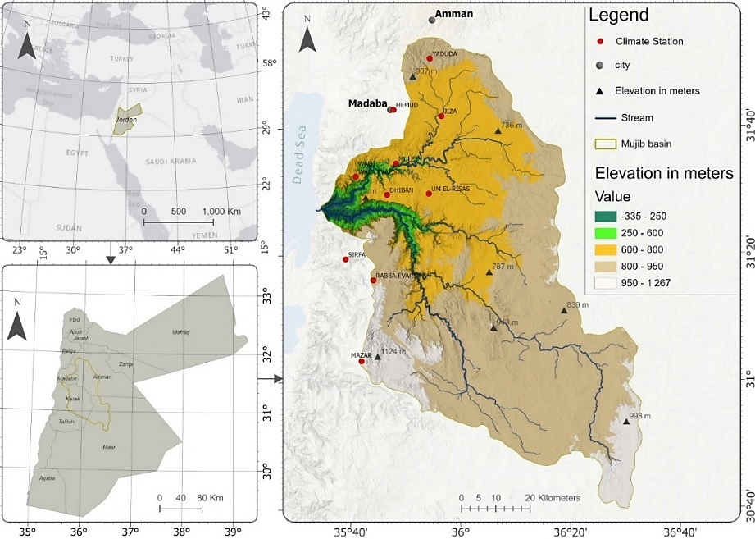

Figure 1. The distribution of the climate stations and topography conditions of the Mujib Basin, Jordan

Data and methodology

Figure 2 displays the research methodology flow of the study, which consists of three main steps: (1) CHIRPS, CFSR and observed data collection; (2) calculation of continuous and categorical statistic metrics, and (3) comparison of the statistical outputs.

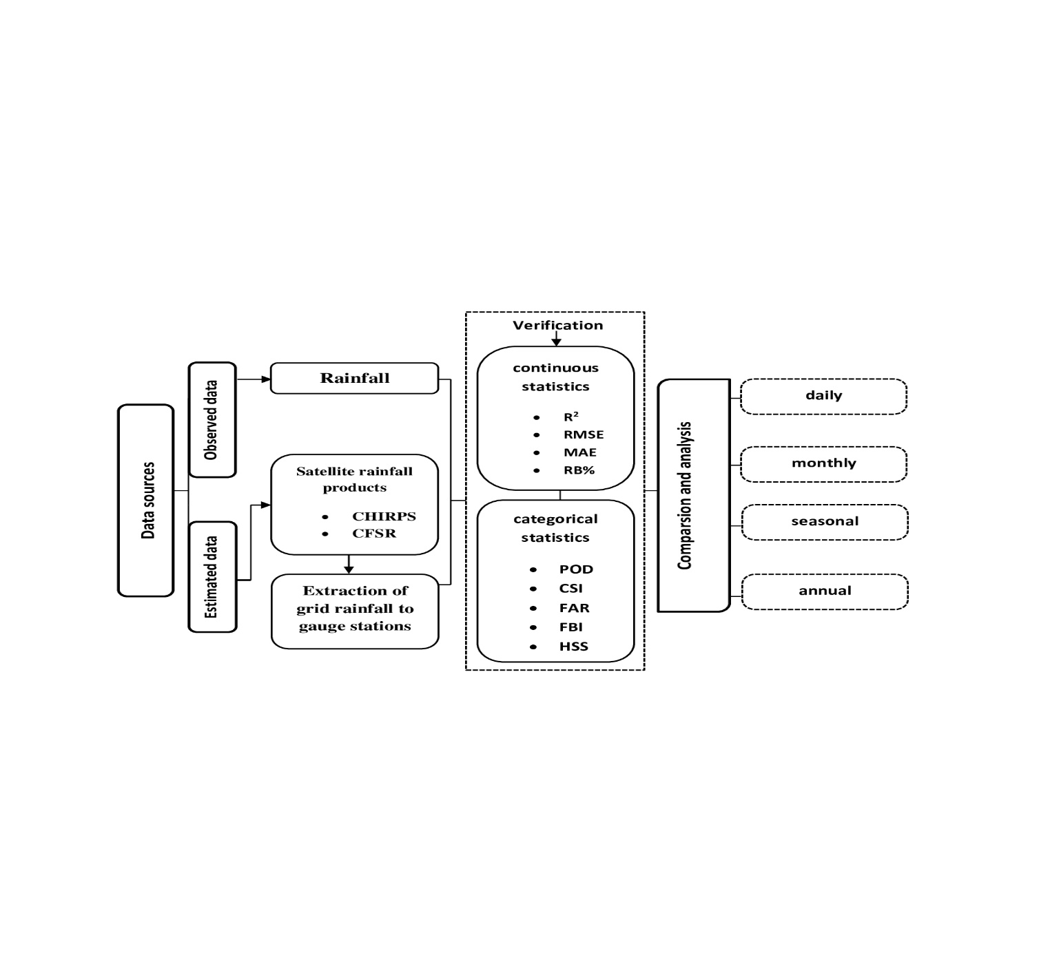

Figure 2. Research methodology flow of this study

Rain gauge data

Observed daily precipitation data from 2002 to 2012 were obtained from the Ministry of Water and Irrigation (MWI). These data, which covered ten stations, served as a reference for comparing and assessing CHIRPS and CSFR for the grids that included the MWI stations. The locations of these stations and the time series for daily rainfall data are shown in Table 1.

Table 1. Basic information of the meteorological stations.
Station number | Station name | Period | Longitude (°E) | Latitude (°N) | Altitude  (m) | Annual average (mm)
CD0005 | JIZA | 1990–2018 | 35° 95' | 31° 75' | 717 | 163.4
CD0006 | WADI WALA.EVP.ST | 1991–-2017 | 35° 65' | 31° 55' | 734 | 238.1
CD0007 | DHIBAN | 1990–2018 | 35° 75' | 31° 45' | 704 | 255.1
CD0009 | HEMUD | 1985–2018 | 35° 85' | 31° 65' | 755 | 266.7
CD0010 | RABBA.EVP.ST | 1990–2017 | 35° 75' | 31° 27' | 920 | 321.2
CD0013 | MAZAR | 1990–2018 | 35 °75' | 31° 05' | 1242 | 297.0
CD0017 | UM ELRISAS | 1985–2018 | 35° 95' | 31° 55' | 746 | 150.4
CD0024 | YADUDUA | 1992–2018 | 35° 95' | 31° 85' | 845 | 346.4
CD0028 | MULEIH | 1990–2018 | 35° 85' | 31° 55' | 670 | 236.4
CD0029 | SIRFA | 1985–2018 | 35° 56' | 31° 35' | 846 | 324.0

Open-source climate products

CHIRPS could be obtained from https://chc.ucsb.edu/data/chirps. It is a worldwide database of precipitation for more than 30 years which can be used to analyze precipitation at various scales. The National Oceanic and Atmospheric Administration (NOAA) and Thermal Infrared Radiation (TIR) satellite precipitation estimates are combined to create CHIRPS for providing recent and comprehensive data in numerous advance warning aims (Funk et al., 2015). CHIRPS has covered a range of 50 °S to 50 °N from 1981 to the present day. CHIRPS employs data from satellites with a resolution of 0.05° and 0.25° along with data from ground stations to construct gridded time series data of precipitation for data analysis (Funk et al., 2015). Daily precipitation data for MWI station sites were exported from the CHIRPS grids in a netcdf file with a spatial resolution of 0.05 for the 2002-2012 period.
CSFR is a reanalysis data with a spatial resolution of ~38 km resolution. It is dependent on the National Weather Service’s Global Forecast System. It is distributed via the official site of Soil and Water Assessment Tool (SWAT) at http://globalweather.tamu.edu/ (Radcliffe & Mukundan, 2017). Table 2 shows the basic details of both CHIRPS and CFSR.

Name | Spatial resolution | Temporal resolution | Period
CHIRPS | 0.05˚ ( ⁓ 5.3 km) | Daily | 1981 – present
CFSR | ⁓38 km | 6 - hourly | 1979 – 2014
Table 2. Basic information of CHIRPS and CFSR

Statistical metrics

Four basic statistical metrics were used to assess CHIRPS and CFSR including the coefficient of determination (R²), mean absolute error (MAE), root mean square error (RMSE), and relative bias (RB). The capability of precipitation detection at the daily scale was also assessed using the critical success index (CSI), frequency bias index (FBI), false alarm ratio (FAR), probability of detection (POD), and Heidke skill score (HSS) data (Zhang et al., 2018). The continuous statistics show how well satellite datasets can predict how much rain will fall. The categorical statistics represent how many rainfall events the satellite rainfall data observed or missed when compared to the gauge data. POD evaluates a rainfall product’s capacity to detect precipitation events, while FAR refers to the times satellite rainfall products reported rain while none existed in the basis dataset to the number of times an event was not identified by the basis dataset (Li et al., 2018; Wang et al., 2019). The CSI is a measure of how well the satellite and rain gauge match up. The FBI indicates if open-source climate products tend to be underestimated or overestimated. The HSS is a measure of the overall skill of the rainfall-day estimates after rain events occurred. This is carried out by a random sampling matchup with reality (Ayehu et al., 2018; Yong et al., 2010) The POD, FBI, HSS, and CSI scores range from 0 to 1, with 1 being the perfect score, which shows complete agreement between both datasets. FAR values near 0 indicate that a remote sensing satellite precipitation dataset can detect rain events. Table 3 summarizes the statistical metrics and indices used for evaluating CHIRPS and CFSR against ground data.

Table 3. Statistical indicators used to evaluate rainfall products

Statistical index | Unit | Equations | Description | Perfect Score
Coefficient of determination (R²) | - | R² $=\frac{\sum_{i=1}^{n}{(Gi-\overline{G})(Si-\overline{S})}}{\sqrt{\sum_{i=1}^{n}{(Gi-G̅)^{2}}}\sqrt{\sum_{i-1}^{n}{(Si-S̅̅)^{2}}}}$ | Indicates the degree of relationship  between rain gauge data and the product | 1
Root mean squared error (RMSE) | mm | $$RMSE =\sqrt{\frac{\sum_{i=1}^{n}{(si-Gi)^{2}}}{n}}$$ | Measures the average mistake magnitude | 0
Mean absolute error (MAE) | mm | MAE =$\frac{\sum_{i=1}^{n}{\left|si-Gi\right|}}{n}$ | Represents information on the average estimation error | 0
Relative bias (RB) | % | $RB =\frac{\sum_{i=1}^{n}{(si-Gi)}}{\sum_{i=1}^{n}{Gi}}×100\%$ | Measures the tendency of the simulation compared to the observed data | 0
Probability of detection (POD) | - | POD= $\frac{H}{H+M}$ | Indicates the rainfall product ability to forecasts rain events. | 1
Critical success index (CSI) | - | $$CSI=\frac{H}{H+M+F}$$ | Measures the ratio of actual rainfall correctly detected by the satellite products | 1
False alarm ratio (FAR) | - | $FAR=\frac{F}{H+F}$ | Describes events detected by the product but not observed | 0
Heidke skill score (HSS) | - | $$HSS=\frac{2(HN-FM)}{\left(H+M\right).\left(M+N\right)+\left(H+F\right).(F+N)}$$ | Measures the skill of the rainfall estimates after rain events occurred | 1
Frequency bias index (FBI) | - | $$FBI=\frac{H+F}{H+M}$$ | Indicates whether the products tend to be overestimated or underestimated | 1
Gi, observed rainfall; Si, rainfall derived from CFSR and CHIRPS; H, observed rain correctly detected; M, observed rain not detected; F, rain detected but not observed; N, correctly estimated no rain events by the product as well as the insitu measurement.

Results and discussion

Daily precipitation analysis

The average daily precipitation was 6.4 mm, with a maximum value of 144 mm recorded in the north and a minimum of 54 mm/day in the west of the basin as shown in Figure 3. The trend of daily precipitation was high at the Rabbaand Hemud station and low at the Dhiban, Giza, and Mazar stations in the dry part of the basin. Figure 3 and Table 4 show the result of each statistical metric obtained after a daily comparison of each grid with observed data. CHIRPS had the highest R² value (0.31) compared to CFSR (0.26), and the lowest error amplitude, with the MAE and RMSE values of 6.25 and 11.1 mm/day, respectively. By contrast, CFSR had higher values of MAE (16.8) and RMSE (24.6 mm/day). The products tend to underestimate rainfall in stations with high rainfall and overestimate the amounts of rainfall in stations with low rainfall. In general, there is a need to improve any mistake stated in the sources above for adapting open-source climate data in the Mujib Basin and raising the products accuracy on a daily basis.
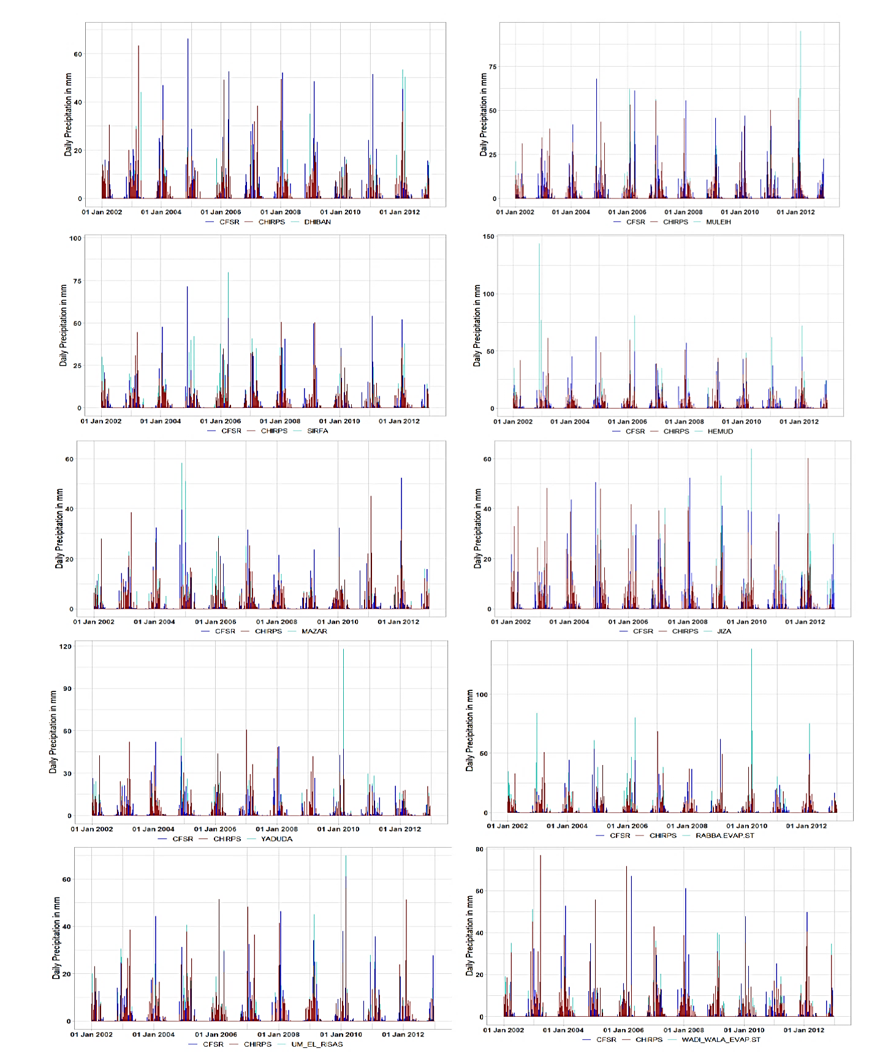

Figure 3. Daily rainfall pattern of observed, CFSR and CHIRPS during the 2002–2012 period

The results reveal a poor relationship between open-source climate products and gauge stations, attributed to a number of causes, such as satellite sampling mistakes and mistakes in algorithms used for predicting rainfall from individual platforms, that is, weather forecasting models, rain gauge analyses, and satellite as well as mistakes in algorithms used for combined or blended estimations (Shen et al., 2010). It is also possible due to the loss of more local convective precipitation with respect to the spatial resolution, so differences can occur between open source climate products and observed data (Dembélé & Zwart, 2016).

Table 4. Statistical analysis for evaluating daily precipitation data of CHIRPS and CFSR over the Mujib Basin from 2002 to 2012

Station ID | Sources | ${ R}^{2}$ | RMSE | MAE | RB%
CD0005 | CHIRPS  CFSR | 0.41  0.26 | 11.1  21.9 | 6.25  13.7 | -4.50  -5.27
CD0006 | CHIRPS  CFSR | 0.31  0.24 | 15.5  20.3 | 8.12  14.7 | 9.47  -11.6
CD0007 | CHIRPS  CFSR | 0.36  0.30 | 12.7  17.2 | 8.85  11.0 | 8.17  11.4
CD0009 | CHIRPS  CFSR | 0.28  0.24 | 20.5  22.6 | 13.7  14.9 | -9.40  -8.81
CD0010 | CHIRPS  CFSR | 0.30  0.28 | 18.8  19.8 | 11.0  13.6 | -11.8  -28.6
CD0013 | CHIRPS  CFSR | 0.29  0.36 | 19.2  12.1 | 13.0  7.85 | -10.9  -6.65
CD0017 | CHIRPS  CFSR | 0.32  0.32 | 12.9  16.4 | 8.67  9.93 | 7.25  4.53
CD0024 | CHIRPS  CFSR | 0.31  0.30 | 14.8  17.6 | 10.5  11.5 | -10.2  -7.14
CD0028 | CHIRPS  CFSR | 0.27  0.13 | 23.6  24.6 | 16.6  16.8 | -4.43  -4.14
CD0029 | CHIRPS  CFSR | 0.28  0.23 | 20.9  23.6 | 13.9  16.1 | -7.60  -24.7

The relatively high differences in the amount of precipitation between the stations and the products, especially in the highlands, could be caused by elevation related reasons (Toté et al., 2015). On the other hand, the study found that products data lacks the ability to estimate precipitation amounts in stations that generally received high amounts, but it provides accurate prediction in stations with low precipitation. This result agrees with the research by Macharia et al. (2020) in Kenya. They found that the accuracy of the CHIRPS data is high in stations that receive low precipitation amounts, which are generally low and are characterized by being tropical arid and semi-arid, but poor in stations that received high amounts of precipitation in high-altitude areas and tropical cool sub-humid (TCSH) regions.
In Table 5, the categorical measurements showed good performance for CHIRPS, with the POD value of 0.76, indicating that the product was able to detect the observed precipitation events up to 76% over the study area, whereas the POD value of CFSR was 0.57. CHIRPS had a lower FAR than CFSR by 0.24, indicating that over 24% of detected precipitation events didn’t recorded by gauges. The CSI value for CHIRPS was 0.61, suggesting that more than half of the precipitations were properly calculated. However, CFSR had a low CSI of 0.37. The HSS analysis revealed that CFSR performed moderately on precipitation detection over the Mujib Basin, although CHIRPS performed better.
Table 5. Categorical statistics results for CHIRPS and CFSR at the Mujib Basin

 | CHIRPS | CFSR
POD | 0.76 | 0.57
FAR | 0.24 | 0.48
CSI | 0.61 | 0.37
HSS | 0.74 | 0.50
FBI | 1.01 | 1.11

Monthly precipitation analysis

The daily rainfall totals were used to calculate the monthly precipitation for CHIRPS, CFSR, and gauge data. The majority of the measured precipitation is centered in the northern and western areas of the basin, with the highest value recorded in February. In contrast, the central part experiences low levels of precipitation. Figure 4 and Table 6 show that the products demonstrated a good relationship with the ground data because the mistakes in daily values are compensated when aggregated to monthly values (Ren et al., 2018). The discrepancies observed between the observed and estimated rainfall amounts can be attributed to mistakes during collection and digitalization, measuring data, particularly with manual methods, or the absence of a direct relationship between observed and estimated rainfall as stated previously (Satgé et al., 2016). The products tend to be lower in the months when rainfall is relatively high attributed to the difficulty of detecting initial precipitation by satellite algorithms (Ebert et al., 2007). During the winter season, snowfall contributes to a portion of the precipitation. This increases the difficulty in retrieving microwave precipitation using satellites, as the presence of ice cover can produce signals that are similar to those of icy particles found in the atmosphere, leading to more errors (Ebert et al., 2007; Tian et al., 2014). The products performed better during the warmer months, which is likely due to the influence of convection systems, as indicated by the results of R², RMSE, MAE, and RB. The CHIRPS data are the most consistent with the observed data, with an R² value of 0.76, indicating superior performance. Although CFSR had a lower value of 0.65, it still demonstrated good results. As shown in the scatter plot in Figure 5, CHIRPS demonstrated the highest level of agreement, followed by CFSR. The calculated RB is mostly negative for CHIRPS and CFSR with an average monthly rainfall of –3.40% and -–9.09%, respectively. Notably, the underestimating of rainfall was higher in high regions, which may be due to the warm orographic precipitation process. Conversely, overestimation values ​​were more pronounced in low areas due to sub-cloud evaporation (Dinku et al., 2011). The margin of error was smaller with CHIRPS and larger with CFSR. The CFSR product had the highest monthly results for MAE and RMSE at 36.1 and 54.8 mm/month, respectively, while the CHIRPS product had the lowest values for MAE and RMSE at 13.1 and 23.3 mm/month, respectively. The monthly scale is much more accurate than the daily scale because errors at the monthly level tend to cancel each other out after being aggregated, resulting in a symmetrical distribution.
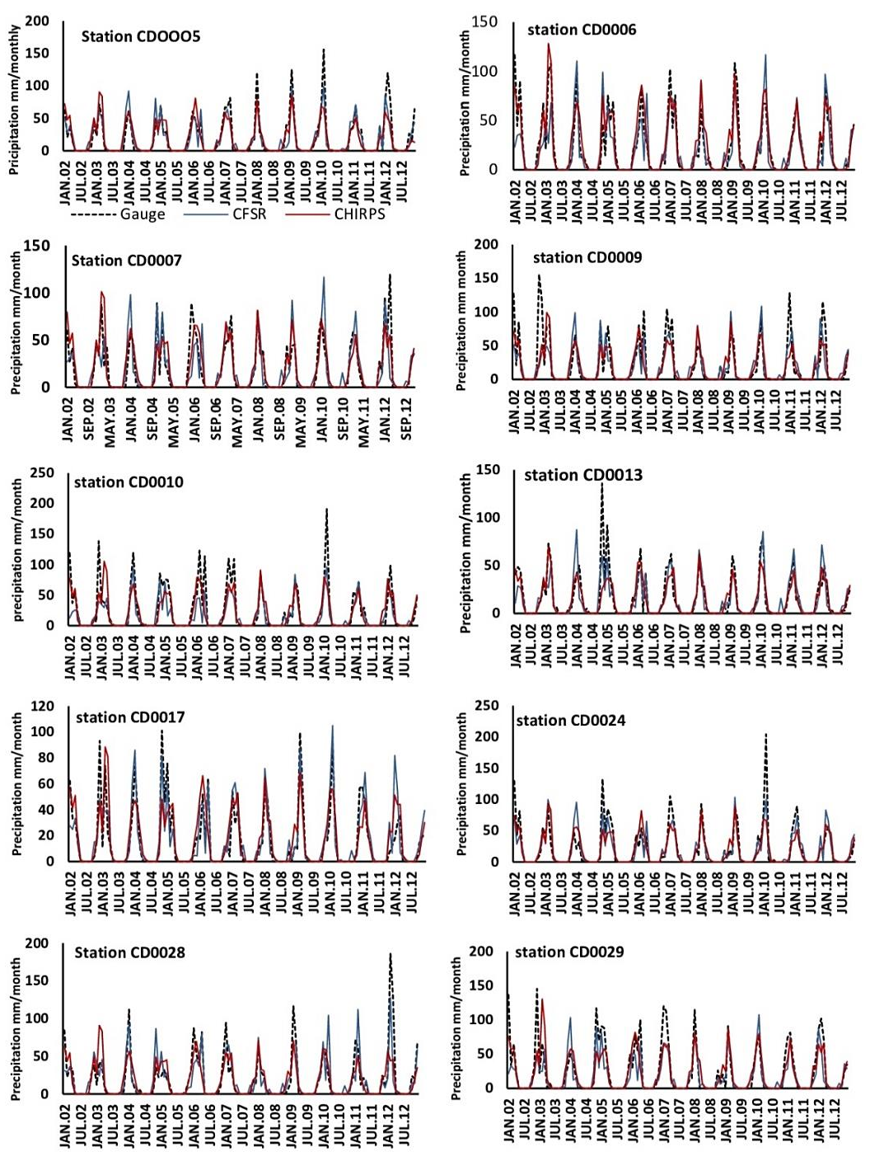

Figure 4. Monthly rainfall pattern of observed, CFSR and CHIRPS during the 2002-2012 period

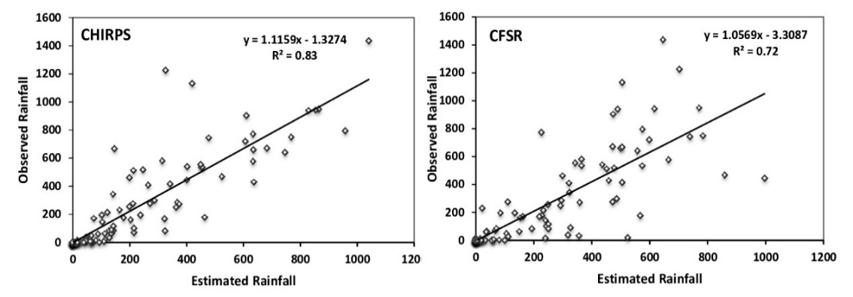

Figure 5. Scatter plots of monthly cumulative precipitation for CHIRPS and CFSR versus observed data
Table 6. Statistical analysis for evaluating monthly precipitation of CHIRPS and CFSR over the Mujib Basin from 2002 to 2012

Station ID | Sources | $${ R}^{2}$$ | RMSE | MAE | RB (%)
CD0005 | CHIRPS  CFSR | 0.81  0.69 | 28.2  31.4 | 18.2  19.8 | -4.50  -5.27
CD0006 | CHIRPS  CFSR | 0.85  0.63 | 23.3  37.3 | 13.1  26.3 | 9.47  -11.6
CD0007 | CHIRPS  CFSR | 0.72  0.63 | 45.3  53.9 | 23.8  30.2 | 8.17  11.4
CD0009 | CHIRPS  CFSR | 0. 77  0.58 | 41.7  54.8 | 23.1  35.9 | -9.40  -8.81
CD0010 | CHIRPS  CFSR | 0.77  0.71 | 29.9  30.6 | 19.2  23.8 | -11.8  -28.6
CD0013 | CHIRPS  CFSR | 0.65  0.72 | 50.9  25.7 | 27.1  15.6 | -10.9  -6.65
CD0017 | CHIRPS  CFSR | 0.81  0.71 | 29.1  31.2 | 19.4  23.9 | 7.25  4.53
CD0024 | CHIRPS  CFSR | 0.62  0.67 | 51.9  33.4 | 26.8  21.8 | -10.2  -7.14
CD0028 | CHIRPS  CFSR | 0.76  0.57 | 35 .1  54.5 | 22.6  36.1 | -4.43  -4.14
CD0029 | CHIRPS  CFSR | 0.84  0.62 | 24.5  38.7 | 14.2  19.7 | -7.60  -24.7

Seasonal precipitation analysis

The analysis of precipitation data revealed inter-seasonal variations in precipitation over Jordan, with the main rainy season in the Mujib Basin starting in October and continuing until April. The statistical indicators generated from the seasonal time series data are presented in Figure 6. There were some differences in R², RMSE, and RB between CHIRPS and CFSR. CHIRPS demonstrated a better performance during the spring, autumn, and winter seasons. The R² values were higher during the spring season for both CHIRPS and CFSR, at 0.85 and 0.80, respectively. The CHIRPS data showed lower RMSE values compared to CFSR. The products underestimated precipitation by 12% to 16% during winter and overestimated precipitation by 14% to 21% during autumn. CHIRPS performed slightly better than CFSR on both seasonal and monthly measures. Previous studies have proven that CHIRPS is superior to CFSR (Dhanesh et al., 2020; Duan et al., 2019; Zhang et al., 2020). In addition, previous research has confirmed that CHIRPS performs better than other products. For instance, Hordofa et al. (2021) found that CHIRPS gave a better estimate of precipitation than Global Precipitation Measurement Integrated Multi-Satellite Retrieval (GPM-IMERG) in terms of systematic biases and random errors in Lake Ziway in Ethiopia. While, Fenta et al. (2018) found that CHIRPS performed better than Africa Rainfall Climatology (ARC), which had high random errors, low efficiency, and more than 20% biases, showing it was not good enough to catch the precipitation. Also, The ARC’s coarser spatial resolution of 10 km compared to CHIRPS’s 5 km may have led to larger underestimations because of the larger area mismatch between gauge and satellite data with ARC. This is attributed to the algorithm’s ability to combine satellite and precipitation measurements, as well as reanalysis products, at larger spatial and temporal resolutions than the other products (Funk et al., 2015). The evaluation’s findings demonstrate that both CHIRPS and CFSR can estimate seasonal and monthly precipitation. As a result, CHIRPS and CFSR data provide a credible basis for modeling hydrological processes in the study area.

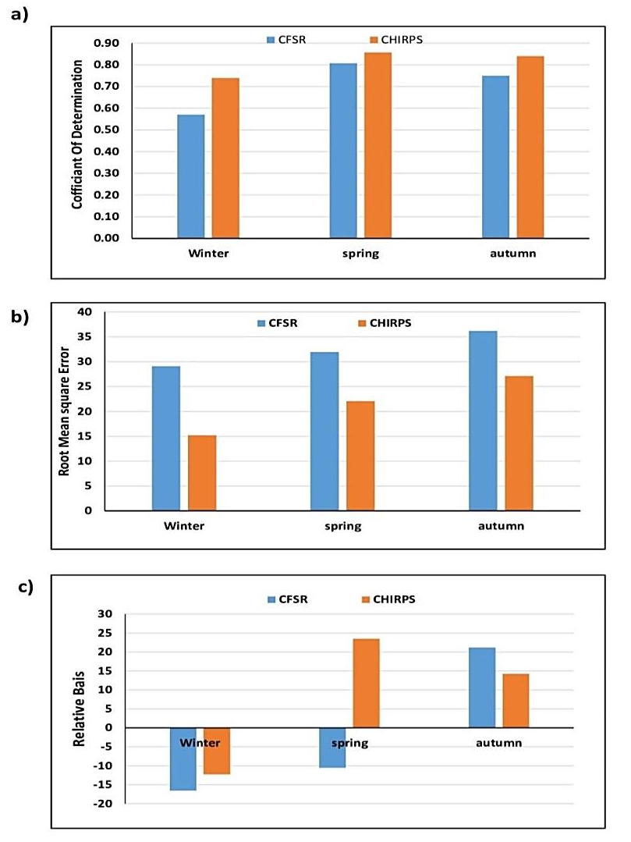

Figure 6. Seasonal performance evaluation indices of CHIRPS and CFSR under (a) coefficient of determination, (b) Root Mean Square Error and (c) Relative Bias for the 2002-2012 period

Annual precipitation analysis

Monthly rainfall totals were accumulated to get the yearly precipitation for CHIRPS, CFSR, and rain gauge data as shown in Figure 7. However, there was no improvement in the relationship with the rain observed data upon accumulation from the monthly to annual time scale (Table 7). There was a decline in R² with open- source climate products. This indicates that the mistakes in the daily and monthly rainfall totals were neither symmetric nor arbitrary. Consequently, the temporal aggregates did not cancel each other out and therefore did not improve the relationship between the products and the observed data (Duan et al., 2016) .
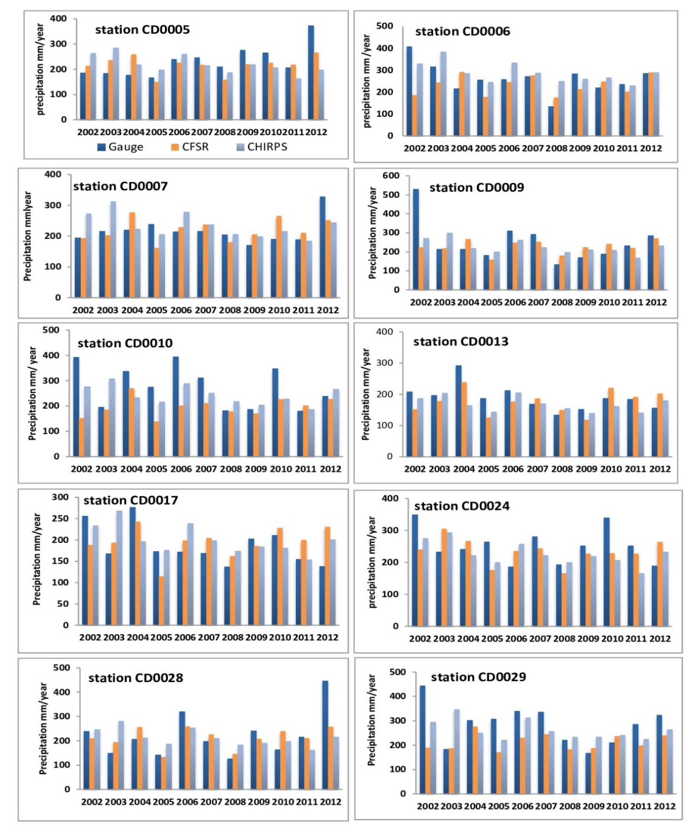

Figure 7. Annual precipitation of observed, CFSR and CHIRPS during the 2002-2012 period

Table 7. Statistical analysis for evaluating annual precipitation of CHIRPS and CFSR over the Mujib Basin from 2002 to 2012

Station ID | Sources | $${ R}^{2}$$ | RMSE | MAE | RB%
CD0005 | CHIRPS  CFSR | 0.12  0.48 | 43.9  28.3 | 29.1  17.1 | -4.50  -5.27
CD0006 | CHIRPS  CFSR | 0.39  0.44 | 33.5  30.9 | 20.7  17.2 | 9.47  -11.6
CD0007 | CHIRPS  CFSR | 0.20  0.41 | 42.3  32.8 | 25.6  24.5 | 8.17  11.4
CD0009 | CHIRPS  CFSR | 0.29  0.41 | 36.4  33.0 | 23.6  21.6 | -9.40  -8.81
CD0010 | CHIRPS  CFSR | 0.22  0.23 | 39.3  39.2 | 25.5  23.6 | -11.8  -28.6
CD0013 | CHIRPS  CFSR | 0.14  0.39 | 43.0  37.3 | 27.1  21.5 | -10.9  -6.65
CD0017 | CHIRPS  CFSR | 0.10  0.24 | 45.3  38.3 | 31.4  23.0 | 7.25  4.53
CD0024 | CHIRPS  CFSR | 0.13  0.41 | 43.5  32.0 | 29.6  12.1 | -10.2  -7.14
CD0028 | CHIRPS  CFSR | 0.17  0.15 | 42.8  44.4 | 24.3  27.2 | -4.43  -4.14
CD0029 | CHIRPS  CFSR | 0.12  0.40 | 44.3  37.2 | 29.3  24.8 | -7.60  -24.7

Figure 8 displays the total mean annual precipitation for the Mujib Basin from 2002 to 2012 of gauges, CHIRPS and CFSR that generated by the Inverse Distance Weighting (IDW) interpolation approach. The average annual precipitation varied from 186 to 276 mm/year. The CFSR product showed the best correlation of 0.35, while CHIRPS had the weakest correlation of 0.18. Products have a tendency to underestimate precipitation, with significant negative results being clearly shown in CFSR and positive, overestimated results in CHIRPS. CFSR had the least MAE and RMSE values, 17.1 and 28.3 mm/year, respectively. On the other hand, CHIRPS had the greatest MAE and RMSE values, 31.4 and 45.3 mm/year, respectively. The total precipitation indicates a descending trend from the west to the east. CHIRPS showed spatial patterns closer to the rain gauge data with high total annual precipitation patterns in the west and a decrease in the southern and eastern regions. Meanwhile, CFSR had lower estimates of the total annual precipitation, making it inappropriate for determining the spatial variation of rainfall in the Mujib Basin. Similarly, Tan et al. (2017) also found that CFSR is not appropriate to measure annual precipitation in river basins of Malaysia, with the CC, RMSE and RB values of 0.11 to 0.21, 1176.88 to 1695.34 mm/year and 44.61 to 49.87%, respectively. These results suggest that caution should be exercised when utilizing products to analyze geographical patterns of rainfall (Ji & Chen, 2012). Therefore, further research should be conducted to enhance the products by exploring spatial errors of precipitation (Chen et al., 2013).

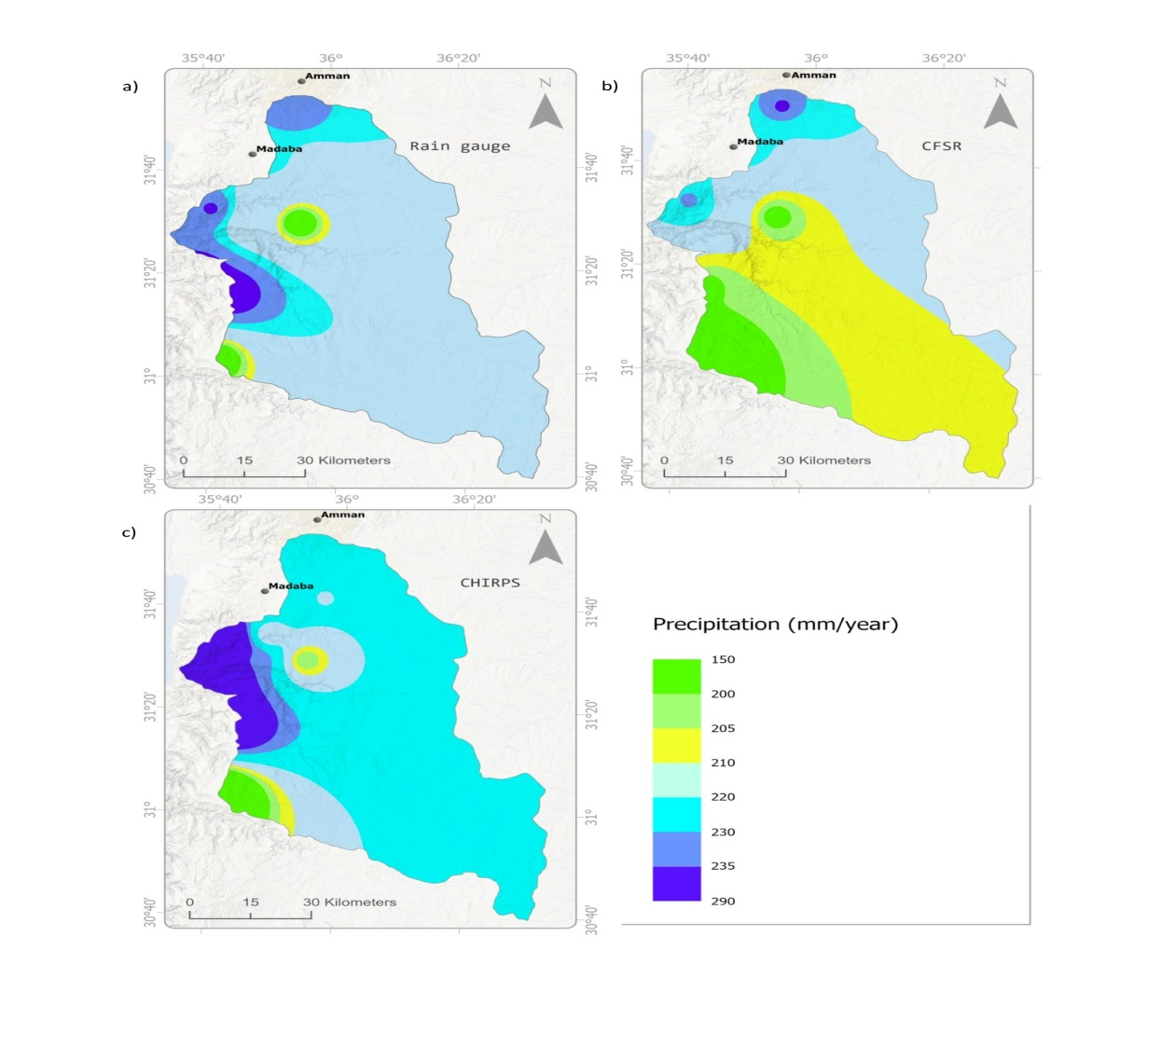

Figure 8. The spatial distribution of average annual precipitation over the Mujib Basin as determined by (a) observed (b) CFSR and (c) CHIRPS data from 2002 to 2012

Conclusions

Two open-source climate products were assessed and compared using observed data over the Mujib Basin, Jordan, during the period 2002–2012. The assessment was done on daily, monthly, seasonal, and annual time scales. Open-source climate products have performed poorly on a daily scale. The categorical statistical equations employing CHIRPS to distinguish rainy and non-rainy days yielded good results with high POD, CSI, and HSS, while FAR was low. The monthly and seasonal analysis showed significant enhancement in product performance, with CHIRPS slightly outperforming the CFSR product. The annual precipitation measurements revealed a weak relation between observed and estimated data. Regarding distribution, both spatial and temporal, the products tended to underestimate the precipitation at stations that typically received high amounts of precipitation. The annual spatial pattern of CHIRPS was found to be closer to the rain observed data whereas CFSR captured the opposite pattern. This study offers recommendations for selecting an alternative for local community precipitation data. The evaluation revealed that the products generally underestimate and overestimate rainfall. The CHIRPS product offers a spatial accuracy of 0.05° and the smallest bias, making it the preferred choice for use in hydrological studies on small basin scales, especially for the monthly time period, which is suitable for water resource planning and drought monitoring.

Acknowledgment

This research was funded by the Universiti Sains Malaysia, Research University Team (RUTeam) Grant Scheme with Project No. 1001/PHUMANITI/8580014. This study utilized remote sensing data from CHIRPS and CFSR and obtained data from the Ministry of Water and Irrigation (MWI) to provide meteorological data for the study.

References

Abu Romman, Z., Al‐Bakri, J., & Al Kuisi, M. (2021). Comparison of methods for filling in gaps in monthly rainfall series in arid regions. International Journal of Climatology, 41(15), 6674-6689. https://doi.org/10.1002/joc.7219

Al-Assa’d, T. A., & Abdulla, F. A. (2010). Artificial groundwater recharge to a semi-arid basin: case study of Mujib aquifer, Jordan. Environmental earth sciences, 60(4), 845-859. https://doi.org/10.1007/s12665-009-0222-2

As-syakur, A. R., Osawa, T., Miura, F., Nuarsa, I. W., Ekayanti, N. W., Dharma, I. G. B. S., Adnyana, I. W. S., Arthana, I. W., & Tanaka, T. (2016). Maritime Continent rainfall variability during the TRMM era: The role of monsoon, topography and El Niño Modoki. Dynamics of Atmospheres and Oceans, 75, 58-77. https://doi.org/10.1016/ j.dynatmoce.2016.05.004

Ayehu, G. T., Tadesse, T., Gessesse, B., & Dinku, T. (2018). Validation of new satellite rainfall products over the Upper Blue Nile Basin, Ethiopia. Atmospheric Measurement Techniques, 11(4), 1921-1936. https://doi.org/10.5194/amt-11-1921-2018

Bai, L., Shi, C., Li, L., Yang, Y., & Wu, J. (2018). Accuracy of CHIRPS satellite-rainfall products over mainland China. Remote Sensing, 10(3), 362. https://doi.org/10.3390/ rs10030362

Chen, S., Kirstetter, P., Hong, Y., Gourley, J., Tian, Y., Qi, Y., Cao, Q., Zhang, J., Howard, K., & Hu, J. (2013). Evaluation of spatial errors of precipitation rates and types from TRMM spaceborne radar over the southern CONUS. Journal of Hydrometeorology, 14(6), 1884-1896. https://doi.org/10.1175/JHM-D-13-027.1

Dembélé, M., & Zwart, S. J. (2016). Evaluation and comparison of satellite-based rainfall products in Burkina Faso, West Africa. International Journal of Remote Sensing, 37(17), 3995-4014. https://doi.org/10.1080/01431161.2016.1207258

Dhanesh, Y., Bindhu, V., Senent-Aparicio, J., Brighenti, T. M., Ayana, E., Smitha, P., Fei, C., & Srinivasan, R. (2020). A comparative evaluation of the performance of CHIRPS and CFSR data for different climate zones using the SWAT model. Remote Sensing, 12(18), 3088. https://doi.org/10.3390/rs12183088

Dile, Y. T., & Srinivasan, R. (2014). Evaluation of CFSR climate data for hydrologic prediction in data‐scarce watersheds: an application in the Blue Nile River Basin. JAWRA Journal of the American Water Resources Association, 50(5), 1226-1241. https://doi.org/ 10.3390/rs12183088

Dinku, T., Ceccato, P., & Connor, S. J. (2011). Challenges of satellite rainfall estimation over mountainous and arid parts of east Africa. International Journal of Remote Sensing, 32(21), 5965-5979. https://doi.org/10.1080/01431161.2010.499381

Dinku, T., Ruiz, F., Connor, S. J., & Ceccato, P. (2010). Validation and intercomparison of satellite rainfall estimates over Colombia. Journal of Applied Meteorology and Climatology, 49(5), 1004-1014. https://doi.org/10.1175/2009JAMC2260.1

Duan, Z., Liu, J., Tuo, Y., Chiogna, G., & Disse, M. (2016). Evaluation of eight high spatial resolution gridded precipitation products in Adige Basin (Italy) at multiple temporal and spatial scales. Science of the Total Environment, 573, 1536-1553. https://doi.org/ 10.1016/j.scitotenv.2016.08.213

Duan, Z., Tuo, Y., Liu, J., Gao, H., Song, X., Zhang, Z., Yang, L., & Mekonnen, D. F. (2019). Hydrological evaluation of open-access precipitation and air temperature datasets using SWAT in a poorly gauged basin in Ethiopia. Journal of Hydrology, 569, 612-626. https://doi.org/10.1016/j.jhydrol.2018.12.026

Ebert, E. E., Janowiak, J. E., & Kidd, C. (2007). Comparison of near-real-time precipitation estimates from satellite observations and numerical models. Bulletin of the American meteorological Society, 88(1), 47-64. https://doi.org/10.1175/BAMS-88-1-47

Fall, C. M. N., Lavaysse, C., Drame, M. S., Panthou, G., & Gaye, A. T. (2019). Wet and dry spells in Senegal: Evaluation of satellite-based and model re-analysis rainfall estimates. Natural Hazards and Earth System Sciences Discussions, 21(3), 1051-1069. https://doi.org/10.5194/nhess-2019-185

Fenta, A. A., Yasuda, H., Shimizu, K., Ibaraki, Y., Haregeweyn, N., Kawai, T., Belay, A. S., Sultan, D., & Ebabu, K. (2018). Evaluation of satellite rainfall estimates over the Lake Tana basin at the source region of the Blue Nile River. Atmospheric Research, 212, 43-53. https://doi.org/10.1016/j.atmosres.2018.05.009

Funk, C., Peterson, P., Landsfeld, M., Pedreros, D., Verdin, J., Shukla, S., Husak, G., Rowland, J., Harrison, L., & Hoell, A. (2015). The climate hazards infrared precipitation with stations—a new environmental record for monitoring extremes. Scientific data, 2(1), 1-21. https://doi.org/10.1038/sdata.2015.66

Funk, C. C., Peterson, P. J., Landsfeld, M. F., Pedreros, D. H., Verdin, J. P., Rowland, J. D., Romero, B. E., Husak, G. J., Michaelsen, J. C., & Verdin, A. P. (2014). A quasi-global precipitation time series for drought monitoring. US Geological Survey data series, 832(4), 1-12. https://dx.doi.org/10.3133/ds832

Gao, F., Zhang, Y., Chen, Q., Wang, P., Yang, H., Yao, Y., & Cai, W. (2018). Comparison of two long-term and high-resolution satellite precipitation datasets in Xinjiang, China. Atmospheric Research, 212, 150-157. https://doi.org/10.1016/j.atmosres.2018.05.016

Guo, J., & Su, X. (2019). Parameter sensitivity analysis of SWAT model for streamflow simulation with multisource precipitation datasets. Hydrology Research, 50(3), 861-877. https://doi.org/10.2166/nh.2019.083

Hordofa, A. T., Leta, O. T., Alamirew, T., Kawo, N. S., & Chukalla, A. D. (2021). Performance evaluation and comparison of satellite-derived rainfall datasets over the Ziway lake basin, Ethiopia. Climate, 9(7), 113. https://doi.org/10.3390/cli9070113

Hou, A. Y., Kakar, R. K., Neeck, S., Azarbarzin, A. A., Kummerow, C. D., Kojima, M., Oki, R., Nakamura, K., & Iguchi, T. (2014). The global precipitation measurement mission. Bulletin of the American meteorological Society, 95(5), 701-722. https://doi.org/10.1175/BAMS-D-13-00164.1

Ji, X., & Chen, Y. (2012). Characterizing spatial patterns of precipitation based on corrected TRMM 3B43 data over the mid Tianshan Mountains of China. Journal of Mountain Science, 9(5), 628-645. DOI: 10.1007/s11629-012-2283-z

Khasawneh, E. (2015). Climate change impacts on water resources in desert area considering irregularity in rainfall intensity and distribution: a case study in Wadi Ziqlab Basin, Jordan. Journal of Natural Sciences Research, 5(16), 1-11.

Li, D., Christakos, G., Ding, X., & Wu, J. (2018). Adequacy of TRMM satellite rainfall data in driving the SWAT modeling of Tiaoxi catchment (Taihu lake basin, China). Journal of Hydrology, 556, 1139-1152. https://doi.org/10.1016/j.jhydrol.2017.01.006

Luo, X., Wu, W., He, D., Li, Y., & Ji, X. (2019). Hydrological simulation using TRMM and CHIRPS precipitation estimates in the lower Lancang-Mekong river basin. Chinese Geographical Science, 29(1), 13-25. https://doi.org/10.1007/s11769-019-1014-6

Ma, D., Xu, Y.-P., Gu, H., Zhu, Q., Sun, Z., & Xuan, W. (2019). Role of satellite and reanalysis precipitation products in streamflow and sediment modeling over a typical alpine and gorge region in Southwest China. Science of the Total Environment, 685, 934-950. https://doi.org/10.1016/j.scitotenv.2019.06.183

Macharia, J. M., Ngetich, F. K., & Shisanya, C. A. (2020). Comparison of satellite remote sensing derived precipitation estimates and observed data in Kenya. Agricultural and Forest Meteorology, 284, 107875. https://doi.org/10.1016/j.agrformet.2019.107875

Mantas, V. M., Liu, Z., Caro, C., & Pereira, A. (2015). Validation of TRMM multi-satellite precipitation analysis (TMPA) products in the Peruvian Andes. Atmospheric Research, 163, 132-145. https://doi.org/10.1016/j.atmosres.2014.11.012

Marra, F., Morin, E., Peleg, N., Mei, Y., & Anagnostou, E. N. (2017). Intensity–duration–frequency curves from remote sensing rainfall estimates: comparing satellite and weather radar over the eastern Mediterranean. Hydrology and Earth System Sciences, 21(5), 2389-2404. https://doi.org/10.5194/hess-21-2389-2017

Meng, J., Li, L., Hao, Z., Wang, J., & Shao, Q. (2014). Suitability of TRMM satellite rainfall in driving a distributed hydrological model in the source region of Yellow River. Journal of Hydrology, 509, 320-332. https://doi.org/10.1016/j.jhydrol.2013.11.049

Monteiro, L. A., Sentelhas, P. C., & Pedra, G. U. (2018). Assessment of NASA/POWER satellite‐based weather system for Brazilian conditions and its impact on sugarcane yield simulation. International Journal of Climatology, 38(3), 1571-1581. https://doi.org/10.1002/joc.5282

Mourtzinis, S., Rattalino Edreira, J. I., Conley, S. P., & Grassini, P. (2017). From grid to field: Assessing quality of gridded weather data for agricultural applications. European Journal of Agronomy, 82, 163-172. https://doi.org/https://doi.org/10.1016/j.eja. 2016.10.013

Radcliffe, D. E., & Mukundan, R. (2017). PRISM vs. CFSR Precipitation Data Effects on Calibration and Validation of SWAT Models. JAWRA Journal of the American Water Resources Association, 53(1), 89-100. https://doi.org/https://doi.org/10.1111/1752-1688.12484

Ren, P., Li, J., Feng, P., Guo, Y., & Ma, Q. (2018). Evaluation of multiple satellite precipitation products and their use in hydrological modelling over the Luanhe River basin, China. Water, 10(6), 677. https://doi.org/10.3390/w10060677

Rivera, J. A., Marianetti, G., & Hinrichs, S. (2018). Validation of CHIRPS precipitation dataset along the Central Andes of Argentina. Atmospheric Research, 213, 437-449. https://doi.org/10.1016/j.atmosres.2018.06.023

Samawi, M., & Sabbagh, N. (2004). Application of methods for analysis of rainfall intensity in areas of Israeli, Jordanian, and Palestinian interest. Amman: Jordanian Meteorological Department, Ministry of Water and Irrigation.

Satgé, F., Bonnet, M.-P., Gosset, M., Molina, J., Lima, W. H. Y., Zolá, R. P., Timouk, F., & Garnier, J. (2016). Assessment of satellite rainfall products over the Andean plateau. Atmospheric Research, 167, 1-14. https://doi.org/10.1016/j.atmosres.2015.07.012

Shehadeh, N. (1991). The climate of Jordan. Dar Al-Bashir, Amman.

Shen, Y., Xiong, A., Wang, Y., & Xie, P. (2010). Performance of high‐resolution satellite precipitation products over China. Journal of Geophysical Research: Atmospheres, 115(D2). https://doi.org/10.1029/2009JD012097

Stagl, J., Mayr, E., Koch, H., Hattermann, F. F., & Huang, S. (2014). Effects of climate change on the hydrological cycle in Central and Eastern Europe. In Managing protected areas in central and eastern Europe under climate change (pp. 31-43). Springer, Dordrecht.

Tan, M.L., Gassman, P.W. and Cracknell, A.P. (2017) Assessment of Three Long-Term Gridded Climate Products for Hydro-Climatic Simulations in Tropical River Basins. Water 9(3), 229. https://doi.org/10.3390/w9030229

Tapiador, F. J., Turk, F. J., Petersen, W., Hou, A. Y., García-Ortega, E., Machado, L. A., Angelis, C. F., Salio, P., Kidd, C., & Huffman, G. J. (2012). Global precipitation measurement: Methods, datasets and applications. Atmospheric Research, 104, 70-97. https://doi.org/10.1016/j.atmosres.2011.10.021

Tian, Y., Liu, Y., Arsenault, K. R., & Behrangi, A. (2014). A new approach to satellite-based estimation of precipitation over snow cover. International Journal of Remote Sensing, 35(13), 4940-4951. https://doi.org/10.1080/01431161.2014.930208

Toté, C., Patricio, D., Boogaard, H., Van der Wijngaart, R., Tarnavsky, E., & Funk, C. (2015). Evaluation of satellite rainfall estimates for drought and flood monitoring in Mozambique. Remote Sensing, 7(2), 1758-1776. https://doi.org/10.3390/rs70201758

Ullah, W., Wang, G., Ali, G., Tawia Hagan, D. F., Bhatti, A. S., & Lou, D. (2019). Comparing multiple precipitation products against in-situ observations over different climate regions of Pakistan. Remote Sensing, 11(6), 628. https://doi.org/10.3390/rs11060628

Wang, Y., Zhao, J., Fu, J., & Wei, W. (2019). Effects of the Grain for Green Program on the water ecosystem services in an arid area of China—Using the Shiyang River Basin as an example. Ecological indicators, 104, 659-668. https://doi.org/10.1016/j.ecolind. 2019.05.045

Wilk, J., Kniveton, D., Andersson, L., Layberry, R., Todd, M. C., Hughes, D., Ringrose, S., & Vanderpost, C. (2006). Estimating rainfall and water balance over the Okavango River Basin for hydrological applications. Journal of Hydrology, 331(1-2), 18-29. https://doi.org/10.1016/j.jhydrol.2006.04.049

Yang, Y., Wang, G., Wang, L., Yu, J., & Xu, Z. (2014). Evaluation of gridded precipitation data for driving SWAT model in area upstream of three gorges reservoir. PLoS One, 9(11), e112725. https://doi.org/10.1371/journal.pone.0112725

Yong, B., Ren, L. L., Hong, Y., Wang, J. H., Gourley, J. J., Jiang, S. H., Chen, X., & Wang, W. (2010). Hydrologic evaluation of Multisatellite Precipitation Analysis standard precipitation products in basins beyond its inclined latitude band: A case study in Laohahe basin, China. Water Resources Research, 46(7). https://doi.org/10.1029/ 2009WR008965

Zambrano, F., Wardlow, B., Tadesse, T., Lillo-Saavedra, M., & Lagos, O. (2017). Evaluating satellite-derived long-term historical precipitation datasets for drought monitoring in Chile. Atmospheric Research, 186, 26-42. https://doi.org/10.1016/j.atmosres.2016.11.006

Zhang, G., Su, X., Ayantobo, O. O., Feng, K., & Guo, J. (2020). Remote-sensing precipitation and temperature evaluation using soil and water assessment tool with multiobjective calibration in the Shiyang River Basin, Northwest China. Journal of Hydrology, 590, 125416. https://doi.org/10.1016/j.jhydrol.2020.125416

Zhang, Y., Li, Y., Ji, X., Luo, X., & Li, X. (2018). Evaluation and hydrologic validation of three satellite-based precipitation products in the upper catchment of the Red River Basin, China. Remote Sensing, 10(12), 1881. https://doi.org/10.3390/rs10121881

