Impact assessment of Sea Level Rise (SLR) on coastal erosion through Multiple-Criteria Index in Pantai Remis, Perak

Nurul Ain Liyana Hamzah¹, Khairul Nizam Abd Maulud^{1,2*}, Noorashikin Md Noor², Wan Hanna Melini Wan Mohtar^{1,3}, Fazly Amri Mohd⁴, Nor Aizam Adnan⁵, Syed Ahmad Fadhli Syed Abdul Rahman^{2,6}

¹Department of Civil Engineering, Faculty of Engineering and Built Environment,
Universiti Kebangsaan Malaysia, Bangi 43600, Selangor, Malaysia
²Earth Observation Centre, Institute of Climate Change,
Universiti Kebangsaan Malaysia, Bangi 43600, Selangor, Malaysia
³Environmental Management Centre, Institute of Climate Change,
Universiti Kebangsaan Malaysia, Bangi 43600, Selangor, Malaysia
⁴Department of Surveying Science and Geomatic,
Universiti Teknologi MARA, Arau 02600, Perlis, Malaysia
⁵Faculty of Architecture, Planning & Surveying,
Universiti Teknologi MARA, Shah Alam 40450, Selangor, Malaysia
⁶Cadastral Division, Department of Survey and Mapping Malaysia,
50578 Kuala Lumpur, Malaysia.

Correspondence: Khairul Nizam Abdul Maulud (email: knam@ukm.edu.my)

Received: 21 March 2023; Accepted: 17 April 2023; Published: 31 May 2023

Abstract

Extreme climate changes have led to natural disasters, especially sea level rise, which leads to coastal erosion and can affect the safety and economy of the local community. Through an index of different criteria, this study aims to find out how sea level rise affects erosion along the coast in Pantai Remis, Perak. A spatial model for determining the impact of sea level rise on coastal erosion was designed, as was a risk assessment framework for the impact of sea level rise on coastal erosion using the multi-criteria index method. This study focuses on the geomorphology, coastal slope, coastal elevation, coastal buffers, tidal range, wind speed, building density, population activity, and road network. As a result of the calculation of indices and weights for the study, four out of 28 (14.3%) management units are in areas that received a very high impact of sea level rise on coastal erosion. Areas classified as very high are likely to be affected by the movement of small boats and cause the level of erosion in the area to worsen. Three out of 28 (10.7%) management units are classified as high, 13 (46.4%) are classified as moderate, and eight out of 28 (28.6%) management units are low. Overall, Pantai Remis, Perak, is a beach with a moderate impact of coastal erosion due to sea level rise. This approach allows for the incorporation of multiple factors and the prioritization of mitigation measures based on their relative importance, which can be useful for decision-making and resource allocation.

Keywords: Coastal erosion, impact, Multiple-Criteria Index, physical criteria, sea level rise, socioeconomic criteria

Introduction

Coastal erosion is a global environmental challenge that affects many coastal regions worldwide. The impact of sea level rise caused by climate change has exacerbated this issue, making it more urgent to understand the potential consequences of coastal erosion in vulnerable areas. Pantai Remis, Perak, Malaysia, is one such area that is particularly susceptible to coastal erosion (Mohd et al., 2019; Ahmad et al., 2021; Rahim et al., 2021; Abdul Maulud et al., 2022), as it is located in a low-lying coastal area that is vulnerable to sea level rise. According to the Intergovernmental Panel on Climate Change (2013), the average global sea level rise is likely to be between 28 and 61 cm and 52 and 98 cm (Representative Concentration Pathways, RCP2.6 and RCP8.5, respectively) by 2100. In recent decades, sea level rise has exceeded the 20th century average, reaching rates as high as 3 mm per year since 1993 (Church & White, 2011; Hay et al., 2015; Kopp et al., 2016) and is driven primarily by ocean thermal expansion and glacier loss and ice flakes (Church et al., 2013).
Sea level rise is a change in water depth that alters the tides, water surges and waves (Idier et al., 2019). Changes in wind in response to climate change induce changes in average coastal wave conditions, including altitude, direction and duration, which in turn induce changes in wave enhancement preparations (Church et al., 2013). Coastal morphological changes are also the result of variability in waves and currents that can occur over a time scale of several hours to several years (Noor & Maulud, 2022). Previous studies have investigated the potential impacts of sea level rise on coastal erosion in various regions worldwide. For instance, a study projected that sea level rise could cause up to 67% of sandy beaches to erode by 2100. Similarly, Zhang et al. (2019) assessed the impact of sea level rise on coastal erosion in China and found that sea level rise could cause up to 48% of sandy beaches to erode by 2100. Several studies have also proposed methodologies for assessing the potential impact of sea level rise on coastal erosion. For instance, Nicholls et al. (2021) improved a global coastal erosion risk assessment framework that incorporates factors such as coastal slope, tidal range, and wave height. Similarly, Aysun et al. (2019) developed a coastal erosion vulnerability index that considers factors such as wave energy, sediment supply, and coastal slope.
The multiple-criteria index (MCI) methodology used in the present study is a novel approach that considers multiple factors to assess the susceptibility of the coastline to erosion under different sea level rise scenarios. This methodology has been used in previous studies to assess the impact of sea level rise on coastal erosion. For instance, Wang et al. (2019) used an MCI methodology to evaluate the vulnerability of the coastline in China to sea level rise and found that the eastern coast was more vulnerable than the western coast.
Analyzing the perceptions of households towards climatic variations, sea level rise, and coastal hazards including coastal erosion, while identifying the socio-economic factors that impact their awareness, is crucial for enhancing knowledge and building adaptive capacity and climate resiliency within local communities. A community that is more aware is likely to be better prepared, making the assessment of household awareness of climate change an essential aspect of this study (Sofia et al., 2022a; Sofia et al., 2022b).
Overall, the literature suggests that coastal erosion is a significant environmental challenge that is exacerbated by sea level rise caused by climate change. Department of Irrigation and Drainage Malaysia, 2015 show that Perak is the fifth state in Malaysia experiencing severe coastal erosion, with 61 percent of its beaches eroded. A preliminary field study demonstrates significant changes in the shoreline in Pantai Remis, Perak since 1974, with an erosion rate of 4.18 m/year according to Landsat 8 data. This emphasizes the need for research and solutions to address coastal erosion in Pantai Remis, Perak, making it an appropriate focus for this study. Thus, this study aims to investigate how tidal changes and sea level rise affect the Malaysian coast of the Straits of Malacca, focusing on Pantai Remis, Perak. A spatial model is used to create an index of various criteria to determine the impact of sea level rise on coastal erosion, as well as develop a risk assessment framework. The study was conducted in two phases: a preliminary study and data analysis, which used an Analytical Hierarchy Process (AHP) based on deep learning methods to predict coastal changes and erosion. The expected output of the study is a linear scale that measures the impact of sea level rise on coastal erosion in Pantai Remis, Perak. The findings of this study could inform evidence-based policy decisions to ensure the long-term sustainability of coastal communities and environments.

Method

Study area

The study was conducted in Pantai Remis, Perak (4º 26’ 51” N, 100º 36’ 59” E ) and covers a coastal stretch of approximately 8 km in length, covering 151.46 km² extending from Kampung Batu Kapor in the north to Sungai Bernam in the south. Pantai Remis is situated on the west coast of Malaysia, adjacent to the Strait of Malacca (Figure 1). The communities living in the Pantai Remis region are primarily involved in fishing and tourism-related activities. The study area includes several fishing villages, including Kampung Batu Kapor and Kampung Tanjung Batu, where the local community depends on fishing as its primary source of livelihood as well as tourism. Additionally, 500-meter buffers around the current shoreline of the study area were created using ARCGIS software. These buffers were created to ensure that each management unit included both the land and sea areas within its boundaries, as the study was focused on assessing the impact of sea level rise on coastal erosion. Figure 2 shows the 28 polygons of the management units that were created using Google Earth Pro software. These polygons are used throughout the study as a way of organizing the data and the analysis.

Assessment Index System and data source

Vulnerability is used to identify areas and individuals that are at risk of harm resulting from coastal disturbances. Vulnerability assessments can be conducted on a national, regional, or local level, depending on the administrative boundaries. In this study, the focus is on assessing vulnerability on a local scale, which takes into account the unique characteristics and development patterns of the area. This approach is primarily aimed at informing local coastal management efforts. The assessment of coastal vulnerability to erosion includes both physical and socio-economic factors. The physical part consists of geomorphology, coastal slope, coastal elevation, coastal buffer, tidal range and wind speed. Meanwhile, the socio-economic part consists of the density of buildings, the population activities and the road network. Table 1 illustrates the parameter and data sources with the main source of the data are from Department of Survey and Mapping Malaysia (JUPEM).

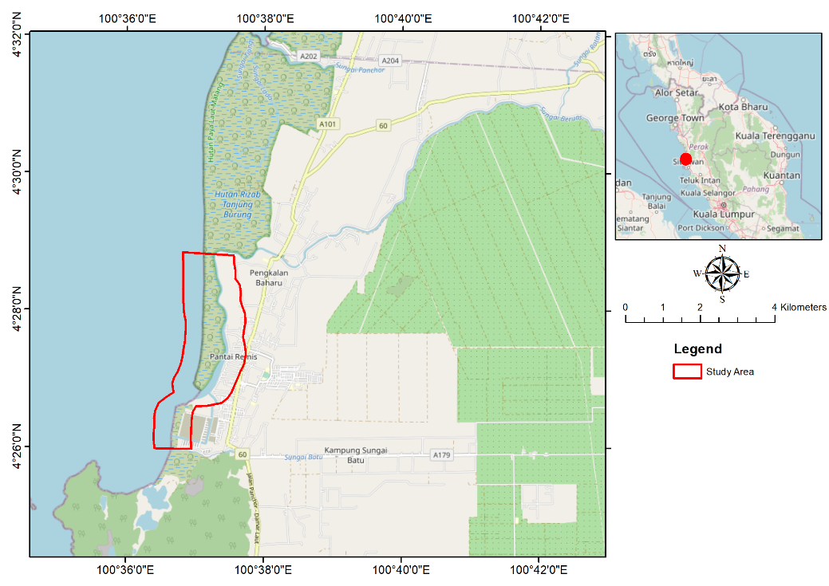

Figure 1. Study area

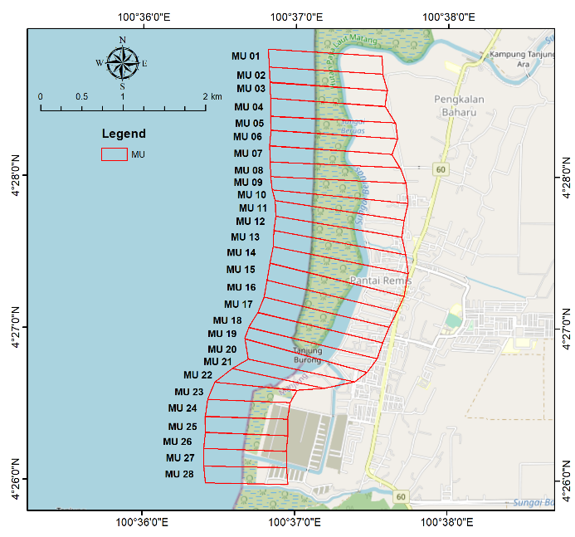

Figure 2. Division of the coastline into Management Units (MU)

Table 1. Index system and data source
Criteria | Parameter | Data type | Data sources | Period
Physical | Geomorphology | (Microsoft Words) | Field Survey | 2022
Physical | Coastal Slope | Elevation Model | JUPEM | 2017
Physical | Coastal Elevation | Elevation Model | JUPEM | 2017
Physical | Coastal Buffer | (Microsoft Words) | Field Survey | 2022
Physical | Wind Speed | NetCDF | Open Source | 2020
Physical | Tidal Range | (Microsoft Excel) | JUPEM | 2000-2020
Socioeconomic | Building Density | Shapefile, (Microsoft Excel) | JUPEM, Google Earth, Field Survey | 2020
Socioeconomic | Population activity | (Microsoft Excel) | Field Survey | 2022
Socioeconomic | Road Network | Shapefile | JUPEM | 2020-2022

Calculation and Categorization of Index

The physical part of the index consists of geomorphology, coastal slope, coastal elevation, coastal buffer, tidal range and wind speed. Meanwhile, the socioeconomic component index includes the density of buildings, population activities, and road network, which are defined as follows:

- Geomorphology

Geomorphology is the study of landforms and their erosive risks in a coastal environment. It includes the type of sediments, the type of cliffs, the seascape and oceanic water bodies, and the coastal vegetation. Geomorphology is mostly concerned with identification rather than measurement, which can be accomplished through site visits, topography maps, or remote sensing photos. The geomorphology variable is rated according to the type of landform found along the shoreline. Tougher and more stable landforms, such as stony cliffs, pose a lower risk of coastal vulnerability because they provide a more effective coastal defense mechanism than vegetation such as coral reefs and mangroves.

- Coastal slope

Coastal slope is defined as the ratio of the change in elevation to the horizontal distance between any two points on the beach perpendicular to the shoreline. On a steep slope, sea level rise is insignificant, necessarily as opposed to sloping beaches, where any sea level rise will submerge large areas of land. The DEM from InSAR can be inserted into Google Earth to generate coastal slope values.

- Coastal elevation

Coastal elevation is defined as the average elevation of a particular area above average sea level (Mani et al., 2013). Area elevation plays an important role in identifying and estimating the land area threatened by future climate change scenarios. Coastal areas with low elevation are considered highly vulnerable to the risk of coastal erosion, while areas with higher elevation are considered less vulnerable. This is mainly because areas in higher areas provide more resistance to floods due to rising sea levels, tsunamis and storm surges compared to low-lying areas.

- Coastal buffer

The Selangor Water Management Authority (LUAS) defined a coastal buffer area as "a portion of land adjacent to a body of water designed or determined to be in undisturbed, natural, or other conditions designated by its distance or width" in March 2021. The function of the buffer area can be divided into three (3) parts, namely floodplains, river development or maintenance requirements and the buffer zone. The buffer zone is an area for the reproduction of flora and fauna as well as other aquatic life. This zone can be used as a green zone where the natural processes of the river can be allowed to occur, such as river formation, erosion and pollution control and riverbank stability.

- Tidal range

The tidal range is frequently linked to both continuous and sporadic flood danger (Koroglu et al., 2019). A large tidal range is related to greater tidal currents, which can erode land and move sediment (Islam et al., 2020). A rise in the average sea level would result in more frequent flooding of intertidal ecosystems, such as deltas and estuaries. Additionally, this will cause locations above astronomically high tidal levels to flood.

- Wind speed

Malaysia is a maritime country located north of the Equator. Thus, its wind flow is dominated by two main monsoons namely the Southwest monsoon from late May to September and the Northeast monsoon from November to March along with a transitional monsoon season from April and October. Due to this monsoon season, wind-related disasters have increased rapidly in recent years in Malaysia, including coastal erosion which is classified as one of the wind-related disasters due to combining wind and water hazards (Yanalagaran et al., 2019).

- Building density

Building density, commonly referred to as Floor Space Ratio (FSR). The density of a building not only determines how crowded or built a neighborhood looks but also the value of the land and the building. Building density is measured by residential units per acre or the ratio of the square floor area of a building divided by the land area of the area. The area of a building and the area of land can be measured through Google Earth software.

- Population activity

Coastal communities refer to those living in coastal areas (5 km from the coast to the mainland) and their economic resources depend directly and indirectly on marine resources (Jaafar et al., 2016). Coastal communities especially fishing communities are highly dependent on coastal natural resources for their food supply and livelihoods. Many fishing communities take precaution on the beach as the location of their settlement space due to the very high impact factor as well as being very close to the beach.

i. Road network

The road network is an important aspect of dealing with natural disasters, especially with reference to the provision of relief work (Mani et al., 2013). Disruption in the road network due to natural disasters can result in disrupted network of activities and increase the impact of the disaster due to a lack of resources.

Indexes are typically classified into five classes (Rajakumari et al., 2022). However, due to variations in the data, some indices are categorized into three or four classes. The classification system uses the numbers 1 to 5 to indicate the vulnerability level, with 1 representing very low vulnerability, 2 representing low vulnerability, 3 representing medium vulnerability, 4 representing high vulnerability, and 5 representing very high vulnerability. Table 2 presents the index classification for this study.

Table 2. Index classification

Criteria | Position of multi-criteria index
Criteria | 1 | 2 | 3 | 4 | 5
Geomorphology | Rocky cliff coast, Cove beach, cape beach | Simple cliffs, Curvy beaches | Low cliffs, glacial drift, alluvial plains | Rocky beaches, estuaries, lagoons | Sandy beaches, saltwater swamps, muddy beaches
Coastal Slope (%) | > 3.5 | > 2.5-3.5 | > 1.5-2.5 | > 1-1.5 | < 1
Coastal  Buffer | Sheet-pile | Mangrove | Buns | Greeneries | No buffer
Wind Speed (m/s) | < 0.10 | > 0.1-0.16 | > 0.16-0.22 | > 0.22-0.28 | > 0.28
Tidal Range (m) | < 1.0 | > 1.0-1.3 | > 1.3-1.6 | > 1.6-1.9 | > 2.0
Coastal Elevation (m) | > 8.0 -10.0 | > 6.0 – 8.0 | > 4.0 – 6.0 | 2.0 – 4.0 | < 2.0
Building Density | < 0.1 | 0.1 – 0.2 | > 0.2 – 0.3 | > 0.3 – 0.4 | > 0.4
Road Network (m) | > 160 | > 120 - 160 | > 80 – 120 | > 40 – 80 | < 40
Population Activity | No economic development | Low development | Modest active development | Active development | Very active development

Data analysis

For the data analysis, the analytical hierarchy process (AHP) is used to make it equal based on its weight. A paired comparison matrix was formed by evaluating the relative importance of an index in a pair, the index of one level was compared with another index at the same level and subsequently its relative importance was calculated, as shown in Table 3.

Table 3. Intensity scale for paired comparisons

Weight / rank intensities | Intensities
1 | Equal
3 | Moderately dominant
5 | Strongly dominant
7 | Very strongly dominant
9 | Extremely dominant
2,4,6,8 | Intermediate values
Reciprocals | For inverse judgements
Source: Saaty, 2006

The weighting vectors can be obtained using linear algebraic operations, which are the principal eigenvectors of the matrix for example, paired comparisons and are confirmed through the evaluation of the accuracy and consistency of the comparisons between the two options. This analysis was performed using ArcGIS 10.8 software. For this purpose, the consistency index (CI) is used as follows:

CI = (λmax-n)/(n-1)

being the consistency index; λmax is the largest or primary eigenvalue of the paired comparison matrix and n is the arrangement of the matrix. The larger the CI value, the lower the consistency of the matrix. The consistency ratio (CR) is calculated as follows:

CR = CI/RI

where RI is the average of the resulting consistent index, depending on the arrangement of the matrix. When the CR is less than 0.10, the matrix has a reasonable consistency; otherwise, the matrix should be changed and the original values ​​in the paired comparison matrix must be revised. The results calculated for the weights are acceptable since the value of CR is satisfactory, which is 0.09. Table 4 show the weightage for every of the index criteria.

λMax | =10.10648
Consistency Index (CI) | =0.13831
Consistency Ratio (CR) | =0.095386

Table 4. Weightage of Index Criteria

Criteria | Weightage Value
Geomorphology | =25.6
Coastal Slope | =19.37
Coastal Buffer | =14.21
Wind Speed | =9.67
Tidal Range | =3.02
Coastal Elevation | =9.93
Building Density | =7.17
Road Network | =6.12
Population Activity | =4.92
Risk assessment study

For the risk assessment for this study, the risk assessment analysis is based on the risk matrix method (Table 5), which determines the risk using qualitative, quantitative or semi-quantitative data. The definition of scores for probability and severity in the risk matrix was adapted from Thomsen et al. (2012). Risk analysis can be performed and classified based on the risk matrix in the Table 5.

Table 5. Risk matrix method

Risk |  | Severity
 |  | Insignificant (1) | Minor  (2) | Moderate  (3) | Major  (4) | Catastrophic (5)
Likelihood | Almost Certain (5) | 5 | 10 | 15 | 20 | 25
Likelihood | Likely (4) | 4 | 8 | 12 | 16 | 20
Likelihood | Moderate (3) | 3 | 6 | 9 | 12 | 15
Likelihood | Unlikely (2) | 2 | 4 | 6 | 8 | 10
Likelihood | Rare (1) | 1 | 2 | 3 | 4 | 5
Risk Score |  |  | <6 | 6-9 | 10-15 | >15
Risk Rating |  |  | Low | Medium | High | Very High
Risk Rating |  |  | Action
Low |  |  | Manage using routine procedures, keep under review
Moderate |  |  | Action required, plan and prepare
High |  |  | Priority action required to mitigate hazard in short term
Very High |  |  | Urgent action required to prevent hazard  Action required to mitigate hazard in short term
Source: Hassan 2021

Results and discussion

Physical and Socio-economic vulnerability distribution

As a result of index and weighting calculations, 4 out of 28 units (14%) of management units are in areas that will receive the very high impact of sea level rise on coastal erosion (Figure 3). Areas that are categorized as very high are likely to be affected by the movement of small boats by the surrounding population and cause the level of erosion in the area to worsen. Out of 28 management units, 11% (3 out of 28) were classified as high, 46% (13 out of 28) were classified as moderate, and 28.6% (8 out of 28) were classified as low. The reason for these findings is that MU 27 has a low coastal slope classification and a high percentage of gradient when compared to the other management units. MU 27 also does not have any activities or road network along the management unit. The findings of this study are consistent with past literature on the vulnerability of coastal areas to sea level rise and erosion. Many studies have shown that low-lying coastal areas with a high population density, as well as areas with significant human activities and infrastructure, are particularly vulnerable to the impacts of sea level rise and erosion (Nicholls et al., 2018; Shrestha et al., 2018; Vousdoukas et al., 2018). In addition, past literature has also highlighted the importance of considering multiple factors when assessing the vulnerability of an area to coastal erosion, including coastal slope, shoreline change, sediment supply, and human activities (Chua et al., 2020; Tang et al., 2020; Thang et al., 2021). The present study takes into account multiple criteria to develop an index for assessing the impact of sea level rise on coastal erosion, which aligns with the approach recommended by many researchers in the field.

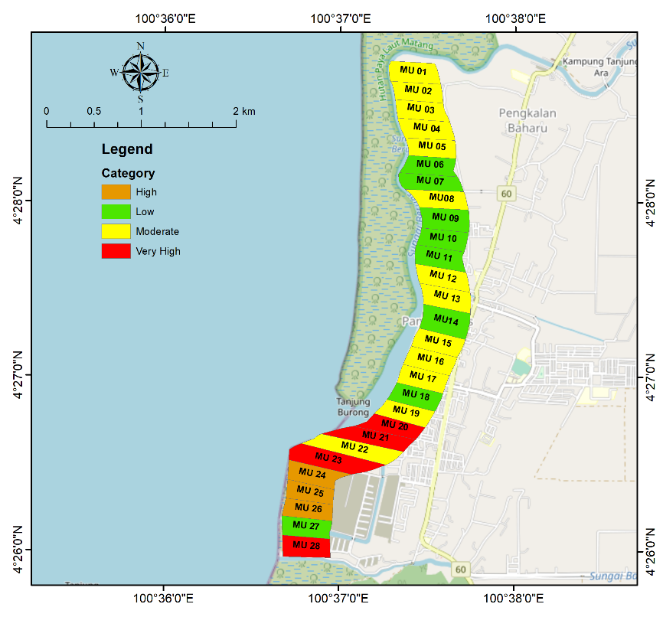

Figure 3. Impact of SLR on Coastal Erosion through Multiple Criteria Index in Pantai Remis, Perak

Analytic hierarchy process

Out of the nine weightings, the geomorphology was not considered in deriving final weights since the consistency ratio was exceeding the 0.1 threshold (0.25). This implies that the weighting in this particular case was relatively more arbitrary than it should have been to be considered consistent. The factors with the highest resulting weight were coastal slopes, elevation, buffer, and building density (0.08), followed by wind, road network, and population activity (0.06), while the lowest was for tidal range (0.05). Coastal slopes, elevation, buffers, and building density were given the highest weights, respectively, in this study based on the AHP. The study found that, out of the nine weightings considered, one of them (geomorphology) was not considered in the final weights due to inconsistency. This finding is consistent with previous literature that has emphasized the importance of ensuring consistency in the use of the analytic hierarchy process (AHP) for decision-making. For instance, a study by Liu et al. (2013) showed that the AHP method could be compromised if consistency was not ensured during the process of deriving final weights. Moreover, the study found that the highest weights were assigned to coastal slopes, elevation, buffers, and building density, while the lowest weight was assigned to tidal range. This finding is consistent with previous studies that have also identified elevation and building density as important factors in vulnerability assessments (Nigusse & Adhanom, 2019; Mullick et al., 2019). Additionally, the finding that wind, road network, and population activity also had significant weights is consistent with previous studies that have highlighted the importance of considering these factors in vulnerability assessments (Zhang et al., 2019). Overall, the study's findings provide valuable insights into the use of AHP in vulnerability assessments and the importance of consistency in weighting criteria. The study's results also highlight the critical role played by factors such as elevation, building density, and coastal slopes in determining vulnerability to natural hazards.

Indexes system of coastal vulnerability to erosion framework for risk assessment

There are 28 management units (MU) that are taken into account for the risk assessment of this study. The potential hazard risk in the study area is based on the observation of current conditions and the history of previous disasters. With that, the risk analysis in Pantai Remis, Perak was carried out based on the observation of the current situation and the history of previous disasters and classified according to the risk matrix of the management unit, which was carried out on January 20, 2022. The risk assessment is divided into four categories, which are very high risk, high risk, moderate risk and low risk (Figure 3).

a. Very high-risk

The MUs involved in this assessment for very high risk are MU20, MU21, MU23 and MU28. Boats can dock at MU 20 and MU 21 near the main entrance. Many economic activities take place in and around this area. The coastal elevation and building density in MU 20, MU 21, and MU 23 are further variables that contributed to the very high-risk area. However, the natural barrier of mangroves protects a part of the area. In addition, the presence of muddy geomorphological conditions increases the likelihood of coastal erosion resulting from the rise in sea levels. Mud is generally more susceptible to erosion than other types of sediment. This is because mud particles are smaller and less cohesive, making them more easily transported by water. Coastal areas with muddy geomorphological conditions often have low-lying, flat topography. This means that a relatively small increase in sea level can result in a large increase in the extent of inundation and erosion. Muddy sediments can also trap water, which can increase the pressure on seawalls and other coastal structures. This can lead to more frequent and severe damage from storm surges and other coastal hazards. Sea level rise is expected to increase the frequency and intensity of storms, which can further exacerbate erosion in muddy coastal areas. MU 28 is also close to Sungai Batu's downstream. There is no economic activity in this area. However, there are a few individuals in the vicinity that use this path to park their private boats close to their homes.

b. High risk

Erosion in the area MU 24 to MU 26 is also categorized as high. This is due to the condition of the beach which is exposed and does not have any buffer in the front area. This area also has a slightly sloping beach and is easy to erode later in the day.
c. Moderate risk

MU 1 is an area close to the upstream portion of Sungai Beruas. Therefore, the rapid flow of the river is also able to increase the rate of erosion. There are no economic activities carried out around this area. In addition, the muddy geomorphological conditions also increase the risk of coastal erosion due to sea level rise.
It is a location near economic activity for MU 12 and MU 13. Exporting marine resources, businesses, places of worship such as Seng Huat Soo Kong Temple, housing, and fishing activities are among the economic activities carried out in this area. This location is frequently used by fishing boats to park their boats near the jetty. The waves created by the fishing boats will storm the riverbanks, worsening the problem of coastal erosion in the future. MU 15, MU 16 and MU 17 have a distance between the road and the coastline in this area of ​​less than 40 meters and causes this management unit to have a moderate impact on coastal erosion.
While in MU 19 and MU 22, this unit is a management unit with the main entrance of fishing boats, as well as numerous other economic activities in the surrounding area. However, this location has a high slope of up to 9.7 percent.

d. Low risk

The management units with the steepest slopes are MU 6, MU 7, and MU 9. There is no economic activity in this area. However, there is a road network close to the coastline that presents a minimal danger in this area in terms of facing the threat of coastal erosion in Pantai Remis, Perak because this road is rarely used and only light vehicles can cross it. Because of their steep slopes, MU 10, MU 11, MU 14, MU 18, and even MU 27 are moderately resistant to coastal erosion caused by sea level rise.
The use of a risk assessment framework to assess the potential hazard risk in the study area is consistent with previous research in the field. There have been numerous studies on the use of risk assessment frameworks for natural hazards, including coastal erosion, and many have shown that these frameworks can provide valuable insights into the potential risks associated with these hazards (Hussain et al, 2023; Noor & Maulud, 2022; Hoque et al., 2018). A study by Tavares et al. (2019) examined the use of risk assessment frameworks for natural hazards in Brazil. The study found that risk assessment frameworks can provide valuable information for disaster risk management and can help identify the most vulnerable areas to natural hazards. Similarly, a study by Rastogi et al. (2021) looked at the use of risk assessment frameworks for coastal erosion in India. The study found that risk assessment frameworks can help identify the potential risks associated with coastal erosion, and can provide useful information for coastal management and planning.
The classification of the risk assessment into four categories is also consistent with previous research. Many studies have used similar classification schemes to assess the potential risks associated with natural hazards, including coastal erosion (Gacu et al., 2022; Koroglu et al., 2019; Rocchi et al., 2022). A study by Wang et al. (2017) used a similar classification scheme to assess the potential risks associated with coastal erosion in China. The finding that the risk level for a management unit yields the same outcomes as the impact assessment performed in the study is also consistent with previous research on risk assessment frameworks. Many studies have shown that risk assessment frameworks can provide accurate estimates of the potential risks associated with natural hazards, and can help identify the most vulnerable areas to these hazards.
The results of the risk assessment analysis reveal that the risk level for a management unit yields the same outcomes as the impact assessment performed in the study. This demonstrates that the established framework is the best for estimating the danger of coastal erosion due to sea level rise in Remis Beach, Perak.

Conclusion

The study found that the tidal trend in Pantai Remis, Perak was consistent over a 20-year period, with a slight difference in 2014 due to upgrades in the National Telemetry Tide Gauge Project. In conclusion, this study discusses the natural and socio-economic vulnerability distribution in Pantai Remis, Perak, based on the impact of sea level rise on coastal erosion. The study found that 14.3% of management units were categorized as very high-risk areas, with 10.7% being high, 46.4% moderate, and 28.6% low. The study also used the Analytic Hierarchy Process (AHP) to determine the weightings of different factors affecting coastal vulnerability, with coastal slopes, elevation, buffers, and building density being given the highest weights. The study's findings emphasize the importance of consistency in weighting criteria and the critical role played by factors such as elevation, building density, and coastal slopes in determining vulnerability to natural hazards. Finally, the study also presents the results of the risk assessment for different management units, with very high, high, moderate, and low-risk areas identified. Overall, the study provides valuable insights into vulnerability assessments and can help in the development of strategies to mitigate the impact of sea level rise on coastal areas.

Acknowledgement

The authors would like to thank Universiti Kebangsaan Malaysia for their financial support under the grant UKM-YSD-2021-003.

References

Abdollahi, S., Sunar, F. M., & Mat Isa, N. A. (2020). A review of coastal erosion in Southeast Asia. Geosciences, 10(10), 415-422.
Abdul Maulud, K. N., Selamat, S. N., Mohd, F. A., Md Noor, N., Wan Mohd Jaafar, W. S., Kamarudin, M. K. A., & Ahmad, A. (2022). Assessment of Shoreline Changes for the Selangor Coast, Malaysia, Using the Digital Shoreline Analysis System Technique. Urban Science, 6(4), 71-79.
Ahmad, H., Maulud, K. N. A., Karim, O. A., & Mohd, F. A. (2021). Assessment of erosion and hazard in the coastal areas of Selangor. Geografia-Malaysian Journal of Society and Space, 17(1), 14-30.
Aysun Koroglu, Roshanka Ranasinghe, José A. Jiménez, Ali Dastgheib. (2019). Comparison of Coastal Vulnerability Index applications for Barcelona Province. Ocean & Coastal Management, 178, 104799.
Chua, S., Switzer, A. D., Kearsey, T. I., Bird, M. I., Rowe, C., Chiam, K., & Horton, B. P. (2020). A new Quaternary stratigraphy of the Kallang River Basin, Singapore: Implications for urban development and geotechnical engineering in Singapore. Journal of Asian Earth Sciences, 200, 104430.
Church, J. A., Monselesan, D., Gregory, J. M. & Marzeion, B. (2013). Environmental Research Letters, 8(1), 014051.
Fu, X., Li, M., Li, Y., Wang, J., & Shang, S. (2021). Risk Assessment and Management of Coastal Erosion in China. Sustainability, 13(11), 6267.
Hasan, H., Parker, A., & Pollard, S. J. T. (2021). Whither regulation, risk and water safety plans? Case studies from Malaysia and from England and Wales. Science of the Total Environment, 755(1), 142868.
Hoque M-A-A, Phinn S, Roelfsema C, Childs I. (2018). Assessing tropical cyclone risks using geospatial techniques. Appl Geogr. 98, 22–33.
Hussain, M.A.; Shuai, Z., Moawwez, M.A.; Umar, T.; Iqbal, M.R.; Kamran, M.; Muneer, M. A. (2023). Review of Spatial Variations of Multiple Natural Hazards and Risk Management Strategies in Pakistan. Water, 15(3), 407.
Idier, D., Bertin, X., Thompson, P., & Pickering, M. D. (2019). Interactions Between Mean Sea Level, Tide, Surge, Waves And Flooding: Mechanisms And Contributions To Sea Level Variations At The Coast. In Surveys In Geophysics (pp. 1603–1630). Netherlands, Springer.
Islam, S. S., Tanim, A. H., & Mullick, M. R. A. (2020). Vulnerability Assessment of Bangladesh Coastline Using Gornitz Method. In Water, Flood Management and Water Security Under a Changing Climate: Proceedings from the 7th International Conference on Water and Flood Management (pp. 301-313). Springer International Publishing.
Jaafar, S. N., Yusoff, M. M. & Ghaffar, F. A. (2016). Ancaman hakisan pantai dan adaptasi komuniti pesisir pantai di Malaysia: Kajian kes Kampung Kemeruk, Kota Bharu, Kelantan Coastal erosion threat and the adaptation of coastal. Geografia-Malaysian Journal of Society and Space, 12(10), 145-158.
Jabatan Pengairan Saliran. (2021). Pengurusan Pantai. Retrieved from http://water.selangor.gov.my/index.php/ms/staf-jpss/sistem-idiary-jps- selangor/root/maklumat-jabatan/fungsi-jabatan/pengurusan-pantai
Kopp, R. E.; Kemp, A. C.; Bittermann, K.; Horton, B. P., Donnelly, J. P., Gehrels, W. R., Hay, C. C., Mitrovica, J. X., Morrow, E. D., & Rahmstorf, S. (2016). Temperature-driven global sea-level variability in the Common Era. Proceedings of the National Academy of Sciences, 201517056.
Koroglu, A., Ranasinghe, R., Jiménez, J. A., & Dastgheib, A. (2019). Comparison of Coastal Vulnerability Index applications for Barcelona Province. Ocean and Coastal Management, 178, 104799.
Mani Murali, R., Ankita, M., Amrita, S., & Vethamony, P. (2013). Coastal vulnerability assessment of Puducherry coast, India, using the analytical hierarchical process. Natural Hazards and Earth System Sciences, 13(12), 3291-3311.
Mohd, F. A., Maulud, K. N. A., Karim, O. A., Begum, R. A., Awang, N. A., Ahmad, A., & Mohtar, W. H. M. W. (2019). Comprehensive coastal vulnerability assessment and adaptation for Cherating-Pekan coast, Pahang, Malaysia. Ocean & Coastal Management, 182, 104948.
Mullick, M. R. A., Tanim, A. H., & Islam, S. S. (2019). Coastal vulnerability analysis of Bangladesh coast using fuzzy logic based geospatial techniques. Ocean & Coastal Management, 174, 154-169.
Department of Irrigation and Drainage Malaysia. (2015). National Coastal Erosion Study. Available online: http://nces.water.gov.my/nces/about (accessed on 20 March 2023).
Gacu J. G., Monjardin C. E. F., Senoro D. B., Tan F. J. (2022). Flood Risk Assessment Using GIS- Based Analytical Hierarchy Process in the Municipality of Odiongan, Romblon, Philippines. Applied Sciences,12(19), 9456.
Koroglu A, Ranasinghe R, Jiménez JA, Dastgheib A. (2019). Comparison of coastal vulnerability index applications for Barcelona Province. Ocean Coast. Manag, 178, 104711.1– 104799.2.
Nicholls, R. J., Hutton, C. W., Lazar, A. N., Allan, A., Adger, W. N., Adams, H., & Whitehead, P. (2018). Integrated assessment of social and environmental sustainability dynamics in the coastal zone. Estuarine, Coastal and Shelf Science, 201, 4-17.
Nicholls, R. J., Hanson, S. E., Lowe, J. A., Slangen, A. B., Wahl, T., Hinkel, J.,& Long, A. J. (2021). Integrating new sea‐level scenarios into coastal risk and adaptation assessments: An ongoing process. Wiley Interdisciplinary Reviews: Climate Change, 12(3), e706.
Nigusse, A. G., & Adhanom, O. G. (2019). Flood hazard and flood risk vulnerability mapping using geo-spatial and MCDA around Adigrat, Tigray region, Northern Ethiopia. Momona Ethiopian Journal of Science, 11(1), 90-107.
Noor, N. M., & Abdul Maulud, K. N. (2022). Coastal vulnerability: A brief review on integrated assessment in southeast Asia. Journal of Marine Science and Engineering, 10(5), 595.
Pratama, R. A., Yasin, M. A., & Siregar, V. P. (2021). Coastal vulnerability assessment and adaptation strategy to climate change in Indonesia. Journal of Environmental Management, 293, 112841.
Rahim, N. A. A., Maulud, K. N. A., Mohd, F. A., Lee, L. H., & Mohtar, W. H. M. W. (2021). Evaluation of coastal hydrodynamic performance using statistical analysis at the Kelantan coast, Malaysia. Geografia-Malaysian Journal of Society and Space, 17(4), 393-405.
Rajakumari, S., Minnu, A., & Sarunjith, K. J. (2022). Determination of vulnerable zones along Brahmapur coast, Odisha using AHP and GIS with validation against multiple cyclones. Environmental Monitoring and Assessment, 194(4), 278.
Rastogi, A. K., Nihar, N., & Sen, D. (2021). Coastal erosion risk assessment: A review of techniques and applications. Ocean & Coastal Management, 209, 105558.
Rocchi A, Chiozzi A, Nale M, Nikolic Z, Riguzzi F, Mantovan L, Gilli A, Benvenuti E. (2022). A Machine Learning Framework for Multi-Hazard Risk Assessment at the Regional Scale in Earthquake and Flood-Prone Areas. Applied Sciences, 12(2), 583.
Saaty, T. L. (2006). Rank from comparisons and from ratings in the analytic hierarchy/network processes. European Journal of Operational Research, 168(2), 557–570.
Shrestha, A. K., Bigdeli, S., Jayasuriya, N., Al-Ansari, N. A., & Aryal, J. (2018). A review of coastal zone vulnerability assessment studies and a future research agenda. Journal of Coastal Research, 8, 63-77.
Sofia Ehsan, Rawshan Ara Begum, Khairul Nizam Abdul Maulud. (2022a). Household External Vulnerability due to Climate Change in Selangor coast of Malaysia. Climate Risk Management, 35, 100408
Sofia Ehsan, Rawshan Ara Begum, Khairul Nizam Abdul Maulud, Zaher Mundher Yaseen. (2022b). Households’ perceptions and socio-economic determinants of climate change awareness: Evidence from Selangor Coast Malaysia. Journal of Environmental Management, 316(2022), 115261
Tang, D. L., Lin, J. Z., Wang, J., Shi, J. J., Zhu, Q. J., Chen, Q., & Liu, X. L. (2020). Comprehensive assessment of coastal vulnerability and ecological risk under sea level rise scenarios: A case study of Shenzhen, China. Science of the Total Environment, 705, 135883.
Tamura, Y., Nishijima, K., Matsui, M., Phuc, P. van, & Yang, Q. (2017). From load estimation to performance estimation—From model-scale test to full-scale test: With special interest in Asian region. Frontiers in Built Environment, 3, 3389-3399.
Tavares, D. D., Barroso, D. D., & Barreto, A. M. (2019). A comparative study of risk assessment frameworks for natural hazards. International Journal of Disaster Risk Reduction, 37, 101130.
Thang, P. C., Li, Y., & Hu, Y. (2021). Assessing the vulnerability of the Mekong Delta to coastal erosion under climate change and sea-level rise. Ocean & Coastal Management, 210, 105689.
Thomsen, D. C., Smith, T. F., & Keys, N. (2012). Adaptation or manipulation? unpacking climate change response strategies. Ecology and Society, 17(3), 20.
Vousdoukas, M. I., Mentaschi, L., Voukouvalas, E., Verlaan, M., Jevrejeva, S., Jackson, L. P., & Feyen, L. (2018). Global probabilistic projections of extreme sea levels show intensification of coastal flood hazard. Nature Communications, 9(1), 1-12.
Wang, W., Li, W., & Li, C. (2017). Coastal erosion risk assessment and management: A case study in Lianyungang, China. Journal of Coastal Research, 77, 82-88.
Yanalagaran, R., Ramli, N. I., & Ramadhansyah, P. J. (2019, February). Overview of Monsoon Induced Coastal Erosion Disaster in Peninsular Malaysia Based On Mass-Media Reports. In IOP Conference Series: Earth and Environmental Science (Vol. 244, No. 1, p. 012035). IOP Publishing.
Zhang, K., Liu, J. P., Zhang, S., Zhang, J., & Chen, Q. (2019). Beach response to sea-level rise in China. Nature Sustainability, 2(7), 634-639.

