Residential satisfaction within selected public housing estates in Lokoja Kogi State, Nigeria

Hassan Ozovehe Saliu¹, Musa Lawal Sagada¹, Joy Joshua Maina¹, Maruf Sani²

¹Department of Architecture, Ahmadu Bello University, Nigeria.
² Department of Urban and Regional Planning, Ahmadu Bello University, Nigeria.

Correspondence: Hassan Ozovehe Saliu (email: hosaliu@abu.edu.ng)

Received: 27 March 2023; Accepted: 15 August 2023; Published: 30 August 2023

Abstract

Residential satisfaction has been assessed by various authors, who reported varying degrees of dissatisfaction and satisfaction. However, the differences in satisfaction among the various housing components remain an issue. The study investigates residential satisfaction in specific housing estates in Lokoja, Kogi State, aiming to understand the various aspects that contribute to satisfaction. The research collected responses from 215 residents and employed statistical analysis using SPSS version 21. Among the four housing sub-components examined, satisfaction levels varied. Housing unit attributes had the lowest satisfaction level, indicating poor satisfaction. Housing socio-economic attributes, housing neighbourhood attributes, and housing management attributes showed moderate satisfaction levels. Significantly different satisfaction levels were found among these sub-components, as demonstrated by the Kruskal-Wallis test outcomes. Satisfaction with housing unit attributes, socio-economic attributes, and neighbourhood attributes were all statistically significant. Interestingly, satisfaction with the management attribute was not statistically significant due to high resident involvement in housing management. The study suggests revising government policies regarding public housing estates and emphasizes resident involvement throughout the housing process to enhance satisfaction across all sub-components. These findings have implications for housing policies, urban planning, and resource allocation, striving for more inclusive and satisfying living conditions. The study's outcomes could influence housing development approaches, ultimately improving the overall quality of life in Lokoja, Kogi State.

Keywords: Differences, housing attribute, Lokoja, public housing, residential satisfaction, satisfaction index

Introduction

Public housing refers to the government's provision of housing for civil occupancy to satisfy the demands of the residents and reduce the financial burden of housing production. Despite this, some authors have suggested that the dwelling of many people living in public housing are unsatisfactory (Ogunsote & Afolabi, 2021; Saliu et al., 2023). This dissatisfaction may be due, in part, to a lack of user participation in the housing development process, particularly in the public sector. According to Ishiyaku (2016) and Kasim et al. (2007), the emphasis on low-cost housing production has often taken precedence over occupant satisfaction in public housing programs.
According to studies, the degree of satisfaction that public housing residents derive from their homes is linked to their demographic and other housing-related factors (Jiboye, 2008; Ibem et al., 2018). Also, Makinde (2015) notes that residents' decisions regarding their living spaces are based on their subjective evaluations of the place. As a result, a person's evaluation of a location will rely on their perception of it, the characteristics of the location, and their personal requirements, expectations, or goals. This viewpoint is shared by other scholars, including Rojek et al. (1975), Lynch and Appleyard (2019), Brown et al. (2020) and Galster (1987).
The definition of residents' satisfaction is based on the perceived difference between their aspirations and achievements, according to Campbell et al. (1976). Similarly, Abe and Kato (2017), Adeyemo and Aderonmu (2020), Fagbenle and Adeyemi (2020) and Olubodun and Adenuga (2021) define residents' satisfaction as the degree to which individuals living in a specific residential area experience a sense of happiness or fulfilment with the physical, social, and environmental conditions of their residential environment. It is a measure of the level of happiness and well-being experienced by residents in their living conditions.
The study of residential satisfaction is crucial in housing research since it helps to assess how the standard of living experienced by residents is impacted by the residential environment and satisfaction with various components of housing, such as housing unit characteristics, neighbourhood characteristics, housing management characteristics, resident demographics, and socioeconomic status (Mohit and Azim, 2012; Salleh et al., 2012; Adeyemo & Aderonmu, 2020; Akin et al., 2014; Huang & Du, 2015; Adenuga, 2021). However, the degree to which each of these components influences overall residential satisfaction varies, as Mohit et al. (2014) pointed out, requiring further research to address this gap.
Therefore, the present study objectives are to 1) examine the socioeconomic characteristics of residents in selected estates, 2) determine the level of residential satisfaction in selected public housing estates in Lokoja from the user's perspective, and 3) compare the differences in residential satisfaction with housing sub-components across the estates. This study aims to assist designers and policymakers in developing programs for public housing in Lokoja, Kogi State.

Literature review

In literature, satisfaction is a broad concept that spans various disciplines, resulting in diverse definitions and understandings (Hui & Zheng, 2010). Aga and Safakli (2007) suggest that customer’s satisfaction is an assessment of how much a product or service meets their desires. Similarly, Jaafar et al. (2006) and Hanif et al. (2010) contend that Consumers use satisfaction as a criterion for evaluation to assess whether a good or service meets their expectations in terms of both performance and quality. Therefore, satisfaction is defined as the appraisal of the capability of products and services to meet the users' needs, expectations, and ambitions, it stems from the difference between what consumers expect from products and services, and what they actually receive. As noted earlier, this understanding of satisfaction is relevant to different areas of inquiry, such as architecture and other service-oriented professions.
Various authors in the field of housing and related research have defined satisfaction studies as housing satisfaction, occupants' satisfaction, residents' satisfaction, and residential satisfaction (Karma et al., 2009; Jiboye, 2010; Mohit et al., 2010; Mohit & Nazyddah, 2011; Adeyemo & Aderonmu, 2020; Ogunsote & Afolabi, 2021). Nonetheless, all these definitions of satisfaction ultimately relate to an individual's satisfaction with their place of dwelling, either directly or indirectly.
Researchers have identified several factors contributing to residential satisfaction, as Huang and Du (2015) observed. These factors are believed to impact or forecast the satisfaction of residents with their housing on a global level. According to the available literature, the satisfaction of residents with their housing is influenced by three main factors, which are the demographic characteristics of residents, housing characteristics, and socio-spatial characteristics of the neighbourhood. These factors have been further broken down into various variables of residential satisfaction, as highlighted by researchers (Lu, 1999; Amerigo & Aragones, 1997).
For example, housing characteristics encompass factors such as house size and age (Muwaffaq, 2020; Fang, 2006), interior and exterior environments (Phillips et al., 2005 in Balathandayutgan & Sritharan, 2013), and other housing aspects such as the number of bedrooms, kitchen size and location, and the quality of housing units. Socioeconomic and demographic attributes of households include age, race, education, gender, marital status, income, and whether children are present.
The socio-spatial characteristics of a neighbourhood refer to the combination of social and spatial factors that make up a community. This includes essential services such as schools, shops, healthcare, and green spaces that are crucial for residents' quality of life. Access to employment opportunities is also a significant factor that contributes to a neighbourhood’s socio-spatial characteristics. If a community has job opportunities nearby, it can positively impact the local economy and residents' employment prospects, making it an attractive place to live.
The management attributes of a neighbourhood are concerned with the physical upkeep and maintenance of the community, as well as the safety and security of its residents. These attributes include factors such as crime rates, cleanliness, maintenance of facilities, and community regulations. A well-managed neighbourhood is one where residents feel safe and secure, facilities are well-maintained and clean, and community rules are followed. The socio-spatial characteristics and management attributes of a neighbourhood play a crucial role in determining its attractiveness and liveability, impacting residents' quality of life, local economy, and future development and growth.
Numerous studies that examine residential satisfaction utilize various factors that affect residents' contentment as a focal point of investigation. For instance, Kaitilla's (1993) research on the satisfaction of urban residents with public housing for the low-income group in West Taraka, Papua New Guinea, found that the occupants were notably unhappy with their housing. The study focused on the attributes of the housing units, such as the size of the houses, the number of rooms and living/dining areas, storage space availability, as well as the layout and design of kitchens, toilets, and bathroom facilities. According to the author, the residents conveyed their discontent with their overall housing situation.
Another study carried out in Nigeria by Ukoha and Beamish (1997) focused on examining residents' satisfaction with public housing in Abuja and the correlation between satisfaction and particular housing features. In general, the study indicated that the residents were generally dissatisfied with their housing situation. While they expressed satisfaction with the amenities in their neighbourhood, they were dissatisfied with the structures, building characteristics, living conditions, and management of their housing.
According to the results of a research by Bruin and Cook in 1997, low-income single-parent women's personality traits are significant determinates of their contentment with their housing, while residential factors, such as feeling secure and having social connections in the neighbourhood, are powerful predictors of their satisfaction with the neighbourhood. Aduwo et al. (2016) also discovered that the absence of involvement of end-users at the local level was responsible for the large-scale failure of public housing programs in Nigeria. Additionally, the authors noted that housing providers rarely had access to accurate household data, which would have aided them in effectively delivering housing across the country.
The study by Ubani and Nwauzoma (2018) aimed to identify the determinants of residents' satisfaction in rented accommodations in Enugu State, Nigeria. The research found six main factors affecting satisfaction, including housing unit quality, infrastructure and amenities accessibility, neighbourhood facilities quality, availability and quality of infrastructure services, social features, and waste disposal. However, despite these determinants being identified, most residents were dissatisfied with all seven attributes measured in the study, indicating significant issues with rental housing and living conditions in Enugu State. It is important to note that these determinants may differ in different locations due to various factors such as culture, economic status, and infrastructure availability.
The literature review discussed the importance of examining all four components of housing satisfaction to evaluate the overall level of residential satisfaction. These components include the physical condition of the housing unit, the neighbourhood and community environment, the quality and availability of housing services, and the affordability of the housing. However, previous studies have often failed to explore the differences among these components and their relative contribution to overall satisfaction.
The present study focuses on identifying the dimensions of residential satisfaction within public housing estates in Lokoja, Nigeria. The study aims to examine specific factors that contribute to residents' overall satisfaction with their housing and provide valuable information for policymakers to improve the living conditions of public housing residents. The conceptual framework of the study is grounded on four components that significantly influence residential satisfaction, namely, socioeconomic characteristics, housing unit characteristics, management characteristics, and neighbourhood characteristics.
The study's findings can aid policymakers in developing targeted interventions to address residents' pressing concerns and raise the standard of living for public housing inhabitants in Lokoja and beyond. The graphical representation provided in the study (figure 1) is a useful tool for policymakers and researchers to understand the complexities of residential satisfaction and develop effective strategies to create sustainable communities that meet the requirements of all residents.

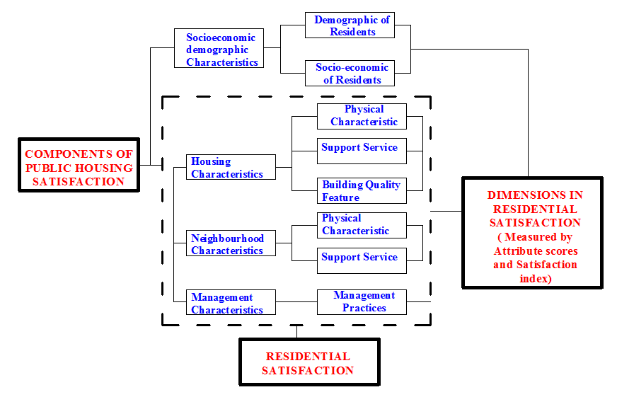

Figure 1. The study's conceptual framework
Method and study area

The survey and interview methods were used in this study as it adopted a mixed-methods approach, incorporating both quantitative and qualitative research methods. This methodology has been used by previous authors such as Ibem et al. (2018) and Maina (2012). The survey was conducted between December 2020 and March 2021, and it targeted a population drawn from three public housing estates located in Lokoja, Kogi State. Lokoja, the capital of Kogi State, is situated between latitudes 7°45'N and 7°51'N and longitudes 6°41'E and 6°45'E, with an elevation of 45 to 125 meters above sea level. The town is located on the western side of the River Niger, close to its merger with the River Benue and surrounded by the river and Mount Patti (Figure 2). It serves as a gateway to five of the country's six geopolitical zones and has experienced rapid urbanization since being designated as the state capital in 1991, resulting in a strain on public and urban infrastructures, including a need for more housing units and facilities (Ukoje & Ibor, 2022).

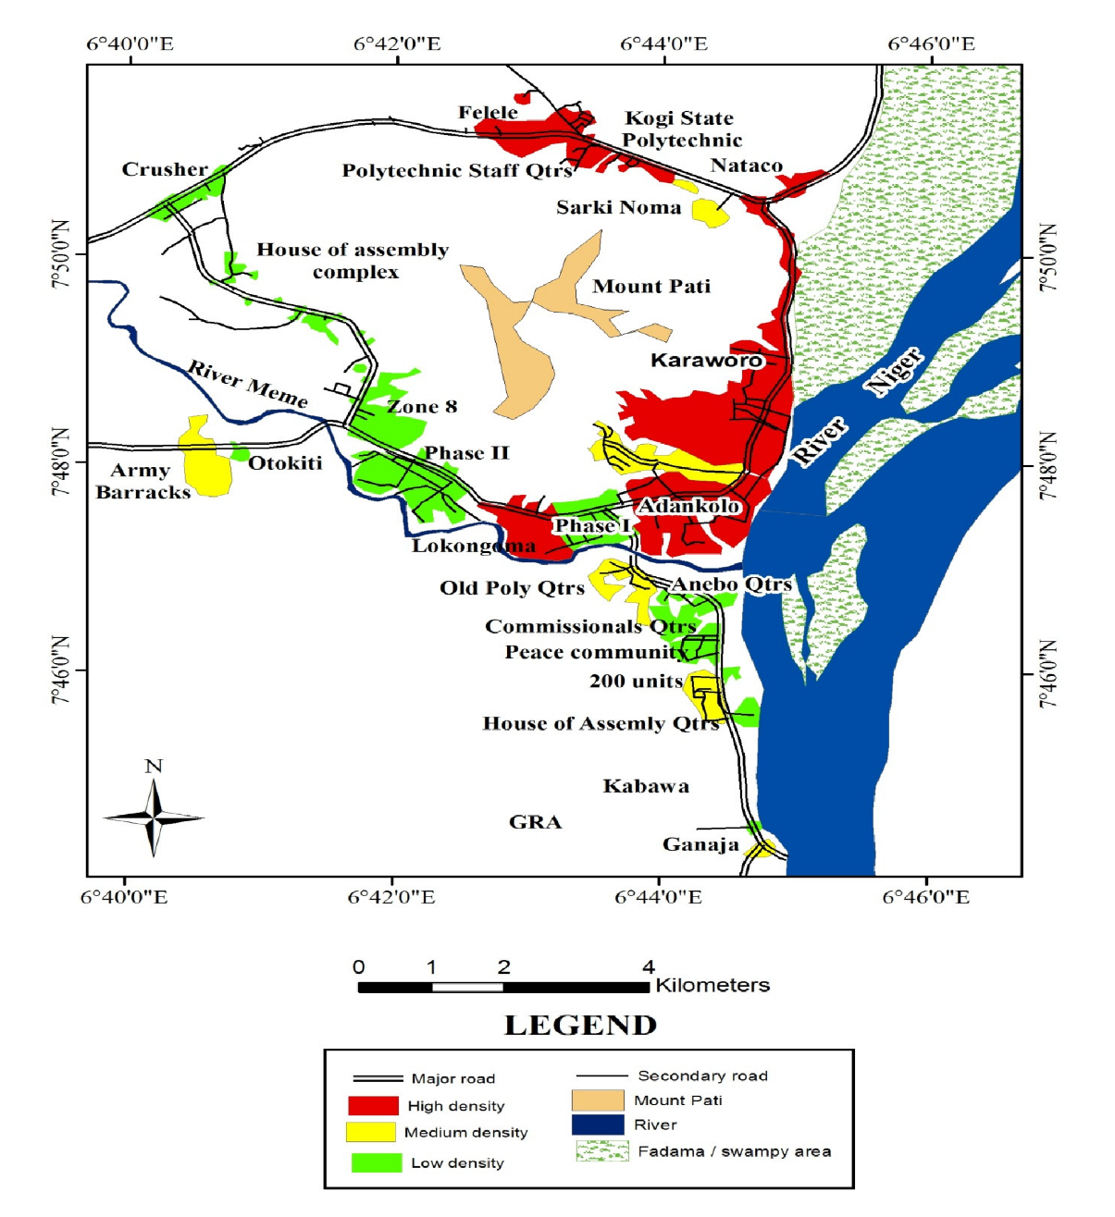

Source: Adapted and Modified from Administrative Map of Kogi State, 2021

Figure 2. Residential areas in the study’s location
The estates investigated were purposefully selected from a total of ten estates based on their longevity, and they include Adankolo estate, Ganaja estate, ad Lokongoma estate. The three estates had a total of 550 housing units, consisting of 200 3-bedroom freestanding bungalows, 150 2-bedroom semi-detached houses, and 200 1-bedroom semi-detached houses (as shown in table 1). All the housing estates were fully occupied during the survey period.
To calculate the study's sample size, a population of 220 housing units was selected using the formula N/(1+N(e^2)), where N represents the total number of housing units (550) and e denotes the margin of error (0.05), as recommended by Yamane (1967) and Maina (2021). The houses surveyed were randomly selected at intervals of three houses, and the fraction of the sample size for each selected housing estate was determined using the following formula:

Proportion (P) = Total number of houses in an estate zx Sample size (s)
Total population of the study

As part of the study's sampling strategy, a total of 80 housing units were selected from Adankolo estate, 60 housing units from Ganaja housing estate, and 80 housing units from Lokongoma estate. These houses were chosen randomly at intervals of three houses. To achieve the study's objective, a mixed-methods approach was employed, which included informal interviews, observations, and a questionnaire survey adapted from Ibem et al. (2018). The information gathered was examined using a program called the Statistical Package for the Social Sciences (SPSS). Several analyses were conducted to address the study's objective. To begin with, the researchers the average ratings for 31 different aspects that described the living conditions in the residential areas, which is known as the mean attribute satisfaction scores (MASS). Additionally, they also determined the total satisfaction score for the residential areas (RSAT) by using data from all of the participants. Descriptive analysis was performed on the data collected on the residents' demographic profiles. Second, satisfaction indices were calculated for the four housing sub-components by dividing the total attribute scores for all housing sub-components by the maximum allowable attribute score for all housing sub- components. Finally, a Kruskal-Wallis test was conducted to determine if there were any differences in satisfaction levels across the four housing sub-components.

Table 1. Public housing developments located in Lokoja

Location | Name | Types of Houses | Age of the scheme | No of Unit | Sample frame size
Adankolo | Phase I | 1,2&3 bedroom | 24* | 200 | 80
Ganaja | Phase2 | 1,2&3 bedrooms | 21* | 150 | 60
Lokongoma | Phase 3 | 1,2&3 bedroom | 21* | 200 | 80
Workers Village | Phase 4 | 3bedroom Twins Flats | 18 | 100 | --
Ganaja | Workers Housing Unit | 2 bedrooms | 12 | 100 | --
GRA. bungalow | Commissioners Quarters | 3-4 bedroom | 19 | 100 | --
Lokongoma | Secretariat Housing Estate | Twin flats | 17 | 150 | --
Ganaja Quarters | House of Assembly | 3 bedrooms | 17 | 50 | --
GRA | DG Quarters | 4 bedrooms | 15 | 20 | --
Barack Road | Otokiti Housing Estate | 2/3 bedrooms | 15 | 250 | --
Total |  |  |  | 1320 | 220
*Selected housing estates
Source: Author’s field survey, 2021
Results and discussion

The information presented in Table 2 reveals that out of the survey participants, 56.6% or 121 individuals were male, while 43.5% or 94 individuals were female. The majority of the sample, consisting of 186 individuals or 86.5%, were married and aged between 30 to 59 years old. Additionally, almost all of the respondents (99.4%) had received tertiary education, and 67.4% of them were employed as civil servants by the government.
Regarding the survey results, the middle value of the monthly income of the participants fell between N51 and 100,000, accounting for 91 individuals or 42.3%. The income range of N101 and 150,000 was closely following with 124 individuals or 57.7%. Moreover, a significant proportion of the respondents, 80.5%, had resided in the estate for at least 11 years, qualifying them to provide answers on their satisfaction with the residential conditions in the estate.
Table 2. Demographic characteristics of respondents

Socio-economic variables | Freq. | % | Socio-economic variables | Freq. | %
Gender |  |  | Monthly Income (in Naira)
Male | 121 | 56.5 | 51-100,000 | 91 | 42.3
Female | 94 | 43.5 | 101-150,000 | 124 | 57.7
Marital status |  |  | Above 150,000 | 0 | 0.0
Married | 186 | 86.5
Divorced | 2 | 0.9 | Length of stay
Widowed | 3 | 1.4 | Less than 3 years | 9 | 4.2
Single | 21 | 9.8 | 3-10 years | 32 | 14.9
 |  |  | 11 years and above | 173 | 80.5
Age (in years) |  |  | No response | 1 | 0.5
No response | 2 | 0.9
18-30 | 38 | 17.7 | Household size in persons
31-45 | 134 | 62.3 | 1 | 6 | 2.8
46-59 | 36 | 16.7 | 2 | 19 | 8.8
Above 60 | 5 | 2.3 | 3 | 45 | 20.9
 |  |  | 4 | 66 | 30.7
Highest educational qualification |  |  | More than 4 | 78 | 36.3
Highest educational qualification |  |  | No response | 1 | 0.5
Primary | 3 | 1.4
Secondary | 6 | 2.8 | Tenure
Tertiary | 203 | 94.4 | Renter | 45 | 20.9
No response | 3 | 1.4 | Owner occupier | 170 | 79.1
 |  |  | Missing | 0 | 0.0
Employment
Civil Service | 145 | 67.4 | Typology
Private organisation | 51 | 23.7 | 2 bedroom semi-detached | 103 | 47.7
Self employed | 16 | 7.7 | 3-bedroom bungalow | 65 | 30.0
Retiree | 3 | 1.4 | 1 bedroom semi-detached | 48 | 22.2
Ethnic Grouping |  |  | Religion Belief
No response | 4 | 1.9 | Christianity | 138 | 64.2
Igala | 71 | 33.0 | Islam | 77 | 35.8
Ebira | 58 | 27.0 | No response | 0 | 0.0
Basange | 48 | 22.3
Yoruba | 34 | 15.8
Source: Author’s field survey, 2021
The majority of households had more than four people (78, 36.3%), followed by three, two, and four people (19, 8.8% each). Owner-occupiers constituted 79.1% (170) of the sample, while the remaining 20.9% (45) were living in privately rented housing. The residents belonged to different ethnic groups such as Igala, Ebira, Basange, and Youruba, which are the major ethnic groups in Kogi State. This discovery supports that of Saliu et al. (2023), indicating that the city of Lokoja is no man’s preserve, and, as a commercial nerve centre of Kogi State, attracts residents from other ethnic origins. It also confirmed that of Amad (2003) that shows that people from different ethnic backgrounds can live together peacefully and harmoniously.
The analysis of the four components of residential satisfaction, including the housing unit, socio-economic environment, management, and neighbourhood components, resulted in an overall residents' satisfaction index (RIS) of 2.67. This indicates that the most of respondents, 63.19%, were dissatisfied with their general housing condition. Researchers Makinde (2015) and Maina (2021) classify respondents who score below 3 on a 5-point Likert scale as dissatisfied with their housing conditions, which aligns with these findings. The outcomes of this study align with Kaitilla's (1993) research that revealed dissatisfaction among public housing occupants in Papua, New Guinea, and Ukoha and Beamish's (1997) findings that demonstrated complete dissatisfaction among public housing residents in Abuja, Nigeria. However, these results contradict Mammadi et al.'s (2020) research, which found that residents of public housing in Maiduguri metropolis in Nigeria were very satisfied with their housing situations, with an average satisfaction score of 5.8 on a 7-point Likert scale. This suggests that residents in all public housing estates have different satisfaction levels across the four housing components.
The third objective of this research necessitated an assessment of residents' contentment levels concerning the four distinct housing sub-components employed to gauge their overall residential satisfaction. This was crucial to assess the degree to which each housing sub-component contributes to overall residential satisfaction across all housing estates. To achieve this, satisfaction indices for the four housing sub-components were computed by dividing the total attribute scores for all housing sub-components by the maximum allowable attribute score for all housing sub-components. It is important to note that the four housing sub-components have different numbers of attributes, so the satisfaction index was chosen for comparison. In order to analyse the findings, a satisfaction scale consisting of three levels was employed, where a score of 70.0 to 100.0 was indicative of high satisfaction, a score of 50.0-69.0 indicated moderate satisfaction, and a score below 50.0 represented poor satisfaction.
The analysis findings are presented in table 3, and upon closer examination, it was discovered that the satisfaction index for the housing unit attribute was 48.95, indicating poor satisfaction levels. Similarly, the socio-economic attribute had a satisfaction index of 57.74, while the management and housing neighbourhood attributes had satisfaction indices of 56.51 and 56.87, respectively, all falling under the moderate satisfaction category. Overall, the results of this study indicate that the housing unit attribute had the lowest satisfaction level, followed by the management and housing neighbourhood attributes, while the socio-economic attribute had the highest satisfaction level. These findings suggest that policymakers and housing authorities need to focus on enhancing the quality of public housing structures, improving management, and promoting a better sense of community in public housing estates to improve overall residential satisfaction levels.

Table 3. Housing sub-components satisfaction indices

Housing sub-components | Attribute  scores | Max. possible  scores | Satisfaction  indices | Levels of  satisfaction
Housing unit attributes | 7367 | 15050 | 48.95 | Poor*
Housing socio-economic attributes | 4345 | 7545 | 57.74 | Moderate
Management of attributes | 2430 | 4300 | 56.51 | Moderate
Housing neighbourhood | 3668 | 6450 | 56.87 | Moderate
Total | 18802 | 33345
Source: Author’s field work, 2021

Based on the results, it is clear that the participants expressed the highest level of contentment with the socioeconomic aspect of their residential areas, which had a satisfaction index of 57.74%. The second highest satisfaction index was recorded for the housing neighbourhood sub-component, which had a satisfaction index of 56.87%, followed by the housing management sub-component with a satisfaction index of 56.51%. These satisfaction indices indicate that the residents of the surveyed estates were moderately satisfied with the socioeconomic sub-component, management sub-component, and neighbourhood sub-component. However, the satisfaction index for the housing unit sub-component was found to be low at 48.95%, indicating that it contributed the least to overall satisfaction. Interestingly, these findings seem to contradict the study of some authors that showed that residents in Lagos, Nigeria, were more satisfied with the design of their housing units than with other aspects of the housing environment (Jiboye, 2009; Fatoye & Odusami, 2009). Additionally, Ibem (2011) suggested that residents of public housing in Ogun State, Nigeria, were more satisfied with the housing unit sub-component than with other sub-components.
The study further aimed to examine whether there were any discrepancies in satisfaction levels with the four housing sub-components between the three housing estates when taken as a whole and when examined individually. To perform this analysis, the Kruskal-Wallis test was utilized. The three housing estates were regarded as the independent variables in this examination, while the attribute scores for each of the housing sub-components were deemed the dependent variables, as presented in table 4.

Table 4. Attribute scores for Housing sub-components across the estates

Housing sub-components | Adankolo | Ganaja | Lokongoma
Housing unit sub component | 2417 | 2157 | 2762
Socio-economics sub component | 1437 | 1227 | 1745
Management sub component | 828 | 678 | 923
Neighbourhood sub component | 1204 | 954 | 1400
Total | 5886 | 5016 | 6830
Source: Author’s field work, 2021

In order to assess whether there were discrepancies in levels of contentment with the four sub-components of housing among the three Lokoja housing estates, a Kruskal-Wallis test was carried out. The three housing estates were treated as the independent variables while the attribute scores for each of the housing sub-components were taken as the dependent variables. The test results indicated that there was no noticeable variation in residents' satisfaction across the three housing estates. This was demonstrated by the following results: λ2 = 0.962, df = 2, k = 3, and p = 0.6183. Additionally, differences in satisfaction with the housing unit attributes, socio-economic attributes, management attributes, and neighbourhood facilities within each estate were evaluated separately using the Kruskal-Wallis test to determine whether there were any statistically significant differences. The results of the test indicated that there were statistically significant differences in satisfaction with the housing unit attributes (λ2 = 14.34, df = 2, P < 0.05), satisfaction with socio-economic attributes (λ2 = 8.33, df = 2, P < 0.05), and satisfaction with neighbourhood attributes of the estates (λ2 = 9.70, df = 2, P < 0.05), as shown in Table 5.
Table 5. Kruskal-Wallis Test for Housing sub-components across the estates

Housing sub-components | H (λ²) | df | k | p | Outcome
Housing unit sub component | 14.34 | 2 | 3 | 0.00077 | Significant (yes)
Socio-economics sub component | 8.33 | 2 | 3 | 0.01553 | Significant (yes)
Management sub component | 2.88 | 2 | 3 | 0.23693 | Not Significant (No)
Neighbourhood sub component | 9.70 | 2 | 3 | 0.00781 | Significant (yes)
Source: Author’s field work, 2021

The statistical analysis presented that there was no significant difference in satisfaction with the management attribute of the three housing estates. This suggests that the level of satisfaction with the management of the housing estates is relatively similar, and it is not a significant factor in the differences in residential satisfaction among the respondents. However, it was found that the satisfaction with the housing unit attributes, socio-economic attributes, and location of neighbourhood facilities differed significantly among the three housing estates. This indicates that differences in these factors account for the variation in residential satisfaction among the respondents.
This finding highlights the importance of resident involvement in the housing process. The residents of the housing estates took control of the management aspect of their housing, which included maintaining the cleanliness of the estates through self-help and ensuring the security of life and properties. They achieved this by engaging the services of vigilantes, erecting perimeter fences, and fortifying all openings with burglary. This level of involvement and commitment to the maintenance and improvement of their living environment is likely to have contributed significantly to their satisfaction level with the housing estates.
Overall, the study suggests that involving residents in the housing process can lead to a higher level of satisfaction with all aspects of the housing environment. It highlights the importance of considering not only the physical attributes of housing but also the socio-economic and management aspects and their relationship with the residents' overall level of satisfaction.

Conclusion

The study found that the majority of respondents (63.33%) in the three surveyed housing estates expressed dissatisfaction with the general housing condition, and only 36.67% of them were satisfied with their housing condition. The overall residential satisfaction score (RSAT) in all the estates surveyed was recorded at 2.67, which is below the median value of 3 on a 5-point Likert scale, indicating that residents in the surveyed estates in Lokoja were generally dissatisfied. When comparing residents' satisfaction with different aspects of housing, three components (housing socio-economic attributes, management attributes, and housing neighbourhood attributes) all had a moderate satisfaction index of 57.74, 56.51, and 56.87, respectively. However, housing unit attributes were considered to have a poor satisfaction index (48.95), suggesting that they contributed least to the overall residential satisfaction of residents of the selected housing in Lokoja, Kogi State. Furthermore, the Kruskal-Wallis test reveals that the differences in residential satisfaction across the three estates surveyed were due to differences in housing unit attributes rather than differences in housing management attributes, with an H value of 14.34. The result indicated that the most of the residents across the estates were more satisfied with the housing management attributes.
Based on these findings, the study recommends that the government and other private agencies adopt a strategy whereby the aspect of housing unit components in public housing production are left for the would-be occupants, while other components (management sub-components, socio-economic environment, and neighbourhood sub-component) should be the responsibility of the public housing providers. The study suggests that residents would be more satisfied with their housing unit attributes if they had more control over them. Failure to do this could result in dissatisfaction and subsequent housing transformation. Although the focus of this study is not on housing transformation or modification, it was observed that some of the residents of the selected estates in Lokoja who were not satisfied with their overall housing environment (main activity area, privacy issue, and opportunity to engage in home-based activities) had made efforts to transform their houses to meet their needs and aspirations.
The findings of this study are crucial for guiding housing policies, urban planning decisions, and resource allocation efforts that aim to create more inclusive, equitable, and satisfying living conditions for residents. It has the potential to drive positive changes in housing development practices and improve the overall quality of life in Lokoja Kogi state.

Acknowledgment

The authors extend their gratitude to the residents who graciously contributed to this study. Additionally, sincere appreciation is expressed to Godman O. Agbo and Zakari Umar Zakari for their invaluable assistance with data collection

References

Abe, R., & Kato, H. (2017). Built environment, travel, and residential satisfaction in a developing city: Can residents under rapid urbanization agree with a sustainable urban form?. Asian Transport Studies, 3, 481–498.
Adeyemo, O. A., & Aderonmu, P. A. (2020). Assessment of residents’ satisfaction with public housing in Nigeria. Journal of Building Performance, 11(2), 1-11.
Aduwo, E. B., Edewor, P., & Ibem, E. O. (2016). Urbanization and housing for low-income earners in Nigeria: A review of features, challenges, and prospects. Mediterranean Journal of Social Sciences, 7(2), 347–357.
Afolarin, A. O. (2013). Factors affecting quality in the delivery of public housing projects in Lagos State, Nigeria. International Journal of Engineering and Technology, 3(3), 332–336.
Aga, M., & Safakli, O. (2007). An empirical investigation of service quality and customer satisfaction in professional accounting firms: Evidence from North Cyprus. Problems and Perspectives in Management, 5, 84-98.
Akin, A. O., Tosin, O., & Abolade, O. (2014). Perceived housing satisfaction in public estates of Osogbo, Nigeria. Journal of Geography and Regional Planning, 7(9), 185–191.
Amerigo, M., & Aragones, J. I. (1997). A theoretical and methodological approach to the study of residential satisfaction. Journal of Environmental Psychology, 17, 47–57.
Balathandayutgan, P., & Sritharan, R. (2013). A focus on factors influencing residential satisfaction. Journal of Asian Architecture and Building Engineering, 12(1), 103–110.
Bruin, M. J., & Cook, C. C. (1997). Understanding constraints and residential satisfaction among low-income single-parent families. Environment and Behavior, 29, 532-553.
Buys, L., & Miller, E. (2012). Residential satisfaction in inner urban higher-density Brisbane, Australia: Role of dwelling design, neighbourhood, and neighbours. Journal of Environmental Planning and Management, 55(3), 319–338.
Dharani, K. (2015). Study on negligence of quality assurance and proposing an effective framework for total quality management. International Journal of Research in Engineering and Technology, 4(2), 604–609.
Fatoye, E. O., & Odusami, K. T. (2009). Occupants' satisfaction approach to housing performance evaluation: The case of Nigeria (Paper presented). RICS COBRA Research Conference held at the University of Cape Town.
Fagbenle, O. I., & Adeyemi, O. A. (2020). Resident satisfaction with public housing in Abeokuta, Nigeria: An analysis of the physical and social dimensions. Journal of Housing and the Built Environment, 35(1), 305-326.
Fang, Y. P. (2006). Residential satisfaction, moving intention and moving behaviors: A study of redeveloped neighborhoods in inner-city Beijing. Housing Studies, 21(5), 671–694.
Galster, G. (1987). Identifying the correlates of dwelling satisfaction: An empirical critique. Environment and Behavior, 19(5), 539-568.
Hanif, M., Hafeez, S., & Riaz, A. (2010). Factors affecting customers' satisfaction. International Journal of Finance and Economics, 60, 44-52.
Huang, Z., & Du, X. (2015). Assessment and determinants of residential satisfaction with public housing in Hangzhou, China. Habitat International, 47, 218-230.
Hui, E. C. M., & Zheng, X. (2010). Measuring customer satisfaction of FM service in housing sector: A structural equation model approach. Facilities, 28(5/6), 306-320.
Ibem, E. O., & Amole, D. (2012). Residential satisfaction in public core housing in Abeokuta, Ogun State, Nigeria. Social Indicators Research, 113(1), 563-581.
Ibem, E. O., Ayo-Vaughan, E. A., Oluwunmi, A. O., & Alagbe, O. A. (2018). Residential satisfaction among low-income earners in government-subsidized housing estates in Ogun State, Nigeria. Urban Forum, 29(1), 1-23.
Ishiyaku, B. (2016). Evaluation of Nigerian public housing performance using occupants' experience and satisfaction. (Unpublished doctoral dissertation). Universiti Tun Hussein Onn Malaysia.
Ishiyaku, B., Kasim, R., & Harir, A. I. (2017). Confirmatory factorial validity of public housing satisfaction constructs. Cogent Business & Management, 4(1359458), 1-17.
Jaafar, M., Hasan, N. L., Mahamad, O., & Ramayah, T. (2006). The determinants of housing satisfaction level: A study on residential development project by PENANG Development Corporation (PDC). Journal of Construction in Developing Countries, 11(2), 69-83.
Jiboye, A. D. (2009). Evaluating tenants' satisfaction with public housing in Lagos, Nigeria. Town Planning and Architecture, 33(4), 239-247.
Jiboye, A. D. (2010). The correlates of public housing satisfaction in Lagos, Nigeria. Journal of Geography and Regional Planning, 3(2), 017-028.
Kasim, R., Ahmad, A. R., & Eni, S. (2007). Skills for engaging communities in the housing neighbourhood facilities process: The European experience. Habitat International, 31(1), 72-88. doi: 10.1016/j.habitatint.2006.06.002.
Maina, J. J. (2021a). An assessment of residential satisfaction in public housing using Housing Habitability System Framework in Gombe, Northeast Nigeria. Geografia-Malaysian Journal of Society and Space, 17(2), 129-142. doi: 10.17576/geo-2021-1702-11.
Maina, J. J. (2021b). Socioeconomic and demographic predictors of residential satisfaction within public housing estates in Northern Nigeria. Covenant Journal in Research & Built Environment (CJRBE), 9(1), 1-11. doi: 10.24331/cjrbe. v9i1.928.
Makinde, O. O. (2015). Influences of socio-cultural experiences on residents' satisfaction in Ikorodu low-cost housing estate, Lagos State. Environment, Development and Sustainability, 17(1), 173-198. doi: 10.1007/s10668-014-9545-6.
Mammadi, A., Baba, H. M., Tukur, S., Muhammad, A. A., & Abdullahi, U. (2020). Residents’ satisfaction levels of public housing in Maiduguri Metropolis of Borno State, Nigeria. Traektoriâ Nauki = Path of Science, 6(3).
Mohit, M. A., Ibrahim, M., & Rashid, Y. R. (2010). Assessment of residential satisfaction in newly designed public low-cost housing in Kuala Lumpur, Malaysia. Habitat International, 34, 18-27.
Mohit, M. A., & Azim, M. (2012). Assessment of residential satisfaction with public housing in Hulhumale’, Maldives. Procedia - Social and Behavioral Sciences, 38, 1-17.
Mohit, M. A., & Raja, A. M. M. A. (2014). Residential satisfaction: Concepts, theories, and empirical studies. Planning Malaysia: Journal of the Malaysian Institute of Planners, 3, 47-66.
Muwaffaq, U. A. (2020). Housing: Concept, definition and components.
Ogunsote, O. O., & Afolabi, A. O. (2021). Evaluation of housing satisfaction among low-income earners in Lagos, Nigeria. Sustainable Cities and Society, 66, 102669.
Rojek, D. A., Clemente, F. R., & Summers, G. A. (1975). Community satisfaction: A study of contentment with local services. Rural Sociology, 40(2), 177-192.
Saliu, H.O., Sagada, M.L., Maina, J.J., & Sani Maruf. (2023). Predictors of Residential Satisfaction Within Selected Public Housing Estates in Lokoja Kogi State, Nigeria. Archiculture. A Journal that Promotes Architecture of Human Culture with the Culture of Architecture, 5(1), 73-86.
Salleh, A. N. A., Yosuf, B. N. A., Salleh, C. A. G., & Johari, D. N. (2012). Tenant satisfaction in public housing and its relationship with rent arrears: Majlis Bandaraya, Perak, Malaysia. International Journal of Trade, Economics, and Finance, 3(1), 10–18.
Salleh, G. (2008). Residential and neighborhood satisfaction in private low-cost housing: Case study of Penang, Malaysia. (Paper presented). Housing Symposium, Universiti Sains Malaysia.
Ubani, O., & Nwauzoma, U. (2018). Residents’ satisfaction determinants in the rental housing in Enugu urban, Enugu State, Nigeria. Research Journal of Environment, 22, 31-38.
Ukoje, J. E., & Ibor, U. W. (2022). Drivers of residential location in suburban areas of Lokoja, Nigeria. AFRIGIST Journal of Land Administration and Environmental Management, 2(1), 39-51. https://doi.org/10.54222/ajlaem/v2i1.4

