High risk areas of snatch theft in Kuala Lumpur, Putrajaya,
and Selangor, Malaysia

Norita Jubit¹, Tarmiji Masron², Mohd Sofian Redzuan²

¹Borneo Institute for Indigenous Studies (BorIIS), University of Malaysia Sabah, Jalan UMS, 88400, Kota Kinabalu, Sabah
Centre for Spatially Integrated Digital Humanities (CSIDH),
²Faculty of Social Science and Humanities, Universiti Malaysia Sarawak, 94300, Kota Samarahan, Kuching, Sarawak

Correspondence: Tarmiji Masron (email: mtarmiji@unimas.my)

Received: 2 May 2023; Accepted: 3 September 2023; Published: 30 November 2023

Abstract

Kuala Lumpur and Selangor are among 14 states in Malaysia that are listed in the high number of reported cases of snatch theft. Basically, public lack of vigilance towards their belongings creates opportunities for criminals to commit crime. On the other hand, criminals are constantly seeking for the opportunity to target their victims when there is an opportunity to do so. This study employs the Getis Ord Gi* method and aims to identify areas of high risk in snatch theft cases with statistical significance by effectively measuring the probability of the null hypothesis. This study uses 111 station boundaries as units of analysis. The attribute data consists of reported snatch theft cases between 2015-2020. It includes cases reported by police station, the frequency of crime and gender of the complainants. The result of the study revealed that the hot spots areas with highest z score >2.58 over 5 years are in Tun H.S. Lee and Dang Wangi whereby these two areas are the main pedestrian entry to shopping complexes. Both areas are detected as repeated hot spots of snatch theft for the period of 2015-2020. The novelty of this study lies in its discovery of statistically significant snatch theft hotspots within the police station boundaries in Federal Territory of Kuala Lumpur and Selangor. Previous studies tend to identify hotspots that employs choropleth map and utilized district and city boundaries as unit of analysis for identifying these hotspots.

Keywords: Getis Ord Gi*, police station boundaries, snatch theft, spatial distribution, urban

Introduction

Open Education Sociology Dictionary (2022) defines street crimes as mugging, kidnapping, targeted killings, extortion, pickpocketing stealing, snatching or stealing cars, motorcycles or other valuables. In Malaysia, street crimes cover three index crime types such as snatch theft, individual robbery without firearms and gang robbery without firearms. It was reported that 83% of snatch thefts were committed by motorcycle riders (Government Transformation Programme, 2011). According to the European Sourcebook of Crime and Criminal Justice Statistics, bag snatchings encompass the act of forcibly stealing from an individual using force or threat of force, with the use of force or threat of force to retain the stolen goods after the theft (UNODC, 2019). In Malaysia, snatch theft and pickpocketing are the most frequently reported crimes. Typically, snatch theft involves perpetrators using motorcycles who lean out and snatch handbags, necklaces, and mobile phones from unsuspecting pedestrians. These thieves are becoming increasingly audacious and have been known to drive through traffic lights and onto sidewalks to steal valuables. On occasion, motorcyclists may even smash car windows at traffic lights to snatch handbags or purses left on the passenger's seat. Unfortunately, victims of these crimes have suffered severe injuries, been dragged to the ground, or even been killed, as noted by the U.S Embassy in Malaysia (2022).
This study focuses on snatch theft. Camoens (2022) reported that an elderly fell victim to snatch theft, injured herself, and lost her jewellery worth RM25, 000 in 2022. A video of the incident was circulated on social media showing a woman being robbed by two men at Bandar Tun Razak and has raised public anxiety. The Anonymous (2021) also reported that there were two gang members involved in nearly 300 snatch theft cases that were nabbed in Gombak. Snatch theft causes injuries and traumatic impacts on victims due to the fear of harm to themselves and their families (Government Transformation Programme, 2015). Abd Rashid et al. (2008) found that drug addicts are involved in snatch theft crimes, as well as selling drugs, committing fraud, housebreaking, homicide, and suicide. Drug addicts who commit snatch theft mostly do so to get money to buy drugs. Allen (2005) found that drug abuse and unemployment are among the contributing factors to the increase in snatch theft cases. Previous studies have also shown that snatch theft crimes are caused by factors such as drug addiction and population growth (Latimaha et al., 2019). Snatch theft can occur at any time when there is an opportunity to commit the crime, with women walking alone in public areas being the most common targets.
Based on news reporting in the local daily newspaper and videos posted on the Internet, snatch theft has always raised concerns among citizens in Malaysia as it brings harm to victims and makes them suffer (Mustafa & Md Sakip, 2017b). Snatch theft is a major concern because it creates discomfort and fear among individuals, especially those living in areas with high rates of street violence. In London, for instance, the Metropolitan Police Service (2015) reported that 10,000 motorcycles, mopeds, and scooters with a combined estimated value of over £28 million were reported missing from April 2014 to March 2015. Many of these vehicles were stolen and used to commit other crimes. Farrell (2015) discovered that robberies involving the theft of mobile phones using motorcycles were prevalent in the Netherlands. Meanwhile, Xu (2012) noted that China implemented a crackdown on snatch theft by prohibiting motorcycle use in Guangzhou, the capital of Guandong. The police seized motorcycles found on the road, except for police motorcycles. This policy was eventually adopted by many other Chinese cities and resulted in the reduction of snatch theft. In Japan, urban planning, specifically Crime Prevention through Environmental Design (CPTED), has been effective in preventing crimes of opportunity such as snatch theft (Fujii et al., 2013). Previous study on snatch theft in Malaysia do not use police station boundaries to identify the hot spots of snatch theft (Mustafa and Mohd Sakip, 2017a; Muhammad Ludin et al., 2013). Thus, this study using Getis Ord Gi* to identify hot spots of snatch theft within the police station boundaries of Selangor and Kuala Lumpur. Getis Ord Gi* analysis needs minimum 30 polygon areas but if it less than 30 polygons the method is not appropriate for the data (Esri, 2018).

Literature review

Md Sakip and Mohd Salleh (2018) conducted a study on snatch theft which focused on 14 districts in Ampang Jaya, Selangor by using buffering. In their study, they utilize Google Maps to identify the land utilization whether the hot spot areas are located in commercial or residential areas and at the same time identifying street patterns. This study geocoded the crime location and color the polygon based on the number of snatch theft cases as red represents an area with the highest number of snatch theft cases while green indicates the lowest or no snatch theft. Kuralasan and Bernasco (2022) used the discrete crime location as a starting point to identify an individual who is motivated to commit a snatching offense and how a decision is made to determine where to commit the crime. The result shows the potential snatching location choices in India are wedding halls and places of worship where many people are wearing valuable jewellery and clothing ornaments outdoors. Jubit et al. (2020) geocoded property crime based on the address of the incidents and then used geocode to get coordinates references (x, y location) or known as latitude and longitude data.
Getis Ord Gi* was chosen to detect the areas that have spatial clustering with similar values around their neighboring boundaries. This study uses police station sector boundaries as spatial units of analysis. Andresen et al. (2020) stated geocoding refers to the process to get latitude and longitude from address to display them on a map. Shu and Huang (2018) conducted a study on snatch theft and the environment in Taiwan's city. Their study found that crime tends to occur where there is inter-visibility, a higher number of targets with little guardianship. The previous study on street crime in Kuala Lumpur mostly focus on factors and modus operandi that influences such crime (Md Latiff, 2015; Rusli & Yusoff, 2022). Some of researchers identify snatch theft hot spots in Ampang Jaya by using choropleth map and categorised areas into five different colour to represent highest and lowest number of snatch theft, so the statistically significant clustering of high values of crime cannot be detected (Mustafa & Md Sakip 2017; Md Sakip, 2019). The differentiation of high risk areas of snatch theft in Kuala Lumpur, Putrajaya, and Selangor, Malaysia with others studies is to identify hot spots of snatch theft with statistically significant using Getis Ord Gi*. Mohammed and Baiee (2020) using Getis Ord Gi* to find the result of the spatial statistics pattern of crime in Baltimore Maryland USA. The finding shows that Getis Ord Gi* help to predict hotspots and coldspots area with statistically significant crime. Phlicharoenphon and Robert (2023) investigate the spatial distribution of crimes against property using Getis Ord Gi* and found hot spots areas with GiZscore greater than 1.65 over 5 years in in Mueang Nakhon Pathom. Chutia et al. (2020) using Getis Ord Gi* to describe clusters of high and low values of crime. Beiji et al. (2017) explore emanating patterns of crime and establish some statistical significance by using Getis Ord Gi*. The result was measured based on z score, p-value and confident level.

Methods and study area

Figure 1 shows all the process in the methodology. In the initial stage of the study, crime data was approved by Bukit Aman. Police station boundaries are scanned to get the image in jpeg format and add into Arcmap 10.3. Once the image is displayed on the map, a georeferencing is run to register the image in tiff format. The next process is to create a new shapefile and digitize the police station boundaries according to road data. The area under study is located in Kuala Lumpur and Selangor and consist of 111 police station boundaries as the spatial unit of analysis. Besides, the study also includes districts of Kuala Lumpur, Putrajaya, and Selangor. Figure 2 shows a map of the study area. After completing the digitizing, a point map crime was created by using random points. The crime data (number of cases) that were obtained from PDRM doesn't have any coordinated references, as the snatch theft data has confidentiality and privacy concerns to take into account. Thus creating random point is a useful especially for researchers to display the distributed random point of snatch theft on each police station boundary. The crime data focused on snatch theft for six years (1 January 2015 – 31 December 2020). The different attributes of crime were recorded in the attribute table of point map crime (snatch theft, 2015-2020). All of the points in each polygon then merge and project the crime data and police station boundaries. This study also using spatial join before run Getis Ord Gi* analysis.

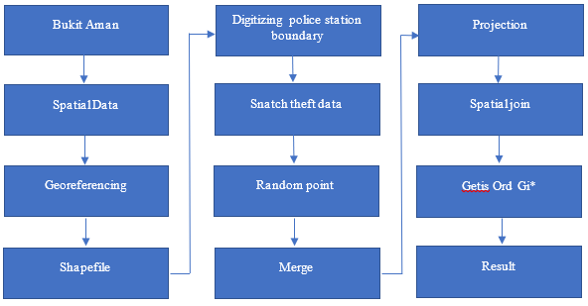

Figure 1. The process in the methodology

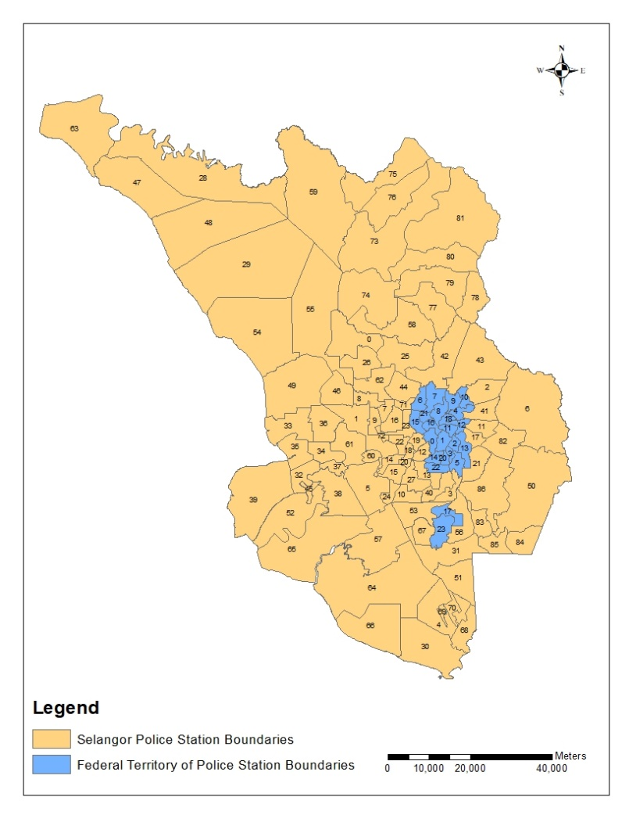

Figure 2. Study area

Table 1. ID and police stations

Getis Ord Gi* was used to identify statistically significant clusters of snatch theft in Federal Territory of Kuala Lumpur and Selangor police station boundaries from 2015 to 2020. This method was used in this study because it can help to indicate statistically significant spatial clusters of high values (hot spots) and low values (cold spots). It also produces three outputs namely z-score, p-value, and confidence level for each feature or polygon. Z score and p-value help to indicate whether the spatial clustering result is either high or low values while confidence level can be used to validate whether the hot spots and cold spots areas were statistically significant or not (ESRI, 2018). Hot spots with statistically significant means a feature shows the positive and largest z score, which indicates the intense clustering of high value. Meanwhile, features with negative and smaller z scores indicate the clustering of low values which is known as cold spot. The hot spot analysis calculates the Getis Ord Gi* statistic for each feature in a dataset (Jana & Sar, 2016)
Gi* spatial statistic was developed by Getis and Ord and is used to study the spatial patterns. This method is more suitable as it can locate unsafe areas and evaluate cluster of high or low value concentration in local context (Songchitruksa & Zeng, 2015). In this study, the hot spots were classified based on the Z-value of the Gi* statistic. Zahran et al (2019) found Getis Ord Gi* is more suitable for area-wide incidents such as crime.

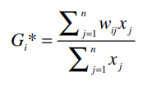
G_{i}* | = | Statistic that describes the spatial dependency of incident i over all n events
x_{j} | = | Magnitude of variable X at incident location j over all n (j may equal i), and
w_{ij} | = | Weight value between event i and j that represents their spatial interrelationship

Results

This is the result section in the form of descriptive statistics. This section revealed trends of snatch theft in Federal Territory of Kuala Lumpur and Selangor.

Figure 3. The trend of snatch theft cases in Kuala Lumpur district from 2015 to 2020

Figure 3 shows the trend of snatch theft cases in the Federal Territory of Kuala Lumpur districts for the period of 2015-2020. Based on the trend, Dang Wangi recorded the highest snatch theft cases compared to other districts. The lowest snatch theft cases were reported in the Putrajaya district. There are three police stations located in Dang Wangi district namely Dang Wangi Police Station, Tun H.S Lee Police Station, and Chow Kit Police Station.

Figure 4. The trend of snatch theft cases in Kuala Lumpur contingent police station from 2015 to 2020
Figure 4 shows the trend of snatch theft cases in the Federal Territory of Kuala Lumpur contingent police headquarters. The snatch theft trend indicated that Tun H. S. Lee police station reported the highest number of cases from 2015 to 2020. The second highest is Dang Wangi police station followed by Brickfield.

Figure 5. The trend of snatch theft complainants by gender in Kuala Lumpur from 2015 to 2020

Figure 5 shows the trend of snatch theft complainants by gender in Kuala Lumpur within the period of 2015-2020. Overall, male complainants are higher than female complainants to report cases of snatch theft. However, previous studies revealed that most of the snatch victims were females. In comparison, the majority of complainants in snatch theft cases in 2016 were females.

Figure 6. The trend of snatch theft cases in Kuala Lumpur from 2015 to 2020, based on the time of the incidents

Figure 6 shows the trend of snatch theft cases based on the time of the incidents in Kuala Lumpur for the period of 2015-2020. Based on the statistics above, the trend of snatch theft occurrences in Kuala Lumpur was frequently reported during daylight compared to night time. Most cases happened during day time as more people are busy on the street which provided ample opportunities for crime to take place. At night time, most people prefer to stay at home thus resulting in low cases being reported at night. This indicates that snatch theft cases are more likely to take place in the day time.

Figure 7. The trend of snatch theft in Selangor district from 2015 to 2020

Figure 7 shows the trend of snatch theft in various districts in Selangor for the period of 2015 to 2020. Based on the cases reported, Petaling Jaya had the highest number of snatch theft cases for the period of 2015-2020. It also indicates that Petaling Jaya has become a hot spot for snatch theft, while KLIA reported the lowest case. The police stations located in Petaling Jaya district are the Police Station of LTSAAS, Sea Park Kelana Jaya, Kota Damansara, Sungai Way, and Petaling Jaya.

Figure 8. The trend of snatch theft complainants in Selangor based on gender from 2015-2020

Figure 8 shows the trend of snatch theft complainants based on gender in Selangor from 2015 to 2020. Based on the report, it was revealed that a higher number of complainants were from males compared to females. The highest cases were reported in 2017. The number of male complainants has increased to a total of 12247 cases from 2015 to 2017. However, from 2018 to 2019, the number of male complainants decreased by 113 and increased again by 193 cases in 2020.

Figure 9. The trend of snatch theft occurrence in Selangor based on time 2015-2020

Figure 9 shows that the trend of snatch theft in Selangor tends to occur during day time and lower at night. The highest number of cases was reported in 2016. Figure 10(a) displays the results of the analysis of snatch theft hot spots in Kuala Lumpur and Selangor in 2015. The analysis identified five police station boundaries as hot spots, with statistically significant levels of significance. Two of the hot spots, Tun H.S Lee (z score 6.85, p <0.01 at 99% level of confidence) and Dang Wangi (z score 5.65, p<0.01 at 99% level of confidence), were detected with the highest z-scores greater than 2.58 and p-values less than 0.01. The other three police station boundaries, Brickfields (z score 1.73, p<0.10, at 90% level of confidence), Pandan Indah (z score 1.90, p-value <0.10 at 90% level of confidence), and Kajang (z score 1.94, p value<0.10 at 90% level of confidence), were classified as hot spots at a lower level of statistical significance, at the 90% level of confidence. Figure 10(b) shows that the total number of snatch theft hot spots with statistical significance declined to three areas in 2016. Two of these areas, Tun H.S. Lee and Dang Wangi, had the highest z scores at the 99% level of confidence, indicating that they remained high-risk areas for snatch theft since 2015.
The study also identified only one police station boundary, namely Brickfields police station located in Kuala Lumpur Contingent Police Headquarters, as a hot spot with a low z score of 1.73 and a statistical significance level of 90%. These results suggest that the police station boundaries in Kuala Lumpur are more susceptible to street crime, particularly snatch theft. In 2016, there were three hot spot areas for snatch theft, and the number of areas remained the same in 2017 (Figure 10(c)). Interestingly, all the hot spot areas with statistical significance in 2017 had the highest z scores and p values less than 0.01 at a 99% level of confidence. These areas include Tun H.S. Lee (z score 6.97), Dang Wangi (z score 5.50), and Kajang (z score 2.58). None of the police station boundaries in Selangor were classified as hot spots for snatch theft with statistical significance since 2015. Figure 10(d) illustrates the hot spot areas of snatch theft in Kuala Lumpur and Selangor in 2018. Out of the three police station boundaries identified as hot spots, two were detected with the highest z scores greater than 2.58 and p values less than 0.01, namely Tun H.S. Lee (z score 7.08, p <0.01 at 99% level of confidence) and Dang Wangi (z score 5.45, p<0.01 at 99% level of confidence). The Klang police station boundary was also classified as a hot spot for snatch theft but at a 90% level of confidence with a z score of 1.91 and p-value less than 0.10. In 2019 (Figure 10e) hot spots of snatch theft were once again identified in Kuala Lumpur contingent areas, specifically in Tun H. S. Lee (z score 6.71, p-value <0.01 at 99% level of confidence) and Dang Wangi (z score 4.17, p-value <0.01 at 99% level of confidence). The results revealed that only two police station boundaries had a z-score value greater than 2.58, indicating that these areas remained classified as high risk for snatch theft.

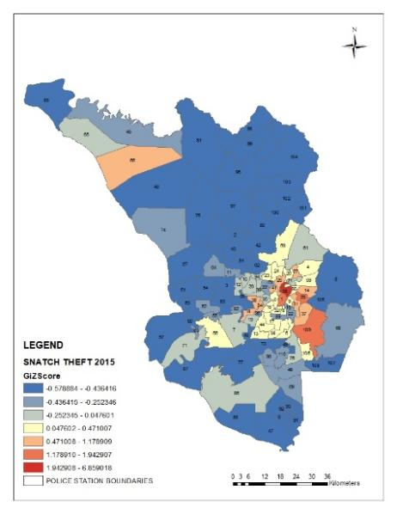  (a) | 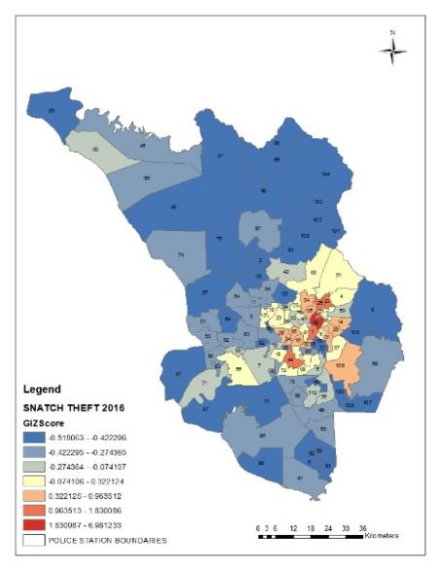  (b)
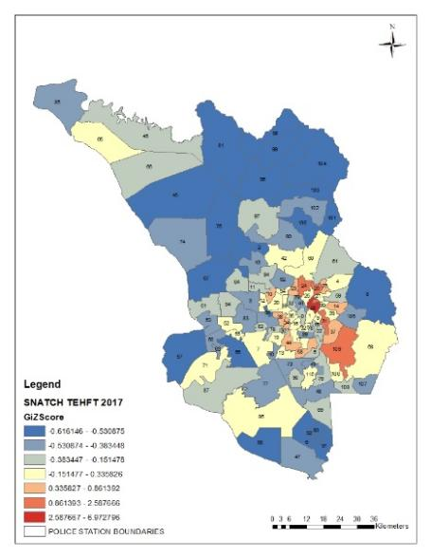  (c) | 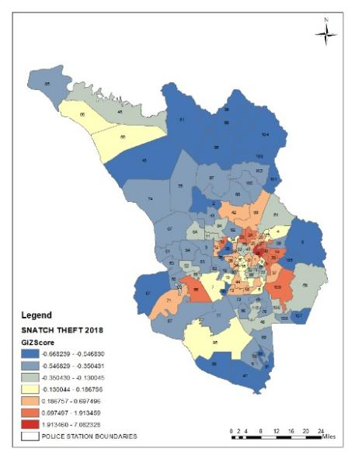  (d)
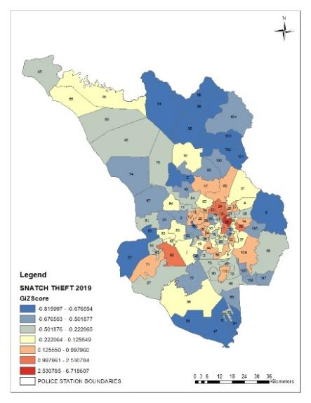  (e) | 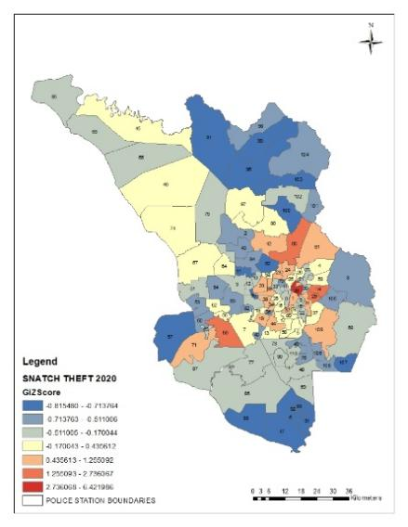  (f)

Figure 10. Hot spots of snatch theft in Kuala Lumpur and Selangor (a) 2015, (b) 2016, (c) 2017, (d) 2018, (e) 2019 and (f) 2020

The hot spots of snatch theft in 2020 are displayed in Figure 10(f), identified through Getis Ord Gi* analysis. The results reveal that there are now five areas with statistically significant hot spots, indicating an increase from previous years. These hot spots are not limited to Kuala Lumpur police station boundaries but also include Selangor police station boundaries. Among the areas classified as hot spots with z score value greater than 2.58 are Ampang police station boundaries (z score 2.73, p-value<0.01 at 99% level of confidence), Tun H. S. Lee (z score 6.42, p-value <0.01 at 99% of level confidence), and Dang Wangi (z score 4.09, p-value<0.01 at 99% of level confidence). These three areas have the highest concentration of snatch theft in 2020. Klang police station boundary was identified as a hot spot with a 95% level of confidence, p-value <0.05, and a z score of less than 2.58. Meanwhile, Pandan Indah was also identified as a hot spot with a 90% level of confidence (z score 1.92, p-value less than 0.10).
According to population statistics from 2015 to 2020, Selangor had a population of 6,613,900, Kuala Lumpur had a population of 1,895,600, and the Putrajaya Region had a population of 93,300. However, projected population statistics from 2021 to 2050 estimate that the population in Selangor will increase to 6,815,100 and in Kuala Lumpur to 1,925,200. These two regions have the highest population in Malaysia compared to other states, as reported by the Malaysia Youth Data Bank System (2022).

Discussion

This paper has investigated snatch theft hot spots within police station boundaries, a phenomenon that has not been identified in previous research, addressing a gap in the existing literature. In this study, crime hot spots not only reveal the clustering tendency of criminal activity but also highlight the significant concentration of snatch theft within the research area. These hot spots pertain to densely clusterered areas of snatch theft, and the significance of clusters can be measured by spatial statistics. Getis Ord Gi* analysis calculate statistics for each feature in a dataset. It will unveil the spatial clustering with either high or low values, indicating significant patterns. The impact of this study lies in its ability to detect spatial variation of snatch theft across the police station boundaries, thereby identifying area with statistically significant clusters. Tenny and Abdelgawad (2022) discovered in their research that statistica significance serves as a measure indicating of the probability of the null hypothesis being accurate. The null hypothesis for the high or low clustering statistics states that there is no spatial clustering of features values (ArcGIS Pro, 2023). In this study, the null hypothesis has been rejected as snatch theft with statistical significance clustering across police station boundaries of the Federal Territory of Kuala Lumpur and Selangor. This finding proves that snatch theft does not occur randomly but tend to occur in concentration in particular areas where there is high potential, such as no CCTV, no guardian, no safety and people bring valuable items, which can attract offenders to commit crime.
The result of this study can assist police in tracking the high risk of snatch theft areas and combating crime to increase the quality of life among those living and travelling in the Federal Territory of Kuala Lumpur and Selangor. Arnesson and Lewenhagen (2018) stated that Getis Ord Gi* is commonly used in crime analysis and this method provides a z-score that shows if a hot spot appears with some statistical significance or if it may have appeared by chance. Most of the high cluster of snatch theft were found in Dang Wangi and Tun H.S. Lee during the period 2015-2020. Kapoor et al. (2020) found that there are certain places that attract potential offenders. In this study, Dang Wangi and Tun H.S. Lee are among the potential areas of snatch theft as they can attract offenders to commit crime, which finally led both areas becoming high risk of snatch theft. Apart from that, Getis Ord Gi* revealed that Dang Wangi and Tun H.S. Lee have had the highest z score and low p value for every year since the period of 2015-2020. Thus, the results indicate that repeat areas are hot spots for snatch theft do exist in these areas. People living or a presence in Dang Wangi and Tun H. S. Lee have a greater risk of being victims of snatch theft, especially when there are many opportunities to allow criminal to do so. In 2020, a total of 31, 660 populations were recorded in Dang Wangi whereas, Tun H. S. Lee had an amount of 57, 238 (Department of Statistics Malaysia, 2020). Even though the population in Brickfield is the highest in Federal Territory of Kuala Lumpur, the z-score of hot spots is still low compared to Dang Wangi and Tun H. S. Lee. Kuralasan & Bernasco (2021) found that in the context of snatch theft, crime generators and attractors increase the number of people present who carry items that are attractive to criminals. Kozlowski et al. (2015) discovered that streets such as Jalan Pudu and Jalan Bukit Bintang are infamous shopping streets among locals in Kuala Lumpur. The main pedestrian entry to shopping complexes is through a forecourt off Jalan Bukit Bintang level, which leads shoppers into the mall by descending a grand staircase onto the lower central space of the Bintang Circle.
Consequently, people who use these roads are at risk of becoming victims of snatch theft. Snatch theft is a common occurrence in urban areas where there are plenty of people and opportunities for criminals. Dang Wangi and Tun H.S. Lee are urban areas that are frequently targeted by offenders. These areas are under the supervision of IPD Dang Wangi. Kuala Lumpur police chief, Datuk Mazlan Lazim, has stated that the increase in snatch theft is due to the public's lack of sensitivity towards their valuable belongings, which provides criminals with an opportunity to commit crimes.
The majority of robbery and snatch theft cases are committed by individuals who constantly seek out opportunities to do so. Shopping malls are popular locations for snatch theft, especially in areas frequented by foreign tourists. The other factors that contribute to snatch theft include gambling syndicates that attract people to engage in unhealthy activities (Msar, 2017). Mohamad Zulkifli et al. (2017) found that the Dang Wangi district has a high population density of 2916.23 residents per hectare, making it a main hotspot for street crimes (Lim et al., 2020). The majority of snatch theft cases reported within the police station boundaries of Tun HS Lee occurred on Jalan Pudu and Jalan Bukit Bintang. This suggests that these two roads are often used as opportunities for snatching to take place. Most snatch theft cases in Selangor occur outside buildings, especially on Jalan SS, Jalan PJS, and Jalan PJU. A previous study by Ju et al. (2011) revealed that Petaling Jaya was the first new town in Malaysia, located in the district of Petaling, with a population of 486,040 residents and situated 11 km from Kuala Lumpur. More than a third (34.4%) of the national population now lives in the ten most populous districts, including Petaling (Peng et al., 2021). Between 2015 and 2020, the Kajang police station recorded the highest number of snatch theft cases. Kajang, situated on the outskirts of Kuala Lumpur, is a quaint town that has has witnessed the impact of urban development, as highlighted by Zainudin and Yapp, (2019). In addition, Kajang has a high population density and has been developed to accommodate the demands of urban sprawl (Shafie et al., 2016).

Conclusion

From this study, it can be concluded that the finding of the snatch theft hot spots using Getis Ord Gi* is more reliable as it can detect areas with statistically significant high clustering. Create random point in GIS, which is crucial to creating the specified number of random point features. In this study, random points were generated inside each of police station boundaries according to the number of snatch theft cases reported. Random points are also appropriate to distribute data, especially for the crime data which doesn’t have any coordinate systems (x, y). Clusters of crime help a lot to prevent the snatching and theft activities in the study area. Using GIS also helps to create a map that can identify where the concentrations of snatch theft and the repeated hot spots are. This study can contribute to the literature review study of crime and areas and improve the effectiveness of police activities in study areas. Analyzing snatch theft crime with references to its spatial distribution in the period of 2015-2020 is important, as the finding can help in combating crime. Apart from that, studying crime allows for understanding snatching patterns through space and period of time. This study also demonstrates the usefulness of GIS in analyzing the distribution of snatch theft cases across different police station boundaries, thereby identifying the hot spots or areas with a high density of cases.

Acknowledgment

This paper is funded under the Fundamental Research Grant Scheme (FRGS) FRGS/1/2020/SS0/UNIMAS/01/1 and the UNIMAS Postdoctoral Research Programme. The author would like to express appreciation to the Royal Malaysian Police Headquarters, Bukit Aman for their support and cooperation in making this study a success.

References

Abd Rashid, R., Md Haris Robson, N. Z., Ahmad Zahari, M. M., & Habil, M. H. (2008). A fifty-year challenge in managing drug addiction in Malaysia. Journal of University of Malaya Medical Centre (JUMMEC), 11(1), 3–6.
Allen, C. (2005). The Links between heroin, crack cocaine and crime: Where does street crime fit in?. British Journal of Criminology, 45(3), 355–372.
Andresen, M. A., Malleson, N., Streenbeek, W., Townsley, M., & Vandeviver, C. (2020). Minimum geocoding match rates: an international study of the impact of data and areal unit sizes. International Journal of Geographical Information Science, 34(70), 2-17.
Anonymous. (2021, February 19). Two gang members involved in nearly 300 snatch theft cases nabbed in Gombak, says KL police chief. Malay Mail.
ArcGIS Pro. (2023). How high/low clustering (Getis Ord General G works).
Arnesson, A., & Lewenhagen, K. (2018). Comparison and prediction of temporal hotspot maps [Master’s dissertation, Blekinge Institute of Technology]. Faculty of Computing, Blekinge Institute of Technology. Retrieved from https://www.diva-portal.org/smash/get/diva2:1228347/FULLTEXT01.pdf
Beiji, Z., Mohammed, N., Chengzhang, Z., & Rongchang, Z. (2017). Crime hotspots detection and monitoring using videobased event modelling and mapping techniques. International Journal of Computational Intelligence systems, 10(10), 962-969.
Camoens, A. (2022, March 26). Elderly snatch theft victim injured loses jewelry worth RM 25, 000. The Star. Retrieved from https://www.thestar.com.my/news/nation/2022/03/26/elderly-snatch-theft-victim- injured-loses-jewellery-worth-rm25000
Chutia, D., Santra, M., Nishant, N., Singh, P. S., Chouhan, A., & Raju, P. L. N. (2020). Mapping of crime incidences and hotspot analysis through incremental auto correlation – A case study of Shillong city, Meghalaya, India. Journal of Geomatics, 14(1), 61-71.
Department of Statistics. (2020). Population in Kuala Lumpur.
ESRI. (2018). Find Hot spots.
ESRI. (2018). Hot spot analysis (Getis Ord Gi*).
Farrell, G. (2015). Preventing phone theft and robbery: The need for government action and international coordination. Crime Science an Interdisciplinary Journal, 4(4), 2–11.
Fujii, T., Sasaki, Y., & Kishimoto, T. (2013). Estimation of the risk of snatching in a suburb: A Case Study of Soka, Saitama Prefecture, Japan. Proceedings of the Ninth International Space Syntax Symposium, Seoul.
Government Transformation Programme. (2011). Reducing crime.
Government Transformation Programme. (2015). Reducing crime.
Jana, M., & Sar, N. (2016). Modeling of hotspot detection using cluster outlier analysis and Getis-Ord Gi* statistic of educational development in upper-primary level, India. Modeling. Earth Systems and Environment, 2(60), 2–10.
Ju, S. R., Ahmad Zaki, S., & Choi, Y. K. (2011). Contextual modernization: New town planning in Petaling Jaya, Malaysia. Journal of Asian Architecture and Building Engineering, 10(1), 93–100.
Jubit, N., Masron, T., & Marzuki, A. (2020). Analyzing the spatial-temporal of property crime hot spots. A case study of Kuching, Sarawak. Planning Malaysia Journal, 18(4), 2–11.
Kapoor, P., Singh, P.K., Cherukuri, A.K. (2020). Crime data set analysis using Formal Concept Analysis (FCA): A survey. In: Jain, V., Chaudhary, G., Taplamacioglu, M., Agarwal, M. (eds). Advances in Data sciences, security and applications. lecture notes in electrical engineering (pp. 15-31), Springer. Retrieved from https://doi.org/10.1007/978-981-15-0372-6_2
Kozlowski, M., Ujang, N., & Maulan, S. (2015). Performance of public spaces in the Kuala Lumpur metropolitan region in terms of the tropical climate. International Journal on Sustainable Tropical Design Research & Practice, 8(1), 41–51.
Kuralasan, K., & Bernasco, W. (2022). Location choice of snatching offenders in Chennai city. Location Choice of Snatching Offenders in Chennai City, 38, 673–696.
Latimaha, R., Bahari, Z., & Ismail, N. A. (2019). Examining the linkages between street crime and selected state economic variables in Malaysia: A panel data analysis. Jurnal Ekonomi Malaysia, 53(1), 59–72.
Lim, S. B., Yong, C. K., Abdul Malek, J., Mat Jali, M. F., Awang, A. H., & Tahir, Z. (2020). Effectiveness of fear and crime prevention strategy for sustainability of a safe city. Sustainability, 12(24), 2–24.
Md Latiff, F. (2015). Towards reducing the street crime index of Kuala Lumpur city centre. Geografia-Malaysian Journal of Society and Space, 11(4), 97-107.
Md Sakip, S. R. (2019). Discovering distinctive street patterns of snatch theft through crime prevention through environmental design. Environment-Behaviour Proceedings Journal, 4(12), 331-340.
Md Sakip, S. R., & Moihd Salleh, M. N. (2018). Linear street patterns in urban cities in Malaysia influence snatch theft crime activities. Environment-Behaviour Proceedings Journal, 3(8), 189–199.
Metropolitan Police Service. (2015). Met launch crackdown on motorcycle-enabled crime.
Mohamad Zulkifli, S. N. A., Kadar Hamsa, A. A., Mohd Noor, N., & Ibrahim, M. (2017). Evaluation of land use density, diversity, and ridership of rail-based public transportation system. Transportation Research Procedia, 25, 5266–5281.
Mohammed, A. F., & Baiee, W. R. (2020). 2nd International Scientific Conference of Al-Ayen University (ISCAU-2020). IOP Conference Series: Materials Science and Engineering 928, 1-8.
Msar, S. (2017, December 4). Snatch theft and robbery crime index in the city increasing. New Straits Time.
Muhamad Ludin, A. N., Abd. Aziz, N., hj Yusoff, N., & Wan Abd Razak, W. J. (2013). Impact of urban landuse on crime patterns through GIS application. Geospatial Analysis in Urban Planning, II(2), 1-22.
Mustafa, A. N., & Md Sakip, S. R. (2017a). Street pattern effects on snatch theft incidents. . Journal of Sustainable Environment, 2(1), 137–160.
Mustafa, A. N., & Md Sakip, S. R. (2017b). Building density attributes towards snatch theft incidents. Proceedings of International Conference on Architecture 2017 (ICRP-AVAN), 136–141.
Open Education Sociology Dictionary. (2022). Street crime.
Peng, T. N., Talha, R., Abdul Rahman, E. N., & Ismail, M. F. (2021). Spatial demographic data for planning, and research. Journal of the Malaysian Institute of Planners, 19(1), 89–101.
Phlicharoenphon, W., & Rober, O. P. (2023). Spatial distribution of crimes against property: A case study in Nakhon Pathom Province. Suan Sunandha Science and Technology Journal, 19(2), 165-175.
Rusli, K. A., & Yusoff, N. H. (2022). Faktor dan modus operandi jenayah ragut: Satu kajian kualitatif. Journal of Social Sciences and Humanities, 19(1), 156-167.
Shafie, F. A., Omar, D., Karuppannan, S., & Shariffuddin, N. (2016). Urban-scale material flow analysis for cities in greater Kuala Lumpur, Malaysia. Procedia - Social and Behavioral Sciences, 234, 424–433.
Shu, C.-F., & Huang, N.-D. (2018). Vulnerability of snatch thefts and environmental situations. Architecturescience, 17, 31–56.
Songchitruksa, P., Zeng, X. (2015). Getis-ord spatial statistics to identify hot spots by using incident management data. Journal of the Transportation Research Board, 2165, 42-51.
Tenny, S., & Abdelgawad, I. (2022). Statistical significance. National Library of Medicine.
U.S Embassy in Malaysia. (2022). Avoiding snatch theft.
UNODC. (2019). Comparison of European collections of crime and criminal justice data.
Xu, J. (2012). Drive-away policing and situational crime prevention in China: An analysis of motorcycle ban (jin mo) policy in Guangzhou. International Journal of Offender Theraphy and Comparative Criminology, 56(2), 239–264.
Zahran, E, S, M, M., Tan, S. J., Mohamad Asri Putra, N. A. A., Tan, E. H. A., Yap, Y. H., & Abdul Rahman, E. K. (2019). Evaluation of various GIS-based methods for the analysis of road traffic accident hotspot. MATEC Web Conference, 258, 03008.
Zainudin, H., & Yapp, A. (2019). Surviving the Kampong Heritage in rapid urbanization: The case of Kajang Town. International Journal of Heritage, Art, and Multimedia, 2(6), 33–40.

