

Sustainability Of Community-Based Tourism in Tourism Industry Through The Lens Of Homestays Operators in Rural Area Penang, Malaysia

Received: ; Accepted: ; Published:

Abstract

Many homestay operators struggle to penetrate the main market without government assistance due to inadequate skills, particularly in financial management. The objective of the study is to provide recommendations for improving the sustainability of Community-Based Tourism (CBT) in rural area homestay in Penang, Malaysia. The sample used in this study comprises 13 homestays managed by the local homestay association. The study's findings are analyzed through content analysis. The three main elements of empowerment of local communities, collaboration and partnerships, and financial viability form the conceptual framework in this study. The main findings of the study suggest that homestay operators are overly reliant on government funding, lack good marketing strategies, and poorly manage their finances, which leads to inadequate income generation. Through this study, researchers have helped to develop seven tourism packages and a website to aid in marketing in rural areas, thereby increasing homestay operator income in rural Penang.

Keywords: Community-Based Tourism; homestay; operator; empowerment of local communities; collaboration and partnerships; financial viability

Introduction

The homestay program is an initiative of the tourism sector in rural areas. Many foreign countries have encouraged the development of homestay programs to improve their tourism sectors, such as Iran (Pakshir & Nair, 2011), Nepal (Walter et al., 2018), Thailand (Kontogeorgopoulos, 2015), Vietnam (Giampiccoli & Mtapuri, 2021), and New Zealand (Cheng, 2022). In addition to lodging, tourists can enjoy cultural events and interact directly with the homestay owner's family and local residents (Hairal & Hussin, 2021; Mapjabil et al., 2011). The homestay program promotes a sustainable lifestyle by encouraging tourists to live simply, without waste, and minimize the use of available resources (Jamaluddin, 2019). Interactions in all aspects of the environment, economy, and society in the rural area can generate economic benefits for the local population (An & Alarcón, 2020).
In Malaysia, the Ministry of Tourism, Arts, and Culture (MOTAC) fully supports the involvement of rural communities in the homestay program, as it can improve the economy and standard of living of the community (Kunjuraman, 2019). However, many homestay operators struggle to penetrate the main market without government assistance due to inadequate skills, particularly in financial management. Moreover, the guidance provided by relevant parties with knowledge, such as homestay management courses or workshops, is not very encouraging (Abdullah et al., 2013). In addition, the quality of service is also one of the things that must be prioritized by homestay operators. This is because this matter will have an impact on the level of satisfaction of homestay customers (Othman dan Buang, 2021). The reason why this happens is because homestay operators lack skills related to the tourism industry and do not have experience in homestay management. Most homestay operators are rural communities and lack exposure to hospitality management (Othman & Buang, 2021).
This study is a study in the form of a case study involving the management and operators of Homestay Area X located in Area X, Penang. Three research questions to be addressed by this paper are [RQ1] How can local communities in the Area X area be empower? [RQ2] How does collaboration and partnership with related parties happen between homestay operators to make community-based tourism successful in Area X? [RQ3] What methods can be used to stabilize the income of homestays operators? Based on the three research questions, the objective of the study is to provide recommendations for improving the sustainability of community-based tourism in rural area homestay. Through this study, researchers provide help to increase homestay income compared to previous years.

Literature review

Community-Based Tourism (CBT)

Community-Based Tourism (CBT) is an approach to tourism that emphasizes the involvement of local communities in the development and management of tourism activities (Bagus et al., 2019). Using this tourism model offers local communities an opportunity to manage natural and cultural resources in order to promote the local economy and generate greater benefits (Lo & Janta, 2020). It must also embrace individual initiatives within the community (WWF, 2001). Overall, Dodds et al. (2018), categorizes CBT into 3 categories:
- A project in which individuals of the community are employed on rotational schedules and profits are distributed as dividend to community projects.
- A project created with community resources that involves family or group events within the communities
- A joint venture between a neighbourhood or family and an outside business partner
Dodds et al. (2018) also states that in accordance with the definition of CBT, which is an alternative type of tourism that includes community participation as the main elements containing important elements, namely [1] participatory planning; [2] collaboration and partnership; [3] local management or empowerment of community members; [4] establishment of environmental or community goals; [5] relief of related parties such as government, funding agencies and the private sector; and [6] focus on generating additional income for the community in the long run. By involving local communities in the planning and management of tourism activities, CBT seeks to ensure that the benefits of tourism are distributed more equitably and that the negative impacts of tourism are minimized (Dangi & Jamal, 2016).
Recent studies have shown that CBT initiatives, such as homestays, can bring a number of economic, social, and environmental benefits to rural communities (Kayat & Zainuddin, 2016). Economically, homestays contribute to a community's economic growth by generating income for local businesses and households (Gu & Wong, 2006). Socially, homestays can lead to increased engagement between tourists and the local community, fostering a positive exchange of ideas, culture, and knowledge (Ibrahim & Razzaq, 2010; Pusiran & Xiao, 2013; Tiberghien et al., 2017). Environmentally, CBT initiatives can lead to sustainable management of natural resources and cultural resources, including biological diversity, water, forests, cultural landscapes, monuments, etc (Islam, 2010). Not just on that, homestays are a great way for tourists to learn more about a particular culture, and they are particularly important in rural areas.

Homestay Sustainability

Homestays provide tourists with an opportunity to immerse themselves in and experience the culture of their host communities, while also providing the community with income (Guttentag & Smith, 2017). Participating in a homestay also provides a more intimate and unique experience compared to other forms of tourism (Dey et al., 2020). Homestays are an example of the practice of commercializing a home to profitably use residential space. Homestays are a type of lodging that sits in between the private spaces of a friend's or relative's home and the strictly commercial, informal settings present in hotels and other more traditional lodging establishments (Kontogeorgopoulos et al., 2015). Kayat & Zainuddin (2016), draw conclusions from the Systematic Literature Reviews (SLR) have they done, unfortunately, the available literature rarely addresses significant issues such homestay branding, homestay and entrepreneurship, homestays and information and communication technology (ICT) competency, and homestay operator's training and development regarding sustainability. These four things are also stated by Dodds et al. (2018) as elements for CBT success which have six things and as barriers of successful CBT which have five things.
Six elements for CBT success from Dodds et al., (2018) are;
- Participatory planning
- Collaboration and partnership
- Local management or empowerment of community members
- Establishment of environmental or community goals
- Relief of related parties
- Generating additional income for the community in the long run.
Five barriers of successful CBT from Dodds et al. (2018) are;
- Financial viability - lack of funding and finance skills
- Marketing – little direct marketing to foreign visitors
- Product development - non market-ready product
- Capacity building - lack of access to markets
- Land management/governance - lack of empowerment of local communities (or centralized governance)
Six elements for CBT success and five barriers outlined by Dodds et al., (2018) were chosen to be the conceptual framework in this study. However, the researcher has modified all those elements by combining them into a conceptual framework to be used in this study. This element is important to be seen comprehensively so that CBT projects that want to be implemented can sustain well as planned. The same goes for the homestays encouraged by MOTAC to grow in Malaysia. The modified elements are synthesized into a conceptual framework that delineates the relationship between the research questions and the framework:

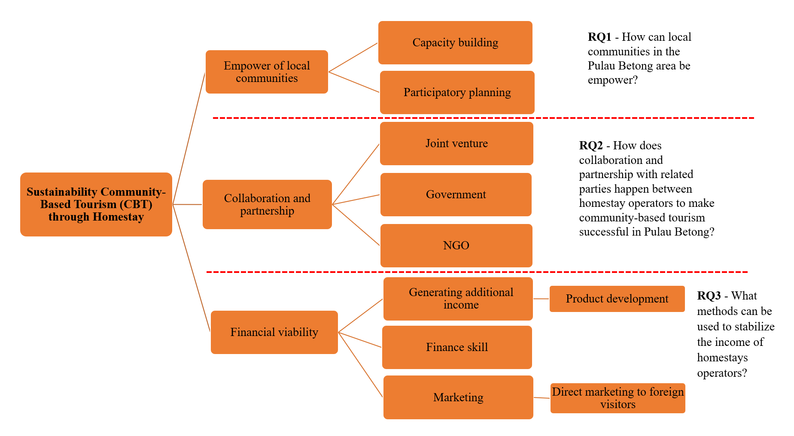
Source: Authors, adapted from Dodds et al., 2018

Figure 1. Connectivity between conceptual framework sustainability of Community-Based Tourism with research questions

Research methodology
Location and Sample of Study
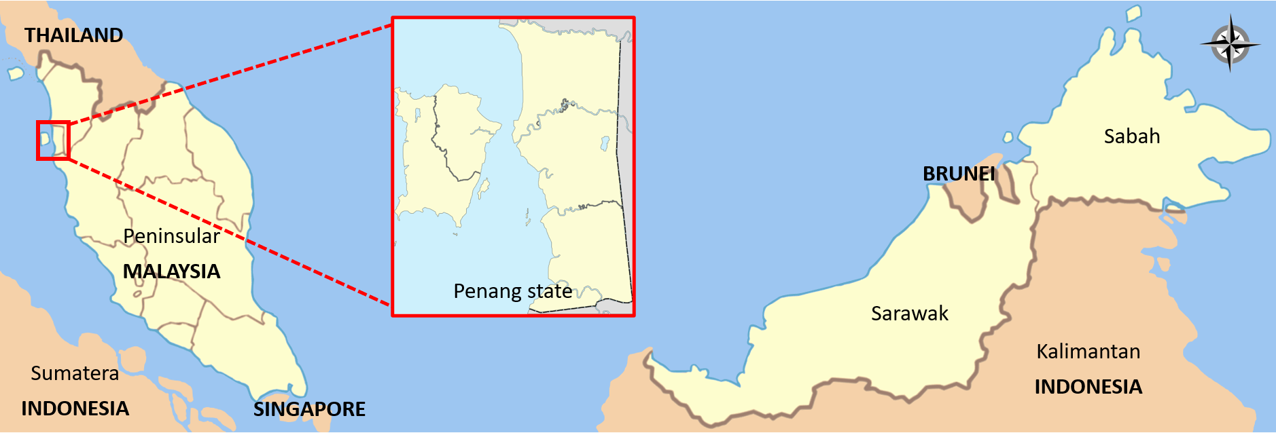Figure 2. The position of Penang state on the map of Malaysia which is the focus area of the study

This study was conducted in a confidential rural area, referred to as Area X, located in Penang (Department of Statistics Malaysia, 2023). The sample used in this study comprises 13 homestays managed by the local homestay association, with reservations being managed by the association chairman. The reason why the specific rural area cannot be mentioned in this study is because of confidentiality concerns. The study involves sensitive information, and therefore, the name of the area had to be hidden in the article.

Instruments and measures

The data collection for this study was conducted in four phases, each designed to address specific research questions have used four qualitative research instruments namely focus group discussion, observation, document analysis and semi-in-depth interview. Each research question in this study can be aligned with the conceptual framework in this study. The themes found in the framework will be used to answer every research question that arises. A flowchart illustrating the data collection process is presented below:

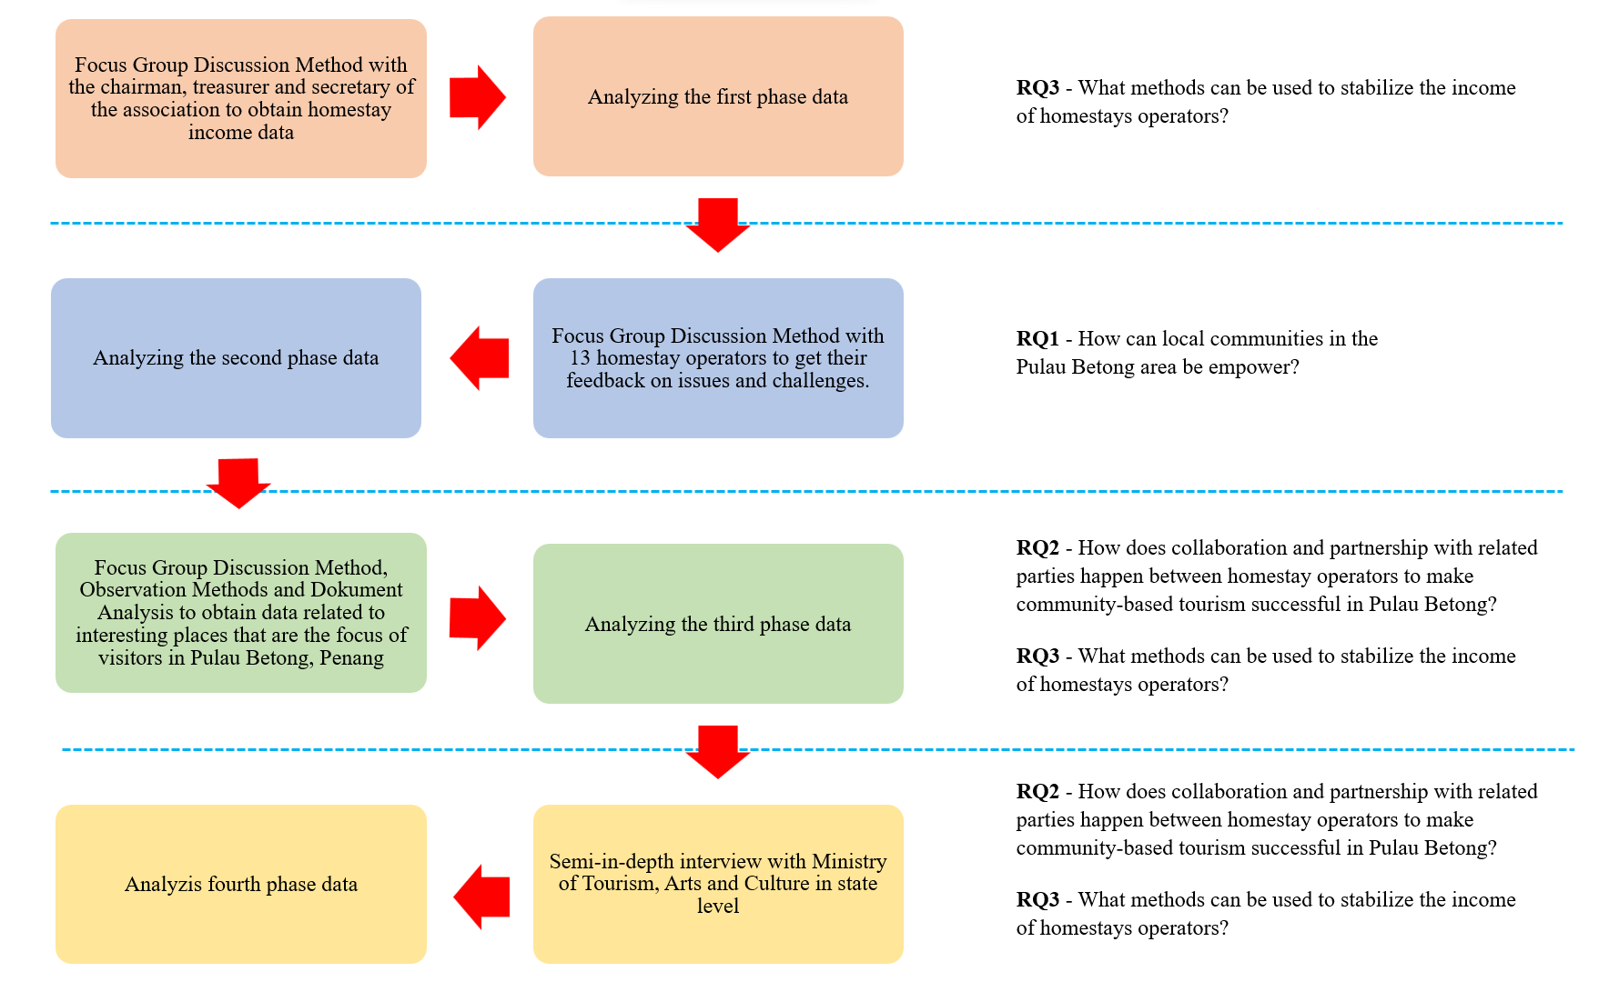
Figure 3. Data collection flow chart research for community-based tourism in the rural tourism industry through the lens of homestays operators in rural area Penang

Data analysis

The study's findings are analyzed through content analysis, which involves applying codes or categories to the content and identifying patterns, themes, and trends based on the study's conceptual framework. This framework is developed through a literature review and serves as the basis for the analysis. The content analysis includes creating a coding scheme to classify key ideas and concepts, a framework to summarize conclusions, and a collection of significant quotations. Coding is a method of indexing or classifying text according to the conceptual framework.

Results and discussion

Before delving into the findings of the study, it is important to note that the situation of Community-Based Tourism (CBT) in Malaysia, particularly in Area X, is unique. According to MOTAC, homestays and kampungstays are the two categories that homestays are divided into. A kampungstay is a house that is booked but the owner is not present, while a homestay is a room booked from a house where tourists will follow the activities arranged by the owner of the homestay. The study found that there are 10 homestays and three kampungstays in Area X.
Furthermore, CBT in Area X offers various activities that generate income not only from homestay bookings but also from other sources such as catering, handicrafts, boat rentals, bicycle rentals, ATV rentals, and cultural performances. The discussion in this study will be divided into three main themes based on the conceptual framework: empowerment of local communities, collaboration and partnerships, and financial viability.

Empower of local communities

To empower local communities in CBT, two things need to be implemented which are capacity building and participatory planning. The discussion is as follows:

- Capacity Building

According to the findings of the study, capacity building is crucial for homestay operators to provide the best service to their visitors. Homestays should have their own unique attractions, just like motels or chalets. During the observation, it was found that the existing homestays only had a one-star rating because they did not meet the required standards. Homestays should have a proper layout of furniture, provision of beds, and organized bathroom facilities. In addition, since most homestay owners are elderly, their use of technology is very limited. This situation requires the registration of visitors to be managed entirely by the association's chairman. Feedback from visitors is also recorded by the chairman, rather than being written by the visitors themselves. This contrasts with the practices of most homestays, motels, and hotels, where feedback forms are filled out by the visitors themselves. This issue has also been emphasized by the MOTAC (2020b), which has provided feedback forms to registered homestay operators in Malaysia.
The situation is quite different for Kampungstay, as all of the Kampungstay establishments meet the standards of a four-star motel. Additionally, their registration and feedback systems are well-designed. This is because Kampungstay operators run their businesses full-time, while homestay operators do it to fill their leisure activities. It is even more unfortunate that some homestay operators use their homestays to obtain government funds. This occurs when the government of Malaysia allocates funds to improve registered homestays with MOTAC (2020c). Recognizing this, some operators take advantage of the situation by registering their homes as homestays to obtain these funds. This situation is detrimental to the government, as the allocated funds may not achieve their intended objectives (Platteau & Gaspart, 2003). The study's findings reveal that this cannot be substantiated as the facts were obtained solely from the perceptions of certain parties within the homestay association.
The research findings also revealed that homestay operators lack a specific system for registering visitors compared to kampungstay. All the information is entered manually by the association chairperson, who is also responsible for determining the suitable homestay for tourists or visitors. Visitors cannot contact the homestay owner directly, but instead, they have to go through the association chairperson. Ensuring fair allocation of homestay premises is also the responsibility of the chairperson. According to the homestay association chairperson, the homestay booking system is designed in such a way because not all homestay owners are willing to accept tourists due to various factors such as their health condition, homestay conditions, or other constraints. The association chairperson will seek approval from the homestay owner before confirming the booking, which may cause a delay in the process. Over-reliance on a single individual to make decisions in an organization should be avoided in the long run, as it may have negative consequences (Singh & Greenhaus, 2004). Thus, to sustain and develop a successful CBT in the long run, the dependence on a single person to make most of the decisions within the CBT needs to be avoided.
Additionally, the registration process should be improved to avoid delays in registration. Such delays can decrease visitors' interest in staying at homestays, which can indirectly harm the homestay's reputation. By improving the registration process, homestays could enhance their reputations, increase their visibility, and attract more visitors. In CBT, the local community is empowered to take a leading role in the management of the tourism project. Havadi Nagy & Espinosa Segui (2020) point innovative CBT strategies emerge in rural areas as a result of entrepreneurially minded charismatic leaders building on the preexisting social, natural, and cultural capital. Capacity building among Area X community’s can enhances the community's sense of ownership and promotes the long-term sustainability of the project.

- Participan Planning

In addition to capacity building, participant planning is also an essential element that needs to be emphasized to empower local communities in CBT. Based on observations and focus group discussions conducted, participant planning in the Area X community was found to be well-implemented. The homestay association established by the community has helped in participant planning not only among its members but also with the local community. Through the association, each homestay entrepreneur assists in managing the needs and weaknesses of each member. In this situation, team members’ performance impacts the bottom line of an organization. For this reason, it is the responsibility of organizational leaders to be aware of the importance of training and development’s impact on the performance and evaluation of team members (Rodriguez & Walters, 2017). The association also holds meetings when there is a significant influx of visitors, especially from abroad. This collaborative effort contributes to the success of CBT in the area, and it highlights the importance of participant planning in empowering local communities.
The collaboration among service networks in the Area X community was found to be informal in nature. This is because there are no formal agreements in place, and the cooperation is facilitated solely by the chairperson, who acts as a liaison between visitors' needs and available services, such as renting fishing boats, bicycles, and ATVs. The reason for this situation is that CBT in Area X, particularly among homestay operators, is seen to generate income from leisure activities. This mindset hinders the development of CBT and prevents homestay owners from fully committing to its development. In contrast, kampungstay owners who view their properties as a supplementary source of income exhibit a different attitude. The income generated by kampungstay and homestay accommodations provides further insight. The data indicates that 95.8% (equivalent to RM101,250) of the revenue comes from the booking of kampungstay accommodations, while only 4.16% (equivalent to RM4,210) comes from homestay bookings, during the period from January 2019 to June 2022. During a focused group discussion, it was revealed that they are not aware of their significantly lower income compared to kampungstay owners. This lack of awareness may be because some homestay owners view their business as merely a leisure activity and rely solely on government funds. As a result, they may not be as passionate about running their business as kampungstay owners. To prevent this right from recurring, MOTAC should carefully select individuals who are truly eligible to receive funds from the government. Interviews and investigations need to be done for that purpose so that government funds are not leaked and wasted.

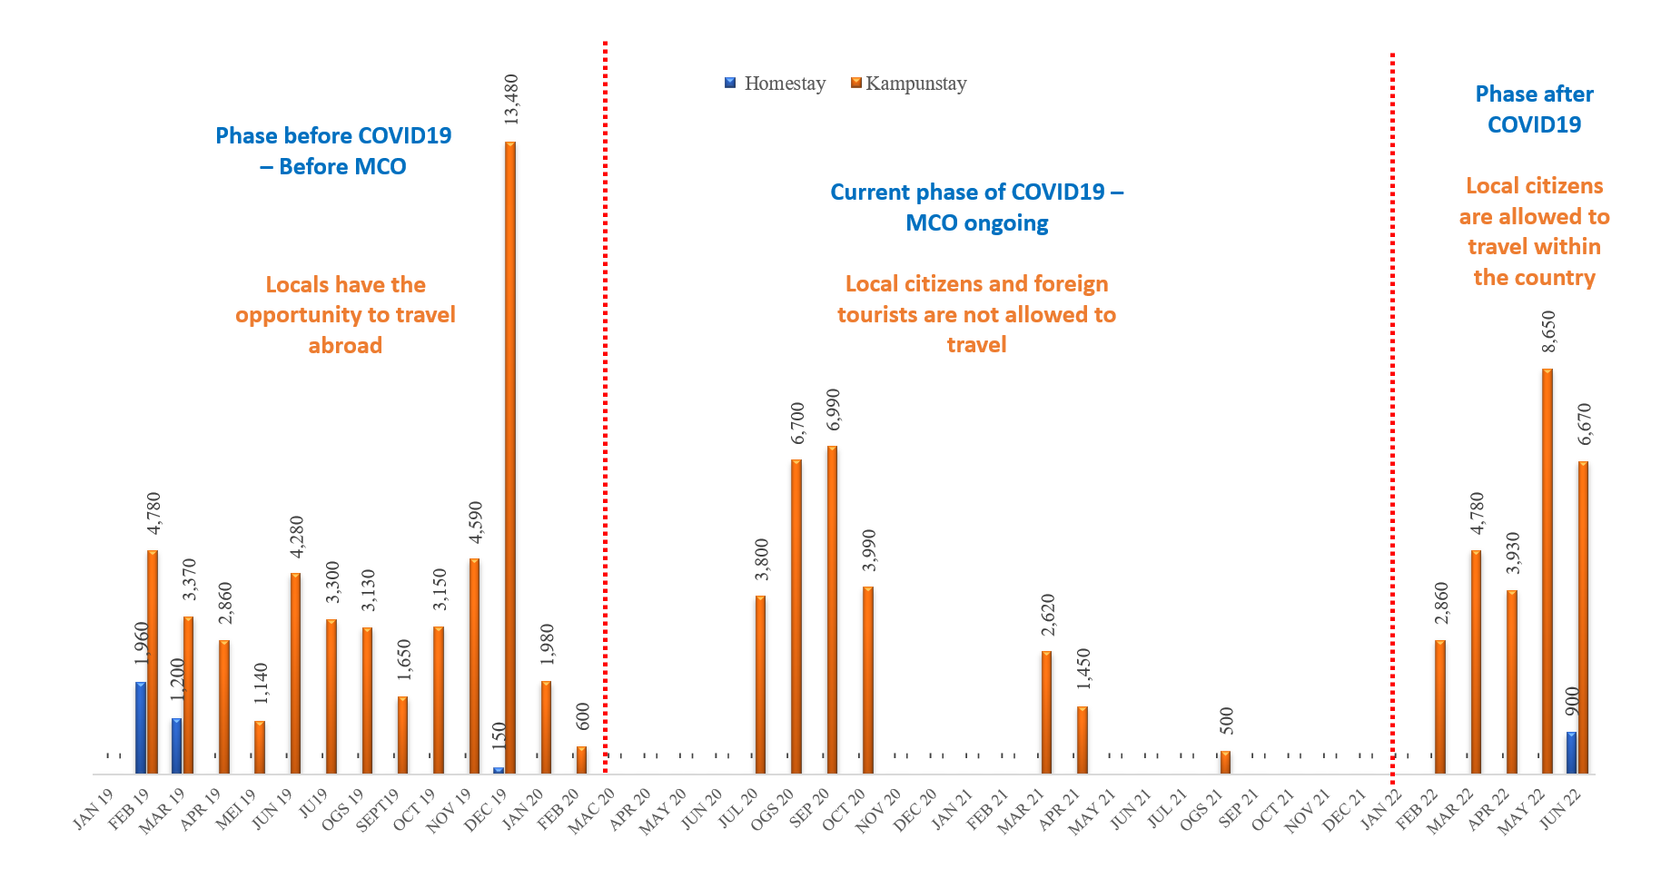
Figure 5: Entire Monthly Income (Ringgit Malaysia) of Homestay and Kampungstay, Area X (2019 – June 2022)

Findings also show that domestic tourists prefer to stay in kampungstays rather than homestays because they do not want to be tied to the activities of the homestay host. In addition, kampungstay facilities that provide private space for the whole family like a hotel also make domestic tourists choose kampungstay because it is much cheaper than staying in hotels, motels and chalets. Compared to a homestay, tourists have to share private spaces such as the toilet, sitting room, dining room, laundry and kitchen. This matter is apparently not favored by domestic tourists compared to international tourists.
In fact, Osman (2022) highlighted the domestic tourists are more likely to visit friends and family, while international tourists are more likely to discover new places. Domestic tourists are also often wealthier than international tourists, leading to different types of experiences. That purpose also affects the demand for renting homestays and kampungstays. Domestic tourists usually look for an affordable place to stay for their entire family, making kampungstay a more suitable option with variety of amenities. On the other hand, international tourists are more interested in experiencing the culture of the local people, which makes homestay a better choice. This claim is supported by research conducted before the COVID-19 pandemic, when the country's borders were open to international tourists. The results of the research indicate that the income of homestay is not comparable to that of kampungstay owners, as the majority of tourists who visit Area X are domestic tourists who prefer to stay in kampungstay for attending life events like weddings, funerals, or indulging in recreational activities with friends such as fishing and high-powered motorcycles. It is different from international tourists who come to participate in volunteering activities and cultural tourism packages to get to know the culture and biodiversity on Area X.
Overall, through capacity building and participatory planning, local communities can be given the ability and opportunity to empower themselves in carrying out CBT activities better and more effectively (Thetsane, 2019). To overcome the weaknesses in the homestay that have been identified, there are several actions that can be taken. To enhance their skills and knowledge in homestay operators management, training or courses on technology skills and homestay operators management can be provided. This training includes backlinks and has been reinforced by the social mobilization process, including local business planning and skills development training (Pandey, 2013). This can help them to understand the standards that homestays should achieve, as well as ways to improve the quality of services provided to tourists (Azimovna et al., 2022). The local association can help by providing support in the implementation of capacity building and participatory planning, including in promoting training or courses to homestay operators, and encouraging the local community to participate in the participatory planning process (Li et al., 2020).
In addition, the association can develop a wider network with the owners of homestays and other services such as fishing boats, bicycles and ATVs, and enter into formal agreements with them to ensure better and more organized cooperation. In the long run, this will reduce the risk of depending on the chairman of the association. The association can also introduce training to ensure that more members can help in managing (Li et al., 2020) homestay activities and be a link between tourists and services. In this way, the association will be able to reduce the workload that is too dependent on one individual and guarantee efficiency and stability (Spagnoli et al., 2020) in homestay operations.
Participant Planning in CBT involves the active participation of local communities in the planning and development of tourism projects (Thetsane, 2019). This approach fosters a sense of ownership and responsibility for the project, aligns with the community's needs, and promotes sustainable tourism development (Duxbury, 2021). By involving the community in decision-making, CBT promotes community empowerment (Scheyvens, 1999), enhances social capital and fosters positive relationships between the tourism industry and the local community (Rocca & Zielinski, 2022). Therefore, it is imperative for tourism planners and policymakers to adopt the CBT approach to enhance the sustainability and inclusivity of their projects (Zapata, et al., 2011).

Collaborating and partnership

Dodds et al., (2018) encourage CBT also requires mature collaborating and partnership among industry players. According to them, there are three types of collaboration and partnership that can be implemented, which are joint ventures in the same or different industries, government and non-government organization (NGO).

- Joint Venture

The findings of the study found that the homestay association has a good joint venture with services that offer various activities to visitors. The intended services are such as boat rentals for fishing or squid fishing, transportation rentals such as vans and buses, bicycle or ATV rentals to enjoy the pleasant atmosphere around the rice fields and mangrove forests, dance and kompang teams for cultural performances, catering services, traditional game rentals such as congkak, batu seremban and sepak takraw. However, this joint venture was done informally without any agreement. When this service is needed, the chairman of the association will contact the owner of the service to make a reservation as required by the visitor. In addition, the homestay association also has a good cooperative relationship with foreign travel agencies from Japan. Each year, at least two visits will be received from Japan with a total of at least 20 tourists will stay at the homestay and enjoy other services provided during the week they are in Area X.
It seems that the Area X homestay association has done some good things in strengthening the homestay industry in their area. Good collaboration and partnership with other industry players, government and tourism agencies can help improve the homestay services provided and provide better benefits to tourists (Kimbu & Ngoasong, 2013). Joint ventures done by homestay associations with other services such as boat, van and bus rental, as well as traditional games and other activities are good actions to attract tourists and expand the coverage of homestay services. However, it is recommended that this action be done with a formal agreement to ensure effective and fair cooperation between both parties (Kayat, 2011; Kimbu & Ngoasong, 2013). Cooperation with overseas travel agencies such as Area X's homestay association with Japanese travel agencies is a good opportunity to expand market reach and increase foreign visitors to their homestays. It is recommended that homestay associations look for more opportunities to establish cooperation with other overseas tourism agencies (Kayat, 2011).

- Government

The homestay association has a strong connection with MOTAC, a ministry responsible for developing and promoting the tourism industry in Malaysia. MOTAC played a key role in promoting the establishment of homestays all over Malaysia, including in Area X. Along with the joint venture, this relationship has been beneficial for the homestay association. MOTAC has provided assistance in the form of training and financial resources to upgrade selected homestays to achieve homestay standards that is supposed. The upgrades carried out by MOTAC to these selected homestays include providing financial assistance to install aircond, toilet and room renovation and painting the house. In addition, MOTAC also provides assistance in the form of providing appropriate pillows and comforters. However, the Area X homestay does not have any collaboration with any NGO to help them empower the homestays they work on. As explained earlier, the funds allocated by MOTAC are a grab for residents to register their homes as homestays.
In addition, partnerships with the government and agencies such as MOTAC can also provide great benefits to homestay associations and the homestay industry as a whole. Financial aid and training provided by MOTAC can help homestays improve their service standards and quality (Bhuiyan, 2019). However, it is recommended that the Area X homestay association also establish partnerships with NGOs related to tourism and the environment to help improve the sustainability of homestays and strengthen environmentally friendly practices.

- Non-government organization (NGOs)

Overall, the Area X homestay association has done some good things to strengthen their homestay industry. However, there are still opportunities to improve cooperation and partnership with other industry players and government and NGO to achieve greater success. In CBT, the benefits of tourism activities should be distributed equitably among the various stakeholders involved (Abukhalifeh & Wondirad, 2019). This approach promotes the sustainability of the project by ensuring that everyone involved is satisfied with the benefits received (Yanes, et al., 2019).
In order to address these challenges, Van der Duim & Caalders (2008) findings pointed out that donors, policymakers, and NGOs should focus their attention and resources on supporting and stimulating conditions for local and endogenous development. They also thought, this can be done by providing the necessary resources, such as access to microcredit, land, ideas, contacts, ownership, influence, knowledge, and skills, for the poor to take advantage of local entrepreneurship, develop and market products, and make linkages with local supply chains. By doing so, communities can better leverage their resources and become more self-reliant in their tourism development efforts.

Financial viability

A CBT will be stable and sustainable in the long term when it has strong financial viability (Dodds et al., 2018). Based on the conceptual framework, there are three things in financial viability that need to be paid attention to by the homestay, namely generating additional income, finance skills and marketing.

- Generating Additional Income

Based on findings related to generating additional income, homestay operators only provide accommodation and food for tourists. Other activities offered are left to other join venture parties to manage them. It is important that the income of the population is not concentrated on a part of the population alone but rather those who also participate also get side income and from the effort. This situation is also the concept of CBT introduced to the population. However, product development must continue to improve existing services. The findings of the study found that product development is not done by CBT, they only depend on existing service products.
Having become aware of the challenges faced by homestay associations in product development is not done, the research team has contributed to the development of seven distinct tour packages, which are intended to be offered by homestays to tourists visiting Malaysia, with a particular focus on Penang state. The tour packages consist of separate activity packages, two half-day packages, two two-day-one-night packages, and two three-day-one-night packages. In addition to the tour packages, the researchers have also aided in the creation of a website to promote ecotourism and cultural tourism in Penang, specifically highlighting the attractive rural area of X. This initiative is expected to facilitate the growth of tourism in the region and provide a unique experience to visitors interested in exploring the rich cultural heritage and natural beauty of Penang. The products were developed as part of a development initiative aimed at promoting CBT in the X area and showcasing its various attractions and activities. The research team conducted a study to identify potential draws for tourists to visit rural areas in Penang, leading to the creation of the tour packages and website. The end result has not only generated additional income for CBT in the X area but has also provided opportunities for homestay owners to receive guests in their accommodations.
CBT and homestay operators also need to consider expanding their products. This can be done through the provision of additional facilities and services such as seminar and business facilities or recreational and sports facilities. By expanding their products, homestays can attract more diverse visitors and further expand their sources of income. In CBT, one of the primary goals is to generate additional income for the local community in the long run (Dodds et al., 2018). This approach promotes the socio-economic development of the community and encourages the long-term sustainability of the project.

- Finance Skill

Financial proficiency is an individual's capacity to comprehend, administer, and oversee financial aspects concerning personal or business matters. This encompasses expertise in financial administration, investment, financial planning, financial risk management, as well as the skill to read and interpret financial reports (Dodds et al., 2018). Competence in financial matters is crucial for both individuals and organizations as it ensures financial stability and facilitates the accomplishment of both short-term and long-term financial objectives. The financial acumen of homestay operators in Area X is sporadic. Although the chairman of the association keeps the statement account and records it in full, the findings reveal that the association's financial records are disorganized and poorly managed. Detailed records of incoming and outgoing funds are not maintained. Furthermore, unclear documentation regarding certain activities makes it difficult to explain the gains or losses incurred.
To ensure the stability and sustainability of the CBT homestay in the long run, the management must pay special attention to the matters of financial viability mentioned in the conceptual framework. The management needs to enhance their financial skills by comprehending and mastering the principles of financial management, including investment, financial planning, financial risk management, and reading and understanding financial reports (Oseifuah, 2010). As a first step, the management can attend courses or receive guidance to improve their financial skills. Additionally, they need to maintain the accuracy of financial records and report them regularly to the association members. Overall, it is crucial for the homestay management to give special attention to the matters of financial viability and take appropriate action to ensure the stability and sustainability of the CBT homestay in the long run.

- Marketing

The homestay market is currently very weak, making it challenging for operators to attract tourists. Only kampungstay operators have regular tourists because they actively promote their kampungstay. However, the focus of kampungstay operators is more on domestic tourists. The association also does not have tourism packages that can be advertised, does not have an active website and social media. It is very different from kampungstay operators, although they do not provide tour packages but they are very active in promoting their kampungstay for tourists to stay.
Homestay operators need to improve their marketing efforts. They can take the initiative to increase the homestay's visibility through social media, websites, and other appropriate marketing channels. Management also needs to ensure that homestay marketing is carried out effectively and efficiently by focusing on the right market segment and carrying out consistent promotional activities.
The situation where the market for homestay operators is very weak is a major challenge that needs to be overcome to ensure the long-term success and stability of CBT. In this case, effective promotion and marketing are crucial to attract tourists to the homestay. To overcome this challenge, the association needs to improve its marketing skills and have an effective marketing strategy to promote homestay. They also need to have attractive and varied tourism packages to attract more tourists especially international tourists because the homestay concept is preferred by international travelers while domestic tourists prefer to stay at kampungstay. Developing an active website and social media can also help increase promotion and outreach of the homestay to a wider audience. This has been done by researchers through packaging activities that attract visitors to Area X. Seven tourism packages have been developed through this study. Additionally, researchers have also helped build a website to promote CBT products in Area X.
In addition, homestay entrepreneurs need to be trained and guided by the government in marketing so that they can promote their homestays more effectively and efficiently. The association also needs to provide support and assistance to homestay operators to improve their marketing skills. In this regard, participation in marketing courses and workshops can help improve their skills and knowledge.

Conclusion

This study discusses various aspects that can help the management and operators of Homestay Area X to increase their income and promote their homestay. The study found several issues, including low local and international tourist traffic, inadequate homestay promotion, inactive promotion, lack of an official website, poorly organized tourism packages, no customer feedback platform, and no promotional brochures or posters. To address these issues, the researchers proposed and assisted the management and owners of Homestay Area X in implementing the proposed solutions. Through the implementation of these solutions, the management and owners of the homestay can improve their management and address any shortcomings. The researchers also assisted the homestay and CBT as a whole in building a website and developing seven tourism packages to promote and increase income for the homestay in rural areas, especially in Area X.
Therefore, this study provides insight for the management and owners of homestays in addressing issues related to homestays. The recommendations and assistance provided by the researchers can guide the management and owners of homestays in providing satisfaction to every tourist and becoming successful homestay entrepreneurs. In conclusion, the study proposes a framework for community-based tourism that emphasizes participatory planning, collaboration, and empowering local communities. The framework highlights the importance of setting environmental and community goals, relieving related parties, and generating additional income for the community in the long run. The framework provides a useful guide for tourism planners, policymakers, and other stakeholders involved in the development of CBT projects.

References

Abdullah, H., Wahab, S., Shahibi, M.S., Malim, M.R. and Ali, J., (2013). Model Integrasi Indeks Utama Prestasi (MIIUPA-KPIAs) Agensi Payung Industri Homestay Melayu Malaysia. Jurnal Pemikiran dan Kepimpinan Melayu, 53-71.
Abukhalifeh, A. N., & Wondirad, A. (2019). Contributions of community-based tourism to the socio-economic well-being of local communities: the case of Pulau Redang Island, Malaysia. International Journal of Tourism Sciences, 19(2), 80–97. doi:10.1080/15980634.2019.162152
An, W., & Alarcón, S. (2020). How Can Rural Tourism Be Sustainable? A Systematic Review. Sustainability, 12(18), 7758. doi:10.3390/su12187758
Azimovna, M. S., Ilkhomovna, U. D., & Shokhrukhovich, U. F. (2022). Innovative Strategies Of Tourism Development In Uzbekistan. European Journal of Innovation in Nonformal Education, 2(1), 1-4.
Bagus, S. I., Imade, S. U., Nyoman, S. I. A., & Putu, W. S. N. (2019). Community based tourism as sustainable tourism support. Russian Journal of Agricultural and Socio-Economic Sciences, 94(10), 70-78.
Bhuiyan, M. A. H. (2019). Homestay for Community Based Tourism Development at Kampung Jelawang in Kelantan, Malaysia. Soc. Sci. J, 3, 73-81.
Cheng. M., Mackenzie. S. H., & Degarege. G. A. (2022) Airbnb impacts on host communities in a tourism destination: an exploratory study of stakeholder perspectives in Queenstown, New Zealand, Journal of Sustainable Tourism, 30:5, 1122-1140, DOI: 10.1080/09669582.2020.1802469
Dacin, P. A., Dacin, M. T., & Matear, M. (2010). Social entrepreneurship: Why we don't need a new theory and how we move forward from here. Academy of management perspectives, 24(3), 37-57.
Dangi, T. B., & Jamal, T. (2016). An integrated approach to “sustainable community-based tourism”. Sustainability, 8(5), 475.
Department of Statistics Malaysia. (2023). Statistik Subnasional Parlimen dan DUN: Pulau Pinang P.053 Balik Pulau. Accessed on 14 April 2023 from https://cloud.stats.gov.my/index.php/s/DBWSX2c2s3ULGlg?path=%2FPULAU%20PINANG#pdfviewer
Dey, B., Mathew, J. and Chee-Hua, C. (2020). Influence of destination attractiveness factors and travel motivations on rural homestay choice: the moderating role of need for uniqueness. International Journal of Culture, Tourism and Hospitality Research. Vol. 14 No. 4, 639-666. https://doi.org/10.1108/IJCTHR-08-2019-0138
Dodds, R., Ali, A., & Galaski, K. (2016). Elements of success and barriers in communitybased tourism. Current Issues in Tourism. DOI: 10.1080 / 13683500.2016.1150257
Dodds, R., Ali, A., & Galaski, K. (2016). Mobilizing knowledge: Determining key elements for success and pitfalls in developing community-based tourism. Current Issues in Tourism, 21(13), 1547-1568. https://doi.org/10.1080/13683500.2016.1150257
Dodds, R., Ali, A., & Galaski, K. (2018). Mobilizing knowledge: Determining key elements for success and pitfalls in developing community-based tourism. Current Issues in Tourism, 21(13), 1547-1568.
Duxbury, N. (2021). (Re) articulating culture, tourism, community, and place: Closing remarks. In Cultural Sustainability, Tourism and Development (pp. 197-212). Routledge.
Forman, J., & Damschroder, L. (2007). Qualitative content analysis. In Empirical methods for bioethics: A primer (Vol. 11, pp. 39-62). Emerald Group Publishing Limited.
Giampiccoli, A., & Mtapuri, O. (2021). From Conventional to Alternative Tourism: Rebalancing Tourism towards a Community-Based Tourism Approach in Hanoi, Vietnam. Social Sciences, 10(5), 176. doi:10.3390/socsci10050176
Gu, M., & Wong, P. P. (2006). Residents' perception of tourism impacts: A case study of homestay operators in Dachangshan Dao, North-East China. Tourism Geographies, 8(3), 253-273.
Guttentag, D., & Smith, S. (2017). Assessing Airbnb as a disruptive innovation relative to hotels: Substitution andcomparative performance expectations. International Journal of Hospitality Management, 64,1–10. https://doi.org/10.1016/j.ijhm.2017.02.003H
Hairal, H. and Hussin, R., (2021). Potensi Membangunkan Program Homestay dan Penglibatan Komuniti di Pulau Gaya, Kota Kinabalu, Sabah, Malaysia: Potential to Develop Homestay Programmes and Community Participation in Pulau Gaya, Kota Kinabalu, Sabah, Malaysia. Journal of Borneo Social Transformation Studies, 7(1), pp.37-55.
Havadi Nagy, K. X., & Espinosa Segui, A. (2020). Experiences of community-based tourism in Romania: Chances and challenges. Journal of Tourism Analysis: Revista de Análisis Turístico, 27(2), 143-163.
Ibrahim, Y., & Razzaq, A. R. A. (2010). Homestay program and rural community development in Malaysia. Journal of Ritsumeikan Social Sciences and Humanities, 2(1), 7-24.
Islam, M. W. (2010). Community-based tourism and ecotourism are potential means to facilitate the conservation of natural resources of the Sundarbans–A theoretical perspective. Khulna University Studies, 127-140.
Jabatan Perangkaan Malaysia. (2022). Poket Stats Negeri Pulau Pinang. Accessed on 21 Disember 2022 from https://cloud.stats.gov.my/index.php/s/aTxF2Zk8fIV5UXZ#pdfviewer.
Jamaluddin, A. (2019). Inovasi Homestay di Pulau Langkawi. Perkongsian artikel Universiti Putra Malaysia. Accessed on 21 Disember 2022 from https://eco1.upm.edu.my/article/inovasi_homestay_di_pulau_langkawi-50109.
Kayat, K. (2011). Homestay Programme as a Malaysian Tourism Product (UUM Press). UUM press.
Kayat, K., & Zainuddin, N. F. A. (2016). Community-based tourism initiative in rural Malaysia: Is it a success? International Review of Management and Marketing, 6(7), 242-249.
Kimbu, A. N., & Ngoasong, M. Z. (2013). Centralised Decentralisation Of Tourism Development: A Network Perspective. Annals of Tourism Research, 40, 235–259. doi:10.1016/j.annals.2012.09.005
Kontogeorgopoulos, N., Churyen, A., & Duangsaeng, V. (2015). Homestay Tourism and the Commercialization of the Rural Home in Thailand, Asia Pacific Journal of Tourism Research, 20:1, 29-50, DOI: 10.1080/10941665.2013.852119
Kunjuraman, V. (2019). Kajian terhadap syarat dan fenomena semasa dalam pembangunan program homestay di Malaysia. Geografia, 15(1).
Lacey, A., & Luff, D. (2001). Qualitative data analysis (pp. 320-357). Sheffield: Trent focus.
Li, X., Zhang, F., Hui, E. C., & Lang, W. (2020). Collaborative workshop and community participation: A new approach to urban regeneration in China. Cities, 102, 102743. doi:10.1016/j.cities.2020.102743
Lo, Y.-C., & Janta, P. (2020). Resident’s Perspective on Developing Community-Based Tourism – A Qualitative Study of Muen Ngoen Kong Community, Chiang Mai, Thailand. Frontiers in Psychology, 11. doi:10.3389/fpsyg.2020.01493
Mapjabil, J., Rosdi, S.A.M., Shuib, M. and Abdullah, S. (2011). Pembangunan program homestay di Wilayah Utara Semenanjung Malaysia: Profil, produk dan prospek (Homestay programme development in the Northern Region of Peninsular Malaysia: Profile, products and prospects). Geografia, 7(2).
MOTAC, Ministry of Tourism, Arts and Culture. (2020a). Program Pengalaman Homestay Malaysia. Accessed on 14 April 2023 from https://www.motac.gov.my/en/programme/tourism/homestay
MOTAC, Ministry of Tourism, Arts and Culture. (2020b). Garis Panduan Pengalaman Homestay. Accessed on 2 May 2023 from https://www.motac.gov.my/en/programme/tourism/homestay.
MOTAC, Ministry of Tourism, Arts and Culture. (2020c). Accessed on 14 April 2023 from https://www.motac.gov.my/en/faqs/pendaftaran-dan-pengelasan-premis-penginapan-pelancong-ppp
Mustafar, F.W., A’zmi, A.A., Noh, N.M., Suhaini, N. and Karim, A.K.A. (2020). Potensi Pelancongan Di Tampin, Negeri Sembilan. Jurnal Tuah, 1(1).
Oseifuah, E. K. (2010). Financial literacy and youth entrepreneurship in South Africa. African journal of Economic and management studies.
Othman, N.K. and Buang, N.A. (2021). Kualiti Perkhidmatan dan Kepuasan Pelanggan Homestay Menggunakan Model Servqual. Advanced International Journal of Business, Entrepreneurship and SME’s, 3(7), pp.59-74.
Pakshir, L., & Nair, V. (2011). Sustainability of homestay as a form of Community-based tourism (CBT): A case study of the rural community in Bavanat-Iran. TEAM Journal of Hospitality and Tourism, 8(1), 5-18.
Pandey, R. J. (2013). Capacity Building and Human Resource Development Initiatives: Community Based Tourism Development in Nepal. Nepal Tourism and Development Review, 1(1), 83–101. https://doi.org/10.3126/ntdr.v1i1.7373
Platteau, J.-P., & Gaspart, F. (2003). The Risk of Resource Misappropriation in Community-Driven Development. World Development, 31(10), 1687–1703. doi:10.1016/s0305-750x(03)00138-4
Pusiran, A. K., & Xiao, H. (2013). Challenges and community development: A case study of homestay in Malaysia. Asian Social Science, 9(5), 1.
Rasulov, A., Madjitova, J., & Islomova, D. (2022). Principles of tourism development in downstream zarafshan district. American Journal of Social Sciences and Humanity Research, 2(05), 11-16.
Rocca, L. H. D., & Zielinski, S. (2022). Community-based tourism, social capital, and governance of post-conflict rural tourism destinations: the case of Minca, Sierra Nevada de Santa Marta, Colombia. Tourism management perspectives, 43, 100985.
Rodriguez, J., & Walters, K. (2017). The importance of training and development in employee performance and evaluation. World Wide Journal of Multidisciplinary Research and Development, 3(10), 206-212.
Scheyvens, R. (1999). Ecotourism and the empowerment of local communities. Tourism management, 20(2), 245-249.
Shaw, E.; Carter, S. (2007). Social entrepreneurship: Theoretical antecedents and empirical analysis of entrepreneurial processes and outcomes. J. Small Bus. Enterp. Dev. 14, pp.418–434.
Singh, R., & Greenhaus, J. H. (2004). The relation between career decision-making strategies and person–job fit: A study of job changers. Journal of Vocational Behavior, 64(1), 198–221. doi:10.1016/s0001-8791(03)00034-4
Spagnoli, P. et al. (2020). Workload, workaholism, and job performance: Uncovering their complex relationship. International Journal of Environmental Research and Public Health, 17(18), 6536.
Thetsane, R. M. (2019). Local community participation in tourism development: The case of Katse villages in Lesotho. Athens Journal of Tourism, 6(2), 123-140.
Tiberghien, G., Bremner, H., & Milne, S. (2017). Performance and visitors’ perception of authenticity in eco-cultural tourism. Tourism Geographies, 19(2), 287-300.
Tourism Malaysia. (2023). Homestay. Accessed on 14 April 2023 from https://www.tourism.gov.my/niche/homestay
Van der Duim, V.R., & Caalders, J. (2008). Tourism chains and pro-poor tourism development: Anactor–network analysis of a pilot project in Costa Rica.Current Issues in Tourism,11(2),109–125.
Walter, P., Regmi, K. D., & Khanal, P. R. (2018). Host learning in community-based ecotourism in Nepal: The case of Sirubari and Ghalegaun homestays. Tourism management perspectives, 26, 49-58.
WWF, World Wildlife Fund. (2001). Guidelines for Community-Based Ecotourism Development. Accessed on 14 April 2023 from http://www.widecast.org/Resources/Docs/WWF_2001_Community_Based_Ecotourism_Develo p.pdf
Yanes, A., Zielinski, S., Diaz Cano, M., & Kim, S. I. (2019). Community-based tourism in developing countries: A framework for policy evaluation. Sustainability, 11(9), 2506.
Zapata, M. J. et al. (2011). Can community-based tourism contribute to development and poverty alleviation? Lessons from Nicaragua. Current Issues in Tourism, 14(8), 725-749.

