The Melanau folklore: An analysis of moral values

Hishamuddin Siri¹, Hafizan Mohamad Naim², Abdul Walid Ali³

¹Faculty of Applied and Creative Arts, Universiti Malaysia Sarawak
²Faculty of Social Sciences and Humanities, Universiti Malaysia Sarawak
³ College of Creative Arts, Universiti Teknologi Mara, Puncak Perdana

Correspondence: Hishamuddin Siri (email: shishamuddin@unimas.my)

Received: 25 May 2023; Accepted: 23 February 2024; Published: 29 February 2024

Abstract

Melanau folklore, abundant with intricate narratives and moral lessons, serves as an essential vehicle for cultural transmission. This paper seeks to scrutinize the representation of moral values within Melanau folklore, specifically looking through its oral narratives through qualitative literary research. Drawing on the thematic analysis of 24 short stories derived from Morris's monograph, this paper identified four principal themes of moral values: Personal Development and Growth, Social and Cultural Values, Interactions with the Supernatural, and Environmental Stewardship. These moral values, deeply embedded in Melanau's worldview, are paramount to the community's understanding and interaction with their environment. Intriguingly, our analysis suggests that the inherent moral values of the Melanau are often intertwined with concepts related to the spirit world, indicating the pivotal role of supernatural elements in shaping the community's ethical landscape. This study highlights the rich moral fabric of Melanau narratives, elucidating their cultural identity and the broader context of their relationship with the supernatural world.

Keywords: Folklore, Melanau, moral values, narratives, oral stories

Introduction

The Melanau people, native to the coastal region of Sarawak, Malaysia, are endowed with a rich cultural heritage that shines through their distinct folklore. Being one of the many indigenous groups of Sarawak, their historical narrative is intricately interwoven with folklore, reinforcing their cultural heritage and shaping their collective identity (Sarawak Museum, 2013). In this context, Melanau folklore serves as a crucial conduit for transmitting societal values, beliefs, and moral principles, thus providing an interpretive lens into their cultural matrix. Recognizing folklore's instrumental role in cultural transmission, this study tries to link the moral dimension of Melanau's oral narratives with their societal norms and ethics.
Often, folklore elucidates the genesis of cultural practices and fortifies social norms pertaining to behaviour, morality, and etiquette. It serves as an essential component of tradition, reflecting the beliefs, values, and experiences of its creators and transmitters. Cultural transmission primarily occurs through oral traditions, a process by which stories, songs, and beliefs are verbally passed from one generation to the next. In the context of indigenous knowledge, this encompasses a wide array of elements—ranging from cultural rituals, oral histories, and legendary tales to musical compositions, mythological narratives, aphorisms, and traditional dances. It also includes societal regulations, local dialects, and classification systems. All these facets of indigenous wisdom are traditionally handed down across successive generations, as concurred by Grenier (1998). This continual process plays a vital role in safeguarding a community's cultural heritage and fostering the perpetuation and evolution of its traditions over time.
Despite the importance of discerning the moral values encapsulated within folklore, existing research has inadequately delved into this aspect of Melanau culture. Therefore, this study intends to bridge this lacuna by examining the manifestation of moral values, both explicit and implicit, within the narratives of Melanau folklore. This investigation unravels the narratives of moral values embedded in these stories, thereby offering profound insights into Melanau society and its prevailing moral ethos.

Literature review

Folklore research is a multidimensional field encompassing the collection, documentation, analysis, and interpretation of a community's customs and traditions. The significance of folklore study lies in its ability to yield insights into a people's cultural heritage, offering a profound understanding of a community's identity and worldviews (Geia et al., 2013). Additionally, such research illuminates the mechanisms through which these cultural elements are transmitted and preserved across generations.
In Malaysia, and more specifically in Sarawak, the study of folklore has deep historical roots, stretching back to the time of the Brooke administration. It was during this period that British academics first began the systematic recording of indigenous folktales and songs. The era of the Brooke administration, succeeded by British colonial governance, saw significant efforts by ethnographers to collect and safeguard the indigenous folklore of Sarawak. The scientific research and cultural conservation efforts were particularly emphasized during the reign of the Brookes, especially during the reign of Rajah Charles Brooke who desired to put Sarawak ‘on the map’ in this area of international endeavour (Morris, 2020).
Notable British ethnographers such as Charles Hose, Tom Harrisson, and Harold Stephen Morris have significantly contributed to this field, studying and documenting the cultures and customs of various indigenous groups in Sarawak. Their work has established an invaluable repository of the lives of Borneo's indigenous inhabitants. Although the narratives captured by these scholars may bear the imprint of their Western lens - as noted by Robert (2021) - they nonetheless remain as an essential historical record.
In Malaya, the rise of Malay folklore was interpreted by Winstedt (1939) as a consequence of a familiar British colonial tactic which involves the assimilation and dominance over 'local wisdom' for colonial purposes. In line with this argument, Shamsul (2000) explains this information acquisation served as an essential component of the British administrative strategy, crucial for shaping the colonial image and for amassing information about the indigenous people of Malaya. In which, fundamentally, it involves the strategic creation of a form of knowledge that the colonial powers could manipulate and manage. In a divergent argument, however, Mohd Taib (1974) believes that Malay oral traditions are not a colonial fabrication but genuine and innovative literary works that emerged during the early stages of societal development. He views these narratives as fundamental to the progression of Malay civilization, serving as an indispensable tool for cultural evolution and expression, especially as a significant means of expressing Malay cultural identity.
Conversely, in the case of Sarawak, as discussed by Morris (2020) the documentation of the local knowledge was not entirely a colonial political agenda, in fact, it was a manifestation of a complex series of human interactions. In her research on the Sarawak Museum, she argues that the indigenous people should not be seen simply as passive recipients of European knowledge. Instead, they actively engaged in interpreting and representing their cultural heritage. The museum served as a convergence point for Sarawak's varied community, offering an opportunity for them to negotiate their own identity representation in the eyes of the state.
The term "folklore" was coined by British scholar William Thomas in 1846 to describe the collective knowledge and beliefs passed down through generations within a community, thereby replacing terms like 'popular antiquities' and 'popular literature' (Dundes, 1965). Since its inception, the definition of folklore has been subject to diverse interpretations among scholars and researchers. This evolution reflects a broader understanding of folklore as not just a repository of stories and songs but as a dynamic embodiment of cultural heritage. In the case of the Melanau, folklore extends to their entire cultural repertoire, encompassing the broad spectrum of their oral, material, and performative traditions that together form their heritage.
Certain academicians, such as Bascom (1953) restrict the understanding of folklore to the realm of verbal heritage alone. Contrarily, scholars like Dundes (1965), and Dorson (1972) propose a more comprehensive definition, suggesting that folklore includes the verbal, material, and ritualistic facets of an unsophisticated culture (Bahta, 2014). Additionally, folklore is perceived as a traditional medium for the dissemination or inheritance of culture, taking the form of oral narratives or exemplifications reinforced by signals or mnemonic aids (Febriagazi & Sunarto, 2020), suggesting that folklore may also be disseminated through both observation and oral narration. Folk dance, games, and gestures exemplify such folklore forms that are typically learned through observation (Dundes, 1965). These folklore forms may not depend on verbal communication for their transmission across generations but are instead acquired through direct observation and active engagement.
On the whole, some scholars interpret folklore as the encapsulation of a specific group's traditional beliefs, customs, practices, and expressions, whereas others perceive it as an expression of human ingenuity, encapsulated in oral traditions, legends, myths, and various other forms of folklore (Dundes, 1965). Despite these definitional differences, the study of folklore consistently concentrates on exploring a community's beliefs, practices, and expressions, and on elucidating their contributions to the community's cultural heritage and identity (Osman, 2020). Arguably, the most profound aspect of folklore is its intimate link to its originators and custodians - the people and communities from which it emerges.
Central to Melanau folklore are the oral stories that serve as a conduit for passing down traditions and moral values from one generation to another, thus playing a critical role in preserving the Melanau cultural heritage. Despite its importance, its representation in literary works remains relatively scarce. However, there are a few notable exceptions that contribute significantly to the preservation and understanding of this cultural heritage. Heidi Munan's 'Melanau Stories', published in 2005 is a remarkable example. Although it comprises only six stories - a modest count compared to the wealth of Melanau tales still untapped. Another significant contribution is 'The Oya Melanau' by Morris H. S. published in 1991. The book, penned from a social historian's viewpoint, provides a comprehensive ethnographic study of the Melanau people along the Oya River in Sarawak. It goes beyond a mere recounting of economic and political histories, offering an in-depth look at the community's pagan beliefs and practices. Despite these important works, the breadth of literary exploration into Melanau folklore is remarkably limited, highlighting the need for further scholarly attention to this rich and diverse cultural heritage.
Melanau folklore often feature mythical beings and other archetypal characters, embodying the cultural wisdom and moral philosophy of the Melanau community (Inai et al., 2020). By examining these narratives and associated beliefs, a deeper understanding of the Melanau cultural identity and the mechanisms of cultural transmission can be achieved. However, the study of moral values inherent in these narratives has been relatively underexplored in existing literature. Recognizing this research gap, our study aims to delve into the moral dimension of Melanau oral stories, bringing to light the community's moral landscape as portrayed in these narratives. Through a comprehensive analysis of these stories, we hope to offer a fresh perspective on the cultural and moral ethos of the Melanau community. Furthermore, we aspire to highlight the importance of folklore studies in appreciating Malaysia's cultural diversity, while paying particular attention to the indigenous Melanau communities of Sarawak.

Method and study area

The aim of this paper is not to provide a historical account or an anthropological synthesis, but rather to delve into the moral dimensions of Melanau oral narratives through a comprehensive exploration of Melanau folklore. Our approach utilizes thematic analysis, a method that permits an in-depth examination of the moral values embodied in the narratives and the ways these values are communicated through the stories. The thematic analysis conducted in this study was primarily inductive, allowing the data itself to guide the identification of themes in the initial stages. This process is inherently data-driven, rooted in the principles of grounded theory (Ismail, 2018), and is designed to uncover, analyze, and report patterns (themes) that organically emerge from within the data itself (Braun & Clarke, 2006). This approach ensures that the themes are intrinsically linked to the narratives being studied and are not the result of any preconceived notions or categories. It facilitated the emergence of themes that are genuinely grounded in the Melanau narratives, thereby preserving the authenticity of the cultural expressions and moral values conveyed through their oral traditions.
To assist with the data analysis, NVivo, a qualitative data analysis software, was employed. NVivo facilitated the organization of data, the coding process, and the efficient identification of emergent themes and subthemes. The process for determining themes and subthemes involved several steps: 1) familiarization with the data: reading and re-reading the narratives to gain a deep understanding of the content; 2) generating initial codes: systematically coding features of the data that were pertinent to the research questions, using NVivo software to assist with data organization; 3) searching for themes: collating codes into potential themes and gathering all data relevant to each potential theme; 4) reviewing themes: checking if the themes work in relation to the coded extracts and the entire dataset, and generating a thematic 'map' of the analysis; and 5) refining and naming themes: ongoing analysis to refine the specifics of each theme and the overall story the analysis tells, developing clear definitions and names for each theme; and 6) producing the report: the final step involved selecting vivid and compelling extract examples, relating the analysis back to the research question, and literature, and producing a scholarly report of the analysis (Braun and Clarke, 2019; Byrne, 2022).
In selecting the primary source for Melanau folklore, there is a scarce documentation on Melanau oral stories available. Due to limited number of available compilation, we elected to focus on the compilation of stories by Harold Stephen Morris, as presented in his 1997 monograph, "The Oya Melanau: Traditional Ritual and Belief with a catalogue of Belum carvings." This seminal work provides a rich trove of Melanau traditional rituals, oral narratives, and a discourse on the Melanau's traditional belief.
The choice of Morris’s compilation was informed by several critical factors: 1) comprehensiveness and depth: Morris's work is recognized for its exhaustive coverage and profound insight into the Melanau’s traditional rituals, oral narratives, and belief systems; 2) scholarly significance: Morris is among the notable British ethnographers who have documented the cultures and customs of indigenous groups in Sarawak during the colonial era. His work stands out due to its detailed documentation and analysis Melanau communities, which has been a cornerstone for subsequent research on the communities; 3) cultural preservation: at the time of his research, Morris was able to capture the oral traditions of the Melanau in a manner that few sources have been able to replicate. This preservation of culture is vital for studies that aim to understand the traditional moral values and belief systems before they were significantly altered by modern influences; and 4) access and verifiability: Morris's monograph provides direct access to a collection of narratives, allowing for accurate analysis and interpretation. The availability of his compilation for scholarly review and its acceptance in academic circles adds to the reliability of the narratives for research purposes.
From the monograph, we have identified 24 stories for our analysis (see Table 1). By meticulously dissecting these narratives, our objective is to offer a unique insight into the cultural and moral norms of the Melanau community.

Table 1. List of story ID and its references

Story ID | Reference
1 | Manet bin Siruh, Medong, 25 Aug. 1963.
2 | Talip bin Litong, Kuala Lama, Mukah, 8 Dec. 1963.
3 | de Crespigny 1876.
4 | Manet bin Siruh, Medong, 25 Aug. 1963.
5 | Ath bin Rimu, Ud, 19 June 1949 and 24 Aug. 1963; also anon. 11 July 1950.
6 | Atuh bin Rimu, Ud, 10 April 1949 and 24 Aug. 1963; also Na'ay binti Tigew, 9 Feb. 1950.
7 | Ngaréng bin Lueng, Medong, 1971.
8 | Atuh bin Rimu, Medong, 1950; also Sinuh, Ud, 4 Nov. 1963.
9 | Atuh bin Rimu, Medong, 1930.
10 | Madin bin Rajan, Medong, 1950.
11 | Madin bin Rajan, Medong, 1950.
12 | Manet bin Siruh, Medong, 28 July 1963.
13 | Bikap binti Nyunying, Kanowit, 13 Nov. 1963.
14 | Sinuh bin Jemuew, Ud, 4 Nov. 1963.
15 | Tayah binti Unus, wife of Sakul, Medong, 4 March 1950.
16 | Idaw bin Pilang, Medong, 1971.
17 | Isah binti Seman, Medong, 1949.
18 | Na'ay binti Tigew, Medong, 13 Feb. 1949.
19 | Na'ay binti Tigew, Medong, 13 Feb. 1950.
20 | Usup bin Tira, Medong, 24 Aug. 1963.
21 | Usup bin Tira, Medong, 24 Aug. 1963.
22 | Usup bin Tira, Medong, 24 Aug. 1963.
23 | Atuh bin Rimu, 5 July 1950 and 16 Feb. 1950.
24 | Sinuh, Ud, 1963.
Results and discussion

Main contexts reflected from the stories

To delve into the unique cultural identity and belief systems of the Melanau community, we must understand that their oral narratives extend beyond mere storytelling (Inai et al., 2020). These tales serve as mirrors, reflecting the community's moral landscape, traditional beliefs, and societal norms (Albrecht, 1954). Understanding this, we aim to provide a comprehensive view of the Melanau community's cultural richness, as seen through the lens of these narratives. This study identifies three main contexts reflected within the stories: (a) boundaries and constrained might of humans; (b) respecting the balance: adherence to the adet; and (c) connection with the supernatural: respecting and outwitting.

a. Boundaries and constrained might of humans

In the world as constructed by Melanau oral narratives, there is an intricate web of interconnected realms exists, within which mythical beings and humans coexist (Inai et al., 2020). Morris (1991) explained the Melanau worldview of the universe is conceptualised as comprising of multiple domains - the underworld, the middle world, and the sky world. Each of these domains serves as the dwelling place for diverse types of beings (Appleton, 2012). The middle world, for instance, is a shared space populated by humans, spirits, animals, and vegetation. Notably, each inhabitant is ascribed a proper place within this realm, as told by Story ID 4 below:

Not all the barriers between the worlds were set up at the same time. Another myth tells of a man who went fishing and snagged his line in the roof of a longhouse in the likew yang, the world immediately below this one. He dived down to clear the line and stayed with the people for a year before returning home with stolen rice grains. At that time rice was not known to men in the middle world. The ruler of likew yang was so angry at the theft that he erected a barrier between the two worlds and now only exceptional shamans can pass it. (Story ID 4)

Specifically, tale illustrates the Melanau belief in the existence of separate yet interconnected worlds, each with its distinct inhabitants. In this story, the middle world which is home to humans, and the likew yang which is the world below inhabited by different beings, were once easily accessible to each other. The tale's protagonist crosses this boundary and even dwells in the likew yang for a year, suggesting a degree of fluidity and interaction between these realms. However, the narrative also signifies the importance of respecting the sanctity and rules of each world. The theft of rice grains which is regarded as an act of disrespect, led to the creation of a barrier between the two worlds. Consequently, passage between these realms became limited, with only a select few shamans—those deemed exceptional for their spiritual prowess—retaining the ability to traverse this boundary. This story reinforces the concept that each world has its rules and boundaries, which need to be respected by its inhabitants, and transgressions can lead to dire consequences such as the limitation of inter-world interactions.
Story ID 1 encapsulates the Melanau understanding of the universe, highlighting the presence of distinct realms and the inherent complexities in navigating between these worlds:

The Mu'eh Rajang epic tells the story of a hero, Sirat Tadan, who went hunting. After many adventures and crossing seven barriers defended by snakes, pigs, a lion, a tiger, dragons (naga) and spirits, he came to a huge banana plant which he climbed and thereby reached the moon. There he met Dayang Kiyew Uri Perman, a beautiful woman. But not all heroes succeeded in crossing barriers. (Story ID 1).

The protagonist, Sirat Tadan, is described as a strong and brave hero, embarks on an arduous journey involving the traversal of seven barriers, of which each barrier was guarded by various creatures. The iteration of the concept of guarded barriers highlights the distinct boundaries separating different worlds. It demonstrates that the travel between worlds are fraught with challenges and that to successfully cross the barries requires courage, skill, and resilience-even to some point superhuman powers and ability (Couderc & Sillander, 2012). Only exceptional individuals, like Sirat Tadan, endowed with these exemplary qualities are capable of successfully navigating these barriers. His reaching the moon and encountering Dayang Kiyew Uri Perman, a beautiful woman, signifies the access to a different world, suggesting an overlap of realms in the Melanau cosmology.
However, the final sentence - "But not all heroes succeeded in crossing barriers"-serves as a sobering reminder of the limitations inherent in these inter-world interactions. It highlights the notion that transitions between different realms are not guaranteed and the success is depended on the capabilities of the individuals attempting the journey. These intricacies of crossing boundaries reflect the complexities and limitations of inter-world interactions within the Melanau's cosmological understanding whilst highlighting limited might of humans. Overall, both stories highlight the complexities of the Melanau cosmological structure, reflecting a universe where various realms coexist, are accessible to certain extents, but require respect for the established norms and laws.

b. Respecting the balance: Adherence to the Adet

In the shared domains of the Melanau community, such as the 'guun' – semi-cultivated communal zones for hunting and foraging – a balance is meticulously maintained. It is not seen as an exclusively human territory, but a shared realm inhabited by spirits, animals, and plant life, each possessing unique, inherent rights (Morris, 1991). 'Adet', the Melanau's customary code of conduct, dictates the necessity of demonstrating respect towards all cohabitants in these shared spaces. The Melanau hold a profound belief that any infringement on these rights or a creature straying from its designated place in the world disrupts the balance of the 'adet'. Such violations, identified as 'tulah' or acts of disrespect, are viewed as potential catalysts for disasters upon the community. Therefore, to respect the balance is to adhere to the 'adet', a principle ingrained deeply within the Melanau worldview and societal norms. Such adherence to the ‘adet’ can be observed in the Story ID 5:

Dayang Kiyew, a female ruler on the moon, or according to some people, another female spirit called Biliong, who also lived on the moon, had all fifteen worlds of the dunia under surveillance to make sure that proper order was kept and the adet was not flouted. The anger of these guardians was immediately aroused by incest and disrespectful laughter and behaviour. Mockery of animals in particular angered them. A man who wound a snake round his head like a turban to amuse his child and then laughed was turned into a monkey. Children who teased cats and dogs by setting them to fight one another put the whole village into danger. When angered, Dayang Kiyew sent a sudden wind, pangay bungeh, as a warning which always caused anxiety, even during the monsoon. Somebody would ask: 'Law basa?', wet day?, with the unspoken suggestion that somewhere in the neighbourhood someone had aroused the anger of Dayang Kiyew. Everybody was reluctant to say baliw, a word which described the consequences [transformation] of her anger. (Story ID 5)

The story serves as a compelling testament to the importance of the ‘adet’ to the Melanau's societal and moral code. It paints a vivid picture of a universe under constant watchful guardianship, reinforcing the concept that the world’s multiple realms are not autonomous entities but are interconnected and subject to a shared set of rules and norms. One of the most striking aspects of the narrative is the way it illustrates the repercussions of actions that breach societal norms and respect for other beings. Through the examples of individuals turned into animals, it allegorically represents how such disrespectful behaviors disrupt the societal fabric, bringing severe consequences not only to the individuals but to the entire community as well. The same observation has been done by Couderc and Sillander (2012) that explains ‘adet’ for the Melanau is not only embodying tradition in a general sense but also, more narrowly, referring to customary law—a set of practices and values both objectified and codified within the community.
The emergence of the sudden wind, ‘pangay bungeh’, as a warning serves as a symbolic reminder that the community must stay vigilant and introspective, always ready to correct behaviors that disrupt the balance and harmony of the universe. It also encapsulates the understanding that every action has the potential to affect the entire community, reinforcing the principle of shared responsibility. Plus, the concept of "baliw" or transformation resulting from the celestial rulers' wrath highlights the importance of upholding adet. This encapsulates the Melanau worldview that maintaining balance, respect, and harmony is not a personal but a communal responsibility, bearing implications for the survival and prosperity of the entire community. It reflects the Melanau community's cultural norms, highlighting the intrinsic values of respect, balance, harmony, and shared responsibility.

c) Connection with the supernatural: Respecting and outwitting

The potrayal of the supernaturals are prominent in the recorded stories where the mythical beings are characterized by a mix of human and animal traits and have profound connections to elements of nature, including the sea, the jungle, and the air. Interestingly, while these mythical beings often bear resemblance to humans in terms of physical or behavioral attributes, they are explicitly distinguished from humanity (Morris, 1997). Consequently, in this study, we recognize both the human and mythical figures depicted in the stories as integral components of the narrative structure. As shown from Story ID 21 and Story ID 3, these beings, as well as some powerful humans are depicted as possessing supernatural abilities, and some beings are depicted as possessing beauty and strength that surpass humans:

A crocodile put off his sarong, his skin, and as a very handsome young man danced at a wedding in a longhouse for seven nights. He danced so well that all the young women were 'mad' about him. (Story ID 21)

She lived at the gate to the likew a-matay with a guard dog Mawiang; from there, she sent the souls of dead humans, who had made the long and difficult canoe journey to her house, on to their future dwelling places. In her capacity as guardian, Balew Aded had power over humans which she exercised impartially. (Story ID 3)

Some mythical beings are depicted as malevolent and unintelligent. As shown from the Story ID 6, humans are urged to employ their wits to outsmart the deceitful maneuvers of these evil beings.

A man once climbed a tree to pick jackfruit. While he was picking, a crowd of tew gathered round the foot of the tree and called up at him. "How did you get up there?" The man was afraid: he knew that tew of that kind ate human beings, so he said, "I climbed the tree, bottom up." The tew then tried to climb and fell down. In the meantime, the man began to fling fruit far and wide, and the tew scattered to pick them up. At home the man's brother teased him for bringing no fruit, and next morning the brother went to pick some. As before the tew gathered at the foot of the tree and called up at him, "How did you get there?" He said, "I climbed head upwards." And the tew immediately did the same and ate him. When his brother and parents discovered what had happened, they went to the large fallen tree trunk in which the tew lived and piled dry brushwood over it and set it alight. All the tew died. (Story ID 6)

From the story, the virtue of intelligence, resourcefulness, and vigilance against looming threats is emphasized. The tale presents the first man, who uses his wits to confuse the tew (a group of evil beings), demonstrating the value of cleverness and resourcefulness as critical survival skills. While lack of caution and failure to heed the example of others is presented through tragic outcome - death - stressing the importance of vigilance and learning from the experiences of others.

Moral values in Melanau oral tradition: Four core themes

Our study has identified four main themes related to moral values in Melanau oral narratives: (a) personal development and growth; (b) social and cultural values; (c) interactions with the supernatural; and (d) environmental stewardship. These themes, taken together, reflect the essential moral principles that underpin the cultural identity and belief systems of the Melanau community.

a. Personal development and growth

Figure 1 shows a Sankey diagram of Personal Development and Growth theme, its subthemes and related Story IDs. Each strand represents the subtheme observed, and the width of these strands at the end of the Sankey strand correlates with the number subthemes highlighted in the respective story. There are 27 identified values under the Personal Development and Growth theme (refer to Figure 1). The most recurrent values within this theme occur in groupings of three values, where each grouping of values emphasizes certain moral concept per story. These groupings of three values are narrated in Story ID 1 (Perseverance, Overcoming obstacles, and Balance and order), Story ID 13 (Loyalty, Compassion, Respect), Story ID 18 (Honesty, Generosity, Greed), and Story ID 24 (The power of friendship and trust, The importance of seeking help, and The value of life and second chances).
This thematic clustering, as visualized in Figure 1, is indicative of the dynamic interplay between different values within individual stories, revealing the emphasized nature of personal growth and moral development in Melanau folklore. Through this visual analysis, the narratives emerge not just as stories but as reflections of the community's ethos, with each tale serving as a way for imparting wisdom and life lessons central to the Melanau way of life.

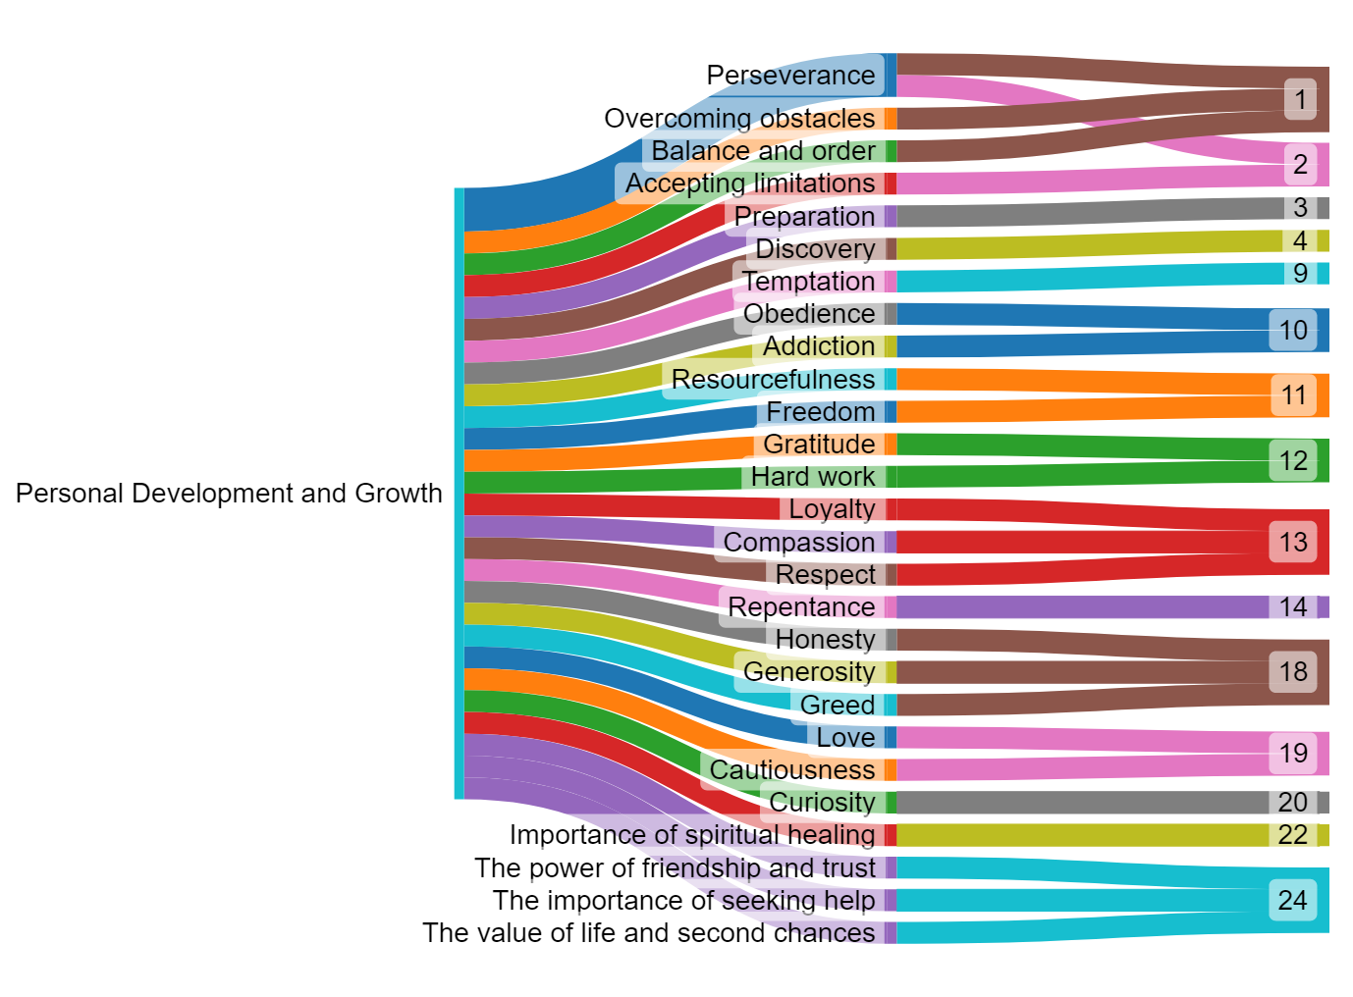
Source: Author

Figure 1. Sankey diagram of personal development and growth, its subthemes and story IDs

b. Social and cultural values

As depicted in Figure 2, the Sankey diagram show a visual representation of the Social and Cultural Values theme, its associated subthemes, and he stories in which they are featured. This specific theme expresses the values that reinforce Melanau social norms and cultural traditions in its stories. The stories provide moral frameworks that dictate appropriate behavior within the Melanau community, emphasizing the significance of respect, cooperation, and harmonious living. There are 13 values observed under the themes (refer to Figure 2). The diagram traces the flow from the broad theme to specific values highlighted in the story.
The strands in the diagram is indicative of the value presented within the narratives. For instance, 'Responsibility' emerges as a significant value, present in two distinct narratives, Story ID 9 and Story ID 15. The convergence of 'Responsibility' with 'Taboos' in Story ID 9 and 'Respect for Ancestors' in Story ID 15 highlights a cultural imperative: the importance for both the community and the individual to honor the 'adet.' This is achieved by observing taboos and revering the traditions handed down by ancestors, thereby ensuring the continuity of cultural heritage.
Another notable pairing is 'Respect' combined with 'Cultural Norms' in Story ID 5, which emphasizes the cultivation of humility and reverence as core components of proper behavior. Similarly, 'Inheritance and Entitlement' coupled with 'Nature of Beings' in Story ID 7 highlights the complex social dynamics such as rivalry and the roles dictated by one's inherent attributes.
The diagram serves as a narrative map that showcases the interplay between different moral aspects presented in the stories and how the values expressed within the narratives. It seems, stories do impart lessons, for the theme Social and Cultural values theme, weight are given on the aspect of living in harmony with others and respecting the established order.

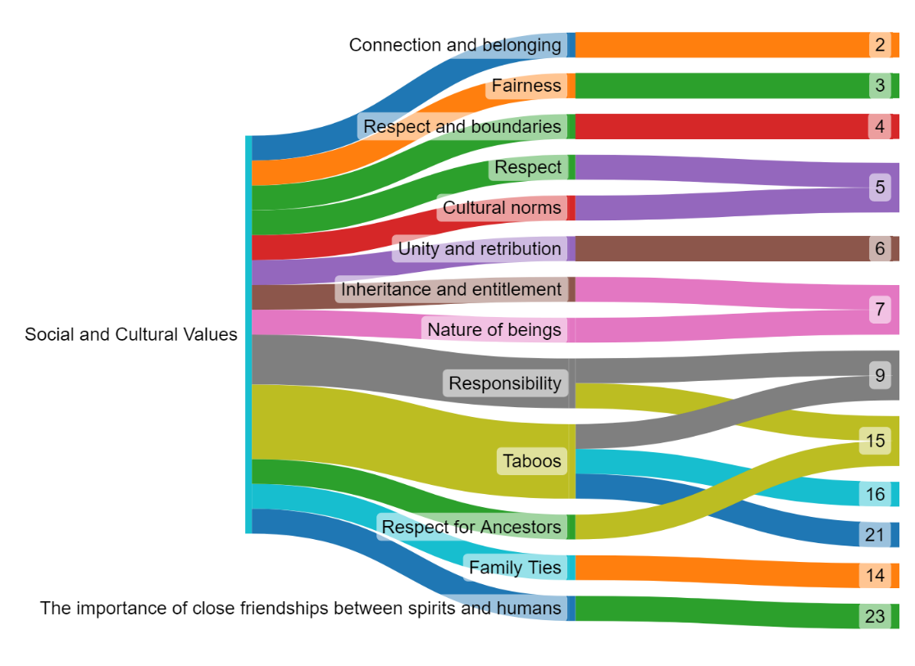
Source: Author

Figure 2. Sankey diagram of social and cultural values, its subthemes and story IDs

c. Interactions with the supernatural

The narratives under this theme delve into complex relationships between humans and mystical beings, illustrating the duality of fear and reverence towards the supernatural. Within the Interactions with the Supernatural theme, five distinct values are discernible, with the 'Consequences' subtheme prominently featured across a majority of the narratives (as evidenced in Story IDs: 3, 4, 5, 6, 11, 12, 14, 15, 17, and 21). These narratives-through stories of ‘consequences’ serve as potent didactic instruments, fostering a deep-seated reverence for the supernatural.
Within the discussion of this theme ‘Interactions with the Supernatural’, the discussion on traditional Melanau ‘adet’ is pivotal. As explained by Appleton (2012) and Morris (1991), the Melanaus recognize ‘adet’ as the intricate connectedness of all entities, encapsulating a principle of equilibrium and order in a cosmos that encompasses both natural and supernatural realms, all of which help shapes their ethical landscape. Consequently, the concept of ‘adet’ and characters’ interactions with the supernatural represents a mandated existential approach, where non-compliance, even unintentional, lead to misfortune – of which potrayed within the narrative of the stories as a form of ‘Consequences’. Also, under the same theme, there are mentioned of the importance of ‘Knowledge’ (Story ID 7) and ‘The need for shamans to restore proper order when things go wrong’ (Story ID 23) which indicative of how the narratives give weight to the supernatural element, reinforcing the idea of knowledge (in supernatural form or not) and the shaman's role in maintaining cosmic balance.

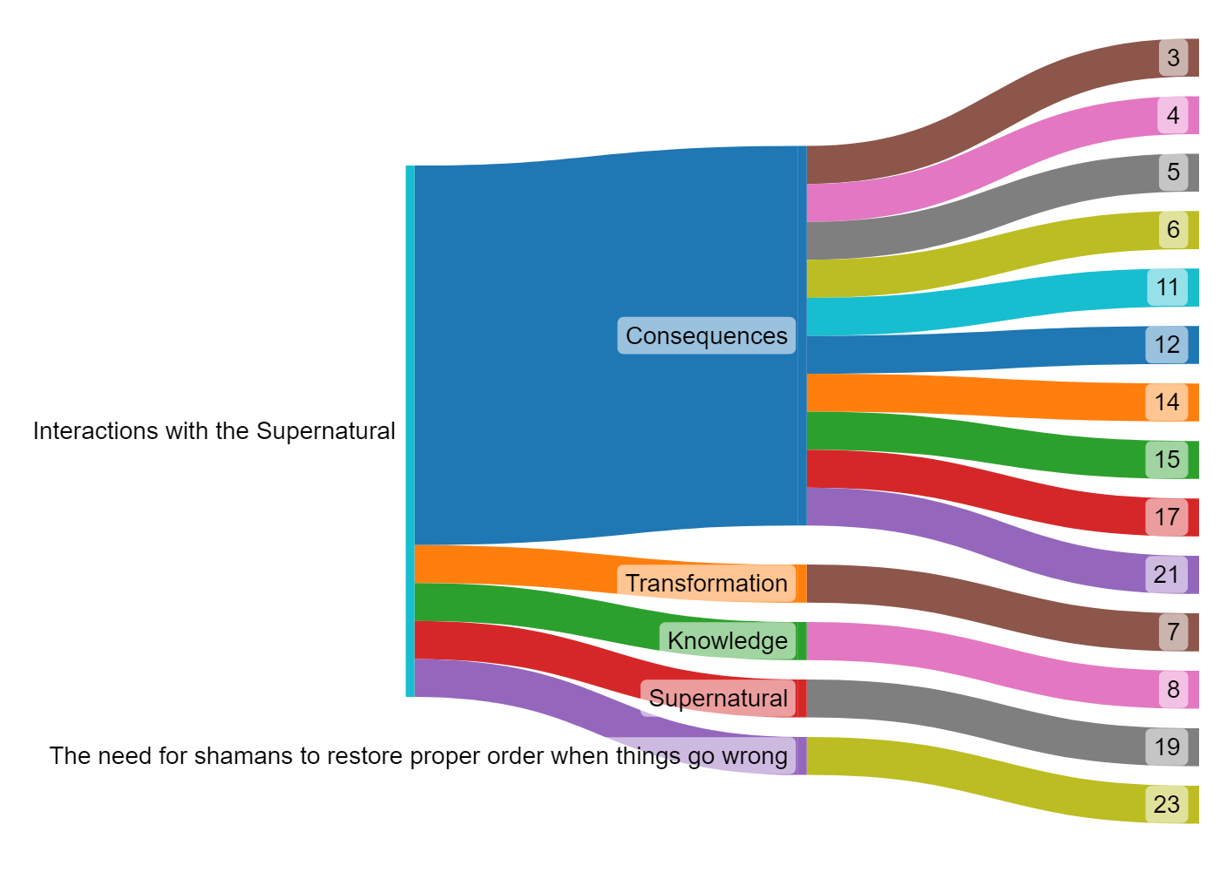
Source: Author

Figure 3. Sankey Diagram of Interactions with the Supernatural, its Subthemes and Story IDs

d. Environmental stewardship

Another interesting theme identified in this study is Environmental Stewardship theme. The theme, which presented in Figure 4 emphasizes the concept of preserving natural equilibrium, cautioning that any disturbances in the natural order of things could lead to bad repercussions. The subthemes such as 'Balance,' 'Preservation,' and 'Respect' signify the importance of the values when Environmental Stewardship theme was presense in the stories (Story IDs: 8, 16 and 18), reinforcing the narrative assertion that sustainability is not merely a practice but a sacred duty ingrained within their cultural fabric.
Environmental Stewardship, as explored in these tales, reflects the Melanau community's profound understanding of ecological symbiosis. All five stories that falls under these themes (Story IDs: 8, 16, 18, 21 and 20), portray the environment as a shared space between humans, animals, and spirits, where all that live in the space deserving respect and care. The findings of Inai et al. (2020) align with this observation, highlighting the deep connection of the Melanau community with nature. This is particularly evident in their reverence for the spirits of rivers, seas, lands, and forests in the symbols of tradition or animism, that are interwoven into their everyday life.
Furthermore, the narrative highlights the community's respect for the power of various creatures and the adherence to taboos (Story ID 21). This respect is not just a cultural practice that is manifested through their ‘adet’ but also a testament to their recognition of the interconnectedness of all life forms and the importance of living in harmony with nature.

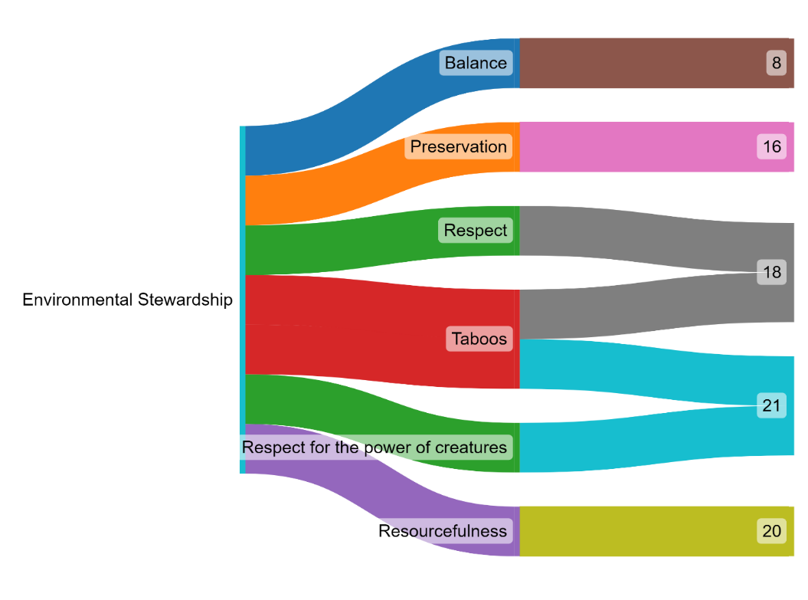
Source: Author

Figure 4. Sankey Diagram of Environmental Stewardship, its Subthemes and Story IDs

The four themes - Personal Development and Growth, Social and Cultural Values, Interactions with the Supernatural, and Environmental Stewardship - collectively provide a comprehensive view of the moral foundations that contributes to the Melanau cultural identity. Personal Development and Growth theme highlights the community’s focus on individual maturation and self-improvement. Social and Cultural Values theme reflects the deep-seated traditions and societal norms that guide daily life. Interactions with the Supernatural theme emphasizes the Melanau’s spiritual connections and their profound respect for unseen forces, which manifested through their tradition and ‘adet’. Lastly, Environmental Stewardship theme showcases their commitment to preserving the delicate balance of nature. Together, these themes not only encapsulate the values and worldviews presented in Melanau folklore but also offer an insightful perspective on their ethical landscape.
Table 2 provides a comprehensive and systematic categorization of the moral themes identified in the 24 Melanau oral stories gathered for this study. Each story ID corresponds to a specific Melanau oral story, with the associated themes indicated alongside. The table demonstrates the complexity and diversity of these narratives as the stories do not stick to a single moral theme but, rather, blend several themes together, creating an interesting and dynamic moral and cultural teachings. The stories reflect the creative approach in emphasizing the depth and complexity in Melanau storytelling traditions.

Table 2. Moral value themes distribution across selected Melanau folklore stories

Story ID | Personal development and growth | Social and cultural values | Interactions with the supernatural | Environmental stewardship | Total themes
1 | / |  |  |  | 1
2 | / | / |  |  | 2
3 | / | / | / |  | 3
4 | / | / | / |  | 3
5 |  | / | / |  | 2
6 |  | / | / |  | 2
7 |  | / | / |  | 2
8 |  |  | / | / | 2
9 | / | / |  |  | 2
10 | / |  |  |  | 1
11 | / |  | / |  | 2
12 | / |  | / |  | 2
13 | / |  |  |  | 1
14 | / | / | / |  | 3
15 |  | / | / |  | 2
16 |  | / |  | / | 2
17 |  |  | / |  | 1
18 | / |  |  | / | 2
19 | / |  | / |  | 2
20 | / |  |  | / | 2
21 |  | / | / | / | 3
22 | / |  |  |  | 1
23 |  | / | / |  | 2
24 | / |  |  |  | 1
Total | 15 | 12 | 14 | 5

For instance, 'Personal Development and Growth' is a recurrent theme that appears in 15 oral stories, emphasizing the Melanau community's value on individual improvement and self-discovery. Stories with this theme often depict characters who grow and evolve through personal trials, testing their wit, strength, and determination. A significant sub-theme within this category focuses on the necessity of self-control and resistance to temptation or addiction. Story ID 10 serves as an exemplary illustration of this sub-theme. In this narrative, a man finds himself lost in a forest and stumbles upon a longhouse inhabited by mosquitoes. As he integrates into this new community, even marrying among them, he is warned against smoking within the house. Over time, however, his desire to smoke becomes overpowering, leading to a crucial test of self-restraint. This tale highlight the importance of respecting community norms, even when they conflict with personal desires, further emphasizing the Melanau belief in the significance of self-discipline and control in personal development.

A man was lost in the forest and came to a longhouse belonging to mosquitoes. The chief allowed him to live with them and he married a wife there. When they married, his wife said "You must never smoke in this house; if you do we shall all die". As time went by his longing to smoke overpowered him. He found leaves, dried them, and made a light by drilling a stick into a piece of soft wood. The smoke from his cigarette killed his wife and everybody in the house. (Story ID 10)

Another noteworthy sub-theme within the 'Personal Development and Growth' category is the value of hard work, diligence, and patience. This sub-theme is beautifully illustrated in an oral story ID 12 that recounts a tale about a man from Muden. In this story, the man carelessly discards some rice grains wrapped in leaves into a stream after his meal, oblivious to the effort that has gone into producing the rice. These grains represent the fruits of hard work and diligence, and their crying out symbolizes the disregard for such efforts.
Simultaneously, the golden mackerel at the mouth of the stream, considered a valuable asset, hears the cries of the rice grains and decides against aiding the humans, understanding their lack of appreciation. This element of the narrative cautions against taking for granted the results of hard work and diligence, symbolized here by the rice and the golden mackerel.
Furthermore, the dream of a villager in which an old woman transforms the beach sand into gold adds another dimension to this moral lesson. Despite witnessing this incredible transformation, the man does not fully seize the opportunity due to the small size of his boat, promising to return with a larger one the next day. However, the old woman, representing wisdom and foresight, reprimands him for his lack of initiative and squandering of resources. Her prophetic warning emphasizes that acquiring valuable assets, like rice and gold, will henceforth require ‘sweat and sadness’, highlighting the importance of diligence, hard work, and seizing opportunities when they present themselves. This narrative strongly underscores the Melanau community's emphasis on hard work, diligence, and patience as key elements in personal development and growth.

Once upon a time there was a man, Muden who ate some cooked rice wrapped in a parcel of leaves. After eating, he threw the leaves, with some grains of rice stuck to them, into the stream and, as they floated away, the rice grains wept, crying out. "you the stream and, as unchrow us away, we who helped you grow!" At the mouth of the stream there was a golden mackerel, jikan legiri (some versions say it was a crocodile). The rice grains asked, "Where are you going?" The mackerel replied: "I am going to help the people up there.""Go no further. The humans up there will only use you for a gold ornament. We who helped them grow and thrive were nevertheless thrown away by them," said the rice grains. So the golden mackerel returned to the sea. That night a man of Muden village dreamt that an old woman came and spoke to him. She said, "Go to the mouth of the River Muden. There is sand there, and it is all gold." Next morning the man went to the river mouth and saw that all the sand on the beach had become gold. He took some of it away because his boat was small. He said, "Tomorrow I will return with a big boat". That night he dreamt again. The old woman said to him, "You men of Muden surely do not want to become rich. First you throw away rice; next you will not even take the gold I made for you. From now on you, your children, and your grandchildren of the elbow and the finger nail (sew sikew, sew silew: second and third generation grandchildren) will acquire rice and gold only with sweat and sadness." (Story ID 12)

The theme of 'Social and Cultural Values' holds substantial prominence in Melanau oral narratives, featuring in 12 different stories. These stories highlights the importance of abiding by community norms, traditions, and shared cultural practices. Characters within these narratives often find themselves guided and restricted by societal customs, thereby reinforcing the need for conformity and respect for communal values.
One such narrative vividly portrays these principles. The Story ID 15 tells the tale of an ancient ancestor who, in his extreme old age, undergoes a transformation where his human features gradually morph into bird feathers. Over time, he fully transforms into a pigeon. Before his final transformation, he makes a solemn decree to his descendants, admonishing them never to harm or consume pigeons. He warns that violation of this prohibition would result in severe consequences – violent death for men and death in childbirth for women.
This narrative emphasizes the significance of respect for ancestral wisdom and traditions, a key social value in the Melanau community. The ancestor's transformation into a pigeon symbolizes the transition from the human realm to the spiritual realm, imparting a cultural value that connects living members of the community with their ancestors and natural environment. The strict prohibition against eating pigeons serves as a societal rule that reinforces the respect for and adherence to traditions passed down through generations.
The story also stresses the Melanau community's belief in the profound consequences of violating these cultural norms. It offers a stern reminder of the severe implications of straying from established societal rules, thereby reinforcing the importance of shared cultural practices and values in the Melanau community.

Long ago an ancestor of ours grew very old. All his brothers and sisters died, and every day he sat on a rush mat in the sun. Every day he grew smaller and lonelier; and as he sat the hair on his head and on his body began to turn into feathers, until one day he said to his children, “I am about to become a pigeon (manok pegam), and you and your children and grandchildren of the elbow and the finger nail must never kill or eat pigeon. If you do, you will die: if a man you will die violently, or if a woman you will die in childbirth." And having said that, he rose up and flew away. And that is why we do not eat pigeons. (Story ID 15)

The 'Interactions with the Supernatural' theme delves into the intricate relationships between humans and mystical beings. As one of the most prominent themes in Melanau oral stories, many narratives feature human characters encountering and interacting with supernatural beings possessing powers that exceed human comprehension. This narrative style embodies the Melanau belief in the coexistence of humans and supernatural entities and the ensuing interactions between them.
This belief is evident in Story ID 8, which begins with an existential debate among plants, animals, and a human, mediated by an angel. In the narrative, the plants voice their concern about potential extinction if men were to live indefinitely, as incessant farming would result in the constant felling of trees. Echoing the plants' concerns, the animals articulate their fear of losing their shelters and becoming easy prey for hunters if all the trees were to be removed. As a countermeasure to the potential threats to their survival, the plants and animals plead with the angel to introduce a range of illnesses to limit human life.
This story represents a clear example of the 'Interactions with the Supernatural' theme, illustrating the role of supernatural entities in maintaining the natural balance in the Melanau belief system.This narrative provides a fascinating glimpse into the Melanau's perception of supernatural intervention in maintaining the balance of nature. It underscores their belief in a complex system of checks and balances, where the spirits (in the forms of plants and animals) have the power to influence human life and death.
The man in the story, however, presents an alternative perspective. He seeks immortality not through an endless physical life, but by transforming himself and his family into spirits with a celestial pathway. This emphasizes the Melanau's belief in the existence of an afterlife and the transformation of human beings into spirits after death. The story highlights the community's faith in the knowledge of spirits causing illnesses and the power of natural remedies. It suggests that understanding and engaging with the supernatural world is crucial for their survival, health, and well-being, further reflecting the theme of 'Interactions with the Supernatural' in the Melanau oral narratives.

The plants spoke first. If men did not die, they said, all the trees would be felled to make farms. The animals spoke next, and said that if men did not die and all the trees were felled, there would be no shelter from the sun and the hunters. All the animals would then be killed. The animals therefore asked the angel to bring one hundred and sixty types of illness to kill men, and the trees asked for a hundred and twenty types of remedy for the illnesses. Everybody except the man agreed to this. He asked that he and his wife and daughter should be turned into spirits with a pathway down the rainbow to the river. His wish was granted. Since then men have had to know which spirits cause illness and what herbs or other remedies will cure them. (Story ID 8)

Finally, the 'Environmental Stewardship' theme highlight the need to foster a harmonious relationship with nature. Stories associated with this theme frequently feature characters who share a deep bond with nature, acting as stewards of their environment. This reflects the Melanau community's profound connection to their natural surroundings and their commitment to environmental conservation.
This connection is particularly evident in stories where the Melanau honor and respect certain plants or animals due to their historical significance in the community. For instance, Story ID 16 tells an ancestor of the community hides in a clump of 'sek belidey', a shrub that grows where primary forest has been felled. Thanks to this plant, the ancestor successfully evades his enemies. As a token of gratitude, the ancestor declares a taboo against consuming the shoots of the 'sek belidey'. This anecdote emphasizes the Melanau's gratitude towards nature and its elements, and how this gratitude translates into a commitment towards environmental preservation. It also demonstrates the respect and reverence the Melanau hold towards nature, recognizing it as a protector and provider, deserving of protection and preservation in return.

In former times there was war. One of my ancestors went into the forest and was seen by enemies who pursued him. He hid in a clump of sek belidey (a shrub, the shoots of which are eaten, and which grows where primary forest has been felled). My ancestor was not found, and after searching a long time for him, the enemies went away. He said, "whoever my descendants may be, they may never on pain of death by violence or in childbirth eat the shoots of sek belidey" (Story ID 16)

Table 2 allows us to appreciate how these themes are variously combined in the narratives, revealing the interesting moral fabric that makes up the Melanau community's ethos. It's worth noting that some narratives integrate multiple themes, suggesting an interconnectedness of these moral teachings in the Melanau cultural framework.

Conclusion

In conclusion, the Melanau oral narratives serve as a rich repository of cultural wisdom, reflecting the community's moral principles and belief systems. Folklore study is key to understanding cultural identity, community's cultural principles and customs, demonstrating how these are influenced by their everyday lives. The identified themes - Personal Development and Growth, Social and Cultural Values, Interactions with the Supernatural, and Environmental Stewardship - illuminate the intrinsic values of the Melanau. These narratives are not just stories but practical lessons that underline the importance of personal growth, societal norms, spiritual coexistence, and environmental conservation. The recurring themes in the narratives establish an inherent link between the individual, society, and nature, guided by the supernatural. This link is observed to be strengthened by the manifestation of tradition through the 'adet' that require the respect for traditional taboos and the supernatural. Hence, this study provides an intimate glimpse into the community's value system, contributing significantly to the preservation and understanding of Melanau cultural heritage.

Acknowledgement

The authors would like to thank the Universiti Malaysia Sarawak (UNIMAS) for the P. Ramlee Research Chair Grant Scheme (PRC) F03/PRC/2181/2021. The authors would like to thank the Faculty of Applied and Creative Arts, UNIMAS; Faculty of Social Sciences and Humanities, UNIMAS; and College of Creative Arts, UiTM for supporting this research.

References

Albrecht, M. C. (1954). The relationship of literature and society. American Journal of Sociology, 59(5), 425-436.
Appleton, A. L. (2012). “These are things we have not seen. How can we know what they are like?” Melanau ancestorship as an existential concern. In P. Couderc & K. Sillander (Eds.), Ancestors in Borneo Societies: Death, Transformation, and Social Immortality, pp. 207–242. NIAS Press.
Bahta, G. T. (2014). Folklore: An instrument of conflict prevention, transformation and resolution in the Ethiopian context. Southern African Journal for Folklore Studies, 24(2), 170-185.
Bascom, W. R. (1953). Folklore and anthropology. The Journal of American Folklore, 66(262), 283-290.
Braun, V., & Clarke, V. (2006). Using thematic analysis in psychology. Qualitative Research in Psychology, 3(2), 77–101.
Braun, V., & Clarke, V. (2019). Reflecting on reflexive thematic analysis. Qualitative Research in Sport, Exercise and Health, 11(4), 589–597.
Byrne, D. (2022). A worked example of Braun and Clarke’s approach to reflexive thematic analysis. Quality and Quantity, 56(3), 1391–1412.
Couderc, Pascal & Kenneth Sillander (eds). (2012). Ancestors in Borneo societies: Death, transformation and social immortality. Nias Press.
Dorson, R. (ed.). 1972. Folklore and folk life: An introduction. The University of Chicago
Dundes, A. (1965). The Study of Folklore. Prentice-Hall.
Febriagazi, T., & Sunarto, S. (2020). Analisis bentuk aransemen lagu Anoman Obong ciptaan Ranto Edi Gudel untuk paduan suara karya V. Mangunsongs. Jurnal Seni Musik, 9(2), 139-144.
Geia, L. K., Hayes, B., & Usher, K. (2013). Yarning/Aboriginal storytelling: Towards an understanding of an indigenous perspective and its implications for research practice. Contemporary nurse, 46(1), 13-17.
Grenier. L. (1998). Working with indigenous knowledge: A guide for researchers. The International Development Research Centre.
Munan, H. (2005). Melanau stories. Utusan Publications & Distributors.
Inai, N. N., Magiman, M. M., Salleh, N., Yusoff, A. N. M., Tugau, M., & Permana, S. A. (2020). The analysis of food symbols in the 'Serarang' ritual of the Melanau Likow community in Dalat, Sarawak. International Journal of Innovation, Creativity and Change, 14(3), 723-741.
Mohd Taib, O. (1974). Kesusasteraan Melayu Lama. Federal Publications.
Morris, H. S. (1991). The Oya Melanau. Malaysian Historical Society, Sarawak Branch.
Morris, H. S. (1997). The Oya Melanau: Traditional ritual and belief with a catalogue of Belum carvings (No. 73). Sarawak Museum Department.
Morris, J. R. (2020). Negotiating Museum Narratives: The Sarawak Museum, the Brooke State and the Construction of Cultural Heritage, 1886–1963. In Gabriel, S. (eds), Making Heritage in Malaysia. Palgrave Macmillan.
Osman, S. A. (2020). Re(con)figuring the nenek kebayan through folktale adaptation: Malaysian folktales as literary and cultural heritage. In S. P. Gabriel (Ed.), Making Heritage in Malaysia (pp. 163–184). Palgrave Macmillan.
Robert, J. D. (2021). Postcolonial criticism in Sabah: A review. Borneo Akademika, 5(1), 34–40.
Sarawak Gazette. (1891, September 1). Opening of the New Museum. Sarawak Gazette.
Sarawak Museum. (2013). The Melanau. https://www.sarawakmuseum.com/the-melanau/
Shamsul, A. B. (2000). Knowing the Malay World: Present-Past-Future. Paper work ATMA-KITLV Colloquium on ‘Dutch Scholarship and the Malay World: A Critical Assessment’, Universiti Kebangsaan Malaysia, Bangi, 20-21 November.
Winstedt, R. O. (1939). A history of classical Malay literature. With a chapter on modern developments by Zainal Abidin Ahmad. Journal of the Malayan Branch of the Royal Asiatic Society, 17, 1-243.

