Geospatial approach for Landslides Vulnerability Assessment of Physical Infrastructures in Sireh Park, Johor Bahru

Umar Mohammed Jambo¹, Mohd Faisal Abdul Khanan², Zakaria Baharuddin³, Muhammad Zulkarnain Abdul Rahman⁴, Suzanna Noor Azmy⁴, Wan Hazli Wan Kadir⁴

¹Department of Geography, Umar Suleiman College of Education Gashu’a, P.M.B. 02 Gashu’a,
Yobe State, Nigeria
²Geospatial Imaging and Information Research Group, Faculty of Built Environment and Surveying, Universiti Teknologi Malaysia, 81310 Johor Bahru, Johor, Malaysia
³Park Operations & Maintenance, The Nusajaya Natural Heritage Trust, 79100 Iskandar Puteri,
Johor Darul Ta’azim, Malaysia.
⁴Tropical Resources Mapping Research Group, Faculty of Built Environment and Surveying,
Universiti Teknologi Malaysia, 81310 Johor Bahru, Johor, Malaysia

Correspondence: Mohd Faisal Abdul Khanan (email: mdfaisal@utm.my)

Received: 18 June 2023; Accepted: 13 November 2023; Published: 30 November 2023

Abstract

According to the landslide records between 1993 and 2019 in Malaysia, 171 individuals lost their lives, many others sustained injuries and numerous families evacuated. Additionally, infrastructures and vehicles incurred damage. Even though landslides present a risk to human life, environment, and infrastructures, there are few studies on landslides vulnerability in Malaysia with most of them focusing on social vulnerability neglecting the physical vulnerability. Consequently, a dearth of information on the vulnerability of an area to landslides may amplify the risks associated with landslides, and the relevant authorities in both the landslide-prone and affected regions may not implement the appropriate mitigation measures. The aim of this study is to estimate vulnerability of elements at risk to landslide in the hazard’s affected area of Sireh Park. An indicator based method was used to calculate the relative vulnerability index for each of the elements at risk. In applying the method, experts assigned weights to the indicators and their respective sub indicators based on their significance to landslides vulnerability. The indicators were grouped into clusters, the total values of weights for all the clusters equals to 1. The results of the study showed that about 252 elements at risk are exposed to landslides in Sireh Park, out of which 226 (89.7%) are buildings, while 26 (10.3%) are roads. The general level of buildings' vulnerability to landslides in the study area is relatively low, however about 20.4% of the buildings display a high degree of vulnerability. Meanwhile, the general vulnerability of roads sections to landslides is averagely high, with about 54.8% of the roads sections exhibiting a high degree of vulnerability while 16.1% exhibits low degree of vulnerability. The study can help stakeholders to identify locations with high landslide vulnerability and guide the development of mitigation measures and emergency preparedness plans to reduce the potential impact of landslides in the study area.

Keywords: Element at risk, landslides runout distance, landslides vulnerability, physical infrastructures, vulnerability indicators, vulnerability index

Introduction

Landslide is a persistent geohazard that frequently occurs in hilly areas and has an impact on worldwide socioeconomic trends (Fakhrul et al., 2022). Although landslides frequently occur in mountainous settings, they can also happen in places with typically low relief. Landslides harm the environment and the services it provides as well as anthropogenic activities worldwide (Arrogante-Funes et al., 2021). According to Froude and Petley (2018), based on dataset of deadly non-seismic landslides in total, 55 997 individuals were killed in 4862 different landslide events worldwide between January 2004 and December 2016. In addition, landslides are distributed unevenly across the world, with Asia being the predominant continent.
According to Leoi and Chan (2018), Malaysia has had 18.5 landslides per year on average over the last ten years. Due to its high landslide rate, the country was ranked fifth among nations with a land area larger than 100,000 square kilometres in terms of landslides per square kilometre. In Malaysia, landslides happened in mountainous areas and were triggered by the construction of highways or housing zones. Failures from landslides and other effects of soil failures rise considerably as house development and human activities continue to expand as well as urbanisation. Communities are now more likely to experience landslides due to the considerable growth in the construction of hilly terrain, particularly in the vicinity of highly populated places (Rahman & Majid, 2020). According to Akter et al. (2019), recent population growth and accelerating economic conditions have prompted the building of high-rise condominiums as well as the development of settlements and lifelines over Malaysia's hilly terrain. The probability of landslide disaster occurrences, which have a higher potential for fatalities and economic damage than in the past, is rising because of these development efforts.
Landslide inventory is a detailed record of the past landslide distribution, characteristics and other important information related to it. It keeps track of the landslide's spatial distribution, frequency, activity, magnitude, date of occurrence, type, volume, material displaced, degree of damage, and density (van Westen et al., 2008; Krishna et al., 2021; Wubalem, 2022). Landslide inventory of an area can be created after a thorough review of historical documents, field surveys, as well as aerial photograph and google earth images interpretation. To get correct landslide data, there is need to integrate as many of the acquisition techniques as possible rather than relying solely on one source. This will make the inventory to be reach and allow for a number of analysis to be possible (Singh et al., 2019; Fakhrul et al., 2022; Wubalem, 2022). However, even in industrialized nations, landslide event databases are frequently far from complete. Landslide inventory is frequently used to assess the performance and correctness of landslide susceptibility, hazard, and risk maps (Rahman & Majid, 2020; UNISDR, 2017). Landslide inventory mapping is the systematic mapping of existing landslides in a region using different sources and techniques such as field survey, air photo/satellite image interpretation, and literature search for historical landslide records (Sivakami & Rajkumar, 2020). Therefore, a landslide inventory provides the spatial distribution of locations of existing landslides and the record of past landslides events in an area. Its data can be obtained from different sources. The record can be used for various purposes that include researches on landslides hazard, risk, and vulnerability assessment. It can also be used in conducting researches related to environmental management and engineering.
Landslide runout distance is the travel distance of landslide and is determined by considering and evaluating the path of movement in terms of the event’s start and the end points (Komu et al., 2023). The run out distance is used to takes into account detailed landslides characteristics (Zakaria et al., 2018). It is frequently necessary to do runout evaluations in order to identify probable flood zones, calculate the risks, and create mitigating measures. In order to anticipate the motion of prospective future landslides, they are utilised to imitate the motion of historical landslides. In order to calculate run out distance, numerous tools and techniques have been created, ranging from straightforward empirical-statistical correlations to sophisticated three-dimensional computer model models (McDougall, 2017). Simple and multiple regression techniques can be used to develop empirical landslide travel distance models from landslides datasets. The primary determinants of landslide travel distances in the research area were the volume of the displaced mass, slope angle, maximum landslide height, and geomorphological environment (Moncayo & Ávila, 2023).
Exposure refers to the physical, social, and environmental factors that expose infrastructure and people to hazard that could result in losses. Landslide exposure refers to the current state of people, infrastructure, housing, production capacity, and other tangible human assets that are situated in landslide prone locations (Krishna et al., 2021). Analysing the proportion of infrastructures and assets situated in hazardous areas allows one to assess the exposure of elements at risk due to landslide. That is to say in order to assess the exposure of elements at risk, we need to analyse the percentage of infrastructures and assets that are located in the landslide areas. The exposure analysis step of risk assessment connects the susceptibility and hazard evaluation with the value of the elements at risk (Westen et al., 2014). They further stated that the exposure often identifies which elements are at risk and could sustain some form of damage. Exposure of the people and/or built environment to landslide risk can be calculated by superimposing landslide hazard map(s) on maps of population density, the built environment, and infrastructure. The exposure map can be calculated using data from element-at-risk mapping and landslide inventories. The procedure can be perform in a GIS software by integrating both elements at risk map and landslide inventory using spatial analysis (Zakaria et al., 2018). Through landslide exposure analysis, the exposed elements at risk like infrastructures, buildings, assets, etc. within the landslide zone as well as landslide run out zone can be identified. To do that, critical infrastructure shape file or map is overlaid with that of the landslide inventory this will show those critical infrastructures affected and those that are not affected (Mastura Azmi, 2020). It's critical to develop a quick, repeatable, and reliable technique for generating landslide hazard and exposure assessments using earth observations and other openly accessible data in areas with little or no other data (Emberson et al., 2021).
Vulnerability refers to situations where physical, social, economic, and environmental elements or processes make a person, a community, a system, or an asset more vulnerable to the effects of hazards (Krishna et al., 2021). The potentially impacted elements in landslide-affected areas are the element at risk (Wubalem, 2022). Therefore, when it comes to landslides, the potentially affected elements are referred to as the "element at risk." This can include buildings, infrastructure, and people living or working in the area. The vulnerability of an element at risk relies on its properties and the intensity of the landslide (Francone, 2022). For instance, if a building is located on a steep slope and is not built to withstand landslides, it would be considered more vulnerable than a building located on steep slope and built to withstand landslides. Landslide magnitude depends on the propagation distance (run out distance), volume, and velocity of slides, as well as the risk factors (property and life) that are present (Roslee et al., 2017, 2020).
Malaysia developed and adopted the Guidelines for Landslide Risk Assessment and Risk Index in Critical Public Infrastructure in Malaysia, approved by the Housing and Local Government Ministry (KPKT) (Malaymail, 2022). Even though landslides present a risk to human life, environment, and infrastructures in Malaysia, there are few studies on landslides vulnerability in the country with most of them focusing on social vulnerability neglecting the physical vulnerability. Consequently, a dearth of information on the vulnerability of an area to landslides may amplify the risks associated with landslides, and the relevant authorities in both the landslide-prone and affected regions may not implement the appropriate mitigation measures. The objectives of this study are: to identify the exposure of the corresponding elements at risk at Sireh Park, to map landslide incidents and identify surrounding elements-at-risk at the study area, as well as to estimate landslide vulnerability of elements at risk at the study area. The scope of this study is limited to the vulnerability assessment of physical infrastructures that comprise of elements at risk of building and road facilities within the study area. This is because evaluating the vulnerability of infrastructures is one of the essential aspects in lowering the risk of landslides in landslide-prone areas (Singh et al., 2019).
According to Singh et al. (2019), buildings' vulnerability is assessed in relation to the intensity of the landslide (I), the buildings' resistance capacity (R), and their proximity (P) to the landslide affected area. According to Mastura Azmi (2020), the suggested set of indicators and their weights for vulnerability assessment are based on a combination of qualitative (professional evaluation of past observations) and quantitative approaches (specific numerical modelling of the impact of landslides). If past records of landslide damage are lacking, experts' advice should take precedence. Vulnerability matrices, vulnerability curves, and vulnerability indicators are the most used techniques for evaluating physical vulnerability (Bera et al., 2020). The vulnerability matrices are based on the qualitative nature of the findings and the application of professional judgement to assess the empirical evidence (Papathoma-Köhle et al., 2017). In summary, the use of these techniques provides a standardized and systematic approach to evaluating the potential impact of landslides on vulnerable elements. As such, these methods are critical in ensuring the safety and protection of infrastructure and communities at risk of landslides.
Wohlers and Damm (2022) used the Indicator Based Method to estimate road network vulnerability in the Harz Mountains, Germany. They considered indicators like mitigation measures, traffic volume, road type, speed reductions, and alternative route length. The study found that marginal road sections with high average daily traffic volumes were highly vulnerable. The IBM for mountain hazards (landslides, floods, and debris flows) aims to assess the relative vulnerability index (RVI) of critical infrastructures such as buildings, assets, and roads, to mountain hazards. The RVI is generated by assigning weightage values to indicators and sub-indicators of critical infrastructure attributes, which are then used to calculate the RVI for each critical infrastructure (Mastura Azmi, 2020; Papathoma-Köhle, 2016). The indicator-based method for vulnerability assessment of critical infrastructure from translational landslides consists of four clusters: Critical Infrastructure (C), Environment (E), Landslide Intensity (I), and People (P). Each cluster has its own set of indicators and weightage values. The total weightage value assigned to each component or cluster should be equal to the sum of all its indicators and sub-indicators. The vulnerability index is calculated using the weightage values of the indicators and sub-indicators (Mastura Azmi, 2020; Papathoma-Köhle, 2016; Yusrin et al., 2021). The vulnerability index for each of the elements at risk is calculated using the formula in equation ii (Bera et al., 2020; Mastura Azmi, 2020; Wohlers & Damm, 2022). Therefore, the indicator-based method (IBM) is proven to be valuable method for assessing the vulnerability of critical infrastructure to natural hazards (landslides, debris flows, and floods). Studies have highlighted the effectiveness of the approach in estimating the vulnerability of road networks, buildings, and assets. The relative vulnerability index generated through the IBM provides a comprehensive assessment of the vulnerability of critical infrastructure by taking into account various indicators and sub-indicators related to critical infrastructure attributes, environmental conditions, and socio-economic factors. The method is a valuable approach that can aid decision-makers in identifying and prioritizing critical infrastructure that requires mitigation measures to reduce the impact of landslides.
The findings of this research will be beneficial to the following organisations for taking necessary actions: The Malaysian Public Works Department/Jabatan Kerja Raya (JKR) Malaysia. For their responsibilities in slope remedy and management (mitigation), as well as assessment; The Department of Mineral and Geoscience Malaysia/Jabatan Mineral dan Geosains Malaysia (JMG). For their work in geological mapping, preservation of the environment and disaster risk management, as well as informing government of areas that are prone to landslide in Malaysia (Abd Sahrin & Abdul Khanan, 2022); The Nusajaya Natural Heritage Trust (TNNHT); and the local authority

Study area

SIREH Park is a 343-acre recreational area with an urban development, developed in the city area of Johor. It offers a wide range of fascinating activities that include fishing, recreation, cycling, and kayaking (Omar, 2022). SIREH Park is a gathering spot for Iskandar Puteri's diverse population. It is enjoyable and engaging for people of all ages and abilities while also encouraging a greater understanding and appreciation of the natural world. To spur sustainable development in Iskandar Puteri, UEM Sunrise Berhad (a UEM Group company) is creating SIREH Park at Iskandar Puteri, a Natural Heritage Park, in Kota Iskandar. The park prioritizes scientific, educational, and recreational concepts. SIREH, the acronym given to the plant because of its originality, stands for Sustainable, Initiatives, Recreational and Educational Haven (Omar, 2022). The Nusajaya Natural Heritage Trust (TNNHT), a non-profit organisation body as defined by the (Incorporation) Act of 1952, is in charge of operating and managing SIREH Park. Due to its hilly location and the history of past landslides, there is a possibility of future landslides occurring in SIREH Park. That was why the Park management has taken the necessary precautionary measures to ensure the safety of its visitors. The camping activities have been temporarily halted, and the campsite and Bukit 2 trekking route have been closed in line with government directives because of the recent Batang Kali tragedy that has brought to light the potential dangers in hazardous areas (Lagi, 2022).
Sireh Park is the largest urban park in Malaysia and it serves the function of residential, educational, and recreational purposes for many people. Moreover, based on the landslides/slope failure inventory, a significant number of slides/failures occurred in the park. Some of those incidents happened nearby infrastructures like roads and buildings next to the park, while some are inside the park nearby visitors’ routes. These make the park to be vulnerable to landslides. This serves as the rationale for selecting Sireh Park for this study. The geology of Sireh Park at Iskandar Puteri is old sedimentary rocks dated from 200 to 250 million years ago. Geologists regard it to be normal, while the general public sees it as everything but (Omar, 2022). In addition, The Park contains outcrops of folded rocks that demonstrate the geological process of rock formation and structure. Plant fossil fragments were also discovered.
Iskandar Johor, Malaysia has tropical rainforest climate characterized with high temperature and precipitation as well as relative humidity, while wind is light due to the location of the country in equatorial zone of doldrums. It has nearly constant temperatures with mean annual temperature of 25.4°c and 1°c difference between in mean monthly temperatures, maximum of 25.9°c in May and minimum of 24.9°c in January. Rainfall is also high with mean annual precipitation of 3085.5mm, and mean monthly precipitation is constant throughout the year, with average monthly precipitation ranges from about 200 mm in June and July to 350 mm in November and December. The whole country has four distinct seasons: the northeast monsoon- from early November to March, southwest monsoon- from May end or early June to September, and two inter-monsoon seasons with shorter durations- from late March to early May and from October to mid-November respectively (Met, 2023; World Bank, 2021).

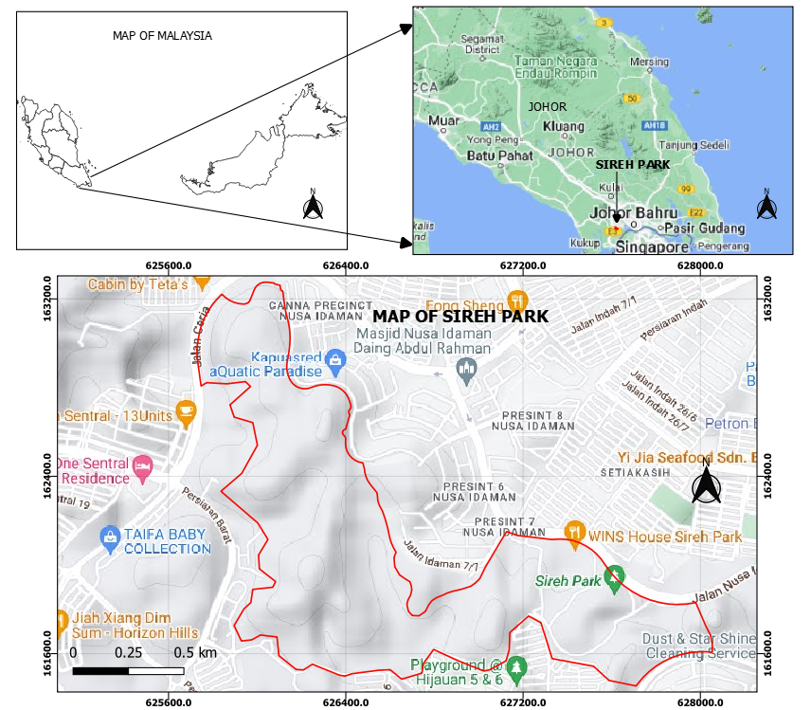

Figure 1. Location of the study area

Figure 1 shows the map of the study area. The map at the left top side shows the map of states in Malaysia, the map at the right top side is for Johor where the study area is located, and the map at the bottom shows the Sireh Park (study area).

Methodology

Methodology of this research encompasses the various steps that involved data collection, analysis, and interpretation, as well as validation. The data were collected through field survey, landslides record inform of inventory obtained from TNNHT, and imagery of the area from Google Earth Pro. The methodology involved landslide runout analysis, landslide exposure analysis, landslide vulnerability analysis, GIS based mapping, and validation analysis as shown in figure 2 below. The landslides inventory was overlaid with google earth image in order to locate the landslides area. This is done by converting obtained landslides inventory shapefile into KML file, the file was then imported to Google Earth Pro. Thereafter, an individual landslide polygon was demarcated from Google Earth imagery through the process of digitization.
The landslides inventory was used to generate landslides hazard map in GIS environment, which was later combined with the slope gradient map to generate the landslides run out distance at the boundary of the Sireh Park. In producing the landslides run out map, slope failure runout analysis is carried out along the boundary of Sireh Park, the value of slope gradient has been integrated with the specific hazard classification in GIS software. The landslides runout distance map was used to identify the interested elements at risks (buildings and roads) around the study area. A mobile tool was used to collect the data about the identified elements at risk and their associated vulnerability indicators and sub-indicators during field surveys. The tool was developed by Universiti Teknologi Malaysia on an ESRI mobile platform. It can collect data on elements at risk that include slope, building, road, and socio-economic. Also, Google Earth Imagery of the study area was georeferenced and used in GIS software to digitized the elements at risk in order to obtained their shape files.

Figure 2. Methodological flow of the study

a. Determining the landslides run out distance

Prior to the determination of run out distance, landslides hazard was computed because it was used in the calculation of run out distance. The levels of the hazards were combined together to produce three levels- low with very low levels, and high with very high levels while medium level was maintained as it was. Hence, a layer of the combined levels of hazards was produced. Slope failure runout analysis was carried out along the boundary of Sireh Park, the value of slope gradient was overlaid with the specific hazard classification. The equation (i) below was used to calculate the runout distance of slope gradients with high (25-35m) and very high (>35m) hazard levels, this category have their slope gradient-hazard classification normalized to 50 meters. For slope gradients with average (25m) hazard levels, their slope gradient-hazard classification is normalized into 25 meters. Finally, for slope gradients with low (5-15m) and very low (0-5m) hazard levels, their slope gradient-hazard classification was normalized into 10 meters. The normalised values were then used in determining the run out distance along the boundary of Sireh Park by substituting H in equation (i) below with each of the normalised values, the run out distance was calculated. The runout distance was then drew around the boundary of Sireh Park. The run out distance is wide in areas with high and very high slope gradient-hazard level, moderate in areas with average slope gradient-hazard level, and narrow in areas with low and very low slope gradient-hazard level.

Table 1. Runout distance related to the slope gradient hazard classification

S/N | Slope gradient hazard classification | Run out distance (L, meters)
1 | Very low and low | 10
2 | Moderate | 25
3 | High and very high | 50

The table 1 above shows the run out distance for normalized slope gradient-hazard classification levels for boundary of Sireh Park. From the table, The value for low and very low combined slope gradient-hazard levels is normalised to 10 meters, that of moderate is normalised to 25 meters, and those for high and very high is normalised to 50 meters.

L = 1.066H^{1.093} (i)
Where,
L = run out distance in meters, and H = height of slope in meters.

Runout distance (L) is the maximum distance that a landslide material travels from its initial starting point (crown) until it comes to a stop. Height of slope (H) is the vertical distance between its highest point and its lowest point of natural or cut off slope (Qarinur, 2015).

b. Determining the landslides exposure for elements at risk

In this study, landslide exposure mapping was utilized to prioritize the elements at risk characterization process in areas with high landslide occurrence compared to those with low or no inventory of landslides.
In determining the exposure of the elements at risk to landslides, run out analysis was used. The run out is generated from the normalised values of slope gradient-hazard classification levels provided in table 1. The levels of the hazards are combined together to produce three levels- low with very low, and high with very high while medium was maintained. A layer of the combined levels of hazards was produced. The value of slope gradient was overlaid with the specific hazard classification. The equation (i) was used to calculate the runout distance of slope gradients with high (25-35m) and very high (>35m) hazard levels, their slope gradient-hazard classification was normalized into 50 meters. For slope gradients with average (25m) hazard levels, their slope gradient-hazard classification was normalized into 25 meters. Finally, for slope gradients with low (5-15m) and very low (0-5m) hazard levels, their slope gradient-hazard classification was normalized into 10 meters. These normalised values were substituted into equation (i) above to represent H respectively; the run out distance is calculated. The run out was drew around the boundary of the Sireh Park and any element at risk that failed within the extent of the run out, or was touched by the run out to some extent was identified as the exposed element at risk.

c. Identifying and assigning weightage values to vulnerability indicators and sub-indicators

A literature review can help identify vulnerability indicators by revealing how they were calculated and applied in earlier landslides vulnerability analyses. The evaluation is based on the requirements for vulnerability assessment, the characteristics of the geographical area, coverage of the socioeconomic condition, and the targeted decision-making stakeholders (Krishna et al., 2021). Based on the field survey, buildings and roads are the most common physical infrastructures in the Sireh Park and are spatially distributed everywhere in the study area. The selected indicators to assess vulnerability of buildings and roads exposed to landslides in this study were obtained based on the literature review and from the standard guidelines approved by the Malaysia Housing and Local Government Ministry (KPKT) which also relied on comprehensive literature review, records of landslide occurrences in Malaysia, and intensive peer review (Mastura Azmi, 2020).
The attributes for buildings in this study include structure construction materials, building foundation depth, number of floor, presence of protection, distance between buildings, building location, accumulation heights, landslide volume, number of people per building, building renovation, maintenance of building, reporting on building damage due to slope failure, element of ownership, and affordability of maintenance. (Bera et al., 2020; Mastura Azmi, 2020; Singh et al., 2019; Subasinghe & Kawasaki, 2021). While those for roads include road category, location of road, road material, road maintenance, presence of protection, presence of warning system, road drainage system, landslide thickness, accumulation height, landslide volume, traffic volume, reporting on road damage due to slope failure, and road used by heavy vehicles (Mastura Azmi, 2020; Wohlers & Damm, 2022). Landslide accumulation height, also known as landslide depth, is the vertical measurement that spans from the highest point of the material deposited at the base of a landslide to the lowest point on the terrain surface where the landslide originated. This measurement is a critical indicator of a landslide's volume and scale. Slope height pertains to the vertical distance measured from the base of a slope to its highest point.
After generating the indicators for landslides vulnerability, experts were then consulted to assign weightage values to these indicators based on their respective significance in influencing landslides vulnerability. The process ensures that indicators are properly weighted, and accurately reflected their relative importance.

d. Determining vulnerability index for each element at risk

The assigned weightage values for the indicators and sub-indicators, as well as digitized shape files, were then input into Microsoft Excel spreadsheets. Using an indicator-based method, the relative vulnerability index for each element at risk was calculated within the same spreadsheet. The indicator-based method involved multiplying the weightage value of each sub-indicator by the weightage value of its respective indicator, and then summing the values for all indicators within a given cluster. The clusters were then summed up to obtain the vulnerability index. Upon completion of the calculation process, the spreadsheet was imported into Geographic Information Systems (GIS), where a geospatial database was created. This database enabled the analysis and visualization of the vulnerability index in a geographic context, allowing for a more comprehensive understanding of the relative vulnerability of the elements at risk to landslides.
The relative vulnerability index for each element at risk or critical infrastructure (CI) is calculated using the equation below.

V = ∑^{m}_{i=1} Wi x Si (ii)

Where, V = total landslide vulnerability, Wi = weight of indicators, and Si = weight of sub indicators (Bera et al., 2020; Mastura Azmi, 2020; Wohlers & Damm, 2022).

Results and discussion

- Landslides exposure

In figure 3 below, the yellow boundary encircling Sireh Park visually represents the extent of the landslides' runout distance, containing both linear road features and polygonal building structures located within, touching, or situated between this delineated area and the Sireh Park. They are the exposed elements at risk of physical infrastructures in the study area. The executed run out distance shows about 252 elements at risk exposed to landslides in Sireh Park, if landslides are to happen. Out of this number, 226 are buildings, which represent 89.7% while 26 are roads, which represents 10.3%. In addition, out of those buildings, 188 that represents 83.2% have 2-5 levels including the Chinese School while the remaining 38 that represents 16.8% have single floor. Meanwhile, out of the 26 roads, 23 that represents 88.5% are urban local streets while the remaining 3 that represents 11.5% are urban arterial roads.
Also, majority of those exposed elements at risks are located in the southern part of Sireh Park with about 138 houses out of 226, and 15 roads out of 26. Altogether, 173 out of 252. This accounted for 68.7% of the total number of the exposed elements at risk in the study area. This indicates that elements at risk in southern part of Sireh Park are more potential to landslides than those in the northern part.

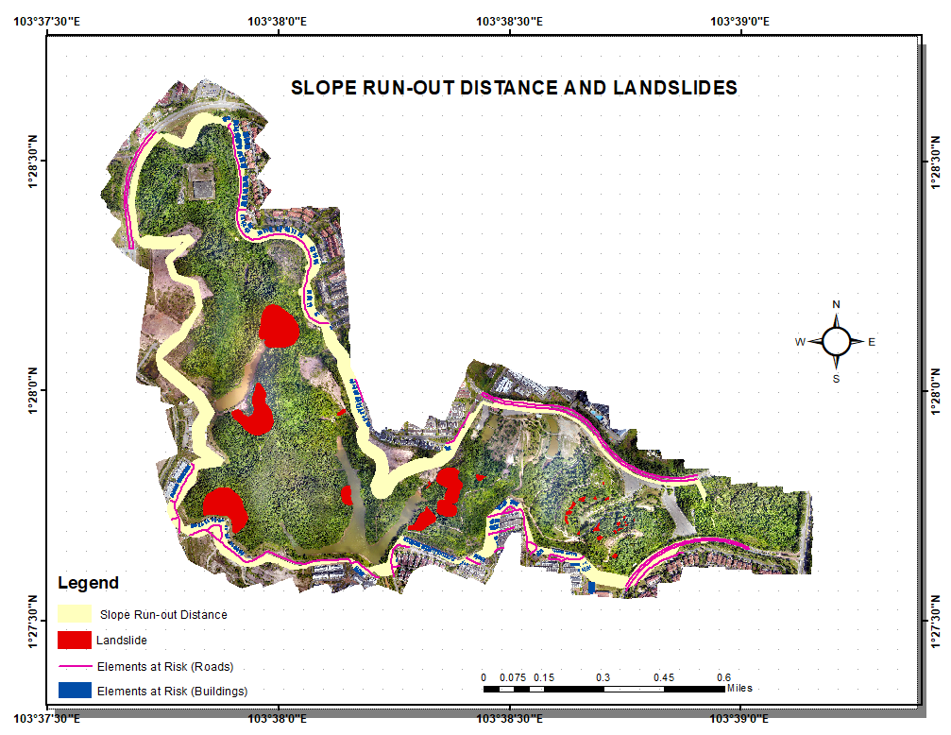
Figure 3. Map showing run-out distance and exposed elements at risk in Sireh Park

- Vulnerability assessment for buildings

The relative vulnerability index for each element at risk or critical infrastructure (CI) is calculated using the equation below.

V = ∑^{m}_{i=1} Wi x Si

Where, V = total landslide vulnerability, Wi = weight of indicators, and Si = weight of sub indicators.

From the figure 4 below, buildings are classified into five (5) classes of vulnerability using natural breaks classification method in GIS software. The classification is from very low- showing those buildings with lowest vulnerability to very high- showing those buildings with highest vulnerability to landslides. Buildings represented with red colour have highest vulnerability with value ranging from 0.0773 to 0.0986, while those with dark blue colour have the least vulnerability values, ranging from 0.0324 to 0.0339. From the map, 137 buildings have low landslides vulnerability, which is about 60.6%; 26 buildings have high landslides vulnerability, vulnerability, which is 11.5%; 25 buildings have very low landslides vulnerability; 20 have very high landslides vulnerability which is 11.1%; and 18 have medium vulnerability which is 8.0%.
The reason for very high vulnerability for those buildings may be due to no protection at the slope around them, they are located at the toe of the slope, landslide accumulation height around them is greater than 2 meters, landslide volume around them is greater than 250000m³, and they have average population density. Some of these reasons are in line with the findings of the studies conducted by Francone (2022) and Singh et al. (2019).

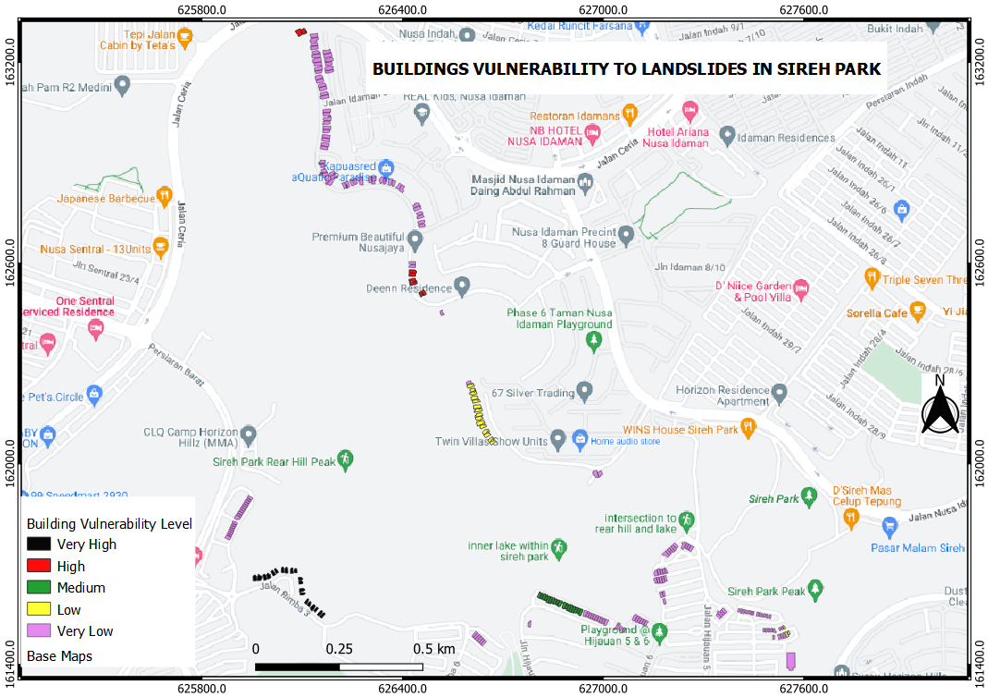

Figure 4. Map of landslide vulnerability of buildings
According to the data presented in figure 5 below, a significant majority of the structures situated within Sireh Park exhibit minimal vulnerability to the hazards posed by landslides. Several factors account for the relatively low level of vulnerability among these buildings, including the presence of deep foundation piles, medium-rise floor plans, engineered slope protection systems, and a lack of landslides with accumulation heights exceeding 1.5 meters in close proximity to the structures. Additionally, the buildings' renovation status and moderate population densities contribute to their resilience. Notably, landslide volumes exceeding 500m³ and accumulation heights greater than 0.2m are observed in the surrounding areas of these structures, further underscoring the importance of implementing effective protective measures.

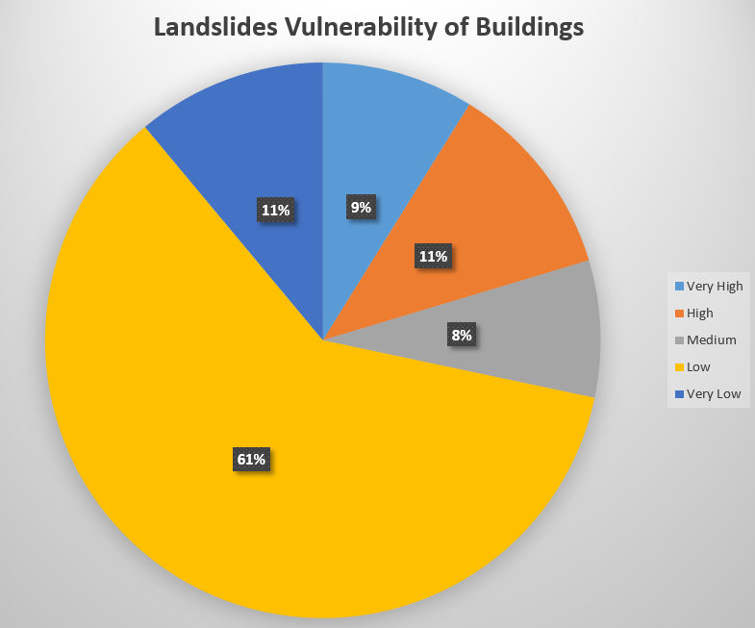

Figure 5. Graphical representation of buildings vulnerability to landslides in Sireh Park

Table 2. Classification of buildings into levels of vulnerability to landslides

Element at risk | Levels of vulnerability | Description | Vulnerability values
Buildings | Very low | Accumulation height/landslide depth is less than 1.5m deep foundation pile, there is engineered protection, buildings are located within slope height, landslide accumulation height is greater than 0.2 meters, landslide volume is greater than 500m3, population density of the buildings are average, and majority of the houses are renovated. | 0.0324-0.0338
Buildings | Low | Accumulation height/landslide depth is less than 1.5 meters and deep foundation pile, buildings have medium rise floor, there is engineered protection at the slope around the buildings, buildings are located within the height of the slope, landslide accumulation height is greater than 0.2m, landslide volume is greater than 500m3, population density is average, and majority of the buildings are renovated. | 0.0339-0.0404
Buildings | Medium | Accumulation height/landslide depth is 1.5-5m versus deep foundation pile, buildings have medium rise floor, there is no protection at the slope around the buildings, buildings are located within the height of the slope, landslide accumulation height is 0.5-2m, landslide volume is 500-1000m3, there is high population density, and majority of the buildings are renovated. | 0.0404-0.0571
Buildings | High | Accumulation height/landslide depth is 1.5-5m deep foundation pile, buildings have medium rise floor, there is no protection, buildings are located within the height of the slope, landslide accumulation height is 0.5-2m, landslide volume is greater than 250000m3, buildings have high population density, and majority of the buildings are renovated. | 0.0571-0.0773
Buildings | Very high | Accumulation height/landslide depth is 1.5-5m deep foundation pile, there is no protection at the slope around the buildings, buildings are located at the toe of the slope, landslide accumulation height is greater than 2 meters, landslide volume is greater than 250000m3, buildings have average population density. | 0.0773-0.0986

Table 2 states the reasons for various classification of the buildings into vulnerability levels from very low to very high. Following the vulnerability values of the exposed buildings in Sireh Park, if landslide is to happen, the damage to the buildings will be slight with no structural damages, this is because majority of the buildings (137) that account for about 60.6% have vulnerability within damage level 2 (lightly damage) with vulnerability values between 0.0339-0.0404. In addition, 25 buildings that account for about 11% have vulnerability within damage level 1 (negligible damage) with vulnerability values between 0.0324-0.0338. This is in line with the claimed made by the JMG Johor, that the rocks of Sireh Park are considered normal by geologist (JMG, 2017). However, there is significant number of buildings with high and very high vulnerability values. 26 buildings that account for about 11.5% with vulnerability values between 0.0571-0.0773 have high vulnerability and fall within damage level 4 (severely damage). This leads to collapse of masonry, partial collapse of floors, severe cracking or collapse of sections of structure. 20 buildings that account for about 8.8% with vulnerability values between 0.0773-0.0986 have very high vulnerability and fall within damage level 5 (very severe damage). This leads to partial or total collapse of the building (Zakaria et al., 2018). Meanwhile, 18 buildings that account for about 8% have medium level of vulnerability.

b. Vulnerability assessment for roads

Roads are also among the physical infrastructures that are exposed to landslide in Sireh Park. About 26 roads are identified to be exposed based on the run out analysis and their vulnerability to landslides is calculated as well using indicator based approach.
The classification of roads based on their vulnerability to landslides in Sireh Park is shown in figure 6. From the figure, approximately 31 sections of roads are vulnerable to landslides in Sireh Park. Of these sections, 13 have a high level of vulnerability (0.0301-0.0341) and account for 41.9% of the vulnerable sections. Additionally, nine sections have a medium level of vulnerability (0.0281-0.0301) and account for 29% of the vulnerable sections. There are also four sections with a very high level of vulnerability (0.0341-0.0419) that account for 12.9% of the vulnerable sections, while three sections have a low level of vulnerability (0.0265-0.0281), accounting for 9.7% of the vulnerable sections. Finally, two sections have a very low level of vulnerability (0.0255-0.0265), accounting for approximately 6.5% of the vulnerable sections in the study area. Most of the roads with high and medium vulnerability are located in the southern part of Sireh Park. This suggests that the majority of roads in the southern part of Sireh Park are more vulnerable to landslides compared to those in the northern part.

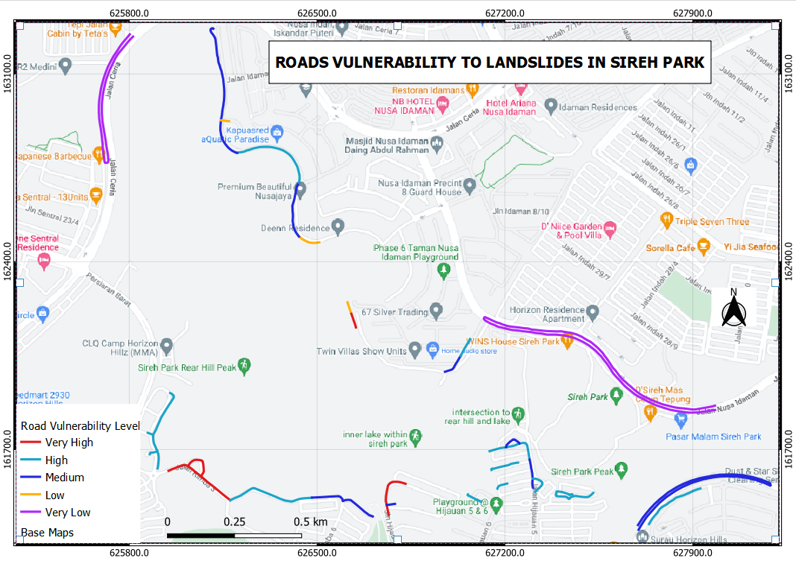
Figure 6. Levels of landslides vulnerability for roads in Sireh Park

In figure 7 below, majority of the roads in Sireh Park are having high vulnerability to landslides. The reasons for this high vulnerability is attributed to the roads having the following indicators: the road is located within the height of the slope, the road has no protection, landslide accumulation height is less than 0.2 meters, landslide thickness is less than 1.5 meters, and landslide volume is less than 500m³

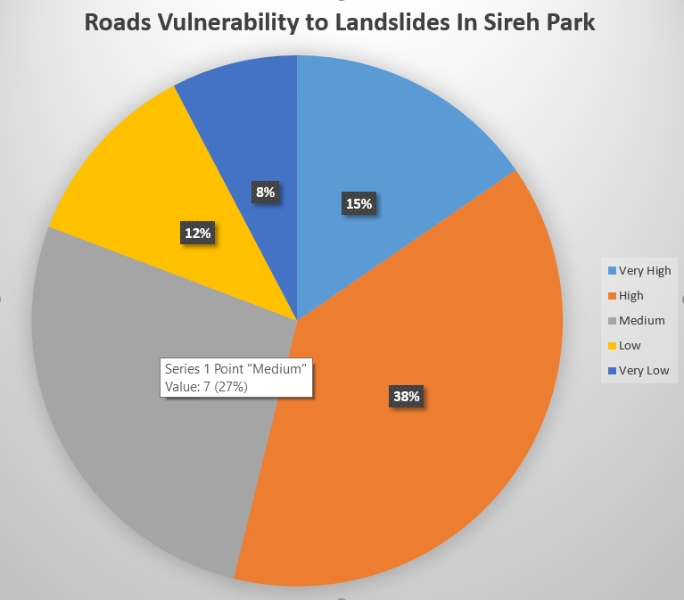

Figure 7. Pie chart showing levels of roads vulnerability to landslides in Sireh Park

Table 3. Reasons for the classification of roads into various classes of landslides vulnerability in Sireh Park

Element at risk | Levels of vulnerability | Description | Vulnerability values
Roads | Very low | The road is located at a distance more than the slope height, no protection at the slope around the road, accumulation height is less than0.2 meters, landslide thickness is less than 1.5 meters, and landslide volume is less than 500m³ | 0.0255-0.0265
Roads | Low | Road is located at a distance within the slope height, there is presence of engineered protection at the slope around the road, landslide accumulation height is less than 0.2 meters, landslide volume is less than 500m³, and landslide thickness is less than 1.5 meters. | 0.0265-0.0281
Roads | Medium | The road is located at a distance more than the slope height, the road has no protection, landslide thickness is less than 1.5 meters, landslide accumulation height is less than 0.2 meters, and landslide volume is less than 500m³ | 0.0281-0.0301
Roads | High | The road is located within the height of the slope, the road has no protection, landslide accumulation height is less than 0.2 meters, landslide thickness is less than 1.5 meters, and landslide volume is less than 500m³ | 0.0301-0.0341
Roads | Very high | The road is located within the height of the slope, no protection system for the road, the estimated accumulation height of landslide is 2.0m, landslide thickness is 5-20m, and the landslide volume is 10000-50000m³ | 0.0341-0.0419

Table 3 provides the reasons for the classification of the roads into various classes of vulnerability. From the values of vulnerability provided in the table, if landslide is to happen in Sireh Park, affected roads sections are expected to have structural damage that can affect the stability and functionality of the road. This is because majority of the roads sections (13) that account for about 41.9% have high vulnerability values (0.0301-0.0341) that belong to the damage level 4 (Severely damage). Four roads sections that account for about 12.9% have very high vulnerability values (0.0341-0.0419) that belong to the damage level 5 (very severe damage). This may leads to partial or total collapse of the road. Two roads sections have very low vulnerability values (0.0265) that account for about 2.5%. They belong to the damage level 1 (negligible damage) which have no significant damage to the roads sections if landslides occur. Three roads sections that account for about 9.7% have low vulnerability with damage level 2 (slightly damage) which may have no structural damage to the roads i.e the roads sections may have minor repairable damage when landslides occur (Zakaria et al., 2018). Meanwhile, nine roads that account for about 29% have medium level of road vulnerability.

Validation of the results

The process of validation plays a crucial role in evaluating the precision and dependability of vulnerability assessments. To confirm the accuracy of vulnerability mapping, it is essential to visually inspect and verify the results by examining photographs captured during field surveys. These photographs document the actual conditions on the ground, specifically focusing on physical infrastructures such as buildings and roads as well as the surrounding environment within the research area. Photographs are used to validate the findings of this study, this is because they serve as tangible proof and offer a visual depiction of the conditions witnessed during the field surveys as shown in table 4.

Table 4. Validation analysis

Buildings and road located within the height of the slope.  1.467175º, 103.636083º | 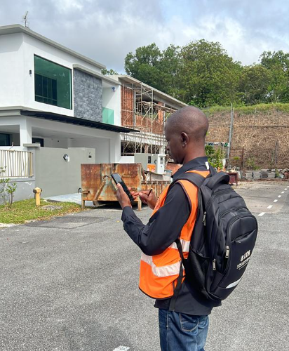
A slope failure outsides the border of Sireh Park but close to residential area  1.466111°, 103.635556° | 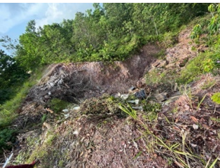
Slope with rubber sheeting above the height of buildings  1.466111°, 103.635556° | 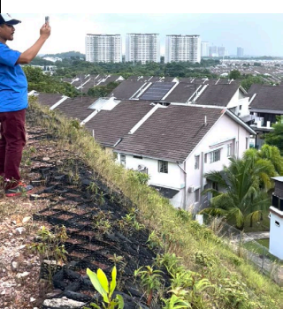
Building located within the height of the slope  1.470233º, 103.635239º | 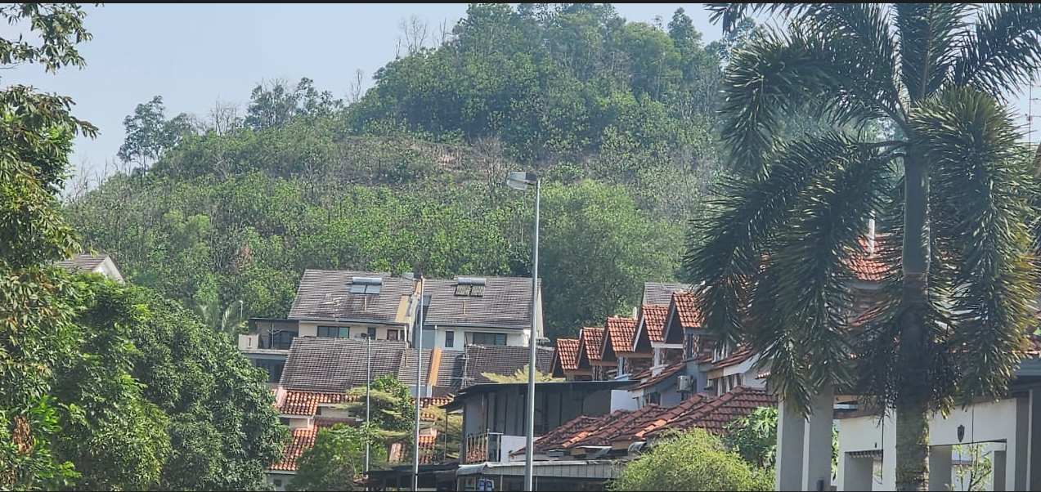
Road located at the foot of the slope  1.475969º, 103.631797º | 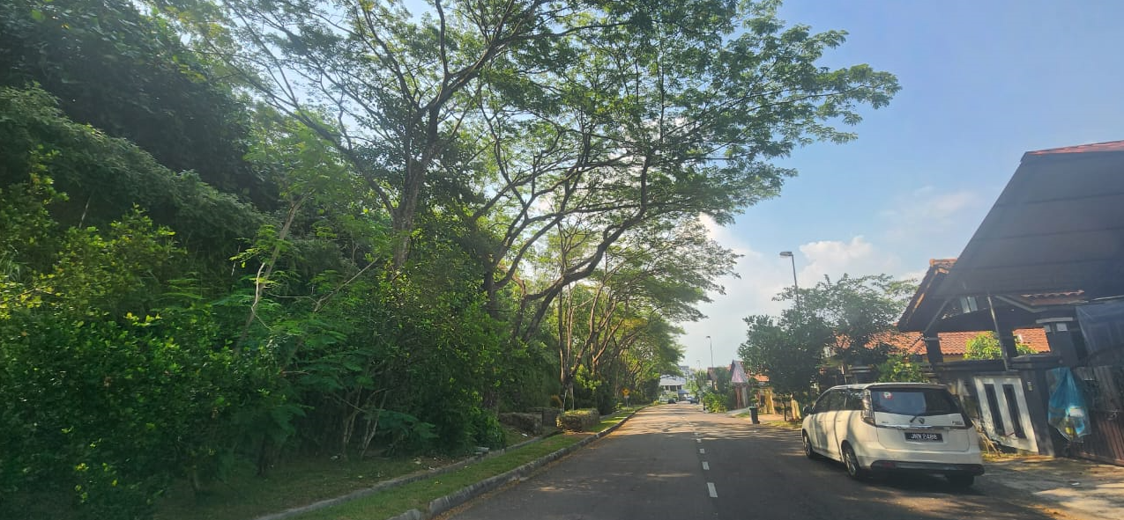

Conclusion

A geospatial approach was employed to conduct a landslides vulnerability assessment of physical infrastructures in Sireh Park, Johor Bahru. The study identified 252 elements at risk are exposed to landslides in Sireh Park, out of which 226 (89.7%) are buildings, while 26 (10.3%) are roads. The general level of buildings' vulnerability to landslides in the study area is relatively low, however about 20.4% of the buildings display a high degree of vulnerability. Meanwhile, the general vulnerability of roads sections to landslides is averagely high, with about 54.8% of the roads sections exhibiting a high degree of vulnerability while 16.1% exhibits low degree of vulnerability. In addition, the relative vulnerability index for each building and road element at risk was calculated separately and by clusters of indicators.
The findings of the research can help inform development planning, including the identification of areas with a high vulnerability to landslides, which can guide decision-making on land use, and infrastructure design. Furthermore, the research can contribute to the development of mitigation strategies aimed at reducing the impact of landslides. For instance, buildings and roads located in areas with a high degree of vulnerability can be strengthened, modified, or relocated to minimize the risk of damage or loss of life. Additionally, infrastructure can be designed to incorporate features that improve resilience to landslides, such as slope stabilization measures, and sufficient drainage systems. The research findings on specific types of damages that buildings and roads are likely to sustain in the event of a landslide, as well as their locations, can guide the allocation of resources such as emergency response equipment and personnel to the areas most likely to be affected. This enables a faster and more effective response to minimize the impact of landslides.

Acknowledgement

This research was funded by the Universiti Teknologi Malaysia (UTM) Matching Grant (MG) (Ref: Q.J130000.3052.04M26).

References

Abd Sahrin, M. S., & Khanan, M. F. A. (2022). Geospatial metamodel for landslide disaster management in Malaysia: Current practices. Journal of Information System and Technology Management, 7(25), 65–82. Retrieved from https://doi.org/10.35631/JISTM.725005
Akter, A., Noor, M. J. M. M., Goto, M., Khanam, S., Parvez, A., & Rasheduzzaman, M. (2019). Landslide Disaster in Malaysia: An Overview. International Journal of Innovative Research and Development, 8(6), 292-302. Retrieved from https://doi.org/10.24940/ijird/2019/v8/i6/JUN19058
Anonymous. (2022, June 23). Housing and Local Government Ministry: Landslide risk assessment guidelines approved. Malaymail Retrieved from https://www.malaymail.com/news/malaysia/2022/06/23/housing-and-local-government-ministry-landslide-risk-assessment-guidelines-approved/13929
Arrogante-Funes, P., Bruzón, A. G., Arrogante-Funes, F., Ramos-Bernal, R. N., & Vázquez-Jiménez, R. (2021). Integration of vulnerability and hazard factors for landslide risk assessment. International Journal of Environmental Research and Public Health, 18(22), 11987. Retrieved from https://doi.org/10.3390/ijerph182211987
Bera, S., Guru, B., & Oommen, T. (2020). Indicator-based approach for assigning physical vulnerability of the houses to landslide hazard in the Himalayan region of India. International Journal of Disaster Risk Reduction, 50, 101891. Retrieved from https://doi.org/10.1016/j.ijdrr.2020.101891
Emberson, R. A., Kirschbaum, D. B., & Stanley, T. (2021). Landslide Hazard and Exposure Modelling in Data‐Poor Regions: The Example of the Rohingya Refugee Camps in Bangladesh. Earth’s Future, 9(2), 1-22. Retrieved from https://doi.org/10.1029/2020EF001666
Fakhrul, I., Iqbal, M. F., Mahmood, I., Shahzad, M. I., & Shah. U. S. (2022). Application of frequency ratio, information value, and weights-of-evidence models and their comparison in landslide susceptibility mapping in Murree Region, SubHimalayas. Research Square, 1-22. Retrieved from https://doi.org/10.21203/rs.3.rs-2218881/v1
Francone, L. (2022). Vulnerability assessment of buildings to landslide. Politecnico di Torino.
Froude, M. J., & Petley, D. N. (2018). Global fatal landslide occurrence from 2004 to 2016. Natural Hazards and Earth System Sciences, 18(8), 2161–2181. Retrieved from https://doi.org/10.5194/nhess-18-2161-2018
JMG. (2017). Memasyarakatkan geologi di Sireh Park, Iskandar Puteri. Retrieved from Retrieved from http://blog.jmg.gov.my/akrab/memasyarakatkan-geologi-di-sireh-park-iskandar-puteri
Komu, M. P., Nefeslioglu, H. A., & Gokceoglu, C. (2023). A review of the prediction methods for landslide runout. Proceedings, 87(1), 3. Retrieved from https://doi.org/10.3390/IECG2022-14604
Krishna, P. S. V. R., Shivakoti, B. R., Dewi, A., Arambepola, N.M.S.I., Kartiko, R. D., Jayasinghe, S., Basnayake, S., & Towashiraporn, P. (2021). On integrating climate change projection into landslide risk assessments and mapping at the river basin level. Jakarta. Retrieved from https://www.nadma.gov.my/images/nadma/documents/riskassessment/Landslide Risk Assessment and Mapping Guideline_ASEAN.pdf
Lagi, L. (2022). Sireh Park, Iskandar Puteri. Retrieved from https://www.facebook.com/SirehPark.IskandarPuteri/?locale=ms_MY
Leoi, S. L., Chan, A. & Trisha, N. (2018, December 4). Malaysia among countries especially prone to landslides. Brudirect Retrieved from https://brudirect.com/news.php?id=58983
Majid, N. A. (2020). Historical landslide events in Malaysia 1993-2019. Indian Journal of Science and Technology, 13(33), 3387–3399. Retrieved from https://doi.org/10.17485/IJST/v13i33.884
Mastura Azmi, K. A. R. (2020). Guidelines for landslide vulnerability assessment and development of risk index for critical infrastructure (CI) in Malaysia. Kuala Lumpur. Retrieved from https://jkt.kpkt.gov.my/sites/default/files/2022-08/Pekeliling KSU KPKT - Bil.1 Tahun 2022 %28Landslide%29 dan GP Resilience Construction.pdf
McDougall, S. (2017). 2014 Canadian Geotechnical Colloquium: Landslide runout analysis — current practice and challenges. Canadian Geotechnical Journal, 54(5), 605–620. Retrieved from https://doi.org/10.1139/cgj-2016-0104
MET. (2023). Malaysia’s Climate. Retrieved from https://www.met.gov.my/en/pendidikan/iklim-malaysia/
Moncayo, S., & Ávila, G. (2023). Landslide travel distances in Colombia from National Landslide Database Analysis. In Sassa, K., Konagai, K., Tiwari, B., Arbanas, Z., & Sassa, S. (eds). Progress in Landslide Research and Technology, 1(1) (pp. 315–325). Springer.
Omar, S. N. A. (2022, April 2). Sireh Park tarikan pelancongan terbaharu di Johor. Astro Awani Retrieved from https://www.astroawani.com/berita-malaysia/sireh-park-tarikan-pelancongan-terbaharu-di-johor-354866
Papathoma-Köhle, M., Gems, B., Sturm, M., & Fuchs, S. (2017). Matrices, curves and indicators: A review of approaches to assess physical vulnerability to debris flows. Earth-Science Reviews, 171, 272–288. Retrieved from https://doi.org/10.1016/j.earscirev.2017.06.007
Pellicani, R., Van Westen, C. J., & Spilotro, G. (2014). Assessing landslide exposure in areas with limited landslide information. Landslides, 11(3), 463–480. Retrieved from https://doi.org/10.1007/s10346-013-0386-4
Qarinur, M. (2015). Landslide runout distance prediction based on mechanism and cause of soil or rock mass movement. Journal of the Civil Engineering Forum, 1(1), 29-35. Retrieved from https://www.researchgate.net/publication/318366111_landslide_runout_distance_prediction_based_on_mechanism_and_cause_of_soil_or_rock_mass_movement/link/5966421fa6fdcc18ea608fbd/download
Rahman, A. A. A., Majid, N. A., & Selamat, N. S. (2020). A comprehensive deriving the factors of landslide happened in Malaysia. International Journal on Emerging Technologies, 11(5), 310–314. Retrieved from https://www.researchtrend.net/ijet/pdf/46 A Comprehensive Deriving the Factors of Landslide Happened in Malaysia-3209-A.A.pdf
Rahman, H. A., & Mapjabil, J. (2017). Landslides Disaster in Malaysia: an Overview. Health and the Environment Journal, 8(1), 58–71. Retrieved from https://www.researchgate.net/profile/Haliza-Abdul-Rahman/publication/321096764_Landslides_Disaster_in_Malaysia_an_Overview/links/5a0d1fe60f7e9b9e33a9e8f3/Landslides-Disaster-in-Malaysia-an-Overview.pdf
Roslee, R., Jamaludin, T. A., & Simon, N. (2017). Landslide Vulnerability Assessment (LVAs): A case study from Kota Kinabalu, Sabah, Malaysia. Indonesian Journal on Geoscience, 4(1), 49-59. Retrieved from https://doi.org/10.17014/ijog.4.1.49-59
Roslee, R., Madri, A. N., & Zikiri, M. F. (2020). Landslide Vulnerability Assesment (LVAS) in Luyang area, Kota Kinabalu, Sabah, Malaysia. Environment & Ecosystem Science, 4(2), 100–104. Retrieved from https://doi.org/10.26480/ees.02.2020.100.104
Singh, A., Kanungo, D. P., & Pal, S. (2019). Physical vulnerability assessment of buildings exposed to landslides in India. Natural Hazards, 96(2), 753–790. Retrieved from https://doi.org/10.1007/s11069-018-03568-y
Singh, A., Pal, S., & Kanungo, D. P. (2019). Site-Specific vulnerability assessment of buildings exposed to rockfalls. In Chattopadhyay, J., Singh, R., & Prakash, O. (eds). Renewable Energy and its Innovative Technologies (pp. 1–11). Springer. Retrieved from https://doi.org/10.1007/978-981-13-2116-0_1
Sivakami, C., & Rajkumar, D. R. (2020). Landslide Vulnerability Zone by Weights of Evidence Model using Remote Sensing and GIS, in Kodaikanal Taluk (Tamil nadu, India). International Journal of Engineering Research And, V9(02), 788-793. Retrieved from https://doi.org/10.17577/IJERTV9IS020201
Subasinghe, C. N., & Kawasaki, A. (2021). Assessment of physical vulnerability of buildings and socio-economic vulnerability of residents to rainfall induced cut slope failures: A case study in central highlands, Sri Lanka. International Journal of Disaster Risk Reduction, 65, 102550. Retrieved from https://doi.org/10.1016/j.ijdrr.2021.102550
UNISDR. (2017). Words into Action Guidelines: National Disaster Risk Assessment Hazard Specific Risk Assessment. Retrieved from https://www.unisdr.org/files/52828_03landslidehazardandriskassessment.pdf
Van Westen, C. J., Castellanos, E., & Kuriakose, S. L. (2008). Spatial data for landslide susceptibility, hazard, and vulnerability assessment: An overview. Engineering Geology, 102(3–4), 112–131. Retrieved from https://doi.org/10.1016/j.enggeo.2008.03.010
Wohlers, A., & Damm, B. (2022). Rockfall Vulnerability of a Rural Road Network—A Methodological Approach in the Harz Mountains, Germany. Geosciences, 12(4), 170. Retrieved from https://doi.org/10.3390/geosciences12040170
World bank. (2021). Current Climate-Climatology. Retrieved from https://climateknowledgeportal.worldbank.org/country/malaysia/climate-data-historical#:~:text=Malaysia has a tropical climate,hottest months of the year.
Wubalem, A. (2022). Landslide inventory, susceptibility, hazard and risk mapping. IntechOpen. Retrieved from https://doi.org/10.5772/intechopen.100504
Zakaria, M., Ramli, Z., Rahman, M. Z. A., Salleh, M. R. M., Ismail, Z., & Khanan, M. F. A. (2018). Vulnerability mapping and analysis: An implementation in geohazard areas in Sabah. The International Archives of the Photogrammetry, Remote Sensing and Spatial Information Sciences, XLII-4/W9, 189-200. Retrieved from https://www.proquest.com/docview/2585419660/fulltextPDF/AB7D82214D994E76PQ/1?accountid=41678

