The benefits of traditional Malay architecture in the traditional settlement

Nur Nazatul Huda Ruhizar¹, Nor Zalina Harun¹, Siti Marziah Zakaria²

¹Institute of the Malay World and Civilization, Universiti Kebangsaan Malaysia
²Faculty of Social Sciences and Humanities, Universiti Kebangsaan Malaysia

Correspondence: Nur Nazatul Huda (email: p116395@siswa.ukm.edu.my)

Received: 21 June 2023; Accepted: 17 August 2023; Published: 30 August 2023

Abstract

Traditional Malay Architecture is built based on different architectural typologies and the advantages that will be acquired by residents that have preserved the bulk of their architecture. A traditional village known as Kampung Pulau Sekati in Kuala Terengganu has been chosen as a research area due to its age and physical characteristics, which have been conserved despite the threat of urbanisation in this study. However, the benefits of traditional architecture conservation on the local community are less discussed due to a lack of understanding about protecting the importance of a traditional settlement. In order to achieve this goal, this study has outlined three main objectives that aim to identify the category of architectural uniqueness in Kampung Pulau Sekati and analyze the architectural uniqueness and the benefits produced to the residents of Kampung Pulau Sekati. This qualitative study employs observation and interviews with 24 people of Kampung Pulau Sekati who have lived there for at least 30 years. Observation, meantime, is conducted using a structured survey based on a checklist separated into building type, building environment, demarcation, accessibility, natural components, and social and cultural area. Seven architectural typologies have been recognised in Kampung Pulau Sekati, including residential dwellings, mosques, wooden bridges, community halls, jetties, dangau, and retail outlets. In the context of residential houses, this study identifies five categories of uniqueness, namely the use of wood as a building material, the construction of structures by the occupants, the variety of spatial functions, the presence of mature plants, and the ease of access to food and water sources. These findings have implications for architecture in traditional settlements and can establish a distinct identity for the village and a desire to conserve residential architecture for future generations.

Keywords: Architecture, benefits, feelings, physical characteristics, traditional settlements, uniqueness

Introduction

Traditional houses are the most essential architectural experience that is in harmony with the people's culture, beliefs, environment, and lifestyles for the resident. The development of design values in old houses architecture by tracking traditional design values in architecture paves the way for arguments concerning the implementation of authentic Malay traditional house design giving lots of benefits to the resident from the uniqueness of their surroundings. So, it's important to celebrate and make use of the fact that some settlements have managed to preserve at least some of their original, traditional architecture. In fact, each type of this architecture is discovered to give occupants a variety of advantages. This can be seen from their efforts in modifying their new settlement for the better without affecting the available resources. The development of traditional settlement has traditional characteristics from the aspect of physical character and the community still maintains socio-cultural activities such as social and cultural activities.
According to studies, the uniqueness of this traditional house is in the use of wooden material which is prominent as robust, long-lasting and not easy to deteriorate spontaneously (Bahardin et al., 2022). The uniqueness and durability of the architectural form of this house are also influenced by the care of its resident to continue to remain intact for the use of future generations.

Literature review

Traditional settlement

Traditional settlement is one of the attractive assets that gives privilege to an area from the past to the future (Setyaningsih et al., 2015). Traditional settlements began with the development of settlements along the coast and rivers (Hassan et al., 2020). Traditional settlements are one of the important assets that have special value from the point of view of history, customs, culture and architecture that are able to develop the identity of a community in a country (Jaffar & Harun, 2019). Before the arrival of foreign influence, traditional settlements were built by the Malay ethnic population in the Malay Peninsula, Singapore, Sumatra and Kalimantan (Borneo). Traditional settlements contribute a lot to the economic and social importance of an area. Most of these areas are well preserved so that the uniqueness of the area can be used as a reference for future generations (Shamsuddina & Ujang, 2008). The uniqueness of the traditional settlement is formed by the characteristics of the area that have importance and contribute to the daily life of the people who live in an area. These settlements are aimed at the needs of individuals and provide conditions that support the daily activities of the community.
In general, traditional settlements are chosen to meet the criteria in terms of location, physical characteristics, economy and which are undergoing changes, especially in terms of modernization and urbanization (Katiman et al., 2011). The settlement is connected by a good transport system. The residential houses and the physical environment of the settlement are mostly at the stage of transition towards modernization but are well maintained by the residents of the area (Katiman et al., 2011). Each traditional settlement has an attractive physical character that can accommodate the variety of activities in the settlement (Hassan et al., 2020). This character is seen in the type of road, demarcation, accessibility, infrastructure facilities and one of them is an architectural typology such as buildings and residential houses that have a variety of spatial functions.

Traditional architecture and its importance

The appearance of architectural forms is a human manifestation of the influence of the environment, its scope includes elements of culture, environment, beliefs, history and technical capabilities. Traditional Malay architecture is also no exception in adapting and integrating the elements of its environment. Therefore, Malay architecture is seen to be able to provide a good example in terms of building materials, techniques and construction concepts (Rahmat et al., 2022). According to Putra and Putri (2023), traditional Malay community residential construction is commonly known as vernacular tradition. Malay architecture is developed in line with the cultural image of the Malay community itself. Therefore, Malay architecture has design elements that suit its climate and environment which are related to building typology, building environment, demarcation, accessibility, natural components, social and cultural space.
The durability of wood as a building material is proven by the remains of old traditional houses, palaces and mosques in Malaysia. This traditional architecture has highlighted the art of Malay woodcarving which depicts the characteristics of traditional Malay architecture and the uniqueness of Malay culture in the past (Azmin et al., 2021). Malay houses, including palaces, are built with an ecological balance that is the use of building materials that do not deposit heat, a design characterized by various openings to promote cross-ventilation, a staged floor, pillars and construction with direct sunlight control. This means that all the constructions of Malay heritage houses choose the style of a stage house or pillared, vaulted house, i.e. the floor is built higher than the ground surface to reduce moisture from the ground and allow hot air to circulate out and encourage cold air to come in (Ismail et al., 2009 & Kassim, 2017). This indirectly describes the art of heritage architecture which has uniqueness and further benefits the economic, environmental and social factors. The importance of heritage architecture to some extent contributes to economically viable tourism (Boskovic et al., 2019).

Place attachment and architecture

The importance of a space was emphasized by scholars such as Relph and Tuan in 1976. Place attachment theory was introduced as early as the 70s by Tuan who is a humanistic geographer. Place attachment is often referred to as an effective bond between people and a place. Place attachment is a concept in the field of environmental psychology that refers to a long-term emotional relationship between an individual and a certain environment. This term can be used to study how residents feel about the space in which they live. Place attachment involves long-term experiences that are present in a person's life. However, it changes from time to time because a sense of attachment makes a certain place a symbol of identity for them (Cowden et al., 2021). But if you look more deeply, the convergence of places involves positive experiences, sometimes it happens without realizing it. This is because it is developed over time depending on the relationship and behavior between individuals or groups and their socio-physical environment.
Attachment is the relationship between stakeholders and residents with the destination. Attachment involves non-physical aspects that lead to physical actions (Razali et al., 2022). Place attachment means the bond between people and places (Seamon, 2013). This shows that human emotional elements give a positive relationship to a place (Hashem et al., 2013). For residents, place attachment is built due to the existence of positive feelings towards the area that affect the experience of the place (Davis, 2016). In addition, the study of architecture and its relationship with the theory of place consolidation plays a very important role in the formation of a settlement (Mohmad Shukri et al., 2022). The importance of the architecture of this place will bring the residents together to achieve a project with the original residents to achieve the same objective, reflect the residents and the cultural identity of an area, build an architectural culture for a land development and one of the strategies to stimulate culture and social through an integrated process to create a sustainable and resilient society for the future (Jamleoui, 2009).

Dimensions of place rootedness

Based on the documentation of past studies and analysis of articles on place rootedness, preliminary analysis shows that there are two main dimensions known as origin and sense or feeling under place rootedness. However, to understand the domain, there are additional concepts parallel to place rootedness described by Tuan (1980) which can be obtained from time to time such as gathering experiences, developing a sense of place and having a strong and positive attachment to a place. This has presented a sense of place in the residents (Clifford, 2020), consisting of local natives and people who were born and have stayed for a long time to carry out social activities and have a deep attachment to the place.
The sense or feeling dimension is divided into four aspects, namely feeling comfortable, safe, loving and proud when living in the area. This feeling of comfort refers to the location of a place that is accurate and does not change its physical shape and feels that he is used to and aware of his surroundings. While feeling safe refers to the presence of the individual in the home environment and surrounded by familiar people. The feeling of love is present in them due to old memories and family relics while the feeling of pride to be visited by outsiders for the village's specialness and uniqueness. This is because they have a strong feeling of inevitability that has existed in them (Walton et.al, 2021) which is related to the concept of sense of belonging. Shafii (2019), thinks that it is important for a person to learn to reach this level of taste and feeling, if a person wants to make peace and imbue those feelings with the places they often visit.

Method and study area

In order to identify and analyze the uniqueness of architecture and its benefits to the population more deeply, this study has adapted qualitative research as the main method of conducting research. This qualitative method involves literature review, interviews and observations. The survey was conducted between February 2022 and November 2022, and it targeted a population of middle-aged and elderly adults as respondents in Kampung Pulau Sekati (KPS). This is because they are more sensitive and knowledgeable about environmental changes in the area.

Justification of site selection

Kampung Pulau Sekati (KPS) was chosen because it has its own uniqueness and special features. This village is also listed in the Terengganu State Structure Plan 2050 to be made a heritage village. KPS is located in the urban area of Kuala Terengganu and it is near Kampung Paloh and the Terengganu Museum. There is a concrete bridge measuring nearly 1.58 kilometers that connects Kampung Teluk Pasu with Losong, passing through Pulau Sekati and spanning the Terengganu River. In addition, there is a wooden bridge that connects KPS with the Terengganu Museum. This makes it easier for residents to go out into the city and provides safety for their children to go to school by bicycle. This village is a remote Malay village. According to the Village Head Salleh (2022), the geographical position of this village is located on an island surrounded by rivers. This caused Sekati Island to be separated from other villages.
The population of Pulau Sekati village consists of around 250 residents consisting of 48 houses, a mosque and a public hall. The average resident of Pulau Sekati carries out rich carpentry activities such as making houses, furniture and other things based on wood. A total of 24 informants representing 10% of the population in KPS were successfully interviewed. Kampung Pulau Sekati as a "living heritage" that has existed naturally since hundreds of years ago to display its uniqueness to future generations (Terengganu State Structure Plan 2050). Pulau Sekati is a village in the cultural heritage tourism zone (Terengganu State Structure Plan 2050). The city of Kuala Terengganu is a cultural heritage tourism hub such as the State Museum, Islamic Civilization Park, Abidin Mosque, Kg. China and the islands of Sg. Terengganu includes Pulau Sekati and Pulau Duyong. The KPS location can be seen through the following figure 1:

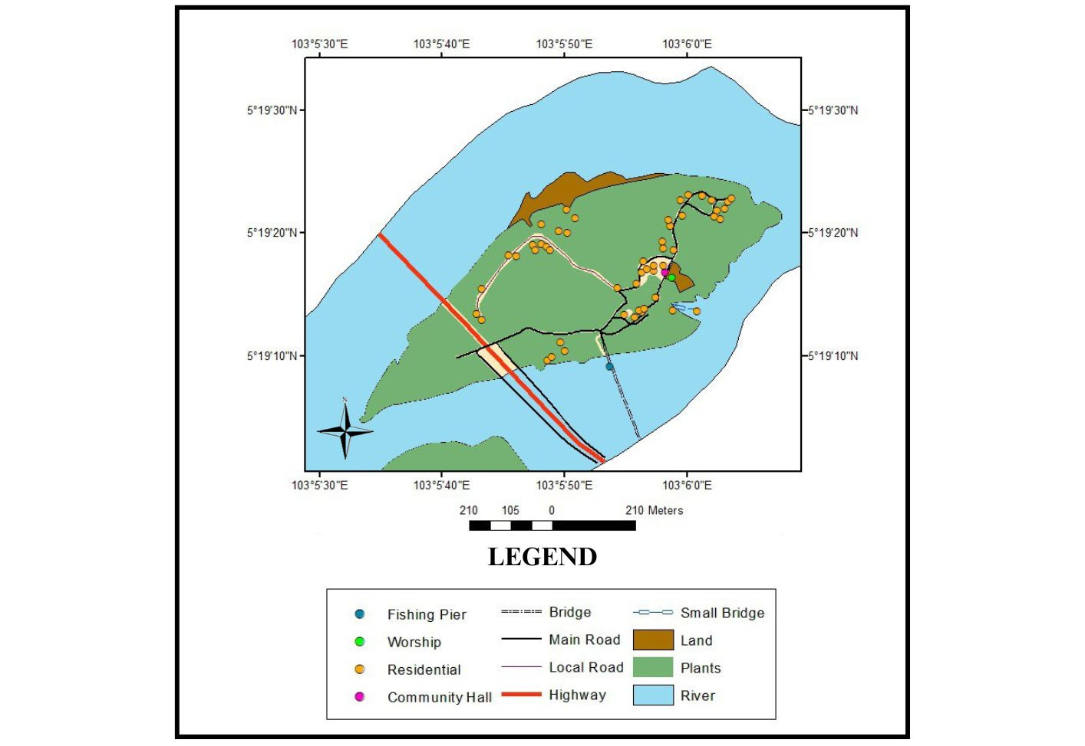
Source: Adapted and Modified from Google Map of Pulau Sekati, 2022

Figure 1. Residential areas in the study’s location

Justification of interview and observation methods

The selection of the interview method was used in this study because it successfully provided detailed information related to the subject being studied. This means that in order to obtain detailed and in-depth information, qualitative research should be used. Therefore, research on the meaning and convergence of places uses the interview method because it successfully answers the questions and objectives of the study (Camille Marcotte & Patricia A. Stokowski, 2021; David J. Trimbach & Kelly Biedenweg, 2021). Interviews were conducted with 24 local residents who have lived in Kampung Pulau Sekati (KPS) for more than 30 years using snow ball sampling. The average interview informant consists of middle-aged and elderly adults as respondents because they are more sensitive and knowledgeable about environmental changes in the area. These 24 informants represent 9.6% of the population in KPS.
Basically, the questions presented in this interview are formed based on the ideas obtained through the literature highlights. This interview question is divided into five parts. Part A involves the informant's background, part B: the physical character and uniqueness of traditional settlements, part C: residents' feelings towards the uniqueness of traditional settlements from the aspect of place identity, part D: the effect of place identity on the level of change that occurs in traditional settlements and E: actions residents in preserving the sustainability of traditional settlements.
As for the observation method, this study was conducted with a structured survey based on a checklist divided into building typology, building environment, demarcation, accessibility, natural components, social and cultural space. Once the data has been obtained, data analysis is done using a thematic analysis that involves the use of AutoCAD applications to map residents' homes that have unique characteristics based on building typology. The process of content analysis is done to analyze the data obtained to achieve the goal of the study.

Results and discussion

Landscape architecture is the art of modifying an area by organizing something natural including planting or building elements in a planned manner in a comprehensive plan. This landscape involves natural and artificial elements in harmony. The architecture and landscape in KPS is seen from the point of view of building typology, the uniqueness of the architecture and the benefits obtained by its residents in terms of social and cultural, economic, and environmental aspects.

Informant background

This section explains the background of the informants who have been interviewed involving middle-aged and elderly adults in Kampung Pulau Sekati (KPS). This interview involved 24 informants consisting of people in the KPS who are the original residents of the area. This interview takes into account the community that has been settled for a long time and knows the changes and things that happen in the area. This can be seen in table 1.

Table 1. Informant background

Demographics | Number
Male | 13
Famale | 11
Age | 30-39 years - 2 informant  40-49 years - 3 informant  50-59 years - 6 informant  60-69 years - 4 informant  70-79 years - 6 informant  80-89 years - 3 informant
Settlement period | >30 years – 2 informant  >40 years – 3 informant  >50 years – 6 informant  >60 years – 4 informant  >70 years – 6 informant  >80 years – 3 informant
Occupancy status | Rent – 1 informant  Permanent resident – 23 informant
Work | Carpentry – 3  Self employed – 8  Government Sector - 2  Babysitter – 1  Retired – 10
Source: Author’s field survey, 2022
- Architecture topology in KPS

From the observation, the construction typology in KPS involves architectural elements such as residential houses, mosques, wooden bridges, public halls, jetties, dangau and retail stores. Most houses in KPS are built using wood. This is because the house is a house left by the ancestors up to the third generation. During the construction of the house, this village did not have road access that could connect KPS with the main road which is the Terengganu Museum. They have to use wooden canoes to carry equipment from the city to the village. Therefore, most of the villages in KPS are old houses that have been passed down from generation to generation and the majority of residents here are skilled in carpentry activities.

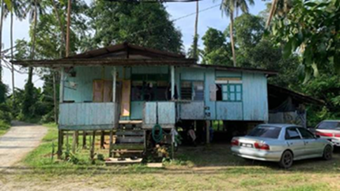
Source: Author’s field survey, 2022

Figure 2. Residential house in Kampung Pulau Sekati

In addition, the second architectural topology in KPS can be seen from the architectural inspiration of the KPS Mosque which is located in the middle of the waterways of the Kuala Terengganu River and close to the Kuala Terengganu Museum. This mosque is more than 60 years old and was built by the villagers. There is a “Geduk Kayu” located in this mosque area. This “Geduk Kayu” is used when there is a feast and is used to make an important announcement when something happens. This can be seen through the following figure 3:

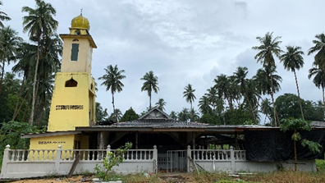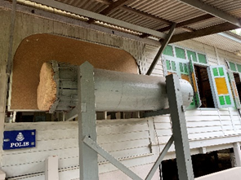
Source: Author’s field survey, 2022

Figure 3. Mosque and Geduk Kayu

The third architectural topology is seen in the architecture of the wooden bridge that connects KPS with Kuala Terengganu Museum. At the same time, residents in KPS use this wooden bridge to go to town. This bridge can only be climbed and passed by pedestrians and cyclists and motorcycles only. The length of this wooden bridge is about 210 meters and it is 30 years old. This bridge seems to be quite low and only boats and small boats can pass under it.

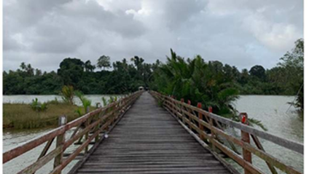
Source: Author’s field survey, 2022

Figure 4. Wooden bridge

The fourth architectural typology is seen in the architectural structure of the community hall in KPS. This hall is used as a place to gather for meetings, social support or activities such as programs from outside parties. Based on the interviews conducted, there is the involvement of outsiders coming to hold sports activities and giving donations to the residents. Most of these sports activities are organized by public universities in Malaysia. They will gather at the public hall in the KPS and carry out activities in the area with the villagers.

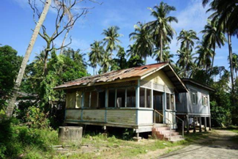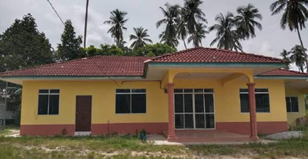
Source: Author’s field survey, 2022

Figure 5. Old community hall (left) New community hall (right)

The fifth architectural topology is seen from the perspective of pier architecture in KPS. There are two jetties at KPS, the House Boat jetty operated by one of the interview informants and the fishing jetty. This jetty is one of the attractions for visitors to visit KPS. The House Boat that is worked by one of the residents makes this village unique in terms of tourism and also the uniqueness of nature found in the surroundings of Pulau Sekati. In addition, the fishing pier is connected to a wooden bridge in the area. This fishing activity is carried out by villagers and outsiders on weekends.

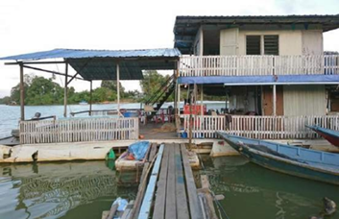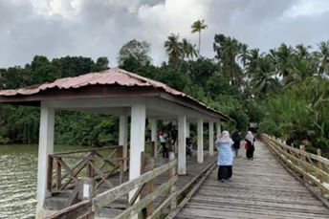
Source: Author’s field survey, 2022

Figure 6. House boat jetty (left) Fishing pier (right)
The sixth architectural topology is seen from the point of view of the wooden dangau architecture that is in front of the villagers' houses. Dangau is a small hut used by residents to rest in the afternoon. Most of the houses in KPS have a dangau by the river, they use it as a place to relax and enjoy afternoon tea with neighbors and close relatives. The final architectural topology found in KPS is the retail store. There is a grocery store that supplies food resources to the residents. This retail store is run by one of the informants who was interviewed and is also a House Boat operator in KPS. This grocery store also provides food delivery services to the elderly in KPS.

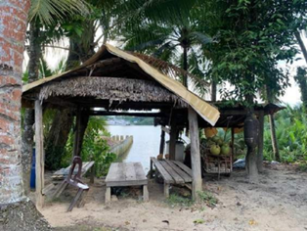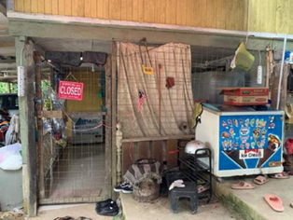
Source: Author’s field survey, 2022

Figure 7. Dangau (left) Grocery store (right)

- Uniqueness of architecture in KPS

The architectural uniqueness of Kampung Pulau Sekati (KPS) can be seen from the perspective of a residential house. Based on the observations carried out there are five houses that have unique architectural features. The majority of houses in this village use building materials consisting of wood. This is because the house was built by the occupants themselves due to the transportation problems they faced at the beginning of the construction of the house. The position of the island which is separated from the main road makes it difficult for the residents to bring carpentry tools using canoes. At the same time, every house in this village still uses water from a well that connected from the Terengganu Museum to the KPS mosque. This source of water indirectly helps residents to carry out daily activities such as washing clothes and so on.
In addition, the resident's house is used as a space for a variety of functions such as carrying out carpentry activities, repairing nets and nets, the house as a grocery store and a place to sew nipah roofs. In addition, the geographical position of Pulau Sekati which is separated from other villages makes this village preserved and kept away from the threat of urbanization causing it to be surrounded by mature plants and natural components. This can be seen through figure 8.
The architectural structure of the house is seen from the angle of the house yard which involves the front yard, the left and right side yard and the kitchen yard. Five houses have been chosen because they show the unique characteristics that have been mentioned before and the houses consist of the houses of the informants who have been interviewed. All the selected houses are 40 years old and above. The wealth of the house was built using agricultural land and sandy soil. Mapping of the house has been done using AutoCAD application to show the picture of the house. This can be seen through figure 9.

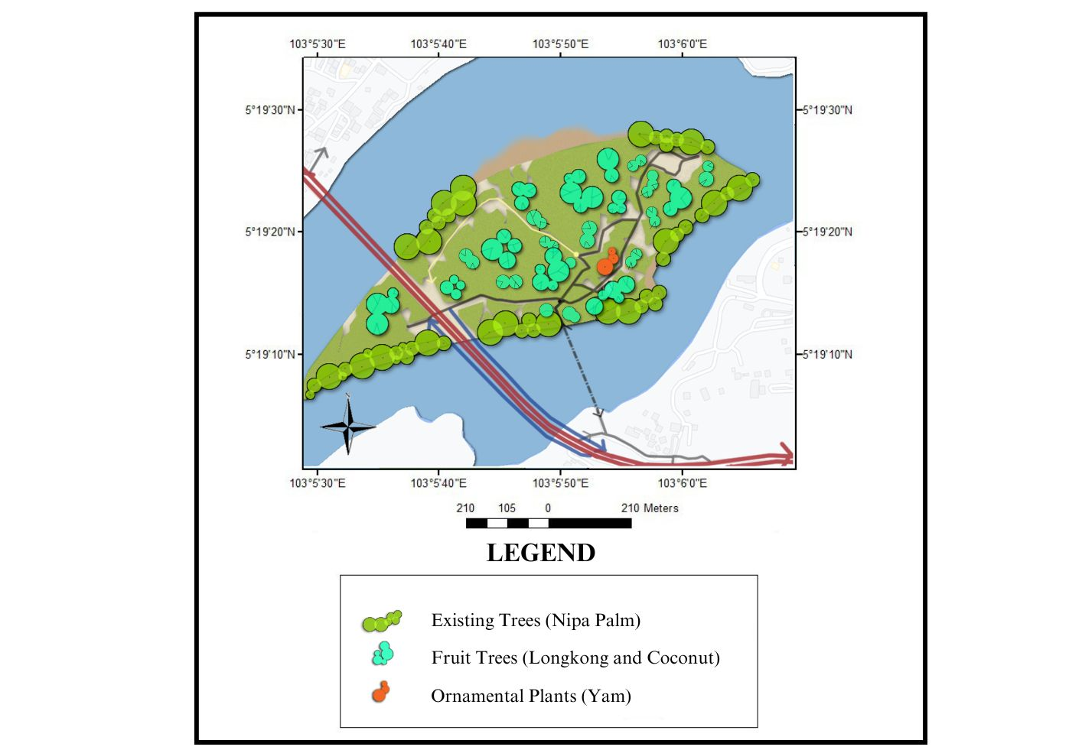
Source: Author’s field survey, 2022

Figure 8. Components of nature

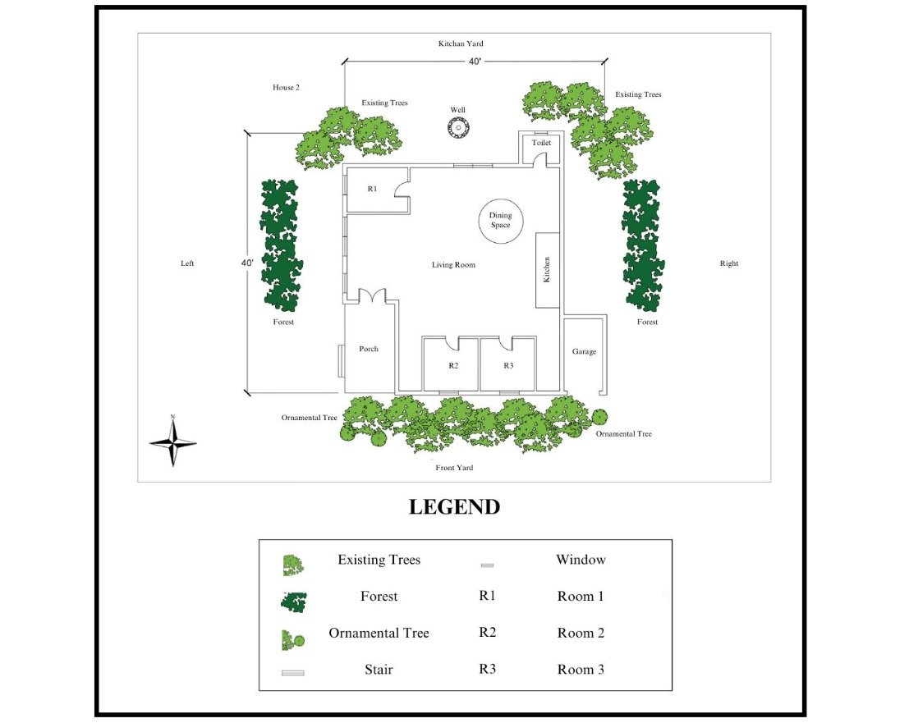
Source: Author’s field survey, 2022

Figure 9. Mapping of residential houses in KPS
- Benefits obtained by residents in KPS based on architectural category

Based on the results of interviews conducted with 24 informants found that there are various benefits obtained by residents according to social, cultural, economic, and environmental categories. The category of architecture in KPS is seen from the architecture of residential houses that provide benefits to the social and cultural i.e. residential houses as a separate identity to the settlement area. This point is also supported in Malek and Mahat study (2020) titled “Typological Transformation of Residential Buildings in Urban Villages” regarding residential houses reflecting the residents' identity. In addition, the house is also used as a mushroom for the variety of spaces to increase the interaction between residents and neighbors. This is also supported in the study of Sanusi et al. (2013) regarding the home providing a function as a space for social interaction.
From an economic point of view, residential houses can reduce the cost of electricity. This is because of the low energy consumption due to the window openings and many air ducts entering the house. This is also supported by Rashad et al. (2021) regarding traditional Malay houses using low electricity supply costs compared to modern houses. The second benefit that residents get is that they are safe from the threat of strong storms because they run their economy in residential houses surrounded by mature trees and strong built structures. This point is also supported by Sebastian et al. (2017) entitled "Shelter from the storm: Upgrading housing infrastructure in Latin American slums" on the architectural structure of houses that can accommodate storms.
Residents obtain environmental benefits from residential houses by using environmentally friendly building materials. This makes it easier for residents to repair their homes when damage occurs. This point is supported by Surat et al. (2012) on the level of well-being of Malay heritage architecture that uses environmentally friendly materials. At the same time, it will present a calm and peaceful atmosphere when using environmentally friendly materials.
The second category of architecture in KPS is Mosque. From a social and cultural point of view, the mosque becomes a center for residents to carry out religious activities. For example, in the afternoon study activities are carried out involving children in KPS and a teacher from outside. This is supported by Basri (2018) regarding the study of mosques as community education centers. From an economic point of view, the mosque receives funding from the Kuala Terengganu religious but does not contribute to the economy of the resident while from an environmental point of view, this mosque uses environmentally friendly materials such as wood. This matter is also supported in Surat’s study (2019) entitled “Interpretation of Domed Mosque Architecture from the Angle of Modernism’s Values”.
The third category of KPS architecture is the wooden bridge. From a social and cultural point of view, this wooden bridge can connect the village with the museum and make it easier to go to the city to buy necessities and work. This point is also supported by Sudin (2001) about the Wang Kelian village that uses a wooden bridge as a link to the main road. From an economic point of view, this bridge is good for the residents because it is one of the places for visitors from outside to come in and take pictures and the atmosphere in KPS. This will have a good impact on the residents and the Terengganu Museum because when there is damage to the wooden bridge, the museum will also help. In terms of the environment, this wooden bridge benefits the residents by using environmentally friendly building materials such as wood. This is also supported by Saiful Bahari’s (2020) study entitled “The Importance of Ecotourism in Taman Negeri Perlis, Malaysia” regarding environmentally friendly wooden bridges while preserving the environment.
The fourth category of architecture that provides benefits to residents in KPS is the community hall. From a social and cultural point of view, this hall is a gathering place for villagers and outsiders who come to visit the village. This point is also supported by Dahan et al. (2012) about the hall which is a gathering place for community members during public events. From an economic point of view, the town hall does not contribute income to the villagers. This is because the place is only used as a gathering place. However, from an environmental point of view, the hall benefits the residents because it was built using environmentally friendly building materials.
The fifth category of architecture in KPS is the pier. From a social and cultural point of view, the jetty becomes a venue for water sports and cultural events organized by outside parties. From an economic point of view, the jetty contributes to the economy of the villagers to catch fish and generate income for the residents from the "House Boat" tourism sector. This point is also supported by the study of Kamal et al. (2016) entitled "Indigenous people, social infrastructure and planned development in Malaysia: A study of the involvement of the Orang Asli community in RPS Air Banun, Belum-Temengor, Perak" regarding physical infrastructure such as jetties that can generate the local community's economy. In terms of the environment, this jetty uses environmentally friendly construction materials and the river as the main source found in KPS.
The sixth category is dangau as a place for villagers to relax and have fun with family members. The position of the wooden stilts located in front of the villagers' houses near the river is one of the unique architectural features of KPS. This matter is also supported by Mohd Nasir et al. (2022) about the dangau or gazebo located in the Penang Botanical Garden which functions as a place to rest and can also be used when picnicking with the family. From an economic point of view, the benefits obtained by residents are generating income from carpentry activities such as making tree houses and small huts. The material used to build this house uses environmentally friendly materials such as wood because it has long durability.
The seventh category is a grocery store that provides a source of supplementary food to the villagers. This grocery store is a small store that can only cover side needs such as sugar, salt and dry goods. From an economic point of view, this grocery store provides a small source of income to the residents because the population in KPS is not many compared to the surrounding villages. This point is also supported by Saidi et al. (2018) in his study on retail stores as a side income for entrepreneurs. Finally, this grocery store is protected from strong winds because it is built in the residents' own homes surrounded by preserved natural resources.
Overall, all categories of architectural uniqueness and its benefits have an impact on the feelings of residents in KPS. This positive feeling is seen from four aspects which are comfortable, safe, loving and proud of its uniqueness which is rarely seen in other villages.

Table 2. Benefits obtained by residents in KPS

Architecture category in KPS | Benefits |  |  | Feelings
Architecture category in KPS | Social/ Cultural | Economy | Environment | Feelings
Residential house | . Give a distinct identity to the settlement area  . The variety of spaces increases the interaction between residents and neighbours | . Low energy consumption due to openings (many windows and air ducts)  . Safe from the threat of strong storms | . Material use friendly construction nature  . The atmosphere calm and peaceful | Comfortable; safe; Affectionate; proud
Mosque | Become a centre for residents to carry out religious activities | None | Environmentally friendly building materials | Comfortable; safe
Wooden bridge | Connecting the village with the museum and making it easier to go to the city to buy necessities | Contributing to the tourism sector and places to take pictures | Natural building materials | Comfortable; safe; Affectionate; proud
Community hall | Become a gathering place for villagers and outsiders who come to visit the village | None | Natural building materials | Comfortable; safe
Jetty | Be a place for sports and cultural events organized by outside parties | Become an economy for villagers to catch fish and generate income for residents from the "House Boat" tourism sector | . Environmentally friendly building materials  . River as a source  main | Comfortable; safe; proud
Dangau | A place for villagers to relax and have fun | Generate income from carpentry activities | Environmentally friendly material because and durable | Comfortable; safe
Grocery store | Being a place to provide daily food resources to the residents | Obtain a source of income | Protected from  strong winds | Comfortable; safe
Source: Author’s field survey, 2022

Conclusion

In conclusion, house architecture in traditional settlements is one of the heritage of carpentry that reflects the identity of the Malay community. The uniqueness of architecture in traditional settlements can create a unique identity for the village. The architecture of this house has been created and developed by the Malays from a simple module to perfection and comfort. This can be seen from time to time, generation to generation with adaptation to the needs, culture and environment so as to provide various benefits to its owners to take care of the home architecture. the residence. However, this traditional settlement has its own unique characteristics in terms of design, natural environment that can provide well-being and harmony to individuals, families and communities. The joint involvement of the villagers has a good effect on the community and can upgrade the heritage settlement in the eyes of the country, the importance of its preservation is highly valued so that it does not disappear in the current of modernisation. Indirectly, this study provides guidance to policy and management regarding heritage settlements in Malaysia.

Acknowledgement

The author would like to thank to the Generation of Information on Museum Heritage Assets through Design Code Development (GUP-2021-065) grant by Universiti Kebangsaan Malaysia.

References

Azmin, A. K., Abdullah, F., Sanusi, A. N. Z., Yusof, B. Z. & Asif, N. 2021. Sustainability of malay wood craftsmanship symbolism in deciphering Malaysia’s architectural identity. Proceedings of DARCH 1st International Conference on Architecture & Design, 37-47.
Bahardin, N. F., Baharuddin, M. N., Azman, M. A. A., Bakhari, M. K. A. H. & Abd Rashid, M. S. (2022). Assessing a condition of timber defect for Perak tradisional malay’s architecture: An initial step to creating Entity Relationship (ER) Model in Databased Management System (DMMS) Journal of the Malaysian Institute of Planners, 20(3), 160–171.
Bahari, S. (2020, June 16). Kepentingan Ekopelancongan di Taman Negeri Perlis, Malaysia. Majalah Sains. Retrieved from https://www.majalahsains.com/kepentingan-ekopelancongan-di-taman-negeri-perlis-malaysia.
Bakhir, N. M. & Asyiek, M. (2017). Warisan kearifan tempatan: Pemeliharaan melalui teknologi. Penerbitan USM.
Basri, J. (2018). Masjid Sebagai Pusat Pendidikan Masyarakat. Jurnal NARATAS, (1), 22–28.
Bošković, N., Vujičićb, Milica. & Ristića, L. (2019). Sustainable tourism development indicators for mountain destinations in the Republic of Serbia. Current Issues in Tourism, 23(22), 2766-2778.
Clifford, J. (2020). Varieties of Indigenous Experience: Diasporas, Homelands, Sovereignties. (1st ed). Routledge.
Cowden, R. G., Counted, V. & Ramkissoon, H. (2021). Transcending place attachment disruption: strengthening character during a pandemic. In Counted, V., Cowden R. G., & Ramkissoon, H., Place and post-pandemic flourishing disruption, adjustment and healthy behaviors (pp. 81–92). Springer Briefs in Psychology.
Dahan, A. M., Idris, Z., Khurmin, M. T., Abdul Kadir, K. N., Yusuf, S. & Dan, A. (2012). Modul latihan teras penerbitan dan penggunaan media pendidikan kesihatan. Bahagian Pendidikan Kesihatan Kementerian Kesihatan Malaysia.
Davis, A. (2016). Experiential places or places of experience? Place identity and place attachment as mechanisms for creating festival environment. Tourism Management, 55, 49–61.
Fadzil, K. S., Ibrahim, S.W., Awang, S., Zainol, R. & Edo, J. (2016). Masyarakat pribumi, infrastruktur sosial dan pembangunan terancang di Malaysia: Kajian penglibatan masyarakat Orang Asli di RPS Air Banun, Belum Temengor, Perak. Geografia-Malaysian Journal of Society and Space, 12(10), 88–100.
Hashem, H., Abbas, Y. S., Akbar, H. A. & Nazgol, B. (2013). Comparison the concept of sense of place and attachment to place in architectural studies. Geografia-Malaysia Journal of Society and Space, 9(1), 107–117.
Hassan, N. A., Harun, Z. & Tambi, N. (2019). Nilai simbolik sebagai penunjuk kelestarian modal sosial petempatan tradisional di Kuala Terengganu, Malaysia. Geografia-Malaysian Journal of Society and Space, 16(3), 201-218.
Ismail, A. H. & Nik Ibrahim N. L. (2009). Pendekatan dasar pemikiran seni bina warisa melayu bagi mendapatkan keselesaan hawa serta penyelesaian masalah iklim dan persekitaran dalam seni bina masa kini. Journal of Design and Built Environment, 2, 18 - 27.
Jaffar, N. & Harun, Z. (2019). Faktor Penetu Kelestarian Sosial di Petempatan Melayu Tradisional. Kolokium Bersama Kajian Pascasiswazah Alam Bina (PETARI2019), Bangi.
Jamleoui, R. (2009). Community art a form of place-making for culturally diverse communities. New Left Book.
Kassim, S. J. (2017). The resilience of tradition – Malay allusions in contemporary architectur. Areca Books.
Leh, F. C., Yunus, N. K. Y, Razak, Z. A. A. & Omar, B. (2013). Konsep Pemasaran tempat dan
kepentingannya dalam sektor pelancongan: Kajian kes di bandar diraja Kuala Kangsar, Perak. Perspektif Jurnal Sains Sosial dan Kemanusiaan, 5(3), 49.
Malek, I. A. & Mahat, N. (2020). Transformasi tipologi bangunan kediaman di perkampungan bandar. Journal of Design and Built Environment, 13(1), 155-157.
Mohd Nasir, M. I., Abdul Rahim, A. & Abu Bakar, M. A. (2022). Perceived cultural ecosystem services benefits among working communities in urban green space: Penang Botanical Garden. Geografia-Malaysian Journal of Society and Space, 10(1), 98–131.
Mohmad Shukri S., Wahab M. H., Awaluddin Z.L., Aminuddin A. M. R. & Hasan, M. I. (2022). The role of attachment in creating sustainable sense of place for traditional streets in Alor Setar, Malaysia. Journal of Design and Built Evironment, 22(1), 55-71.
Nasir, A. H. (1985). Pengenalan rumah tradisional melayu Semenanjung Malaysia. Kuala Lumpur.
Putra, B. A. & Putri, O. T. D. (2023). The representation of the traditional residential in Jambi Malay Islamic culture. Proceeding ADRI International Conference on Multidisciplinary Research, 1(1), 214–227.
Rahmat, M. H., Ismail, A. S. & Mandala, A. A. (2022). Framework of national architectural identity of public administration buildings: A case study of Majlis Bandaraya Johor Bahru (MBJB). International Journal of Sustainable Construction Engineering and Technology, 13(4), 399–414.
Razali, M.K., Ahmad, H., Choy, E. A. & Jusoh, H. (2022). Pembangunan kerangka teoritis bagi bina tempat pelancongan Tapak Warisan Dunia Bandaraya Melaka. Jornal of Tourism, Hospitality and Environment Management, 29(7), 238-259.
Rostam, K., Choy, E. A., Sakawi, Z., Nor, A. R. M. & Muhammad, A. (2011). Pembandaran di pinggir wilayah metropolitan lanjutan: Beberapa implikasi terhadap corak dan kualiti kejiranan. Akademika, 81(3), 19-29.
Saidi, Z., Sino, H. & Othman, N. K. (2018). Taraf pendidikan dan sosio-ekonomi penduduk di Kampung Sungai Budor, Kelantan Darul Naim. Journal of Social Science and Humanities, 13(3), 222-233.
Sanusi, M. S., Hadi, A. S., Idrus, S., Abdullah, K. & Ahmad, S. (2013). Dayahuni Komuniti dalam Pembangunan Perumahan Densiti Tinggi. (1st ed). Prosiding Seminar Serantau Ke-2 Pengurusan Persekitaran di Alam Melayu, Selangor.
Seamon, D. (2013). Place attachment and phenomenology: The synergistic dynamism of place. In Devine L. M. & Wright, P. (Eds.), Place attachment: Advances in theory, methods and research (pp. 11–22). Routledge.
Setyaningsih, W., Nuryanti, W., Prayitno B. & Sarwadi, A. (2015). Proses perubahan arsitektural kawasan bersejarah Kampung Wisata Kauman Surakarta. Jurnal Pembangunan Wilayah dan Perencanaan Partisipatif, 6(2), 69-73.
Shafii, C. (2019). Home, belonging and rootedness. Retrieved from https://chakameh.medium.com/home-belonging-and-rootedness-a3b34d33976f.
Shamsuddina, S. & Ujang, N. (2008). Making places: The role of attachment in creating the sense of place for traditional streets in Malaysia. Habitat International, 32(3), 399-409.
Sudin, A. (2001). Wang Kelian. Jurnal Warisan Indera Kayangan, 13, 30-49.
Surat, M. (2019). Pentafsiran senibina masjid berkubah dari sudut nilai modernism. Journal of Design and Built Environment, 12(1), 40-55.
Surat, M., Baharum, M. A., Usman, I. M. S., Musa, A. R. & Tawil, N. M. (2012). Mengenalpasti tahap kesejahteraan seni bina warisan melayu melalui konsep islam. Journal of Design and Built Environment, 5(1).
Tuan, Y. F. (1980). Rootedness versus sense of place. Landscape, 24(1), 3–8.
Walton, G. M., Cohen G. L., Cwir D., & Spencer S. J. (2021). Mere belonging: The power of social connections. Journal of Personality and Social Psychology, 102(3), 513–532.

