Assessing the Suitability of Rooftop Solar Photovoltaic Systems for Sustainable Electricity Generation

Shaban R. S. Aldhshan¹, Khairul Nizam Abdul Maulud^{1,2*}, Othman A. Karim¹, Wan Shafrina Wan Mohd Jaafar², Mohd Faizal Fauzan³

¹Department of Civil Engineering, Faculty of Engineering and Built Environment, Universiti Kebangsaan Malaysia, Bangi 43600 UKM, Selangor, Malaysia
²Earth Observation Centre, Institute of Climate Change, Universiti Kebangsaan Malaysia, Bangi 43600 UKM, Selangor, Malaysia
³Solar Energy Research Institute, Universiti Kebangsaan Malaysia, Bangi 43600 UKM, Selangor, Malaysia;

Correspondence: Khairul Nizam Abdul Maulud (email: knam@ukm.edu.my)

Received: 17 July 2023; Accepted: 2 September 2023; Published: 30 November 2023

Abstract

The adoption of solar energy as a sustainable solution is gaining momentum in Malaysia. Universities, as prominent stakeholders, are at the forefront of implementing energy efficiency and renewable generation objectives. This study aimed to evaluate the suitability of photovoltaic systems for electricity generation by assessing the solar radiation potential of the Universiti Kebangsaan Malaysia (UKM) campus in Bangi. Geospatial data and GIS approaches were utilized to characterize solar potential across the 1096-hectare campus. Unmanned aerial vehicle (UAV) images were processed to derive digital surface models, enabling the calculation of slope and aspect. By considering slope, aspect, shadow, area, and total solar radiation, suitable buildings for photovoltaic installation were identified. Out of the 546 buildings assessed, two were highly suitable, seven were suitable, 32 were moderately suitable, 134 were unsuitable, and 367 were highly unsuitable. The selected rooftops have the potential to generate 69,975 MWh annually, representing about 17% of the total electricity consumption from the grid. These findings highlight the viability of rooftop solar arrays for UKM and suggest an estimated energy production ranging from 9,949 MWh/year. The methods employed in this study, leveraging high-resolution UAV images, can be adapted to comprehensively assess solar potential in other institutions across Malaysia, contributing towards meeting campus energy goals and advancing sustainable practices.

Keywords: Renewable energy, Energy Consumption, urban, Unmanned aerial vehicle, photovoltaic

Introduction

The increasing demand for energy and the need to mitigate climate change have placed a strong emphasis on the transition to sustainable energy sources. One such source is rooftop solar energy, which has gained significant attention for its potential to contribute to sustainable development and reduce carbon emissions. Rooftop solar PV systems have emerged as an effective means of harnessing clean and renewable energy directly from the sun, making them an attractive option for universities and other institutions striving to achieve their sustainability goals (Kalyan & Sun, 2022).
Universities, with their expansive campuses and significant energy demands, confront a challenge in meeting their energy needs while simultaneously minimizing their environmental impact. The reliance on conventional energy sources, specifically fossil fuels, not only contributes to greenhouse gas emissions but also entails long-term risks associated with price volatility and energy security. Thus, there exists an urgent necessity to explore alternative energy solutions that can offer reliable and sustainable power sources for universities (Radosevic et al., 2022; Tian et al., 2022).
Furthermore, it is important to note that unlike residential assessments, a campus-wide evaluation focuses on an area managed by a single entity. Consequently, proposed installations can be implemented uniformly across the study area, avoiding discrepancies in efficiency or installation methods that may arise among different homeowners. Moreover, university campuses can be likened to small-to-medium-sized towns in terms of their extensive physical dimensions, population, operational activities, and infrastructural requirements (Amaral et al., 2020). Considering these factors, alongside their vital roles in education and research, universities play a pivotal role in driving sustainable development (Amaral et al., 2021; Cuesta‐Claros et al., 2022)
Universities worldwide have assumed a vital role in advancing sustainable practices and reducing their carbon footprint, in line with global sustainability initiatives. One impactful measure adopted by universities is the integration of rooftop solar energy, showcasing their dedication to sustainable development and serving as exemplars for their students, staff, and the broader community. The installation of renewable systems, such as solar PV, not only contributes to universities' energy objectives, but also provides opportunities for learning in the classroom, promotes research that supports sustainable development goals, and can create pathways for sustainability careers (Amaral et al., 2021; Hernandez-Aguilera et al., 2021).
Indeed, the incorporation of rooftop PV systems is a significant step toward achieving zero-carbon campuses. By generating clean and renewable energy, universities can offset a substantial portion of their electricity consumption previously reliant on conventional energy grids. This transition to sustainable energy not only mitigates greenhouse gas emissions but also cultivates a culture of environmental stewardship and innovation within the academic sphere (Sharma et al., 2022).
In Malaysia, the emergence of high-quality aerial imagery, offering a resolution of 1 meter, has created a distinctive chance to assess the efficacy of solar PV systems in meeting the electricity requirements. With an increasing number of higher education institutions embracing renewable energy, evaluating such systems becomes crucial in providing decision-makers with crucial data for achieving sustainability objectives. Therefore, the main aim of this research was to evaluate the feasibility of implementing rooftop PV systems and determine the corresponding capacity for electricity generation, specifically focusing on the case study of Universiti Kebangsaan Malaysia (UKM) campus in Bangi. With the expansion of campuses like UKM, their carbon footprint and energy requirements are expected to increase, rendering this study a valuable source of information for the university, addressing both financial and sustainability considerations.
This study makes a significant contribution to the field of research in several ways. Firstly, it employs advanced GIS-based techniques that utilize freely available remote sensing data to identify appropriate rooftops within the UKM campus. Secondly, it evaluates the potential for generating electricity from the proposed photovoltaic (PV) systems and compares it to the actual energy consumption of the university. Lastly, the study conducts a thorough financial assessment of the installation of PV systems. Given that many Malaysian universities have developed climate action plans, the evaluation of viable renewable energy sources, particularly economically viable options like rooftop solar PV systems, has become increasingly relevant. By utilizing similar data, this study can be replicated in other regions that possess high-resolution aerial imagery. The implementation of solar PV systems offers universities the opportunity to reduce their carbon footprint, encourage environmental responsibility, and foster innovation. The findings of this research not only provide a basis for further studies in similar contexts but also facilitate the wider adoption of sustainable energy solutions in higher education institutions worldwide.

Materials and methods

Study area

The research conducted at Universiti Kebangsaan Malaysia (UKM), a public university situated in Bandar Baru Bangi, Selangor, south of Kuala Lumpur, Malaysia (Figure 1), was chosen due to the availability of appropriate data, good building distribution, favorable topography conditions, and the need to reduce energy costs and greenhouse gas emissions. The main UKM campus in Bangi, which commenced operations in 1977, occupies an extensive area of 1,096.29 hectares. The campus contains nine faculties and fifteen research institutes, with a total of approximately 546 buildings included in this study.
The analysis of UKM's electricity usage reveals interesting patterns. Months like February, June, July, August, and September show the lowest energy consumption, likely due to academic vacations. In contrast, March, April, and May exhibit higher energy demands. March stands out with the highest consumption of approximately 37,362 MWh over five years. Conversely, July records the lowest energy usage, amounting to around 30,191 MWh. Therefore, UKM is an ideal location to implement this study on its buildings. The university is in need of sustainable alternatives to reduce carbon dioxide emissions. Furthermore, there is a significant electricity consumption within the university, resulting in high costs on the university's budget. According to statistics, this issue can be addressed by generating energy from suitable alternative sources at lower costs. By adopting such measures, UKM can not only contribute to environmental sustainability but also alleviate the financial burden caused by excessive energy consumption.

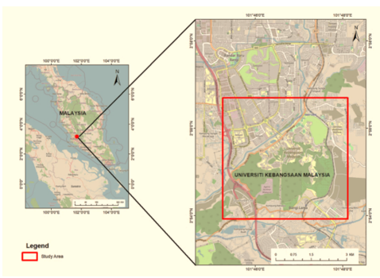

Figure 1. The location of the study area
Data

Various forms of data are employed in this analysis. To assess solar capacity, an array of data sources is utilized, including UAV photography images from 2017, vector data on the UKM (Urban Masterplan), a Digital Surface Model (DSM) generated by a UAV platform with a spatial resolution of 1 meter through the utilization of elevation point clouds, as well as statistical information regarding energy consumption and electricity demand within the UKM. It is imperative to note that this data represents the most contemporary version accessible to undertake this scientific endeavor and achieve optimal outcomes (Table 1).

Table 1. Data of research and description

Name | Type | Description
UAV Photography Image from 2017 | TIFF | Three bands (RGB) with 0.5 × 0.5 m spatial resolution.
DSM image | FGDBR | Extracted from UAV image by point clouds of elevation with 1 m spatial resolution.
Bangunan UKM | Shapefile | Shapefile data includes the details of buildings' names, IDs, areas, years, etc.
Bangunan UKM | pdf | The layout image includes the names of buildings and faculties.
Electricity Meter Reading Schedule 2018,2019,2020 | Excel | Energy data contains the amount of electrical energy consumed and cost monthly and annually for departments, faculties, and buildings at the university for the years 2018, 2019, 2020, and 2020. Data for 2020 is incomplete.
Energy Consumption from 2013 to 2020 | Excel | Energy consumption and cost monthly and annually for UKM from the years 2013 to 2020. Data for 2020 is incomplete.

Framework

In assessing the feasibility of utilizing solar photovoltaic technology for rooftop installations, the process can be divided into three distinct phases. The initial phase involves the pre-processing of aerial imagery data, specifically by preparing DSM, and rooftop data. Moreover, it is imperative to verify the attributes of shapefile data, the coordinate system, and spatial resolutions. Subsequently, the precise derived data, such as DSMs, slope charts, and aspect charts, are employed to extract comprehensive roof outlines and planes. These derived data sets serve as crucial inputs for the examination of solar radiation patterns. The outcomes obtained from the first phase serve as inputs for the second phase, wherein the amount of solar radiation accessible for each rooftop area is determined. This phase encompasses the estimation of mean annual solar radiation, as well as evaluations of aspect and slope incidents over each rooftop. The third phase integrates the data and outputs from the preceding two phases to evaluate the solar photovoltaic capacity of each building. This phase also encompasses the validation process, which involves calculating the required power capacity for installing the photovoltaic system and estimating the potential reduction in unclean power. An illustrative flowchart, as depicted in Figure 2, provides a visual representation of the overall process.
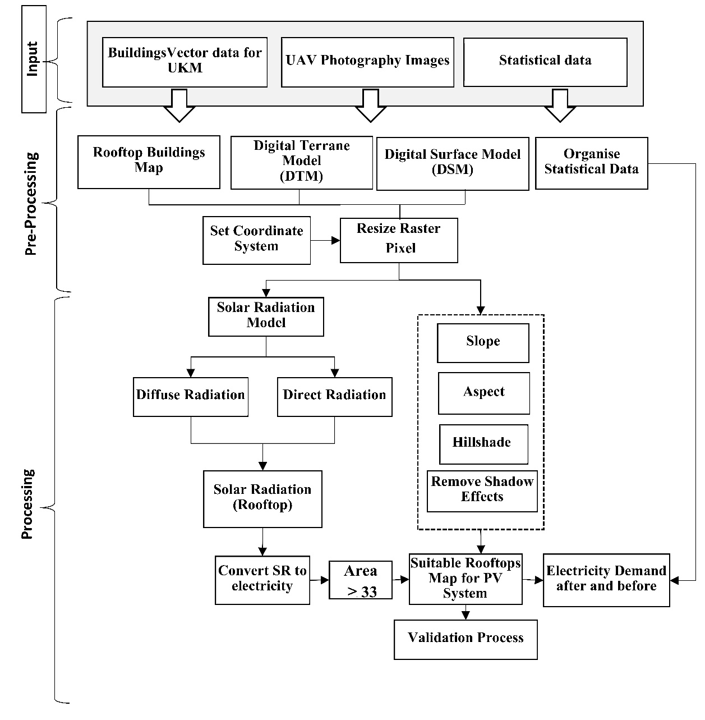
Figure 2. The methodology of study

Calculate SR of building footprints

The building polygons representing individual structures within the campus were acquired from the Institute of Climate Change, situated in UKM. While certain sections of the campus have undergone modifications and new constructions have been finalized up until 2020, the aerial imagery and building footprint data still correspond to the campus as it appeared in 2017. To analyze solar energy distribution on the Earth's surface within the university boundaries, a raster layer was generated using the Area Solar Radiation tool in ArcGIS Pro. This tool employs a model that takes into account the sun's position throughout the study year of 2017 at various times of the day. The resulting output raster estimates the solar radiation in watt-hours per square meter (Wh/m²). The computations take into account the solar declination, the position of the sun determined by the latitude of the site, the slope and aspect of the surface obtained from the DSM, and any potential barriers that could impede the penetration of sunlight (Fu & Rich 2000, 2002).
In order to concentrate exclusively on the rooftop surfaces designated as building footprints, a mask was implemented to compute solar radiation specifically for these areas, as they were the ones evaluated for rooftop photovoltaic systems. The outcomes obtained, depicted as energy measurements in a raster layer, were transformed into (kWh/m²). Subsequently, upon symbolization, the map portrays a raster layer illustrating the spectrum of solar radiation present on the rooftops across the campus. Lower radiation surfaces are depicted in blue tones, while higher solar radiation areas are shown in orange tones (Figure 3).

DECTAR | Dewan Canselor Tun Abdul Razak
FSSK | Fakulti Sains Sosial dan Kemanusiaan
PTSL | Perpustakaan Tun Sri Lanang
FEP | Fakulti Ekonomi dan Pengurusan
FST | Fakulti Sains dan Teknologi
FP | Fakulti Pendidikan
Hotel PP | Hotel Puri Pujangga
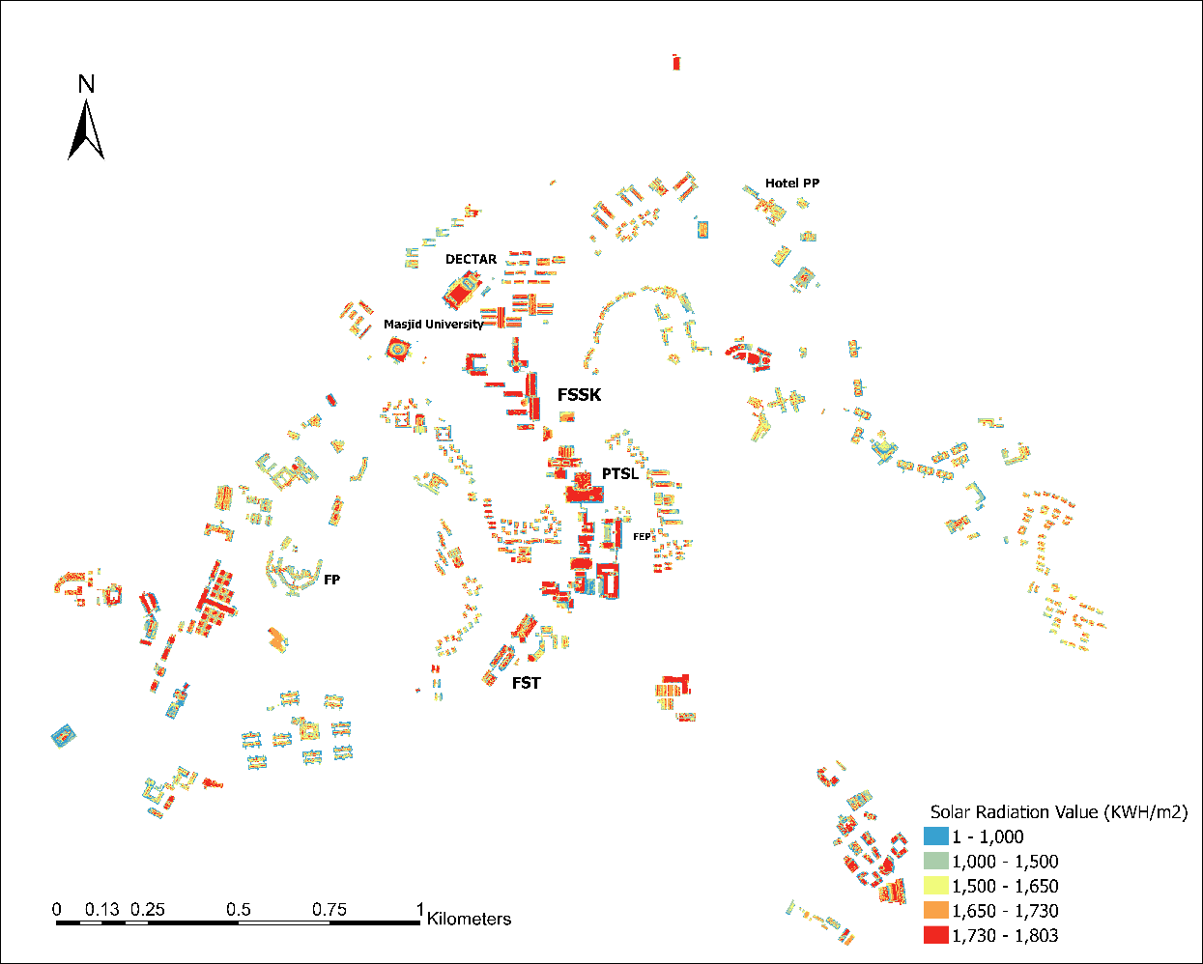

Figure 3. Solar radiation raster of UKM'S Rooftops in ArcGIS Pro

Rooftop suitability

Rooftop selection plays a crucial role in determining the feasibility of installing PV systems. Various factors must be considered to ensure optimal solar energy generation. One significant factor is the slope of the rooftops, as it directly impacts the amount of sunlight received. To evaluate this, a slope raster layer has been developed, which enables the calculation of rooftop slopes. Ideally, rooftops with a slope of 45 degrees or less are considered most suitable, as steeper slopes tend to receive less sunlight (Jakubiec & Reinhart, 2012). Another vital consideration in assessing solar radiation distribution is the influence of topographic features and nearby obstructions. To identify consistently shadowed areas, solar radiation levels are analyzed against a predetermined threshold. Insolation maps already incorporate factors such as aspect, slope, and visibility, which aid in this assessment. By employing the Jenks Natural Breaks method, statistical analysis of solar radiation distribution allows for the establishment of suitable thresholds. Pixels with values lower than 800 kWh/m² can be classified as permanently shaded. Therefore, to ensure adequate solar radiation for PV systems, rooftops should receive at least 800 kWh/m². The evaluation of this criterion relies on the solar radiation raster layer (Wong et al., 2016).
Moreover, the orientation of rooftops is an important consideration in determining their suitability for PV system installation. North-facing rooftops, particularly in the northern hemisphere, receive less sunlight. To assess rooftop orientation, an aspect raster layer has been developed, providing valuable insights into the direction rooftops face (Nguyen et al., 2012) (Figure 4). In addition to slope and orientation, the available rooftop area is a critical factor when considering the installation of solar panels. Generally, buildings with less than 33 square meters of suitable rooftop area are deemed unsuitable for solar panel installation (Hong et al. 2017). Regions that failed to satisfy this ultimate criterion were eliminated from the solar radiation raster. The cells are adjacent to the structure were consolidated using a zonal statistics tool, thereby determining the average solar radiation, expressed in MWh/m², for each building.

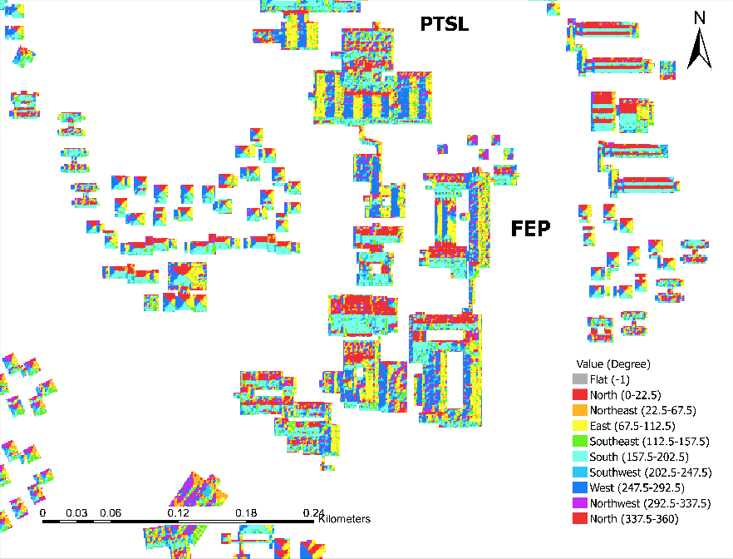
Figure 4. Aspect Raster of Some Rooftops in ArcGIS Pro

Energy and electricity assessment

The evaluation of the potential energy generation from rooftop arrays commences by assessing the total amount of solar radiation received by the usable area of each building over the course of a year. This calculation entails multiplying the area of the building by the average solar radiation and converting the result into megawatt-hours per square meter. Subsequently, the solar radiation is transformed into annual electric power production, a crucial factor in determining the overall potential of a rooftop installation. Although the annual solar radiation in a particular area primarily governs the production potential, the efficiency of the solar system also significantly contributes to the generation of usable energy. According to (Stack & Narine, 2022), the United States Environmental Protection Agency (EPA) provides a conservative estimate of 15 percent efficiency and an 86 percent performance ratio, signifying that solar panels can convert 15 percent of solar energy into electricity and retain 86 percent of that electricity throughout the installation. To ascertain the electricity production for each building, the usable solar radiation is multiplied by 0.15 and then by 0.86. By aggregating the potential annual electricity production from all suitable buildings, the total energy potential for the study area can be determined.
The statistical data about energy consumption at UKM was meticulously obtained, encompassing both annual and monthly figures, along with a breakdown of consumption across various faculties and departments, spanning the years 2018 to 2020. It is worth noting that although certain data points were incomplete, their absence did not exert a substantial impact on the overall findings. For this investigation, a comprehensive evaluation of 546 buildings was conducted, followed by a meticulous organization of the statistical data in this section. Subsequently, a clear demarcation was established between the dataset and the resultant outcomes.

Results

Rooftop suitability

The suitability map depicted in Figure 5 delineates five distinct categories deemed appropriate for the implementation of photovoltaic systems. Specifically, a pair of buildings have been classified as "highly suitable" for PV system installation, whereas 41 other structures are deemed from "suitable" to "moderately suitable". On the other hand, a significant gradient spanning approximately 501 degrees separates the categories of "highly unsuitable" and "unsuitable". Notably, it has been observed that flat rooftops present the most favorable surfaces for PV system construction, particularly when considering expansive roof areas. Moreover, upon examining the overall assemblage of buildings in terms of their potential for energy generation, a substantial proportion of these structures are concentrated within the central region of UKM. Consequently, this fortuitous circumstance provides a remarkable opportunity to furnish a substantial quantity of electrical energy to a wide array of UKM edifices and amenities.

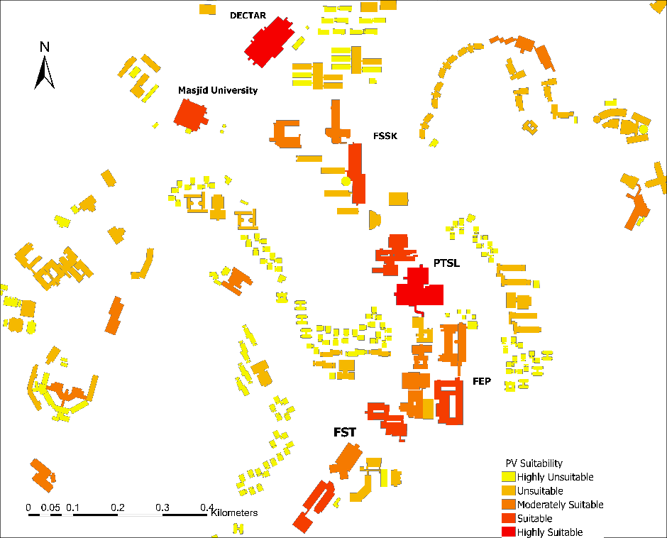

Figure 5. Suitability map for PV installation potential on building's rooftop

Electricity production

The cumulative rooftop area of the ten highest-ranking rooftop buildings is approximately 46,015 m². The Findings reveal that the collective energy generation capacity of PV systems is projected to reach 9,949 MWh, constituting 17% of the overall electricity demand of the UKM, as compared to the statistics recorded in 2019. Whereas, the total electricity consumption for the year 2019 amounted to 55,542 MWh.
The findings of the study revealed that the PTSL edifice is anticipated to generate a substantial quantity of renewable electrical energy through the utilization of rooftop photovoltaic panels, as elucidated in Table 2, amounting to approximately 1,556 MWh. Functioning as the principal library on the Bangi Campus, PTSL spans six floors. It is noteworthy that the energy consumption within this establishment amounted to 2,879 MWh in the year 2019.

Table 2. Compare between energy consumption, usable solar radiation, and electricity production for the top ten buildings in 2019

No. | Name | Elec. power production (MWh)/ Y | Elec. con. MWh/ Y / 2019 | Energy covered (%)
1 | PTSL | 1,556 | 2,879 | 54%
2 | DECTAR | 1,414 | 784 | 180%
3 | FST, BB | 1,092 | 2,017 | 54%
4 | Pusanika | 1,048 | 1,088 | 96%
5 | FSSK, Blok A | 911 | 1,532 | 59%
6 | FKAB, BB | 853 | 2,718 | 31%
7 | FST, BSK | 842 | 1,044 | 81%
8 | FST, BMT | 826 | 681 | 121%
9 | Masjid | 755 | 184 | 410%
10 | FST, PK | 652 | 461 | 74%
Total |  | 9,949 | 12,183 | 81%

Financial assessment

Based on the energy data of UKM for the fiscal year 2019, the monetary value assigned to each kilowatt stands at approximately 0.4 Malaysian Ringgit (RM). Consequently, an assessment of the aggregate energy expenditure across ten edifices during this period reveals a substantial sum of approximately 22,697,468 RM. This valuation corresponds to total energy consumption in UKM of 55,542 MWh. As previously elucidated, the findings obtained demonstrate that the implementation of solar energy systems can yield a reduction of 17% in total energy consumption. Consequently, when contrasting the aforementioned outcome with the data from 2019, it becomes apparent that the total reduction amounts to approximately 3,858,569 RM, that is not account for the expenses incurred for solar system operation and periodic maintenance.

Discussion

The present research has yielded noteworthy insights into the advantages and constraints associated with PV systems in fostering sustainable energy production within architectural structures. The outcomes indicate that PV systems possess the capacity to generate a substantial quantity of electrical power, as evidenced by the current study's production of 69,975 MWh/year. This outcome proves especially advantageous for energy-intensive buildings. Furthermore, structures incorporating PV systems exhibit a heightened potential for sustainability. Nevertheless, the investigation emphasizes that only a limited number of buildings are suitable for PV installation, with the majority deemed unsuitable. The proposed scenarios for PV implementation effectively demonstrate the potential for considerable reductions in CO² emissions and a more sustainable energy consumption pattern. These findings underscore the criticality of assessing building suitability before embarking on PV system integration to maximize the benefits derived from such systems.
UKM, a distinguished educational establishment dedicated to the pursuit of sustainability, presents a promising opportunity for investment in rooftop solar arrays. Boasting expansive and well-distributed structures, as well as a tropical climate characterized by minimal heating requirements, the university campus offers a conducive environment for the installation of photovoltaic systems on its rooftops. Particularly noteworthy is the reduced residential occupancy during the summer break, further enhancing the suitability of UKM as an ideal site to implement these solar energy solutions, thereby elevating its sustainability endeavors.
The complete installation of the proposed solar cells on all buildings presents financial challenges due to the associated costs. However, it is worth noting that PV systems exhibit modular and scalable characteristics, allowing for their installation in incremental clusters. This approach enables UKM to gradually offset emissions in small increments over time. To initiate this process, it is advisable to focus on the ten buildings that rank highest in terms of energy production on campus, as indicated in Table 2. These buildings, selected based on their assessed solar potential, present the most promising rooftops for the initial installation phase.
Based on the findings of the study, there is an opportunity for UKM to consider the installation of PV systems, which would involve utilizing solar-generated electricity on appropriate rooftops. To achieve this, UKM can collaborate with its current electricity provider, Tenaga Nasional, in order to assess the most efficient and cost-effective approach for implementing solar cells. These research results have the potential to position UKM as a leader in sustainable design and renewable energy within Malaysian colleges. The suggested PV installation could also serve as a valuable platform for research and learning, benefiting various stakeholders on campus. Mechanical engineering students, for example, could apply thermodynamics principles to the study of renewable energy, while students in building science and architecture could explore sustainable building design. Additionally, future investigations could focus on identifying the solar potential of areas within the university grounds that are not rooftops. Considering UKM's surplus agricultural land, the installation of large solar ground arrays outside the main campus could make a significant contribution to the renewable energy mix. By embracing these possibilities, UKM has the opportunity to maximize its renewable energy capacity and establish itself as a model for sustainability in the higher education sector.
One prospective constraint of the research pertains to the temporal dimension of the UAV image data. Since its acquisition in 2017, UKM has transformed, rendering the data outdated. In a dynamic setting where continuous changes transpire, the acquisition of novel UAV imagery may not always be feasible. Nevertheless, in the absence of up-to-date UAV images, alternative geospatial technologies such as terrestrial unit-based 3D modeling and photogrammetry warrant exploration for solar radiation modeling.

Conclusion

This research conducted a thorough evaluation aiming to determine the appropriateness of solar PV systems for generating electricity on the UKM campus, a university located in Malaysia. The study was carried out in collaboration with UKM, utilizing UAV photographs and GIS techniques to assess the potential of the campus buildings' rooftops for solar energy production. The analysis of solar potential was conducted alongside the examination of actual energy consumption data from 2019. The findings of this study affirm the viability of installing PV systems on the rooftops of the campus buildings, which possess the capability to make a substantial contribution to overall electricity generation. Based on the characteristics of suitable rooftops, including their size, aspect, and slope, the estimated solar potential of the UKM campus is determined to be 69,975 MWh for all applicable buildings. However, if the ten most suitable buildings were equipped with solar arrays, these multiple systems could fulfill up to 17% of the metered electricity requirements of the buildings at UKM.
Furthermore, a comparison with the 2019 data reveals a substantial reduction in electricity costs amounting to approximately 3,858,569 RM/year. It should be noted that this reduction does not consider the expenses associated with the operation and periodic maintenance of the solar systems. Future research could explore the solar potential of non-rooftop areas and utilize Lidar data in urban environments, thereby further augmenting the electricity supply and enabling more accurate analysis at the campus level. These investigations will contribute to the ongoing development and implementation of solar PV systems in meeting the electricity demands of university campuses and beyond.

Acknowledgement

The author would like to thank Universiti Kebangsaan Malaysia (UKM) for the financial support under research grant DIP-2021-006.

References

Amaral, A. R., Rodrigues, E., Gaspar, A. R. & Gomes, Á. (2020). A review of empirical data of sustainability initiatives in university campus operations. Journal of Cleaner Production, 250, 119558.
Amaral, A. R., Rodrigues, E., Gaspar, A. R. & Gomes, Á. (2021). Lessons from unsuccessful energy and buildings sustainability actions in university campus operations. Journal of Cleaner Production, 297, 126665.
Cuesta‐Claros, A., Malekpour, S., Raven, R. & Kestin, T. (2022). Understanding the roles of universities for sustainable development transformations: A framing analysis of university models. Sustainable Development, 30(4), 525–538.
Fu, P. & Rich, P. M. (2000). The solar analyst 1.0 user manual. Helios Environmental Modeling Institute 1616.
Fu, P. & Rich, P. M. (2002). A geometric solar radiation model with applications in agriculture and forestry. Computers and electronics in agriculture, 37(1–3), 25–35.
Hernandez-Aguilera, J. N., Anderson, W., Bridges, A. L., Fernandez, M. P., Hansen, W. D., Maurer, M. L., Ilboudo Nébié, E. K. & Stock, A. (2021). Supporting interdisciplinary careers for sustainability. Nature Sustainability, 4(5), 374–375.
Hong, T., Lee, M., Koo, C., Jeong, K. & Kim, J. (2017). Development of a method for estimating the rooftop solar photovoltaic (PV) potential by analyzing the available rooftop area using Hillshade analysis. Applied Energy, 194, 320–332.
Jakubiec, J. A. & Reinhart, C. F. (2012). The ‘adaptive zone’–A concept for assessing discomfort glare throughout daylit spaces. Lighting Research & Technology, 44(2), 149–170.
Kalyan, S. & Sun, Q. (2022). Interrogating the Installation Gap and Potential of Solar Photovoltaic Systems Using GIS and Deep Learning. Energies, 15(10), 3740.
Nguyen, H.T., Pearce, J.M., Harrap, R. & Barber, G. (2012). The application of LiDAR to assessment of rooftop solar photovoltaic deployment potential in a municipal district unit. Sensors, 12(4), 4534–4558.
Radosevic, N., Liu, G. J., Tapper, N., Zhu, X. & Sun, Q. C. (2022). Solar Energy modeling and mapping for the sustainable campus at Monash University. Frontiers in Sustainable Cities, 3, 745197.
Sharma, G. D., Verma, M., Shahbaz, M., Gupta, M. & Chopra, R. (2022). Transitioning green finance from theory to practice for renewable energy development. Renewable Energy, 195, 554–565.
Stack, V. & Narine, L. L. (2022). Sustainability at Auburn University: Assessing rooftop solar energy potential for electricity generation with Remote Sensing and GIS in a Southern US Campus. Sustainability, 14(2), 626.
Tian, X., Zhou, Y., Morris, B. & You, F. (2022). Sustainable design of Cornell University campus energy systems toward climate neutrality and 100% renewables. Renewable and Sustainable Energy Reviews, 161, 112383.
Wong, M. S., Zhu, R., Liu, Z., Lu, L., Peng, J., Tang, Z., Lo, C. H. & Chan, W. K. (2016). Estimation of Hong Kong’s solar energy potential using GIS and remote sensing technologies. Renewable Energy, 99, 325–335.

