Flood inundation mapping in the Kelantan River Basin, Malaysia, using Sentinel-1 SAR and Google Earth Engine

Yi Lin Tew¹, Mou Leong Tan¹, Liew Juneng², Sazali Osman³, Mohamad Hafiz Hassan³,
Narimah Samat¹, Chun Kiat Chang⁴, Longhui Li⁵

¹GeoInformatic Unit, Geography Section, School of Humanities, Universiti Sains Malaysia
²Department of Earth Sciences and Environment, Faculty of Science and Technology,
Universiti Kebangsaan Malaysia
³National Flood Forecasting and Warning Centre, Department of Irrigation and Drainage
⁴River Engineering and Urban Drainage Research Centre (REDAC), Universiti Sains Malaysia
⁵School of Geography, Nanjing Normal University

Correspondence: Mou Leong Tan (email: mouleong@usm.my)

Received: 1 August 2023; Accepted: 14 November 2024; Published: 29 November 2024

Abstract

One of the most severe floods in Peninsular Malaysia occurred during 2021-2022, displacing over 20,000 people and resulting in two deaths in Kelantan. Accurate flood extent data during such events is crucial for effective flood management, however, gathering this information is challenging due to limited access to affected area. Google Earth Engine (GEE) offers rapid satellite image processing for flood inundation mapping, making it an effective tool for this purpose. In this study, GEE was utilized to generate flood inundation maps for the Kelantan River Basin (KRB) using Sentinel-1 SAR data. Site inspections and Sentinel-2 Multispectral Instrument (MSI) satellite images of the actual flood regions were then used to validate the flood inundation maps. Additionally, this study evaluated the effects of three distance thresholds (3-, 4- and 5-pixel) to differentiate inundated area from preliminary water surfaces. The findings showed that the flood inundation maps achieved an accuracy of 57 – 60%, with the highest accuracy observed under the 5-pixel threshold. The 2021-2022 flood, with an inundated area of 8.92 km², was one of the worst experiences in Kota Bharu. These findings provide valuable insights to support local authorities in designing better flood mitigation strategies for the future.

Keywords: Climate change, climate extreme, flood GEE, Kelantan, Sentinel-1

Introduction

Severe tropical precipitation events have become increasingly frequent and intense over the past few decades (IPCC, 2021). These extreme precipitation events often lead to significant flooding. According to the Emergency Event International Disaster Database (EM-DAT, 2022), there were 5,608 occurrences of extreme floods worldwide from 1906 to 2021, resulting in total damage losses of approximately US $953 billion and 7 million deaths. The number of flood events has increase significantly in the past two decades.
In Malaysia, the 2021–2022 flood stands out as one of the most severe, affecting more than 125,000 people, leading to 54 deaths, and causing losses up to MYR 6.1 billion (BERNAMA, 2021; Ong, 2022). Eight states in the Peninsular Malaysia were impacted during the event, including Selangor, Pahang, Terengganu, Melaka, Negeri Sembilan, Perak, Kelantan. The 2021-2022 flood was attributed to unexpected extreme precipitation brought by the 29W depression (Rahman, 2022). Additionally, heavy precipitation associated with the northeast monsoon frequently causes flooding in Kelantan, Terengganu, and Pahang, which are located on the east coast of Peninsular Malaysia (Hussain Shah et al., 2017; Ibrahim et al., 2021).
Accurate flood inundation mapping is important yet challenging, as ground surveys in flooded areas can be expensive, time-consuming and often hindered by inaccessibility (Ghosh et al., 2022). Moreover, creating real-time flood inundations maps is difficult due to the need for substantial modelling expertise, current hydrology and meteorology data, high computation power and detailed river geometry data. Cloud-based computing platforms like Google Earth Engine (GEE) are increasingly being used for flood mapping because they can process various open-source satellite images without requiring extensive computational resources. However, there is limited literature on GEE in tropical regions, leaving the optimal setting and satellite images for tropical flood mapping within the GEE platform unclear.
Tew et al. (2022b) developed a framework to utilize Sentinel-1 SAR and GEE for mapping flooded area during extreme seasons in Malaysia. However, their study focused primarily on a national scale, and did not specially address the Kelantan region. Thus, this study aims to map the flood areas of the Kelantan River Basin (KRB) during the 2021-20233 event using the RETRACE framework proposed by Tew et al. (2022b), concentrating on the flood extent extraction. Additionally, this study evaluates how different distance thresholds between flooded area and water bodies may influence the effective flood inundation mapping. The findings will be valuable for local authorities in monitoring and managing floods in tropical basins.

Study area

Kelantan, the northernmost state in Peninsular Malaysia’s east coast region, covers a total area of 17,100 km² as shown in Figure 1. Mountainous regions are found in the eastern and southern parts of the basin, while plains dominate the north, with altitudes ranging from -13 to 2,163 m. The Kelantan River stretches 248 km and originates from the Titiwangsa and Tahan mountain ranges, forming the major river basin in Kelantan, with an area of 12685.42 km². The climate in Kelantan is humid, receiving over 2500 mm of precipitation annually. The mean daily temperature averages around 27.5 ℃, with recorded minimum and maximum temperatures of 24 °C and 28 °C, respectively (Tew et al., 2022a).
Kelantan frequently experiences water-related disasters especially flood, due to prolonged precipitation from November to January (Koh et al., 2021). The 2014 flood, for example, resulted in an estimated RM1,535 million in property damage and 12 fatalities (Hussain Shah et al., 2017; Mohd Taib et al., 2016). Due to climate change, floods in Kelantan are expected to become more frequent and severe. Under the RCP8.5 scenario, annual precipitation and maximum temperatures are projected to increase by 18% and 2.86 °C/decade, respectively, by 2100 (Tan et al., 2023). These climatic shifts are likely to lead to more severe floods and droughts in the future.
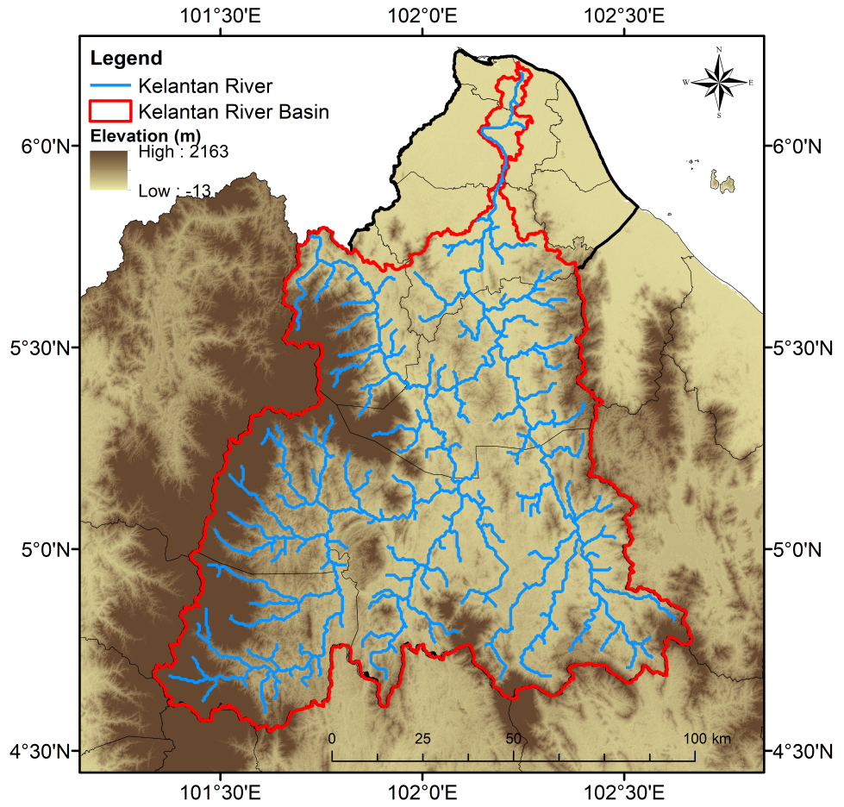
Source: SRTM (https://earthexplorer.usgs.gov/)

Figure 1. Elevation of Kelantan

Data and methodology

Sentinel satellite datasets

The Sentinel program, launched by the European Space Agency (ESA), is a satellite mission designed to monitor lands, oceans, and the atmospheric, utilizing radar and super-spectral imaging (ESA, 2022). A key advantage of Sentinel data is its high spatial resolution (global scale at 10-60 meters over land and coastal waters) and temporal resolutions. In this study, Sentinel datasets were accessed via the GEE data collection platform.
Sentinel-1 is a constellation of bi-polar orbiting satellites equipped with C-band Synthetic Aperture Radar (SAR) that captures images day and night, in all weather conditions, covering areas of 400 km², with a spatial resolution of 10-20 meters (ESA, 2022). It was selected for this study due to its ability to capture images through dense forest cover and clouds without requiring sunlight (Potin et al., 2012). This study used Level-1 Ground Range Detected (GRD) data for water surface detection (Pramanick et al., 2021).
The data was collected in Interferometric Wide Swath IW scanning mode, which excludes phase data from the swath. The Level-1 GRD product package includes SAR data that is detected, multi-looked, and projected onto the ground range Earth ellipsoid model. Vertical-Vertical (VV) and Vertical-Horizontal (VH) are two polarization configuration choices for the product (Kseňak et al., 2022). VH and VV have a strong return over areas with volume scattering and specular scattering, respectively (Huang et al., 2018). Monitoring of water surface and land cover have both benefited greatly from the use of backscattering GRD products (Schlaffer et al., 2022; Tsyganskaya et al., 2018).
This study utilizes the Sentinel-2 Level-1B product from the Copernicus Sentinel-2 Surface Reflectance image collection for accuracy assessment. Sentinel-2 is an optical sensor with 13 multispectral bands, spanning visible to shortwave infrared wave lights, and provides high spatial resolution data on Earth's surface (Baillarin et al., 2012). Sentinel-2 is widely used for land use mapping due to its higher spectral and spatial resolutions.

Methodology

The flood inundation map is validated using flood location points captured by Sentinel-2 data and site inspections by National Flood Forecasting and Warning Centre (PRABN) under the Department of Drainage (DID) Malaysia. Data processing is computerized on the GEE platform via JavaScript, eliminating the need to download data individually. The flood inundation map generated can be downloaded for further analyses. The methodology flow of this research is summarized in Figure 2, which can be divided into four major steps: (1) determining the flood dates and pre-processing of the Sentinel data; (2) creating a flood inundation map from Sentinel-1 data; (3) collecting actual flood locations from Sentinel-2 and site visits; and (4) validating the flood inundation map with the actual flood locations.

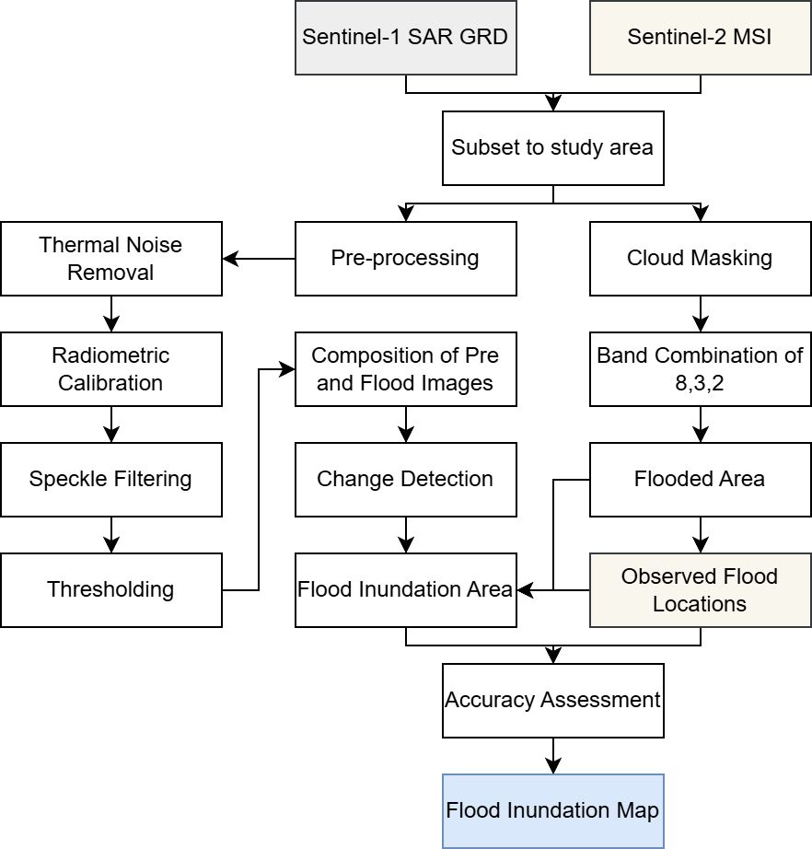

Figure 2. Methodology flow of flood inundation mapping using Google Earth Engine

Pre-processing of the sentinel data

Flood dates from December 15 – 21, 2021, were identified using site visit information from the DID and posts on social media platforms like Facebook and Twitter. Sentinel data Sentinel data captured during this period over the KRB was used for flood inundation mapping. Common pre-processing steps for satellite images include geometric and radiometric corrections. The geometric correction for this dataset was completed in the GEE archive before public release. Using the FAO GAUL dataset in GEE, a subset of the geometrically corrected dataset with minimal cloud cover was clipped to the Kelantan boundary(GoogleDevelopers, 2022a).
The Sentinel-1 GRD dataset used in this study involved only the VH polarized data as the VH is lower than VV over flat surfaces and it is more suitable to describe the variations in volume scattering (Kseňak et al., 2022). Within the GEE platform, the multi-looked Sentinel-1 GRD VH product has been adjusted to the ground range Earth ellipsoid model (Twele et al., 2016), thus the radiometric calibration and speckle filtering were performed to get the backscatter values. Following that, the smoothing approach is used to filter the speckle by removing the granular noise. In order to balance the demands of computational speed, resilience to outliers, and edge preservation, a speckle filter window of 5x5 (speckle filtering smoothing radius value 25) can be used (Amitrano et al., 2018; Haralick et al., 1973). Next, the JRC Global Surface Water Mapping Layers (GoogleDevelopers, 2022b) is added into the pre-processing and a threshold of 1.25 is set to mask the permanent surface waters (sea, rivers and lakes) out from the filtered images. Then, the 3 Arc-Seconds WWF HydroSHEDS Void-Filled DEM available in the Google Earth Engine Data Catalog (GoogleDevelopers, 2022c) is added into the code to filter out the false flood pixels by removing the flood pixels above 0.5% slope and the remaining water pixels in the result will be the true flood pixels. The same process is applied to both flooding images (15 – 31 December 2021) and the dry season images (1 – 28 February 2021).
As stated earlier, actual flood locations were extracted from the Sentinel-2 Level 1-B product since the flooded area can be detected easily when comparing with the images captured during non-flood periods. Similar to other satellite images, the Sentinel-2 images have been radiometric and geometric corrected by the GEE developers. Hence, the Sentinel-2 images on 15 – 31 December 2021 were retrieved and mosaicked at 50% cloud-masked. The Sentinel-2 images are viewed using a band composition of B8 (visible and near infrared), B3 (green), B2 (blue), so that the water bodies are clearly visible.

Flood inundation mapping

The Sentinel-1 SAR data is filtered using thresholds to extract flood-related surface water pixels (Pramanick et al., 2021; Zhang et al., 2020), since the threshold approach is capable of performing image binarization effectively (Landuyt et al., 2018). The results in an inundation map can also be considered as flooding areas.
In this study, the threshold approach based on the Otsu’s concept, a built-in function within GEE, can be used for image segmentation (Kseňak et al., 2022). This method automatically adjusts the ideal threshold depending on the pixel values distributed across the study area, particularly over the regions covered by water bodies. It is helpful to identify the best threshold to differentiate the between-class variance of water and non-water pixels. The permanent water regions, such as lakes, rivers and ocean, were identified using JRC Global Surface Water Mapping Layers (GoogleDevelopers, 2022b). Next, a threshold of 1.25 is set to remove pixels that classified as floods but duplicate within a 1.25 pixels range from permanent water surface (Landuyt et al., 2018). In addition, the flood pixels located in highlands are filtered by a threshold of 0.5% slope slope using the WWF HydroSHEDS Void-Filled DEM accessible in the GEE (GoogleDevelopers, 2022c) as floods are commonly to occur in lowland regions.
Image differencing method is applied by deriving the difference between the data captured on flooded days and the data captured on the days before the flooding period. This process enables the changes of the detected open water surfaces to be classed as a flood inundation area. When the same procedure is applied onto both images for flood and dry season, the difference between the classified flood pixels in both images are compared and the overlapped flood pixels are removed as the mis-classified flood pixels. Therefore, the remaining flood pixels are labelled as the final inundated area.

Accuracy assessment

Accuracy assessment is conducted by validating the generated final inundated area with the actual flood locations extracted site visits and randomly from Sentinel-2 images. It is evaluated pixel-by-pixel, where the flood pixels are labelled as “1” while the others “0” (Tulbure et al., 2022). As the majority of the pixels are the background class 0, we would just consider the flood pixels for accuracy assessment to avoid overestimation tendencies (Landuyt et al., 2018). The indicator used for the classification performance is Critical Success Index (CSI). It is more appropriate for evaluating the efficacy of classification algorithms on a single picture than it is for classifying floods among many catchments or at various intensities. (Mason et al., 2021). CSI is computed as:
$$CSI=\frac{t_{p}}{S₂}$$
where $t_{p}$ represents the flooded pixels that have been accurately identified by Sentinel-1 and $S_{2}$ is the total number of actual flood locations extracted from the Sentinel-2 image and site visits. Due to the data availability restriction, 20 actual flood points were acquired for this validation purposes,

Results and Discussion

Validation of the inundation mapping

A total of 20 flood areas were gathered for the accuracy evaluation due to the limited availability of cloud-free Sentinel-2 images during the flood event, as illustrated in Figure 3. In order to determine the appropriate threshold for defining the inundation region in the filtered Sentinel-1 SAR images, three distance criteria, 3-, 4-, and 5-pixel, between the flooded region and the permanent water surface that are inclusive were investigated. The results are tabulated in Table 1.

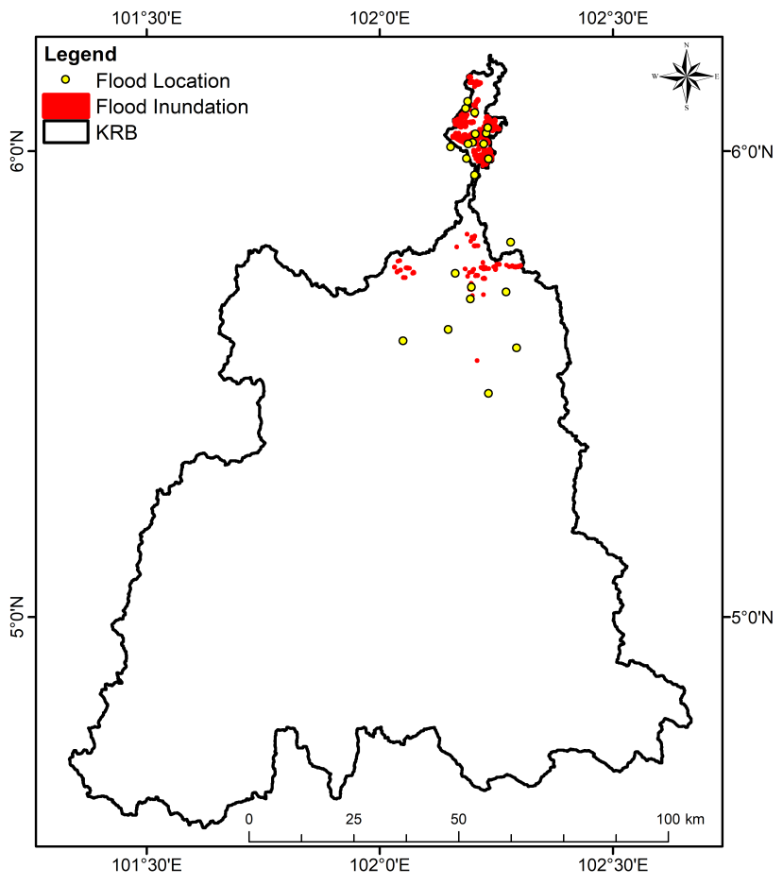

Figure 3. Distribution of the actual flood locations collected from the Sentinel-2 data

Table 1. Accuracy for each value of threshold

Threshold (pixel) | Accuracy (%)
3 | 57.6
4 | 58.5
5 | 60.0

Table 1 shows that threshold 5-pixel, which has the best performance in flood inundation mapping than 3- and 4-pixel, has been selected to map the flood region in the KRB. The process of identifying inundated area in this study is conceptualized by differentiating the water pixels elevated below the land pixels during flood event and dry event. The threshold of inundated area identified and the permanent waterbodies plays an important role here because of the lack of information about the river environment during the flood event and so the impact of river subsidence is not considered (Gao et al., 2021).

Flood inundation mapping of the KRB

Flooding of 8.92 km² has occurred in six districts as a result of the 2021–2022 flood, with the distribution of each district within the KRB being shown Figure 4 and Table 2. The flooded area, particularly in the low land regions, mostly found the northern region of the downstream Kelantan River (Figure 4). In general, Kota Bharu being the most flooded district in the basin (6.52 km²) and Pasir Mas coming in second (1.12 km²). During the 2021–2022 flood, the inundated area distributed around the Sawa River, with a total flooded area of 0.63 km² in the Machang district.

Table 2. Flood inundated areas in each district in the KRB during the Malaysia 2021-2022 flood

District | Area (km²)
Kota Bharu | 6.52
Kuala Krai | 0.01
Machang | 0.63
Pasir Mas | 1.12
Tanah Merah | 0.16
Tumpat | 0.47

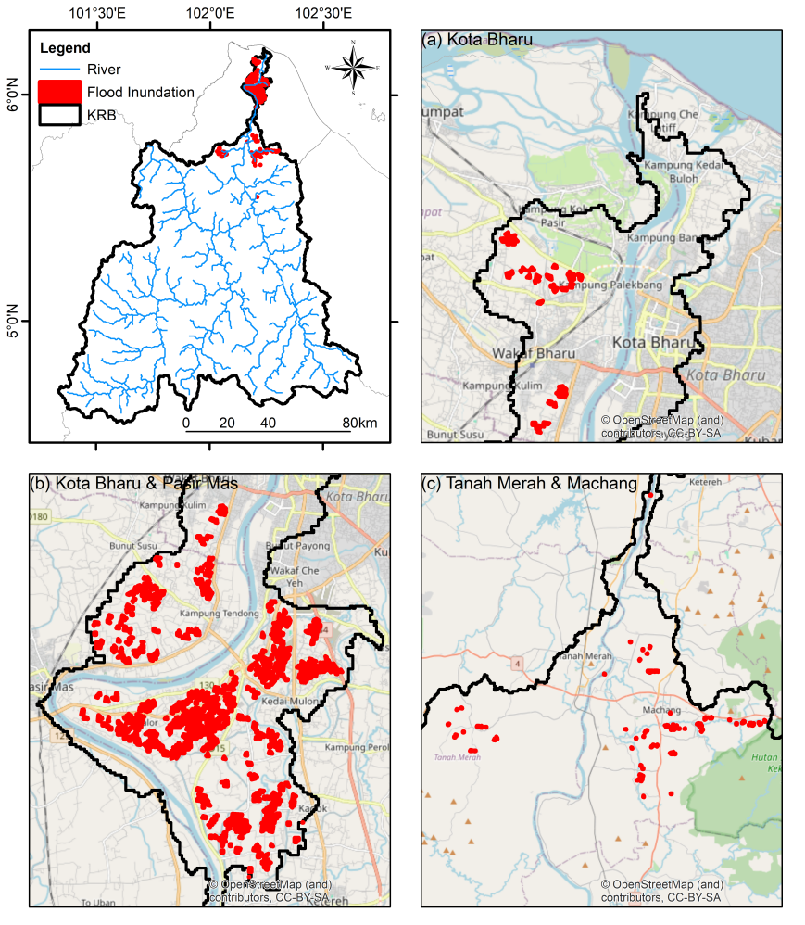

Figure 4. Sentinel-1 SAR generated flood inundation area distribution in: (a) zoom at the basin near river inlet; (b) Kota Bharu and Pasir Mas district; (c) Tanah Merah and Machang district

Discussion

Referring to the elevation map in Figure 1, the KRB is geographically surrounded by hills at the left and slightly elevated at the right and has lower elevation towards the center of the basin. Therefore, the inundation area generated in this study is relevant whereby the flooded areas are low-lying areas in the Kota Bharu, Tumpat, Machang, Tanah merah, Kuala Kerai and Pasir Mas. However, a big part of the flooded areas in Figure 4 (b) were found to be paddy fields, the flood over the paddy fields may affect the land preparation works of the farmers for the next seeding process (Lee et al., 2005). Therefore, the flood inundation mapping shown in this study could be a technique for crop management before the rainy seasons in the future as the climate change induced extreme precipitation is affecting rice production in Malaysia (Firdaus et al., 2020).
Referring to the flood analysis for the past December 2014 Big Yellow Flood in KRB, Alias et al. (2016) discussed about the changes of global climatic patterns during the northeast monsoon season that elevated the effects of extreme rainfall events over the basin. The detailed rainfall distribution assessment over the basin shows that heavy precipitation began over upstream of the river at the eastern and western part of the basin, resulting in the rise of water level in Kelantan River, particularly Kuala Krai. This is due to the fact that the Kelantan River, Lebir River, and Galas River meet at this region, making it the junction of Kelantan's three main rivers. Hence, the accumulated water in the river during continued extreme precipitation have led to flood events in Kota Bharu, Machang, and Dabong.
The results in this study show a similar flood distribution pattern as discussed in the flood during December 2014, as shown in Figure 4 (b). As the data and method of generation adopted in this study are all open-sourced, the concept of mapping the flood inundation with SAR imageries in the KRB is a solution for the researchers and the flood management members to identify the extent of the flood in a simpler manner at a finer scale.
Hydraulic modelling is currently a common practice in Malaysia for creating a flood inundation map (Faghih et al., 2017). For instance, Faghih et al. (2017) used the HEC-RAS model to produce the flood inundation map for Langat River Basin and Tam et al. (2019) applied the same model onto the KRB. Both studies concluded that modelling could produce high accuracy flood inundation mapping, however, the modelling process can be only run after the flood events by professional with the hydrology data during the flood event collected from the local agencies, therefore the ability of the SAR images to capture near real time flood area in large scale is a value added in flood mapping, especially in the remote areas such as forest and plantation farms that are hard to access during the flood event (Pramanick et al., 2021).

Limitation of the study

Although the proposed methodology to map the inundation area in the KRB is efficient, data availability is one of the major limitations of this study. The Sentinel-1 SAR data has a temporal resolution of 6 to 12 days, whereby this may cause the lack of data during the flood event when the data is not captured on the day of the flood and the solution is to mosaic the data pre and post flood for the processing and this might cause the loss of flood data collection as the flood might have receded during the data capture. Sentinel-2 data having the same issue as well, and the thick cloud cover over the flood area would have blocked the satellite to collect the targeted information.
When interpreting SAR data for flood mapping, dense vegetation in tropical regions can have a substantial impact due to the sensitivity of SAR signals to vegetation. Backscatters signals from SAR may be less accurate in identifying flooded areas in forested or other vegetation regions, for example, rubber and oil palm estates. In addition, some built-up areas were not included in the inundation area generated, which might be caused by the information loss during speckle filtering and elevation delineation. Therefore, both polarization modes in the SAR GRD product have to be included in the processing to discover the potential of the combination of the polarization modes in increasing the effectiveness of using SAR data to map floods (Tulbure et al., 2022). Additionally, combining extremely high resolution SAR digital slope model (DSM) such as the Interferometric Synthetic Aperture Radar (IFSAR) data may improve the mapping of urban floods (Mason et al., 2021).
As mentioned earlier, speckle noise in Sentinel-1 SAR might reduce the visual quality of images, thus make flood mapping more difficult. Besides that, Sentinel 1’s spatial resolution could not be adequate to capture small-scale floods since flooded and non-flooded may co-exist in the same pixel. The “mixed-pixel” effect happens when the SAR signals contains both water and non-water elements within a single pixel, making it difficult to distinguish these two features. In addition, small-scale flood may be obscured by the urban areas with high density buildings like the Kota Bharu town. To overcome this limitation, higher resolution data should be integrated in the GEE-based flood mapping framework. Continuously improvements in SAR processing approaches and the development of higher-resolution SAR satellites are essential to address the challenges of tropical flood mapping.

Conclusion

Flood inundation information is crucial in flood management especially for the resource allocation planning. This research has demonstrated a quick procedure of producing such information with a combination of advanced satellite technologies with a powerful cloud-based analysis platform. The presented approach is helpful for the local authorities for flood preparedness and response strategies development of mitigation strategies during the early stage of the event as soon as the data is available.
The flood event has caused 8.92km² of flooded areas in the KRB during the 2020-2021 event, as generated by the Sentinel-1 SAR image. The location of the inundated region demonstrates that the flood is concentrated along the main rivers, particularly in the downstream region. According to the accuracy assessment, the GEE-based method performs moderately in mapping flood inundation area in the KRB.
Since flood models are mainly used to produce flood maps in Malaysia, future research could explore the coupling or integration of GEE and Sentinel-1 SAR flood outputs with flood models to provide real-time flood forecasting. This could help to better understand the impact of flood events in the KRB. Future work should consider additional indices, datasets or algorithms to improve the flood inundation mapping in tropical regions. Furthermore, the GEE-based flood inundation mapping framework could be tested in other river basins in Malaysia or similar nearby tropical regions to understand the effectiveness of the method across different types of river basins.

Acknowledgment

The project was funded by the Ministry of Higher Education Malaysia under the Long-term Research Grant Scheme project 2, grant number LRGS/1/2020/UKM-USM/01/6/2, which is under the program of LRGS/1/2020/UKM/01/6.

References

Alias, N. E., Mohamad, H., Chin, W. Y., & Yusop, Z. (2016). Rainfall analysis of the Kelantan big yellow flood 2014. Jurnal Teknologi, 78(9-4), 83-90.

Amitrano, D., Di Martino, G., Iodice, A., Riccio, D., & Ruello, G. (2018). Unsupervised rapid flood mapping using Sentinel-1 GRD SAR images. IEEE Transactions on Geoscience and Remote Sensing, 56(6), 3290-3299.

Baillarin, S. J., Meygret, A., Dechoz, C., Petrucci, B., Lacherade, S., Tremas, T., Isola, C., Martimort, P., & Spoto, F. (2012). Sentinel-2 Level 1 products and image processing performances. The International Archives of the Photogrammetry Remote Sensing and Spatial Information Sciences, XXXIX-B1, 197-202.

Bernama. (2021, December 19). Flood situation worsens as at afternoon, more than 34,000 victims evacuated. The Sun Daily. https://www.thesundaily.my/local/flood-situation-worsens-as-at-afternoon-more-than-34000-victims-evacuated-YC8675809

EM-DAT. (2022). EM-DAT: The emergency events database. www.emdat.be

ESA. (2022). The Sentinel missions. https://www.esa.int/Applications/Observing_the_Earth/Copernicus/The_Sentinel_missions#:~:text=ESA%20is%20developing%20a%20new,robust%20datasets%20for%20Copernicus%20services.

Faghih, M., Mirzaei, M., Adamowski, J., Lee, J., & El-Shafie, A. (2017). Uncertainty Estimation in Flood Inundation Mapping: An Application of Non-Parametric Bootstrapping. River Research and Application, 33(4).

Firdaus, R. B. R., Tan, M. L., Rahmat, S. R., & Gunaratne, M. S. (2020). Paddy, rice and food security in Malaysia: A review of climate change impacts. Cogent Social Sciences, 6(1).

Gao, G., Lim, H. S., & Zhu, Y. (2021). Flood inundation analysis in Penang Island (Malaysia) based on InSAR maps of land subsidence and local sea level scenarios. Water, 13(11), 1518.

Ghosh, S., Kumar, D., & Kumari, R. (2022) Cloud-based large-scale data retrieval, mapping, and analysis for land monitoring applications with Google Earth Engine (GEE). Environmental Challenges, 9, 100605.

GoogleDevelopers. (2022a). FAO GAUL: Global Administrative Unit Layers 2015, First-Level Administrative Units. https://developers.google.com/earth-engine/datasets/catalog/FAO_GAUL_2015_level1

GoogleDevelopers. (2022b). JRC Global Surface Water Mapping Layers, v1.3. https://developers.google.com/earth-engine/datasets/catalog/JRC_GSW1_3_GlobalSurfaceWater

GoogleDevelopers. (2022c). WWF HydroSHEDS Void-Filled DEM, 3 Arc-Seconds. https://developers.google.com/earth-engine/datasets/catalog/WWF_HydroSHEDS_03VFDEM

Haralick, R. M., Shanmugam, K., & Dinstein, I. H. (1973). Textural features for image classification. Studies in Media and Communication SMC-3(6), 610-621.

Huang, W., DeVries, B., Huang, C., Lang, M. W., Jones, J. W., Creed, I. F., & Carroll, M. L. (2018). Automated extraction of surface water extent from Sentinel-1 data. Remote Sensing, 10(5), 797.

Hussain Shah, S. M., Mustaffa, Z., & Wan Yusof, K. (2017). Disasters worldwide and floods in the Malaysian region: A brief review. Indian Journal of Science and Technology, 10(2), 1-9.

Ibrahim, N. A., Wan Alwi, S. R., Abdul Manan, Z., Mustaffa, A. A., & Kidam, K. (2021). Flood impact on renewable energy system in Malaysia. Chemical Engineering Transactions, 89, 193-198.

IPCC. (2021). AR6 Climate Change 2021: The Physical Science Basis. https://www.ipcc.ch/report/ar6/wg1/#FullReport

Koh, L. S., Nayan, N., Hashim, M., Saleh, Y., & Mahat, H. (2021). Alternative water resources quality assessment during flood disaster in Kuala Krai, Kelantan, Malaysia. Sains Malaysiana, 50(3), 645-654.

Kseňak, Ľ., Pukanská, K., Bartoš, K., & Blišťan, P. (2022). Assessment of the usability of SAR and optical satellite data for monitoring spatio-temporal changes in surface water: Bodrog River case study. Water, 14(3), 299.

Landuyt, L., Van Wesemael, A., Schumann, G. J.-P., Hostache, R., Verhoest, N. E. C., & Van Coillie, F. M. B. (2018). Flood Mapping based on Synthetic Aperture Radar: An assessment of established approaches. IEEE Transactions on Geoscience and Remote Sensing, PP(99), 1-18.

Lee, T. S., Haque, M. A., & Najim, M. M. M. (2005). Scheduling the cropping calendar in wet-seededrice schemes in Malaysia. Agricultural Water Management, 71(1), 71-84.

Mason, D. C., Bevington, J., Dance, S. L., Revilla-Romero, B., Smith, R., Vetra-Carvalho, S., & Cloke, H. L. (2021). Improving urban flood mapping by merging Synthetic Aperture Radar-derived flood footprints with flood hazard maps. Water, 13(11), 1577.

Mohd Taib, Z., Jaharuddin, N. S., & Mansor, Z. (2016). A review of flood disaster and disaster management in Malaysia. International Journal of Accounting & Business Management, 4(2), 98-106.

Ong, H. S. (2022, January 4). Expert: Debris flood in Pahang and Selangor caused by multiple landslides, streams of waste. The Star. https://www.thestar.com.my/news/nation/2022/01/04/expert-debris-flood-in-pahang-and-selangor-caused-by-multiple-landslides-streams-of-waste

Potin, P., Bargellini, P., Laur, H., Rosich, B., & Schmuck, S. (2012). Sentinel-1 mission operations concept. 2012 IEEE International Geoscience and Remote Sensing Symposium, pp. 1465-1468, Quebec City, QC, Canada.

Pramanick, N., Acharyya, R., Mukherjee, S., Mukherjee, S., Pal, I., Mitra, D., & Mukhopadhyay, A. (2021). SAR based flood risk analysis: A case study Kerala flood 2018. Advances in Space Research, 69(4), 1915-1929.

Rahman, S. (2022, March 16). Malaysia’s Floods of December 2021: Can Future Disasters be Avoided? Researchers at ISEAS – Yusof Ishak Institute Analyse Current Events. https://www.iseas.edu.sg/wp-content/uploads/2022/03/ISEAS_Perspective_2022_26.pdf

Schlaffer, S., Chini, M., Dorigo, W., & Plank, S. (2022). Monitoring surface water dynamics in the Prairie Pothole Region of North Dakota using dual-polarised Sentinel-1 Synthetic Aperture Radar (SAR) time series. Hydrology and Earth System Sciences, 26(3), 841-860.

Tam, T. H., Abd Rahman, M. Z., Harun, S., Hanapi, M. N., & Kaoje, I. U. (2019). Application of satellite rainfall products for flood inundation modelling in Kelantan River Basin, Malaysia. Hydrology, 6(4), 95.

Tan, M.L., Juneng, L., Kuswanto, H., Do, H. X., & Zhang, F. (2023). Impacts of solar radiation management on Hydro-Climatic Extremes in Southeast Asia. Water, 15(6), 1089.

Tew, Y. L., Tan, M. L., Chun, K. P., Samat, N., & Mahamud, M. A. (2022a). Analysis of the relationship between climate change and land use change using the ESA CCI Land Cover maps in Sungai Kelantan Basin, Malaysia. Sains Malaysiana, 51(2), 437-449.

Tew, Y. L., Tan, M. L., Juneng, L., Chun, K. P., Hassan, M. H., Osman, S., Samat, N., Chang, C. K., & Kabir, M. H. (2022b). Rapid Extreme Tropical Precipitation and Flood Inundation Mapping Framework (RETRACE): Initial testing for the 2021–2022 Malaysia flood. ISPRS International Journal of Geo-Information, 11(7), 378.

Tsyganskaya, V., Martinis, S., Marzahn, P., & Ludwig, R. (2018). Detection of temporary flooded vegetation using Sentinel-1 time series data. Remote Sensing, 10(8), 1286.

Tulbure, M. G., Broich, M., Vincius, P., Gaines, M., Ju, J., Stehman, S. V., Pavelsky, T., Masek, J. G., Yin, S., Mai, J., & Betbeder-Matibet, L. (2022). Can we detect more ephemeral floods with higher density harmonized Landsat Sentinel 2 data compared to Landsat 8 alone?. ISPRS Journal of Photogrammetry and Remote Sensing, 185, 232-246.

Twele, A., Cao, W., Plank, S., & Martinis, S. (2016). Sentinel-1-based flood mapping: A fully automated processing chain. International Journal of Remote Sensing, 37(13), 2990-3004.

Zhang, M., Chen, F., Liang, D., Tian, B., & Yang, A. (2020). Use of Sentinel-1 GRD SAR images to delineate flood extent in Pakistan. Sustainability, 12(14), 5784.

