Synergizing IFSAR and LiDAR data fusion using Delta Surface Fill for Hybrid DEMs accuracy in topographic mapping

Norfaraedayu Azman¹, Helmi Zulhaidi M. Shafri¹, Ahmad Fikri Abdullah¹, Syed Ahmad Fadhli Syed Abdul Rahman²

¹Department of Civil Engineering, Faculty of Engineering, Universiti Putra Malaysia,
43400, Serdang, Selangor, Malaysia
¹Department of Biological and Agricultural Engineering, Faculty of Engineering, Universiti Putra Malaysia, 43400, Serdang, Selangor, Malaysia
²Earth Observation Centre, Institute of Climate Change (IPI), Universiti Kebangsaan Malaysia, 43600 UKM, Bangi, Selangor, Malaysia.

Correspondence: Norfaraedayu Azman (email: norfaraedayu@jupem.gov.my)

Received: 13 August 2023; Accepted: 9 November 2023; Published: 30 November 2023

Abstract

A Digital Elevation Model (DEM) continuously represents a ground surface landform created from photogrammetry and field surveys commonly used to produce topographic maps. However, obtaining aerial photography is costly and often fails to capture areas obstructed by clouds, mist, or haze due to the limitation of the optical systems. Consequently, the data collection process lacks efficiency and incurs high costs. Therefore, this study addresses the challenge of enhancing DEM accuracy through a fusion approach using the Delta Surface Fill (DSF) method to fulfill the need for accurate and detailed representations of topographic maps. The investigation focused on fusing Interferometric Synthetic Aperture Radar (IFSAR) and Light Detection and Ranging (LiDAR) data with distinct spatial resolutions and vertical accuracies to generate a Hybrid DEM. The DSF method was applied to fill gaps and reduce noise, ensuring a seamless fusion of datasets. Quantitative analysis unveiled a significant enhancement in vertical positional accuracy with the Hybrid DEM. The Root Mean Square Error (RMSE) for Hybrid DEM was reduced from 1.065 m to 0.312 m, signifying a remarkable 70.7% improvement over IFSAR DEM. Geomorphological assessments demonstrated the Hybrid DEM's aesthetic precision and spatial resolution superiority, contributing to sharper building edges and more explicit topographic features. Terrain profile analysis validated the robustness of the Hybrid DEM, showcasing strong agreement with LiDAR DEM across varying landscape conditions. The result proved that this study provides valuable insights for researchers and professionals engaged in geospatial data fusion, contributing to the advancement of topographic mapping and related applications.

Keywords: Delta Surface Fill, DEM, fusion, IFSAR, LIDAR, topographic map

Introduction

Digital Elevation Models (DEMs) are among the most vital types of geodata. They are needed in a large number of applications, ranging from visualization to engineering and environmental planning. It is a crucial primary data source in Topographic Mapping (Anantakarn et al., 2019). DEMs represent the ground surface's elevation with respect to any difference datum in a raster format that provides gridded elevation data. It consists of x-, y- and z- values representing latitude, longitude coordinates, and elevation information, respectively (Muhadi et al., 2020; Mohamad et al., 2021). DEMs can be produced using ground surveys, digitising hardcopy topographic maps, UAV mapping and remote sensing technology (Kamarulzaman et al., 2021; Abd Mukti & Tahar, 2021). Due to the rapid advancements in remote sensing technology, DEMs generated using remote sensing methods such as photogrammetry, Interferometric Synthetic Aperture Radar (IFSAR), or Light Detection and Ranging (LiDAR) have become the preferred choice mainly to cover large-scale areas (Pa'suya et al., 2022).
In Malaysia, the Department of Survey and Mapping Malaysia (JUPEM) is the authority agency for producing topographic maps for the country. JUPEM has used various kinds of data sources for its topographic mapping exercises. Most data sources for mapping activities are obtained from airborne platforms such as aerial photography, IFSAR, and LiDAR (Hassan & Rahman, 2021). Presently, JUPEM allocates over one million ringgits annually for data acquisition using aircraft to update the topographic maps of Malaysia.
However, obtaining aerial photography is quite costly and often fails to capture areas obstructed by clouds, mist, or haze throughout Malaysia. This is because aerial photography techniques employ optical systems that cannot penetrate clouds. Consequently, the data collection process lacks efficiency and incurs high costs (Haron & Omar, 2019). With the vast development in mapping technology, alternative methods can solve the problems described above in this new era. That method offers acceptable accuracy for generated topographic maps.
Implementing IFSAR and LiDAR technologies has significantly increased the availability of three-dimensional mapping products in the form of DEM in recent years. These technologies are active remote sensing systems capable of generating an elevation model of the terrain by transmitting pulses and receiving backscattered returns. They measure the two-way-time delay from the transmitting element to the scattering elements and convert it into a range measurement. This system is equipped with highly accurate onboard INS/GPS positioning data to support the computation of the scattering coordinates in these technologies. The differences between IFSAR and LiDAR systems are that IFSAR wavelengths vary and can penetrate clouds and haze.
In contrast, LiDAR wavelength tends to be refracted or absorbed by the water instead of being reflected to the sensor, resulting in significant gaps on the surfaces of the water body (Bohak et al., 2020). DEM generated from radar techniques such as IFSAR may have a stable accuracy level over flat. However, it can be prone to errors caused by layovers and shadow effects resulting from radar side-view imaging in regions with significant terrain fluctuations. In contrast, LiDAR DEM has no geometric distortion, like side-looking radars with higher accuracy, and the range of vertical accuracy is within 15 to 100 centimetres (Cheng et al., 2018; Idris et al., 2023). As a result, the widespread utilisation of DEMs faces limitations due to variations in observation and processing methods and disparities in the resolutions of DEMs datasets (Guan et al., 2020). As different sensors capture the data with verifying resolutions, accuracies, and data quality, this study proposes a DEM data fusion to effectively utilise the advantages of different data sources to improve the accuracy and data quality of existing DEM products (Zhao et al., 2022).

Literature review

Wang et al. (2018) apply a simple averaging method to fuse DEMs between Advanced Spaceborne Thermal Emission and Reflection Radiometer Global Digital Elevation Model (ASTER GDEM) and Ice, Cloud, and land Elevation (ICESat). The mean elevation is calculated on corresponding cells to derive new heights. In contrast, Okolie and Smit (2022) stated that an optimal solution is not always achieved by averaging all the corresponding elevation points to derive new heights. Research by Fu and Tsay (2016) defines Weighting Averaging (WA) as a standard method for DEM fusion. This is applied as a fast and straightforward method for DEM fusion. Pasapaika et al. (2008) applied the WA approach by combining the height value from two DEMs using the weighted average rule (Bagheri et al., 2018). This method depends on the weights describing each pixel's height error distribution. This method empirically demonstrated significant results (Pasapaika et al., 2008; Pasapaika et al., 2009; Deng et al., 2011; Bagheri et al., 2018).
Next, Mohamed and Saleh (2018) applied the WA approach based on height error to determine weight by merging Shuttle Radar Topography Mission (SRTM) and ASTER GDEM Version 2 (GDEM2) DEM at sites in Egypt. The root mean square error (RMSE) for SRTM, ASTER GDEM2, and weighted fused were ±6.94, ±7.97 and ±6.71 after fusion. Tran et al. (2014) performed WA DEM fusion between 90 m SRTM and 30 m ASTER GDEM2 based on a landforms classifications map. The results demonstrate a reduction in RMSE from 14.9 m for ASTER GDEM2 and 14.8 m for SRTM to 11.6 m for the fused DEM.
Based on previous studies, it can be identified that DEM fusion usually takes place at the pixel level. Most conventional methods use height error maps to determine the influence of each source DEM in the fusion before the merging process. Meanwhile, Delta Surface Fill (DSF) method uses an appropriate reference source (delta surface) to replace a DEM gap, which is adjusted to the input DEM values found at the void interface (Gonzalez et al., 2022). Therefore, the objective of this study is to demonstrate the effectiveness of a Hybrid Digital Elevation Model (DEM) produced by fusing Interferometric Synthetic Aperture Radar (IFSAR) and Light Detection and Ranging (LiDAR) data using the DSF approach in improving the accuracy of the DEM. The approach proposed in this study is potentially practical to improve the quality of high-resolution DEM data, which past studies on DEM fusion utilising DSF techniques have not done. Most previous studies used DSF approaches by integrating global DEMs from satellite data (Grohman et al., 2006; Hoja & d'Angelo, 2009; Schindler et al., 2011; Takaku et al., 2020).

Methodology

Study area

This study covers approximately 25 square km (5km x 5km) in the Federal Territory of Putrajaya, Malaysia. Putrajaya is a planned city and the federal administrative centre of the Malaysian capital, replacing Kuala Lumpur in 1999. Putrajaya's topography has changed significantly due to the city's rapid development. The location of the study area is shown in Figure 1.

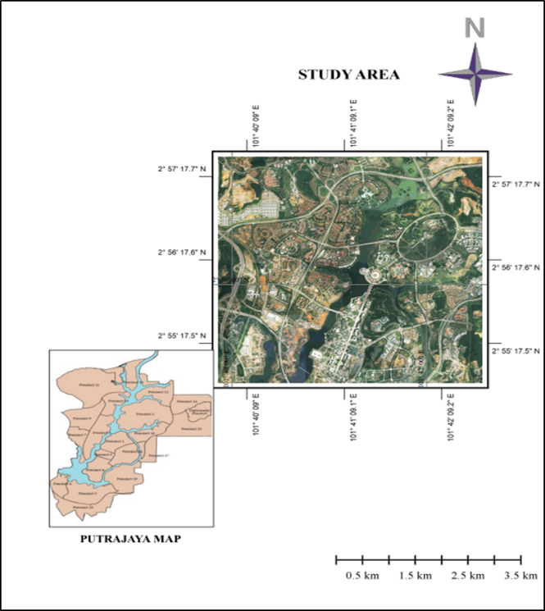

Figure 1. Study area, Federal Territory of Putrajaya, JUPEM, 2020

Data

The data source used for this study comprised two (2) sets of DEMs acquired from IFSAR and LiDAR techniques. IFSAR data was acquired in the year 2016 by the Intermap Technologies Corporation for Peninsular Malaysia using a STAR 3i-Sensor mounted on a Learjet 36A aircraft at a 28,000 feet altitude. It is a dual antenna interferometer that consists of X-Band and P-Band separated by a ~1-meter baseline across the track plane.
Intermap Product Handbook (2016) stated that the Intermap mapping system can achieve a vertical accuracy of 0.5-1.0m RMSE for the airborne IFSAR DSM and DTM. LiDAR data for this study was collected in 2014 using a Leica ALS70HP sensor mounted on a fixed wings aircraft with a flying height of 900 meters above the Mean Sea Level (MSL). For this study, both DEMs were obtained from JUPEM. The data specifications are shown in Table 1.

Table 1. Data specification

Terrain product |  | Accuracy | Resolution | Coordinate systems
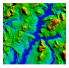 | IFSAR | 100 cm | 500 cm | Geographic WGS84
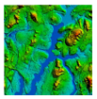 | LiDAR | 15cm | 50 cm | Geographic WGS84

Research procedure

Figure 2 presents the flowchart of the methodology adopted for this study. The fusion process requires all datasets to be in the same spatial reference system and area coverage. DEM data from JUPEM consists of tiles with different area coverage in ASCII format. Due to that, image subset was carried out to clip data to obtained same coverage for both DEMs using Global Mapper software.

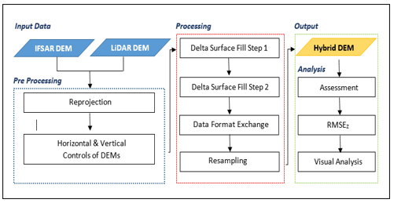

Figure 2. Research methodology flowchart

Next, the pre-processing stage includes geometric correction and a georeferencing process where all data are displayed in Geographic WGS84 coordinate systems. Having consistent horizontal and vertical datum across the DEMs is of utmost importance for comprehending the data prior to conducting any additional analysis or application. Both DEMs were then aligned, and a fusion procedure was carried out. ERDAS Imaging 2020 software was utilized to perform the DEM Fusion procedure.
Then data processing involved measuring the vertical distance between IFSAR DEM and LiDAR DEM at Delta Surface Fill Step 1. This returns a surface, termed here a “Delta Surface. In this process, LiDAR DEM is set as Fill DEM while IFSAR DEM is defining as Parent DEM. A delta surface has gaps in between corresponding pixels within the grids. As per the original study (Abrams et al., 2020), the gaps seamlessly fill by adjusted vertically to compensate for height differences (the delta) between DEMs. Next, the average value for entire delta surface was added back into the centre of IFSAR DEM, and the remaining pixels were then fused using interpolated values at Delta Surface Fill Step 2 stage.
As a result, a new 5-meter DEM product was generated from the fusion process. Next, data format exchange to ascii format is carried out to facilitate easier data editing for next phase of processing. Given the nature of the DEMS obtained from dense remotely sensed measurements, including LiDAR and RADAR-based DEMs, they provide significantly more surface detail than traditional interpolated DEMs. However, random noise affects the surface of the shape measurements, such as slope and flow direction. Hence, a smoothing process was applied to reduce noise in the output Hybrid DEM data. Smoothing is an effective method for reducing noise but has a detrimental effect on critical surface details lost throughout the process (Huber et al., 2021). Ideally, a smoothing method would provide additional smoothing where noise is considerable compared to the actual surface and little or no smoothing where noise is substantially smaller. For this purpose, Global Mapper Software was utilized. The geomorphological quality differences between the Hybrid DEM final products are shown in Figure 3.
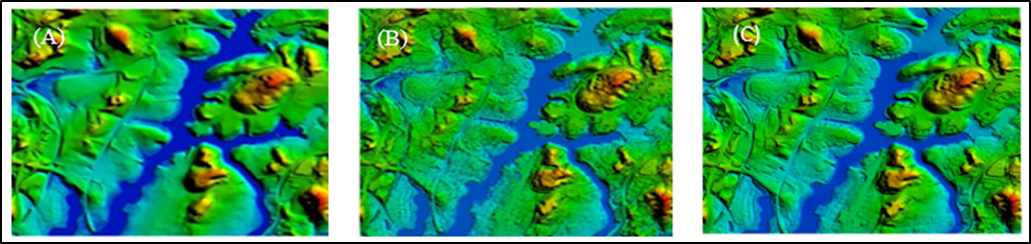

Figure 3. Geomorphological quality different between (A) IFSAR DEM, (B) LiDAR DEM and (C) Hybrid DEM

As the number of extra-terrestrial DEMs grows, fusion techniques will likely become an increasingly viable solution for creating more comprehensive topographic maps of the planet (Okolie & Smit, 2022). Therefore, the DSF method was chosen in this study because it yields more accurate results than traditional void-filling approaches alone (Robinson et al., 2014). Furthermore, DSF is categorized as specialized void-filling algorithms compared to spatial interpolation methods such as kriging, spline and inverse distance weighted. In order to evaluate the overall quality of the hybrid DEM product, accuracy assessments were performed in which elevation values between hybrid DEM, four (4) Ground control points (GCP) and fifty-six (56) Check Points (CP) (Figure 4) were then compared by calculating the RMSE. The RMSE was derived from a statistical formula for measuring the accuracy of the Hybrid DEM data against independent GCPs and CPs data. The resulting RMSEz value measures the difference between these two (2) data sets. GCPs were established using the GNSS static technique with one-hour observations for each point using a Trimble R8 receiver while CPs were also established in a scatter location throughout the study area using the rapid static technique with a 15-minute observation at each point. All the data were then processed using Trimble Business Center (TBC) software. The geoid model WMGEOID04 (Peninsular Malaysia) obtained from JUPEM was applied to obtain the orthometric mean sea level (MSL) height.
The final step was the visual analysis, performed by comparing the level of detail in IFSAR DEM and Hybrid DEM. Visual quality assessment was carried out in Global Mapper software using 3D view tools.

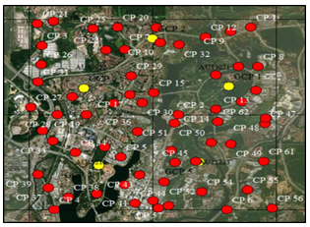

Figure 4. Location of GCP (yellow points) and CPs (red points) over the study area
Results and discussion

Quantitative analysis

A total of 60 points stations were used for vertical positional accuracy. The RMSEz for the coordinates generated from the Hybrid DEM was 0.312 m, with minimum and maximum height errors ranging from -0.913 m to 0.985 m, respectively. The RMSEz equation is defined in Equation (1), where n is the number of datasets, zi is the value of CP, and z is the predicted value.

RMSEz = $\sqrt{\sum_{i=1}^{t=n}{\frac{{(zi-z)}^{2}}{n}}}$ | (1)

Furthermore, vertical positional accuracy for IFSAR DEM was also performed by comparing the CPs, and the RMSEz was computed. The minimum and maximum height differences ranged from -2.483 m to 2.960 m, while the RMSEz was 1.065 m. Table 2 describes RMSEz before and after the fusion process. The higher the value of the RMSE, the lower the accuracy (Mesa-Mingorance & Ariza-López, 2020). As can see in Table 2, statistical analysis showed a significant in RMSEs after the fusion process. RMSEs for both DEMs reduced from 1.065m to 0.312m, respectively.

Table 2. RMSEz between Hybrid and IFSAR DEM

DEM product | Min error (m) | Max error (m) | RMSEz | Percentage of improvement (%)
IFSAR | -2.483 | 2.960 | 1.065 | 70.7
Hybrid | -0.913 | 0.985 | 0.312 | 70.7

Meanwhile, Figures 5 and 6 show scatter plots of height difference between IFSAR DEM and Hybrid DEM against CP. The results show a significant height difference between IFSAR DEM and CP before fusion process occurred, while the height difference between Hybrid DEM and CP after the fusion process becomes lesser.

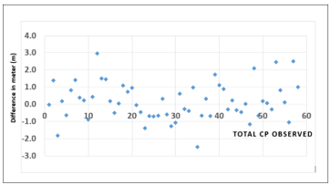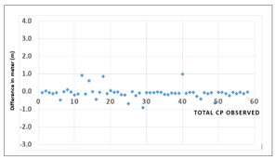
Figure 5. Height Difference between IFSAR DEM  and CPs | Figure 6. Height Difference between Hybrid DEM  and CPs

Next, the statistical relationship between IFSAR and Hybrid DEM against CPs is shown in Figures 7 and 8. Based on the relationship, the obtained value of R² is 0.9926 for IFSAR DEM and 0.9994 for Hybrid DEM. It shows that Hybrid DEM has a stronger positive relationship with CPs than IFSAR DEM.
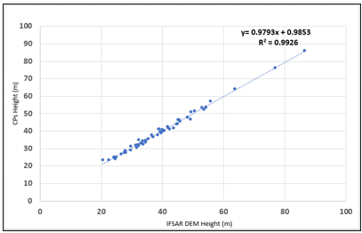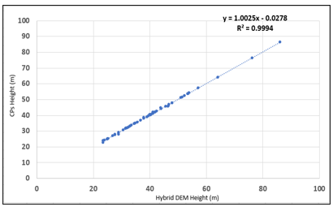

Figure 7. Relationship of IFSAR DEM and CPs | Figure 8. Relationship of Hybrid DEM and CPs  CPs Height (m)

JUPEM (2018) specified that the tolerance for vertical positional accuracy (RMSEz) is ± 2.5 m for a 1: 10,000 map scale in Data Quality Management (MS ISO 9001:2015). The results through independent vertical assessment show that the Hybrid DEM product conforms to the JUPEM Data Quality Management.

Geomorphological analysis

Visual quality assessment was carried out in Global Mapper software using 3D view. The visual quality between different image resolutions will affect the DEM. The lower the spatial resolution is given, the better visualization. Figure 9 shows the geomorphological quality difference between (a) IFSAR DEM and (b) Hybrid DEM.

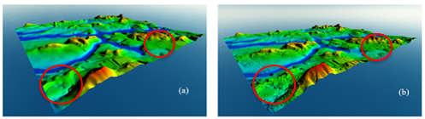

Figure 9. Geomorphological quality different between (a) IFSAR DEM and (b) Hybrid DEM

Visually from the assessment, it can be concluded that hybrid DEM is more aesthetically precise; building edges and borders are sharper than the IFSAR DEM used as a comparison. Each data can complement each other and generate a new value-added product. The red circle representing terrain changes could be easily identified after fusion. IFSAR DEM is coarser and makes terrain changes not easily identified, affecting data analysis and decision-making. Table 3 describes the spatial resolutions of IFSAR DEM before and after the fusion process.

Table 3. Spatial resolutions comparisons

DEM product | Pixel width (m) | Pixel height (m) | Percentage of improvement (%)
IFSAR | 5.000 | 5.000 | 7.74
Hybrid | 4.613 | 4.613 | 7.74
Terrain profile analysis

Next, terrain profiling analysis is performed along the three cross-sections selected within the study area, as shown in Table 4. Cross-section 1 was across a hilly area, while Cross-section 2 was a vegetation area. Cross-section 3 was located within the study area's residential and relatively flat section. Figure 10 (a), (b) and (c) showed the profile plot along the cross-section. In all three cross-sections, there is a strong agreement between profiles generated from IFSAR DEM, Lidar DEM and Hybrid DEM. Generally, all cross-sections showed a similar pattern of elevation profiles, although there maybe variations at certain points along the cross-sections. Visually, Hybrid DEM showed an elevation close to LiDAR DEM (accuracy indicator), compared to IFSAR DEM, in the flat and vegetation areas (refer to Figures 10 (b) and 10 (c)). The most significant elevation difference between the Hybrid DEM and LiDAR DEM was occupied in a hilly area (Figure 10 (a)).

Table 4. Terrain profile description

Area | Terrain profile
Hilly  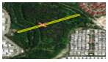 | Start Position  End Position  Straight Line Distance  3D Distance  Max Path Slope  Total Climbing  Total Descending | Latitude 2° 57ʹ 06.1231ʺ N  Longitude 101° 40ʹ 10.9880ʺ E  Latitude 2° 57ʹ 10.6978ʺ N  Longitude 101° 40ʹ 20.0883ʺ E  314.2 m  338.7 m  51.64° [105.04m along path]  50.6m over 156.77 on surface  52.5m over 181.92m on surface
Vegetation  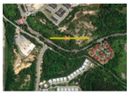 | Start Position  End Position  Straight Line Distance  3D Distance  Max Path Slope  Total Climbing  Total Descending | 2° 57ʹ 25.1341ʺ N  101° 40ʹ 01.6838ʺ E  2° 57ʹ 25.7878ʺ N  101° 40ʹ 12.0063ʺ E  319.4m  323.02m  40.19° [169.85 along path]  25.8m over 237.12m on surface  7.4m over 85.9m on surface
Residential and relatively flat  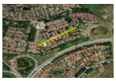 | Start Position  End Position  Straight Line Distance  3D Distance  Max Path Slope  Total Climbing  Total Descending | 2° 57ʹ 19.8225ʺ N  101° 41ʹ 02.8665ʺ E  2° 57ʹ 23.7449ʺ N  101° 41ʹ 12.0510ʺE  308.16m  308.7m  21.38° [269.9m along path]  11.5m over 249.63m on surface  1.3m over 59.074m on surface

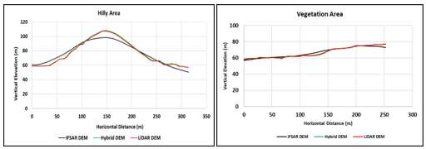 (a) Scatter plot of height difference along Hilly area (b) Scatter plot of height difference along Vegetation area

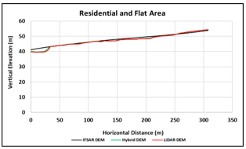
(c) Scatter plot of height difference along Residential and Flat area

Figure 10. Scatter plot of height difference along cross-section

Table 5. Statistics of height errors along cross-section (in meters)

Area | No. of samples | IFSAR DEM |  |  |  | Hybrid DEM
Area | No. of samples | Min | Max | Mean | Std. Dev | Min | Max | Mean | Std. Dev
Hilly | 1025 | -8.880 | 7.030 | -0.516 | 4.562 | 0.010 | 2.450 | 0.815 | 0.490
Vegetation | 1025 | -3.760 | 3.900 | 0.394 | 1.501 | -0.150 | 0.960 | 0.277 | 0.198
Residential and Flat | 1025 | -0.612 | 2.941 | 0.569 | 0.796 | -0.152 | 0.992 | 0.152 | 0.137

Table 5 show the statistics of height errors along cross section before and after fusion process. According to the terrain type on which the evaluation was conducted, the area with the most significant error was the hilly area. This was expected, given that slope conditions significantly affect the quality and accuracy based on RMSE of DEM products (Tian et al., 2018; Uuemaa et al., 2020) due to its limited distribution on steep terrain as well as the penetration of the radar signal. The values of means and standard deviation for hilly area are -0.516m and 4.562m before fusion process and have been improved to 0.815m and 0.490m respectively after fusion. This indicate that DSF technique successfully integrates both DEMs and produced value added DEM with improved accuracy that fulfill the need for accurate and detailed representations of topographic maps.
Additionally, a sizable error was found in several vegetation-heavy regions. This indicates that land cover affects a DEM's accuracy regarding vegetation characteristics such as density and height. Inaccurate DEM calculations from the sensor's reception of the backscattered signal could reflect the data's accuracy. The value of means and standard deviation improved from 0.394m and 1.501m to 0.277m and 0.198m accordingly.
The quality and accuracy of DSM and DTM products are affected by various factors, including slopes, obstructed areas and artefacts (Intermap, 2016). Slopes more significant than 10 degrees can cause reduced accuracy, with the RMSE increasing in areas with slopes above 10 degrees. In areas with 20-30 degrees slopes, the RMSE may double and continue to increase as the slope increases. Obstacles, such as regions with heavy vegetation, can also contribute to lower accuracy for DEM. The radar signals that bounce off the vegetation collide with multiple leaves and branches, resulting in signal distortion until it exits the plant.

Conclusion

In conclusion, this study has successfully enhancing DEM accuracy through an innovative fusion approach utilizing the DSF method. The motivation for this research arose from the growing need for accurate and detailed representations of topographic maps, especially in the face of limitations posed by traditional data acquisition methods. The process of seamlessly integrating IFSAR and LiDAR datasets has yielded a Hybrid DEM that surpasses the individual datasets in terms of vertical positional accuracy. The RMSE analysis clearly indicates a remarkable 70.7% reduction in RMSE values for the Hybrid DEM compared to the IFSAR DEM, underlining the effectiveness of the fusion approach. Geomorphological assessments have highlighted the enhanced aesthetic precision and spatial resolution of the Hybrid DEM, resulting in sharper building edges and more explicit representation of topographic features. Furthermore, terrain profile analysis has confirmed the robustness of the Hybrid DEM, exhibiting strong agreement with LiDAR DEM across diverse topographic conditions. As the demand for precise topographic mapping continues to rise, this study contributes significantly to the advancement of geospatial science and technology. It offers a practical solution to the challenges associated with DEM generation, paving the way for improved decision-making processes in various fields such as urban planning, environmental management, and infrastructure development.

Acknowledgement

The authors would like to thank Department of Survey and Mapping Malaysia (JUPEM) for providing data for this study and the Faculty of Engineering, Universiti Putra Malaysia (UPM), for their support and tutoring in completing this study.

References

Abd Mukti, S. N., & Tahar, K. N. (2021). Low altitude multispectral mapping for road defect detection. Geografia-Malaysian Journal of Society and Space, 17(2), 102-115. https://doi.org/10.17576/geo-2021-1702-09
Abrams, M., Crippen, R., & Fujisada, H. (2020). ASTER Global Digital Elevation Model (GDEM) and ASTER Global Water Body Dataset (ASTWBD). Remote Sensing, 12(7), 1156. https://doi.org/10.3390/rs12071156
Anantakarn, K., Sornchomkaew, P., & Phothong, T. (2019). Improve quality of global DEM for topographic mapping: Case study of Petchaburi Province, Thailand. International Transaction Journal of Engineering, Management, & Applied Sciences & Technologies, 10(9), 115.
Bagheri, H., Schmitt, M., & Xiao Xiang Zhu. (2018). Fusion of urban TanDEM-X Raw DEMs Using Variational Models. IEEE Journal of Selected Topics in Applied Earth Observations and Remote Sensing, 11(12), 4761–4774. https://doi.org/10.1109/jstars.2018.2878608
Bohak, C., Slemenik, M., Kordež, J., & Marolt, M. (2020). Aerial LiDAR Data Augumentation for Direct Point-Cloud Visualisation. Sensors, 20(7), 2089. https://doi.org/10.3390/ s20072089
Cheng, L., Chen, S., Liu, X., Xu, H., Wu, Y., Li, M., & Chen, Y. (2018). Registration of Laser Scanning Point Clouds: A Review. Sensors, 18(5), 1641. https://doi.org/10.3390/ s18051641
Deng, S., Zhang, J., Li, P., & Huang, G. (2011). DEM Fusion and Its Application in Mapping Topography of Complex Areas. International Symposium on Image and Data Fusion (pp. 1-4), Tengchong, China. https://doi.org/10.1109/isidf.2011.6024255
Fu, C. Y., & Tsay, J. R. (2016). Statistic Tests Aided Multi-Source DEM Fusion. ISPRS- International Archives of the Photogrammetry, Remote Sensing and Spatial Information Sciences, XLI-B6, 227–233. https://doi.org/10.5194/isprsarchives-xli-b6-227-2016
González, C., Bachmann, M., Jose-Luis Bueso-Bello, Rizzoli, P., & Zink, M. (2020). A fully automatic algorithm for editing the TanDEM-X Global DEM. Remote Sensing, 12(23), 3961. https://doi.org/10.3390/rs12233961
Kroenung, G., Strebeck, J., & Grohman, G. (2006). Filling SRTM voids: The Delta Surface Fill method. Photogrammetric Engineering and Remote Sensing, 72(3), 213–216.
Guan, L., Hu, J., Pan, H., Wu, W., Sun, Q., Chen, S., & Fan, H. (2020). Fusion of public DEMs based on sparse representation and adaptive regulawrisation variation model. ISPRS Journal of Photogrammetry and Remote Sensing, 169, 125-134.
Haron, N., & Omar, A.H. (2020). Topographic map updating using raster based datasets [Master Dissertation, Universiti Teknologi Malaysia]. Faculty of Built Environment & Surveying.
Hassan, H., & Rahman, S. A. F. S. A. (2021). Integration of Aerial Photography, Airborne LiDAR, and Airborne IFSAR for Mapping in Malaysia. IOP Conference Series: Earth and Environmental Science, 767(1), 012020. https://doi.org/10.1088/1755-1315/767/1/012020
Hoja, D., & d'Angelo, P. (2009). Analysis of DEM combination methods using high resolution optical stereo imagery and interferometric SAR data. ISPRS-The International Archieves of the Photogrammetry, Remote Sensing and Spatial Information Sciences, XXXVIII(1), 2-5.
Huber, M., Osterkamp, N., Marschalk, U., Tubbesing, R., Wendleder, A., Wessel, B., & Roth, A. (2021). Shaping the Global High-Resolution TanDEM-X Digital Elevation Model. IEEE Journal of Selected Topics in Applied Earth Observations and Remote Sensing, 14, 7198–7212. https://doi.org/10.1109/jstars.2021.3095178
Idris, R., Abu Bakar, R., & Abdul Rasam, A. R. (2023). LiDAR Assessments and Mapping for Klang Valley: A Case Study at Jinjang District, Selangor. The International Archives of the Photogrammetry, Remote Sensing and Spatial Information Sciences, 48, 445-450.
Intermap. (2016). Product Handbook & Quick Start Guide. Intermap Technologies, Inc.
JUPEM (Department of Survey and Mapping Malaysia). (2018). MS ISO 9001:2015.6.
Kamarulzaman, A. M. M., Jaafar, W. S. W. M., Saad, S. N. M., Omar, H., & Mahmud, M. R. (2021). An object-based approach to detect tree stumps in a selective logging area using Unmanned Aerial Vehicle imagery. Geografia-Malaysian Journal of Society and Space, 17(4), 353-365.
Mesa-Mingorance, J. L., & Ariza-López, F. J. (2020). Accuracy assessment of Digital Elevation Models (DEMs): A critical review of practices of the past three decades. Remote Sensing, 12(16), 2630. https://doi.org/10.3390/rs12162630
Mohamad, N., Ahmad, A., & Md Din, A. H. (2021). Estimation of surface elevation changes at bare earth riverbank using differential DEM technique of UAV imagery data. Geografia-Malaysian Journal of Society and Space, 17(4), 339-352. https://doi.org/10.17576/geo-2021-1704-23
Mohamed, M. H., & Saleh, S. S. (2018). Fusion of SRTM and ASTER GDEM2 DEMs based on height error weighted average technique. Australian Journal of Basic and Applied Sciences, 12(6), 23-29. https://doi.org/10.22587/ajbas.2018.12.6.5
Muhadi, N. A., Abdullah, A. F., Bejo, S. K., Mahadi, M. R., & Mijic, A. (2020). The Use of LiDAR-derived DEM in flood applications: A review. Remote Sensing, 12(14), 2308. https://doi.org/10.3390/rs12142308
Okolie, C. J., & Smit, J. L. (2022). A systematic review and meta-analysis of Digital elevation model (DEM) fusion: Pre-processing, methods and applications. ISPRS Journal of Photogrammetry and Remote Sensing, 188, 1-29.
Pa’suya, F. M., Talib, N., Narashid, R. H., Fauzi, A. A., Mohd, F. A., & Abdullah, M. A. (2022). Quality assessment of TanDEM-X DEM 12m using GNSS-RTK and Airborne IFSAR DEM: A case study of Tuba Island, Langkawi. International Journal of Geoinformatics, 18(5), 87-103.
Papasaika, H., Poli, D., & Baltsavias, E. (2008). A framework for the fusion of Digital Elevation Models. International Archives of the Photogrammetry, Remote Sensing and Spatial Information Sciences, XXXVII(B2), 811–818. https://doi.org/10.3929/ethz-b-000011988
Papasaika, H., Poli, D., & Baltsavias, E. (2009). Fusion of Digital Elevation Models from various data sources. International Conference on Advanced Geographic Information Systems & Web Services (pp. 117-122), Cancun, Mexico. https://doi.org/10.1109/ geows.2009.22
Robinson, N., Regetz, J., & Guralnick, R. P. (2014). EarthEnv-DEM90: A nearly-global, void-free, multi-scale smoothed, 90m digital elevation model from fused ASTER and SRTM data. ISPRS Journal of Photogrammetry and Remote Sensing, 87, 57–67. https://doi.org/ 10.1016/j.isprsjprs.2013.11.002
Schindler, K., Papasaika-Hanusch, H., Schütz, S., & Baltsavias, E. (2011). Improving wide-area DEMs through data fusion-chances and limits. Photogrammetric Week, 11, 159-170.
SKiP (SmartKADASTER Interactive Portal). (2020). Putrajaya Map.
Takaku, J., Tadono, T., Doutsu, M., Ohgushi, F., & Kai, H. (2020). Updates of “Aw3d30” Alos Global Digital Surface model with other open access datasets. The International Archives of the Photogrammetry, Remote Sensing and Spatial Information Sciences, XLIII-B4-2020, 183–189. https://doi.org/10.5194/isprs-archives-xliii-b4-2020-183-2020
Tian, Y., Lei, S., Bian, Z., Lu, J., Zhang, S., & Fang, J. (2018). Improving the accuracy of open source digital elevation models with multi-scale fusion and a slope position-based linear regression method. Remote Sensing, 10(12), 1861. https://doi.org/10.3390/rs10121861
Tran, T. A., Raghavan, V., Masumoto, S., Vinayaraj, P., & Yonezawa, G. (2014). A geomorphology-based approach for digital elevation model fusion – case study in Danang city, Vietnam. Earth Surface Dynamics, 2(2), 403–417. https://doi.org/10.5194/esurf-2-403-2014
Uuemaa, E., Ahi, S., Montibeller, B., Muru, M., & Kmoch, A. (2020). Vertical accuracy of freely available Global Digital Elevation Models (ASTER, AW3D30, MERIT, TanDEM-X, SRTM, and NASADEM). Remote Sensing, 12(21), 3482. https://doi.org/10.3390/ rs12213482
Wang, X., Holland, D. M., & Gudmundsson, G. H. (2018). Accurate coastal DEM generation by merging ASTER GDEM and ICESat/GLAS data over Mertz Glacier, Antarctica. Remote Sensing of Environment, 206, 218–230. https://doi.org/10.1016/ j.rse.2017.12.041
Zhao, S., Liu, J., Cheng, W., & Zhou, C. (2022). Fusion scheme and implementation based on SRTM1, ASTER GDEM V3, and AW3D30. ISPRS International Journal of Geo-Information, 11(3), 207. https://doi.org/10.3390/ijgi11030207.

