Geospatial mapping of an Orang Asli (Indigenous People) settlement using a UAV and GIS approach

Nur Hakimah Asnawi¹, Abdul Aziz Ab Rahman^{2,3}, Rokiah Omar^{4*}

¹Geography Programme, Center for Research in Development, Social and Environment,
Faculty of Social Science and Humanity, Universiti Kebangsaan Malaysia
²Studies of Geomatics Science and Natural Resources, School of Geomatics Science and Natural Resources, College of Built Environment, Universiti Teknologi MARA
³Institute for Environment and Development (LESTARI), Universiti Kebangsaan Malaysia
⁴Optometry & Vision Science Programme, Faculty of Health Sciences, Universiti Kebangsaan Malaysia

Correspondence: Rokiah Omar (email: r_omar@ukm.edu.my)

Received: 1 October 2023; Accepted: 3 July 2024; Published: 29 August 2024

Abstract

The utilisation of Unmanned Aerial Vehicles (UAV) has become ubiquitous in multidiscipline because of its advanced capabilities and multifunctional. This device can be very useful especially in remote and distant locations such as Orang Asli settlements to determine the geographical characteristics and land-use area for prospective community engagement and development programmes. This study aimed to use a UAV integrated with a Geographic Information System (GIS) to produce a land-use map of a distant rural indigenous community with accurate geospatial data. Aerial photography was captured using a UAV during a field trip to the Pos Gob Orang Asli Settlement, Gua Musang District in October 2019. UAV aerial photography was used to capture high-resolution images of the settlement as it is located deep in the tropical jungle along the Central Spine (Banjaran Titiwangsa) in Kelantan. The aerial photographs captured were analysed using Agisoft Photoscan i.e. photogrammetric digital processing software to produce an orthophoto. The orthophoto was then processed in GIS application for visual interpretation through the digitalisation of the captured geographical features and various socio-cultural developments found in the settlement to generate a land-use map. The digitized land-use features were classified into housing, commercial, institutional, public facilities, infrastructure, utilities, green space/forest, water bodies, and off-road types. Geospatial mapping of remote rural settlements using a UAV and GIS application is an alternative method in acquiring updated land-use patterns instantly. This UAV method has advantage with greater cost-effectiveness in data acquisition especially when funding and manpower is limited. In conclusion, the use of UAV with GIS approach provides a precise method of determining site land area and to produce an updated land use map that can be used for monitoring development planning and implementation of community projects.

Keywords: GIS, indigenous people, land-use, mapping, UAV

Introduction

The pace of land development in Malaysia, particularly in Peninsular Malaysia has occurred at a fast pace, especially over the last four decades due to continuously increasing industrialization and urbanization. Malaysian society is rapidly transforming into an urban society (Hassan, 2009) and presently about 78% of the population is classified as urban as at 2022 (World Bank Data, n.d.). This has been a result of numerous development activities throughout the nation especially those centred around various municipalities. Continuous population growth has also been a driving factor behind this rapid development which in turn does play a significant role in modernizing Malaysian society. In 2015, Malaysia was ranked fifth among Southeast Asia’s largest volume of built-up land with its urban land area growing from 7,531.97 km² to 11,417.64 km² between 1990 and 2015 (World Bank, 2015). This increasing development of land area together with the increasing population has impacted the utilization of land leading to various land-use transformations to meet the needs of this increasing population.
Possession of precise and updated land information is important in various fields involving environmental assessment, monitoring, and management in order to enable an accurate understanding of the evolution of land-use in various localities nation-wide. Mora et al. (2021) stated there are various techniques can be applied to obtain data and information regarding the Earth’s surface such as ground surveying, photogrammetric surveys, and Global Positioning System (GPS) surveys. Unmanned Aerial Vehicles (UAV) or more simply known as drones are one of the methods used to acquire geographical surface data by means of aerial surveillance and it has gained much attention among researchers and stakeholders for research and project development and monitoring purposes. The use of UAVs as a remote sensing platform is rapidly growing due to its ability in acquiring remote data with relative ease and manageable cost at low altitudes, and is typically able to reach or access previously inaccessible or remote areas (Ruzgiene & Aksamitauskas, 2013; Evaraerts, 2008) . The UAV has the ability to rapidly acquire data in a digital form without the need for intermediary processes to digitize captured visual data and to provide data that has unparalleled high temporal and spatial resolution. Furthermore its use is very flexible with simple operation processes (Nebiker et al., 2008). Nowadays, UAV platforms have become valuable data capture sources suitable for surveillance, inspection, modelling, and mapping purposes (Remondino et al., 2011).
Over the last two decades, UAVs have demonstrated profound improvements in their development, currently becoming low-cost platforms with high performance imagery sensors (Hassanein, Khedr, & El-Sheimy, 2019). Unmanned Aerial Systems were first described in 1918 at the end of World War I (WWI) (Estrada & Ndoma, 2019) and referred to aircraft that were operated autonomously or without an on-board pilot (Pytharouli et al., 2019; Nex & Remondino, 2014; Gupta, Ghonge & Jawandhiya, 2013). UAVs have now progressed to represent a multitude of new types of remote sensing platforms used in a wide range of applications (Mohd Noor, Abdullah, & Hashim, 2018; Xia et al., 2018). UAVs may be equipped with various types of smart sensors such as a barometer, Global Positioning System (GPS), Inertial Navigation System (INS), infrared and sonar emitters and receivers in addition to aircraft control devices such as Electronic Speed Controller (ESC), navigation, and flight control instruments (Junaid, Lee & Kim, 2016; Chahl, 2014). Generally, UAV type classification often varies widely and typically reflects their size and configuration or would depend on the platform design and mission role. Eisenbeiss (2011) classified UAVs based on their range, endurance, weather dependency, manoeuvrability, and payload capacity. On the other hand, according to Arjomandi et al. (2006), there are six different types of UAVs comprising of HTOL (horizontal take-off landing), VTOL (vertical take-off landing), hybrid model, helicopter, heliwing, and unconventional types. This wide variety of UAV types indicates the continuing advancement of evolved technology in line with current market demands according to various research and essential industrial needs.
The utility of UAVs covers a wide range of fields in which they are capable of performing either or even both outdoor and indoor missions in very challenging environments (Rodriguez et al., 2013). From its initial development and use, the primary driver for the use of UAVs was commonly the military, however with increasing utility in UAV design and the advent of light-weight yet powerful sensors and greater load carrying capacity, UAVs are now well established in numerous non-military industries and have found numerous applications (González-Jorge et al., 2017; Evaraerts, 2008). These UAV applications include agricultures (Sah et al., 2023; Ahmadi et al., 2023; Lee at al., 2022; Radoglou-Grammatikis et al., 2020; Ampatzidis et al., 2019; Xiang & Tian, 2011), security and surveillance (Sutheerakul et al., 2017; Cho et al., 2015), logistic and infrastructure monitoring (Keyvanfar et al., 2022; Kujawski, Lemke, & Dudek 2019; Spencer, Hoskere & Narazaki, 2019), healthcare (Steven et al., 2024; Zailani et al., 2021), geomorphological field (Mokhtar et al., 2023; Nasir et al., 2022; Zolkepli et al., 2021), hydro morphological study (Ansari et al., 2021), landscaping (Suhaizad et al., 2023; Jamal et al., 2022), disaster analysis (Galgau et al., 2023; Mohd Noor & Hashim, 2022; Malandrino et al., 2019; Silva, De Mello Bandeira & Gouvêa Campos, 2017), mapping purposes (Van Trung et al., 2023; Hamylton et al., 2020), and other miscellaneous applications. However, it must still be warned that despite the ubiquitousness of UAVs, users may nonetheless encounter various challenges depending on the device’s specifications, climate, and terrain conditions (Nordin & Salleh, 2022; Yazid et al., 2019).
Nowadays, the UAV has become a primary resource to acquire remotely sensed GIS data due to high demand for high-quality image resolution, near-real-time imagery, and fast delivery of the data collection (Tiwari & Dixit, 2015). GIS technology helps the user to gain actionable intelligence from all types of data (ESRI, 2011) and can be very useful for the management of the UAV navigation in external environments with the use of cartographic maps, orthophotos, satellite images, and digital elevation models (Mangiameli et al., 2013). In the mapping and monitoring process of the earth’s surface, UAV provides a convenient remote sensing platform to collect ultra-high-resolution imagery over terrain that is often difficult to access (Lucieer, Jong & Turner, 2014) which then can be analysed and visualized in GIS (Sonnemann, Hung & Hofman, 2016). The integration of UAV and GIS offers an innovation in the field of mapping and gives an excellent result for various applications through visual interpretation based on an image. These techniques are very useful especially in remote locations (Popoola et al., 2016) with difficult access and poor or limited archival data. In these kinds of situations, the use of UAV platforms for aerial data capture of remote communities such as those of indigenous settlements becomes a particularly useful solution since aerial data capture would require less manpower to survey and map land features and less time needed to complete the data capture. This being of marked importance for remote regions located in hilly terrain, in forested areas and areas where there are no roadways or vehicular access, which makes any investigation or data collection requiring the presence of heavy equipment difficult and challenging (Sonnemann, Hung, & Hofman, 2016).
In Peninsular Malaysia, approximately 36.1% of indigenous people, who are also known as ‘Orang Asli’ live in remote areas which are close to or located within forested or jungle areas (JAKOA, 2019). These indigenous people still practicing their traditional ways of living that remain influenced by their ancestral practices and environment (Shah et al., 2018). It is also important to realise that these communities have a strong sense of identity as ‘Orang Asli’ and they are very staunch to their tribal beliefs, cultures and lands (Abdullah et al., 2016). The Orang Asli communities in Malaysia are acknowledged to possess a lower quality of life as compared to the rest of the population because collectively, their communities are economically less well off, face educational shortcomings, are afflicted by a high mortality rate, poor health conditions, and live under harsh environmental conditions (Norhayati, Aniza, & Norfazilah, 2018). Their poor living conditions are largely influenced by their residential locations being deep in the forest with poor communication routes and modalities. Many community locations, even when they constitute a village like collection of families are sometimes only communicable by foot paths or tracks and without access to any telecommunication means other than emergency high frequency radio sets. These types of situations make any data collection within these areas difficult to organise and require significant funding to ensure travel into and out of these areas and so does affect development, management, and research initiatives.
Therefore, using UAV platforms for data capture has become a relevant tool for use in remote locations for purposes such as land-use surveys. Many Orang Asli still live in rural remote areas with limited or no information being available on many aspects of daily living including information concerning the local physical environment and human socio-cultural aspects. For the purposes of planning and implementing any socio-economic development, the current challenge for remote settlements of Orang Asli is the unavailability of recent high-resolution spatial geographical datasets covering the locations of each of these communities. An up-to-date set of geospatial data is required for efficient and effective development planning, monitoring, and management by individuals, corporate organizations and other stakeholders in order to bring sustainable and long-term benefits to these communities. Presently, available land-use maps only provide outdated versions of limited spatial information since they were produced some decades ago based on topographical maps derived from aerial photographic surveys and as such do not represent current circumstances. For instance, in the land area where this study is conducted, there are no current land-use maps available that could help for the purpose of planning area development and management projects. Therefore, this study aims to map current land-use in the Orang Asli settlement of Pos Gob in Gua Musang, Kelantan through the integration of Unmanned Aerial Vehicle (UAV) aerial photography data and a Geographic Information System (GIS) to produce a high accurate geospatial map of the area.

Study area

In Peninsular Malaysia, the Orang Asli population has at least 95 subgroups have been identified, each with their own unique language and culture (Masron, Masami, & Ismail, 2013). Many of these subgroups are socioeconomically and culturally marginalised, especially those who remain more distant rural and forest communities. This research was conducted in the Orang Asli settlement at Pos Gob located in the remote area of Gua Musang District, Kelantan which is in the northeast of Peninsular Malaysia at the latitude of 5°15ʼ0.10ʼʼ North and longitude of 101°39ʼ29.40ʼʼ East (Figure 1). Pos Gob, Gua Musang is administered by the Gua Musang District Council with a total population of 533 indigenous people based on a JAKOA survey conducted in 2017. The total land area of Pos Gob is 967.532 hectares, comprising of 10 villages (kampung) within which are Kampung Gaweng, Kampung Chaler, Kampung Guvainch, Kampung Tenau, Kampung Pinchong, Kampung Tembaga, Kampung Berchap, Kampung Berog, Kampung Kacheng, and Kampung Gob. The Orang Asli community at Pos Gob is largely made up of the Temiar tribe (subgroup) who mostly are still practicing traditional lifestyles and who depend on primary activities to support their families such as agriculture, farming, hunting, and handicraft activities.

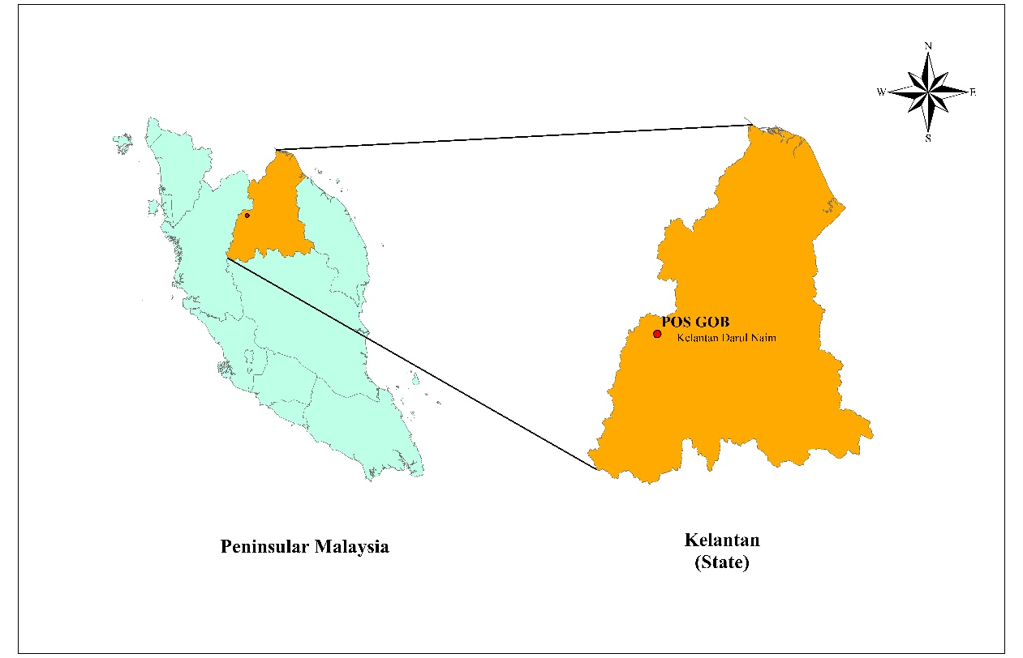
Source: GIS work, 2019

Figure 1. The location map of Pos Gob, Gua Musang, Kelantan

During engagement activities with this Orang Asli community in conjunction with collaborative work concerning a university Community Project, during the first site visit to Pos Gob in 2016, the researchers identified that there was no school facility in the area. Furthermore, it was also found that majority of the children here did not attend school or had dropped out from school. One of the major reasons for this was due to distance. The nearest school with Pos Gob villages is Sekolah Kebangsaan Tohoi. The distance from this school to Kampung Gob is about 47 kilometres which could take at least 4 to 5 hours travel time depending on offroad and weather conditions. The only means to commute is via an offroad track which is partly a former loggers lorry trail as there is road or trail available for the school children to go to school. Furthermore, while the school does have hostel facilities available for children whose homes are remote from the school, the children’s parents were not willing to be separated with their children should they provided with hostel accommodation, especially those aged below 10 years of age. The solution proposed by the researchers at this time was to bring the school to the community. The working concept was to provide the means for young children between 6 and 9 years of age to learn basic scholastic skills, i.e. Standard 1 to Standard 3 school learning, where these children will learn the 3Ms i.e Membaca (Reading), Menulis (Writing) and Mengira (Counting) at a Community School type facility located in the Pos Gob settlement area. When the children reached Standard 4, they will then join the mainstream primary school at Sekolah Kebangsaan Kuala Betis as by this time their parents are receptive to their living away in hostel facilities at the school. This initiative was supported by Orang Asli in Pos Gob and a collaborative project between Universiti Kebangsaan Malaysia (UKM) and CIMB Islamic bank was launched. The aims were to provide Orang Asli children a comfortable learning ecosystem close to their families by bringing the school to community. Besides, that intent, health and socioeconomic aspects of this Orang Asli Community were also addressed. The Orang Asli community in Kampung Gob collectively built a simple community school from locally sourced materials. This Jungle school was then named Pusat Pendidikan Komuniti UKM-CIMB Islamic and was inaugurated on May 20, 2017.
In order for the community project, which focused on education, health and socioeconomic values to be successful, an accurate map of the current land-use in the area of the Orang Asli settlement of Pos Gob in Gua Musang, Kelantan was needed and was achieved through the integration of UAV aerial survey data and GIS approaches into producing a highly accurate geospatial map of the settlement and its surroundings. This data was collected and focused on Kampung Gob, Kampung Kacheng, and Kampung Berog as the main study area because these 3 villages are the closest to the established jungle school. Since then, Pos Gob has gradually expanded through various improvements of facilities and the community’s way of living as a consequence to these improvements. Therefore, an updated land-use map of this study area is needed for future research, development planning, and monitoring purposes.

Method

The mapping of the Orang Asli settlement at Pos Gob, Gua Musang was conducted using a UAV to capture serial aerial photographs of the settlement and to create a land-use map by processing these digital images with a GIS application, namely ArcGIS 10.4. In general, the methodology of this study can be divided into four main stages which were aerial photograph acquisition, image processing, data analysis, and the construction of the thematic map as the final product. Figure 2 describes the methodology stages applied in this study.

Data Acquisition
Flight design planning using Fly DJI Phantom 3
Drone fly at flight altitude of 100 m
Data Processing
Image mosaicking and composition
Data Analysis
Orthophoto
Digitizing land-use features
Thematic Maps
Acquiring aerial photograph
Agisoft Photoscan software
ArcGIS 10.4 software
Final Product
Stage 1
Stage 2
Stage 3
Stage 4
Source: Fieldwork and GIS work, 2019

Figure 2. Method of land-use mapping of indigenous people settlement of Pos Gob using drone images and GIS application

Aerial photographs acquisition

The data for this study was obtained using a low-cost UAV DJI Phantom 3 Professional drone that provided an integrated GNSS positioning module, a camera stabilization system, an inertial measurement unit (IMU), and a 12-megapixel camera with 94° view angle providing a high-resolution images and videos (Figure 3). This type of drone has been used widely among researchers at the international level (Hovhannisyan, Efendyan & Vardanyan, 2018; Clark et al., 2017; Trujano et al., 2016) and the national level (Suteris, Rahman & Ismail, 2018; Arif et al., 2018) in multiple research disciplines due to its ease of use and available functional modalities. Table 1 and Figure 3 show the UAV components and their functions.
Table 1. UAV components and functions

Component | Function
Type | DJI Phantom 3 Professional
Mobile | Using iPad to connect with controller as function display view from the drone
Drone | Capturing the images using the camera attached with the drone
Controller | Function to navigate the drone during mission and take off
Source: Fieldwork, 2019

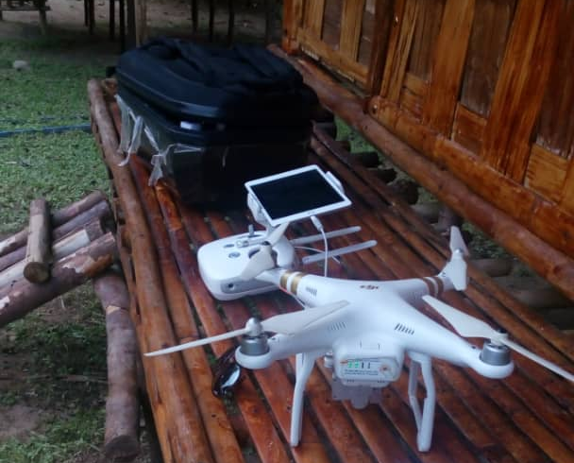
Source: Fieldwork, 2019

Figure 3. DJI Phantom 3 Professional drone used during a field survey at the indigenous people settlement of Gob, Gua Musang, Kelantan

Furthermore, as mentioned in the research of Pepe et al. (2018), it is stated that proper flight planning must be set up in order to get a good set of data collection. Flight planning is a necessary step to identify the required area with consideration of suitable weather conditions and wind speed during the flight. In this study, an image from Google Earth was used as a base map of the flight path of the UAV at the site with a flying altitude of 100 meters from the ground level to obtain data at its highest resolution and to avoid any obstacle from the ground.

Table 2. Details of data acquisition

Indigenous village | Date of acquisition | Start time of acquisition | Flight altitude (m) | Total taken images
Kampung Kacheng | 15 October 2019 | 11.36 am | 100 | 154
Kampung Gob | 15 October 2019 | 12.28 pm | 100 | 199
Kampung Berog | 16 October 2019 | 10.51 am | 100 | 204
Source: Fieldwork, 2019

Table 2 shows the village name, date, and time acquisition as well as the total images that were taken. There were 557 overlapping aerial photographs that were collected. The images of the identified villages at Pos Gob were obtained from different temporal resolutions in October 2019 to observe the current land use of indigenous people settlement.

Data processing

In this study, images were processed using photogrammetric software which was Agisoft Photoscan. At this stage, the mosaicking of all images taken from the UAV was carried out using Agisoft Photoscan software in which the software would align each single image using several necessary tools and functions to generate one orthophoto. Besides, these images already contained a coordinate system, WGS84, so the end product would be geotagged with (x, y, z) coordinates and in a TIFF file format. The orthophoto product was then further analyzed in ArcGIS software for mapping purposes. Research conducted by Gonçalves and Henriques (2015) using the Agisoft Photoscan software to produce an orthophoto was used to standardize the method used in this study.

Data analysis

An exported digital orthophoto with WGS 1984 projected coordinate system was used and previewed in ArcGIS 10.4 software for visual interpretation to assess the available features and various developments around the study area so that the current land-use map of indigenous people settlement could be produced. At this stage, the new features, identified from the produced orthophoto, were digitized to extract the land-use features and classify them into several land-use categories. Digitizing the orthophoto is a common technique that has long been practiced when mapping an area (Verhoeven, Taelman & Vermeulen, 2012; Banerjee & Mitra, 2004; Hohle, 1996). In this study, the digitized land-use features were classified into housing, commercial, public facilities and institution, infrastructure and utility, forest/green space, water bodies, and the off-road. The result of the image analysis was presented in the form of a table and thematic map to simplify its reading and image interpretation.

Results and Discussions

UAV orthophoto

The first essential result needed for mapping was the orthophoto of the study area. The processing of the data captured by the UAV generated the orthophoto plane with better view and clear surroundings of the area of interest. At the beginning of this process, the digital orthophoto was designed using a photogrammetry process which included overlapping multiple images to produce a highly accurate map that could be applicable for many purposes.
In this study, a photogrammetric result was generated after completing the mosaic processing to align a total of 557 aerial photographs to produce one orthophoto covering Kampung Gob, Kampung Kacheng, and Kampung Berog as shown in Figure 4. The orthophoto gave a clear and detailed image of the indigenous people's settlement, thus successfully creating a clear, updated image of the 50-hectare study area from the high-resolution images captured. The details of interest and structures such as buildings, road networks, water bodies, and streams were properly presented and can be observed in the orthophoto which indicated the high resolution of the spatial datasets captured that were vastly practical for mapping visual interpretation. Therefore, the high resolution orthophoto imagery had successfully proven to be the best method in producing a real-time classification map, especially in a very remote area.

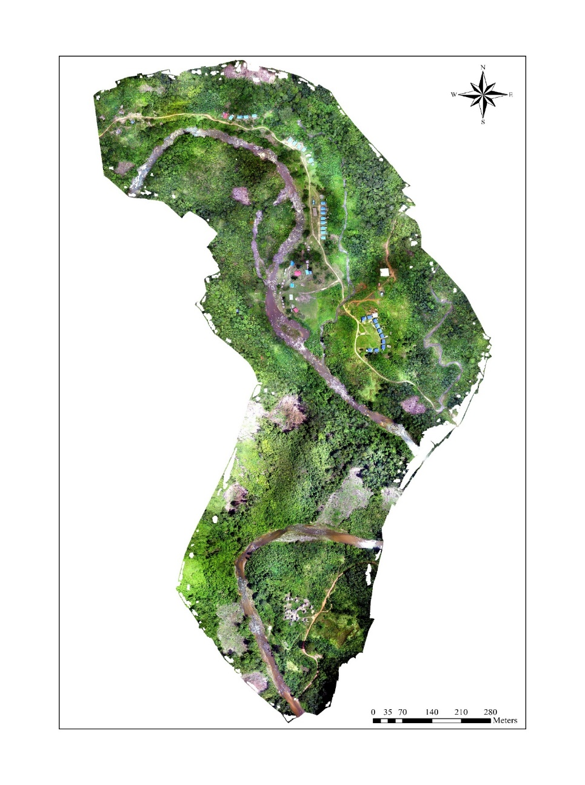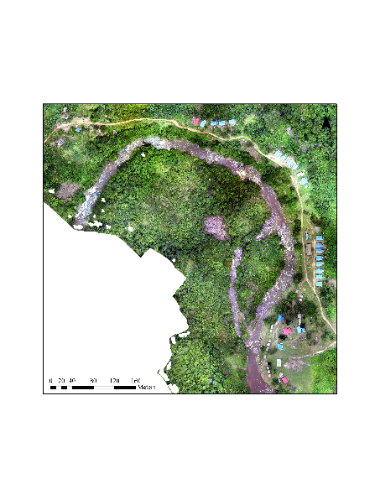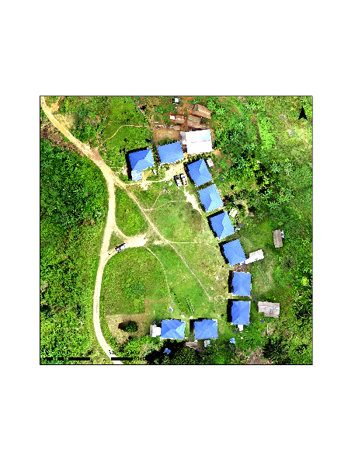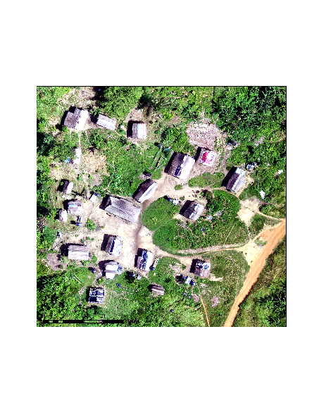
Kampung Gob
Kampung Kacheng
Kampung Berog
Source: Fieldwork and GIS work, 2019

Figure 4. The digital orthophoto of the study area with the show of the details of three villages

Visual interpretation

The high resolution of the acquired data was very useful and it was suitable for visual interpretation for monitoring, regional planning, and land-use patterns using the naked eye to identify, classify, and interpret the objects or circumstances in the image via human interpretation (Samad et al., 2013). In the next step after processing orthophoto imagery, the classification map was generated.
Based on the analysis using the UAV imagery and GIS application, the current land use was able to be observed and identified at a high spatial resolution. The digital orthophoto was used to digitize the land-use features in the study area. Figure 5, Figure 6, and Figure 7 showed the digitized land-use map of Kampung Gob, Kampung Kacheng, and Kampung Berog. The land-use classification of the study area was divided into several categories comprising of housing, commercial, institution, public facilities, infrastructure, utilities, green space/forest, water bodies, and off-road.

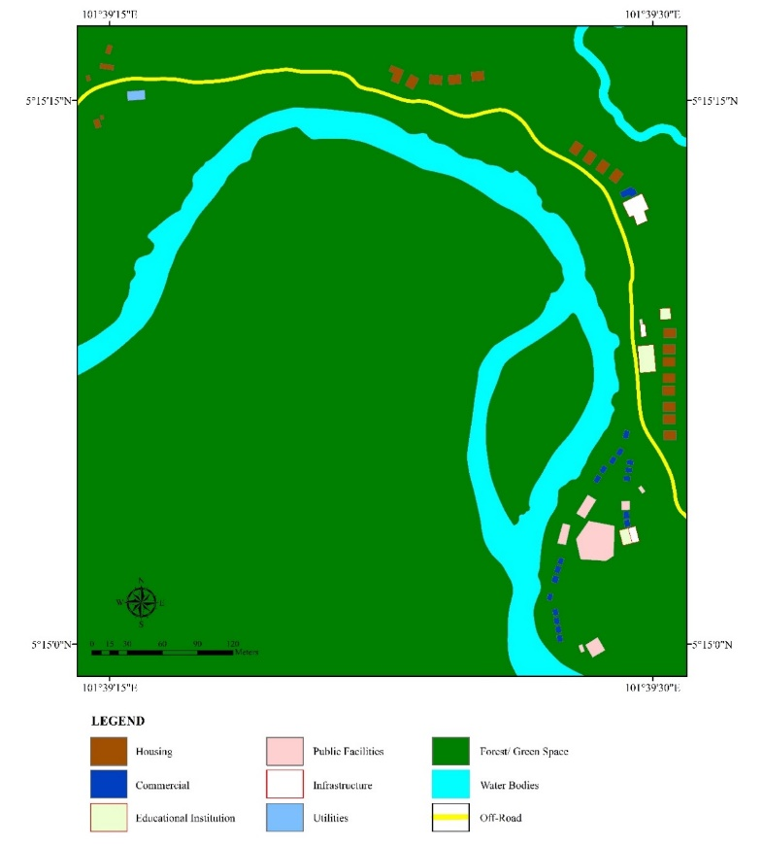
Source: Fieldwork and GIS work, 2019

Figure 5. The digitized land-use of Kampung Gob by interpreting the orthophoto

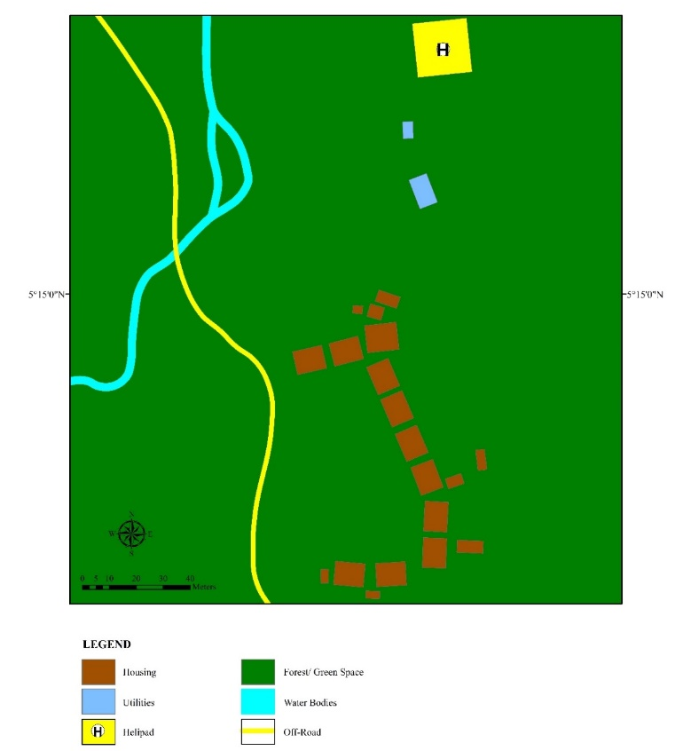
Source: Fieldwork and GIS work, 2019

Figure 6. The digitized land-use of Kampung Kacheng by interpreting the orthophoto

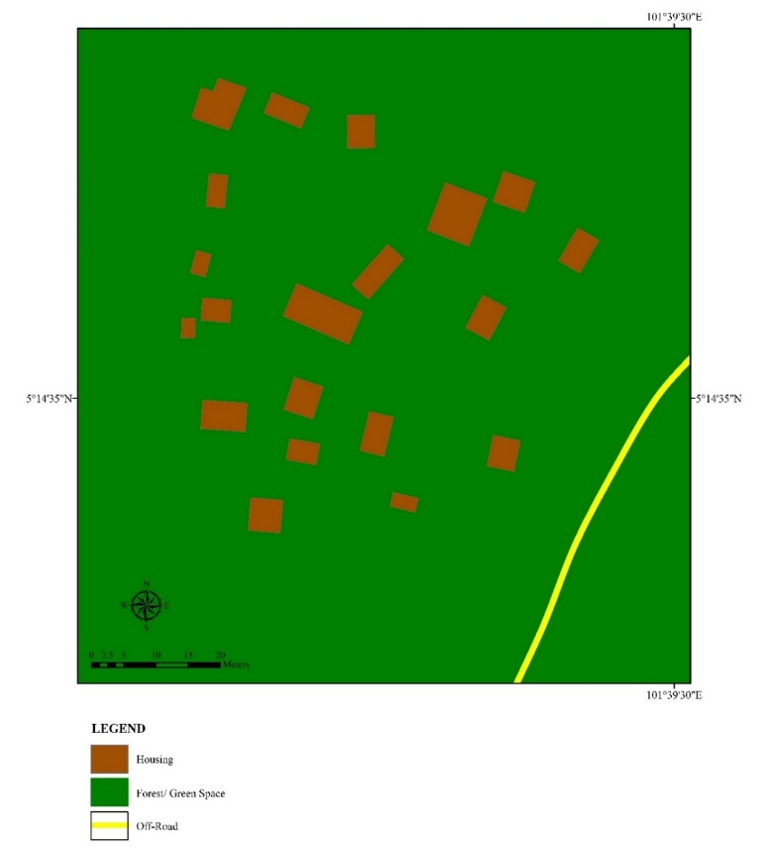
Source: Fieldwork and GIS work, 2019

Figure 7. The digitized land-use of Kampung Berog by interpreting the orthophoto
Existing land use of indigenous people settlement

The UAV-based survey on the remote Orang Asli settlement indicated a pattern and spatial layout of the Pos Gob villages. The land-use classification with detailed characteristics is outlined in Table 3. The current land-use displayed that these Orang Asli villages were surrounded by forest and more green spaces available within the area.

Table 3. The land-use classification and its detailed description

Land-use classification | Description
Housing | Orang Asli settlement
Commercial | Homestays built by the local community
Educational institution | Including the jungle school, school canteen and kindergarten
Public facilities | Including the community centre, cultural house, public toilet, health centre and musolla (means a space for praying in Islam)
Infrastructures | Telecentre and store
Utilities | Water pump house
Forest/ Green Space | Open space, recreation, and undeveloped land
Water Bodies | River and stream

Currently, some of the residents of these villages are residing in the Hardcore-Poor Housing Project (PPRT) houses provided by the Federal Government and Department of Orang Asli Development (JAKOA), particularly at Kampung Gob and Kampung Kacheng to improve their standard of living (Figure 8). Meanwhile, other residents still remain living in traditional houses that are structurally made of wood, leaves, bamboo and rattan. Each village has different house designs depending on their own ancestral cultures and practices. The commercial buildings identified were composed of local homestay huts that were built by the community members themselves following their own traditional and unique architectural and structural designs (Figure 9). The jungle school or formally known as Pusat Pendidikan Komuniti UKM-CIMB Islamic (PPK UKM-CIMB) in Figure 10 is the only educational institution available at Pos Gob that has been continuously operational so that the indigenous children can access proper education. Kampung Gob is made as the administrative centre at Pos Gob as well as the location of the jungle school. The existing public facilities, infrastructures, and utilities at Pos Gob were shown in Figure 11, Figure 12, and Figure 13, respectively.

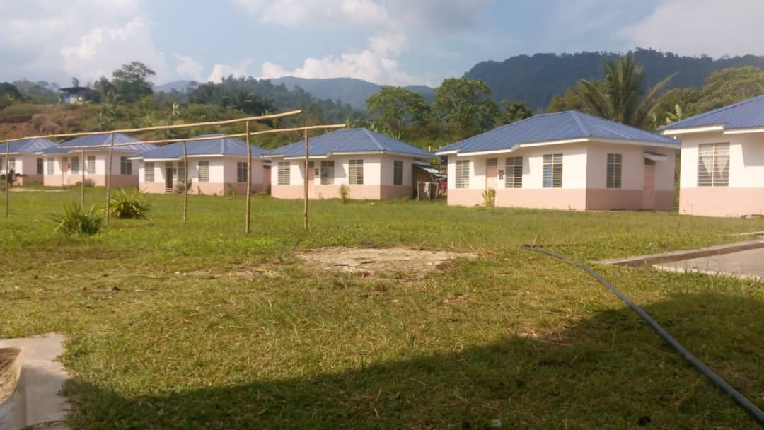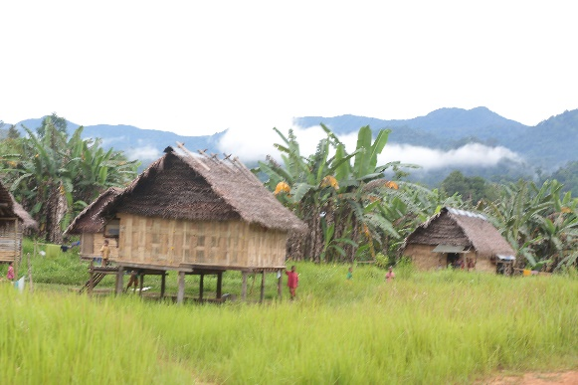
(a) Housing project from the government (b) Traditional housing

Figure 8. The residential area of the indigenous community as in (a) and (b)

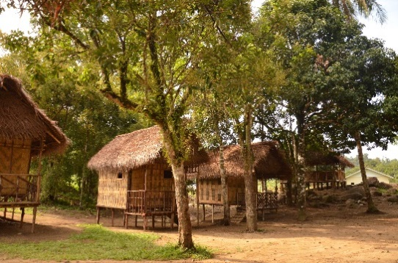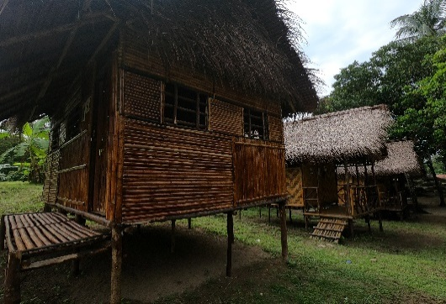

Figure 9. Homestay as a commercial building provided for visitors.

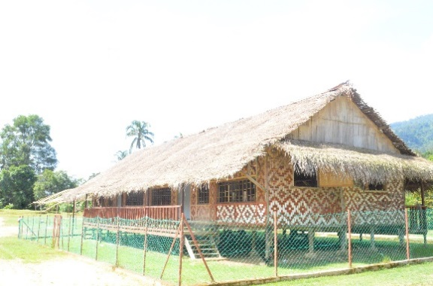

Figure 10. The educational institution or known as the jungle school among local people.

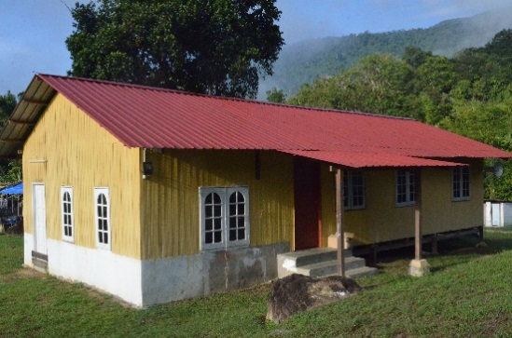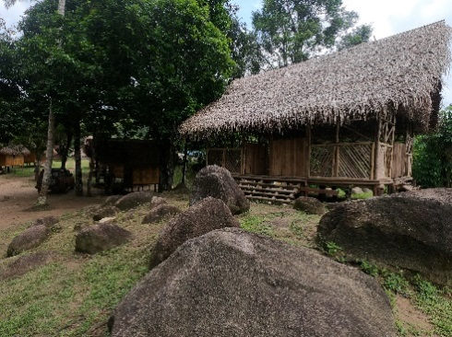
- Musolla (b) Cultural house

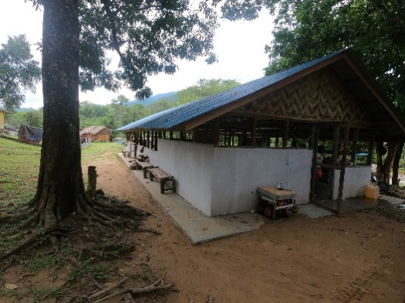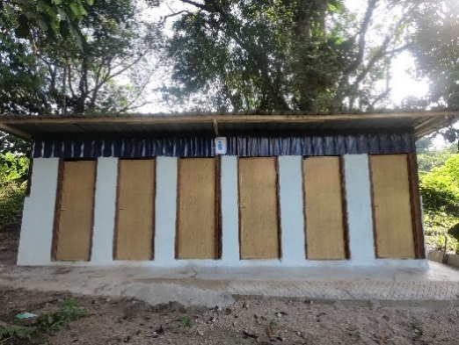
(c) Multipurpose community hall (d) Public toilets
Figure 11. Existing public facilities provided at Pos Gob as in (a), (b), (c) and (d)

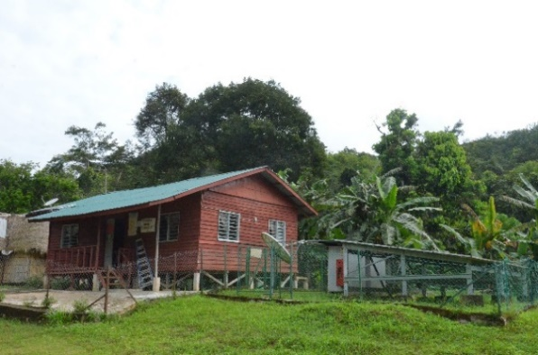

Figure 12. A telecentre is an existing infrastructure provided for the local community.

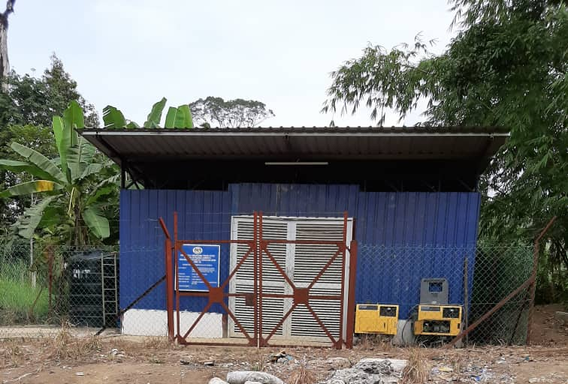

Figure 13. Existing water pump house at Kampung Gob

Opportunities for UAV application

The analysis outcome from this study illustrates the opportunity for the use of UAV obtained aerial survey data as a reliable solution in developing a means of visually representing a study area. The UAV’s ease of use and utility for mapping remote settlements of indigenous people can fill the knowledge deficits on a local scale, improve data acquisition, and increase captured data reliability and accuracy. Technically, the type of UAV does play a fundamental role in producing high-resolution imagery. The DJI Phantom 3 Professional used in this study was equipped with an enhanced sensor and high-resolution camera that offer greater accuracy, less noise, and better image capture. These high-specification tools significantly improved real-time map generation that could be used to monitor the development progress and update cadastral maps for small and remote areas.
In practice, the UAV-based data and analysis provided great precise results compared to conventional survey practices. Its use is less time-consuming, cost-effective, and requires less manpower in operation, the UAV drone does offer an affordable, practical and reliable solution for data collection and analysis of much larger areas, particularly for digital mapping. Furthermore, the safety and well-being of the surveyor can be assured in obtaining the data since the drone captures the imagery while the operator remains in a safe location. Drone mapping allowed the researchers to acquire far-reaching and reliable data, specifically from inaccessible locations with unstable steep slopes or hazardous topography. This method reduced the work risk on the ground while enabling the researcher to accomplish a series of measurements that facilitated subsequent work performance in the office when processing the data.

Challenges in UAV application

Even though the utilization of a UAV did provide many opportunities, there were some challenges in UAV application during data acquisition such as geographically, the terrain conditions of the study area was the main challenging factor in the flight planning procedure. With the topography of hilly land surfaces, the significant elevation with the presence of large stands of tall trees did cause some difficulty to fly the drone safely along the identified flight path. Therefore, the UAV operator does require professional training to ensure workflow efficiency and safety.
Besides that, the weather conditions also affect the flight mission. Rainy weather with strong winds sometimes halted data acquisition because of the limited flight vision. Thus, the selection of the perfect time to capture the images is very crucial to ensure its quality. In addition, the UAV aircraft characteristics do influence flight performance as well. Some flight procedures were unable to be conducted with one-time flying due to the available flight time limit imposed by the UAV’s battery capacity. The image acquisition by drone had to be divided into separate flight segments with an optimal overlap track according to the battery life. The larger the targeted flight area, the more segment divisions were needed.

Conclusion

The integration of UAV aerial image acquisition and GIS application to map indigenous people's settlement patterns in Pos Gob, Gua Musang has proven successful. This study showed the potential of a UAV photogrammetric survey in mapping a remote indigenous people settlement. This method demonstrated practically the experiences of using UAV-based remote sensing to support cost-effective land use mapping. The integration of GIS and UAV have become ideal tools for monitoring the land areas and environment. The results showed the successful creation of a detailed map of the Temiar tribe settlement at Pos Gob, Gua Musang which is located within the deep forest (jungle) area.
The data obtained from the UAV which was an orthophoto has contributed to producing an updated land use map of the indigenous settlement at Pos Gob, Gua Musang. Significantly, this map successfully benefited the researcher in conducting the survey planning of development initiatives in terms of infrastructure for future projects in the village. Besides, obtaining an accurate overview of the site size and spatial organization of the study area, it was found to be very helpful to various authority’s and stakeholder engagements in development planning for the Temiar tribe socially and economically. As consequences, it had helped trigger the enhancement of these indigenous people's lives while sustaining their ancestral customs and cultures. It is undeniable that this method of mapping not only is cost-effective but also requires less manpower. Furthermore, the method can be completed in a shorter time frame. This method of mapping can be recommended and adopted by JAKOA to map all remote indigenous villages in Malaysia. By doing so this mapping method can aid JAKOA for their social and economic planning of the Orang Asli community in the future.
This study, thus, concludes that the use of a low-cost UAV can be a cost-effective way to create a very high-resolution spatial dataset and contribute to up-to-date current land use of a remote settlement of indigenous people. This UAV application indicates a great opportunity for the use of technology that could help further in-depth understanding and identification of miscellaneous applications of UAV, specifically for surveying and mapping purposes.

Acknowledgement

This research was supported by Universiti Kebangsaan Malaysia Research Ethics Committee UKM under Grant No. 1.5.3.5/244/SPP2/AP2017004/3 and approval from the Department of Orang Asli Development (JAKOA). We would also like to thank Aisha Nadira Mohd Redzuan from the Centre for Industry & Community Partnerships (I-COMM) UKM for her invaluable contributions and insight into this article’s writing.

References

Abdullah, J., Sayuti, N. M., Arshad, A. A. M., & Embong, M. R. (2016). Living conditions in Orang Asli Resettlement Project (PROSDET) of Pantos, Pahang, Malaysia. Procedia - Social and Behavioral Sciences, 222, 143-150.
Ahmadi, P., Mansor, S. B., Ahmadzadeh Araji, H., & Lu, B. (2023). Convolutional SVM Networks for detection of Ganoderma Boninense at early stage in oil palm using UAV and Multispectral Pleiades Images. ISPRS Annals of the Photogrammetry, Remote Sensing and Spatial Information Sciences, 10, 25-30.
Ampatzidis, Y., Partel, V., Meyering, B., & Albrecht, U. (2019). Citrus rootstock evaluation utilizing UAV-based remote sensing and artificial intelligence. Computers and Electronics in Agriculture, 164, 104900.
Ansari, E., Akhtar, M. N., Abdullah, M. N., Othman, W. A. F. W., Bakar, E. A., Hawary, A. F., & Alhady, S. S. N. (2021). Image processing of UAV imagery for river feature recognition of Kerian River, Malaysia. Sustainability, 13(17), 9568.
Arif, F., Rahman, A. A. A., & Maulud, K. N. A. (2018). Low-cost unmanned aerial vehicle photogrammetric survey and its application for high-resolution shoreline changes survey. Proceedings of the 39th Asian Conference on Remote Sensing: Remote Sensing Enabling Prosperity, Kuala Lumpur, Malaysia, 15-19.
Arjomandi, M., Agostino, S., Mammone, M., Nelson, M., & Zhou, T. (2006). Classification of unmanned aerial vehicles. Report for Mechanical Engineering Class, University of Adelaide, Adelaide, Australia, 1-48.
Banerjee, S., & Mitra, S. (2004). Remote surface mapping using orthophotos and geologic maps draped over digital elevation models: Application to the sheep mountain Anticline, Wyoming. American Association of Petroleum Geologists Bulletin, 88(9), 1227-1237.
Chahl, J. (2014). Three biomimetic flight control sensors. International Journal of Intelligent Unmanned Systems, 2(1), 27-39.
Cho, J., Lim, G., Biobaku, T., Kim, S., & Parsaei, H. (2015). Safety and security management with unmanned aerial vehicle (UAV) in oil and gas industry. Procedia Manufacturing, 3, 1343-1349.
Clark, D. R., Meffert, C., Baggili, I., & Breitinger, F. (2017). DROP (Drone Open source Parser) your drone: Forensic analysis of the DJI Phantom III. Digital Investigation, 22, S3-S14.
Eisenbeiss, H. (2011). The potential of unmanned aerial vehicles for mapping. Photogrammetrische Week, 11, 135-145.
Estrada, M. A. R., & Ndoma, A. (2019). The uses of unmanned aerial vehicles–UAV’s-(or drones) in social logistic: Natural disasters response and humanitarian relief aid. Procedia Computer Science, 149, 375-383.
Evaraerts, J. (2008). The use of unmanned aerial vehicles (UAVs) for remote sensing and mapping. The International Archives of the Photogrammetry, Remote Sensing and Spatial Information Sciences, XXXVIII(B1), 1187-1192.
Gâlgău, R., Naș, S. M., Radulescu, V. M., Vereș, I. S., & Bondrea, M. V. (2023). The use of UAVs to obtain necessary information for flooding studies: The case study of Somes River, Floresti, Romania. Applied Sciences, 13(21), 11688.
Gonçalves, J. A., & Henriques, R. (2015). UAV photogrammetry for topographic monitoring of coastal areas. ISPRS Journal of Photogrammetry and Remote Sensing, 104, 101-111.
González-Jorge, H., Martínez-Sánchez, J., Bueno, M., & Arias, P. (2017). Unmanned Aerial systems for civil applications: A review. Drones, 1(1), 1-19.
Gupta, S. G., Ghonge, M., & Jawandhiya, P. M. (2013). Review of Unmanned Aircraft System (UAS). International Journal of Advanced Research in Computer Engineering & Technology, 2(4), 1646-1658.
Hamylton, S. M., Morris, R. H., Carvalho, R. C., Roder, N., Barlow, P., Mills, K., & Wang, L. (2020). Evaluating techniques for mapping island vegetation from unmanned aerial vehicle (UAV) images: Pixel classification, visual interpretation and machine learning approaches. International Journal of Applied Earth Observation and Geoinformation, 89, 102085.
Hassanein, M., Khedr, M., & El-Sheimy, N. (2019). Crop row detection procedure using low-cost uav imagery system. The International Archives of the Photogrammetry, Remote Sensing and Spatial Information Sciences, XLII/W13, 349-356.
Hassan, N. (2009). Issue and challenges of sustainable urban development in Malaysia. In. Nurhaslina, H. (Eds.), Sustainable urban development issues in Malaysia (pp. 1-22). Dewana Sdn. Bhd.
Hohle, J. (1996). Experiences with the production of digital orthophotos. Photogrammetric Engineering and Remote Sensing, 62(10), 1189-1190.
Hovhannisyan, T., Efendyan, P., & Vardanyan, M. (2018). Creation of a digital model of fields with application of DJI Phantom 3 Drone and the opportunities of its utilization in agriculture. Annals of Agrarian Science, 16(2), 177-180.
Jamal, J., Mohd Zaki, N. A., Talib, N., Md Saad, N., Mokhtar, E. S., Omar, H., Abd Latif, Z., & Suratman, M. N. (2022). Dominant tree species classification using remote sensing data and object-based image analysis. IOP Conference Series: Earth and Environmental Science, 1019, 012018.
JAKOA. (2019). Pelan strategik Jabatan Kemajuan Orang Asli 2016-2020. Jabatan Kemajuan Orang Asli Malaysia.
Junaid, A. B., Lee, Y., & Kim, Y. (2016). Design and implementation of autonomous wireless charging station for rotary-wing UAVs. Aerospace Science and Technology, 54, 253-266.
Keyvanfar, A., Shafaghat, A., & Awanghamat, M. A. (2021). Optimization and trajectory analysis of drone’s flying and environmental variables for 3D modelling the construction progress monitoring. International Journal of Civil Engineering, 20, 363-388.
Kujawski, A., Lemke, J., & Dudek, T. (2019). Concept of using unmanned aerial vehicle (UAV) in the analysis of traffic parameters on oder waterway. Transportation Research Procedia, 39, 231-241.
Lee, C. C., Koo, V. C., Lim, T. S., Lee, Y. P., & Abidin, H. (2022). A multi-layer perceptron-based approach for early detection of BSR disease in oil palm trees using hyperspectral images. Heliyon, 8(4), e09252.
Lucieer, A., Jong, S. M., & Turner, D. (2014). Mapping landslide displacements using Structure from Motion (SfM) and image correlation of multi-temporal UAV Photography. Progress in Physical Geography, 38(1), 97-116.
Masron, T., Masami, F., & Ismail, N. (2013). Orang Asli in Peninsular Malaysia: Population, spatial distribution and socio-economic condition. J Ritsumeikan Soc Sci Humanit, 6, 75-115.
Malandrino, F., Chiasserini, C.F., Casetti, C., Chiaraviglio, L., & Senacheribbe, A. (2019). Planning UAV activities for efficient user coverage in disaster areas. Ad Hoc Networks, 89, 177-185.
Mangiameli, M., Muscato, G., Mussumeci, G., & Milazzo, C. (2013). A GIS application for UAV flight planning. IFAC Proceedings Volumes, 46(30), 147-151.
Mohd Noor, N., & Hashim, M. (2021). Environmental gaseous sensing using sniffer drone for urban development control. International Conference on Unmanned Aerial System in Geomatics, 145-156.
Mohd Noor, N., Abdullah, A., & Hashim, M. (2018). Remote sensing UAV/drones and its applications for urban areas: A review. IOP Conference Series: Earth and Environmental Science, 169, 012003.
Mokhtar, M., Daud, M. E., Kaamin, M., Hayazi, F., Sabri, M. S., Hamid, N. B., Abd Kadir, A., & Zain, N. A. M. (2023). Evaluation coastal volume changes with UAV photogrammetry: An example in West Coast Malaysia. Journal of Advanced Research in Applied Sciences and Engineering Technology, 33(2), 67-75.
Mora, P., Baldi, P., Casula, G., Fabris, M., Ghirotti, M., Mazzini, E., & Pesci, A. (2003). Global positioning systems and digital photogrammetry for the monitoring of mass movements: Application to the Ca'di Malta landslide (northern Apennines, Italy). Engineering Geology, 68(1-2), 103-121.
Nasir, F., Roslee, A., Zakaria, J., Ariffin, E. H., & Mokhtar, N. A. (2022). Shoreline identification bias: Theoretical and measured value for meso-tidal beaches in Kuala Nerus, Terengganu (Malaysia). Journal of Marine Science and Application, 21(3), 184-192.
Nebiker, S, Annen, A., Scherrer, M., & Oesch, D. (2008). A light-weight multispectral sensor for micro UAV—opportunities for very high resolution airborne remote sensing. The International Archives of the Photogrammetry, Remote Sensing and Spatial Information Sciences, 37(3), 1193-1200.
Nex, F., & Remondino, F. (2014). UAV for 3D mapping applications: A review. Applied Geomatics, 6(1), 1-15.
Nordin, Z., & Salleh, A. M. (2022). Application of unmanned aerial vehicle (UAV) in terrain mapping: Systematic literature review. International Journal of Sustainable Construction Engineering and Technology, 13(4), 216-223.
Norhayati, M., Aniza, I., & Norfazilah, A. (2018). Housing infrastructure and quality of life of Orang Asli and Non-Orang Asli populations in Kuala Langat Selangor. Malaysian Journal of Public Health Medicine, 18(1), 28-37.
Pepe, M., Fregonese, L., Scaioni, M., & Pepe, M. (2018). Planning airborne photogrammetry and remote- sensing missions with modern platforms and sensors. European Journal of Remote Sensing, 51(1), 412–36.
Popoola, O, Salami, A., Adepoju, K., Alaga, A., Oloko-Oba, M., & Badru, R. (2016). Updating landuse map of Obafemi Awolowo University Campus using low-cost unmanned aerial vehicle (UAV) image. Journal of Geography, Environment and Earth Science International, 8(3), 1-7.
Pytharouli, S., Souter, J., & Tziavou, O. (2019). Unmanned aerial vehicle (UAV) based mapping in engineering surveys: Technical considerations for optimum results. 4th Joint International Symposium on Deformation Monitoring.
Radoglou-Grammatikis, P., Sarigiannidis, P., Lagkas, T., & Moscholios, I. (2020). A compilation of UAV applications for precision agriculture. Computer Networks, 172, 107148.
Remondino, F., Barazzetti, L., Nex, F. C., Scaioni, M., & Sarazzi, D. (2011). UAV photogrammetry for mapping and 3D modeling: Current status and future perspectives. Proceedings of the International Conference on Unmanned Aerial Vehicle in Geomatics (UAV-g) (pp. 25-31), 14-16 September, Zurich, Switzerland.
Rodríguez, R. M., Alarcón, F., Rubio, D. S., & Ollero, A. (2013). Autonomous management of an UAV airfield. Proceedings of The 3rd International Conference on Application and Theory of Automation in Command and Control Systems (pp. 28-30), Naples, Italy.
Ruzgiene, B., & Aksamitauskas, C. (2013). The use of UAV systems for mapping of built-up area. The International Archives of the Photogrammetry, Remote Sensing and Spatial Information Sciences, 40(1), 349-353.
Sah, S. S., Maulud, K. N. A., Sharil, S., Karim, O. A., & Pradhan, B. (2023). Monitoring of three stages of paddy growth using multispectral vegetation index derived from UAV images. The Egyptian Journal of Remote Sensing and Space Sciences, 26(4), 989-998.
Samad, A. M., Kamarulzaman, N., Hamdani, M. A., Mastor, T. A., & Hashim, K. A. (2013, August). The potential of Unmanned Aerial Vehicle (UAV) for civilian and mapping application. IEEE 3rd International Conference on System Engineering and Technology (pp. 313-318).
Sekolah rimba terap minat belajar. (2017, May 22). Sinar Harian.
Shah, N. M., Rus, R. C., Mustapha, R., Hussain, M. A M., & Wahab, N. A. (2018). The Orang Asli profile in Peninsular Malaysia: Background & challenges. International Journal of Academic Research in Business and Social Sciences, 8(7), 1157-1164.
Silva, L. D. O., Bandeira, R. A. D. M., & Campos, V. B. G. (2017). The use of UAV and geographic information systems for facility location in a post-disaster scenario. Transportation Research Procedia, 27, 1137-1145.
Sonnemann, T. F., Hung, J. U., & Hofman, C. L. (2016). Mapping indigenous settlement topography in the Caribbean using drones. Remote Sensing, 8(10), 1-17.
Spencer, B. F., Hoskere, V., & Narazaki, Y. (2019). Advances in computer vision-based civil infrastructure inspection and monitoring. Engineering, 5(2), 199-222.
Steven, M. C., Solomon, P. D., Arumugam, P., Rasali, R., Dominic, A. C., Ideris, H. M., & Marius, D. F. A. P. (2024). Unmanned aerial vehicle for wide area larvicide spraying (WALS) using Vectobac® WG at Kota Kinabalu, Sabah. The Journal of Infection in Developing Countries, 18(02), 299-302.
Suhaizad, L., Khalid, N., & Abu Sari, M. (2023). Tree Height and Crown Extraction From UAV-Based Multispectral Imagery. International Journal of Geoinformatics, 19(5), 61-68.
Suteris, M. S., Rahman, F. A., & Ismail, A. (2018). Route schedule optimization method of unmanned aerial vehicle implementation for maritime surveillance in monitoring trawler activities in Kuala Kedah, Malaysia. International Journal of Supply Chain Management, 7(5), 245-249.
Sutheerakul, C., Kronprasert, N., Kaewmoracharoen, M., & Pichayapan, P. (2017). Application of unmanned aerial vehicles to pedestrian traffic monitoring and management for shopping streets. Transportation Research Procedia, 25, 1717-1734.
The World Bank. (2015). Malaysia among most urbanized countries in East Asia. http://www.worldbank.org/en/news/feature/2015/01/26/malaysia-among-most-urbanized-countries-in-east-asia
Tiwari, A., & Dixit, A. (2015). Unmanned aerial vehicle and geospatial technology pushing the limits of development. American Journal of Engineering Research, 4(1), 16-21.
Trujano, F., Chan, B., Beams, G., & Rivera, R. (2016). Security analysis of DJI Phantom 3 standard. Massachusetts Institute of Technology 1.
Tuan Lah, A. (2017). “Sekolah Rimba” khas untuk anak Orang Asli Pos Gob. Kosmo.
Van Trung, Le Phu, V., Trang, T. N. H., & Khai, H. Q. (2023). Opportunities and challenges of UAV Application for monitoring the construction progress and updating the geographic database in urban area of Ho Chi Minh City, Vietnam. IOP Conference Series: Earth and Environmental Science, 1170(1), 012014.
Verhoeven, G., Taelman, D., & Vermeulen, F. (2012). Computer Vision-based orthophoto mapping of complex archaeological sites: The ancient quarry of Pitaranha (Portugal-Spain). Archaeometry, 54(6), 1114-1129.
World Bank Open Data. (n.d.). Urban population (% of total population) - Malaysia. https://data.worldbank.org/indicator/SP.URB.TOTL.IN.ZS?locations=MY
Xia, G. S., Datcu, M., Yang, W., & Bai, X. (2018). Information Processing for unmanned aerial vehicles (UAVs) in surveying, mapping, and navigation. Geo-Spatial Information Science, 21(1), 1.
Xiang, H.,& Tian, L. (2011). Development of a low-cost agricultural remote sensing system based on an autonomous unmanned aerial vehicle (UAV). Biosystems Engineering, 108(2), 174-190.
Yazid, A. S. M., Wahid, R.A ., Nazrin, K. M., Ahmad, A., Nasruddin, A. S., Rozilawati, D., Hamzah, M. A., & Razak, M. Y. A. (2019). Terrain mapping from unmanned aerial vehicles. Journal of Advanced Manufacturing Technology, 13(1), 1–16.
Zailani, M. A. H., Sabudin, R. Z. A. R., Rahman, R. A., Saiboon, I. M., Ismail, A., & Mahdy, Z. A. (2021). Drone technology in maternal healthcare in Malaysia: A narrative review. The Malaysian journal of pathology, 43(2), 251-259.
Zolkepli, M. F., Ishak, M. F., Yunus, M. Y. M., Zaini, M. S. I., Wahap, M. S., Yasin, A. M., Sidik, M.H. & Hezmi, M. A. (2021). Application of Unmanned Aerial Vehicle (UAV) for slope mapping at Pahang Matriculation College, Malaysia. Physics and Chemistry of the Earth, Parts A/B/C, 123, 103003.

